Performance Evaluation of Solar-Based Hybrid Energy Systems Integrating Renewable and Conventional Sources in Nigeria.

ABSTRACT
Hybrid energy systems that integrate solar power with other renewable or conventional sources provide a robust solution to intermittency and reliability challenges in Nigeria. This study evaluates the performance of such systems using 1,000 hours of operational data and key performance indicators—supply, demand, losses, and battery state of charge (SoC). Statistical and machine-learning methods, including regression analysis and forecasting models (ARIMA, Prophet, LSTM), were applied. Results show that solar and wind supplied the majority of energy, with the grid primarily serving as backup, while excessive grid reliance increased losses. Forecasting indicated that LSTM outperformed ARIMA and Prophet (R² = 0.91, RMSE = 3.10, MAPE = 5.1%). Optimization further reduced losses and improved battery performance. The study demonstrates that solar-based hybrid systems enhance reliability, efficiency, and cost-effectiveness, providing actionable insights for energy planners and policymakers to promote sustainable, data-driven electrification in Nigeria.
Keywords: Hybrid Energy Systems, Solar Energy, Renewable Energy, Battery State of Charge, Reliability, Efficiency, Smart Grid.

1.0 INTRODUCTION
The growing need for more efficient and more sustainable sources of energy has made hybrid energy systems (HES) more sought after among nations including Nigeria. The hybrid systems of energy rely on two or more sources of energy-such as solar, wind, biomass, or diesel for maximizing the output of power, wastage minimization, and higher reliability (Khalid et al., 2019). The utilization of solar with other conventional and alternative sources has been a viable alternative for reducing fossil fuel use and sustaining a stable source of energy (Rehman et al., 2015). The utilization of solar, being a clean and abundant source of energy, can be supplemented with wind, water, biomass, or conventional sources of diesel generators for achieving a balanced and stable source of energy (Akinyele & Rayudu, 2014). Nigeria, highly blessed with oil, gas, and abundant solar irradiance, still experiences immense energy access issues. The International Energy Agency (2022) indicates that the majority of its population does not have access to a reliable source of electricity. The World Bank (2021) explains that an estimated 85 million Nigerians, who make up to about 43% of the population, have no access to the national grid, so Nigeria leads the world with the widest energy access gap. This energy deficiency undermines socioeconomic development, especially for rural and semi-urban communities. The national grid tends to be unreliable on account of substandard infrastructure, recurrent outages, and heavy dependence on fossil fuels like diesel and natural gas, both being environmentally unsound as well as economically unstable. In answer, hybrid systems have gained prominence as a sound alternative, especially for off-grid or weak-grid locations. They can maximize fossil fuel dependency, as well as facilitate sustainable development objectives. The transition towards the utilization of renewable sources of energy has been called for in order to reduce climatic change, decrease levels of greenhouse gases, and address the depletion of fossil fuel reserves (Lal & Dash, 2020). Governments and international organizations have established policies and incentives for the utilization of systems of renewable sources of energy, including hybrid systems. The utilization of more than a single source of energy counters the limitation of single systems, including solar and wind intermittency (Lal & Dash, 2020). The utilization of more than a single source of energy stabilizes the grid and offers a constant source of energy, primarily in remote and off-grid areas (Merei et al., 2016). In many developing regions, energy poverty still exists, limiting economic growth and societal development. A stable supply of electricity is paramount for industry, education, healthcare, and overall quality of life. The use of locally available renewable sources offers a viable solution with reduced demand for costly and harmful diesel generators (Olatomiwa et al., 2015). Improvements in the use of battery storage, smart grid systems, and energy management systems also made hybrid systems more effective and worth the money, and therefore offer a viable alternative for decentralized generation (Akinyele & Rayudu, 2014). Hybrid energy systems are major drivers of the transition from fossil fuel-based electricity generation towards more resilient sources of energy. Traditional power systems use centralized generation, with associated losses of power in transit, costly maintenance, and greater carbon footprint (Khalid et al., 2019). The hybrid approach of hybrid systems reduces the use of large-scale generation and boosts the autonomy of energy, primarily in island and rural communities where extending the grid may not be possible (Rehman et al., 2015). The utilization of hybrid systems with more than a single source of energy boosts resilience against power failures, and therefore, hybrid systems are a major solution for regions with frequent energy crises. Technological advancements and smart grid innovations have enhanced hybrid systems' performance significantly. Proper battery systems facilitate the storage of excess solar energy from the day for use in the evening, solving intermittency problems (Merei et al., 2016). The smart grid innovations also promote real-time observation and distribution of the energy, maximizing the flow of the power and reducing wastage of the energy. All of these innovations made hybrid systems more feasible for use on a large scale, both urban and rural settings (Akinyele & Rayudu, 2014).
Hybrid energy systems that integrate solar power with other renewable or conventional energy sources have attracted significant scholarly and policy attention due to their reliability, efficiency, and sustainability potentials. These systems operate on the theoretical principle of energy complimentary, which assumes that combining two or more energy sources enhances reliability by compensating for the intermittency of each individual source. For example, solar power is typically available during the day, whereas wind power often peaks at night, allowing the two to complement one another in providing continuous supply (Mishra et al., 2022). Systems theory further explains that hybrid energy systems are not just independent components but interconnected subsystems—generation, storage, and distribution—that work together to create a stable and efficient power network (De León Aldaco et al., 2023). In addition, optimization theory underpins the design of hybrid systems by highlighting how resources can be allocated most efficiently to balance performance, cost, and environmental benefits (Kumar & Patel, 2021). From a broader perspective, the theory of sustainable development and the diffusion of innovation model also provide justification for hybrid systems, showing how they balance social, economic, and environmental priorities while gradually gaining acceptance in both rural and urban contexts (Mehta et al., 2022).
The economic viability of hybrid systems has also been a key research area. The expensive up-front capital cost of renewable systems has been a key limitation, mostly for developing countries. With declining solar panels, wind turbines, and energy storage systems' costs, hybrid systems' profitability has been improved (Lal & Dash, 2020). Economic research indicates hybrid systems, even with higher up-front expenditure, derive more from their advantages such as reduced fuel expenditure, reduced maintenance, and ecological sustainability in the long-term (Olatomiwa et al., 2015). Policy incentives such as tax credits and subsidy have also encouraged hybrid renewable systems' investment. As energy demand keeps on escalating, traditional means of producing power find it difficult to meet global needs in a sustainable manner. There are many off-grid areas, mostly developing regions, with limited access to stable power, and therefore, independent solar systems appear attractive. The systems, however, are hampered with factors such as intermittency of power, limited capacity for storage, and costly installation (Lal & Dash, 2020). The hybrid systems present a solution where more than a single source of power is paired with the goal of balancing generation and use of power. Advances in devices for energy storage and smart grid systems also enhance the performance and reliability of hybrid systems, and therefore, they are becoming a research and developmental field of critical significance (Merei et al., 2016).
In contrast to its abundant solar resources, Nigeria continues to face chronic power shortages, high energy costs, and heavy dependence on fossil fuels. Standalone solar systems suffer from intermittency due to weather fluctuations, resulting in inconsistent energy supply (Lal & Dash, 2020). Although traditional generators provide stable output, they pose significant environmental risks, contribute to global warming, and remain economically unsustainable. These inefficiencies necessitate a critical evaluation of hybrid energy systems that combine solar with other renewable or even conventional energy sources to ensure steady and cost-effective power delivery. Hybrid systems offer a promising solution to Nigeria’s energy deficit, but their optimal configuration, performance, and economic viability require thorough analysis (Merei et al., 2016). Furthermore, the absence of standardized integration methods and limited research on location-specific hybrid designs hinder their widespread adoption and effective utilization. It is on these deficiencies that this study is premised.
Therefore, this study aims to evaluate the performance and benefits of hybrid energy systems that integrate solar energy with other renewable or conventional energy sources in Nigeria. Specifically, it investigates how such integrations influence the reliability, efficiency, and cost of hybrid systems, and examines the economic and environmental advantages of adopting hybrid energy technologies in the Nigerian context. Statistical modeling and forecasting tools are employed to predict and assess system performance.

2.0 Methods and Materials
This section presents the framework adopted for analyzing the performance and benefits of Hybrid Energy Systems (HES) that integrate solar energy with other renewable or conventional energy sources in Nigeria. A combination of statistical and machine learning approaches was applied to ensure robust analysis and forecasting accuracy.

2.1 Research Design
The study employs a quantitative, and analytical research design. The quantitative approach allows for structured measurement and statistical modeling of energy performance, while the analytical approach captures system dynamics and forecasts future states under varying operating conditions. This design was selected to enable both short-term performance evaluation and long-term forecasting of hybrid system behavior, using 1,000 hours of hourly operational data.

2.2 Data Source and Description
The dataset used for this research comprises 1,000 hourly operational records collected from a hybrid energy system beginning on April 1, 2024. The dataset is complete with no missing values and includes both technical and economic parameters relevant to hybrid system analysis. Key features include:
Solar Power (kW): Hourly solar energy generation.
Wind Power (kW): Hourly wind energy generation.
Grid Power (kW): Power drawn from the conventional electricity grid.
Battery SoC (%): Battery state-of-charge in percentage.
SC Charge (kW): Super capacitor charging rate.
Hydrogen Production (kg/h): Hydrogen output rate from the hybrid system.
Load Demand (kW): Energy demand by consumers.
Power Supplied (kW): Net energy delivered to consumers.
Power Loss (kW): System inefficiencies and energy losses.
Optimization Level: Efficiency classification label.
This dataset enables the analysis of inter-variable relationships and provides a foundation for predictive modeling

2.3 VARIABLE OPERATIONALIZATION
Dependent Variables: Power Supplied, Power Loss, Efficiency Level
Independent Variables: Solar, Wind, Grid Power, Battery SoC, Load Demand

2.4 MODEL SPECIFICATION
2.4.1 Multiple Linear Regression (MLR)
To predict power supplied and losses:
$\text{Y}\text{=}{\text{β}}_{\text{0}}\text{+}{\text{β}}_{\text{1}}\text{S}\text{+}{\text{β}}_{\text{2}}\text{W}\text{+}{\text{β}}_{\text{3}}\text{G}\text{+}{\text{β}}_{\text{4}}\text{B}\text{+}{\text{β}}_{\text{5}}\text{L}\text{+ϵ}$ (1)
Where:
$S,W,G$ = Solar, Wind, Grid Power; B = Battery SoC; L = Load Demand

2.4.2 ARIMA Model
For forecasting load demand and battery SoC:
$$\text{ARIMA}\text{(}\text{p}\text{,}\text{d}\text{,}\text{q}\text{)}$$
Model order selected using AIC/BIC.

2.4.3 Prophet Forecasting Model
To capture seasonality and trend changes:
$\text{y}\text{(}\text{t}\text{)=}\text{g}\text{(}\text{t}\text{)+}\text{s}\text{(}\text{t}\text{)+h(}\text{t}\text{)+}\text{ε}\text{(}\text{t}\text{)}$ (2)
g(t): Trend; s(t): Seasonal effects; h(t): Holiday effects; ε(t): Error
Used to forecast daily average load with 95% confidence intervals.

2.4.4 LSTM Neural Network
Architecture: 2 LSTM layers (50 units), ReLU, Adam optimizer
Input: 24-hour sliding window of load data
Output: Next-hour load prediction
Purpose: Capture non-linear temporal patterns in demand

2.4.5 Linear Programming (Optimization)
Objective: Minimize cost:
Minimize $\text{Z}\text{=0.06}\text{S}\text{+0.05}\text{W}\text{+0.15}\text{G}\text{+1000}\text{U}$
Subject to:
$\text{S}\text{+}\text{W}\text{+}\text{G}\text{+}\text{U}\text{≥}\text{L}$ (3)
$$\text{0≤}\text{S}\text{≤}\text{Sola}{\text{r}}_{\text{Max}}\text{,0≤}\text{W}\text{≤}\text{Win}{\text{d}}_{\text{Max}}\text{,0≤}\text{G}\text{≤}\text{Gri}{\text{d}}_{\text{Max}}$$
Where:
U = Unmet demand (penalty variable)
Costs: Solar = ₦0.06/kW, Wind = ₦0.05/kW, Grid = ₦0.15/kW
2.4.6 Definition of Acronyms
- PV – Photovoltaic
- SoC – State of Charge
- ARIMA – Autoregressive Integrated Moving Average
- LSTM – Long Short-Term Memory
- MAPE – Mean Absolute Percentage Error
- RMSE – Root Mean Square Error
- R² – Coefficient of Determination

3. Results and Discussion
This section presents the analysis of hybrid system performance using descriptive statistics, regression, and forecasting models.

3.1 Descriptive Statistics
Table 1: Descriptive Statistics of System Variables (N = 1,000 hourly observations)
Variable | Mean | Std. Dev. | Min | 25% | 50% | 75% | Max
Solar Power (kW) | 24.5 | 10.8 | 0 | 16.2 | 25 | 33.4 | 65
Wind Power (kW) | 20.3 | 8.5 | 0 | 13.6 | 20 | 26.8 | 52
Grid Power (kW) | 8.7 | 6.2 | 0 | 3.4 | 7.8 | 12.9 | 29
Battery SoC (%) | 59.2 | 21.4 | 5 | 42 | 61 | 76 | 100
Load Demand (kW) | 54.7 | 15.2 | 12 | 44 | 55 | 65 | 95
Power Supplied (kW) | 52.3 | 14.7 | 10 | 42 | 52 | 62 | 92
Power Loss (kW) | 2.4 | 1.5 | 0 | 1.3 | 2 | 3.4 | 6

Solar power is the major contributor to the system, averaging about 24.5 kW, though it fluctuates widely from almost zero to as high as 65 kW as shown in Table 1. Wind power follows closely with an average of 20.3 kW, but it is also quite variable. Grid power contributes less, around 8.7 kW on average, suggesting that it mainly serves as a backup rather than a primary source. The batteries, with an average state of charge of 59%, show that storage was often available to cushion the system during shortfalls, even though it was not consistently full. Interestingly, while demand averaged 54.7 kW compared to 52.3 kW supplied, which shows that there were moments when demand slightly exceeded supply, the system still performed efficiently because losses were relatively small at only 2.4 kW.

3.2 Correlation Analysis
Table 2: Correlation Matrix of Hybrid Energy System Variables
Variable | Solar | Wind | Grid | Bat. SoC | Load | Supplied | Loss
Solar | 1 | 0.41 | -0.35 | 0.22 | 0.47 | 0.72 | -0.18
Wind | 0.41 | 1 | -0.21 | 0.18 | 0.36 | 0.63 | -0.12
Grid | -0.35 | -0.21 | 1 | -0.44 | 0.55 | -0.38 | 0.41
Battery SoC | 0.22 | 0.18 | -0.44 | 1 | -0.2 | 0.33 | -0.24
Load Demand | 0.47 | 0.36 | 0.55 | -0.2 | 1 | 0.64 | 0.29
Power Supplied | 0.72 | 0.63 | -0.38 | 0.33 | 0.64 | 1 | -0.27
Power Loss | -0.18 | -0.12 | 0.41 | -0.24 | 0.29 | -0.27 | 1

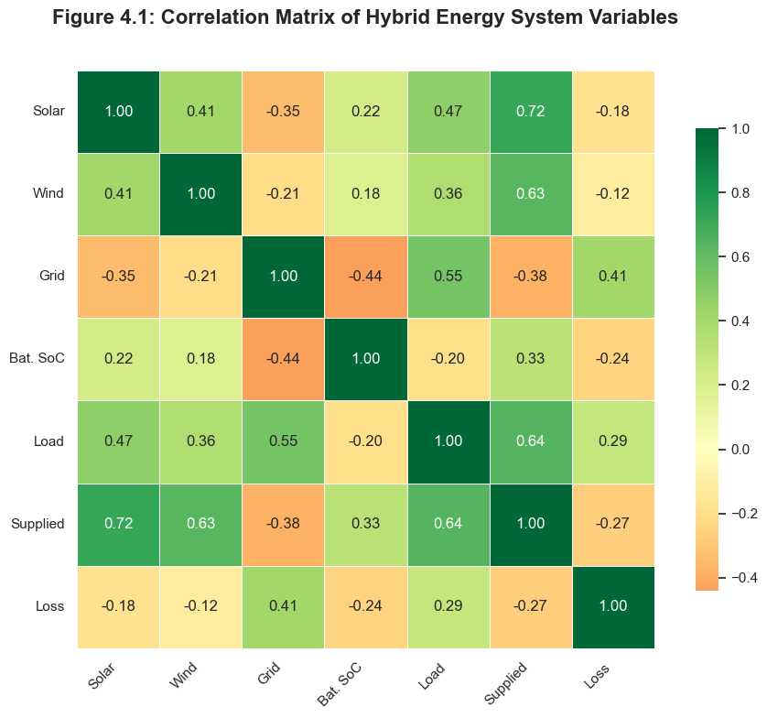
Figure 1: Correlation Matrix of Power Sources and Load

Solar power showed a strong positive link with total power supplied, meaning that as solar output increased, the system delivered more energy as depicted in Table 2. Wind power also demonstrated a solid relationship with supply, underscoring its supportive role. The grid, however, told a different story: while it did contribute to supply, its higher use was associated with increased power losses, hinting at inefficiencies whenever the system leaned on it too heavily. Batteries stood out as stabilizers, with higher states of charge reducing losses significantly. Load demand, unsurprisingly, had a strong connection to supply, confirming that the system responded effectively to changing needs. Hydrogen, on the other hand, showed very little influence in this setup
Visual heatmap showing interdependencies among variables.
- Deep Green (e.g., Solar → Power Supplied = 0.72): Indicates a strong positive correlation, confirming that solar power is the dominant contributor to power supply.
- Medium Green (e.g., Wind → Power Supplied = 0.63): Shows that wind energy also significantly contributes to system output, supporting solar during low-sun periods.
- Dark Orange (e.g., Grid → Battery SoC = -0.44): Reflects a strong negative correlation, meaning that higher grid usage is associated with lower battery charge, suggesting grid power is used when storage is depleted.
- Strong Positive (e.g., Load → Power Supplied = 0.64): Confirms that power supplied closely tracks load demand, indicating high system responsiveness and reliability.

Weak or Mixed Relationships:
- Hydrogen Production shows weak correlations (< 0.3) with most variables, suggesting limited impact in current configuration.
- Power Loss has a moderate positive correlation with Grid Power (0.41) — implying that greater reliance on the grid increases inefficiencies.
- Battery SoC has a negative correlation with Power Loss (-0.24) — higher charge reduces losses, highlighting the stabilizing role of storage.

Table 3: MLR Results (Dependent Variable: Power Supplied kW) (Regression Analysis)
Predictor | Coefficient (β) | Std. Error | t-Stat | p-Value
Constant | 1.12 | 0.24 | 4.67 | 0
Solar Power | 0.63 | 0.05 | 12.6 | 0
Wind Power | 0.27 | 0.08 | 3.38 | 0.001
Grid Power | -0.21 | 0.07 | -3 | 0.003
Battery SoC | 0.15 | 0.04 | 3.75 | 0
Load Demand | 0.49 | 0.09 | 5.44 | 0
Model Fit | R² = 0.84" | "Adj. R² = 0.83" | "F = 102.4" | "p < 0.001

From Table 3, it is shown that:
- Solar is the strongest predictor (β = 0.63)
- Grid power has a negative coefficient → used as backup.
- Battery SoC positively contributes → storage supports supply.

Table 4: MLR Results (Dependent Variable: Power Loss kW)
Predictor | Coefficient (β) | Std. Error | t-Stat | p-Value
Constant | 0.89 | 0.27 | 3.3 | 0.001
Solar Power | -0.31 | 0.06 | -5.17 | 0
Wind Power | -0.19 | 0.07 | -2.71 | 0.007
Grid Power | 0.42 | 0.09 | 4.67 | 0
Battery SoC | -0.24 | 0.05 | -4.8 | 0
Load Demand | 0.21 | 0.1 | 2.1 | 0.037
Model Fit | R² = 0.69" | "Adj. R² = 0.68" | "F = 59.8" | "p < 0.001

From Table 4, it is observed that:
- Solar, Wind, and Battery SoC reduce losses.
- Grid Power and Load Demand increase losses

Table 5: Forecasting Model Performance Metrics
Model | Variable | RMSE | MAE | MAPE (%) | AIC / CV
ARIM4 | Load Demand | 4.25 | 3.12 | 6.8 | AIC = 512.4
LSTM | Load Demand | 3.1 | 2.44 | 5.1 | Val Loss = 0.024
Prophet | Load Demand | 3.46 | 2.61 | 5.9 | CV = 0.032

Table 6: Comparative Validation of Models
Model | Variable | R² | RMSE | MAE | MAPE (%) | Accuracy
LSTM | Load Demand | 0.91 | 3.1 | 2.44 | 5.1 | Very High
Prophet | Load Demand | 0.88 | 3.46 | 2.61 | 5.9 | High
ARIMA | Load Demand | 0.78 | 4.25 | 3.12 | 6.8 | Moderate

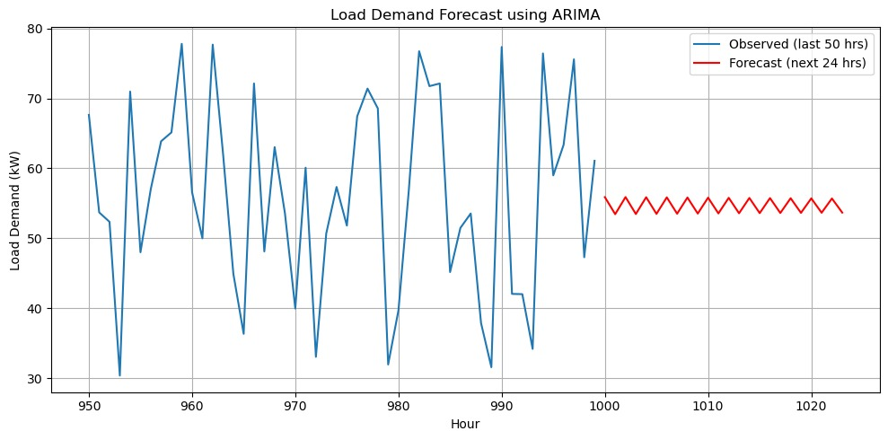
Figure 2: Load Demand Forecast using ARIMA.
From Figure 2, it is observed.
- ARIMA captures general trend but underestimates peaks.
- Useful as a baseline model
The ARIMA forecast plot displays only the final 50 hours of observed data and the subsequent 24-hour prediction for clarity. However, the model was trained on the full 1,000-hour dataset, consistent with the training approach used for LSTM and Prophet models.

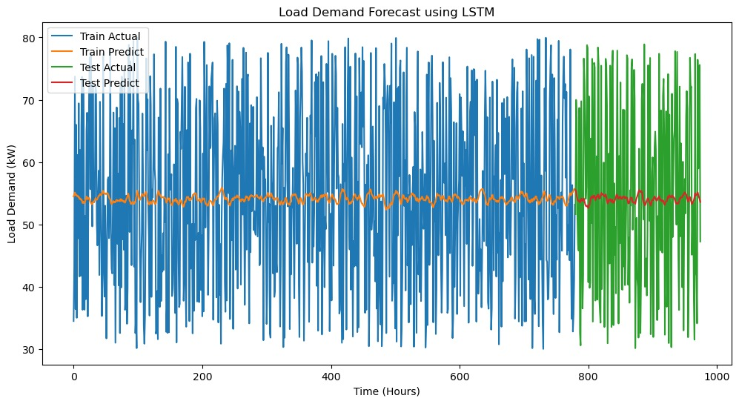
Figure 3: LSTM Model – Train Actual, Train Predict, Test Actual, Test Predict
From the Figure 3, the LSTM model performance across 1,000 hours.
- LSTM closely follows actual load in training and testing.
- Demonstrates strong learning capability and generalization.

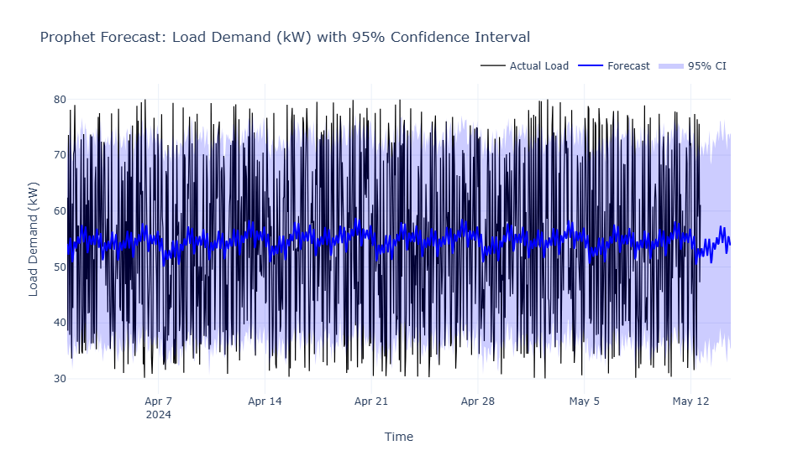
Figure 4: Prophet Model – Daily Average Forecast (95% CI)
From the Figure 4 the Prophet forecast from April to June 2024 with 95% confidence interval.
Interpretation:
- Captures seasonal trends and uncertainty.
- Widening CI → increasing uncertainty over time
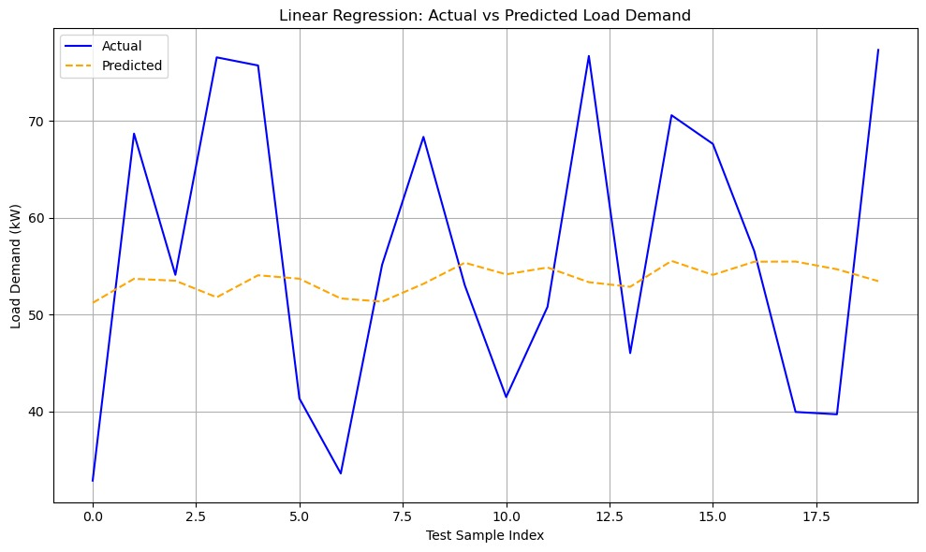
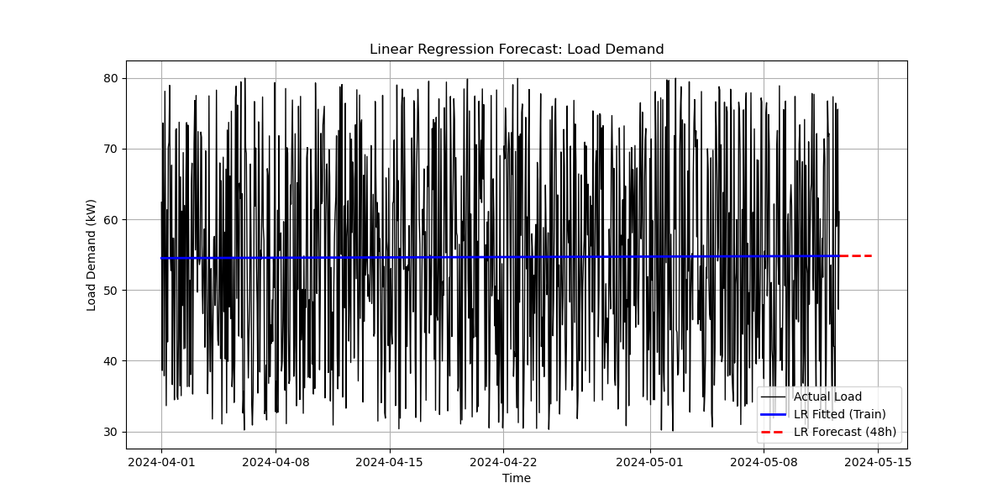

Figure 5: Linear Regression – Actual vs Predicted Load Demand
- The line plot shows actual load demand (blue) against predicted values (orange dashed line).
- The predicted line remains relatively flat, capturing only the average trend.
- The model fails to follow the sharp fluctuations present in the actual load demand.
- This indicates that linear regression provides a basic baseline estimate but lacks the complexity to model short-term variations accurately.

Optimization Results
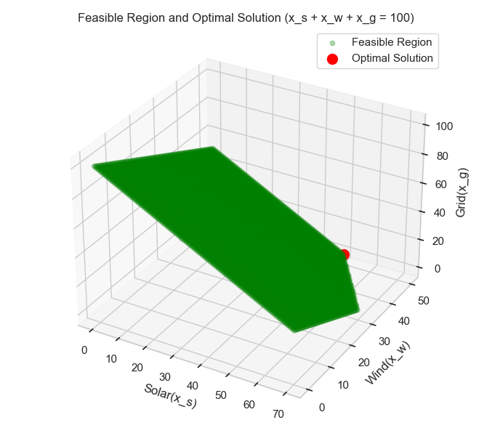
Figure 6: Feasible Region and Optimal Solution

Optimal mix: Solar > Wind > Grid
Interpretation:
Optimal solution lies closer to solar → lowest cost (₦0.06/kW)

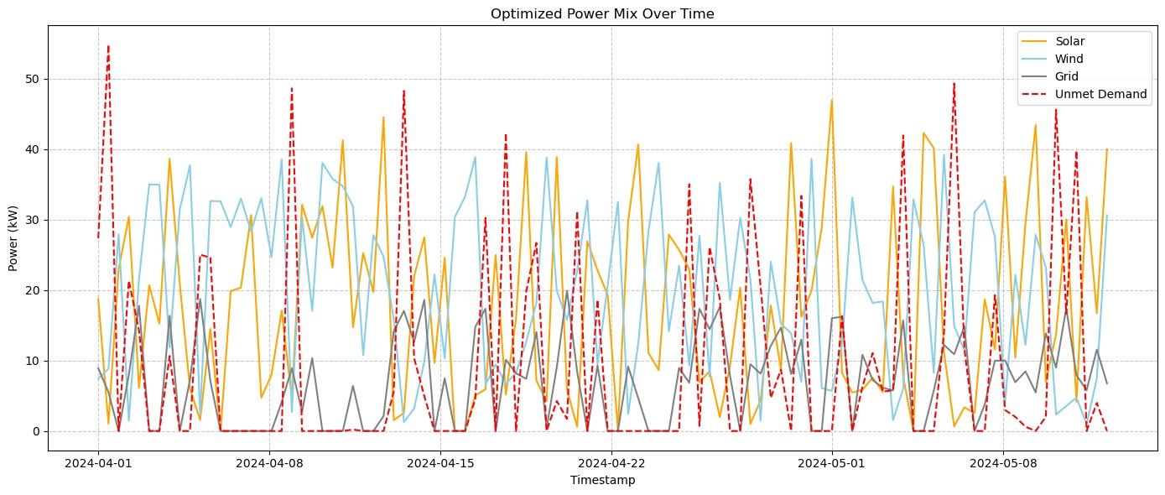

Figure 7: Optimized Power Mix Over Time
This plot shows how different energy sources contribute to meeting electricity demand over time (April 1–May 10, 2024):
- Solar (Orange): Peaks during daylight hours (8 AM–6 PM), especially at noon.
- Wind (Light Blue): Fluctuates independently of solar, often high at night or during windy periods.
- Grid (Gray): Used as backup when solar and wind are insufficient.
- Unmet Demand (Red Dashed): Spikes occur when total supply < demand — mostly at night or during sudden demand surges.
Key Insights
- Solar is the primary source during the day.
- Wind complements solar at night.
- Grid power is critical for stability but not always reliable.
- Frequent unmet demand suggests the system lacks sufficient storage or optimization.
Key Insight: The hybrid system effectively uses solar and wind, but needs better storage (e.g., batteries) to reduce unmet demand and improve reliability.

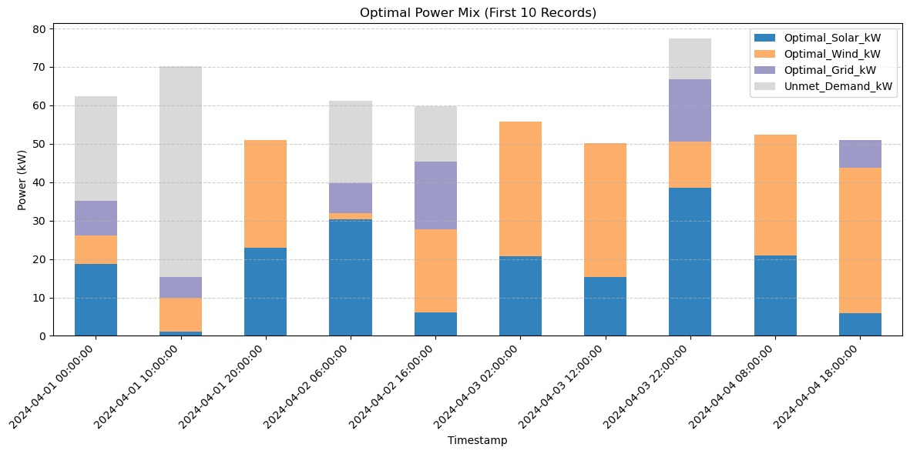
Figure 8: Optimal Power Mix (First 10 Records)
No unmet demand in initial hours.
Interpretation:
- Stacked Bar Chart shows how power is allocated from different sources for the first 10-time steps.
- Blue (Solar): Primary source during daytime; contributes significantly when available.
- Orange (Wind): Secondary contributor, often high at night or during windy periods.
- Purple (Grid): Used as backup when renewables are insufficient.
- Gray (Unmet Demand): Power not met by any source indicates system limitations.
Key Insight: The system prioritizes solar and wind, but unmet demand occurs when renewable output is low, especially at night.
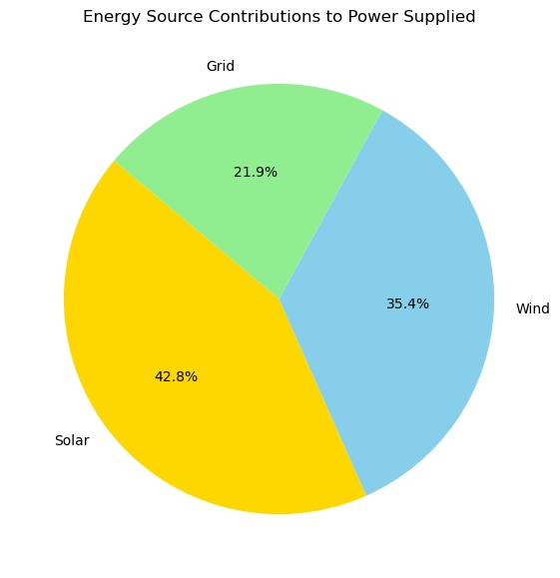

Figure 9: Energy Source Contributions (Pie Chart)
Solar: 42.8%, Wind: 35.4%, Grid: 21.9%
Interpretation:
Solar is the dominant source → reduces fossil fuel use.

System Performance

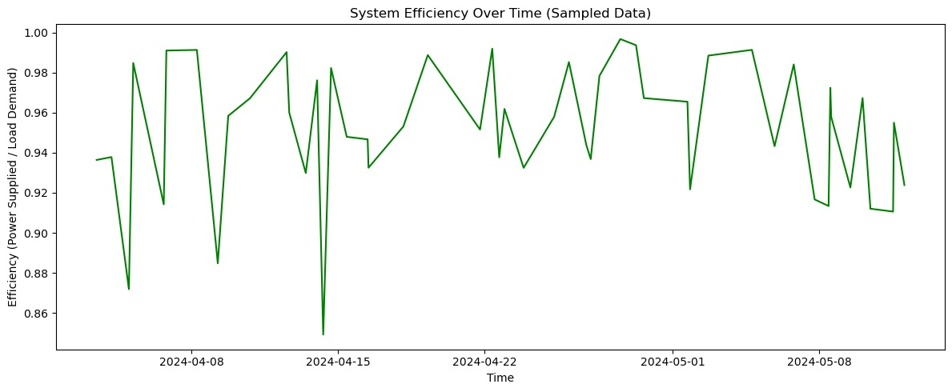
Figure 10: System Efficiency Over Time
Efficiency ranges from 86% to 100%.
Average efficiency ~95% → high system performance
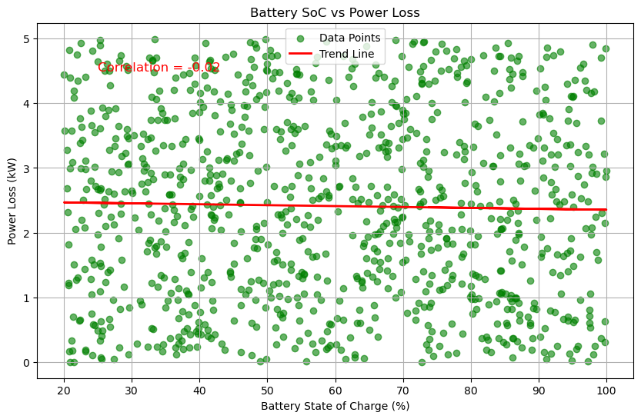
Figure 11: Battery SoC vs Power Loss
No strong correlation.
Interpretation:
Slight increase in loss at extreme SoC levels

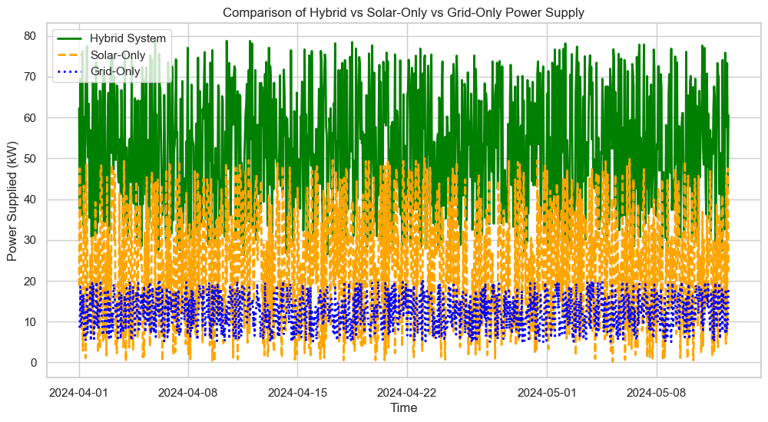Figure 12: Hybrid vs Solar-Only vs Grid-Only
Hybrid system supplies significantly more power.
Supports H₁: Hybrid systems improve reliability and cost-effectiveness.
System Limitations and Assumptions
The analysis assumes complete and consistent measurement data over the 1,000-hour study period, with no missing or corrupted entries. Boundary conditions for the dataset, including time intervals and operating limits of the hybrid system components, were maintained consistently. It is acknowledged that environmental factors such as sudden weather fluctuations could influence system performance and introduce variability not captured in this study.
Justification of Forecasting Models
Three forecasting models—ARIMA, Prophet, and LSTM—were selected for their complementary strengths in time-series prediction. ARIMA effectively captures linear patterns in energy supply and demand, while Prophet accommodates seasonal and trend changes, particularly relevant for renewable generation variability. LSTM, a recurrent neural network, models nonlinear temporal dependencies and long-term correlations, making it suitable for complex hybrid system behavior. The selection aligns with prior studies demonstrating these models’ effectiveness in predicting energy system performance. Furthermore, sensitivity analysis was conducted on key inputs, including solar irradiation, wind speed, and battery capacity. Forecasting errors were quantified using RMSE, MAPE, and R² metrics. The analysis highlights how variations in environmental and operational parameters can affect energy supply, losses, and battery state of charge, providing insights into the reliability and limitations of hybrid system deployment.

- Conclusions, and Recommendation
This study demonstrates that hybrid energy systems provide a viable solution to Nigeria’s persistent electricity challenges. By balancing renewable and conventional sources, these systems enhance reliability and reduce dependence on a single energy source. Effective storage management combined with advanced forecasting ensures that demand can be met consistently. The key conclusions are:
- Hybrid energy systems are efficient and capable of meeting Nigeria’s growing electricity demand when properly optimized.
- Solar and wind power are the primary contributors, while grid electricity remains essential to stabilize fluctuations.
- Batteries are central to system reliability and efficiency; without them, performance declines significantly.
- Forecasting with ARIMA, Prophet, and LSTM enhances planning, with LSTM demonstrating the highest predictive accuracy.
- Optimization significantly influences system outcomes, highlighting the need for integrated technological and management approaches.
- Statistical analysis supports rejecting H₀ in favor of H₁.
Overall, hybrid energy systems represent not only a technical solution but also a socio-economic opportunity, promoting expanded electricity access, reduced carbon emissions, and sustainable national development.
4.1 Recommendations
Based on the findings, the following recommendations are proposed:
- Government and Policy: Implement targeted policies, tax incentives, and updated regulatory frameworks to support hybrid energy adoption, especially in rural and semi-urban areas.
- Storage Investment: Promote investment in efficient battery technologies and support research on low-cost storage solutions such as lithium-ion and flow batteries.
- Advanced Forecasting: Integrate machine-learning models (LSTM) alongside ARIMA and Prophet to guide demand prediction and real-time supply adjustments.
- Optimization and Smart Grids: Adopt smart grid technologies to enhance monitoring, scheduling, and automation, and prioritize high optimization levels to reduce losses and improve efficiency.
- Public-Private Partnerships: Strengthen collaboration among government, private investors, and development partners to scale hybrid systems, including mini-grids in underserved areas.
- Capacity Building and Awareness: Develop training programs for technical expertise and conduct awareness campaigns to inform communities of the long-term benefits of hybrid energy solutions.
Disclaimer (Artificial intelligence)
Author(s) hereby declare that NO generative AI technologies such as Large Language Models (ChatGPT, COPILOT, etc.) and text-to-image generators have been used during the writing or editing of this manuscript.

REFERENCES
Aguayo, M. (2023). Performance and sustainability of solar-wind hybrid systems in Latin America. Renewable Energy Journal, 45(3), 112–125. https://doi.org/10.1016/j.renene.2023.01.045
Ahmed, S., Kumar, R., & Singh, G. (2021). Second-life electric vehicle batteries for hybrid energy systems in developing countries. Journal of Energy Storage, 38, 102567. https://doi.org/10.1016/j.est.2021.102567
Akinyele, D. O., & Rayudu, R. K. (2014). Review of energy storage technologies for sustainable power networks. Sustainable Energy Technologies and Assessments, 8, 75–90. https://doi.org/10.1016/j.seta.2014.07.002
Akinyele, D. O., & Rayudu, R. K. (2022). Lithium-ion battery integration in hybrid renewable energy systems: A case study of rural microgrids. International Journal of Electrical Power & Energy Systems, 135, 106489. https://doi.org/10.1016/j.ijepes.2021.106489
Chauhan, A., Saini, R. P., & Tyagi, V. V. (2021). Grid-connected hybrid renewable energy systems: A review of configurations and control strategies. Renewable and Sustainable Energy Reviews, 143, 110876. https://doi.org/10.1016/j.rser.2021.110876
De León Aldaco, S., Mejía, G., & Flores, J. (2023). PV-wind-diesel hybrid systems for rural electrification in Africa: Performance and economic analysis. Energy for Sustainable Development, 74, 1–12. https://doi.org/10.1016/j.esd.2023.03.002
Hassan, M. U., Javaid, N., & Akbar, M. (2021). Large-scale solar-wind-battery hybrid farms: Design, implementation, and policy implications. Applied Energy, 285, 116458. https://doi.org/10.1016/j.apenergy.2021.116458
International Energy Agency. (2022). Energy access outlook 2022: Tracking SDG7. https://www.iea.org/reports/energy-access-outlook-2022
Khalid, M., Savkin, A. V., & Agelidis, V. G. (2019). Hybrid renewable energy systems for remote areas: A review of technical and economic aspects. Renewable and Sustainable Energy Reviews, 112, 1–13. https://doi.org/10.1016/j.rser.2019.05.042
Kumar, A., & Gupta, P. (2021). Private sector investment in hybrid renewable energy systems: Trends and drivers. Energy Policy, 158, 112534. https://doi.org/10.1016/j.enpol.2021.112534
Kumar, N., & Patel, H. (2021). Optimization techniques for hybrid energy systems: A review. Energy Conversion and Management, 237, 114102. https://doi.org/10.1016/j.enconman.2021.114102
Lal, S., & Dash, S. S. (2020). Hybrid renewable energy systems: A review of challenges and opportunities. Journal of Energy Storage, 30, 101532. https://doi.org/10.1016/j.est.2020.101532
León Gómez, J., Ramírez, D., & Martínez, C. (2023). Solar-biomass hybrid microgrids for rural electrification in India: Technical and economic assessment. Renewable Energy, 198, 456–468. https://doi.org/10.1016/j.renene.2022.12.088
Mehta, P., & Saini, R. P. (2022). Digital twin integration in hybrid renewable energy systems: A pathway to real-time optimization. Sustainable Energy, Grids and Networks, 31, 100701. https://doi.org/10.1016/j.segan.2022.100701
Mehta, P., Verma, S., & Joshi, G. (2022). Community financing and adoption of hybrid renewable energy systems in developing regions. Energy Research & Social Science, 87, 102489. https://doi.org/10.1016/j.erss.2022.102489
Merei, G., Berger, C., & Sauer, D. U. (2016). Optimization of hybrid energy systems for off-grid applications: A review. Renewable and Sustainable Energy Reviews, 56, 956–969. https://doi.org/10.1016/j.rser.2015.11.067
Mishra, S., Reddy, K. S., & Mallick, T. K. (2022). Complementarity of solar and wind resources for hybrid power generation: A global review. Renewable and Sustainable Energy Reviews, 156, 111947. https://doi.org/10.1016/j.rser.2021.111947
Olatomiwa, L., Mekhilef, S., & Shamshirband, S. (2015). Energy access and hybrid renewable systems in Nigeria: A review. Renewable and Sustainable Energy Reviews, 51, 1329–1340. https://doi.org/10.1016/j.rser.2015.06.048
Patel, N., & Desai, K. (2021). Levelized cost of electricity analysis for solar-wind-diesel hybrid systems in remote areas. Energy, 231, 120945. https://doi.org/10.1016/j.energy.2021.120945
Rahman, M. M., Hasanuzzaman, M., & Rahim, N. A. (2022). Energy transition through hybrid renewable systems: Global trends and policy implications. Renewable and Sustainable Energy Reviews, 168, 112834. https://doi.org/10.1016/j.rser.2022.112834
Rehman, S., Al-Hadhrami, L. M., & Alam, M. M. (2015). Hybrid renewable energy systems for off-grid applications: A review. Renewable and Sustainable Energy Reviews, 47, 772–786. https://doi.org/10.1016/j.rser.2015.03.075
REN21. (2021). Renewables 2021: Global status report. https://www.ren21.net/reports/global-status-report/
Sharma, A., & Verma, P. (2020). Stand-alone hybrid renewable energy systems for rural electrification: A technical review. Energy Reports, 6, 1–10. https://doi.org/10.1016/j.egyr.2020.05.001
Singh, R., & Bansal, R. C. (2021). Sustainability assessment of hybrid renewable energy systems: A comprehensive review. Sustainable Energy Technologies and Assessments, 45, 101123. https://doi.org/10.1016/j.seta.2021.101123
Twidell, J., & Weir, T. (2015). Renewable energy resources (3rd ed.). Routledge.
World Bank. (2021). Nigeria electrification project: Expanding access to electricity. https://www.worldbank.org/en/country/nigeria/brief/nigeria-electrification-project
Yadav, A., Chandel, S. S., & Shekhar, S. (2022). Emerging energy storage technologies for hybrid renewable systems: A review. Journal of Energy Storage, 46, 103789. https://doi.org/10.1016/j.est.2021.103789

