Original Research Article

Prediction of the Service Life and Wear of Electric Hoist Wheels using the GM(1,1) Grey Model

ABSTRACT

As one of the core components of electric hoists, the wheels of the traveling mechanism directly affect the working efficiency and operational safety of the equipment through their wear degree. To address the need for accurate service life assessment of the wheels in the electric hoist traveling mechanism, this study aims to predict the wheel wear amount and remaining service life. Based on the collected wheel wear life test data, the grey GM (1,1) prediction model was adopted for modeling and life prediction. The results show that the model has high prediction accuracy: the average relative error between the predicted values and actual values is 2.03%, with a maximum relative error of 3.08%. This provides a feasible method for the wear amount prediction and life analysis of the electric hoist traveling mechanism wheels during actual operation. This method is applicable to standard operating conditions with limited sample data in the early stage of equipment operation. It does not consider complex operating conditions and the coupling effect of multiple factors, and further optimization is required for relevant scenarios.
Keywords:Electric Hoist; Traveling Mechanism Wheels; Grey Model; Life Prediction

- INTRODUCTION

The electric hoist is a common lifting equipment used for cargo handling and heavy-duty lifting in engineering construction. Its operational reliability and safety are directly related to the work efficiency and work safety in actual production. The running mechanism is one of the core components of the electric hoist, mainly composed of driving wheels, driven wheels, motors, reducers and other parts. The working principle of the running mechanism is that the motor outputs power, which is then transmitted to the reducer to reduce the torque, and then drives the wheels to rotate, making the wheels move along the running track to realize the lateral movement of the electric hoist. During the long-term process of the electric hoist moving heavy objects, repeated friction occurs between the wheels of the running mechanism and the track, which easily leads to the wear of the wheel tread. This will reduce the working performance and efficiency of the running mechanism, cause problems such as rail gnawing during operation, shutdown due to faults, and even lead to safety accidents. Therefore, it is urgent to carry out research on the prediction of the wear amount and service life of the wheels in the electric hoist running mechanism. At present, the maintenance methods of lifting equipment mainly include regular maintenance and post-fault maintenance. Due to differences in operating conditions, work intensity, and personnel skills, wheels may be scrapped in advance or the operational risks may increase, resulting in the waste of human and financial resources and the occurrence of safety accidents. Therefore, predicting the wear amount and service life of wheels based on collected test data has become an important issue to improve the reliability of the running mechanism and reduce operation and maintenance costs. To obtain accurate wheel wear data, this paper builds a life test platform for the electric hoist running mechanism, and measures the wear amount of the driving wheels and driven wheels operating under standard working conditions. By regularly collecting the wheel wear data, a reliable data foundation is provided for the subsequent model establishment. Based on the wear data obtained from the test platform, this paper uses the grey prediction model GM(1,1) to predict the service life of the wheels in the electric hoist running mechanism, providing a theoretical basis for the health management and maintenance of lifting equipment, which has certain engineering application value.

Q Li et al. proposed a method for predicting the remaining service life of rail train wheels based on an extended mixed-effects degradation model and the Bayesian method. By performing independence transformation on the online monitoring data, the Bayesian method is used to combine the online monitoring data with historical data to update parameters, and then predict the remaining service life of the wheels¹. S Hong et al. proposed a train wheel life prediction algorithm based on the nonlinear Wiener process. By monitoring the wheel data to update the model, the probability density function of the remaining service life of the wheels can be obtained to calculate the remaining service life². Jiang et al. proposed a method for predicting the remaining service life of wheels based on a discrete state-space model. This method estimates the remaining service life according to the degradation state of the wheels and analyzes the effects caused by the random degradation of the wheels and measurement errors³.

A Shebani et al. established a nonlinear regression model using artificial neural networks to predict the wear of wheels and rails under different contact conditions, and built a test bench to train, test and verify the neural network. The results show that the neural network can effectively predict the wear of wheels and rails⁴. L Ren et al. introduced the mathematical normal distribution to describe the random parameters of wheel-rail interaction, and used the Archard wear model and FASTSIM algorithm to calculate the wheel tread wear. The accuracy of this method is verified by the measured data⁵. A. Marzia et al. proposed a prediction method for material wear amount and wheel service life based on the Archard model and the local contact model⁶. G Tao et al. developed a new online prediction model for wheel wear. On the basis of considering the track flexibility, dynamic simulation of the wheels is carried out to realize the online update of wheel wear prediction, and then predict the wheel service life⁷. P. Han used the least squares method for polynomial fitting, established a binary numerical prediction model for wheel wear with operating mileage and profile wear position as variables, and verified the model's accuracy through actual comparison⁸. L. Wang et al. collected measured wheel wear data, analyzed the relationship between wheel diameter, rim thickness and wear rate, and established a data-driven model for wheel wear⁹. S. Liu et al. proposed a wheel tread wear prediction model based on the genetic algorithm-optimized backpropagation neural network (GA-BPNN) and long short-term memory (LSTM) algorithm. It adopts a two-step data-driven prediction method, which improves the accuracy of the model prediction¹⁰.

S. H-Ni et al. proposed a railway wheel life prediction framework based on the simulation output of a model-driven system, which calculates the remaining wheel life by considering wear, rolling contact fatigue, and their interaction¹¹. N. Ao et al. proposed a stepwise fatigue assessment method combining the nominal stress method, damage tolerance analysis method, and finite element model, and evaluated the remaining life of high-speed train wheels by comparing three fatigue crack growth rate models¹². I. A. Iliopoulos et al. predicted the remaining service life of wheels by collecting on-board vibration signals and establishing a function between rim depth and vehicle operating mileage¹³. C. Chen et al. proposed a wheel wear prediction method based on domain knowledge and multi-signal sources, constructed a regression model through data fusion and feature extraction to predict wheel tread wear, and input measured signals to realize wheel wear monitoring¹⁴. To address the problem that data-driven algorithms are difficult to extract effective features due to the noisy, complex, and non-stationary nature of high-speed train operation signals, H. Wang et al. proposed a novel Multi-layer Wavelet Fusion Convolutional Neural Network (MWI-Net) integrating discrete wavelet transform and dynamic frequency aggregation mechanism for wheel wear prediction¹⁵.

2. GREY PREDICTION MODEL

The grey system theory was proposed by Professor Deng Julong in the 1980s. As a well-developed emerging discipline system, it is widely used in various fields such as ecology, geography, water conservancy, geology, agriculture, economy, and society. The grey system theory is mainly used for system modeling and prediction research with a small number of samples and limited information. Compared with traditional statistical models, the grey model does not rely on a large amount of historical data, and has high adaptability especially when the mechanical equipment is in the initial operation stage or the test data is incomplete. In the grey system theory, the GM(1,1) model is the most widely used type of model. Usually, the original data sequence may be random or even messy, and in this case, the original data sequence is called a grey sequence. Therefore, it is necessary to process the original data sequence. By performing cumulative generation on the original data sequence, the randomness of the original data sequence is weakened, and a first-order linear differential equation is established to obtain the predicted value of the system. Due to the advantages of requiring a small amount of data, high modeling efficiency, and convenient calculation, the GM(1,1) model has been widely used in the field of mechanical component life prediction and degradation modeling.
Let the original data sequence be:
$${\text{x}}^{\left(\text{0}\right)}\text{=\{}{\text{x}}_{\left(\text{1}\right)}^{\left(\text{0}\right)} \text{,} {\text{x}}_{\left(\text{2}\right)}^{\left(\text{0}\right)} \text{,}{ \text{x}}_{\left(\text{3}\right)}^{\left(\text{0}\right)} \text{,} \text{⋯,} {\text{x}}_{\left(\text{n}\right)}^{\left(\text{0}\right)}\text{\}}\text{（1）}$$
In the formula:$x_{\left(k\right)}^{\left(0\right)}$represents the data at the k-th moment, that is, the wear amount of the wheels in the electric hoist running mechanism at the k-th time point.
To weaken the randomness of the original data sequence, a first-order cumulative generation (1-AGO) process is performed on $x^{\left(0\right)}$ to obtain a new first-order cumulative sequence $x^{\left(1\right)}$.
The calculation formula is:
$${\text{x}}_{\left(\text{k}\right)}^{\left(\text{1}\right)}\text{=}\sum_{\text{i}\text{=0}}^{\text{k}}{{\text{x}}_{\left(\text{i}\right)}^{\left(\text{1}\right)}}\text{，}\left(\text{k}\text{=}\text{1}\text{,2,3,⋯,}\text{n}\right)\text{（2）}$$
After the first-order cumulative generation, the new sequence $x^{\left(1\right)}$has smaller volatility and shows a trend close to exponential change.
To reduce the modeling error and improve the model accuracy, the mean sequence ${\text{z}}^{\left(1\right)}$is defined as:
$${\text{z}}_{\left(\text{k}\right)}^{\left(\text{1}\right)}\text{=}\frac{\text{1}}{\text{2}}\left[{\text{x}}_{\left(\text{k}\right)}^{\left(\text{1}\right)}\text{+}{\text{x}}_{\left(\text{k}\text{-1}\right)}^{\left(\text{1}\right)}\right]\text{，}\left(\text{k}\text{=2,3,⋯,}\text{n}\right)\text{（3）}$$
The least-squares prediction sequence of the grey differential equation GM(1,1) is:
$${\text{x}}_{\left(\text{k}\right)}^{\left(\text{0}\right)}\text{+}\text{a}{\text{z}}_{\left(\text{k}\right)}^{\left(\text{1}\right)}\text{=}\text{u}\text{，}\left(\text{k}\text{=2,3,⋯,}\text{n}\right)\text{（4）}$$
The whitening differential equation of GM(1,1) for $x_{\left(k\right)}^{\left(1\right)}$ is:
$$\frac{\text{d}{\text{x}}_{\left(\text{k}\right)}^{\left(\text{1}\right)}}{\text{d}\text{t}}\text{+}\text{α}{\text{x}}_{\left(\text{k}\right)}^{\left(\text{1}\right)}\text{=}\text{u}\text{（5）}$$
Among them, parameters a and u are constants. a is the development coefficient, and u is the grey action quantity. a and u can be determined using the least-squares method:
$${\left[\text{a}\text{,}\text{u}\right]}^{\text{T}}\text{=}{\left({\text{B}}^{\text{T}}\text{B}\right)}^{\text{-1}}{\text{B}}^{\text{T}}{\text{Y}}_{\text{N}}\text{（6）}$$
Among them,B and Y_{N} can be expressed as:
$$\text{B}\text{=}\left[\begin{matrix}\text{-}{\text{z}}_{\left(\text{1}\right)}^{\left(\text{1}\right)} & \text{1} \\ \text{-}{\text{z}}_{\left(\text{2}\right)}^{\left(\text{1}\right)} & \text{1} \\ \text{⋮} & \text{⋮} \\ \text{-}{\text{z}}_{\left(\text{k}\right)}^{\left(\text{1}\right)} & \text{1}\end{matrix}\right]\text{,}{\text{Y}}_{\text{n}}\text{=}{\left[\begin{matrix}{\text{x}}_{\left(\text{2}\right)}^{\left(\text{0}\right)}\text{,}{\text{x}}_{\left(\text{3}\right)}^{\left(\text{0}\right)}\text{,} & \text{⋯,}{\text{x}}_{\left(\text{n}\right)}^{\left(\text{0}\right)}\end{matrix}\right]}^{\text{T}}（7）$$
By solving the differential equation, the solution of the GM(1,1) model can be obtained:
$${\hat{\text{x}}}_{\left(\text{k}\text{+1}\right)}^{\left(\text{1}\right)}\text{=}\left({\text{x}}_{\left(\text{0}\right)}^{\left(\text{1}\right)}\text{-}\frac{\text{u}}{\text{α}}\right){\text{e}}^{\text{-}\text{ak}}\text{+}\frac{\text{u}}{\text{α}}\text{，}\left(\text{k}\text{=}\text{0 }\text{,}\text{1}\text{,}\text{2}\text{,⋯,}\text{n}\right)\text{（8）}$$
The calculated value is subjected to inverse cumulative generation to obtain the predicted value of the original data:
$${\hat{\text{x}}}_{\left(\text{k}\text{+1}\right)}^{\left(\text{0}\right)}\text{=}{\hat{\text{x}}}_{\left(\text{k}\text{+1}\right)}^{\left(\text{1}\right)}\text{-}{\hat{\text{x}}}_{\left(\text{k}\right)}^{\left(\text{1}\right)}\text{，}\left(\text{k}\text{=}\text{0}\text{,}\text{1}\text{,}\text{2}\text{,⋯,}\text{n}\right)\text{（9）}$$
The absolute error and relative error between the predicted value and the actual value are:
$$\left\{\begin{matrix}{\text{δ}}_{\left(\text{k}\text{+1}\right)}^{\left(\text{0}\right)}\text{=∣}{\text{x}}_{\left(\text{k}\text{+1}\right)}^{\left(\text{0}\right)}\text{-}{\hat{\text{x}}}_{\left(\text{k}\text{+1}\right)}^{\left(\text{0}\right)}\text{∣} & \\ {\text{E}}_{\left(\text{k}\text{+1}\right)}^{\left(\text{0}\right)}\text{=}{\text{δ}}_{\left(\text{k}\text{+1}\right)}^{\left(\text{0}\right)}\text{/}{\text{x}}_{\left(\text{k}\text{+1}\right)}^{\left(\text{0}\right)}\text{×100\%} & \end{matrix}\right.\left(\text{k}\text{=}\text{0}\text{,}\text{1}\text{,}\text{2}\text{,⋯,}\text{n}\right)\text{（10）}$$

3 .TEST PLATFORM CONSTRUCTION AND DATA COLLECTION

To obtain the wheel wear data of the electric hoist running mechanism under actual operating conditions, this paper builds a life test platform for the electric hoist running mechanism. The test platform is mainly composed of a track, support columns, driving wheels and driven wheels, a drive motor, a data acquisition system, a hook, and a load device. It can simulate the working process of the electric hoist running mechanism under actual working conditions, realize long-term stable operation, real-time monitor the operating status, and collect operating data. Figure 1 intuitively shows the main components and the overall structural layout of the test platform.

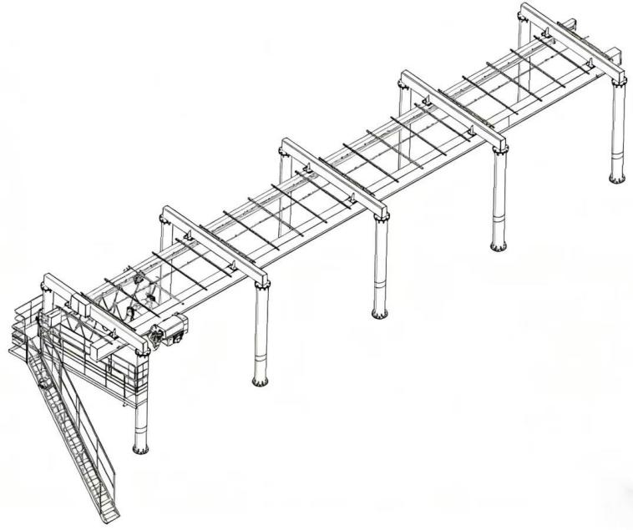

Fig. 1. Electric hoist traveling mechanism life test platform

The structural design of the life test platform for the electric hoist running mechanism adopts an overall architecture of dual-station parallel operation, consisting of two independent running tracks. It can simultaneously conduct life tests on the running mechanisms of two electric hoists on the same platform, with the two running tracks of the platform arranged side by side in space. The platform is mainly supported by mounting columns, which are arranged opposite each other in pairs. The tops of the two mounting columns are connected by crossbeams, and hoist beams are installed between the crossbeams to form a stable supporting structure.

During the test, the drive motor outputs torque, which drives the driving wheels and driven wheels to move reciprocally at a constant speed along the track through the reducer. The load device is used to simulate the load under rated working conditions to ensure that the test conditions are consistent with the actual working conditions. On the console page, the test operating data such as running distance, running speed, and running time can be monitored in real time. At the same time, the speed and direction of the test mechanism can be adjusted, and the start and stop of the test mechanism can be controlled to realize the control function.

During the operation, the measurement of the running distance is realized through an infrared distance measuring device, which can be displayed in real time on the console page to realize the visual management of the running mileage. The test bench is not equipped with a wear amount measuring sensor; instead, the wheels are disassembled regularly after shutdown to measure the wear amount. When the running mechanism reaches the target running mileage, the wheels of the running mechanism are disassembled, and a coordinate measuring machine is used to measure the driving wheels and driven wheels with high precision. This process is repeated multiple times to obtain multiple sets of wear amount data corresponding to different running mileages, forming a data sequence of running mileage and wear amount. This measurement method ensures the accuracy and reliability of the measured data, greatly reduces the error of the test data, and provides a reliable basis for the accuracy of the subsequent grey model modeling.

4. WHEEL WEAR PREDICTION BASED ON THE GM(1,1) MODEL

This chapter takes the front wheel of the driven wheel in the electric hoist running mechanism as the research object, and predicts the wheel based on the data measured by the electric hoist running mechanism test platform built in this paper. During the test, the operation is stopped every 30 km of cumulative running distance for inspection. The wheels are disassembled, and a micrometer is used to measure the thickness at 3 evenly distributed points on the rim circumference. The wear amount is calculated, and the wear amount at the most severely worn position is taken as the wheel wear data. The wheel rim wear detection data is shown in Table 1. Given the wheel rim wear amount within the first 6 distance intervals, the wheel rim wear amount within the next distance interval is predicted.

Table 1. Wheel rim wear amount and mileage

Mileage/km | 30 | 60 | 90 | 120 | 150 | 180
Wear Amount/mm | 0.65 | 1.58 | 2.75 | 3.82 | 4.60 | 5.05

- Construct a sequence from the original data in Table 1, and denote the original sequence as:
$${\text{x}}^{\left(\text{0}\right)}\text{=\{}\text{0.65}\text{,}\text{1.58}\text{,}\text{2.75}\text{,}\text{3.82}\text{,}\text{4.60}\text{,}\text{5.05}\text{\}}$$
- Perform a first-order cumulative generation process on the above formula to obtain the 1-AGO sequence:
$${\text{x}}^{\left(\text{1}\right)}\text{=\{}\text{0.45}\text{,}\text{2.23}\text{,}\text{4.98}\text{,}\text{8.80}\text{,}\text{13.40}\text{,}\text{18.45}\text{\}}$$
- Construct the mean sequence ${\text{z}}^{\left(\text{1}\right)}$, and the calculation result is:
${\text{z}}^{\left(1\right)}\text{=\{}\text{1.44}\text{,}\text{3.605}\text{,}\text{6.89}\text{,}\text{11.10}\text{,}\text{15.925}\text{\}}$
- Establish the matrix equation of the grey model using the least-squares method. The least-squares prediction sequence of the GM(1,1) model is:
$${\text{x}}_{\left(\text{k}\right)}^{\left(\text{0}\right)}\text{+}\text{a}{\text{z}}_{\left(\text{k}\right)}^{\left(\text{1}\right)}\text{=}\text{u}\text{，}\left(\text{k}\text{=2,3,⋯,}\text{n}\right)$$
Substitute the results of the mean sequence ${\text{z}}^{\left(\text{1}\right)}$ into B and Y_{N}:
$$\text{B}\text{=}\left[\begin{matrix}\text{-}{\text{z}}_{\left(\text{2}\right)}^{\left(\text{1}\right)} & \text{1} \\ \text{-}{\text{z}}_{\left(\text{3}\right)}^{\left(\text{1}\right)} & \text{1} \\ \text{-}{\text{z}}_{\left(\text{4}\right)}^{\left(\text{1}\right)} & \text{1} \\ \text{-}{\text{z}}_{\left(\text{5}\right)}^{\left(\text{1}\right)} & \text{1} \\ \text{-}{\text{z}}_{\left(\text{6}\right)}^{\left(\text{1}\right)} & \text{1}\end{matrix}\right]\text{=}\left[\begin{matrix}\text{-1.44} & \text{1} \\ \text{-3.605} & \text{1} \\ \text{-6.89} & \text{1} \\ \text{-11.10} & \text{1} \\ \text{-15.925} & \text{1}\end{matrix}\right] \text{, }{\text{Y}}_{\text{n}}\text{=}\left[\begin{matrix}{\text{x}}_{\left(\text{2}\right)}^{\left(\text{0}\right)} \\ {\text{x}}_{\left(\text{3}\right)}^{\left(\text{0}\right)} \\ {\text{x}}_{\left(4\right)}^{\left(\text{0}\right)} \\ {\text{x}}_{\left(\text{5}\right)}^{\left(\text{0}\right)} \\ {\text{x}}_{\left(6\right)}^{\left(\text{0}\right)}\end{matrix}\right]\text{=}\left[\begin{matrix}\text{1.58} \\ \text{2.75} \\ \text{3.82} \\ \text{4.60} \\ \text{5.05}\end{matrix}\right]$$
- Solve the parameter ${\left[\text{a}\text{,}\text{u}\right]}^{\text{T}}$,using the least-squares method, ${\left[\text{a}\text{,}\text{u}\right]}^{\text{T}}\text{=}{\left({\text{B}}^{\text{T}}\text{B}\right)}^{\text{-1}}{\text{B}}^{\text{T}}{\text{Y}}_{\text{N}}$.
The calculation result is:
$${\left[\text{a}\text{,}\text{u}\right]}^{\text{T}}\text{=}{\left[\text{-}\text{0.025}\text{,}\text{0.62}\right]}^{\text{T}}$$
- Let ${\text{x}}_{\left(\text{0}\right)}^{\left(\text{1}\right) }\text{=}{\text{x}}_{\left(\text{1}\right)}^{\left(\text{0}\right) }$, the cumulative solution of the GM(1,1) model is:
$${\hat{\text{x}}}_{\left(\text{k}\text{+1}\right)}^{\left(\text{1}\right)}\text{=}\left({\text{x}}_{\left(\text{0}\right)}^{\left(\text{1}\right)}\text{-}\frac{\text{u}}{\text{α}}\right){\text{e}}^{\text{-}\text{ak}}\text{+}\frac{\text{u}}{\text{α}}$$
In the formula, ${\text{x}}_{\left(\text{0}\right)}^{\left(\text{1}\right) }\text{=}$0.65. Substitute parameters a and u into the formula to get:
${\hat{\text{x}}}_{\left(\text{k}\text{+1}\right)}^{\left(\text{1}\right)}\text{=}\text{25.45}{\text{e}}^{\text{0.025}\text{k}}\text{-}$24.8
- Calculate the predicted value of the cumulative sequence:
When k=0, corresponding to the original serial number 1, ${\hat{\text{x}}}_{\left(\text{1}\right)}^{\left(\text{1}\right)}\text{=}$0.65
When k=1, corresponding to the original serial number 2, ${\hat{\text{x}}}_{\left(\text{2}\right)}^{\left(\text{1}\right)}\text{=}$2.20
When k=2, corresponding to the original serial number 3, ${\hat{\text{x}}}_{\left(\text{3}\right)}^{\left(\text{1}\right)}\text{=}$4.95
When k=3, corresponding to the original serial number 4, ${\hat{\text{x}}}_{\left(\text{4}\right)}^{\left(\text{1}\right)}\text{=}$8.85
When k=4, corresponding to the original serial number 5, ${\hat{\text{x}}}_{\left(\text{5}\right)}^{\left(\text{1}\right)}\text{=}$13.45
When k=5, corresponding to the original serial number 6, ${\hat{\text{x}}}_{\left(\text{6}\right)}^{\left(\text{1}\right)}\text{=}$18.48
- The grey model predicted wear amount is obtained by subtractive reduction of the calculated value. The comparison between the predicted value and the actual wear value, as well as their absolute error and relative error, are shown in Table 2.

Table 2. Comparison between predicted values and actual values

Serial Number | Mileage/km | Actual Wear Amount/mm | Predicted Wear Amount/mm | Absolute Error/mm | Relative Error/%
1 | 30 | 0.65 | 0.63 | 0.02 | 3.08
2 | 60 | 1.58 | 1.55 | 0.03 | 1.90
3 | 90 | 2.75 | 2.80 | 0.05 | 1.82
4 | 120 | 3.82 | 3.90 | 0.08 | 2.10
5 | 150 | 4.60 | 4.68 | 0.08 | 1.74
6 | 180 | 5.05 | 4.97 | 0.08 | 1.58

By comparing the predicted values of the grey model with the actual values, it can be seen that both the absolute error and the relative error are low, and the average relative error is 2.04%. This proves that the prediction method is accurate and verifies that the grey model is feasible for predicting the wheel wear of the electric hoist running mechanism with the running mileage.

- The comparison between the actual wear amount and the predicted wear amount is presented in Figure 2。

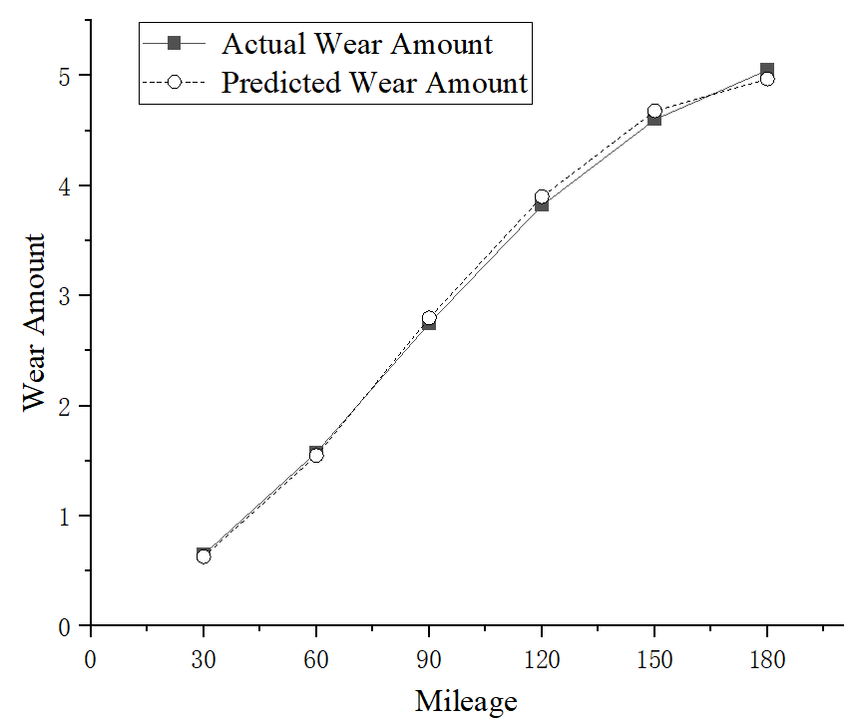

Fig. 2. The comparison between the actual wear amount and the predicted wear amount

5. WHEEL REMAINING SERVICE LIFE PREDICTION

- Conduct subsequent extended prediction on the cumulative sequence and calculate the subsequent cumulative wear trend:
When k=6, corresponding to the original serial number 7, ${\hat{\text{x}}}_{\left(\text{7}\right)}^{\left(\text{1}\right)}\text{=}$23.75
When k=7, corresponding to the original serial number 8,${ \hat{\text{x}}}_{\left(\text{8}\right)}^{\left(\text{1}\right)}\text{=}$29.61
- Calculate the single-segment predicted wear amount through subtractive reduction, so as to obtain the wear rate v per unit mileage:
Single-segment predicted wear amount: ${\hat{\text{x}}}_{\left(\text{7}\right)}^{\left(\text{0}\right)}\text{=}{\hat{\text{x}}}_{\left(\text{7}\right)}^{\left(\text{1}\right)}\text{-}{\hat{\text{x}}}_{\left(\text{6}\right)}^{\left(\text{1}\right)}$=5.22
Wear rate:$\text{v}\text{=}\frac{{\hat{\text{x}}}_{\left(\text{7}\right)}^{\left(\text{0}\right)}}{\text{30}}$=0.174mm/km
- Set the scrap threshold as the target for the grey model prediction:
According to the scrap standard for crane wheels, when the wear amount of the wheel rim thickness reaches 50% of the original thickness, the wheel should be scrapped and stopped from use. The thickness of the rim at the most severely worn position is taken as the original rim thickness of the wheel, so the initial rim thickness H₀ is 10.55mm.
Scrap threshold thickness: H₁=H₀×50%=5.275mm
Current rim thickness: H₂=H₀$\text{-}$4.97=5.58mm
Wear thickness required to reach the scrap threshold: ∆H=H₂$\text{-}$H₁=0.305mm
- Based on the wear rate predicted by the grey model, the remaining service life of the wheel can be derived: ∆S=$\frac{\text{∆H}}{\text{v}}$=1.7529km
The model calculation shows that when the wheel travels to 181.7529km, the rim thickness will reach 50% of the original thickness, and the remaining mileage that the wheel can travel is 1.7529km.

6. CONCLUSIONS

This paper takes the rim wear of the wheels in the electric hoist running mechanism as the research object, and conducts a systematic study from the construction of the grey model, parameter solution to the calculation of wear amount and remaining service life. The sample size of wheel rim wear data is limited and the wear mechanism is complex. The grey GM(1,1) model, which requires a small number of sample data, is simple and convenient, can be used to predict the wheel wear amount and remaining service life, and the accuracy of the model is verified through error calculation. The results show that the grey GM(1,1) model is completely feasible for predicting the wheel wear amount and remaining service life.

The grey GM(1,1) model shows good adaptability and accuracy in predicting the wear and remaining service life of key components of lifting equipment, providing a feasible path for predicting the wear and service life of other mechanical equipment components. It is of great significance for improving the utilization rate of mechanical equipment, ensuring the safety and reliability of equipment operation, avoiding the occurrence of safety accidents, and providing a basis for the operation and maintenance strategy of equipment.

DISCLAIMER (ARTIFICIAL INTELLIGENCE)
Author(s) hereby declare that NO generative AI technologies such as Large Language Models (ChatGPT, COPILOT, etc) and text-to-image generators have been used during writing or editing of manuscripts.
COMPETING INTERESTS
Author has declared that no competing interests exist.

COMPETING INTERESTS DISCLAIMER:
Authors have declared that they have no known competing financial interests OR non-financial interests OR personal relationships that could have appeared to influence the work reported in this paper.
References

- Li Q , Zhou J , Jiang Z ,et al.Train Wheel Degradation Modeling and Remaining Useful Life Prediction Based on Mixed Effect Model Considering Dependent Measurement Errors[J].IEEE Access, 2019, 7(99):159058-159068.DOI:10.1109/ACCESS.2019.2950696.
- Shi H , Yang J , Si J .Centralized Maintenance Time Prediction Algorithm for Freight Train Wheels Based on Remaining Useful Life Prediction[J].Mathematical Problems in Engineering, 2020, 2020.DOI:10.1155/2020/9256312.
- Zengqiang J , Dragan B , Mingcheng E ,et al.Remaining useful life estimation of metropolitan train wheels considering measurement error[J].Journal of Quality in Maintenance Engineering, 2018, 24:00-00.DOI:10.1108/JQME-04-2016-0017.
- Shebani,A,Iwnicki,et al.Prediction of wheel and rail wear under different contact conditions using artificial neural networks[J].Wear: an International Journal on the Science and Technology of Friction, Lubrication and Wear, 2018, 406-407:173-184.
- Luo R , Shi H , Teng W ,et al.Prediction of Wheel Profile Wear and Vehicle Dynamics Evolution Considering Stochastic Parameters for High-Speed Train[J].Wear, 2017, 392.DOI:10.1016/j.wear.2017.09.019.
- A M A C , B B L , C Y H ,et al.Predicting railway wheel wear under uncertainty of wear coefficient, using universal kriging[J].Reliability Engineering & System Safety, 2016, 154:49-59.DOI:10.1016/j.ress.2016.05.012.
- Gongquan T , Dexiang R , Linfeng W ,et al.Online prediction model for wheel wear considering track flexibility[J].Multibody System Dynamics, 2018:1-22.DOI:10.1007/s11044-018-09633-5.
- Han P , Zhang W H .A new binary wheel wear prediction model based on statistical method and the demonstration[J].Wear, 2015, 324-325:90-99.DOI:10.1016/j.wear.2014.11.022.
- A L W , A H X , B H Y ,et al.Optimizing the re-profiling strategy of metro wheels based on a data-driven wear model[J].European Journal of Operational Research, 2015, 242(3):975-986.DOI:10.1016/j.ejor.2014.10.033.
- Liu S , He Q , Fu W ,et al.A two-step data-driven method for predicting the wear of train wheel treads using GA-BPNN and LSTM algorithms[J].International Journal of Rail Transportation, 2025(1):13.DOI:10.1080/23248378.2024.2324092.
- H-Nia S , Flodin J , Stichel A S .Predictive maintenance in railway systems: MBS-based wheel and rail life prediction exemplified for the Swedish Iron-Ore line[J].Vehicle System Dynamics: International Journal of Vehicle Mechanics and Mobility, 2024, 62(1/3):3-20.DOI:10.1080/00423114.2022.2161920.
- Ao N , Zhang X , Zhao X ,et al.Remaining fatigue life assessment of high-speed railway wheel web under measured load spectra[J].Engineering Fracture Mechanics, 2024:295.DOI:10.1016/j.engfracmech.2023.109813.
- Iliopoulos I A , Sakellariou J S .Remaining Useful Life Estimation of Hollow Worn Railway Vehicle Wheels via On-Board Random Vibration-Based Wheel Tread Depth Estimation[J].Sensors (Basel, Switzerland), 2024, 24(2):375-375.DOI:10.3390/s24020375.
- C. Chen et al., "Knowledge-Informed Wheel Wear Prediction Method for High-Speed Train Using Multisource Signal Data," in IEEE Transactions on Instrumentation and Measurement, vol. 73, pp. 1-12, 2024, Art no. 3522912, DOI: 10.1109/TIM.2024.3413151.
- H. Wang, Y. -F. Li and T. Men, "Wavelet Integrated CNN With Dynamic Frequency Aggregation for High-Speed Train Wheel Wear Prediction," in IEEE Transactions on Intelligent Transportation Systems, vol. 25, no. 8, pp. 8960-8971, Aug. 2024, DOI: 10.1109/TITS.2024.3365808.

