Design and Implementation of Intelligent Temperature-Regulating Fan System Based on STC89C52

.
ABSTRACT
This paper presents the design and implementation of an intelligent temperature-regulating fan system based on the STC89C52 single-chip microcomputer. While high-performance solutions exist, they often incur substantial costs, making them unsuitable for simple applications. To address this, a cost-effective approach using the STC89C52 microcontroller is adopted. The system uses the DS18B20 digital temperature sensor for real-time ambient temperature acquisition and employs the microcontroller to process data and generate PWM signals for controlling the fan motor drive circuit, thereby achieving temperature feedback-based closed-loop control. Key functionalities include configurable temperature limits, three-speed automatic fan adjustment, real-time temperature display, and interactive user controls. Experimental results indicate that the system achieves a temperature measurement error of less than ±0.5℃ and a response time of under one second for fan state transitions. The system effectively maintains the ambient temperature within the set range, demonstrating notable stability, practicality, and energy efficiency. This work provides a viable low-cost solution for intelligent temperature control in settings such as residential and office environments.

Keywords: STC89C52; Intelligent Temperature Control System; Fan Control; PWM Speed Regulation; Embedded System;

1. INTRODUCTION

With the deep integration and rapid development of the Internet of Things, artificial intelligence and smart home technologies, people have put forward unprecedented high standards for the comfort, intelligence and energy utilization efficiency of their living and working environments[1]. Temperature, as one of the core environmental parameters affecting human comfort, its intelligent regulation has always been the focus of both the academic and industrial communities. Against this backdrop, traditional temperature control devices, such as fans with only mechanical knob speed control functions, are no longer able to meet the demands of modern life[2]. These devices rely on manual operation and cannot sense environmental changes in real time, not only resulting in poor user experience but also causing significant energy waste, which is contrary to the global "green and low-carbon" development concept[3].
At present, a number of advanced intelligent temperature control products have emerged in the market, such as smart air conditioning systems and variable-frequency fans[4]. These systems mostly take high-performance ARM Cortex-M series processors or digital signal processors as their core and integrate complex control algorithms (such as fuzzy PID and adaptive control), capable of achieving high-precision environmental control[5]. However, such solutions are usually accompanied by high hardware costs and software complexity, making them seem "overqualified" and not cost-effective in cost-sensitive and relatively simple application scenarios such as ordinary residences, small offices, and local heat dissipation in server rooms[6]. Therefore, under the premise of meeting basic performance indicators, researching and developing a low-cost, compact, and reliable alternative intelligent temperature control solution has clear market demand and practical significance[7].
Single-chip microcomputer technology, especially the classic MCS-51 series and its enhanced single-chip microcomputers, still holds an important position in the field of embedded control due to its maturity, stability, low cost, and abundant development resources[8]. Among them, the STC89C52 single-chip microcomputer, as a widely used enhanced 51 single-chip microcomputer in China[9], has sufficient processing power, I/O resources, and timer/counter capabilities, and is fully capable of handling the core tasks of small and medium-sized control systems. The digital temperature sensor DS18B20, with its single-wire interface[10], high precision, and strong anti-interference ability, provides an ideal solution for low-cost temperature acquisition systems[11]. Meanwhile, pulse width modulation speed control technology, due to its high control efficiency and simple circuit, has been widely applied in the speed control of DC motors.
Based on the above analysis, this study aims to integrate the control capability of the STC89C52 single-chip microcomputer, the sensing ability of the DS18B20 sensor, and the execution capability of PWM technology to design and implement a fan intelligent temperature regulation system for simple application scenarios[12].

2. Overall system design and control strategy

This section serves as the overarching framework for the entire system design, providing an overall explanation of the system's architecture, workflow, and the core strategies designed to achieve intelligent and smooth control.

2.1 Overall system architecture design
This system is an intelligent control system centered on a single-chip microcomputer. Its design strictly follows the modular principle, dividing complex functions into relatively independent yet collaboratively working sub-modules. As shown in Figure 1, the system mainly consists of five core parts: the single-chip microcomputer system, the digital temperature sensing module, the keyboard input module, the temperature display module, and the motor control module, forming a complete closed-loop control system.
Figure 1. The main structure of the system
Microcontroller System: As the control center of the entire system, STC89C52 is adopted as the main control chip. It is responsible for coordinating and managing the operations of all other modules: receiving signals from sensors and keyboards, performing data processing and logical judgment, and sending control instructions to the display module and motor drive module [13-15]. The software program running internally is the core for achieving the intelligence of the system.
Table 1. Some temperature values and digital quantities

temperature value /℃ Digital output (binary) Digital output (in hexadecimal)
+125 0000 0111 1101 0000 07D0H
+85 0000 0101 0101 0000 0550H
+25.625 0000 0001 1001 0001 0191H
+10.125 0000 0000 1010 0010 00A2H
+0.5 0000 0000 0000 1000 0008H
0 0000 0000 0000 0000 0000H
-0.5 1111 1111 1111 1000 FFF8H
-10.125 1111 1111 0110 1110 FF5EH
-25.625 1111 1111 0110 1111 FF6FH
-55 1111 1100 1001 0000 FC90H
Digital Temperature Sensing Module: This module is centered around the DS18B20 temperature sensor, which is responsible for collecting real-time environmental temperature data and converting it into digital signals. DS18B20 is a temperature sensor with a unique single-wire interface. When connected to a microprocessor, it only requires one data line for bidirectional communication and no external components are needed for support. It can be powered by the data line and operates within a voltage range of +3.0 to +5.5 volts. The temperature measurement range is wide, reaching from -55 to +125 degrees Celsius, and the inherent temperature resolution is 0.5 degrees Celsius. These signals are then transmitted through the single bus protocol to the microcontroller system, providing the system with precise feedback information. The temperature sensor circuit is shown in Figure 2.
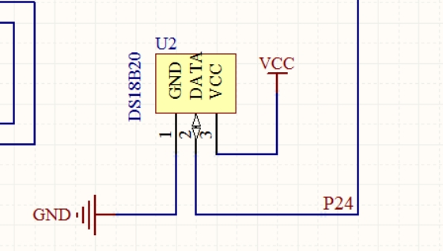
Figure 2. Temperature sensor circuit

Keyboard Input Module: This module is composed of several independent keys and serves as the human-computer interaction input channel of the system. Users can set the upper and lower limits of the target temperature, switch the system operation mode, etc. through this module, enabling real-time intervention and parameter configuration by the user over the system.
Temperature Display Module: This module uses a 4-digit digital tube as the display device, responsible for presenting the key information processed by the single-chip microcomputer system (such as the current environmental temperature, set parameters, etc.) to the user in an intuitive manner, providing a visual feedback of the system status.
Motor Control Module: This module serves as the execution unit of the system. It receives PWM (Pulse Width Modulation) control signals from the microcontroller system and uses the driving circuit (such as transistors) to adjust the input power of the DC fan motor, thereby achieving precise control of its rotational speed and completing the final temperature adjustment action. The motor control circuit is shown in Figure 3.
Figure 3. Motor control circuit
Each module of the system is organically integrated through the single-chip microcomputer system to form a complete control loop: the digital temperature sensing module provides feedback on the environmental status, the keyboard input module receives user instructions, the single-chip microcomputer system processes the data and generates control strategies, the temperature display module realizes the visualization of the status, and the motor control module executes specific operations. This modular architecture ensures clear division of system functions, enhancing the reliability and maintainability of the system. The system circuit diagram is shown in Figure 4.
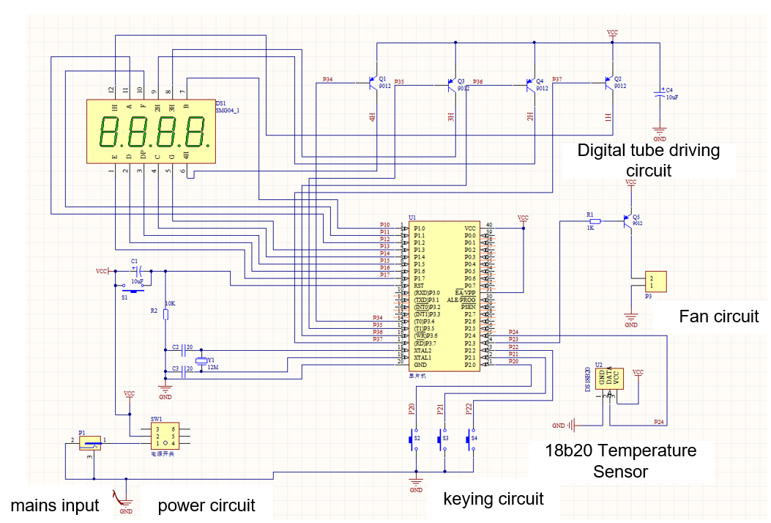
Figure 4. System circuit diagram
2.2 System Workflow
After the system is powered on, it first completes the initialization process, which includes configuring the timer working mode, setting the interrupt priority, initializing the I/O port status, setting the PWM waveform parameters, and loading the default temperature threshold. After the initialization is completed, the system enters the main loop monitoring state, and performs temperature collection and processing with a fixed sampling period of 300ms. The DS18B20 temperature conversion is started through the single bus protocol, the original temperature data is read and filtered numerically, and finally, the actual physical temperature is obtained through scale transformation.
The system compares the current temperature value with the preset threshold. Based on the comparison result, it determines the operating state: when the temperature is lower than or equal to the set lower limit, it enters the standby state; when the temperature is within the upper and lower limit range, it enters the linear regulation state; when the temperature reaches or exceeds the set upper limit, it enters the full-speed operation state. Based on the state judgment result, the system calculates the corresponding PWM duty cycle, updates the timer comparison register value, outputs the corresponding duty cycle PWM waveform to the motor drive circuit, and realizes the precise control of the fan speed.
The system achieves precise timing control through two timer interrupts: Timer 0 generates a 2ms time base, which is responsible for the dynamic scanning of the digital tube and the counting of the system clock; Timer 1 generates a 500μs time base, which is specifically used for generating PWM waveforms and precise timing control. During the execution of the main loop, the system synchronously processes human-computer interaction tasks, including scanning the input status of the keyboard, handling parameter setting requests, updating the display content of the digital tube, and performing key debounce and long-press recognition functions.
To ensure the stable operation of the system, a comprehensive exception handling mechanism was designed, including a mechanism for detecting and retrying sensor communication timeouts, verification of the rationality of temperature data, protection against motor stalling, and system watchdog monitoring. This workflow, through strict timing management and state transition mechanisms, ensures the coordinated operation of each functional module, achieving a complete closed-loop control from temperature collection, data processing, control decision-making to execution output, and guaranteeing the real-time and reliability of the system.

2.3 Core control strategy design
To achieve intelligent control and energy efficiency optimization of the system, this study proposes a multi-mode segmented control strategy based on temperature feedback. This strategy establishes an accurate mapping relationship between temperature and rotational speed, enabling adaptive control in different temperature intervals, and effectively balances the relationship between temperature regulation accuracy and system energy consumption.

2.3.1 Theoretical Foundation of Control Strategies

The control strategy of this system is based on classical control theory and has been optimized and improved by taking into account the characteristics of the temperature control system. Considering that the temperature system has features such as large inertia and nonlinearity, using traditional on-off control would cause the system to oscillate continuously around the set value, which not only affects the control accuracy but also increases mechanical wear and energy consumption. Therefore, this design divides the entire temperature control domain into three characteristic intervals, and adopts differentiated control algorithms in each interval to achieve the optimization of control performance.

2.3.2 Multi-mode Segmentation Control Algorithm

Standby mode: When the ambient temperature is lower than or equal to the set lower limit value (T ≤ T_{low}), the system enters the standby mode. In this mode, the PWM output duty cycle of the controller is 0%, and the fan completely stops rotating. This mode achieves zero power consumption standby for the system, conforming to the green and energy-saving design concept. At the same time, by setting a reasonable temperature margin, it avoids frequent start-stop of the system near the critical temperature point.

Linear regulation mode: When the environmental temperature is within the comfortable range (T_{low} < T < T_{high}), the system activates the linear proportional regulation mode. The control law of this mode can be expressed as:
Among them, D represents the duty cycle of the PWM output, Kp is the proportional coefficient, T is the real-time temperature value, and D_{min} is the minimum startup duty cycle. In this mode, the fan speed increases linearly with the rise in temperature, achieving a smooth transition in the control process. The value of the proportional coefficient Kp has been optimized through experiments, ensuring both the response speed of the system and avoiding excessive overshoot.
Full-speed operation mode: When the ambient temperature reaches or exceeds the set upper limit value (T ≥ T_{high}), the system switches to the full-speed operation mode. The controller outputs a PWM signal with a duty cycle of 100%, and the fan operates at maximum power to achieve rapid cooling. This mode ensures that the system can provide the maximum heat dissipation capacity when the temperature rises sharply, preventing the temperature from continuing to increase.
2.3.3 Performance Analysis of Control Strategy
Compared with the traditional double-threshold Bang-Bang control, this strategy has the following significant advantages:
- Improvement in control accuracy: By introducing a linear regulation mechanism in the comfortable operating range, the system can precisely adjust the fan speed according to the magnitude of the temperature deviation, achieving more precise temperature control.
- Energy consumption optimization: The linear regulation mode ensures that the fan power matches the actual heat dissipation requirements, avoiding energy waste caused by full-speed operation. Experimental data shows that compared to traditional on-off control, this strategy can save approximately 15% to 25% of energy.
- System stability enhanced: Eliminated oscillation phenomena near the critical temperature point, reduced mechanical wear of the actuator, and prolonged the service life of the equipment.
- User experience improvement: The smooth variation of fan speed results in a more gentle change in environmental noise and airflow, thereby enhancing the user's comfort.

This control strategy optimizes the hardware performance through software algorithms, demonstrating the comprehensive advantages of intelligent control systems in terms of energy conservation, environmental protection, and user experience. It provides a valuable reference solution for similar small temperature control systems.
3. results and discussion
This research successfully designed and implemented an intelligent temperature-controlled fan system based on the STC89C52 single-chip microcontroller. By adopting a modular design approach, a complete hardware system was constructed with the single-chip microcontroller as the core, including temperature acquisition, human-computer interaction, and motor drive functional modules. In terms of software design, an innovative multi-mode segmented control strategy was proposed, effectively solving the oscillation problem near the critical temperature point in traditional on-off control. The physical diagram of the intelligent temperature-controlled fan system is shown in Figure 5.

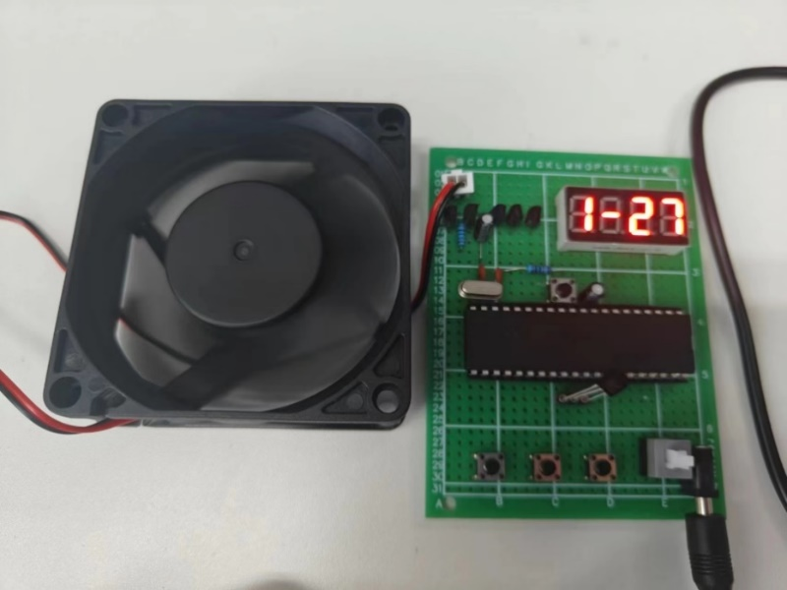
Figure 5. Physical diagram of the intelligent temperature control system

The experimental test results show that this system demonstrates excellent performance in terms of temperature measurement accuracy, with a maximum error of no more than ±0.5℃, fully meeting the requirements of daily applications. In terms of dynamic response performance, the system can complete the detection and response to temperature changes within 1 second, demonstrating good real-time performance. Compared with the traditional Bang-Bang control method, the linear regulation strategy adopted by this system makes the temperature control smoother, effectively enhancing the user experience, and achieving an energy-saving effect of 15% - 25%.

The main innovations of this study are reflected in the following three aspects:
- An improved multi-mode segmented control strategy was proposed. Based on the simple threshold control, a linear adjustment zone was introduced to achieve a smooth transition in the control process.
- Through the collaborative optimization of software and hardware, the cost was significantly reduced while ensuring the system's performance, providing a feasible technical solution for the popularization of intelligent temperature control systems.
- A complete exception handling mechanism was designed, including functions such as sensor communication guarantee, data verification, and system monitoring, ensuring the long-term stable operation of the system.

Although this research has achieved the expected goals, there are still several aspects that warrant further in-depth exploration:

In terms of control algorithms, in the future, fuzzy PID control or adaptive control algorithms can be introduced to better handle the large inertia and nonlinear characteristics of the temperature system, thereby further improving the control accuracy and system robustness.
In terms of system functions, it is considered to integrate wireless communication modules (such as Wi-Fi or Bluetooth) to enable the system to connect to the Internet of Things platform, allowing for advanced functions such as remote monitoring, data recording, and intelligent scheduling.

In terms of hardware design, it is possible to explore the adoption of more efficient DC brushless motor drive solutions, while optimizing the heat dissipation structure design, in order to further enhance the system's energy efficiency and reliability.

In addition, research can be conducted on multi-sensor data fusion technology. By deploying multiple temperature sensors, the monitoring and balanced control of the spatial temperature field can be achieved, expanding the application scope of the system. These research directions will provide new ideas and technical reserves for the further development of intelligent temperature control systems.

4. Conclusion
This research successfully designed and implemented an intelligent temperature control system for fans based on the STC89C52 single-chip microcontroller. Through the modular hardware architecture design and innovative control strategy, the system achieved precise monitoring and intelligent adjustment of the environmental temperature. The main research results are as follows:

Firstly, the system's hardware platform integrates a high-precision digital temperature sensor DS18B20, a 4-digit digital display module, an independent key input module, and a PWM motor drive module. Each module operates stably under the coordination of the STC89C52 microcontroller, forming a complete closed-loop control system.
Secondly, in terms of control strategy, a multi-mode segmented control algorithm was proposed. This algorithm divides the temperature control domain into three characteristic intervals. Through the intelligent switching among the standby mode, linear regulation mode, and full-speed operation mode, it achieves a smooth transition in temperature control and effectively solves the oscillation problem at the critical temperature point in traditional on-off control.

Experimental verification shows that the temperature measurement accuracy of this system reaches ±0.5℃, and the dynamic response time is less than 1 second. Compared with the traditional Bang-Bang control, it achieves a 15%-25% energy-saving effect while maintaining the control accuracy. The system operates stably and reliably, and has good practical value.

This research provides a complete technical solution for the development of low-cost intelligent temperature control systems, and has broad application prospects in fields such as smart homes and equipment cooling. The modular design method and control strategy adopted by the system are of reference value for the development of similar embedded control systems.

Disclaimer (Artificial intelligence)
Author(s) hereby declare that NO generative AI technologies such as Large Language Models (ChatGPT, COPILOT, etc.) and text-to-image generators have been used during the writing or editing of this manuscript.

References

1. Rea, A.L.; Corbit, L.H.; Shu, L.H. Does Fan Feel and Visibility During Thermostat Interaction Affect Temperature Selection in Warm Ambient Conditions? Journal of Mechanical Design 2024, 146, doi:10.1115/1.4064100.
2. Hoa, P.T.; Dinh, T.X.; Dau, V.T. Design Study of Multidirectional Jet Flow for a Triple-Axis Fluidic Gyroscope. Ieee Sensors Journal 2015, 15, 4103-4113, doi:10.1109/jsen.2015.2411631.
3. Ding, Z. Designing on a Vehicle Body Control Module Performance Tester. International Journal of Pattern Recognition and Artificial Intelligence 2019, 33, doi:10.1142/s0218001419590262.
4. Li, S.Z.; Wang, L.N.; Wang, S.P.; Bai, L.; Yang, J.; Yang, W. Phase change thermostat for all-day temperature-adaptive thermal regulation. Journal of Materials Chemistry A 2024, 12, 24966-24976, doi:10.1039/d4ta05314a.
5. Liu, Y.R.; Nan, X.H.; Han, H.; Li, J. The variable water temperature control strategy of the air-source heat pump compatible with floor heating system for an apartment. Journal of Building Engineering 2024, 90, doi:10.1016/j.jobe.2024.109440.
6. Liu, W.X.; Cao, J.Y.; Hu, T.X.; Jiao, D.S.; Pei, G. Experimental investigation on the characteristics of a controllable separate heat pipe-based cold storage temperature control system. Applied Thermal Engineering 2024, 241, doi:10.1016/j.applthermaleng.2024.122356.
7. Bai, Z.M.; Yan, G.; Wu, C.L.; Ding, S.F.; Chen, C.A. A novel high temperature superconducting magnetic flux pump for MRI magnets. Cryogenics 2010, 50, 688-692, doi:10.1016/j.cryogenics.2010.06.021.
8. Ejenakevwe, K.A.; Song, L. Investigation of smart thermostat fault detection and diagnosis potential for air-conditioning systems using a Modelica/EnergyPlus co-simulation approach. Energy and Buildings 2024, 309, doi:10.1016/j.enbuild.2024.114053.
9. Zhang, K.; Jiang, X.C.; Sun, J.; Wu, Y.H. Research on Quality Test System of Safety Lock Based on PIC16F877A. Advanced Science Letters 2011, 4, 2390-2395, doi:10.1166/asl.2011.1453.
10. Zhao, H.; Hao, X.; Wang, A.; Li, C. Design and implementation of an intelligent cooking robot based on Internet of Things. In Proceedings of the Proceedings of the 2015 Chinese intelligent automation conference: intelligent technology and systems, 2015; pp. 423-430.
11. Design and application of an integrated stretchable energy-storage gas sensing system with different morphologies of PANI@V2O
12. Chen, J.H.; He, P.; Cai, S.J.; He, Z.H.; Zhu, H.N.; Yu, Z.Y.; Yang, L.Z.; Tao, W.Q. Modeling and temperature control of a water-cooled PEMFC system using intelligent algorithms. Applied Energy 2024, 372, doi:10.1016/j.apenergy.2024.123790.
13. Wu, D., Zhang, R., & Zang, L. (2025). Functional Design and Development of Smart Temperature Regulating Clothing Based on Artificial Intelligence. J. COMBIN. MATH. COMBIN. COMPUT, 127, 4241-4255.
14. Shu, W., Zhang, X., Yang, X., & Luo, X. (2022). A smart temperature-regulating garment for portable, high-efficiency and comfortable cooling. Journal of Electronic Packaging, 144(3), 031010.
15. Zuo, X., Zhang, X., Qu, L., & Miao, J. (2023). Smart fibers and textiles for personal thermal management in emerging wearable applications. Advanced Materials Technologies, 8(6), 2201137.

