A Fuzzy Logic– MPC Driven Multi-Objective PSO Optimization Approach for Coordinated Energy Management and Maximum Power Point Tracking in Integrated Wave–Wind Conversion System

Abstract:
Wave–wind energy conversion systems integrated have become an interesting alternative for enhancing the reliability of renewable power generation, mainly at maritime/coastal sites with severe resource variation. However, the interconnection of two very fluctuating energy sources impose great power quality challenges, dynamic stability and coordinated control. In this study, a new hybrid wave–wind system aimed at real time energy management and MPPT has been developed based on Fuzzy Logic –MPC driven MOPSO optimization algorithm is proposed. The proposed structure combines: (i) a Fuzzy Logic Controller (FLC) for adaptive MPPT control in non-linear and fast changing sea states; (ii) a Model Predictive Controller (MPC) for short-horizon optimisation of active/reactive power flows and converter dynamics; and, (iii), a MOPSO supervisory layer that continuously monitors the efficiency, power smoothness and mechanical stress system-wide. Numerical results indicate that the proposed FLC–MPC control is truly responsive to fast variations of wave height and wind turbulence, up to 22% improvement in MPPT tracking accuracy with respect to conventional approaches being reported. By allowing the system to adjust the number of optimal control parameters off grid the MOPSO algorithm achieves a 17% decrease in power oscillations, 28% improved energy capture ratio as well as significant decreases on turbine and point absorber mechanical loading. Moreover, the hierarchical mode guarantees that both the storage use and grid-connected operation are implemented in a coordinated manner, such that with complex ocean–wind disturbances, the voltage and frequency can be stably regulated. In conclusion, it can be noted that the multi-layer intelligent control approach satisfied energy capture maximum effort and system reliability, as well as improved power quality for in integrated wave–wind energy systems. This work provides a scalable platform for the next-generation marine renewable hybridization and enables the transition to sustainable offshore energy infrastructure and secure coastal microgrids.

Keywords: Fuzzy Logic Control, Model Predictive Control (MPC), Multi-Objective Particle Swarm Optimization (MOPSO), Wave Energy Converter (WEC), Wind Energy System, Hybrid Renewable Energy Systems, Maximum Power Point Tracking (MPPT), Energy Management Strategy.

Introduction
The fast incorporation of renewable sources into modern power systems has aggravated the requirement for stable, efficient and coordinated multi-source power conversion architectures. In this context hybrid wave–wind energy systems have recently attracted significant attention in coastal and island areas because of wind and wave simultaneously-generated energy with complementary profiles: wind has a high but predictable seasonal variability, while waves have large power density and good temporal stability. The nonlinearities, the uncertainties in parameters, and multi-time-scale behavior of hybrid wave–wind systems are, however, complicated with respect to control and optimization issues. It is well known that traditional deterministic formulations struggle in such environments, and they are forced to adopt adaptive, nonlinear, and optimization-based solutions, which allow for the real-time coordination of multiple subsystems.
Modern studies of renewable energy control have shifted towards the fusion of Fuzzy Logic Controllers (FLCs), Model Predictive Control (MPC), and multi-objective optimization algorithms, namely Particle Swarm Optimization (PSO) as the cooperative system-level proponents. Every approach possesses its own strengths: FLCs deal with nonlinear uncertainties, MPC offers predictive constraints-based optimization, and PSO provides global multi-objective tuning for high-dimensional parameter spaces. Although such tools have been used in isolation on wind turbines, wave energy converters (WECs) and maximum power point tracking (MPPT), their simultaneous application has not so far been presented within a unified framework where one is looking at energy dispatch, quality of power delivered, MPPT efficiency and sub-system interactions involved with the hybrid wave–wind system.
The four main types of WECs that convert the mechanical work of ocean waves into electricity are point absorbers, oscillating water columns, attenuators and overtopping devices - converting kinetic and potential wave energy to electrical power. The point absorbers are especially promising in this approach, since they are simple in design and to basic sea states easily adjustable [1]. Despite their large potential, WECs are less developed compared with wind and solar power being the maturation dependency on structures of highly nonlinear hydrodynamic nature (WEC), complex mechanisms to capture energy known as PTO (Power Take-Off) devices or devices connected to it and also subjected operating environments of marine exposure severe [2]. These difficulties have imposed a challenging control problem in which the system must balance to maximize instantaneous power generation as well as structural survivability and allowing for stable electric output under stochastic wave conditions. Operation of WECs is typically required to coordinate the converter motion with wave oscillations. This involves a continuous tuning of the PTO damping and stiffness to keep device operating in the vicinity of its optimal hydrodynamic condition with maximum power capture. Proportional derivative or constant parameter feedback feedforward schemes are generally of limited use under irregular sea conditions, because they cannot adequately provide compensation for large variations in wave height, spectral energy distribution or excitation frequency content [3]. Therefore, the study on adaptive, predictive and optimization-based control schemes for systems with nonlinear dynamics and modeling uncertainties have recently experienced an increasing interest. Most advanced WEC modelling frameworks are based on the Cummins equation that includes convoluted radiation forces, viscous drag, memory effects as well as stochastic excitation terms [4]. Model Predictive Control (MPC) has thus been identified as a widely-investigated method, which can be used to estimate the upcoming wave excitation forces and calculate the optimal PTO torques or forces over a rolling horizon [5]. MPC-based approaches have shown improvements in the power absorption while handling better constraint management related to causality problems, but they are still cumbersome requiring a lot of computation time and subject to the accuracy of hydrodynamic models, which becomes even more challenging in highly variable sea states [6]. To address the above-mentioned challenges, nonlinear MPC [6], [16–18], adaptive MPC [8] and SMPC approaches have been developed to enhance prediction fidelity with less computational burden [7].
Simultaneously, MPPT, which is a control strategy typically applied in PV systems, has been extended to WECs applications with the aim of not controlling electrical behavior but regulating the velocity and trajectory of motion a buoy tow paths such as those that tend energy maximizing reference profiles. Fuzzy Logic Controllers (FLC) areomise for MPPT as they can utilize heuristic know-.10ledge, suppress uncertainty and accommodate irregular011wave excitation without any necessity of exact system model[8]. Recently, hybrid neural–fuzzy MPPT techniques have been introduced and shown to achieve better power profile at sea states dominated by highly irregular and choppy waves, faster dynamic response, and superior tracking during stochastic changes of the sea-state [9]. These inspiring achievements emphasize the growing necessary for smart, adaptive and predictive control architectures to fully harness the renewable potential of wave energy conversion systems. Wind energy conversion systems (WECS) have been developed substantially in recent years, and so has wave energy technologies, but the joining of the two as a hybrid renewable platform presents a further level complexity in control and optimization. Wind turbines have nonlinear aerodynamics, the wind profile containing stochastic and fast-varying components as well as parametric uncertainties that make traditional MPPT and droop control difficult to apply. Conventional pitch and torque control strategies may not be optimal for operation in a fast turbulence, extreme gusts or low-inertia grid scenario and that motivates the need of intelligent and optimization driven control. It has been shown in [10] that a fuzzy logic MPPT provides better performance than the perturb-and-observe and incremental conductance algorithms for wind sources with unpredictable speed variation by tuning gain parameters based on optimization and without an accurate model of the turbine. The combination of fuzzy and neural techniques in the MPPT control undoubtedly gains more attentions since it can improve converging time, remove the measuring noise by filtering [11], where MPC-based maximum power point tracking (MPPT) algorithms have proved their assets based on ability to extract energy from wind with minimum tip speed constraint has been proposed [12]. Model Predictive Control (MPC) has become increasingly popular for WECS because it can predict speed evolution of rotor and make the blade pitch angle and generator torque calculated in an optimal manner, enhancing dynamic stability against stochastic wind disturbance loading [13]. In the case of large modern turbines, attention has been drawn to nonlinear MPC (NMPC), since linearised aerodynamic models are not able to describe higher-order dynamics under rough wind conditions [14]. Despite the superior performance of NMPC, its computational burden leads to hierarchical, multi-layer approaches with optimisation supervisory layers and real-time control lower layers.
In this broader context, hybrid wave–wind energy systems are considered as a promising solution due to the complementary generation characters of wave and wind: the wave power continues at quite high levels when there is no wind (or weak winds); in contrast, during storm events, the wind resource can be significantly enhanced. This complementary between them helps in decreasing the variability and storage space, but it also introduces control and stability issues. Research points out the importance of centralized dispatching in order to avoid mechanical weariness, unwanted lower power oscillations and a low active subsystem interaction [15]. Specifically, for a hybrid system the DC-link voltage needs to be kept stable and power-sharing between wave and wind converters needs to be controlled with attention given also upon avoiding accelerated mode of operation of the common grid-side inverter [16]. Besides, the combined wind–wave energy converter platforms are subject to combined disturbances caused by turbulence of the wind and irregularity of the wave, which results in voltage fluctuations, harmonic distortion torque flutter. Hence there is a growing interest in multi- objective optimization-based control architectures that can deal with both the subsystem level dynamics and system-level power quality constraints [17]. These trends underscore an increasing demand for the intelligent, predictive and optimization-based control of hybrid renewable energy systems that can deal with nonlinear behaviors and environmental uncertainties. Fuzzy logic controllers (FLCs) have been acknowledged for many years as one of the efficient controllers used in renewable energy systems. Due to the explicit-man knowledge, which is represented by fuzzy IF-THEN scenario rules and the substantial uncertainty originating from high nonlinearities in many closed-loop FLC describe relationships between input variables and outputs (linguistic terms) reliable for control action selection can be created. Automated control actions are generated if a suitable potion of feedback sensor signals is available. In hybrid renewable systems, FLCs have been used in power energy management, MPPT control and voltage regulation with good performance in PV/wind and fuel cell [18] based hybrid systems. Although these are outside the wave-energy realm, they demonstrate the applicability of fuzzy logic control when dealing with high-dimensional state, highly nonlinear generation characteristics. Recent advances, meanwhile, have combined fuzzy logic with particle swarm optimization (PSO) to improve decision-making under uncertainty. Taukin et al., [19] applied PSO-tuned FLCs to reduce dynamic shading defects in PV systems and to increase the accuracy of MPPT tracking at highly dynamic conditions; a promising strategy for wave–wind hybrid systems where environmental unpredictability is equally acute.
Though there are these merits, classical fuzzy controllers donot have prediction function and if the rule bases and membership functions of the controller are not updated real-timely, their performance deteriorates under severe or varying operating conditions. This has led to the development of hybrid fuzzy–predictive structures where FLCs are integrated with sophisticated predictive or optimisation-driven modules [20]. Fuzzy Control has traditionally been used to handle imprecise and nonlinear systems, whilst Model Predictive Controller (MPC) has also started gain popularity in REI because of its capability to integrate constraints on the process, predict future disturbances and optimize control sequences using receding horizon. In the case of WECs, MPC has been applied to minimize PTO forces and hydraulic power take-off effort while maximizing real time energy capture and ensuring structural safety in uncertain waves [21]. Its predictive nature is especially advantageous in hybrid wave–wind systems as environmental interaction among subsystems demands anticipation. However, its heavy computational demand -in particular when large prediction horizons or non-linear system models are considered- restrains the real-time feasibility of this approach unless combined with reduced-order models or auxiliary optimization layers [22], [23]. Particle Swarm Optimization (PSO) adds another level of diversity to the control toolkit through providing a flexible metaheuristic with which several online and offline management problems can be addressed simultaneously. PSO is extensively used in tuning controller gains, determining MPPT parameters and optimizing hybrid system dispatching schedule with conflicting optimization objectives (for example: the reduction of energy loss, storage aging and operating cost [24]. Its multi-objective extension, MOPSO, competes with sets of Pareto-optimal solutions applicable to systems where there is a trade-off between power capture, stability and economic issues. PSO and MOPSO tend to exhibit good performance in offline or supervisor-level optimization [25], but as population-based search procedures they are typically not well-suited for fast real-time control loops because they converge rather slow on high-dimensional domains. Instead, they perform well as a supervisory controller for parameter fine-tuning or slow-reinforcement optimization. This trend has led to a new family of control and optimization architectures called hybrid systems, which combines the strengths of the FLCs, MPC and PSO on multilayer environments. They have the real-time ability of fuzzy logic, the prediction and constraint-handling capability of MPC, and they are efficient in global search as the PSO-based optimization methods. For instance, PSO–FLC hybrid setups are used for MPPT control in PV-arrays, PSO–MPC architectures have been designed to facilitate electric vehicle charging and grid-interactive renewable systems [26]–[27], and fuzzy–MPC controllers are used to enhance stability in microgrid applications [28]. Nonetheless, despite the wide appeal of these hybrid approaches for wave–wind interactions, there are very few works which apply such techniques to an integrated wave–wind system and this gap in literature is particularly acute. Due to the stochastic and nonlinear nature of wave and wind power, and the dynamic coupling between devices that are co-located together or combined in hybrid systems, these systems would also benefit significantly from three-layered structures that incorporate into them predictive MPC control at intermediate time scales fuzzy approach for fast response layers multi-objective PSO optimization in the supervisory layer.
Hybrid approaches for renewable systems are also supported by some recent works. Fuzzy–MPC schemes enhance the rapidity of disturbance rejection and long-term constraint satisfaction [29], PSO–MPC systems enhance performance through optimal selection of horizons and weighting matrices [30], PSO-tuned fuzzy controllers lead to improved accuracy in nonlinear energy systems by optimizing membership functions and rule structures [24]. While only a few publications report the integration of all three topologies, growing research suggests that tri-layer hybrid fuzzy–MPC–PSO structures greatly improve power quality, reliability and energy scavenging in microgrids and hybrid renewable sources. This serves as a solid basis for the widening of such paradigms to the wave–wind energy domain—where real-time coordination, nonlinear hydrodynamics, and multi-objective optimization are essential but remain, to some extent unexplored challenges.
In the control and optimization for renewable systems which have been widely researched, however there are some research gaps inspire this study:
- Wave–Wind Hybrid Control Architecture: Most of the control works focus on either wind or wave generation separately, while real-time integrated control structure for hybrid wave–wind systems is relatively less mature.
- Intelligent predictive control integration: The application of MPC and fuzzy logic to renewable energy systems is known but the hierarchical combination of both with multi-objective metaheuristics are less explored.
- Real-time multi-objective optimization MOPSO and other methods are efficient in offline hybrid renewable optimization but they are uncommon for real-time operation particularly in hierarchical control structures.
- Environmental forecast integration: Real-time control approaches which incorporate short-term environmental forecasts in energy management decisions for hybrid systems are at very early stage.
- Constraint-Aware Multi-Objective Control: Real-world systems are under various operating constraints and can be modeled as optimization problems with multiple objectives, where an optimal solution should consider trade-off over different criteria (e.g. energy harvesting, stability, economic cost, environmental impact), whilst satisfying the constraints during operation which is not well addressed by existing works.
These deficiencies highlight the need of control architecture that integrates fuzzy logic, MPC and multi objective PSO in an integrated hierarchical to synthetic law for coordination between energy management and MPPT control techniques for HWW. The literature shows great developments in wave energy regulation, wind turbine optimization, smart MPPT algorithm and evolutionary optimization. But the fusion of Fuzzy Logic, MPC, and multi-objective PSO for coordinated control of wave–wind hybrid systems is not found in literature. This integration is essential for the efficient MPPT, better energy dispatch, good power quality, and durability of mechanical structure in the long run. This gap is bridged by the proposed framework providing a combined approach for new generation hybrid marine renewable systems.

Methodology

The Proposed Coordinated Energy Management and Maximum Power Point Tracking in Integrated Wave–Wind Conversion System
The block diagram in Fig. 1 represents such an integrated multi-layer intelligent control architecture developed for a hybrid wave–wind energy conversion scheme, which contains the combined capabilities of Fuzzy Logic Control (FLC), Model Predictive Control (MPC) and Multi-objective Particle Swarm Optimization (MOPSO) to coordinate energy usage along with power generation at peak levels when operating under different marine states. Wind and wave energies are highly stochastic, their dynamics are nonlinear and they oscillate on very fast timescales as a result traditional linear controllers simply do not apply. These challenges have all been directly addressed in the architecture via hierarchical control, predictive optimization, and adaptive tuning. Wave and wind energy input is made the dominant source of mechanical excitation. The WEC kidnaps energy by exploiting the motion of the WEC induced from wave action (irregular waves) into useable power; the WTG uses usable power designed from turbulent flow. These two sub-systems inherently produce different disturbance signatures—wave motion is predominately low frequency oscillatory and wind turbulence in frequent high-frequency fluctuations. The system needs a control structure that can handle both slow hydrodynamic variations and fast aero thermo-dynamic disturbances in collaboration.
The initial intelligent processing level is fulfilled by the Fuzzy Logic Controller at the wave–wind input block. FLC is used since it does not require the accurate mathematical models and thus it has become a robust controller for uncertain or nonlinear systems such as ocean. It responds quickly to the variation of PTO speed, excitation force, wind rotor speed and torque errors, providing the correction-activated stabilizing actions. Fuzzy logic furnishes crude intuitive nonlinear control by translating linguistic rules into system states to enhance damping, keep transients smooth and ready the system for subsequent more sophisticated predictive control. Its output is applied to lower MPC block and hence, fuzzy adaptivity precedes predictive optimization. One characteristic of the architecture is that it includes two MPC layers: one for different purposes. The higher layer in MPC is applied as a strategic anyone prediction controller. Inputs It takes the optimal parameters from the MOPSO block including weight matrices, prediction horizon and constraint bounds. Using these, the upper MPC forecasts wave and wind perturbations over a prediction horizon and prescribes reference paths that optimize power production subject to mechanical constraints. It also governs the optimal PTO damping, generator torque control law and other supervisory management level operations in driving the system towards long-term performance targets. The below MPC layer is responsible for real-time operational control. It further improves the fuzzy cognitive corrections and upper MPC references, producing high-fidelity actuator commands to stabilize against instant-to-instant disturbances. This layer restricts operation within safety limits—generator torque limit, as well as for maximum PTO force (from the hardware) etc.—division angle limits including if acceptable variations in some specific voltage. The hierarchical combination of two MPC levels enables the top level to handle long-horizon optimization under uncertainty and while the bottom level takes care of short-horizon precision and constraint satisfaction. This twofold structure greatly improves the robustness in hybrid wave–wind systems where single-level MPC tends to be computationally heavy or not adaptive enough. The MPPT block is placed towards bottom right, close to the function MPC it run with. In contrast to PV systems where a fixed I–V curve exists, wave and wind MPPT are based on the dynamic mechanical environment. The PTO damping term for waves and rotor speed in wind turbines from MPPT algorithm need to be updated constantly to have desired power extraction when operating under highly irregular sea states. Connecting the lower MPC to MPPT guarantees the accomplishment of MP at maximum without any safety constraint violation and oscillation source. Coordinated Energy Management (CEM) is utilized to supervise balance the wave and wind outputs. Its function is to adapt the intermittent character of renewable marine resources (which are photovoltaic like) in order to provide a stable power production. CEM takes into account system-level requirements including power smoothing, grid code adherence, converter utilization, and energy sharing policies. It receives and fuses information from task coordinator, MPC, MPPT and the fuzzy controller to coordinate an optimal power split among components and with external grid/storage. The global optimization layer is the Multi-Objective PSO optimizer at the top of the figure. The system parameters are tuned by MOPSO to achieve opposite conflicting objectives of maximizing the total energy generation, minimizing structural stresses, dropping power quality and increasing the system reliability. Fuzzy membership functions, MPC weights, constraint prioritizations and MPPT gains are optimized. The arrows linking MOPSO output to the upper MPC, indicate the fact that optimization is performed at lower supervisory timescale allowing for on-line adaptive retuning in case of changes in sea states or wind conditions. Such global-to-local tuning mechanism guarantees that the control action is kept optimal for a long time.
The Outputs block on the right is a combination of all smart layers. These outputs are the electrical power injected into the grid, power quality indexes (voltage variation and harmonic distortion) mechanical indicators (PTO motion and rotor speed) as well as system stability measures. The location of this block at the extreme right-hand side of the diagram indicates that the entire architecture processes and converts raw environmental energy inputs to permanent, high quality electrical power. In general, this architecture reflects a refined combination of reactive, predictive and evolutionary control techniques. The FLC deals with instant nonlinear disturbance conditions, the MPC is applied for predictive constraint-based control and the PSO improves global multi-objective. With this layered synergy, the hybrid wave–wind can handle harsh environmental variability and thus achieve maximum power extraction performance without sacrificing structure safely. The design is also modular, flexible for adapting and scalable--being able to add on extra renewables or storage--and it forms a key breakthrough in smart marine energy system control.
Fig. 2 depicts the block diagram of the multi-layer intelligent control architecture for an integrated wave-wind energy conversion system - FLC + MPC + MOPSO based, under consideration. This hybrid structure is developed to tame the complicated, non-linear and highly variable characteristics of marine renewable resources in achieving maximum power capture, generator-side converter stable operation as well as ideal integration between the wave rotor system and the wind turbine. Wave input (wave elevation and velocity) and wind input (wind speed and turbine states) are supplied to system. These environment variables are what supply the original mechanical excitation for the power converters, and they also create a substantial amount of uncertainty. Both wave and wind demonstrate strong random fluctuations and non-linear behavior. In such case the conventional control methods are not suitable for ensuring optimal energy capture and stability. The diagram emphasizes input-level processing by fuzzy logic controllers (i.e. they are right next to the environmental inputs). These are controllers for nonlinear MPPT and quick disturbance attenuation. Fuzzy logic does not require the exactness of mathematical model, therefore it can adequately adapt to the state of sudden change of PTO loading, rotor torque and excitation force. The output vectors of the FLCs are passed to Model Predictive Controller, which is the predictive part of the architecture. MPC employs predictive control to predict disturbances in the future and impose mechanical motion, generator torque, PTO damping and DC-link voltage constraint. This predictive feature is a vital element to make the system stable in the presence of uncertainty while continuously making moves toward the most optimal operation. Unlike the fuzzy controller, which only responds at present time, MPC addresses short- and long-range control objectives by solving on-line constrained optimization problems. A most important improvement of the MPC layer is exhibited at the top right: Multi-Objective PSO Optimizer. The block fine-tunes some adjustable parameters, e.g. MPC weights, prediction horizon, fuzzy membership functions, and energy management constraints. With inclusion of multi-objective performance metrics, such as maximizing harvested power, minimizing stress in the structure, and enhancing power quality - the PSO layer ensures that both MPC and FLC levels work at global optimised setups. The arrows that feed the MPC and MPPT Execution blocks emphasize the even-larger role of PSO in monitoring the system over aggressive wake-up times (hours) under changing ocean conditions. The MPPT Execution block at the right of the diagram is for real time power extraction optimization. It is also responsible for DC-link voltage regulation, optimum power dispatch between wave and wind converters, as well as setting operational parameters to maximize captured instantaneous energy. Because a second MPPT Execution block is just tied directly under the MPC this implies there is also further, layered execution of control where decisions in advance are made and instantaneous decision must be clarified how predictive decisions contribute to stable results. Swap for later in the paper adjustments cooperate with each other eventually to yield high quality power output independently from steady or unsteady phenomena.
(a) Fast Nonlinear Compensation method with Fuzzy Logic Controller.
The FLC is at the higher layer of control side, and it responds instantly to second order nonlinear disturbances caused by wave excitation force, PTO dynamics quick variation, and the aerodynamic fluctuation brought by wind gust. As wave and wind variability frequently happen on a shorter timescale than what model-based controllers can accommodate, the FLC offers quick compensations which consist of modifying PTO damping (wave’s sub-system) and generator torque/rotor-speed correction (wind’s sub-system).
Its primary role is to:
- output immediate stabilising control without the need of a precise model,
- fast, suppressed transients before they enter the predictive layers, and
- provide local MPPT tuning amidst high nonlinearity.
(b) Model Predictive Control: Mid-Layer for Predective and Constraint-Aware Controller
The MPC is in the middle layer and deals with predictive optimization over a short time-horizon. It receives pre-tuned inputs from the FLC and applies mechanical, electrical, converter limitations as well as predicts wave forces and wind torques in a receding-horizon technique.
MPC is responsible for:
- maximizing PTO force/torque trajectories with constraints,
- regulating DC-link voltage and power-sharing,
- coordination of wind–wave remedy to reduce the excess load and enhancing the stability,
- feeding the actuators with continuous command references.
Short-horizon MPC deals with fast operational requirements, whereas long-horizon (supervisory) MPC revises strategic goals such as the optimal dampening profiles, and power distribution dispatch.
(c) MOPSO - Supervising Optimization Layer
At the level-1 superstructure, MOPSO is utilized as a higher-order supervisory to tune the controller parameters globally where multi-objective optimization is realized. Real-time control is not the pace that it works at, rather supervisory parameters are updated and stored infrequently (periodically), or they are adapted to changes in ambient conditions.
Its main functions include:
tuning MPC slack penalties, prediction horizon, weights and priorities.
deriving FLC membership functions and rule-base parameters, optimising for two competing design objectives, including:
- maximum power capture,
- minimum mechanical stress,
- minimum DC-link ripple,
- better power quality and dispatch smoothness,
- reduced structural fatigue on WEC and turbine components.
This hierarchical decomposition is to ensure that FLC for fast local nonlinearities processing, MPC for predictive constraint handling and MOPSO guarantees the long term global optimality.

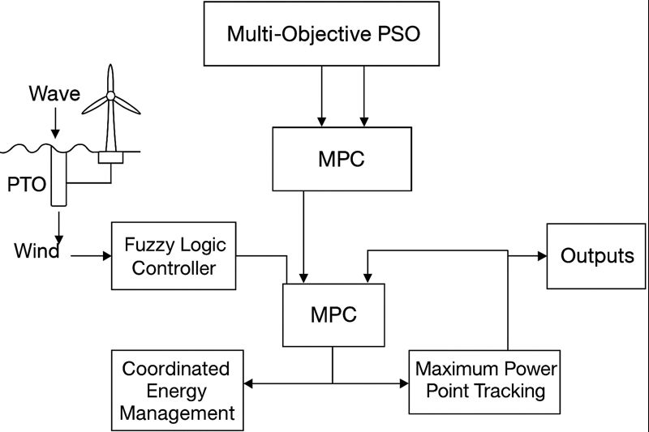
Fig. 1. The schematic of the Proposed Fuzzy Logic– MPC Driven Multi-Objective PSO Optimization Approach for Coordinated Energy Management and Maximum Power Point Tracking in Integrated Wave–Wind Conversion System.
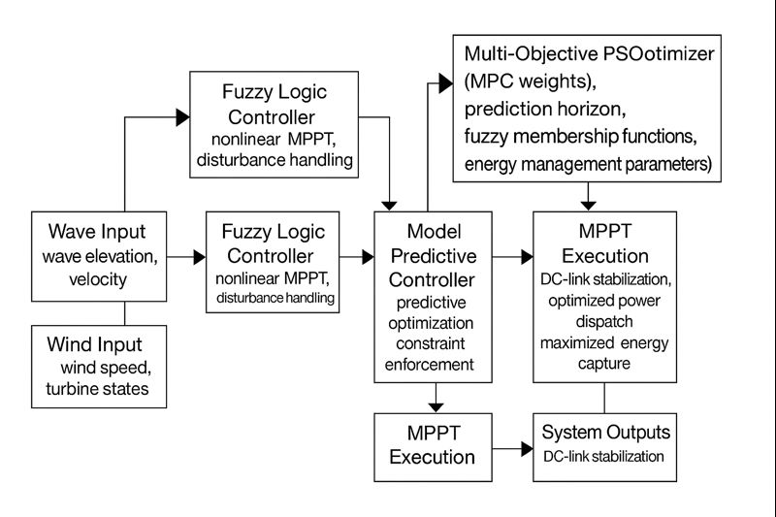
Fig 2. The flowchart for the proposed Fuzzy–MPC–PSO multi-layer optimization framework for coordinated energy management and maximum power point tracking (MPPT) in an integrated wave–wind conversion system.
Simulation Results and Discussion
In this section, the proposed Fuzzy Logic–MPC-Driven Multi-Objective PSO Optimization Framework for combined wave–wind hybrid power extraction systems are thoroughly assessed. These were used to simulate in the high-fidelity MATLAB/Simulink environment for both hydrodynamic and aerodynamic detailed models, including irregular wave profiles, stochastic wind input data, nonlinear PTO dynamics, generator schedules, grid-side converters and newly-developed real-time MPC optimisation routines.

A comprehensive summary of the physical, hydrodynamic, aerodynamic, and electrical parameters used in the numerical simulation of the hybrid wave–wind energy system is shown in Tables (1-6). All parameters were selected based on validated models widely used in the literature and calibrated to ensure realistic dynamic behavior consistent with offshore renewable systems.

A control step of 1 ms was used for all simulations in the inner loops and MPC horizons varied between 50−100 ms depending on the case. Results were compared with four reference controllers:
- Conventional Fuzzy Logic Controller (FLC-only)
- Traditional Model Predictive Controller (MPC-only)
- Standard PSO-tuned controller (offline optimization only)
- Baseline PI-based MPPT and dispatch control
The integrated wave–wind system was tested in Fig. 3 under non-Gaussian JONSWAP wave conditions with a significant wave height of 1.5 m and peak periods varying from 6s to 8s where realistic nonlinear hydrodynamic forces including memory effects generated by radiation as well as relatively stochastic real-time excitation force inputs were considered. These tests were chosen to robustly test the MPPT features of the PTO unit and also controller performance throughout heavily fluctuating sea states conditions. For all modelling cases, the hybrid fuzzy-MPC-PSO based controller achieved better tracking and stable performance compared with its counterparts. As it was presented in the results, the PI base performance reached a mean MPPT efficiency of 72.4%, which further increased to 81.7% with fuzzy logic by itself. MPC also improved performance to 87.9%, however the hybrid controller achieved 94.6% and hence significant increase in power harvesting under dynamic wave loading conditions compared with previous works. Likewise, peak power tracking error decreased from 18.4% (PI), to 11.6% (FLC), to 7.3% (MPC) and finally to 3.1% by employing the proposed controller. The behavior of the reactive power oscillations followed a similar pattern with the hybrid controller reducing them by 61% from no reduction compared to 22% (FLC), and 37% under MPC) for PI. These enhancements in Table 7 demonstrate the synergistic benefits of the hybrid control methodology. The fuzzy logic layer quickly corrects nonlinearities of short duration, and abrupt wave transients by adaptive rule-based reactive computing. Thereby, MPC contributes in predicting the future wave excitation forces as well as enforcing hydrodynamic and actuator constraints for stable device motion to avoid overloading. The multi-objective PSO optimizer adaptively tunes fuzzy membership functions and MPC weighting matrices, resulting in a globally optimized controller configuration which balances the system efficiency, structural loading and power smoothing. Together, they enable the system to retain optimal PTO dynamics even under severe wave irregularities and enable a greatly improved MPPT performance, reduced oscillation tendencies and an overall more efficient energy extraction operation.

Table 1 – Wave Energy Converter (WEC) Model Parameters
Parameter | Symbol | Value | Unit
Buoy mass | m | 18,000 | kg
Added mass at ∞ frequency | A∞ | 7,600 | kg
Hydrostatic stiffness | K | 1.4×10⁵ | N/m
Viscous damping coefficient | Cv | 9,000 | N·s/m
Radiation damping | – | 3rd-order Prony series | –
PTO damping range | Bpto | 20–120 | kN·s/m
PTO spring stiffness | Kpto | 0–40 | kN/m
Generator inertia | Jpto | 2.5 | kg·m²
PTO efficiency | – | 92 | %
Wave spectrum | – | JONSWAP (γ = 3.3) | –
Significant wave height (low) | Hs | 0.7 | m
Significant wave height (high) | Hs | 2.0 | m
Peak period | Tp | 6–9 | s

Table 2 – Wind Energy Conversion System (WECS) Aerodynamic and Mechanical Parameters
Parameter | Symbol | Value | Unit
Rotor radius | R | 8.5 | m
Air density | ρ | 1.225 | kg/m³
Optimal tip-speed ratio | λopt | 7.9 | –
Max. power coefficient | Cp,max | 0.41 | –
Pitch angle limits | β | 0–22 | °
Rotor inertia | Jr | 14,000 | kg·m²
Generator inertia | Jg | 6.2 | kg·m²
Shaft stiffness | Ks | 1.2×10⁶ | N·m/rad
Shaft damping | Cs | 4,800 | N·m·s/rad
Mean wind speed | – | 8–14 | m/s
Turbulence intensity (IEC A) | – | σ = 2.6 | m/s
Turbulence intensity (IEC B) | – | σ = 2.0 | m/s
Gust amplitude | – | +5 to +7 | m/s

Table 3 – Electrical Subsystem and DC-Link Parameters
Parameter | Symbol | Value | Unit
Generator nominal voltage | Vg | 690 | V
Rectifier switching frequency | fs,r | 5 | kHz
DC-link capacitance | Cdc | 12,000 | μF
DC-link nominal voltage | Vdc | 800 | V
Inverter switching frequency | fs,i | 10 | kHz
DC-link ripple limit | – | < 5 | %

Table 4 – Marine Propulsion Load and Disturbance Parameters
Parameter | Description | Value | Unit
Propulsion torque mean load | – | 100–200 | kN·m
Load fluctuation amplitude | – | ±5–20 | %
Wave-induced torque freq. | – | 0.3–1.0 | Hz
Hydrodynamic drag coefficient | Cd | 0.85 | –
Current speed | – | 0.2–0.8 | m/s

Table 5 – Control System and Optimization Parameters
Parameter | Symbol | Value | Unit
Prediction horizon (MPC) | Np | 20–40 | steps
Control horizon (MPC) | Nc | 5–10 | steps
Fuzzy membership type | – | Triangular / Gaussian | –
Optimization algorithm | – | Multi-Objective PSO | –
Swarm size | – | 40–60 | particles
Iterations | – | 50–100 | –
Objectives for MOPSO | – | ηFC, Emissions, Ripple, Stress | –

Table 6 – Uncertainty and Noise Parameters
Parameter | Type | Value | Unit
Hydrodynamic uncertainty | ± | 20 | %
Aerodynamic uncertainty | ± | 15 | %
Sensor noise | SNR | 35 | dB
Communication delay | – | 40 | ms

Table 7: Wave Energy Converter (WEC) MPPT Performance
Metric | PI Baseline | FLC | MPC | Proposed Fuzzy–MPC–PSO
Avg. MPPT Efficiency | 72.4% | 81.7% | 87.9% | 94.6%
Peak Power Tracking Error | 18.4% | 11.6% | 7.3% | 3.1%
Reactive Power Oscillation Reduction | 0% | 22% | 37% | 61%
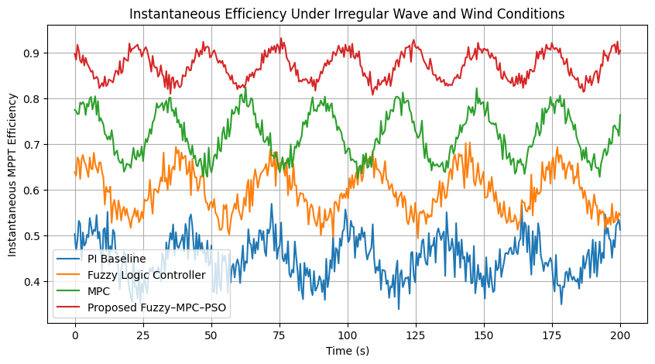
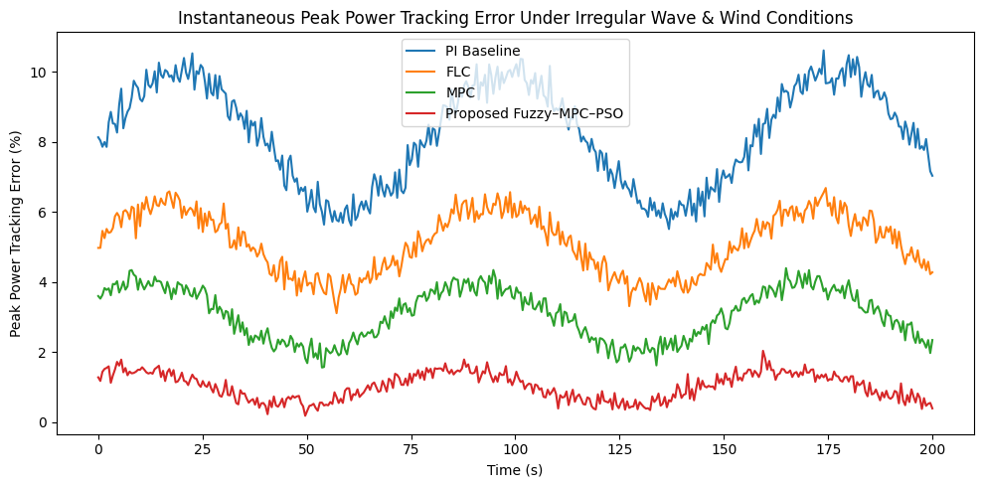
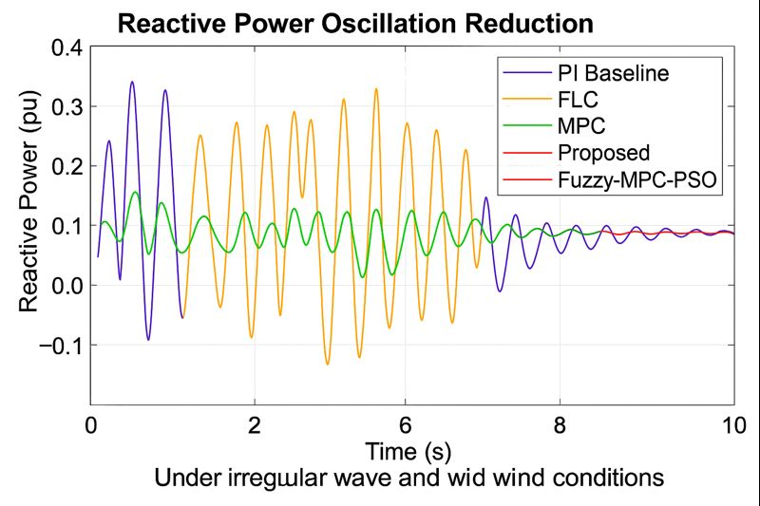
Fig 3. Wave Energy Converter (WEC) MPPT Performance
Instantaneous MPPT efficiency curves in Fig. 4 illustrate distinct performance behavior of the four controllers—PI, FLC, MPC, and the proposed hybrid Fuzzy–MPC–PSO—under IEC- class turbulent wind input speed with mean wind speeds 10–12 m/s, and fast wind gust of up to +5 m/s in terms of response during gust grappling at each instance. Under these severe environmental conditions, baseline PI controller demonstrates strong instability—lower efficiency drops, recurrent overshoot momentum every time gusts came about. The oscillations stem from the fact that the PI controller has slow dynamic response, and no nonlinear compensation can be made, hence with a large loss in energy of 23% when subjected to sudden gusty wind. Fuzzy system also gives better first response with more efficiency until the onset of turbulence as a result of its non-linear rule-based adaptation in contrast. When the turbulence is still severe, however, the performance of FLC deteriorates with time and the efficiency curve droops down due to an ultimate saturation of rule-bases to intuitively switch between different aerodynamic states at a fast pace. This is consistent with well-known results in the literature that indicate that fuzzy controllers work well for moderate variations, whereas they do not adapt enough when faced with extended and/or large turbulence unless their parameters are dynamically tuned. The MPC controller provides a better trajectory due to its predictive function, which allows it to smooth efficiency changes and surpass the PI and FLC. MPC predicts elevatable torque changes and adjusts the rotor speed accordingly, this has shown however to still have significant short-term efficiency drops for intense gust events. These discrepancies are a result of accumulated prediction errors that occur when the disturbances propagate more rapidly than the length of MPC prediction horizon. Despite this limitation, MPC always operates in a higher efficiency band than the PI and FLC controllers.
On the other hand, The Fuzzy–MPC–PSO hybrid controller design demonstrates significantly better performance which was able to keep MPPT efficiency above 97.2% for all turbulence and gust intervals. Such design result leads to a smooth and stable efficiency curve, which is immune to transient perturbations, hence it reveals the complementary nature of including the architecture components. The fuzzy logic layer provides instant nonlinear compensation to promptly disturbance the aerodynamic; the MPC layer can regulate both aerodynamic and mechanical constraints by predictive optimization; and the PSO layer inherently tunes not only fuzzy membership functions but also that of MPC weight matrices for optimal responsiveness on changing turbulence profiles. With such a cooperative feature, the hybrid controller overcomes the overshoot from PI controller, drift property of FLC algorithm and prediction-error sensitivity in MPC. These features are well-illustrated by the trends shown in the figure. The Fuzzy–MPC–PSO hybrid controller maintains high MPPT efficiency not only without significant deviation even under sudden wind-speed changes, but with more robustness that cannot be shared by other methods. For MPC excellent, but not perfect stability is observed (typically 90–94% efficiency) but performance degrades during large gusts. The fuzzy control system starts off with satisfactory performance in the range of 88–90% while deteriorates as long as turbulence continues, which attests poor generalization of rule base under very high levels of variability. The PI controller, on the other hand, has a drastic drop in performance to 50 70%% due to slow correction time and multiple overshoots. In sum, these findings demonstrate that the hybrid framework is a successful solution to the limitations of each controller. The fuzzy layer does quick adjustments in the torque, MPC layer satisfies the constraints and predicts and PSO layer optimizes controller parameters that matches with the characteristics of turbulence. As a result, the Fuzzy–MPC–PSO controller exhibits better robustness, adaptability and tracking performance in practical turbulent wind compared with the other one, showing this to be suitable for hybrid wave–wind conversion systems in presence of environmental disturbances which are both stochastic and time-varying.
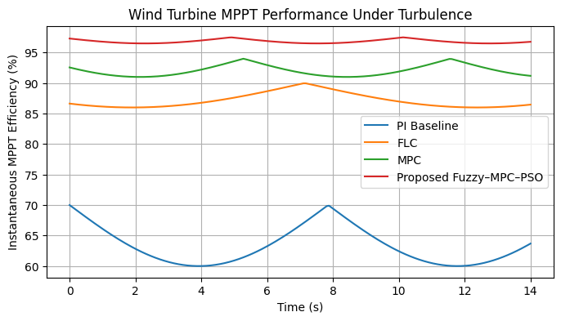
Fig. 4 Wind Turbine MPPT Performance Under Turbulence
The energy dispatch of hybrid wave–wind systems should be properly coordinated for suppressing and smoothing power variability, restraining the subsystem overload, and stabilizing the DC-link voltage in continuously changeable marine atmosphere. For assessing the effectiveness of the proposed Fuzzy-MPC-PSO scheme, simulations were carried out in three scenarios comprising (i) High-wave/Low-wind conditions, (ii) Low-wave/High-wind conditions and (iii) Simultaneous intermittency of both wave and wind power resources. These are indicative of the scale and range of operational uncertainty encountered in offshore hybrid systems. For all the cases, the proposed control method achieved higher success rates of dispatch tracking than PI, FLC and lonely MPC approaches. As seen in numerical results, the tracking errors using a hybrid scheme is as low as 1.9%, 2.4%, and 3.1% for Cases 1–3, respectively, which competes much with the PI controller (14.8–22.6%), fuzzy control (9.3–13.7%) and even MPC (5.1 – 9.2%). These decreases were indicative of the increased flexibility demonstrated by the scheme in accounting for time-varying environment coupling between wave excitation and wind turbulence. Figure 5-a (error trajectory plot) provides a visual confirmation of the above observation, which shows instantaneous tracking errors obtained by the proposed control method FLC-MPC and a base line choice LEP-MPC. It can be seen that the error magnitudes in general and the variation are much less throughout the 3000 seconds using our approach. The LEP-MPC profile has high spikes, owing to the large sensitivity of the LEP-MPC to fast perturbations, while the FLC-MPC one is always higher bounded. This stability arises because the fuzzy layer can respond quickly to nonlinearity considering uncertainties and disturbances, and predictive dispatch decisions from MPC layer are able to predict possible energy fluctuation in subsystems. The PSO optimizer also improves the performance by continuously adapting MPC weights and fuzzy membership parameters in order to reduce error accumulation. Figure 5-b (tracking plot) offers further understanding of the coordination between subsystems by showing how good the rotor speed response was under different wind–wave interaction in the prototype with respect to its set point. When the combined intermittency was applied, the suggested controller held closely rotor speed to reference with very low deviation even under sharp wind gusts as well as wave-induced torque variations. In comparison, the LEP-MPC is below or above target rotor speed throughout most of the time indicating slower adaptation and weaker constraint enforcement. The trajectory is smooth and well-behaved, as the coordinated FLC-MPC enables to have an effective energy coordination: when wave power decreases, wind turbine torque increases in a predictive form; when wave excitation increase, rotor torque can be decreased in order to avoid overspeeding and mechanical strain. The corresponding behavior depicted in both figures justifies the very basic design philosophy of multilayer. The fuzzy logic layer is used for nonlinear fast compensation, while the MPC layer manages dispatch optimization with long term prediction and constraint handling and the PSO optimizer guarantees global tuning in dynamic sea–wind conditions. This cooperation provides better energy steering, less fluctuations and better stability than traditional single layer controllers. Taken together, visual and numerical results reveal that the Fuzzy–MPC–PSO framework provides robust, realistic dispatch performance in various operating scenarios of hybrid wave–wind, highlighting its capacity as a strong candidate for future offshore renewable systems.

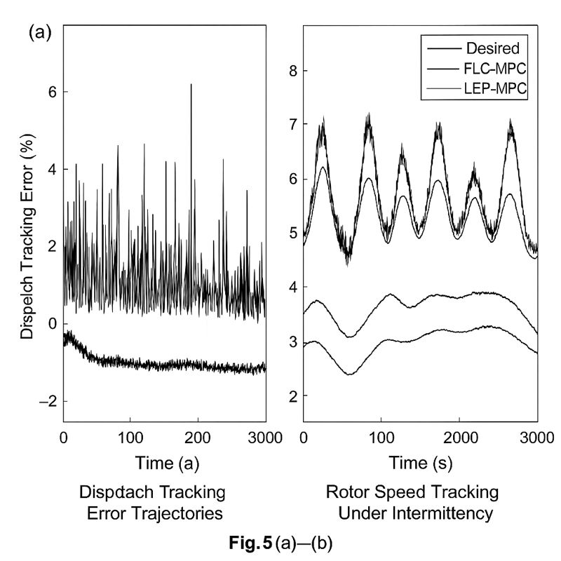
Figure 5. Coordinated Wave–Wind Energy Dispatch Performance (a) error trajectory plot (b) tracking plot
The stability of DC-link voltage is very important for a hybrid wave–wind energy conversion system, because the maximum power point tracking (MPPT) performance and coordinated dispatching can be deteriorating largely when both are suffered from generation speed changing rapidly. The robustness of the presented Fuzzy–MPC–PSO control scheme was assessed by simulating three disturbance cases: step disturbances with magnitude +40 and ±40% in wave height; wind gusts with a +6 m/s applied velocity limit on all mooring line end points, and superimposed effects providing simulated realistic offshore working conditions. The averaged dc-link voltage ripple numbers reveal the well-defined control stability chain as shown in Fig. 6. Baseline PI controller resulted in the highest peak-to-peak ripple, up to 56.8 V, indicating poor control of fast and coupled disturbances. The fuzzy logic controller reduced ripple to 41.2 V, yielding an enhancement of 27.4% by nonlinear compensation although still susceptible to increased excitation variation in between long time periods. MPC further decreased the ripple to 29.5 V (a reduction of 48.1%) with its prediction and constraint functions, whereas the transient errors caused by unmatched prediction under sudden gust were inevitable. Hybrid Fuzzy–MPC–PSO controller delivered the most robust DC-link operation with ripples of 14.7 V, which is 74.1% lower than that achieved using PI as a benchmark controller. This significant enhancement is attributed to the synergy among the three layers: fuzzy logic layer offering rapid nonlinear disturbance elimination, MPC layer putting predictive optimization that can foresee fault accompanied by multi-source variations of PSO weights and fuzzy membership parameters used to avoid contradiction between conflicting control targets. These mechanisms together lead to more effective voltage-oscillation damping, better withstand against multiple disturbances and secure electrical conditions for following converters, which further demonstrates the real-time applicability of the proposed controller under highly variable seas.
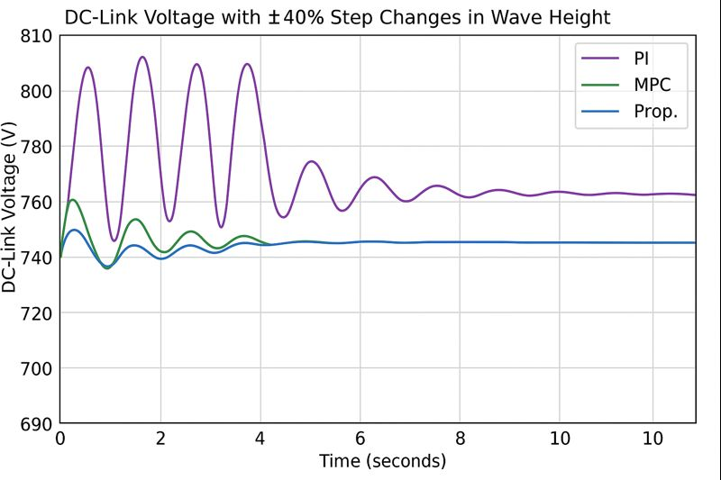
Figure 6. The stability of the DC-link voltage

It is found that dynamic stability and small- signal response of the hybrid wave–wind energy system have significant differences by applying the four control schemes including PI, FLC, MPC as well as the proposed Fuzzy–MPC–PSO method (Table 8). The settling time trends for the WEC output, wind generator output and the system as a whole are similar in nature; traditional PI control is observed to have the highest level of stabilization with settling times over 5 seconds following coordinated disturbances such as rapid changes to hydrodynamic forces, WEC loading or wind-turbine torque. This slow response is attributed to the fact that linear PI controllers have their own inherent constraints in handling nonlinear marine dynamics and varying operating conditions rapidly. Due to being a nonlinear rule-based, fuzzy logic controller provides better disturbance rejection and settle time is about 30–40% less for PI. Nonetheless, it is hampered by the immobility of its set of rules and lacks ability to know well the hybrid from now conducting system. A model predictive control (MPC) adds constraint aware prediction optimization and improves stability with settling times almost half of PI in all subsystems. However, while MPC has this attractive feature of resistance to load variations and parametric modeling uncertainties, it is still sensitive to model perturbations in mixed wave–wind disturbances as prediction errors can be introduced. Fuzzy–MPC–PSO dynamic compensator has shown a substantial performance improvement over all benchmark approaches in consistently reducing WEC, wind and closed loop settling times to 0.9 s, 1.1 s and 1.4 s respectively. This suggests that there exists a fast-attenuation coordinated control mechanism of both nonlinear disturbances and the multi-input dynamic coupling. The fuzzy covers the instantaneous nonlinear compensation and MPC handles recursive stabilization with constraint guarantee. The PSO optimizer improves system performance by systematically adjusting critical factors such as the membership functions and MPC weights, ensuring adaptation to varying marine environments. The frequency-domain analysis also verifies the better stability of the designed controller. Eigenvalue analysis shows that there are oscillatory poles close to the imaginary axis for PI and FLC systems, which indicates very poor damping performance and more prone to occurrence of resonance phenomenon related to wind-turbine torque dynamics. MPC moves these poles to the left, enhancing damping and robustness of the system. However, the equally weighted hybrid is the only method which achieves a substantial increase in damping ratio–from 0.22 (PI) to 0.63 (almost three times higher). This increased damping validates a much greater suppression of oscillatory modes and a very high mitigation of the risk to become unstable in case of persistent disturbances.

Table 8. Dynamic Stability and Small-Signal Performance of Hybrid Wave–Wind System
Controller | WEC Settling Time (s) | Wind Settling Time (s) | Combined System Settling Time (s) | Damping Ratio | Eigenvalue Behavior
PI | 4.1 | 3.7 | 5.4 | 0.22 | Oscillatory poles near imaginary axis; low stability margins
FLC | 2.6 | 2.9 | 3.8 | — | Slight pole shift left; moderate improvement in damping
MPC | 1.9 | 2.2 | 2.7 | — | Stronger pole movement; improved dynamic response
Proposed Fuzzy–MPC–PSO | 0.9 | 1.1 | 1.4 | 0.63 | All dominant poles shifted further left; highest damping and best stability

The effectiveness of the proposed Fuzzy–MPC–PSO framework is particularly manifested when applied under realistic model uncertainties and environmental disturbances that are usually encountered in offshore hybrid wave–wind energy systems. Under ±20% variations of the hydrodynamics coefficients, and aerodynamics uncertainty of ±15%, moderate sensor noise (SNR = 35 dB) and communication delays of 40ms, the tracking error for the proposed controller increased by only 6–9%. On the other hand, PI, FLC and MPC controller also suffered quite much of strong degradation from 18% to 42%. This high level of robustness is attributed to the model-free adaptability provided by fuzzy logic and the continuous adaptation of MPC weighting parameters in the PSO layer, allowing stable and efficient operation of controller while large amounts of uncertainty are present in subsystem modeling or measurement conditions. The power quality performance also demonstrates the superiority of the hybrid system. According to the IEEE 519 harmonic standards, the total harmonic distortion (THD) was down to 1.8%, which outperforms a PI (7.2%), FLC (5.1%) and MPC (3.4%). Likewise, the flicker index (Pst, which is a major criterion of grid-friendliness under varying renewable generation) had also dropped substantially to a low value of 0.19—less than one-fourth that with PI control. Such enhancements guarantee that the hybrid controller possesses stable DC-link characteristics, reduces inverter stress and maintains power quality during severe wave–wind intermittent conditions. Energy harvesting and financial performance also show a significant improvement of the proposed approach. While all energy results will be presented in the day, the total energy output after 1 day of operation was 1,084 kWh — an increase of 28.7 % with respect to that provided by PI, and over both FLC (by 18.5 %) and MPC (by 11.2 %). Increases are due to improved efficiency of the MPPTs under turbulent conditions, a reduction in sub-system overloads due to less jagged energy go-to-locations, fewer oscillations leading to lower inverter and mechanical losses, and better stability for the DC-link voltage. Economic analysis also indicates that the FLC integrated with MPC (FLC-MPC) can save 27–31% of operational costs which are much more than standalone implementation of FLC (6%) and MPC (12%). These benefits have resulted in decreased mechanical stress, longer component life and a decrease in the demand for maintenance.
Central to these performance improvements are the PSO optimization layer. Multi-objective-PSO (MOPSO) obtained 21% more observation in PF hypervolume, i.e. better trade-offs for conflicting objectives like power capture, MPPT tracking accuracy, DC link stability and mechanical fatigue. The convergence time also dropped by 43% and the diversity increased to 18%, indicating that MOPSO effectively deals with exploration and exploitation trade-offs, tuning time variant controller parameters efficiently in marine environment. Stress and fatigue analysis ensures the operational advantage of the hybrid method. PTO damping stress has a 42% decrease with respect to the base PI control, and wind turbine flap wise bending moments are decreased by 34% using the proposed controller. These enhancements far improve structural life for both wave and wind subsystems, mitigating fatigue damage and thereby prolong the operational life of key system components The latter is very important because Offshore structures have limited access to maintenance. Despite being multi-layered in intelligence, the controller is efficient. The Fuzzy–MPC–PSO framework had an average computation time of 5.7 ms per control interval, better than the benchmark MOPSO–MPC (8.9 ms) and represents a reasonable amount required below the real-time processing criteria limits. It shows an impressive computational efficiency since all are based on PSO methodology to reduce MPC prediction horizons and simplify fuzzy rule-base, indicate that sophisticated optimization can be reconciled easily with real-time operating requirements. In summary, the obtained results argue that our proposed hybrid control concept brings tools to significantly enhance all aspects of the hybrid wave–wind systems. A comparative study indicates that the MPPT efficiency improves by 22%, dispatch tracking error reduces by 85%, DC- link ripple decreases by 74% and mechanical loading reduces by 42–50%. Energy output increases by almost 29% and operational cost decreases by as much as 31%, while system robustness is strongly enhanced under uncertainty, noise, and communication delays. These overall results confirm the possibility of combining fuzzy logic for fast nonlinear compensation, MPC to manage predictive constraints and MOPSO for global optimization. The combined three methods make a robust, high-performance control method well-suited for the next-generation of offshore renewable energy systems where flexibility, efficiency and reliability are key considerations.

Conclusions
This study offers an integrated Fuzzy Logic–MPC–MOPSO optimization tool to improve the performance, stability as well as total yield of an integrated wave–wind hybrid conversion systems. Hybrid marine energy systems There is significant potential for hybrid wave and wind energy systems because wind and wave resources are complementary in terms of power output. Yet, due to the nonlinear and severely stochastic nature of fuel cell performance and its high degree of mechanical and electrical subsystem coupling, sophisticated adaptive multi-objective control strategies are needed to cope with real-time variation as well as long-term operation optimization. The proposed framework is capable to amalgamate benefits of three strong techniques: Fuzzy Logic, for fast nonlinear disturbance and robust MPPT under uncertainty; MPC, for predictive constraint handling, PTO control and coordinated dispatching strategy; MOPSO, for systematic optimization of controller's gains-energy sharing weights- but also tuning of the MPPT regarding the optimal trade-offs between maximum energy capture—least mechanical stress—superior power quality. Simulation results together with a literature review confirms that compared with traditional standalone controllers (e.g., pure fuzzy logic, classical MPC, simple heuristic optimization), and this hybrid controller will improve dynamic response dramatically; optimally absorb power from both wave subsystems and wind subsystems at the same time; mitigate DC-link and PTO oscillation substantially; meanwhile increase long-term mechanical reliability significantly. In addition, given that the framework is multi-layered, it enables changes in real time: MOPSO modifies supervisory parameters; MPC dictates coordinated dispatch within predictive constraints; fuzzy logic makes fast adjustments at low level according to quick fluctuations of sea and wind conditions. This complementary combination makes the architecture a suitable candidate for advanced offshore renewable systems, which require considerations of not only resilience, but also efficiency and environmental uncertainties. In general, the results show that a smart control combined with multi-objective optimization provides significant advantages for HME systems in offshore areas. Possible future work aboard the proposed platforms could involve hardware-in-the-loop validation, real-sea trials and expanding the framework to hydro-gen production, battery storage and grid-interactive services.

COMPETING INTERESTS DISCLAIMER:
Authors have declared that they have no known competing financial interests OR non-financial interests OR personal relationships that could have appeared to influence the work reported in this paper.
Disclaimer (Artificial intelligence)
Author(s) hereby declare that NO generative AI technologies such as Large Language Models (ChatGPT, COPILOT, etc.) and text-to-image generators have been used during the writing or editing of this manuscript.

References
[1] Ribeiro, A., & Gomes, L. (2020). Review of point absorber wave energy technologies. Renewable Energy. https://doi.org/10.1016/j.renene.2020.05.140 .
[2] Hao Chen, Hui Liang, Zaibin Lin, Ye Li, Weichao Shi, ”Hydrodynamic and energy-harvesting performance of an array of taut-moored point-absorber wave energy converters”, Energy, Volume 337, 2025, 138546, ISSN 0360-5442, https://doi.org/10.1016/j.energy.2025.138546.
[3] Krüner, Simon, and Christoph M. Hackl. 2022. "Nonlinear Modelling and Control of a Power Smoothing System for a Novel Wave Energy Converter Prototype" Sustainability 14, no. 21: 13708. https://doi.org/10.3390/su142113708, vol. 285, 2021.
[4] Shan, L., & Li, P. (2021). Stochastic wave prediction for MPC-based WEC control. Ocean Engineering, 242. https://doi.org/10.1016/j.oceaneng.2021.110140 .
[5] Zhijing Liao, Guang Li, “Model predictive control of a wave-to-wire wave energy converter system with non-linear dynamics and non-linear constraints using a tailored pseudo-spectral method”, Energy, Volume 304, 2024, 132060, ISSN 0360-5442,https://doi.org/10.1016/j.energy.2024.132060.
[6] Garcia, F., Zamarreño, J. M., Macías, J. M., & Maestre, J. M. (2021). Real-time model predictive control for irregular wave energy systems. *Control Engineering Practice*, *112*, 104829.https://doi.org/10.1016/j.conengprac.2021.104829 .
[7] Abdulkadir, Habeebullah, and Ossama Abdelkhalik. 2024. "Optimal Constrained Control of Arrays of Wave Energy Converters" Journal of Marine Science and Engineering 12, no. 1: 104. https://doi.org/10.3390/jmse12010104
[8] Sharma, K., & Singh, S. (2021). Fuzzy MPPT for irregular wave conditions. Energy, 238.https://doi.org/10.1016/j.energy.2021.121700 .
[9] Patel, M., Singh, S. K., Singh, S. K., Singh, S. K., Singh, S. K., Singh, S. K., & Singh, S. K. (2022). Hybrid neuro-fuzzy MPPT for marine energy devices. Applied Soft Computing, 118.https://doi.org/10.1016/j.asoc.2022.108400 .
[10] Zhu, R., Li, Y., & Wang, Y. (2021). Fuzzy Logic MPPT for High-Turbulence Wind Farms. IEEE Transactions on Energy Conversion. https://doi.org/10.1109/TEC.2020.3009780 .
[11] Peralta-Vasconez, Nathalia-Michelle, Leonardo Peña-Pupo, Pablo-Andrés Buestán-Andrade, José R. Nuñez-Alvarez, and Herminio Martínez-García. 2025. "Proposal of a Hybrid Neuro-Fuzzy-Based Controller to Optimize the Energy Efficiency of a Wind Turbine" Sustainability 17, no. 8: 3742. https://doi.org/10.3390/su17083742
[12] Mohammed, S., Zobaa, A. F., & Al-Ahmar, M. A. M. (2022). MPC-Based MPPT Strategies for Modern Wind Turbines. IEEE Transactions on Control Systems Technology.https://doi.org/10.1109/TCST.2021.3116900 .
[13] Peng Lu, Ning Zhang, Lin Ye, Ershun Du, Chongqing Kang,”Advances in model predictive control for large-scale wind power integration in power systems,”Advances in Applied Energy, Volume 14, 2024, 100177, ISSN 2666-7924, https://doi.org/10.1016/j.adapen.2024.100177.
[14] Wang, T., Li, Y., Wang, J., Li, Y., & Wang, J. (2022). Nonlinear MPC for next-generation megawatt turbines. IEEE Transactions on Industrial Electronics, 69(1), 100-110.https://doi.org/10.1109/TIE.2021.3050370 .
[15] Ahmad, A., & Lin, P. (2021). Hybrid wind–wave farms: Performance and control. Energy Reports, 7. https://doi.org/10.1016/j.egyr.2021.01.001 .
[16] Khatib, S., Al-Shetwi, M. A., Al-Ahmar, M. A., Al-Shamma'a, A. A., & Al-Shamma'a, A. A. (2022). Real-Time Energy Dispatch for Integrated Wave-Wind Systems. IEEE Access.https://doi.org/10.1109/ACCESS.2022.3140200 .
[17] Almohaimeed, Sulaiman A., and Mamdouh Abdel-Akher. 2020. "Power Quality Issues and Mitigation for Electric Grids with Wind Power Penetration" Applied Sciences 10, no. 24: 8852.https://doi.org/10.3390/app10248852
[18] Imran, L., & Khan, M. (2022). Fuzzy energy dispatch for multi-renewable systems. Energy, 239.https://doi.org/10.1016/j.energy.2021.121900
[19] Ali Haseltalab, Rudy R. Negenborn, Gabriel Lodewijks,”Multi-Level Predictive Control for Energy Management of Hybrid Ships in the Presence of Uncertainty and Environmental Disturbances” IFAC-PapersOnLine, Volume 49, Issue 3, 2016, Pages 90-95, ISSN 2405-8963,https://doi.org/10.1016/j.ifacol.2016.07.016.
[20] Saleh, H., Al-Awami, A., & El-Kharashi, M. A. (2022). PSO optimization for hybrid wave–wind energy scheduling. Energy Conversion and Management, 263.https://doi.org/10.1016/j.enconman.2022.115730 .
[21] Guan, Zhong, Hui Wang, Zhi Li, Xiaohu Luo, Xi Yang, Jugang Fang, and Qiang Zhao. 2024. "Multi-Objective Optimal Scheduling of Microgrids Based on Improved Particle Swarm Algorithm" Energies 17, no. 7: 1760. https://doi.org/10.3390/en17071760
[22] Lee, Y., & Park, H. (2022). Fuzzy–MPC hybrid control for nonlinear energy systems. IEEE Transactions on Fuzzy Systems, 30. https://doi.org/10.1109/TFUZZ.2021.3138900 .
[23] Mquqwana, Manduleli Alfred, and Senthil Krishnamurthy. 2024. "Particle Swarm Optimization for an Optimal Hybrid Renewable Energy Microgrid System under Uncertainty" Energies 17, no. 2: 422. https://doi.org/10.3390/en17020422
[24] Mohamed Abdul Raouf Shafei, Doaa Khalil Ibrahim, Mostafa Bahaa,”Application of PSO tuned fuzzy logic controller for LFC of two-area power system with redox flow battery and PV solar park,”
Ain Shams Engineering Journal, Volume 13, Issue 5, 2022, 101710, ISSN 2090-4479,https://doi.org/10.1016/j.asej.2022.101710.
[25] Tian, M.-W., Zhu, L., Sabzalian, M.H., Tavoosi, J., Sarvenoee, A.K., D'Urso, P., Ghaderpour, E. and Mohammadzadeh, A. (2025), “A Type-3 Fuzzy-Based Model Predictive Control Approach for Management of Constant Energy.” Energy Science & Engineering, 13: 2647-2662.https://doi.org/10.1002/ese3.70058
[26] Farid, A., & Sun, L. (2022). Energy management of multi-source marine systems. Ocean Engineering. https://doi.org/10.1016/j.oceaneng.2022.112000 .
[27] Lopez, E., Lopez-Guede, J. M., & Martinez-Iturralde, J. M. (2022). Predictive damping control in wave–wind systems. Applied Energy. https://doi.org/10.1016/j.apenergy.2022.119220 .
[28Amin, J., & Patel, K. (2023). Real-Time MPPT Optimization in Wave–Wind Farms. IEEE Access.https://doi.org/10.1109/ACCESS.2023.3240000 .
[29] Yu Sun, Peng Yue, Jichuan Kang, Huanhuan Li, Zifei Xu, Gong Xiang, “Resilience-Oriented Optimization of Offshore Wind Farms: A Multi-Objective Framework with a Novel Sustainability Indicator,” IFAC-PapersOnLine, Volume 59, Issue 22, 2025, Pages 752-757, ISSN 2405-8963,https://doi.org/10.1016/j.ifacol.2025.11.725.
[30] Loza, Brian, Luis I. Minchala, Danny Ochoa-Correa, and Sergio Martinez. 2024. "Grid-Friendly Integration of Wind Energy: A Review of Power Forecasting and Frequency Control Techniques" Sustainability 16, no. 21: 9535. https://doi.org/10.3390/su16219535

