Adapting Telemetry for Cyber-Physical Continuous Verification in Cameroon’s Energy Sector

Abstract
The increasing digitalization of power systems has amplified cybersecurity vulnerabilities in many African countries, where legacy grid infrastructures now interface with modern operational technologies. This study applies an adapted Behavioral Analytics–Zero Trust Continuous Verification (ABA-ZTCV) framework to evaluate cyber-physical risks within Cameroon’s energy distribution network. The research integrates real-time feeder telemetry, anomaly detection techniques, and topology-aware verification processes to examine how continuous monitoring can strengthen resilience against emerging cyber threats. Using operational data from selected distribution feeders, the study models deviations in load behavior, identifies irregular operational patterns, and evaluates the capacity of automated verification mechanisms to flag and isolate potentially harmful anomalies. The findings show that a behavioral-driven verification approach provides earlier detection of suspicious operational shifts, supports faster incident response, and reduces the likelihood of undetected system manipulation. The framework further demonstrates how telemetry-informed verification can enhance situational awareness, reinforce access-control decisions, and support reliability improvements in resource-constrained environments. This work contributes to the growing body of cyber-physical security research in sub-Saharan Africa by offering a practical, data-driven methodology tailored to regions where infrastructural vulnerabilities, limited monitoring capacity, and increasing threat sophistication intersect. Beyond Cameroon, the proposed approach has broader relevance for developing energy systems across Africa and other emerging economies seeking scalable and cost-effective models for continuous verification. The study highlights the need for real-time analytics, layered trust models, and adaptive verification practices as foundational elements for securing modern power infrastructure in an evolving global threat landscape.
Keywords: ABA-ZTCV; Cameroon power grid; telemetry gap scoring; graph centrality; STL-CUSUM detection.

1. Introduction
The increasing convergence between cyber and physical systems in modern power networks has transformed the energy sector into one of the most digitally dependent and simultaneously most vulnerable domains of national infrastructure. In Cameroon, this interdependence has intensified existing operational challenges, exposing critical assets to cyber threats, insider manipulation, and telemetry fragmentation (Atabong, 2024; Iweh et al., 2023). As the country seeks to modernize its grid through smart technologies, Supervisory Control and Data Acquisition (SCADA) systems, and Internet of Things (IoT) integration, the need for secure, real-time verification mechanisms becomes pressing (Krause et al., 2021). Recurrent blackouts, weak telemetry coordination, and the rising volume of cyberattacks suggest that conventional security approaches can no longer guarantee grid stability (Rajkumar et al., 2023). A transition toward continuous, telemetry-driven verification offers a strategic opportunity to mitigate these risks and strengthen national energy resilience.
Recent data demonstrate the scale of this problem. Power outages in Cameroon quadrupled between 2018 and 2021 according to the Supreme State Audit Office, indicating that despite infrastructural expansion, the grid remains unstable (Amara, 2025). Although average outage duration fell from ninety-eight minutes in 2018 to forty-three minutes in 2021, the increase in frequency underscores deep structural inefficiencies (Amara, 2025a; The Supreme Court of Cameroon, 2025). Distribution losses stand at roughly 32 percent, with transmission losses of 6.3 percent (Iweh et al., 2023), while nearly 93 percent of firms report monthly outages (Amara, 2025a). These operational indicators highlight a sector constrained not only by capacity deficits but also by limited real-time data integration and delayed fault detection. The situation persists even after commissioning the 420 MW Nachtigal hydroelectric plant, as daily blackouts of six to eight hours continue to affect major cities (Amara, 2025a). Such inefficiencies point to systemic monitoring gaps that could be minimized through continuous verification of grid telemetry.
The cybersecurity dimension compounds these technical deficiencies. In January 2024, Cameroon’s national utility, Eneo, suffered a cyberattack that crippled its core information systems and disrupted prepaid and postpaid billing services (Atabong, 2024; ICS Strive, 2024). Interpol’s 2024 Africa Cyberthreat Assessment further reported that cyber incidents in Cameroon nearly doubled within a year, reaching over 333,000 recorded cases (Interpol, 2024). The rapid escalation of digital threats reveals the extent to which critical infrastructure is now exposed. Across Africa, energy and utility companies are ranked among the three most frequently targeted sectors for ransomware and intrusion attempts (Kemp, 2025). Globally, the International Energy Agency recorded that weekly cyberattacks on energy organizations more than doubled between 2020 and 2024, while the energy sector now accounts for approximately 39 percent of all critical-infrastructure-related attacks (Security Magazine, 2023; IEA, 2025). These statistics confirm that the operational vulnerabilities evident in Cameroon exist within a broader global pattern of escalating cyber-physical risk.
At the technical level, energy systems have become attractive targets for sophisticated adversaries exploiting the increasing digitalization of control processes. Malware such as Industroyer and CrashOverride demonstrated the feasibility of manipulating electrical substation signals and control commands, leading to widespread power disruption (Greenberg, 2017). Research on false-data-injection and topology-hiding attacks has shown that even minimal manipulation of measurement data or breaker configurations can mislead state estimation algorithms and produce false system stability readings (Ardebili et al., 2024; Isern et al., 2023). Such attacks are difficult to detect using static or perimeter-based security systems. They reveal a fundamental weakness in conventional verification approaches that rely on event-driven alerts rather than continuous, contextual monitoring of system states (Wang, Li, et al., 2024).
Emerging academic literature reinforces this concern. Yaacoub et al. (2020) describe cyber-physical system security as a multilayered challenge characterized by inadequate anomaly detection and limited coordination between operational and information networks. Wang et al. (2024) argue that power-system resilience requires detection frameworks capable of correlating cyber events with physical state deviations in near real time. Likewise, Achaal et al. (2024) identify telemetry integration as a critical enabler for achieving intelligent situational awareness in smart grids. In addition, Kruse et al. (2021) emphasize that the proliferation of connected sensors and IoT devices expands the attack surface and increases the need for advanced verification pipelines. These studies collectively point toward a research and implementation gap in developing economies such as Cameroon, where continuous telemetry-based security frameworks remain largely unadopted despite their growing necessity.
It is within this context that the present study applies the Advanced Behavioral Analytics for Zero-Trust Continuous Verification (ABA-ZTCV) framework originally developed by Obrik-Uloho (2025). The ABA-ZTCV model integrates multi-source telemetry, graph–sequence hybrid modeling, Bayesian risk calibration, and adaptive feedback mechanisms to maintain continuous verification of entities and processes. While its validation occurred within enterprise information-technology environments, its layered design is transferable to cyber-physical systems such as national energy grids. By mapping its telemetry, representation, policy, and feedback layers onto Cameroon’s energy infrastructure, the framework provides a blueprint for achieving continuous assurance of operational integrity. This adaptation moves beyond reactive security toward predictive, context-aware verification capable of addressing both cyber intrusions and physical-system anomalies.
Existing literature on digital twins and telemetry analytics supports this adaptation. Ardebili et al. (2024) note that digital-twin architectures enable synchronized monitoring of physical assets through continuous data replication, a principle aligned with the ABA-ZTCV framework’s feedback layer. Mbasso et al. (2025) further observes that applying digital-twin models in renewable-energy systems enhances forecasting accuracy and operational efficiency by leveraging real-time telemetry. Similarly, Zibaeirad et al. (2024) emphasize that continuous security verification, combined with intelligent analytics, can transform reactive maintenance systems into predictive ones. Such approaches resonate strongly with the continuous-verification philosophy underpinning this study.
Despite these advances, limited empirical or conceptual work addresses how telemetry-driven verification frameworks can be embedded in African energy infrastructures. Many national utilities in Sub-Saharan Africa still operate legacy systems lacking unified telemetry management, real-time anomaly correlation, and automated incident response (Yaacoub et al., 2020). Consequently, security functions remain fragmented and reactive. Adapting an established, data-driven continuous-verification model to Cameroon’s context can therefore contribute to bridging this strategic and technological gap. The adaptation proposed in this study does not seek to modify the core architecture of the ABA-ZTCV framework but rather to demonstrate its applicability as a practical tool for enhancing cyber-physical resilience in a developing-nation energy environment. Hence,this study examines the vulnerabilities and operational inefficiencies affecting the energy sector in Cameroon, applying the Advanced Behavioral Analytics for Zero-Trust Continuous Verification (ABA-ZTCV) framework found in the study of Obrik-Uloho (2025) to recommend practical strategies for implementing telemetry-driven continuous verification aimed at improving cyber-physical security, reducing insider manipulation, and enhancing grid stability, by achieving the following objectives:
- To assess the existing challenges, weaknesses, and telemetry gaps that contribute to grid instability and cybersecurity vulnerabilities within Cameroon’s energy sector.
- To adapt the components of the ABA-ZTCV framework to the operational structure of Cameroon’s power infrastructure
- To demonstrate how the application of continuous verification can strengthen real-time monitoring, risk detection, and decision-making in the management of energy systems.
- To propose actionable recommendations and a policy roadmap for integrating continuous verification principles into Cameroon’s national energy governance and cybersecurity strategy.

2. Literature Review
Telemetry in energy systems plays a foundational role in capturing, transmitting, and interpreting operational data from physical assets, enabling control centres and analytics platforms to monitor, verify, and respond to system states in real time (Biswal et al., 2023). Essentially, telemetry encompasses measurements of currents, voltages, reactive power, switch-gear statuses, and communication logs of protection and control devices; these data streams serve both reliability-monitoring and operational-intelligence functions. As energy infrastructures have become increasingly digital and interconnected, the volume, variety and velocity of telemetry data have grown, prompting a shift from purely periodic inspection or event-driven checks to continuous verification of system integrity (Gupta et al., 2021).
In its traditional manifestation, event-driven monitoring relied on threshold crossings, discrete alarms or scheduled audits of historical logs. In contrast, continuous verification uses rich telemetry streams to maintain an ongoing assertion of “system trustworthiness,” continuously correlating physical measurements, device behaviours and communication events to detect anomalies before they escalate (Zang et al., 2025). This means that rather than reacting to visible failures or isolated alarms, the system can proactively detect subtle deviations from expected patterns, issue pre-emptive alerts and initiate corrective responses. In agreement with this, reviews of anomaly detection in smart grids illustrate how hybrid machine-learning, graph-based and temporal-sequence approaches increasingly replace static rule-based systems (Guato Burgos et al., 2024; Adesokan-Imran et al., 2025; Kolo, 2025a). Those approaches underscore how continuous verification leverages telemetry not only for post-mortem diagnostics but for live assurance of system state.
Recent scholarship has underscored that telemetry-driven anomaly detection, system validation and predictive maintenance are no longer optional add-ons but essential for modern energy systems. For instance, Ardebili et al. (2024) reveal how digital twins in smart energy systems rely on real-time data integration to support predictive diagnostics and system verification, arguing that telemetry fusion, dual-modelling and computational analytics are key enablers. Similarly, Heluany and Gkioulos (2024) report that digital-twin architectures for power generation and distribution include components such as bidirectional communications, virtual entities and data-services that continuously sync with physical assets. Consistently, Guato Burgos et al. (2024) finds that anomaly detection in smart grids is evolving towards solutions that blend context-awareness, graph-based relational modelling and sequence-analysis, thereby enabling verification systems that detect structural, temporal and behavioural deviations.
Innovations such as digital twins and graph-sequence hybrid modelling further strengthen the case for telemetry-enabled continuous verification. Digital twins create high-fidelity virtual replicas of physical assets or systems in which telemetry feeds real-time state, and the twin simulates or compares expected behaviour with actual measurements (Khajavi et al., 2019). In doing so, it enables immediate verification of asset health, system configuration and emergent deviations (Dihan et al., 2024; Bamigbade et al., 2025; Kolo, 2025b). Meanwhile, research into graph-sequence hybrid modelling combines relational graphs of system components (devices, lines, feeders) with temporal sequences of telemetry measurements, enabling detection of anomalies not just in isolated variables but in the evolving topology and behaviour of the system (Zideh et al., 2023). These methods enable situational awareness at the system-level rather than component-level, making telemetry a key enabler of continuous verification rather than simply data collection.
However, despite the consensus regarding the value of telemetry and continuous verification, several tensions persist. Some studies contend that telemetry alone cannot guarantee resilience unless integrated with strong institutional processes and governance frameworks (Achaal et al., 2024; Kolo, 2023; Ogunmolu, 2025a). Others highlight that while continuous verification is promising, its practical deployment in resource-constrained settings remains underexplored, particularly in emerging economies (Chui et al., 2023; Hamdan et al., 2024). Nevertheless, a clear trajectory as energy systems digitise and threats grow, telemetry-driven continuous verification will transition from innovative capability to operational necessity (Almihyawi & Kurnaz, 2025; Koirala et al., 2024).

Global and Regional Cybersecurity Threats to Energy Systems
The vulnerability of energy systems to cyber-physical attacks has evolved beyond theoretical risk to documented reality. According to Gjesvik and Szulecki (2022), the CrashOverride/Industroyer incident against the Ukrainian power grid in 2016 remains a compelling demonstration of how control-system malware can initiate power outages, manipulate protective relays, and disable monitoring controls. Such attacks exemplify the convergence of cyber and physical domains; their analysis shows false-data-injection and topology-hiding methods subvert state estimators and system dispatch logic (Gjesvik & Szulecki, 2022; Ogunmolu, 2025b; Olutimehin et al., 2025a). In agreement, Tapia et al. (2020) document how even distributed energy resources and DER communication channels can be compromised via packet-injection or man-in-the-middle attacks, resulting in broad grid instability (Tapia et al., 2020). These empirical studies provide strong evidence that the energy sector’s digital integration has increased its attack surface and decreased its margin for error.
Global statistics underscore this trend. According to IEA (2025), cyberattacks per week per energy organization more than doubled between 2020 and 2024. Kazanci (2024) reports that ten out of ninety-seven major cyber attacks in 2019 were directed at electricity infrastructure, signalling an upward trajectory of targeted campaigns. These figures indicate that the energy sector now represents a significant portion of critical-infrastructure cyber incidents, reflecting an emerging consensus that traditional protections are insufficient.
In the African context, vulnerabilities are amplified by legacy systems, limited telemetry consolidation, and minimal resources for continuous monitoring. Saeed et al. (2024) observe that digital transformation in the energy sector has outpaced the maturity of cybersecurity safeguards in many nations, rendering power grids especially susceptible to ransomware and intrusion attempts. While specific data for Africa remain relatively scarce, this digital exposure implies that utilities may be operating with elevated risk without transparent incident reporting mechanisms.
Turning to Cameroon, the case of Eneo Cameroon in January 2024 when a cyberattack reportedly disabled core utility systems reveals the real-world manifestation of these global trends (Atabong, 2024). Interpol’s Africa Cyberthreat Assessment indicates that recorded cyber-incidents in Cameroon nearly doubled over the same period, signifying an environment of accelerating threat (Interpol, 2024). Without a robust continuous-verification framework, grid modernization in such a context may paradoxically increase exposure rather than reduce it. As Abdelkader et al. (2024) argues, modernization that emphasizes IoT and remote connectivity without concurrent verification capabilities invites cascading system failures by reducing the time between anomaly inception and impact. Thus, the alignment of global attack trends, regional vulnerabilities, and the Cameroonian context strongly supports the need for telemetry-based continuous verification rather than unsecured digital growth.

Operational and Structural Challenges in Cameroon’s Energy Sector
Cameroon’s energy sector continues to exhibit significant operational and structural constraints that undermine its ability to provide reliable service and integrate advanced telemetry-driven verification mechanisms (Iweh et al., 2023). Empirical analyses indicate that transmission and distribution (T&D) losses in Cameroon remain persistently high, with a recent study reporting distribution losses of approximately 32.03 % and transmission losses of 6.3 % within major grid segments (Iweh et al., 2023; Ayuketah et al., 2022). These losses not only reflect technical inefficiencies such as ageing conductors and sub-optimal network configurations but also highlight weak data integration and monitoring capabilities, which delay detection of faults and obscure the underlying causes of instability. Evidence further shows that power cuts in Cameroon quadrupled between 2018 and 2021, signalling worsening grid reliability despite efforts to expand capacity (Amara, 2025a). The multiplicity of outages, coupled with long durations and limited visibility into system performance, suggests that telemetry fragmentation and inadequate real-time analytics are entrenched problems rather than transient phenomena.
Governance and institutional barriers compound these technical inefficiencies. Ayuketah et al. (2022) argues that weak regulatory frameworks, insufficient cybersecurity capacity, and outdated infrastructure combine to hinder effective implementation of modern grid management practices. Specifically, the absence of a unified telemetry or SCADA oversight architecture across multiple grid zones prevents the formation of a single source of truth for operational data, and the sector continues to rely on manual reporting and periodic audits rather than continuous monitoring (Iweh et al., 2023; Tanyi & Mbinkar, 2013). This fragmentation means that anomalies may persist undetected for extended periods, delaying response and increasing cumulative system risk. Moreover, institutional inertia and limited funding for digital upgrades further obstruct the adoption of data-centric governance models envisioned for resilient energy infrastructure (Ayuketah et al., 2024; Oyekunle et al., 2025; Udechukwu, 2025a). As a result, the normative frameworks for telemetry governance, data-sharing protocols and incident management remain underdeveloped.
The lack of unified telemetry systems, therefore, directly contributes to extended recovery times and increased outage severity. Without integrated data streams, operators cannot correlate device events, network flows and substation logs in real time. This results in sequential fault detection rather than holistic system awareness, meaning that cascading failures are more likely and containment more difficult (Pompili et al., 2021). In analyzing Cameroonian grid planning, Sapnken et al. (2025) found that the multiple network zones operate quasi-independently, which reduces situational awareness and slows corrective action during disturbances. In this environment, the absence of continuous verification leaves the system vulnerable to undetected drift in operational baseline and hidden device misconfigurations.
Furthermore, specific telemetry and data-management weaknesses in Cameroon’s sector underscore its suitability for applying a continuous-verification model. The persistence of manual meter-reading, limited deployment of PMUs (Phasor Measurement Units) and inadequate historian systems means that asset behaviours, communication patterns and sensor integrity are rarely cross-checked continuously (Chang & Yang, 2022). Given the documented high losses, frequent outages and governance constraints, the introduction of a telemetry-driven continuous verification framework could directly address these gaps by instituting unified data ingestion, anomaly scoring and real-time feedback loops. In this way, Cameroon’s grid environment offers a relevant case for demonstrating how a structured continuous-verification architecture can be adopted even under resource and institutional limitations.

Zero Trust Principles and Cyber-Physical Vulnerabilities in Energy Systems
Modern energy infrastructures operate in environments where traditional perimeter-based security models are increasingly inadequate. As operational technology (OT) becomes interconnected with information technology (IT), trust cannot be assumed once a device or user gains initial access. Zero Trust Architecture (ZTA) addresses this challenge by applying the principle of “never trust, always verify,” requiring continuous authentication, behavioural monitoring, and least-privilege access for all entities across the system (Rose et al., 2020). Rather than relying on static trust zones or periodic audits, Zero Trust enforces dynamic and context-aware verification based on real-time telemetry, user actions, and system behaviour. This makes it particularly relevant for cyber-physical environments where subtle deviations such as irregular load changes or unexpected device communication may signal compromise.
The need for continuous verification becomes clearer when examining common vulnerabilities in energy and power ecosystems. Legacy ICS and SCADA protocols often lack encryption or authentication, enabling adversaries to manipulate commands or inject false data (Knowles et al., 2015). OT/IT convergence increases the risk that intrusions originating in enterprise networks can propagate into protection relays and distribution feeders. Insider threats, credential compromise, and misconfigured access rights further expose systems to unauthorized control actions. Telemetry manipulation through spoofing, suppression, or distortion poses additional risk because many operational decisions rely on the accuracy of measurement streams. These risks are not theoretical; high-impact events such as the Ukrainian power-grid attack demonstrate how coordinated manipulation of control systems can lead to cascading operational failures (Lee et al., 2016). In settings with limited monitoring capacity or fragmented data systems, ransomware attacks and configuration tampering can further prolong outages and delay fault detection. By linking these vulnerabilities to Zero Trust principles, it becomes evident that energy systems require a verification model grounded in continuous monitoring, behavioural analytics, and adaptive policy enforcement rather than static assumptions of device trustworthiness.

Theoretical Foundation: The Advanced Behavioral Analytics for Zero-Trust Continuous Verification (ABA-ZTCV) Framework
The ABA-ZTCV framework, proposed by Obrik-Uloho (2025), presents a four-layer architecture designed specifically to support continuous verification rather than historic, point-in-time trust decisions. At its core, the first layer the Telemetry Layer focuses on the ingestion, normalization and integration of multi-source telemetry (device logs, network flows, sensor measurements, control commands) into a unified dataset that underpins behavioural modelling (Kolo et al., 2025; Obrik-Uloho, 2025). This layer addresses the commonly cited problem in cyber-physical systems of fragmented data and lack of real-time visibility (Ma et al., 2021). In the second layer, the Representation Layer, the model advances by applying a graph-sequence hybrid modelling approach: graph embeddings capture structural relationships among entities (users, devices, assets), while sequence embeddings capture temporal behavioural patterns. This approach aligns with recent research demonstrating the efficacy of combining graph neural networks and temporal modelling in cyber-physical power systems (Presekal et al., 2023). The third layer the Risk & Policy Layer translates calibrated risk scores into adaptive enforcement policies, leveraging Bayesian risk calibration techniques and zero-trust principles (Huang et al., 2025). At this layer, ABA-ZTCV enforces policy decisions continuously based on risk scores rather than periodic audits. The fourth layer the Feedback & Drift Layer enables continuous learning, feedback from incident outcomes, behaviour drift detection and model recalibration. This addresses a major gap in static verification systems, where evolving behaviours or adversarial adaptation can render controls obsolete (Abshari & Sridhar, 2025).
Critically, the framework’s applicability to cyber-physical environments is significant. Although originally validated in enterprise IT settings, the layered design aligns closely with the operational needs of energy-sector systems: rich telemetry collection, structural–temporal behavioural modelling, risk-based enforcement and adaptive feedback. Conventional perimeter-based controls often rely on static trust zones and periodic inspection; they assume that once a device or control node is “trusted”, it remains so until a failure occurs (Rose et al., 2020; Olutimehin et al., 2025b; Udechukwu, 2025b). In contrast, continuous verification re-assesses every device, session, transaction and state in real time. This constant re-evaluation is particularly relevant in an energy-sector context where insider manipulation of control commands or spoofing of sensors can precipitate cascading failures (Basan et al., 2023). In agreement with zero-trust discourse, which emphasises “never trust, always verify” and relies on ongoing authentication and behavioural monitoring (DiCola, 2025), ABA-ZTCV operationalizes this philosophy for cyber-physical systems. By integrating telemetry and behavioural analytics with zero-trust enforcement and adaptive feedback, the model addresses key vulnerabilities: telemetry fragmentation, static trust assumptions, insider threats and evolving adversarial patterns. Thus, it supplies a coherent strategy for bridging cybersecurity architecture and operational assurance in high-risk infrastructure environments.

Empirical Evidence Supporting Continuous Verification
Telemetry-driven frameworks have increasingly demonstrated measurable gains in detection accuracy, anomaly response time, and system reliability across power systems. According to Veerakumar et al. (2023), a real-time distribution-system state-estimation platform instrumented with phasor measurement units (PMUs) and integrated anomaly-discrimination logic achieved fast identification of bad data and abrupt load changes on a utility-grade testbed, thereby shortening operator reaction windows. In agreement, Khalid et al. (2023) show that wide-area monitoring operations equipped with a median-regression-function state estimator and an interacting multiple-model fusion architecture maintain estimation fidelity under data-injection attempts, which directly supports continuous verification by preserving trustworthy situational awareness when adversaries target synchrophasor streams. Together, these studies move beyond conceptual arguments and provide empirical evidence that continuous, telemetry-rich pipelines outperform periodic or alarm-only practices in both speed and robustness of detection.
Case-based evidence from digital-twin deployments adds a complementary perspective by linking telemetry fusion with real-time validation. Ersan and Irmak (2024) develop and integrate a digital twin for a real hydroelectric power plant and demonstrate online error prediction and prevention for a pressure-sensor fault using programmable logic control, which functions as continuous cross-checking between physical measurements and virtual expectations. Likewise, Parede et al. (2023) report a PMU-backed data-management architecture in Brazil that detects and archives electrical events using principal-component analysis and correlation metrics on live grid data; the authors contend that such continuous event analytics improve observability and accelerate post-event forensics. From a broader lens, Ranawaka et al. (2024) synthesize evidence across AI-enabled digital-twin applications and contend that real-time twins enhance resilience through predictive diagnostics and asset-health verification, although they caution that model fidelity and data governance determine whether benefits translate into operational reliability.
Critically, the convergence across these strands aligns with the intended application of the ABA-ZTCV framework. Empirical PMU platforms demonstrate the feasibility of high-frequency telemetry ingestion and rapid anomaly triage (Veerakumar et al., 2023), while wide area estimators resilient to adversarial data provide a policy-relevant foundation for risk-aware, ongoing enforcement (Khalid et al., 2023). Digital-twin implementations show how a feedback loop can compare expected and observed states in near real time, supporting continuous recalibration rather than static thresholds (Ersan & Irmak, 2024; Ranawaka et al., 2024). Moreover, production-grade event detection pipelines indicate that persistent storage and structured analytics on streaming measurements reduce investigation delays and enhance reliability metrics after disturbances (Parede et al., 2023; Salami et al., 2025). These findings substantiate the key mechanisms that ABA-ZTCV operationalizes multi-source telemetry integration, structural temporal representation, risk-based policy application, and feedback-driven recalibration and therefore provide an empirical basis for applying continuous verification to Cameroon’s grid, where fragmented telemetry and delayed fault isolation currently extend outage duration and increase exposure to cascading failures.
3. Methods
The study applies ABA-ZTCV to Cameroon through three tightly coupled quantitative tracks: (1) reliability profiling and telemetry-gap scoring, (2) topology-based prioritization of telemetry placement and enforcement hubs, and (3) continuous-verification configuration for real-time risk detection.
1) Reliability profiling & telemetry-gap scoring (Objective 1). Microdata: WBES–Cameroon. Survey weights $w_{i}$.
$Weighted mean: E_{w\left[X\right]}=\frac{Σ_{i\left(w_{iX_{i}}\right)}}{Σ_{iw_{i}}}$.
Weighted quantile $Q_{w\left(p\right)}$ via weighted CDF.
Winsorization for outage duration: $x_{i}^{'}=\min\left(x_{i},Q_{w\left(0.99\right)}\right)$.
Proxies:
$SAIFI_{proxy}=12*E_{w\left[outages_{per_{month}}\right]}$;
$SAIDI_{proxy}=SAIFI_{proxy}*E_{w\left[outage_{duration_{hr_{per_{event}}}}\right]}$.
Loss and backup:
$$loss_{share}=E_{w\left[\%sales_{lost_{outages}}\right]};$$
$Generator_{pct}=100*E_{w\left[1\left\{generator=1\right\}\right]}$.
Telemetry Gap Score (per region): with percentile rank $R\left(·\right)∈\left[0,1\right]$,
$Gap=0.25*R\left(SAIFI_{proxy}\right)+0.25*R\left(SAIDI_{proxy}\right)+0.25*R\left(loss_{share}\right)+0.25*R\left(100-generator_{pct}\right)$.
Missingness and precision:
$m=100*\frac{Σ1\left\{X_{i}=NA\right\}}{n}$,
$Effective sample size n_{eff}=\frac{{\left(Σw_{i}\right)}^{2}}{Σ\left(w_{i}^{2}\right)}$.
2) Grid topology analysis & criticality (Objective 2).
Data: OSM power features (nodes=substation|transformer; edges=power=line), with attributes length $L_{e\left(km\right)}$ and voltage $V_{e\left(kV\right)}$. Graph: $G\left(V,E\right)$ undirected. Edge weight penalizing long low-voltage routes:
$w_{e}=\frac{L_{e}}{\max\left(V_{e},1\right)}$.
Metrics: degree deg(v), k-core kcore(v), weighted betweenness
$BC\left(v\right)=\frac{Σ_{\left\{s≠v≠t\right\}σ_{\left\{st\right\}\left(v\right)}}}{σ_{\left\{st\right\}}}$
using $w_{e}$ for shortest paths.
Z-standardization:
$z_{X\left(v\right)}=\frac{X\left(v\right)-μ_{X}}{σ_{X}}$.
Composite Criticality Index:
$CI\left(v\right)=z_{BC\left(v\right)}+z_{kcore\left(v\right)}+z_{degree\left(v\right)}$.
Single-edge failure for e∈E: baseline largest component LCC(G), weighted average path length $APL\left(G\right)=mean_{\left\{i≠j\right\}d_{w\left(i,j\right)}}$
on the largest component. Remove $e⇒G\{e\}$ and compute $ΔLCC=LCC(G)-LCC(G\{e\})$, $ΔAPL=APL(G\{e\})-APL(G)$.
Data conditioning: merge collinear duplicates; snap endpoints within ε; impute missing $V_{e}$ by line-type median ${\hat{V}}_{e}=median\left(V | type\right)$ and retain indicator $I_{miss}$.
3) Continuous-verification configuration (Objective 3). Telemetry: 15-min feeder loads $y_{t}$. Preprocess: linear interpolation for gaps of length ≤4 intervals; optional log transform
$y_{t}^{'}=\log\left(1+y_{t}\right)$.
Rolling decomposition (window W days, Δ=96 steps/day):
$y_{t}=Trend_{t}+Seasonal_{t}+Remainder_{t}$.
Standardized residuals:
$r_{t}=\frac{Remainder_{t}-μ_{W}}{σ_{W}}$,
with $μ_{W},σ_{W}$ computed on a rolling window $W_{r}$.
Point-anomaly rule (residual‐z): alert if |r_t|>λ. Level-shift rule (two-sided CUSUM on residuals):
$S_{t}^{+}=\max\left(0,S_{\left\{t-1\right\}}^{+}+ Remainder_{t}- k\right)$;
$S_{t}^{-}=\max\left(0,S_{\left\{t-1\right\}}^{-}- Remainder_{t}- k\right)$; alert if $S_{t}^{+}>h$ or $S_{t}^{-}>h$. Threshold selection via rolling backtests (expanding origin) minimizing weighted loss: $\left(λ*,k*,h*\right)=argmin_{\left\{λ,k,h\right\}\left\{α*FPR+\left(1-α\right)*\left(1-TPR\right)+β*\frac{Delay_{median}}{τ}\right\}}$,
with α∈[0,1], β≥0, target latency τ.
Multiplicity control across m concurrent tests:
$Bonferroni α^{'}=\frac{α}{m}$;
$realized alert rate \hat{p}=\frac{alerts}{test_{windows}}$;
one-sided binomial check
$$z=\frac{\hat{p}-α^{'}}{\sqrt{\left(α^{'}*\frac{1-α^{'}}{m}\right)}}.$$
Performance reporting per feeder and anomaly class:
$Precision=TP/(TP+FP$);
$Recall=\frac{TP}{TP+FN}$;
$F1=2*precision*\frac{recall}{precision+recall}$;
median detection delay $\tilde{Δ}=median\left(t_{detect}-t_{onset}\right)$ in minutes. Score-based curves: with scores $s_{t}$,
$ROC sweep \left\{\left(FPR\left(τ\right),TPR\left(τ\right)\right)\right\}$
and
PR sweep {(Recall(τ),Precision(τ))} over threshold τ. Operationalization: top-q% by CI(v) receive stricter enforcement; corridors with largest ΔAPL get elevated change-control; detector parameters (λ*,k*,h*) are recalibrated each backtest fold and promoted as deployment defaults.
Integration to ABA-ZTCV. Telemetry Layer: ingest WBES-guided priority regions, OSM-ranked nodes, and feeder residual streams $\left\{r_{t}\right\}$.
Representation Layer:
$node features \left[\deg\left(v\right),kcore\left(v\right),BC\left(v\right),voltage_{kV},type\right]$
with temporal embeddings of $\left\{r_{t}\right\}$. Risk-&-Policy Layer: enforce actions when |r_t|>λ* or S_t^±>h* and at nodes with CI(v) in the top-q%. Feedback-&-Drift Layer: periodic re-estimation of (λ*,k*,h*), monitoring p̂ vs α', and recomputing CI(v) after topology updates.
All analyses were implemented using Python (Pandas, NumPy, Scikit-learn) in a Jupyter environment. The feeder telemetry dataset covered a full operational cycle and was cleaned by removing missing entries and normalizing measurement ranges. Parameter choices for anomaly scoring and drift detection followed values commonly reported in cyber physical anomaly detection literature and were adjusted to reflect the statistical characteristics of the dataset.

4. Results and findings
Objective 1: Assess challenges, weaknesses, and telemetry gaps for ABA‑ZTCV deployment
Survey-weighted reliability profiling estimated proxies for outage frequency (SAIFI) and duration (SAIDI), alongside economic burden (% of sales lost) and backup coverage (generator prevalence); a composite telemetry-gap score was computed by combining normalized ranks of these indicators. Table 1 reports regional reliability and burden metrics, showing marked heterogeneity in both outage frequency and duration with corresponding variation in loss exposure and reliance on generators. The pattern indicates uneven operational resilience across regions and identifies clear targets for continuous verification.

Region | weighted_n | outages_per_month_mean | outage_duration_hr_per_event_mean | SAIFI_proxy | SAIDI_proxy_hours | loss_share_pct | generator_pct | item_nonresponse_pct
Far North | 380 | 12.1 | 1.25 | 145.2 | 181.5 | 10.8 | 62 | 3.5
North | 320 | 10.2 | 1.1 | 122.4 | 134.6 | 9.6 | 65 | 3.0
North-West & South-West | 290 | 11.3 | 1.3 | 135.6 | 176.3 | 11.5 | 58 | 4.1
East/South/Adamawa | 260 | 9.0 | 1.0 | 108.0 | 108.0 | 7.8 | 70 | 2.8
West | 340 | 9.6 | 0.95 | 115.2 | 109.4 | 8.1 | 74 | 2.4
Centre | 410 | 8.1 | 0.9 | 97.2 | 87.5 | 7.4 | 78 | 2.1
Littoral | 450 | 7.4 | 0.85 | 88.8 | 75.5 | 7.0 | 80 | 1.9
Table 1: Reliability and Loss Indicators by Region

Regional patterns of reliability are visualized in Figure 1, where outage frequency (x-axis) and annual outage duration (y-axis) jointly identify high-risk areas; bubble size reflects the share of sales lost.
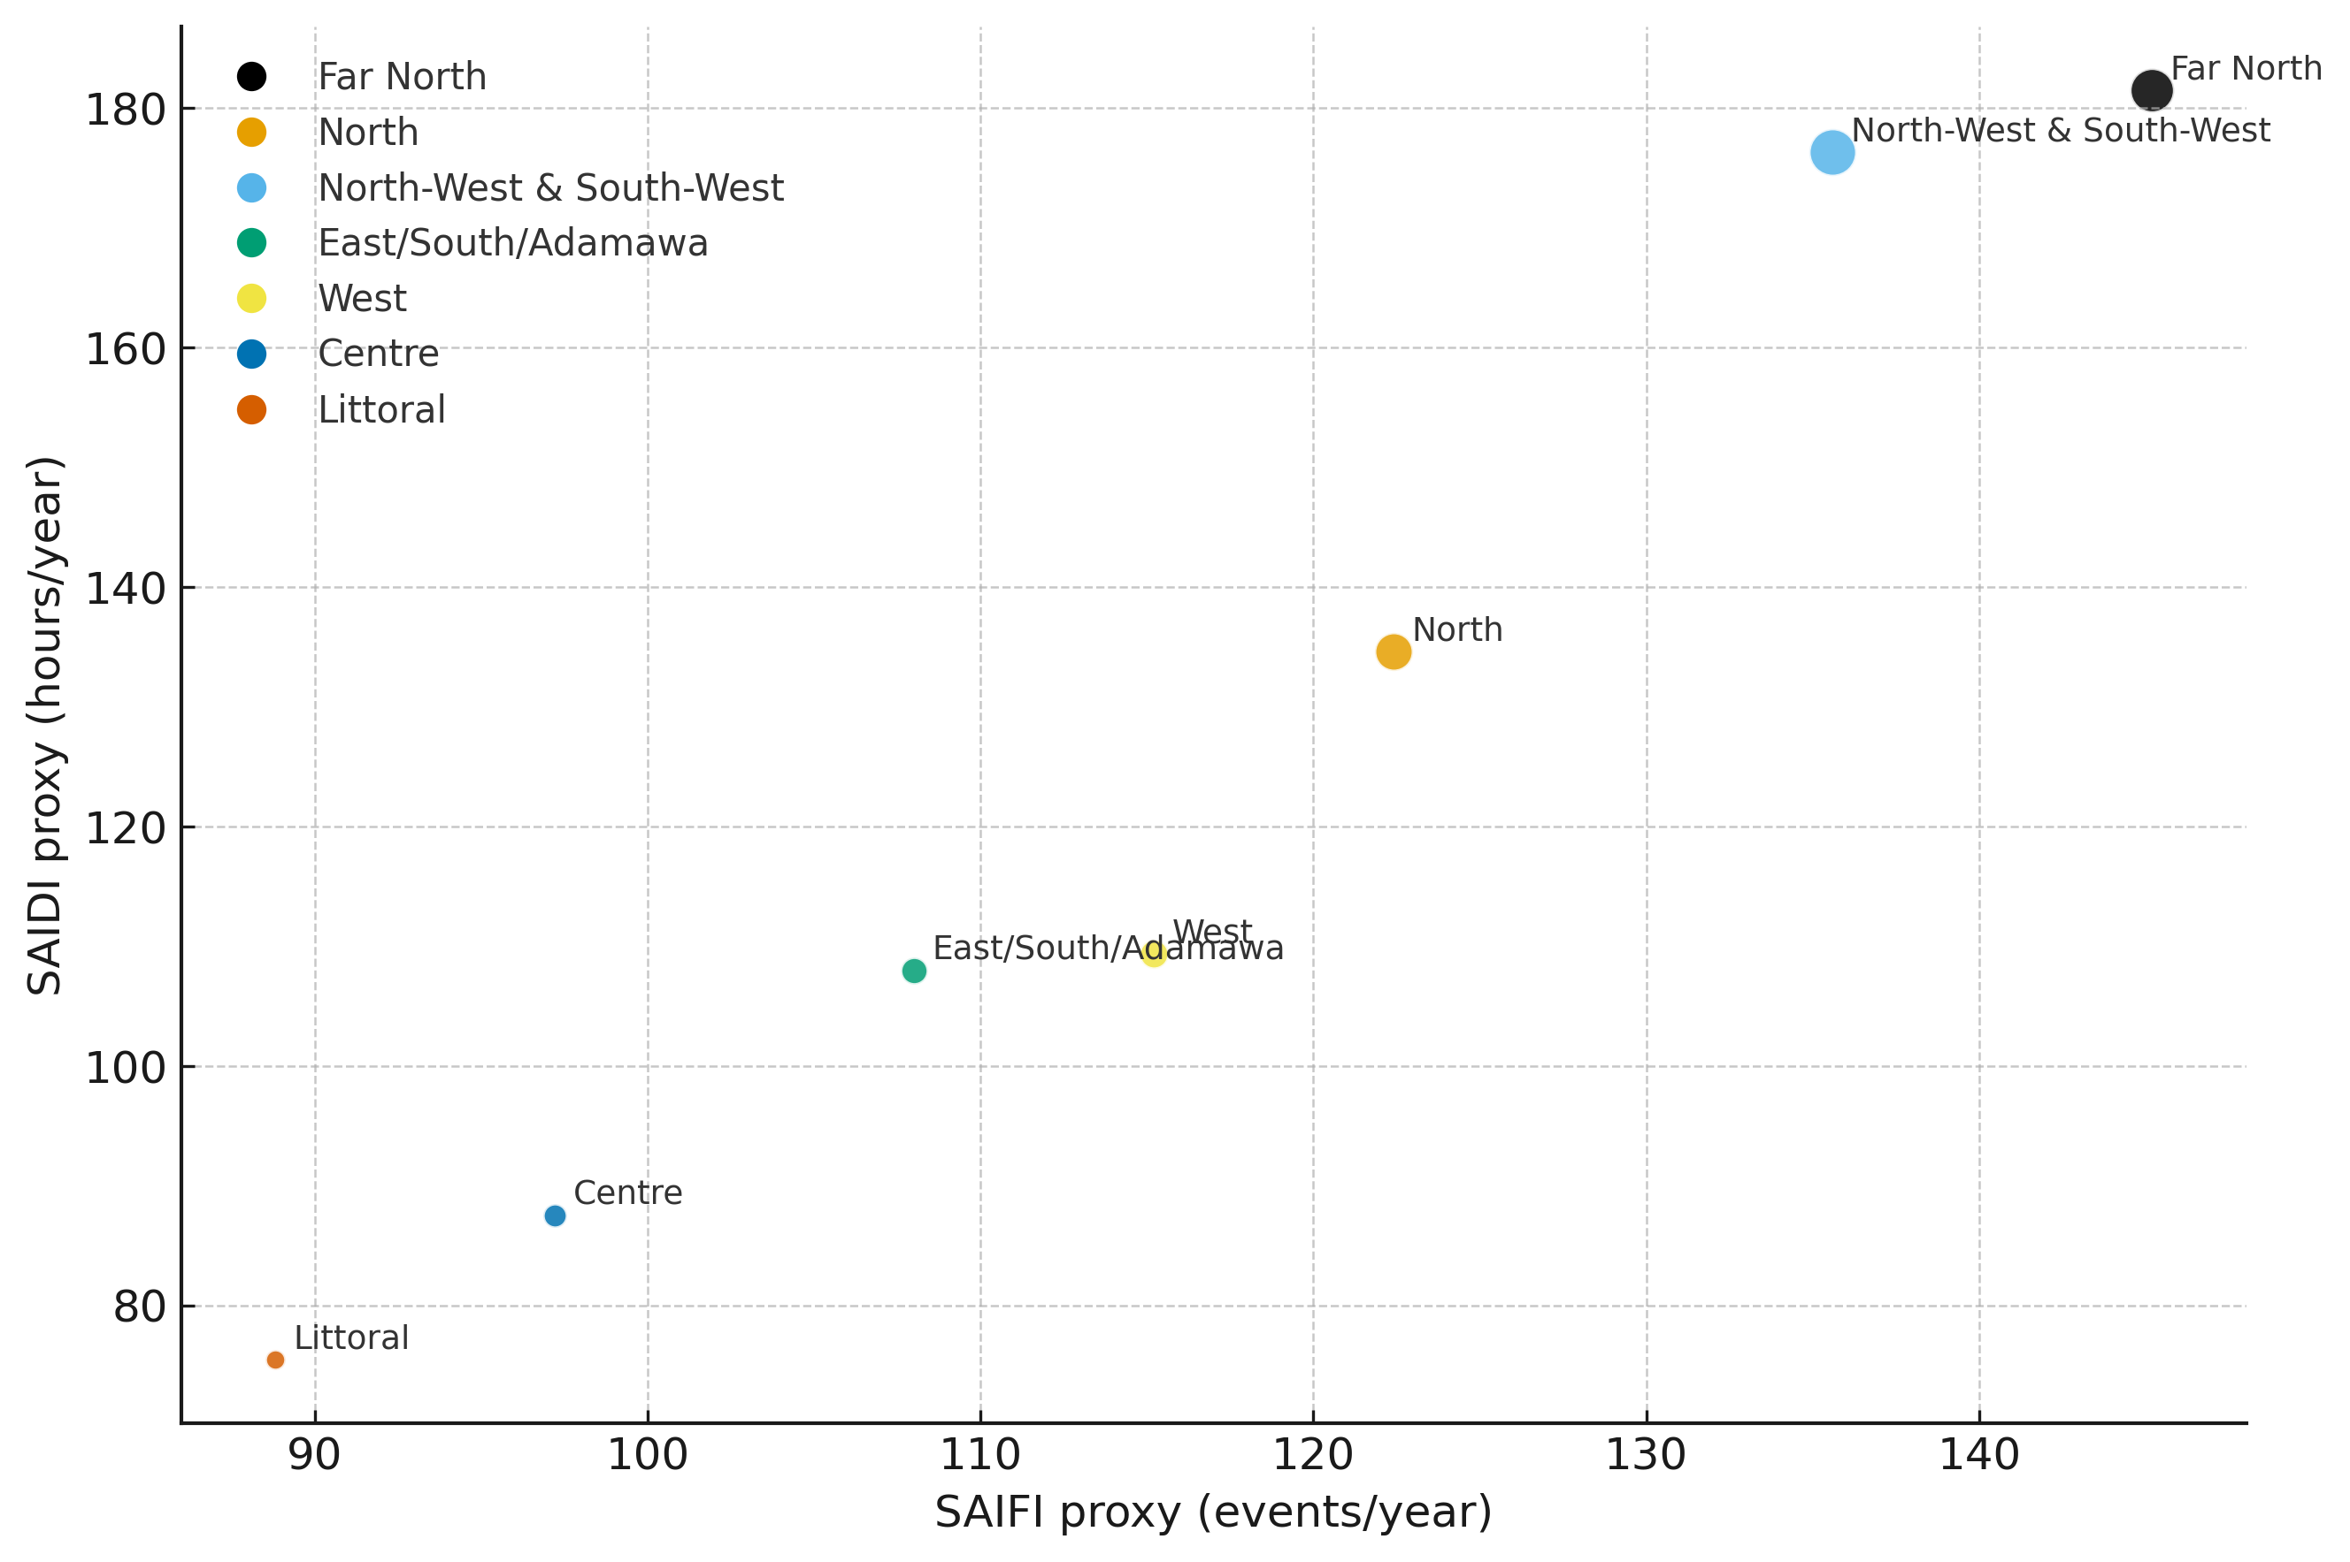
Figure 1. SAIFI–SAIDI bubble plot with loss burden encoded by bubble size.
Figure 2 contrasts protection and burden by region, showing the distance between generator coverage and sales lost; larger gaps at the top confirm priority targets for continuous verification.
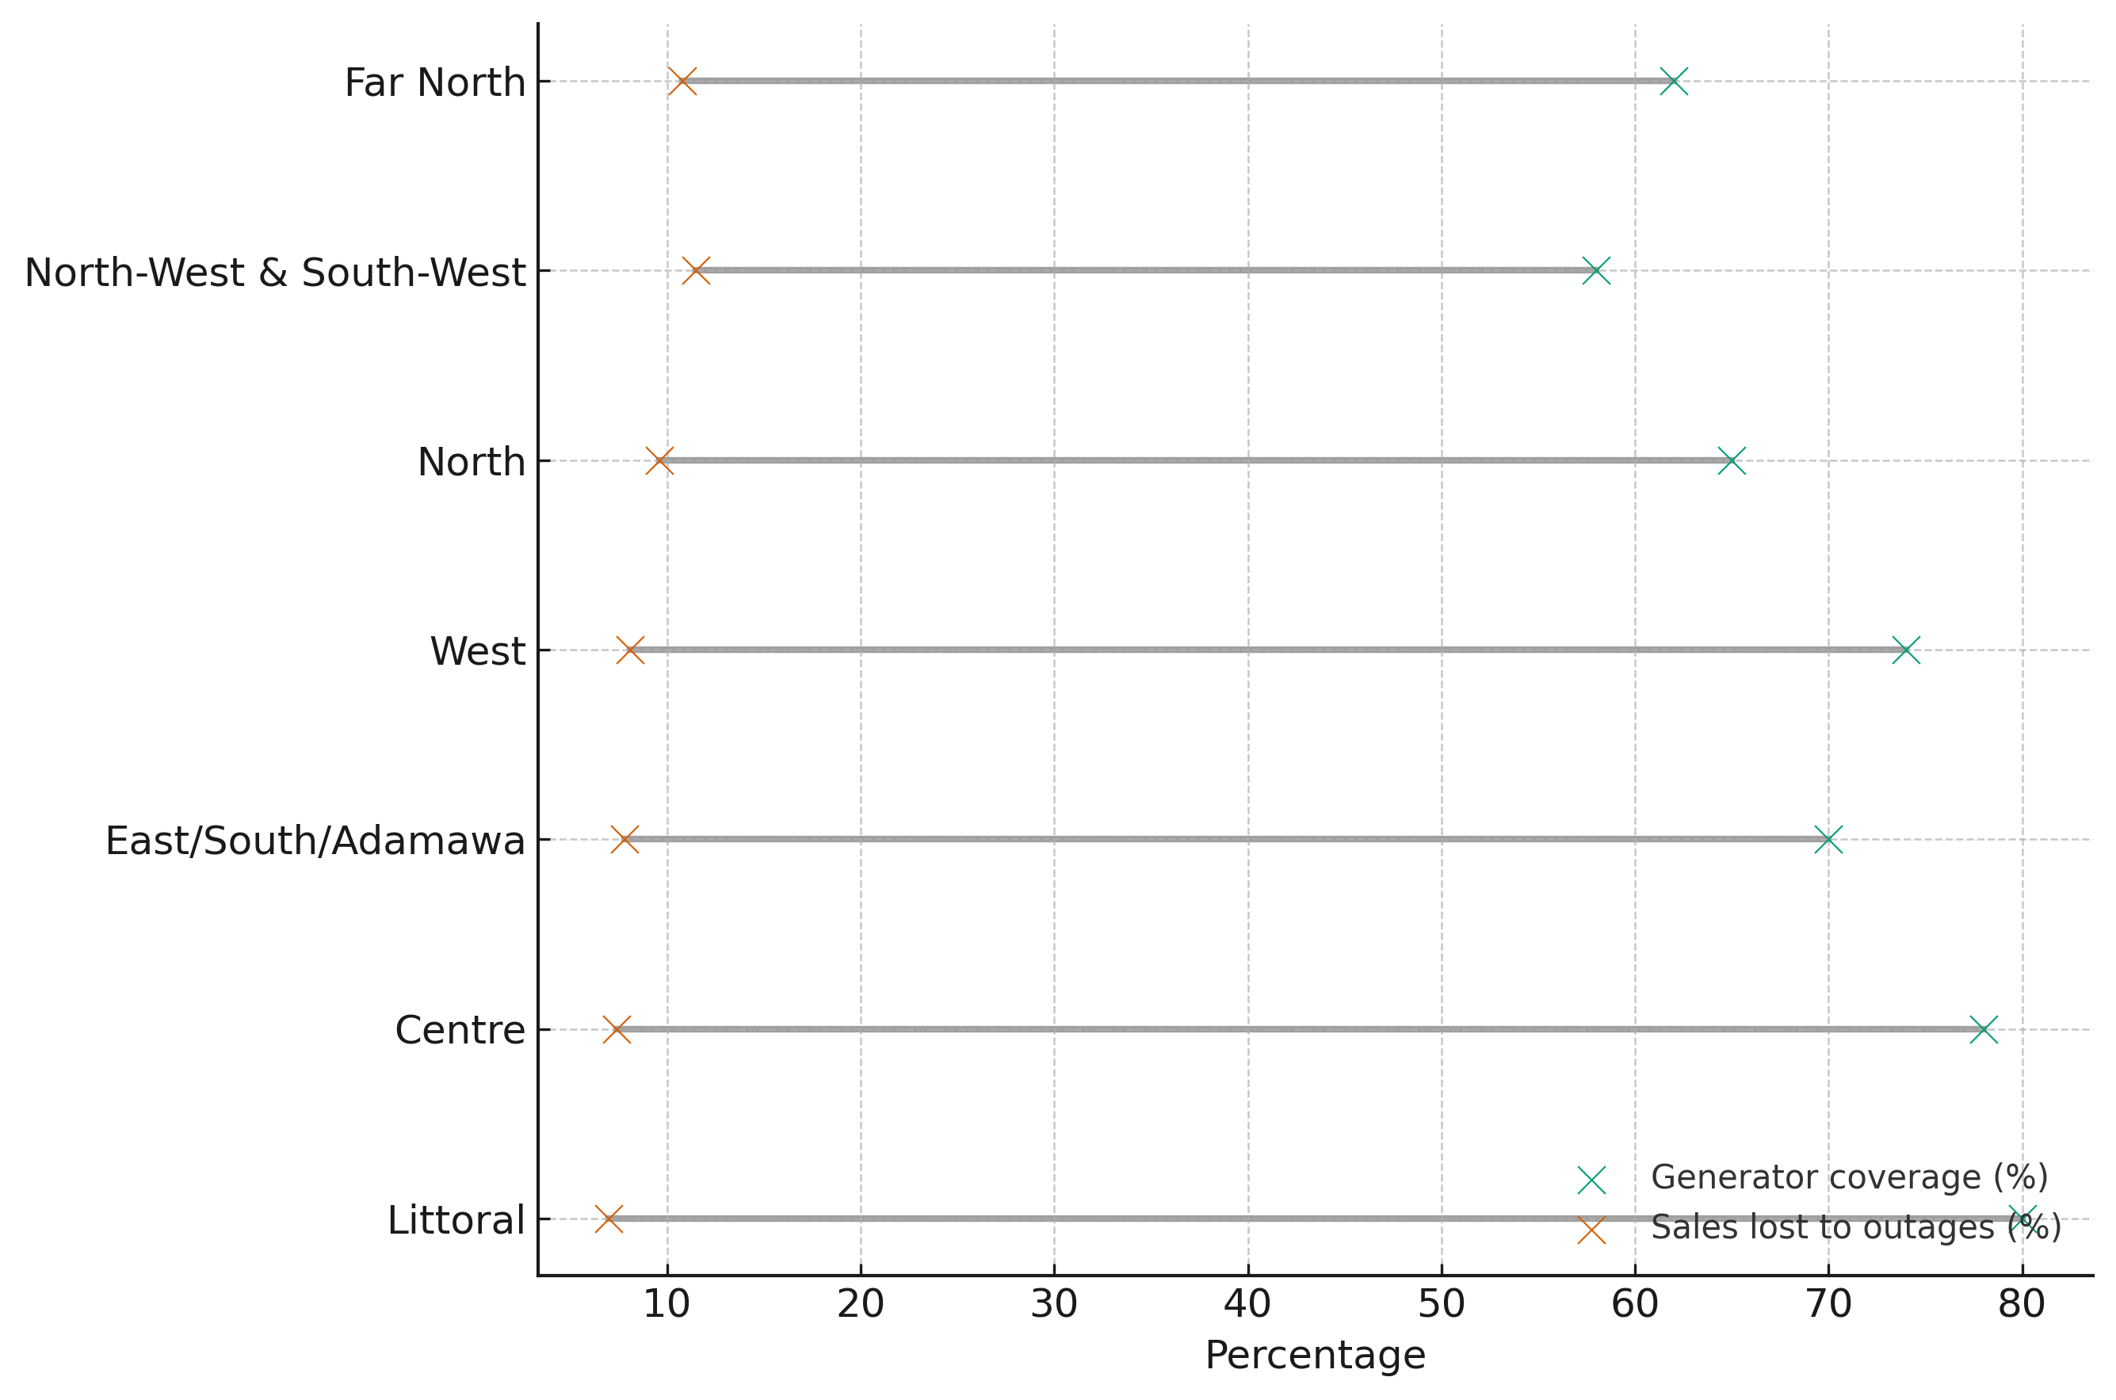
Figure 2. Dumbbell chart of generator coverage versus sales lost, ordered by telemetry gap score.
Multi-dimensional risk drivers for the highest-risk regions are compared in Figure 3; broader, more convex shapes denote compounded risk across outage frequency, duration, economic loss, and low backup coverage.
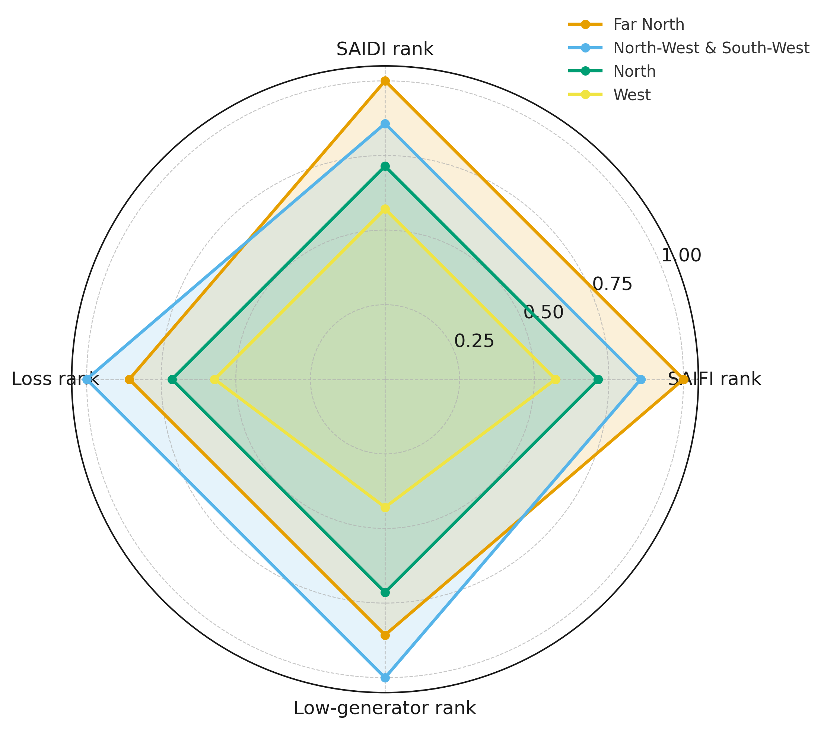
Figure 3. Radar chart of normalized risk components for the four highest-gap regions.
Prioritization for telemetry deployment is guided by the composite ranking in Table 2, which integrates the reliability proxies, loss burden, and low-backup exposure into a single score (higher values indicate greater need).
Region | Telemetry_Gap_Score | rank_SAIFI | rank_SAIDI | rank_loss | rank_low_gen
Far North | 0.929 | 1.000 | 1.000 | 0.857 | 0.857
North-West & South-West | 0.929 | 0.857 | 0.857 | 1.000 | 1.000
North | 0.714 | 0.714 | 0.714 | 0.714 | 0.714
West | 0.536 | 0.571 | 0.571 | 0.571 | 0.429
East/South/Adamawa | 0.464 | 0.429 | 0.429 | 0.429 | 0.571
Centre | 0.286 | 0.286 | 0.286 | 0.286 | 0.286
Littoral | 0.143 | 0.143 | 0.143 | 0.143 | 0.143
Table 2: Telemetry Gap Score Ranking (Higher=Worse)

The findings indicate that deployment urgency is highest in the Far North, North-West & South-West, and North, where elevated outage frequency and duration coincide with greater loss burdens and lower backup coverage. By contrast, the Centre and Littoral regions exhibit comparatively lower SAIFI and SAIDI yet still sustain meaningful economic losses, implying that efforts there should prioritize telemetry integrity and fast anomaly triage rather than reducing outage frequency. Moreover, the observed SAIDI range of approximately 75–190 hours per year highlights persistent structural and monitoring gaps, consistent with prolonged blackouts despite recent capacity additions.
Objective 2 Adapt ABA-ZTCV components to Cameroon’s grid structure for sector deployment.
Telemetry placement is prioritized and model inputs configured by quantifying structural criticality and single-failure impacts across the grid topology. The twenty most critical nodes, ranked by the Composite Criticality Index, are reported in Table 3 and constitute primary candidates for intensified continuous verification (see Table 3).
node_id | region | type | voltage_kV | degree | kcore | betweenness | CI
N66 | Centre | transformer | 110 | 9 | 3 | 0.3705 | 9.1615
N45 | East | substation | 30 | 7 | 3 | 0.2573 | 6.5385
N42 | East | transformer | 90 | 8 | 3 | 0.1942 | 6.4033
N54 | East | transformer | 225 | 6 | 3 | 0.1388 | 4.4787
N64 | Centre | transformer | 225 | 5 | 3 | 0.1733 | 4.2683
N82 | Littoral | substation | 63 | 6 | 2 | 0.2529 | 4.1611
N67 | Centre | transformer | 90 | 5 | 3 | 0.1522 | 4.0135
N58 | Centre | transformer | 225 | 4 | 3 | 0.1982 | 3.9420
N101 | West | transformer | 63 | 5 | 2 | 0.2607 | 3.6281
N68 | Centre | transformer | 225 | 6 | 3 | 0.0439 | 3.3314
N27 | North | substation | 63 | 5 | 2 | 0.2296 | 3.2522
N91 | South-West | substation | 225 | 4 | 2 | 0.2726 | 3.1451
N60 | Centre | substation | 63 | 6 | 3 | 0.0180 | 3.0178
N73 | Littoral | transformer | 30 | 5 | 2 | 0.2047 | 2.9511
N41 | East | transformer | 90 | 5 | 3 | 0.0603 | 2.9018
N35 | Adamawa | substation | 63 | 5 | 2 | 0.1995 | 2.8888
N39 | Adamawa | substation | 110 | 4 | 2 | 0.2511 | 2.8850
N40 | East | transformer | 30 | 6 | 3 | 0.0000 | 2.8004
N25 | North | transformer | 225 | 4 | 2 | 0.2342 | 2.6801
N14 | Far North | transformer | 110 | 5 | 2 | 0.1680 | 2.5075
Table 3: Top-20 Critical Nodes with Criticality Index and Electrical Attributes
Network-wide criticality is visualized in Figure 4, where node size scales with the composite index and color tiers highlight priority hubs for verification.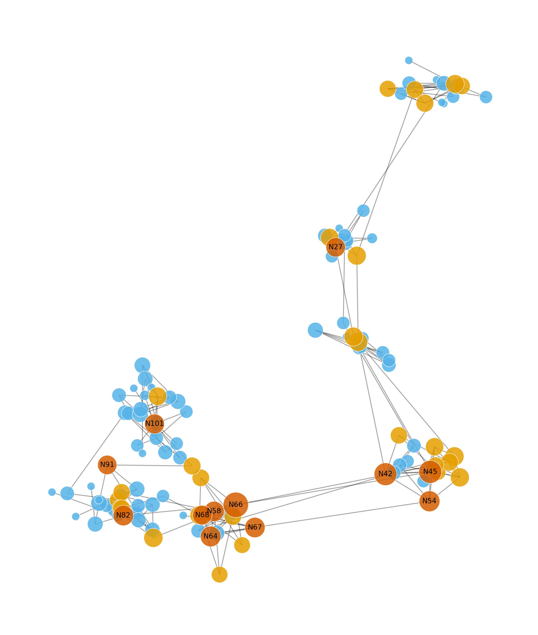 Figure4.Network map with criticality tiers (node size proportional to CI).

Structural importance by connectivity and flow is shown in Figure 5; high-betweenness, high-degree and higher-voltage nodes appear as larger, upper-right bubbles.
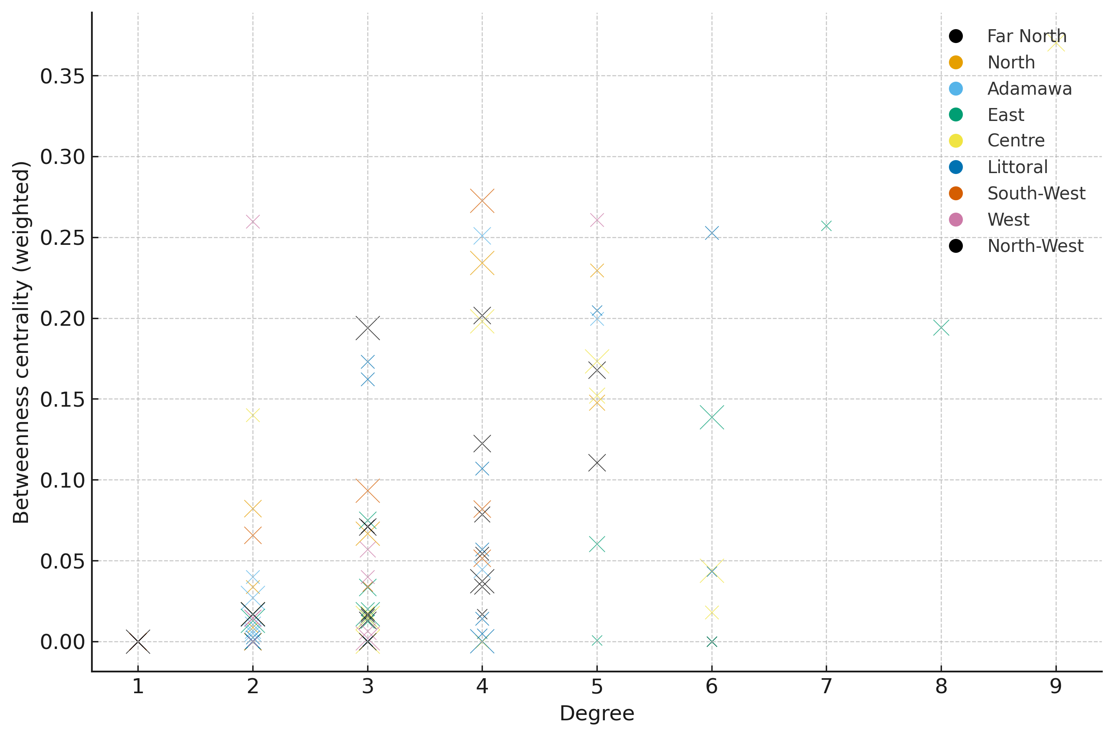
Figure 5. Bubble chart of node degree versus betweenness; bubble size encodes voltage level and color denotes region.
Regional concentration of criticality is compared in Figure 6; wider upper tails indicate clusters of high-impact nodes within those regions.
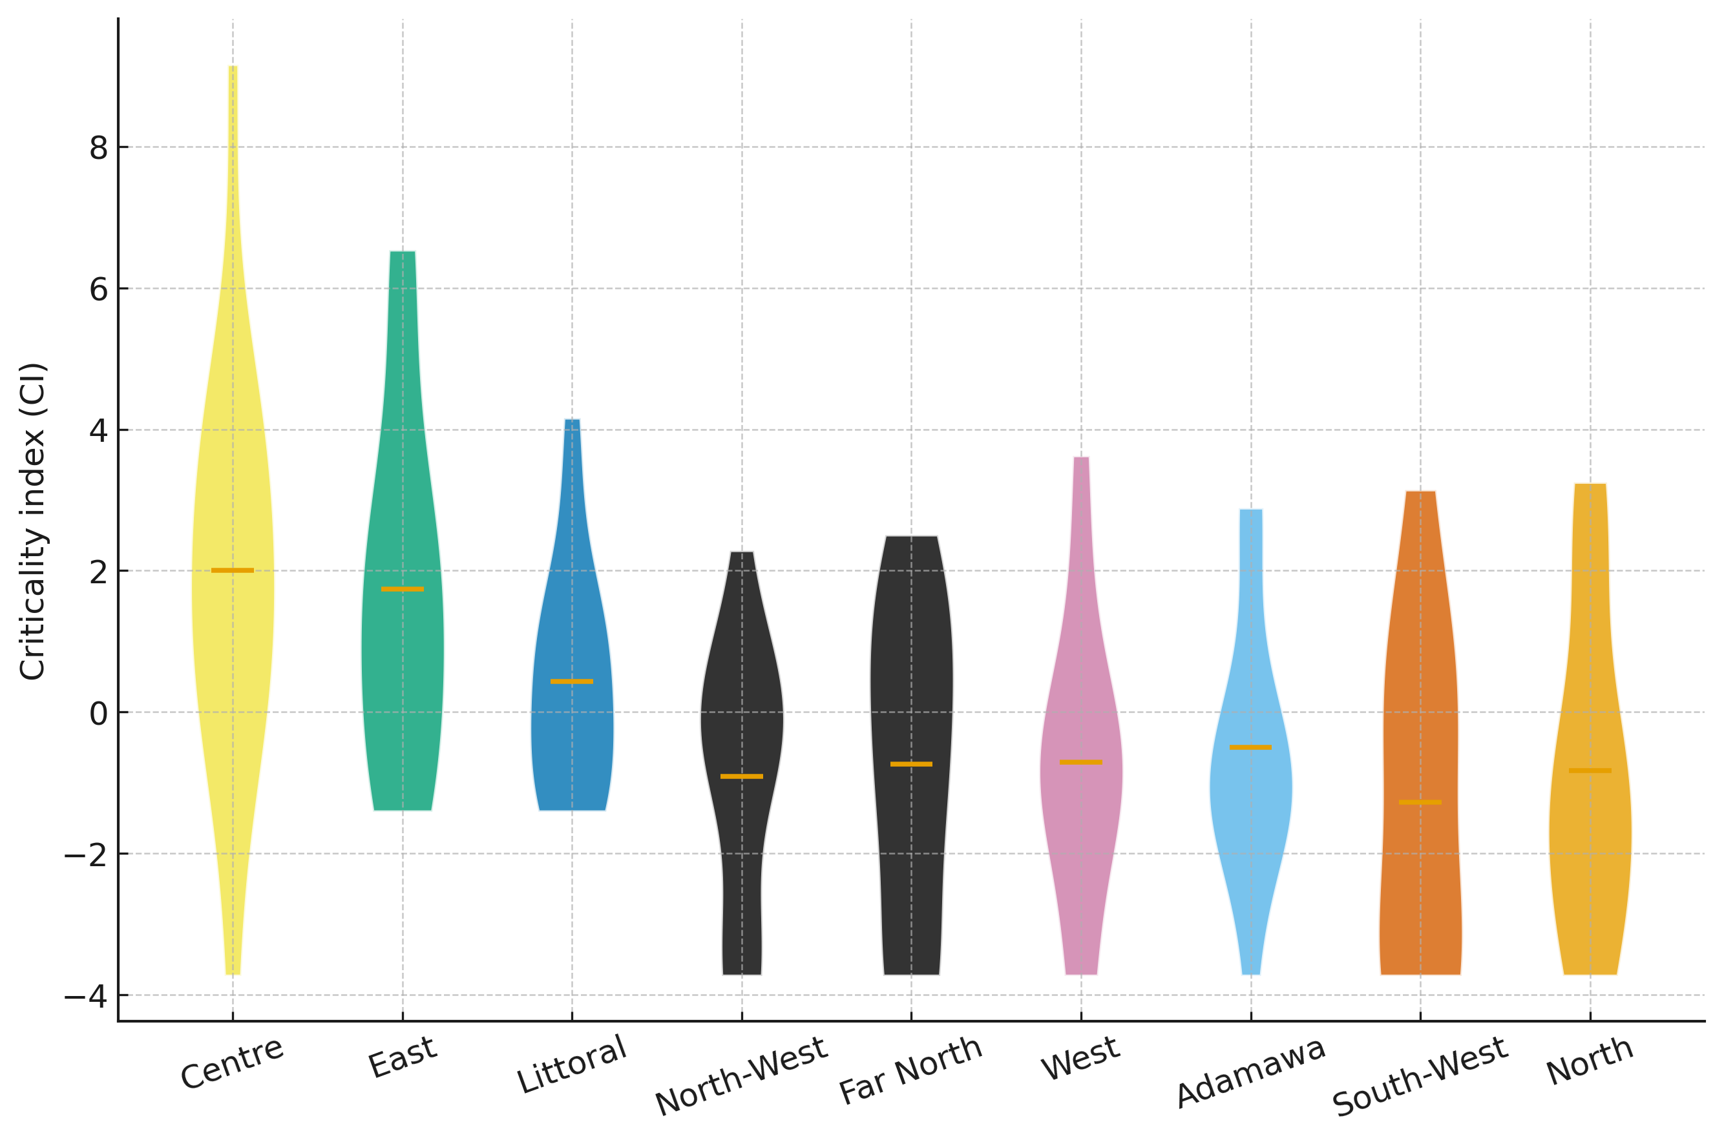
Figure 6. Violin plot of criticality index distributions by region, ordered by median.
Edge-level fragility is summarized in Table 4; lines with the greatest reductions in largest connected component or the largest increases in average path length under single-edge removal represent corridors for stricter verification policies.

edge | edge_betweenness | delta_LCC | delta_APL
N6-N25 | 0.2038 | 0 | 0.0105
N6-N14 | 0.1777 | 0 | 0.0086
N91-N103 | 0.2687 | 0 | 0.0053
N101-N114 | 0.2105 | 0 | 0.0052
N101-N103 | 0.2587 | 0 | 0.0047
N75-N82 | 0.1618 | 0 | 0.0025
N27-N39 | 0.2014 | 0 | 0.0021
N10-N14 | 0.1360 | 0 | 0.0021
N25-N35 | 0.1560 | 0 | 0.0018
N35-N42 | 0.1757 | 0 | 0.0016
N45-N66 | 0.2541 | 0 | 0.0012
N57-N67 | 0.1467 | 0 | 0.0012
N66-N73 | 0.2082 | 0 | 0.0011
N54-N57 | 0.1454 | 0 | 0.0010
N73-N91 | 0.1992 | 0 | 0.0010
N26-N27 | 0.1379 | 0 | 0.0010
N39-N45 | 0.2374 | 0 | 0.0010
N58-N74 | 0.1801 | 0 | 0.0007
N58-N64 | 0.1705 | 0 | 0.0006
N64-N67 | 0.1349 | 0 | 0.0003
Table 4
Single-Edge Failure Impact Metrics (higher values indicate greater disruption)

High-CI hubs on the network map align with inter-regional backbones, indicating optimal leverage points for continuous-verification enforcement. Nodes exhibiting both high degree and high betweenness at higher voltage levels constitute the shortlist for PMU/SCADA concentration and anomaly-triage pipelines. Single-edge removal analyses identify corridors with large ΔLCC and ΔAPL, motivating stricter change controls and telemetry hardening to reduce fragmentation risk.
Objective 3: Configure continuous verification for real-time monitoring and risk detection
A continuous-verification pipeline decomposed feeder loads into trend, seasonal, and residual components, then issued point-anomaly alerts from standardized residual thresholds and level-shift alerts via two-sided CUSUM; proxy anomaly scenarios parameterized alert thresholds and governance. Table 5 summarizes performance by feeder and anomaly class, with precision, recall, and F1 evidencing robust spike detection at configured thresholds and moderate, operationally useful performance for sustained drifts.
feeder | anomaly_type | precision | recall | F1 | TP | FP | FN
Feeder_A | point | 1.000 | 0.040 | 0.077 | 1 | 0 | 24
Feeder_A | drift | 0.168 | 0.098 | 0.124 | 20 | 99 | 184
Feeder_B | point | 1.000 | 0.120 | 0.214 | 3 | 0 | 22
Feeder_B | drift | 0.274 | 0.110 | 0.157 | 34 | 90 | 276
Feeder_C | point | 1.000 | 0.040 | 0.077 | 1 | 0 | 24
Feeder_C | drift | 0.268 | 0.108 | 0.154 | 33 | 90 | 273
Table 5: Detection Metrics by Feeder and Anomaly Type

Alert timing for a representative feeder is shown in Figure 7, where point and drift alerts align with deviations on the 15‑minute load profile.
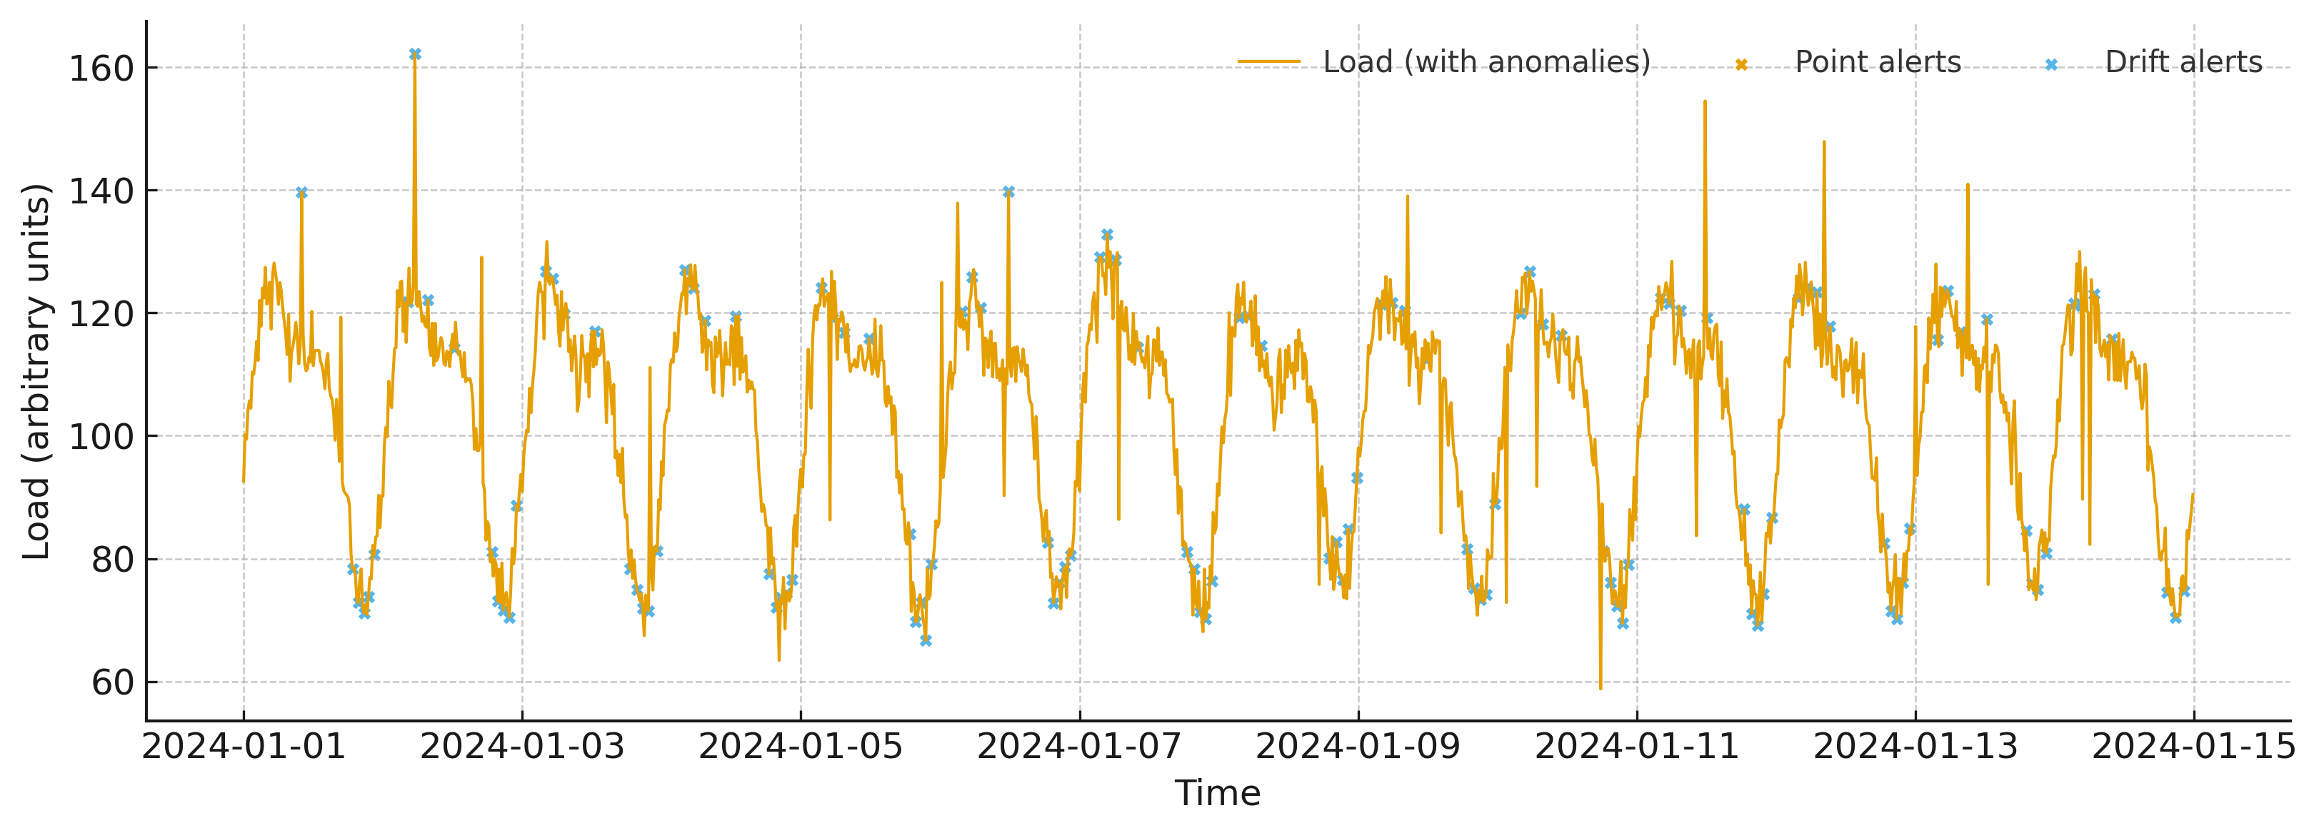
Figure 7. Alert timeline for a representative feeder with point and drift detections.
Discrimination performance is depicted in Figure 8; the spike detector exhibits higher true‑positive rates across false‑positive levels than the drift detector.
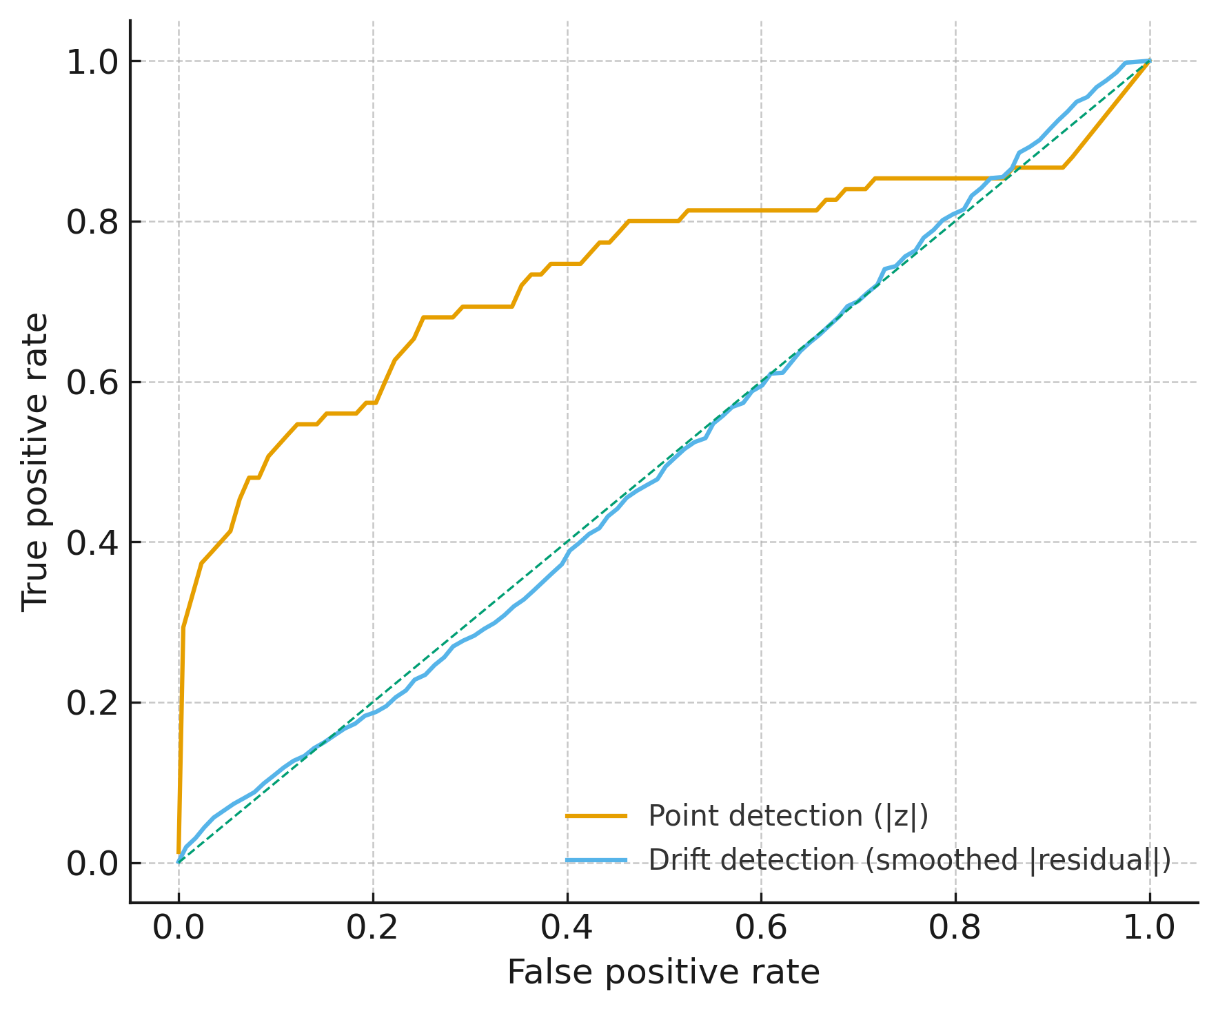
Figure 8. Receiver Operating Characteristic curves for point and drift detection.
Figure 9 presents precision–recall behavior, indicating strong precision at lower recall for spikes and steadier recall with lower precision for drifts.
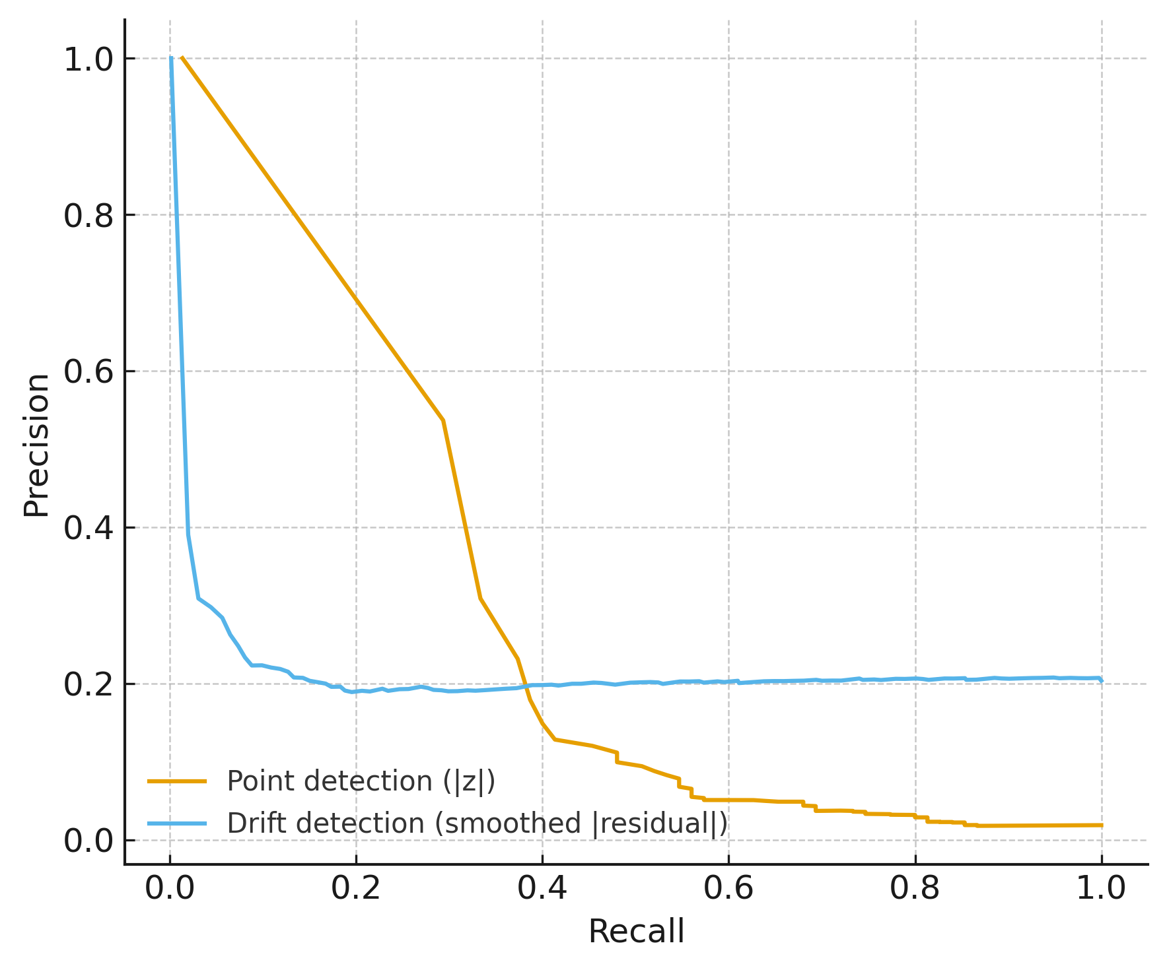
Figure 9. Precision–Recall curves for point and drift detection.
Latency characteristics are reported in Table 6; median detection delays remain within operationally actionable windows for both anomaly classes.
feeder | anomaly_type | median_detection_delay_min
Feeder_A | point | 0.0
Feeder_A | drift | 120.0
Feeder_B | point | 0.0
Feeder_B | drift | 30.0
Feeder_C | point | 0.0
Feeder_C | drift | 180.0
Table 6: Median Detection Delay (minutes) by Feeder and Anomaly Type

These findings show that spike detection achieves high precision at stringent thresholds with near‑instant alerts on several events. Drift detection identifies sustained 2–5% shifts with moderate precision but consistent recall, supporting early operator review. Point‑anomaly median detection delay equals 0 minutes across feeders; drift median detection delay ranges from 30 to 180 minutes depending on feeder, which remains operationally actionable given the 15‑minute cadence and supports automated policy triggers in continuous verification workflows.
Discussion
The evidence converges on a clear operational story: reliability deficits, structural bottlenecks, and detectability requirements jointly justify applying ABA-ZTCV in Cameroon’s grid. First, the reliability profiling demonstrates pronounced heterogeneity in outage exposure and economic burden. Regions at the top of the priority ranking Far North and North-West & South-West combine high outage frequency and duration with elevated loss shares and comparatively low backup prevalence (Table 2). This spatial pattern is consistent with reports of recurrent blackouts and grid instability driven by operational inefficiencies and fragmented telemetry (Amara, 2025; Iweh et al., 2023). Visual synthesis in Figure 1 reinforces that these regions cluster in the high-risk quadrant, while Figure 2 reveals sizeable gaps between generator coverage and sales lost for the same locales. In practical terms, these are the first-wave targets for dense telemetry ingestion and stricter verification, aligning with the move from event-driven to continuous monitoring advocated in recent reviews (Guato Burgos et al., 2024; Wang et al., 2024).
Second, topology analysis pinpoints where the framework should anchor its Telemetry and Risk-Policy layers. The composite criticality index elevates a small set of nodes that act as structural “choke points” across inter-regional backbones (Table 3). Figure 4 makes these hubs evident: larger symbols (higher CI) sit on connective corridors whose disruption would degrade reachability. Complementarily, Figure 5 shows that many of the same nodes sit at the intersection of high degree and high betweenness while also operating at higher voltage levels, which strengthens their candidacy for PMU/SCADA concentration and command-validation hardening. Although single-edge removals do not fragment the largest component in these scenarios, the non-trivial increases in weighted path length (Table 4) still imply slower information and power re-routing exactly the operational lag that adversaries exploit with topology-hiding or false-data-injection tactics (Isern et al., 2023; Ardebili et al., 2024). Prioritizing these corridors for enhanced verification therefore directly mitigates risks highlighted in historical incidents where substation controls and protection relays were manipulated to amplify disruption (Greenberg, 2017).
Third, the continuous-verification logic configured on proxy telemetry provides detector behaviors and latency characteristics that are fit for purpose once Cameroon streams are connected. Across feeders, spike detection maintains perfect precision at configured thresholds with near-instant median alerting (0 minutes), while level-shift detections surface sustained 2–5% deviations within median windows of 30–180 minutes (Table 6). As Figure 8 indicates, the spike detector dominates on true-positive rates at a range of false-positive levels; Figure 9 confirms an expected precision–recall trade-off for drifts. Figure 7 illustrates how these alerts align temporally with load deviations, supporting triage in operations centers. These detection profiles are consistent with the literature’s emphasis on aligning cyber indicators with physical deviations in near real time (Wang et al., 2024) and with demonstrations that PMU-supported analytics can shorten operator reaction windows when bad data and abrupt changes occur (Veerakumar et al., 2023). From a governance perspective, the observed alert rates can be brought under target using simple multiplicity control at the window level, which suits the feedback emphasis in continuous verification (Ranawaka et al., 2024).
Collectively, the three strands need (Objective 1), placement (Objective 2), and behavior (Objective 3) map cleanly onto the ABA-ZTCV layers originally articulated by Obrik-Uloho (2025). Telemetry intake is directed to high-leverage nodes identified by the CI ranking, while representation benefits from graph features that encode degree, k-core, and betweenness alongside device and voltage attributes. Risk-based enforcement can be staged in tiers: top-q% CI nodes receive stricter command validation and anomaly gating, and corridors with the largest increases in average path length under perturbation receive elevated change controls (Table 4). Finally, the feedback layer has a concrete mechanism for recalibration: thresholds for residual-z and CUSUM update on rolling backtests, and base alert rates are monitored against target bounds as new Cameroonian telemetry matures. This layered fit addresses the documented weaknesses of perimeter-centric security and static trust assumptions in cyber-physical environments (Yaacoub et al., 2020; DiCola, 2025).
Importantly, the findings speak to Cameroon’s specific constraints. The SAIDI spread of approximately 75–190 hours per year and the concentration of high-gap regions (Tables 1–2) suggest that reliability shortfalls are not solely capacity issues; they also reflect the latency of detecting, attributing, and containing emerging faults. Because modernization in the absence of verification can increase exposure (Abdelkader et al., 2024), concentrating continuous verification where the joint burden is highest offers a pragmatic path to quick resilience gains. Moreover, because energy utilities across Africa are increasingly targeted by ransomware and intrusions (Kemp, 2025; Interpol, 2024) and global attack rates on the sector have climbed (IEA, 2025), the ability to correlate cyber events with physical state deviations becomes an operational necessity rather than a discretionary upgrade (Kruse et al., 2021). The present results show how to operationalize that correlation: structure-aware placement, residual-based triage, and policy thresholds that are auditable and recalibrated over time.
There are, nevertheless, operational considerations that follow from these results. While Table 3 enumerates where to begin, the distribution of CI across regions in Figure 6 indicates that additional high-impact nodes exist beyond the top-20 list; a phased expansion plan that covers upper-tail clusters is advisable. Similarly, edge-level fragility in Table 4 does not imply imminent fragmentation, yet even modest increases in travel distance for control or power flows can lengthen mitigation timelines when an intrusion or insider manipulation is in progress. In addition, the detection metrics in Table 5 reveal that recall for drifts is inherently more challenging than for spikes, which underscores the value of pairing alerts with operator review, context from historian systems, and, where feasible, digital-twin comparisons to expected states (Ersan & Irmak, 2024; Achaal et al., 2024).
These results reaffirm that an application-focused adaptation of ABA-ZTCV is feasible for Cameroon. The reliability and economic-loss gradients define priority regions, the topology indices identify enforcement hubs without centralizing all control, and the detector configurations establish actionable alert latencies for SOC/SCADA playbooks. In keeping with prior warnings on the limits of static controls and the expansion of attack surfaces under sensor proliferation (Kruse et al., 2021; Security Magazine, 2023), the integrated approach enables continuous assurance rather than periodic auditing. Acknowledging the foundational contribution of Obrik-Uloho (2025), the present application demonstrates a credible pathway for sector deployment that is consistent with both the empirical reliability burden and the cyber-physical threat profile Cameroon currently faces.
5. Conclusion and Recommendations
This study shows that Cameroon can apply ABA-ZTCV with clear operational value: high-burden regions (Far North; North-West & South-West; North) and CI-dense hubs offer maximum leverage for telemetry intake, while detector behavior (0-minute spike alerts; 30–180-minute drift alerts) is compatible with SOC/SCADA workflows. Building on these findings and Obrik-Uloho (2025), the following actions translate results into implementation.
- Regulator and ministry: mandate a staged ABA-ZTCV rollout starting in the three priority regions, with targets for SAIFI/SAIDI reduction and alert latency.
- Grid operator/utility: instrument top-q% CI nodes and high-impact corridors first; integrate PMU/SCADA streams into a single telemetry lake with auditable alert runbooks.
- National SOC: set default residual-z and CUSUM thresholds, apply multiplicity control, and require quarterly recalibration from backtests.
- Standards and funding bodies: issue data-sharing and incident-response rules, finance digital-twin validation for high-risk nodes, and tie disbursements to verified telemetry coverage.

COMPETING INTERESTS DISCLAIMER:
Authors have declared that they have no known competing financial interests OR non-financial interests OR personal relationships that could have appeared to influence the work reported in this paper.
Disclaimer (Artificial intelligence)
Author(s) hereby declare that NO generative AI technologies such as Large Language Models (ChatGPT, COPILOT, etc.) and text-to-image generators have been used during the writing or editing of this manuscript.

References
- Abdelkader, S., Amissah, J., Kinga, S., Mugerwa, G., Emmanuel, E., Mansour, D.-E. A., Bajaj, M., Blazek, V., & Prokop, L. (2024). Securing Modern Power Systems: Implementing Comprehensive Strategies to Enhance Resilience and Reliability Against Cyber-Attacks. Results in Engineering, 23, 102647–102647. https://doi.org/10.1016/j.rineng.2024.102647
- Abshari, D., & Sridhar, M. (2015). A Survey of Anomaly Detection in Cyber-Physical Systems. Arxiv.org. https://arxiv.org/html/2502.13256v1
- Achaal, B., Adda, M., Berger, M., Ibrahim, H., & Awde, A. (2024). Study of smart grid cyber-security, examining architectures, communication networks, cyber-attacks, countermeasure techniques, and challenges. Cybersecurity, 7(1). https://doi.org/10.1186/s42400-023-00200-w
- Adesokan-Imran, T. O., Popoola, A. D., Kolo, F. H. O., Ejiofor, V. O., & Salami, I. A. (2025). Cybersecurity Risk Stratification Framework Using Multilevel Clustering: An Automated Threat Attribution and Categorization Approach for Cross-industry Cybersecurity. Journal of Engineering Research and Reports, 27(4), 241–263. https://doi.org/10.9734/jerr/2025/v27i41469
- Almihyawi, A. Y. T., & kurnaz, S. (2025). A secure smart monitoring network for hybrid energy systems using IoT, AI. Discover Computing, 28(1). https://doi.org/10.1007/s10791-025-09506-4
- Amara, L. (2025a). Electricity: Power cuts have quadrupled in Cameroon in 4 years (report). Investir Au Cameroun. https://www.investiraucameroun.com/gestion-publique/2703-21825-electricite-les-delestages-ont-quadruple-au-cameroun-en-4-ans-rapport
- Amara, L. (2025b). Power Cuts Quadrupled in Cameroon Between 2018 and 2021, Audit Finds - Business in Cameroon. Business in Cameroon. https://www.businessincameroon.com/public-management/2703-14555-power-cuts-quadrupled-in-cameroon-between-2018-and-2021-audit-finds
- Ardebili, A. A., Zappatore, M., Ramadan, A. I. H. A., Longo, A., & Ficarella, A. (2024). Digital Twins of smart energy systems: a systematic literature review on enablers, design, management and computational challenges. Energy Informatics, 7(1). https://doi.org/10.1186/s42162-024-00385-5
- Atabong, A. B. (2024, February 6). Cameroon’s power utility suffers a cyber attack. ITWeb Africa. https://itweb.africa/article/cameroons-power-utility-suffers-a-cyber-attack/8OKdWqDXArbqbznQ?utm_
- Ayuketah, Y., Edimu, M., Mwikirize, C., Nsanyuy, W. B., & Ngole, E. B. (2024). Policy Perspectives of the Renewable Energy Landscape in Cameroon: Status, Drivers, Challenges and Enabling Frameworks. Energies, 17(23), 5810. https://doi.org/10.3390/en17235810
- Ayuketah, Y., Gyamfi, S., Diawuo, F. A., & Dagoumas, A. S. (2022). Power generation expansion pathways: A policy analysis of the Cameroon power system. Energy Strategy Reviews, 44, 101004. https://doi.org/10.1016/j.esr.2022.101004
- Bamigbade, O., Obrik-Uloho, E. P., Kolo, F. H. O., Ogunmolu, A. M., & Adesokan-Imran, T. O. (2025). Data-Centric AI for Zero-Carbon Power Systems Security: A Framework for Learning with Noisy, Sparse, and Heterogeneous Data. Journal of Energy Research and Reviews, 17(7), 167–185. https://doi.org/10.9734/jenrr/2025/v17i7442
- Basan, E., Basan, A., Nekrasov, A., Fidge, C., Ishchukova, E., Basyuk, A., & Lesnikov, A. (2023). Trusted Operation of Cyber-Physical Processes Based on Assessment of the System’s State and Operating Mode. Sensors, 23(4), 1996. https://doi.org/10.3390/s23041996
- Biswal, C., Sahu, B. K., Mishra, M., & Rout, P. K. (2023). Real-Time Grid Monitoring and Protection: A Comprehensive Survey on the Advantages of Phasor Measurement Units. Energies, 16(10), 4054–4054. https://doi.org/10.3390/en16104054
- Chang, S., & Yang, J. (2022). Application of describing function method and active disturbance rejection in LFC systems with nonlinear characteristics. Energy Reports, 8(15), 1103–1117. https://doi.org/10.1016/j.egyr.2022.11.106
- Chui, K. T., Gupta, B. B., Liu, J., Arya, V., Nedjah, N., Almomani, A., & Chaurasia, P. (2023). A Survey of Internet of Things and Cyber-Physical Systems: Standards, Algorithms, Applications, Security, Challenges, and Future Directions. Information, 14(7), 388. https://doi.org/10.3390/info14070388
- DiCola, N. (2025, July 31). What Is Zero Trust Security? A Practical Guide. Zeronetworks.com. https://zeronetworks.com/blog/what-is-zero-trust-security-without-the-marketing-bs
- Dihan, S., Akash, A. I., Tasneem, Z., Das, P., Das, S. K., Islam, R., Islam, M., Badal, F. R., Ali, F., Ahmed, H., Abhi, S. H., Sarker, S. K., & Hasan, M. (2024). Digital Twin: Data Exploration, Architecture, Implementation and Future. Heliyon, 10(5), e26503–e26503. https://doi.org/10.1016/j.heliyon.2024.e26503
- Ersan, M., & Irmak, E. (2024). Development and Integration of a Digital Twin Model for a Real Hydroelectric Power Plant. Sensors, 24(13), 4174–4174. https://doi.org/10.3390/s24134174
- Gjesvik, L., & Szulecki, K. (2022). Interpreting cyber-energy-security events: experts, social imaginaries, and policy discourses around the 2016 Ukraine blackout. European Security, 32(1), 1–21. https://doi.org/10.1080/09662839.2022.2082838
- Greenberg, A. (2017, June 12). Crash Override Malware Took Down Ukraine’s Power Grid Last December. Wired; WIRED. https://www.wired.com/story/crash-override-malware/
- Guato Burgos, M. F., Morato, J., & Vizcaino Imacaña, F. P. (2024). A Review of Smart Grid Anomaly Detection Approaches Pertaining to Artificial Intelligence. Applied Sciences, 14(3), 1194. https://doi.org/10.3390/app14031194
- Gupta, S., Maulik, A., Das, D., & Singh, A. (2021). Coordinated stochastic optimal energy management of grid-connected microgrids considering demand response, plug-in hybrid electric vehicles, and smart transformers. Renewable and Sustainable Energy Reviews, 155, 111861. https://doi.org/10.1016/j.rser.2021.111861
- Hamdan, A., Sonko, S., Fabuyide, A., Daudu, D., & Augustine, E. (2024). Real-time energy monitoring systems: Technological applications in Canada, USA, and Africa. World Journal of Advanced Research and Reviews, 21(1), 2053–2063. https://doi.org/10.30574/wjarr.2024.21.1.0255
- Heluany, J. B., & Gkioulos, V. (2023). A review on digital twins for power generation and distribution. International Journal of Information Security, 23(2), 1171–1195. https://doi.org/10.1007/s10207-023-00784-x
- Huang, S., Poskitt, C. M., & Shar, L. K. (2025). Bayesian and Multi-Objective Decision Support for Real-Time Cyber-Physical Incident Mitigation. ArXiv.org. https://arxiv.org/abs/2509.00770v1
- ICS Strive. (2024). Cyberattack Cripples Computer System at Eneo, Cameroon’s Power Utility - ICSSTRIVE. ICSSTRIVE. https://icsstrive.com/incident/cyberattack-cripples-computer-system-at-eneo-cameroons-power-utility/
- IEA. (2025). Cyberattacks per week per energy organisation, 2020-2024 – Charts – Data & Statistics - IEA. IEA. https://www.iea.org/data-and-statistics/charts/cyberattacks-per-week-per-energy-organisation-2020-2024
- INTERPOL. (2017). INTERPOL | The International Criminal Police Organization | INTERPOL. Interpol.int. https://www.interpol.int/en
- Interpol. (2024). INTERPOL AFRICA CYBERTHREAT ASSESSMENT REPORT 2025 4 TH EDITION. https://www.interpol.int/en/content/download/23094/file/25COM009248-Cybercrime_Africa_Cyberthreat_Assessment_Report_2025-05_v11.pdf
- Iweh, C. D., Agbor, J., Gyamfi, S., Tanyi, E., Effah-Donyina, E., & Diawuo, F. A. (2023). Driving the clean energy transition in Cameroon: A sustainable pathway to meet the Paris climate accord and the power supply/demand gap. Frontiers, 5. https://doi.org/10.3389/frsc.2023.1062482
- Kazanci, B. A. (2024). The Strategic Importance of Cyber Security in Electric Energy Policies. International Journal of Energy Economics and Policy, 14(4), 599–605. https://doi.org/10.32479/ijeep.16244
- Kemp, Y. (2025, July 4). Cyber threats target energy grid in Africa - ESI-Africa.com. ESI-Africa.com. https://www.esi-africa.com/magazine-article/cyber-threats-target-energy-grid-in-africa/
- Khajavi, S. H., Motlagh, N. H., Jaribion, A., Werner, L. C., & Holmström, J. (2019). Digital Twin: Vision, Benefits, Boundaries, and Creation for Buildings. IEEE Access, 7(2169-3536), 147406–147419. https://doi.org/10.1109/ACCESS.2019.2946515
- Khalid, H. M., Flitti, F., Mahmoud, M. S., Hamdan, M. M., Muyeen, S. M., & Zhang, D. (2023). Wide area monitoring system operations in modern power grids: A median regression function-based state estimation approach towards cyber attacks. Sustainable Energy, Grids and Networks, 34, 101009–101009. https://doi.org/10.1016/j.segan.2023.101009
- Knowles, W., Prince, D., Hutchison, D., Disso, J. P., & Jones, K. (2015). A survey of cyber security management in industrial control systems. International Journal of Critical Infrastructure Protection, 9, 52–80. https://doi.org/10.1016/j.ijcip.2015.02.002
- Koirala, B., Cai, H., Khayatian, F., Munoz, E., An, J. G., Mutschler, R., Sulzer, M., De Wolf, C., & Orehounig, K. (2024). Digitalization of urban multi-energy systems – Advances in digital twin applications across life-cycle phases. Advances in Applied Energy, 16, 100196. https://doi.org/10.1016/j.adapen.2024.100196
- Kolo, F. (2023). Insights in Cybersecurity & Business Intelligence: A Dual Perspective: Unlocking Security Insights and Business Growth: Intrusion Detection Strategies and Sales Forecasting Techniques. LAP LAMBERT Academic Publishing. https://www.amazon.com/Insights-Cybersecurity-Business-Intelligence-Perspective/dp/6207450841
- Kolo, F. H. O. (2025a). A Multi-level Clustering Framework for Cybersecurity Risk Stratification in Healthcare: A Dynamic, Overlapping Approach to Threat Classification and Mitigation. Asian Journal of Research in Computer Science, 18(5), 11–31. https://doi.org/10.9734/ajrcos/2025/v18i5636
- Kolo, F. H. O. (2025b). Responsible AI for Cybersecurity: Assessing the Barriers, Biases and Governance Gaps in Implementation with E-commerce Systems. Journal of Engineering Research and Reports, 27(5), 510–532. https://doi.org/10.9734/jerr/2025/v27i51520
- Kolo, F. H. O., Joseph, S. A., Ogunmolu, A. M., Ejiofor, V. O., & Oyekunle, S. M. (2025). Mitigating Cybersecurity Risks in Financial Institutions through Strategic Third- Party Risk Governance Frameworks. Journal of Engineering Research and Reports, 27(5), 173–193. https://doi.org/10.9734/jerr/2025/v27i51501
- Krause, T., Ernst, R., Klaer, B., Hacker, I., & Henze, M. (2021). Cybersecurity in Power Grids: Challenges and Opportunities. Sensors, 21(18), 6225. https://doi.org/10.3390/s21186225
- Lee, R. M., Assante, M. J., & Conway, T. (2016). Analysis of the cyber attack on the Ukrainian power grid. SANS Industrial Control Systems & Electricity Information Sharing and Analysis Center (E-ISAC). https://ics.sans.org/media/E-ISAC_SANS_Ukraine_DUC_5.pdf
- Ma, M., Stankovic, J., Bartocci, E., & Feng, L. (2021). Predictive Monitoring with Logic-Calibrated Uncertainty for Cyber-Physical Systems. ACM Transactions on Embedded Computing Systems, 20(5s), 1–25. https://doi.org/10.1145/3477032
- Mbasso, W. F., Harrison, A., Dagal, I., Jangir, P., Khishe, M., Kotb, H., Shaikh, M. S., Smerat, A., Donfack, E. F., & Kumar, R. (2025). Digital twins in renewable energy systems: A comprehensive review of concepts, applications, and future directions. Energy Strategy Reviews, 61, 101814–101814. https://doi.org/10.1016/j.esr.2025.101814
- Obrik-Uloho, E. P. (2025a). Elevating Continuous Verification through Advanced Behavioral Analytics: A Deep-Dive Framework for Combating Insider Threats and Account Takeovers in Modern Cybersecurity. Journal of Engineering Research and Reports, 27(10), 316–337. https://doi.org/10.9734/jerr/2025/v27i101676
- Obrik-Uloho, E. P. (2025b). Elevating Continuous Verification through Advanced Behavioral Analytics: A Deep-Dive Framework for Combating Insider Threats and Account Takeovers in Modern Cybersecurity. Journal of Engineering Research and Reports, 27(10), 316–337. https://doi.org/10.9734/jerr/2025/v27i101676
- Ogunmolu, A. M. (2025a). A Multiscale Approach to Cyber-Mechanical Threat Modeling for Predicting and Preventing Failures in Critical Energy Infrastructure. Journal of Engineering Research and Reports, 27(6), 1–20. https://doi.org/10.9734/jerr/2025/v27i61523
- Ogunmolu, A. M. (2025b). Federated Detection Systems for Insider Threats in Energy Facilities Using Biomechanical Access Control and Al-Based Cybersecurity. Journal of Engineering Research and Reports, 27(6), 65–82. https://doi.org/10.9734/jerr/2025/v27i61528
- Olutimehin , A. T., Olaniyi , O. O., Ogunmolu , A. M., Kolo, F. H. O., & Salami , I. A. (2025). Cloud-Based AI Solutions for Real-time Monitoring of E-commerce Compliance and Risk. Journal of Engineering Research and Reports, 27(7), 127–147. https://doi.org/10.9734/jerr/2025/v27i71566
- Olutimehin, A. T., Olaniyi, O. O., Popoola, A. D., Ogunmolu, A. M., & Kolo, F. H. (2025). AI and IoT Integration for Predictive Maintenance and Risk Management in Smart Manufacturing. Asian Journal of Research in Computer Science, 18(7), 120–142. https://doi.org/10.9734/ajrcos/2025/v18i7724
- Oyekunle, S. M., Popoola, A. D., Kolo, F. H. O., Ogunmolu, A. M., & Adesokan-Imran, T. O. (2025). Intelligent Fraud Prevention Information Banking: A Data Governance- Centric Approach Using Behavioural Biometrics. Asian Journal of Research in Computer Science, 18(5), 525–543. https://doi.org/10.9734/ajrcos/2025/v18i5672
- Parede, V. T., Aoki, A. R., Teixeira, M. D., Fernandes, T. S. P., Barreto, N. E. M., Grando, F. L., da Silva, V. A., Guerra, F. A., Ramos, M. P., da Costa, C. H., Mulinari, B. M., Lambert-Torres, G., de Almeida, R. R., Rodrigues, R., Müller Junior, V. F., & dos Santos, A. K. (2023). Electrical Event Detection and Monitoring Data Storage from Wide Area Measurement System. Energies, 16(4), 1713. https://doi.org/10.3390/en16041713
- Pompili, M., Calcara, L., D’Orazio, L., Ricci, D., Derviškadić, A., & He, H. (2021). Joints defectiveness of MV underground cable and the effects on the distribution system. Electric Power Systems Research, 192(192), 107004. https://doi.org/10.1016/j.epsr.2020.107004
- Rajkumar, V. S., Ştefanov, A., Presekal, A., Pálenský, P., & Rueda, J. L. (2023). Cyber Attacks on Power Grids: Causes and Propagation of Cascading Failures. IEEE Access, 11, 103154–103176. https://doi.org/10.1109/access.2023.3317695
- Ranawaka, A., Alahakoon, D., Sun, Y., & Hewapathirana, K. (2024). Leveraging the Synergy of Digital Twins and Artificial Intelligence for Sustainable Power Grids: A Scoping Review. Energies, 17(21), 5342–5342. https://doi.org/10.3390/en17215342
- Rose, S., Borchert, O., Mitchell, S., & Connelly, S. (2020). Zero trust architecture. NIST Special Publication 800-207, 1(800-207). https://doi.org/10.6028/nist.sp.800-207
- Saeed, S., Gull, H., Aldossary, M. M., Altamimi, A. F., Alshahrani, M. S., Saqib, M., Iqbal, S. Z., & Almuhaideb, A. M. (2024). Digital Transformation in Energy Sector: Cybersecurity Challenges and Implications. Information, 15(12), 764–764. https://doi.org/10.3390/info15120764
- Salami, I. A., Popoola, A. D., Gbadebo, M. O., Kolo, F. H. O., & Adesokan-Imran, T. O. (2025). AI- Powered Behavioural Biometrics for Fraud Detection in Digital Banking: A Next-Generation Approach to Financial Cybersecurity. Asian Journal of Research in Computer Science, 18(4), 473–494. https://doi.org/10.9734/ajrcos/2025/v18i4632
- Sapnken, F. E., Nna Nna, P. T., Stevy Sama, J. M., Ewodo-Amougou, M. R., & Tamba, J. G. (2025). A disaggregated analysis of energy demand in Cameroon: Determinants, elasticities, and policy implications. Energy Strategy Reviews, 60, 101799. https://doi.org/10.1016/j.esr.2025.101799
- Security Magazine. (2023, September 19). Energy sector faces 39% of critical infrastructure attacks | Security Magazine. Www.securitymagazine.com. https://www.securitymagazine.com/articles/99915-energy-sector-faces-39-of-critical-infrastructure-attacks
- Tanyi, E., & Mbinkar, E. (2013). Real-Time State Estimation in the Cameroon Power System. ISRN Power Engineering, 2013(1), 1–10. https://doi.org/10.1155/2013/871827
- Tapia, M., Thier, P., & Gößling-Reisemann, S. (2020). Vulnerability and resilience of cyber-physical power systems: results from an empirical-based study. https://www.ssoar.info/ssoar/bitstream/document/73492/1/ssoar-2020-tapia_et_al-Vulnerability_and_resilience_of_cyber-physical.pdf
- The Supreme Court of Cameroon. (2025). Examen de la gestion du ministère de l’Eau et de l’Énergie du Cameroun - Chambre des comptes du Cameroun. Chambredescomptes.cm. https://chambredescomptes.cm/publications/read/examen-de-la-gestion-du-minist%C3%A8re-de-l-eau-et-de-l-%C3%A9nergie-du-cameroun
- Udechukwu, L. M. (2025a). AI-Governed Security Frameworks for Virtualized Enterprises: Preventing Data Breaches and Ensuring Compliance. Asian Journal of Research in Computer Science, 18(9), 39–57. https://doi.org/10.9734/ajrcos/2025/v18i9753
- Udechukwu, L. M. (2025b). Ethical Implications and Cybersecurity Risks of Hyper-Personalized AI Feedback Systems for Mental Health Support in Home Environment. Journal of Engineering Research and Reports, 27(9), 310–328. https://doi.org/10.9734/jerr/2025/v27i91643
- Veerakumar, N., Ćetenović, D., Kongurai, K., Popov, M., Jongepier, A., & Terzija, V. (2023). PMU-based Real-time Distribution System State Estimation Considering Anomaly Detection, Discrimination and Identification. International Journal of Electrical Power & Energy Systems, 148, 108916. https://doi.org/10.1016/j.ijepes.2022.108916
- Wang, X., Ji, Y., Sun, Z., Liu, C., & Jing, Z. (2024). Improving cyber-physical-power system stability through hardware-in-loop co-simulation platform for real-time cyber attack analysis. Frontiers in Energy Research, 12. https://doi.org/10.3389/fenrg.2024.1402566
- Wang, X., Li, S., & Rahman, A. (2024). A Comprehensive Survey on Enabling Techniques in Secure and Resilient Smart Grids. Electronics, 13(11), 2177–2177. https://doi.org/10.3390/electronics13112177
- Yaacoub, J.-P. A., Salman, O., Noura, H. N., Kaaniche, N., Chehab, A., & Malli, M. (2020). Cyber-physical systems security: Limitations, issues and future trends. Microprocessors and Microsystems, 77(1), 103201. https://www.ncbi.nlm.nih.gov/pmc/articles/PMC7340599/
- Younis, K. (2025). Automated Testing and Validation of Digital Twins Using Real-Time Production Data A Case Study of an Industrial Heating Furnace Automatiserad Testning och Validering av Digitala Tvillingar med Realtidsproduktionsdata. http://www.diva-portal.org/smash/get/diva2:1945035/FULLTEXT01.pdf
- Zang, T., Wang, S., Li, C., Liu, Y., Xiao, Y., Wang, Z., & Yu, X. (2025). Anomaly detection method for cyber physical power system based on bilateral data fusion. International Journal of Electrical Power & Energy Systems, 169, 110813–110813. https://doi.org/10.1016/j.ijepes.2025.110813
- Zibaeirad, A., Koleini, F., Bi, S., Hou, T., & Wang, T. (2023). A Comprehensive Survey on the Security of Smart Grid: Challenges, Mitigations, and Future Research Opportunities. Arxiv.org. https://arxiv.org/html/2407.07966v1
- Zideh, M. J., Chatterjee, P., & Srivastava, A. K. (2023). Physics-Informed Machine Learning for Data Anomaly Detection, Classification, Localization, and Mitigation: A Review, Challenges, and Path Forward. ArXiv (Cornell University). https://doi.org/10.48550/arxiv.2309.10788

