Original Research Article

Pyrolysis Kinetics of Chestnut Fruit Shells

.
ABSTRACT

After consuming chestnut fruit, their shells are considered waste and are essentially waste lignocellulosic biomass and should be recycled into the economy. This study focuses to evaluate in terms of pyrolysis. Firstly, the structural characterization of the shells was examined, followed by thermogravimetric analysis of pyrolysis and pyrolysis kinetics. The structure of the shells was examined by ultimate and proximate analyses, scanning electron microscopy (SEM) and Fourier-transform infrared spectroscopy (FTIR), X-ray diffraction (XRD). Pyrolysis was carried out at different heating rates of 10, 20, 30 and 40 °C/min up to 750 °C in a nitrogen atmosphere. It was observed that pyrolysis occurred in three stages. The effect of the heating rate on each stage of pyrolysis, such as initial and final temperature of the stages, max. pyrolysis temperature, max. pyrolysis rate, and total mass loss, was observed. All the temperature values ​​in the pyrolysis stages are in a linear relationship with the heating rate. The Coats & Redfern kinetic model was used to determine the activation energy for each stage at different reaction degrees. The highest correlation value was accepted as the reaction degree for that stage. While there is no relationship between the reaction rate and activation energy for the second stage of pyrolysis, there is for the third stage. In this kinetic model, a kinetic compensation effect was also found between the activation energies and pre-exponential factors.

Keywords: Lignocellulosic biomass; chestnut fruit shell; thermogravimetric analysis; pyrolysis; kinetic analysis

1. INTRODUCTION

Fossil fuels are a good source of energy. However, due to economic and environmental factors, the trend towards clean energy technologies is accelerating. These technologies are renewable energies, for example biomass, solar energy, hydroelectricity. One of the most important issues today, from a biomass perspective, is the efficient conversion of biomass into various types of energy, bioproducts, or biochemicals. This conversion specifically includes chemical kinetic and energy conversion and thermochemical processes (Serra, 2015). Pyrolysis is a thermochemical process. It is a technique used to convert organic and inorganic-based materials into more valuable products such as liquids, solids and gases by heating biomass, fossil fuels, etc. in an oxygen-reduced environment (Al-Haj Ibrahim, 2020). When pyrolysis is performed at different heating rates with the thermogravimetric analysis method, information about the pyrolysis kinetics can be obtained as well as the decomposition characterization of the biomass.

Biomass is one of the natural sources of renewable energy, which includes organic matter from plants (Yadav & Jagadevan, 2019). Chestnut is an extremely important agricultural product in terms of tree and fruit, with its properties and the substances it contains. Apart from being consumed as a fruit, especially, chestnut is also used in the production of candied chestnut throughout the year in Türkiye. Thus, the shells removed after cleaning are classified as lignocellulosic biomass and the evaluation of the waste is mostly done by burning. This is a significant amount, considering that the weight of the shells constitutes 10 % of the total weight of the chestnut fruit. (Echegaraya et al., 2018). Türkiye ranks third in the world with 63.580 tons of chestnut fruit production. It constitutes 2.7% of the world's chestnut production (URL1).

Although there are studies in the literature in which the thermal analysis of chestnut tree and its kinetic analysis are available (Vecchio et al., 2006; Várhegyi et al., 2004), there is no study in this direction on fruit shells.

This study is on the investigation of chestnut fruit shells as an energy source, which have been structurally characterized by proximate and ultimate analyses, SEM, FTIR, XRD, thermogravimetric analysis, kinetic calculation.

2. MethodOlogy

2.1 Preparation of chestnut fruit shells

Chestnut fruits were collected from the forests of Zonguldak province in the Western Black Sea Region of Türkiye. After washing, the fruits were air-dried, and the shells were removed. For pyrolysis experiments, the shells were ground to below 250 μm.

2.2 Characterization of chestnut fruit shells

Proximate analysis of shells was performed according to ASTM standards. Ultimate analysis was performed on Leco CHN-600 elemental analyzer and Leco SC-132 sulphur analyzer.

SEM imaging was provided with Jeol JSM model 5410 LV scanning electron microscope. The FTIR spectrum was obtained using Perkin Elmer Spectrum One in the wavelength range of 650 – 4000 cm⁻¹. The X-Ray diffraction analysis was carried out on Philips Panalytical X'Pert PRO Model diffraction meter using CuKα radiation at a diffraction angle of 0-80°.

2.3 Thermogravimetric analysis of chestnut fruit shells

Thermogravimetric analyses experiments were performed in Perkin Elmer Pyris 1 TGA device at heating rates of 10, 20, 30 and 40 °C/min, from ambient temperature to 750 °C, under nitrogen flow rate of 100 ml/min.

2.4 Thermal calculations

The kinetic parameters of depending the reaction degree (n) of pyrolysis were calculated by the Coats & Redfern kinetic model (Coats & Redfern, 1964). For this, the equation given below is used.

for (n≠1) (1)

The n value was changed by increasing by 0.1 from 0.1 to 2.0 and curves were drawn between the left side of the equation and 1/T. R² value of each line was determined. Graphs were drawn between this R² value and n, and the n value at the highest R² value was accepted as the reaction degree of that pyrolysis stage. And then the activation energy (E, kJ/mol) and pre-exponential factor (A, min⁻¹) of this reaction degree were calculated.

Thermodynamic parameters, enthalpy (ΔH), Gibbs free energy (ΔG), and entropy (ΔS), were calculated using the equations given below (Kumar & Mohanty, 2025).

$A=\frac{aEe^{\frac{E}{RT_{m}}}}{RT_{m}^{2}}$ (2)

$ΔH=E-RT_{m}$ (3)

$∆G=E+RT_{m}ln⁡(\frac{k_{B}T_{m}}{hA}$) (4)

$∆HS= \frac{∆H- ∆G}{T_{m}}$ (5)

In these equations, a is the heating rate (°C/min), T_{m} is the maximum decomposition temperature (°C), k_{B} is the Boltzmann constant (1.381×10⁻²³ J/K) and h is the Planck constant (6.626×10⁻³⁴ Js).

3. results and discussion

3.1 Structural characterization

The results of the proximate and ultimate analysis of the shells are given in Table 1.

Table 1. Analyses results of shells (on dry free basis).

Ash (%) | Volatile matter (%) | Fixed carbon (%)
1.69 | 76.80 | 21.51

C  (%) | H  (%) | N  (%) | S  (%) | O  (%, by difference) | H/C  (molar) | O/C  (molar)
47.38 | 5.38 | 0.21 | 0.11 | 46.92 | 1.36 | 0.74

Fig. 1 and 2 show the SEM and the XRD images, respectively. The diffraction ranges of the XRD pattern indicate cellulose formation. Similar to other studies (Cheng et al., 2011; Kumar et al., 2009; Öztürk et al., 2022; Vassilev et al., 2012; Sahay, 2022; Ferrer et al., 2016).

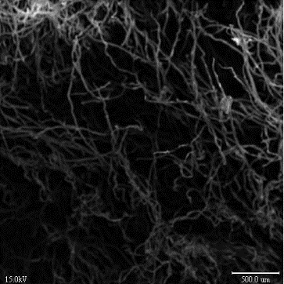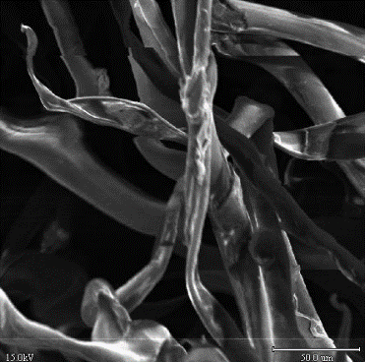
Fig. 1. SEM images of chestnut fruit shells

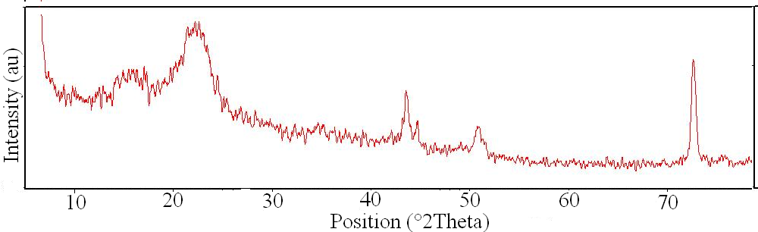
Fig. 2. XRD pattern of chestnut fruit shells

Fig. 3 gives the FTIR spectrum of the shells. The band seen in the range of 3600-3000 cm⁻¹ indicates hydroxyl groups. Bands between 3000 and 2800 cm⁻¹ also indicate C-H stretching. The frequency region at 1730 cm⁻¹ expresses the C=O vibration, those at 1600 cm⁻¹ and 1400 cm⁻¹ express the C=C stretching vibration and the C-OH and O-H stretching vibration of phenolic groups at 1250 cm⁻¹. 1050 cm⁻¹ also represents the stretching of C-O in holocellulose.

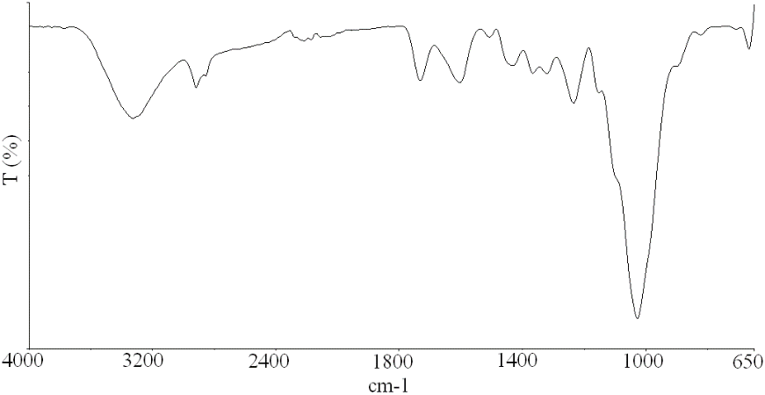
Fig. 3. FTIR spectrum of chestnut fruit shells

3.2 Pyrolysis behaviour

Fig. 4 shows TG-DTG graphs of pyrolysis of chestnut fruit shells performed at heating rates of 10, 20, 30 and 40 °C/min by thermogravimetric analysis.

A lignocellulosic biomass contains the components cellulose, hemicellulose and lignin (Sahay, 2022). Pyrolysis consists of three stages that show the degradation of the lignocellulosic structure. The first stage of pyrolysis of chestnut fruit shell refers to the drying of moisture, the stage up to about 150-200 °C. Other stages involve the initiation and degradation of cellulose. The second stage, the stage of about 158-359 °C, indicates the degradation of phenolic, carboxyl, carbonyl groups. The last stage, between 318-429 °C, indicates the breakdown of more complex structures such as aromatic structures.

Fig. 4. TG-DTG curves of chestnut fruit shells

Figure 5 shows graphs of changing of pyrolysis temperatures.In each stage of pyrolysis, the initial and final decomposition temperatures increase as the heating rate increases. The lowest initial temperature is 158 °C and final is 318 °C at heating rate 10 °C/min, for second stage. That temperatures are 318°C and 417 °C for third stage, respectively. For the 2nd and 3rd stages, the highest initial decompositon temperatures are 194 and 359 °C, respectively. The highest final temperatures are 359 and 429 °C. These values ​​refer to pyrolysis performed at a heating rate of 40°C/min.

The average second and third stages of the pyrolysis of the chestnut fruit shells take place in the temperature range of 175-336 and 336-422°C, respectively.

Fig. 5. Graphs of the initial and final temperatures of the all pyrolysis stages

The changes in the max. values ​​in pyrolysis are shown in Figure 6. Max pyrolysis temperature is in the range of 294-311 °C for second stage and 362-386 °C for third stage. In the second stage, the highest max. pyrolysis temperature was 311 °C at a heating rate of 40 °C/min. The lowest temperature was 294 °C in the pyrolysis at a heating rate of 10 °C/min. Likewise, the lowest max. pyrolysis temperature for the third stage is 362 °C at a heating rate of 10 °C/min, and the highest is 386 °C at 40 °C/min. As the heating rate increased, the max. pyrolysis temperature increased to higher temperatures for all stages.

Max pyrolysis rates are between 3.5-16 %/min for second stage and 7.5-28.54 %/min for third stage. By increasing the heating rate, max. pyrolysis rate increased.

The average max. pyrolysis temperature is 303 and 338°C for stage II and III, respectively. For the same stages, the average maximum pyrolysis rate was 9.80 and 18.60 %/min, respectively

Fig. 6. Graphs for max. pyrolysis temperature and max. pyrolysis rate

In Fig. 7, the variation of the char yields obtained depending on the heating rate of the pyrolysis is given. The char yield decreased and mass loss increased with the increase at the heating rate. Accordingly, the maximum and minimum char yields belong to 19 and 21 %, for heating rates of 40 and 10 °C/min, respectively.

The average total mass loss for the pyrolysis is 80 %.

Fig. 7. Graph of char yield depending on heating rate

3.3 Pyrolysis kinetics

Graphs (Fig. 8) were drawn between the R² of each curve and n according to section 2.4. In Table 2, E and A values calculated or each stage and heating rate are given.

Fig. 8. R²-n curves depending on heating rates

For the second stage, the heating rate and the reaction rate are interrelated. As the heating rate increases, the reaction rate also increases. It was calculated at the lowest heating rate of 10 °C/min with 0.47 and the highest heating rate of 40 °C/min with 1.27.

Heating rate had no effect on reaction degrees for the third pyrolysis stage. There is a decrease from 10 to 30 °C/min, an increase to 40 °C/min. For the 3rd stages, the lowest and highest reaction degree is at heating rates of 30 and 10 °C/min, respectively.

There is a relationship between the heating rate and activation energy for the second stage, but not for the third stage. The highest and lowest activation energy values for the second pyrolysis stage were calculated as 105,30 and 81,82 kj/mol for heating rates of 40 and 10 °C/min, respectively. For the third stage, these highest and lowest values belong to the heating rates of 40 and 30 °C/min and are 382.43 and 261 kj/mol, respectively.

The average values of activation energy of the chestnut fruit shells for pyrolysis II and III stages, were calculated as 93,82 and 302,10 kj/mol.

The average n values are 0.81 and 1.78, respectively.

Table 2. Kinetic parameters calculated by applying Coats & Redfern kinetic model.
Heating rate (°C/min) | Pyrolysis stage | n | E (kj/mol) | A  (min⁻¹) | R²
10 | II | 0.47 | 81.82 | 2.30*10⁸ | 0.9865
10 | III | 1.90 | 270.52 | 6.63*10²³ | 0.9749
20 | II | 0.67 | 92.92 | 2.15*10⁹ | 0.9792
20 | III | 1.77 | 294.40 | 3.20*10²⁵ | 0.9800
30 | II | 0.84 | 95.23 | 3.50*10⁹ | 0.9813
30 | III | 1.59 | 261.00 | 2.40*10²² | 0.9763
40 | II | 1.27 | 105.30 | 2.20*10¹⁰ | 0.9836
40 | III | 1.85 | 382.43 | 7.60*10³¹ | 0.9806
Average | II n= 0.81 E= 93.82 kj/mol A= 7.00*10⁹ min⁻¹  III n= 1.78 E= 302.10 kj/mol A= 1.90*10³¹ min⁻¹

Fig. 9 shows the kinetic compensation effect curves for all heating rates for the second and third stages of pyrolysis. It is clear from the R² values ​​of these curves that there is a kinetic compensation effect in both stages.

Fig. 9. Kinetic compensation effect for all stages

The results for ΔH, ΔG, and ΔS are given in Table 3.

If ΔH is positive, it represents the energy required for the decomposition of biomass. An increase in enthalpy change was observed as the heating rate increased in both stages of pyrolysis of shells. This also indicates that pyrolysis is endothermic. The enthalpy values ​​in the third stage are higher, indicating that more complex pyrolysis reactions occur in this stage (Lomada et al., 2024; Mishra et al., 2023; Vasudev et al., 2020).

ΔG describes equilibrium, or the tendency for a reaction to proceed in a particular direction. These values ​​for the shells are inversely proportional to the heating rate for both stages. As the heating rate increases, ΔG values ​​decrease. Positive values ​​indicate that the reactions in these stages are not spontaneous (Lomada et al., 2024; Jagtap & Kalbande, 2022).

Table 3. Thermodynamic parameters.
Heating rate (°C/min) | Pyrolysis stage | ΔH  (kj/mol) | ΔG  (kj/mol) | ΔS  (kj/mol)
10 | II | 78.16 | 147.50 | -0,12
10 | III | 255.72 | 160.82 | 0.15
20 | II | 88.15 | 156.50 | -0,12
20 | III | 265.14 | 160.25 | 0.16
30 | II | 90.42 | 145.00 | -0.10
30 | III | 289.00 | 160.00 | 0.20
40 | II | 100.44 | 144.40 | -0.08
40 | III | 377.00 | 157.83 | 0.33
Average | II ΔH=89.30 kj/mol ΔG=148.40 kj/mol ΔS=-0.11 kj/mol  III ΔH=296.72 kj/mol ΔG=159.73 kj/mol ΔS= 0.21 kj/mol

Entropy indicates the disorder of the system. Negative or positive ΔS values ​​indicate the complexity of the reactions (Lomada et al., 2024; Ali et al., 2017). In the second stage of pyrolysis, negative ΔS values ​​increase as the heating rate increases. In the third stage, they increase with positive values.

For the second and third stages, the average ΔH values ​​were calculated as 89.30 and 296.72 kJ/mol, respectively. ΔG values ​​were 148.40 and 159.73 kJ/mol, while ΔS values ​​were -0.11 and 0.21 kJ/mol.

4. Conclusion

In this study, structural characterization, pyrolysis by thermogravimetric analysis and pyrolysis kinetics of chestnut fruit shells was investigated by using Coats & Redfern kinetic model. The pyrolysis of chestnut fruit shells occurs in three stages. Increasing the heating rate increased both the initial and final temperatures of the pyrolysis stages, as well as the max pyrolysis temperature and max pyrolysis rate. That is, the heating rate has an effect on both the temperature steps and the char yield of the pyrolysis. However, there is a linear relationship between the heating rate and the activation energy and reaction rate for the second stage of the pyrolysis. There is no significant effect for the third stage.

Chestnut fruit shells, which are lignocellulosic biomass, are a waste material that can be used in the field of energy by blending it with fossil fuels at different rates, using methods such as pyrolysis, producing activated carbon, and adsorption.

COMPETING INTERESTS
Authors have declared that they have no known competing financial interests OR non-financial interests OR personal relationships that could have appeared to influence the work reported in this paper.

DISCLAIMER (ARTICIAL INTELLIGENCE)

Author hereby declare that generative AI technologies such as Large Language Models has been just used in the translation of this manuscript.

Details of the AI usage are given below:

1.Google translate

References

- Al- Haj Ibrahim, H. (2020). Introductory chapter: Pyrolysis. In: Al- Haj Ibrahim H (ed), Recent Advances in Pyrolysis, Intech Open, London. https://www.intechopen.com/chapters/70273
- Ali, I., Bahaitham, H. & Naebulharam, R. (2017). A comprehensive kinetics study of coconut shell waste pyrolysis. Bioresource Technology.235:1-11. https://doi.org/10.1016/j.biortech.2017.03.089
- Cheng, G., Varanasi, P., Li, C., Liu, H., Melnichenko, Y.B., Simmons, B.A., Kent, M.S. & Singh, S. (2011). Transition of Cellulose Crystalline Structure and Surface Morphology of Biomass as a Function of Ionic Liquid Pretreatment and Its Relation to Enzymatic Hydrolysis. Biomacromolecules 12(4): 933-941. https://doi.org/10.1021/bm101240z
- Coats, A. W. & Redfern, J. P. (1964). Kinetic Parameters from Thermogravimetric Data, Nature 201:68-69. https://doi.org/10.1038/201068a0
- Echegaraya, N., Gómezb, B., Barbac, F.J., Francob, D., Estévezd, M., Carballoa, J., Marszałeke, K. & Lorenzo, J.M. (2018). Chestnuts and by-products as source of natural antioxidants in meat and meat products: A review. Trends in Food Science&Technology 52:110-121. https://doi.org/10.1016/j.tifs.2018.10.005
- Ferrer, A., Alciaturi, C., Faneite, A. & Ríos, J. (2016). Analyses of Biomass Fibers by XRD, FT-IR, and NIR, In: Vaz Jr, S. (eds) Analytical Techniques and Methods for Biomass, Springer, 45-83. https://doi.org/10.1007/978-3-319-41414-0_3
- Jagtap, A, & Kalbande S.R. (2022). Investigation on pyrolysis kinetics and thermodynamic parameters of soybean straw: A comparative study using model-free methods. Biomass Conversion and Biorefinery. 02228-9. https://doi.org/10.1007/s13399-021-02228-9
- Kumar, P. & Mohanty, K. (2025) Insight in to the Pyrolysis of Melocanna baccifera Biomass: Pyrolysis Behavior, Kinetics, and Thermodynamic Parameters Analysis Based on Iso-conversional Methods, ACS Omega 10:8420-8432. https://doi.org/10.1021/acsomega.4c10423?urlappend=%3Fref%3DPDF&jav=VoR&rel=cite-as
- Kumar, P., Barrett, D.M., Delwiche, M.J. & Stroeve, P. (2009). Methods for Pretreatment of Lignocellulosic Biomass for Efficient Hydrolysis and Biofuel Production. Industrial&Engineering Chemistry Reserach. 48(8):3713-3729. https://doi.org/10.1021/ie801542g
- Lomada, K., Poyilil, S., Palatel, A. & Chandrasekharan, M. (2024). Investigations on the pyrolysis behavior of Sapindus mukorossi based on kinetic and thermodynamic parameters. Journal of Thermal Engineering. 10(6):1480-1493. 10.14744/thermal.0000889
- Mishra, A., Nanda, S., Ranjan Parida, M., Jena, P.K., Dwibedi, S.K., Manjari Samantaray, S., Samantaray, D., Mohanty, M.K. & Dash, M. (2023). A comparative study on pyrolysis kinetics and thermodynamic parameters of little millet and sunflower stems biomass using thermogravimetric analysis. Bioresource Technology. 367:128231. https://doi.org/10.1016/j.biortech.2022.128231
- Öztürk, F. S., Önal, Y. & Gökbulut, İ. (2022). Alıç (Crataegus orientalis subsp.) Çekirdeğinin Bazı Karakteristik Özellikleri ve Çekirdek Yağının Yağ Asidi Bileşen Karakterizasyonu. European Journal of Science and Technology. 41:79-84. https://doi.org/10.31590/ejosat.1113941
- Sahay, S. (2022). Deconstruction of Lignocelluloses: Potential Biological Approaches. In: Sahay S(ed), Handbook of Biofuels, Academic Press, 207-232. https://doi.org/10.1016/B978-0-12-822810-4.00010-5
- Serra, L.M. (2015). Foreword, In: Tannous K (ed), Innovative solutions in fluid-particle systems and renewable energy management, IGI Global, USA, pp xiv-xviii.
- URL1: https://www.yatirimadestek.gov.tr/pdf/assets/upload/fizibiliteler/kastamonu-ili-kestane-isleme-tesisi-on-fizibilite-raporu2021.pdf (20 March 2025)
- Várhegyi, G., Grønli, M.G. & Di Blasi, C. (2004). Effects of Sample Origin, Extraction, and Hot-Water Washing on the Devolatilization Kinetics of Chestnut Wood, Industrial&Engimeering Chemistry Research. 43(10): 2356- 2367. https://doi.org/10.1021/ie034168f
- Vasudev, V., Ku, X. & Lin, J. (2020). Pyrolysis of algal biomass: Determination of the kinetic triplet and thermodynamic analysis. Bioresource Technology. 317:124007. https://doi.org/10.1016/j.biortech.2020.124007
- Vassilev, S.V., Baxter, D., Andersen, L.K., Vassileva, C.G. & Morgan, T.J. (2012). An Overview of the Organic and Inorganic Phase Composition of Biomass. Fuel 94:1-33. https://doi.org/10.1016/j.fuel.2011.09.030
- Vecchio, S., Luciano, G. & Franceschi, E. (2006). Explorative Kinetic Study on the Thermal Degradation of Five Wood Species for Applications in the Archaelogical Field, Annali di Chimica. 96(11-12): 715-725. https://doi.org/10.1002/adic.200690074
- Yadav, K. & Jagadevan, S. (2019). Influence of Process Parameters on Synthesis of Biochar by Pyrolysis of Biomass: An Alternative Source of Energy. In: Al- Haj Ibrahim H (ed), Recent advances in pyrolysis, Intech Open, London. http://dx.doi.org/10.5772/intechopen.88204

