Major Constraints Faced by Beekeepers in
South Gujarat Region of Gujarat, India

.
ABSTRACT

Beekeeping served as an accessible supplementary source of income for farm households. It improves earnings for the rural poor, enhances the nutritional security of rural women and children and ensures continuous employment throughout the year via different activities. However, beekeeping faces significant challenges from numerous factors that either independently or in combination affect honeybees and their valuable products. The present study was carried out to examine constraints faced by the beekeepers in the production and marketing of honey in the South Gujarat region. A multi-stage random sampling technique was used for the study. The study was based on primary data collected from 120 beekeepers selected from six randomly chosen talukas (Dharampur, Kaprada, Ahwa, Waghai, Dolvan and Vyara) within three districts (Valsad, Dang and Tapi). The data were collected through one-to-one personal interviews using a pre-structured schedule. Garrett’s ranking technique was used to analyze the problems perceived by beekeepers in honey production and marketing. Beekeepers said that unfavourable weather patterns, problems with their colonies, pesticide poisoning, a shortage of bee food and a lack of recognition for technology were the main obstacles to honey production. While inadequate storage facilities, an unfixed price for raw honey, a lack of information about the honey industry, a disorganized market structure and the absence of quality testing labs were the major marketing challenges.

Keywords: Beekeeping; honey; production constraints; marketing constraints;
South Gujarat, farm households

1. INTRODUCTION

Apiculture, commonly known as beekeeping, is the scientific practice of raising and caring for honey bees. The main goal of this activity is to produce honey and other valuable hive products, including beeswax, royal jelly, propolis, and bee venom (Ajay et al., 2023). Beekeepers also perform other vital roles, such as breeding and selling bees and using them to pollinate specific agricultural crops. The primary goal of beekeeping is honey production, which holds significant importance both quantitatively and economically. Honey, a substance cherished by mankind for centuries, serves as a vital source of food, medicine and cultural significance (Cartland, 1970; Mcinerney, 1990; Molan, 1999). Beekeeping is an agricultural activity that doesn't need specific land and doesn't compete with other livestock for resources or food. Anywhere there are plenty of flowering plants that provide nectar and pollen, it can be successfully practiced. Fruit orchards, fields and forest areas are frequently ideal places. Every member of the family including older children, young adults and people with disabilities can find work through this activity. Beekeeping helps rural communities become self-sufficient and promotes the diversification of the local economy because it may be done in the backyard of a rural home (Abrol, 2010).
Globally, 2.15 million metric tons of honey were produced. China contributes 28.03 per cent of the total world’s honey produced, followed by Turkey, which contributes 6.95 per cent and Ethiopia, which contributes 5.11 per cent. India is the 7th largest country in honey production, accounting for 4.28 per cent of the total global production (Tridge, 2025). India has more than 22.83 lakh honeybee colonies and 14,859 registered beekeepers. Additionally, there are 269 beekeeping and honey societies, 150 firms, and 206 companies registered with the National Bee Board through the Madhukranti Portal. Together, these contribute to an estimated honey production capacity of about 1.4 lakh metric tons per year. During FY 2023–24, India exported approximately 1.07 lakh metric tons of natural honey, valued at USD 177.52 million, representing a significant increase from FY 2020–21, when exports totaled 59,999 metric tons, worth USD 96.77 million. The major honey-producing states in India are Uttar Pradesh (17%), West Bengal (16%), Punjab (14%), Bihar (12%) and Rajasthan (9%) (Ministry of Agriculture and Farmers Welfare, 2025). In India, Gujarat is one of the highly potential honey-producing states, ranking 21st among honey-producing states with a production estimate of 910 tonnes in 2021-22 (Indiastat, 2023). The state of Gujarat is naturally well-suited for beekeeping due to its diverse floral resources and favourable environment for honey production. To promote and motivate people to adopt beekeeping, the Government of Gujarat introduced the Honey Beekeeping Project in 2017-18. The project’s vision is to develop beekeeping as an income-generating activity for tribal households in Gujarat through scientific methods. Under this initiative, each participant is provided with a certain number of bee boxes, enabling them to earn around Rs. 10,000 to Rs. 12,000 per month, thereby making beekeeping a sustainable and profitable livelihood option (Tribal Development Department, GOG, 2018).
In the areas of apiculture, rural livelihoods and agricultural extension, this paper tackles a significant and practically pertinent problem. Particularly in India's rural and tribal areas, beekeeping is essential to sustainable agriculture, nutritional security and economic diversification. The study offers region-specific empirical knowledge that can help policy design, extension planning and focused interventions by methodically identifying and ranking the production and marketing restrictions experienced by beekeepers in South Gujarat. The findings will be useful for researchers, policymakers and development organizations working to promote beekeeping as a sustainable and viable source of income.

2. material and methods

Study Area

This study took place in the South Gujarat region, where a significant number of beekeepers are located, attributed to the plentiful mango orchards and the considerable potential for honey production. The districts of Valsad, Dang and Tapi were purposively chosen from the South Gujarat region due to the large number of beekeepers engaged in apiculture independently. From each district, two talukas: Dharampur and Kaprada from Valsad, Ahwa and Waghai from Dang, and Dolvan and Vyara from Tapi, were purposefully selected based on their nearness to the district headquarters and the availability of infrastructure for honey production. From each taluka, two clustered villages were randomly selected. Thus, a total of twelve clustered villages was selected for the study.

Data

The primary data were used for the study. Primary data, i.e., constraints faced by beekeepers in the production and marketing of honey obtained information was collect through beekeepers with a personal interview with the help of pre-tested schedule. The sample size included 120 farmers from 3 districts in South Gujarat region of Gujarat.

Analytical tools

The primary data were collected through one-on-one interviews with beekeepers using a pre-structured schedule. To analyze the problems perceived by beekeepers in the honey production, Garrett’s ranking technique was used. Garrett’s ranking technique provides the change of orders of constraints and suggestions into numerical scores. The prime advantage of this technique over the simple frequency distribution of constraints was arranged based on their importance from the point of view of respondents. Garrett’s formula for converting ranks into per cent is given by,
$$Percent Position= \frac{100 (R_{ij}-0.5)}{N_{j}}$$
Where, R_{ij} = Rank given for the i^{th} item by the j^{th} individual,
N_{j} = Number of items ranked by the j^{th} individual

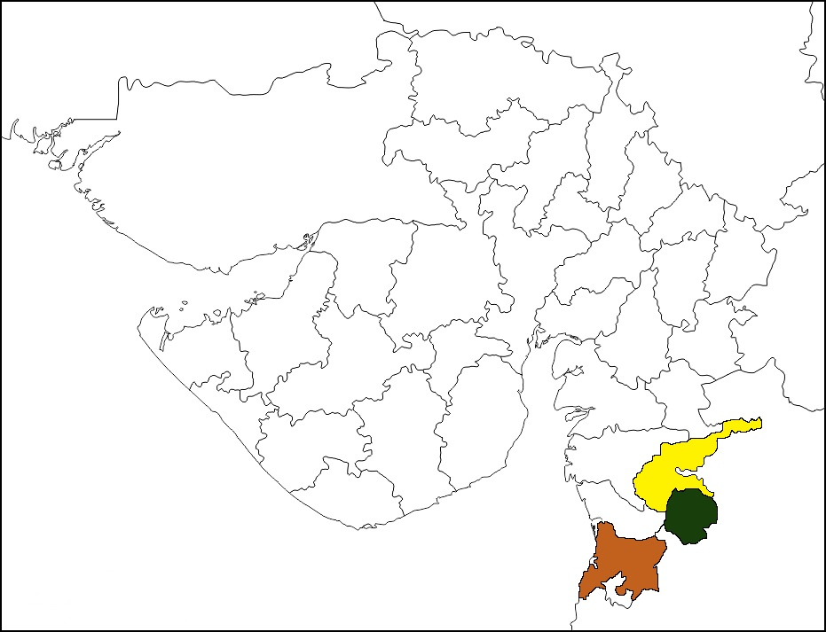


The per cent position of each rank was converted into scores referring to the table given by the Garrett and Woodworth ranking method (1969). For each factor, the scores of individual respondents were added together and divided by the total number of the respondents for whom scores were added. These mean scores for all the factors were arranged in descending order and the constraints were ranked accordingly.
Note*: Black, Red and Blue locations indicate the Tapi, Dang and Valsad districts, respectively.
Fig. 1. Map of the study area
3. results and discussion

The South Gujarat region has a rich tradition and culture of beekeeping, supported by a wide variety of flora that is highly suitable for apiculture. The local beekeepers possess substantial experience and are well-trained in managing bee colonies. However, despite these advantages, beekeepers in these districts face several challenges that hinder the successful operation of their enterprises, resulting in much of the region’s beekeeping potential remaining underutilized. Various constraints related to beekeeping were identified and categorized into two main groups: production and marketing of honey.

- Constraints Related to Honey Production
There were several issues limiting honey production, which were directly related to the strength and activity of the bees in the colony. The main constraint related to honey production was presented in table 1.

Table 1 Constraints related to honey production in the selected districts

Sr. No. | Constraints faced by the beekeepers | Garrett  mean score | Rank
1 | Bee diseases, predators and natural enemy problems | 53.45 | 4
2 | Shortage of bee forage | 49.35 | 6
3 | Unfavourable weather and climatic conditions | 76.44 | 1
4 | High cost of standardized beekeeping equipment | 46.42 | 7
5 | Problems during migrations | 31.74 | 8
6 | Lack of Skilled labour availability | 23.97 | 10
7 | High cost of supplement feed (sugar syrup) | 29.29 | 9
8 | Death, Absconding, swarming and theft problems of bee colony | 72.97 | 2
9 | Lack of Credit supply for technology advancement | 50.78 | 5
10 | Pesticide poisoning | 65.59 | 3
*Source Field survey data

The table indicated that the unfavourable weather and climatic conditions were the most prioritized limitation, with a mean score of 76.44. The colony's bee population declines as a result of the heavy rainfall and overcast skies during the monsoon, which creates a severe dearth period due to nectar and pollen washout and prevents bees from foraging, directly leading to a decline in the colony's bee population. The tropical conditions also favour the proliferation of key pests and predators like wasps and wax moths. The present findings is somewhat similar to the results reported by Arya et. al. (2021).

Death, absconding, swarming, and theft were the second most serious constraints in the eyes of the beekeepers. The mean score for these constraints was 72.97. Death, absconding, swarming, and theft constraints of bee colonies have also caused a reduction in the number and strength of bee colonies. The present findings are in agreement with the results reported by Yadav et. al. (2023), who showed somewhat similar results. The next prioritized constraint was the pesticide poisoning, which secured third rank among ten constraints with a mean score of 65.59. Due to pesticide poisoning, bees got infected because of the pesticide sprays in the crop field. It causes death to honeybees.

Bee diseases and natural enemy constraints ranked as the fourth serious constraint for beekeepers, with a mean score of 53.45. Bee diseases and natural enemies pose a significant threat, causing considerable damage to honeybee colonies. A critical challenge with these illnesses was that their symptoms are often not immediately visible, which can allow the problem to worsen undetected and lead to severe consequences for the colony down the line. Ultimately, these infections cause individual bees to become sluggish, inactive (dormant), or result in their death. Similar results have been reported by Panchani and Lakhlani (2022). The fifth major constraint reported by beekeepers, with a mean score of 50.78, was the lack of credit supply for technology advancement. This was primarily due to the high investment required for new technologies, which deterred most beekeepers from adopting them. The present findings are in agreement with the results reported by Arya et. al. (2021), who showed somewhat similar results.

Ranking sixth out of ten with a mean score of 49.35, the shortage of bee foraging was identified as the next significant constraint. This shortage was attributed to the steady decline in flora availability within the research area and the diminishing quality of locations visited during migratory beekeeping. The present findings are in agreement with the results reported by Yadav et. al. (2023), who showed somewhat similar results. The high cost of standardized beekeeping equipment was ranked as the seventh major constraint, with a mean score of 46.42. This expense was a significant barrier, as beekeeping requires specific equipment for various activities and it ultimately leads to a reduction in both the number and strength of bee colonies. Similar findings were reported by Tomas et. al. (2022), who reported that 45.91 per cent of the responders are facing the same problem.

Beekeepers identified migration-related constraints as the eighth most significant constraint, with a mean score of 31.74. They faced numerous challenges when moving from one location to another. Major issues included high transportation costs, the reluctance of farmers to allow beekeeping boxes in their fields and a lack of labour for loading and unloading, etc. These findings are different from those reported by Panchani and Lakhlani (2022). The high cost of supplement feed was assessed as another significant obstacle to achieving a mean score of 29.29. This limitation was ranked ninth, primarily due to the high price of sugar used in the supplemental feeding of colonies. The present findings are in agreement with the results reported by Kumar et. al. (2023), who showed somewhat similar results. The scarcity of skilled labour was identified as the last major barrier, ranked tenth with a mean score of 23.97. Because the majority of beekeepers manage all operations alone, they face considerable difficulty meeting their needs when specialized trained labour is required. These findings are different from those reported by Tomas et. al. (2022).

- Constraints Related to Marketing

Several constraints that beekeepers encounter concerning the marketing and sale of their produce are listed in Table 2.

Table 2 Marketing constraints faced by the beekeepers in the selected districts

Sr. No. | Constraints faced by the beekeepers | Garrett mean score | Rank
1 | Lack of credit supply for high-cost standard implements used in processing, packaging and quality testing | 53.15 | 4
2 | Unfixed price of raw honey | 47.10 | 6
3 | Lack of government concern and support for the marketing of honey | 34.75 | 7
4 | Cumbersome procedure for registration as a firm for sale of in retail | 29.67 | 8
5 | Unavailability of a quality testing lab | 67.00 | 3
6 | Lack of information about the honey market | 75.47 | 1
7 | Lack of proper storage containers and facilities | 49.75 | 5
8 | Delay in payment | 23.57 | 9
9 | Unorganized and unregulated market | 69.53 | 2
*Source Field survey data

The most important and prioritized constraint was lack of information about the honey market, with a mean score of 75.47. The local processors and traders were the only sources of information available to beekeepers regarding market prices. The present findings are in agreement with the results reported by Yadav et. al. (2023), who showed somewhat similar results.

The unorganized and unregulated market structure emerged as the second most important constraint in honey marketing, with a mean score of 69.53. Beekeepers reported that very few buyers purchase honey directly from them, and this led to an imperfect market situation characterized by insufficient competition among buyers. The present study is in line with the findings of Arya et. al. (2021), who reported that 57.73 per cent of the respondents reported regarding the unorganized and unregulated market.

The third important constraint was the unavailability of quality testing, with a mean score of 67.00. Beekeepers highlighted that the lack of testing facilities leads to uniform honey pricing, effectively removing the financial incentive for beekeepers to invest in and produce superior quality products. These findings are different from those reported by Arya et. al. (2021). Lack of credit availability for expensive standard instruments needed in processing, packaging and quality testing was the fourth major limitation listed by beekeepers, with a mean score of 53.15. The present study is consistent with the findings of Kumar et. al. (2023).

Ranked fifth with a mean score of 49.75, the absence of suitable storage facilities and containers emerged as an important issue. Since standard storage containers were unavailable in the area, beekeepers were compelled to sell their produce during the short growing season, often leading to reduced negotiating power. The present findings are in agreement with the results reported by Arya et. al. (2021), who showed somewhat similar results. Ranked sixth out of ten, the unfixed price of raw honey was another important constraint, with a mean score of 47.10. Beekeepers noted significant price fluctuations and unpredictable pricing, leading to a feeling of insecurity regarding honey sales over time. This instability consequently made beekeepers less confident about expanding their operations. The present findings are different from those reported by Arya et. al. (2021).

The next major marketing-related constraint reported in the area was the lack of government attention and support for honey marketing, which had a mean score of 34.75 and was ranked seventh. Although the government has emphasized the promotion of beekeeping and honey production, it has taken few concrete measures to strengthen marketing infrastructure. Unlike the cooperative systems established for milk procurement, no similar initiatives have been introduced for honey as well, and the government has shown no inclination toward setting a minimum support price (MSP) for honey. The constraint ranked eighth by beekeepers, with a mean score of 29.67, was the complicated process of registering a business to sell branded honey in the market. This complexity reduces opportunities to add value to bee-based products. The present findings are different from those reported by Arya et. al. (2021). The constraint least prioritized by beekeepers, with the minimum mean score of 23.57, was the delay in payment. Beekeepers often sell honey to local buyers who do not pay on time and in some cases even become defaulters.

4. Conclusion

The study revealed that although South Gujarat has strong potential for beekeeping, multiple production and marketing constraints limit its full development. Unfavourable climatic conditions, colony losses, pesticide poisoning and bee diseases emerged as the most serious production challenges, directly reducing colony strength and honey yield. Marketing-related barriers such as lack of market information, an unorganized market structure and absence of quality testing facilities further restrict beekeepers’ income opportunities, as well as the high cost of equipment, limited credit availability and shortage of skilled labour, which also hinder technological adoption and efficient management. Overall, the findings highlight the need for improved market infrastructure, supportive policies, credit access and training programs to strengthen beekeeping as a sustainable livelihood option in the region.
Consent
As per international standards or university standards, Participants’ written consent has been collected and preserved by the author(s).

Disclaimer (Artificial intelligence)

Author(s) hereby declare that NO generative AI technologies such as Large Language Models (ChatGPT, COPILOT, etc.) and text-to-image generators have been used during the writing or editing of this manuscript.

References

- Abrol, D. P. (2010). Beekeeping: A compressive guide to bees and beekeeping. Scientific Publishers (India). https://www.vedamsbooks.com/no67000.htm
- Anonymous (2018). Honey bee keeping project. Tribal Development Department, Government of Gujarat. https://tribal.gujarat.gov.in/vky-central-sector-scheme
- Anonymous (2023). State-wise honey production in India. Indiastat. https://www.indiastat.com/data/agriculture/apiculture-beekeeping/data-year/all-years.
- Anonymous (2025). Honey production trends overview of the top 10 Countries. Tridge. https://www.tridge.com/intelligences/honey/production
- Arya, S., Kumar, A., Kumar, K., & Kumar, D. (2021). Major constraints faced by the beekeepers in production and marketing of honey in the Nainital district of Uttarakhand. The Pharma Innovation Journal, 10(8), 276-279. https://www.thepharmajournal.com/archives/2021/vol10issue8S/PartE/10-8-10-700.pdf
- Cartland, B. (1970). The magic of honey. Corgi Books, London. 160 p.
- Garrett H. E. & Woodworth R.S. (1969). Statistics in Psychology and Education, Vakils, Feffer and Simons Pvt. Ltd. Bombay, 329.
- Kumar, J., Shukla, P., Chaudhary, S. K., Kumar, V., Singh, N. K., Kunal, G., Kumar, R., & Kalyani, S. (2023). Beekeeping barriers: Unravelling constraints to foster sustainable enterprise adoption: A holistic examination. The Pharma Innovation Journal, 12(12), 745-749. https://www.thepharmajournal.com
- McInerney, R. J. (1990). Honey—a remedy rediscovered. Journal of the Royal Society of Medicine, 83(2), 127. https://www.ncbi.nlm.nih.gov/pmc/articles/PMC1292529/
- Ministry of Agriculture and Farmers Welfare, Government of India. (2025, November 2). National Beekeeping & Honey Mission: Bringing Sweet Revolution: Buzzing for a Better India (Press Release No. 2185400). Press Information Bureau. https://www.pib.gov.in/PressReleasePage.aspx?PRID=2185400&reg=3&lang=2
- Molan, P. C. (1999). Why honey is effective as a medicine. 1. Its use in modern medicine. Bee World. https://doi.org/10.1080/0005772X.1999.11099430
- Panchani, P. N., & Lakhlani, C. D. (2022). Production and marketing constraints faced by beekeepers in Gujarat State. *International Journal of Agriculture Sciences*, *14*(1), 11013-11014. https://bioinfopublication.org/pages/jouarchive.php?id=2022-14-1-11013-11014
- Thomas, C. A., Ramchandra, D., Biswas, S., & Ansari, A. A. (2022). Constraints related to production and marketing of honey in Pathanamthitta district of Kerala. The Pharma Innovation Journal, 11(5S), 1383-1385. https://www.thepharmajournal.com/archives/2022/vol11issue5S/PartS/11-5S-10-100.pdf
- Yadav, V., Sharma, D., Thakur, M., Rathour, B., Khajuria, M., Kapoor, B., & Shakya, J. (2023). Constraints and challenges faced by beekeepers of Jammu and Kashmir. The Pharma Innovation Journal, 12(12), 1477-1479. https://www.thepharmajournal.com
- Ajay S. Singh, Douglas Kibirige & Phumlani S. Malaza. (2023). Analytical Study of Small Scale Beekeeping Farming in Eswatini: A Case Study in Manzini Region, Eswatini . Asian Journal of Advances in Agricultural Research, 23(1), 1–9. https://doi.org/10.9734/ajaar/2023/v23i1449

