Original Research Article

Dose-Dependent Impact of Bacillus thuringiensis on Silkworm (Bombyx mori) Survival and Pathogenicity

Abstract
The environmental impact of microbial pesticides, including Bacillus thuringiensis (Bt), is a growing concern. Although Bt is widely used for pest control due to its efficacy, understanding its potential toxicity to non-target organisms such as silkworms is essential for environmental safety. The current study was conducted to determine how different Bt doses affect larval mortality, growth, and development of silkworm (Bombyx mori) larvae. The study was conducted at Group of Pesticide environmental risk assessment and control, Institute of Plant Protection, Chinese Academy of Agricultural Sciences (IPPCAAS), between 2019 and 2020. This study investigated the dose-dependent toxicity of Bt to silkworms following the NY/T 3152.3-2017 guidelines for microbial pesticide risk assessment. A dose-response experiment was conducted using five Bt concentrations (3.16 × 10⁴, 1 × 10⁵, 3.16 × 10⁵, 1 × 10⁶, and 3.16 × 10⁶ CFU/mL), along with blank and inactivated controls. Each treatment consisted of 20 silkworms with four replicates, and the experiment lasted 23 days. The effects of Bt on silkworm survival and development were evaluated using Probit analysis and one-way ANOVA. The result revealed that the 23-day LC₅₀ was 4.48 × 10⁵ CFU/mL (95% confidence interval: 2.77 × 10⁵- 6.06 × 10⁵ CFU/mL). At 1.00 × 10⁶ CFU/mL, cocoon weight was significantly higher than in the blank control, though no significant differences were observed among other groups. Cocoon shell weight was significantly higher at 3.16 × 10⁴ and 1 × 10⁶ CFU/mL compared to the control. Pathogenicity tests confirmed that the isolated and tested strains were identical, and infected silkworms exhibited typical Bt-induced symptoms, including body decay and side-lying behavior. Overall, these findings provide important data for environmental risk assessment, indicating that careful management of Bt concentrations is critical to minimize unintended harm to beneficial organisms within agricultural ecosystems.

Keywords: Bacillus thuringiensis (Bt); Pathogenicity; Strains; Silkworm (Bombyx mori); LC₅₀ value; Dose-dependent response.

1. Introduction
Bacillus thuringiensis (Bt) is widely used as a microbial pesticide due to its effectiveness against specific insect pests (Kumar et al., 2021). However, its potential environmental impact has raised concerns. Although generally considered safe for non-target organisms, recent studies suggest possible ecological risks (Li et al., 2022; Sharma et al., 2019). For example, in Drosophila melanogaster, Bt var. kurstaki (Btk) products can impair larval growth and induce enterocyte apoptosis, disrupting protein digestion (Nawrot-Esposito et al., 2020). In silkworms (Bombyx mori), non-lethal exposure to the Cry1F toxin affects growth, immune response, and intestinal microbiota (Xu et al., 2023). Furthermore, colony exposure to Bacillus thuringiensis ssp. aizawai under field-realistic conditions negatively influenced brood development and caused gut microbiome dysbiosis (Steinigeweg et al., 2023).
Silkworms (Bombyx mori) are widely considered as an ideal organism in practical, cost-effective toxicology model due to their mammal-like detoxification systems, well-characterized genetics, and high sensitivity to diverse chemicals, while offering advantages such as rapid life cycle, easy rearing, and ethical suitability for preliminary screening and ecological risk assessment (Panthee et al., 2017; Abdelli et al., 2018). Moreover, Silkworms are valued for their rich protein content, represent a promising source of nutrition for both humans and animals and have long been utilized in traditional medicine (Han et al., 2024).
Studies have indicated potential Bt toxicity to soil microorganisms, plants, and food chains, with possible off-target effects on various invertebrates and even vertebrates (Belousova et al., 2021; Mandal et al., 2020). The safety assessment of Bt crops includes evaluations of invertebrates, mammals, and birds, along with comparative analyses with conventional crops (Ge et al., 2023). Notably, Bt has shown high toxicity to silkworms, with previous studies reporting significant mortality even at low concentrations (Zou et al., 2024).
Nevertheless, Bt has limitations, such as a narrow activity spectrum and sensitivity to environmental conditions. It remains the most widely used microbial insecticide (Ragasruthi et al., 2024; Girón-Calva et al., 2020). Efforts to enhance its efficacy include isolating novel strains, improving toxin stability, and developing genetically modified plants expressing Bt genes (Ortiz et al., 2023; Alves et al., 2023; Park et al., 2022; Jehangir & Ali, 2023). Despite these concerns, Bt remains a promising alternative to chemical pesticides due to its eco-friendly properties. Given its complex ecological interactions, further investigation into its safety at various ecosystem levels is warranted.
These findings enhance our understanding of the ecological risks posed by insecticides to non-target organisms such as silkworms and provide crucial information for environmental risk assessments.
- Materials and Methods
2.1. Test Conditions and Concentration Design
Environmental conditions were monitored throughout the test period. Temperature ranged from 23.4 to 26.5°C, relative humidity from 75.8% to 84.3%, and the light cycle was 16h:8h (light: dark).
The experiment followed a dose-response design with five treatment concentrations (3.16 × 10⁴, 1.00 × 10⁵, 3.16 × 10⁵, 1.00 × 10⁶, and 3.16 × 10⁶ CFU/mL), a blank control (CK1), and an inactivated control (CK2). Each treatment was replicated four times, with 20 silkworms per replicate.
2.2. Preparation of Mother Liquor
A total of 0.2286 g of the test substance was dissolved in sterile water in a 50 ml beaker and diluted to 100 ml in a volumetric flask. The solution was transferred to a 500 ml flask containing glass beads and shaken at 185 rpm and 25°C for 40 minutes to obtain a stock solution of 1.00 × 10⁸ CFU/mL. Serial dilutions were prepared by transferring 3.160 ml, 1.000 ml, and 0.316 ml into separate 100 ml volumetric flasks and adjusting the volume with sterile water to obtain concentrations of 3.16 × 10⁶, 1.00 × 10⁶, and 3.16 × 10⁵ CFU/ mL. Further dilutions yielded 1.00 × 10⁵ and 3.16 × 10⁴ CFU/ mL. For the inactivated control (CK2), 50 mL of the 3.16 × 10⁶ CFU/ mL solution was autoclaved at 121°C for 20 minutes.
2.3. Isolation of Bacillus thuringiensis
A 0.005 g sample of Bt (437.5 billion CFU/g) was dissolved in a clean 10 ml volumetric flask, shaken thoroughly, and serially diluted to 10⁻⁴ using a tenfold dilution method. A 0.10 ml aliquot of the 10⁻⁵ dilution was prepared and used as the test strain.
2.4. Silkworm Infection
Isolated strains cultured on LB medium plates were transferred to liquid LB medium and incubated in a shaker at 150 rpm and 30°C for 48 hours. The culture was centrifuged at 4000 rpm for 30 minutes, the supernatant was discarded, and the bacterial pellet was resuspended in sterile water. The resuspended solution was transferred to a 50 ml volumetric flask, mixed with glass beads, and shaken at 185 rpm and 25°C for 40 minutes. A 1.0 ml aliquot was diluted to 10⁻⁸, plated using dilutions from 10⁻⁶ to 10⁻⁸, and colonies were counted after 24 hours. For silkworm infection, 5 g of mulberry leaves were dipped in 50 ml of the test solution to ensure even distribution. The leaves were air-dried, placed in 12 cm culture dishes, and inoculated with 20 second-instar silkworms per dish. Symptoms were observed after 24 hours, with four replicates per treatment.
2.5. Poisoning Procedure
The leaf-dipping method was used. Approximately 5 g of mulberry leaves were soaked in 50 ml of test solution to ensure even coverage. After shade-drying, the leaves were placed in 12 cm diameter culture dishes, each containing 20 second-instar silkworms. After 24 hours, the silkworms were transferred to clean culture dishes and fed fresh, non-toxic mulberry leaves. Upon reaching the fourth instar, they were moved to clean containers and fed until the mature stage. Silkworms were allowed to cocoon and pupate fully.
Throughout the experiment, poisoning symptoms and mortality were observed and recorded daily. Cocoon weight, cocoon shell weight, and pupal weight were measured on the 8th day.
2.6. Statistical Analysis
Mortality rates were adjusted using Formula (1). Probit analysis was performed on silkworm mortality data using SPSS 22.0 to calculate the LC₅₀ and 95% confidence limits. Formulas (2), (3), and (4) were used to calculate cocooning rate, pupation rate, and cocoon shell rate for each treatment and control group. One-way ANOVA (LSD test) was applied to analyze differences in whole cocoon weight, cocoon shell weight, and pupal weight between concentration groups and the control.
$$Mortality rate (\%) =\frac{\text{Number of dead silkworms}}{Total number of silkworms} × 100$$
$$Cocooning rate (\%)=\frac{\text{Number of cocoons formed​}}{Total number of silkworms} × 100$$
$$Pupation rate (\%) =\frac{\text{Number of pupae formed}}{Total number of silkworms} × 100$$
- Results and Discussion
  - Poisoning Symptoms, Mortality, and Toxicity of Bacillus thuringiensis (Bt)
Silkworms exposed to Bt exhibited symptoms including side-lying, body blackening, shrinkage, soft and darkened abdomen, rotting, and foul odor. These symptoms were exclusively observed in Bt-treated groups, while the blank control (CK1) and inactivated control (CK2) remained unaffected throughout the experiment.
The onset and severity of symptoms were closely linked to mortality. The highest concentration (3.16 × 10⁶ CFU/ mL, T5) induced the most rapid and severe reaction, with over 90% of individuals showing lateral lying on day 1 and reaching 100% mortality by day 2. The sub-high concentration group (1.00 × 10⁶ CFU/mL, T4) also showed rapid symptom progression, with over half of the silkworms affected on day 1 and a final mortality of 80%. In contrast, symptom development in the low and medium concentration groups (T1-T3) was slower, with body shrinkage, darkening, and incomplete cocooning observed mainly during the mid to late stages of the experiment.
Mortality data confirmed a strong dose and time-dependent toxic effect (Table 1, Figure 1). The blank and inactivated control groups showed no mortality. The lowest mortality was recorded at the lowest concentration (3.16 × 10⁴ CFU/ mL, T1), while the highest concentration (T5) caused 76% mortality on the first day, culminating in 100% mortality by day 2. The cumulative mortality over 23 days was significantly higher in the higher Bt concentration groups (Table 2, Figure 2).
Probit analysis of the 23-day cumulative mortality data determined the LC₅₀ to be 4.48 × 10⁵ CFU/ mL, with a 95% confidence interval of 2.77 × 10⁵ to 6.06 × 10⁵ CFU/ mL. The toxicity regression equation was Y = -11.304 + 2.000X (R² = 0.808) (Table 4).
The LC₅₀ of Bt against fifth-instar Bombyx mori larvae at 96h is 0.08 × 10⁻³ mg/l, and prolonged exposure at this sublethal level significantly reduces larval and cocoon weights while damaging the midgut, with an even lower concentration producing the same lethal effect, highlighting heightened silkworm sensitivity to Bt (Zou et al., 2024).
LC₅₀ stands for the concentration or dose of a substance that causes death in 50% of a tested population under defined exposure conditions, and is a standard metric used to gauge acute toxicity and compare hazards across substances (Galvan et al., 2005). In pesticides studies, like indoxacarb, imidacloprid, and thiamethoxam, reported the lower lethal concentration as 1.08 × 10², 1.92, 0.66, and 1.66 mg/l, respectively (Galvan et al., 2005; Yang et al., 2023). Other studies have observed that the median lethal concentration (LC₅₀) of Cry1F for newly hatched Bombyx mori larvae on artificial diet is 0.75 μg/g, which is markedly lower than Cry1Ab’s LC₅₀ of 3.06 μg/g, indicating Cry1F is more toxic to silkworm larvae (Jiao et al., 2016).
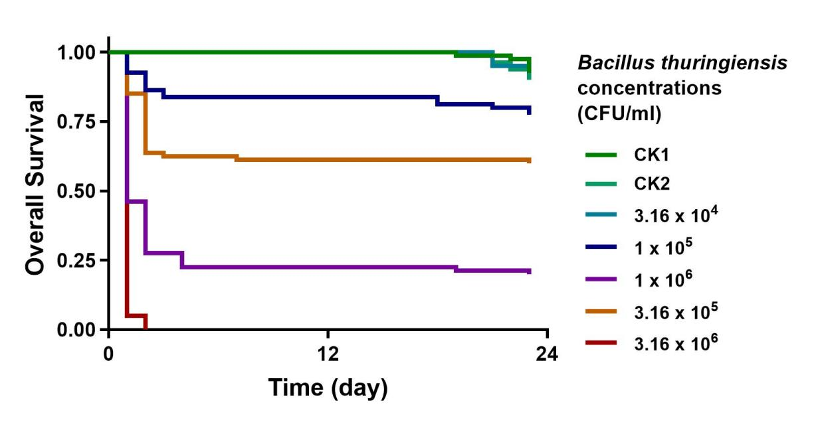
Figure 1. Daily mortality rate of silkworms exposed to Bt

Table 1. Effect of different Bacillus thuringiensis concentrations on Silkworm larvae mortality

Days (d) | Total silkworms (head) | Treatment (concentration CFU / mL)
Days (d) | Total silkworms (head) | CK1 | CK2 | T1  3.16 x 10⁴ | T2  1 x 10⁵ | T3  3.16 x 10⁵ | T4  1 x 10⁶ | T5  3.16 x 10⁶
1 | 80 | 0 | 0 | 0 | 6 | 12 | 43 | 76
2 | 80 | 0 | 0 | 0 | 11 | 29 | 58 | 80
3 | 80 | 0 | 0 | 0 | 13 | 30 | 58 | 80
4 | 80 | 0 | 0 | 0 | 13 | 30 | 62 | 80
5 | 80 | 0 | 0 | 0 | 13 | 30 | 62 | 80
6 | 80 | 0 | 0 | 0 | 13 | 30 | 62 | 80
7 | 80 | 0 | 0 | 0 | 13 | 31 | 62 | 80
8 | 80 | 0 | 0 | 0 | 13 | 31 | 62 | 80
9 | 80 | 0 | 0 | 0 | 13 | 31 | 62 | 80
10 | 80 | 0 | 0 | 0 | 13 | 31 | 62 | 80
11 | 80 | 0 | 0 | 0 | 13 | 31 | 62 | 80
12 | 80 | 0 | 0 | 0 | 13 | 31 | 62 | 80
13 | 80 | 0 | 0 | 0 | 13 | 31 | 62 | 80
14 | 80 | 0 | 0 | 0 | 13 | 31 | 62 | 80
15 | 80 | 0 | 0 | 0 | 13 | 31 | 62 | 80
16 | 80 | 0 | 0 | 0 | 13 | 31 | 62 | 80
17 | 80 | 0 | 0 | 0 | 13 | 31 | 62 | 80
18 | 80 | 0 | 0 | 0 | 15 | 31 | 62 | 80
19 | 80 | 1 | 0 | 0 | 15 | 31 | 63 | 80
20 | 80 | 1 | 0 | 0 | 15 | 31 | 63 | 80
21 | 80 | 1 | 4 | 3 | 16 | 31 | 63 | 80
22 | 80 | 2 | 4 | 5 | 16 | 31 | 63 | 80
23 | 80 | 6 | 6 | 8 | 18 | 32 | 64 | 80
CK1: blank control group; CK2: inactivated control group.

Table 2. Cumulative mortality of Silkworms in toxicity tests using 100 million CFU/g Bacillus thuringiensis

Handle | Concentration  CFU/mL | Total silkworms (head) | Repeat 1 (head) |  | Repeat 2 (head) | Repeat 3 (head) | Repeat 4 (head)
CK1 | - | 20 | 3 |  | 0 | 1 | 2
CK2 | - | 20 | 0 |  | 1 | 4 | 1
T1 | 3.16 x 10⁴ | 20 | 2 |  | 0 | 1 | 5
T2 | 1 x 10⁵ | 20 | 3 |  | 7 | 5 | 3
T3 | 3.16 x 10⁵ | 20 | 8 |  | 8 | 6 | 10
T4 | 1 x 10⁶ | 20 | 16 |  | 15 | 18 | 15
T5 | 3.16 x 10⁶ | 20 | 20 |  | 20 | 20 | 20

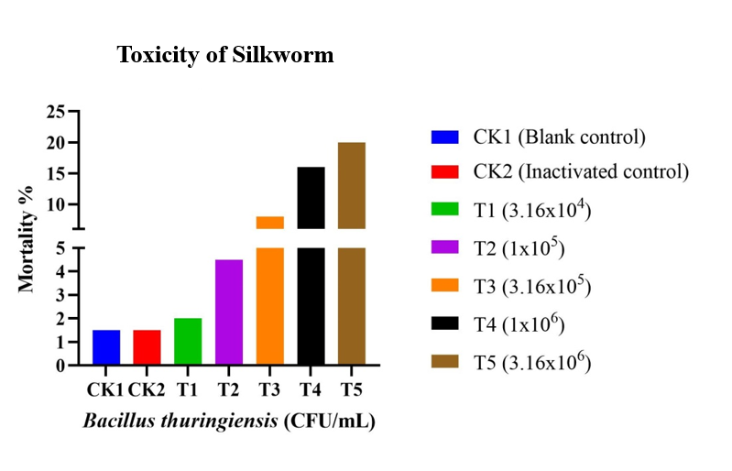
Figure 2. Cumulative mortality of silkworms over 23 days.

Table 3. Toxicity assessment of 100 million CFU/g Bacillus thuringiensis on Silkworms

Time  (d) | Regression curve equation of virulence  Y= a + bX | R² | LC₅₀  (mg a.i./L) | 95% Confidence limit  (mg a.i./L)
23d | Y = -11.304 + 2.000X | 0.808 | 4.48 x 10⁵ | 2.77×10⁵~6.06×10⁵

  - Effect of Bacillus thuringiensis on Silkworm Pupation and Cocooning
Control groups (CK1 and CK2) showed cocoon weights of 1.8467 ± 0.0364 g and 1.8204 ± 0.0148 g, cocoon shell weights of 0.4215 ± 0.0061 g and 0.4264 ± 0.0223 g, and pupal weights of 1.4006 ± 0.0386 g and 1.3698 ± 0.0212 g, with cocoon shell rates of 22.8% and 23.4%, respectively. No data were recorded for the highest concentration (T5). At 3.16 × 10⁴ CFU/mL, cocoon and pupal weights decreased, but the cocoon shell rate increased to 25.0%. At 3.16 × 10⁵ CFU/mL, cocoon weight and shell weight increased, with a stable shell rate of 23.9%. The highest cocoon weight (2.0469 ± 0.0355 g) and shell weight (0.4803 ± 0.0132 g) were observed at 1 × 10⁶ CFU/mL, with a shell rate of 23.5% (Table 4, Figure 3). Evidence from laboratory and field studies reveals that even sub-lethal residues of synthetic insecticides can cause severe biological effects, from acute larval mortality to disruptions in growth and development (Dutta et al., 2025).
Exposure to 100 μg/mL Cry1F markedly reduces body weight gain within 24 hours, and after 96 hours causes significant declines in larval body, cocoon, pupal, and cocoon-shell weights, with some larvae failing to reach the pupal stage (Xu et al., 2023).

Table 4. Effect of Bacillus thuringiensis on Silkworm pupation and cocooning
Handle | Concentration  CFU/mL | Cocoon weight (g)  Mean + SE | P value | Cocoon layer quantity (g)  Mean + SE | Pupa weight (g)  Mean + SE | Cocoon layer rate (%)
CK1 | - | 1.8467±0.0364 | - | 0.4215±0.0061 | 1.4006±0.0386 | 22.8
CK2 | - | 1.8204±0.0148 | 0.736 | 0.4264±0.0223 | 1.3698±0.0212 | 23.4
T1 | 3.16 x 10⁴ | 1.6976±0.0288 | 0.068 | 0.4244±0.0202 | 1.2179±0.0466 | 25.0
T2 | 1 x 10⁵ | 1.7607±0.1113 | 0.277 | 0.3976±0.0223 | 1.3342±0.0994 | 22.6
T3 | 3.16 x 10⁵ | 1.8575±0.0339 | 0.888 | 0.4447±0.0206 | 1.3963±0.0277 | 23.9
T4 | 1 x 10⁶ | 2.0469±0.0355 | 0.018 | 0.4803±0.0132 | 1.5594±0.0273 | 23.5
T5 | 3.16 x 10⁶ | - | - | - | - | -
Cocoon layer rate: the percentage of cocoon layer amount to the whole cocoon amount of bare cocoon.
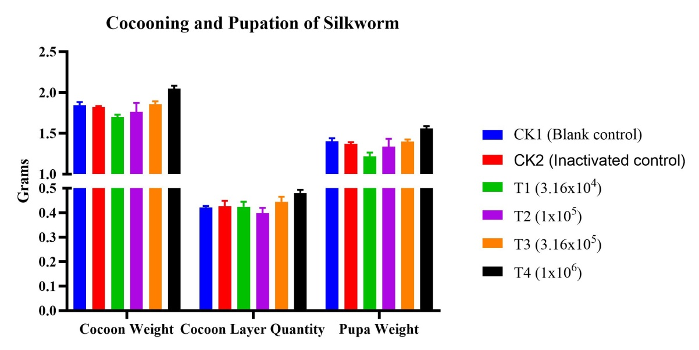
Figure 3. Effects of Bt on cocoon and pupal traits.

  - Effect of Bt on Pupal Weight and Cocoon Weight
Compared to CK1, CK2 showed no significant differences in cocoon weight, cocoon shell weight, or pupal weight (P = 0.736, 0.857, and 0.674, respectively). Pupal weight was significantly lower at 3.16 × 10⁴ CFU/mL (P = 0.021). No significant differences were observed at 1 × 10⁵ or 3.16 × 10⁵ CFU/mL. At 1 × 10⁶ CFU/ml, cocoon weight, shell weight, and pupal weight were significantly higher (P = 0.018, 0.037, and 0.040, respectively). No data were available for 3.16 × 10⁶ CFU/mL (Table 5). Sublethal Bt exposure has been shown to reduce pupal weight over time, potentially enhancing resistance in species like Helicoverpa zea (Reay-Jones et al., 2020; Bryant et al., 2024). However, such reductions did not affect fecundity or egg viability in H. zea (Bilbo et al., 2019), indicating that Bt may impair larval development without significantly impacting reproductive success. Several studies have provided evidence that insects are capable of initiating both humoral and cellular immune responses in order to mitigate the detrimental effects caused by Bt exposure (Grizanova et al., 2014; Li et al., 2018; Rahman et al., 2004). This finding is consistent with the observations of Gabriel de Carvalho et al. (2025), who found that Bti treatments can elicit compensatory effects that boost the fitness of surviving individuals and shift population dynamics. Similarly, Gándara et al. (2024) observed that more than half of agrochemicals can alter insect physiology and behavior even at sublethal doses. Such sublethal stimulations, often described as hormetic effects, can impact key traits like respiration and reproductive capacity (Agathokleous et al., 2023).

Table 5. Effect of Bacillus thuringiensis on the pupal weight and cocoon weight

Handle | Concentration  CFU/mL | P value *
Handle | Concentration  CFU/mL | Cocoon weight | Cocoon layer | Pupal weight
CK1 | - | - | - | -
CK2 | - | 0.736 | 0.857 | 0.674
T1 | 3.16 x 10⁴ | 0.068 | 0.917 | 0.021
T2 | 1 x 10⁵ | 0.277 | 0.370 | 0.369
T3 | 3.16 x 10⁵ | 0.888 | 0.386 | 0.953
T4 | 1 x 10⁶ | 0.018 | 0.037 | 0.040
T5 | 3.16 x 10⁶ | - | - | -
*One way ANOVA (LSD test α = 0.05)
  - Pathogenicity Symptoms
Silkworms exposed to the isolated Bacillus thuringiensis strains exhibited typical infection symptoms, including lateral recumbency, body rigidity, tissue degradation, and the presence of an unpleasant odor. These manifestations were consistent with those caused by the reference Bt strain, indicating that the isolates retained pathogenic activity toward silkworms. Detailed phenotypic observations are provided in Figure S1. Cry1F treatment at 100 μg/mL mulberry leaves feeding raised detrimental effects in fifth-instar silkworms, such as reduced feeding, head shaking, and brown excretions, with the most severe impact; microscopic examination showed Cry1F-induced damage to the midgut structure (Xu et al., 2023). The midgut serves as the primary tissue targeted by the Bt toxin. By binding to specific receptors situated on the brush border membrane of the midgut, the Bt toxin triggers pore formation (Bravo et al., 2011; Pardo-L´opez et al., 2013). This mechanism ultimately results in the disruption of normal physiological functions and subsequent larvae mortality.
- Conclusion
This study demonstrates the dose-dependent toxicity of Bt to silkworm larvae, consistent with previous research. Symptoms were exclusive to Bt-treated groups, confirming the specificity of Bt pathogenicity. Higher Bt concentrations led to more severe symptoms, including softening, rotting, blackening, and shrinkage, indicating a direct concentration-dependent effect. Increased Bt concentrations resulted in higher mortality, particularly in early instars, with the highest concentration (3.16 × 10⁶ CFU/mL) causing 76% mortality on the first day. The LC₅₀ of 4.48 × 10⁵ CFU/mL further confirms the high toxicity of Bt at elevated concentrations. While high Bt concentrations increased mortality, they also reduced cocoon yield and pupation rates. The decline in cocoon and pupal weights at high concentrations aligns with findings in other species, highlighting broader ecological concerns. Interestingly, lower Bt concentrations increased cocoon shell rates, suggesting a possible compensatory response at sublethal doses, a phenomenon warranting further study. This study contributes to the growing evidence on the complex interactions between Bt concentrations and silkworm physiology. The results underscore the importance of carefully managing Bt applications in silkworm rearing to mitigate adverse effects on larval development and overall production. These findings highlight a critical need for enhanced technical training and awareness initiatives among silkworm rearers. A comprehensive understanding of the lethal and sub-lethal thresholds of Bt will enable industry stakeholders to design more targeted management strategies and region-specific training programs, thereby reducing the risk of unintended exposure within sericulture regions. Further research is needed to elucidate the underlying mechanisms and develop strategies for minimizing Bt-related risks in sericulture.

DISCLAIMER (ARTIFICIAL INTELLIGENCE)
Author(s) hereby declare that NO generative AI technologies such as Large Language Models (ChatGPT, COPILOT, etc) and text-to-image generators have been used during writing or editing of this manuscript

COMPETING INTERESTS
Authors have declared that they have no known competing financial interests or non-financial interests or personal relationships that could have appeared to influence the work reported in this paper.

References
- Abdelli, N., Peng, L., & Chen, K. (2018). Silkworm, Bombyx mori, as an alternative model organism in toxicological research. Environmental Science and Pollution Research, 25(35), 35048-35054. https://doi.org/10.1007/s11356-018-3442-8
- Agathokleous, E., Blande, J. D., Masui, N., Calabrese, E. J., Zhang, J., Sicard, P., Guedes, R. N. C., & Benelli, G. (2023). Sublethal chemical stimulation of arthropod parasitoids and parasites of agricultural and environmental importance. Environmental Research, 236(Pt 1), 116876. https://doi.org/10.1017/10.1016/j.envres.2023.116876
- Alves, G. B., Oliveira, E. E., Aguiar, R. W., Barreto, F. R. S., Lima, K. L. G., Ferreira, T. M., Melo, J. F., & Lobo, F. P. (2023). Genomic–proteomic analysis of a novel Bacillus thuringiensis strain: Toxicity against two lepidopteran pests, abundance of Cry1Ac5 toxin, and presence of InhA1 virulence factor. Archives of Microbiology, 205(5), 197. https://doi.org/10.1007/s00203-023-03534-1
- Belousova, M. E., Malovichko, Y. V., Shikov, A. E., Nizhnikov, A. A., & Antonets, K. S. (2021). Dissecting the environmental consequences of Bacillus thuringiensis application for natural ecosystems. Toxins, 13(5), 355. https://doi.org/10.3390/toxins13050355
- Bilbo, T. R., Reay-Jones, F. P., Reisig, D. D., & Greene, J. K. (2019). Evaluation of Helicoverpa zea (Lepidoptera: Noctuidae) development on Bt and non-Bt corn yields in South Carolina. Journal of Economic Entomology, 112(3), 1246–1258. https://doi.org/10.1093/jee/toy424
- Bravo, A., Likitvivatanavong, S., Gill, S. S., & Soberón, M. (2011). Bacillus thuringiensis: A story of a successful bioinsecticide. Insect Biochemistry and Molecular Biology, 41(7), 423–431. https://doi.org/10.1016/j.ibmb.2011.02.006
- Bryant, T. B., Greene, J. K., Reisig, D., & Reay-Jones, F. P. F. (2024). Continued decline in sublethal effects of Bt toxins on Helicoverpa zea (Lepidoptera: Noctuidae) in field corn. Journal of Economic Entomology, 117(5), 1876-1883. https://doi.org/10.1093/jee/toae152
- Dutta, P. L., Nath, I., Sarma, J., & Saikia, S. (2025). Toxicological perspectives of pesticide use in mulberry cultivation: Challenges and pathways to sustainable sericulture. International Journal of Plant & Soil Science, 37(9), 446–469. https://doi.org/10.9734/ijpss/2025/v37i95465
- Gabriel de Carvalho, G., Cozzer, G., & Dal Magro, J. (2025). Assessing neighbourhood-scale BTI spray applications and laboratory-based mortality testing on Aedes aegypti larval development. Bulletin of Entomological Research. Advance online publication. https://doi.org/10.1017/s0007485324000889
- Gándara, L., Jacoby, R., & Crocker, J. (2024). Pervasive sublethal effects of agrochemicals on insects at environmentally relevant concentrations. Science, 386(6719), 332–339. https://doi.org/10.1126/science.ado0251
- Ge, L., Song, L., Wang, L., Li, Y., Sun, Y., Wang, C., Li, S., Wang, S., & Li, P. (2023). Evaluating response mechanisms of soil microbiomes and metabolomes to Bt toxin additions. Journal of Hazardous Materials, 448, 130904. https://doi.org/10.1016/j.jhazmat.2023.130904
- Girón-Calva, P. S., Twyman, R. M., Christou, P., & Capell, T. (2020). The impact of environmental stress on Bt crop performance. Trends in Plant Science, 25(3), 205–207. https://doi.org/10.1016/j.tplants.2019.12.019
- Grizanova, E. V., Dubovskiy, I. M., Whitten, M. M., & Glupov, V. V. (2014). Contributions of cellular and humoral immunity of Galleria mellonella larvae in defence against oral infection by Bacillus thuringiensis. Journal of Invertebrate Pathology, 119, 40–46. https://doi.org/10.1016/j.jip.2014.04.003
- Han, Y.-M., Lee, D.-Y., Song, M.-Y., & Kim, E.-H. (2024). Toxicological evaluation verifies the safety of oral administration of steamed mature silkworm powder in rats. Foods, 13(21), 3465. https://doi.org/10.3390/foods13213465
- Jehangir, N., & Ali, S. (2023). The insecticidal efficacy and performance of Bt Cotton under variable abiotic stresses – A Review on recent findings. Plant Stress, 8, 100151. https://doi.org/10.1016/j.stress.2023.100151
- Jiao, Y., Yang, Y., Meissle, M., Peng, Y., & Li, Y. (2016). Comparison of susceptibility of Chilo suppressalis and Bombyx mori to five Bacillus thuringiensis proteins. Journal of Invertebrate Pathology, 136, 95–99. https://doi.org/10.1016/j.jip.2016.03.010
- Li, S., Xu, X., Shakeel, M., Xu, J., Zheng, Z., Zheng, J., Yu, X., Zhao, Q., & Jin, F. (2018). Bacillus thuringiensis Suppresses the Humoral Immune System to Overcome Defense Mechanism of Plutella xylostella. Frontiers in Physiology. https://doi.org/10.3389/fphys.2018.01478
- Li, Y., Wang, C., Ge, L., Hu, C., Wu, G., Sun, Y., Song, L., Wu, X., Pan, A., Xu, Q., Shi, J., Liang, J., & Li, P. (2022). Environmental behaviors of Bacillus thuringiensis (Bt) insecticidal proteins and their effects on microbial ecology. Plants, 11(9), 1212. https://doi.org/10.3390/plants11091212
- Liu, L. L., Chen, Z. W., Yang, Y. C., Xiao, Y. T., Liu, C. X., Ma, Y. M., Soberon, M., Bravo, A., Yang, Y. B., & Liu, K. Y. (2018). A single amino acid polymorphism in ABCC2 loop 1 is responsible for differential toxicity of Bacillus thuringiensis Cry1Ac toxin in different Spodoptera (Noctuidae) species. Insect Biochemistry and Molecular Biology. https://doi.org/10.1016/j.ibmb.2018.06.004
- Mandal, A., Sarkar, B., Owens, G., Thakur, J. K., Manna, M. C., Niazi, N. K., Jayaraman, S., & Patra, A. K. (2020). Impact of genetically modified crops on rhizosphere microorganisms and processes: A review focusing on Bt cotton. Applied Soil Ecology, 148, 103492. https://doi.org/10.1016/j.apsoil.2019.103492
- Nawrot-Esposito, M. P., Babin, A., Pasco, M., Poirié, M., Gatti, J. L., & Gallet, A. (2020). Bacillus thuringiensis Bioinsecticides Induce Developmental Defects in Non-Target Drosophila melanogaster Larvae. Insects, 11(10), 697. https://doi.org/10.3390/insects11100697
- Ortiz, A., & Sansinenea, E. (2023). Genetically Modified Plants Based on Bacillus Genes and Commercial Bacillus-Based Biopesticides for Sustainable Agriculture. Horticulturae, 9(9), 963. https://doi.org/10.3390/horticulturae9090963
- Panthee, S., Paudel, A., Hamamoto, H., & Sekimizu, K. (2017). Advantages of the Silkworm As an Animal Model for Developing Novel Antimicrobial Agents. Frontiers in Microbiology, 8, 373. https://doi.org/10.3389/fmicb.2017.00373
- Pardo-López, L., Soberón, M., & Bravo, A. (2013). Bacillus thuringiensis insecticidal three-domain Cry toxins: Mode of action, insect resistance and consequences for crop protection. FEMS Microbiology Reviews, 37(1), 3–22. https://doi.org/10.1111/j.1574-6976.2012.00341.x
- Park, M. G., Choi, J., Yang, Y., Han, J., Kim, K. H., Park, S. W., Shin, J. Y., & Je, Y. H. (2022). Isolation and molecular characterization of Bacillus thuringiensis subsp. kurstaki toxic to lepidopteran pests, Spodoptera spp. and Plutella xylostella. Pest Management Science, 78(7), 2976–2984. https://doi.org/10.1002/ps.6922
- Ragasruthi, M., Balakrishnan, N., Murugan, M., Swarnakumari, N., Harish, S., & Sharmila, D. J. S. (2024). Bacillus thuringiensis (Bt)-based biopesticide: Navigating success, challenges, and future horizons in sustainable pest control. Science of The Total Environment, 954, 176594. https://doi.org/10.1016/j.scitotenv.2024.176594
- Rahman, M. M., Roberts, H. L., Sarjan, M., Asgari, S., & Schmidt, O. (2004). Induction and transmission of Bacillus thuringiensis tolerance in the flour moth Ephestia kuehniella. Proceedings of the National Academy of Sciences of the United States of America, 101(9), 2696–2699. https://doi.org/10.1073/pnas.0306669101
- Reay-Jones, F. P. F., Bilbo, T. R., & Reisig, D. D. (2020). Decline in sublethal effects of Bt corn on corn earworm (Lepidoptera: Noctuidae) linked to increasing levels of resistance. Journal of Economic Entomology, 113(5), 2241-2249. https://doi.org/10.1093/jee/toaa163
- Sharma, A., Kumar, V., Shahzad, B., Tanveer, M., Sidhu, G. P. S., Handa, N., Kohli, S. K., Yadav, P., Bali, A. S., Parihar, R. D., Dar, O. I., Singh, K., Jasrotia, S., Bakshi, P., Ramakrishnan, M., Kumar, S., Bhardwaj, R., & Thukral, A. K. (2019). Worldwide pesticide usage and its impacts on ecosystem. SN Applied Sciences, 1(11), 1446. https://doi.org/10.1007/s42452-019-1485-1
- Steinigeweg, C., Alkassab, A. T., Erler, S., Beims, H., Wirtz, I. P., Richter, D., & Pistorius, J. (2023). Impact of a microbial pest control product containing Bacillus thuringiensis on brood development and gut microbiota of Apis mellifera worker honey bees. Microbial ecology, 85(4), 1300-1307. https://doi.org/10.1007/s00248-022-02004-w
- Xu, X., Liang, X., Wei, W., Ding, X., Peng, C., Wang, X., Hou, Y., & Xu, J. (2023). Effects of non-lethal Cry1F toxin exposure on the growth, immune response, and intestinal microbiota of silkworm (Bombyx mori). Ecotoxicology and Environmental Safety, 267, 115648. https://doi.org/10.1016/j.ecoenv.2023.115648
- Yang, J., Guan, D., Wei, J., Ge, H., Cao, X., Lv, S., Zhou, X., Zheng, Y., Meng, X., Wang, J., & Guo, Y. (2023). Mechanisms underlying the effects of low concentrations of chlorantraniliprole on development and reproduction of the fall armyworm, Spodoptera frugiperda. Pesticide Biochemistry and Physiology, 191, 105362. https://doi.org/10.1016/j.pestbp.2023.105362
- Zou, H., Gu, H., Cheng, J., Tian, C., Shu, Q., Peng, P., & Li, B. (2024). The Mechanism of Damage to the Midgut by Low Concentration of Bacillus thuringiensis in the Silkworm, Bombyx mori. Insects, 15(12), 911. https://doi.org/10.3390/insects15120911

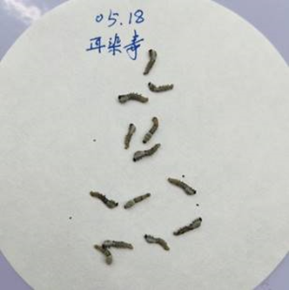
Figure S1. Symptoms in Bt-infected silkworms: side-lying, body decay, and discoloration.

