Determinants of Perception and Attitude Towards Agripreneurship Among Agricultural Students in Manipur, India

Abstract
This study examines the determinants of agricultural students’ perception and attitude toward agripreneurship in Manipur, based on research conducted during 2024–2025. A cross-sectional survey involving 100 undergraduate and postgraduate students from the South Asian Institute of Rural and Agricultural Management (SAIRAM) was carried out using a structured questionnaire. Descriptive analysis revealed high baseline awareness of agripreneurship (92%) but only moderate knowledge of government schemes. Correlation analysis showed that awareness, information sources, and scheme knowledge were significantly associated with perception. The regression model explained a substantial proportion of variation in attitudes (R² = 0.523), revealing agripreneurship awareness as the only significant predictor (β = 0.70), while demographic and background variables contributed no meaningful effects. This highlights that students’ entrepreneurial orientation is shaped primarily by exposure and understanding rather than personal characteristics. Strengthening practical agripreneurship modules, experiential learning, and targeted awareness initiatives can enhance students’ readiness for agribusiness. A key implication is that awareness-building is a scalable and effective strategy for promoting youth engagement in agripreneurship and advancing rural development in Manipur.
Keywords: agripreneurship, agricultural students, perception, attitude, extension education, awareness
1. Introduction
Agriculture constitutes one of the principal sources of revenue in Manipur and plays a pioneering role in strengthening the state's fiscal backbone. Despite its strategic importance, the agricultural sector faces significant challenges, including persistent youth unemployment, rural poverty, limited value-added enterprise development, and inadequate adoption of modern farming practices. In this context, agripreneurship the practice of combining agricultural production with entrepreneurial innovation has emerged as a critically needed strategy to revitalize the agricultural sector, boost rural income, create employment opportunities for youth, and foster innovation in farm-based enterprises[1].
Agripreneurship encompasses diverse activities ranging from precision agriculture and organic farming to value-addition, agricultural input supply, mechanization services, and agrotourism. By transitioning from subsistence farming to commercial agricultural enterprises, agripreneurship can unlock the region's substantial untapped potential for agribusiness development[1]. For Manipur specifically, where the economy is heavily dependent on traditional agriculture, the promotion of agricultural entrepreneurship represents a strategic imperative for economic diversification and rural development.
However, the transition towards agripreneurial activities requires not only infrastructure and financial support but also a fundamental shift in the perceptions and attitudes of agricultural professionals and students towards self-employment and business enterprise in agriculture. Agricultural students represent a critical demographic, as they constitute the future workforce that will either adopt traditional employment paths or venture into entrepreneurial activities. Understanding the factors that shape their perceptions of agripreneurship is essential for designing effective extension education programs and interventions.
1.1 Problem Context
Manipur’s agrarian economy remains a critical livelihood source, with nearly 70% of the population dependent on agriculture, yet the sector contributes only about 16–20% to the state’s Gross State Domestic Product (GSDP), reflecting persistent productivity gaps and limited value addition [2]. Youth unemployment in the state continues to rise, with estimates indicating rates significantly above the national average, making agripreneurship an increasingly relevant pathway for income generation and rural transformation. Despite this potential, there is limited understanding of the psychosocial factors that shape students’ willingness to pursue agribusiness careers.
Existing studies identify demographic characteristics, family background, educational exposure, and awareness of entrepreneurial opportunities as determinants of entrepreneurial intention [3] [4]. However, little is known about which of these factors matter most in shaping agripreneurial perception and attitude in the Northeast, a region with distinct sociocultural and agro-ecological features and limited agribusiness infrastructure. Research in Northeastern India remains sparse, with only a handful of studies addressing youth entrepreneurship or agripreneurship readiness [5] [6]. This creates a critical knowledge gap regarding how students in this region form entrepreneurial orientations.
In this study, perception refers to students’ cognitive appraisal and understanding of agripreneurship how they interpret its relevance, opportunities, and feasibility. Attitude reflects their evaluative disposition toward agripreneurial engagement, including interest, willingness to participate, and openness to pursuing agribusiness as a career pathway. Given the socioeconomic challenges and structural constraints in Manipur, understanding these psychological determinants is essential for designing targeted interventions that strengthen agripreneurial aspirations among youth.
1.2 Study Objectives
This study was designed to:
- Assess the current level of awareness among agricultural students regarding the agripreneurship concept
- Examine the relationship between demographic characteristics and perception of agripreneurship
- Evaluate the role of awareness, information sources, and knowledge of government schemes in shaping attitudes towards agripreneurship
- Identify the primary determinants of positive perception and attitude towards agripreneurship
- Provide evidence-based recommendations for extension education programs promoting agripreneurship
2. Materials and Methods
2.1 Study Design
A cross-sectional survey design was adopted to assess the determinants of agricultural students’ perception and attitude toward agripreneurship. This design enables the simultaneous examination of multiple variables at a single point in time and is widely used in behavioral, entrepreneurial, and social research for identifying associations and testing theoretical propositions [7] [8]. The study was conducted during 2024–2025.
2.2 Study Area, Population and Sampling
The study was conducted at the South Asian Institute of Rural and Agricultural Management (SAIRAM), located in Imphal West district of Manipur, India (Figure 1). The institute is situated at approximately 24°48′–25°12′ N latitude and 93°45′–93°54′ E longitude, at an average elevation of about 780 m above mean sea level (MSL). Imphal West lies within the Imphal Valley, which constitutes a major agricultural and educational hub of the state.
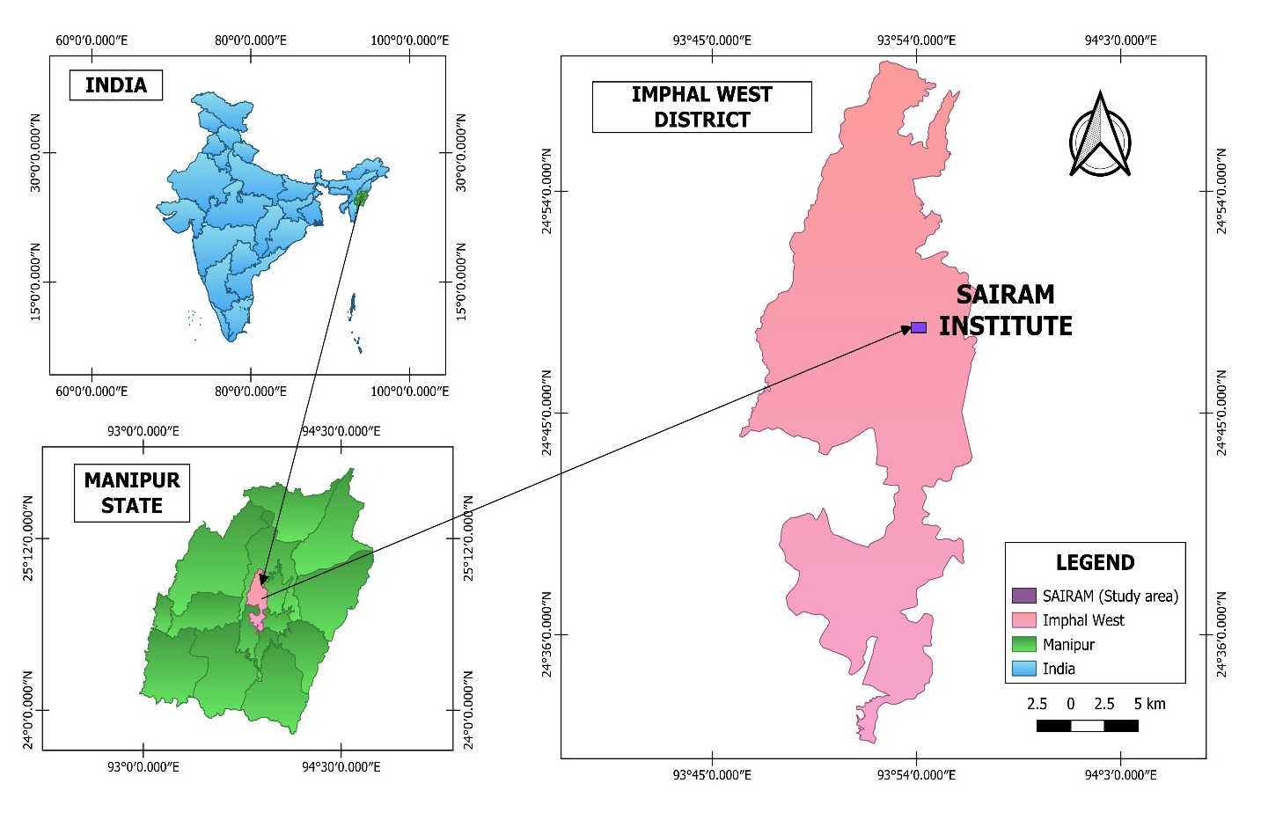
Figure 1: Spatial location of the study area, showing the position of SAIRAM within Imphal West district, Manipur, India. The study area map was generated using QGIS software (version 3.34).
This geographic setting is particularly relevant for examining agripreneurship awareness, as the region represents a transitional agrarian economy with increasing emphasis on entrepreneurship, value addition, and youth employment.
The study population comprised all undergraduate and postgraduate students enrolled in agricultural programs at the South Asian Institute of Rural and Agricultural Management (SAIRAM), Manipur (N = 257) (Figure 1). A purposive sampling strategy was employed to select 100 respondents. Purposive sampling was justified because agripreneurship awareness and attitude are most meaningfully assessed among students actively engaged in agricultural coursework, making them the most relevant target group for the study’s objectives [9]. Additional efforts ensured representation across gender, academic year, family background, and place of residence, thereby strengthening the internal validity of the findings. Purposive sampling is commonly applied in exploratory attitudinal studies where specific participant expertise or exposure is required [10].
2.3 Data Collection Instrument
A structured questionnaire was developed and administered to collect data [2] [3]. The questionnaire comprised four main sections:
- Demographic Information: Variables included gender, age, year of study (undergraduate vs. postgraduate), family background (agricultural vs. non-agricultural), and place of residence (urban, semi-urban, or rural).
- Awareness and Exposure: This section assessed prior knowledge of agripreneurship using a binary item ("Have you heard about the concept of agripreneurship?"), sources of information (ranging from educational institutions, media, personal networks, extension services, and others), and familiarity with government schemes supporting agripreneurship (binary yes/no format).
- Perception and Attitude: Multiple Likert-scale statements (typically 5-point) measured overall perception and attitude towards agripreneurship, with both positively and negatively worded items to ensure reliability and reduce response bias.
- Additional variables: The instrument also collected information on year of study and educational status.
The perception and attitude scale consisted of multiple 5-point Likert items (1 = strongly disagree to 5 = strongly agree). Scale reliability was assessed using Cronbach’s alpha; the attitude/perception scale showed acceptable internal consistency (Cronbach’s α = 0.78), indicating satisfactory reliability for group-level comparisons [11]. Item-level descriptive statistics and inter-item correlations were inspected to ensure no redundant or poorly performing items were retained.
2.4 Data Analysis
Data were analysed using IBM SPSS Statistics (v.26). Descriptive statistics (mean, standard deviation) summarized sample characteristics. Pearson correlation coefficients were computed to examine bivariate associations [12] [13]. A multiple linear regression model estimated unique predictors of overall perception and attitude. Prior to running the model, standard regression diagnostics were performed:
- Normality of residuals was assessed by inspection of histogram and Q–Q plots; residuals approximated normality.
- Multicollinearity was evaluated using Variance Inflation Factor (VIF); all predictors had VIF < 2.5, indicating no serious multicollinearity.
- Homoscedasticity of residuals was examined via scatter plot of standardized residuals against predicted values and indicated no strong heteroscedastic pattern.
- Influential cases were checked using Cook’s distance; no case exceeded commonly used cutoffs (Cook’s D < 1).
Statistical significance was set at α = 0.05. Regression coefficients (B), standard errors (SE B), standardized coefficients (β), t-values, p-values, R² and adjusted R² are reported in the Results section.
3. Results
3.1 Descriptive Statistics of Sample Characteristics
The descriptive statistics for the study sample (N = 100) provide an overview of respondents’ demographic and exposure-related characteristics relevant to understanding their perception and attitude toward agripreneurship. These indicators reflect the diversity of student backgrounds and levels of awareness that may later influence analytical outcomes. The summary of all variables is presented in Table 1, which outlines the distribution, ranges, means, and variances for each measure included in the study.
Table 1: Descriptive Statistics of Sample Characteristics (N = 100)
Variable | N | Range | Min | Max | Mean | Std. Dev. | Variance
Gender | 100 | 1 | 1 | 2 | 1.44 | 0.499 | 0.249
Age | 100 | 7 | 18 | 25 | 20.91 | 2.036 | 4.143
Year of Study | 100 | 1 | 1 | 2 | 1.39 | 0.490 | 0.240
Family Background | 100 | 1 | 1 | 2 | 1.66 | 0.476 | 0.227
Place of Residence | 100 | 2 | 1 | 3 | 1.92 | 0.849 | 0.721
Awareness of Agripreneurship | 100 | 1 | 0 | 1 | 0.83 | 0.378 | 0.143
Source of Information | 100 | 5 | 0 | 5 | 2.61 | 1.413 | 1.998
Knowledge of Govt. Schemes | 100 | 1 | 1 | 2 | 1.28 | 0.451 | 0.204

The sample consisted predominantly of young adults, with ages ranging from 18 to 25 years and an average age of 20.91 years (SD = 2.036). This suggests that respondents are primarily at a stage of early career exploration, which is particularly relevant when assessing entrepreneurial intentions. A young population often demonstrates higher openness to innovation and new livelihood opportunities, making agripreneurship a potentially attractive career path.
In terms of gender distribution, the mean value of 1.44 (coded as 1 = male, 2 = female) indicates a slightly higher proportion of female participants, comprising approximately 56% of the sample. This is noteworthy, as female engagement in agripreneurial initiatives is increasingly recognized as a driver of inclusive rural development. The representation of both genders ensures a balanced perspective on agripreneurship perceptions. Regarding educational status, the mean year of study was 1.39 (SD = 0.490), suggesting that most participants were in early stages of their academic program. Early-year students may have limited exposure to advanced entrepreneurship coursework, which could influence their baseline awareness and attitudes.
Family background results indicate that a majority of respondents (61%) came from agricultural households (coded 1 = agriculture, 2 = non-agriculture; M = 1.66). This demographic composition implies substantial direct or indirect familiarity with farming, potentially shaping students’ openness toward considering agriculture-based enterprises. Place of residence displayed moderate variability (M = 1.92, SD = 0.849), with many students coming from rural or semi-urban areas. These settings may influence access to agripreneurial resources, extension services, and exposure to agricultural innovations.
Exposure-related variables revealed important insights. A large proportion (92%) of students had previously heard about agripreneurship (M = 0.83), suggesting that the concept is relatively well-disseminated in the academic environment. However, knowledge of government schemes supporting agripreneurship was moderate (M = 1.28, SD = 0.451), indicating room for enhanced extension and institutional communication efforts. The mean score for sources of information (M = 2.61) shows considerable diversity in students’ access to agripreneurship-related information. This variation suggests that information channels such as media, peer learning, and academic instruction play differing roles across the student body. Overall, the descriptive statistics provide an informative context for understanding the patterns explored in subsequent correlation and regression analyses, highlighting the rich variability in student backgrounds and levels of awareness.
3.2 Correlation Analysis
Pearson correlation analysis was conducted to examine the direction and strength of associations between selected background/exposure variables and students’ overall perception and attitude toward agripreneurship. This analysis provides foundational insight into which factors meaningfully influence students’ agripreneurial orientation and which variables exert negligible effects. The full correlation matrix is presented in Table 2, followed by a heatmap visualization in Figure 1, designed to enhance interpretability and highlight the magnitude of significant associations.
Table 2. Correlations between Background/Exposure Variables and Overall Perception and Attitude towards Agripreneurship (N = 100).
Variable | Gender | Family Background | Place of Residence | Awareness of Agripreneurship | Source of Information | Knowledge of Govt. Schemes | Overall Perception & Attitude
1. Gender | ---
2. Family Background | 🟦 (.141) | ---
3. Place of Residence | 🟦 (−.053) | 🟦 | ---
4. Awareness of Agripreneurship | 🟦 (.025) | 🟦 | 🟦 | ---
5. Source of Information | 🟥 (.708)** | 🟦 | 🟦 | 🟧 (.569)** | ---
6. Knowledge of Govt. Schemes | 🟧 (.236)* | 🟦 | 🟦 | 🟥 | 🟧 | ---
7. Overall Perception & Attitude | 🟨 (.141) | ⬜ (−.053) | 🟦 (.025) | 🟥 (.708)** | 🟧 (.569)** | 🟨 (.236)* | ---
*Notes on the Heat-Map Table
The highest correlation (strong) is between awareness and perception → 🟥 (.708).
The second highest (moderate) is source of information → 🟧 (.569).
Knowledge of government schemes shows a weak but significant relationship → 🟨 (.236).
All demographic variables fall into weak or near-zero correlation ranges, showing they do not meaningfully influence perception.
Values represent Pearson correlation coefficients; p-values in parentheses. p < .05, p < .001.
The correlations show that gender, family background, and place of residence are not significantly associated with perception and attitude. Specifically, gender (r = .141, p = .162), family background (r = −.053, p = .601), and place of residence (r = .025, p = .806) exhibit very weak relationships. These results suggest that inherent demographic traits do not meaningfully shape agripreneurial orientation, reinforcing the perspective that entrepreneurial disposition in agriculture is a learned rather than innate attribute. In contrast, variables reflecting awareness, exposure, and knowledge demonstrate stronger and statistically significant associations. Awareness of agripreneurship stands out with a strong positive correlation (r = .708, p < .001), indicating that students who have prior familiarity with the concept tend to possess substantially more favorable perceptions and attitudes. The source of information shows a moderate positive correlation (r = .569, p < .001), implying that access to diverse information channels such as media, extension programs, or academic institutions—supports the development of positive agripreneurial perceptions. Knowledge of government schemes also displays a weak yet significant association (r = .236, p = .018), suggesting that awareness of institutional support structures plays a role in shaping students’ inclination toward agripreneurship.
To enhance interpretation, a heat-map visualization of these correlations is presented in Figure 2, allowing readers to quickly identify influential variables through color intensity and significance markers.
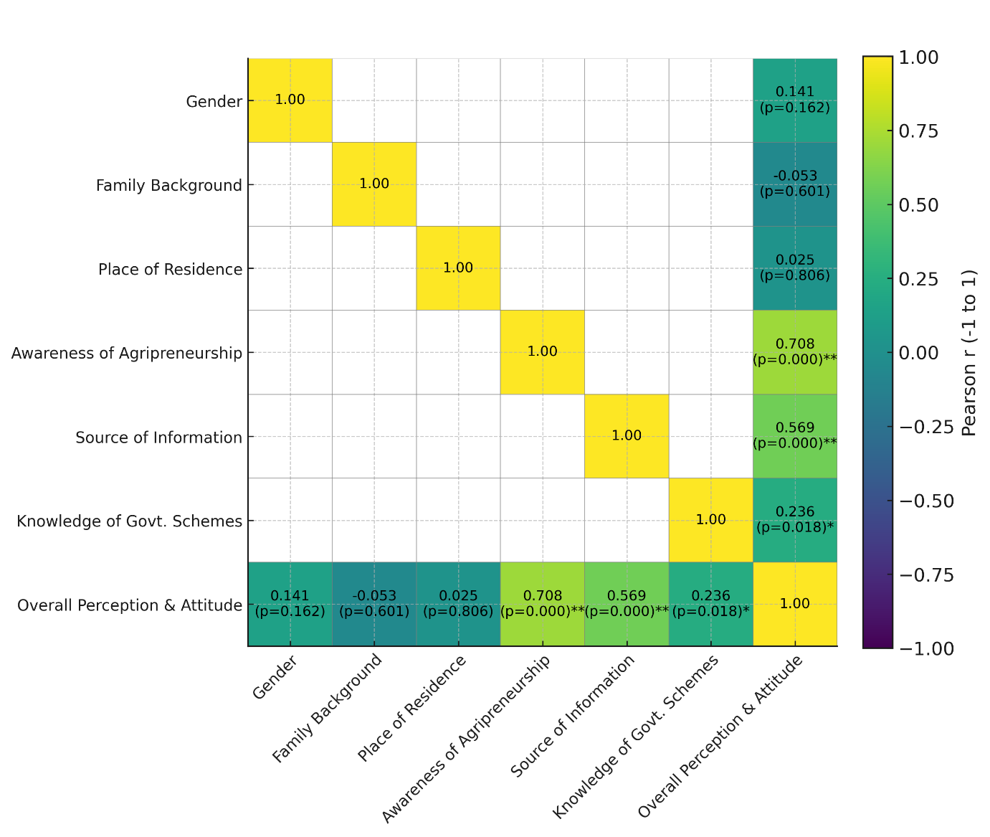
Figure 2: *Correlation heatmap illustrating the relationships between background and exposure variables and overall perception and attitude towards agripreneurship among agricultural students (N = 100). Pearson correlation coefficients are displayed within cells, with significance levels indicated by asterisks (*p < .05; *p < .001). Strong positive correlations are indicated by darker shading, while weak or non-significant correlations appear lighter. Only significant associations—awareness of agripreneurship, source of information, and knowledge of government schemes—show meaningful positive relationships with overall perception and attitude.
Collectively, these findings underscore the importance of exposure, awareness, and knowledge dissemination mechanisms in shaping agripreneurial attitudes providing valuable guidance for extension education and curriculum design efforts aimed at fostering entrepreneurial mindsets among youth.
3.3 Multiple Linear Regression Analysis
A multiple linear regression model was developed to identify the strongest predictors of agricultural students’ perception and attitude toward agripreneurship. The model incorporated eight predictors gender, age, year of study, family background, place of residence, prior awareness of agripreneurship, source of information, and knowledge about government schemes to determine their unique contributions to explaining variance in perception scores. The summary of the model outputs is provided in Table 3.
A multiple linear regression model was constructed to identify the strongest predictors of agricultural students’ overall perception and attitude toward agripreneurship. The model incorporated eight predictors: gender, age, year of study, family background, place of residence, prior awareness of agripreneurship, source of information, and knowledge of government schemes. This analytical approach allows for the simultaneous assessment of each variable’s unique contribution while controlling for other factors. The complete regression output is presented in Table 3, with graphical representations shown in Figures 3.
Table 3. Multiple Linear Regression Predicting Overall Perception and Attitude Towards Agripreneurship (N = 100).
Predictor | B | SE B | β | t | p
Constant | 22.63 | 2.70 | – | 8.38 | <.001
Gender | 0.48 | 0.49 | 0.07 | 0.97 | .336
Age | -0.01 | 0.15 | -0.01 | -0.09 | .925
Year of study | -0.53 | 0.59 | -0.08 | -0.89 | .376
Family background | -0.29 | 0.59 | -0.04 | -0.49 | .622
Place of residence | 0.59 | 0.34 | 0.16 | 1.72 | .088
Heard about agripreneurship | 6.04 | 1.14 | 0.70 | 5.31 | <.001
Source of information | 0.09 | 0.31 | 0.04 | 0.29 | .770
Knowledge about govt schemes | 0.13 | 0.59 | 0.02 | 0.22 | .830
Note. B = unstandardized coefficient; SE B = standard error; β = standardized coefficient; p = significance level.
The overall regression model was statistically significant, F(8, 91) = 12.43, p < .001, and explained a substantial proportion of variance with R² = 0.523 and Adjusted R² = 0.481. This indicates that the included predictors collectively account for 52.3% of the variability in perception and attitude. Among all predictors, prior awareness of agripreneurship emerged as the only statistically significant variable (B = 6.04, β = 0.70, p < .001). This exceptionally strong standardized coefficient indicates that awareness is the dominant predictor, far outweighing demographic or informational variables. A one-unit increase in awareness results in an estimated 6.04-point rise in perception scores, emphasizing awareness as the most influential determinant.
Place of residence demonstrated a marginal effect (B = 0.59, p = .088), suggesting that students from urban or semi-urban areas may exhibit slightly more favorable views, likely due to greater exposure to entrepreneurial activity or better access to support infrastructure. Although this effect does not reach statistical significance, it may signal an emerging pattern worthy of further investigation. All other predictors gender, age, year of study, family background, source of information, and knowledge of schemes showed non-significant effects (p > .05), indicating that neither demographic characteristics nor general informational exposure independently influence perceptions unless paired with deeper conceptual awareness.
Graphical interpretation of the regression model is presented in Figure 3, which depicts the unstandardized regression coefficients along with their variability estimates. The visualization clearly highlights that awareness of agripreneurship is the only statistically significant predictor influencing students’ perceptions and attitudes, as its coefficient remains distinctly above zero, while the variability intervals for all other predictors cross zero, indicating non-significance.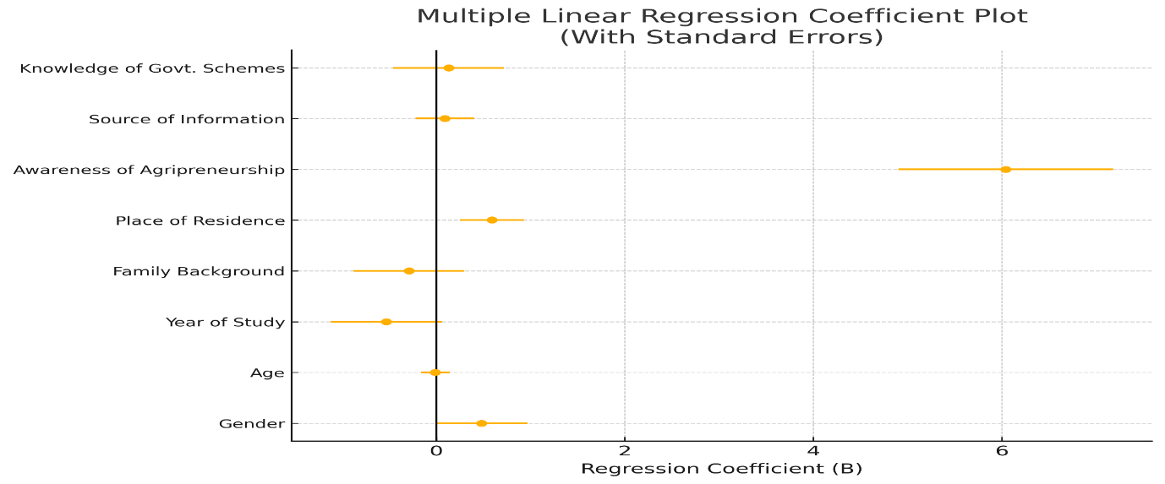
Figure 3: Forest plot illustrating the unstandardized regression coefficients and their associated variability for the predictors included in the multiple linear regression model. The plot shows that awareness of agripreneurship is the only significant determinant of perception and attitude, whereas the intervals for all other predictors cross zero, indicating non-significance.
4. Discussion
4.1 Interpretation of Descriptive Statistics of Sample Characteristics
The sample consists of young agricultural students who are largely at an early stage of their professional and academic journey. Most respondents were in the early years of study, and a majority came from agricultural households, indicating familiarity with agricultural practices. Gender distribution was slightly female-skewed. General awareness of agripreneurship was very high across the group, although knowledge of government schemes remained only moderate. Sources of information about agripreneurship varied widely among students. This pattern aligns with entrepreneurship literature, which highlights awareness and knowledge as foundational cognitive elements influencing entrepreneurial intention and behavior [14] [15].
For SAIRAM, these descriptive patterns suggest a strong opportunity for targeted intervention: students are young, receptive, and have some agricultural exposure, yet lack clarity on how to navigate support mechanisms. In Manipur’s broader context characterized by a predominantly rural economy and limited agribusiness infrastructure the combination of agricultural family backgrounds and high conceptual awareness signals readiness for capacity-building initiatives. However, the moderate level of scheme knowledge highlights a communication gap: students may know about agripreneurship conceptually but may not fully understand how to operationalize government programs such as incubation and credit-linkage schemes. To address this, SAIRAM can integrate practical modules, scheme walkthroughs, and local internship placements that mirror Manipur’s agro-ecological strengths, including horticulture, floriculture, aquaculture, and small-scale food processing.
4.2 Interpretation of Correlation Findings
The correlation patterns reveal that demographic variables such as gender, family background, and place of residence show no meaningful association with students’ perceptions and attitudes toward agripreneurship. In contrast, exposure-related variables such as awareness, information sources, and scheme knowledge show positive associations of varying strength, with awareness demonstrating the strongest relationship. This pattern differs from earlier studies that attributed entrepreneurial differences primarily to demographic factors [16].
These findings indicate that cognitive exposure, rather than demographic background, plays a more influential role in shaping agripreneurial attitudes. When students know what agripreneurship entails and have access to reliable sources of information, they are more likely to develop positive perceptions. For SAIRAM, this suggests that efforts aimed at improving conceptual clarity through case studies, laboratory sessions, guest lectures, or interactions with entrepreneurs may be more effective than demographic-targeted strategies.
In Manipur, the strong relationship between awareness and perception suggests that statewide awareness initiatives, including collaboration with KVKs, extension units, and targeted digital outreach, could meaningfully shift attitudes at scale [17]. However, the comparatively weaker association with scheme knowledge indicates that simply informing students about schemes is insufficient; communications must provide practical, localized illustrations of how these schemes work in real contexts (such as small processing units in the Imphal Valley) to improve perceived utility and adoption.
4.3 Interpretation of Multiple Regression Findings
The regression model demonstrates that awareness of agripreneurship is the only meaningful predictor of students’ perceptions and attitudes, as shown in Table 3 and Figure 2. A slight trend related to place of residence suggests small differences in readiness across locations, but this remains secondary compared to the dominant influence of awareness. All other variables gender, age, year of study, family background, source of information, and knowledge of schemes do not meaningfully contribute to prediction once awareness is considered.
These findings suggest that although several factors show positive associations at the bivariate level, awareness acts as the primary causal lever when controlling for other variables. For SAIRAM, this underscores the importance of structured pathways that move students from conceptual awareness to practical skills through modules on business planning, entrepreneurship workshops, mentorship programs, and enterprise exposure visits.
In Manipur, where agripreneurial opportunities exist but are not widely visible, policy and extension bodies should pair awareness campaigns with localized support mechanisms, such as improved market linkages, access to micro-credit, and demonstration enterprises. This approach ensures that strong awareness translates into actual entrepreneurial behavior. The slight effect related to place of residence suggests that semi-urban areas may provide initial advantages due to better access to markets and infrastructure, offering strategic locations for pilot interventions.
5. Implications for Extension Education
Based on our findings, the following priority actions are recommended:
- Scale up awareness campaigns: Use multimedia, campus outreach, and extension networks to communicate agripreneurial concepts and success stories [18].
- Curriculum integration: Embed practical agripreneurship modules, case studies and business plan assignments into undergraduate and postgraduate curricula.
- Experiential learning: Facilitate field visits, internships, incubation projects and mentorship linking students to local agribusinesses [19].
- Scheme facilitation: Conduct hands-on workshops on navigating government schemes (eligibility, application, benefit examples) and provide one-on-one scheme advisory clinics.
- Campus incubation hubs: Establish agripreneurship hubs that offer mentorship, market linkages, and assistance to access credit and inputs [20].
- Targeted outreach: Provide tailored support for students from non-agricultural backgrounds or first-generation farm families to ensure inclusivity.
- Monitoring & evaluation: Implement M&E for awareness initiatives to measure changes in knowledge, attitudes and subsequent entrepreneurial actions.
6. Context-Specific Relevance for Manipur
Manipur presents diverse agro-ecological strengths that offer significant potential for agripreneurship development. The state’s varied terrain and climate enable profitable ventures across sectors such as high-value horticulture, including vegetables and fruits that are increasingly demanded in urban markets; floriculture, particularly orchids and ornamental plants for which Manipur is well known; and medicinal and aromatic plants, which thrive in the hill districts and offer opportunities for essential oil extraction and herbal product development [21] [22] [23] [24] [25]. Aquaculture also represents a major opportunity, with the valley regions supporting fish production and growing demand for farmed and processed fish products [26]. Additionally, there is expanding potential in value-added food processing, including traditional fermented foods, dried products, herbal teas, and spices, which can be commercialized with appropriate packaging and branding support [27] [28]. The rising interest in organic farming, especially crops such as black rice (Chakhao), ginger, turmeric, and indigenous pulses, further positions Manipur as an emerging niche-agriculture hub [29]. Other promising sectors—such as beekeeping, honey-based enterprises, and agro-tourism—provide youth-friendly, low-investment agribusiness pathways [30] [31].
Awareness is especially critical in Manipur’s predominantly hilly and remote areas, where limited market connectivity, fragmented value chains, and infrastructure constraints often restrict information flow. Enhanced awareness can reduce information asymmetry, improve students’ understanding of market opportunities, and encourage adoption of value-addition techniques suited to small and medium-scale enterprises. It also helps rural youth understand government schemes, credit channels, and incubation opportunities that they may otherwise overlook. Exposure to successful agripreneurial models within the state or region can lower perceived risk and improve entrepreneurial confidence, making awareness a foundational driver of agribusiness initiation.
Manipur’s agrarian economy, characterized by fragmented markets, limited value addition, and high youth unemployment, creates both a pressing need and an enabling context for agripreneurship [1]. While students demonstrate high conceptual awareness, this must translate into practical, actionable knowledge for entrepreneurship to materialize. Agripreneurship development aligns directly with Manipur’s broader development goals, including livelihood diversification, rural enterprise growth, and sustainable agricultural modernization [22]. SAIRAM, as a key academic institution, is strategically positioned to function as an agripreneurship incubation node working with extension agencies, government departments, private partners, and financial institutions to deliver opportunity-driven training and exposure. Strengthening awareness through targeted communication, entrepreneurship clubs, mentorship programs, and regional demonstration models can significantly accelerate youth participation in agribusiness ventures. Thus, agripreneurship promotion in Manipur is not merely an educational recommendation but a strategic pathway for rural transformation, enabling young agricultural professionals to engage with emerging sectors and contribute to the state’s economic resilience.
7. Conclusions
This study shows that agripreneurship awareness is the strongest influence on agricultural students’ perceptions and attitudes in Manipur, exceeding the contribution of demographic or background factors. The findings indicate that positive entrepreneurial orientation emerges when students gain meaningful insight into agripreneurship opportunities, suggesting that informed understanding is more decisive than characteristics such as gender, age, or family background. This highlights the need to shift institutional efforts toward deepening awareness and strengthening practical exposure. Two actionable recommendations follow from these results. First, institutions such as SAIRAM should establish structured awareness-to-skill pathways, including hands-on modules, enterprise demonstrations, and mentorship programs that guide students toward real agribusiness application. Second, state agencies should invest in localized awareness ecosystems, using community demonstrations, digital outreach, and coordinated extension messaging to make agripreneurship opportunities visible and accessible across diverse regions. Overall, the study positions awareness-building as a strategic entry point for expanding youth participation in agribusiness and supporting long-term rural transformation in Manipur.
8. Key Recommendations
8.1. For Extension Education Programs:
- Develop Comprehensive Awareness Campaigns: Design and implement targeted awareness campaigns highlighting the diversity of agripreneurial opportunities, including value-added agriculture, precision farming, agricultural technology services, and agrotourism.
- Establish Agripreneurship Hubs: Create campus-based or community-based agripreneurship hubs providing mentorship, business planning support, market linkages, and access to financial resources.
- Integrate Entrepreneurship into Agricultural Curricula: Mandate inclusion of agripreneurship modules in undergraduate and postgraduate agricultural programs, with emphasis on practical skill-building and experiential learning.
- Facilitate Entrepreneur Mentorship: Connect agricultural students with successful agripreneurs for mentoring, knowledge transfer, and motivation.
- Strengthen Communication of Government Support Schemes: Conduct targeted workshops and webinars to educate students about relevant government schemes, eligibility criteria, application processes, and success stories of beneficiaries.
8.2. For Policy and Agricultural Development:
- Fund Extension Education Initiatives: Allocate dedicated funding to extension services for agripreneurship awareness campaigns and capacity-building programs.
- Create Student Entrepreneur Incentives: Develop specific incentive programs (grants, concessional credit, tax benefits) for agricultural students and recent graduates entering agripreneurship.
- Establish Market Linkages: Facilitate connections between agripreneur initiatives and markets, supply chains, and distribution networks to enhance viability and sustainability.
8.3. For Future Research:
- Longitudinal Studies: Conduct follow-up studies tracking changes in attitudes and actual entrepreneurial behavior over time.
- Qualitative Investigations: Employ qualitative methods to gain deeper understanding of how awareness translates into behavioral intention and actual entrepreneurial action.
- Intervention Evaluations: Evaluate the effectiveness of specific awareness-building interventions in changing attitudes and fostering entrepreneurial behavior.

Ethical Approval and Consent:
The study protocol was reviewed and approved by the Institutional Ethics Committee, South Asian Institute of Rural and Agricultural Management. Participation was voluntary and informed written consent was obtained from all respondents prior to data collection. Confidentiality and anonymity were maintained, data were collected without personal identifiers and stored on password-protected devices accessible only to the research team.

DISCLAIMER (ARTIFICIAL INTELLIGENCE)
Author(s) hereby declare that NO generative AI technologies such as Large Language Models (ChatGPT, COPILOT, etc) and text-to-image generators have been used during writing or editing of this manuscript.
References
[1] Chungkham, D., Singh, S. R., Ram, D., & Leishangthem, B. S. (2025). Prospects of agripreneurship in Manipur, India. Journal of Scientific Research and Reports, 31(6), 1015–1032. https://doi.org/10.9734/jsrr/2025/v31i63194.
[2] NABARD. (2019). National Bank for Agriculture and Rural Development. State Focus Paper: Manipur State Focus Paper 2019–20. https://www.nabard.org/auth/writereaddata/tender/1702201825Manipur.pdf
[3] Ajzen, I. (1991). The theory of planned behavior. Organizational Behavior and Human Decision Processes, 50(2), 179–211. https://doi.org/10.1016/0749-5978(91)90020-t
[4] Licht, A. N., & Siegel, J. I. (2009). The social dimensions of entrepreneurship. In Oxford University Press eBooks (pp. 511–539). https://doi.org/10.1093/oxfordhb/9780199546992.003.0019
[5] Kadirvel, G., Gangmei, D. L., Banerjee, B. B., Assumi, S. R., Dkhar, S. E., & Mukherjee, A. (2020). Agri-business in North East India: current status, potential ventures and strategies. Current Journal of Applied Science and Technology, 74–85. https://doi.org/10.9734/cjast/2020/v39i3331021
[6] Hijam, K., & Meetei, K. D. (2025). A study on growth progress of start-ups in the North East India. International Journal of Creative Research Thoughts, 13(2), [pages]. International Journal of Creative Research Thoughts. https://www.ijcrt.org/papers/IJCRT2502081.pdf
[7] Creswell, J. W. (2009). Research design: Qualitative, quantitative, and mixed methods approaches (3rd ed.). SAGE Publications. https://www.ucg.ac.me/sklad
[8] Bryman, A. (2016). Social research methods (5th ed.). Oxford University Press. https://ktpu.kpi.ua/wp-content/uploads/2014/02/social-research-methods-alan-bryman.pdf
[9] Etikan, I. (2016). Comparison of convenience sampling and purposive sampling. American Journal of Theoretical and Applied Statistics, 5(1), 1. https://doi.org/10.11648/j.ajtas.20160501.11
[10] Palinkas, L. A., Horwitz, S. M., Green, C. A., Wisdom, J. P., Duan, N., & Hoagwood, K. (2013). Purposeful sampling for qualitative data collection and analysis in mixed method implementation research. Administration and Policy in Mental Health and Mental Health Services Research, 42(5), 533–544. https://doi.org/10.1007/s10488-013-0528-y
[11] Tavakol, M., & Dennick, R. (2011). Making sense of Cronbach’s alpha. International Journal of Medical Education, 2, 53–55. https://doi.org/10.5116/ijme.4dfb.8dfd
[12] Creswell, J. W., & Creswell, J. D. (2018). Research design: Qualitative, quantitative, and mixed methods approaches (5th ed.). SAGE Publications. https://edge.sagepub.com/field5e
[13] Osborne, J. W., & Waters, E. (2002). Four assumptions of multiple regression that researchers should always test. Practical Assessment, Research & Evaluation, 8(2). https://www.researchgate.net/publication/234616195_Four_Assumptions_of_Multiple_Regression_That_Researchers_Should_Always_Test
[14] Megaladevi, P., Malini, D. H., Nagi, M. S., Kumar, S. a. S., & Muthukrishnan, B. (2024). Entrepreneurial Intentions among the Agricultural Graduates in Rural Location [English]. In ORGANIZATION, PURPOSE, AND VALUES (1st ed., Vol. 1, pp. 456–468). Taylor & Francis. https://doi.org/10.4324/9781003501374-34.
[15] Nath, D., Tamuk, Y., & Gohain, I. (2024). Constraints encountered by the KVK beneficiaries of Manipur and their suggestions. Journal of Experimental Agriculture International, 46(9), 1061–1067. https://doi.org/10.9734/jeai/2024/v46i92902.
[16] Condor, R. (2020). Entrepreneurship in agriculture: a literature review. International Journal of Entrepreneurship and Small Business, 40(4), 516. https://doi.org/10.1504/ijesb.2020.10031117.
[17] Verheul, I., Thurik, R., Grilo, I., & Van Der Zwan, P. (2011). Explaining preferences and actual involvement in self-employment: Gender and the entrepreneurial personality. Journal of Economic Psychology, 33(2), 325–341. https://doi.org/10.1016/j.joep.2011.02.009.
[18] Pan, Y., Zhang, S., & Zhang, M. (2023). The impact of entrepreneurship of farmers on agriculture and rural economic growth: Innovation-driven perspective. Innovation and Green Development, 3(1), 100093. https://doi.org/10.1016/j.igd.2023.100093.
[19] Neck, H. M., & Greene, P. G. (2010). Entrepreneurship Education: known worlds and new frontiers. Journal of Small Business Management, 49(1), 55–70. https://doi.org/10.1111/j.1540-627x.2010.00314.x.
[20] United Nations. (2015). Transforming our world: The 2030 agenda for sustainable development. UN Sustainable Development Goals 1 (No Poverty), 8 (Decent Work and Economic Growth), and 12 (Responsible Consumption and Production). https://sdgs.un.org/publications/transforming-our-world-2030-agenda-sustainable-development-17981.
[21] Panmei, R. R., & Sorokhaibam, R. (2024). Exploring regional growth and variations in horticultural production: The case of Manipur. International Journal of Creative Research Thoughts, 12(11). https://www.ijcrt.org/papers/IJCRT2411769.pdf
[22] Behera, T.K. and Dubey, R.K. (2023). Prospects of Vegetable Crop Production in Northeast Region. Indian Council of Agricultural Research-Indian Horticulture, 45-49. https://epubs.icar.org.in/index.php/IndHort/article/download/148516/53879/472664
[23] Sadananda K., Thongam B. and Konsam B. (2019). Orchid species of Manipur and its commercial aspect. International Journal of Pharmacy and Life Sciences, 10(7-8): 6302-6314. https://ijplsjournal.com/index.php/ijpls/article/view/426/410
[24] Maibam, P., Sahi, V. P., & Singh, T. G. (2022). A Review of Medicinal Plants Commonly Used in Manipur: with Special Reference Against COVID-19. Journal of Ayurvedic and Herbal Medicine, 8(3), 204–208. https://doi.org/10.31254/jahm.2022.8312
[25] Singh, N. B., Devi, M. L., Biona, T., Sharma, N., Das, S., Chakravorty, J., Mukherjee, P. K., & Rajashekar, Y. (2023). Phytochemical Composition and Antimicrobial Activity of Essential Oil from the Leaves of Artemisia vulgaris L. Molecules, 28(5), 2279. https://doi.org/10.3390/molecules28052279
[26] Dorothy, M.S., Monsang, S.J., Sribidya, W., Parhi, J. and Bidyasagar, S. (2018). Present Status and Future Prospects of Fisheries In Manipur. Indian Journal of Ecology (2018) 45(1): 222-226. https://indianecologicalsociety.com/wp-content/themes/ecology/volume_pdfs/abstract37.pdf
[27] Kabui, K. K., Rawson, A., & Athmaselvi, K. (2024). Selected fermented foods of Manipur, India: Traditional preparation methods, nutritional profile, and health benefits. Food Chemistry Advances, 6, 100864. https://doi.org/10.1016/j.focha.2024.100864
[28] Singh, H. N., Devi, M. L., & Thongam, H. (2025). Indigenous spices of Manipur: traditional practices, health benefits, and economic potential. Zenodo (CERN European Organization for Nuclear Research). https://doi.org/10.5281/zenodo.14603049
[29] Konjengbam, M. D., Singh, D., Yadav, R. N., Singh, D. K., Singh, L. B., Kumar, M., Sachan, D. K., & Pandey, M. K. (2023). Impact of organic farming on the livelihood of organic farmers in Manipur. Asian Journal of Agricultural Extension Economics & Sociology, 41(10), 350–356. https://doi.org/10.9734/ajaees/2023/v41i102178
[30] Patle, N.K. and Shitiri, M. (2019). Beekeeping in Northeast Region of India. Indian Council of Agricultural Research-Indian Horticulture, 102–104. https://epubs.icar.org.in/index.php/IndHort/article/download/148537/53891/472683
[31] Rubita, I. (2024). The concept of Agri-Tourism and the traditional farming in Manipur. International Journal of Research and Scientific Innovation, XI(VIII), 694–697. https://doi.org/10.51244/ijrsi.2024.1108056

