Impact of Manure Synergy on Growth and Yield in Paddy Cultivation through Frontline Demonstrations in ASR District, Andhra Pradesh, India

ABSTRACT.
Krishi Vigyan Kendra, Kondempudi conducted 30 Front Line Demonstrations (FLDs) on organic paddy cultivation covering 12 ha over three consecutive years (2022–23 to 2024–25) in farmers’ fields of Alluri Sitarama Raju (ASR) district to evaluate the performance of an integrated organic farming package in comparison with traditional farmer practices. The demonstrations followed the organic package of practices developed by Acharya N.G. Ranga Agricultural University (ANGRAU), comprising green manuring, farmyard manure (10 t ha⁻¹), biofertilizers (Azospirillum, PSB, KRB), neem cake application, seed treatment with Pseudomonas fluorescens, and soil application of liquid organic formulations, whereas farmers’ practice involved the sole application of FYM at 6.25 t ha⁻¹.Pooled analysis revealed that the demonstrated organic package recorded a significantly higher mean grain yield of 34.2 q ha⁻¹, representing a 29% increase over farmers’ practice (26.5 q ha⁻¹). The integrated organic approach also resulted in superior economic returns, with an average net income of ₹40,790 ha⁻¹ and a benefit–cost (B:C) ratio of 2.12, compared to ₹28,179 ha⁻¹ net income and a B:C ratio of 1.91 under traditional practice. Yield enhancement under demonstrations was attributed to improved nutrient availability, better crop growth, and enhanced soil biological activity due to the combined application of multiple organic inputs rather than FYM alone. The study clearly demonstrates that adoption of an integrated organic nutrient management package can substantially enhance productivity, profitability, and sustainability of paddy cultivation in tribal farming systems.
Keywords: Paddy, Front Line Demonstration, Organic and Traditional Farmer Practices, Yield and Economics

Introduction

Rice (Oryza sativa L.) is the principal staple food for more than half of the global population and plays a central role in food and nutritional security, particularly in Asia. With increasing population pressure, shrinking arable land, climate variability, and changing dietary patterns, enhancing rice productivity through sustainable means has become a major global challenge. In India, rice occupies a pivotal position in the agricultural economy, as leading states such as West Bengal, Uttar Pradesh, Punjab, Andhra Pradesh, Tamil Nadu, Bihar, Odisha, and Chhattisgarh collectively contribute over 70% of the country’s total paddy production (Singh et al., 2021). However, decades of intensive rice cultivation dependent on chemical fertilizers, pesticides, and high external inputs have resulted in widespread concerns related to soil degradation, declining factor productivity, groundwater pollution, biodiversity loss, and risks to human health. In this context, organic and natural farming systems are increasingly recognized as viable pathways for achieving long-term sustainability in rice production. These systems emphasize ecological balance, soil health restoration, and efficient nutrient recycling while minimizing reliance on synthetic inputs. Organic amendments such as compost, farmyard manure (FYM), green manures, and vermicompost not only supply nutrients but also enhance soil organic carbon, improve physical properties, stimulate microbial activity, and strengthen nutrient use efficiency, thereby improving crop resilience under biotic and abiotic stresses (Sharma, 2006). Evidence suggests that well-managed organic systems can stabilize yields over time while improving soil fertility and ecosystem services, which are critical under climate-change-prone environments.
The Alluri Sitarama Raju (ASR) district of Andhra Pradesh, located in a hilly tribal agro-ecological zone, presents a particularly important case for promoting organic agriculture. Farming in this region is largely “organic by default,” as tribal farmers traditionally use minimal chemicals and depend on locally available organic inputs such as FYM, forest litter, and crop residues. In mandals including Hukkumpeta, Araku, Dumbriguda, Pedabayalu, Anantagiri, and Munchingput, agriculture is predominantly rainfed, characterized by mixed cropping systems and low-input management. While these practices align well with organic principles, the absence of structured nutrient management, scientific guidance, and access to organic inputs often results in suboptimal yields and low farm income. This highlights a critical gap between traditional knowledge and scientifically validated organic production technologies. Previous studies have demonstrated that the optimization and integration of multiple organic inputs rather than reliance on FYM alone can significantly enhance crop growth, yield attributes, and economic returns while preserving soil health (Stockdale et al., 2001) and Kumar, S. (2025). Therefore, the ASR district offers a strong foundation and a unique opportunity for transforming subsistence, low-input tribal farming into a profitable and sustainable organic production system through evidence-based interventions, capacity building, and effective extension mechanisms.
In view of these challenges and opportunities, the present study was undertaken to assess and promote integrated organic farming practices in paddy cultivation under tribal conditions through frontline demonstrations. The study emphasizes the importance of moving beyond the traditional practice of sole FYM application and adopting a holistic organic nutrient management package that combines green manuring, biofertilizers, organic amendments, and improved agronomic practices. By scientifically evaluating the productivity and economic benefits of such integrated organic approaches, the study aims to generate location-specific evidence that can support technology dissemination, policy decisions, and scaling up of organic farming in tribal and rainfed ecosystems. Ultimately, the findings are expected to contribute not only to higher paddy yields and farm income, but also to long-term soil health, environmental sustainability, livelihood security, and nutritional well-being of tribal communities
Materials and Methods:
Krishi Vigyan Kendra, Kondempudi has conducted 30 front line demonstrations in 12 ha area on farmer’s field in different villages of ASR district from 2022 to 2024. In front line demonstrated field, the paddy crop was sown with a variety of RGL-2537 and treatments of T1: Organic farming package of ANGRAU (T₁ : Organic farming (Seed treatment with Pseudomonas fluorescence @ 10 g/ kg of seed first and shade dry for few hours. Basal application: Raising green manure crop with a seed rate of 15 kg per acre and in situ incorporation at 50% flowering stage before transplanting. Application of farm yard manure (FYM) @ 10.0 t per hactare at the time of planting. Application of Azospirillum, PSB and KRB @ 1250 ml per ha each, along with 100 kg FYM at the time of planting. Top dressing: Neemcake @ 500 kg per hectare at tillering and Pl stage. Soil application of Drava Jeevamrutham (500 L per hactare) three times from 15 DAT at 20 days interval and T2: farmers practice (FYM @ 6.25 t/ha). Soils condition of ASR district was red loamy in texture with low to medium in organic carbon content and other nutrients like Nitrogen, Phosphorous, and High in Potassium. In front line demonstrated fields; Seeds were sown as nursery after seed treatment and transplant only healthy seedlings in the field at 30 days old. All the organic package was imposed as per information mentioned in Package of Practices in paddy field as per. The output data like growth attributes, yield attributes , expenditure, profit, yield etc were collected from farmers grow paddy under demonstrated field as well as farmer grown paddy under traditional farming practices to compare the gap between the technologies. Finally, the Technology gap, Extension gap, Technology index along with B:C ratio were analysed by the formulas as given by (Katare et al. 2011) and (Samui et al. 2000).

Results and Discussion:
Effect of Organic Package of ANGRAU on Growth, Yield Components, and Yield
30 Front line demonstration on organic farming paddy were shown on farmers field in 12ha areas during three consecutive years i.e., 2022-23, 2023-24 and 2024-25. In demonstration field, farmers follows all the cultural and management practices from nursery sowing of paddy crop to final harvest in their field as mentioned in organic Package of Practices like Pseudomonas fluorescence @ 10 g/ kg of seed first and shade dry for few hours. Basal application: Raising green manure crop with a seed rate of 15 kg per acre and in situ incorporation at 50% flowering stage before transplanting. Application of farm yard manure (FYM) @ 10.0 t per hectare at the time of planting. Application of Azospirillum, PSB and KRB @ 1250 ml per ha each, along with 100 kg FYM at the time of planting. Top dressing: Neemcake @ 500 kg per hectare at tillering and Pl stage. Soil application of Drava Jeevamrutham (500 L per hectare) three times from 15 DAT at 20 days interval. The application of the organic package developed by ANGRAU had a significant influence on growth parameters, yield components, and overall yield when compared to the sole application of farmyard manure (FYM), as shown in Table 1. Growth parameters such as plant height and number of tillers per hill were recorded at 30-day intervals. In the frontline demonstration plots, the average plant height was 50.7 cm at 30 days after transplanting (DAT), 90.8 cm at 60 DAT, 114.4 cm at 90 DAT, and 113.6 cm at harvest. In contrast, under farmers' practice, the corresponding values were lower, recorded at 42.6 cm, 82.5 cm, 101.3 cm, and 100.3 cm, respectively. With record to Yield components were measured at harvest and included the number of productive tillers per hill, number of grains per panicle, and panicle length. In the demonstration plots, the average number of productive tillers per hill was 12.5, with 252 grains per panicle and a panicle length of 24.5 cm. Under farmers' practice, the averages were 7.9 productive tillers per hill, 218 grains per panicle, and a panicle length of 24.4 cm. The organic input package demonstrated a positive impact on both growth and yield attributes compared to the application of FYM alone. This improvement could be attributed to the higher concentration of macro- and micronutrients, as well as the steady and continuous release of nutrients provided by the organic package. The consistent nutrient supply likely enhanced tillering ability and improved the conversion rate of total tillers into productive tillers, ultimately leading to a greater number of panicles per square meter. These findings are in line with the results reported by Sangeetha et al. (2010) and Ananda et al. (2006).
Table:1 Growth parameters and yield attributing parameters in between Front Line Demonstration and Farmer’s Practices.
Treatments | At 30 DAT |  | At 60 DAT |  | At 90 DAT
Treatments | Plant height (cm) | No.of Tillers/hill (No.) | Plant height (cm) | No.of Tillers/hill (No.) | Plant height (cm) | No.of Tillers/hill (No.)
T₁:Organic farming method (ANGRAU) | 50.7 | 9.1 | 90.8 | 14.7 | 114.4 | 14.0
T₂: Farmers’ practice (use of FYM 6.25 t/ha) | 42.6 | 6.4 | 82.5 | 8.6 | 101.3 | 8.1
Treatments | At harvest
Treatments | Plant height (cm) | No.of Tillers/hill (No.) | No.of productive tillers/ hill (No.) |  | No. of grains/ panicle (No.) | Panicle Length (cm)
T₁:Organic farming method (ANGRAU) | 113.6 | 13.0 | 12.5 |  | 252 | 24.5
T₂ : Farmers’ practice (use of FYM 6.25 t/ha) | 100.3 | 8.0 | 7.9 |  | 218 | 24.4

Yield Performance and Impact of the Organic Package of ANGRAU
The three-year study results, presented in Table 2, demonstrate the positive impact of the organic package developed by ANGRAU on paddy yield when compared to traditional farmers' practice (sole application of FYM). In the frontline demonstration plots, the paddy yield recorded was 28.5 q/ha, 33.6 q/ha, and 40.4 q/ha during the agricultural years 2022–23, 2023–24, and 2024–25, respectively. In contrast, under the farmers’ practice, yields were consistently lower at 22.5 q/ha, 25.3 q/ha, and 31.6 q/ha across the corresponding years. An analysis of the data revealed that the application of ANGRAU’s organic package led to per cent yield improvements of 26.3%, 33.0%, and 27.7% over farmers' practice during 2022–23, 2023–24, and 2024–25, respectively. These results clearly highlight the effectiveness of the integrated organic nutrient management approach advocated in the ANGRAU package.
The consistent yield advantage observed in the demonstration fields can be attributed to several key factors. Firstly, the organic package ensured a balanced and continuous supply of both macro- and micronutrients throughout the crop growth cycle. Unlike the sole application of FYM, which may release nutrients slowly and in lower quantities, the comprehensive organic package included a combination of nutrient sources that provided both immediate and sustained nutrient availability. This steady nutrient supply supported critical physiological processes such as tillering, panicle initiation, flowering, and grain filling, leading to overall better crop performance. Secondly, the improvement in soil physical properties, such as increased water-holding capacity, better aeration, and enhanced microbial activity due to the application of organic inputs, may have played a crucial role. Healthier soil conditions promote stronger root development, which improves nutrient and water uptake efficiency, directly influencing plant vigor and productivity. Furthermore, the adoption of good cultural management practices, such as timely sowing, proper plant spacing, regular weeding, pest and disease management, and efficient irrigation scheduling, as part of the demonstration package, contributed significantly to the yield enhancement.
The findings of the study are in agreement with earlier research by Sangeetha et al. (2010), Ananda et al. (2006), Kamal Prasad (2022) and more recently S.K. Dutta et al. (2024), who also reported that the application of multiple organic nutrient sources, combined with best agronomic practices, leads to significant improvements in crop growth, yield components, and final yield. Their studies similarly emphasized that organic farming systems, when managed effectively, can achieve yields comparable to or even surpassing those of conventional systems, especially over the long term due to improvements in soil health.
Technology Gap, Extension Gap, and Technology Index:
The technology gap during the three-year study period varied from 4.6 to 16.5, with specific values of 16.5 in 2022–23, 11.4 in 2023–24, and 4.6 in 2024–25 and presented in table.2 . Similarly, the extension gap ranged from 5.9 to 8.8 q/ha, recorded as 5.9 in 2022–23, 8.4 in 2023–24 and 8.8 in 2024–25. The observed technology and extension gaps among farmers were primarily attributed to a lack of awareness and knowledge regarding improved organic production practices for paddy cultivation. These gaps can be effectively minimized by organizing frontline demonstration programs on farmers' fields, which significantly enhance farmers' technical knowledge and adoption levels, as reported by Beigh et al. (2015). The average technology index across the three years was 24.0%, with yearly variations of 36.6% in 2022–23, 25.2% in 2023–24 and 10.2% in 2024–25. A lower technology index indicates higher feasibility and better adaptability of the demonstrated technology under field conditions.
The persistent gaps were mainly due to the traditional farming practices prevalent among tribal farmers, who typically cultivated paddy without the application of sufficient nutrient sources and proper agronomic practices. The exclusive reliance on FYM, without supplementation by other organic inputs, resulted in inadequate nutrient availability during critical crop growth stages, leading to reduced yields. The yield gap between potential and demonstration plots is thus largely explained by the combined impact of extension and technology gaps. To bridge these gaps, farmers must be educated on improved technologies through strengthened technology transfer mechanisms and the establishment of farmer education centres, as emphasized by Mandavkar et al. (2012)

Table: 2. Comparison of Yield, % increase over farmers practices, technology gap, extension gap and technology index in between Front Line Demonstration and Farmer’s Practices.
Year | No .of farmers | Area | Yield (q/ha) |  |  | % increase Yield Over farmers Practice | Technology gap | Extension Gap | Technology Index
Year | No .of farmers | Area | PY | DY | FP
2022-2023 | 10 | 4 | 45 | 28.5 | 22.5 | 26.3 | 16.5 | 5.9 | 36.6
2023-2024 | 10 | 4 | 45 | 33.6 | 25.3 | 33.0 | 11.4 | 8.4 | 25.2
2024-2025 | 10 | 4 | 45 | 40.4 | 31.6 | 27.7 | 4.6 | 8.8 | 10.2
Total/Mean | 30 | 12 | 45 | 34.2 | 26.5 | 29.0 | 10.8 | 7.7 | 24.0
PY: Potential Yield, DY: Demonstration Yield and FP: Farmers Practice
Economics of Frontline Demonstrations versus Traditional Farmers’ Practices
The comparative economic analysis between frontline demonstrations and traditional farmers’ practices, as presented in Table 3, revealed a distinct economic advantage in favor of the demonstration plots. On average, the gross cost, gross return, and net return under the frontline demonstration fields were recorded as Rs. 37,486, Rs. 78,275, and Rs. 40,790 per hectare, respectively. In contrast, under traditional farmers' practices, the gross cost, gross return, and net return were comparatively lower, amounting to Rs. 32,552, Rs. 60,731, and Rs. 28,179 per hectare, respectively. Analyzing the results year-wise, in the frontline demonstration plots, the gross cost incurred was Rs. 28,675 during 2022–23, Rs. 38,640 during 2023–24, and Rs. 45,143 during 2024–25. On the other hand, in the farmers' practice fields, the gross cost was recorded at Rs. 23,567, Rs. 34,200, and Rs. 39,890 during the corresponding years. Although the input costs were marginally higher under demonstration fields, this was justified by the substantially greater gross and net returns observed. In terms of returns, the gross and net returns achieved in the demonstration fields were Rs. 68,448 and Rs. 39,773 during 2022–23, Rs. 73,458 and Rs. 34,818 during 2023–24, and Rs. 92,920 and Rs. 47,778 during 2024–25, respectively. Meanwhile, under traditional farmers’ practices, the gross and net returns were significantly lower, recorded at Rs. 54,192 and Rs. 30,625 during 2022–23, Rs. 55,230 and Rs. 21,030 during 2023–24, and Rs. 72,772 and Rs. 32,882 during 2024–25. These results are supported with Mallikarjun et al., (2024) and Yadav et al., (2025)
Table: 3 Gross cost, Gross return, Net return and B:C ratio in between Front Line Demonstration and Farmer’s Practices.
Year | Economics of Demonstration |  |  |  | Economics of Demonstration
Year | Gross Cost (Rs/ha) | Gross Returns (Rs/ha) | Net Returns (Rs/ha) | B:C Ratio (Rs/ha) | Gross Cost (Rs/ha) | Gross Returns (Rs/ha) | Net Returns (Rs/ha) | B:C Ratio (Rs/ha)
2022-2023 | 28675 | 68448 | 39773 | 2.4 | 23567 | 54192 | 30625 | 2.3
2023-2024 | 38640 | 73458 | 34818 | 1.9 | 34200 | 55230 | 21030 | 1.6
2024-2025 | 45143 | 92920 | 47778 | 2.1 | 39890 | 72772 | 32882 | 1.8
Mean | 37486 | 78275 | 40790 | 2.12 | 32552 | 60731 | 28179 | 1.91
Further, the Benefit-Cost (B:C) ratio, which is a vital indicator of the profitability of an agricultural intervention, was consistently higher in the frontline demonstration plots compared to the farmers' practice plots. In the demonstration plots, the B:C ratio was recorded as 2.4 during 2022–23, 1.9 during 2023–24, and 2.1 during 2024–25. In contrast, under farmers' practices, the B:C ratio was slightly lower, recorded at 2.3, 1.6, and 1.8 for the corresponding years. This clearly indicated that even though the gross cost of cultivation was slightly higher under demonstrations due to the adoption of improved organic technologies, the returns realized were much higher, making the demonstration plots economically more viable and attractive. Additionally, S.K. Dutta et al. (2024) observed that the use of integrated organic nutrient management practices not only improved soil health but also resulted in higher crop yields and better economic returns, thereby advocating for the widespread dissemination of such technologies among farming communities.
Conclusion:
The present study clearly demonstrates that the adoption of the ANGRAU organic package significantly outperformed the traditional farmers’ practice of using only farmyard manure (FYM) in terms of growth, yield attributes, productivity, and economic returns in paddy cultivation. The frontline demonstration plots consistently recorded higher plant height, more productive tillers per hill, greater panicle length, and a higher number of grains per panicle compared to the farmers’ practice, reflecting the beneficial effects of a balanced and steady supply of macro and micro nutrients provided by the organic package. Overall, the results underline the importance of adopting a holistic organic package rather than relying on a single input like FYM. The ANGRAU organic technology demonstrated not only the potential for higher yields but also offers a sustainable pathway for improving soil fertility and productivity over time, which is crucial for long-term agricultural sustainability.

Disclaimer (Artificial intelligence)
Option 1:
Author(s) hereby declare that NO generative AI technologies such as Large Language Models (ChatGPT, COPILOT, etc.) and text-to-image generators have been used during the writing or editing of this manuscript.
Option 2:
Author(s) hereby declare that generative AI technologies such as Large Language Models, etc. have been used during the writing or editing of manuscripts. This explanation will include the name, version, model, and source of the generative AI technology and as well as all input prompts provided to the generative AI technology
Details of the AI usage are given below:
1. no. Artificial intelligence tools were used in preparation of this manuscript.
2.
3.

References:
Ananda, M.G., Ananda, M.R., Reddy, V.C and Ajayakumar, M.Y. 2006. Influence of different organic sources on yield and its components and benefit cost ratio of paddy (Oryza sativa L.) and groundnut (Arachis hypogaea L.) in paddy – groundnut cropping system. Crop Research. 31 (3): 329-333. https://www.cabidigitallibrary.org/doi/full/10.5555/20063144372
Beigh, M.A., Rufaida Mi,r S Z A., Matoo, J.M. and Sibat, F.K. 2015. Impact analysis of front line demonstration of rice (Oryza sativa) on the yield, economics and farmer’s knowledge in temperate region of India. Scientific Research and Essays. 10(4): 449-455. https://doi.org/10.5897/SRE2015.6284
Kamal Prasad. 2022. Growth and Yield Response of Indica Paddy Cultivars Cultivated Through Organic Agriculture System of Paddy Intensification and Conventional Technique under Wetland Conditions in East Uttar Pradesh, India. International Journal of Scientific Engineering and Applied Science (8), 5: 2395-3470. www.ijseas.com
Katare, S., Pandey, S.K. and Mustafa, M. 2011. Yield gap analysis of Rapeseed-mustard through front line demonstrations. Agriculture Update. 6: 5-7. https://www.cabidigitallibrary.org/doi/full/10.5555/20133292720
Keelery S. Production volume of rice India FY 2010-2023; 2024. www.statistica. com Available:https://www.statista.com/statistic s/1140236/india-production-volume-of-rice.
Kumar, S. (2025). Organic farming for a sustainable future: soil and yield stabilisation under organic systems. Frontiers in Sustainable Food Systems (2025).
Mallikarjun,M., Radha Kumari,C., Sireesha,E., Balaji Naik,K., Yugandhar.,V and Harini.M.2025. Effect of organic, natural and inorganic farming practices on growth, yield and economics of paddy. International Journal of Research in Agronomy. 7(3): 572-575
Mandavkar, P.M., Sawant, P.A. and Mahadik. 2012. Evaluation of Front Line Demonstration traials on rice in raigad district of Maharashtra. Raj J Extn Edu 20: 4-6. http://www.rseeudaipur.org/wp-content/uploads/2013/02/023.pdf
M.K. Singh, Fateh Singh and Praduman Bhatnagar. (2021). Impact of front line demonstration over traditional farmers practice on short duration paddy. Int. J. Adv. Res. Biol. Sci. 8(5): 143-146.
Peng S B, Yang J C. 2003. Current status of the research on high yielding and high efficiency in resource use and improving grain quality in rice. Chin J Rice Sci, 17: 275–280. https://www.cabidigitallibrary.org/doi/full/10.5555/20033132361
Sangeetha, S.P., Balakrishna and Bhuvaneshswari, J. 2010. Organic nutrient sources on growth and yield of rice. Madras Agricultural Journal. 97 (7 9): 251-253. https://www.cabidigitallibrary.org/doi/full/10.5555/20113290006
Samui, S.K., Maitra, S., Roy, D.K., Mondal, A.K. and Saha, D. 2000. Evaluation on front line demonstration on groundnut (Arachis hypogea L.). J of Indian Soc of Coastal Agriculture Research. 18: 180-183.
Sharma AK. The potential of organic farming in drylands of India; 2006. https://orgprints.org/9844/
S.K. Dutta, Sarma, H. H., Saud, R. K., Konwar, M. J., Gogoi , B., Mahanta. S. and Pathak. K. 2024. Impact of Organic and Natural Farming Practices on Growth, Yield Attributes and Yield of Joha Rice. Journal of Scientific Research and Reports. 30, (6):302-309. 10.9734/JSRR/2024/v30i62045
Stockdale EA, Lampkin NH, Hovi M, Keatings R, Lennartsson EM, Macdonold DW, Padel S, Tattersall FH, Wolfe MS, Watson CA. Agronomic and environmental implications of organic farming systems. Advan. Agron. 2001;70:261-327.(8). https://doi.org/10.1016/S0065-2113(01)70007-7 .
Yadav, K. K., Anil Kumar, Sarvesh Kumar & Tapasya Tiwari. 2025. Influence of organic manure, inorganic fertilizers and biochar on growth character and yield attributes of rice (Oryza sativa L.). International Journal of Research in Agronomy 8 (11): 388–390. DOI: 10.33545/2618060X.2025.v8.i11f.4197.

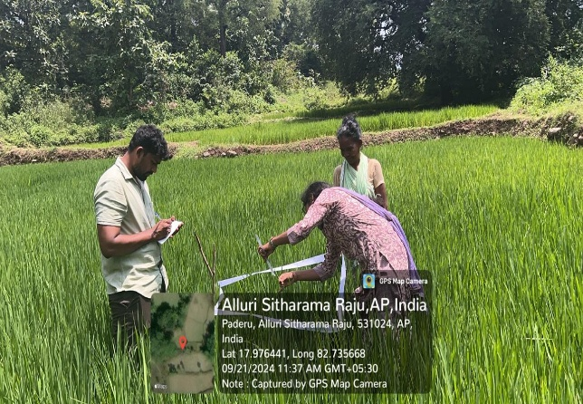 | 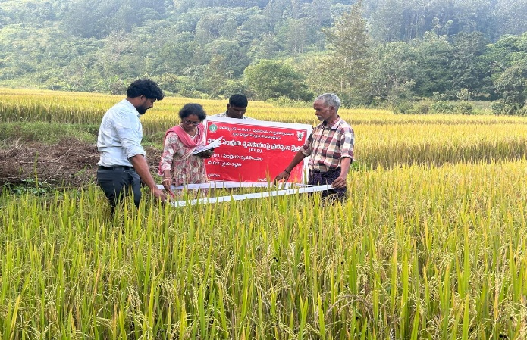
Plate:1 & 2 Recording of Bio-Metric Observations
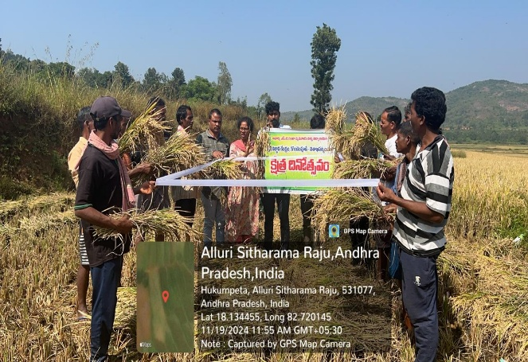 | 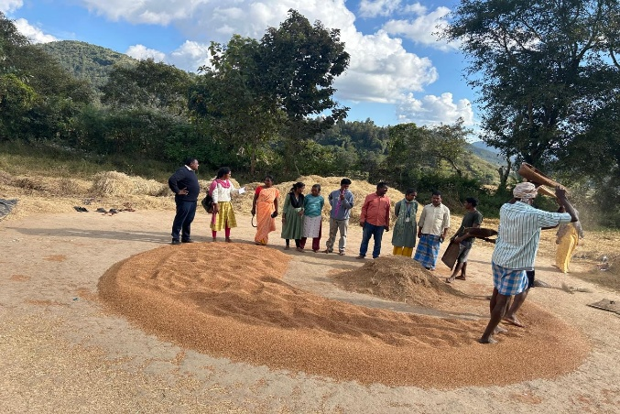
Plate : 3 Conducting field Day | Plate: 4 Involved in threshing operations

