Ultraviolet Disinfection of Air in Incubatory and Silkworm Rearing Rooms

.
ABSTRACT

Aims: This study aimed to evaluate the effectiveness of ultraviolet irradiation combined with air ionization for disinfecting incubatory and rearing rooms in sericulture, and to determine its impact on hatching rate, larval survival, disease incidence, larval biomass, and cocoon productivity of Bombyx mori L.
Study Design: A multiyear controlled experiment with four treatment variants, including ultraviolet exposure at different durations and intensities, compared with a non-treated control group.
Place and Duration of Study: The experiments were conducted at the Sericulture Research Institute, Tashkent, Uzbekistan, during the spring seasons of 2023–2025.
Methodology: Larvae of the hybrid “Ipakchi-1 × Ipakchi-2” were incubated and reared in rooms equipped with bactericidal ultraviolet lamps (wavelength 254 nm, 90 W) and an electro-technological air ionization system. Treatments included ultraviolet exposure for 10 minutes and 30 minutes per day, as well as irradiation with two lamps. Each treatment consisted of five replications of 100 eggs. Hatching rate, larval survival, disease incidence, larval weight across instars, and cocoon productivity indicators were recorded. Cocoon, shell, and larval weights were measured using analytical scales, and biological indicators were assessed according to standard sericultural procedures.
Results: Ultraviolet treatment increased the hatching rate to 99.0% compared with 95.0% in the control. Larval survival reached 86.5–90.1%, improving by 2.2–5.8% relative to the control (84.3%). Disease incidence decreased to 1.06–2.1%, compared with 3.1% in untreated groups. The mean weight of 50 fifth-instar larvae increased to 79.9 g compared with 70.4 g in the control, while individual larval weight rose to 1.59–1.60 g versus 1.42 g. Cocoon shell weight reached 0.365 g and silk content 22.8%, exceeding the control values of 0.304 g and 20.9%.
Conclusion: Ultraviolet irradiation combined with air ionization is an effective, environmentally safe method for reducing microbial contamination in sericulture facilities. It enhances larval viability, reduces disease incidence, and improves cocoon yield and quality, making it a practical component of modern industrial sericulture.

Keywords: ultraviolet irradiation; sericulture; Bombyx mori; air disinfection; larval survival; eco-friendly technologies

1. INTRODUCTION

The development of sericulture on a global scale and the achievement of abundant, high-quality cocoon yields largely depend on the prevention of silkworm (Bombyx mori L.) diseases. A key factor in maintaining the health and productivity of silkworm populations is the quality of eggs (grains) used for incubation and rearing, as well as the aseptic conditions in rearing facilities. The sanitary conditions of these environments directly determine larval survival and the quality of the harvested cocoons. By cocoon production volume, the leading countries in the world are the People’s Republic of China (about 782 thousand tons), India (225 thousand tons), and Uzbekistan (25,8 thousand tons) (FAO, 2025). These countries are recognized leaders in the field and define global trends in sericulture development. However, despite significant progress, the spread of diseases remains a serious problem: up to 6-8% of larvae die before reaching the cocooning stage (Kiruthika et al., 2025). The resulting economic losses are substantial, making the development and implementation of modern preventive and control measures a top priority.
In recent years, environmentally friendly and resource-saving technologies aimed at reducing losses and improving cocoon quality have been actively introduced in sericulture (Thangavel and Rathinamoorthy, 2017; Altman and Farrell, 2022). Among them, ultraviolet (UV) irradiation has attracted special attention due to its pronounced bactericidal and immunomodulatory properties. UV rays are known to be absorbed by all biologically important cell structures, as their energy is sufficient to ionize atoms. Even at low doses, UV irradiation exerts a stimulating effect by enhancing metabolism, activating vitamin D biosynthesis, and strengthening non-specific resistance (Zhang at al., 2025; Kishore, 2025).
The effect of UV irradiation on living organisms depends on dose, wavelength, and exposure conditions. The most effective bactericidal range is around 253.7 nm, which ensures the inactivation of bacteria, viruses, fungi, and even the destruction of bacterial toxins (Kowalski, 2019). In agriculture, optimal doses of UV irradiation have been shown to stimulate plant growth, improve immunity, and accelerate physiological processes (Subhrata at al., 2024; Dolgikh at al., 2022). By analogy, in sericulture UV irradiation can be applied for: air disinfection in incubators and rearing rooms; sterilization of silkworm egg surfaces; suppression of pathogenic microorganisms in the rearing environment; and stimulation of metabolic processes in larvae, thereby increasing their survival (Khan at al., 2022).
Several researchers (Devi at al., 2024) have noted that light and UV exposure can modify silkworm growth parameters: larvae grow more actively under violet light; additional illumination in the early stages increases cocoon and silk yield by up to 6%; excessive quartz lamp exposure slows larval growth; while UV treatment of eggs increases hatching and larval viability (Ali et al., 2016; Khan et al., 2022). Thus, at moderate doses, UV irradiation serves a dual function: suppressing pathogenic microflora while acting as a biostimulant for silkworm development.
The use of bactericidal lamps for air disinfection and egg treatment is therefore an eco-friendly, cost-effective, and highly efficient method (Bintsis et al., 2000). Unlike chemical agents, UV irradiation leaves no toxic residues, requires no expensive reagents, and can be applied repeatedly. With proper dosing, it ensures lower larval morbidity, higher survival and productivity rates, and the production of better-quality cocoons. Collectively, these factors make UV irradiation a promising biotechnological tool for disease prevention in sericulture, particularly relevant for industrial and year-round rearing systems (Xue et al., 2025).

2. material and methods

In the spring of 2023-2025, experimental studies on the incubation and rearing of Bombyx mori L. larvae of the hybrid “Ipakchi-1 × Ipakchi-2” were carried out at the Scientific Research Institute of Sericulture (Tashkent).
The following equipment was used in the experiments:
- bactericidal UV lamps (λ = 254 nm, 90 W),
- an electro-technological air ionization system.
The purpose of this equipment was to disinfect the air and surfaces in incubators and rearing rooms. Rearing was performed in accordance with standard agrotechnical practices for white-cocoon silkworm breeds (Devi at al., 2024).
The experimental site consisted of 3 incubator-feeding rooms with a volume of 60 m³ each, which were respectively equipped with bactericidal lamps. The lamp power was calculated according to the standard of 1 W of UV irradiation per 1 m³ of air (San.PiN, 2004). The lamps were placed in opposite directions to ensure uniform light distribution, and the intensity of irradiation was monitored using a dosimeter.
A review of the literature and our own data confirm that electrophysical factors (electric and magnetic fields, optical irradiation, ultrasound, spark discharge, etc.) have a pronounced effect on living cells (Mukhammadiev and Yusupov, 2021; Brian, 2002). The main effect is the activation of metabolism and stimulation of development.
Ultraviolet radiation (UVR) represents electromagnetic waves in the range of 100–400 nm, subdivided into UV-A (315–400 nm), UV-B (280–315 nm), and UV-C (200–280 nm). The most effective bactericidal action is exerted by UV-C, with maximum efficiency at wavelengths of 253.7–254 nm (Kowalski, 2019).
The mechanism of UV irradiation on microorganisms located on the surface of silkworm eggs is based on two main processes:
1. Photochemical DNA damage – photon absorption induces thymine dimer formation and replication blockage, leading to microbial death in the first or subsequent generations (Bede and Blande, 2025).
2. Protein and enzyme denaturation – local heating and intermolecular friction in membranes cause enzyme inactivation and membrane disruption (Bintsis, 2000).
Pathogenic microorganisms, which have higher cellular water content compared to silkworm eggs, are selectively heated, resulting in their destruction. At the same time, the structure of silkworm eggs remains intact, which makes the method safe and environmentally friendly (Zhang et al., 2025).
Additionally, exposure to a direct-current electric field causes polarization of the phospholipid bilayer, altering the membrane potential (50-70 mV), thereby disturbing K⁺ and Na⁺ ion transport and leading to blocked metabolism in microbial cells (Kiruthika et al., 2025).

3. results and discussion

A review of the literature on electro-technological methods of disinfecting biological objects, as well as our own studies on silkworm stimulation through electrophysical treatments, confirms that such impacts share common patterns. Any electrophysical effect—including electric and magnetic fields, optical irradiation, electromagnetic waves, spark discharge, electric current, or ultrasound—affects living cells, triggering metabolic activation that results in accelerated development and increased viability.
Experiments on incubation and hatching of silkworm (Bombyx mori L.) eggs tested different exposure regimes of bactericidal UV lamps (λ = 254 nm).
Experimental variants:
I. Irradiation 10 min × once daily.
II. Irradiation 30 min × once daily.
III. Irradiation of 2 lamps for 30 min × once daily.
IV. Control (no irradiation).
Each variant was replicated 5 times, with 100 eggs placed in each replicate. The hatching rate of silkworm eggs was measured in this experiment, and the data are presented in Table 1.

Table 1. Hatching rates of “Ipakchi-1 × Ipakchi-2.” silkworm eggs (2023–2025)
Variants | Number of eggs incubated, pcs | Number of hatched eggs, pcs  X̄±SD | Number of unhatched eggs, pcs  X̄±SD | Hatching rate, %  X̄±SD | Pd
I | 100 | 95.0 ± 1.3 | 5.0 ± 0.9 | 95.0 ± 0.93 | 0.884
II | 100 | 97.0 ± 1.0 | 3.0 ± 0.93 | 97.0 ± 0.93 | 0.825
III | 100 | 99.0 ± 1.3 | 1.0 ± 0.9 | 99.0 ± 0.9 | 0.806
IV | 100 | 95.0 ± 0.9 | 5.0 ± 0.93 | 95.0 ± 0.9 | -

The results showed that in the experimental groups the hatching percentage of eggs was higher than in the control (95.0%). Under 10-minute irradiation, the hatching rate reached 99.0% (+4,0%), while 30-minute exposure also improved the outcome, although the effect was less pronounced. In the third experimental variant, using two lamps for 30 minutes, the hatching rate was 95.5%, which was comparable to the control. Similar findings were reported by (Devi at al 2024), who noted that moderate doses of UV irradiation increase hatching rates and larval viability.
During the rearing of larvae in rearing rooms with the use of ultraviolet irradiation, the absence of diseases was strictly monitored at each stage of larval molting. In addition, starting from the third instar and continuing until cocoon spinning at the fifth instar, larval mass was recorded by weighing randomly selected samples of 50 larvae, see Table 2.

Table 2. Average body weight of mulberry silkworms in the 3rd–5th instars (2023–2025)
Variants | Year | III instar 50 larvae weight, g | 1 larva weight, g | IV instar 50 larvae weight, g | 1 larva weight, g | V instar 50 larvae weight, g | 1 larva weight, g
I | 2023 | 4.20 | 0.084 | 16.94 | 0.339 | 80.02 | 1.60
 | 2024 | 3.92 | 0.078 | 16.62 | 0.332 | 78.30 | 1.57
 | 2025 | 4.10 | 0.082 | 16.80 | 0.336 | 79.16 | 1.58
Average |  | 4.07± 0.082 | 0.081 ± 0.002 | 16.79± 0.093 | 0.336 ± 0.002 | 79.16± 0.497 | 1.583± 0.003
Pd |  | 0.833 |  | 0,106 |  | 0.006
II | 2023 | 4.21 | 0.084 | 17.55 | 0.351 | 80.15 | 1.60
 | 2024 | 4.09 | 0.082 | 16.78 | 0.336 | 78.47 | 1.57
 | 2025 | 4.19 | 0.084 | 17.10 | 0.342 | 79.95 | 1.59
Average |  | 4.16± 0.037 | 0.083 ± 0.001 | 17.14± 0.223 | 0.343 ± 0.006 | 79.52± 0.53 | 1.59± 0.009
Pd |  | 0.196 |  | 0.045 |  | 0.005
III | 2023 | 4.30 | 0.086 | 17.95 | 0.359 | 80.67 | 161
 | 2024 | 4.18 | 0.084 | 16.98 | 0.34 | 78.97 | 1.58
 | 2025 | 4.28 | 0.086 | 17.45 | 0.349 | 80.15 | 1.60
Average |  | 4.25±0.037 | 0.085±0.001 | 17.46±0.28 | 0.349±0.006 | 79.93±0.503 | 1.60±0.009
Pd |  | 0.030 |  | 0.025 |  | 0.004
IV | 2023 | 4.11 | 0.082 | 16.23 | 0.325 | 72.3 | 1.45
 | 2024 | 4.05 | 0.080 | 15.10 | 0.302 | 68.7 | 137
 | 2025 | 4.12 | 0.082 | 16.12 | 0.322 | 70.2 | 1.40
Average |  | 4.09± 0.022 | 0.082 ± 0.001 | 15.82± 0.36 | 0.316 ± 0.007 | 70.4 ± 1.044 | 1.408± 0.008

Significant differences were observed at the fifth instar: the total weight of 50 larvae in the experimental groups (Variants I–III) ranged from 79.87 to 79.92 g, compared with 70.40 g in the control (Variant IV). This represents an increase of about 13.5%, which is substantial for sericulture productivity. The mean weight per larva increased from 1.42 g in the control to 1.59–1.60 g in the experimental treatments, yielding a gain of 0.17–0.18 g per individual. While these increments may appear modest, when extrapolated to population scale they result in a considerable increase in cocoon yield and raw silk production.
Based on the data in the table, the following histogram was compiled, reflecting the average weight of silkworm caterpillars of the III-V age with the best indicators. Figure 1 clearly shows the difference between the experimental and control variants. According to literature, larval body weight is strongly correlated with cocoon weight and shell yield (Kiruthika at al., 2025; Dong et al., 2024). Our findings confirmed this relationship: UV irradiation not only disinfected rearing rooms, reducing microbial load, but also enhanced larval productivity. The observed improvement in biomass accumulation at later instars suggests that UV treatment may positively influence metabolic efficiency and feed conversion, thereby leading to heavier and better-quality cocoons.
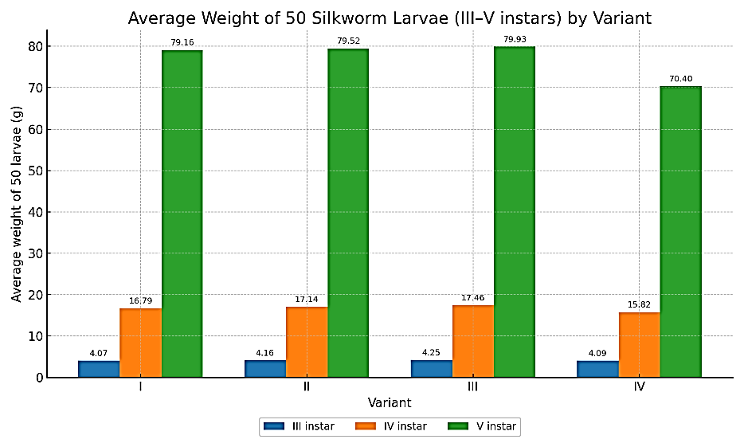

Fig. 1. Average weight of 50 silkworm larvae (III–V instars) by variant

These results highlight the dual role of UV irradiation: as a prophylactic measure that minimizes disease incidence, and as a growth stimulator contributing to improved productivity. Such combined effects make UV-based technologies a valuable, eco-friendly component of modern sericulture.
During the experiments, biological indicators (viability of the silkworm, morbidity, duration of the larvae stage) were determined, and these indicators are shown in Table 3.

Table 3. Biological indicators of mulberry silkworms treated with UV-B
Variants | Duration of larval period, days | Disease incidence, % | Pd | Larval survival rate, % | Pd
I | 27 | 2.10 ± 1.30 | 0.294 | 86.5 ± 5.78 | 0.151
II | 27 | 1.10 ± 0.67 | 0.679 | 89.6 ± 1.23 | 0.591
III | 26 | 1.06 ± 0.69 | 0.679 | 90.1 ± 1.36 | 0.673
IV | 27 | 3.10 ± 0.97 |  | 84.3 ± 3.53

After UV irradiation, larval survival improved to 86.5–90.1% compared with 84.3% in the control, corresponding to an increase of 2.2–5.8%. Among the treatments, the third variant (two UV lamps for 30 minutes) demonstrated the highest survival rate of 90.1%. Similarly, disease incidence declined from 3.1% in the control to 1.06–2.1% in the treated groups. The lowest incidence (1.06%) was observed in the third variant, again confirming the superior efficiency of dual-lamp irradiation. This suggests that more intensive UV exposure, when properly controlled, provides a stronger bactericidal effect without compromising larval health. Importantly, the duration of the larval period remained consistent at 26–27 days across all treatments, including the dual-lamp variant.
Figure 2 clearly shows the difference between the experimental and control variants.

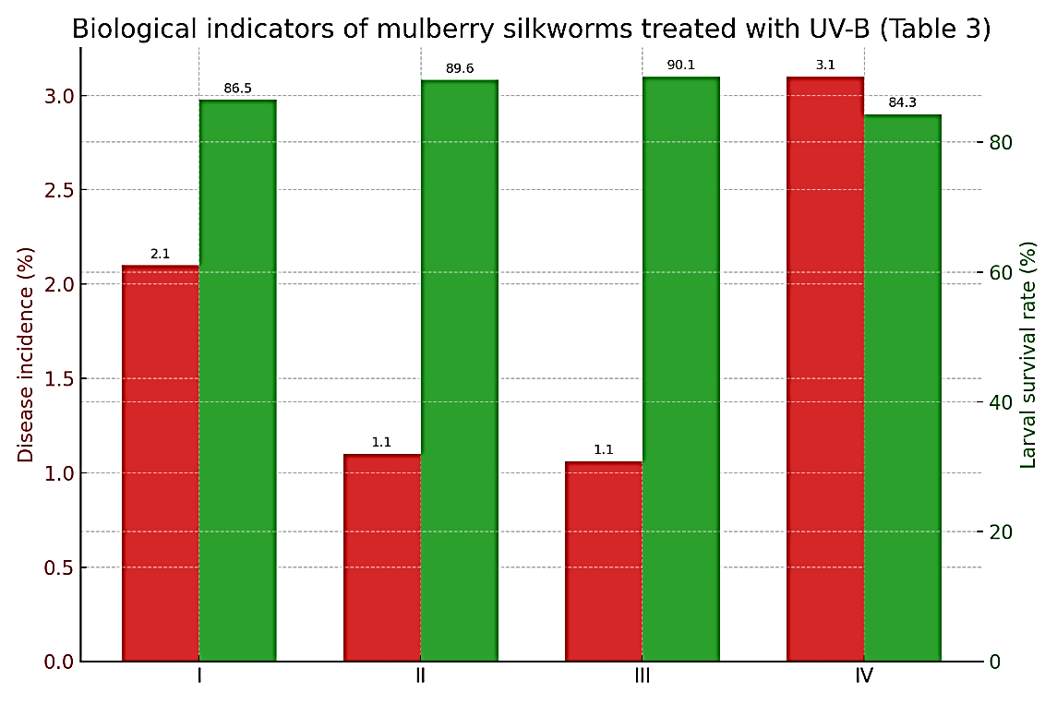

Fig. 2 Graph shows the difference between the experimental and control variants.

This indicates that while survival and health parameters were improved, developmental timing was not negatively affected. Maintaining the normal growth cycle is crucial, as any extension would increase feeding costs and management risks. Cocoon productivity indicators (average of 5 repetitions) are shown in Table 4 and Figure 3.

Table 4. Productivity indicators of raw cocoons (average of 5 replications)
Variants | Weight of 1 cocoon, g |  |  | Weight of 1 cocoon shell, g |  |  | Silk content of cocoons, %
Variants | ♀ | ♂ | Average  X̄±SD | ♀ | ♂ | Average  X̄±SD | ♀ | ♂ | Average  X̄±SD
I | 1.6 | 1.5 | 1.54±0.03 | 0.350 | 0.353 | 0.352±0.007 | 21.8 | 22.9 | 22.4±0.2
II | 1.6 | 1.5 | 1.55±0.04 | 0.349 | 0.344 | 0.346±0.010 | 21.9 | 23.1 | 22.5±0.1
III | 1.7 | 1.5 | 1.6±0.01 | 0.379 | 0.352 | 0.365±0.005 | 22.3 | 23.3 | 22.8±0.2
IV | 1.5 | 1.4 | 1.5±0.05 | 0.307 | 0.301 | 0.304±0.006 | 20.7 | 21.1 | 20.9±0.1

Cocoon productivity data (mean of five replicates) demonstrate consistent advantages of UV-treated groups over the control. Both cocoon and shell weights were higher in the experimental variants, suggesting improved nutrient assimilation and larval vigor under disinfected and bio-stimulated rearing conditions. The shell ratio (silk content of cocoons) reached 22.4–22.8% in UV treatments, compared with 20.9% in the control, reflecting a clear improvement in raw silk yield. The differences, although numerically modest (0.1–0.4% above other UV groups and 1.5–1.9% above control), are statistically meaningful when projected to industrial scale.
Particular emphasis should be placed on Variant III (30-minute irradiation with two lamps). This treatment achieved the highest cocoon weight (1.60 g) and shell weight (0.365 g), along with the maximum silk content (22.8%). These indicators surpass both the control and other experimental groups, confirming that prolonged but balanced UV exposure creates optimal sanitary and physiological conditions for silkworm development.

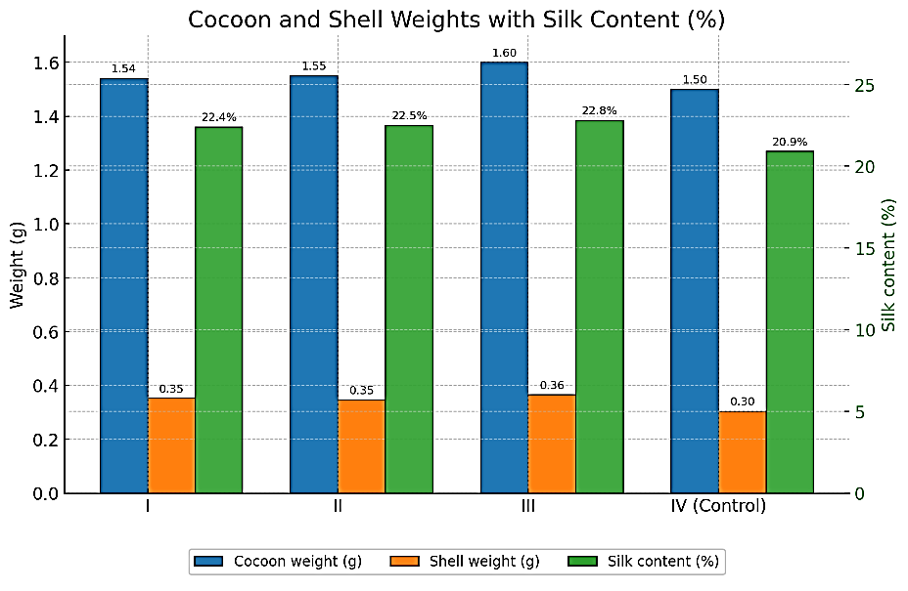

Fig. 3. Cocoon and shell weights with Silk content (%).

Our findings are in line with both international and domestic research. (Kishore et al., 2024) demonstrated that UV irradiation enhances insect immunity, while (Jena at al., 2024) reported its effectiveness in pathogen inactivation without chemical agents. Classic works by (Yemmireddy et al., 2022; Senderskiy at al., 2024) also confirmed that bactericidal lamps reduce silkworm disease incidence and improve survival. (Kundu and Natarajan, 2021) highlighted UV disinfection as an efficient tool for lowering microbial loads in sericulture facilities.
An important factor associated with UV irradiation is the formation of ozone, which adds a secondary disinfecting effect (Rahmathulla, 2012; Ashrith at al., 2025). However, excessive ozone levels may negatively affect both larvae and workers (Dong et al., 2024). Therefore, a short ventilation period (5–10 minutes) after irradiation is strongly recommended to maintain safe sanitary conditions.

4. Conclusion

The experimental results demonstrated that in rearing facilities treated with UV irradiation, no cases of disease, developmental delay, or mass larval mortality were observed. The risk of microbial infection from feed or external sources was significantly reduced. Moreover, larval viability and weight improved, leading to higher cocoon yield and enhanced cocoon quality. Overall, these results confirm that ultraviolet irradiation—particularly the two-lamp 30-minute regime—represents an effective, eco-friendly, and economically justified agro-electrotechnological approach.

Disclaimer (Artificial intelligence)
Author(s) hereby declare that NO generative AI technologies such as Large Language Models (ChatGPT, COPILOT, etc.) and text-to-image generators have been used during the writing or editing of this manuscript.

References

- Ali A, Rashid MA, Huang Q, & Lei C. 2016. Effect of UV-A radiation as an environmental stress on the development, longevity, and reproduction of the oriental armyworm, Mythimna separata (Lepidoptera: Noctuidae). Environmental Science and Pollution Research 23(17): 17589–17599. https://doi.org/10.1007/s11356-016-6865-0
- Altman GH, Farrell BD. 2022. Sericulture as a sustainable agroindustry. Cleaner and Circular Bioeconomy 2:100011. https://doi.org/10.1016/j.clcb.2022.100011
- Ashrith S, Pavithra MR, Gagana Sindhu S, Moulidharshan R, Arun Kumar MR, Suhas BV. 2025. Organic sericulture practices and potentials: a review on sustainable silk production. International Journal of Advanced Biochemistry Research 9(8):651–655. https://doi.org/10.33545/26174693.2025.v9.i8i.5282
- Bede JC, Blande JD. 2025. Effects of elevated CO₂ and O₃ on aboveground brassicaceous plant–insect interactions. Annual Review of Entomology 70:205–227. https://doi.org/10.1146/annurev-ento-022024-015159
- Bintsis T, Litopoulou-Tzanetaki E, Robinson RK. 2000. Existing and potential applications of ultraviolet light in the food industry – a critical review. Journal of the Science of Food and Agriculture 80(6):637–645. https://doi.org/10.1002/(SICI)1097-0010(20000501)80:6<637::AID-JSFA603>3.0.CO;2-1
- Brian L D (2002) Sources and measurement of ultraviolet radiation Methods. Sep;28(1):4-13. https://doi.org/10.1016/s1046-2023(02)00204-9.
- Diffey BL. 2002. Sources and measurement of ultraviolet radiation. Methods 28(1):4–13. https://doi.org/10.1016/S1046-2023(02)00204-9
- Devi YS, Hossain A, Lalremruatpuia V, Raviraj VS. 2024. Effect of UV radiation on physiological performance of silkworm Bombyx mori. Biological Forum – An International Journal 16(6):221–229. Available from: https://www.researchtrend.net/bfij/pdf/Effect-of-UV-Radiation-on-Physiological-Performance-of-Silkworm-Bombyx-mori-Raviraj-VS-44-.pdf
- Dolgikh VV, Senderskiy IV, Timofeev SA, Zhuravlyov VS, Dolgikh AV, Seliverstova EV, Ismatullaeva DA, Mirzakhodjaev BA. 2022. Construction of scFv antibodies against the outer loops of the microsporidium Nosema bombycis ATP/ADP-transporters and selection of the fragment efficiently inhibiting parasite growth. International Journal of Molecular Sciences 23(23):15307. https://doi.org/10.3390/ijms232315307
- Dong W, Hou D, Hou Q, Jin H, Li F. 2024. Effects of ultraviolet light stress on protective and detoxification enzymes in insects. Tropical Plants 3:e007. https://doi.org/10.48130/tp-0024-0008
- FAO. 2025. FAOSTAT – Crops and livestock products: silk raw and silkworm cocoons (QCL). Food and Agriculture Organization of the United Nations, Rome, Italy. Available from: http://www.fao.org/faostat/en/#data/QCL
- Jena S, Nadaf HA, Mittal V, Chowdary NB, Selvakumar T, Padhy PC. 2024. Traditional vs. scientific Eri silkworm rearing: a study in Bhubaneswar zone. Archives of Current Research International 24(5):165–184. https://doi.org/10.9734/acri/2024/v24i5694
- Khan MM, Fan Z-Y, Sabir IA, Hafeez M, Wen S, Wu J-H, Qiu B-L. 2022. Physiological and molecular response modifications by ultraviolet-C radiation in Plutella xylostella (Lepidoptera: Plutellidae) and its compatibility with Cordyceps fumosorosea. International Journal of Molecular Sciences 23(17):9800. https://doi.org/10.3390/ijms23179800
- Kishore SM, Khajuria M, Saini A, Srivastav S, Manideep KSN, Chethan MN, Parvati B. 2024. Advancing sustainable sericulture: a review on biological control agents in managing pests and diseases of mulberry and silkworms. Journal of Experimental Agriculture International 46(9):1139–1146. https://doi.org/10.9734/jeai/2024/v46i92910
- Kishore SM, Suchith Kumar C. 2025. Comprehensive disinfection strategies for effective silkworm disease management and enhanced silk production. Agriallis 7(1):19–23. Available from: https://agriallis.com/wp-content/uploads/2025/02/COMPREHENSIVE-DISINFECTION-STRATEGIES-FOR-EFFECTIVE-SILKWORM-DISEASE-MANAGEMENT-AND-ENHANCED-SILK-PRODUCTION.pdf
- Kiruthika C, Susikaran S, Karthick Mani Bharathi B. 2025. Common diseases of silkworm and their management – a comprehensive overview. International Journal of Insects 2(1):22–28.
- Kowalski WJ. 2009. Ultraviolet Germicidal Irradiation Handbook: UVGI for Air and Surface Disinfection. Springer, Berlin, Germany. https://doi.org/10.1007/978-3-642-01999-9
- Mukhammadiev A, Yusupov DR. 2021. Ecologically clean electrotechnological method of disinfection and stimulation of silkworm grenes. International Journal of Advanced Research in Science, Engineering and Technology 8(1):16369–16373. Available from: http://www.ijarset.com/upload/2021/january/19-research-40.PDF
- Rahmathulla VK. 2012. Management of climatic factors for successful silkworm (Bombyx mori L.) crop and higher silk production: a review. Psyche 2012:121234. https://doi.org/10.1155/2012/121234
- SanPiN R 3.5.1904-04. 2004. Ispol’zovanie ul’trafioletovogo bakteritsidnogo izlucheniya dlya obezzarazhivaniya vozdukha v pomeshcheniyakh. Rukovodstvo. Ministry of Health of the Russian Federation, Moscow, Russia. Available from: https://10.rospotrebnadzor.ru/upload/medialibrary/602/rukovodstvo-r-3.5.1904_04.pdf
- Senderskiy IV, Dolgikh VV, Ismatullaeva DA, Mirzakhodjaev BA, Nikitina AP, Pankratov DL. 2024. Treatment of Microsporidium Nosema bombycis spores with the new antiseptic M250 helps to avoid bacterial and fungal contamination of infected cultures without affecting parasite polar tube extrusion. Microorganisms 12(1):154. https://doi.org/10.3390/microorganisms12010154
- Subhrata Jena, Hasansab A. Nadaf, Vishal Mittal, N. B. Chowdary, T. Selvakumar and P. C. Padhy. Traditional vs. Scientific Eri Silkworm Rearing: A Study in Bhubaneswar Zone. Arch. Curr. Res. Int. [Internet]. 2024 Apr. 29 [cited 2025 Nov. 22];24(5):165–184. Available from: https://journalacri.com/index.php/ACRI/article/view/694
- Thangavel K, Rathinamoorthy R. 2017. Sustainable silk production. In: Subramanian SM (ed.). Sustainable Fibres and Textiles. Woodhead Publishing, Cambridge, UK, pp. 187–213. https://doi.org/10.1016/B978-0-08-102041-8.00006-8
- Xue R, Li Y, Shen X, Shao Y. 2025. Research progress on comprehensive utilization of silkworm excrement bioresource. Resources 14(8):128. https://doi.org/10.3390/resources14080128
- Yemmireddy, V., Adhikari, A., & Moreira, J. (2022). Effect of ultraviolet light treatment on microbiological safety and quality of fresh produce: An overview. Frontiers in Nutrition, 9, 871243. https://doi.org/10.3389/fnut.2022.871243
- Zhang Y-H, Xue J-Z, Qian H-Y, Bai Q-R, Li T-H, Mei J-F, Monticelli LS, Kandegama WMW, Zang L-S. 2025. Unfertilized and washed Eri silkworm eggs as superior hosts for mass production of Trichogramma parasitoids. Insects 16(8):751. https://doi.org/10.3390/insects16080751

