Assessing Rice Phenology and Growth Using Agrometeorological Indices in Jagtial, Telangana, India

Abstract
Rice (Oryza sativa L.) is the principal staple crop of India, highly sensitive to temperature, rainfall distribution and radiation. To assess its climatic requirements, a long-term study (2014–2024) was conducted at RARS, Polasa, Telangana, using rice variety JGL 24423. Daily weather data were analyzed to compute agrometeorological indices - Growing Degree Days (GDD), Heliothermal Units (HTU) and Photothermal Units (PTU) from sowing to phenological stages. Results showed that a minimum of 776 GDD, 2624 HTU and 10045 PTU are required for panicle initiation, while physiological maturity needs 2076 GDD, 7759 HTU and 26054 PTU. Substantial variation across years reflected the influence of ENSO phases, rainfall variability and radiation availability. Excess rainfall during La Nina years lowered sunshine hours and HTU values, reducing yield, whereas balanced conditions in El Nino and normal years supported better productivity. The study underscores the importance of agrometeorological indices in predicting phenology, understanding crop-climate interactions and guiding weather-based management to sustain rice production in semi-arid tropics.
Keywords: Rice, Agrometeorological indices, ENSO phases, Phenology, Climate variability
Introduction
Rice (Oryza sativa L.) is the principal staple food crop of India, playing a vital role in food and livelihood security. Its growth, development and productivity are strongly influenced by weather parameters such as temperature, rainfall, relative humidity and solar radiation. Being thermo and photo-sensitive, rice responds differently to weather variability at each phenophase and even small deviations in climatic conditions during reproductive stages can significantly reduce yield (Jagadish et al., 2007). Rice quality traits, including phenolic content, vary by genotype and can be influenced by environmental conditions (de Mira et al., 2009). Therefore, understanding crop-weather interactions is essential for sustainable rice production under changing climatic conditions.
According to recent research, rice phenology and yield are highly regulated by agrometeorological parameters based on temperature and radiation. While Shi et al. (2025) observed that low-temperature occurrences considerably diminish production in colder places, Jagadish et al. (2015) shown that increasing temperatures increase growth but cause heat stress that reduces grain filling. According to Qiu et al. (2023), photothermal responses are still crucial in regulating tillering and blooming. Li et al. (2025) showed that ratoon rice yields are increased when nitrogen consumption is coordinated with available heat and radiation. A recent meta-analysis by Zhang et al. (2019) demonstrated that climatic variability continues to raise yield uncertainty across rice-growing settings, while improvements in phenology detection by Lu et al. (2025) give better climate-response monitoring. Rice phenology and yield can be effectively monitored using agrometeorological indices and remote-sensing approaches. Growth-curve simulation with multi-temporal Sentinel-1 data has improved phenology prediction accuracy (Wang et al., 2022). Field studies under rainfed conditions show that heat and weather-based indices significantly influence rice growth and yield (Beck et al., 2020).
Agrometeorological indices such as Growing Degree Days (GDD), Heliothermal Units (HTU), Photothermal Units (PTU) and Hydrothermal Units (HyTU) provide a quantitative basis for assessing crop-weather relationships (Bhagat et al., 2023). These indices have been successfully applied to explain crop duration, growth dynamics and yield potential across diverse regions. For instance, rice phenology and yield were well explained through thermal unit accumulation in Punjab (Hundal & Prabhjyot, 2007), Gujarat (Chaudhari et al., 2019) and West Bengal (Ghosh et al., 2014). Similar findings on heat and radiation requirements were reported in Tamil Nadu (Bhuvaneswari et al., 2014) and Northern India (Aggarwal et al., 2016).
Variability in sowing dates and agro-climatic conditions has also been shown to influence rice phenology and yield. Studies in Punjab revealed that changes in sowing dates altered accumulated GDD and PTU, thereby affecting crop duration and productivity (Majumder et al., 2024). Internationally, accumulated temperature and radiation were identified as key drivers of rice growth and development in South Asia (Krishnan et al., 2007) and East Asia (Tu et al., 2022). These studies highlight that thermal indices are reliable tools to understand crop-climate interactions and to forecast yield under variable environments.
In Telangana, particularly the northern districts such as Jagtial, rice cultivation is highly vulnerable to climatic variability. The region faces a semi-arid climate, erratic rainfall distribution and high temperature stress, which often disrupt crop phenology and reduce yields (Moulkar & Peddi, 2024). However, limited systematic studies have focused on linking agrometeorological indices with rice growth and phenology in this region. Therefore, the present study was undertaken to evaluate the relationship between weather-based indices and rice phenology in Jagtial district of Telangana, with the objective of supporting location-specific agromet advisories and improving climate-resilient rice production strategies.
Materials and Methods
Experimental Site
The field study was conducted at the Regional Agricultural Research Station (RARS), Polasa, Jagtial, situated in the northern agro-climatic zone of Telangana, India. The region experiences a semi-arid tropical climate, characterized by hot summers and moderate monsoon rainfall. The experimental site is located at an altitude of 264 m above mean sea level, with geographical coordinates 18.8° N latitude and 78.9° E longitude.
Crop and Variety
Rice (Oryza sativa L.) of the variety JGL 24423 was selected for the study. This medium-duration, high-yielding cultivar is widely recommended for Telangana and extensively adopted by farmers in Jagtial district for Kharif season cultivation. It is a semi-dwarf plant (90-110 cm) with long, slender grains, resistant to lodging, blast, brown spot and brown plant hopper. JGL 24423 exhibits strong seedling vigor and a yield potential of 40-50 quintals per hectare under irrigated conditions, making it a preferred choice for stable cultivation in the region.
Data Period
A long-term dataset covering 11 years (2014-2024) experimental data was utilized to analyze the thermal and radiation requirements of rice. Daily weather data on maximum and minimum temperatures, bright sunshine hours and day length were recorded from the Agrometeorological Observatory installed at RARS, Polasa.

Agroclimatic Indices
Three agroclimatic indices, namely Growing Degree Days (GDD), Heliothermal Units (HTU), and Photothermal Units (PTU), were computed to quantify the cumulative thermal and radiation environment influencing rice growth and development. The indices were estimated from sowing (nursery) to each of the phenological stages i.e., Transplanting, Panicle Initiation, 50% Flowering and Physiological Maturity
Growing Degree Days (GDD)
The thermal time requirement of rice was estimated using the following equation:
GDD = (T_{max} + T_{min})/2 – T_{base}
Where:
- T_{max} = Daily maximum temperature (°C)
- T_{min} = Daily minimum temperature (°C)
- T_{base} = Base temperature for rice (10 °C)
Negative GDD values were considered as zero. Cumulative GDD was computed from sowing to each phenological stage.
Heliothermal Units (HTU)
HTU, which integrates thermal time with actual sunshine hours, was computed as:
HTU = GDD × Sunshine Hours
Where Sunshine Hours = Daily bright sunshine hours (h), recorded from Agrometeorological Observatory at the experimental site.
Cumulative HTU values were calculated for each crop stage.
Photothermal Units (PTU)
PTU, which represents the interaction of thermal time with day length, was estimated using:
PTU = GDD × Day Length
Where Day Length = Astronomical day length (h), estimated from latitude and date using verified astronomical data source i.e., NOAA Solar Calculator.
Cumulative PTU was calculated from sowing to each phenological stage of the crop.

Results and Discussion
The results were derived from a long-term analysis (2014–2024) of rice growth, phenology, and yield during the Kharif season, in relation to rainfall variability and ENSO phases (Table 1).
The climatic variability during the study period (2014-2024) revealed the influence of ENSO phases on rainfall distribution and rice performance. Years with El Nino events (2014, 2015, 2018, 2023) generally experienced reduced or erratic rainfall, while La Nina years (2016, 2017, 2020-2022, 2024) recorded above-normal rainfall. The Southwest Monsoon (SWM) rainfall ranged widely from 418.2 mm in 2017 (La Nina, weak) to 1512.7 mm in 2022 (La Nina, weak), highlighting the high inter-annual variability characteristic of the semi-arid tropics.
The rainfall received during the crop growth period was more closely associated with rice performance. The lowest rainfall was recorded in 2017 (374.9 mm), coinciding with lower yield (8615 kg/ha), whereas the highest was in 2022 (1528.3 mm), though yield was not correspondingly higher (6179-7615 kg/ha across 2022 sowings), indicating that excess rainfall may not always favor productivity. Years with well-distributed rainfall, such as 2016 (734.2 mm) and 2020 (959.4 mm), supported better yields (9312 and 10100 kg/ha, respectively) (Fig. 1).
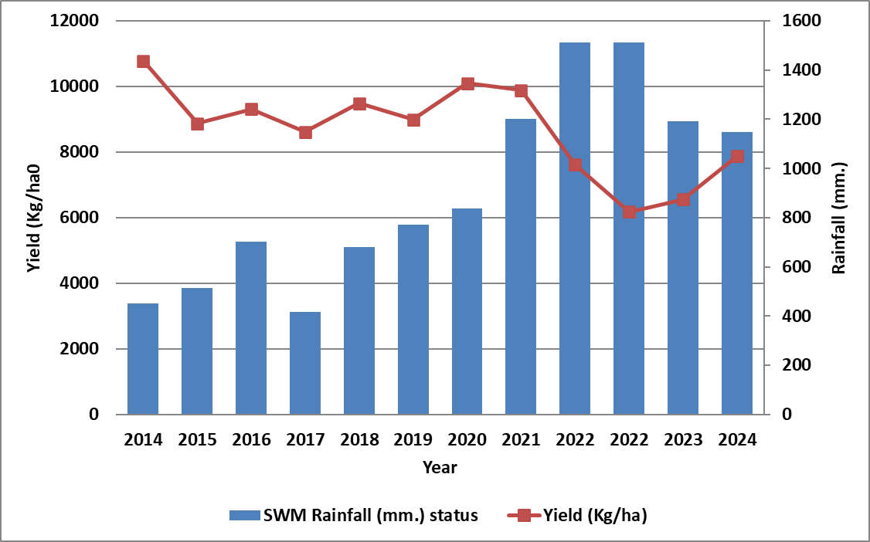
Fig. 1. Yields of JGL 24423 in relation to rainfall
The phenological development of rice varied across years under different climatic conditions. Days to panicle initiation (PI) ranged from 58 days in 2024 to 75 days in 2018, while the period to 50% flowering varied between 86 days (2024) and 99 days (2016). Physiological maturity was generally attained between 120 and 129 days, with slight delays observed in years of cooler temperatures or excessive rainfall (2016, 2023, 2024). These variations highlight the sensitivity of the variety JGL 24423 to prevailing agroclimatic conditions (Fig. 2).

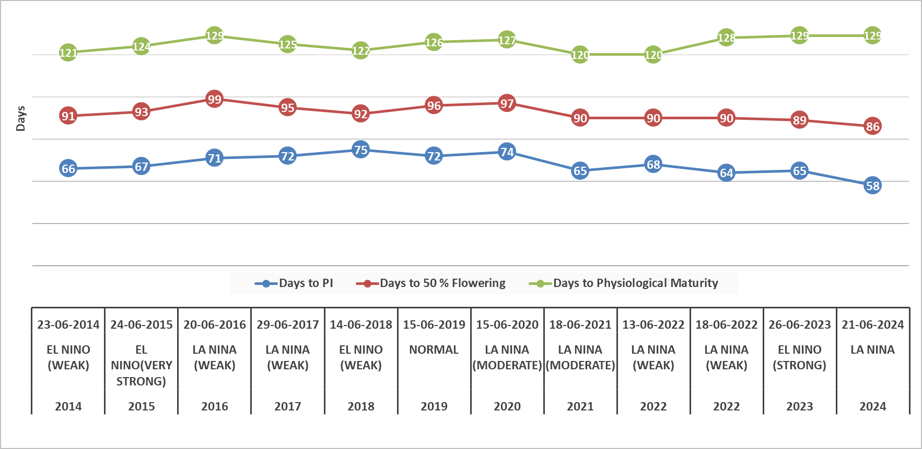
Fig. 2. Phenology of JGL 24423 under varying climatic pattern
Rice grain yield reflected the combined effect of rainfall distribution, climatic anomalies and crop duration. The maximum yield of 10,780 kg/ha was recorded in 2014, despite a weak El Nino year, likely due to favorable rainfall distribution during the crop growth phase. In contrast, yields were severely reduced in 2022 (6179–7615 kg/ha) despite very high seasonal rainfall, pointing to adverse impacts of excessive moisture and possible lodging or disease incidence. Overall, yields remained stable in normal and moderately favorable La Nina years (2016, 2020, 2021) but declined sharply in years of extreme climatic deviations (Table 1).
Table 1. Climatic pattern, rainfall, phenology and yield of rice (JGL 24423) during Kharif season (2014–2024) at RARS, Polasa.
Year | 2014 | 2015 | 2016 | 2017 | 2018 | 2019 | 2020 | 2021 | 2022 | 2022 | 2023 | 2024
Climate pattern | El Nino (Weak) | El Nino  (Very Strong) | La Nina (Weak) | La Nina (Weak) | El Nino (Weak) | Normal | La Nina (Moderate) | La Nina (Moderate) | La Nina (Weak) | La Nina (Weak) | El Nino (Strong) | La Nina
SWM Rainfall (mm.) status | 450.3 | 514.5 | 702.3 | 418.2 | 679.8 | 770.7 | 836 | 1200.9 | 1512.7 | 1512.7 | 1192.4 | 1149.4
Rainfall (mm.) received during crop growth period | 340 | 433.2 | 734.2 | 374.9 | 639.6 | 800.9 | 959.4 | 1027.3 | 1528.3 | 1467.1 | 1192.7 | 1099.6
Date of Sowing | 23-06-2014 | 24-06-2015 | 20-06-2016 | 29-06-2017 | 14-06-2018 | 15-06-2019 | 15-06-2020 | 18-06-2021 | 13-06-2022 | 18-06-2022 | 26-06-2023 | 21-06-2024
Days to Panicle Initiation | 66 | 67 | 71 | 72 | 75 | 72 | 74 | 65 | 68 | 64 | 65 | 58
Days to 50 % Flowering | 91 | 93 | 99 | 95 | 92 | 96 | 97 | 90 | 90 | 90 | 89 | 86
Days to Physiological Maturity | 121 | 124 | 129 | 125 | 122 | 126 | 127 | 120 | 120 | 128 | 129 | 129
Yield (Kg/ha) | 10780 | 8872 | 9312 | 8615 | 9491 | 8986 | 10100 | 9891 | 7615 | 6179 | 6553 | 7875

The analysis of Growing Degree Days (GDD) requirement of rice variety JGL 24423 revealed considerable variation across years and phenological stages. GDD accumulation up to panicle initiation (PI) ranged from a minimum of 776.05 (2017) to a maximum of 1377.9 (2020), while for 50% flowering it varied between 1548.0 (2024) and 1848.5 (2017). Physiological maturity required between 2134.25 (2021) and 2610.0 (2015) GDD, indicating that cooler or wetter years with delayed development increased thermal time requirement, while warmer years shortened the duration (Fig. 3).
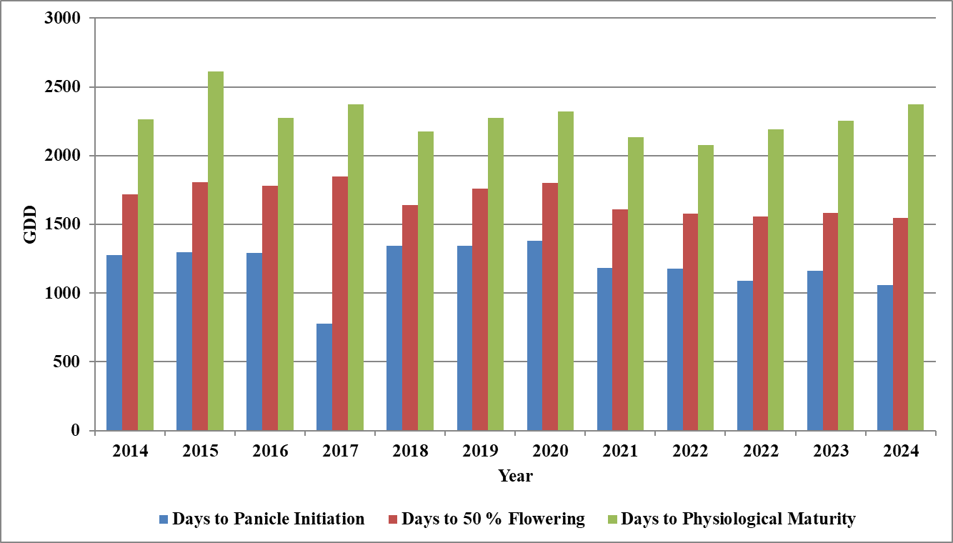
Fig. 3. Growing Degree Days (GDD) required for JGL 24423 during Kharif season
The Heliothermal Units (HTU) followed a similar trend, reflecting the combined effect of thermal time and sunshine hours. HTU up to PI ranged from 2623.5 (2017) to 6449.8 (2019), while at 50% flowering, values extended between 4704.3 (2021) and 8423.4 (2019). Physiological maturity showed the widest variation, with the lowest at 7758.6 (2021) and the highest at 14545.1 (2015). These results suggest that years with higher bright sunshine hours significantly enhanced HTU accumulation, whereas cloudy or high-rainfall years such as 2017 and 2021 reduced radiation availability, thereby lowering HTU values (Fig. 4).
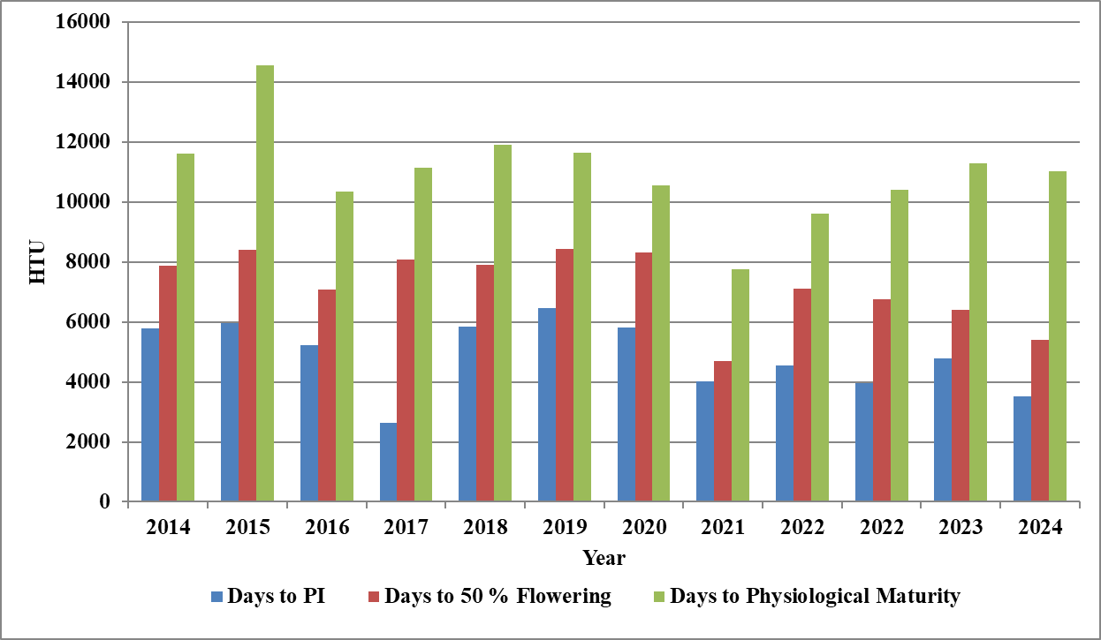
Fig. 4. Heliothermal Units (HTU) required for JGL 24423 during Kharif season
The pattern of Photothermal Units (PTU) requirement showed greater magnitude of variability compared to GDD and HTU. PTU values for PI ranged between 10045.2 (2017) and 17735.7 (2020), while 50% flowering required between 19679.0 (2024) and 23142.9 (2017). At physiological maturity, PTU extended from 26054.0 (2022) to 32110.0 (2015). These findings highlight that photothermal requirements were consistently higher in years with delayed crop development under El Nino or extreme rainfall conditions, while in comparatively normal years, lower PTU sufficed for attaining maturity (Fig. 5).
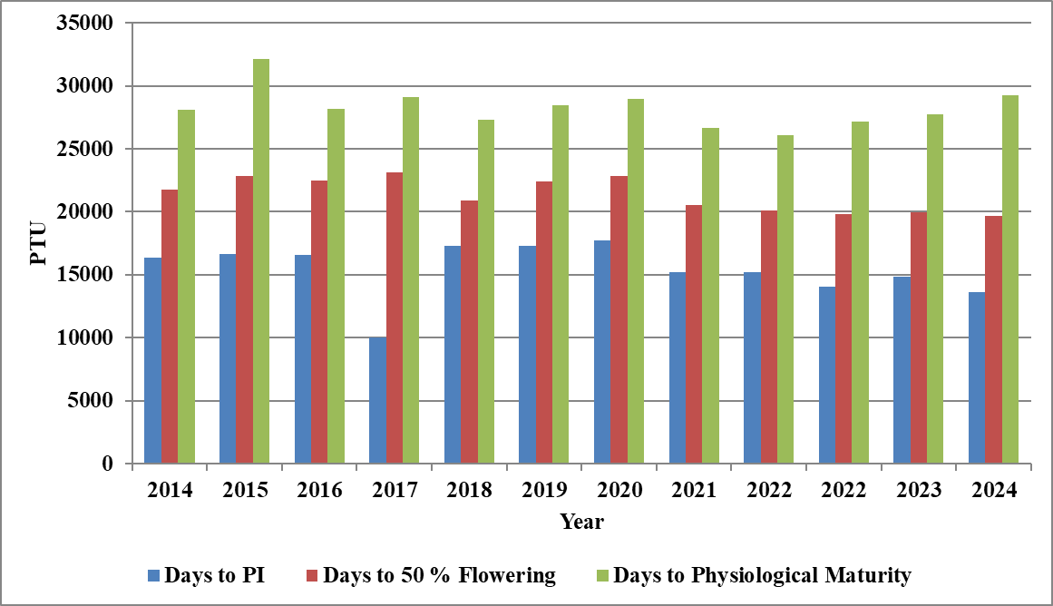
Fig 5. Photothermal Units (PTU) required for JGL 24423 during Kharif season
Similar responses of rice to rainfall extremes and ENSO phases were reported by Jensen et al. (2021) and Chen et al. (2018), showing that climatic anomalies disrupted crop duration and reduced yield stability.
Agrometeorological indices provided important insights into crop-weather interactions. GDD, HTU and PTU requirements varied widely across years, with reduced HTU and PTU in high-rainfall and low-radiation periods, which was consistent with the findings of Medhi et al. (2019). Higher PTU accumulation in delayed maturity years confirmed the strong influence of temperature-radiation interactions on crop phenology, supporting earlier observations by Halder et al. (2025). These results reinforced the importance of agrometeorological indices in linking climate variability with rice performance and suggested their potential application in developing climate-resilient crop management strategies (Rahman et al., 2017).
Conclusion
The findings of the study revealed that rice variety JGL 24423 requires a minimum of 776.1 GDD, 2624 HTU, and 10045 PTU to attain panicle initiation, while 2075.5 GDD, 7759 HTU and 26054 PTU are essential to reach physiological maturity. The variation in thermal and radiation requirements across years highlights the strong influence of weather conditions on crop phenology. Increased rainfall during recent years, particularly due to heavy spells in July and September, adversely affected yields despite sufficient thermal accumulation, indicating the negative impact of excess moisture on productivity. Furthermore, lower HTU values during La Nina years due to reduced bright sunshine hours exposed that solar radiation plays a decisive role in yield realization. These results underline the importance of integrating weather-based agrometeorological advisories and climate-resilient management practices for sustaining rice yields in the semi-arid tropics of Telangana.

Disclaimer (Artificial intelligence)
Author(s) hereby declare that NO generative AI technologies such as Large Language Models (ChatGPT, COPILOT, etc.) and text-to-image generators have been used during the writing or editing of this manuscript.
References
- Aggarwal, N., Singh, A. & Singh, S. P. (2016). Heat utilization and radiation interception in transplanted rice (Oryza sativa L.) in relation to seedling age. Journal of Agrometeorology, 18(1), 93–96. https://doi.org/10.54386/jam.v18i1.908
- Beck, M. K., Puranik, H. V., Kar, G. & Das, G. K. (2020). Assessing the effect of agrometeorological indices on rainfed rice crop at Bhubaneswar (Odisha), India. International Journal of Current Microbiology and Applied Sciences, 9(8), 3125–3131. https://doi.org/10.20546/ijcmas.2020.908.355
- Bhagat, R., Singh, M. & Sharma, B. C. (2023). Crop weather relationship in oilseed rape (Brassica napus) for north-west foothills of Himalayas, India. The Indian Journal of Agricultural Sciences, 93(4), 409–414. https://doi.org/10.56093/ijas.v93i4.132659
- Bhuvaneswari, K., Geethalakshmi, V., Lakshmanan, A., Anbhazhagan, R. & Nagothu, U. S. (2014). Climate change impact assessment and developing adaptation strategies for rice crop in western zone of Tamil Nadu. Journal of Agrometeorology, 16(1), 38–43. https://doi.org/10.54386/jam.v16i1.1484
- Chaudhari, N. V., Kumar, N., Parmar, P. K., Dakhore, K. K., Chaudhari, S. N. & Chandrawanshi, S. K. (2019). Thermal indices in relation to crop phenology and yield of rice (Oryza sativa L.) grown in the south Gujarat region. Journal of Pharmacognosy and Phytochemistry, 8(2), 146–149.
- Chen, Y., Zhang, Z. & Tao, F. (2018). Impacts of climate change and climate extremes on major crops productivity in China at a global warming of 1.5 and 2.0 °C. Earth System Dynamics, 9, 543–562. https://doi.org/10.5194/esd-9-543-2018
- de Mira, N. V. M., Massaretto, I. L., Pascual, C. de S. C. I. & Marquez, U. M. L. (2009). Comparative study of phenolic compounds in different Brazilian rice (Oryza sativa L.) genotypes. Journal of Food Composition and Analysis, 22(5), 405–409. https://doi.org/10.1016/j.jfca.2008.06.012
- Ghosh, M. (2014). Phenology, thermal indices and yield of early rice hybrids in red and laterite zone of West Bengal, India. Agricultural Science Digest, 34(2), 137–140. https://doi.org/10.5958/0976-0547.2014.00033.0
- Halder, T., Biswas, A., Barman, H. N., Akter, S., Shupta, S. A. & Pervin, M. S. (2025). Thermal requirement for the phenological development and yield of rice as influenced by seeding date. Bangladesh Rice Journal, 27(2), 39–50. https://doi.org/10.3329/brj.v27i2.77303
- Hundal, S. S. (2007). Climatic variability and its impact on cereal productivity in Indian Punjab. Current Science, 506-512. https://www.jstor.org/stable/24097565
- Jagadish, S. V. K., Craufurd, P. Q. & Wheeler, T. R. (2007). High temperature stress and spikelet fertility in rice (Oryza sativa L.). Journal of Experimental Botany, 58(7), 1627–1635. https://doi.org/10.1093/jxb/erm003
- Jagadish, S. V. K., Murty, M. V. R. & Quick, W. P. (2015). Rice responses to rising temperatures—challenges, perspectives and future directions. Plant, Cell & Environment, 38(9), 1686–1698. https://doi.org/10.1111/pce.12430
- Jensen, N. E., Fadl, A., & Ahmed, A. (2021). Impact of El Niño–Southern Oscillation on rainfall and rice production: A micro-level analysis for Karnataka, India. Agronomy, 11(6), 1021. https://doi.org/10.3390/agronomy11061021
- Krishnan, P., Swain, D. K., Bhaskar, B. C., Nayak, S. K. & Dash, R. N. (2007). Impact of elevated CO₂ and temperature on rice yield and methods of adaptation as evaluated by crop simulation studies. Agriculture, Ecosystems & Environment, 122, 233–242. https://doi.org/10.1016/j.agee.2007.01.019
- Li, Z., Yang, L., Cheng, S., Ji, Y., Xu, Y. & Zhou, Y. (2025). High Ratoon Season Rice Yield is Achieved Through Optimized Variety, Nitrogen Management and Temperature-Solar Radiation Resources. Rice, 18, 103. https://doi.org/10.1186/s12284-025-00862-9
- Lu, J., Li, J., Fu, H., Zou, W., Kang, J., Yu, H. & Lin, X. (2025). Estimation of rice yield using multi-source remote sensing data combined with crop growth model and deep learning algorithm. Agricultural and Forest Meteorology, 370, 110600. https://doi.org/10.1016/j.agrformet.2025.110600
- Majumder, A. & Dhaliwal, L. K. (2024). Assessment of Phenology and Agro-climatic Indices of Direct-seeded and Transplanted Rice Crop under Punjab Conditions. Journal of Agricultural Physics, 24(1), 56–66.
- Medhi, K., Neog, P., Goswami, B., Deka, R. L. & Hussain, R. (2019). Agrometeorological indices in relation to phenology and yield of rice (Oryza sativa L.) under Upper Brahmaputra Valley Zone of Assam, India. International Journal of Current Microbiology and Applied Sciences, 8(6), 1459–1471.
- Moulkar, R. & Peddi, D. (2024). Climate sensitivity of major crops yield in Telangana state, India. Journal of the Asia Pacific Economy, 29(4), 2023–2040. https://doi.org/10.1080/13547860.2023.2230007
- Qiu, L., Zhou, P., Wang, H., Zhang, C., Du, C., Tian, S., Wu, Q., Wei, L., Wang, X., Zhou, Y., Huang, R., Huang, X. & Ouyang, X. (2023). Photoperiod Genes Contribute to Daylength-Sensing and Breeding in Rice. Plants, 12(4), 899. https://doi.org/10.3390/plants12040899
- Rahman, M. A., Kang, S., Nagabhatla, N. & Macnee, R. (2017). Impacts of temperature and rainfall variation on rice productivity in major ecosystems of Bangladesh. Agriculture & Food Security, 6(1), 10. https://doi.org/10.1186/s40066-017-0089-5
- Shi, Y., Ma, H., Deng, Y., Li, T., Guo, E., Zhang, T., Zhang, X., Yang, X., Wang, L., Jiang, S., Guan, K., Li, M. & Liu, Z. (2025). Innovative modeling on the effects of low-temperature stress on rice yields. Journal of Experimental Botany, 76(4), 1230–1243. https://doi.org/10.1093/jxb/erae452
- Tu, D., Wu, W., Xi, M., Zhou, Y., Xu, Y., Chen, J., Shao, C., Zhang, Y. & Zhao, Q. (2022). Effect of temperature and radiation on indica rice yield and quality in a middle rice cropping system. Plants, 11(20), 2697. https://doi.org/10.3390/plants11202697
- Wang, B., Liu, Y., Sheng, Q., Li, J., Tao, J. & Yan, Z. (2022). Rice phenology retrieval based on growth curve simulation and multi-temporal Sentinel-1 data. Sustainability, 14(13), 8009. https://doi.org/10.3390/su14138009
- Zhang, H., Zhou, G., Liu, D. L., Wang, B., Xiao, D. & He, L. (2019). Climate-associated rice yield change in the Northeast China Plain: a simulation analysis based on CMIP5 multi-model ensemble projection. Science of the Total Environment, 666, 126–138. https://doi.org/10.1016/j.scitotenv.2019.01.415

