Effect of pulse irrigation (drip) under different lateral spacing and Its Effect on Water Productivity, Growth and Yield of Wheat Crop (Triticum aestivum L.)

Abstract
The field experiment was carried out during the rabi season of 2021–22 at the College of Agricultural Engineering & Technology, Anand Agricultural University, Godhra. to evaluate the effect of pulse drip irrigation and different lateral spacing on the growth, yield, and water productivity of wheat (Triticum aestivum L.). A split-plot design was adopted with four pulse irrigation levels—continuous flow (P₁), two pulses (P₂), three pulses (P₃), and four pulses (P₄)—and three lateral spacings: 0.6 m (S₁), 0.8 m (S₂), and 1.0 m (S₃), replicated three times. The experiment used 16 mm laterals with 0.4 m emitter spacing and a discharge rate of 4 lph. Irrigation was scheduled at an IW/CPE ratio of 0.8 at four-day intervals, following recommendations by Rao et al. (2016) and Chen et al. (2015). The high-yielding wheat variety GW 496 was selected, sown on November 28, 2021, at a seed rate of 120 kg ha⁻¹ using a seed-cum-fertilizer drill. The recommended fertilizer dose of 120:60:60 kg N: P: K per hectare was applied, with half the nitrogen and the full phosphorus and potash given as a basal dose. The results revealed that both pulse frequency and lateral spacing significantly influenced wheat growth and yield parameters. The highest plant height (70.5 cm), number of effective tillers (62.5 m⁻¹), grains per spike (51.2), and grain yield (4228 kg ha⁻¹) were recorded under P₄, while P₁ recorded the lowest. Among lateral spacings, S₁ produced the highest grain yield (3913 kg/ha) and water productivity. The combined treatment P₄S₁ (four pulses with 0.6 m spacing) achieved the best overall performance, with a grain yield of 4854 kg ha⁻¹, straw yield of 5163 kg ha⁻¹ and a maximum benefit-cost ratio of 2.84. hence offering a sustainable and economically viable practice for enhancing wheat productivity in the water-scarce regions of Gujarat.

Key words: B C ratio, Irrigation scheduling, lateral spacing, Pulse irrigation (drip), Wheat crop, Yield attributes.

INTROCTION
In Gujarat, drip irrigation has emerged as a vital water-saving technology, particularly in its semi-arid and arid regions where rainfall is scarce and groundwater levels are declining. The state has actively promoted micro-irrigation systems to improve water-use efficiency in agriculture, especially for cash crops like cotton, sugarcane, banana, and vegetables. Through government initiatives such as the Gujarat Green Revolution Company (GGRC) and subsidies under the Pradhan Mantri Krishi Sinchayee Yojana (PMKSY), a large number of farmers have adopted drip irrigation to ensure precise water application and higher crop yields (Government of Gujarat, 2023; Ministry of Jal Shakti, 2022). Studies have shown that the adoption of micro-irrigation has significantly enhanced water productivity and crop performance across various regions of the state. Despite these benefits, challenges remain, including high initial installation costs, maintenance issues, and limited awareness among small and marginal farmers. Overall, drip irrigation has played a crucial role in improving agricultural productivity and ensuring sustainable water management in Gujarat’s water-scarce landscape.
Pulsed irrigation is a modified form of drip irrigation in which water is supplied to the root zone intermittently in short, frequent pulses rather than continuously. This technique helps maintain optimal soil moisture conditions by reducing deep percolation and evaporation losses while improving soil aeration and nutrient availability (Kumar et al., 2021). By dividing irrigation into multiple short cycles, pulsed irrigation allows better water distribution and enhances the efficiency of water use, particularly in sandy or coarse-textured soils where water infiltration is rapid.
Pulsed drip irrigation with optimized lateral spacing has produced measurable gains in crop growth and yield across several studies: tomatoes showed yield increases of about 20–35% and water productivity gains of 25–40% compared with conventional drip (Abd-Elhakim et al., 2020); vegetables and high-density plantings frequently recorded the largest improvements in both vegetative growth and marketable yield (20–40%) when lateral spacing was tightened to improve wetted-zone overlap; for row crops such as cotton and maize, researchers reported yield increases of roughly 8–18% and water productivity improvements of 10–25% when pulsing was combined with crop-appropriate wider lateral. Overall biomass accumulation, root growth, and early-season vigor were commonly higher under pulsed regimes, translating into better harvest indices and more efficient water use across crop types (Kumar et al., 2021; Abd-Elhakim et al., 2020).
Wheat (Triticum aestivum L.) is one of the world’s most important cereal crops, cultivated across temperate, Mediterranean, and subtropical regions, and accounting for about 27% of global cereal production. It covers around 217 million hectares globally, producing approximately 653 million tons, with major contributions from the EU, China, India, Russia, the USA, and other key producers, which together supply about 76% of total output. As the world population is expected to reach 9.3 billion by 2050, the demand for wheat is projected to rise by 60%, requiring sustainable productivity improvements (Chauhan & Yadav, 2012). India ranks second globally in both area (29.65 Mha) and production (94.6 MT), contributing about 12% to world wheat output, with an average productivity of 3 tons per hectare. In Gujarat, wheat occupies about 0.85 million hectares with a production of 2.49 million tons and productivity of 2919 kg/ha, mainly grown during the rabi season under irrigated conditions. In regions like Saurashtra, yield variations depend on water availability, highlighting the importance of efficient irrigation practices such as drip irrigation to ensure timely and judicious water application for sustainable wheat production.
MATERIALS AND METHODS
The experiment was be undertaken to evaluate the conjugate impact of four level of pulse irrigation and three laterals spacing. The pulse irrigation level selected in the present investigation include P1(continuous flow), P2(two pulse), P3 (three pulse) and P4 (four pulse). The three laterals to lateral spacing includes 0.6 m, 0.8 m and 1.0 m. The emitter to emitter spacing was invariant and kept at 0.4 m spacing on the 16 mm lateral. An emitter discharge of 4 lph was kept constant throughout all the treatments. Throughout experiment irrigation scheduling is based on 0.8 IW/CPE and four-day interval. Which is suggested by (Rao et al., 2016; Danger, et al. 2017; Dholiya et al. 2017 and Chen et al., 2015).
Wheat was sown on 28 November 2021 and harvested after 110–120 days, following manual cutting with a sickle. Water productivity was measured as grain yield per ha-mm of total water applied through the IW/CPE method. Yield attributes such as plant height, grains per spike, 1000-grain weight, and effective tillers were recorded from randomly selected plants using standard procedures. Nutrients were supplied through urea (N), SSP (P), and MOP (K), with the basal application containing full phosphorus and potash and half nitrogen, while the remaining nitrogen was applied 50 days after sowing as a split dose. Harvesting involved manual cutting, sun drying, threshing, and cleaning. The net plot size was 12.6 m², and the field layout followed a 30 × 30 m bed arrangement. The soil was sandy loam, with pH 7.3–7.5, EC 0.11–0.13 dS/m, organic carbon 0.27–0.36%, available nitrogen 478–521 kg/ha, phosphorus 38–44 kg/ha, and potassium 324–455 kg/ha.
In the present study impact of four Number of pulse irrigation and three lateral spacing will be analyzed using split plot design. There will be total 12 treatments existing in the present investigation. Each treatment will be replicated thrice. The first factor will level of pulse irrigation and second factor will lateral spacing. The formation regarding the treatments and replications are presented in the following tables 1 and 2. The experiment layout is shown in figure 1.

Table 1: Details of Factors.
Main Factor: Number of Pulse Irrigation
P1 | Continues flow
P2 | Total irrigation time divide in two pulse
P3 | Total irrigation time divide in three pulse
P4 | Total irrigation time divide in four pulse
Sub Factor: Lateral spacing
S1 | 0.6 m
S2 | 0.8 m
S3 | 1.0 m

Table 2: Details of Treatment Combination.
Treatment |  | Number of Pulse | Lateral Spacing
T1 | P1S1 | One pulse (continues flow) | 0.6 m
T2 | P1S2 | One pulse (continues flow) | 0.8 m
T3 | P1S3 | One pulse (continues flow) | 1.0 m
T4 | P2S1 | Two pulse | 0.6 m
T5 | P2S2 | Two pulse | 0.8 m
T6 | P2S3 | Two pulse | 1.0 m
T7 | P3S1 | Three Pulse | 0.6 m
T8 | P3S2 | Three Pulse | 0.8 m
T9 | P3S3 | Three Pulse | 1.0 m
T10 | P4S1 | Four Pulse | 0.6 m
T11 | P4S2 | Four Pulse | 0.8 m
T12 | P4S3 | Four Pulse | 1.0 m

Despite growing interest in water-saving technologies, limited research exists on the use of pulse irrigation in field crops like wheat. Most drip-irrigated wheat fields currently use emitters with a 4 lph discharge rate and 60 cm lateral spacing, as recommended by Rao et al. (2016), Danger (2016), Dholiya et al. (2017) and Chen et al. (2015). Although this setup performs better than surface irrigation, it still faces challenges in achieving uniform moisture distribution and efficient water use. Pulse irrigation—applying water in short, intermittent bursts—offers potential advantages such as improved soil moisture uniformity, wider lateral spacing, reduced installation costs, and enhanced water-use efficiency. However, more field-based studies are needed to optimize pulse duration, frequency, and their effects on wheat growth, yield, and water productivity. In the present study, the high-yielding wheat variety GW 496 was selected, and the field was prepared with fine tilth through two ploughings and bed formation. Sowing was carried out on November 28, 2021, using a seed-cum-fertilizer drill at a seed rate of 120 kg/ha, with a recommended fertilizer dose of 120:60:60 kg N:P:K per hectare. Half of the nitrogen and the full dose of phosphorus and potash were applied as a basal dose, while the remaining nitrogen was applied 50 days after sowing. Weed control was managed using Pendimethalin 30% EC (Stomp) after the initial surface irrigation. The first irrigation was applied uniformly through flood irrigation for germination, followed by irrigation as per treatment based on the IW/CPE ratio, with lateral cocks used to control water supply. Evaporation was measured using a pan evaporimeter to schedule irrigation precisely.

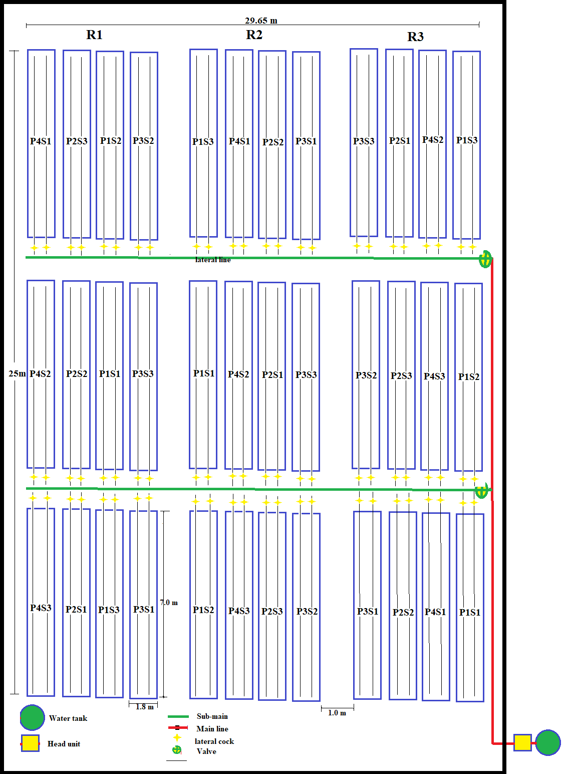
Fig. 1 Experimental Layout.

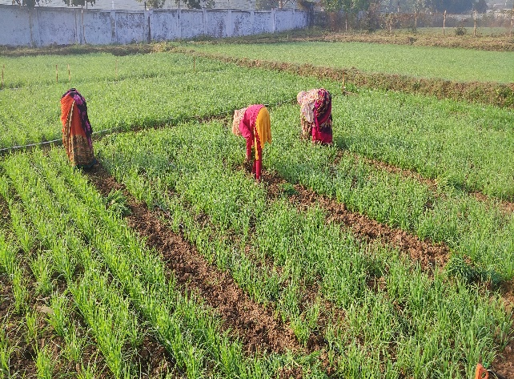  30 DAS | 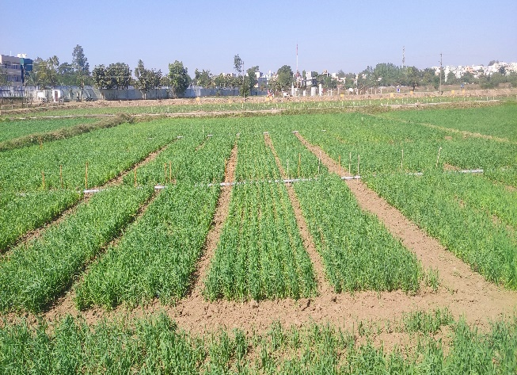  40
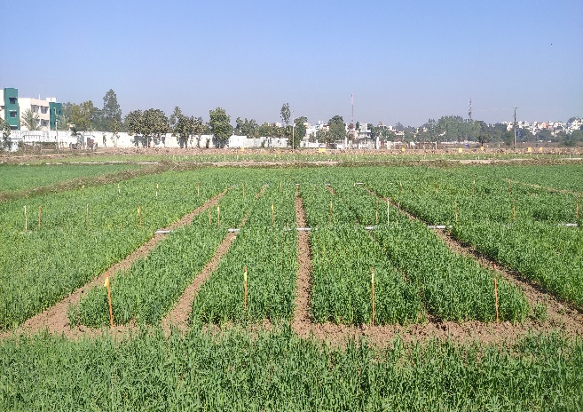  50 | 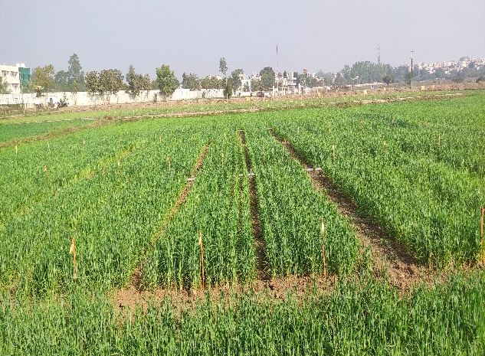  60
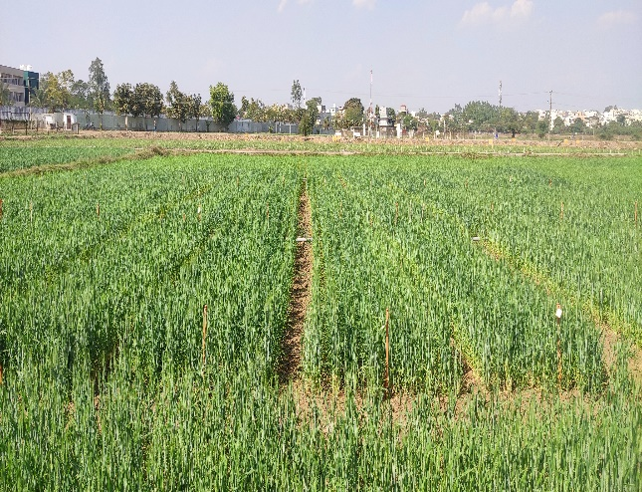  70 | 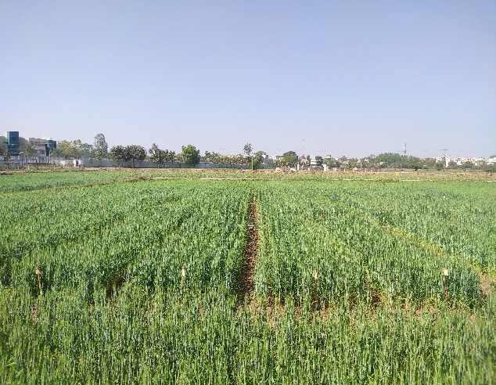  80
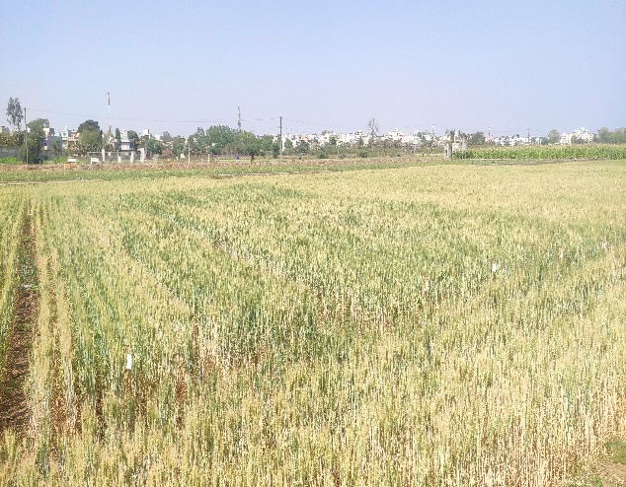  100 | 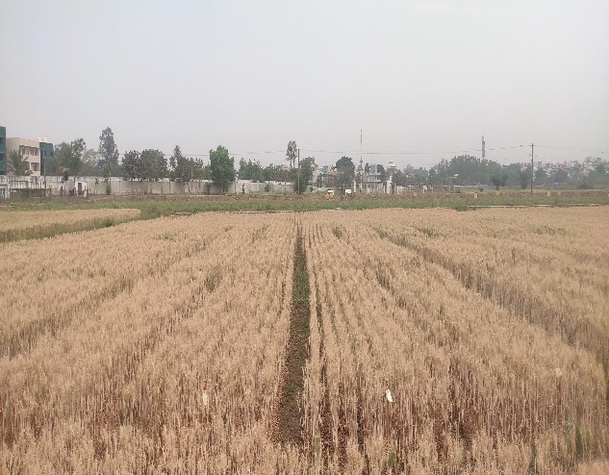  110
Plate 1: Crop condition day after showing.

RESULTS AND DISCUSSION
The data presented in Table 3 reveals that both the number of pulse irrigations and lateral spacing had a significant influence on the yield parameters of wheat crop. Among the main treatments, plant height, number of effective tillers, number of grains per spike, 1000-grain weight, and grain yield all increased progressively with a higher number of pulses. The tallest plants (70.5 cm), the highest number of effective tillers (62.5 per meter row length), and the maximum number of grains per spike (51.2) were recorded under treatment P4, which received the highest number of pulse irrigations. Similarly, P4 also achieved the highest 1000-grain weight (45.4 g) and grain yield of 4228 kg/ha, indicating that more frequent pulse irrigation improved soil moisture distribution and enhanced nutrient uptake efficiency. In contrast, the lowest values for these parameters were observed in P1, the single-pulse treatment, suggesting that limited irrigation frequency restricted plant growth and yield potential. However, the harvest index did not vary significantly among treatments, implying that pulse irrigation primarily influenced total biomass rather than partitioning efficiency.
Regarding the effect of lateral spacing, the results indicated that closer lateral spacing improved plant growth and yield performance. The treatment S1 (0.6 m spacing) produced the highest plant height (69 cm), effective tillers (60.3), grains per spike (48.1), and grain yield (3913 kg/ha), while the widest spacing S3 (1.0 m) recorded the lowest yield (3100 kg/ha). This trend suggests that reduced spacing provided more uniform water distribution, optimizing root-zone moisture and promoting better crop development. The interaction effect (P × S) showed that the combination P4S1 (four pulses with 0.6 m spacing) yielded the best performance across all parameters, achieving the maximum grain yield of 4854 kg/ha and straw yield of 5163 kg/ha. This demonstrates that frequent pulsed irrigation coupled with closer lateral spacing is most effective for enhancing wheat productivity under drip irrigation systems.
Drip irrigation has proven to be highly profitable for horticultural and orchard crops due to their high market value, but its economic feasibility for field crops like wheat remains under study. The main limitation lies in the high initial installation cost of drip systems, where lateral lines contribute nearly 30–40% of total expenses (Pandya & Rank, 2014). Increasing lateral spacing can reduce system cost but may negatively affect yield, as reported by Rui Chen et al. (2015), Chouhan et al. (2015), Danger (2016) and Abd El-Rahman (2009). In this study, the fixed cost of the drip system decreased from ₹1,94,632/ha at 0.6 m lateral spacing to ₹1,26,132/ha at 1.0 m spacing, showing that system cost is highly sensitive to lateral configuration. However, total cost of cultivation, which includes both fixed and variable costs, ranged between ₹42,267/ha and ₹46,934/ha, depending on the treatment and pulse frequency applied.

Table: 3. Effect of Number of Pulse Irrigation and lateral spacing on yield parameters of wheat crop
Treatments | Plant height (cm) | Number of Effective Tillers per MRL | Number of Grains per Spike | 1000 Grain Weight (gm) | Harvest Index % | Grain Yield, kg/ha | Straw Yield, kg/ha
A. Main plot (Number of Pulse Irrigation)
P1 | 53.1 | 40.5 | 34.8 | 33.2 | 48.5 | 2717 | 2888
P2 | 62.8 | 47.4 | 41.4 | 39.9 | 49.0 | 3301 | 3448
P3 | 67.1 | 58.6 | 42.9 | 42.4 | 50.2 | 3752 | 3720
P4 | 70.5 | 62.5 | 51.2 | 45.4 | 48.4 | 4228 | 4531
S.Em. ± | 2.61 | 2.15 | 2.91 | 2.09 | 0.90 | 149 | 263
C.D. at 5 % | 9.02 | 7.44 | 10.08 | 7.23 | NS | 515 | 910
C.V. (%) | 12.34 | 12.35 | 20.53 | 15.58 | 5.49 | 12.75 | 21.64
B. Sub plot (Lateral Spacing)
S1 | 69 | 60.3 | 48.1 | 43.9 | 48.9 | 3913 | 4065
S2 | 62.4 | 50.0 | 40.0 | 39.3 | 49.6 | 3486 | 3564
S3 | 58.7 | 46.5 | 39.6 | 37.4 | 48.5 | 3100 | 3311
S.Em. ± | 2.2 | 1.48 | 2.11 | 1.66 | 0.57 | 86 | 94
C.D. (0.05) | 6.59 | 4.43 | 6.34 | 4.97 | NS | 259 | 283
C.V. (%) | 12.01 | 9.79 | 17.21 | 14.28 | 4.06 | 8.54 | 8.96
C. Interaction Effect (P x S) on Plant Height, cm
P1S1 | 53.9 | 43.9 | 34.7 | 32.5 | 47.1 | 2996 | 3336
P1S2 | 53.3 | 40.3 | 36.1 | 35.8 | 49.6 | 2753 | 2798
P1S3 | 52.2 | 37.4 | 33.5 | 31.4 | 48.8 | 2403 | 2529
P2S1 | 65.3 | 51.6 | 48.0 | 42.1 | 49.4 | 3388 | 3480
P2S2 | 59.3 | 45.2 | 37.3 | 37.5 | 49.9 | 3250 | 3261
P2S3 | 63.7 | 45.5 | 39.1 | 40.1 | 47.6 | 3266 | 3604
P3S1 | 71.4 | 68.5 | 47.2 | 46.2 | 50.8 | 4412 | 4281
P3S2 | 68 | 57.6 | 40.3 | 41.6 | 49.9 | 3542 | 3562
P3S3 | 61.9 | 49.7 | 41.1 | 39.4 | 49.9 | 3302 | 3316
P4S1 | 85.4 | 77.2 | 62.4 | 54.9 | 48.5 | 4854 | 5163
P4S2 | 69 | 57.0 | 46.4 | 42.4 | 49.0 | 4399 | 4634
P4S3 | 57.1 | 53.4 | 44.8 | 39.0 | 47.6 | 3430 | 3796
S.Em. ± | 4.396 | 2.95 | 4.23 | 3.32 | 1.15 | 173 | 189
C.D. (0.05) | NS | 8.86 | NS | NS | NS | 518 | 565

Economic analysis of different treatments revealed that gross returns varied from ₹63,870/ha to ₹1,29,108/ha, while net returns ranged from ₹23,811/ha to ₹83,574/ha. The highest economic performance was observed under treatment P4S1 (4854 kg/ha grain yield and 5163 kg/ha straw yield), with a benefit-cost (B:C) ratio of 2.84, indicating that pulsed irrigation with closer lateral spacing provided maximum profitability. In contrast, treatment P1S3 yielded the lowest B:C ratio of 1.59, suggesting that both inadequate pulsing and wider lateral spacing reduced efficiency and returns. These results demonstrate that optimizing pulse frequency and lateral spacing not only enhances yield and water productivity but also significantly improves the economic viability of drip irrigation for wheat cultivation in semi-arid regions like Gujarat.
Table: 4 Cost Economics of Wheat Cultivation
Treatments |  | Grain Yield  (kg/ha) | Straw Yield  (kg/ha) | Variable  Cost  (₹/ha) | Fixed  Cost  (₹/ha) | TCC  (₹/ha) | Gross Income  (₹/ha) | Net Return  (₹/ha) | B:C
 |  |  |  |  |  |  |  |  | Ratio
T1 | P1S1 | 2996 | 3336 | 28300 | 17234 | 45534 | 79896 | 34362 | 1.75
T2 | P1S2 | 2753 | 2798 | 28300 | 13866 | 42166 | 73016 | 30850 | 1.73
T3 | P1S3 | 2403 | 2529 | 28300 | 11759 | 40059 | 63870 | 23811 | 1.59
T4 | P2S1 | 3388 | 3480 | 28300 | 17234 | 45534 | 89923 | 44389 | 1.97
T5 | P2S2 | 3250 | 3261 | 28300 | 13866 | 42166 | 86134 | 43968 | 2.04
T6 | P2S3 | 3266 | 3604 | 28300 | 11759 | 40059 | 87053 | 46994 | 2.17
T7 | P3S1 | 4412 | 4281 | 28300 | 17234 | 45534 | 116728 | 71194 | 2.56
T8 | P3S2 | 3542 | 3562 | 28300 | 13866 | 42166 | 93889 | 51723 | 2.23
T9 | P3S3 | 3302 | 3316 | 28300 | 11759 | 40059 | 87527 | 47468 | 2.18
T10 | P4S1 | 4854 | 5163 | 28300 | 17234 | 45534 | 129108 | 83574 | 2.84
T11 | P4S2 | 4399 | 4634 | 28300 | 13866 | 42166 | 116937 | 74771 | 2.77
T12 | P4S3 | 3430 | 3796 | 28300 | 11759 | 40059 | 91448 | 51389 | 2.28

CONCLUSION
The study clearly demonstrates that pulsed drip irrigation, particularly with optimized lateral spacing, significantly enhances the growth, yield, and economic returns of wheat cultivation under semi-arid conditions like those in Gujarat. Increasing the number of irrigation pulses from continuous flow (P1) to four pulses (P4) resulted in substantial improvements in plant height, tiller formation, grain weight, and overall productivity, with the P4S1 combination (four pulses and 0.6 m lateral spacing) achieving the highest grain yield (4854 kg/ha) and straw yield (5163 kg/ha). These findings indicate that more frequent pulsed irrigation improves soil moisture uniformity and nutrient uptake, leading to better crop performance. Although closer lateral spacing increases system cost, the yield and water productivity gains offset the investment, yielding a maximum benefit-cost ratio of 2.84. Conversely, wider spacing and fewer pulses reduced yield and profitability. Overall, the results affirm that adopting pulsed drip irrigation with optimal lateral spacing offers a technically sound and economically viable solution for enhancing wheat productivity and sustainable water management in water-scarce regions of Gujarat.

Disclaimer (Artificial intelligence)
Option 1:
Author(s) hereby declare that NO generative AI technologies such as Large Language Models (ChatGPT, COPILOT, etc.) and text-to-image generators have been used during the writing or editing of this manuscript.
Option 2:
Author(s) hereby declare that generative AI technologies such as Large Language Models, etc. have been used during the writing or editing of manuscripts. This explanation will include the name, version, model, and source of the generative AI technology and as well as all input prompts provided to the generative AI technology
Details of the AI usage are given below:
1.
2.
3.

REFERENCES
Abd-Elhakim, A., Elmeadawy, M., El-Sybaee, I., & Egela, M. (2021). Effect use of pulsed deficit drip irrigation for tomato crop in greenhouse powered by solar energy. Misr Journal of Agricultural Engineering, 38(1), 1-14.
Abd-El-Rahman, G. (2009). Water use efficiency of wheat under drip irrigation systems at Al-Maghara area, North Sinai, Egypt. American-Eurasian Journal of Agricultural and Environment Science, 5 (5), 664-670.
Chauhan, R. P. S., & Yadav, B. S. (2012). Effect of levels and depth of sprinkler irrigation for chickpea (Cicer arietinum). Journal of Progressive Agriculture, 3 (2), 60-62.
Chouhan, S. S., Awasthi, M. K. and Nema, R. K. (2015). Studies on water productivity and yields responses of wheat based on drip irrigation systems in clay loam soil. Indian Journal of Science & Technology, 8 (7), 650-654.
Dangar, D. M., Dwivedi, K. and Mashru, H. H. (2017). Effect of irrigation regimes and lateral spacing on drip irrigated wheat. International Journal of Agricultural Science and Research, 7 (1), 417-422.
Government of Gujarat. (2023). Gujarat Green Revolution Company (GGRC): Micro Irrigation Project Report. Gandhinagar: Department of Agriculture, Farmers Welfare & Co-operation.
Kumar, M., Rajput, T., & Patel, N. (2016). Spatio-temporal movement of water and nitrate under different dripper discharges in drip fertigation. The Indian Journal of Agricultural Sciences, 86 (3), 310 – 314.
Ministry of Jal Shakti. (2022). Pradhan Mantri Krishi Sinchayee Yojana (PMKSY): Annual Report 2021–22. Government of India.
Pandya, P. A. and Rank, H. D. (2014). Summer sesame response to irrigation methods
and mulching. Research on Crops. 15 (4), 810-815.
Rui, C., Cheng, W., Cui, J., Lia, O., Jiang, G., Fan, H., Zeng, Z. and Ma, F. (2015). Lateral spacing in drip irrigated wheat: The effects on soil moisture, yield and water use efficiency. Field Crop Research, 179, 52-62.

