Influence of Organic Amendments and Microbial Consortium on Growth and Yield Performance of Radish (Raphanus sativus L.) cv. Japanese White

Abstract
Radish is cultivated for its delicate roots, which are consumed raw in salads or as a cooked vegetable. It provides a beneficial supply of fibre, vitamin C, folic acid, and potassium, as well as a valuable source of riboflavin, vitamin B6, magnesium, copper, calcium, and manganese. Biofertilizers are recognized as a supplementary source for soil fertility because they enhance nutrient availability via living organisms. The current study was conducted to examine the effect of organic inputs and microbial consortium on the growth characteristics of radish cv Japanese white. The study was conducted at the experimental farm, Department of Horticulture, Jorhat, in the years 2018-19 and 2019-20. Data aggregated over two years showed that T8 (80:60:60kg NPK + 10t FYM ha-1) produced Radish yields of 191.45q ha-1, while T7 (Enriched compost 5t ha) yielded 169.73q ha-1. The application of various nutrient sources had a significant impact on the growth and yield-related traits. The tallest plant height (32.84 cm), greatest number of leaves (16.31), longest leaf length (24.91 cm), widest leaf width (7.6 cm), and highest leaf area index (3.42) were observed in treatment T8, followed by 29.25 cm, 16.0, 22.73 cm, 7.35 cm, and 3.35 in T7, respectively. Data collected over two years showed that the longest root length (25.45cm) and the widest root diameter (2.715cm) occurred in treatment T8. In the organic treatments, the greatest root length (24.26 cm) and highest total yield (25.41 t ha-1) were observed in treatment T7. All the growth and yield metrics were significantly inadequate in T1:(Rock phosphate + Consortium). Out of the inorganic treatments, T8 recorded the highest total yield of 22.75 t ha-1. Among the organic treatments, T7 showed a higher total yield of 18.34 t ha-1, which was followed by T6 (17.30 t ha-1). The lowest total yield was found in T1 (7.34 t ha-1). From the study, it was clearly observed that organic manure and microbial consortium had a positive impact on the growth and yield of radish. Among organic treatments, T7: T1 Enriched compost (5 t ha-1) was found to be best.

Keywords: Organic, Vermicompost, Enriched Compost, Consortium, growth parameters

Introduction:
“Radish (Raphanus sativus L.), under the family Cruciferae, is a popular root vegetable grown all over the world. They are characterised as a small plant. It needs large amounts of nutrients in a relatively short period. As a result, fertiliser application should be efficient using appropriate sources and doses” (Bonfim-Silva et al., 2019). “Its roots are consumed raw as salad or as cooked vegetables known for their unique pungent flavour. It is grown both as an annual and a biennial root crop, depending on the type. Radish is grown for its tender roots, which are eaten raw as a salad or cooked vegetable. It is a good source of fibre, vitamin C, folic acid and potassium, and a good source of riboflavin, vitamin B6, magnesium, copper, calcium and manganese. It is a heavy feeder and an exhaustive crop, also responds very well to the application of nutrients. The low production of radish may be due to several factors, of which nutrition is the most important. In recent days, in order to increase productivity and profitability, the use of chemical fertilisers, pesticides and other chemical inputs is increasing day by day, resulting in environmental and ecological problems, which adversely affect the sustainability of the agricultural system” (Ram & Singh, 2018). Soil health is a key factor for sustaining agricultural productivity. “Soil health is the state of the soil in relation to its potential ability to maintain its biological productivity, strengthen environmental quality, and foster plant and animal health. Sustainable agriculture can be defined as agriculture that can be practised in a productive and profitable way without affecting the health of the soil” (Cárceles Rodríguez et al., 2022). “Low and abundant use of chemical fertilisers coupled with continuous cropping results in deterioration of innate soil fertility and poses a serious threat to soil biochemical properties. Soils of Assam have medium availability of phosphorus and potassium, low in nitrogen. Biofertilizers have been designated as the supplement source of soil fertility as they improve nutrient supply through living organisms. Biofertilizers are produced by using selected beneficial and live microorganisms, which help to improve plant growth and productivity. Biofertilizers are applied to seed, root, soil, or by foliar spray to enhance the microbial activity through their multiplication, which then mobilises the nutrients to target plants, which remarkably improves the soil fertility and sooner increases the crop health and production” (Chaudhary et al., 2022; Zhao et al., 2024). Recently customised consortia of such biofertilizers that are better adapted to local climatic conditions have also been developed and are available commercially. This consortium, along with organic inputs, is applied in soil which increases the nutrient use efficiency. Hence, there is a need to popularise and standardise this eco-friendly and cost-effective organic manure and microbial consortium for vegetable crops. So, keeping the above factors in view, the present investigation was carried out.

Materials and methods:
The experiment was laid out in RBD with three replications. There were altogether 8 treatments, T1:(Rock phosphate + Consortium), T2:T1 +Compost (2.5 t ha⁻¹), T3: T1 +Compost (5t ha-1), T4 : T1+Vermicompost (2.5 t ha-1), T5: T1+Vermicompost (5 t ha⁻¹ ), T6 :T1 +Enriched compost (2.5t ha⁻¹), T7 : T1+ Enriched compost (5t ha⁻¹) and T8 : RDF (Recommended dose of fertilizer@50:50:100kg NPK ha-1) + FYM @10t ha⁻¹ .
The farm yard manure was applied @25 t ha⁻¹ as a basal dose during field preparation. For organic plots, Compost, Vermicompost and Enriched compost were applied according to the dosage mentioned in a particular treatment. Rock phosphate is applied as per the recommended dose of phosphorus. For inorganic plots, Nitrogen, phosphorus and potassium were applied at 50:50:100 NPK Kgha⁻¹. For organic plots, a microbial consortium was mixed with respective organic nutrients at a ratio of 1:100 and mixed properly, and water was sprinkled and heaped. The heaps were covered by gunny bags. After 8-10 days, the mixture was applied in the plot per treatment. Thinning of plants was carried out at 15 – 20 DAS, maintaining a distance of 10 cm between plants in a row.
Results and discussion:
Growth parameters:
Plant height(cm): The interpretation of pooled data at 60 DAS over two years revealed that the highest plant height (32.84 cm) was observed under T₈ [RDF (50:50:100 kg ha⁻¹ NPK +10 t ha⁻¹ FYM)]. Among the organic treatments, the highest plant height (29.25 cm) was observed in T₇ (T₁ + Enriched compost 5 t ha⁻¹), which was followed by T₆ (28.85 cm). The lowest plant height (24.58 cm) was found in T₁ (Rock phosphate+ consortium).
Number of leaves: Similarly, the maximum number of leaves (16.31 cm) was observed under T₈. Among the organic treatments, the highest leaf number (16.00) was observed in T_{7,} which was followed by T₆ (15.82). The lowest leaf number (11.89) was found in T₁(Rock phosphate+ consortium).
Leaf length: Likewise, the leaf length at 60 days of sowing was highest (24.91 cm) in the treatment T₈. Analysis of variance revealed that among organic treatments, the highest leaf length (22.73) at harvest was found in the treatment T_{7,} which was at par with T₆(21.64), which was further followed by T₅ (20.51). The lowest leaf length of 19.06 cm was found in the treatment T₁.
Leaf area index (LAI): Significantly, the highest leaf area index of 3.42 was recorded in T_{8,} followed by 3.35 in T₇ (T1 + Enriched compost 5 t ha-1). Whereas T₁ (Rock phosphate +Consortium) recorded the lowest leaf area index of 2.70. The application of the suggested fertiliser dosage achieved the highest levels concerning growth parameters owing to the presence and absorption of nutrients such as nitrogen, phosphorus, and potassium for the plants during the early stages of growth. The report by Sharma (1995) on tomatoes substantiated this rise in outcomes. “The potential reason for enhanced growth performance using organic sources could stem from the introduction of organic nutrients, which may have enhanced the soil's physical, chemical, and biological properties, facilitating improved nutrient utilization and absorption by plants, ultimately resulting in superior plant growth and development. This might also be attributed to growth-promoting substances secreted by the biofertilizers, which in turn might lead to better root development, better transportation of water, uptake and absorption of nutrients” which has been reported by Kanwar et al.(2002) in cauliflower, Chumyani et al. (2012) in tomato, and Merentola et al(2012) in cabbage.

Table 1 Effect of organic fertiliser and microbial consortium on growth parameters of radish
(Pooled data over 2 years -20018-19, 2019-20)
Treatments | Plant height | No of  leaves | Leaf length | Leaf area index (LAI)
T1: Rock phosphate+Consortium | 24.58 | 11.89 | 19.06 | 2.70
T2 :T1 + Compost (2.5 t ha⁻¹) | 26.17 | 13.22 | 19.79 | 2.76
T3 : T1 + Compost (5 t ha⁻¹) | 26.42 | 13.69 | 20.97 | 2.80
T4:T1 +Vermicompost(2.5 t ha⁻¹) | 27.30 | 14.06 | 19.10 | 2.86
T5: T1 + Vermicompost (5 t ha ⁻¹) | 27.39 | 14.58 | 20.51 | 2.98
T6:T1+Enrichedcompost(2.5t ha⁻¹) | 28.85 | 15.82 | 21.64 | 3.08
T7: T1+ Enriched compost(5tha⁻¹) | 29.25 | 16.00 | 22.73 | 3.35
T8 : RDF* (50:50:100 kg ha-1 NPK +10 t ha⁻¹ FYM) | 32.84 | 16.31 | 24.91 | 3.42
S.Ed(±) | 1.12 | 0.09 | 0.13 | 0.02
CD (5%) | 2.40 | 0.20 | 0.28 | 0.04
*RDF: Recommended Dose of Fertiliser

Table 2 Effect of organic fertiliser and microbial consortium on yield parameters of radish
(Pooled data over 2 years -20018-19, 2019-20)
Treatments | Root length  (cm) | Root diameter (cm) | Total yield  (t ha⁻¹)
T1:Rock phosphate+Consortium | 18.14 | 1.98 | 4.39
T2 :T1 + Compost (2.5 t ha-1) | 18.64 | 2.08 | 5.23
T3 : T1 + Compost (5 t ha-1) | 20.36 | 2.16 | 5.34
T4:T1 +Vermicompost(2.5 t ha-1) | 19.63 | 2.30 | 5.69
T5: T1 + Vermicompost (5 t ha -1) | 21.53 | 2.46 | 6.17
T6:T1+Enriched compost (2.5t ha-1) | 21.91 | 2.48 | 6.32
T7: T1+ Enriched compost(5tha-1) | 24.26 | 2.55 | 6.58
T8 : RDF (50:50:100 kg ha-1 NPK +10 t ha-1 FYM) | 25,45 | 2.75 | 8.44
S.Ed(±) | 1.83 | 0.10 | 0.46
CD (5%) | 3.93 | 0.22 | 0.99

Yield parameters:
Root length(cm): Pooled data over two years exhibited the highest root length of 25.45 cm in T₈. Among organic treatments, T₇ was observed to have the highest root length of 26.63cm, 21.88 cm and 24.26 cm during 2018-2019,2019-2020 and pooled data over two years, respectively, which was followed by T₆ with a root length of 21.91 cm. There was also a significant difference among the treatments, T₅ (21.53 cm), which was followed by T₄ (19.63 cm). The lowest root length was found in treatment T_{1,} with a root length of 18.14 cm.
Root diameter (cm): Root diameter was found to be significant among different treatments. Results depicted that the minimum root diameter of 1.99 cm was found in T₁. Among organic treatments, Root diameter was highest in T_{7,} 2.56 cm, which was followed by T₆ (2.48 cm). Overall all the root diameter was highest in T₈ with 2.71cm
Total yield (t ha-1): Data presented in Table 2 depicted that there was a significant difference among the treatments. Out of the inorganic treatments, T₈ recorded the highest total yield of 22.75 t ha⁻¹. Among the organic treatments, T₇ showed a higher total yield of 18.34 t ha^{- 1,} which was followed by T₆ (17.30 t ha-1). The lowest total yield was found in T₁ (7.34 t ha⁻¹)
“This increase in root parameters might be due to a higher photosynthetic rate from greater photosynthetic area and their movement towards the root, resulting in an increase in root parameters. The present findings were in close conformity” with the findings reported by Chaurasia et al ;2001 and Sharma and Singh (2003). The increase in root length and root diameter in organic treatment might be due to the direct contribution of organic inputs to the consortium in improving the fertility condition of the soil because of the increased microbial activity and better plant stand in the soil.
The yield improvement under T₈ was also found due to the long-term fertiliser application along with farm yard manure (Swaroop,1998). “Yield improvement in organic treatments was due to improvement in the physical and biological properties of soil as a result of the supply of additional nutrients through organics” (Sharma et al,2005). Meanwhile, “the beneficial effect of organic manure on yield might be due to an increase in organic matter content caused by the carbon dioxide generation during the process of compost degradation”. (Wilkinson,1979) and “enhancement of the soil physical conditions, which helped the plant to have good root development by improving the aeration of the soil”. (Arisha et al ;2003).
Conclusion:
The study finds that using organic fertilizer in combination with the Consortium enhances the microbial population in soil, facilitating the release of several immobile nutrients and generating plant growth promoters that stimulate plant growth related to photosynthesis. These findings aligned with those of Raja et al. (2006). The research clearly showed that organic fertilizer and microbial groups positively influenced the growth and yield of radish. Among organic treatments, T7 :T1 +Enriched compost (5 t ha-1) was identified as the most effective.

Disclaimer (Artificial intelligence)
Option 1:
Author(s) hereby declare that NO generative AI technologies such as Large Language Models (ChatGPT, COPILOT, etc.) and text-to-image generators have been used during the writing or editing of this manuscript.
Option 2:
Author(s) hereby declare that generative AI technologies such as Large Language Models, etc. have been used during the writing or editing of manuscripts. This explanation will include the name, version, model, and source of the generative AI technology and as well as all input prompts provided to the generative AI technology
Details of the AI usage are given below:
1.
2.
3.

References:
Arisha, H. M. E., Gad, A. A., & Younes, S. E. (2003). Response of some pepper cultivars to organic and mineral nitrogen fertilizers under sandy soil conditions. Zagazig J Agric. Res.30: 1875-1899.
Chaurasia, S. N. S., Prasad, R. N., Yadava, R. B., & Singh, D. K. (2012). Nutrient Management in Vegetable Crops for Sustainable Production. Green Agril, 281.
Chumyani, K. S., Singh, A. K., & Singh, V. B. (2012). Effect of integrated nutrient management on growth, yield and quality of tomato (Lycopersicon esculentum mill.). J. of Soil and Crops, 22, 5-9.
Levy, J. S., & Taylor, B. R. (2003). Effects of pulp mill solids and three composts on early growth of tomatoes. Biores Technol , 89(3), 297-305.
Merentola; Kanaujia, S. P., & Singh, V. B. (2012). Effect of integrated nutrient management on growth, yield and quality of cabbage (Brassica oleracea var.capitata). J. of Soils and Crops, 22(2), 233-239.
Raja, P., Uma, S., Gopal, H., & Govindarajan, K. (2006). Impact of bio inoculants consortium on rice root exudates, biological nitrogen fixation and plant growth. J. Biol. Sci.6: 815-823.
Sharma, R. P., Sharma, A., & Sharma, J. K. (2005). Productivity, nutrient uptake, soil fertility and economics as affected by chemical fertilizers and farmyard manure in broccoli (Brassica oleracea var italica) in an Entisol. Ind. J. of Agric.Sci., 75(9), 576-579.
Sharma, S. K., & Singh, H. (2003). Effect of Seed Rate and Fertilizer Doses on Growth, Yield and Seed Quality of Pea (Pisum sativum L.) cv. Arkel. Seed Res. New Delhi-, 31(1), 43-46.
Wilkinson, S. R. (1979). Plant nutrient and economic values of animal manures. J. of animal Sci.48(1), 121-133.
Bonfim-Silva, E. M., Beltrão, J. de S., de Paula, R. P. F., Roque, W. F., Damasceno, A. P. A. B., & José, J. V. (2019). Water availabilities associated with natural phosphate and triple superphosphate in radish cultivation. International Journal of Plant & Soil Science, 29(3), 1–11. Chaudhary, P., Singh, S., Chaudhary, A., Sharma, A., & Kumar, G. (2022). Overview of biofertilizers in crop production and stress management for sustainable agriculture. Frontiers in Plant Science, 13, 930340.
Zhao, G., Zhu, X., Zheng, G., Meng, G., Dong, Z., Baek, J. H., ... & Jia, B. (2024). Development of biofertilizers for sustainable agriculture over four decades (1980–2022). Geography and Sustainability, 5(1), 19-28.
Cárceles Rodríguez, B., Durán-Zuazo, V. H., Soriano Rodríguez, M., García-Tejero, I. F., Gálvez Ruiz, B., & Cuadros Tavira, S. (2022). Conservation agriculture as a sustainable system for soil health: A review. Soil Systems, 6(4), 87.
Ram, R. M., & Singh, H. B. (2018). Microbial consortium in biological control: An explicit example of teamwork below ground. Journal of Eco-friendly Agriculture, 13(1), 1-12.

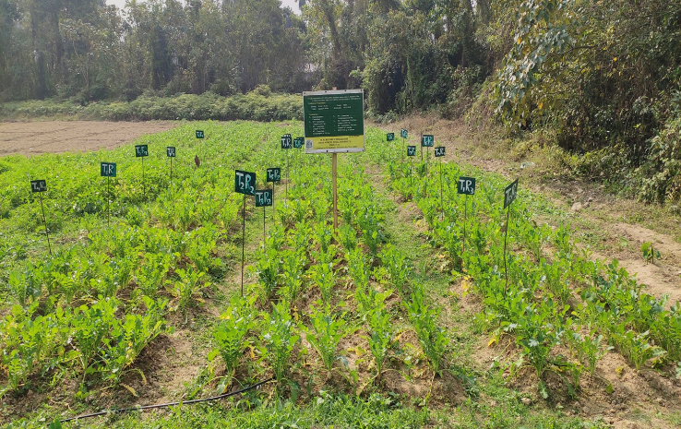
Fig1. Experimental plot

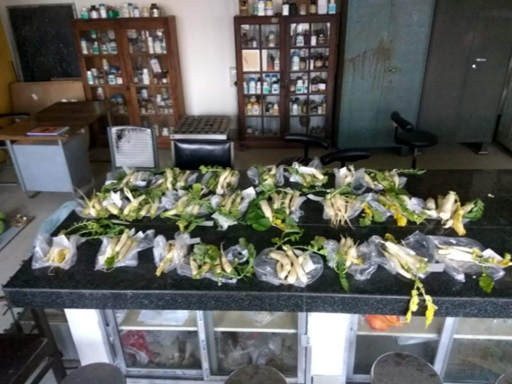
Fig 2. Harvested radish

