Case report

Atypical Neurological Presentation of Eosinophilic Granulomatosis with Polyangiitis: Concurrent Quadriparesis and Refractory Seizures as Initial Manifestations

.
ABSTRACT

Background:
Eosinophilic granulomatosis with polyangiitis (EGPA) is a small to medium-vessel vasculitis characterized by asthma, hyper eosinophilia, and multisystem involvement. Neurological disease most frequently manifests as mononeuritis multiplex, whereas symmetric polyradiculopathy and central nervous system (CNS) vasculitis are distinctly uncommon.
Case Presentation:
We report a 40-year-old woman with long-standing asthma who presented with a rapidly progressive ascending quadriparesis, glove-and-stocking sensory loss and vasculitic rash, she subsequently experienced focal seizures that evolved into refractory status epilepticus. Investigations revealed marked eosinophilia, axonal sensorimotor polyradiculopathy on nerve conduction studies, and a skin biopsy demonstrating eosinophilic vasculitis. Cytogenetic analyses excluded clonal hyper eosinophilic syndromes. MRI of the brain revealed multifocal acute infarcts consistent with CNS vasculitis. ANCA testing was negative. The constellation of asthma, hyper eosinophilia, neuropathy, extravascular eosinophilic inflammation, multisystem involvement and ANCA being negative, fulfilled ACR/EULAR classification criteria for EGPA after excluding clonal HES. Despite initiation of high-dose corticosteroids and cyclophosphamide, she developed aspiration pneumonia during prolonged seizures and mechanical ventilation and ultimately died from intractable status epilepticus.
Conclusion:
This case exemplifies an under-recognized neurological spectrum of EGPA, where simultaneous peripheral and central nervous system involvement results in rapid clinical deterioration and fatal outcome. Early recognition of this rare and aggressive variant is crucial to improving therapeutic opportunities and preventing catastrophic progression.

Keywords: ANCA-negative vasculitis, Central nervous system vasculitis, Eosinophilic granulomatosis with polyangiitis (EGPA), Generalized tonic clonic seizures, Polyradiculopathy

1. INTRODUCTION

Eosinophilic granulomatosis with polyangiitis (EGPA) is an eosinophil-rich vasculitis characterized by asthma, eosinophilia, and multisystem involvement. Neurological manifestations are frequent, affecting nearly two-thirds (55-72 %) of patients [1], yet they typically present as mononeuritis multiplex or an asymmetric axonal neuropathy rather than a symmetric sensorimotor polyradiculopathy [2]. Such atypical patterns may closely mimic Guillain-Barré syndrome (GBS) and can delay recognition and treatment. Central nervous system (CNS) involvement is significantly less common, reported in only 5-9% of cases, but is associated with substantial morbidity. The spectrum includes ischemic infarcts, hemorrhage, seizures, encephalopathy, and rarely, diffuse vasculitic injury [3]. Case reports describe presentations ranging from quadriplegia and stroke-like episodes to rapidly progressive paraplegia, reflecting the expanding neurological phenotype of EGPA [2,3]. Distinguishing EGPA from hyper eosinophilic syndromes (HES) remains essential, as therapeutic strategies diverge substantially. However, when EGPA presents with simultaneous peripheral and CNS involvement, diagnosis may be obscured by its resemblance to GBS [4,5], acute cerebrovascular disease, or infectious neuropathies [6]. Concurrent asthma, eosinophilia, vasculitic rash, and atypical neuropathy should prompt consideration of EGPA to avoid delays in treatment [7,8]. This case highlights the diagnostic challenges and the consequences of delayed recognition in aggressive neurological EGPA
2. CAse presentation:-

A 40-year-old woman with a 15-year history of bronchial asthma on intermittent metered-dose inhaler use, presented to the emergency department with progressive neurological symptoms. She initially developed numbness, tingling, and weakness in both lower limbs over a period of two weeks, followed by similar symptoms in the upper limbs over the subsequent week. The weakness was distal-predominant, beginning as difficulty holding footwear and later manifesting as impaired fine motor activities such as buttoning clothes, mixing food, writing, and gripping objects. She also reported diminished perception of hot and cold stimuli in the distal extremities. One week before admission, she experienced two focal seizures, and during hospitalization, she developed recurrent episodes of generalized seizures refractory to initial therapy.
On examination, her vital signs were stable and mild expiratory wheeze was noted. Neurological assessment revealed distal-predominant weakness in all four limbs with hypotonia, absent deep tendon reflexes in the lower limbs and mute plantar responses. Sensory examination demonstrated impaired touch, pain, temperature, vibration, and joint position sense in a glove-and-stocking distribution. Cranial nerve and cerebellar examinations were normal. Skin examination revealed ill-defined erythematous and violaceous patches over both lower limbs and the trunk [Figure 1].
Lab Investigations [Table 1] demonstrated marked leukocytosis (51,900/μL). Peripheral smear revealed marked eosinophilia (80%). Bone marrow biopsy showed normocellular marrow with myeloid hyperplasia, showing predominantly eosinophils and their precursors with no evidence of blasts or necrosis [Figure 2]. Molecular tests for hyper eosinophilic syndrome (eosinophilic leukemia) demonstrated no evidence of CBFB, FGFR1, PDGFRA or PDGFRB gene rearrangements . Skin biopsy revealed atrophic skin with hyperkeratosis with underlying dermis showing numerous scattered congested blood vessels. One focus showed thrombi and many foci of extravasated red blood cells were present. The Perivascular areas showed dense eosinophilic and some lymphocytic infiltrates [Figures 3, 4]. Nerve conduction studies (NCS) suggested a severe axonal sensorimotor polyradiculopathy, shown by markedly reduced Compound muscle action potential (CMAP) and Sensory nerve action potential (SNAP) amplitudes with preserved velocities [Figures 5-7]. MRI of the brain demonstrated multiple acute infarcts (diffusion restriction imaging showing diffusion restriction in multiple areas of cerebral hemispheres) consistent with CNS vasculitis [Figure 8]. ANCA and other serological tests were negative [Table 2].
The combination of asthma, marked eosinophilia, vasculitic rash, peripheral neuropathy and histological evidence of eosinophilic vasculitis fulfilled the American College of Rheumatology (ACR)/ European Alliance of Associations for Rheumatology (EULAR) classification criteria for EGPA. High-dose intravenous corticosteroids were initiated, followed by cyclophosphamide. Despite this, she developed aspiration pneumonia during prolonged seizures and mechanical ventilation, and ultimately died from intractable status epilepticus.

3. discussion

Neurological involvement in eosinophilic granulomatosis with polyangiitis (EGPA) is well recognized, but it most often presents as mononeuritis multiplex or asymmetric axonal neuropathy. Symmetric sensorimotor polyradiculopathy, as seen in this patient, is distinctly uncommon and may closely mimic Guillain-Barré syndrome (GBS), increasing the potential for misdiagnosis [4]. Axonal injury in EGPA results from both eosinophil-mediated cytotoxicity and necrotizing vasculitis of the vasa nervorum, consistent with severe amplitude reduction observed on nerve conduction studies [4].
Central nervous system (CNS) involvement is rare, occurring in only 5-9% of EGPA cases, and most often manifests as ischemic lesions, hemorrhage, or seizures. A recent systematic review highlighted wide variability in neuroimaging findings and emphasized the diagnostic difficulty when CNS vasculitis accompanies peripheral neuropathy [1]. The multifocal acute infarcts in this patient align with previously reported vasculitic CNS patterns, including cases presenting with quadriplegia or stroke-like episodes [2,9,10]
Differentiating EGPA from hyper eosinophilic syndrome (HES) is critical, as management diverges substantially. In this case, the absence of clonal markers on the eosinophilic leukemia panel presence of eosinophilic vasculitis on biopsy, favored EGPA. Asthma, eosinophilia, neuropathy, and extravascular eosinophilic inflammation fulfilled the ACR/EULAR criteria, even in the absence of ANCA positivity, which is typical of the eosinophilic phenotype of EGPA [11,12].
Early immunosuppression is essential to prevent irreversible neurological injury. Large EGPA cohorts show improved outcomes in neuropathic disease with timely corticosteroids and cyclophosphamide. Similar benefits have been reported in severe quadriparesis and CNS vasculitis treated with high-dose glucocorticoids and cytotoxic agents [3]. Despite initiation of immunosuppression, the patient progressed to refractory status epilepticus and ultimately sustained a cardiac arrest. This outcome highlights the aggressive nature of neurological EGPA and reinforces the importance of considering EGPA early when eosinophilia, vasculitic features, and atypical neuropathy are present [5-8].
4. conclusion

This fatal presentation of EGPA demonstrates how the disease can initially mimic more common neurological conditions while rapidly progressing to life-threatening complications. The development of refractory status epilepticus and cardiac arrest in this patient highlights the need to recognize EGPA early in asthmatic individuals with eosinophilia and atypical neuropathy. Prompt diagnosis is essential, even though outcomes may remain poor in aggressive phenotypes of the disease

Table 1: Investigation panel

LAB INVESTIGATIONS | RESULTS | REFERENCE RANGE
Haemoglobin | 13.5 | 12 – 16 g/dL
Platelet | 233000 | 150000 -450000 /μL
White Blood Cells (WBC) | 51900 | 4000-11000 /μL
Blood Urea | 30 | 18–40 mg/dL
Serum Creatinine | 0.5 | 0.5-1.1 mg/dL
Serum Sodium | 131 | 135-145 mEq/L
Serum Potassium | 4.5 | 3.5-5.0 mmol/L
Serum Calcium | 9.2 | 8.5-10.5 mg/dL
Serum Magnesium | 1.9 | 1.7- 2.2 mg/dL
Serum Phosphorus | 3.1 | 2.5 - 4.5 mg/dL
Total Bilirubin | 0.7 | 0.3 - 1 mg/dL
Direct Bilirubin | 0.3 | 0.1 - 0.3 mg/dL
Serum Aspartate Aminotransferase (AST) | 28 | 10-40 IU/L
Serum Alanine Aminotransferase (ALT) | 18 | 10-40 IU/L
Alkaline phosphatase (ALP) | 75 | 30-120 IU/L
Total Protein | 5.7 | 5.5-9 g/dL
Serum Albumin | 3.3 | 3.5-5.5 g/dL
Prothrombin time (PT) | 13.54 s | 11-13 s
International Normalised Ratio (INR) | 0.9 | 0.8-1.1
Activated partial thromboplastin time (APTT) | 28.5 s | 25-35 s
Urine Albumin | 100 | <30 mg/dL
Urine RBC | Nil | 0-2/ high power field (hpf)
Serum Creatine phosphokinase (CPK) | 1200 | 30 – 135 IU/L
Hepatitis B Surface Antigen (HBsAg ) | Negative
Anti- Hepatitis C Virus Antibody (Anti-HCV Ab) | Negative
Human immunodeficiency virus (HIV) | Negative
Anti-nuclear Antibody (ANA) | Negative
Cytoplasmic and Perinuclear Anti-Neutrophil Cytoplasmic Antibody (C & P- ANCA) | Negative
USG Abdomen & Pelvis | No significant abnormality
Fundoscopy | Multiple intra- retinal hemorrhages present
ECG:- | Heart rate -90bpm, normal axis, normal sinus rhythm, no ST-T segment changes, no LVH features
Abbreviations:-

ng- nanogram, pg- picogram, mg- milligram, g- gram, dL- deciliter, mL- millilitre, IU- International Unit, μ-micro, cm- centimetre, mm – millimetre, mEq/L – milliequivalents per litre, s- seconds, USG- Ultrasonography, ECG- Electro cardio gram, LVH- Left ventricular hypertrophy

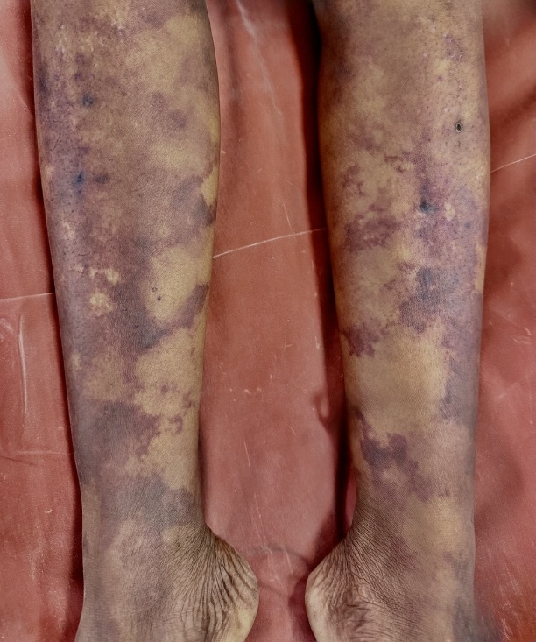

FIGURE 1: Ill-defined diffuse erythematous and violaceous patches noted over bilateral lower limbs

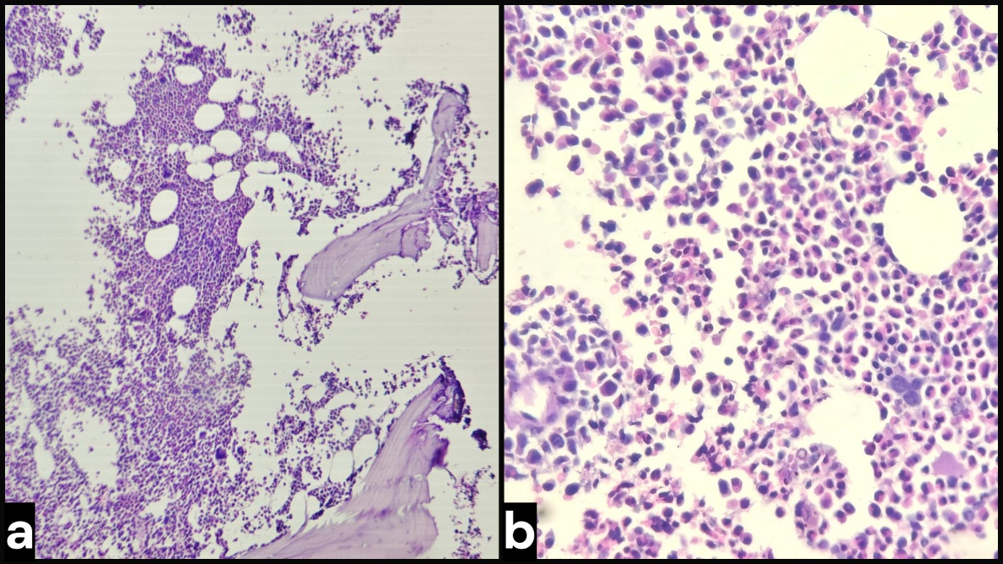

FIGURE 2: Bone marrow biopsy (40x, 100x- H& E stain) :- Normocellular marrow with myeloid hyperplasia, showing predominantly eosinophils and their precursors, no evidence of blasts and necrosis.
a-(40x): Normocellular marrow with myeloid hyperplasia
b-(100x): Myeloid hyperplasia, showing predominantly eosinophils and their precursors

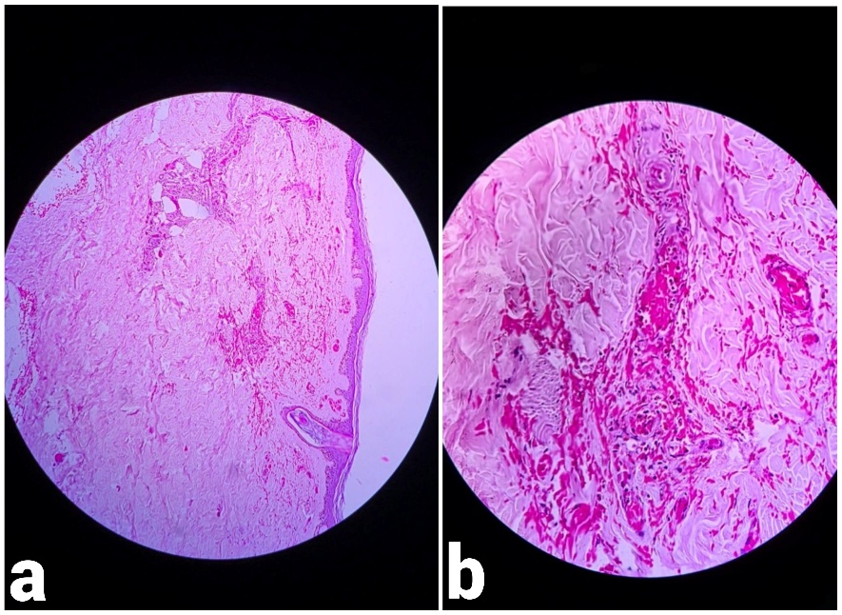

FIGURE 3: Skin biopsy (40x, 100x- Hematoxylin & Eosin stain)

a- (40x- H& E stain)- Section studied shows atrophic skin with hyperkeratosis, the underlying dermis showing
numerous scattered congested blood vessels. One focus shows thrombi, and many foci of extravasated red
blood cells seen]
b- (100x- H& E stain)- Numerous scattered congested blood vessels with a focus of thrombi seen.

FIGURE 4: Skin biopsy ( 100x- H& E stain) :- Section studied shows perivascular area with dense eosinophilic and some lymphocytic infiltrates

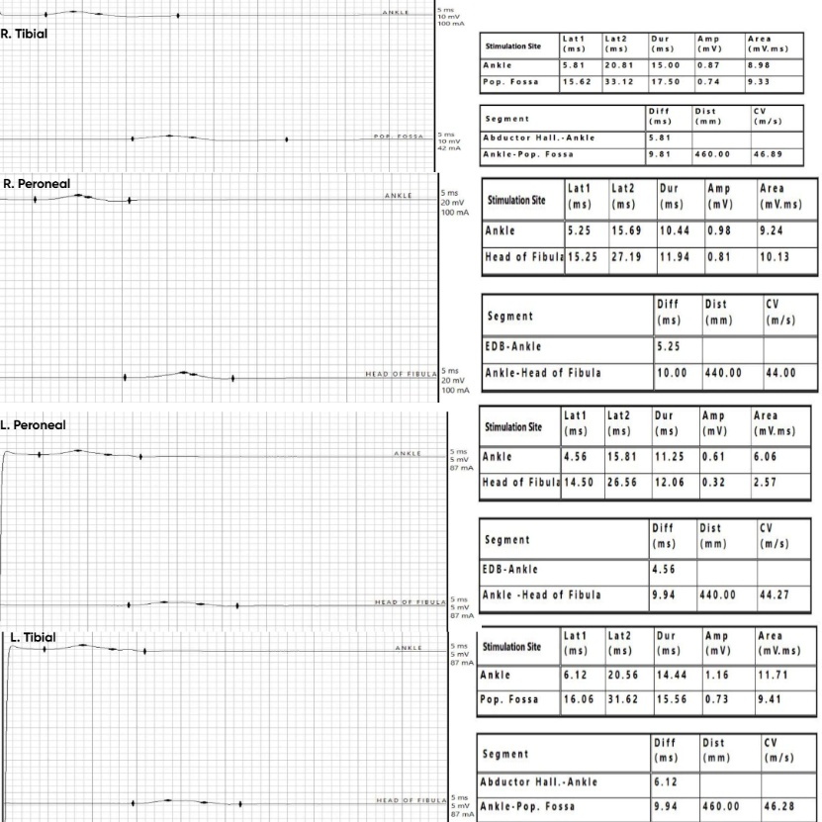

FIGURE 5: Lower limb Motor Nerve Conduction Study (NCS) – showed markedly reduced CMAP amplitudes in all tested nerves with preserved conduction velocities and normal/mildly prolonged latencies, consistent
with a severe symmetrical motor axonal neuropathy

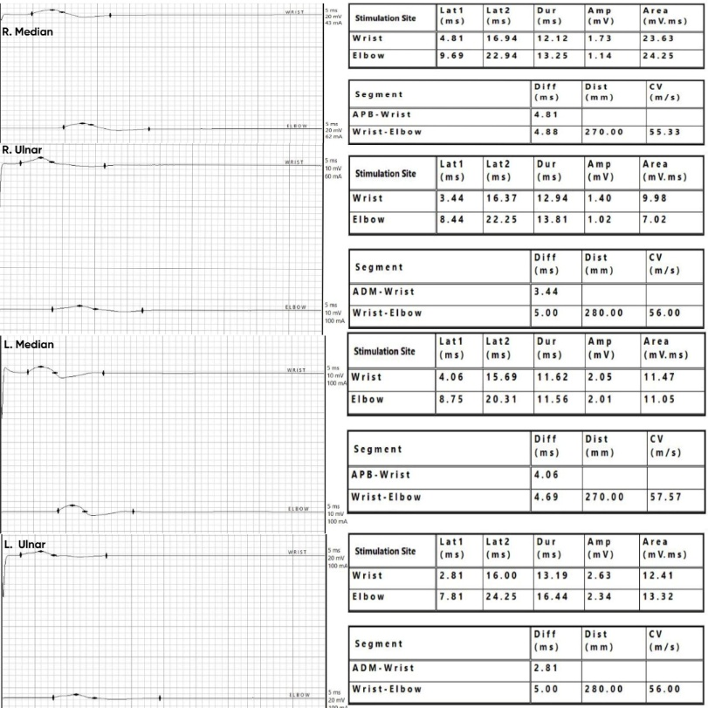

FIGURE 6: Upper limb Motor Nerve Conduction Study (NCS) – showed markedly reduced CMAP amplitudes in all tested nerves with preserved conduction velocities and normal/mildly prolonged latencies, consistent with a severe symmetrical motor axonal neuropathy

.
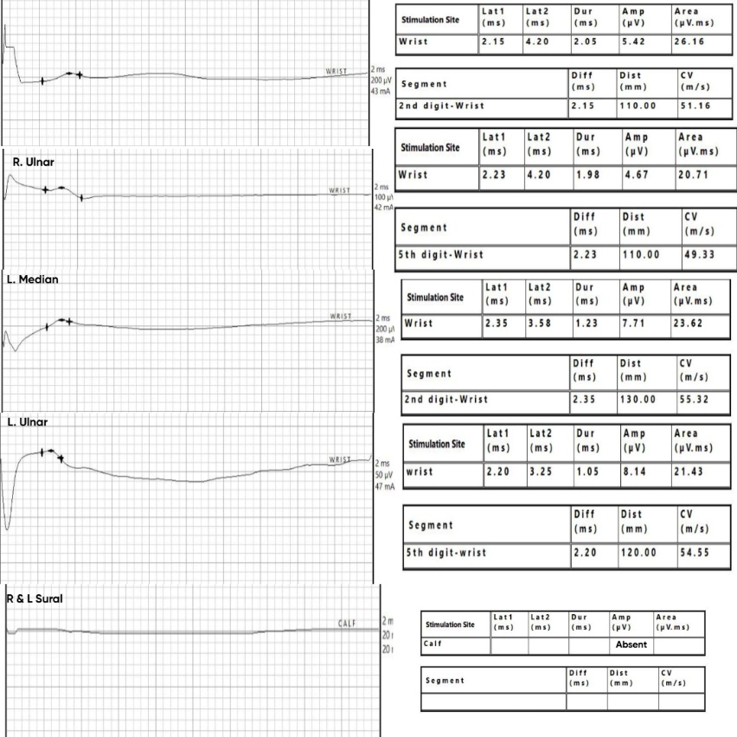

FIGURE 7: Sensory Nerve Conduction Study (NCS) - revealed severely reduced sensory amplitudes in upper limbs and absent sural responses bilaterally with preserved velocities, indicating a severe symmetrical
sensory axonal neuropathy

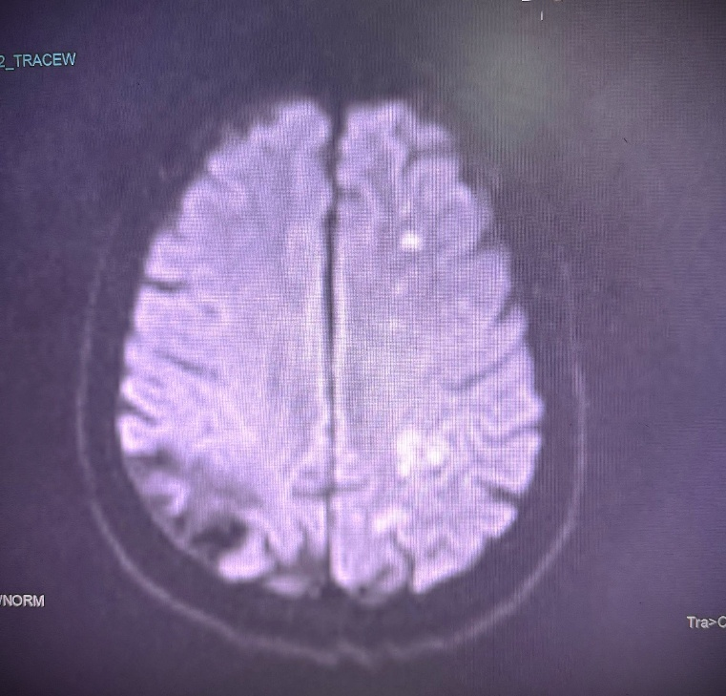

FIGURE 8: Magnetic Resonance Imaging (MRI) Brain- Diffusion Weighted Imaging (DWI) showing diffusion restriction in cerebral hemisphere, consistent with acute infarction

Consent
As per international standards or university standards, patient(s) written consent has been collected and preserved by the author(s).

Disclaimer (Artificial intelligence)
Author(s) hereby declare that NO generative AI technologies such as Large Language Models (ChatGPT, COPILOT, etc.) and text-to-image generators have been used during the writing or editing of this manuscript.

References

1. Vasandani, V., O’Leary, S., Gandhi, R., Koneru, S., Vasandani, S. K., Vasandani, S. K., & Vasandani, S. K. (2025). Unraveling cerebrovascular involvement in EGPA through digital subtraction angiography: case presentation and systematic literature review. *BMC Rheumatology*, *9*(1), 80. https://doi.org/10.1186/s41927-025-00518-7
2. Inayat, W., Iqbal, S., Adnan, F., Ali, A., & Zeb, A. (2025). "A Case of Eosinophilic Granulomatosis With Polyangiitis Presenting as Quadriplegia": A Clinical and Diagnostic Report. Journal of Investigative Medicine High Impact Case Reports. https://doi.org/10.1177/23247096251374513 .
3. Challa, A., Sirisha, S., Khandelia, H., Parekh, M., Patil, A., & Jayalakshmi, S. (2023). A case of eosinophilic granulomatous polyangiitis with concurrent central and peripheral nervous system involvement. Oxf Med Case Reports. https://doi.org/10.1093/omcr/omad067
4. Khandelwal, D., Singh, M., Jagota, R., & Mathur, V. (2021). Eosinophilic granulomatosis with polyangiitis (Churg–Strauss syndrome) imitating Guillain–Barre syndrome (GBS): a case report. The Egyptian Journal of Neurology, Psychiatry and Neurosurgery, 57(1), 173. https://doi.org/10.1186/s41983-021-00411-3
5. Liu, S., Guo, L., Fan, X., Zhang, Z., Zhou, J., Tian, X., Li, M., Zeng, X., Wang, L., & Zhang, F. (2021). Clinical features of central nervous system involvement in patients with eosinophilic granulomatosis with polyangiitis: a retrospective cohort study in China. Orphanet Journal of Rare Diseases. https://doi.org/10.1186/s13023-021-01780-x
6. Nie, N., Liu, L., Bai, C., Wang, D., Gao, S., Liu, J., Zhang, R., Lin, Y., Zhang, Q., & Chang, H. (2024). Eosinophilic granulomatous polyangiitis with central nervous system involvement in children: a case report and literature review. Frontiers in Immunology, 15, 1406424. https://doi.org/10.3389/fimmu.2024.1406424
7. Zhang, Z., Liu, S., Guo, L., Wang, L., Wu, Q., Zheng, W., Hou, Y., Tian, X., Zeng, X., & Zhang, F. (2020). Clinical characteristics of peripheral neuropathy in eosinophilic granulomatosis with polyangiitis: A retrospective single-center study in China. Journal of Immunology Research. https://doi.org/10.1155/2020/3530768
8. Guerra, M., Marado, D., & Fortuna, J. (2023). Acute paraplegia in a patient with eosinophilic granulomatosis and polyangiitis with 20 years of evolution: case report. Acta Biomed, 94(6), e2023243.
https://doi.org/10.23750/abm.v94i6.14209
9. Camara-Lemarroy, Carlos R., Infante-Valenzuela, Adrian, Villareal-Montemayor, Hector J., Soto-Rincon, Carlos A., Davila-Olalde, Javier A., Villareal-Velazquez, Hector J., Eosinophilic Granulomatosis with Polyangiitis Presenting as Acute Polyneuropathy Mimicking Guillain-Barre Syndrome, Case Reports in Neurological Medicine, 2015, 981439, 3 pages, 2015. https://doi.org/10.1155/2015/981439
10. Saeed Khan, Laveeza Fatima, Khurram Shahzad, et al. A Rare Presentation: Eosinophilic Granulomatosis with Polyangiitis Accompanied by Sensory and Motor Axonal Polyneuropathy. Authorea. June 06, 2024.
doi: 10.22541/au.171768000.03869047/v1
11. Yoo, Il-Han & Choi, Sang & Choi, Seong-Ho & Kim, Jeong-Min & Ahn, Suk-Won. (2017). Eosinophilic Granulomatosis with Polyangiitis Presented as Acute Polyneuropathy and Cerebral Vasculitis. Experimental Neurobiology. 26. 168. 10.5607/en.2017.26.3.168. DOI:10.5607/en.2017.26.3.168
12. Hamid M, Benmoh Y, Moussavou C, Ahizone A, Bakal A, Ajamate M, Satte A, Bourazza A. Eosinophilic granulomatosis with polyangiitis presenting with acute polyneuropathy resembling Guillain–Barre syndrome. Int J Case Rep Images 2022;13:101282Z01MH2022. doi:10.5348/101282Z01MH2022CR

