Case report

Management of refractory cancer pain in advanced mesothelioma; success of neuraxial analgesia with tunneled epidural port catheter: A Case Report

.
ABSTRACT

Introduction: Refractory cancer pain is one of the greatest challenges in palliative care, especially in aggressive cancers with a high symptom burden, such as malignant pleural mesothelioma. This rare and fatal disease presents mixed pain that often remains significant despite initial measures, making it necessary to combine different approaches to achieve satisfactory relief.
Presentation of case: We present the case of a 27-year-old woman with metastatic mesothelioma and abrupt functional decline, whose breakthrough and refractory pain caused her profound physical and emotional suffering. Despite systemic morphine administration, relief was insufficient. Given the urgency, continuous epidural neuraxial analgesia (ropivacaine and morphine) was initiated, achieving substantial pain control and greater well-being for the patient. The need for a safe discharge plan and the patient's limited life expectancy led to the placement of a tunneled epidural port.
Conclusion: This device enabled effective pain and anxiety management at home, reaffirming the value of specialized intervention for patients in advanced stages of their illness. The comprehensive, person-centered approach, focused on their dignity, demonstrated how symptom optimization contributes to quality of life.

Keywords: Refractory pain, pleural mesothelioma, palliative care, neuraxial analgesia, tunneled epidural catheter.

1. INTRODUCTION

Cancer-related pain often becomes one of the most complex challenges in palliative care, particularly when it ceases to respond to standard pharmacological strategies. While the analgesic ladder proposed by the World Health Organization remains a fundamental reference for the treatment of cancer pain, in clinical practice, many patients in advanced stages do not achieve sufficient relief with systemic drugs. This occurs due to both poor therapeutic response and the appearance of adverse effects that prevent further increases in dosage (Portenoy, 2011) (Fallon, Giusti, Aielli, Hoskin, Rolke, Sharma, Ripamonti, & ESMO Guidelines Committee, 2018).
Strong opioids are the mainstay of analgesic therapy in the treatment of moderate to severe cancer-related pain. Although there are a variety of strong opioids and no one in superior to another, morphine remains the most widely used therapeutic standard. Its wide availability and solid track record position it as the first-line option in most palliative care protocols (Fallon, et al., 2018).
Morphine is a pure opioid agonist. Structurally, its pharmacological activity is determined by three domains: the phenolic part, the alcoholic part, and a basic nitrogen group (tertiary amine). It has a multitarget profile, acting at the peripheral, spinal, and supraspinal (thalamus) levels. Khamooshi, et al. (2023). Opioids increase the release of gamma-aminobutyric acid and serotonin in the nervous system, thereby reducing the shock ands stress caused by pain, creating relaxation, and decreasing the sensation of pain (Khamooshi, et al., 2025).
Malignant mesothelioma is a relatively rare but lethal tumor, with an incidence rate ranging from 7 to 40 cases per million, causing approximately 40,000 deaths worldwide annually Rigon, Mutti, & Campanella, 2024). Pleural mesothelioma, which involves the internal thoracic cavity and the visceral lining covering the lungs, accounts for more than 70% of all cases (Rigon, et al., 2026).
Malignant pleural mesothelioma has a considerable symptom burden and a poor prognosis, with a median life expectancy of between 8 and 22 months after diagnosis, depending on the stage and histological subtype (Rigon, et al., 2026).
Patients typically present with a diverse array of symptoms, including dyspnea, pain, and cachexia. In many cases, the pain becomes refractory to standard management measures due to tumor infiltration of the pleura, chest wall, and nerve structures. This pain, of mixed origin, poses a therapeutic challenge and is exacerbated by the rapid progression of the disease and the limited life expectancy, necessitating the prioritization of effective pain relief strategies (Saunders, Ashton, Hall, Laird, & MacLeod, 2019).
Although opioids and adjuvant therapies form the basis of treatment, many patients require more specialized interventions when these drugs are insufficient. In this regard, neuraxial analgesia (epidural or intrathecal) is considered an effective alternative, as it allows for the administration of localized medications and reduces the dose of systemic opioids (Díaz, Sánchez, Fontán, Peralta, Berraquero, Naranjo, Gándara, & Fernández, 2023) (Heo, Pyeon, Lee, Kim, Choi, & Yoon, 2014). However, the prolonged use of epidural or intrathecal catheters carries risks, such as infections, displacement, or serious complications if not managed properly (Bomberg, Kubulus, Herberger, Wagenpfeil, Kessler, Steinfeldt, Standl, Gottschalk, Stork, Meissner, Birnbaum, Koch, Sessler, Volk, & Raddatz, 2016) (van Kassel, Hermanides, Lirk, & Hollmann, 2025). Therefore, the development of tunneled or subcutaneous port catheters has been an important advance: these systems offer a more stable route for continuous infusion, with a lower incidence of technical problems (Heo, et al., 2014).
Even with these improvements, evidence on the use of port-type epidural systems in patients with mesothelioma is limited, as there are few detailed clinical reports in this specific population.
Such reports can provide useful information on their safety, efficacy, and tolerability, and contribute to strengthening the available evidence for their application within the field of palliative care.

2. PRESENTATION OF CASE

The case was a 27-year-old woman, previously healthy and with no relevant personal or family history. Following a fall in May 2025, she began experiencing pain localized to the right scapula region. She was initially evaluated at the primary care level, where symptomatic management was prescribed; however, due to persistent and progressive pain, a non-contrast and contrast-enhanced computed tomography scan of the chest, abdomen, and pelvis was performed in September 2025.
The radiological study identified lesions suggestive of malignancy, leading to a lung biopsy performed in October 2025 (Figure 1).
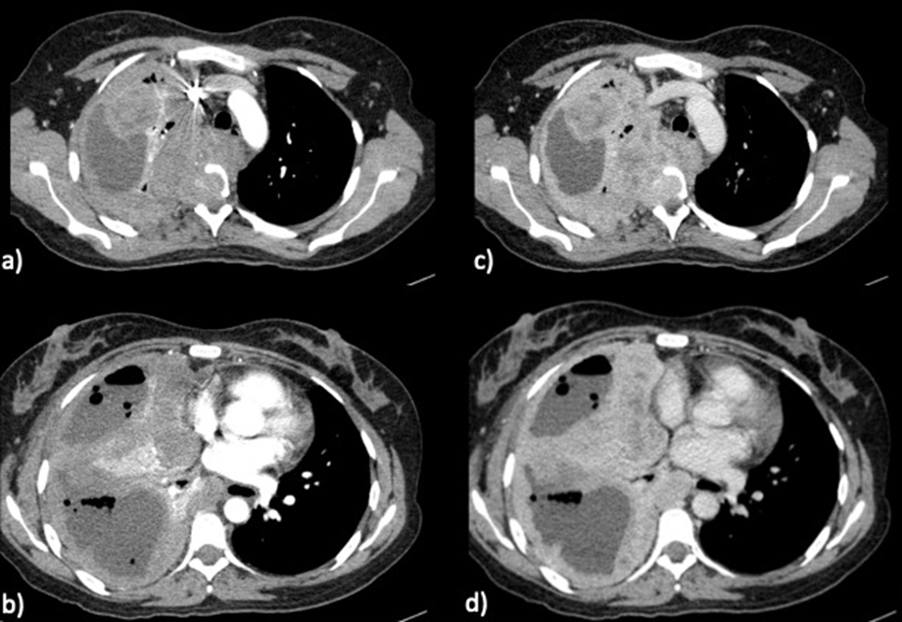
Source: File from the patient
Figure 1. Contrast-enhanced chest CT scan in arterial (a-b) and venous (c-d) phases; circumferential pleural thickening with loculated fluid inside is observed, presenting significant enhancement, occupying the right hemithorax and infiltrating the middle and posterior mediastinum.
Histopathological analysis of pleura sample, revealed an epithelioid tumor with an immunophenotype compatible with mesothelial origin, establishing a diagnosis of metastatic mesothelioma with pulmonary, bone, hepatic, and mediastinal involvement, and bone marrow infiltration (Figure 2).

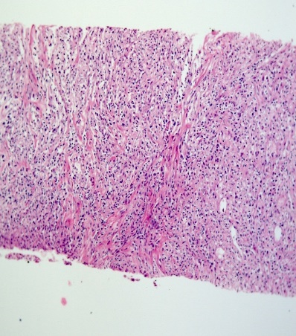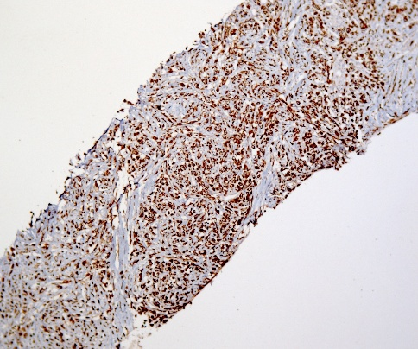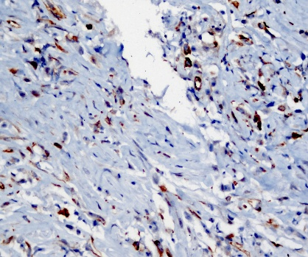
A B C
Source: File from the patient
Figure 2. Histopathological images. A) Hematoxylin and eosin stain, 10x. Neoplasm with infiltrative pattern, discohesive cells separated by fibrous septa, medium in size and with moderate cytoplasm. B) Immunohistochemistry for cytokeratin, 10x. Positive expression of the membranous epithelial marker. C) Immunohistochemistry for WT1, 40x. Intense nuclear positivity is observed, a finding consistent with mesothelial differentiation.
Upon admission, in September 2025, the patient presented with an Eastern Cooperative Oncology Group (ECOG), on quality of life, performance status of 4, with pain in the right hemithorax radiating to the shoulder, scapula, and ipsilateral hypochondrium, with a Analogous visual scale (AVS) intensity of 10/10, of nociceptive and neuropathic characteristics, exacerbated when lying supine or prone, which forced the patient to remain in the right lateral decubitus position. This condition was accompanied by significant dyspnea with respiratory effort scale (BORG) 8/10. Analgesic management was initiated with morphine, requiring progressive dose increases due to poor pain control. The loss of peripheral venous access led to a switch to subcutaneous administration. Throughout this process, the patient developed episodes of anxiety, agitation, diaphoresis, and an internal sensation described as "burning inside," indicative of significant physical and emotional distress.
Given the presence of refractory pain, neuraxial analgesia was initiated by placing an epidural catheter at the T7 level, with a continuous infusion of 0.15% ropivacaine and morphine at a dose of 1 mcg/kg/hour, achieving substantial relief. However, the incidental dislodgement of the catheter, coupled with the patient's strong desire to continue her care at home—since she could no longer receive active cancer therapy—led to the placement of a tunneled port-type epidural catheter, which allowed for the safe continuation of analgesia (Figure 3).

Source: File from the patient
Figure 3. Fluoroscopic images of the procedure for placing a tunneled port-type epidural catheter. A) Lateral view showing the approach to the thoracic epidural space. B) Fluoroscopic control with contrast demonstrating adequate distribution in the epidural space. C) Anteroposterior projection confirming catheter placement at the T7 thoracic level. D) Placement of the epidural port at the iliac crest.
The progressive administration of the opioid with the new device allowed for effective pain control and a significant reduction in suffering, notably improving the patient's physical and emotional well-being. Simultaneously, the team worked with the patient and her family to understand the diagnosis and prognosis, facilitating the discussion of fears, expectations, and desires, and promoting shared decision-making.
The oncology and palliative care team established maintaining comfort and dignity as a priority, comprehensively addressing physical, psychological, social, and spiritual needs. Thanks to this person-centered approach, it was possible to optimize symptom management, offer emotional support, and assist caregivers.
As a result, the patient was able to remain at home with greater peace of mind, supported by effective pain management and continuous interdisciplinary care, consolidating a care model focused on quality of life and the reduction of overall suffering.

3. DISCUSION

The case presented highlights the therapeutic complexity and the overall suffering associated with the diagnosis of metastatic mesothelioma in a young, previously healthy patient. This clinical scenario, characterized by an aggressive oncological disease, a limited prognosis, and rapid functional decline (ECOG 4), underscores the need for early and specialized intervention by a multidisciplinary team (World Health Organization, 2018). The initial presentation with localized pain, which rapidly progressed to complex pain of extreme intensity (VAS 10/10), demonstrates the high symptomatic burden imposed by this pathology and the urgency of advanced analgesic strategies.
Refractory cancer pain is defined as pain that persists despite adequate titration of potent opioids and adjuvants (Habib, Schlögl, Raza, Chwistek, & Gulati, 2023) (Mercadante, 2023). The development and study of compounds with opioid receptor modulating activity, such as mitragynine, highlights the need for therapeutic alternatives in the management of refractory pain (Khamooshi, et al., 2024). In this case, the suboptimal response to systemic morphine and the stepped dose requirements justified the consideration of interventional techniques.
The use of neuraxial analgesia (epidural or intrathecal) represents a valid strategy when pain becomes intractable. In this regard, a recent systematic review concludes that the co-administration of epidural opioids with local anesthetics or adjuvants offers better pain control in patients with refractory cancer pain, with a reduction in the dose of systemic opioids and an improvement in quality of life (Kiehelä, Hamunen, & Heiskanen, 2017). In contrast, a systematic review of intrathecal drug delivery systems for the management of cancer pain revealed critical methodological limitations, such as unclear inclusion criteria and the omission of a clear definition of refractoriness in patients evaluated (Mercadante, 2023).
Observational studies have also shown that continuous epidural analgesia can significantly decrease the proportion of patients with severe pain after two weeks of epidural catheterization (Jeon, Lee, Choi, Kang, Jung, Kim, Shim, Park, & Joo, 2012).
Regarding the tunneled catheter modality, although specific evidence in mesothelioma is limited, its use in patients with refractory cancer pain has proven to be feasible and effective, with important advantages: greater catheter stability, a lower risk of technical complications, and the possibility of maintaining continuous analgesia at home, promoting continued stay in a familiar environment with dignity and comfort (Vargas-Bermúdez, González-Barboteo, & Casals-Merchán, 2017).
This case reinforces the idea that interventional techniques should be considered early in patients with advanced disease and refractory pain, within a person-centered approach that prioritizes their overall well-being: physical, emotional, and social. Furthermore, it highlights the usefulness of tunneled epidural systems as a tool to ensure continuity of care, especially when home-based care is chosen.
Finally, although the available evidence comes mostly from observational studies and case series, current results support the safety and efficacy of neuraxial analgesia in advanced cancer. However, further studies, ideally prospective and with long-term follow-up, are needed to consolidate protocols that allow for standardized use in palliative care settings.

4. CONCLUSION

Pain management in advanced mesothelioma presents a significant challenge, especially when conventional strategies fail to alleviate suffering. This case demonstrates that neuraxial analgesia via a tunneled epidural catheter can offer effective and sustained pain control, allowing the patient to remain at home with greater comfort and dignity. The intervention, integrated with interdisciplinary palliative care, showed that individualizing treatment and prioritizing quality of life are key elements for comprehensively addressing refractory pain in advanced diseases.

Consent

The patient signed an informed consent to publish her clinical data and imagen files.

Ethical approval

There is not needed submit it for the Ethics Committee.

Disclaimer (Artificial intelligence)
Option 1:
Authors hereby declare that NO generative AI technologies such as Large Language Models (ChatGPT, COPILOT, etc.) and text-to-image generators have been used during the writing or editing of this manuscript. Only the authors used translator from Google to review the English version.

References

- Bomberg, H., Kubulus, C., Herberger, S., Wagenpfeil, S., Kessler, P., Steinfeldt, T., Standl, T., Gottschalk, A., Stork, J., Meissner, W., Birnbaum, J., Koch, T., Sessler, D.I., Volk, T., & Raddatz, A. (2016). Tunnelling of thoracic epidural catheters is associated with fewer catheter-related infections: a retrospective registry analysis. British Journal of Anaesthesia, 116(4), 546-553. https://doi.org/10.1093/bja/aew026
- Díaz, D., Sánchez, C., Fontán, I. M., Peralta, E., Berraquero, M. L., Naranjo, C., Gándara, A. V., & Fernández, B. (2023). Care needs of intrathecal infusion therapy in patients with cancer pain. *Revista de la Sociedad Española del Dolor, 30*(4), 227-242. https://doi.org/10.20986/resed.2024.4099/2023
- Fallon, M., Giusti, R., Aielli, F., Hoskin, P., Rolke, R., Sharma, M., Ripamonti, C.I., & ESMO Guidelines Committee. (2018). Management of cancer pain in adult patients: ESMO Clinical Practice Guidelines. Annals of Oncology, 29(Suppl 4), iv166-iv191.https://doi.org/10.1093/annonc/mdy152
- Habib, M. H., Schlögl, M., Raza, S., Chwistek, M., & Gulati, A. (2023). Interventional pain management in cancer patients—a scoping review. Annals of Palliative Medicine, 12(6), 1198-1214. https://doi.org/10.21037/apm-23-433
- Heo, B. H., Pyeon, T. H., Lee, H. G., Kim, W. M., Choi, J. I., & Yoon, M. H. (2014). Epidural Infusion of Morphine and Levobupivacaine through a Subcutaneous Port for Cancer Pain Management. Korean J Pain, 27(2), 139-144.https://doi.org/10.3344/kjp.2014.27.2.139
- Jeon, Y. S., Lee, J. A., Choi, J. W., Kang, E. G., Jung, H. S., Kim, H. K., Shim, B. Y., Park, J. H., & Joo, J. D. (2012). Efficacy of epidural analgesia in patients with cancer pain: A retrospective observational study. Yonsei Medical Journal, 53(3), 649-653.https://doi.org/10.3349/ymj.2012.53.3.649
- Khamooshi, F., Doraji-Bonjar, S., Akinnawo, A.S., Ghaznavi, H., Salimi-Khorashad, A.R., & Khamooshi, M.J. (2023). Dark Classics in Chemical Neuroscience: Comprehensive Study on the Biochemical Mechanisms and Clinical Implications of Opioid Analgesics. Chemical Methodologies, 7(12), 964-993.https://doi.org/10.48309/chemm.2023.414616.1731.
- Khamooshi, F., Akinnawo, A.S., Doraji-Bonjar, S., & Modarresi-Alam, A.R. (2024). Mitragynine Chemistry: Extraction, Synthesis, and Clinical Effects. Chemistry Africa, 7(5), 2907-2920. https://doi.org/10.1007/s42250-024-00921-6.
- Khamooshi, F., S. Doraji-Bonjar, S., Ghaznavi, H., Mohammadi, M.A., Modarresi-Alam, A. R., Navidian, A., Khajeh, A., & Momeni M.K. (2025). Chemical Neuroscience of Heterocyclic N-Amines: Implications for Pain Management, Mental Health, and Opioid Withdrawal. OBM Neurobiology, 9, 1-19.https://doi.org/10.21926/obm.neurobiol.2502289.
- Kiehelä, L., Hamunen, K., & Heiskanen, T. (2017). Spinal analgesia for severe cancer pain: A retrospective analysis of 60 patients. Scand J Pain, 16, 140-145.https://doi.org/10.1016/j.sjpain.2017.04.073
- Mercadante, S. (2023). Refractory Cancer Pain and Intrathecal Therapy: Critical Review of a Systematic Review. Pain Ther., 12(3), 645-654.https://doi.org/10.1007/s40122-023-00507-z
- Portenoy, R. K. (2011). Treatment of cancer pain. The Lancet, 377(9784), 2236–2247.https://doi.org/10.1016/S0140-6736(11)60236-5
- Rigon, M., Mutti, L., & Campanella, M. (2024). Pleural mesothelioma (PMe): The evolving molecular knowledge of a rare and aggressive cancer. Molecular Oncology.https://doi.org/10.1002/1878-0261.13591 .
- Saunders, J., Ashton, M., Hall, C., Laird, B., & MacLeod, N. (2019). Pain management in patients with malignant mesothelioma: challenges and solutions. Lung Cancer (Auckl), 10, 37-46. https://doi.org/10.2147/LCTT.S192558 .
- van Kassel, M. N., Hermanides, J., Lirk, P., & Hollmann, M. W. (2025). Prevention of Epidural Catheter Migration and Inflammation by Tunneling: A Systematic Review and Meta-Analysis. J Clin Med., 14(16), 5788. https://doi.org/10.3390/jcm14165788
- Vargas-Bermúdez, A., González-Barboteo, J., & Casals-Merchán, M. (2015). Long term epidural catheter for the palliative management of a patient with refractory cancer pain. Medicina Paliativa, 24(2), 99-103. https://doi.org/10.1016/j.medipa.2015.02.002.
- World Health Organization. (2018). Integrating palliative care and symptom relief into primary health care: A WHO guide for planners, implementers and managers.https://iris.who.int/handle/10665/274559
Definitions, Acronyms, Abbreviations

AVS Analogous visual scale of pain intensity
BORG Respiratory effort scale
ECOG Eastern Cooperative Oncology Group

