Case Report

Oral and Facial Manifestations as Early Indicators of Systemic Sclerosis: A Case Report

Abstract:
Aim
In order to facilitate prompt diagnosis and referral, it is important to emphasize the part dentists play in the early detection of oral and facial signs of systemic sclerosis (SSc).
Presentation of the Case
A 20-year-old girl complained of dental issues and oral discomfort. A clinical examination showed signs of a connective tissue condition, including sclerodactyly, xerostomia, microstomia, and face telangiectasia. Limited cutaneous systemic sclerosis (CREST syndrome) was confirmed by serological testing for anticentromere antibodies. At presentation, there was no obvious systemic organ involvement.
Discussion
Microvascular dysfunction and fibrosis are hallmarks of the uncommon autoimmune disease known as systemic sclerosis. Dental assessment is essential for early detection since oral and facial features can emerge early and precede systemic signs.

Conclusion
Early identification of oro-facial symptoms by dental professionals improves patient outcomes by enabling timely diagnosis, referral, and multidisciplinary care.

Introduction:
Systemic sclerosis (SSc), or scleroderma, is a chronic autoimmune connective tissue disorder characterized by excessive collagen deposition, progressive fibrosis, immune dysregulation, and widespread microvascular abnormalities (1,2). Although SSc primarily affects the skin and internal organs, involvement of the oral and maxillofacial region is common and may serve as an early indicator of disease. Orofacial manifestations—including microstomia, xerostomia, mucosal rigidity, periodontal disease, and telangiectasia—can significantly impair mastication, speech, oral hygiene practices, and overall quality of life (3–5). In many cases, these features may precede major systemic involvement, leading patients to seek dental care before a formal rheumatologic diagnosis is established.
Recognizing oral features associated with SSc is essential for early identification and timely referral. Dental clinicians play a pivotal role, as subtle changes such as reduced oral aperture, perioral skin tightening, and dryness of the oral mucosa may be observed during routine examinations (6–8). Early diagnosis allows for improved monitoring, better symptom management, and prevention of long-term complications.
This case report presents a 20-year-old female who reported with oral discomfort and functional limitations. Detailed clinical evaluation revealed characteristic orofacial findings consistent with systemic sclerosis, prompting further serological assessment. The case highlights the importance of awareness among dental professionals regarding the oral manifestations of SSc and their role in early detection.

Case Presentation:
A 20-year-old female reported to the Department of Oral Medicine and Radiology with chief complaint of multiple decayed teeth and a burning sensation in the bilateral buccal mucosa. She also noted a gradual tightening of the skin around her mouth and neck over the past six months. There was no relevant medical or dental history, she even didn’t had history of tobacco or arecanut chewing.
Extraoral examination revealed an expressionless, mask-like facies and induration of perioral and cervical skin. Telangiectasia was evident over the malar region and nasal bridge (Figure 1a). Intraoral examination showed severe microstomia, blanching of the buccal mucosa, angular cheilitis, xerostomia (positive tongue blade test), reduced mouth opening and erythematous gingiva. Multiple carious teeth were present. (Figure 2)
Inspection of her hands revealed pale, tapered fingers with sclerodactyly (Figure 1b). The patient described episodic blanching of all fingers on exposure to cold, suggestive of Raynaud’s phenomenon.
A panoramic radiograph (OPG) revealed generalized thinning and resorption of the mandibular body and ramus, along with multiple dental caries and relative microdontia (Figure 3). Routine blood investigations were found to be in normal limits.
Based on these findings Oral Submucous Fibrosis was ruled out and a provisional diagnosis of systemic sclerosis was made, and ANA profiling was advised (Figure 4). The serology report showed positivity for centromere B antibodies and negative SSA and SSB were negative, confirming limited systemic sclerosis (CREST syndrome) and excluding Sjogrens syndrome. There was no evidence of pulmonary, cardiac, renal, or gastrointestinal involvement at the time of diagnosis.
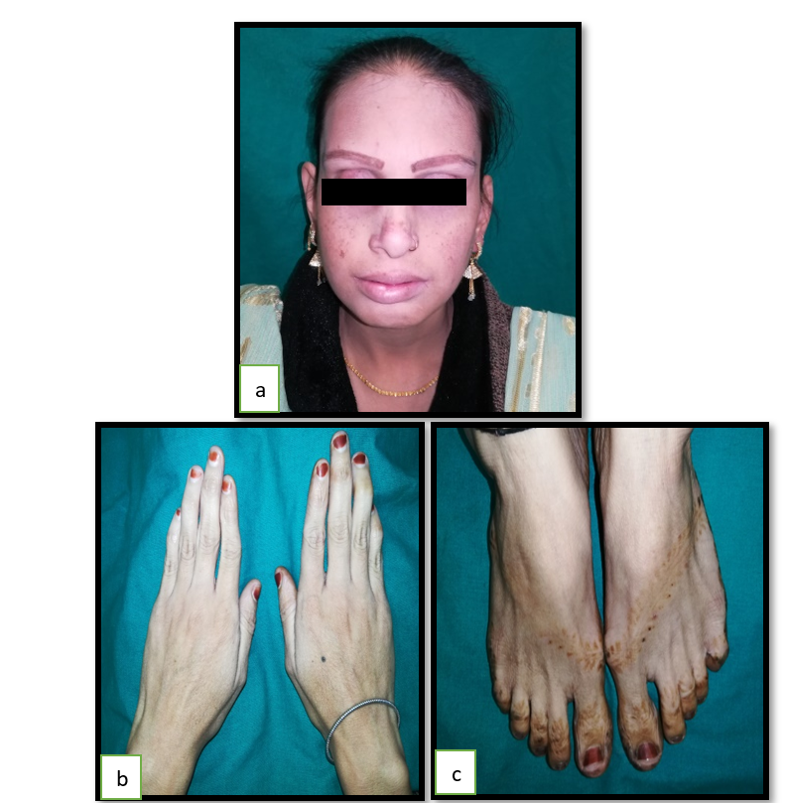

Figure 1 a. Telangestesia on malar region
b,c Sclerodactyly

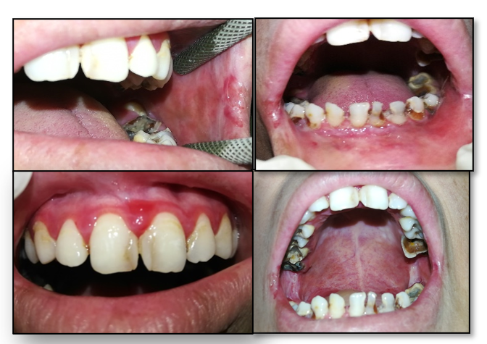
Figure 2-Intraoral pictures

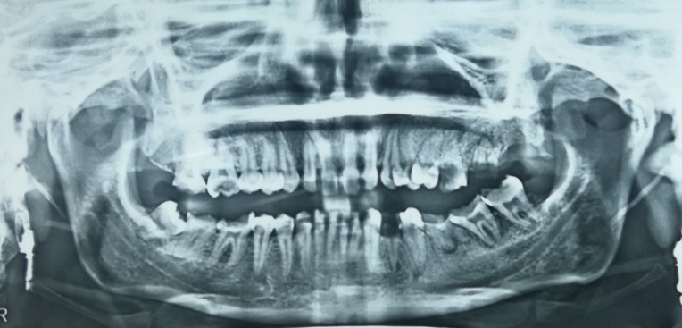
Figure 3 Orthopantogram
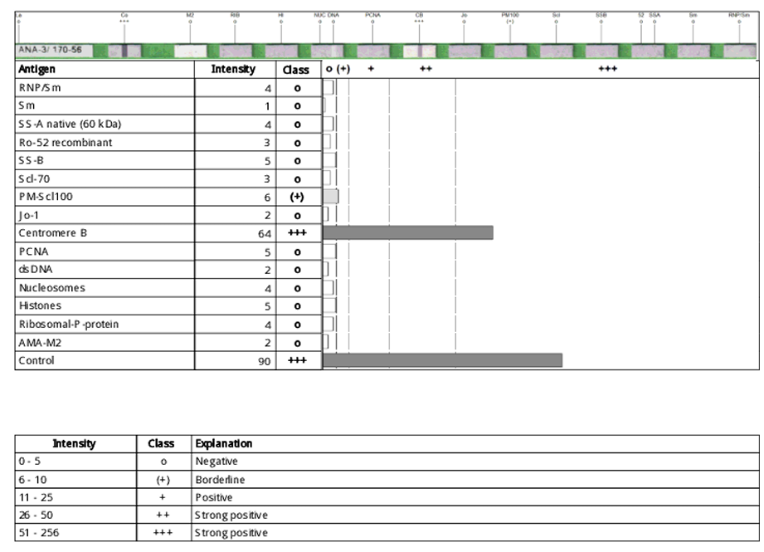
Figure 4 ANA Profile

Discussion
Fibroblast dysfunction, microvascular damage, and excessive collagen and extracellular matrix protein deposition in the skin and internal organs are the hallmarks of systemic sclerosis (SSc), sometimes referred to as scleroderma, a rare immune-mediated connective tissue disease (1, 2). Diffuse cutaneous systemic sclerosis (dcSSc) and limited cutaneous systemic sclerosis (lcSSc), both with unique patterns of organ involvement and progression, are the two clinical subtypes (3). Oral and facial symptoms, which often appear before major visceral symptoms, may serve as early indicators of systemic sickness, according to mounting data(4).
Oral manifestations are frequent yet underrecognized in SSc. A key feature is microstomia, resulting from fibrosis of perioral tissues, leading to decreased oral aperture and compromised oral hygiene and prosthodontic management(5,6). A 2021 clinical review reported that microstomia affects over 70% of SSc patients and progresses with disease duration(7).
Radiographically, generalized widening of the periodontal ligament (PDL) space, loss of mandibular cortical bone, and resorption of the mandibular angle or condyle have been observed in SSc, possibly due to chronic ischemia, muscle atrophy, or pressure from fibrotic tissues(5,9). A study by Zanatta et al. (2022) confirmed a strong correlation between SSc duration and bone changes in panoramic radiographs, supporting the role of dentists in early detection(10).
Recent advances have also highlighted the role of oxidative stress and vascular injury in the oral cavity. Increased levels of salivary and serum oxidative biomarkers have been observed in patients with SSc, which may contribute to both mucosal and periodontal tissue damage(11,12).
Facial manifestations, such as tightening of facial skin, reduced elasticity, and telangiectasias, are particularly prominent in lcSSc. These may be cosmetically distressing and also interfere with speech and mastication(3,6). Dentists and oral medicine specialists should be vigilant in recognizing these signs, particularly in patients with overlapping autoimmune symptoms.
In recent years, non-invasive imaging modalities, including shear wave elastography and intraoral ultrasonography, have shown promise in assessing the degree of skin and mucosal fibrosis in systemic sclerosis(13,14). These tools may enhance early diagnosis and monitoring of oral involvement.
The presence of anticentromere (ACA) and anti-topoisomerase I (Scl-70) antibodies remains a crucial serological marker. ACA is more often associated with lcSSc and vascular complications, while Scl-70 predicts diffuse cutaneous involvement and pulmonary fibrosis(1,9).
Effective management requires a multidisciplinary approach, involving rheumatologists, dermatologists, oral medicine experts, and physiotherapists. Oral physiotherapy, use of salivary substitutes, and surgical release procedures (e.g., commissurotomy) have shown benefit in selected cases(6,10,14). As no definitive cure currently exists, early detection and intervention remain the cornerstone of managing systemic sclerosis.
Early multidisciplinary collaboration among specialists can reduce oropharyngeal complications and improve quality of life in systemic sclerosis. Orofacial features such as perioral skin tightening, microstomia, tongue rigidity, and facial skin hardening may allow early diagnosis. Panoramic radiographs showing periodontal ligament widening with intact lamina dura can indicate early progressive SSc.(15)

In conclusion, oral and facial manifestations of systemic sclerosis are common, progressive, and may precede systemic involvement. Timely recognition by dental professionals can significantly impact disease outcomes. Increasing interdisciplinary collaboration and application of newer diagnostic tools may improve patient quality of life and delay disease-related complications.

Conclusion:
Systemic sclerosis may initially manifest through subtle orofacial changes, which can easily be overlooked. This case highlights the significance of oral findings such as microstomia, xerostomia, and telangiectasia in prompting the diagnosis of limited systemic sclerosis. Early recognition by dental practitioners and subsequent serological confirmation via ANA profiling allowed for diagnosis before significant systemic involvement, emphasizing the importance of interdisciplinary collaboration in managing autoimmune disorders.

Disclaimer (Artificial intelligence)
Option 1:
Author(s) hereby declare that NO generative AI technologies such as Large Language Models (ChatGPT, COPILOT, etc.) and text-to-image generators have been used during the writing or editing of this manuscript.

References
- Denton, C. P., & Khanna, D. (2017). Systemic sclerosis. Lancet, 390(10103), 1685–1699. https://doi.org/10.1016/S0140-6736(17)30933-9 .
- Allanore, Y., Simms, R., Distler, O., Trojanowska, M., Pope, J., Denton, C. P., & Varga, J. (2015). Systemic sclerosis. Nature Reviews Disease Primers. https://doi.org/10.1038/nrdp.2015.2 .
- Herrick AL, Murray AK, Ruckemann-Dziurdzińska K, et al. Pathogenesis and management of Raynaud’s phenomenon. Nat Rev Rheumatol. 2020;16(8):469–479.
- Fischer A, Steen VD. Oral and facial manifestations of systemic sclerosis. Curr Opin Rheumatol. 2016;28(6):576–582.
- Matarese G, Currò M, Isola G, et al. Systemic sclerosis: a challenge for oral health care. Int J Mol Sci. 2016;17(7):1182.
- Al-Dwairi ZN, AlHadidi A, Alnazzawi A, et al. Oral health and microstomia in patients with systemic sclerosis: A clinical review. J Clin Med. 2021;10(10):2061.
- Rusu LC, Vasilescu MD, Rusu D, et al. Orofacial manifestations of systemic sclerosis—A comprehensive review. Diagnostics (Basel). 2021;11(12):2309.
- Silvestre, F. J., Silvestre-Rangil, J., & López-Jornet, P. (2016). Dental considerations in patients with systemic scleroderma. Medicina Oral Patología Oral y Cirugía Bucal, 21(5), e556–e562. https://doi.org/10.4317/medoral.21556 .
- Varga, J., Denton, C. P., Wigley, F. M., Allanore, Y., & Kuwana, M. (Eds.). (2017). Scleroderma: From pathogenesis to comprehensive management (2nd ed.). Springer. https://doi.org/10.1007/978-3-319-31407-5 .
- Zanatta FB, Ardenghi TM, Rocha R dos S, et al. Panoramic radiographic changes and masticatory function in systemic sclerosis patients: a cross-sectional study. Clin Oral Investig. 2022;26(9):6287–6296.
- Isola, G., Matarese, G., Alibrandi, A., Cordasco, G. P. P., Cicciù, M., & Lo Giudice, A. (2017). Evaluation of salivary and serum oxidative stress markers in patients with systemic sclerosis. *International Journal of Molecular Sciences*, *18*(12), 2432. https://doi.org/10.3390/ijms18122432
- Rao PV, Madhavi J. Biomarkers in systemic sclerosis—Recent insights. Autoimmun Rev. 2021;20(2):102727.
- Piga M, Mathieu A. Ultrasound imaging in systemic sclerosis: skin, subcutaneous tissues and beyond. Rheumatology (Oxford). 2021;60(7):3024–3035.
- Karaçayli Ü, Karaçayli E, Korkmaz C, et al. Intraoral ultrasonographic examination for oral soft tissue fibrosis in systemic sclerosis. Oral Dis. 2023;29(1):275–284.
- Smirani, R., Truchetet, M. E., Poursac, N., Naveau, A., Schaeverbeke, T., & Devillard, R. (2018). Impact of systemic sclerosis oral manifestations on patients’ health‐related quality of life: A systematic review. Journal of Oral Pathology & Medicine, 47(9), 808-815.

