Case Report

Use of Endoguide in accessing a calcified maxillary canine using CBCT guided: a case report

.
ABSTRACT

Aims: To describe the endodontic treatment of a tooth with extensive calcification in the pulp chamber, using the guided endodontic technique (Endoguide).
Case Report: A 36-year-old female patient, with normal systemic function, presented to the Dental Clinic of UFC - Sobral Campus for evaluation. After anamnesis, clinical and radiographic examinations, endodontic treatment was deemed necessary for tooth 13, which presented with necrosis and periapical rarefaction. The same radiographic examination identified that the tooth presented with pulpal calcification extending to the middle third of the root. As a complementary examination, a cone-beam computed tomography scan was requested, which guided the fabrication of the guide. With this guide and the aid of a specific drill operated at low speed, access to the root canal was achieved without major difficulties. Odontometry and instrumentation of the canal were then performed with instruments from the Reciproc system (R25 and R40); subsequently, calcium hydroxide paste was applied and remained in place for 21 days. The root canal obturation was performed with Hydro Sealer endodontic cement and gutta-percha using the modified Tagger Hybrid technique.
Conclusion: The Endoguide proved to be an efficient and easy-to-use tool, acting as a facilitator during the endodontic treatment of the reported case, minimizing the risk of accidents and increasing the predictability of the procedure.

Keywords: Endodontics; Dental pulp calcifications; Root canal preparation; Root canal therapy

1. INTRODUCTION

Knowledge of internal anatomy is fundamental for performing endodontic treatment, as it will guide us in determining the shape of the access. Along with clinical and imaging examination, which provide details such as the inclination of the tooth in the dental arch, volume of the pulp chamber, occurrence of internal calcifications, number of roots and canals, images suggestive of periradicular lesions and other anatomical structures (Torabinejad et al., 2009; Connert et al., 2017).
In endodontic practice, not only is visualization and knowledge of anatomy important, but it is also essential to relate this to the different protocols for endodontic treatment (Dowker et al., 1997), since the morphological characteristics of the Root Canal System (RCS) support decisions during the planning and execution of clinical procedures (Villas-Bôas et al., 2011).
Canines constitute the group of teeth with the longest roots in the human dental arch. Their root is conical and robust, with a tendency towards distal curvature. The external contour of the access to the pulp chamber is oval or flame-shaped. The palatal shoulder is present and must be removed to allow adequate access and biomechanical preparation of the canal along its entire length. It usually has only one root canal reflecting the external anatomy, however, there are reports in the literature of the presence of a second canal (Uchiyama et al., 2011). The apical foramen is located laterally in the root in most cases (Vertucci, 1984), with the average diameter (in mm) of the canal at 1.0 mm from the apical foramen being 0.31 mm in the vestibulo-lingual direction and 0.29 mm in the mesio-distal direction (Wu et al., 2000).
Knowledge of the anatomy of the pulp cavity offers the opportunity to determine some of the factors that can complicate the preparation of the access cavity for root canals. The presence of nodules in the pulp chamber or calcifications can hinder the preparation of the access cavity and induce surgical accidents (Estrela et al., 2008).
Root canal calcification is mainly determined based on imaging examinations, in conjunction with root canal preparation. Both age-related changes and endodontic/periodontal diseases can cause physiological or pathological calcification in the root canal system (Huang and Zhou, 2006). Its origin may be linked to several factors, such as: as a consequence of dental trauma after orthodontic treatment, in response to pulp lesions such as caries or restorative materials, or even in elderly patients (Moreno-Rabité et al., 2020).
Root canal calcification is characterized by the deposition of calcified tissue along the canal walls (Tavares et al., 2018). As a result, the pulp chamber and root canal space may become partially or completely obliterated, resulting in a recessed pulp chamber, narrow root canal, and even apical blockage, which increases the risk of procedural errors during root canal preparation (Chaniotis and Ordinola-Zapata, 2022).
Coronal access represents the most challenging operative step in a calcified tooth, making it difficult to maintain the correct trepanation direction when it extends mainly to the middle and apical thirds. Even for experienced endodontists, it can result in deviations or perforations, increasing the chances of failure (Loureiro et al., 2021). In this sense, the use of the guided technique provides greater safety and predictability, less dental tissue removed, and less clinical time with the patient (Connert et al., 2017).
Guided endodontics, a relatively recent approach, has been indicated for better management of teeth with partial or total canal obliterations (Krastl et al., 2016). This technique uses specific software, with high precision, cone-beam computed tomography (CBCT), and 3D scanning images to produce a surgical guide that directs the bur during the preparation of the access cavity (Connert et al., 2019).
The Digital Workflow begins with the acquisition of DICOM and STL files. The DICOM file will be obtained by requesting the CBCT examination, and the STL file will be obtained through intraoral scanning of the patient's arch. After acquiring the DICOM and STL files, the endodontic guide planning is performed by Digital Planning Centers or by trained professionals, using specific software for surgical planning guides (Decurcio et al., 2021). The dimensions of the wear length and diameter, the direction, and the region to be worn down by the bur must be carefully planned. Once defined, it is essential to estimate the thickness of the dental tissue after performing the guided procedure. The plans should not project wear at a distance of less than 1.0 mm from the root surface in contact with the periodontal ligament to avoid perforation accidents (Decurcio et al., 2021). Deviations are minimized by rigorous planning; the more adapted it is to the occlusal surface of the teeth, the greater the stability of the guide and the lower the risk of deviation during the wear procedure. To ensure this, inspection windows are planned in different parts of the guide to verify the adaptation in the operative phase (Decurcio et al., 2021).

In addition to the aspects already discussed, this technique can be a valuable tool for endodontic intervention, reducing chair time and the risk of iatrogenic damage to the dental structure (Ali and Arslan, 2019), due to the predictability of the technique. Another valuable aspect is that the learning curve for performing this technique is small, allowing less experienced professionals to perform it (Casadei et al., 2020). However, guided endodontics also has disadvantages, such as the longer time required to perform the technique and the additional cost due to the acquisition of CBCT, intraoral digitization, virtual planning and model printing, in addition to the increase in radiation dose (Ribeiro, 2020).
The use of the technique in curved canals has limitations, as a straight access is necessary, so its main indication is for teeth with straight roots. However, to access curved roots in the apical portion, a very detailed plan is essential so that the result is achieved without the risk of causing iatrogenic damage. Another issue is that the Endoguide in posterior regions has a more complex installation, as the inter-occlusal relationship is reduced, hindering access (Coelho, 2019).
Given the above, understanding the importance of this technology in the current scenario of endodontic therapy, considering the technical challenges of accessing a tooth with pulp calcification, characterizing it as an important technological resource for the maintenance of the dental element, it is necessary to discuss the guided endodontics technique (Endoguide), addressing aspects related to its applicability, advantages, limitations, and operative steps that allow for the reproducibility of the technique. Therefore, the objective of this work is to report a clinical case that illustrates the use of the guided endodontics technique in the treatment of a tooth with pulp calcification that extended to the middle third of the root. Furthermore, to present the benefits and challenges of using the 3D guide in the endodontic treatment of teeth with calcifications.

2. PRESENTATION OF CASE

A 36-years-old female patient, with normal systemic function, presented to the dental clinic of the Federal University of Ceará – Sobral Campus, for a dental evaluation. During the clinical examination, resin veneers were observed on teeth 11, 12, 21, and 22; areas of gingival inflammation were noticeable in these teeth. Based on this finding, periapical radiographic examinations of the aforementioned teeth were performed, revealing a periapical lesion and pulp calcification in tooth 13 (Figure 1).

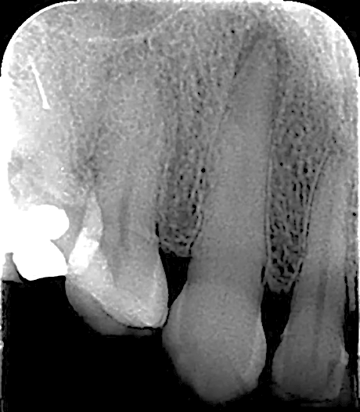
Figure 1 - Periapical radiograph of tooth 23.
Source: Author’s own

Pulp sensitivity tests to cold stimuli and horizontal percussion were also performed, with a negative response, suggesting pulp necrosis; a positive response was reported to the vertical percussion test, suggesting, in association with the radiographic image, a picture of chronic apical periodontitis. When questioned, the patient reported never having presented painful symptoms related to this element. Given the observed findings, a small voxel cbct scan was requested to better delineate the extent of the calcification and assist in treatment planning.
With the tomographic examination, it was possible to confirm the presence of calcification of the pulp chamber in the root canal of tooth 13 that extended apically to the middle third of the root (Figure 2). Furthermore, the presence of apical bone loss compatible with chronic apical periodontitis was confirmed.

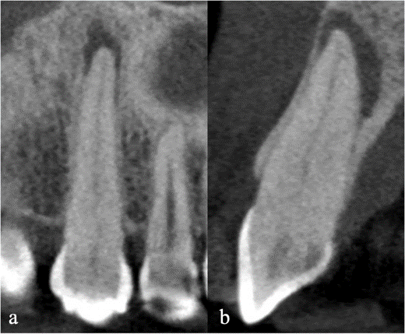
Figure 2 - Cone beam computed tomography, showing details of the images of the cervical third, middle third and apical third; frontal (a) and sagittal (b) views.
Source: Author’s own

Given the difficulty of reaching the root canal using conventional methods, the creation of a guide, through virtual planning, was proposed to facilitate access to the root canal. After the patient's agreement, she was referred for an intraoral scan, necessary for the creation of the Endoguide; with the scan and cbct scan, the planning of the personalized surgical guide (EXON, Fortaleza, CE, Brazil) was carried out, manufactured on a 3D printer (Figure 3a/b).

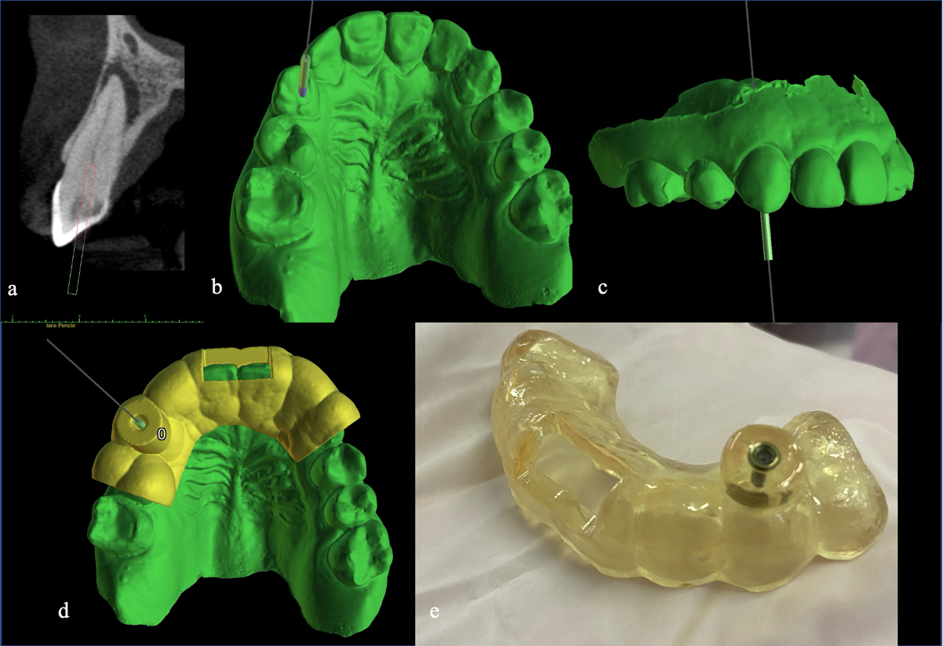
Figure 3 – Virtual planning (a-d); prepared custom surgical guide (e).
Source: Author’s own

During the treatment session, after decontamination, the guide was adapted to the patient's upper arch (Figure 4a/b); the "window" in the guide allowed for verification of its correct positioning (Figure 4b).

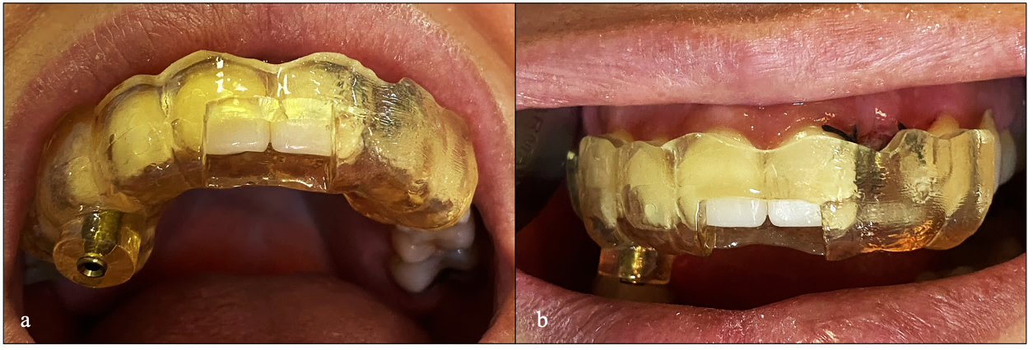
Figure 4 - Guide adapted to the upper arch (a); detail of the safety window (b).
Source: Author’s own

With the guide still in place, graphite marking was performed to demarcate the position of the enamel wear (Figure 5a). After removing the guide, local infiltrative anesthesia was performed in the vestibular sulcus with 1.8 mL of 2% mepivacaine with 1:100,000 epinephrine (DLA Pharma, Catanduva, SP, Brazil). Initial wear of the coronal enamel was then performed with a diamond bur (#1014; KG Sorensen, São Paulo, SP, Brazil), operated at high speed and under abundant irrigation, limited to the area previously marked with graphite (Figure 5b).

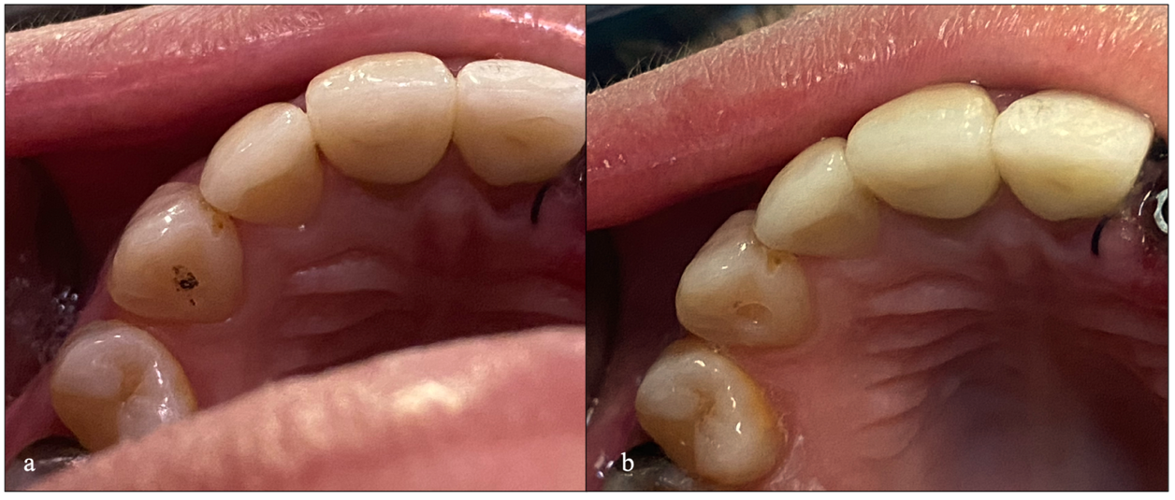
Figure 5 - Area previously marked with graphite (a); image after initial wear (b).
Source: Author’s own

The Endoguide was then adapted to the patient's teeth, at which point dentin wear began. This was performed with a steel bur (Figure 6a), with a 20 mm active part and 1.3 mm diameter (Guided Surgery; Neodent, Curitiba, PR, Brazil), coupled to an endodontic motor (VDW GmbH, Munich, Germany) with a rotation of 800 RPM and a torque of 4 N. The depth of wear was set at 20 mm, according to the previous virtual planning (Figure 6b). During wear, the bur was continuously irrigated with 2% chlorhexidine gel (CHX; BioPhormula, Fortaleza, CE, Brazil).

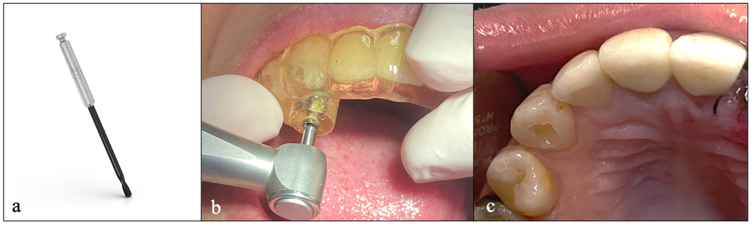
Figure 6 – Steel drill bit used (a); drill bit reaching 20 mm (b); final aspect of the access cavity (c).
Source: Author’s own

It is worth highlighting that intraoperative radiographs (Figure 7 a/b) were performed in order to confirm the correctness of the path taken by the drill.

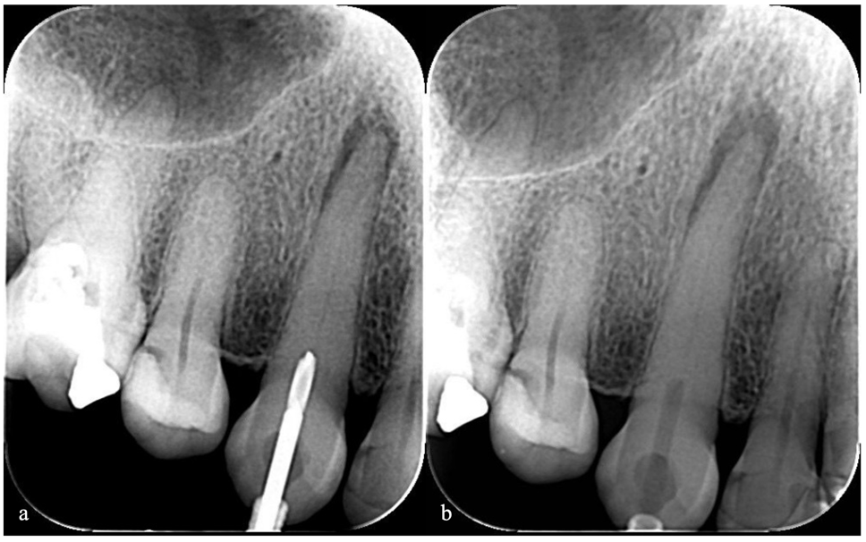
Figure 7 – Intraoperative radiographs (a); Intraoperative radiographs with the drill (b).
Souce: Author’s own

Upon reaching the drill's penetration limit, the guide was removed from its position. Absolute isolation of the operative field was then performed using a rubber dam (Madeitex, Santa Branca, SP, Brazil) and a #206 clamp (SSWhite Dufllex, São Cristóvão, RJ, Brazil). Using K-Flexofile files #8, #10, and #15 (Impla, Londrina, PR, Brazil) and employing 2.5% sodium hypochlorite (Rioquímica S/A, São José do Rio Preto/SP, Brazil) as an irrigating solution, canal catheterization was performed; odontometry was performed with the Iroot Apex electronic foraminal locator (Bomedent, Changzhou City, Jiangsu, China), determining the actual tooth length (ATL); this was established at 27.5 mm. A periapical radiograph was taken to confirm access to the root canal (Figure 8).

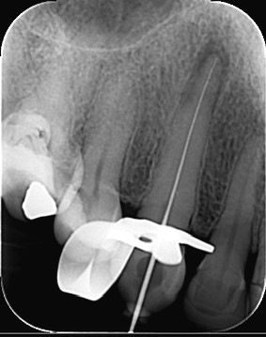
Figure 8 – Radiographic confirmation of electronic odontometry
Source: Author’s own

Root canal preparation was performed mechanically using instruments from the Reciproc System (VDW GmbH, Munich, Germany), powered by a VDW Silver motor (VDW GmbH) in the ‘Reciproc all’ kinematics. R25 and R40 instruments were used, both brought to working length (WL; 26.5 mm); foraminal patency was maintained throughout the preparation with a #15 manual file.
After preparation, intracanal medication was applied. The medication of choice was calcium hydroxide paste (Maquira, Maringá/PR, Brazil), manipulated with anesthetic as a vehicle. The medication was inserted into the canal with the aid of a Lentulo #3 spiral (TDK, Shanghai, China) coupled to the endodontic motor. Coronal sealing was performed with resin-modified glass ionomer cement (Riva Light Cure; SDI, Victoria City, Australia).
After 21 days, the patient returned to the clinic for root canal obturation. A gutta-percha cone test was performed using an extra-long FM cone (Tanari, Boa Vista, RR, Brazil) calibrated to #40 and adapted to the CT. Next, the canal was irrigated with 17% EDTA (Biodinâmica Química e Farmacêutica, Ibiporã, PR, Brazil), agitating the solution with Easy Clean (Easy, Belo Horizonte, MG); followed by irrigation with physiological saline (Farmace, Barbalha, CE, Brazil). The canal was then dried with sterile absorbent paper cones calibrated to #40 (Dentsply-Maillefer, São Paulo, SP, Brazil). Hydro Sealer cement (Biodinâmica Química e Farmacêutica) was used, prepared according to the manufacturer's instructions. The cement was introduced into the canal using the cone itself, with slow apical movements and moderate pressure, until the desired length was reached. Then... The gutta-percha cone was thermoplasticized using a McSpadden #50 condenser (Dentsply-Maillefer), followed by vertical condensation with Schilder condensers (Odous de Deus, Belo Horizonte, MG, Brazil). A confirmatory periapical radiograph was taken, followed by cleaning of the access cavity and its final restoration with Opallis composite resin (FGM, Joinville/SC, Brazil); finally, the final radiograph was taken (Figure 9).

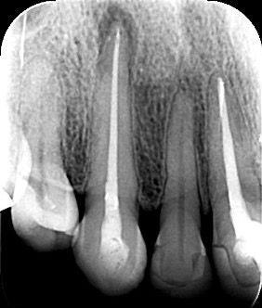
Figure 9 – Periapical radiograph after completion of endodontic treatment.
Source: Author’s own

3. discussion

Dental pulp calcifications result from the accelerated deposition of mineralized tissue in the pulp chamber and the root canal system (RCS). They occur in response to external aggressors, as a result of trauma, orthodontic movements, caries lesions, and previous restorative interventions using materials that induce the formation of this mineralized tissue (Lara-Mendes et al., 2018).
Clinically, teeth with calcifications may appear discolored and yellowish, opaque, and with a higher degree of chromaticity, in addition to a decreased response to pulp sensitivity tests, making the diagnosis of pulp disorders difficult (Torres et al., 2019). Not all cases of dental pulp calcifications require intervention; however, the presence of an inflammatory process in the pulp tissue, microbial contamination of the RCS, or the development of periapical pathology with consequent pulp necrosis makes endodontic treatment necessary (Siqueira Jr and Rôças 2008).
The American Association of Endodontists considers endodontic treatment of calcified canals to be highly difficult and complex. Notably, in this condition, locating the canal orifices and their biomechanical preparation represent a clinical challenge, mainly due to the difficulties in locating and negotiating them to the full working length, making the predictability of treatment results uncertain even for experienced professionals (Torabinejad et al., 2009; Uchiyama et al., 2011).
High-quality digital radiographs, with the possibility of expansion and the use of different contrasts, are important to begin the identification process. However, complete obliteration seen radiographically is not necessarily indicative that pulp tissue is not present, clinically or histologically (McCabe and Dummer 2012). Dental operating microscopy offers magnification and illumination. However, in some situations, despite all these resources and the operator's skill and expertise, CBCT is necessary and allows the capture of three-dimensional images without overlapping adjacent structures, which facilitates the identification of canals, their directions, degrees of obstruction, and dimensions (Estrela et al., 2008; McCabe and Dummer 2012).
The combined use of CBCT images and intraoral scanning of the target area allows the fabrication of access guides that are extremely useful in locating severely calcified root canals in highly complex cases, for which guided endodontic access, or simply Endoguide, is recommended (Abella et al., 2012). Guided access through root calcifications can help avoid accidents such as deviations and perforations and improve treatment success (Penã-Bengoa et al., 2023). Furthermore, guided access has already been reported in the literature as a safe and predictable technique in anterior teeth (Krastl et al., 2016; Tavares et al., 2018). Some of the limitations of this technique are the blockage of direct vision during treatment and the limited cooling of the water, as there is no space to cool the bur adequately. In addition, vertical space can be a problem when treating posterior teeth or patients with limited mouth opening, as sufficient space is needed to place the guide (Casadei et al., 2019).
Faced with the challenge of optimizing cooling during root canal preparation, the use of lubrication with CHX has proven to be an efficient alternative. Scientific literature demonstrates that CHX gel, in addition to having antimicrobial action and biocompatibility similar to the liquid solution, offers the advantage of lubricating the canal walls, reducing friction between the instrument and the dentin, facilitating instrumentation and decreasing the risk of instrument fracture (Ferraz et al., 2000).
As for the endodontic treatment itself, calcium hydroxide medication was chosen because it is able to fill the canal lumen space, in addition to its antimicrobial efficacy and alkalization of the medium (Vilaça et al., 2024). The presence of periapical rarefaction denoted the importance of a cautious chemomechanical preparation; however, this need, along with the time spent during access with the guide, ended up influencing the decision to use the medication between sessions. When the obturation was performed, the modified Tagger hybrid technique was used, employing resin-based cement and gutta-percha. Due to the flattened anatomy in its middle third, the choice of thermoplastic obturation favored better filling of the anatomy (Collado-Castallanos et al., 2023). As for the cement, it was chosen due to the intention of performing coronal sealing with adhesive restorative material in the same session.

In light of the above, it is understood that Guided Endodontics has shown promise in various clinical situations. The improved understanding of its nuances, along with the increasing exploration of digital resources in Endodontics, has undoubtedly expanded considerably the possibilities for applying this innovative technique. A better understanding of its characteristics and the exploration of digital resources in Endodontics have led to greater applicability in the specialty. However, it has specific indications and should not be interpreted as a facilitating agent for professionals with less clinical experience and/or who do not use the appropriate technology for complex endodontic treatments, but rather as an additional tool in the endodontist's arsenal (Torres et al., 2023).

4. Conclusion

Based on the above, it can be concluded that the use of the Endoguide as an aid in accessing the canal was of fundamental importance and very efficient in this case, reinforcing that guided endodontics is a safe and precise approach that facilitates access and enables efficient, agile, and highly predictable endodontic treatment.
In this context, although the treatment protocol with this technique involves a greater number of steps and higher costs compared to the conventional method, it provides a reduction in execution time.

Ethical approval

Regarding ethical aspects, the case was conducted and submitted to the Research Ethics Committee – CEP, of the Vale do Acaraú State University (UVA), registered under opinion number 7,460,875

Consent

All authors declare that ‘written informed consent was obtained from the patient for publication of this case report and accompanying images. A copy of the written consent is available for review by the Editorial office/Chief Editor/Editorial Board members of this journal.

DISCLAIMER (ARTIFICIAL INTELLIGENCE)

Author(s) hereby declare that NO generative AI technologies such as Large Language Models (ChatGPT, COPILOT, etc.) and text-to-image generators have been used during the writing or editing of this manuscript.

References

- Abella, F., Patel, S., Duran-Sindreu, F., Mercadé, M., Bueno, R., and Roig, M. (2012). Evaluating the periapical status of teeth with irreversible pulpitis by using cone-beam computed tomography scanning and periapical radiographs. Journal of endodontics, 38(12), 1588-1591. https://doi.org/10.1016/j.joen.2012.09.003
- Ali, A., and Arslan, H. (2019). Guided endodontics: a case report of maxillary lateral incisors with multiple dens invaginatus. Restorative dentistry & endodontics, 44(4). https://doi.org/10.5395/rde.2019.44.e38
- Casadei, B. D. A., Lara‐Mendes, S. T. D. O., Barbosa, C. D. F. M., Araújo, C. V., de Freitas, C. A., Machado, V. C., and Santa‐Rosa, C. C. (2020). Access to original canal trajectory after deviation and perforation with guided endodontic assistance. Australian Endodontic Journal, 46(1), 101-106. https://doi.org/10.1111/aej.12360
- Chaniotis, A., and Ordinola‐Zapata, R. (2022). Present status and future directions: Management of curved and calcified root canals. International Endodontic Journal, 55, 656-684. https://doi.org/10.1111/iej.13685
- Coelho, C. M. S. (2019). EndiGuide: Uma Nova Abordagem na Microcirurgia Aplical. https://repositorio.cespu.pt/handle/20.500.11807/5475
- Collado-Castellanos, N., Aspas-García, A., Albero-Monteagudo, A., Manzano-Saiz, A., and Micó-Muñoz, P. (2023). Quantitative analysis of the obturation of oval-shaped canals using thermoplastic techniques. Journal of Clinical and Experimental Dentistry, 15(4), e311. https://doi.org/10.4317/jced.60491
- Connert, T., Zehnder, M. S., Weiger, R., Kühl, S., and Krastl, G. (2017). Microguided endodontics: accuracy of a miniaturized technique for apically extended access cavity preparation in anterior teeth. Journal of endodontics, 43(5), 787-790. https://doi.org/10.1016/j.joen.2016.12.016
- Connert, T., Krug, R., Eggmann, F., Emsermann, I., ElAyouti, A., Weiger, R., ... and Krastl, G. (2019). Guided endodontics versus conventional access cavity preparation: a comparative study on substance loss using 3-dimensional–printed teeth. Journal of endodontics, 45(3), 327-331. https://doi.org/10.1016/j.joen.2018.11.006
- Decurcio, D. A., Bueno, M. R., Silva, J. A., Loureiro, M. A. Z., Sousa-Neto, M. D., and Estrela, C. (2021). Digital planning on guided endodontics technology. Brazilian dental journal, 32, 23-33. https://doi.org/10.1590/0103-6440202104740
- Dowker, S. E., Davis, G. R., and Elliott, J. C. (1997). X-ray microtomography: nondestructive three-dimensional imaging for in vitro endodontic studies. Oral Surgery, Oral Medicine, Oral Pathology, Oral Radiology, and Endodontology, 83(4), 510-516. https://doi.org/10.1016/s1079-2104(97)90155-4
- Estrela, C., Leles, C. R., Hollanda, A. C. B., Moura, M. S., and Pécora, J. D. (2008). Prevalence and risk factors of apical periodontitis in endodontically treated teeth in a selected population of Brazilian adults. Brazilian dental journal, 19, 34-39. https://doi.org/10.1590/s0103-64402008000100006
- Ferraz, C. C. R., Gomes, B. P. F. A., Zaia, A. A., Teixeira, F. B., and Souza-Filho, F. J. (2000). In vitro assessment of chlorhexidine gel as an endodontic irrigant. Journal of Endodontics. https://doi.org/10.1097/00004770-200107000-00004
- Huang, D., Wang, X., Liang, J., Ling, J., Bian, Z., Yu, Q., ... and Zhou, X. (2024). Expert consensus on difficulty assessment of endodontic therapy. International Journal of Oral Science, 16(1), 22. https://doi.org/10.1038/s41368-024-00285-0
- Krastl, G., Zehnder, M. S., Connert, T., Weiger, R., and Kühl, S. (2016). Guided endodontics: a novel treatment approach for teeth with pulp canal calcification and apical pathology. Dental traumatology, 32(3), 240-246. https://doi.org/10.1111/edt.12235
- Lara-Mendes, S. T. O., Barbosa, C. F. M., Santa-Rosa, C. C., and Machado, V. C. (2018). Guided Endodontic Access in Maxillary Molars Using Cone-beam Computed Tomography and Computer-aided Design/Computer-aided Manufacturing System: A Case Report. Journal of endodontics, 44(5), 875–879. https://doi.org/10.1016/j.joen.2018.02.009
- Loureiro, M. A. Z., Silva, J. A., Chaves, G. S., Capeletti, L. R., Estrela, C., and Decurcio, D. A. (2021). Guided endodontics: The impact of new technologies on complex case solution. Australian Endodontic Journal, 47(3), 664-671. https://doi.org/10.1111/aej.12498
- McCabe, P. S., and Dummer, P. M. H. (2012). Pulp canal obliteration: an endodontic diagnosis and treatment challenge. International endodontic journal, 45(2), 177-197. https://doi.org/10.1111/j.1365-2591.2011.01963.x
- Moreno‐Rabié, C., Torres, A., Lambrechts, P., and Jacobs, R. (2020). Clinical applications, accuracy and limitations of guided endodontics: a systematic review. International endodontic journal, 53(2). https://doi.org/10.1111/iej.13216
- Peña-Bengoa, F., Valenzuela, M., Flores, M. J., Dufey, N., Pinto, K. P., and Silva, E. J. N. L. (2023). Effectiveness of guided endodontics in locating calcified root canals: a systematic review. Clinical Oral Investigations, 27(5), 2359-2374. https://doi.org/10.1007/s00784-023-04863-0
- Ribeiro, F. H. B., Maia, B. D. G. O., Verner, F. S., and Junqueira, R. B. (2020). Current aspects of guided endodontics. HU revista, 46, 1-7. https://doi.org/10.34019/1982-8047.2020.v46.29153
- Siqueira Jr, J. F., and Rôças, I. N. (2008). Clinical implications and microbiology of bacterial persistence after treatment procedures. Journal of endodontics, 34(11), 1291-1301. https://doi.org/10.1016/j.joen.2008.07.028
- Tavares, W. L. F., Viana, A. C. D., de Carvalho Machado, V., Henriques, L. C. F., and Sobrinho, A. P. R. (2018). Guided endodontic access of calcified anterior teeth. Journal of endodontics, 44(7), 1195-1199. https://doi.org/10.1016/j.joen.2018.04.014
- Torabinejad, M., Corr, R., Handysides, R., and Shabahang, S. (2009). Outcomes of nonsurgical retreatment and endodontic surgery: a systematic review. Journal of endodontics, 35(7), 930-937. https://doi.org/10.1016/j.joen.2009.04.023
- Torres, A., Shaheen, E., Lambrechts, P., Politis, C., and Jacobs, R. (2019). Microguided Endodontics: a case report of a maxillary lateral incisor with pulp canal obliteration and apical periodontitis. International endodontic journal, 52(4), 540-549. https://doi.org/10.1111/iej.13031
- Torres, A., Dierickx, M., Coucke, W., Pedano, M. S., Lambrechts, P., and Jacobs, R. (2023). In vitro study on the accuracy of sleeveless guided endodontics and treatment of a complex upper lateral incisor. Journal of Dentistry, 131, 104466. https://doi.org/10.1016/j.jdent.2023.104466
- Uchiyama, M., Anzai, M., Yamamoto, A., Uchida, K., Utsuno, H., Kawase, Y., and Kasahara, E. (2011). Root canal system of the maxillary canine. Okajimas folia anatomica Japonica, 87(4), 189-193. https://doi.org/10.2535/ofaj.87.189
- Vertucci, F. J. (1984). Root canal anatomy of the human permanent teeth. Oral surgery, oral medicine, oral pathology, 58(5), 589-599. https://doi.org/10.1016/0030-4220(84)90085-9
- Vilaca, A. L. X., Bertocco, M. S., Francisco, J. K. P., de Lima Ferreira, N. M., and Vaneli, Y. L. (2024). O USO DO HIDRÓXIDO DE CÁLCIO NA MEDICAÇÃO INTRACANAL: REVISÃO DE LITERATURA. Revista Científica da UNIFENAS-ISSN: 2596-3481, 6(7). https://doi.org/10.29327/2385054.6.7-10
- Villas-Bôas, M. H., Bernardineli, N., Cavenago, B. C., Marciano, M., del Carpio-Perochena, A., De Moraes, I. G., ... and Ordinola-Zapata, R. (2011). Micro–computed tomography study of the internal anatomy of mesial root canals of mandibular molars. Journal of endodontics, 37(12), 1682-1686. https://doi.org/10.1016/j.joen.2011.08.001
- Wu, M. K., R'oris, A., Barkis, D., and Wesselink, P. R. (2000). Prevalence and extent of long oval canals in the apical third. Oral Surgery, Oral Medicine, Oral Pathology, Oral Radiology, and Endodontology, 89(6), 739-743. https://doi.org/10.1067/moe.2000.106344

