Review Article

Effectiveness of low-level laser therapy with or without hyaluronic acid gel in tissue healing and pain control after gingival surgery: a systematic review

.
ABSTRACT

Aims: This systematic review assessed the effectiveness of low-level laser therapy (LLLT), alone or combined with hyaluronic acid (HA), in enhancing tissue healing and reducing postoperative pain after gingival surgery.
Study design: Systematic review of randomized controlled trials (RCTs), conducted according to PRISMA 2020 guidelines, and utilizing the SWiM (Synthesis Without Meta-analysis) approach for narrative synthesis. This methodological decision was made due to the substantial anticipated clinical and methodological heterogeneity among the included RCTs, which is further detailed in the methodology section.
Place and Duration of Study: This review was carried out between August and November 2025.
Methodology: Randomized controlled trials evaluating adult patients (≥18 years) undergoing gingival surgical procedures and receiving postoperative LLLT, HA gel, or their combined application were eligible for inclusion. Searches were carried out in EMBASE, LILACS, PubMed, SCOPUS, Web of Science, The Cochrane Library, and additional gray literature sources. Risk of bias was assessed using the Cochrane RoB 2.0 tool. Due to clinical and methodological heterogeneity related to laser parameters, HA formulations, application protocols, and outcome assessment methods, the synthesis followed a narrative approach without meta-analysis. Three studies met the eligibility criteria, comprising a total of 116 participants.
Results: Postoperative pain showed an average reduction of approximately 30% within 48–72 hours, with the greatest reductions observed with combined LLLT and HA1. Regarding soft tissue healing, modest early improvements were observed with the combined approach, but these effects were not sustained over time, and two of three trials reported no significant long-term differences. Overall, the certainty of the evidence remains low due to small samples, risk of bias, and heterogeneity among studies.
Conclusion: The combined application of LLLT and HA demonstrates potential to enhance early soft tissue healing and reduce postoperative pain following gingival surgery. However, due to the limited number of RCTs and methodological weaknesses identified, the certainty of the evidence remains low. Further well-designed RCTs with standardized protocols are necessary to substantiate these findings.

Keywords: Low-Level Light Therapy. Hyaluronic Acid. Wound Healing. Pain, Postoperative. Periodontics.

1. INTRODUCTION

Gingival surgical procedures constitute a fundamental component of periodontal therapy. Their indications are broad. Functionally, they are used for the correction of periodontal defects and root coverage. Aesthetically, indications include the correction of excessive gingival display and clinical crown lengthening. Furthermore, these procedures meet pre-prosthetic demands aimed at adequately exposing cavity margins for restorative rehabilitation (Sousa et al. 2010). However, these procedures are frequently associated with considerable postoperative morbidity, especially pain and delayed tissue healing. Such factors significantly compromise patient comfort and masticatory function, prolonging the recovery period (Azevedo et al. 2023; Malpartida-Carrillo et al. 2021; Tavelli et al. 2023).

Successful clinical outcomes are intrinsically linked to the optimization of soft tissue healing, a biological process that unfolds in three distinct phases. The first is the inflammatory phase, which occurs immediately after surgical trauma and is characterized by hemostasis, infiltration of immune cells, and the release of inflammatory mediators such as prostaglandins and bradykinin (Balbino et al. 2005; Eming et al. 2014). This is followed by the proliferative phase, marked by granulation of tissue formation, neoangiogenesis, and epithelialization, culminating in the remodeling phase, during which collagen matures and tissue strength increases (Gurtner et al. 2008). In this context, adjuvant therapies are strategically employed to modulate the acute inflammatory response, optimize cellular proliferation, and alleviate pain. Among these approaches, low-level laser therapy (LLLT) and the application of hyaluronic acid (HA) have emerged as promising interventions due to their biomodulatory effects on tissue repair (Bhati et al. 2022; Rocha et al. 2007).

LLLT is widely used as a supportive therapeutic modality in various medical and dental procedures (Abesi and Derikvand 2023). This therapy employs non-ionizing electromagnetic radiation characterized by monochromaticity, coherence, and collimation of the light beam(Rathod et al. 2022). Its mechanism of action is based on photobiomodulation (PBMT). This process, induced by exposure to a specific wavelength, stimulates cellular metabolism and proliferation. Consequently, LLLT exerts crucial anti-inflammatory, analgesic, and biostimulatory effects, which collectively contribute to enhanced tissue repair and accelerated wound healing (Abesi and Derikvand 2023; Kohale et al. 2018a; Yakout et al. 2023; Zhao et al. 2021).

In parallel with LLLT, hyaluronic acid, a glycosaminoglycan that is a fundamental component of the extracellular matrix, has been explored as a potent adjunct in tissue repair (Antoszewska et al. 2024). When applied in gel form, HA functions as a temporary scaffold that stabilizes the blood clot and maintains hydration of the surgical wound, while also exerting intrinsic anti-inflammatory and anti-edematous effects (Wang et al. 2025; Yakout et al. 2023). Its benefits extend across all phases of healing: in the inflammatory phase, it supports cellular migration; in the proliferative phase, it attracts fibroblasts and stimulates keratinocytes; and during remodeling, it promotes tissue integrity and mechanical strength (Frenkel 2014; Yakout et al. 2023). These properties make HA a relevant agent following gingival surgical procedures (Pilloni et al. 2025; Yakout et al. 2023).

The combined therapeutic use of LLLT and HA is based on the potential synergy of their complementary mechanisms (Adel et al. 2025a). LLLT provides photobiomodulation, bioenergetic stimulation, and analgesia, whereas HA offers structural support and modulates the wound microenvironment. Although individual benefits of LLLT (Amorim et al. 2006; Kohale et al. 2018b; Ozcelik et al. 2008) and HA (Fawzy El-Sayed et al. 2012; Ibraheem et al. 2022; Pilloni et al. 2023) in tissue repair and postoperative pain control have been demonstrated, their combined use has shown superior outcomes at the surgical site.

While the individual benefits of LLLT and HA in tissue repair and postoperative pain control have been demonstrated, recent experimental evidence (Adel et al., 2025b) suggests that their combined application may offer a superior synergistic effect. However, this combined therapeutic approach currently lacks a systematic and rigorous synthesis, primarily due to existing methodological heterogeneity and small sample sizes across the literature. Therefore, the present systematic review is essential to address this gap by comprehensively evaluating the effectiveness of LLLT (used alone or combined with HA) in optimizing tissue healing and reducing pain following gingival surgery.

2. methodology

This systematic review was conducted and reported in accordance with the PRISMA 2020 Statement guidelines (Page et al. 2021). The research protocol was prospectively registered in the PROSPERO database (International Prospective Register of Systematic Reviews) under the number CRD420251161003.

2.1 Research question (PICO)

The research question was formulated using the PICO framework, as presented in Table 1: “To evaluate the effectiveness of low-level laser therapy, used alone or in combination with hyaluronic acid gel, on tissue healing and postoperative pain control in patients undergoing gingival surgical procedures.”

Table 1. PICO criteria for the research question

PICO component | Description
Population (P) | Adult patients undergoing gingival surgery
Intervention (I) | Hyaluronic acid gel
Comparator (C) | Low-level laser therapy
Outcome (O) | Improved tissue healing and reduced pain sensitivity

2.2 Eligibility criteria

Randomized controlled trials (RCTs) of any duration and publication year, written in Portuguese, English, or Spanish, were eligible for inclusion. Studies had to involve adult patients (≥18 years) who underwent gingival surgical procedures and received postoperative low-level laser therapy and/or hyaluronic acid gel, either alone or in combination.

2.3 Search strategy

Search strategies were customized for each of the following electronic databases: EMBASE, Latin American and Caribbean Health Sciences (LILACS), PubMed, SCOPUS, Web of Science, and The Cochrane Library. Additionally, complementary searches were conducted in Google Scholar, OpenGrey, and MedNar. All searches were conducted from inception (the earliest available date of indexing) up to October 2025. EndNote Web® was used as a reference management tool. The search terms used across databases are listed in Table 2.

Table 2. Search terms used in the electronic databases, maintained exactly as a table of terms, as in the original, preserving mesh terminology and related descriptors
Free terms | MeSH terms
Gingivectomies [TiAb]  "Gingivectomy Procedure"[TiAb]  "Surgical Gingivectomy"[TiAb]  "Laser Gingivectomy"[TiAb]  "Gingivoplasty"[TiAb]  "Gingivoplasty Procedure"[TiAb]  "Crown Lengthening"[TiAb]  "Esthetic Crown Lengthening"[TiAb]  "Gingival Recontouring"[TiAb]  Hyaluronan [TiAb]  ''HA Application'' [TiAb]  ''Hyaluronic Acid Gel'' [TiAb]  ''Topical Hyaluronic Acid'' [TiAb]  ''Hyaluronic Acid Therapy" [TiAb]  “Low-Level Laser Therapy” [TiAb]  “Laser Therapy” [TiAb]  “Low Intensity Laser Therapy” [TiAb]  “Low-Level Light Therapy” [TiAb] | Humans [MeSh]  Adult [MeSh]  Female [MeSh]  Male [MeSh]  ''Middle Aged'' [MeSh]  ''Gingival Hyperplasia'' [MeSh]  Hyperplasia [MeSh]  ''Gingival Diseases'' [MeSh]  Hyperpigmentation [MeSh]  Gingivectomy [MeSh]  Gingiva [MeSh]  ''Hyaluronic acid'' [MeSh]  Gels [MeSh]  ''Low-Level Light Therapy'' [MeSh]  Photobiomodulation [MeSh]  ''Wound Healing'' [MeSh]  ''Treatment Outcome'' [MeSh]

2.3 Study selection and data extraction

Study selection was carried out independently by three reviewers (VBJ, MCD, CWS) in two phases using the Rayyan platform. In the first phase, titles and abstracts of all retrieved records were screened to identify potentially relevant studies. In the second phase, the full texts of the pre-selected articles were examined to determine their eligibility according to the predefined criteria. Any disagreements between reviewers were resolved through discussion and consensus, or, when necessary, by consulting a third reviewer (VBJ). The entire selection process was documented using a PRISMA flow diagram to ensure transparency and reproducibility.

Data extraction was also performed independently by the same reviewers using standardized data extraction forms. The extracted information included the authors and year of publication, study design and registration status, study objectives, sample characteristics (such as age and number of participants), methods of randomization and blinding, details of the surgical procedure performed, and comprehensive descriptions of the intervention and comparator—including concentrations, application protocols, and duration. Additional data collected encompassed follow-up times, outcomes assessed (specifically wound healing and pain), the methods used for outcome assessment, the results obtained for each outcome, patient satisfaction when reported, study limitations, and declared conflicts of interest. This systematic extraction process ensured consistency and minimized the risk of bias in data handling.

2.5 Risk of bias assessment

The methodological quality of the included randomized controlled trials was evaluated independently by three reviewers using the revised Cochrane Risk of Bias Tool for randomized trials (RoB 2.0) (Sterne et al. 2019). The assessment considered five domains of potential bias: the integrity of the randomization process, the possibility of deviations from the intended interventions, the completeness of outcome data, the accuracy and consistency of outcome measurement, and the risk of selective reporting of results. For each included study, reviewers assigned an overall judgment for each outcome, categorized as “low risk,” “some concerns,” or “high risk” of bias. This structured evaluation ensured a systematic appraisal of the internal validity of the evidence and allowed the interpretation of findings to be weighed according to the robustness of each study.

2.6 Narrative Data Synthesis (SWiM)

A qualitative narrative synthesis of the results was conducted following the SWiM (Synthesis Without Meta-analysis) reporting guideline, given the considerable clinical and methodological heterogeneity anticipated among the included randomized controlled trials. The explicit decision to forgo a formal meta-analysis was warranted by the wide variation observed in key intervention parameters, including LLLT specifications, HA concentrations and formulations, application protocols, and outcome assessment methods.
The synthesis process involved organizing and reporting the findings for each predefined primary and secondary outcome, describing the direction and magnitude of the observed effects, and evaluating the consistency of results across studies. The interpretation of these findings was informed by the risk-of-bias assessment (RoB 2.0), with greater weight given to evidence from studies assessed as having a low risk of bias. Potential sources of heterogeneity were systematically examined, reinforcing the methodological necessity of adopting the SWiM approach to ensure a robust, transparent, and rigorous synthesis of the available evidence.

3. results and discussion

3.1 Study selection and PRISMA flow

The initial electronic and gray literature search yielded 1,088 records. After removing 121 duplicates, 967 studies proceeded to title and abstract screening, during which 962 were excluded. Five full-text articles were then assessed for eligibility, resulting in the inclusion of three studies in the qualitative synthesis.

The main reasons for full-text exclusion were inappropriate study design (in vitro or animal studies) and incompatibility with the PICO population or outcomes. The complete identification and selection process is detailed in the PRISMA Flow Diagram (Figure 1).

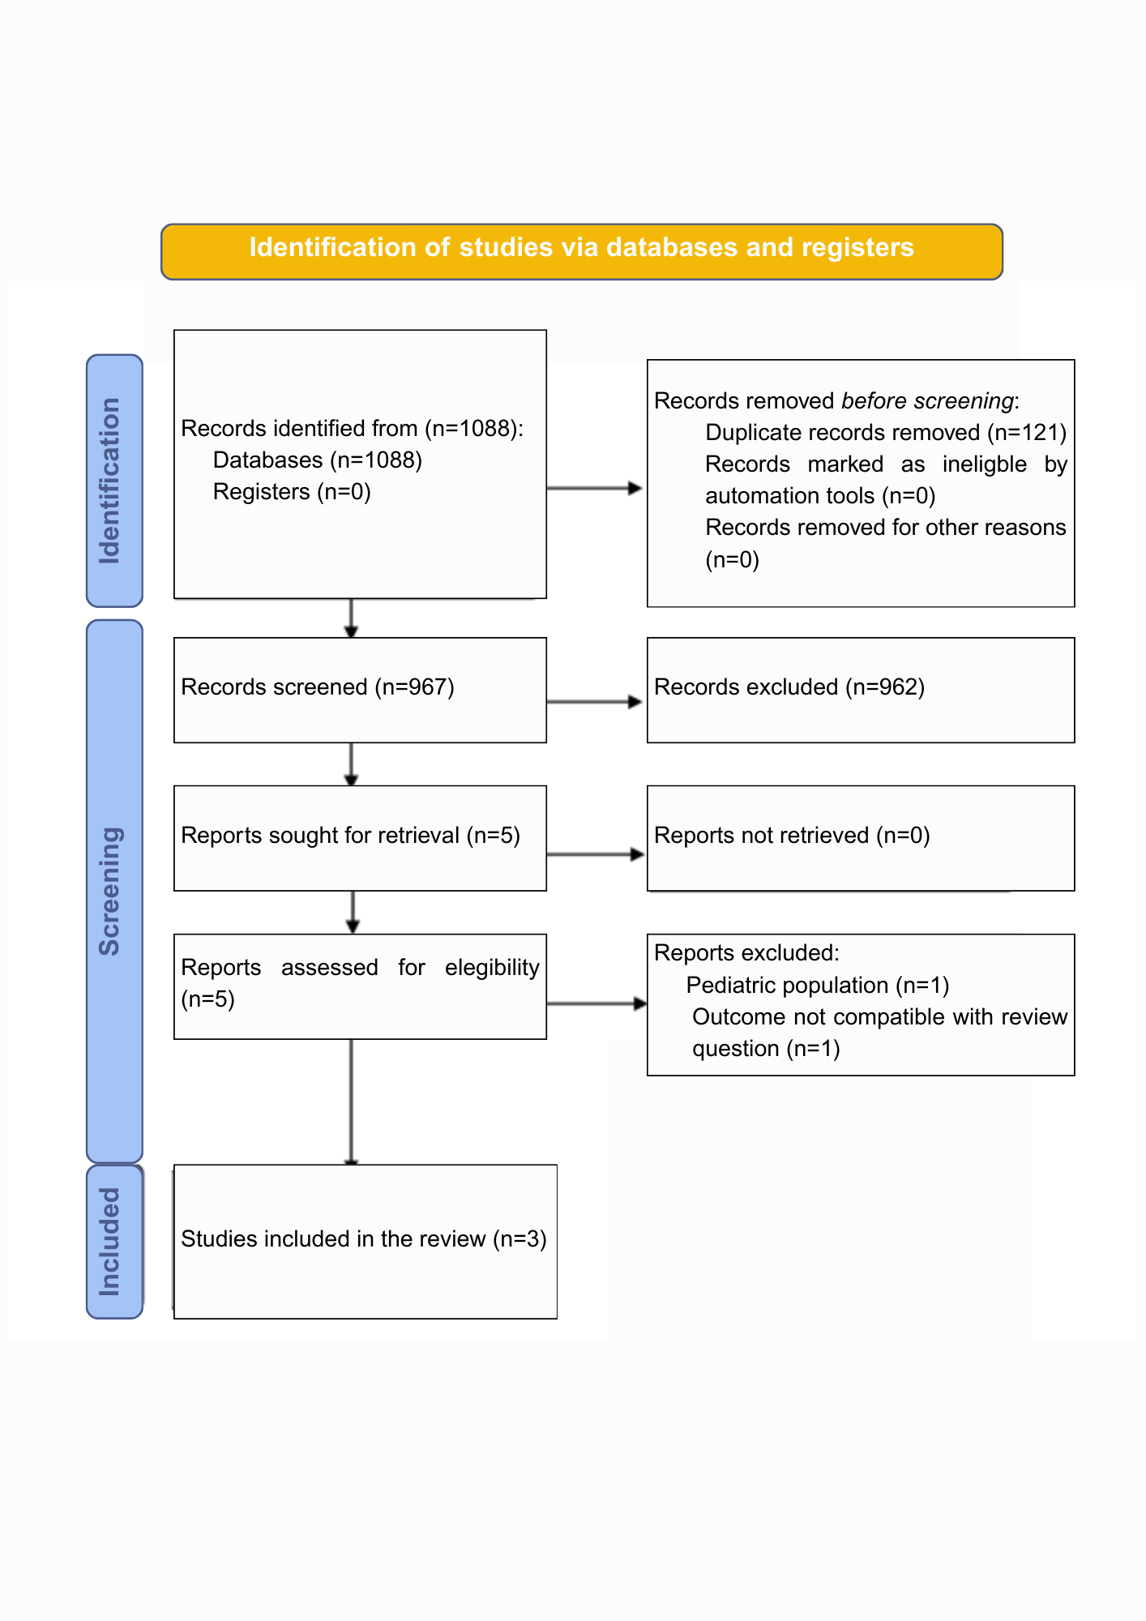

Fig 1. PRISMA 2020 flow diagram for study identification, screening, eligibility, and inclusion

3.2 Characteristics of included studies

A total of three studies were included in the final synthesis, encompassing 116 participants. All studies adopted a parallel-group design, with no use of split-mouth models. Postoperative soft tissue healing was evaluated in all included trials. Notable variations were observed in the hyaluronic acid application protocols, including differences in concentration, frequency, and duration of use. These factors were considered when planning the SWiM narrative synthesis to better address heterogeneity among the studies.

3.3 Risk of bias assessment (RoB 2.0)

The summary of the Risk of Bias (RoB) evaluation is illustrated in the Risk of Bias Summary Chart (Figure 2). Overall, one study was classified as low risk of bias, one presented some concerns, and one was rated as high risk. The main source of high risk was identified in Domain 2, which refers to deviations from the intended interventions. Selective reporting of outcomes (Domain 5) was generally judged as “some concerns,” primarily due to the lack of preregistered protocols.

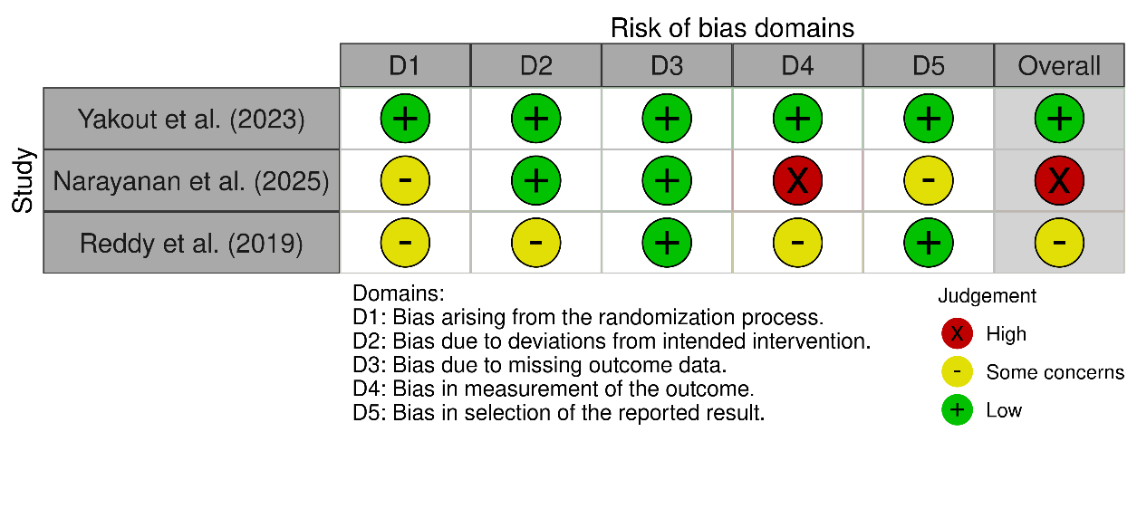
Fig 2. Risk of bias assessment by domain for each included study according to the RoB 2 tool

3.4 Narrative synthesis of results (SWiM)

The narrative synthesis was conducted on an outcome-by-outcome basis to assess the effectiveness and safety of the interventions, and the findings were interpreted in conjunction with the RoB 2.0 assessment. Two out of three studies did not detect significant differences in postoperative soft tissue healing between the intervention and comparator groups. Regarding effect magnitude, a modest clinical improvement was observed during the early phases of healing in groups receiving laser therapy, particularly when combined with hyaluronic acid. However, these differences were not sustained during later follow-up assessments, resulting in limited clinical relevance. Moderate heterogeneity was identified, likely attributable to variations in intervention protocols, differences in laser application parameters, and the presence or absence of HA use across the studies.

3.4.1 Soft Tissue Healing Outcomes

Two out of three studies did not detect significant differences in postoperative soft tissue healing between the intervention and comparator groups. Regarding effect magnitude, a modest clinical improvement was observed during the early phases of healing in groups receiving laser therapy, particularly when combined with hyaluronic acid. However, these differences were not sustained during later follow-up assessments, resulting in limited clinical relevance. Moderate heterogeneity was identified, likely attributable to variations in intervention protocols, differences in laser application parameters, and the presence or absence of HA use across the studies.

The studies included in this review indicated that low-level laser therapy (LLLT) accelerated soft tissue healing during the early postoperative phases following gingivectomy. This finding aligns with previous evidence demonstrating that LLLT enhances mitochondrial activity and ATP synthesis, stimulates fibroblast proliferation, promotes angiogenesis, and facilitates collagen deposition—all fundamental processes for tissue regeneration. These mechanisms support the clinical improvements observed in healing indices across the included studies(Kermanshah et al. 2022; Nowak-Terpiłowska et al. 2023).

The use of hyaluronic acid (HA) also produced favorable results in accelerating gingival wound healing and promoting tissue regeneration, consistent with recent scientific evidence. According to Malcangi et al. (2025) HA exhibits anti-inflammatory, angiogenic, and cell-proliferation–stimulating properties that contribute to re-epithelialization and reorganization of the connective tissue. Additionally, its strong hygroscopic capacity helps maintain a moist wound environment, creating optimal conditions for tissue repair. These biological attributes justify the positive outcomes observed in this review and reinforce HA’s potential role as an adjunctive agent in periodontal soft-tissue regeneration (Malcangi et al. 2025). However, confidence in these findings is mitigated by the high risk of bias identified in several of the included studies.

The study that most robustly demonstrated the benefits of HA was classified as having a low overall risk of bias. In the randomized clinical trial by Yakout et al. (2023), the topical application of HA gel in combination with a photobiomodulation therapy (PBMT) protocol after gingivectomy resulted in statistically significant improvements in the Landry Healing Index on days 7, 14, and 21 compared with PBMT alone. These results suggest that LLLT and HA act through complementary and potentially synergistic mechanisms. PBMT primarily provides metabolic stimulation and accelerates cellular activity. In contrast, HA offers crucial benefits by enhancing the biophysical wound environment, supporting cellular migration and proliferation, modulating the extracellular matrix, reducing collagen degradation, and maintaining tissue hydration.

3.4.2 Postoperative Pain Control

Regarding pain perception, the same study reported significant reductions during the first 2–3 postoperative days among patients treated with LLLT, which is consistent with literature describing the therapy’s analgesic and anti-inflammatory effects (Abesi and Derikvand 2023; Kohale et al. 2018b; Yakout et al. 2023; Zhao et al. 2021). LLLT modulates peripheral nociceptors, reduces the release of inflammatory mediators, and increases the release of β-endorphins, resulting in early symptomatic relief, improved postoperative comfort, and potentially greater adherence to treatment recommendations (Kermanshah et al. 2022).

3.4.3 Certainty of Evidence and Methodological Limitations

Although the trial by Yakout et al. (2023) was the only study classified as low risk of bias, its inability to blind participants and operators introduces potential performance bias, especially regarding subjective outcomes such as pain and perceived healing. In the remaining included studies, moderate to high risk of bias was observed, primarily due to inadequate randomization processes and lack of blinding of outcome assessors, which may have influenced the consistency and reliability of reported effects for both HA and photobiomodulation. These methodological limitations reduce confidence in the effect estimates and warrant cautious interpretation of the findings.

In addition to the identified risk-of-bias concerns, this review found substantial clinical and methodological heterogeneity across studies. This variability manifested in differing LLLT parameters, HA concentrations, application frequency, and follow-up duration. Furthermore, several specific methodological limitations were noted: for example, the study by Reddy et al. (2019) used a restricted study design that lacked an appropriate control group. Other studies, such as Shalaby (2019), employed non-surgical PICO frameworks. This broad lack of comparability across studies precluded the performance of a meta-analysis, thereby justifying the adoption of the SWiM method for narrative synthesis.

Despite these limitations, the present systematic review features a robust and transparent methodological approach, supported by a comprehensive and sensitive search strategy that encompasses multiple databases and gray literature sources. This rigorous approach ensured the identification of the greatest possible number of relevant studies, minimizing publication bias and strengthening the representativeness of the evidence on HA and photobiomodulation in gingival surgery. Furthermore, the use of the Cochrane RoB 2.0 tool allowed a systematic and thorough appraisal of internal validity, providing greater reliability in the interpretation of findings.

Nevertheless, some limitations must be acknowledged. The most significant relates to the small number of randomized controlled trials that fully met the proposed PICO criteria. Additionally, part of the available evidence originated from studies with less rigorous designs or important methodological weaknesses, such as a lack of blinding and incomplete reporting of randomization procedures. Consequently, most studies were classified as having “some concerns” or “high risk” of bias, which lowers the certainty of the evidence according to the GRADE framework and limits the clinical generalizability of the findings.

Despite these limitations, this systematic review features a robust and transparent methodological approach, supported by a comprehensive search strategy that minimizes publication bias and strengthens the representativeness of the evidence. Nevertheless, some critical limitations must be acknowledged. The most significant challenges relate to the small number of randomized controlled trials that met the PICO criteria, the prevalence of studies with important methodological weaknesses (such as lack of blinding and inadequate reporting of randomization), and the high degree of clinical and methodological heterogeneity observed across interventions. Consequently, most studies were classified as having 'some concerns' or 'high risk' of bias, which lowers the certainty of the evidence according to the GRADE framework and severely limits the clinical generalizability of the findings. Although the available evidence suggests that hyaluronic acid is a promising and biologically plausible adjunctive intervention for enhancing wound healing and reducing postoperative pain in gingival surgery, high-quality, well-designed RCTs are necessary to substantiate these findings. Future research must prioritize trials with larger samples, standardized protocols, and appropriate blinded placebo controls (e.g., sham laser) to consistently validate the effectiveness and safety of this therapeutic approach.

4. Conclusion

The available evidence suggests that the use of hyaluronic acid (HA), particularly in combination with Low-Level Laser Therapy (LLLT), demonstrates promising potential for promoting early healing and reducing postoperative pain following gingival surgery. However, the certainty of this evidence is currently low due to the limited number of available Randomized Controlled Trials (RCTs) and the methodological weaknesses identified. Consequently, clinical recommendations for this combined approach must be approached with caution. Therefore, to consistently validate these promising findings and facilitate their widespread clinical adoption, future research must urgently focus on conducting high-quality randomized controlled trials that incorporate larger sample sizes, rigorously standardized intervention protocols, and appropriate blinded placebo controls (e.g., sham laser).

Disclaimer (Artificial intelligence)

Option 2:
Author(s) hereby declare that generative AI technologies such as Large Language Models, etc. have been used during the writing or editing of manuscripts. This explanation will include the name, version, model, and source of the generative AI technology and as well as all input prompts provided to the generative AI technology
Details of the AI usage are given below:
1. Technology: Gemini (Google's Generative AI model).
2. Purpose: Assistance was utilized exclusively during the revision and editing process of the manuscript, specifically for: restructuring sections (Abstract, Discussion) to improve clarity, implementing changes requested by the peer reviewer, correcting and standardizing academic language/flow, and drafting the final 'Response to Reviewers' table. No content generation was used for the original scientific findings, data collection, data analysis, or original conclusions.

References

- Sousa, S. J. B., Magalhães, D., Silva, G. R., Soares, C. J., Soares, P. F. B., & Santos-Filho, P. C. F. (2010). Periodontal plastic surgery for correction of gummy smile associated with composite resin restorations: Clinical case report. Revista Odontológica Do Brasil Central, 19(51). https://doi.org/10.36065/robrac.v19i51.501
- Malpartida-Carrillo, V., Tinedo-Lopez PL, Guerrero, ME., Huamani-Echaccaya JL., Özcan, M., Rösing, CK. (2021). Outcome measurements following palatal soft tissue graft harvesting: A review. Journal of Clinical and Experimental Dentistry, e527–e535. https://doi.org/10.4317/jced.57625
- Tavelli, L., Barootchi, S., Stefanini, M., Zucchelli, G., Giannobile, W. V., et al. (2022). Wound healing dynamics, morbidity, and complications of palatal soft‐tissue harvesting. Periodontology 2000. https://doi.org/10.1111/prd.12466

- Azevedo A. R. P., Reis I. R., Araújo R. J. G., Teles B. J. T., Pagliarini J. L. (2023). The therapeutic use of low-level laser in promoting healing and pain relief in minor oral surgical interventions: an integrative review. Brazilian Journal of Natural Sciences, 5(1). https://bjns.com.br/index.php/BJNS/article/view/168
- Eming, S. A., Martin, P., & Tomic-Canic, M. (2014). Wound repair and regeneration: Mechanisms, signaling, and translation. Science Translational Medicine, 6(265). https://doi.org/10.1126/scitranslmed.3009337
- Balbino, C. A., Pereira, L. M., & Curi, R. (2005). Mechanisms involved in wound healing: A review. Revista Brasileira de Ciências Farmacêuticas, 41(1), 27–51. DOI:10.1590/S1516-93322005000100004. https://www.scielo.br/j/rbcf/a/HXZMLDrTL5B7mrRRqSsbtmh/abstract/?lang=pt
- Gurtner, G. C., Werner, S., Barrandon, Y., & Longaker, M. T. (2008). Wound repair and regeneration. Nature, 453(7193), 314–321. https://doi.org/10.1038/nature07039
- Rocha, A. M., Vieira, B. J., de Andrade, L. C. F., & Aarestrup, F. M. (2007). Effects of low-level laser therapy on the progress of wound healing in humans: The contribution of in vitro and in vivo experimental studies. Jornal Vascular Brasileiro, 6(3), 257–265. https://jvascbras.org/journal/jvb/article/doi/10.1590/S1677-54492007000300009
- Bhati, A., Fageeh, H., Ibraheem, W., Fageeh, H., Chopra, H., & Panda, S. (2022). Role of hyaluronic acid in periodontal therapy (Review). Biomedical Reports, 17(5). https://doi.org/10.3892/br.2022.1574
- Abesi, F., & Derikvand, N. (2023). Efficacy of Low-Level Laser Therapy in Wound Healing and Pain Reduction After Gingivectomy: A Systematic Review and Meta-analysis. Journal of Lasers in Medical Sciences, 14, e17. https://doi.org/10.34172/jlms.2023.17
- Rathod, A., Jaiswal, P., Bajaj, P., Kale, B., & Masurkar, D. (2022). Implementation of Low-Level Laser Therapy in Dentistry: A Review. Cureus. https://doi.org/10.7759/cureus.28799
- Yakout, B. K., Kamel, F. R., Khadr, M. A. E. A. A., Heikal, L. A. H., El-Kimary, G. I. Efficacy of hyaluronic acid gel and photobiomodulation therapy on wound healing after surgical gingivectomy: a randomized controlled clinical trial. (2023). Efficacy of hyaluronic acid gel and photobiomodulation therapy on wound healing after surgical gingivectomy: a randomized controlled clinical trial. BMC Oral Health, 23(1). https://doi.org/10.1186/s12903-023-03519-5
- Kohale, B., Raut, C., & Agrawal, A. (2018). Effect of low-level laser therapy on wound healing and patients’ response after scalpel gingivectomy: A randomized clinical split-mouth study. Journal of Indian Society of Periodontology, 22(5), 419. https://doi.org/10.4103/jisp.jisp_239_18
- Zhao, H., Hu, J., & Zhao, L. (2020). The effect of low-level laser therapy as an adjunct to periodontal surgery in the management of postoperative pain and wound healing: a systematic review and meta-analysis. Lasers in Medical Science, 36(1), 175–187. https://doi.org/10.1007/s10103-020-03072-5
- Antoszewska, M., Sokolewicz, E. M., & Barańska-Rybak, W. (2024). Wide Use of Hyaluronic Acid in the Process of Wound Healing—A Rapid Review. Scientia Pharmaceutica, 92(2), 23. https://doi.org/10.3390/scipharm92020023

- Wang, L., Zhou, F., & Xie, W. (2025). Advances in hyaluronic acid-based biomaterials: applications in cancer therapy, wound healing, and disease management. Journal of Materials Science Materials in Medicine, 36(1). https://doi.org/10.1007/s10856-025-06946-8
- Frenkel, J. S. (2012). The role of hyaluronan in wound healing. International Wound Journal, 11(2), 159–163. https://doi.org/10.1111/j.1742-481x.2012.01057.x
- Pilloni, A., Shirakata, Y., Marini, L., Božić, D., Miron, R. J., Rotundo, R., et al. (2025). Hyaluronic acid: A novel approach in regenerative/reconstructive periodontal therapy? Periodontology 2000. https://doi.org/10.1111/prd.12644
- Adel, N., Harhash, T., & Abdallah, N. (2025a). Combined Effect of Low-level Laser Therapy and Hyaluronic Acid Injection in Oral Wound Healing: An Experimental Study. Plastic and Reconstructive Surgery - Global Open, 13(5), e6837. https://doi.org/10.1097/gox.0000000000006837
- Adel, N., & Stankovic, N. (2025b). Hyaluronic acid skin booster injection and cold laser therapy in oral wounds: an experimental study. Plastic and Aesthetic Research. https://doi.org/10.20517/2347-9264.2025.25
- Ozcelik, O., Cenk Haytac, M., Kunin, A., & Seydaoglu, G. (2008). Improved wound healing by low-level laser irradiation after gingivectomy operations: a controlled clinical pilot study. Journal of Clinical Periodontology, 35(3), 250–254. https://doi.org/10.1111/j.1600-051x.2007.01194.x
- Faria Amorim, J. C., Sousa, G. R. D., Silveira, L. D. B., Prates, R. A., Pinotti, M., & Ribeiro, M. S. (2006). Clinical Study of the Gingiva Healing after Gingivectomy and Low-Level Laser Therapy. Photomedicine and Laser Surgery, 24(5), 588–594. https://doi.org/10.1089/pho.2006.24.588
- Fawzy El-Sayed, K. M., Dahaba, M. A., Aboul-Ela, S., & Darhous, M. S. (2011). Local application of hyaluronan gel in conjunction with periodontal surgery: a randomized controlled trial. Clinical Oral Investigations, 16(4), 1229–1236. https://doi.org/10.1007/s00784-011-0630-z
- Ibraheem, W., Jedaiba, W. H., Alnami, A. M., Hussain Baiti, L. A., Ali Manqari, S. M., Bhati, A., et al. (2022). Efficacy of hyaluronic acid gel and spray in healing of extraction wound: a randomized controlled study. European Review for Medical and Pharmacological Sciences, 26(10), 3444–3449. https://doi.org/10.26355/eurrev_202205_28838
- Page, M. J., McKenzie, J. E., Bossuyt, P. M., Boutron, I., Hoffmann, T. C., Mulrow, C. D., et al. (2021). The PRISMA 2020 statement: An updated guideline for reporting systematic reviews. British Medical Journal, 372(71). https://doi.org/10.1136/bmj.n71
- Sterne, J. A. C., Savović, J., Page, M. J., Elbers, R. G., Blencowe, N. S., Boutron, I., et al. (2019). RoB 2: a revised tool for assessing risk of bias in randomised trials. BMJ, 366(1), l4898. https://doi.org/10.1136/bmj.l4898
- Campbell, M., McKenzie, J. E., Sowden, A., Katikireddi, S. V., Brennan, S. E., Ellis, S., et al. (2020). Synthesis without meta-analysis (SWiM) in systematic reviews: reporting guideline. British Medical Journal, 368(1). https://doi.org/10.1136/bmj.l6890
- Kermanshah, H., Chiniforush, N., Kolahdouz, M. M., Motevasselian, F. (2022). Effect of Photobiomodulation Therapy with 915 nm Diode Laser on Pain Perception during Local Anesthesia of Maxillary Incisors: A Randomized Controlled Trial. Photochemistry and Photobiology, 98(6), 1471–1475. https://doi.org/10.1111/php.13644
- Nowak-Terpiłowska, A., Zeyland, J., Hryhorowicz, M., Śledziński, P., Wyganowska, M. (2023). Influence of Three Laser Wavelengths with Different Power Densities on the Mitochondrial Activity of Human Gingival Fibroblasts in Cell Culture. Life, 13(5), 1136–1136. https://doi.org/10.3390/life13051136
- Malcangi, G., Inchingolo, A. D., Trilli, I., Ferrante, L., Casamassima, L., Nardelli, P., et al. (2025). Recent Use of Hyaluronic Acid in Dental Medicine. Materials, 18(8), 1863. https://doi.org/10.3390/ma18081863
- Reddy, S. P., Koduganti, R. R., Panthula, V. R., Surya Prasanna, J., Gireddy, H., Dasari, R., Ambati, M., & Chandra G, B. (2019). Efficacy of Low-level Laser Therapy, Hyaluronic Acid Gel, and Herbal Gel as Adjunctive Tools in Gingivectomy Wound Healing: A Randomized Comparative Clinical and Histological Study. Cureus. https://doi.org/10.7759/cureus.6438

- Shalaby, H. (2019). Effect of Diode Laser combined with Hyaluronic Acid Gel in Treatment of Recurrent Aphthous Stomatitis in Children: Randomized Clinical Trial. Egyptian Dental Journal, 65(4), 3555–3566. https://doi.org/10.21608/edj.2019.74812

