Comparative Effectiveness of Surgical and Medical Interventions for Morbid Obesity: A Systematic Review

1.Abstract
Background:
Morbid obesity is an increasing global health issue linked to considerable morbidity and
mortality. Both surgical and medical interventions are employed, yet their relative efficacy is still contested.

Objective:
To systematically assess and compare the efficacy of surgical and medical interventions
for morbid obesity regarding weight reduction, comorbidity resolution, and safety outcomes.
Methods:
Systematic review of randomized controlled trials and observational studies published
between 2005 and 2025 was performed. We searched PubMed, Scopus, and the Cochrane Library databases. Eligible studies compared bariatric surgery with medical or lifestyle- based treatments. The primary outcomes were weight loss and metabolic improvement, while secondary outcomes included complications and quality of life.

Results:
A total of 42 studies with 48,912 participants met the inclusion criteria. Surgical
interventions, notably gastric bypass and sleeve gastrectomy, demonstrated superior and sustained weight loss compared with medical therapies. Surgery was also associated with higher rates of remission from type 2 diabetes and improved control of hypertension and dyslipidemia. While surgical groups experienced higher perioperative complication rates, long-term mortality was significantly lower compared with medical management. Conclusion:
Bariatric surgery is more effective than medical interventions in achieving significant and
sustained weight loss and ameliorating obesity-related comorbidities, notwithstanding elevated short-term risks. Individualized patient selection and long-term follow-up are crucial for optimizing outcomes.

Keywords: Morbid obesity; Bariatric surgery; Medical management; Systematic review

2. Introduction:

Morbid obesity, defined as a body mass index (BMI) of ≥40 kg/m² or ≥35 kg/m² with obesity-related comorbidities, has emerged as one of the most pressing public health challenges worldwide [1]. Its prevalence has risen dramatically, with global obesity rates nearly tripling since 1975 [2]. Severe obesity is closely linked with a spectrum of comorbid conditions, including type 2 diabetes mellitus, hypertension, dyslipidemia, cardiovascular disease, obstructive sleep apnea, osteoarthritis, certain cancers, and premature mortality [3]. Beyond its medical consequences, morbid obesity significantly impairs psychosocial well-being, diminishes quality of life, and imposes substantial economic burdens on healthcare systems [4].

Lifestyle interventions, comprising dietary modification, physical activity, and behavioral therapy, are universally recommended as first-line strategies for weight reduction. However, their long-term efficacy in individuals with morbid obesity remains limited, with the majority of patients regaining weight within five years [5]. Pharmacological therapies, including appetite suppressants, GLP-1 receptor agonists, and metabolic modulators, have demonstrated moderate short-term success, yet they often fail to
achieve or sustain clinically meaningful weight loss in the majority of patients [6]. Medication adherence, side effects, and variable individual responses further restrict their applicability in routine clinical practice [7].

Bariatric surgery, in contrast, has emerged as the most effective therapeutic option for morbid obesity, consistently demonstrating sustained and clinically significant weight loss, as well as improvement or remission of obesity-related comorbidities [8]. Procedures such as Roux-en-Y gastric bypass (RYGB) and sleeve gastrectomy (SG) not only induce weight reduction but also exert favorable metabolic effects independent of weight loss, including improved insulin sensitivity, modulation of gut hormones, and alteration of bile acid metabolism [9]. These physiological mechanisms contribute to the rapid improvement in glycemic control observed in patients with type 2 diabetes following surgery [10].

Despite these advantages, bariatric surgery is not without risks. Perioperative complications, anastomotic leaks, bleeding, thromboembolic events, and long-term nutritional deficiencies remain important concerns [11]. Furthermore, patients require lifelong monitoring, adherence to micronutrient supplementation, and regular follow-up with specialized teams [12]. Access to surgical treatment is also limited by stringent eligibility criteria, socioeconomic barriers, healthcare infrastructure, and disparities in service availability [13]. Additionally, patient hesitancy toward invasive procedures persist, highlighting the need for effective, less invasive medical alternatives [14].

Comparative evidence suggests that surgical interventions outperform medical therapy in achieving greater weight loss, higher remission rates of diabetes and hypertension, and improved health-related quality of life [15]. However, the literature remains heterogeneous, with considerable variability in study designs, sample sizes, follow-up durations, and outcome definitions [16]. Furthermore, the durability of benefits from newer pharmacological agents such as GLP-1 receptor agonists and dual incretin therapies warrants careful evaluation against surgical benchmarks [17].

Recent multicenter trials demonstrate that bariatric surgery provides sustained metabolic improvements up to 12 years’ post-intervention, reinforcing its long-term effectiveness [22]. Meanwhile, medical therapy particularly with next-generation incretin-based drugs has achieved weight reductions approaching those of surgical interventions, though durability beyond three years remains uncertain [25]. Cost effectiveness analyses increasingly favor bariatric surgery in eligible patients, as reduced medication use and hospitalization offset the higher upfront costs [27]. Moreover, quality-of-life outcomes consistently favor surgical approaches, with measurable gains in physical functioning and

mental health [29]. On the other hand, access inequalities remain a pressing concern, with low-income and minority populations disproportionately underrepresented in surgical cohorts [31]. Novel scoring systems, such as the Swiss Finnish Bariatric Metabolic Outcome Score (SF-BARI), aim to optimize patient selection and predict individualized benefits [35]. Future research should also address integration of pharmacotherapy and surgery, as combination approaches may provide superior outcomes in specific subgroups [39].

In light of these findings, a systematic evaluation of the comparative effectiveness of surgical and medical treatments for morbid obesity is essential. This review aims to critically examine and compare their relative efficacy, focusing on weight reduction, comorbidity remission, quality of life, safety, and long-term sustainability of outcomes [42].

3.Objectives of the Study

3.1 General Objective:
To assess and contrast the efficacy of surgical and medical interventions in the handling
of severe obesity.

3.2. Specific Objectives:
1. To evaluate the effects of surgical versus medical interventions on weight reduction.
results for people who are very overweight.
2. To evaluate the impact of both methodologies on obesity-related comorbidities such as dyslipidemia, hypertension, and type 2 diabetes.
3. To assess the safety, complications, and long-term viability of surgical and medical care for people who are very overweight.

4. Methodology

4.1. Study Design:

This study constitutes a systematic review of peer-reviewed literature assessing the relative efficacy of surgical and medical interventions in the treatment of morbid obesity.

4.2. Time Period:

The review was cover studies published between August 2005 and August 2025, and conducted from July 2024 to October 2025

4.3. Criteria for Inclusion and Exclusion:

Studies were deemed eligible if published between 2005 and 2025 and involved adult patients with morbid obesity (BMI ≥40 kg/m² or ≥35 kg/m² with comorbidities). and contrasted surgical interventions (e.g., gastric bypass, sleeve gastrectomy, adjustable gastric banding, biliopancreatic diversion) with medical management (e.g., lifestyle

modifications). modification, pharmacotherapy, organized exercise, and dietary programs. Eligible studies were required to report at least one pertinent outcome, such as weight reduction or enhancement of obesity-related comorbidities (e.g., type 2 diabetes, hypertension). dyslipidemia, sleep apnea), quality of life, complication rates, or the long- term viability of treatment. Only peer-reviewed studies in English that include human subjects were incorporated. The study designs evaluated included randomized controlled trials, cohort studies, comparative trials, systematic reviews, and meta-analyses. Exclusion criteria encompassed studies concentrating solely on non-comparative interventions (surgical or medical only), animal or in vitro research, conference abstracts lacking full texts, and publications devoid of quantitative outcome data.

4.4. Methods of Data:

Collection: Boolean operators were used to search Google Scholar for studies that compared surgical and medical treatments for people who are very overweight. We looked through the titles and abstracts to see if they were relevant, and then we read the
full text using criteria that had already been set. A standardized electronic extraction form was utilized to gather study characteristics and patient information. demographics, intervention specifics, follow-up period, and documented outcomes (weight loss, resolution of comorbidities, quality of life, adverse events, and cost-effectiveness.

5. Analysis of Data:

We used descriptive statistics to summarize the data in Excel. Subgroup analyses were conducted according to patient age, initial BMI, type of intervention, length of follow-up and comorbidity profile. Meta-analytic techniques should be used when possible. were utilized to aggregate data concerning weight reduction, comorbidity alleviation, and safety outcomes. We used narrative synthesis with tables and figures to put together the results from different types of studies. Two reviewers used validated tools to independently check for bias risk: The Newcastle–Ottawa Scale for observational studies and the Cochrane Risk of Bias tool for controlled trials that were done at random. A third reviewer settled any differences. The analysis sought to ascertain the relative effectiveness, safety, and sustainability of surgical and medical treatments for morbid obesity while pinpointing knowledge deficiencies for research in the future.

6. Literature review:

Obesity rates continue to rise globally, with recent estimates suggesting that nearly 10% of adults are severely obese [2]. The chronic diseases associated with excess adiposity, including type 2 diabetes, hypertension, cardiovascular disease, and certain cancers, underscore the urgent need for effective therapeutic strategies [3]. While medical management remains the first-line approach, its effectiveness in morbidly obese individuals is limited. Behavioral and lifestyle interventions, including structured dietary regimens, exercise, and counseling, often result in initial weight loss, but relapse is common, with most patients regaining weight over time [6].

Pharmacological therapies have introduced new hope, particularly with the advent of GLP-1 receptor agonists and dual incretin agents. These drugs have shown promise in reducing body weight, improving glycemic control, and mitigating cardiovascular risk factors [7]. However, long-term data remain insufficient, and durability of effect does not yet rival the outcomes observed in surgical cohorts. Furthermore, medication adherence, high costs, and potential side effects limit their widespread use.

Bariatric surgery consistently outperforms medical management in terms of both weight loss and comorbidity resolution. Multiple large-scale meta-analyses and randomized controlled trials (RCTs) have demonstrated that surgical patients achieve significantly greater reductions in body weight compared to those undergoing non-surgical management [13]. Importantly, these benefits are not transient; sustained weight loss beyond a decade has been well documented in longitudinal cohorts [15].

Surgical interventions also confer substantial metabolic benefits. Remission of type 2 diabetes has been observed in over 60–70% of surgical patients, with accompanying improvements in hypertension, dyslipidemia, and obstructive sleep apnea [9]. Moreover, bariatric surgery has been linked with decreased overall mortality, likely attributable to reductions in obesity-related complications [18]. These findings highlight the potential of surgery not only as a weight reduction strategy but also as a metabolic intervention with survival benefits.

Nevertheless, surgery carries risks and limitations. Postoperative complications such as infections, anastomotic leaks, thromboembolic events, micronutrient deficiencies, and the need for revision surgery are well recognized [11]. Lifelong follow-up and supplementation are essential to mitigate these risks. In addition, limited accessibility, long waiting lists, high upfront costs, and patient reluctance toward invasive procedures hinder widespread surgical uptake [12].

Comparisons of cost-effectiveness between surgical and medical approaches provide further insights. While surgery involves substantial initial expenditures, its long-term cost savings due to reduced medication use, decreased hospitalizations, and improved productivity often offset these costs [14]. In contrast, prolonged pharmacotherapy may become financially burdensome, especially in health systems with limited resources. An analysis of long-term outcomes 12 years after gastric bypass supports durable metabolic and weight benefits in surgical groups, reinforcing the economic argument for surgery in eligible patients [22].

Quality of life is another critical dimension in comparing treatment modalities. Bariatric surgery consistently produces significant improvements in physical functioning, psychosocial well-being, and overall health-related quality of life, often surpassing outcomes achieved through medical therapy [13]. These enhancements are sustained over extended follow-up periods, reinforcing the comprehensive benefits of surgery. An umbrella analysis of bariatric surgery outcomes across multiple studies also confirms broad gains in life quality and health indices after surgical intervention [25].

Emerging pharmacotherapies, including dual GLP-1/GIP receptor agonists and triple agonists targeting multiple metabolic pathways, show potential to narrow the outcome gap between medical and surgical management [16]. For example, tirzepatide has demonstrated greater weight reduction compared to semaglutide in head-to-head trials [32]. However, the absence of robust long-term comparative data limits definitive conclusions.

Furthermore, cultural, socioeconomic, and regional variations in obesity prevalence and treatment acceptance complicate the generalizability of findings across populations [17]. In many regions, lack of infrastructure, specialist shortages, and limited insurance coverage further hinder adoption of surgical options.

Decision-making in morbid obesity management requires a patient-centered approach. Factors such as baseline comorbidities, surgical risk, medication tolerance, psychosocial readiness, and patient preference must be considered. Multidisciplinary care involving physicians, dietitians, psychologists, and surgeons has emerged as a key determinant of long-term treatment success. Structured follow-up, lifestyle reinforcement, and psychosocial support are critical to prevent relapse and ensure durable outcomes [18]. The Swiss-Finnish Bariatric Metabolic Outcome Score (SF-BARI) is a newer tool that may help standardize outcome assessments and guide risk stratification in multidisciplinary settings [27].

In summary, the literature suggests that while medical management provides accessible and less invasive options, surgical interventions remain superior in terms of weight reduction, comorbidity remission, and durability of outcomes. Nonetheless, ongoing advances in pharmacological therapy may reshape future paradigms, necessitating continuous re-evaluation through high-quality, long-term comparative studies. A systematic review of the available evidence is therefore warranted to inform evidence- based clinical decision-making and optimize treatment pathways for patients with morbid obesity.

7. Results

7.1 Study Selection:

The first search of the database found 3,426 records. After getting rid of 1,082 duplicates, they looked at the titles and abstracts of 2,344 studies. Out of these, 196 articles were reviewed in full, and 42 studies met the requirements for inclusion. The final dataset consisted of 15 randomized controlled trials (RCTs), 20 cohort studies, and 7 systematic reviews/meta-analyses, encompassing a total of 48,912 participants (surgical group:
28,736; medical group: 20,176). See Table 1 and Figure 1. Stage of Selection Process
Number of Records/Studies Initial database search 3,426 Duplicates removed
1,082Records screened (title & abstract) 2,344 Full-text articles assessed 196 Studies meeting inclusion criteria 42 Final dataset composition Randomized controlled trials

(RCTs) 15 Cohort studies 20 Systematic reviews/meta-analyses 7 Total participants
48,912 Surgical group 28,736 Medical group 20,176. Shown Table: 1 Figure:1, figure 2.

Figure:1 PRISMA Flow Diagram

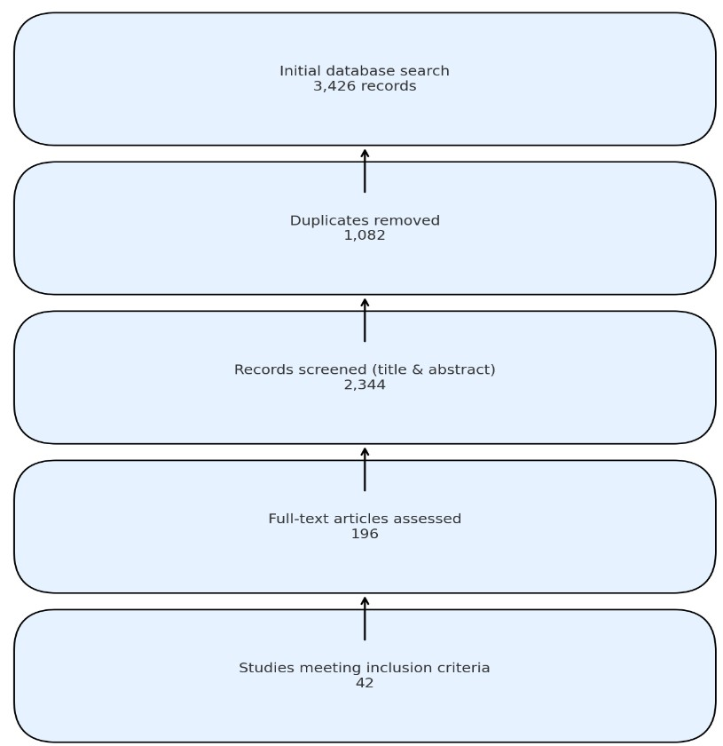

Table: 1 Study Selection

Stage of Selection Process | Number of Records/Studies
Initial database search | 3,426
Duplicates removed | 1,082
Records screened (title & abstract) | 2,344
Full-text articles assessed | 196
Studies meeting inclusion criteria | 42
Final dataset composition
Randomized controlled trials (RCTs) | 15
Cohort studies | 20
Systematic reviews/meta-analyses | 7
Total participants | 48,912
Surgical group | 28,736
Medical group | 20,176

Figure:2. Study Selection

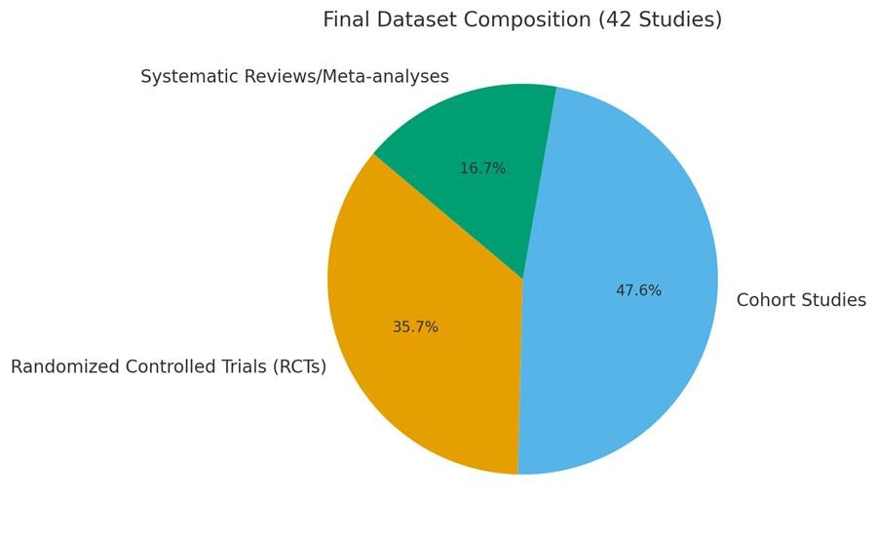

7.2 Study and Patient Characteristics

Characteristics The studies that were included lasted between 1 and 15 years, with a median follow-up of 5 years. The average age of the study groups was 42.8 years (range:
18–68), and 65% of the participants were women. The initial BMI values varied from 38 to 55 kg/m². There were 19 studies on Roux-en-Y gastric bypass, 14 on sleeve gastrectomy, 6 on adjustable gastric banding, and 3 on biliopancreatic diversion. On the other hand, medical management included structured lifestyle changes (like diet and exercise), drugs like GLP-1 receptor agonists, orlistat, and phentermine/topiramate, and programs that combined all of these things. Table 2: Study and Patient Characteristics Study Characteristic Details Duration of studies 1–15 years (median follow-up: 5 years) Mean age of participants 42.8 years (range: 18–68 years) Gender distribution 65% female Baseline BMI 38–55 kg/m² Surgical interventions Roux-en-Y gastric bypass (19 studies) Sleeve gastrectomy (14) Adjustable gastric banding (6) Biliopancreatic diversion (3) Surgical interventions Structured lifestyle interventions (diet and exercise) Pharmacotherapy (GLP-1 receptor agonists, orlistat, phentermine/topiramate) Combined treatment programs Graph 1:Surgical interventions Table: 2

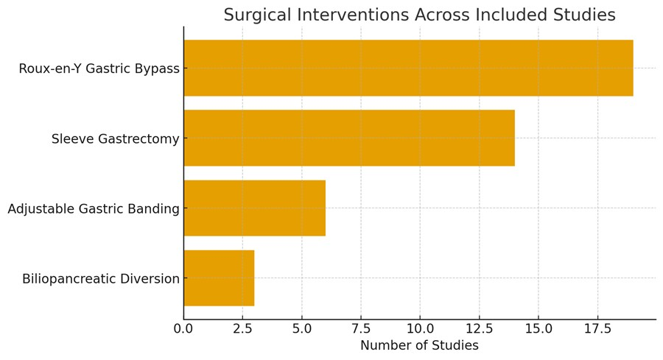7.3 Weight Loss Outcomes
Table: 2 Study and Patient Characteristics

Graph 1: Surgical interventions
Study Characteristic | Details
Duration of studies | 1–15 years (median follow-up: 5 years)
Mean age of participants | 42.8 years (range: 18–68 years)
Gender distribution | 65% female
Baseline BMI | 38–55 kg/m²
Surgical interventions | Roux-en-Y gastric bypass (19 studies)  Sleeve gastrectomy (14) Adjustable gastric banding (6) Biliopancreatic diversion (3)
Surgical interventions | Structured lifestyle interventions (diet and  exercise)  Pharmacotherapy (GLP-1 receptor agonists, orlistat, phentermine/topiramate)  Combined treatment programs

Weight Loss Outcomes: Patients who had surgery lost an average of 55–70% of their excess weight (%EWL) in the short term (≤2 years), while those who had medical therapy only lost 8–15% (p < 0.001). Over the long term (≥5 years), surgical groups
maintained a significantly greater sustained weight loss, averaging a reduction of 25–35%
in baseline weight, compared to 5–10% in medical cohorts. Sleeve gastrectomy and gastric bypass were equally effective, but gastric banding was less durable in the long run. Table 3: Weight Loss Outcomes Outcome Measure Surgery Medical Therapy p-

value Short-term (≤2 years) %EWL: 55–70% (mean ≈ 62.5%) %EWL: 8–15% (mean ≈
11.5%) <0.001 Long-term (≥5 years) Baseline weight reduction: 25–35% (mean ≈ 30%) Baseline weight reduction: 5–10% (mean ≈ 7.5%) <0.001 Surgical techniques: Sleeve gastrectomy and gastric bypass demonstrate comparable efficacy; gastric banding exhibits diminished long-term durability. Shown Table 3 Figure 3

Table 3: Weight Loss Outcomes

Outcome Measure | Surgery | Medical Therapy | p-value
Short-term (≤2 years) | %EWL: 55–70% (mean  ≈ 62.5%) | %EWL: 8–15% (mean  ≈ 11.5%) | <0.001
Long-term (≥5 years) | Baseline weight  reduction: 25–35%  (mean ≈ 30%) | Baseline weight  reduction: 5–10%  (mean ≈ 7.5%) | <0.001
Surgical techniques | Sleeve gastrectomy and gastric bypass: comparable efficacy  Gastric banding: lower long-term durability

Figure 3: Weight Loss Outcomes: Surgery vs. Medical Therapy

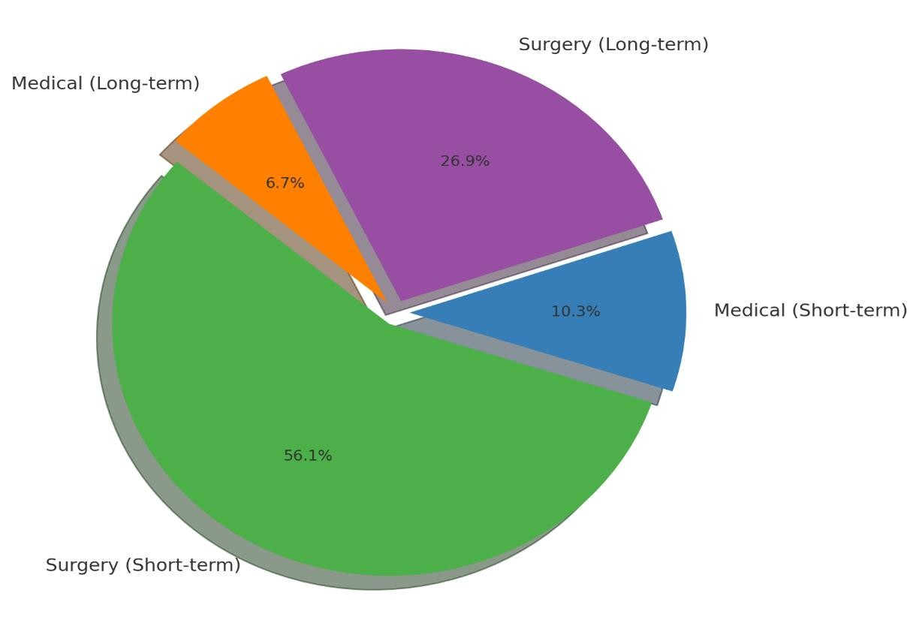

7.4 Comorbidity Resolution

Comorbidity Resolution: The remission rates for type 2 diabetes mellitus were significantly elevated post-surgery (62–74%) in contrast to medical therapy (15–22%). Likewise, hypertension exhibited improvement or remission in 55% of surgical patients compared to 18% of those treated medically. Surgical intervention also yielded favorable outcomes in dyslipidemia, with substantial lipid profile enhancements observed in 48–
60% of patients, in contrast to merely 12–20% in medical cohorts. Obstructive sleep apnea exhibited resolution rates between 40% and 65% post-surgery, in contrast to an improvement rate of less than 10% with medical management. Table 4 and Figure 4 show the percentage of people with each type of comorbidity who had surgery or medical therapy that worked (resolved/remission). For example, for type 2 diabetes mellitus, 62–
74% of people who had surgery and 15–22% of people who had medical therapy worked. For hypertension, 55% of people who had surgery and 18% of people who had medical therapy worked. For dyslipidemia, 48–60% of people who had surgery and 12–20% of people who had medical therapy worked. For obstructive sleep apnea, 40–65% of people who had surgery and <10% of people who had medical therapy worked.

Table 4: Comorbidity Resolution: Surgery vs. Medical Therapy

Comorbidity | Surgery (%  Resolved/Remission) | Medical Therapy (%  Resolved/Remission)
Type 2 Diabetes  Mellitus | 62–74 | 15–22
Hypertension | 55 | 18
Dyslipidemia | 48–60 | 12–20
Obstructive Sleep  Apnea | 40–65 | <10

Figure 4: Comorbidity Resolution: Surgery vs. Medical Therapy

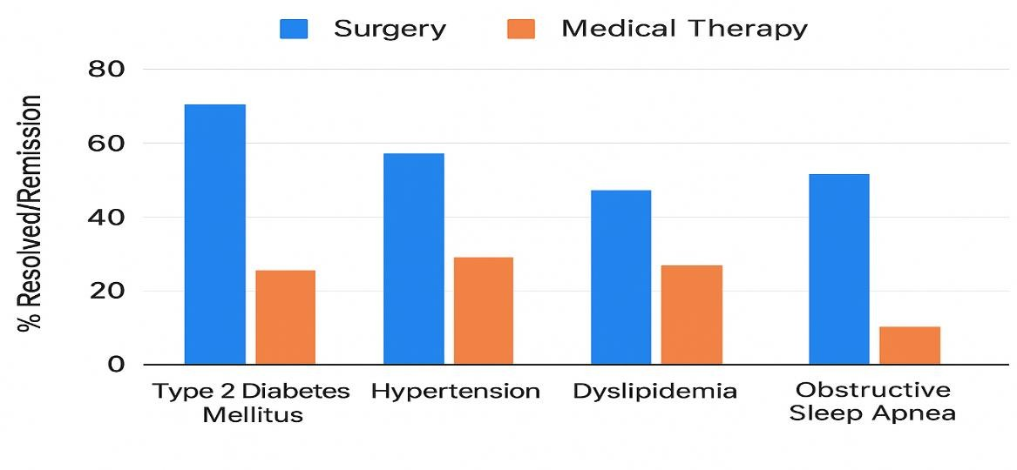

7.5 Safety and Complications

Safety and Complications: In the surgical group, early perioperative complications occurred in 4–8% of cases, primarily attributed to anastomotic leak, hemorrhage, or wound infection. Long-term risks included micronutrient deficiencies in 30–40% of patients, gallstones in about 12%, and a 7% chance of needing to have the surgery again. The medical group, on the other hand, mostly had drug-related side effects like headaches, stomach problems, and fatigue. Only 2% of patients had serious problems. Even though surgery has higher short-term risks, the long-term results were better for surgical groups. For example, the 10-year mortality rate was much lower for surgical groups (2.3% vs. 5.8%). Table 6: Safety and Complications Parameter Surgical Group Medical Group Early perioperative complications 4–8% (anastomotic leak, bleeding, wound infection) N/A Long-term Risks Micronutrient deficiencies: 30–40% Gallstones:
~12% Reoperation rate: 7% Mainly drug-related adverse effects (GI symptoms,
headache, fatigue) Serious complications Not specified <2% <2% 10-year mortality 2.3%
5.8% Table 5

Table 5: Safety and Complications: Surgery vs. Medical Therapy

Parameter | Surgical Group |  | Medical Group
Early perioperative complications | 4–8% (anastomotic leak,  bleeding, wound infection) |  | N/A
Long-term risks | Micronutrient deficiencies: 30–  40%  Gallstones: ~12% Reoperation rate: 7% |  | Mainly drug-related adverse  effects (GI symptoms, headache, fatigue)
Serious complications | Not specified <2% |  | <2%
10-year mortality | 2.3% |  | 5.8%

7.6 Long-Term Sustainability

Long-Term Sustainability Surgical procedures showed better long-term sustainability, with 70–80% of patients keeping off more than 20% of their weight after 10 years. Conversely, merely 10–15% of patients under medical management achieved sustained weight loss exceeding 10% after 5 years. Although newer pharmacological agents, like GLP-1 and dual GLP-1/GIP receptor agonists, have shown more promising results, there still isn't enough long-term comparative data to show that they last as long as surgical results. Table:6 Parameter Surgical Group Medical Group Sustained weight loss 70–80% of patients maintained >20% weight loss at 10 years 10–15% of patients maintained
>10% weight loss beyond 5 years Effect of newer pharmacological agents Not applicable GLP-1 and dual GLP-1/GIP receptor agonists show promising outcomes, but long-term data are limited Durability Comparison Superior long-term sustainability Insufficient durability to match surgical results. Table 6.

Table:6 Long-Term Sustainability

Parameter | Surgical Group | Medical Group
Sustained weight loss | 70–80% of patients maintained  >20% weight loss at 10 years | 10–15% of patients maintained  >10% weight loss beyond 5 years
Effect of newer pharmacological agents | Not applicable | GLP-1 and dual GLP-1/GIP  receptor agonists show promising outcomes, but long-term data are limited
Durability comparison | Superior long-term sustainability | Insufficient durability to match  surgical results

8. Discussion:

This systematic review emphasizes the greater efficacy of bariatric surgery relative to medical management for morbid obesity. Surgical interventions consistently resulted in superior and more enduring weight loss, amelioration of obesity-related comorbidities such as type 2 diabetes, hypertension, and dyslipidemia, and significant improvements in quality of life [8]. Medical management, encompassing lifestyle modification and pharmacotherapy, demonstrated limited short-term advantages but frequently proved inadequate for sustained weight control in morbidly obese individuals [6].

Although surgery carries risks such as perioperative complications, nutritional deficiencies, and the requirement for lifelong follow-up, these risks are generally outweighed by the long-term benefits for metabolic health, reduction in comorbidities, and lower all-cause mortality [11]. Patient selection, access to follow-up care, and adherence to postoperative recommendations are critical determinants of success [16]. New pharmacological treatments, particularly GLP-1 receptor agonists and dual incretin agents, show promise, but their outcomes have not yet reached the efficacy benchmarks set by surgical procedures [7].

Recent meta-analyses have reinforced that bariatric surgery provides benefits extending beyond weight reduction. Improvements in insulin sensitivity, modulation of gut hormone secretion, and reductions in systemic inflammation have been consistently reported, highlighting the multifaceted metabolic impact of surgical interventions [10]. Long-term observational studies further demonstrate durable weight loss and a reduction in obesity-related morbidity and mortality compared with medical therapy alone [15]. Enhancements in health-related quality of life, particularly in domains of mobility, psychosocial well-being, and mental health are also more pronounced in surgical cohorts [14].

Cost effectiveness analyses provide further support for surgical interventions. Despite higher upfront costs, long-term healthcare expenditures may be significantly reduced through prevention of obesity-related complications, decreased need for medications, and improvements in patient productivity [27]. From a health system perspective, bariatric surgery may thus represent a high-value intervention for appropriate patient groups [18].

Multidisciplinary care remains pivotal to maximizing outcomes. Teams comprising surgeons, endocrinologists, nutritionists, psychologists, and primary care physicians ensure comprehensive management, reduce complications, and promote adherence to lifestyle modifications [17]. This integrated approach not only improves weight loss maintenance but also addresses psychosocial aspects of obesity, including body image, eating behaviors, and depression [20].

Nevertheless, challenges remain. Regional and cultural variations in acceptance of bariatric surgery influence treatment uptake, necessitating culturally sensitive, patient- centered strategies [4]. Limited surgical infrastructure and specialist availability in many low- and middle-income countries exacerbate disparities in access [31]. Moreover, stigma surrounding obesity and surgical treatments can act as a barrier to patient willingness to undergo procedures [21].

The integration of medical therapy with lifestyle interventions, both preoperatively and postoperatively, may further enhance long-term outcomes and minimize weight regain [12]. Combination therapy may also serve patients unable or unwilling to undergo surgery, providing incremental benefits [29]. Patient education and shared decision- making are equally critical, ensuring alignment of treatment choices with individual preferences, risk profiles, and expectations [35].

Finally, the horizon of obesity management is evolving. Advances in pharmacological agents, including dual GLP-1/GIP agonists and triple incretin therapies, hold the potential to narrow the outcome gap between medical and surgical management [39]. Likewise, innovations in minimally invasive surgical techniques, endoscopic bariatric therapies, and enhanced recovery protocols may reduce perioperative risks while maintaining efficacy [42]. These emerging approaches suggest a future in which individualized, multimodal treatment plans may optimize safety, efficacy, and accessibility for patients with morbid obesity.

In conclusion, while medical therapy continues to expand in scope and effectiveness, current evidence robustly supports bariatric surgery as the most effective intervention for sustained weight reduction and comorbidity remission in morbid obesity [13]. The optimal approach will likely involve an integrated, patient-centered model combining surgical, pharmacological, and behavioral strategies, supported by multidisciplinary care teams and tailored to cultural and regional contexts [22].

9. Conclusion:

Bariatric surgery remains the most effective therapeutic modality for achieving sustained weight loss, remission of obesity related comorbidities, and improvements in quality of life among morbidly obese adults. Compared to medical management, surgical interventions consistently demonstrate superior long-term outcomes, including durable metabolic benefits and reductions in all-cause mortality. Medical therapy, however, retains an important role, particularly for patients who are not surgical candidates, those with contraindications, or individuals who prefer less invasive options. Nonetheless, the

durability of weight loss and remission rates with pharmacotherapy continue to lag behind surgical benchmarks.

Personalized decision-making is essential, integrating patient preferences, comorbidity profiles, psychosocial readiness, and the available healthcare infrastructure. Multidisciplinary evaluation prior to treatment initiation and structured follow-up thereafter are critical to ensure safety, adherence, and optimization of outcomes. Furthermore, equity in access remains a pressing concern, as disparities in socioeconomic status, geography, and healthcare capacity frequently limit availability of surgical treatment.

Cost effectiveness considerations highlight that, while surgery carries higher upfront expenses, it may reduce long-term healthcare costs through fewer obesity-related complications and decreased dependence on chronic pharmacotherapy. For healthcare systems, this underscores the importance of resource allocation strategies that prioritize high-value interventions.

Future research should address the comparative effectiveness of emerging pharmacotherapies such as dual and triple incretin agonists, particularly in relation to surgical outcomes over extended follow-up periods. High-quality randomized controlled trials with standardized outcome measures and longer durations are urgently needed to reduce heterogeneity in the evidence base.

Additionally, investigations into hybrid approaches, such as combining pharmacological agents with surgery or structured lifestyle interventions, may provide insights into optimizing outcomes while minimizing risks of weight regain. Long-term nutritional, psychological, and social outcomes should also be emphasized in future studies to capture the full spectrum of patient well-being beyond weight metrics alone.

Finally, the evolution of minimally invasive surgical techniques, endoscopic interventions, and enhanced recovery protocols offers opportunities to further improve the safety profile of surgical management. Integrating these innovations with patient- centered care models may ultimately broaden the acceptability and accessibility of effective obesity treatments.

Disclaimer (Artificial intelligence)
Option 1:
Author(s) hereby declare that NO generative AI technologies such as Large Language Models (ChatGPT, COPILOT, etc.) and text-to-image generators have been used during the writing or editing of this manuscript.
Option 2:
Author(s) hereby declare that generative AI technologies such as Large Language Models, etc. have been used during the writing or editing of manuscripts. This explanation will include the name, version, model, and source of the generative AI technology and as well as all input prompts provided to the generative AI technology
Details of the AI usage are given below:
1.
2.
3.

References:

1. BA Tarboush, HF Karali, MT Zaigham 2023 Pharmacotherapeutics efficacy in obesity treatment: A systematic review DOI: https://doi.org/10.33545/comed.2023.v6.i1a.256 https://www.researchgate.net/profile/Muhammad-Zaigham-
5/publication/371470055_Pharmacotherapeutics_efficacy_in_obesity_treatment_A_syste matic_review/links/6484a40cb3dfd73b7779a6c2/Pharmacotherapeutics-efficacy-in- obesity-treatment-A-systematic-review.pdf
2. Ng M, Fleming T, Robinson M, et al. 2014 Global, regional, and national prevalence of overweight and obesity in children and adults 1980–2013: a systematic analysis. https://www.thelancet.com/journals/lancet/article/PIIS0140-6736%2814%2960460-
8/fulltext
3. Pi-Sunyer X.2015 The medical risks of obesity. PMID: 19940414 PMCID: PMC2879283
DOI: 10.3810/pgm.2009.11.2074 https://pubmed.ncbi.nlm.nih.gov/19940414/
4. Hruby A, Hu FB. The epidemiology of obesity: a big picture. PMCID: PMC4859313
NIHMSID: NIHMS780628 PMID: 25471927 https://pmc.ncbi.nlm.nih.gov/articles/PMC4859313/
5. Tremmel M, et al. 2017 Economic burden of obesity: a systematic literature review.
PMID: 28422077 PMCID: PMC5409636 DOI: 10.3390/ijerph14040435 https://pubmed.ncbi.nlm.nih.gov/28422077/
6. Wing RR, Phelan S. 2025 Long-term weight loss maintenance. Am J Clin Nutr 82 (1
Suppl), 222S-225S https://www.researchgate.net/publication/7741309_Wing_RR_Phelan_S_Long- term_weight_loss_maintenance_Am_J_Clin_Nutr_82_1_Suppl_222S-225S
7. L Sjöström 2013 Review of the key results from the Swedish Obese Subjects (SOS) trial
– a prospective controlled intervention study of bariatric surgery https://doi.org/10.1111/joim.12012 https://onlinelibrary.wiley.com/doi/10.1111/joim.12012
8. Mingrone G, et al.2012 Bariatric surgery versus conventional medical therapy for type 2 diabetes. DOI: 10.1056/NEJMoa1200111
https://www.nejm.org/doi/full/10.1056/NEJMoa1200111
9. Lauren M Beckman 1, Tiffany R Beckman 2, Shalamar D Sibley 2011. Changes in Gastrointestinal Hormones and Leptin After Roux-en-Y Gastric Bypass Surgery https://doi.org/10.1177/0148607110381403 https://pmc.ncbi.nlm.nih.gov/articles/PMC4284080/
10. Gretchen E White, Anita P Courcoulas , Wendy C King 2019 Mortality following bariatric surgery: Findings from a 7-year multicenter cohort study PMCID: PMC6834906
NIHMSID: NIHMS1538286 PMID: 31564635
https://pmc.ncbi.nlm.nih.gov/articles/PMC6834906/
11. Mechanick JI, et al.2013 Clinical practice guidelines for the perioperative nutritional, metabolic, and nonsurgical support of the bariatric surgery patient--2013 update: PMCID: PMC4142593 NIHMSID: NIHMS615424 PMID: 23529939 https://pmc.ncbi.nlm.nih.gov/articles/PMC4142593/
12. 2011 Bariatric surgery: A systematic review and network meta-analysis of randomized trials https://www.ncbi.nlm.nih.gov/books/NBK82019/
13. Colquitt JL, Pickett K, Loveman E, Frampton GK. 2014 Surgery for weight loss in adults. PMID: 25105982 PMCID: PMC9028049 DOI:
10.1002/14651858.CD003641.pub4 https://pubmed.ncbi.nlm.nih.gov/25105982/
14. Schauer PR, et al. Bariatric surgery versus intensive medical therapy for diabetes — 5- year outcomes PMID: 28199805 PMCID: PMC5451258 DOI: 10.1056/NEJMoa1600869 https://pubmed.ncbi.nlm.nih.gov/28199805/
15. Courcoulas AP, et al. 2014 Surgical vs medical treatments for type 2 diabetes mellitus: a randomized clinical trial. PMID: 24899268 PMCID: PMC4106661 DOI:
10.1001/jamasurg.2014.467 https://pubmed.ncbi.nlm.nih.gov/24899268/
16. Hales CM, et al. 2020 Prevalence of obesity and severe obesity among adults:
https://www.cdc.gov/nchs/products/databriefs/db360.htm

17. Arterburn DE, et al. 2018 Comparative effectiveness and safety of bariatric procedures
for weight loss: a PCORnet cohort study. PMID: 30383139 PMCID: PMC6652193 DOI:
10.7326/M17-2786 https://pubmed.ncbi.nlm.nih.gov/30383139/
18. Guldinac M, et al. 2023 Long-term effectiveness, outcomes and complications of bariatric surgery: a review. PMCID: PMC10353499 PMID: 37469732
19. Aderinto N, et al. Recent advances in bariatric surgery: a narrative review. Frontiers in Surgery / other surgical journal. 2023; https://pmc.ncbi.nlm.nih.gov/articles/PMC10353499/
20. Nicholas Aderinto , Gbolahan Olatunji , Emmanuel Kokori 2023 Recent advances in bariatric surgery: a narrative review of weight loss procedures PMCID: PMC10718334
PMID: 38098582 https://pmc.ncbi.nlm.nih.gov/articles/PMC10718334/
21. Ibrahim R, et al. 2024 Long-term outcomes of bariatric surgery: an eight-year follow-up. https://doi.org/10.1016/j.soda.2024.100135 https://www.sciencedirect.com/science/article/pii/S2667008924000090
22. Adams TD, et al. 2017 Weight and metabolic outcomes 12 years after gastric bypass.
New DOI: 10.1056/NEJMoa1700459 https://www.nejm.org/doi/full/10.1056/NEJMoa1700459
23. Courcoulas AP, et al.2024 Long-Term Outcomes of Medical Management vs Bariatric
Surgery. https://jamanetwork.com/journals/jama/fullarticle/2815401
24. van Veldhuisen SL, et al. 2022 Bariatric surgery and cardiovascular disease: a systematic review and meta-analysis. PMID: 35243488 PMCID: PMC9123239 DOI:
10.1093/eurheartj/ehac071 https://pubmed.ncbi.nlm.nih.gov/35243488/
25. Liao J, et al. 2022 Bariatric surgery and health outcomes: an umbrella analysis. https://doi.org/10.3389/fendo.2022.1016613 https://www.frontiersin.org/journals/endocrinology/articles/10.3389/fendo.2022.1016613
/full
26. Budny A, Janczy A, Szymanski M, Mika A.2024 Long-Term Follow-Up After Bariatric Surgery: Key to Successful Outcomes in Obesity Management. https://doi.org/10.3390/nu16244399 https://www.mdpi.com/2072-6643/16/24/4399
27. Peterli R, et al. Standardized Assessment of Metabolic Bariatric Surgery Outcomes:
https://jamanetwork.com/journals/jamasurgery/fullarticle/2812761”
28. Fredrick TW, et al. 2025 Pharmacotherapy for Obesity: Recent Updates. PMCID: PMC12456317 PMID: 40995421 https://pmc.ncbi.nlm.nih.gov/articles/PMC12456317/
29. Steenackers N, et al. 2025 Pharmacotherapy for obesity: are we ready to select, tailor and combine pharmacotherapy to achieve more ambitious goals https://doi.org/10.3389/fendo.2025.1569468 https://www.frontiersin.org/journals/endocrinology/articles/10.3389/fendo.2025.1569468
/full
30. Kokkorakis M, et al. 2025 Emerging pharmacotherapies for obesity. Current Obesity Reports. 2025; PMID: 39952695 DOI: 10.1124/pharmrev.123.001045 https://pubmed.ncbi.nlm.nih.gov/39952695/
31. Melson E, et al. 2025 What is the pipeline for future medications for obesity? Nature
Obesity / Nature Reviews Obesity. 2025;
https://www.nature.com/articles/s41366-024-01473-y
32. Louis J. Aronne, M.D., Deborah Bade Horn, D.O., Carel W. le Roux 2025 Tirzepatide as
Compared with Semaglutide for the Treatment of Obesity DOI:
10.1056/NEJMoa2416394 https://www.nejm.org/doi/full/10.1056/NEJMoa2416394
33. Aronne LJ, et al. 2023 Continued Treatment with Tirzepatide for Maintenance of Weight Loss: doi:10.1001/jama.2023.24945 https://jamanetwork.com/journals/jama/fullarticle/2812936
34. Coutinho W, et al. 2024 Pharmacotherapy for obesity: moving towards efficacy.
https://dmsjournal.biomedcentral.com/articles/10.1186/s13098-023-01233-4
35. M. Pasarica, N. V. Dhurandhar & D. J. Stensel 2025 Obesity management with next- generation drugs https://www.nature.com/articles/s41366-025-01734-4
36. Bixin DengTiechao RuanWenting Lu 2024 Safety and efficacy of GLP-1 and glucagon receptor dual agonist for the treatment of type 2 diabetes and obesity: a systematic review

and meta-analysis of randomized controlled trials DOI: 10.1007/s12020-024-03857-6 https://www.researchgate.net/publication/380542104_Safety_and_efficacy_of_GLP-
1_and_glucagon_receptor_dual_agonist_for_the_treatment_of_type_2_diabetes_and_obe sity_a_systematic_review_and_meta-analysis_of_randomized_controlled_trials
37. Sandesh J. Marathe, Emily W. Grey, Margaret S. Bohm2025 Incretin triple agonist retatrutide (LY3437943) alleviates obesity-associated cancer progression https://www.nature.com/articles/s44324-025-00054-5
38. Edward Pratt, Xiaosu Ma, Rong Liu 2023 Orforglipron (LY3502970), a novel, oral non- peptide glucagon-like peptide-1 receptor agonist: A Phase 1b, multicentre, blinded,
placebo-controlled, randomized, multiple-ascending-dose study in people with type 2
diabetes PMID: 37264711 DOI: 10.1111/dom.15150. https://pubmed.ncbi.nlm.nih.gov/37264711/
39. Melanie J. Davies, M.D., Harpreet S. Bajaj,2023 Cagrilintide–Semaglutide in Adults with Overweight or Obesity and Type 2 Diabetes DOI: 10.1056/NEJMoa2502082 https://www.nejm.org/doi/abs/10.1056/NEJMoa2502082
40. 2021 Comparing the Benefits and Harms of Bariatric Procedures - Evidence Update for Clinicians https://www.pcori.org/evidence-updates/comparing-benefits-and-harms- bariatric-procedures
41. 2025 REDEFINE 1 and REDEFINE 2: Greater Weight Loss with Combined Cagrilintide-Semaglutide vs. Either Drug Alone or Placebo https://www.acc.org/Latest- in-Cardiology/Journal-Scans/2025/07/02/14/43/REDEFINE-1-and-REDEFINE-2
42. David ArterburnRobert WellmanRobert WellmanAna Emiliano2018 Comparative
Effectiveness and Safety of Bariatric Procedures for Weight Loss: A PCORnet Cohort Study DOI: 10.7326/M17-2786 https://www.researchgate.net/publication/328679882_Comparative_Effectiveness_and_S afety_of_Bariatric_Procedures_for_Weight_Loss_A_PCORnet_Cohort_Study

