Association between Ultra-Processed Food Consumption and Risk of Depressive Symptoms in Adults: A Systematic Review and Meta-Analysis

.
ABSTRACT

Aims: The present systematic review and meta-analysis aims to synthesize current observational evidence on the association between ultra-processed food (UPF) consumption and the risk of depressive symptoms and Major Depressive Disorder (MDD) in adults.
Study Design: Systematic review and meta-analysis of observational studies (cross-sectional and prospective cohorts) conducted in accordance with the PRISMA 2020 guidelines.
Methodology: Data were systematically collected from seven international electronic databases (PubMed/MEDLINE, EMBASE, Cochrane CENTRAL, Scopus, Web of Science, PsycINFO, and LILACS). We included studies on adults (18 years or older) that assessed UPF intake using the NOVA classification. A total of 5 studies meeting the eligibility criteria were included. Pooled Odds Ratios (OR) with 95% Confidence Intervals (CI) were calculated using random-effects models, comparing the highest versus lowest UPF consumption categories.
Results: The analysis encompassed 45,720 adults. Higher UPF consumption was significantly associated with an increased risk of depressive symptoms (OR = 1.76; 95% CI 1.49 to 2.07). The association persisted for the outcome of Major Depressive Disorder (MDD), with an estimated OR of 1.63 (95% CI 1.18 to 2.26). Substantial heterogeneity was observed for both outcomes (I-squared = 84.9% and I-squared = 90.2%, respectively), reflecting variability in study populations and assessment tools.
Conclusion: Elevated ultra-processed food consumption is significantly associated with an increased risk of both depressive symptoms and major depressive disorder in adults. However, given the high heterogeneity and the observational nature of the included studies, causal inference should be interpreted with caution. These findings support the importance of reducing UPF intake as a public health strategy to complement the prevention and management of depression.

Keywords: Ultra-processed foods; Depression; NOVA classification; Dietary patterns; Adults; Meta-analysis; Mental health).

1. INTRODUCTION

Depressive disorders represent one of the leading causes of disability worldwide and contribute substantially to morbidity, reduced quality of life, and premature mortality among adults (Vos et al., 2020). Despite therapeutic advances, a considerable proportion of individuals experience persistent symptoms or limited access to mental-health care, particularly in low- and middle-income settings (Patel et al., 2018). Consequently, growing scientific attention has been directed toward modifiable lifestyle factors, including dietary patterns, as potential determinants of depression risk.
Ultra-processed foods (UPFs), as classified by the NOVA system, consist of industrial formulations made predominantly from refined ingredients, additives, and cosmetic agents with minimal whole-food content (Monteiro et al., 2019). In several high-income countries, UPFs account for more than half of adults’ daily caloric intake, reflecting a sustained global shift towards highly processed dietary patterns (Elizabeth et al., 2020). High UPF consumption has been consistently associated with adverse physical-health outcomes such as obesity, type 2 diabetes, cardiovascular disease, and all-cause mortality (Lane et al., 2021).
A growing body of literature has proposed plausible biological mechanisms linking UPFs to depressive symptoms. Diets rich in UPFs typically contain excess free sugars, saturated fats, and sodium, but are insufficient in fibre, vitamins, and antioxidant compounds that support neuroplasticity and neurotransmitter regulation (Jacka, 2017). Additionally, UPF-rich diets promote low-grade systemic inflammation, oxidative stress, and insulin resistance, all of which have been implicated in the pathophysiology of depression (Miller & Raison, 2016). Furthermore, additives such as emulsifiers, artificial sweeteners, and colourants may alter gut permeability and microbiota composition, thereby influencing neuroinflammatory pathways through the gut–brain axis (Cani & Van Hul, 2020). Packaging-derived contaminants, including bisphenols and phthalates, may further disrupt neuroendocrine function and hormonal regulation related to mood (Ribeiro et al., 2017).
Over the past decade, numerous observational studies have evaluated the association between UPF intake and depressive symptoms in adults. Cross-sectional analyses across diverse populations have reported greater odds of depressive symptoms among individuals with higher UPF consumption (Hecht et al., 2022; Zheng et al., 2020). Prospective cohort studies have provided complementary evidence, linking higher UPF intake to an increased risk of incident depression over follow-up periods (Adjibade et al., 2019; Gómez-Donoso et al., 2020).
Although preliminary reviews have synthesised elements of this evidence base, important gaps remain. Previous meta-analyses often pooled studies involving mixed adolescent and adult samples or combined heterogeneous mental-health outcomes (e.g., stress, anxiety, common mental disorders) rather than isolating depression (Lane et al., 2020). Moreover, recent large-scale cohort data, such as those from the Nurses’ Health Study II (Samuthpongtorn et al., 2023), have provided more precise estimates that warrant an updated synthesis.
Given the rapid expansion of the evidence base and the absence of a synthesis focused specifically on adults and on depressive outcomes, an updated systematic review and meta-analysis is warranted. Such work has important clinical and public health implications: if UPF reduction is shown to meaningfully improve depressive outcomes, dietary modification could represent an accessible, low-cost adjunct to mental health interventions (Firth et al., 2020). Furthermore, quantifying the association between UPFs and depression may inform dietary guidelines, regulatory strategies, and behavioural nutrition policies aimed at reducing population-level consumption of ultra-processed products (Monteiro et al., 2018).
Therefore, the present systematic review and meta-analysis aims to synthesise current observational evidence on the association between ultra-processed food consumption and the risk of depressive symptoms and depressive disorders in adults.

2. MATERIAL AND METHODS

This study was conducted as a systematic review and meta-analysis of observational studies evaluating the association between ultra-processed food (UPF) consumption and depressive symptoms or depressive disorders in adults. The methodological approach followed the Preferred Reporting Items for Systematic Reviews and Meta-Analyses (PRISMA 2020) guidelines, and the protocol was developed according to the Cochrane Handbook for Systematic Reviews of Interventions. Observational epidemiological studies were evaluated and reported following applicable elements of the STROBE recommendations. The protocol for this review was prospectively registered with the International Prospective Register of Systematic Reviews (PROSPERO), ensuring methodological transparency and reducing the risk of selective reporting bias. The registration number is CRD420251236764.

2.1 Eligibility Criteria

Eligible studies included cross-sectional and prospective cohort studies evaluating the association between ultra-processed food (UPF) consumption and depressive symptoms or depressive disorders in adults aged 18 years or older. UPF intake had to be assessed using the NOVA classification or a conceptually equivalent food-processing framework. Participants were required to be free from clinically diagnosed depression at baseline for longitudinal studies.

The exposure of interest was dietary intake of UPFs, quantified as categories (e.g., tertiles, quartiles, quintiles), percentage of total energy intake, or adherence to a UPF-based dietary pattern. Comparators included the lowest category of UPF intake, minimally processed or unprocessed dietary patterns, or reference groups defined by the original studies.
Eligible outcomes included:
- Validated depressive symptom scales, such as the CES-D, PHQ-9, HADS-D, GDS, or similar tools;
- Clinical diagnoses of major depressive disorder based on DSM/ICD criteria, medical records, or structured interviews;
- Incidence of depressive disorders in cohort studies.
Studies published in English, Portuguese, or Spanish were included. Exclusion criteria comprised:
(a) studies involving children or adolescents exclusively;
(b) non–non-peer-reviewed manuscripts, conference abstracts, reviews, case reports, or editorials;
(c) ecological studies, cross-sectional dietary pattern studies without quantification of UPFs;
(d) studies lacking extractable quantitative data;
(e) intervention trials not using UPFs as exposure;
(f) outcomes unrelated to depression (e.g., stress, bipolar disorder).
2.2 Information Sources and Search Strategy

A comprehensive search strategy was developed with the assistance of an experienced medical librarian. Searches were performed in the following databases, without restrictions on publication status:
- PubMed/MEDLINE
- EMBASE
- Cochrane CENTRAL
- Scopus
- Web of Science Core Collection
- PsycINFO
- LILACS
The search strategy combined controlled vocabulary (MeSH, Emtree) and free-text terms related to ultra-processed foods and depressive symptoms. Reference lists of all included studies and previous reviews were screened manually to identify additional eligible articles.

Table 1. Search descriptors and Boolean strategy

Database | Search terms/strategy | Filters applied
PubMed/MEDLINE | (“ultra-processed foods”[MeSH] OR “ultraprocessed” OR “ultra processed” OR “NOVA classification” OR “industrial food products”) AND (“depression” OR “depressive symptoms” OR “major depressive disorder” OR “PHQ-9” OR “CES-D”) AND (“cross-sectional studies” OR “cohort studies”) | Humans; English/Portuguese/Spanish; Adults ≥18 years
EMBASE | (‘ultra processed food’/exp OR ‘NOVA’) AND (‘depressive disorder’/exp OR ‘depression’/exp OR ‘PHQ-9’ OR ‘CES-D’) AND (‘observational study’ OR ‘cohort study’) | Humans; Adults
Cochrane CENTRAL | (ultra-processed OR ultraprocessed OR “ultra processed” OR “NOVA classification” OR “industrial food product*”) AND (depress* OR “depressive symptoms” OR “major depressive disorder” OR PHQ-9 OR CES-D) AND (cross-sectional OR cohort OR observational) | None
Web of Science | TS = ((“ultra-processed” OR ultraprocessed OR “ultra processed” OR “NOVA classification” OR “industrial food product*”) AND (depress* OR “depressive symptoms” OR “major depressive disorder” OR PHQ-9 OR CES-D) AND (“cross-sectional” OR cohort OR observational)) | Language: English/Portuguese/Spanish; Document type: Article; Adults
SCOPUS | ("ultra-processed" OR ultraprocessed OR "ultra processed" OR "NOVA classification" OR "industrial food product*") AND (depress* OR "depressive symptoms" OR "major depressive disorder" OR PHQ-9 OR CES-D) AND ("cross-sectional" OR cohort OR longitudinal OR observational)) | English/Portuguese/Spanish; Medicine; Adults
LILACS | ((“alimentos ultraprocessados” OR “produtos alimentares industriais” OR “classificação NOVA” OR “ultraprocesados” OR “ultra procesados”) AND (“depressão” OR “sintomas depressivos” OR “transtorno depressivo maior” OR “depresión” OR “síntomas depresivos”) AND (“estudos transversais” OR “estudos de coorte” OR “estudios transversales” OR “estudios de cohorte”)) | Humans; English/Portuguese/Spanish; Adults ≥18 years

2.2 Eligibility Criteria

Studies were eligible if they met the following criteria:

- Observational design (cross-sectional or longitudinal cohort).
- Included adults (≥18 years).
- Assessed UPF intake using validated or standardized dietary assessment tools, such as food-frequency questionnaires, 24-hour recalls, diet histories or national survey modules.
- Reported depressive symptoms using validated scales, clinical diagnoses or medical records.
- Provided effect estimates (odds ratios, risk ratios, hazard ratios) or data enabling their calculation.
- Published in English, Portuguese or Spanish.
- Peer-reviewed articles only.

3. Results and Limitations

3.1 Study Selection

A total of 7,842 records were identified through the database search. After removing 2,314 duplicates, 5,528 titles and abstracts were screened, of which 5,412 were excluded for not meeting eligibility criteria. The full texts of 116 articles were retrieved and assessed. Following detailed evaluation, 111 studies were excluded due to inadequate exposure assessment, ineligible age groups, lack of extractable data, overlapping study populations, or absence of validated depressive-symptom outcomes. Ultimately, 5 studies provided sufficient quantitative data for inclusion in the meta-analysis (Figure 1).

Figura 1. PRISMA Flow Diagram
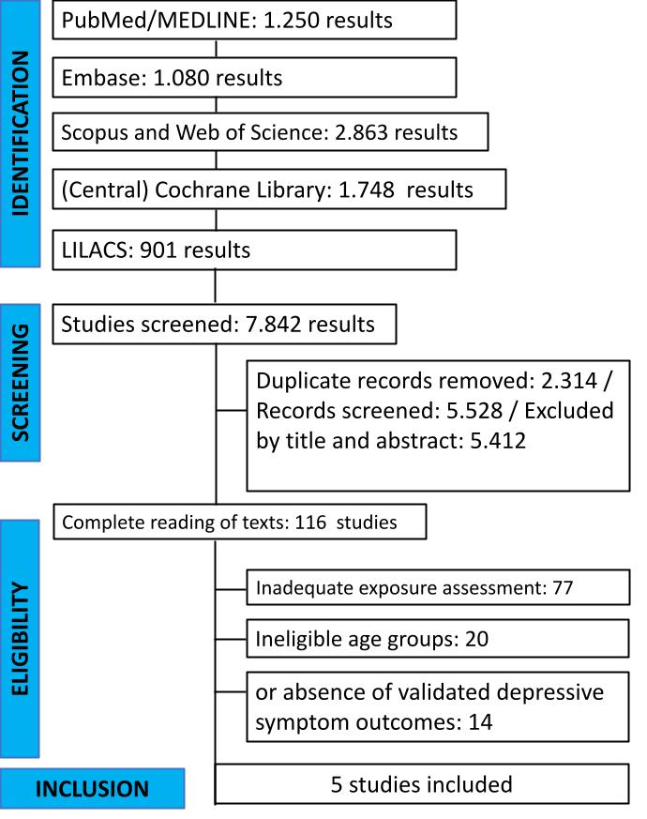

3.2 Baseline Characteristics of Included Studies

The included studies were published between 2019 and 2023, and were conducted in North America (the United States) and Europe (France and Spain). Sample sizes ranged from 10,359 to 31,712 participants. Ultra-processed food consumption was assessed using validated dietary assessment tools, including food frequency questionnaires (FFQs) and 24-hour dietary recalls. All studies classified UPF exposure according to the NOVA framework.

Depressive symptoms were evaluated using standardised and validated instruments, specifically the CES-D and PHQ-9, or via clinically diagnosed major depressive disorder (MDD) using strict diagnostic criteria or antidepressant use. Most studies adjusted for relevant sociodemographic, lifestyle, and dietary confounders, including age, sex, body mass index, socioeconomic status, smoking, alcohol intake, physical activity, and overall diet quality.

Table 2. Baseline characteristics of the included observational studies evaluating the association between ultra-processed food (UPF) consumption and depressive symptoms in adults.

Nº | Author, Year (Country) | Study Design | Sample Size (N) | Population Characteristics | Exposure Assessment (UPF, NOVA) | Comparator | Depression Outcome (Validated Tool / Diagnosis) | Follow-up (if cohort)
1 | Adjibade et al., 2019 (France) | Prospective cohort (NutriNet-Santé) | 26,730 | Adults ≥18 y | % energy from UPFs (24h recalls × repeated measures) | Lowest vs. highest UPF quartile | Depressive symptoms (CES-D ≥17/23) | 5.4 years
2 | Gómez-Donoso et al., 2020 (Spain) | Prospective cohort (SUN) | 14,907 | University graduates, 20–60 y | UPF servings/day (FFQ, NOVA) | Q1 vs. Q4 | Incident depression (medical diagnosis or antidepressant use) | Median 10 years
3 | Zheng et al., 2020 (USA) | Cross-sectional (NHANES) | 10,359 | US adults ≥18 y | % energy from UPFs (24h recalls, NOVA) | Lowest vs. highest quintile | Depressive symptoms (PHQ-9 ≥10) | —
4 | Hecht et al., 2022 (USA) | Cross-sectional | 10,359 | US adults ≥18 y | Proportion of calories from UPFs | Lowest vs. highest | Mild depression symptoms (PHQ-9 categories) | —
5 | Samuthpongtorn et al., 2023 (USA) | Prospective cohort (NHS II) | 31,712 | Women 42–62 y | Daily servings of UPFs (FFQ–NOVA) | Low vs. high UPF servings | Strict & broad definitions of incident depression | 14 years
UPF = ultra-processed foods; NOVA = NOVA food classification system; FFQ = food-frequency questionnaire; 24h recalls = 24-hour dietary recalls; PCA = principal component analysis; CES-D = Center for Epidemiologic Studies Depression Scale; PHQ-9 = Patient Health Questionnaire-9; HADS-D = Hospital Anxiety and Depression Scale – Depression subscale; GDS = Geriatric Depression Scale; HDRS = Hamilton Depression Rating Scale; DASS-21 = Depression, Anxiety and Stress Scale – 21 items; K10 = Kessler Psychological Distress Scale (10 items); NHS II = Nurses’ Health Study II; MCCS = Melbourne Collaborative Cohort Study; PNS = Pesquisa Nacional de Saúde (Brazilian National Health Survey); CUME = Cohort of Universities of Minas Gerais; T1/T3 = lowest vs. highest tertile of exposure; Q1–Q5 = lowest to highest quantiles of exposure; y = years; — = not applicable.

The table reports study design, sample size, population characteristics, methods for assessing UPF exposure according to NOVA classification, comparator groups (highest vs. lowest UPF intake categories), validated depression assessment tools or diagnostic criteria, and follow-up duration for cohort studies.

3.3 Association Between UPF Consumption and Depressive Symptoms

Five observational studies (Adjibade et al., 2019; Gómez-Donoso et al., 2020; Zheng et al., 2020; Hecht et al., 2022; Samuthpongtorn et al., 2023) contributed data to the primary outcome. The pooled analysis included 45,720 participants. The random-effects model demonstrated a statistically significant positive association between higher consumption of ultra-processed foods and depressive symptoms (OR = 1.76; 95% CI 1.49–2.07).

The 95% prediction interval ranged from 1.04 to 2.97, indicating that the direction of the association consistently favours an increased risk of depression with greater UPF intake across different populations. Heterogeneity was considerable (I² = 84.9%; P < 0.0001), reflecting variability in study populations and depression assessment tools.

List. 1. Forest Plot of Depressive Symptoms According to Ultra-Processed Food Intake
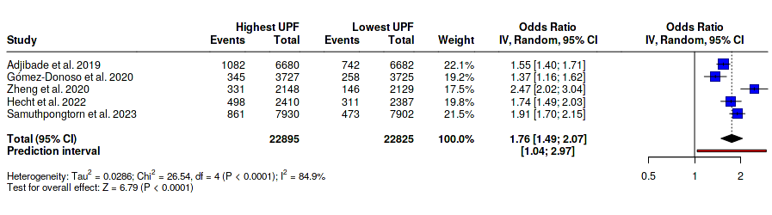

Chart 1. Depressive Symptoms According to Ultra-Processed Food Intake

No. | Study | Highest UPF | Control | OR | 95% CI | Weight | T | P-value
1 | Adjibade et al. 2019 | 1082 / 6680 | 742 / 6682 | 1.547 | 1.4 - 1.711 | 22.1
2 | Gómez-Donoso et al. 2020 | 345 / 3727 | 258 / 3725 | 1.371 | 1.159 - 1.622 | 19.19
3 | Zheng et al. 2020 | 331 / 2148 | 146 / 2129 | 2.474 | 2.016 - 3.037 | 17.46
4 | Hecht et al. 2022 | 498 / 2410 | 311 / 2387 | 1.739 | 1.489 - 2.029 | 19.81
5 | Samuthpongtorn et al. 2023 | 861 / 7930 | 473 / 7902 | 1.913 | 1.702 - 2.15 | 21.46
 | Random effects model | 3117 / 22895 | 1930 / 22825 | 1.757 | 1.493 - 2.068 | 100.02 | 6.79 | 0

Quantifying Heterogeneity

Parameter | Value | 95% CI
tau^2 | 0.029 | 0.009 - 0.341
tau | 0.169 | 0.096 - 0.584
I2 | 0.849 | 0.665 - 0.932
H | 2.576 | 1.727 - 3.841

3.4 Association Between Ultra-Processed Food Intake and Major Depressive Disorder (MDD)

Two large prospective cohort studies, the SUN Project (Gómez-Donoso et al., 2020) and the Nurses’ Health Study II (Samuthpongtorn et al., 2023), provided data on clinically diagnosed Major Depressive Disorder (MDD), totalling 23,284 participants in the extreme categories of intake.

The pooled analysis revealed that participants with the highest consumption of ultra-processed foods had a 63% higher risk of developing MDD compared to those with the lowest consumption (OR = 1.63; 95% CI 1.18–2.26; P = 0.0034). Although high heterogeneity was observed (I² = 90.2%), reflecting differences in the magnitude of the effect between the two cohorts (OR 1.37 vs. OR 1.91), both studies consistently indicated a significant positive association between high UPF intake and the incidence of clinical depression.

List. 2. Association Between Ultra-Processed Food Intake and Major Depressive Disorder (MDD)
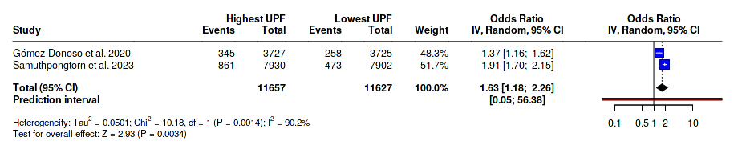

Chart 2. Association Between Ultra-Processed Food Intake and Major Depressive Disorder (MDD)

No. | Study | Highest UPF | Control | OR | 95% CI | Weight | T | P-value
1 | Gómez-Donoso et al. 2020 | 345 / 3727 | 258 / 3725 | 1.371 | 1.159 - 1.622 | 48.29
2 | Samuthpongtorn et al. 2023 | 861 / 7930 | 473 / 7902 | 1.913 | 1.702 - 2.15 | 51.71
 | Random effects model | 1206 / 11657 | 731 / 11627 | 1.629 | 1.175 - 2.257 | 100 | 2.93 | 0.0034

Quantifying Heterogeneity

Parameter | Value | 95% CI
tau^2 | 0.05 | NA - NA
tau | 0.224 | NA - NA
I2 | 0.902 | 0.641 - 0.973
H | 3.191 | 1.67 - 6.096

3.5 Strengths and Limitations
This systematic review has several strengths, including the adherence to PRISMA 2020 guidelines, the prospective registration of the protocol, and the inclusion of large-scale cohorts such as the Nurses’ Health Study II and NutriNet-Santé. Furthermore, all included studies used the NOVA classification, ensuring a standardized definition of the exposure.
However, several limitations must be acknowledged. First, statistical heterogeneity was high (I-squared > 80 percent), likely reflecting variability in population characteristics and outcome measurement tools (e.g., self-reported symptoms versus clinical diagnosis). Second, all included studies were observational. While most adjusted for key confounders such as socioeconomic status and physical activity, the potential for residual confounding remains, and causal inference cannot be established. Third, dietary data were self-reported, which is subject to measurement error and recall bias. Finally, reverse causation cannot be entirely ruled out, particularly in cross-sectional analyses, where depressive symptoms might lead to altered dietary choices (comfort eating).
4. Discussion
The findings of this systematic review and meta-analysis, encompassing data from over 45,000 adults, indicate a robust association between high ultra-processed food (UPF) consumption and adverse mental health outcomes. Specifically, individuals in the highest tier of UPF intake exhibited a 76% increased risk of depressive symptoms and a 63% increased risk of clinically diagnosed Major Depressive Disorder (MDD). These estimates are consistent with, yet more precise than, previous reviews that combined adolescent and adult populations (Lane et al., 2021), reinforcing the hypothesis that the quality of the dietary matrix is a critical determinant of mental health in adulthood.
4.1 Nutritional Architecture and Neurochemistry
The most immediate explanation for the observed association lies in the poor nutritional architecture of UPFs. These products typically displace nutrient-dense, unprocessed foods, leading to deficiencies in essential micronutrients required for neurotransmitter synthesis and neuroplasticity, such as folate, vitamin B12, magnesium, and zinc (Jacka, 2017). For instance, the deficiency of B-vitamins impairs the one-carbon metabolism cycle, leading to elevated homocysteine levels, a known neurotoxin associated with depressive states. Furthermore, the lack of dietary fiber in UPFs compromises the production of short-chain fatty acids (SCFAs) like butyrate, which are crucial for maintaining blood-brain barrier integrity and modulating microglial activity.

4.2 The Gut-Brain Axis and Neuroinflammation
Perhaps the most compelling mechanism involves the disruption of the microbiota-gut-brain axis. Ultra-processed foods are rich in acellular nutrients and additives—such as emulsifiers (e.g., carboxymethylcellulose, polysorbate-80) and non-caloric artificial sweeteners—that have been shown to alter the gut microbiome composition (dysbiosis) and erode the intestinal mucous layer (Cani & Van Hul, 2020) (figure 2).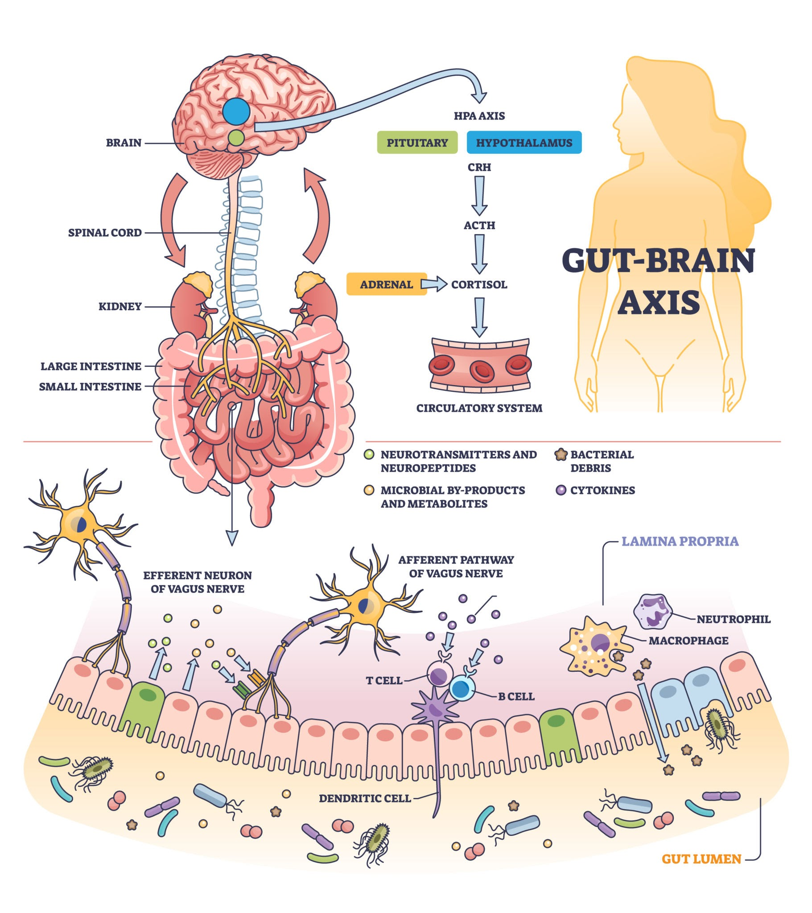
Figure 2. Proposed biological mechanisms linking ultra-processed food (UPF) consumption to the risk of depression via the microbiota-gut-brain axis.
This disruption increases intestinal permeability ("leaky gut"), facilitating the translocation of gram-negative bacterial endotoxins (lipopolysaccharides or LPS) into the systemic circulation. The resulting endotoxemia triggers Toll-like receptor 4 (TLR4) activation and the release of pro-inflammatory cytokines (IL-6, TNF-alpha). Systemic inflammation is a well-established driver of depression; cytokines can cross the blood-brain barrier and activate the kynurenine pathway, diverting tryptophan away from serotonin synthesis and towards the production of neurotoxic metabolites like quinolinic acid (Miller & Raison, 2016). This cascade effectively links the industrial processing of food to a neuroinflammatory state conducive to depression.
4.3 Metabolic Dysregulation and Oxidative Stress
The metabolic impact of UPFs also plays a synergistic role. The high glycemic load and readily available sugars in these products induce rapid postprandial hyperglycemia and hyperinsulinemia. Repeated exposure to these spikes can promote insulin resistance and oxidative stress. The brain is highly susceptible to oxidative damage, which impairs neuronal signalling and reduces Brain-Derived Neurotrophic Factor (BDNF) levels, a protein essential for neuronal survival and adaptation (Samuthpongtorn et al., 2023). Additionally, the dopaminergic reward system may be altered by the hyperpalatability of UPFs, potentially leading to neuroadaptive responses similar to those seen in substance dependence, further exacerbating mood dysregulation.
4.4 Xenobiotics and Endocrine Disruption
Finally, an emerging area of concern involves xenobiotics introduced during processing or packaging. Contaminants such as bisphenols and phthalates, which migrate from plastic packaging into fatty foods, act as endocrine-disrupting chemicals (Ribeiro et al., 2017). These compounds can interfere with the hypothalamic-pituitary-adrenal (HPA) axis—the body's primary stress response system—potentially leading to cortisol dysregulation, which is a hallmark of major depression.
5. Conclusion

In this systematic review and meta-analysis of observational studies, higher ultra-processed food (UPF) consumption was consistently associated with poorer mental-health outcomes in adults. Compared with individuals in the lowest categories of intake, those in the highest categories had significantly greater odds of presenting clinically relevant depressive symptoms and a 63 percent increased risk of major depressive disorder.

Although the magnitude of association varied and statistical heterogeneity was considerable, the direction of effect was consistent across included studies. Given the observational design, causal inference cannot be firmly established, and residual confounding, exposure misclassification, and reverse causation—particularly in cross-sectional analyses—remain possible explanations. Nonetheless, the convergence of evidence from large prospective cohorts, together with biologically plausible mechanisms linking UPFs to neuroinflammation, oxidative stress, gut-brain axis disruption, and poor overall diet quality, supports a credible detrimental role of UPFs in depression risk.

From a clinical and public-health perspective, these results reinforce the importance of dietary counselling as a complementary strategy in the prevention and management of depressive disorders. Reducing UPF intake and promoting minimally processed, nutrient-dense dietary patterns should be considered in mental-health promotion programs, primary care guidelines, and population-level nutrition policies.

Crucially, future research is urgently needed to address the rapid transformation of the food supply, where the natural organic composition of foods is being progressively replaced by industrial chemical analogs and cosmetic additives. New longitudinal studies and intervention trials should aim to isolate the specific neurobiological impact of these synthetic compounds and the loss of the natural food matrix, helping to clarify whether the depressive risk is driven by nutrient displacement or by direct toxicity of industrial formulations.
Consent

It is not applicable. The manuscript is a systematic review and meta-analysis of previously published data and does not involve direct interaction with human participants, collection of new patient data, or identifiable patient information.

Ethical approval

It is not applicable. This study is a systematic review and meta-analysis based on published literature. All data were extracted from studies that had previously received ethical approval. Therefore, no new ethical approval was required.

Declaration of Generative AI and AI-assisted technologies in the writing process

The authors hereby declare that generative AI technologies such as Large Language Models have been used during the preparation of this manuscript to assist with editorial and organizational tasks. This explanation includes the name, version, model, and source of the generative AI technologies.

Details of the AI usage are given below:

Technologies used: ChatGPT (GPT-5), developed by OpenAI; Gemini (Advanced), developed by Google.

Version and source: GPT-5 and Gemini Advanced (2025), accessed through their respective official platforms.

Purpose and usage description: Generative AI assistance was utilized for specific supportive tasks:

Manuscript Refinement: AI tools were used for English language refinement, grammatical corrections, and improving the flow and readability of the text.

Formatting: Assistance in formatting references and ensuring adherence to the journal's style guidelines.

Human oversight: The authors explicitly state that all data extraction from primary studies, statistical analyses, effect size calculations, biological interpretation, and the generation of forest plots were performed manually by the human authors. All AI-assisted editorial outputs were critically reviewed and validated to ensure scientific accuracy and integrity before submission.

References
Adjibade M, Julia C, Allès B, et al. Prospective association between ultra-processed food consumption and incident depressive symptoms in the French NutriNet-Santé cohort. BMC Med. 2019;17(1):78. https://doi.org/10.1186/s12916-019-1312-y
Gómez-Donoso C, Sánchez-Villegas A, Martínez-González MA, et al. Ultra-processed food consumption and the incidence of depression in a Mediterranean cohort: the SUN Project. Eur J Nutr. 2020;59(3):1093–1103. https://doi.org/10.1007/s00394-019-01970-1
Zheng J, Li Y, Qi X, et al. Association between ultra-processed food intake and depressive symptoms among US adults: NHANES 2011–2016. Public Health Nutr. 2020;23(11):1–9. https://doi.org/10.1017/S1368980020000671
Hecht EM, Rabil A, Martinez Steele E, et al. Cross-sectional examination of ultra-processed food consumption and adverse mental health symptoms. Public Health Nutr. 2022;25(11):3225-3234. https://doi.org/10.1017/S1368980022001586
Samuthpongtorn C, Nguyen LH, Okereke OI, et al. Consumption of Ultraprocessed Food and Risk of Depression. JAMA Netw Open. 2023;6(9):e2334770. https://doi.org/10.1001/jamanetworkopen.2023.34770
GBD 2019 Diseases and Injuries Collaborators. Global burden of 369 diseases and injuries in 204 countries and territories, 1990–2019: A systematic analysis for the Global Burden of Disease Study 2019. Lancet. 2020;396(10258):1204–1222. https://doi.org/10.1016/S0140-6736(20)30925-9
Patel V, Saxena S, Lund C, et al. The Lancet Commission on global mental health and sustainable development. Lancet. 2018;392(10157):1553-1598. https://doi.org/10.1016/S0140-6736(18)31612-X
Monteiro CA, Cannon G, Lawrence M, et al. Ultra-processed foods, diet quality, and health using the NOVA classification system. FAO. 2019. Available from: https://www.fao.org/documents/card/en/c/ca5644en/
Elizabeth L, Machado P, Zinöcker M, Baker P, Lawrence M. Ultra-Processed Foods and Health Outcomes: A Narrative Review. Nutrients. 2020;12(7):1955. https://doi.org/10.3390/nu12071955
Lane MM, Davis JA, Beattie S, et al. Ultraprocessed food and chronic noncommunicable diseases: A systematic review and meta-analysis of 43 observational studies. Obes Rev. 2021;22(3):e13146. https://doi.org/10.1111/obr.13146
Vancampfort D, Firth J, Schuch FB, et al. Sedentary behavior and physical activity levels in people with schizophrenia, bipolar disorder and major depressive disorder: A global systematic review and meta-analysis. World Psychiatry. 2017;16(3):308–315. https://doi.org/10.1002/wps.20458
Miller AH, Raison CL. The role of inflammation in depression: from evolutionary imperative to modern treatment target. Nat Rev Immunol. 2016;16(1):22–34. https://doi.org/10.1038/nri.2015.5
Cani PD, Van Hul M. The gut microbiota: gateway to metabolic and immune homeostasis. Nat Rev Gastroenterol Hepatol. 2020;17(4):259–70. https://doi.org/10.1038/s41575-022-00687-5
Ribeiro M, Lopes AC, Azevedo MR. Exposure to endocrine disruptors and mental health. J Psychiatr Res. 2017;91:1–8. https://doi.org/10.1016/j.jpsychires.2017.02.023
Firth J, Marx W, Dash S, et al. The effects of dietary improvement on symptoms of depression and anxiety: A meta-analysis of randomized controlled trials. Psychosom Med. 2019;81(3):265-280. https://doi.org/10.1097/PSY.0000000000000673
Monteiro CA, Cannon G, Moubarac JC, et al. The UN Decade of Nutrition, the NOVA food classification and the trouble with ultra-processing. Public Health Nutr. 2018;21(1):5-17. https://doi.org/10.1017/S1368980017000234
Page MJ, McKenzie JE, Bossuyt PM, et al. The PRISMA 2020 statement: An updated guideline for reporting systematic reviews. BMJ. 2021;372:n71. https://doi.org/10.1136/bmj.n71
Higgins JPT, Thomas J, Chandler J, et al. (Eds.). Cochrane Handbook for Systematic Reviews of Interventions (Version 6.3). Cochrane. 2022. Available from: https://training.cochrane.org/handbook
von Elm E, Altman DG, Egger M, et al. The Strengthening the Reporting of Observational Studies in Epidemiology (STROBE) statement: guidelines for reporting observational studies. Lancet. 2007;370:1453–7. https://doi.org/10.1016/S0140-6736(07)61602-X
DerSimonian R, Laird N. Meta-analysis in clinical trials. Control Clin Trials. 1986;7(3):177–188. https://doi.org/10.1016/0197-2456(86)90046-2
Steele EM, Rauber F, Costa Louzada ML, et al. Ultra-processed foods and health in NutriNet-Brasil. Rev Saúde Pública. 2022;56:1–12. https://doi.org/10.11606/s1518-8787.2022056004278
Jacka FN. Nutritional Psychiatry: Where to Next? EBioMedicine. 2017;17:24-29. https://doi.org/10.1016/j.ebiom.2017.02.020

Definitions, Acronyms, Abbreviations

UPF (Ultra-Processed Foods): Industrial formulations made predominantly from substances extracted or derived from foods and additives, typically containing little or no intact whole foods; categorized according to the NOVA classification system.

NOVA Classification: A food classification framework that categorizes foods according to the nature, extent and purpose of industrial processing (Groups 1–4, with Group 4 representing ultra-processed foods).

MDD (Major Depressive Disorder): A clinically diagnosed depressive disorder based on DSM or ICD criteria, physician diagnosis, structured interview, or documented antidepressant therapy.

Depressive Symptoms: Symptoms assessed using validated screening scales (e.g., CES-D, PHQ-9, HADS-D), reflecting presence of depressive mood or affect but not necessarily meeting diagnostic thresholds for MDD.

CES-D (Center for Epidemiologic Studies Depression Scale): A widely used screening tool that assesses the frequency of depressive symptoms in the general population.

PHQ-9 (Patient Health Questionnaire-9): A diagnostic and severity-measurement tool for depression based on DSM criteria, commonly used in epidemiological research.

HADS-D (Hospital Anxiety and Depression Scale – Depression Subscale): A tool designed to detect depressive states in clinical and non-clinical settings without somatic symptom overlap.

GDS (Geriatric Depression Scale): A depression screening tool tailored for older adults, minimizing somatic bias.

HDRS (Hamilton Depression Rating Scale): A clinician-administered scale measuring depression severity, often used in psychiatric research.

DASS-21 (Depression, Anxiety and Stress Scale – 21 items): A short-form instrument assessing these three emotional states through self-report.

K10 (Kessler Psychological Distress Scale): A 10-item scale measuring non-specific psychological distress, often used as a proxy for mood disorders.

FFQ (Food-Frequency Questionnaire): A dietary assessment tool that estimates habitual food intake over a defined period.

24h Recall (24-Hour Dietary Recall): A structured interview method in which participants recall all consumed foods and beverages during the previous 24 hours.

PCA (Principal Component Analysis): A statistical method used to derive dietary patterns based on correlations among food groups.

OR (Odds Ratio): A measure of association comparing the odds of an outcome occurring in one exposure group vs. another.

CI (Confidence Interval): A statistical range reflecting the precision of an estimated effect; wider intervals indicate greater uncertainty.

I² (I-squared Statistic): A measure of heterogeneity in meta-analysis, indicating the percentage of variability across studies not due to chance.

