Original Research Article

Assessment of Oral Conditions Among Patients in Intensive Care Units in the Port Region of Baixada Santista, SP, Brazil

.
ABSTRACT

Aims: The worsening of oral health conditions, with a deficit in oral hygiene care and the absence of daily care for patients in intensive care units (ICU), make the dental surgeon an extremely important professional at the hospital level. The objective of this study was to assess the oral conditions of patients in the intensive care units in the port region of Baixada Santista, SP, Brazil.
Study design: Observational, cross-sectional study.
Place and Duration of Study: Intensive Care Units at Hospital Irmandade Santa Casa de Misericórdia de Santos, between August and December of 2023.
Methodology: This was a descriptive analysis study using medical records and evaluations of patients treated by the Hospital Dentistry team at the Hospital Irmandade Santa Casa de Misericórdia de Santos. During the consultations, information regarding the patients' oral and systemic health was collected. The study lasted 4 months, with the participation of hospitalized patients of all ages, genders and races. In view of the number of beds at the hospital, 500 patients were evaluated.
Results: The results are presented with a selection of frequencies and percentages of all variables. The median Glasgow Coma Scale score was 15 for all participants, both female and male. Main results: 132 participants (26.5%) had total edentulism in the upper arch and 83 participants (16.6%) had total edentulism in the lower arch. The mean number of teeth present was 17.4 ±10.5 (range: 0.0–32.0). The mean number of decayed teeth was 0.6 ±1.5 (range: 0.0–17.0). The mean number of teeth indicated for extraction was 0.8 ±2.0 (range: 0.0–17.0). 395 patients (79.2%) had biofilm; 360 (72.1%) had coated tongue; 301 (60.3%) had dental calculus; 166 participants (33.3%) had periodontal disease and 76 (15.2%) had caries lesions. Conclusion: The analysis revealed that many patients presented unfavorable oral conditions that can negatively impact their systemic health. This study highlights the importance of oral health care in patients in intensive care units.

Keywords: Oral Health, ICU, Hospital Dentistry, Prevalence, Brazil

1. INTRODUCTION

“Hospital dentistry can be defined as a practice that aims to care for oral changes that require highly complex multidisciplinary team procedures for the patient. Oral health, as a state of harmony, normality or health of the oral cavity, only has meaning when accompanied, to a reasonable degree, by the individual's general health” [1,2]. The possibility of a relationship between oral changes and systemic diseases is quite present in the literature [3].

The acquisition and maintenance of oral health, in addition to a greater integration of Dentistry and Medicine, aims at the overall treatment of patients [4]. Scientific advances provide support for believing in the significant contribution of dental treatment, specifically periodontal intervention, in the prevention and/or improvement of systemic conditions, especially in critically ill patients [5,6].

“A recent systematic review highlights the importance of establishing guidelines for the evaluation of oral status in Intensive Care Unit (ICU) patients. The authors also state that further studies on maintaining good oral hygiene among ICU patients are needed” [7]. Oral care is a disease preventive and cost-effective measure for patients [8] and current dentistry can and should provide safe care for different patients in the hospital area [9]. Even patients have reported that they think dental care is very important in hospitals settings [10]. “The scientific and statistical panorama is favorable to the performance of dentists in a hospital environment” [11].
The objective of this study was to assess the oral and systemic health conditions of patients in intensive care units in the port region of Baixada Santista. This survey seeks to identify the prevalence of unfavorable conditions that could impact the systemic health of patients. In addition, the objective of the product generated by this study is to develop and implement a specific oral hygiene protocol for patients admitted to the ICU, aiming to improve the quality of hospital dental care. This protocol may initially be experimental, without a defined application focus, but with the potential to be a solution to previously identified problems in the oral care of critically ill patients.

2. methodology

This study was conducted as a descriptive cross-sectional analysis study, focusing on the evaluation of oral and systemic health conditions of patients admitted to Intensive Care Units (ICU) at Hospital Irmandade Santa Casa de Misericórdia de Santos, located in Baixada Santista, Brazil. This hospital has one of the most equipped ICUs of the city and it functions as a teaching hospital for medical and dental students in the region. A masters’ degree student and two professors were allowed in the ICUs to perform data collection. As this is an observational study, it follows The Strengthening the Reporting of Observational Studies in Epidemiology (STROBE) Statement: guidelines for reporting observational studies, and the STROBE checklist is attached as a Supplementary File. Patient data, including medical history and oral clinical examination, were collected between August and December of 2023. The study was completed with 499 participants; 1 participant withdrew participation. The study size was arrived at by convenience (number of accessible patients in the hospital), and using non-probability, purposive sampling. To avoid bias, researchers followed the eligibility criteria described below.
This study strictly complied with the principles of research involving human beings, as established by Resolution 466/12 and 510/16 of the Brazilian National Research Ethics Commission (CONEP) and the Declaration of Helsinki. Participants who were of age signed the Free and Informed Consent Form before being included in the study. Children signed an Assent Form and their legal guardians signed the Consent Form, as well. The study was approved by the Institutional Research Ethics Committee of the Metropolitan University of Santos and the Irmandade Santa Casa de Misericórdia Hospital of Santos, under protocols CAAE: 69348323.6.0000.5509 and CAAE: 69348323.6.3001.0139.

2.1 Eligibility Criteria

2.1.1 Inclusion Criteria

- Patients between 6 months and 80 years old, admitted to the intensive care units of the Hospital Irmandade da Santa Casa da Misericórdia de Santos.
- Glasgow coma scale score between 3 and 15.
- Individuals who voluntarily provided informed consent to participate in the study.

2.1.2 Exclusion Criteria

- Palliative care patients without guardian authorization.
- Participants with any condition that, in the researcher's judgment, prevented them from participating in the study.

2.1.3 Withdrawal Criteria

- The participant who did not wish to continue in the study for personal reasons (or even without reason);
- The legal representative who stated that his/her representative would no longer participate in the study for personal reasons (or even without reason);
- Positive response to the reassessment of any of the exclusion criteria, at the time of admission to the study or on a subsequent occasion.

2.2 Evaluations

As primary evaluation criteria, oral clinical examination and a survey of all patient anamnesis and development records were performed. As secondary evaluation criteria, an assessment of the oral and systemic health conditions of patients in hospitals in the Intensive Care Units in the port region of Baixada Santista was performed. Data such as types of ICU, allergies, oxygen supplementation, feeding types, biometric data, and intra and extra oral alterations were collected. Data collection was performed by a masters’ degree student and two professors, who carried out the examinations, asked the questions to patients and/or responsible parties and checked the records/data that were available at the ICU.

2.3 Analysis

Statistical analyses were conducted in which data entry and initial processing were obtained through MS Excel files, based on data derived from the analysis equipment. The raw data as well as the results of the evaluations and statistics are available in paper and electronic media. The statistics and graph generation were performed in Microsoft Excel (version 2510 of Microsoft 365), using an updated edition of the software to ensure the integrity and reproducibility of the procedures. The results were presented in descriptive statistics using tables and graphs, highlighting the frequency and percentages of various conditions and patient characteristics.

3. results and discussion

Out of the total available hospital beds, 500 patients were identified as eligible. One patient withdrew from the study, resulting in a final sample of 499 participants who were included and assessed. The main characteristics of the included participants are displayed in Table 1.

Table 1. Characteristics of the population of the present analysis evaluated in all Intensive Care Units (ICU)

Characteristics | n (%)
Total Patients  Male  Female | 499 (100)  264 (52.9)  235 (47.09)
Types of ICU
General ICU  Male  Female | 245 (49.0)  159 (60.23)  86 (36.60)
Coronal ICU  Male  Female | 109 (21.84)  21 (7.95)  88 (37.45)
Neurological ICU  Male  Female | 74 (14.82)  60 (22.73)  14 (5.96)
Pediatric ICU  Male  Female | 3 (0.3)  3 (1.14)  0 (-)
Cardiac ICU  Male  Female | 68 (13.63)  21 (7.95)  47 (20.00)
Patients with a clinical history of some type of allergy  Male  Female | 78 (15.63)  32 (12.1)  46 (19.6)
Patients required oxygen supplementation | 20 (4)
Patients with an endotracheal tube  Male  Female | 106 (21.24)  63 (23.86)  34 (14.47)
Source: Prepared by the authors using data from the research (2023).

Regarding the most prevalent types of allergies in ICUs, the following information is provided regarding the number of patients and their percentage, in decreasing order of the total: dipyrone 13 (11.8%), acetylsalicylic acid and penicillin 10 (9.1%), iodine 8 (7.3%), tramadol 6 (5.5%), captopril 6 (4.5%), diclofenac 5 (4.5%), NSAIDs 4 (3.6%), scopolamine butylbromide 4 (3.6%), metoclopramide hydrochloride 4 (3.6%), shrimp, adhesive tape, ibuprofen, and tenoxicam 3 (2.7%), aminophylline, amoxicillin, benzathine benzylpenicillin and dexamethasone 2 (1.8%), allopurinol, amiodarone, atorvastatin, caffeine, pork, ketoprofen, clavulanate, hydrochloride promethazine, dye, betamethasone dipropionate + betamethasone disodium phosphate, seafood, hydrocortisone, ieca, nimesulide, protective film, simvastatin, soy, sulfa, sulfadiazine, sulfamethoxazole + trimethoprim and vancomycin, with only one incidence each, being a percentage of 0.9%.
The median Glasgow Coma Scale score was 15 for all participants, both female and male. The minimum value observed in both female and male participants was 3, while the maximum was 15 for all groups. The standard deviation (SD) for all participants was 4.8, being 5.2 for males and 4.0 for females.
The distribution of feeding type among the 499 patients can be found in Table 2.
Table 2. Feeding types of the population of the present analysis
Characteristics | n (%)
Orally fed  Male  Female | 330 (66.3)  156 (59.09)  173 (73.93)
Enteral fed  Male  Female | 85 (17.03)  60 (22.73)  25 (10.68)
Solid food | 4 (0.80)
Fluid restriction | 1 (0.20)
Any feeding types | 79 (15.83)
Source: Prepared by the authors using data from the research (2023).

The mean biometric data were as follows: the mean body temperature was 36.4°C±1.2 (range: 30.0–39.4°C); the mean oxygen saturation was 95.2%±3.6 (range: 74.0–100.0%); the mean systolic blood pressure was 126.2 mmHg ±23.1 (range: 46.0–222.0 mmHg); and the mean diastolic blood pressure was 74.5 mmHg ±14.6 (range: 32.0–121.0 mmHg) (Figure 1).
Fig. 1. Biometric data of patients in the ICU
Source: Prepared by the authors using data from the research (2023).

The data of the extra-oral examination for all patients, were as follows: 466 (93.4%) presented facial symmetry; 89 (17.8%) patients presented with ulcerated lips; 65 patients (13.0%) presented eyelid edema; 11 (2.2%) presented saddle nose; 11 (2.2%) presented pallor of the lips; 4 (0.8%) had enlarged lymph nodes; 4 (0.8%) labial herpes was observed; 4 (0.8%) had cheilitis; 3 (0.6%) presented with cyanosis of the lips; 2 (0.4%) had eyelid ptosis (Figure 2).
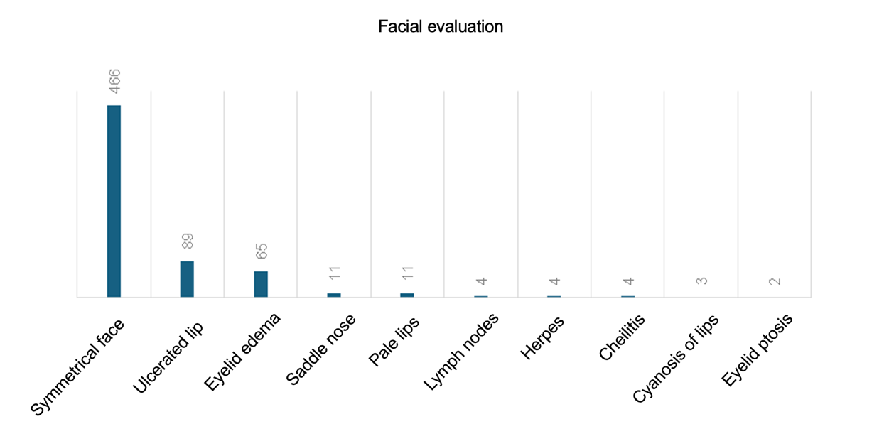Fig. 2. Assessment of the face of patients in the ICU
Source: Prepared by the authors using data from the research (2023).

Regarding edentulism for all participants: 132 participants (26.5%) had total edentulism in the upper arch and 83 participants (16.6%) had total edentulism in the lower arch.
The dental condition of all patients in the study was assessed based on the number of teeth present, decayed teeth, and teeth indicated for extraction. The mean number of teeth present was 17.4 ±10.5 (range: 0.0–32.0). The mean number of decayed teeth was 0.6 ±1.5 (range: 0.0–17.0). The mean number of teeth indicated for extraction was 0.8 ±2.0 (range: 0.0–17.0).
Regarding the intraoral evaluation of all participants, the following results were obtained: 395 (79.2%) had biofilm; 360 (72.1%) had coated tongue; 301 (60.3%) had dental calculus; 166 participants (33.3%) had periodontal disease; 128 (25.7%) underwent tooth extraction; 121 (24.2%) had stains; 107 (21.4%) had dysphagia; 76 (15.2%) had caries lesions; 43 (8.6%) had pseudomembranous candidiasis; 26 (5.2%) had magralossia; 25 participants (5.0%) had geographic tongue; 13 (2.6%) had enamel hypoplasia; 13 (2.6%) had hairy leukoplakia; 10 participants (2.0%) had oral ulcers; 7 (1.4%) had hyperplasia; 5 (1.0%) had herpes simplex; 4 (0.8%) had erythematous candidiasis; 2 participants (0.4%) had hyperplastic candidiasis (Figure 3).
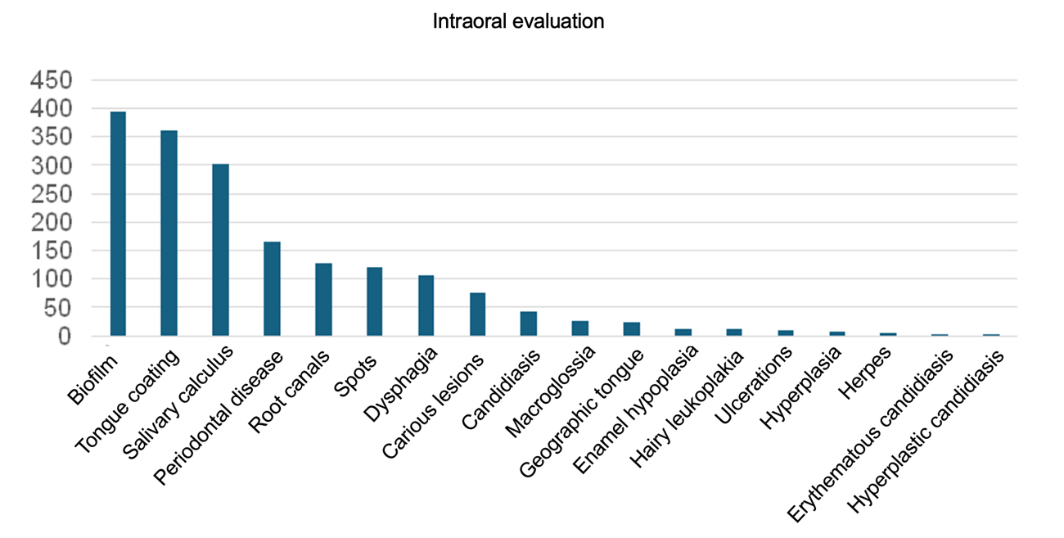Fig. 3. Intraoral evaluation of patients in the ICU Source: Prepared by the authors using data from the research (2023).
Hospital dentistry plays a crucial role in maintaining and improving the oral and systemic health of patients admitted to intensive care units (ICUs). This study aimed to assess the oral and systemic health conditions of patients hospitalized in ICUs in the port region of Baixada Santista, providing a relevant epidemiological overview for the formulation of hospital dental policies and practices.
Poor oral hygiene conditions are very common in hospitalized patients, who often remain with their mouths open due to tracheal intubation. This promotes mucosal dehydration and leads to decreased salivary flow, allowing greater colonization of bacteria leading to the development of periodontal disease and other possible foci of infection [12].
The data collected in this study showed a high prevalence of adverse oral conditions among patients admitted to the evaluated ICUs. The presence of dental biofilm was significantly high, and consequently, a high presence of caries lesions and periodontal disease, corroborating previous studies that indicate the rapid deterioration of oral health in hospital environments due to decreased oral hygiene and immunosuppression of patients [12,13].
In approximately 24 hours without cleaning the oral cavity, it is possible to clinically detect a layer of dental biofilm. And the absence or the technique of oral hygiene adopted will be closely linked to the number and species of microorganisms found in the oral cavity. Dental biofilm can play a significant role in the occurrence of respiratory infections in patients undergoing mechanical ventilation in ICUs [14,15].
The presence of biofilm interferes in the worsening and development of oral alterations present in the patient, such as caries disease, periodontal disease, pulp necrosis, among others. These alterations impact both medical therapy and the general condition of the patient and must be controlled [13].
Several studies have highlighted the importance of hospital dentistry in the prevention of systemic infections [16]. Recently, oral hygiene protocols in ICUs have shown a reduction in infection rates [6]. The results of this study are in line with these studies, suggesting that the implementation of dental care routines can significantly reduce systemic complications in critically ill patients.
In addition, the literature points to the need for specialized training of dentists to work in a hospital environment. Hospital dentistry is still a developing area in Brazil, with legislation and regulations being improved. The inclusion of dentists in multidisciplinary health teams can provide more holistic and effective care, improving the clinical outcomes of patients [17].
According to the Federal Council of Dentistry (a Brazilian institution), according to its resolution CFO-162/2015, the clinical implications of this study are clear: the inclusion of dental professionals in ICU health teams can significantly improve the oral and systemic health of patients. Oral hygiene protocols, regular training for the nursing team on oral care, and the constant presence of a dentist can reduce the incidence of nosocomial infections, thus reducing associated morbidity and mortality.
This study evaluated patients on mechanical ventilation. Of the total of 499 patients evaluated, 21.24% (men and women) had an endotracheal tube; of these 106 patients, 63 (23.86%) were men and 34 (14.47) were women, a significant number to justify the implementation of a dentist in Intensive Care Units. Patients require careful care and evaluation, since the tube can cause pneumonia associated with mechanical ventilation, that is, lead to death of these individuals, if correct oral hygiene procedures are not performed. “Several reasons put patients at higher risk associated with VAP, such as the presence of an endotracheal tube, body position, possible aspiration of contaminated secretions from the oropharynx or gastrointestinal respiratory tract, and open and dry mouth. The direct association with lung infections and oral health has been explored in several studies” [18].
The implementation of an oral hygiene protocol associated with a continuous training program for professionals is crucial to reducing VAP rates, as the lack of clarification about the importance of this care results in low adherence by the nursing team [19,20]. A recent systematic review showed that dental care by oral health teams contributed to a reduction in VAP of patients admitted to the ICU [21]. Other current studies have also shown that chlorhexidine is effective when applied for oral hygiene of patients submitted to mechanical ventilation [22,23].
Furthermore, there is a need for public policies that integrate dentistry into the hospital environment. Training more professionals and raising awareness about the importance of oral health in critically ill patients should be priorities. Oral health prevention and promotion programs can be incorporated into hospital routines, promoting a preventive rather than a reactive approach [24]. Medical practices are all influenced by culture, and dentistry is no exception [25].
“In most ICUs, oral hygiene care is performed by nurses and, although these professionals have an important role in health promotion, they do not have sufficient training or legal permission to treat caries lesions, remove calculus, drain intraoral abscesses or perform tooth extractions in critically ill patients during ICU admission” [20].
Although this study provides valuable data, it has some limitations. The sample was restricted to a single geographic region, and a convenience sample was used, which may lead to difficult generalization of the results. Furthermore, the data collection period was relatively short, and longitudinal studies could provide a deeper understanding of changes in oral health conditions over time in hospital settings. Another limitation is the reliance on medical records and charts, which can vary in accuracy and detail. Future studies could benefit from more standardized and detailed data collection, including regular and systematic clinical assessments.

4. Conclusion

This study highlights the importance of oral health in patients hospitalized in intensive care units (ICUs). The analysis of medical records of 499 patients at the Hospital Irmandade Santa Casa de Misericórdia de Santos revealed that many patients presented unfavorable oral conditions that can negatively impact their systemic health. The lack of adequate oral hygiene in ICUs facilitates bacterial growth, promoting interactions between native bacteria in dental plaque and respiratory pathogens, which can contribute to the development of respiratory infections, including VAP. Therefore, the role of the dentist is crucial in the hospital environment, especially in ICUs, to perform preventive and therapeutic interventions aimed at maintaining oral health and, consequently, improving the general health of patients. Thus, it is important to implement a specific oral hygiene protocol for patients admitted to ICUs, aiming to improve the quality of hospital dental care.

Consent

All authors declare that written informed consent was obtained from the patient and/or their responsible parties. A copy of the written consent is available for review by the Editorial office/Chief Editor/Editorial Board members of this journal. The datasets are available only for the authors, which will keep the stored in hard drives, ensuring confidentiality of the data.

Ethical approval

All authors hereby declare that all experiments have been examined and approved by the Institutional Research Ethics Committee of the Metropolitan University of Santos and the Irmandade Santa Casa de Misericórdia Hospital of Santos, under protocols CAAE: 69348323.6.0000.5509 and CAAE: 69348323.6.3001.0139. They have been performed in accordance with the ethical standards laid down in the 1964 Declaration of Helsinki.

Disclaimer (Artificial intelligence)
No generative AI technologies such as Large Language Models (ChatGPT, COPILOT, etc.) and text-to-image generators have been used during the writing or editing of this manuscript.

References

- Pedrón IG. The importance of hospital dentistry in improving the quality of life of patients in the intensive care unit (ICU). SVOA Dent. 2023;4(4):140-144. doi:10.58624/svoade.2023.04.0141.
- de Souza IPR, do Nascimento SM, Yamashita RK. Odontologia hospitalar: a importância do cirurgião-dentista na prevenção de infecções bucais na unidade de terapia intensiva (UTI). Rev Ibero-Am Hum Cienc Educ. 2023;9(10):653-665. doi:10.51891/rease.v9i10.11434.
- Cardoso MO, Nascimento LLDS, Mesquita KT, Pergentino SMR, Alves V, Gomes GG, et al. Importância do cirurgião-dentista na prevenção de infecções bucais em pacientes internados em unidade de terapia intensiva: uma revisão de literatura. Brazilian Journal of Implantology and Health Sciences [Internet] Brazilian Journal of Implantology and Health Sciences; 2024 May 30;6(5):2349–64. Available from: https://bjihs.emnuvens.com.br/bjihs/article/download/2230/2453
- Morais TNM, Silva A, Avi ALRO, Souza PHR, Knobel E, Camargo LFA. A importância da atuação odontológica em pacientes internados em unidade de terapia intensiva. Rev Bras Ter Intensiva. 2006;18:412-7.
- De Riso AJ, Ladowski JS, Dillon TA, et al. Chlorhexidine gluconate 0.12% oral rinse reduces the incidence of total nosocomial respiratory infection and nonprophylactic systemic antibiotic use in patients undergoing heart surgery. Chest. 1996;109:1556-61.
- Yoneyama T, Yoshida M, Ohrui T, et al. Oral care reduces pneumonia in older patients in nursing homes. J Am Geriatr Soc. 2002;50:430-3.
- Jun,M.-K.;Ku,J.-K.;Kim, I.-h.; Park, S.-Y.; Hong, J.; Kim, J.-Y.; Lee, J.-K. Hospital Dentistry for Intensive Care Unit Patients: A Comprehensive Review. J. Clin. Med. 2021,10,3681. https://doi.org/ 10.3390/jcm10163681
- dos Santos AA, Silva LDdA, Santos CCO, Fonseca-Silva T. Oral care practices for patients in intensive care unit: A systematic review. Int J Dent Hygiene. 2024;00:1-9. doi:10.1111/idh.12822
- Chaves AS, Sousa ISP, Laurindo TC, Reges RV, Andrade LA, Teixeira Neto AO, Pereira CM. Odontologia hospitalar no ambiente de Unidade de Terapia Intensiva: Uma revisão de literatura. Research, Society and Development, v. 12, n. 8, e9012842908, 2023 (CC BY 4.0) | ISSN 2525-3409 | DOI: http://dx.doi.org/10.33448/rsd-v12i8.42908
- Amaral COF, Belon LMR, Silva EA, Nadai A, Amaral Filho MSP, Straioto FG. The importance of hospital dentistry: oral health status in hospitalized patients. RGO, Rev Gaúch Odontol. 2018;66(1):35-41. http://dx.doi.org/10.1590/1981-863720180001000053410
- Simões ACCD, Campos FRO, Câmara JVF, Probst LF, Groisman S, Cedro VQM, et al. Legislation in hospital dentistry: Gaps, perspectives and desires. Pesqui Bras Odontopediatria Clín Integr. 2024; 24:e220153. https://doi.org/10.1590/pboci.2024.003
- Berry AM, Davidson PM. Beyond comfort: oral hygiene as a critical nursing activity in the intensive care unit. Intensive Crit Care Nurs. 2006;22(6):318-28.
- Doro GM, Fialho LM, Losekann M, Pfeiff DN. Projeto “Odontologia Hospitalar”: Aperfeiçoamento do conhecimento técnico necessário em situações de risco à vida do paciente e levantamento das condições de saúde bucal de pacientes hospitalizados. Rev ABENO. 2006;6(1):49-53.
- Kite K, Pearson L. A rationale for mouth care: the integration of theory with practice. Intensive Crit Care Nurs. 1995;11(2):71-6.
- Hillier B, Wilson C, Chamberlain D. Preventing ventilator-associated pneumonia through oral care product selection and application method: a literature review. AACN Adv Crit Care. 2013;24(1):38–58. [Accessed 2024 Jan 10].
- Bezerra TP, Campêlo CSP, Oliveira FAF, Forte CPF, Gomes AKP, Silva PGB, Carvalho BM, Alves APNN, Sousa FB. Pneumonia and the role of dentistry on ICU staff: 8-year analysis of health indicators. Braz J Oral Sci. 2020;19. doi:10.20396/bjos.v19i0.8660436
- Aranega AM, Bassi APF, Ponzoni D, et al. Qual a importância da odontologia hospitalar? Rev Bras Odontol. 2012;69(1):90-3.
- Curley MAQ, Schwalenstocker E, Deshpande JK, Ganser CC, Bertoch D, Brandon J, et al. Tailoring the Institute for Health Care Improvement 100,000 Lives campaign to pediatric settings: the example of ventilator-associated pneumonia. Pediatr Clin North Am [Internet]. 2006 [cited 2017 Oct 7];53(6):1231–51. Available from: https://doi.org/10.1016/j.pcl.2006.09.001.
- Lorente L, Lecuona M, Jiménez A, Palmero S, Pastor E, Lafuente N, et al. Ventilator-associated pneumonia with or without toothbrushing: a randomized controlled trial. Eur J Clin Microbiol Infect Dis. 2012;31(10):2621–9. https://doi.org/10.1007/s10096-012-1605-y.
- Chacko R, Rajan A, Lionel P, Thilagavathi M, Yadav B, Premkumar J. Oral decontamination techniques and ventilator-associated pneumonia. Br J Nurs. 2017;26:594–9. https://doi.org/10.12968/bjon.2017.26.11.594.
- de Araújo ECF, da Silva RO, Raymundo MLB. Does the presence of oral health teams influence the incidence of ventilator-associated pneumonia and mortality of patients in intensive care units? Systematic review. Spec Care Dentist. 2023;43:452-463. https://doi.org/10.1111/scd.12785
- Rabello F, Araújo VE, Magalhães SMS. Effectiveness of oral chlorhexidine for the prevention of nosocomial pneumonia and ventilator-associated pneumonia in intensive care units: Overview of systematic reviews. Int J Dent Hygiene. 2018;16:441-449. https://doi.org/10.1111/idh.12336
- de Camargo L, da Silva SN, Chambrone L. Efficacy of toothbrushing procedures performed in intensive care units in reducing the risk of ventilator-associated pneumonia: A systematic review. J Periodont Res. 2019;54:589-611. https://doi.org/10.1111/jre.12668
- Alrawashdeh BN, Hammadeen SA, Hamadeneh KN, Almaaitah HM, Altarawneh HA. The influence of oral health on comprehensive health outcomes in critically ill patients. Cureus. 2025. doi:10.7759/cureus.78605.
- Pathekar JM, Chabra KG, Madhu PP, Reche A, Dadgal KV, Tikar NN. Spiritual dimension in oral health. J Pharm Res Int. 2021;33(45B):447-453. Available from: https://journaljpri.com/index.php/JPRI/article/view/3609.

