Characterization and Antibiotic Resistance Profile of Biofilm Forming Pseudomonas aeruginosa Isolated From Infected Wounds

ABSTRACT
Pseudomonas aeruginosa is a leading cause of chronic and hard-to-heal wound infections due to its strong ability to form biofilms and develop multidrug resistance. Biofilm-associated growth significantly limits antibiotic penetration and promotes persistent infection, making treatment challenging. This study aimed to determine the prevalence, biofilm-forming ability, and antimicrobial susceptibility patterns of P. aeruginosa isolated from infected wounds. A total of 248 wound swab samples were aseptically collected from in-patients and out-patients presenting with clinical evidence of wound infection in hospitals within Enugu metropolis. Samples were cultured on Blood agar and MacConkey agar plates and incubated aerobically at 37 °C for 24–48 hours and isolates were identified using standard microbiological and biochemical tests. Antibiotic susceptibility testing was performed using the Kirby–Bauer disk diffusion method following CLSI guidelines. Also, biofilm formation was detected using Congo Red Agar (CRA). A total of 248 wound swab samples were collected from patients with clinically diagnosed wound infections and analyzed. Out of these, 184 samples (74.2%) yielded significant bacterial growth, while 64 samples (25.8%) showed no bacterial growth after 24–48 hours of incubation. Among the positive cultures, Gram –negative bacteria were 61.4% and Pseudomonas aeruginosa had 56 isolates (30.4%) which were the predominant isolates. Out of the 248 samples that were analysed, 184 samples (74.2%) showed significant bacterial growth, and P. aeruginosa had 56 isolates (30.4%) which were the predominant isolates. Antimicrobial susceptibility testing of all P. aeruginosa isolates was performed using the Kirby–Bauer disk diffusion method. High resistance was observed against commonly used antibiotics: Cefotaxime (80.4%), Ceftazidime (75.0%), Ciprofloxacin (69.6%), Gentamicin (62.5%) and Ofloxacin (58.9%). Moderate susceptibility was observed with Piperacillin–tazobactam (59.0%), Imipenem (55.4%) and Meropenem (51.8%) while the highest susceptibility was seen in amikacin, with 64.3% sensitivity. All 56 P. aeruginosa isolates were screened for biofilm formation using the Congo Red Agar (CRA) method. It was observed that 24 isolates (42.9%) were strong biofilm formers, 18 (32.1%) were moderate/weak while 14 (25.0%) isolates did not form biofilms. The high prevalence of biofilm formation shows the organism’s inherent ability to establish persistent infection, particularly in chronic wound environments where biofilm facilitates adhension, protects bacteria from host defenses and significantly reduces antibiotic penetration which will lead to resistance. These findings emphasize the clinical relevance of biofilm formation as a key virulence mechanism contributing to antimicrobial resistance and treatment failure in Pseudomonas aeruginosa wound infections.

Keywords: Pseudomonas aeruginosa, biofilm formation, wound infection, antibiotic resistance.

- INTRODUCTION

A wound is defined as a physical injury to the skin or underlying tissues that disrupts normal anatomical structure and function. Wounds may result from surgical procedures, trauma, burns, pressure ulcers, or infections. They are broadly categorized into acute and chronic wounds, based on the healing pattern. While acute wounds follow a predictable sequence of inflammation and repair, chronic wounds often persist due to underlying infections or impaired immune responses and therefore fail to heal within the expected timeframe (Bowler et al., 2001).
Infected wounds occur when microbial colonization exceeds a critical threshold, resulting in pathological changes in the wound bed. This involves the invasion of a wound by proliferating microorganisms to a level that elicits local and/or systemic response in the host, ultimately leading to extensive tissue damage and impaired wound healing. Wound infections progress from contamination to colonization, followed by local infection and, in severe cases, systemic infections, in parallel with increase in microbial load, virulence, and pathogenicity (Kebede et al. 2024). Clinically, infected wounds may be characterized by symptoms such as pain, swelling, erythema, foul odor, delayed healing, and exudate formation. These infections are commonly caused by opportunistic or nosocomial pathogens capable of evading host immune responses and establishing persistent colonization (Gnanadhas et al., 2013). Wound infections represent a major burden in clinical settings, contributing to delayed healing, prolonged hospitalization, increased healthcare costs, and in severe cases, amputations or death. This burden is particularly pronounced in developing countries where poor hygiene, limited access to health care and indiscriminate use of antibiotics contribute to increased morbidity and mortality (Hong et al. 2025).
Pseudomonas aeruginosa is one of the most common microorganisms isolated from chronic wounds and is frequently found as a biofilm producer, where it acts as a barrier to wound healing and exhibits resistance to antimicrobial therapy (Wang et al., 2025; Tuon et al., 2022). It is a Gram-negative, rod-shaped opportunistic pathogen and a major causative agent of wound infections, contributing to delayed wound healing (Kashif et al., 2017; Sang et al., 2023). Its clinical significance in wound infections arises not only from its widespread occurrence but also from its extensive array of virulence factors, which facilitate colonization of compromised tissues, evasion of host immune responses, and persistence in hostile environments (Tuon et al., 2022). In severe cases, infections caused by P. aeruginosa may spread to deeper tissues or progress to systemic infections such as sepsis, particularly in immunocompromised individuals (Bassetti et al., 2018).
A biofilm is a structured consortium of bacterial cells embedded within a self-produced extracellular matrix that adheres to biotic or abiotic surfaces. This matrix is essential for bacterial interconnection and is composed primarily of polysaccharides, proteins, and extracellular DNA (eDNA) (Kashif et al., 2017). Within biofilm communities, bacterial cells exhibit altered physiological states, including slower growth rates, reduced antimicrobial penetration, and increased tolerance to host immune responses.
The biofilm of P. aeruginosa functions as a dynamic reservoir of resistance genes and virulence factors, serving as the core mechanism underlying persistent clinical infections ((Kashif et al. 2017). A critical barrier to effective treatment is biofilm formation, a quorum-sensing-mediated process that impedes antibiotic penetration and complicates intravenous therapy (Hong et al. 2025). In chronic wound environments, biofilm formations by P. aeruginosa have been shown to delay wound closure or healing, exacerbate inflammation and enhance resistance of the bacteria to both antibiotics and immune clearance (Rias et al., 2023) thereby leading to treatment failure despite the use of broad-spectrum antibiotics (Al-Judaibi et al., 2023). The organism can acquire further resistance determinants through horizontal gene transfer and mutation under antibiotic-selection pressure (Donlan, 2022).

- MATERIALS AND METHODS

2.1 Study Design
The study population consisted of 248 in-patients and out-patients presenting with clinical evidence of wound infection, including pus discharge, inflammation, or delayed wound healing, in selected hospitals within Enugu metropolis.

2.2 Study Population

The study population used were 248 in-patients and out-patients presenting with clinical evidence of wound infection such as pus discharge, inflammation, or delayed healing in hospitals within Enugu metropolis.

2.3 Study Location
The study was conducted in Enugu metropolis, Enugu State, Nigeria.

2.4 Determination of Sample Size

A total population of 650 in-patients and out-patients with clinical evidence of wound infection was identified as the study population. Using a confidence level of 95% and assuming maximum variability (p= 0.5), a sample size of 248 patients was determined.
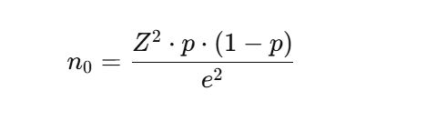
Where:

- Z = Z-score corresponding to the desired confidence level
- p = estimated proportion of the population
- e = margin of error
(Adopted from Daniel, 1999)

2.5 Sample collection
A total of 248 wound swab samples were collected aseptically using sterile swab sticks moistened with sterile normal saline. Each sample was properly labeled and transported immediately to the microbiology laboratory for analysis.
2.6 Sample Inoculation and Identification of Isolates
The wound swab samples were inoculated onto Blood agar and MacConkey agar plates and incubated aerobically at 37 °C for 24–48 hours. Colonies exhibiting characteristic Pseudomonas aeruginosa features, including greenish pigment production, fruity odor, and β-hemolysis on blood agar, were subjected to Gram staining and standard biochemical tests such as oxidase, catalase, citrate utilization, and triple sugar iron (TSI) tests for confirmation (Forbes et al., 2017; Olajuyigbe & Afolayan, 2021).
2.7 Antibiotics susceptibility test
The antibiotic susceptibility profiles of all confirmed Pseudomonas aeruginosa isolates were determined using the Kirby–Bauer disk diffusion method on Mueller–Hinton agar (Oxoid Ltd., UK) in accordance with the Clinical and Laboratory Standards Institute (CLSI) guidelines (CLSI, 2024). The antibiotics tested included cefotaxime (30 µg), ceftazidime (30 µg), ofloxacin (5 µg), imipenem (10 µg), meropenem (10 µg), ciprofloxacin (5 µg), gentamicin (10 µg), amikacin (30 µg), and piperacillin–tazobactam (100/10 µg).

A bacterial suspension equivalent to a 0.5 McFarland standard was prepared for each isolate and uniformly swabbed onto Mueller–Hinton agar plates. Antibiotic discs were applied aseptically, and the plates were incubated at 37 °C for 18–24 hours. The diameters of the inhibition zones were measured and interpreted as susceptible, intermediate, or resistant according to CLSI performance standards (CLSI, 2024).

2.8 Biofilm formation test (Congo red agar method)
Biofilm production was determined using the Congo red agar (CRA) method. The medium consisted of Brain Heart Infusion (BHI) agar (52 g/L) supplemented with sucrose (36 g/L), agar (10 g/L), and Congo red (0.8 g/L). The Congo red dye was prepared as a concentrated solution and autoclaved separately. It was added to the medium after cooling to 55 °C, after which the agar was poured into sterile Petri dishes.

The plates were inoculated with the test isolates and incubated at 37 °C for 24–48 hours. Black colonies with a dry, crystalline morphology were considered positive for biofilm production, whereas weak or non-biofilm-producing colonies appeared red in color (Kala et al., 2020).
RESULTS AND DISCUSSION
A total of 248 wound swab samples were collected from patients with clinically diagnosed wound infections and analyzed. Of these, 184 samples (74.2%) yielded significant bacterial growth, while 64 samples (25.8%) showed no bacterial growth after 24–48 hours of incubation. Among the positive cultures, Gram-negative bacteria accounted for 61.4% of the isolates, with Pseudomonas aeruginosa being the predominant species, comprising 56 isolates (30.4%) (Table 1; Figure 1).
Table 1: Distribution of wound samples and Pseudomonas aeruginosa isolates
Sample Category Number (n) Percentage (%)
Wound samples collected 248 100%
Positive cultures 184 74.2%
Negative cultures 64 25.8%
Pseudomonas aeruginosa isolates
among positive cultures 56 30.4%

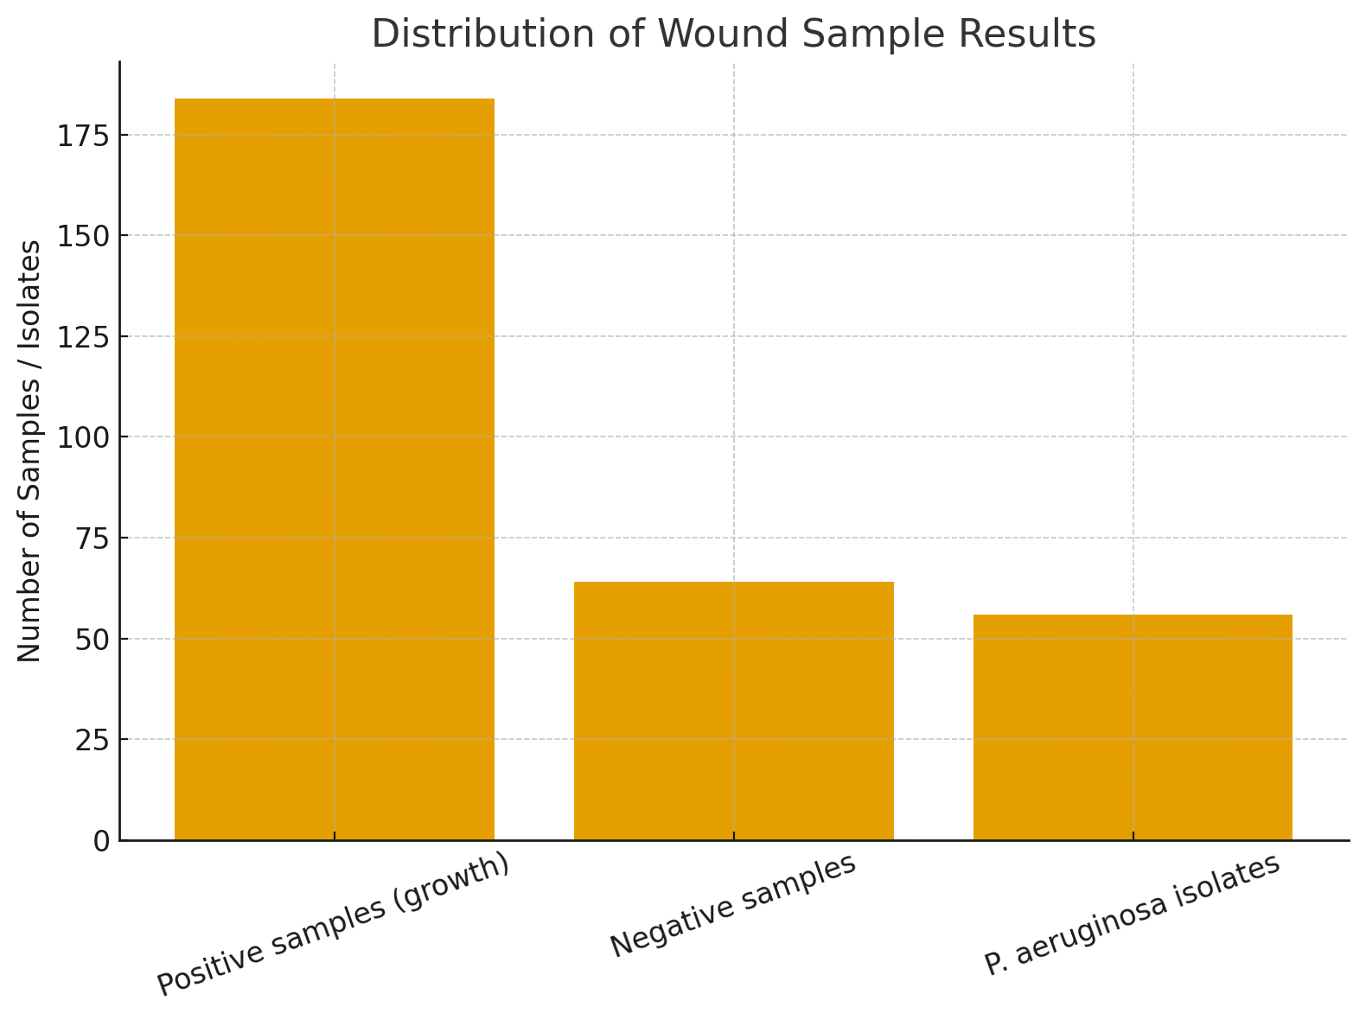
Figure 1: Result on the distribution of wound samples
Colonies of P. aeruginosa appeared large, flat, and exhibited the characteristic blue-green pigment along with a grape-like odor. The isolates were Gram-negative rods, oxidase-positive, catalase-positive, and motile. They demonstrated beta-hemolysis on blood agar and were further confirmed using standard biochemical tests (Table 2).
Table 2: Result on morphology and biochemical characteristics of Pseudomonas aeruginosa isolates
Test Result
Gram Staining Gram – negative rods
Motility Motile
Pigment production Bluish-green pigment on nutrient agar
Odour Characteristic fruity/grape-like smell
Catalase Positive
Oxidase Postive
Citrate utilization Positive
Urease Negative
Indole Negative

Antimicrobial susceptibility testing of all P. aeruginosa isolates was conducted using the Kirby–Bauer disk diffusion method. High resistance was observed against commonly used antibiotics: cefotaxime (80.4%), ceftazidime (75.0%), ciprofloxacin (69.6%), gentamicin (62.5%), and ofloxacin (58.9%). Moderate susceptibility was noted for piperacillin–tazobactam (58.9%), imipenem (55.4%), and meropenem (51.8%), whereas the highest susceptibility was observed with amikacin, showing 64.3% sensitivity (Table 3, Figure 2).
Table 3: Result of Antibiotic susceptibility profile of Pseudomonas aeruginosa
Antibiotic Sensitive n (%) Resistant n (%)
Cefotaxime 11 (19.6%) 45 (80.4%)
Ceftazidime 14 (25.0%) 42 (75.0%)
Ciprofloxacin 17 (30.4%) 39 (69.6%)
Gentamicin 21 (37.5%) 35 (62.5%)
Ofloxacin 23 (41.1%) 33 (58.9%)
Amikacin 36 (64.3%) 20 (35.7%)
Piperacillin-Tazobactam 33 (58.9%) 23 (41.1%)
Imipenem 31 (55.4%) 25 (44.6%)
Meropenem 29 (51.8%) 27 (48.2%)

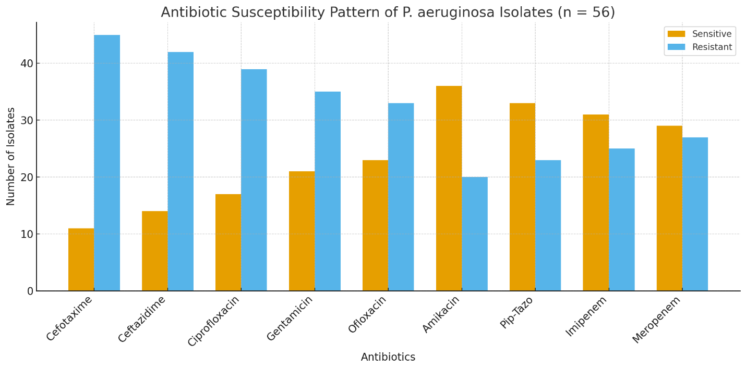
Figure 2: Result of Antibiotic susceptibility profile of Pseudomonas aeruginosa

All 56 P. aeruginosa isolates were screened for biofilm formation using Congo Red Agar. Isolates producing black colonies were classified as strong biofilm formers, dark red or dry red colonies indicated moderate/weak biofilm formation, and smooth red colonies represented non-biofilm formers. Among the isolates, 24 (42.9%) were strong biofilm producers, 18 (32.1%) exhibited moderate/weak biofilm formation, and 14 (25.0%) did not form biofilms (Table 4, Figure 3).

Table 4: Result of biofilm formation of Pseudomonas aeruginosa
Biofilm Reaction No. of Isolates Percentage (%)
Strong biofilm formerd 24 42.9%
Moderate/weak biofilm formers 18 32.1%
Non-biofilm formers 14 25.0%
Total 56 100%

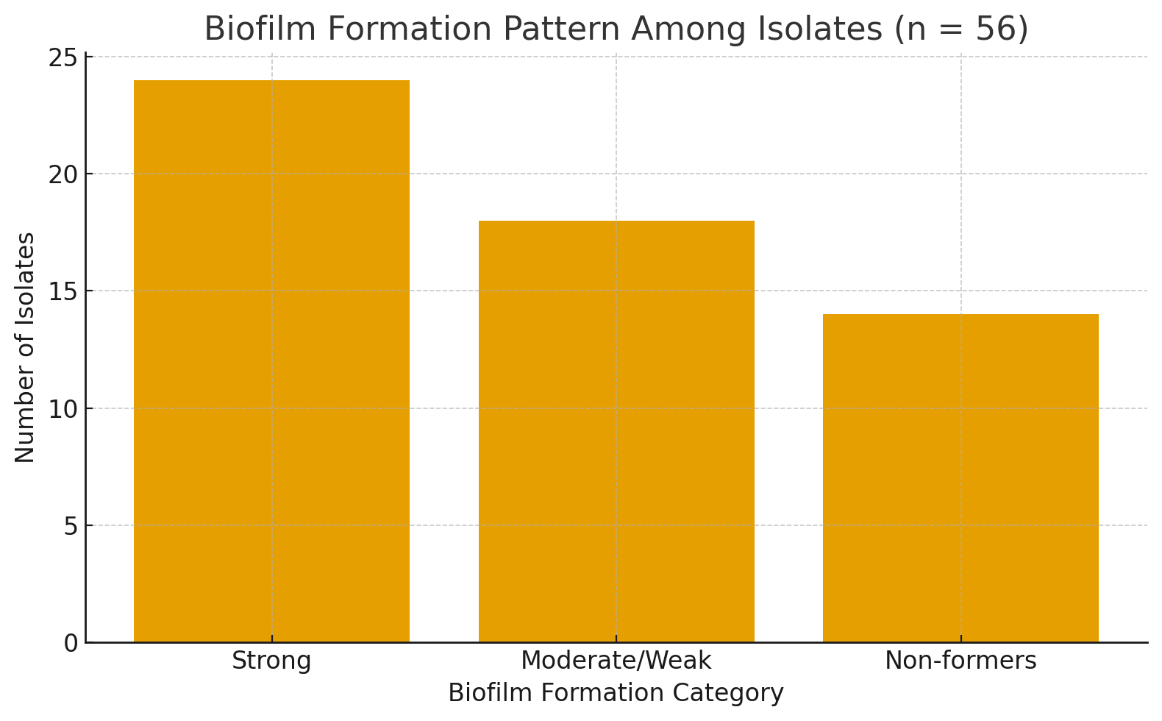
Figure 3: Result of biofilm formation of Pseudomonas aeruginosa

Wound infections remain a significant public health concern, particularly in healthcare settings, where they often lead to delayed healing, prolonged hospitalization, and increased treatment costs. This study investigated the prevalence, biofilm-forming capacity, and antibiotic susceptibility of Pseudomonas aeruginosa isolated from infected wounds. Among 248 wound swab samples analyzed, 184 (74.2%) showed significant bacterial growth, with P. aeruginosa being the most prevalent isolate (30.4%). These results are consistent with previous studies reporting P. aeruginosa as a common pathogen in wound and burn infections, owing to its remarkable adaptability and intrinsic resistance mechanisms (Lister et al., 2022; Ananda-Rajah et al., 2024).
In this study, 42.9% of the P. aeruginosa isolates were strong biofilm formers, while 32.1% exhibited moderate or weak biofilm formation. These findings are consistent with those of Akinjogunla et al. (2023) and Olayinka et al. (2023), who also reported a high prevalence of biofilm formation among P. aeruginosa wound isolates. The high prevalence of biofilm formation highlights the organism’s inherent ability to establish persistent infections, particularly in chronic wounds, where biofilms facilitate bacterial adhesion, protect against host defenses, and significantly reduce antibiotic penetration. Biofilm formation provides a protective environment against immune responses and antimicrobial agents, allowing chronic infections to persist (Hall and Mah, 2022). Additionally, the extracellular polymeric substance (EPS) matrix of biofilms impedes antibiotic penetration and promotes horizontal gene transfer, enhancing multidrug resistance (Donlan, 2022).
The antibiotic susceptibility pattern revealed high resistance rates to cefotaxime (80.4%), ceftazidime (75.0%), and ciprofloxacin (69.6%), while the highest sensitivities were observed with piperacillin–tazobactam (58.9%) and imipenem (55.4%). These results align with the findings of Mannmeet and Ashish (2019), who reported that most P. aeruginosa wound isolates were multidrug-resistant, with high susceptibility to amikacin and imipenem. Similarly, Shirin et al. (2023) observed high resistance to cefotaxime and ceftazidime. The pronounced resistance to third-generation cephalosporins may be attributed to the widespread presence of extended-spectrum β-lactamases (ESBLs) and AmpC β-lactamases, which hydrolyze β-lactam antibiotics (Livermore, 2024).
The results of this study indicate that Pseudomonas aeruginosa is a significant cause of wound infections and demonstrates considerable resistance to commonly used antibiotics, consistent with current global trends. The high level of resistance observed among P. aeruginosa isolates can be attributed to a combination of intrinsic and acquired mechanisms, including low outer-membrane permeability, overexpression of efflux pumps, β-lactamase production, and the ability to form biofilms within wound environments (Pang et al., 2019). Biofilm formation is particularly important in chronic and burn wounds, as it enhances bacterial persistence, reduces antibiotic penetration, and contributes to delayed wound healing and recurrent infections (Hu & Chua, 2025). Similar resistance profiles, especially to β-lactams, fluoroquinolones, and carbapenems, have been reported in recent surveillance studies, highlighting the increasing prevalence of multidrug-resistant P. aeruginosa and the consequent limitation of therapeutic options (Tacconelli, 2022). The growing dependence on last-line agents such as colistin underscores the urgent need for routine antimicrobial susceptibility testing, strengthened infection control practices, and effective antimicrobial use to mitigate the clinical and public health impact of resistant P. aeruginosa in wound infections.

- CONCLUSION
This study demonstrates a high prevalence of biofilm-forming Pseudomonas aeruginosa in wound infections, with a considerable proportion of isolates exhibiting multidrug resistance. The frequent biofilm formation highlights the organism’s inherent ability to establish persistent infections, particularly in chronic wound environments, where biofilms enhance bacterial adhesion, protect against host defenses, and significantly reduce antibiotic penetration, contributing to resistance. Addressing biofilm-associated resistance is therefore critical to improving treatment outcomes and reducing the burden of chronic wound infections, which can result in increased morbidity and mortality among affected patients.

Consent
As per international standards or university standards, patient(s) written consent has been collected and preserved by the author(s).

ETHICAL APPROVAL
Ethical approval was gotten from the ethical committee of the Faculty of Biological Sciences of the University.
Disclaimer (Artificial intelligence)
Option 1:
Author(s) hereby declare that NO generative AI technologies such as Large Language Models (ChatGPT, COPILOT, etc.) and text-to-image generators have been used during the writing or editing of this manuscript.

REFERENCES
- Akinjogunla, O.J., Enabulele, I.O. & Mboto, C.I. (2023). Biofilm formation and multidrug resistance in Pseudomonas aeruginosa isolated from wound swabs. Ann Med Health Sci Res. 13(2):112-119.
- Al- Judaibi, A., Al-Harbi, N., & Al-Ghamdi, A. (2023). Multidrug resistant Pseudomonas aeruginosa in wound infections: prevalence and impact on treatment outcome. J. Infect Public Health, 16(4): 527-534. https://doi.org/10.1016/j.jiph.2023.02.012
- Ananda-Rajah, M.R., Grayson, M.L. & Johnson, P.D.R. (2024). Emerging patterns of Pseudomonas aeruginosa wound infections in clinical practice: A comprehensive review. Clin Microbiol Rev. 37(2):17-23.
- Bassetti, M., Vena, A., Croxatto, A., Righi, E., & Guery, B. (2018). How to manage Pseudomonas aeruginosa infections. Drugs in Context. https://doi.org/10.7573/dic.212527
- Bowler, P. G., Duerden, B. I., & Armstrong, D. G. (2001). Wound microbiology and associated approaches to wound management. Clinical Microbiology Reviews, 14(2), 244–269. https://doi.org/10.1128/CMR.14.2.244-269.2001
- Clinical and Laboratory Standards Institute. (2024). Performance Standards for Antimicrobial Susceptibility Testing, 34th ed. CLSI supplement M100. Wayne, PA. https://clsi.org
- Daniel, W.W (1999). Biostatistics: A Foundation for Analysis in the Health Sciences, 7th Edition pp.140-145.
- Donlan, R. M. (2002). Biofilms: microbial life on surfaces. Emerging Infectious Diseases, 8(9), 881–890. https://doi.org/10.3201/eid0809.020063
- Tille, P. M. (2015). Bailey & Scott's Diagnostic Microbiology (14th ed.). Elsevier. https://www.elsevier.com/books/bailey-and-scotts-diagnostic-microbiology/tille/978-0-323-35482-0
- Gnanadhas, D. P., Marathe, S. A., & Chakravortty, D. (2013). Biopharmaceuticals for Wound Healing: Newer Approaches. Current Pharmaceutical Biotechnology, 14(2), 119–132. https://doi.org/10.2174/138920101402130904100909

Hall, C. W., & Mah, T.-F. (2017). Molecular mechanisms of biofilm-based antibiotic resistance and tolerance in pathogenic bacteria. FEMS Microbiology Reviews, 41(3), 276–301. https://doi.org/10.1093/femsre/fux010
- Hong, X., Li, Z., Xia, W., Tan, Z., Hu, Y., Zhang, L., & Liu, G. (2025). Pseudomonas aeruginosa in wound infections: Genomic characterization and emergence of hypervirulent ST1965/ST3418 strains co-harbouring exoU and exoS. Journal of Global Antimicrobial Resistance, 43, 220-228. https://doi.org/10.1016/j.jgar.2025.05.007
- Hu, M., & Chua, S. L. (2025). Antibiotic-resistant Pseudomonas aeruginosa: Current challenges and emerging alternative therapies. Microorganisms, 13(4), 913. https://doi.org/10.3390/microorganisms13040913
- Kala, H., Shenoy, V. P., Narasimhaswamy, N., & Chawla, K. (2020). Detection of Biofilm Production and Its Impact on Antibiotic Resistance Profile of Bacterial Isolates from Chronic Wound Infections. Journal of Global Infectious Diseases, 12(3), 129–134. https://doi.org/10.4103/jgid.jgid_150_19
- Rahim, K., Saleha, S., Basit, A., Zhu, X., Ahmed, I., Huo, L., Zhang, P., Usman, B., Muneer, S., & Franco, O. L. (2017). Pseudomonas aeruginosa as a powerful biofilm producer and positive action of amikacin against isolates from chronic wounds. Jundishapur Journal of Microbiology, 10(10), e57564. https://doi.org/10.5812/jjm.57564
- Kebede, K., Zerihun, Z., Mohammed, S., Amanuel, D., Aseer, M., Teshome, K., Alahmadi, R. M., Raman, G., & Akbar, I. (2024). Biofilm formation and antibiogram profile of bacteria from infected wounds in a general hospital in southern Ethiopia. Scientific Reports, 14(1), 26359. https://doi.org/10.1038/s41598-024-78283-9
- Lister, P. D., Wolter, D. J., & Hanson, N. D. (2009). Antibacterial-Resistant Pseudomonas aeruginosa: Clinical Impact and Complex Regulation of Chromosomally Encoded Resistance Mechanisms. Clinical Microbiology Reviews, 22(4), 582–610. https://doi.org/10.1128/CMR.00040-09
- Livermore, D.M. (2024). Mechanisms of β-lactam resistance in Gram-negative bacteria: Clinical relevance and evolving threats. J Antimicrob Chemother. 79(2):241-253. https://doi.org/10.1093/jac/dkaa447
- Gill, M. K., & Khanna, A. (2019). Antibiogram of Pseudomonas aeruginosa Isolated from Infected wounds. IP International Journal of Medical Microbiology and Tropical Diseases. https://doi.org/10.18231/j.ijmmtd.2019.036
- Olajuyigbe, O.O. & Afolayan, A..J. (2021). Isolation and characterization of Pseudomonas aeruginosa from wound infections in a tertiary hospital. Afr J Clin Exp Microbiol. 22(2):172-179.
- Olayinka, A.T., Abiola-Owolabi, B. & Olasunkanmi A.O. (2023). Phenotypic detection of biofilm-producing Pseudomonas aeruginosa from wound infections in North-West Nigeria. Niger J Microbiol. 37(2):85-92.
- Pang, Z., Raudonis, R., Glick, B. R., Lin, T. J., & Cheng, Z. (2019). Antibiotic resistance in Pseudomonas aeruginosa: Mechanisms and alternative therapeutic strategies. Biotechnology Advances, 37(1), 177–192. https://doi.org/10.1016/j.biotechadv.2018.11.013
- Riaz, S., Latif, S., Quddus, S., Bukhari, N. T., Ali, K., Alveena, Asghar, S., & Shah, S. M. A. (2025). Role of biofilm-forming bacteria in chronic wound infections and their antibiotic resistance profiles. Journal of Medical & Health Sciences Review, 2(3). https://doi.org/10.62019/adzs3w86
- Sang, P., Feng, C. H., Huang, R., Lee, Z. X., Moua, Y., Phung, O. J., & Lenhard, J. R. (2023). Relative Abundance and Detection of Pseudomonas aeruginosa from Chronic Wound Infections Globally. Microorganisms, 11(5), 1210. https://doi.org/10.3390/microorganisms11051210
- Shirin, G., Kargar, M., Hadadi, H., Khademi, S., Khosravani, E., Gholami, S., Moradi, A., & Kafil, H. S. (2023). Molecular characterizations of antibiotic resistance, biofilm formation, and virulence determinants of Pseudomonas aeruginosa isolated from burn wound infection. Journal of Clinical Laboratory Analysis. https://doi.org/10.1002/jcla.24850
- Tacconelli, E. (2022). Discovery, research, and development of new antibiotics: The WHO priority list of antibiotic-resistant bacteria revisited. The Lancet Infectious Diseases, 22(9), e217–e230. https://doi.org/10.1016/S1473-3099(22)00088-6
- Tuon, F. F., Dantas, L. R., Suss, P. H., & Tasca Ribeiro, V. S. (2022). Pathogenesis of the Pseudomonas aeruginosa Biofilm: A Review. Pathogens, 11(3), 300. https://doi.org/10.3390/pathogens11030300
- Wang, Y., Qian, X., Qiong, Y., Lin, Y., Jin, Z., Zhang, T., Hu, Y., Gao, B., Chen, X., Wang, T., & Xu, L. (2025). Impact of Pseudomonas aeruginosa biofilm formation by different sequence types on treating lower limb vascular infections. Current Research in Microbial Sciences, 8, 100379. https://doi.org/10.1016/j.crmicr.2025.100379

