Original Research Article
Bacteriological Analysis of Freshwater Ecosystems in the Prefectures of Kindia and Forécariah-Republic of Guinea

Abstract
Poor-quality surface water with microbial contamination intended and/or used for recreational purposes is implicated in many infectious diseases worldwide, particularly in countries where waste management systems are currently failing. A prospective study was conducted from June to December 2022. Classical bacteriological techniques were used during the analysis of samples. Thirty-four (34) samples were collected from surface waters used for recreation. In Kindia, the results indicated that the intestinal enterococci (IE) had values exceeding the WHO thresholds in rivers, streams, and creeks at 5.88% each, and in brooks at 82.35%. Regarding E. coli, the same trend was observed with 70.83% contamination in brooks. In the Prefecture of Forécariah, only E. coli was found in brooks and the oceanic branch with 75.00% and 25.00% respectively. The studied waters have been contaminated by fecal matter (fecal germs) of animal and human origin. If urgent and sustainable solutions are not implemented, these water sources would pose a major public health challenge (proliferation of pathogens and antibiotic resistance) in the future.
Keywords : Bacteriological analysis, freshwater ecosystems, public health, Kindia and Forécariah.
INTRODUCTION
Water is an essential resource for the existence of living organisms on Earth. It is important in the fields of transportation, health, housing, production, and agriculture. Its uses for humans are multiple, but three categories are generally highlighted: domestic uses, industrial uses, and agricultural uses (Anctil, 2016; Seki et al., 2024). It is essential for human needs and for the proper functioning of the biosphere (ecosystems) (Baechler, 2012).
However, its availability and quality vary depending on the activities for which it is used (WHO, 2017). According to WHO and OMS (2018), water plays an essential role for life, health, and human dignity. According to projections from a modeling study, 5.5 billion people could be exposed to contaminated water worldwide by 2100. Pollution crosses national borders, according to Mr. Edokpayi, and inter-state or inter-regional cooperation will be just as crucial to prevent the worst predictions from coming true (Tozer, 2023).
The use of water for food or hygiene purposes requires it to be of excellent physico-chemical and bacteriological quality (Kahoul, Touhami, 2014 ; Hounsounou and al., 2018).
The poor quality of water intended for drinking and/or recreational activities is responsible for numerous diseases such as skin disorders, typhoid fever, cholera, diarrhea, hepatitis, schistosomiasis, etc. (EL Ouali and al., 2010). The transmission of an infectious disease involves an infectious agent, a susceptible host, and a route of introduction. In the case of infections caused by the aquatic environment, factors implicated in water contamination include warm-blooded animals (homeotherms). In the case of waterborne diseases, the contamination agents usually come from the digestive tract of humans and animals and are excreted in feces. This is referred to as fecal contamination. Fecal-origin pathogens (bacteria, viruses, protozoa) reach the aquatic environment through the discharge of contaminated waters and through the leaching and surface runoff of agricultural or urban soils (Servais P. and al., 2009).
The Republic of Guinea, like several other developing countries, is not immune to waterborne enteric infections caused by the poor microbiological quality of freshwater resources, a public health problem linked to substandard environmental sanitation and waste management systems.
The aim of the study was to assess the microbiological quality of freshwater in order to reduce the health risks to which the population is exposed.
MATERIALS AND METHODS
Study area
Our collection work took place from june to december 2022 in the waterways of the Kindia prefecture, and the analyses were carried out at Research Institute in Applied Biology of Guinea (IRBAG).
Covering an area of 8,828 km², the prefecture of Kindia is located at an altitude of 458.13 metres in the transition zone between coastal Guinea and Foutah. It lies between 10°03' north latitude and 12°52' west longitude. It is bordered to the west by Coyah Prefecture, to the north-west by Dubreka Prefecture, to the north by Fria Prefecture, to the north-east by Télimélé Prefecture, to the east by Mamou Prefecture, to the south by the Republic of Sierra Leone and to the south-east by Forécariah Prefecture.
Kindia has a fairly dense hydrographic network, consisting of numerous rivers, most of which are torrential. These are: the Samou (in the sub-prefecture of Samaya), the Kilissi (in the sub-prefecture of Molota), the Kolente (in the sub-prefectures of Madina-Oula and Kolenté), the Wantamba and the Mayeya (in the sub-prefecture of Friguiagbè), the Garafiri (a tributary of the Konkouré) (north-east of Souguéta), and the Konkouré north of the sub-prefecture of Bangouya (which forms the boundary between Télimélé and Kindia).
The prefecture of Forécariah, located in south-western Guinea, is bordered to the north by the prefecture of Coyah, to the south by the Republic of Sierra Leone, to the east by the prefecture of Kindia and to the west by the Atlantic Ocean. With an area of 4.250 km², its terrain rises to 1.124 meters near Sikhourou, and its population is 288.950. It lies between 9° 43′ north latitude and 13° 10′ west longitude. Based on an extrapolation from the 2014 census (RGPH3), the population of Forécariah Centre was estimated at 21.670 in 2016. In terms of hydrography, the prefecture is rich and its coastline, cut into large estuaries, is dotted with islands and islets. From the north-west to the south-west, the following coastal rivers flow through the prefecture: the Moribaya, the Gbéréyiré, the Tanna and the Mellacorée have a regular flow, as do the rivers Forécariah, Kaambo, Baffou, Kassogué, Kissi-Kissi, Tanna, Koulèté and Kili.
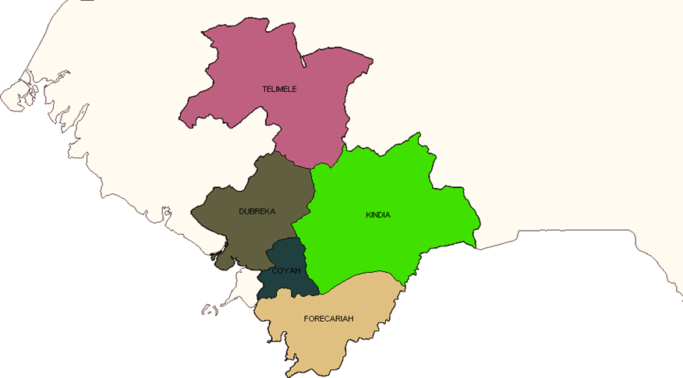
Study setting
The bacteriology laboratory at the Guinea Institute for Applied Biology Research (IRBAG) served as the setting for the analysis of samples.
The Guinea Institute for Applied Biology Research (IRBAG) is located 6 km west of Kindia-Ville and 141 km from Conakry. Its mission is to promote medical biology research in fundamental and applied fields (studying bacterial, viral, parasitic and other germs).
The study was prospective and took place from June to December 2022. Freshwater ecosystems was used as biological material and 116 samples were taken (102 in Kindia and 14 in Forecaiah).
Laboratory equipment
Petri dishes measuring approximately 49 mm x 9 mm, sterile distilled water, sterile grid filter membranes with a porosity of 0.45 µm and a diameter of 47 mm, sterile pipettes, autoclave (Pasteur oven), incubator, filtration ramp with funnels and filter holders, vacuum pump, pH meter paper, refrigerator at a temperature of 2-6 °C, 250 ml wide-mouth bottles or vials with caps, sterile disposable gloves, sampling labels, Tryptone-Sulfite-Cycloserine, Mac Conkey Agar, Bile-Esculin-Azide Agar, CollD/PCA, sterile slides, 70% and 95% alcohol, Pasteur pipettes, platinum wires, dry ice, cooler box (sterile), etc.
Biomaterial
It consisted of samples taken from water sources used for recreational purposes (swimming).
Transport
The samples were placed in a cooler (at minus 10o C) to maintain the cold chain and then transported to the laboratory where they were immediately analysed or stored in a refrigerator at 4°C prior to further analysis.
Assembly of the apparatus
The analysis of the samples began with the installation of the ramp
(vacuum pump) followed by filtration.
To do this, we:
✓ Sterilised the funnels and supports with ultraviolet rays or in an autoclave
for 2 minutes;
✓ Placed the supports and funnels on the filtration ramp;
✓ Taken a sterile filter membrane near the edge using tweezers
sterilised by flaming with alcohol and then placed it on the filter support;
✓ Placed the funnel on the support and secured it firmly;
✓ Homogenised (shaking the water bottles vigorously vertically);
✓ Pour the required volumes (100 ml) of the sample (water source) to be analysed into the funnel.
✓ Turn on the vacuum pump (power source).
✓ Turn off the vacuum pump as soon as the volume to be filtered has been reached.
✓ Remove the filter from the filter holder and place it in a sterile container.
Methods
The membrane filtration method and the direct seeding method were used. Filter 100 ml of each sample to recover bacteria from a filter. Write the sample numbers and filtered volumes on the Petri dishes.
Next, the funnel (cup) was removed and the recovered filter was placed upside down in a Petri dish (selective culture medium) (first option). Using sterile forceps, take the filter, place it in a sterile Petri dish and wash it with sterile distilled water using a pipette (second option). Take 0.5 microlitres using a sterile loop or platinum wire and seed it in a selective culture medium.
Then place the Petri dishes upside down in an incubator at 35°C ± 0.5°C or 44°C for 24 hours ± 2 hours as soon as possible after filtration. Turning the Petri dishes upside down prevents condensation on the membranes.
At the end of incubation, a reading is taken and the results are expressed as the number of germs per 100 ml of filtered water (intestinal enterococci and Escherichia coli). The bacteria are counted in comparison with the current European Union and WHO values in order to interpret the results and determine the level of bacteriological pollution in the bathing water and thus assess the health risk involved (ref table below).
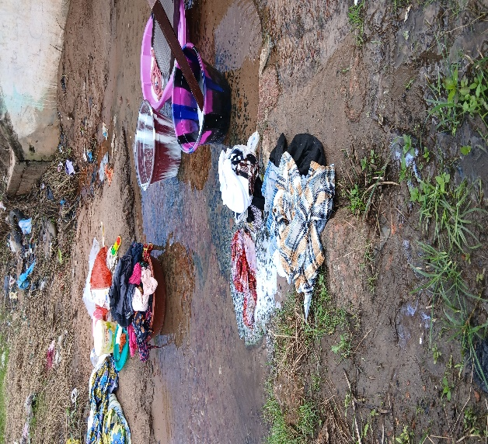

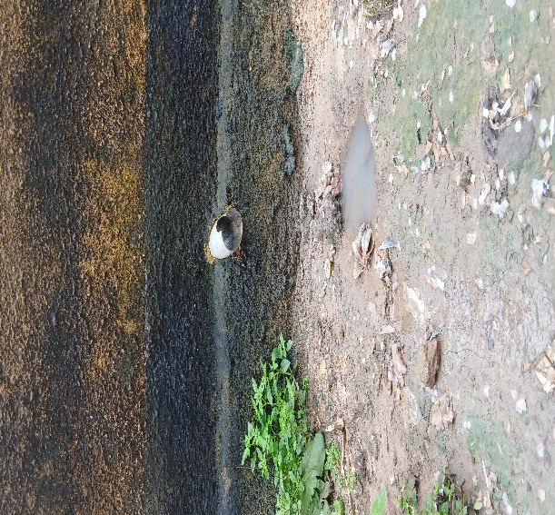
Figure 1 : Laundry being done in a stream in Kindia

Figure 2: Drainage channel for untreated domestic wastewater in the environment in Forécariah

RESULTS AND DISCUSSION
This study shows that streams would be contaminated than other sources (rivers, flow backwaters and dams). In terms of bacterial germs, CT and Escherichia coli were the most common, with 41 and 29 positive samples respectively, or 38.31% and 27.10%, followed by EI, for which 21 samples were positive, or 19.62%, while ASR totalled 16 positive samples, or 14.95%. Backwaters came after streams in terms of contamination levels. At this level, CT were the most common with 9 positive samples, or 42.85%, ASR had 6 positive samples, or 28.57%, E. coli had with 4 positive samples, or 19.04%, and EI in last place with 2 positive samples, or 9.52%. In rivers, ASR and EI were present in 1 sample each, or 12.5%, while CT and E. coli were positive in 3 samples each, or 37.50%. For samples taken from rivers and dams, the absence of ASR was noted. At the dams, CT, EI and E. coli were all found in one positive sample, or 33.33% for each. The flow showed the presence of CT, EI and E. coli in 2, 1 and 3 samples, respectively, giving 33.33%, 16.66% and 50%, and E. coli was present in 50% of samples (ref. table 2).
ASR and EI were not found in water sources except in streams, where ASR was found in one sample, representing 10%. From the specific focus on streams, it is understood that the most commonly found bacterial indicators were: E. coli with 5 positive samples (50%), CT with 4 positive samples (40%) and ASR in 1 sample, or 10%. In backwaters, CT and E. coli were both positive in one sample, or 50% each, and in sea branches, two samples were positive for CT and E. coli only, or 50% each. The single sample from rivers did not yield any positive results (ref. table 3).
The data showed that the bacterial load of intestinal enterococci and E. coli in the bathing waters of Kindia Prefecture exceeded WHO thresholds. It was noted that the only river sample that tested positive for IE exceeded the WHO threshold values by 5.88%, while two-thirds of the samples that tested positive for E. coli (8.33%) exceeded the thresholds. As for the rivers, the only positive sample (5.88%) gave a result that exceeded the threshold values proposed by the same organisation. In streams, 14 out of 21 samples that tested positive for EI exceeded the accepted thresholds (82.35%), while 17 out of 29 (70.83%) samples that tested positive for E. coli exceeded the thresholds. As for backwaters, of the two samples that tested positive for EI, one (5.88%) exceeded the thresholds set by the same institution, and two out of four samples that tested positive for E. coli exceeded the WHO thresholds (ref. table 4).
Observations indicated that all samples taken from rivers, streams, backwaters and inlets (ocean branches) tested negative for enterococci. In contrast, streams (3/5 or 75.00%) and inlets (1/2 or 25.00%) exceeded the threshold values proposed by the WHO for the sanitary assessment of bathing waters mentioned in Table 1. This provides sufficient evidence that the waters studied have been in contact with faecal matter of animal or human origin and that users are at risk of contamination by waterborne pathogens (ref. table 5).
Table 1: Proposed guideline values (European Union) and threshold values that must not be exceeded for bathing water (WHO)

Indicator Germs Guide values Threshold values not to exceed
Intestinal enterococci 100 germs/100ml 200 germs/100ml
Escherichia coli 250 germs/100ml 500 germs/100ml
Table 2: Distribution of indicator bacteria for bacteriological pollution according to water sources in Kindia Prefecture
Water sources | Number of  Samples | Control bacterial germs
Water sources | Number of  Samples | ASR | CT | EI | E. coli
Rivers | 7 | 1(12.50%) | 3(37.5%) | 1(12.50%) | 3(37.50%)
Flow | 5 | 0(0.00%) | 2(33.33%) | 1(16.66%) | 3(50.00%)
Streams | 72 | 16(14.95%) | 41(38.31%) | 21(19.62%%) | 29(27.10%)
Backwaters | 17 | 6(28.57%) | 9(42.85%) | 2(9.52%) | 4(19.04%)
Dams | 1 | 0(0.00%) | 1(33.33%) | 1(33.33%) | 1(33.33%)
TOTAL | 102 | 23 | 56 | 26 | 40
Key:
• SRA: Sulphite-reducing anaerobes.
• TC: Total coliforms.
• IE: Intestinal enterococci.
• E. coli : Escherichia coli.
Table 3: Distribution of indicator bacteria for bacteriological pollution according to water sources in the Prefecture of FORECARIAH
Water sources | Number of  Samples | Control bacterial germs
Water sources | Number of  Samples | ASR | CT | EI | E. coli
Flow | 1 | 0(0.00%) | 0(0.00%) | 0(0.00%) | 0(0.00%)
Streams | 8 | 1(10.00%) | 4(40.00%) | 0(0.00%) | 5(50.00%)
Backwaters | 1 | 0(0,00%) | 1(50.00) | 0(0.00%) | 1(50.00%)
Sea Arm | 4 | 0(0.00%) | 2(50.00%) | 0(0.00%) | 2(50.00%)
TOTAL | 14 | 1 | 7 | 0 | 8

Table 4 : Bacterial loads in bathing waters (intestinal enterococci and Escherichia coli) in Kindia Prefecture

Water sources | Control bacterial germs  E I % E. coli %
Rivers 1/1 5.88 2/3 8.33
Flow 1/1 5.88 2/3 8.33
Streams 14/21 82.35 17/29 70.83
Backwaters 1/2 5.88 2/4 8.33
Dams 0/1 0.00 1/1 4.16
Total 17/26 99.99 24/40 99.98

Table 5 : Bacterial loads in bathing waters (intestinal enterococci and Escherichia coli) in the Prefecture of FORECARIAH
Water sources | Control bacterial germs  E I % E. coli %
Samples | 0/0 | 0.00 | 0/0 | 0.00
Streams | 0/0 | 0.00 | 3/5 | 75.00
Backwaters | 0/0 | 0.0 | 0/1 | 0.00
Sea Arm | 0/0 | 0.00 | 1/2 | 25.00
Total | 0/0 | 0.00 | 4/8 | 100
DISCUSSION
Bacteriological analysis identified intestinal enterococci and Escherichia coli in almost all samples, with bacterial loads exceeding the threshold values proposed by the WHO (ref. Table 1).
The study conducted in Lebanon by Fatmé and al. (2019) showed that CTTs ranged from 14.104 (at the Koussba and Abou Samra 2 sites) to 25.5.105 CFU/100ml (Al Mardachych). These densities increased from upstream to downstream (arm A), where the Mr location, dominated by recreational activities, had the highest bacterial density (21.4 x 10⁵ CFU per 100 ml). In arm B, the coefficients were lowest at the Kousssba sites, close to the source, while Bkeftine had lower bacterial concentrations. These results are similar to those found in the analysis of recreational waters in the prefectures of Kindia and Forécariah.
The levels of E. coli (1.322 CFU/100 ml) and enterococci (2.067 CFU/100 ml) determined in this section were above the acceptable thresholds. The high average loads of indicators, particularly Escherichia coli, faecal streptococci and sulphite-reducing anaerobes, indicated that the Banco River (Côte d'Ivoire) is contaminated with faecal matter (Awomon D.F.A.E, 2020). These data are consistent with those obtained in the present study.
The existence of rubbish dumps along watercourses, the practice of agriculture (gardening) and livestock farming (extensive and intensive), the connection of toilet drainage channels to watercourses (installation of toilets near watercourses), open defecation along waterways, laundry practices, the discharge of wastewater without any prior treatment process, and runoff (the environment) could be sources of contamination of the bathing waters studied. These sources of pollution are identical to those reported by Mèhounou J.P., Josse R.G. and al. (2016), who indicated that the poor quality of surface water in the cotton-growing area of Aplahoué (Benin) was generally due to the presence of human and animal excrement, which is often used as fertiliser and is carried by runoff into watercourses. These findings are similar to those made in the present study with regard to sources of bacteriological contamination.
In Dapaong (northern Togo), Kpiagou P. and al. (2022) noted high levels of Escherichia coli (coliforms), faecal streptococci and sulphite-reducing anaerobic bacteria. All of this pollution was due to the abundance of rubbish dumps, uncontrolled defecation, roaming animals (especially pigs during the dry season), and the discharge of wastewater from homes and the abattoir into the environment (such as in the Didagou backwater). The factors contributing to the bacteriological contamination of the water were identical to those identified during the investigation into the bacteriological pollution of bathing waters in the prefectures of Kindia and Forécariah.
Adjagodo and al. (2017) demonstrated contamination of the Ouémé River (Benin) by thermotolerant coliforms, the presence of which suggested that the pollution was of human origin (domestic waste) and animal origin (livestock effluent), without ruling out the installation of public latrines along the river. The presence of faecal bacteria (intestinal enterococci and E. coli) in the water samples analysed during this study shows a perfect similarity with the results obtained.
Silga and al. (2021) reported that market gardening remains the most dangerous activity given that it is practised on the banks and even in the reservoir bed as the water recedes. It was observed that market gardening was practised along certain watercourses, using droppings, manure and humus (decaying vegetation) collected from illegal dumps (a major source of contamination of recreational waters covered by this study) as fertiliser. These data corroborate those mentioned in our survey.
In developing countries, water pollution is usually the result of human activities due to uncontrolled urbanisation, with a lack of adequate wastewater treatment and direct discharge into the natural environment (Youmbi and al., 2013). The same analyses were carried out in the prefectures covered by our study.
According to Singh and al. (2013) and Bengherbia and al. (2014), the direct discharge of wastewater into watercourses without prior treatment leads to their bacteriological contamination by faecal streptococci. However, faecal streptococci have now been replaced by intestinal enterococci (IE). This observation is similar to that described in the course of this research.
Domestic wastewater discharges into watercourses are the major contributor to bacteriological pollution of surface waters (Massoud and al., 2010). The same source of degradation of the microbiological quality of surface waters (recreational waters) was described during our investigation.
Conclusion
Bacteria indicative of bacteriological contamination (intestinal enterococci and Escherichia coli) were found in bathing waters in the prefectures of Kindia and Forécariah, with levels exceeding WHO thresholds (200 bacteria/100 ml and 500 bacteria/100 ml). The presence of bacteria indicating faecal pollution in bathing waters proves the presence of several other pathogens. This is an indication that the use of these water sources would be hazardous to health. Human activities and the environment, combined with inadequate sanitation systems, are among the sources of microbiological contamination of recreational waters. If urgent and sustainable solutions are not implemented, these water sources will pose a major public health challenge (proliferation of pathogens and antibiotic resistance) in Guinea in the future.

Disclaimer (Artificial intelligence)
The authors declare that generative AI technologies such as large language models... were not used in the writing or revision of the manuscript.
REFERENCES
- Adjagodo, A., Agassounon, D. T. M., Kèlomè, N. C., Vissin, E., W., & Agbossou, E. (2017). Physical and bacteriological pollution of river water in the Lower Ouémé Valley during low and high water periods in Benin. European Scientific Journal, 13(33): 167-186. https://doi.org/10.19044/esj.2017.v13n33p167
- Anctil, F. (2016). Water and its challenges (2nd edition). Presses de l'Université Laval. https://www.pulaval.com/livres/l-eau-et-ses-enjeux-2e-edition .
- Awomon, D., F., A. (2020). Study of the vulnerability of the Banco River laundry workers through research and counting of faecal contamination indicators. African Journal of Social Sciences and Public Health, 2(2): 72-88. https://www.revue-rasp.org/index.php/rasp/article/view/33
- Baechler, L. (2012). Good water management: a major challenge for sustainable development. Europe in Training, 365(3): 3-21. https://doi.org/10.3917/eufor.365.0003
- Bengherbia, A., Hamaidi, F., Zahraoui, R., Hamaidi, M. S., & Megateli, S. (2014). Impact of wastewater discharges on the physicochemical and bacteriological quality of the Oued Beni Aza (Blida, Algeria). Lebanese Science Journal, 15: 39–51. http://lsj.cnrs.edu.lb/
- El Ouali Lalami, A., Merzouki, M., El Hillali, O., Maniar, S., & Ibnsouda Koraichi, S. (2010). Surface water pollution of the Fes town in Marocco: typology, origin and consequences. Larhyss Journal, 09: 55-72. http://www.larhyss.net/journal.html
- Merhabi, F., Amine, H., & Halwani, J. (2019). Assessment of surface water quality in the Kadicha River. Lebanese Scientific Journal, 20(1): 10-34. https://doi.org/10.22453/LSJ-020.1.010-034
- Hounsounou, E. O., Ayi-Fanou, L., Ayéna, A. C., Agassounon Djikpo Tchibozo, M., & Mama, D. (2018). Contamination of Well Water by Salmonella and Non-O1/Non-O139 Vibrio in Poor Neighbourhoods of the Sixth District of Cotonou (Southern Benin). European Scientific Journal (ESJ), 14(6): 252-268. https://doi.org/10.19044/esj.2018.v14n6p252
- Kahoul, M., & Touhami, M. (2014). Assessment of the physical and chemical quality of drinking water in the city of Annaba (Algeria). Larhyss Journal, (19): 129–138. https://www.asjp.cerist.dz/en/article/1000
- Kpiagou, P., Tchegueni, S., Boguido, G., Sama, D., Gnandi, K., Tchacondo, T., & Glitho, A. I. (2022). Assessment of water resource pollution in the Didagou watershed (Dapaong, Northern Togo). Int. J. Biol. Chem. Sci., 16(1): 481-497. https://doi.org/10.4314/ijbcs.v16i1.39
- Massoud, M. A., Tareen, J., Tarhini, A., Nasr, J., & Jurdi, M. (2010). Effectiveness of wastewater management in rural areas of developing countries: A case of Al-Chouf Caza in Lebanon. Environmental Monitoring and Assessment, 161: 61-69. https://doi.org/10.1007/s10661-008-0727-2
- Mèhounou, J. P., Josse, R. G., Dossou-Yovo, P., Sènou, S. F., & Toklo, R. M. (2016). Physicochemical and microbiological characterisation of groundwater and surface water in the cotton-producing area of Aplahoué. Journal of Applied Biosciences, 103(1): 9841-9853. https://doi.org/10.4314/jab.v103i1.6
- World Health Organization. (2017). Guidelines for drinking-water quality: Fourth edition incorporating the first addendum. World Health Organization. https://apps.who.int/iris/bitstream/10665/254637/1/9789241549950-eng.pdf
- World Health Organization & United Nations Children's Fund. (2018). Drinking Water, Sanitation, and Hygiene in Schools: Global baseline report 2018. UNICEF and World Health Organization. https://washdata.org/reports/jmp-2018-global-report-wash-schools
- National Institute of Statistics (INS) Guinea. (2015). Third General Population and Housing Census (RGPH-3). https://www.stat-guinee.org/index.php
- Servais P., Billen G., Garcia-Armisen T., George I., Goncalves A., Thibert S., 2009. Microbial contamination of the Seine basin. Seine-Normandy Water Agency, Vol. 8, Number ISBN : 978-2-918251-08-8 ; 52 p.
- Silga, R. P., Ouéda, A., Kpoda, W. N., Mano, K., Ouédraogo, I., Weesie, P. D. M., & Kabré, G. B. (2021). Local knowledge of fishermen and aquatic environmental changes: impacts on fishing and adaptation strategies in the Volta Basin, Open Journal of Ecology, 11(7): 507-526. https://doi.org/10.4236/oje.2021.117033
- Singh, C., Singh, J. S., Kumar, V., Chandra, R., & Kumar, N. (2013). Screening out of coliform bacteria from different location of Gomti river in Lucknow. African Journal of Microbiology Research, 7(29): 3762–3771. https://doi.org/10.5897/AJMR12.1994
- Seki, T. O., Yapo, W. T., Kpaibé, S. A. P., Meless, D. F. R., & Amin, N. C. (2024). Physicochemical and microbiological characterisation of well water used for drinking in the town of Aboisso (south-east Côte d'Ivoire). International Journal of Biological and Chemical Sciences, 18(1): 311-325. https://doi.org/10.4314/ijbcs.v18i1.26
- Tozer, L. (2023). The « time bomb » of water pollution threatens global health. Nature Briefing. https://doi.org/10.1038/d44148-023-00191-3
- Youmbi, J. G. T., Feumba, R., Njitat, V. T., De Marsily, G., & Ekodeck, G. E. (2013). Groundwater pollution and health risks in Yaoundé, Cameroon. Proceedings – Biology, 336(5-6): 310-316. https://doi.org/10.1016/j.crvi.2013.04.013

