Original Research Article

Biochemical Characterization and Assessment of Polyethylene Glycol (PEG)-Induced Drought Tolerance Potential of Azospirillum Isolates

Abstract
Drought stress is a major constraint to crop productivity and the use of drought-tolerant plant growth-promoting bacteria such as Azospirillum offers a promising strategy for sustainable agriculture. The present study aimed to characterize twenty Azospirillum isolates collected from the Culture Collection Bank of the Department of Agricultural Microbiology and assess their drought tolerance potential under Polyethylene Glycol (PEG-6000)-induced osmotic stress. The isolates were subjected to a series of biochemical tests, including Gram staining, catalase activity, methyl red, Voges–Proskauer and citrate utilization. All isolates were Gram-negative and catalase-positive, while variability was observed in MR-VP and citrate utilization profiles, indicating metabolic diversity among the isolates. Drought tolerance was evaluated by measuring the growth (OD₆₀₀) of isolates cultured in nitrogen-free Okon’s medium supplemented with increasing PEG concentrations (0%, 10%, 20% and 30%). A progressive decline in bacterial growth was observed with higher PEG levels; however, the magnitude of reduction varied markedly among isolates. Strong osmotic stress tolerance was demonstrated by Azos-CH-48, which continuously showed the highest growth across all PEG concentrations, followed by Azos-RS-177 and Azos-12. Overall, the study revealed significant biochemical and physiological variability among Azospirillum isolates and identified a subset of strains with superior tolerance to PEG-induced water stress. These drought-resilient isolates hold potential as promising bio-inoculants for improving crop performance under moisture-deficit conditions. Further molecular characterization and field validation are recommended to support their application in stress-prone agroecosystems.
Keywords: Azospirillum, Drought Tolerance, Polyethylene Glycol (PEG-6000), Osmotic Stress.

Introduction
Drought is one of the most devastating environmental stresses that severely limits agricultural productivity worldwide (Farooq et al., 2012). It affects plant growth, development and yield by disrupting physiological processes such as relative water content, chlorophyll stability, photosynthetic efficiency and nutrient uptake (Gupta et al., 2020; Kasim et al., 2021). Drought also induces oxidative stress through the overproduction of reactive oxygen species (ROS), which damage cellular components including membranes, proteins and nucleic acids (Sharma and Dubey, 2005; Anjum et al., 2011; Manschadi et al., 2006; Navyashree et al., 2024). With the increasing frequency of droughts under changing climatic conditions, developing effective and sustainable strategies to mitigate its impact has become a major challenge for agriculture (Gupta et al., 2011; Haghpanah et al., 2024). In this context, the role of beneficial microorganisms has become increasingly significant. Among them, bacteria belonging to the genus Azospirillum has been extensively studied for its adaptability to environmental stress and its strong plant-growth-promoting potential (Vurukonda et al., 2016). Azospirillum is a heterotrophic, nitrogen-fixing, microaerophilic bacterium that forms associative symbiosis with plant roots and sometimes with aerial plant parts (Steenhoudt and Vanderleyden, 2000). Its ability to fix atmospheric nitrogen, produce phytohormones and enhance root development makes it an important bio-inoculant for sustainable agriculture (Bashan and de-Bashan, 2010; Zaheer et al., 2022). Improved root systems developed under Azospirillum influence support plants to extract more water and nutrients from deeper soil layers under moisture-limited conditions. Beyond their plant-growth-promoting abilities, Azospirillum species possess remarkable biochemical and physiological mechanisms that enable them to survive and function efficiently under drought stress (Fadiji et al., 2022). One key adaptation is the production of exopolysaccharides (EPS), which form a protective biofilm around the bacterial cells and plant roots. This biofilm minimizes desiccation, enhances root–soil contact and retains moisture in the rhizosphere (Ilyas et al., 2020; Khan and Bano, 2019; Solanki et al., 2020). In addition, Azospirillum synthesizes osmoprotectants such as proline, trehalose, glycine betaine and soluble sugars. These molecules stabilize cellular structures, maintain osmotic balance and protect both bacterial and plant cells from dehydration (Gouffi and Blanco, 2000; Saxena et al., 2012; Goszcz et al., 2025). The bacterium also boosts antioxidant defense enzymes including superoxide dismutase (SOD), peroxidase (POD) and catalase (CAT), which neutralize ROS and maintain redox homeostasis within cells (Zandi and Schnug, 2022; Fukami et al., 2018; Kumar et al., 2019). Collectively, these mechanisms enable Azospirillum to persist under drought conditions and enhance the tolerance of their host plants by improving physiological stability, chlorophyll maintenance and water-use efficiency (Barquero et al., 2022; Creus et al., 2004). For simulating drought stress under laboratory conditions, polyethylene glycol (PEG) is widely used as an osmotic agent due to its high molecular weight, non-ionic nature and inability to penetrate cell membranes. PEG, particularly with higher molecular weight (such as PEG 6000), is a water-soluble polymer that reduces the water potential of growth media, simulating drought-like conditions. (Hamayun et al., 2010; Sardar and Kamil, 2017; Ahmad et al., 2020). Therefore PEG-induced assays become a reliable method to identify drought-tolerant microbial isolates capable of maintaining growth and metabolic activity under simulated stress (Mishra et al., 2021). Considering the increasing challenges of drought-induced yield loss and the potential of Azospirillum as a stress-alleviating biofertilizer, the present study was undertaken to evaluate the biochemical characterization and PEG-induced drought tolerance potential of different Azospirillum isolates. This work aims to identify drought-tolerant strains with strong biochemical and adaptive traits that could be utilized in sustainable agriculture to improve crop performance under water-limited conditions.
Materials and Methods
Collection of Azospirillum isolates
A total of 20 Azospirillum isolates used in this study were collected from the Culture Collection Bank of the Department of Agricultural Microbiology, College of Agriculture, Indira Gandhi Krishi Vishwavidyalaya Raipur (Chhattisgarh).
Revival of Azospirillum isolates
The collected Azospirillum isolates were revived aseptically by transferring them into sterilized nitrogen-free bromothymol blue (Okon’s) medium. For this purpose Azospirillum isolates were streaked in sterilized nitrogen-free bromothymol blue (Okon’s) agar medium. The inoculated agar plates were incubated at 30±2°C for 24 to 48 hours (till colonies developed) in a BOD incubator. To obtain pure culture, individual colony of Azospirillum isolates with distinct shape was selected and inoculated in their respective agar slants and was kept in BOD incubator. The agar slants showing well desired growth were picked and stored at 6-8°C in a refrigerator for further use. The revived cultures were further sub-cultured at a regular interval of 15 days and maintained for subsequent experiments.
Biochemical characterization of Azospirillum isolates
All 20 Azospirillum isolates collected from the Culture Collection Bank were characterized using standard biochemical methods to confirm their identity and functional traits as given in the Bergey’s manual of systematic bacteriology (2001). Standard biochemical tests, including Gram staining, catalase test, methyl red (MR) test, Voges-Proskauer (VP) test and citrate utilization test were performed in triplicate manner. The result of these tests were recorded to assess the physiological and metabolic properties of the selected isolates.
Gram staining
Gram staining was carried out as per the method described by Gram (1884) and Beveridge (2001) to determine the gram nature of 20 collected Azospirillum isolates. A loopful of fresh culture of Azospirillum was smeared on clean glass slide and was heat fixed. The smear was sequentially stained with crystal violet for one minute, followed by iodine solution for one minute, then decolorized using 95% ethanol for 10-15 seconds and finally counterstained with safranin for 30 seconds. After each step, the slide was rinsed with distilled water. The stained slides were air-dried and observed under compound microscope using immersion oil.
Catalase test
The catalase test was performed as per the method described by Cappuccino and Sherman (2013). Firstly, fresh culture was placed on a clean glass slide and a few drops of 3% hydrogen peroxide (H₂O₂) were added. The reaction was observed for the immediate formation of gas bubbles which indicate a positive result. Isolates producing bubbles were considered catalase-positive while those showing no bubble formation were recorded as catalase-negative.
Methyl red and Voges-proskauer (MR-VP) test
The Methyl Red (MR) and Voges-Proskauer (VP) test was performed as per the method described by James and Cappuccino (2017) and Forbes et al., (2007), respectively, to assess the fermentation pattern of the Azospirillum isolates. MR-VP broth was prepared in two sets of tube. Fresh bacterial cultures were inoculated into MR-VP broth and incubated at 28°C for 48 hours. After incubation, 5 drops of methyl red indicator was added to first set of the tubes, development of red color indicated a positive MR test. For Voges-Proskauer test, 0.6 ml of α-naphthol (Barritt’s A solution) and 0.2 ml of KOH (Barritt’s B solution) were added to the second set of the tubes. The tube was gently shaken and allowed to stand for 10–20 minutes. Development of red or pink color indicates the positive VP test while no color or a copper color indicates the negative VP test.
Citrate utilization test
The citrate utilization test was performed as per the method described by Atlas (2004) and Cheesbrough (2005) to determine the ability of Azospirillum isolates to utilize citrate as the sole carbon source. Simmons citrate agar slant was prepared and fresh culture was streaked onto the surface of the Simmons citrate agar slant. Streaked tubes were incubated at 30°C for 48 hours. After incubation, slants were observed for a color change. A color change from green to blue indicated a positive result.
Screening of Azospirillum isolates for drought tolerance using Polyethylene Glycol (PEG-6000) test
To evaluate the drought tolerance potential of the Azospirillum isolates, a Polyethylene Glycol (PEG-6000) tolerance test was assessed by simulating osmatic stress as described by Michel and Kaufmann (1973). The isolates were inoculated into a nitrogen-free broth medium (Okon’s media) supplemented with PEG-6000 at different concentrations (0%, 10%, 20% and 30%), creating varying levels of water stress. The cultures were incubated at 30°C for 48 hours under constant shaking incubator to ensure uniform exposure to stress conditions. After incubation, bacterial growth was evaluated by measuring optical density (OD) at 600 nm using a spectrophotometer. Isolates exhibiting higher OD values under increasing PEG-6000 concentrations were considered more tolerant to osmotic stress. This test was used to identify effective Azospirillum isolates with promising drought tolerance potential.
Results and Discussion
Collection of Azospirillum isolates
A total of 20 Azospirillum isolates (Table 1) were collected from the Culture Collection Bank of the Department of Agricultural Microbiology, Indira Gandhi Krishi Vishwavidyalaya, Raipur, (C.G.). These isolates were originally obtained from various agricultural fields of different districts of Chhattisgarh and had been maintained under standard laboratory conditions in the culture bank.
Table 1. Collection details of Azospirillum isolates obtained from various agricultural fields in different districts of Chhattisgarh
S/No | Name of isolates | S/No | Name of isolates
1 | Azos-12 | 11 | Azos-CH-22
2 | Azos-16 | 12 | Azos-CH-28
3 | Azos-19 | 13 | Azos-CH-30
4 | Azos-35 | 14 | Azos-CH-33
5 | Azos-3427 | 15 | Azos-CH-48
6 | Azos-3461 | 16 | Azos-PAC-37
7 | Azos-3473 | 17 | Azos-RS-125
8 | Azos-3477 | 18 | Azos-RS-139
9 | Azos-3478 | 19 | Azos-RS-177
10 | Azos-3480 | 20 | Azos-RS-178

Biochemical Characterization of Azospirillum isolates
Gram staining
Gram staining was performed to determine the cell wall characteristics of the Azospirillum isolates. All 20 Azospirillum isolates were found to be Gram-negative (Table 2). This result was evident by the pink coloration observed under the microscope after staining, which is characteristic of Gram-negative bacteria. The uniform Gram-negative nature of all isolates confirms their identity within the genus Azospirillum, which is known to be composed of Gram-negative bacteria. These findings are in agreement with earlier reports by Tarrand et al., (1978), Okon and Labandera-Gonzalez (1994), Steenhoudt and Vanderleyden (2000), Reis et al., (2015) and Cassán et al., (2015), who also confirmed the Gram-negative nature of Azospirillum species. This characteristic is important for identification and classification purposes and also relates to their structural and functional properties.
Catalase test
The catalase test was performed to evaluate the ability of the Azospirillum isolates to produce the enzyme catalase. All 20 Azospirillum isolates showed positive result for the catalase test (Table 2 and Figure 1). The positive catalase activity in all isolates indicating their effective adaptation to oxygen-rich environments and their potential to mitigate oxidative stress by neutralizing reactive oxygen species such as hydrogen peroxide. These findings are close to findings of earlier studies by Mehnaz and Lazarovits (2006), Ilyas et al., (2012), Di Salvo et al., (2014), Narayan and Gupta (2018), Sulaiman et al., (2019), Rabara et al., (2023) and Yadav et al., (2024), who also reported catalase-positive reactions in a wide range of Azospirillum strains. These findings support the role of catalase-positive Azospirillum isolates in promoting plant growth through improved stress resilience and metabolic activity.
Methyl red (MR) test
The methyl red test was conducted to assess the ability of isolates to produce stable acid end products from glucose fermentation. Out of 20 Azospirillum isolates tested, 12 isolates showed positive result for the MR test (Table 2 and Figure 2). These isolates are capable of mixed acid fermentation and production of stable acidic compounds. The remaining 8 isolates gave negative result, indicating they either do not produce stable acidic end products or their fermentation products are neutral. The positive reactions observed in these Azospirillum isolates indicate their ability to ferment glucose and produce acidic end products. This metabolic activity indicate that the isolates can effectively utilize glucose as a carbon source under anaerobic or microaerophilic conditions. These findings are consistent with the observations made by Kanimozhi and Panneerselvam (2011), Di Salvo et al., (2014), Sulaiman et al., (2019), Rabara et al., (2023) and Ogunniyi et al., (2024), who also reported positive MR test in several Azospirillum strains.
Voges-proskauer (VP) test
The Voges-Proskauer test was conducted to evaluate the production of acetoin, a neutral end product of glucose metabolism via the butylene glycol pathway, in Azospirillum isolates. Out of the 20 isolates tested, 13 isolates gave a positive VP reaction, while 7 isolates were negative (Table 2 and Figure 3). These positive reactions indicate their potential ability to produce neutral metabolic products. On the other hand, negative VP reactions suggest variability in their metabolic traits. The differential response observed in the Voges-Proskauer (VP) test among the Azospirillum isolates indicates the biochemical and metabolic diversity within the genus. This diversity is a critical parameter for microbial screening and selection. These findings are in agreement with earlier studies by Azlin et al., (2005), Shubha et al., (2014), Rabara et al., (2023), Ogunniyiet al., (2024) and Yadav et al., (2024), which have documented the heterogeneity among Azospirillum strains, particularly in terms of carbon utilization patterns and fermentation profiles.

Citrate utilization test
Out of 20 Azospirillum isolates tested, 16 isolates showed positive result for citrate utilization (Table 2 and Figure 4). These isolates demonstrated the ability to utilize citrate as a carbon source. The remaining 4 isolates were negative, indicating their inability to metabolize citrate. The positive citrate utilization by Azospirillum isolates reflects their metabolic versatility and adaptability to different environmental conditions. Such isolates are often better adapted to varied environments and can play a significant role in nutrient cycling and plant growth promotion. These result align with findings by Tejera et al., (2005), Tyagi and Singh (2014), Hossain et al., (2015), Reis et al., (2015) and Muthukumar et al., (2021), who also reported citrate utilization in various Azospirillum strains.

Table 2. Biochemical characterization of Azospirillum isolates
S/N | Name of isolates | Gram staining | Catalase test | Methyl red (MR) test | Voges-Proskauer (VP) test | Citrate utilization test
1 | Azos-12 | -ve | + | - | + | +
2 | Azos-16 | -ve | + | - | - | +
3 | Azos-19 | -ve | + | - | - | +
4 | Azos-35 | -ve | + | + | + | -
5 | Azos-3427 | -ve | + | + | + | +
6 | Azos-3461 | -ve | + | - | - | +
7 | Azos-3473 | -ve | + | - | + | +
8 | Azos-3477 | -ve | + | + | + | +
9 | Azos-3478 | -ve | + | + | - | +
10 | Azos-3480 | -ve | + | + | + | -
11 | Azos-CH-22 | -ve | + | + | + | +
12 | Azos-CH-28 | -ve | + | + | - | -
13 | Azos-CH-30 | -ve | + | - | - | +
14 | Azos-CH-33 | -ve | + | + | + | +
15 | Azos-CH-48 | -ve | + | + | + | +
16 | Azos-PAC-37 | -ve | + | - | - | +
17 | Azos-RS-125 | -ve | + | + | + | -
18 | Azos-RS-139 | -ve | + | - | + | +
19 | Azos-RS-177 | -ve | + | + | + | +
20 | Azos-RS-178 | -ve | + | + | + | +
(-) = Negative, (+) = Positive

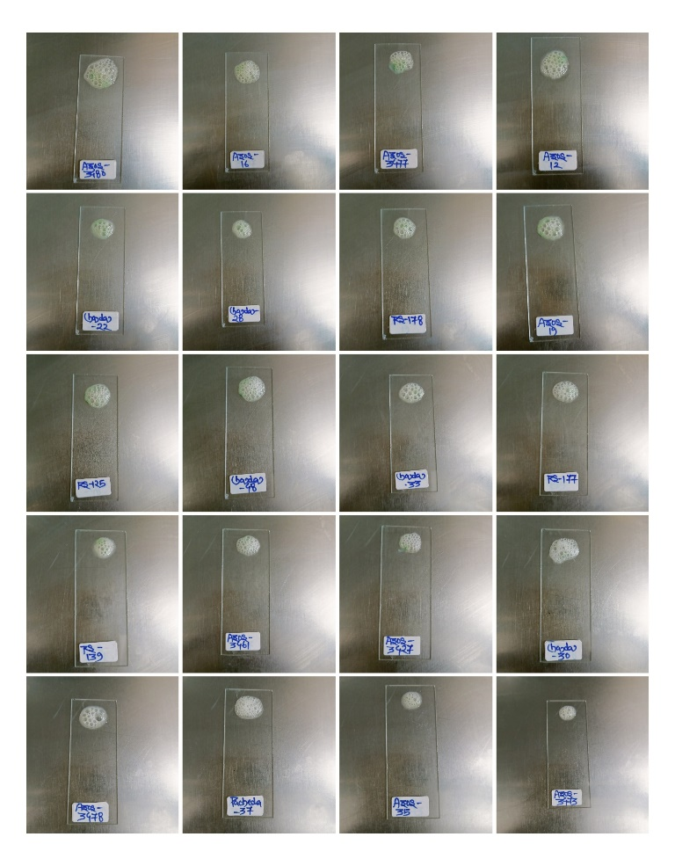

Figure 1. Catalase test of Azospirillum isolates using 3% hydrogen peroxide. The immediate formation of gas bubbles indicates a positive catalase reaction.

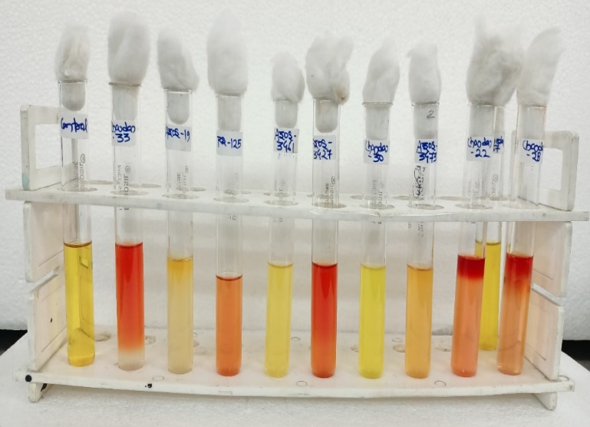
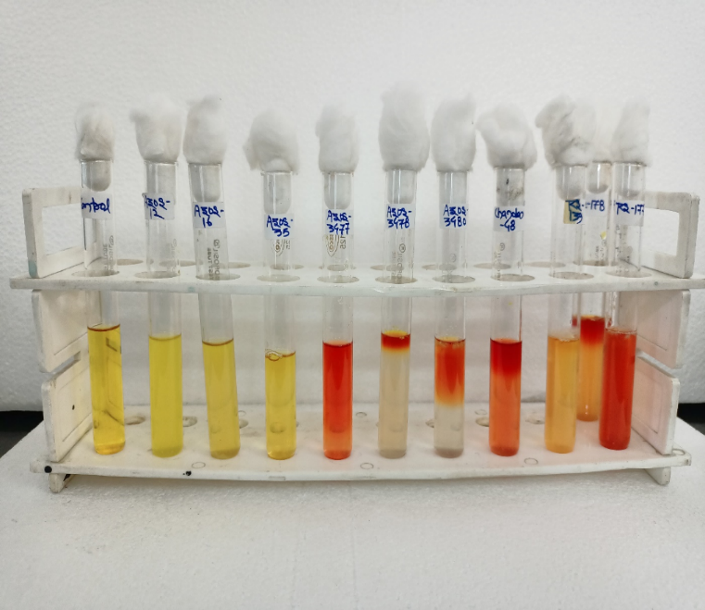

Figure 2. Methyl red test of Azospirillum isolates in MR broth. After adding methyl red indicator the development of a red coloration indicates a positive result
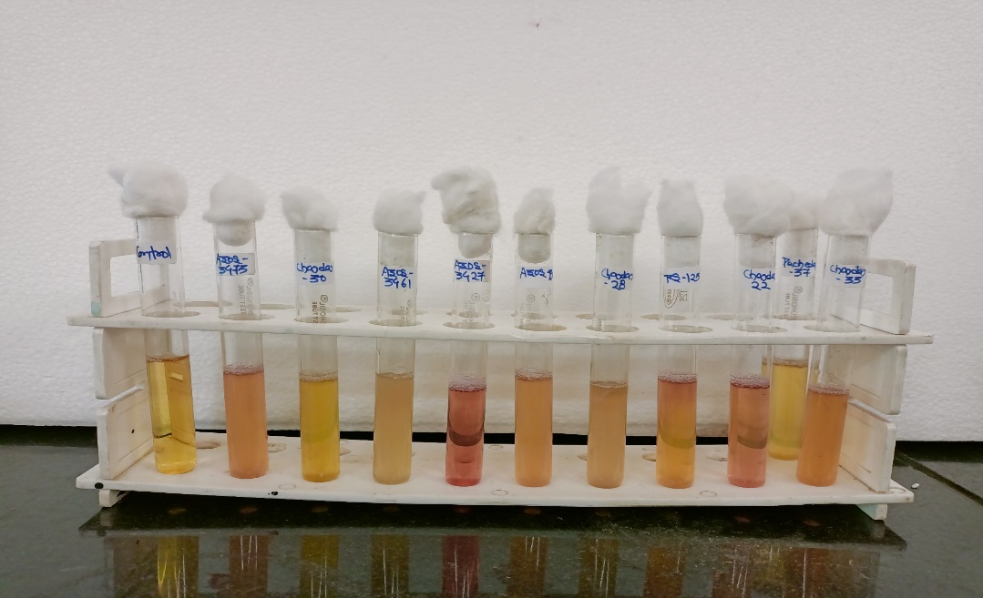
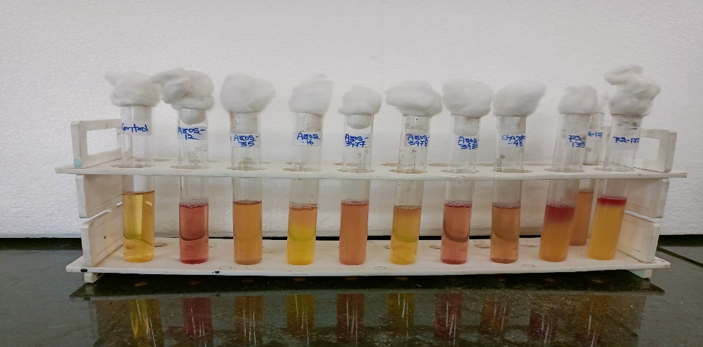

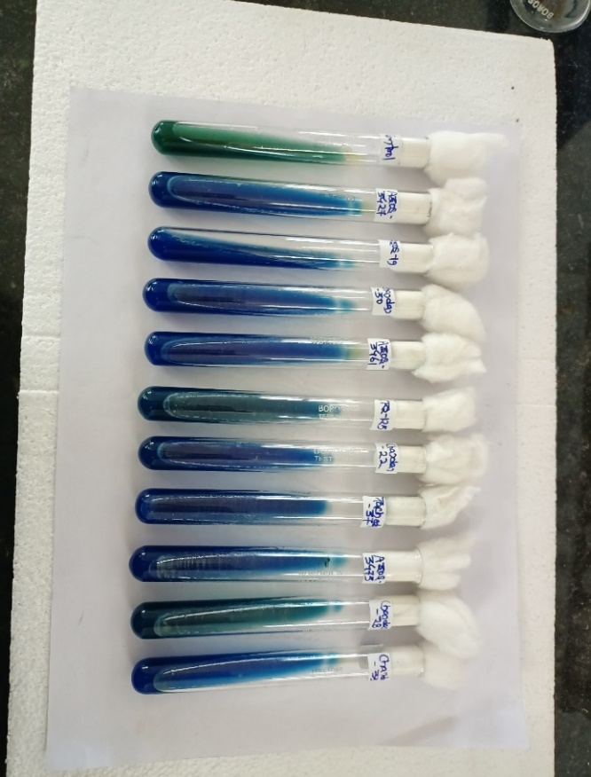
Figure 3. Voges-proskauer test of Azospirillum isolates. The development of a pink to red color after adding VP reagents indicates a positive reaction for acetoin production.
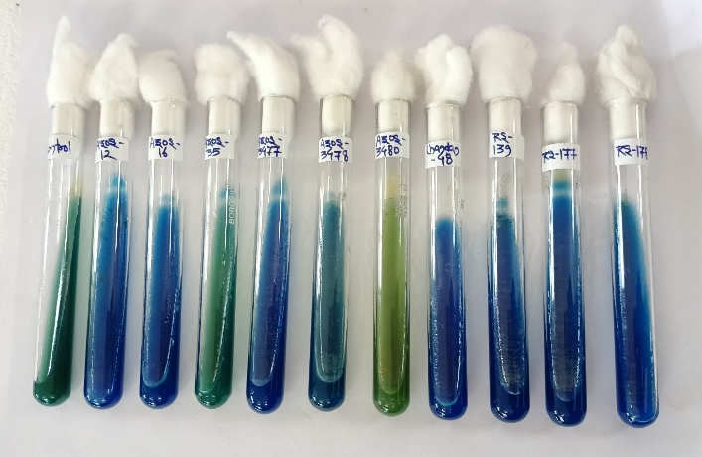

Figure 4. Citrate utilization test of Azospirillum on Simmon’s citrate agar. The development of blue coloration of the medium indicates a positive result
Screening of Azospirillum isolates for drought tolerance using Polyethylene Glycol (PEG-6000)
The data regarding PEG-induced osmotic stress tolerance of all Azospirillum isolates are presented in Table 3 and Figure 5. The isolates were grown in nitrogen-free broth medium (Okon’s media) supplemented with different concentrations of PEG-6000 (0%, 10%, 20% and 30%) and their growth was determined by measuring optical density (OD₆₀₀) after 48 hours of incubation. At 0% of PEG concentration (control), the optical density (OD₆₀₀) values of Azospirillum isolates ranged from 0.266 to 1.264 (Figure 6). The highest growth was recorded in Azos-CH-48 (1.264) followed by Azos-RS-177 (0.823) and Azos-12 (0.696). The lowest OD₆₀₀ was observed in Azos-CH-28 (0.266), indicating comparatively lower growth under non-stress conditions. At 10% of PEG concentration, a moderate reduction in growth was observed for all isolates compared to the 0% of PEG concentration (control). OD₆₀₀ values ranged from 0.233 to 0.721 (Figure 7). Azos-CH-48 continued to exhibit the highest growth (0.721) followed by Azos-12 (0.498) and Azos-RS-177 (0.499). The lowest OD₆₀₀ value was recorded in Azos-CH-28 (0.233). With increased PEG concentration (20%), the growth of Azospirillum isolates declined further with OD₆₀₀ values ranging from 0.131 to 0.612 (Figure 8). Azos-CH-48 again exhibited the highest growth (0.612) followed by Azos-12 (0.464) and Azos-RS-177 (0.480). Azos-CH-28 remained the lowest performer with an OD₆₀₀ value of 0.131. Under high osmotic stress (30% PEG), a sharp decline in growth was observed among all isolates, ranging OD₆₀₀ value from 0.080 to 0.425 (Figure 9). Azos-CH-48 maintained the highest OD₆₀₀ (0.425) followed by Azos-RS-177 (0.372) and Azos-12 (0.349) whereas Azos-CH-28 had the lowest value (0.080). Among all isolates, Azos-CH-48 consistently showed superior tolerance to osmotic stress across all PEG concentrations, followed by Azos-RS-177 and Azos-12 which indicate better survival and stronger osmotic stress adaptation. Azos-CH-28 showed the lowest growth at all PEG levels which indicate least stress tolerance. The differential growth responses of Azospirillum isolates under PEG-induced osmotic stress suggest variability in their drought tolerance capabilities. A gradual decline in optical density (OD₆₀₀) was observed with increasing PEG concentrations in all isolates, reflecting reduced bacterial growth under osmotic stress. Similar trends have been reported by earlier researchers, indicating that PEG-induced water stress impairs bacterial cellular metabolism and proliferation (Sandhya et al., 2009; Fu et al., 2016). The high tolerance even at 30% PEG shown by specific isolates may be attributed to the synthesis of osmoprotectants, exopolysaccharides, phytohormones and enzymes such as ACC deaminase that mitigate stress effects (Teale et al., 2006; Paul et al., 2008; Yang et al., 2009; Fahad et al., 2015; Glick, 2014). Isolates such as Azos-CH-28, Azos-CH-33 and Azos-3461 showed sharp declines in OD₆₀₀, especially at higher PEG concentrations, indicating lowest drought adaptability. This variation may be attributed to differences in physiological or genomic attributes such as exopolysaccharide production, stress-responsive gene expression and antioxidant enzyme activity (Schimel et al., 2007; Ghosh et al., 2019; Lopes et al., 2022). These findings align with the observations of Omar et al., (2017), García et al., (2017), Latif et al., (2022), Mokeev et al., (2022) and Jayasurya and Grover (2023), who reported that growth of Azospirillum and other plant growth promoting rhizobacteria (PGPR) significantly decreased with increasing PEG concentration but able to survive even at higher levels of PEG concentration.

Table 3. Growth performance of Azospirillum isolates under different concentrations of Polyethylene Glycol (PEG-6000)
S/No | Name of isolates | Optical density (OD₆₀₀)
S/No | Name of isolates | 0% PEG | 10% PEG | 20% PEG | 30% PEG
1 | Azos-12 | 0.696 | 0.498 | 0.464 | 0.349
2 | Azos-16 | 0.555 | 0.470 | 0.442 | 0.322
3 | Azos-19 | 0.387 | 0.283 | 0.267 | 0.168
4 | Azos-35 | 0.545 | 0.462 | 0.430 | 0.291
5 | Azos-3427 | 0.397 | 0.315 | 0.276 | 0.200
6 | Azos-3461 | 0.294 | 0.248 | 0.235 | 0.122
7 | Azos-3473 | 0.372 | 0.255 | 0.238 | 0.157
8 | Azos-3477 | 0.420 | 0.354 | 0.328 | 0.256
9 | Azos-3478 | 0.410 | 0.344 | 0.302 | 0.228
10 | Azos-3480 | 0.480 | 0.395 | 0.339 | 0.270
11 | Azos-CH-22 | 0.383 | 0.282 | 0.250 | 0.165
12 | Azos-CH-28 | 0.266 | 0.233 | 0.131 | 0.080
13 | Azos-CH-30 | 0.407 | 0.318 | 0.300 | 0.225
14 | Azos-CH-33 | 0.287 | 0.235 | 0.229 | 0.108
15 | Azos-CH-48 | 1.264 | 0.721 | 0.612 | 0.425
16 | Azos-PAC-37 | 0.377 | 0.258 | 0.241 | 0.161
17 | Azos-RS-125 | 0.390 | 0.299 | 0.275 | 0.188
18 | Azos-RS-139 | 0.425 | 0.359 | 0.335 | 0.265
19 | Azos-RS-177 | 0.823 | 0.499 | 0.480 | 0.372
20 | Azos-RS-178 | 0.494 | 0.444 | 0.376 | 0.273

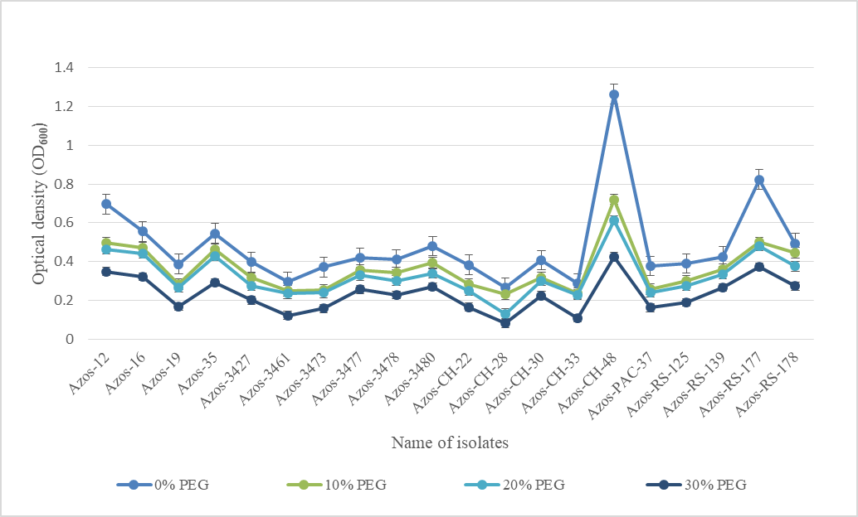

Figure 5. Variation in growth performance of Azospirillum isolates under different concentrations (0-30%) of Polyethylene glycol (PEG-6000)

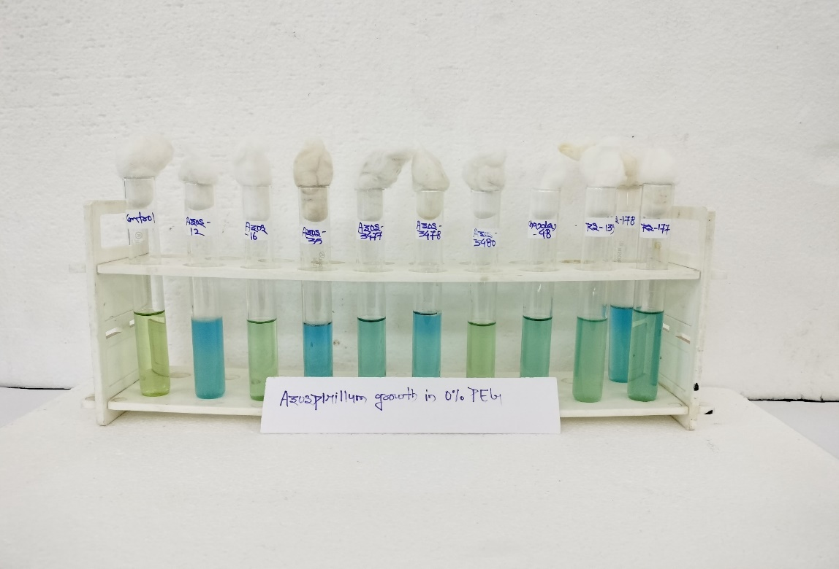
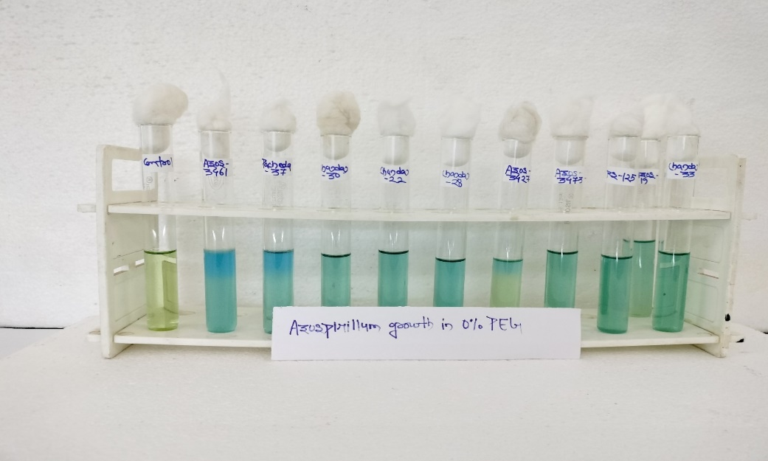

Figure 6. Screening of Azospirillum isolates based on their growth under 0% (control) polyethylene glycol

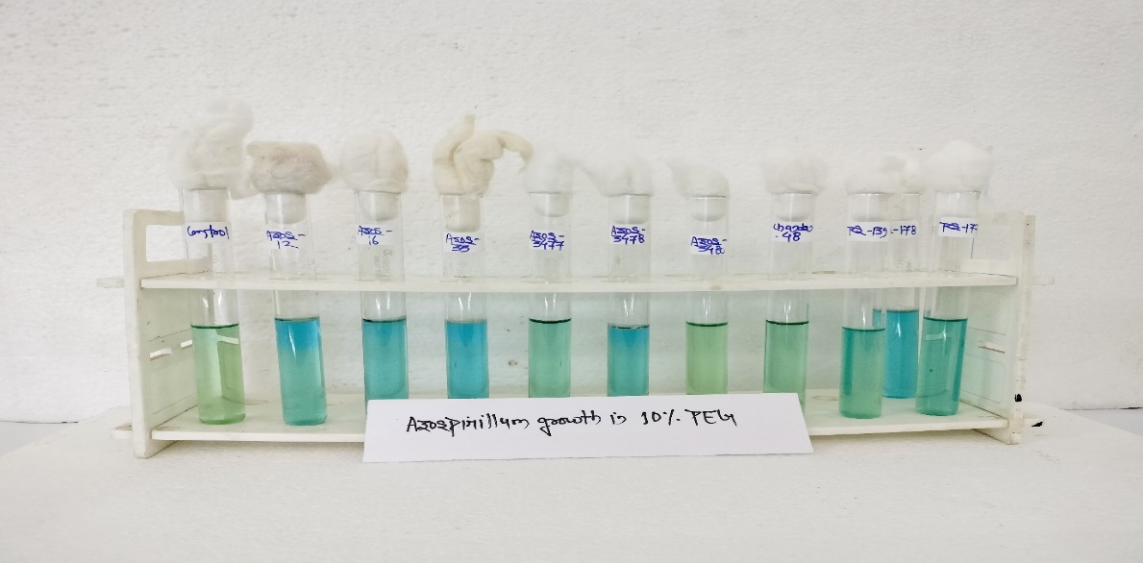
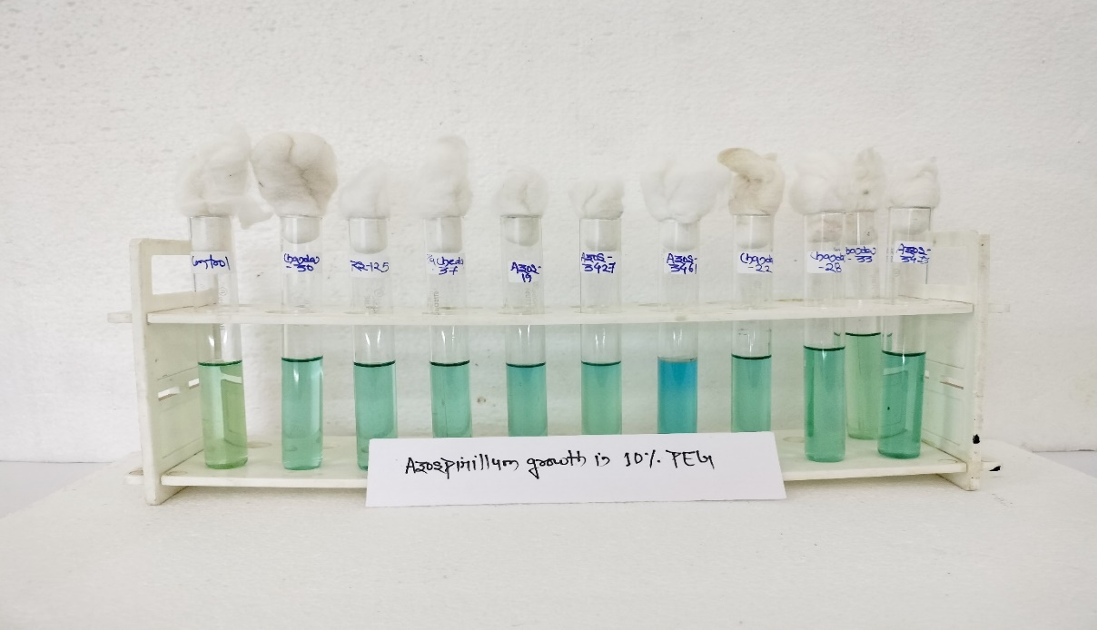

Figure 7. Screening of Azospirillum isolates based on their growth under 10% polyethylene glycol

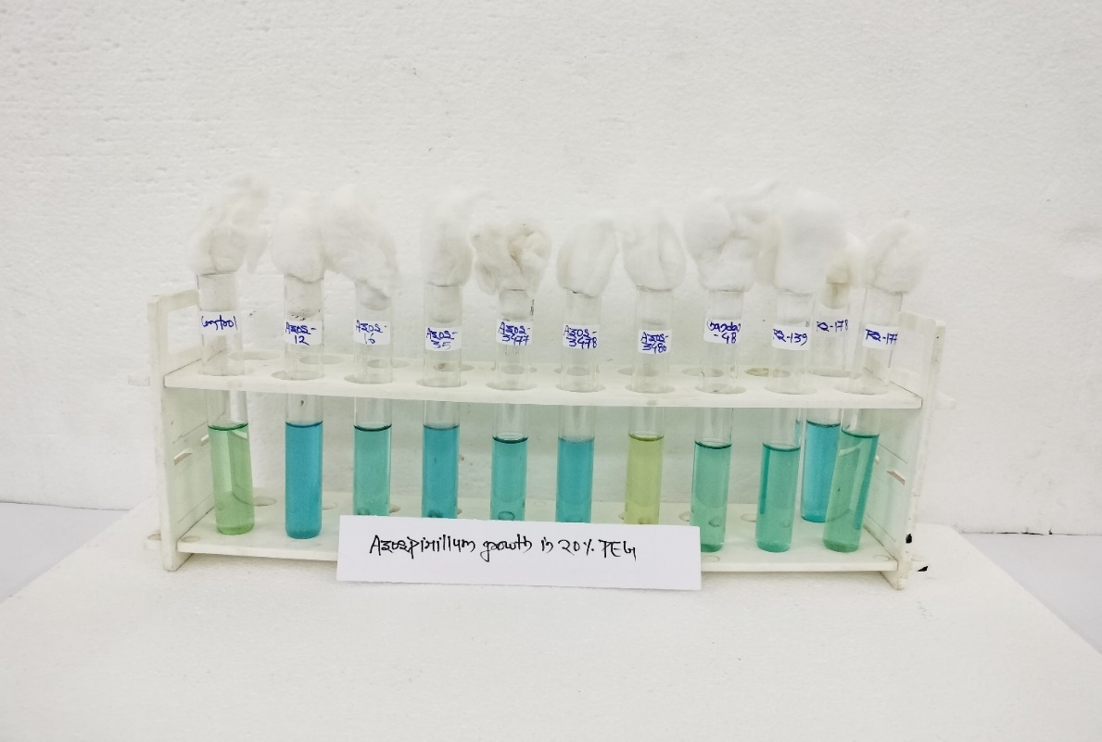
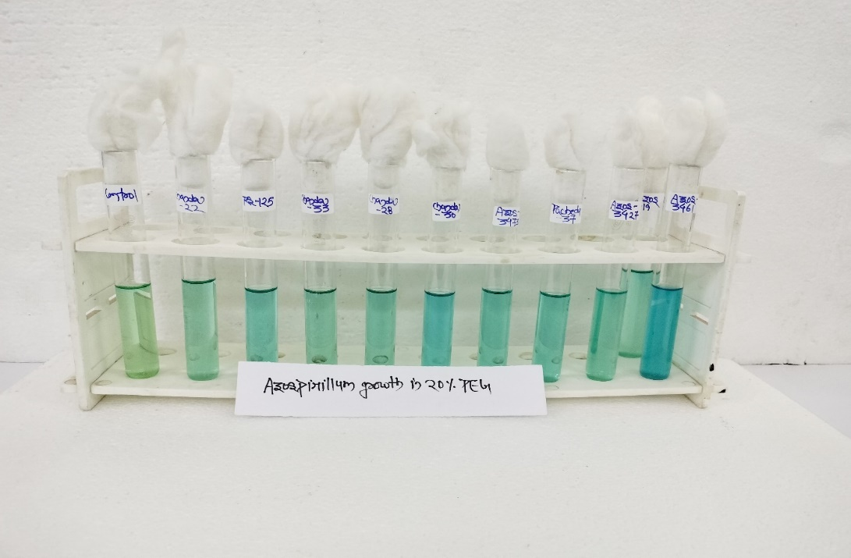

Figure 8. Screening of Azospirillum isolates based on their growth under 20% polyethylene glycol

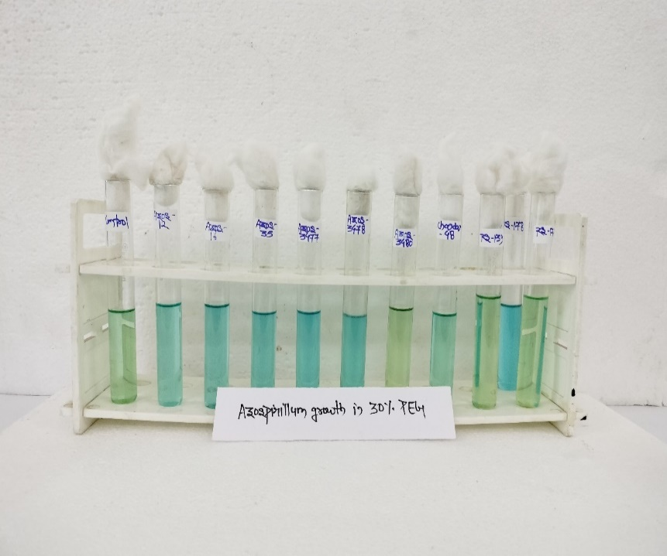
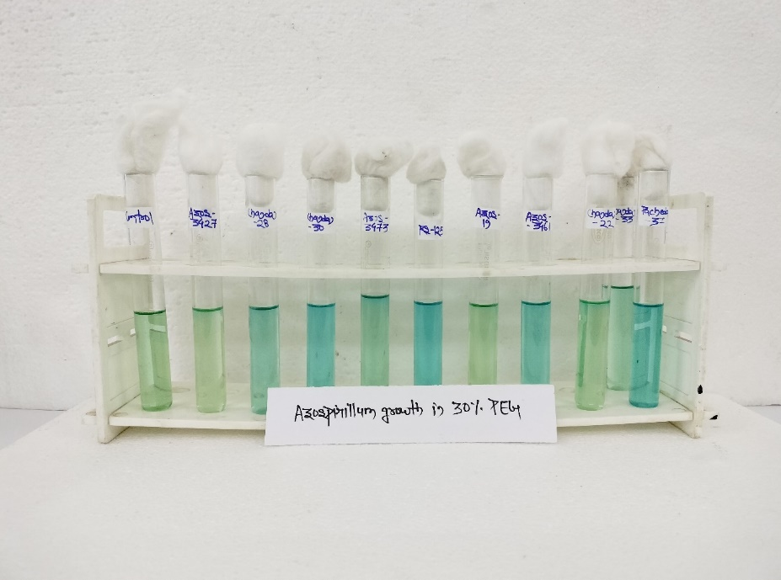

Figure 9. Screening of Azospirillum isolates based on their growth under 30% polyethylene glycol

Conclusion
The present study evaluated the biochemical traits and PEG-induced drought tolerance potential of twenty Azospirillum isolates. All isolates exhibited consistent Gram-negative reaction and were catalase-positive which confirm their typical taxonomic identity and their inherent ability to cope with oxidative conditions. Variability in metabolic traits was evident from the MR-VP and citrate utilization tests, indicating biochemical diversity within the isolates, which is important for screening and selecting functionally superior strains. Exposure to increasing concentrations of PEG-6000 revealed clear differences in drought tolerance among the isolates. Although growth declined in all isolates with rising osmotic stress, a few isolates consistently maintained higher optical density values even at 30% PEG. Among these, Azos-CH-48 emerged as the most drought-tolerant strain, followed by Azos-RS-177 and Azos-12, demonstrating stronger resilience and better physiological adaptation under water-limited conditions. Overall, the study highlights the presence of substantial physiological and biochemical variability among Azospirillum isolates and identifies a set of promising strains with high drought tolerance potential. These drought-tolerant isolates could be useful bio-inoculants for enhancing crop performance in conditions of water-stress.
DISCLAIMER (ARTIFICIAL INTELLIGENCE)
Author(s) hereby declare that NO generative AI technologies such as Large Language Models (ChatGPT, COPILOT, etc.) and text-to-image generators have been used during the writing or editing of this manuscript.
References
- Ahmad, M. A., Javed, R., Adeel, M., Rizwan, M., & Yang, Y. (2020). PEG 6000-Stimulated Drought Stress Improves the Attributes of In Vitro Growth, Steviol Glycosides Production, and Antioxidant Activities in Stevia rebaudiana Bertoni. Plants, 9(11), 1552. https://doi.org/10.3390/plants9111552
- Anjum, S. A., Xie, X., Wang, L. C., Saleem, M. F., Man, C., & Lei, W. (2011). Morphological, physiological and biochemical responses of plants to drought stress. African Journal of Agricultural Research, 6(9), 2026-2032. https://doi.org/10.5897/AJAR10.027
- Atlas, R. M. (2004). Handbook of microbiological media. CRC Press. https://doi.org/10.1201/9781420039726
- Azlin, C. O., Amir, H. G., & Chan, L. K. (2005). Isolation and characterization of diazotrophic rhizobacteria from oil palm roots. *Malaysian Journal of Microbiology*, *1*(1), 31-35. https://doi.org/10.21161/mjm.110506
- Barquero, M., Poveda, J., Laureano-Marín, A. M., Ortiz-Liébana, N., Brañas, J., & González-Andrés, F. (2022). Mechanisms involved in drought stress tolerance triggered by rhizobia strains in wheat. Frontiers in Plant Science, 13, 1036973. https://doi.org/10.3389/fpls.2022.1036973
- Bashan, Y., & de-Bashan, L. E. (2010). How the plant growth-promoting bacterium Azospirillum promotes plant growth—A critical assessment. Advances in Agronomy, 108, 77–136. https://doi.org/10.1016/S0065-2113(10)08002-8
- Beveridge, T. J. (2001). Use of the Gram stain in microbiology. Biotechnic & Histochemistry, 76(3), 111-118. https://doi.org/10.1080/714028139
- Cappuccino, J.G. and Sherman, N. 2013. Microbiology: a laboratory manual. Pearson Higher Ed.
- Cassán, F. D., Penna, C., Creus, C. M., Radovancich, D., Monteleone, E., García de Salamone, I., Di Salvo, L., Mentel, I., García, J., Pasarello Mayans, M. C., Lett, L. A. C., Puente, M., Correa, O., Punschke Valerio, K., Massa, R., Catafesta, M., Rossi, A., Díaz, M., Righes, S., Carletti, S., & Rodríguez Cáceres, E. (2015). Protocol for the quality control of Azospirillum spp. inoculants. In F. D. Cassán, Y. Okon, & C. M. Creus (Eds.), Handbook for Azospirillum: Technical Issues and Protocols (pp. 487-499). Springer. https://doi.org/10.1007/978-3-319-06542-7_27
- Cheesbrough, M. (2005). District laboratory practice in tropical countries, Part 2. Cambridge University Press. https://doi.org/10.1017/CBO9780511543470.001
- Creus, C. M., Sueldo, R. J., & Barassi, C. A. (2004). Water relations and yield in Azospirillum-inoculated wheat exposed to drought in the field. Canadian Journal of Botany, 82(2), 273-281. https://doi.org/10.1139/b03-119
- Di Salvo, L. P., Silva, E., Teixeira, K. R., Cote, R. E., Pereyra, M. A., & Garcia de Salamone, I. E. (2014). Physiological and biochemical characterization of Azospirillum brasilense strains commonly used as plant growth‐promoting rhizobacteria. Journal of Basic Microbiology, 54(12), 1310-1321. https://doi.org/10.1002/jobm.201400135
- Fadiji, A. E., Santoyo, G., Yadav, A. N., & Babalola, O. O. (2022). Efforts towards overcoming drought stress in crops: Revisiting the mechanisms employed by plant growth-promoting bacteria. Frontiers in Microbiology, 13, 962427. https://doi.org/10.3389/fmicb.2022.962427
- Fahad, S., Hussain, S., Bano, A., Saud, S., Hassan, S., Shan, D., Khan, F. A., Khan, F., Chen, Y., Wu, C., Tabassum, M. A., Chun, M. X., Afzal, M., Jan, A., Jan, M. T., & Huang, J. (2015). Potential role of phytohormones and plant growth-promoting rhizobacteria in abiotic stresses: Consequences for changing environment. Environmental Science and Pollution Research, 22(7), 4907–4921. https://doi.org/10.1007/s11356-014-3754-2
- Farooq, M., Hussain, M., Wahid, A., & Siddique, K. H. M. (2012). Drought stress in plants: An overview. In Plant Responses to Drought Stress: From Morphological to Molecular Features (pp. 1-33). Springer-Verlag Berlin Heidelberg. https://doi.org/10.1007/978-3-642-32653-0_1
- Forbes, B. A., Sahm, D. F., & Weissfeld, A. S. (2007). *Bailey & Scott's Diagnostic Microbiology*. Mosby, Elsevier, pp. 288-302. https://books.google.com/books/about/Bailey_Scott_s_Diagnostic_Microbiology.html?id=2_00AQAAIAAJ
- Fu, L., Ding, Z., Han, B., Hu, W., Li, Y., & Zhang, J. (2016). Physiological investigation and transcriptome analysis of polyethylene glycol (PEG)-induced dehydration stress in cassava. International Journal of Molecular Sciences, 17(3), 283. https://doi.org/10.3390/ijms17030283
- Fukami, J., Ollero, F. J., de la Osa, C., Valderrama-Fernández, R., Nogueira, M. A., Megías, M., & Hungria, M. (2018). Antioxidant activity and induction of mechanisms of resistance to stresses related to the inoculation with Azospirillum brasilense. Archives of Microbiology, 200, 1191-1203. https://doi.org/10.1007/s00203-018-1535-x
- García, J. E., Maroniche, G., Creus, C., Suárez-Rodríguez, R., Ramirez-Trujillo, J. A., & Groppa, M. D. (2017). In vitro PGPR properties and osmotic tolerance of different Azospirillum native strains and their effects on growth of maize under drought stress. Microbiological Research, 202, 21-29. https://doi.org/10.1016/j.micres.2017.04.007
- Ghosh, D., Gupta, A., & Mohapatra, S. (2019). A comparative analysis of exopolysaccharide and phytohormone secretions by four drought-tolerant rhizobacterial strains and their impact on osmotic-stress mitigation in Arabidopsis thaliana. World Journal of Microbiology and Biotechnology, 35(6), 90. https://doi.org/10.1007/s11274-019-2659-0
- Glick, B. R. (2014). Bacteria with ACC deaminase can promote plant growth and help to feed the world. Microbiological Research, 169(1), 30-39. https://doi.org/10.1016/j.micres.2013.09.009
- Goszcz, A., Furtak, K., Stasiuk, R., Wójtowicz, J., Musiałowski, M., Schiavon, M., & Dębiec-Andrzejewska, K. (2025). Bacterial osmoprotectants-a way to survive in saline conditions and potential crop allies. FEMS Microbiology Reviews. https://doi.org/10.1093/femsre/fuaf020
- Gouffi, K., & Blanco, C. (2000). Is the accumulation of osmoprotectant the unique mechanism involved in bacterial osmoprotection?. International Journal of Food Microbiology, 55(1-3), 171-174. https://doi.org/10.1016/s0168-1605(00)00192-6
- Gram, C., 1884. The differential staining of Schizomycetes in tissue sections and in dried preparations. Fortschitte der Medicin, 2(6), pp.185-189. https://scholar.google.com/scholar?q=Gram+1884
- Gupta, A., Rico-Medina, A., & Caño-Delgado, A.I. (2020). The physiology of plant responses to drought. Science, 368(6488), 266-269. https://doi.org/10.1126/science.aaz7614
- Gupta, A. K., Tyagi, P., & Sehgal, V. K. (2011). Drought disaster challenges and mitigation in India: strategic appraisal. *Current Science*, *100*(12), 1795-1806. https://www.semanticscholar.org/paper/Drought-disaster-challenges-and-mitigation-in-Gupta-Tyagi/26a80661809f756fd84cfacecebcf4cea5e0f3b7
- Haghpanah, M., Hashemipetroudi, S., Arzani, A., & Araniti, F. (2024). Drought tolerance in plants: physiological and molecular responses. Plants, 13(21), 2962. https://doi.org/10.3390/plants13212962
- Hamayun, M., Khan, S.A., Shinwari, Z.K., Khan, A.L., Ahmad, N. and Lee, I.J., 2010. Effect of polyethylene glycol induced drought stress on physio-hormonal attributes of soybean. Pak. J. Bot, 42(2), pp.977-986. https://mail.pakbs.org/pjbot/PDFs/42(2)/PJB42(2)0977.pdf
- Hossain, M., Jahan, I., Akter, S., Rahman, N. and Rahman, B. 2015. Isolation and identification of Azospirillum isolates from different paddy fields of North Bengal. Indian Journal of Research in Pharmacy and Biotechnology, 3(1): 74-80. https://www.academia.edu/download/50471082/Isolation_and_identification_of_Azospiri20161121-7108-1l791t0.pdf
- Ilyas, N., Bano, A., Iqbal, S., & Raja, N.I. (2012). Physiological, biochemical and molecular characterization of Azospirillum spp. isolated from maize under water stress. *Pakistan Journal of Botany*, *44*, 71-80. https://www.pakbs.org/pjbot/archive.php?vol=44&issue=1
- Ilyas, N., Mumtaz, K., Akhtar, N., Yasmin, H., Sayyed, R. Z., Khan, W., El Enshasy, H. A., Dailin, D. J., Elsayed, E. A., & Ali, Z. (2020). Exopolysaccharides producing bacteria for the amelioration of drought stress in wheat. *Sustainability*, *12*(21), 8876. https://doi.org/10.3390/su12218876
- Cappuccino, J. G., & Welsh, C. T. (2017). Microbiology: A laboratory manual, Global Edition. Pearson. https://www.pearson.com/uk/educators/higher-education-educators/product/Microbiology-A-Laboratory-Manual-Global-Edition-11th-edition/9781292175782.html
- Jayasurya, A. and Grover, M. 2023. Studies on endurance of Azospirillum formosense strains to osmotic stress and modulation of early stage pearl millet growth. Applied Biochemistry and Microbiology, 59(2): 206-215. https://doi.org/10.1134/s0003683823020023
- Kanimozhi, K., & Panneerselvam, A. (2011). Studies on Morphological, Physiological and Biochemical characterization Azospirillum spp. Research Journal of Science and Technology, 3(2), 85-94. https://rjstonline.com/ (Navigate to Past Issues -> Volume 3, Issue 2, 2011)
- Kasim, W. A., Osman, M. E. H., Omar, M. N., & Salama, S. (2021). Enhancement of drought tolerance in Triticum aestivum L. seedlings using Azospirillum brasilense NO40 and Stenotrophomonas maltophilia B11. Bulletin of the National Research Centre, 45(1), 1–14. https://doi.org/10.1186/s42269-021-00546-6
- Khan, N., & Bano, A. (2019). Exopolysaccharide producing rhizobacteria and their impact on growth and drought tolerance of wheat grown under rainfed conditions. PLoS One, 14(9), e0222302. https://doi.org/10.1371/journal.pone.0222302
- Kumar, A., Patel, J. S., Meena, V. S., & Ramteke, P. W. (2019). Plant growth-promoting rhizobacteria: strategies to improve abiotic stresses under sustainable agriculture. Journal of Plant Nutrition, 42(11-12), 1402-1415. https://doi.org/10.1080/01904167.2019.1616757
- Latif, M., Bukhari, S. A. H., Alrajhi, A. A., Alotaibi, F. S., Ahmad, M., Shahzad, A. N., Dewidar, A. Z., & Mattar, M. A. (2022). Inducing drought tolerance in wheat through exopolysaccharide-producing rhizobacteria. Agronomy, 12(5), 1140. https://doi.org/10.3390/agronomy12051140
- Lopes, T., Cardoso, P., Matos, D., Rocha, R., Pires, A., Marques, P., & Figueira, E. (2022). Graphene oxide influence in soil bacteria is dose dependent and changes at osmotic stress: growth variation, oxidative damage, antioxidant response, and plant growth promotion traits of a Rhizobium strain. Nanotoxicology, 16(5), 549-565. https://doi.org/10.1080/17435390.2022.2109528
- Manschadi, A. M., Christopher, J., deVoil, P., & Hammer, G. L. (2006). The role of root architectural traits in adaptation of wheat to water-limited environments. Functional Plant Biology, 33(9), 823-837. https://doi.org/10.1071/FP06055
- Mehnaz, S., & Lazarovits, G. (2006). Inoculation effects of Pseudomonas putida, Gluconacetobacter azotocaptans, and Azospirillum lipoferum on corn plant growth under greenhouse conditions. Microbial Ecology, 51(3), 326-335. https://doi.org/10.1007/s00248-006-9039-7
- Michel, B. E., & Kaufmann, M. R. (1973). The osmotic potential of polyethylene glycol 6000. Plant Physiology, 51(5), 914–916. https://doi.org/10.1104/pp.51.5.914
- Mishra, N., Tripathi, M. K., Tiwari, S., Tripathi, N., Sapre, S., Ahuja, A., & Tiwari, S. (2021). Cell suspension culture and in vitro screening for drought tolerance in soybean using poly-ethylene glycol. Plants, 10(3), 517. https://doi.org/10.3390/plants10030517
- Mokeev, D. I., Volokhina, I. V., Telesheva, E. M., Evstigneeva, S. S., Grinev, V. S., Pylaev, T. E., Petrova, L. P., & Shelud'ko, A. V. (2022). Resistance of biofilms formed by the soil bacterium Azospirillum brasilense to osmotic stress. Microbiology, 91(6), 682-692. https://doi.org/10.1134/s0026261722601567
- Muthukumar, A., Sandhya, G. M., & Dakshayini, G. (2021). Morphological and biochemical characterization – A comparative analysis of non-commercial and commercial plant growth promoting microorganisms. International Journal of Current Microbiology and Applied Sciences, 10(2), 867-874. https://doi.org/10.20546/ijcmas.2021.1002.102
- Narayan, R. and Gupta, N.C. 2018. Isolation, cultural and physiological characterisation of Azospirillum from acidic soils of Ranchi. J Pharmacognosy and Phytochem, 7(4): 2611-2617. https://www.academia.edu/download/84793034/7-4-386-726.pdf
- Ogunniyi, D. E., Onukogu, S. C., Jaiyeola Tolulope, & Ogunyemi, A. D. (2024). Isolation of Azospirillum spp and Evaluation of its Plant Growth Promoting Abilities. BIOMED Natural and Applied Science, 4(1), 23-29. https://doi.org/10.53858/bnas04010109
- Okon, Y., & Labandera-Gonzalez, C. A. (1994). Agronomic applications of Azospirillum: An evaluation of 20 years worldwide field inoculation. *Soil Biology and Biochemistry*, *26*(12), 1591-1601. https://doi.org/10.1016/0038-0717(94)90311-5
- Omar, M.N., Osman, M.E., Kasim, W.A. and Salama, S. 2017. Characterization of two drought-tolerant PGPB. Azospirillum brasilense NO40 and Stenotrophomonas maltophilia. Journal of Environmental Sciences, 46(2): 121-136. https://doi.org/10.1186/s42269-021-00546-6
- Paul, M. J., Primavesi, L. F., Jhurreea, D., & Zhang, Y. (2008). Trehalose metabolism and signaling. Annual Review of Plant Biology, 59(1), 417-441. https://doi.org/10.1146/annurev.arplant.59.032607.092945
- Rabara, S., Vishwakarma, N. P., & Patel, S. (2023). Isolation and Biochemical Identification of N2 Fixing Bacteria (Azospirillium Sp.) from Saurashtra Region. Current Agriculture Research Journal, 11(1), 277-286. https://doi.org/10.12944/CARJ.11.1.24
- Reis, V. M., Baldani, V. L. D., & Baldani, J. I. (2015). Isolation, identification and biochemical characterization of Azospirillum spp. and other nitrogen-fixing bacteria. In F. D. Cassán, Y. Okon, & C. M. Creus (Eds.), Handbook for Azospirillum: Technical issues and protocols (pp. 3-26). Springer International Publishing. https://doi.org/10.1007/978-3-319-06542-7_1
- Sandhya, V. D., Ali, S. Z., Grover, M., Reddy, G., & Venkateswarlu, B. (2009). Alleviation of drought stress effects in sunflower seedlings by the exopolysaccharides producing Pseudomonas putida strain GAP-P45. Biology and Fertility of Soils, 46, 17-26. https://doi.org/10.1007/s00374-009-0401-z
- Sardar, N., Kamil, M., & Kabir-ud-Din. (2017). Studies on solution behavior of aqueous mixtures of nonionic polymer in presence of cationic surfactants. Journal of Surfactants and Detergents, 20(3), 631-645. https://doi.org/10.1007/s11743-017-1932-1
- Saxena, S.C., Kaur, H., Verma, P., Petla, B.P., Andugula, V.R., & Majee, M. (2013). Osmoprotectants: Potential for Crop Improvement Under Adverse Conditions. In N. Tuteja & S.G. Singh (Eds.), Plant Acclimation to Environmental Stress (pp. 197-232). Springer. https://doi.org/10.1007/978-1-4614-5001-6_9
- Schimel, J., Balser, T. C., & Wallenstein, M. (2007). Microbial stress-response physiology and its implications for ecosystem function. Ecology, 88, 1386-1394. https://doi.org/10.1890/06-0219
- Sharma, P., & Dubey, R.S. (2005). Drought induces oxidative stress and enhances the activities of antioxidant enzymes in growing rice seedlings. Plant Growth Regulation, 46(3), 209-221. https://doi.org/10.1007/s10725-005-0002-2
- Shubha, S., Savalagi, V. P., Anantha Rama, A., & Santoshagowda, G. B. (2014). Occurrence and microbiological characteristics of Azospirillum strains associated with wheat rhizoplane and endorhizosphere. Biochemical and Cellular Archives, 14, 81-88. https://connectjournals.com/bca
- Solanki, M. K., Solanki, A. C., Kumari, B., Kashyap, B. K., & Singh, R. K. (2020). Plant and soil-associated biofilm-forming bacteria: Their role in green agriculture. In M. K. Yadav & B. P. Singh (Eds.), New and future developments in microbial biotechnology and bioengineering: Microbial biofilms (pp. 151-164). Elsevier. https://doi.org/10.1016/b978-0-444-64279-0.00012-8
- Steenhoudt, O., & Vanderleyden, J. (2000). Azospirillum, a free-living nitrogen-fixing bacterium closely associated with grasses: genetic, biochemical and ecological aspects. FEMS Microbiology Reviews, 24(4), 487-506. https://doi.org/10.1111/j.1574-6976.2000.tb00552.x
- Sulaiman, K. H., Al-Barakah, F. N., Assafed, A. M., & Dar, B. A. M. (2019). Isolation and identification of Azospirillum and Azotobacter species from Acacia spp. at Riyadh, Saudi Arabia. Bangladesh Journal of Botany, 48(2), 239-251. https://doi.org/10.3329/bjb.v48i2.47546
- Tarrand, J. J., Krieg, N. R., & Döbereiner, J. (1978). A taxonomic study of the Spirillum lipoferum group, with descriptions of a new genus, Azospirillum gen. nov. and two species, Azospirillum lipoferum (Beijerinck) comb. nov. and Azospirillum brasilense sp. nov. Canadian Journal of Microbiology, 24(8), 967–980. https://doi.org/10.1139/m78-160
- Teale, W. D., Paponov, I. A., & Palme, K. (2006). Auxin in action: signalling, transport and the control of plant growth and development. Nature Reviews Molecular Cell Biology, 7(11), 847-859. https://doi.org/10.1038/nrm2020
- Tejera, N., Lluch, C., Martínez-Toledo, M. V., & González-López, J. (2005). Isolation and characterization of Azotobacter and Azospirillum strains from the sugarcane rhizosphere. Plant and Soil, 270, 223-232. https://doi.org/10.1007/s11104-004-1522-7
- Tyagi, S., & Singh, D. K. (2014). Azospirillum himalayense sp. nov., a nifH bacterium isolated from Himalayan valley soil, India. Annals of Microbiology, 64(1), 259-266. https://doi.org/10.1007/s13213-013-0658-1
- Vurukonda, S. S. K. P., Vardharajula, S., Shrivastava, M., & SkZ, A. (2016). Enhancement of drought stress tolerance in crops by plant growth promoting rhizobacteria. Microbiological Research, 184, 13-24. https://doi.org/10.1016/j.micres.2015.12.003
- Yadav, N. S., Issar Sakshi, & Gaur, R. K. (2024). Biochemical characterization of bacteria isolated from Rhizosphere soils of sugarcane grown in Uttar Pradesh. *Research Journal of Biotechnology*, *19*(3), 70–75. https://doi.org/10.25303/1903rjbt070075
- Yang, J., Kloepper, J. W., & Ryu, C. M. (2009). Rhizosphere bacteria help plants tolerate abiotic stress. Trends in Plant Science, 14(1), 1-4. https://doi.org/10.1016/j.tplants.2008.10.004
- Zaheer, M. S., Ali, H. H., Iqbal, M. A., Erinle, K. O., Javed, T., Iqbal, J., Hashmi, M. I. U., Mumtaz, M. Z., Salama, E. A. A., Kalaji, H. M., & Wróbel, J. (2022). Cytokinin production by Azospirillum brasilense contributes to increase in growth, yield, antioxidant, and physiological systems of wheat (Triticum aestivum L.). Frontiers in Microbiology, 13, 886041. https://doi.org/10.3389/fmicb.2022.886041
- Zandi, P., & Schnug, E. (2022). Reactive oxygen species, antioxidant responses and implications from a microbial modulation perspective. Biology, 11(2), 155. https://doi.org/10.3390/biology11020155
- Navyashree R, Mummigatti U.V, Nethra P, Basavaraj B & Hanamaratti N. G. (2024). Assessment of Drought Tolerance in Rabi Sorghum Genotypes under Polyethylene Glycol-induced Osmotic Stress. Journal of Experimental Agriculture International, 46(8), 577–584. https://doi.org/10.9734/jeai/2024/v46i82738

