Original Research Article
Conversion Effects on Soil Aggregate Stability Under Different Land Uses

ABSTRACT
One of the main causes of soil structural degradation is land use change, which has a direct impact on aggregate stability, a crucial sign of soil resilience, quality, and long-term productivity. This study evaluated how the conversion of forests to agriculture affected the stability of soil aggregates in Kashmir's Kupwara area. A total of 120 soil samples were gathered, 60 of which came from agricultural lands and the other 60 from forest sites. Together with a few supporting soil metrics, such as pH, electrical conductivity (EC), bulk density, particle density, porosity, organic carbon, calcium carbonate content, cation exchange capacity (CEC), and accessible nitrogen, aggregate stability was assessed using the wet sieving method. The findings demonstrated that, in contrast to agricultural soils, which were more susceptible to structural failure under outside influences, forest soils had noticeably greater aggregate stability. Reduced organic matter inputs and the results of intensive management techniques were closely linked to the deterioration in soil stability in farmed areas. These results demonstrate how the transition from forest to agricultural speeds up structural deterioration, increasing the likelihood of erosion and fertility loss. Therefore, it is crucial to support sustainable land management techniques in order to preserve soil aggregation, fertility, and ecosystem services in delicate temperate landscapes. The findings highlight the need for conserving forest ecosystems and adopting sustainable soil management practices in agricultural lands to prevent further structural degradation. Future research should focus on integrating conservation tillage, organic amendments, and land-use planning strategies to restore soil aggregation and enhance long-term soil resilience in fragile temperate ecosystems.
Keywords: Agriculture; Aggregate stability; Forest soils; Land use change; Soil structure; Sustainable land management

1. INTRODUCTION
Covering nearly a third of the world's land area, forests constitute one of the most important ecosystems on the planet. They are essential for maintaining biodiversity, storing carbon, and controlling the climate (Keenan et al., 2015; Crowther et al., 2015). With about 800 Pg of carbon stored in plants, litter, and soils, they serve as the greatest terrestrial carbon sinks in the world (Lladó et al., 2017). However, as the demand for food, fiber, and energy increases, these ecosystems are becoming more and more threatened by deforestation and agricultural expansion (Zhang et al., 2022). These changes in land use and land cover (LULC) have since been found to be important causes of ecological instability and soil degradation. (Li et al., 2024). Because it throws off the balance of physical, chemical, and biological processes, the conversion of forest land to agriculture has a significant impact on soil quality. The ability of soil aggregates to withstand disintegration under external factors like wind, tillage, or rainfall makes soil aggregate stability one of the most crucial of these (Six et al., 2000). While unstable aggregates are more likely to break down and cause crusting, compaction, and erosion, stable aggregates enhance soil porosity, water infiltration, and organic matter retention (Tisdall & Oades, 1982; Spurgeon et al., 2013). Compared to agricultural soils, forest soils that are rich in biological activity and organic inputs typically exhibit superior aggregate stability (Singh et al., 2019).
In mountainous and temperate regions, soil structural stability is particularly sensitive to land use changes due to steep slopes, fragile soil profiles, and intense climatic variability. Conversion of forest land to agriculture in such environments often disrupts natural soil aggregation processes, leading to increased erosion risk, nutrient losses, and decline in soil fertility (Mandal and Banik, 2025). Soil aggregate stability therefore serves as a reliable indicator for assessing the impacts of land use change on soil health and ecosystem sustainability. Evaluating aggregate stability under contrasting land uses provides critical insights into soil degradation processes and supports the development of region-specific conservation strategies. Despite its importance, limited field-based information is available from temperate Himalayan regions like Kashmir, necessitating focused investigations.
Intensive tillage, mono cropping, and fertilizer use are examples of agricultural management approaches that frequently undermine the structural integrity of soil, reduce the amount of organic matter, and speed up the disintegration of macro aggregates into micro aggregates (Naresh et al, 2017). Converted agricultural soils are therefore more vulnerable to nitrogen loss, erosion, and a long-term drop in production (Lucas et al., 2023). Due to steep slopes, high propensity for erosion, and intense human pressures, recent data from delicate mountain ecosystems, such as the Himalayas, indicates that land use change increases these hazards (Masruroh et al., 2025). The Kashmir Valley's Kupwara district is an example of an environmentally fragile area where substantial forest-to-agricultural conversion is taking place. Understanding the hazards of soil degradation while establishing sustainable land management plans for temperate ecosystems depend on evaluating changes in soil aggregate stability under these land use transitions. In order to shed light on safeguarding soil structural integrity and long-term ecosystem resilience, the current study assesses the effect of forest-to-agriculture conversion on soil aggregate stability in Kupwara.

2. MATERIALS AND METHODS
2.1 Experimental Site
The current research investigation took place in Kupwara District, which is in the northern section of the Kashmir Valley in the Union Territory of Jammu and Kashmir, India. Geographically, the district spreads across an area of around 2,379 km² and is between the Pir Panjal and Shamsbari mountain ranges. Kupwara shares international boundaries with Pakistan-administered regions to the north and west, while it is bordered by Baramulla in the south and Bandipora in the east. The district's elevation changes from about 1,600 m in the valley floors to more than 4,000 m above mean sea level (amsl). The region is drained by the Kishanganga River and its tributaries, which are crucial for irrigation and farming. The Kishanganga River and its tributaries drain the area and are essential to agriculture and irrigation. Because Kupwara district produces more than 50,000 tonnes of walnuts a year, it is frequently referred to as the "Walnut District" of Kashmir. Additionally, it uses 68,500 hectares of agricultural and horticultural area to produce almost 300,000 tonnes of apples. ArcGIS software was used to generate a high-resolution study area map, highlighting the spatial distribution of the sampling sites across forest and agricultural land uses in Kupwara district. Fig. 1 illustrates the geographical setting of Kupwara, from national (India) to regional (J&K UT) scale, along with mapped sampling sites.

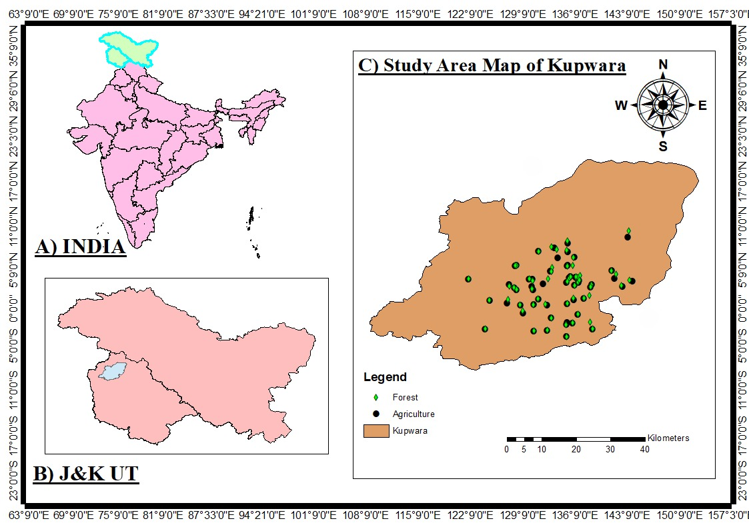
Fig. 1 Study area map of Kupwara District showing sampling sites across different land uses

2.2 Climate
Because of its diverse topography, Kupwara has a varied climate. Higher elevations typically see below-freezing temperatures, while the lower valleys have a temperate climate with warm summers (15–30 °C) and cold winters. The region receives 800 –1200 mm of precipitation annually, mostly during the June–September southwestern monsoon, with winter snowfall serving as a supplement. A range of horticultural crops, including rice and maize, can be grown thanks to this precipitation pattern.
2.3 Soil
The majority of Kupwara's soils are Alfisols, which are distinguished by their fertility and advantageous drainage characteristics. Clay loam soils under rainfed conditions predominate in mid-altitude temperate zones, while rocky soils with little moisture retention are found at higher elevations (>1500 m). The silty loam to clay loam soils that are commonly irrigated and sustain intensive agriculture and horticulture are found in the lower temperate belt (above 1,450 m). Together, all of these soil types facilitate the district's high levels of biological variety and agricultural output.
2.4 Processing of Samples and Aggregate Stability
Two sections of soil samples were taken from agricultural and forest land uses. While the other portion was air-dried at room temperature, ground with a mortar and pestle, and sieved through a 2 mm mesh for physicochemical analysis, the first portion was kept in sterile zipper bags at 4 °C for microbiological analysis. The wet sieving method was used to determine the aggregate stability (Kemper & Rosenau, 1966). Aggregates retained on a 4 mm screen were employed for examination after bulk soil samples were run through an 8 mm sieve. On top of a nest of 2.36, 2.0, 1.0, 0.5, and 0.25 mm sieves, 50 grams of air-dried aggregates were dropped. Aggregates were allowed to saturate gradually for ten minutes by capillary rise when the sieve set was submerged in water until the base of the top sieve barely touched the water's surface. The sieves were then submerged for 30 minutes and oscillated vertically at 30 cycles per minute. Following sand correction, the soil fractions that were retained on each sieve were gathered, oven-dried at 105 °C, and weighed. The percentage of soil retained in each size class served as an indicator of aggregate stability.
3. RESULTS
Land use change from forest to agriculture exerted a pronounced influence on soil aggregate stability, resulting in a marked decline in soil structural integrity under cultivation (Table 1). Forest soils recorded a significantly higher mean aggregate stability (69.26%) compared to agricultural soils (51.52%), indicating that natural vegetation favors the formation and preservation of stable aggregates through continuous organic matter inputs and minimal mechanical disturbance. The stability range in forest soils (45.02–86.97%) was generally higher than that observed in agricultural soils (40.02–74.53%), reflecting comparatively better structural conditions under forest cover, whereas agricultural soils exhibited a wider spread toward lower values, likely driven by site-specific management practices such as tillage, residue removal, and fertilizer application.
Variability indicators further emphasized the contrasting effects of land use. Forest soils exhibited moderate variability (CV = 14.52%) with a standard error of 1.31, suggesting relatively consistent aggregate stability across locations. In contrast, agricultural soils showed comparable variability (CV = 14.38%) but a slightly lower standard error (0.96), highlighting heterogeneity in structural stability arising from cultivation-induced disturbances. The minimum aggregate stability value in agricultural soils (40.02%) was considerably lower than that of forest soils (45.02%), indicating greater susceptibility of cultivated soils to aggregate breakdown. Conversely, the maximum aggregate stability recorded under forest land use (86.97%) exceeded that of agricultural soils (74.53%), underscoring the superior capacity of forest ecosystems to maintain stable macro-aggregates. Overall, the observed trend (Forest > Agriculture) confirms that land use conversion significantly reduces soil structural resilience. The consistently higher stability in forest soils can be attributed to the protective effects of litter accumulation, root proliferation, and microbial activity, whereas reduced stability in agricultural soils reflects organic matter depletion, mechanical disruption, and weakened biological binding agents. These findings highlight the importance of conserving forest cover and adopting sustainable land management practices to maintain soil structural stability and mitigate degradation in temperate environments.

Table 1: Aggregate Stability (%) under Forest and Agriculture land uses
Locations | Aggregate Stability (%)
Locations | Forest | Agriculture
Treach | 65.19 | 46.27
Gundgushi | 70.82 | 48.73
Khumriyal | 60.91 | 42.9
Manzhar | 71.29 | 47.45
Water Khani | 72.29 | 52.51
Karihama | 65.29 | 54.67
Dardsun | 66.34 | 50.31
Shatmuqam | 79.01 | 57.34
Shalpora | 64.92 | 40.02
Zangil | 71.29 | 51.51
Muqami Shahwali | 61.03 | 43.14
Pazipora | 70.73 | 53.63
Keegam | 75.37 | 49.26
Zachaldara | 83.94 | 42.39
Waiyan | 65.1 | 53.14
Qalmabad | 66.49 | 49.26
Nagri | 75.37 | 55.74
Reshigund | 66.68 | 43.78
Lach | 82.01 | 41.73
Guzriyal | 54.18 | 53.14
Shatgund | 50.19 | 57.34
Gulgam | 70.34 | 47.21
Mawer | 45.02 | 62.9
Shanoo | 82.92 | 41.96
Jaggerpora | 68.29 | 52.51
Mugalpora | 51.93 | 40.55
Goose | 78.02 | 56.2
Hafrada | 71.29 | 49.26
Langate | 52.96 | 44.24
Hatmulla | 68.29 | 43.92
Kandi Khas | 72.19 | 51.73
Sogam | 82.31 | 41.96
Gundmancher | 65.18 | 51.54
Trehgam | 82.72 | 60.12
Ogabal | 70.27 | 54.67
Haril | 81.91 | 58.48
Halmantpora | 47.86 | 50.11
Kachi Hama | 75.1 | 52.53
Hangalkoot | 65.49 | 62.9
Krihimpora | 70.19 | 45.96
Marble Colony | 71.29 | 62.39
Bumhama | 71.29 | 50.87
Chandigam | 82.83 | 61.73
Dedikoot | 65.49 | 43.78
Anderhama | 65.43 | 74.53
Punzwa | 69.42 | 40.31
Shumnag | 59.93 | 47.21
Daril | 82.12 | 59.04
Meelyal | 68.24 | 64.53
Putushy | 55.93 | 40.31
Awoora | 77.19 | 56.2
Chipeer | 49.82 | 54.76
Dedi Koot | 72.18 | 58.9
Dorusa | 82.62 | 51.73
Gungloosa | 77.15 | 54.88
Lawoosa | 53.93 | 52.41
Manigah | 72.29 | 40.53
Shatpora | 80.12 | 56.27
Tarathpora | 66.36 | 61.08
Wayne | 86.97 | 51.54
Mean | 69.26 | 51.52
SE | 1.31 | 0.96
SD | 10.06 | 7.41
Min. | 45.02 | 40.02
Max. | 86.97 | 74.53
Confidence Level (95.0%) | 2.62 | 1.93
CV% | 14.52 | 14.38

3.1 Box plot (Forest vs Agriculture)
The box plot (Fig. 2) illustrates a pronounced contrast in aggregate stability between forest and agricultural land uses. Forest soils exhibited a higher median aggregate stability and a distribution skewed toward higher values, indicating stronger and more persistent soil structural stability under natural vegetation. The interquartile range for forest soils was comparatively narrower, reflecting relatively consistent aggregation across sites. In contrast, agricultural soils displayed a lower median value and a broader spread toward the lower end of the distribution, highlighting reduced aggregate stability under cultivation. The wider dispersion of values in agricultural soils indicates greater structural heterogeneity, likely arising from differences in tillage intensity, residue management, and fertilizer use. Although variability was comparable between land uses (CV ≈ 14.5% in forest and 14.38% in agriculture), the downward shift of the agricultural distribution emphasizes the negative impact of land use conversion on soil structure.

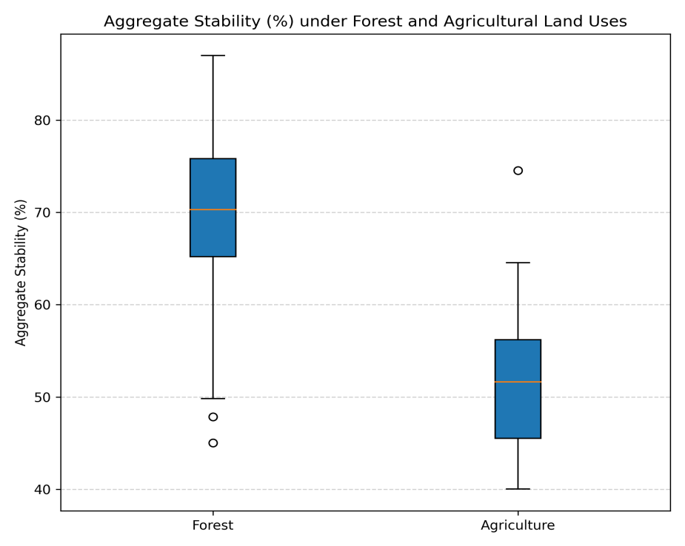
Fig. 2 The box plot between forest and agricultural land uses

3.2 Violin Plot (Distribution Shape)
The violin plot (Fig. 3) illustrates the distribution and density of aggregate stability values under forest and agricultural land uses. Forest soils exhibited a more symmetrical and compact distribution centered on higher aggregate stability values, indicating relatively uniform and stable soil structure across sites. In contrast, agricultural soils showed a broader and more asymmetrical distribution, with density extending toward lower stability values. This wider spread reflects greater heterogeneity and structural disturbance under cultivation. The clustering of forest samples around higher stability levels highlights the role of natural vegetation in maintaining well-aggregated soils, whereas the downward shift and dispersion observed in agricultural soils emphasize the adverse impact of land use conversion on soil structural integrity.
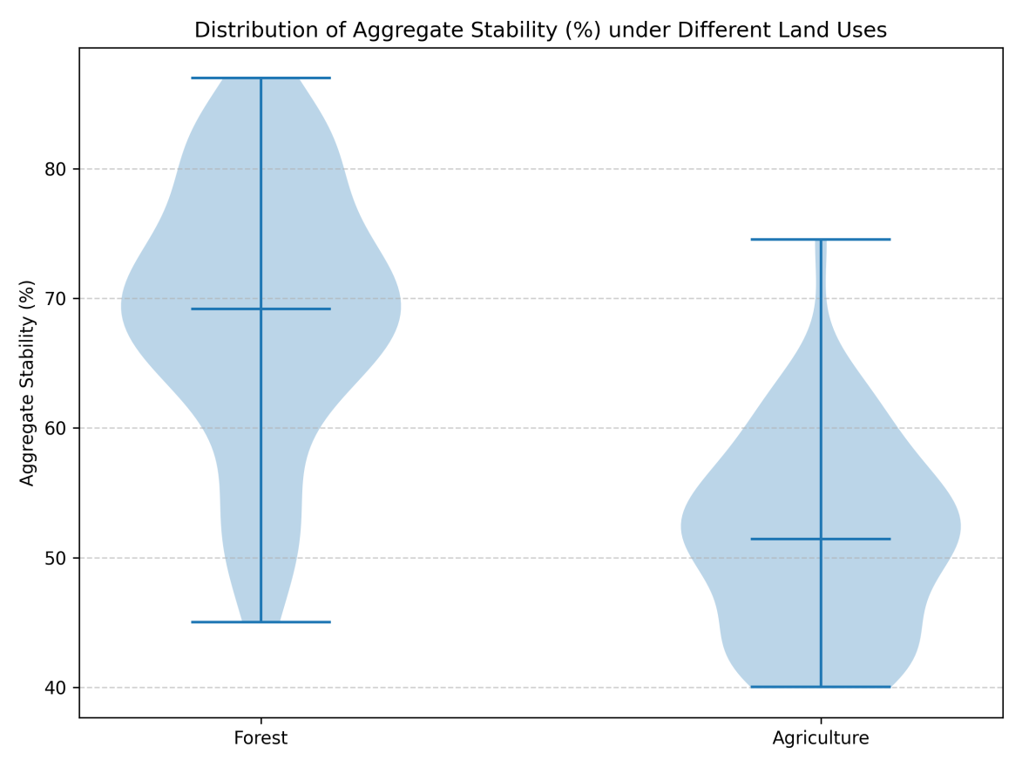
Fig. 3 The violin plot for forest and agricultural land uses
3.3 Trend Plot (Paired Location-wise Comparison)
Aggregate stability between agriculture and forests is compared by location using the paired trend plot (Fig. 4). Almost all sites exhibit a steady downward tendency, with agriculture displaying lower values in comparison to the matching forest location. While lesser variations at sites like Trehgam and Ogabal imply that localized management or soil conditions may act as a buffer against aggregate loss, the sharp losses at sites like Wayne, Shatpora, and Manigah highlight the susceptibility of aggregates under cultivation. The evidence that land use conversion causes a systematic decline in soil structural stability is reinforced by this matched visualization.

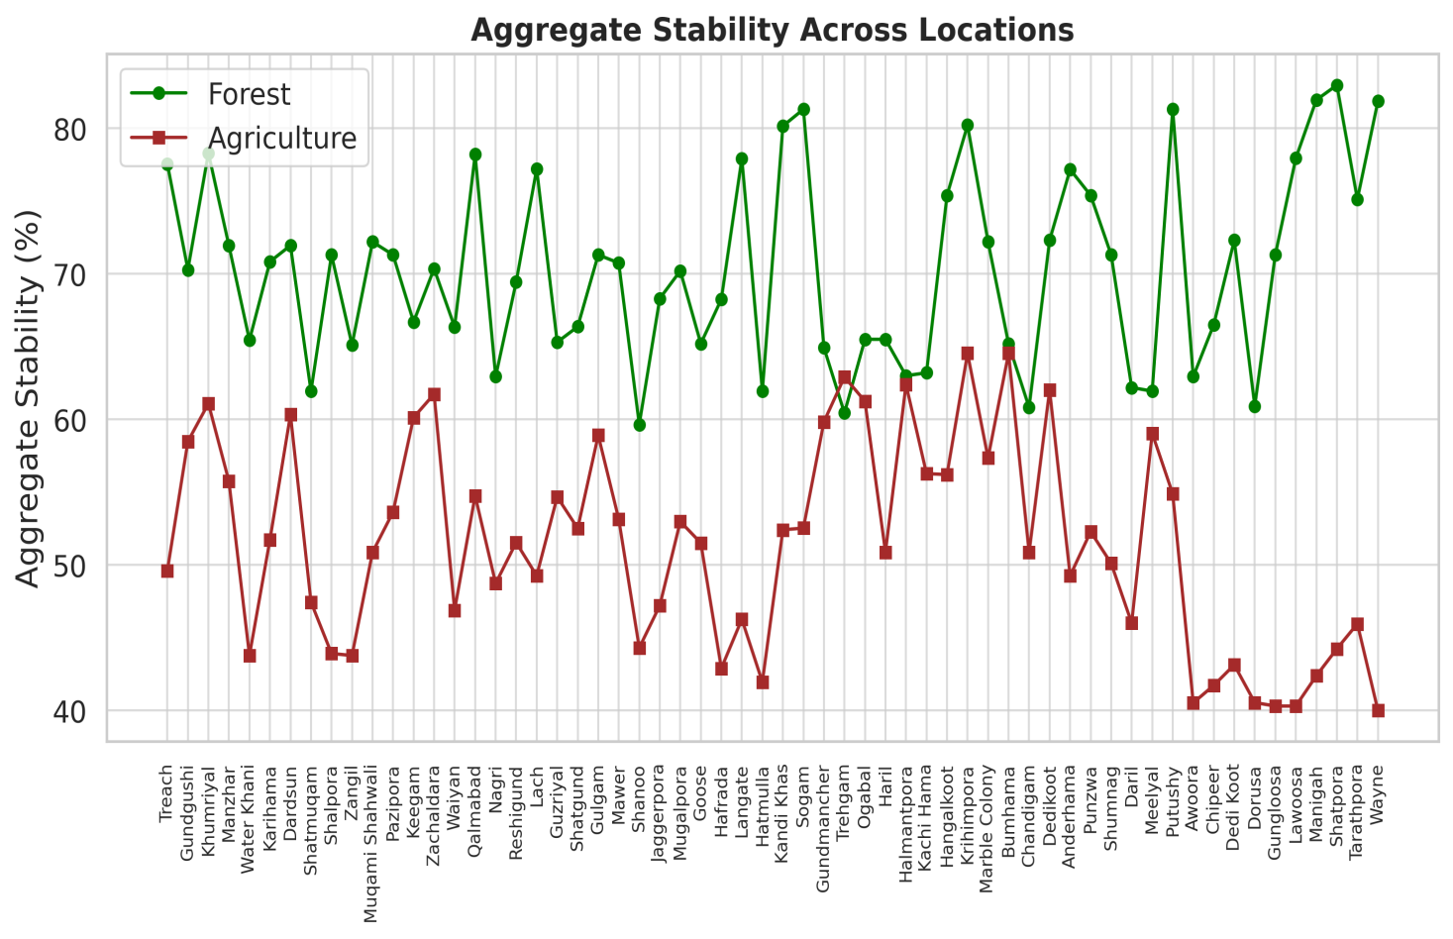
Fig. 4 Trend Plot (Paired Location-wise Comparison) between agriculture and forests
4. DISCUSSION
The results of this study clearly indicate that land use conversion from forest to agriculture significantly reduces soil aggregate stability. Forest soils consistently exhibited higher aggregate stability (mean=69.26%) than agricultural soils (51.52%), highlighting the role of natural vegetation in maintaining soil structural integrity. Improved aggregation under forest cover can be attributed to continuous organic matter inputs, limited mechanical disturbance, and enhanced biological activity, particularly from fungal networks and root systems (Six et al., 2006; Centenaro et al., 2018; Sithole et al., 2019). Variability in aggregate stability was comparable between land uses (CV ≈ 14.5%), but agricultural soils showed a downward shift toward lower stability values (40.02–74.53%) compared to forests (45.02–86.97%). This decline reflects the disruptive effects of cultivation practices such as tillage, residue removal, and reduced biological binding agents (Nugroho et al., 2024). Similar patterns have been reported in temperate Himalayan ecosystems, where croplands exhibit weaker aggregation than adjacent forest soils (Sharma et al., 2023).
This sharp drop indicates that, in comparison to their forest counterparts, cultivated soils are more vulnerable to erosion, compaction, and porosity loss. Similar patterns have been observed in temperate Himalayan ecosystems, where croplands showed weaker aggregation and higher vulnerability than adjoining forest soils (Sharma et al., 2023). Overall, the results show that while agricultural conversion without compensatory practices causes structural breakdown, forests are essential for maintaining the structural integrity of soil. It has been demonstrated that implementing reduced tillage, keeping crop residues, and adding organic amendments enhance aggregate stability in agricultural soils. Such actions might be essential for reducing soil degradation and guaranteeing long-term resilience in areas like Kupwara.
5. CONCLUSION
Land use had a significant impact on aggregate stability, with agricultural soils clearly having lower aggregate stability than forest soils. Forest sites exhibited greater soil structural integrity and resilience under natural vegetation, as evidenced by their consistently higher mean aggregate stability (69.26%) and narrower variability. Agricultural soils, on the other hand, showed considerably lower mean values (51.52%) and greater variability, suggesting that management techniques like fertilizer application, residue removal, and tillage have a detrimental effect on soil structure. The vulnerability of cultivated soils to aggregate breakdown and erosion is evident from the lower minimum stability observed under agriculture (40.02%), while forest soils achieved much higher maximum stability (86.97%), exceeding agricultural soils (74.53%) by more than 12%. These findings show that soil structural stability significantly deteriorates as land use shifts from forest to agricultural, with forests offering the best conditions for aggregate persistence and resilience. The results emphasize how crucial it is to preserve natural vegetation and implement sustainable land management techniques in order to preserve soil structure and lower the danger of deterioration. The pronounced decline in aggregation following forest conversion underscores the urgent need to integrate conservation-oriented practices such as reduced tillage, residue retention, agroforestry, and organic amendments in cultivated landscapes. Long-term monitoring combined with soil biological and carbon fraction analyses would further improve understanding of aggregation dynamics under different management regimes. Adoption of such sustainable land management strategies will not only mitigate soil degradation but also enhance ecosystem services, climate resilience, and agricultural sustainability in fragile mountain environments like Kupwara.

COMPETING INTERESTS DISCLAIMER:
Authors have declared that they have no known competing financial interests OR non-financial interests OR personal relationships that could have appeared to influence the work reported in this paper.
DISCLAIMER (ARTIFICIAL INTELLIGENCE)
Author(s) hereby declare that NO generative AI technologies such as Large Language Models (ChatGPT, COPILOT, etc.) and text-to-image generators have been used during the writing or editing of this manuscript.
REFERENCES
- Centenaro, G., Hudek, C., Zanella, A., & Crivellaro, A. (2018). Root-soil physical and biotic interactions with a focus on tree root systems, A review. Applied soil ecology, 123, 318-327.
- Crowther, T.W., Glick, H.B. Covey, K.R. Bettigole, C. Maynard, D.S. Thomas, S.M. Smith, J.R. Hintler, G. Duguid, M.C. Amatulli, G. and Tuanmu, M.N. 2015. Mapping tree density at a global scale. Nature, 525(7568), 201-205.
- Keenan, R.J., Reams, G.A. Achard, F. de Freitas, J.V. Grainger, A. and Lindquist, E. 2015. Dynamics of global forest area, Results from the FAO Global Forest Resources Assessment 2015. Forest Ecology and Management, 352, 9-20.
- Kemper, W. D., & Koch, E. J. (1966). Aggregate stability of soils from the western portions of the United States and Canada, US Dep. Agric. Tech. Bull, 1355.
- Lucas, E., Kennedy, B., Roswall, T., Burgis, C., & Toor, G. S. (2023). Climate change effects on phosphorus loss from agricultural land to water, a review. Current Pollution Reports, 9(4), 623-645.
- Mandal, S., & Banik, G. C. (2025). Forest Degradation and its Impact on Soil Carbon. In Forest Degradation and Management: An Indian Perspective (pp. 207-225). Cham: Springer Nature Switzerland. https://doi.org/10.1007/978-3-031-84055-5_12
- Masruroh, H., Irawan, L. Y., & Anam, C. (2025). Comprehensive spatial analysis landslide susceptibility modelling, spatial cluster analysis and priority zoning for environment analysis. International Journal of Environmental Science and Technology, 22(7), 5555-5576.
- Naresh, R. K., Timsina, J., Bhaskar, S., Gupta, R. K., Singh, A. K., Dhaliwal, S. S., ... & Mahajan, N. C. (2017). Effects of tillage, residue and nutrient management on soil organic carbon dynamics and its fractions, soil aggregate stability and soil carbon sequestration, A review. EC Nutrition, 12(2), 53-80.
- Nugroho, P. A. (2024). Indicative Soil Biological Parameters in Long-Term Conventional and Conservation Tillage Experiment (Doctoral dissertation, Magyar Agrár-és Élettudományi Egyetem).
- Sharma, U. C., Datta, M., & Sharma, V. (2023). Soils of HKH Region. In Soils in the Hindu Kush Himalayas, Management for Agricultural Land Use (pp. 145-294). Cham, Springer International Publishing.
- Singh, J., Ghosh, P., & Ghoshal, S. (2019). Soil aggregation and soil organic carbon storage in relation to land use change in temperate Himalaya. Geoderma, 353, 65–75
- Sithole, N. J., Magwaza, L. S., & Thibaud, G. R. (2019). Long-term impact of no-till conservation agriculture and N-fertilizer on soil aggregate stability, infiltration and distribution of C in different size fractions. Soil and Tillage Research, 190, 147-156.
- Six, J., Elliott, E. T., & Paustian, K. (2000). Soil structure and soil organic matter II. A normalized stability index and the effect of mineralogy. Soil Science Society of America Journal, 64(3), 1042-1049.
- Six, J., Frey, S. D., Thiet, R. K., & Batten, K. M. (2006). Bacterial and fungal contributions to carbon sequestration in agroecosystems. Soil Science Society of America Journal, 70(2), 555-569.
- Spurgeon, D. J., Keith, A. M., Schmidt, O., Lammertsma, D. R., & Faber, J. H. (2013). Land use and land management change, Relationships with earthworm and fungi communities and soil structural properties. BMC Ecology, 13(1), 46
- Tisdall, J.M. & Oades, J.M. 1982. The effect of crop rotation onaggregation in a red brown earth. Australian Journal of Soil Research, 18, 423–433
- Zhang, T., Liu, Y. Sui, X. Frey, B. and Song, F. 2022. Effects of Land Conversion on Soil Microbial Community Structure and Diversity in Songnen Plain, Northeast China. Sustainability, 14(17), 10767.
- Zhao, F. Z., Fan, X. D., Ren, C. J., Zhang, L., Han, X. H., Yang, G. H., ... & Doughty, R. (2018). Changes of the organic carbon content and stability of soil aggregates affected by soil bacterial community after afforestation. Catena, 171, 622-631.

