Effect of Tea tree oil as a Natural feed Additive to enhance growth and survival in White leg Shrimp (Penaeus vannamei)

Abstract
The aquaculture industry plays crucial role in ensuring the global food security. As an alternative approach, eco-friendly additives like essential oils are employed to avoid the direct and indirect effect on the aquatic ecosystem and human health. The current study aimed to explore the effect of tea tree oil (TTO) on growth and survival of Penaeus vannamei. Five treatments were prepared with formulation of 35% protein level. The TTO treatment diets were 0 mg/kg (T0, control), 25 mg/kg (T1), 50 mg/kg (T2), 75 mg/kg (T3) and 100 mg/kg (T4) and the experiment was conducted for 60 days. Two hundred and twenty-five shrimps were stocked in the 15 plastic aquarium tanks in five treatments with three replications by employing CRD design. The shrimps were fed twice in a day during morning and evening. The growth parameters like mean weight, mean weight gain, was evaluated in fortnight intervals till 60 days. The survival rate was observed on daily basis and reported the data of mortality. The specific growth rate (SGR), feed conversion ratio (FCR), feeding efficiency ratio (FER), and protein efficiency ratio (PER) were evaluated after the 60 days experiment. The result of the experiment demonstrated higher mean weight gain and SGR in treatment T4 incorporated with 100 mg/kg TTO in the diet with the significant difference among all the treatments. The higher survival rate was exhibited in TTO treatment groups as compared to control. While, the FCR, FER, and PER was also demonstrated the higher in the treatments T4, but shows non-significant difference between treatments T2, T3 and T4. In conclusion, the study recommends the inclusion of 100 mg/kg in treatment T4 demonstrated the beneficial effects on growth performance and survival rate of Penaeus vannamei.
Keywords: Essential oil, Tea tree oil, Penaeus vannamei, completely randomized design (CRD).

- INTRODUCTION
Aquatic organisms have long been integral to human nutrition and livelihoods, providing high-quality animal protein and supporting millions of people worldwide. With global fish consumption rising from 9.5 kg per capita in 1999 to 20.7 kg in 2022, aquaculture has become the fastest-growing food-production sector and a key contributor to global food security (De Silva & Davy, 2010; FAO, 2024). In 2022, total aquatic animal production reached 185 million tonnes, and around 61.8 million people depended directly or indirectly on fisheries and aquaculture for their livelihoods (FAO, 2024). Ensuring optimal nutrition, health, and performance of cultured species is essential for sustainable aquaculture development (Acar et al., 2015).
In India, the shrimp industry represents a major economic sector, contributing significantly to employment and export earnings. Among shrimp species, the Pacific white shrimp Penaeus vannamei is the most widely cultivated globally, contributing 6.8 million tonnes and ranking as the top species in world aquaculture production in 2022 (FAO, 2024). India alone produced 1,076,970 metric tons during 2023-24, with Andhra Pradesh leading national production (MPEDA, 2024). Native to the Eastern Pacific, P. vannamei has become a dominant species in Asian aquaculture due to its rapid growth, high nutritional value, adaptability, and economic importance (Albalat et al., 2022; Amaya et al., 2007).
Feed constitutes 60-80% of shrimp farming operational costs, making efficient feeding strategies and high-quality ingredients essential for profitable production (Divakaran & Velasco, 1999). P. vannamei is typically fed pelleted diets containing 25–40% protein and 6-8% lipid along with essential fatty acids and cholesterol (Thomas & Amaresan, 2023). Diseases caused by bacterial, fungal, parasitic, and viral pathogens remain the major limiting factor for crustacean aquaculture. Antibiotics were widely used in aquaculture for growth and disease control, but their use is now limited due to residue concerns. With rising awareness of the risks of synthetic chemicals, interest in natural and eco-friendly solutions has grown. As a result, medicinal herbs are increasingly used as dietary supplements in aquaculture (Ebrahimi et al., 2020; Ji et al., 2007). Functional feed additives, including plant extracts and essential oils have gained increasing attention as environmental friendly alternatives to synthetic chemicals due to their roles in growth promotion, stress reduction, immune enhancement, and disease resistance (Vaseeharan & Thaya, 2014; Liu et al., 2011).
Essential oils (EOs) are volatile plant-derived compounds recognized for their antimicrobial, antioxidant, immunostimulatory, and digestive-enhancing properties (Bakkali et al., 2008; Ngugi et al., 2017). Tea tree oil (TTO), extracted from Melaleuca alternifolia, is particularly known for its strong bacteriostatic and fungistatic activity (Verghese et al., 1996; Carson et al., 2006). Terpinen-4-ol, its major bioactive component, exhibits antiviral, antifungal, anti-inflammatory, and metabolic regulatory effects (Benelli et al., 2013; An et al., 2019). Previous studies have demonstrated that dietary TTO can improve growth performance, intestinal morphology, antioxidant status, hepatic lipid metabolism, and immune response in various fish and crustaceans (Valladão et al., 2017; Baldissera et al., 2017; Liu et al., 2022).
Despite extensive evidence in finfish and some crustaceans, little is known about the efficacy of TTO as a dietary additive for P. vannamei. Given the species economic importance and the increasing use of high-lipid diets in shrimp aquaculture, investigating natural additives that can enhance feeding efficiency, growth, and health is of considerable interest. Therefore, the present study evaluates the effects of dietary tea tree oil on the growth performance and feeding efficiency of Penaeus vannamei.
- MATERIALS AND METHODS
  - Experimental set-up
The shrimps were procured from a commercial hatchery and transported to the experimental facility in airtight plastic bags filled with oxygenated water. Upon arrival, they were acclimatized for 15 days under continuous aeration and regular feeding. After acclimatization, a total of 225 juveniles (15 shrimp per tank) were stocked into 50 L capacity tanks (2×1×1 ft). The experiment followed a completely randomized design (CRD) comprising five treatments with three replications each. Before stocking, all tanks were disinfected with potassium permanganate at 4 mg L⁻¹ and filled with water adjusted to a salinity of 15 ppt.
  - Experimental diets
Experimental diets were formulated using the Pearson’s square method to obtain a 35% crude protein level. Five dietary treatments were prepared: T1 – 0 mg kg⁻¹ (control), T2 – 25 mg kg⁻¹, T3 – 50 mg kg⁻¹, T4 – 75 mg kg⁻¹, and T5 – 100 mg kg⁻¹ tea tree oil (TTO) supplementation (Liu et al., 2022a). All feed ingredients were accurately weighed, finely ground, sieved to ensure uniform particle size, and thoroughly mixed to achieve a homogeneous blend. The mixed feed was then pelletized using a laboratory pelletizer, followed by drying at room temperature to remove excess moisture. After drying, the pellets were stored in clean, airtight containers to maintain freshness and prevent contamination until use in the feeding trial.
Table 1: Feed Formulation
The diet composition is given below:
Ingredients (%) | Diets (35% protein)
Ingredients (%) | T0 | T1 | T2 | T3 | T4
Tea Tree Oil (mg/kg) | 0 | 25 | 50 | 75 | 100
Fish Meal (%) | 38 | 38 | 38 | 38 | 38
Groundnut Oil Cake (%) | 30 | 30 | 30 | 30 | 30
Tapioca Flour (%) | 14 | 14 | 14 | 14 | 14
Wheat Flour (%) | 12 | 12 | 12 | 12 | 12
Plant Oil (%) | 2 | 1.975 | 1.95 | 1.925 | 1.9
Fish Oil (%) | 2 | 2 | 2 | 2 | 2
Vitamins & Minerals (%) | 2 | 2 | 2 | 2 | 2

  - Experimental Procedure
After the 60-day experimental period, the growth was calculated at 15-day intervals. Feed intake was closely monitored throughout the study. Survival rate was determined by daily observation of each tank, and all mortalities were recorded for the entire 60-day duration. Shrimps were fed twice daily at 10% of their biomass, which was gradually reduced to 5% during the final 15 days of the experiment, with uneaten feed removed promptly.
  - Growth Study
Mean weight increment = Final average body weight - initial average body weight
Specific growth rate (SGR, % day⁻¹) = [(ln final weight – ln initial weight) / No. of days of experiment (day)] × 100
Feed conversion ratio (FCR) = Feed intake (g)/ Weight gain (g)
Feed efficiency ratio (FER) = Weight gain (g)/ Feed intake (g)
Protein efficiency ratio (PER) = Weight gain (g)/ Protein intake (g)
  - Survival
The survival rate of P. vannamei was observed and recorded by the daily observation of each experimental tank. The dead shrimps were removed from the tanks and mortality was recorded. The survival of P. vannamei in percentage was calculated using the formula.
Survival rate (SR, %) = 100 × (No. of shrimp survived after rearing / No. of shrimp stocked)
  - Analysis of Water Quality Parameters
The water quality parameters such as temperature, dissolve oxygen (DO), pH, salinity and total hardness were recorded in weekly interval of experimental period and maintained at optimal levels.
  - Statistical Analysis
Data were analyzed using one-way ANOVA, and differences among treatment means were determined using Duncan’s Multiple Range Test (DMRT) at a significance level of P < 0.05.

- Result and Discussion
  - Growth Performance
Table 2: Effects of dietary tea tree oil on growth performance and survival of P. vannamei
 | T0 | T1 | T2 | T3 | T4
IW (g) | 0.14±0.002 | 0.14±0.004 | 0.14±0.002 | 0.14±0.004 | 0.14±0.004
FW (g) | 3.23±0.045 | 3.58±0.050 | 3.92±0.063 | 4.21±0.024 | 4.50±0.028
WG (g) | 3.08±0.046e | 3.44±0.050^{d} | 3.78±0.061^{c} | 4.07±0.027^{b} | 4.36±0.027ª
SGR | 5.13±0.077e | 5.74±0.083 ^{d} | 6.29±0.101^{c} | 6.79±0.045^{b} | 7.27±0.045ª
FCR | 1.41±0.004ª | 1.38±0.011^{ab} | 1.33±0.029^{bc} | 1.31±0.005^{c} | 1.30±0.007^{c}
FER | 0.71±0.002^{b} | 0.73±0.006 ^{b} | 0.75±0.016ª | 0.76±0.003ª | 0.77±0.004ª
PER | 2.02±0.006^{b} | 2.08±0.016 ^{b} | 2.15±0.045ª | 2.18±0.008ª | 2.20±0.012ª
(SR %) | 88.33±2.33^{b} | 90.67±2.33^{ab} | 93±0.000^{ab} | 97.67±2.33ª | 97.67±2.33ª
IW-initial weight; FW-final weight; WG-weight gain; SGR-specific growth rate; FCR-feed conversion rate; FER-feed intake rate; PER-protein efficiency rate; SR-survival rate.
    - Mean Weight
During the 60-day experiment, the mean weight of shrimp increased progressively across all treatments. The initial mean weight for all groups was 0.14±0.002 g. By the end of the experiment, the final mean weights were 3.23±0.045 g for the control (T0), and 3.58±0.050 g, 3.92±0.063 g, 4.21±0.024 g, and 4.50±0.028 g for T1, T2, T3, and T4, respectively. The results demonstrate a clear positive correlation between TTO concentration in the diet and growth of shrimp. Treatments supplemented with TTO exhibited higher growth rates compared to the control, with the highest growth observed in T4, containing 100 mg/kg of TTO. This trend aligns with previous studies in Macrobrachium rosenbergii and other fish species, where TTO enhanced growth, potentially due to the active component terpinol-4 improving nutrient absorption and hepatopancreas function.
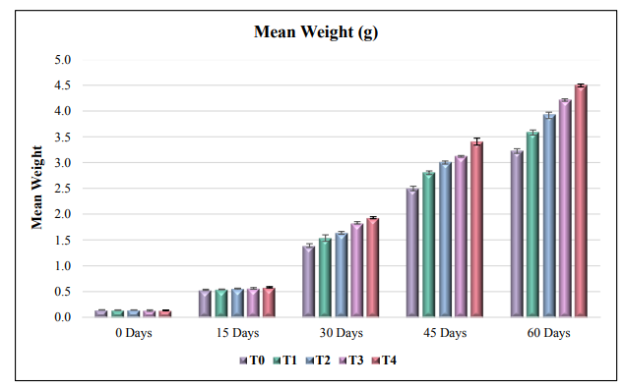
Fig. 1: Mean weight of Penaeus vannamei
    - Weight Gain
The mean weight gain of shrimp also increased with higher concentrations of TTO. After 60 days, weight gain was highest in T4 (4.36 g) and lowest in the control T0 (3.08 g). Statistical analysis revealed significant differences among all treatments at each 15-day interval. T4 consistently showed superior weight gain, followed by T3 and T2, whereas T0 had the lowest gain. This supports the observation that TTO enhances growth performance, likely by improving digestion and nutrient assimilation.
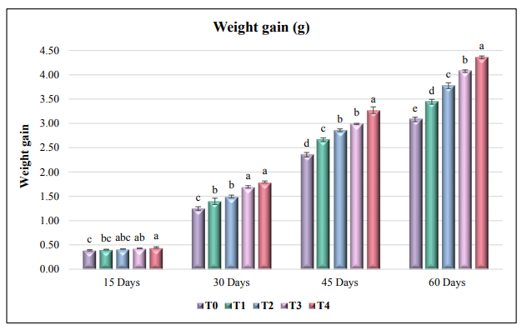
Fig. 2: Weight gain of Penaeus vannamei
    - Specific Growth Rate (SGR)
The specific growth rate mirrored the trends in weight gain. The highest SGR was observed in T4 (7.27%/day), followed by T3 (6.79%), T2 (6.29%), and T1 (5.74%), with T0 showing the lowest (5.13%). Statistical analysis confirmed significant differences among treatments. The findings of current study align with Liu et al. (2022b) as they indicate that 100 mg/kg TTO was feeding in diet of M. rosenbergii resulted the higher specific growth rate as compared to control group. Liu et al. (2022) in Largemouth bass and Domínguez-Borbor, et al. (2020) in P. vannamei also reported the similar result. The finding of Aktaş et al. (2022) is consistent with the present study which observed the higher specific growth rate in P. vannamei treated with thyme oil in diet.
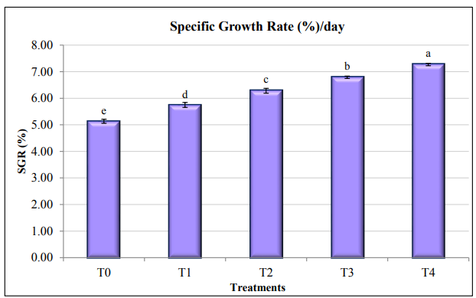
Fig. 3: Specific growth rate (%/day)

    - Effect on Feed Conversion Ratio (FCR)
The feed conversion ratio (FCR) decreased as TTO concentration increased. T4 had the lowest FCR (1.30), followed closely by T3, indicating better feed utilization compared to the control (T0, 1.41). Statistical analysis showed significant differences between treatments, suggesting TTO improves feed efficiency, likely due to enhanced digestion and absorption of nutrients. The present study aligns with the findings of Aktaş et al. (2022) and Sheikh et al. (2018) on effect of thyme oil and cumin essential oil respectively on P. vannamei significantly improved FCR as compared to control diet.
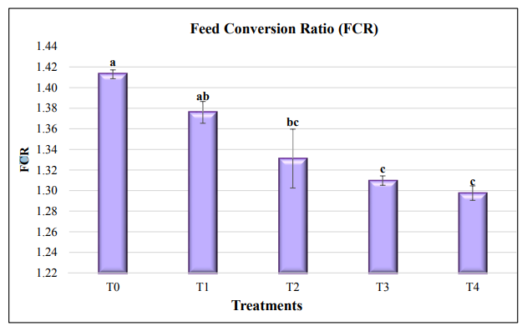
Fig. 4: Feed conversion ratio (FCR)
    - Effect on Feeding Efficiency Ratio (FER)
The feeding efficiency ratio (FER) was highest in T4 (0.77) and lowest in T0 (0.71), with T2 and T3 showing comparable results to T4. Significant differences were observed among treatments. The improvement in FER is consistent with the increased villus height in the intestine reported in previous studies, which enhances nutrient absorption. This study was similar to Li et al. (2014) demonstrated the improved FER through inclusion of linseed oil in diet of darkbarbel catfish (Pelteobagrus vachelli). Feeding efficiency is might be better due to the proper absorbtion and digestion due to higher villus height (Valladão et al., 2017).
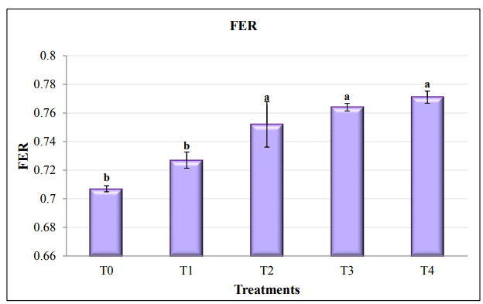
Fig. 5: Feeding efficiency ratio (FER)
3.1.6 Effect on Protein Efficiency Ratio (PER)
The protein efficiency ratio (PER) followed a similar trend, with the highest value in T4 (2.20) and the lowest in T0 (2.02). Treatments T2 and T3 showed PER values comparable to T4. Statistical analysis confirmed significant differences between treatments. These findings indicate that TTO supplementation improves protein utilization efficiency, supporting better growth performance. Similar result was observed by Liu et al. (2022) increased the PER in largemouth bass. In M. rosenbergii also the PER shows better results by Liu et al. (2022a).
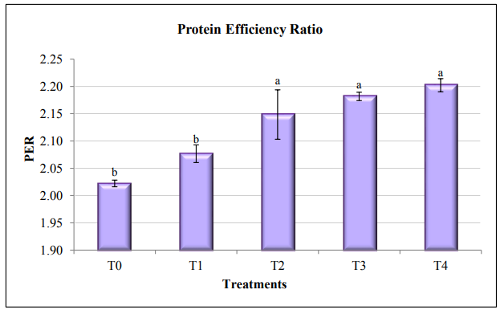
Fig. 6: Protein efficiency ratio (PER)
3.2. Survival Rate
The survival rate of shrimp was influenced by TTO supplementation. During the first 30 days, no significant difference was observed among treatments. However, at 45 and 60 days, T4 exhibited the highest survival rate (97.67%), while the control group had the lowest (88.33%). Statistical analysis confirmed that TTO treatments significantly improved survival compared to the control at the end of the experiment. This aligns with previous studies showing essential oils, including TTO, enhance immunity and resistance to stress, thereby improving survival. The result of present study is similar with the findings of Liu et al. (2022a), Liu et al. (2022b) and Liu et al. (2022c) at 100 mg/kg TTO got higher survival rate in Marcrobrachium rosenbergii as compared to control group on feeding in diet. According to the study of Domínguez-Borbor et al. (2020) the survival rate in P. vannamei was significantly increased when five different essential oils were incorporated into their diet where TTO was also present.
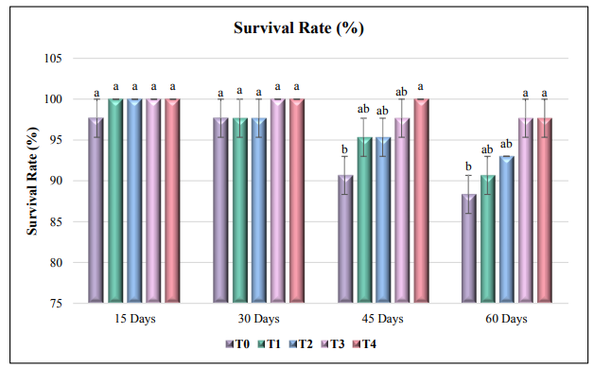Fig. 7: Survival rate (%)

4. Conclusions
The present study aimed to evaluate the impact of tea tree oil on growth and survival of Penaeus vannamei. The findings revealed that treatment T4, which was incorporated with 100 mg/kg TTO, reflects the positive effect on the growth parameters, including mean weight gain and specific growth rate (SGR). Moreover, T4 exhibited the lower FCR and higher FER and PER with 100 mg/kg TTO incorporation in diet. The higher survival rate of 88% was recorded in both T3 and T4 treatments. These results highlight the potential of Tea Tree oil in promoting the well-being of Penaeus vannamei. Overall, the TTO incorporated with 100 mg/kg gives the better outcomes as compared to other treatments. So, the inclusion of 100 mg/kg TTO (Treatment T4) is recommended for higher growth and survival of the P. vannamei.

Disclaimer (Artificial intelligence)
Option 1:
Author(s) hereby declare that NO generative AI technologies such as Large Language Models (ChatGPT, COPILOT, etc.) and text-to-image generators have been used during the writing or editing of this manuscript.

5. References
Acar, Ü., Kesbiç, O. S., Yılmaz, S., Gültepe, N., & Türker, A. (2015). Evaluation of the effects of essential oil extracted from sweet orange peel (Citrus sinensis) on growth rate of tilapia (Oreochromis mossambicus) and possible disease resistance against Streptococcus iniae. Aquaculture, 437, 282-286. https://doi.org/10.1016/j.aquaculture.2014.12.015
Aktaş, M., Genç, M. A., Bircan Yıldırım, Y., Kaya, D., Narin, Ö. Ç., & Genç, E. (2022). Effects of Thyme and Thyme Oil on Growth of White Shrimp, Litopenaeus vannamei. Acta Aquatica Turcica, 18(1), 81-92. https://doi.org/10.22392/actaquatr.976901
Albalat, A., Zacarias, S., Coates, C. J., Neil, D. M., & Planellas, S. R. (2022). Welfare in farmed decapod crustaceans, with particular reference to Penaeus vannamei. Frontiers in Marine Science, 9, 886024. https://doi.org/10.3389/fmars.2022.886024
Amaya, E. A., Davis, D. A., & Rouse, D. B. (2007). Replacement of fish meal in practical diets for the Pacific white shrimp (Litopenaeus vannamei) reared under pond conditions. Aquaculture, 262(2-4), 393-401. https://doi.org/10.1016/j.aquaculture.2006.11.015
An, P., Yang, X., Yu, J., Qi, J., Ren, X., & Kong, Q. (2019). α-terpineol and terpene-4-ol, the critical components of tea tree oil, exert antifungal activities in vitro and in vivo against Aspergillus niger in grapes by inducing morphous damage and metabolic changes of fungus. Food Control. https://doi.org/10.1016/j.foodcont.2018.11.013
Bakkali, F., Averbeck, S., Averbeck, D., & Idaomar, M. (2008). Biological effects of essential oils–a review. Food and Chemical Toxicology, 46(2), 446-475. https://doi.org/10.1016/j.fct.2007.09.106
Baldissera, M. D., Souza, C. F., Júnior, G. B., de Vargas, A. C., Boligon, A. A., de Campos, M. M., Stefani, L. M., & Baldisserotto, B. (2017). Melaleuca alternifolia essential oil enhances the non-specific immune system and prevents oxidative damage in Rhamdia quelen experimentally infected by Aeromonas hydrophila: Effects on cholinergic and purinergic systems in liver tissue. Fish & shellfish immunology, 61, 1-8. https://doi.org/10.1016/j.fsi.2016.12.016
Barreto, A., Peixoto, D., Fajardo, C., Pinto, W., Rocha, R. J., Conceição, L. E., & Costas, B. (2023). Health-promoting additives supplemented in inert microdiets for whiteleg shrimp (Penaeus vannamei) post-larvae: effects on growth, survival, and health status. Animals, 13(4), 726. https://doi.org/10.3390/ani13040726
Benelli, G., Canale, A., Flamini, G., Cioni, P. L., Demi, F., Ceccarini, L., Macchia, M., & Conti, B. (2013). Biotoxicity of Melaleuca alternifolia (Myrtaceae) essential oil against the Mediterranean fruit fly, Ceratitis capitata (Diptera: Tephritidae), and its parasitoid Psyttalia concolor (Hymenoptera: Braconidae). Industrial Crops and Products https://doi.org/10.1016/j.indcrop.2013.08.006
Bona, A. M., Passos, L. S., Coppo, G. C., Boldrini-França, J., de Oliveira Pacheco, C. F., Merçon, J., ... & Gomes, L. D. C. (2024). Enhancing anesthesia and minimizing toxicity: evaluation of clove, Cinnamon, and tea tree essential oils in nile tilapia (Oreochromis niloticus). Aquaculture International, 32(5), 6691-6706.
Carson, C. F., Hammer, K. A., & Riley, T. V. (2006). Melaleuca alternifolia (Tea Tree) Oil: a Review of Antimicrobial and Other Medicinal Properties. Clinical Microbiology Reviews. https://doi.org/10.1128/cmr.19.1.50-62.2006
De Silva, S. S., & Davy, F. B. (2010). Success stories in Asian aquaculture. Springer. https://doi.org/10.1007/978-90-481-3087-0
Divakaran, S., & Velasco, M. (1999). Effect of proteolytic enzyme addition to a practical feed on growth of the Pacific white shrimp, Litopenaeus vannamei (Boone). Aquaculture Research, 30(5), 335-339. https://doi.org/10.1046/j.13652109.1999.00333.x
Domínguez-Borbor, C., Sánchez-Rodríguez, A., Sonnenholzner, S., & Rodríguez, J. (2020). Essential oils mediated antivirulence therapy against vibriosis in L. vannamei. Aquaculture, 529, 735639. https://doi.org/10.1016/j.aquaculture.2020.735639
Ebrahimi, E., Haghjou, M., Nematollahi, A., & Goudarzian, F. (2020). Effects of rosemary essential oil on growth performance and hematological parameters of young great sturgeon (Huso huso). Aquaculture. https://doi.org/10.1016/j.aquaculture.2019.734909
FAO. (2024). The State of World Fisheries and Aquaculture 2024 – Blue Transformation in action. Rome, Italy. https://doi.org/10.4060/cd0683en
Ji, S. C., Takaoka, O., Jeong, G. S., Lee, S. W., Ishimaru, K., Seoka, M., & Takii, K. (2007). Dietary medicinal herbs improve growth and some non-specific immunity of red sea bream Pagrus major. Fisheries Science, 73(1), 63-69. https://doi.org/10.1111/j.1444-2906.2007.01302.x
Li, M., Yu, N., Qin, J. G., Li, E., Du, Z., & Chen, L. (2014). Effects of ammonia stress, dietary linseed oil and Edwardsiella ictaluri challenge on juvenile darkbarbel catfish Pelteobagrus vachelli. Fish & Shellfish Immunology, 38(1), 158-165. https://doi.org/10.1016/j.fsi.2014.03.015
Liu, H. W., Tong, J. M., & Zhou, D. W. (2011). Utilization of Chinese herbal feed additives in animal production. Agricultural Sciences in China, 10(8), 1262-1272. https://doi.org/10.1016/s1671-2927(11)60118-1
Liu, M., Gao, Q., Sun, C., Liu, B., Liu, X., Zhou, Q., Zheng, X., & Xu, P. (2022). Effects of dietary tea tree oil on the growth, physiological and non-specific immunity response in the giant freshwater prawn (Macrobrachium rosenbergii) under high ammonia stress. Fish & Shellfish Immunology, 120, 458-469. https://doi.org/10.1016/j.fsi.2021.12.025
Liu, M., Sun, C., Xu, P., Liu, B., Zheng, X., Liu, B., & Zhou, Q. (2022). Effects of dietary tea tree (Melaleuca alternifolia) oil and feeding patterns on the zootechnical performance and nonspecific immune response of the giant freshwater prawn (Macrobrachium rosenbergii). Journal of the World Aquaculture Society, 53(2), 542-557. https://doi.org/10.1111/jwas.12831
Liu, M., Sun, C., Zheng, X., Zhou, Q., Liu, B., Zhou, Y., & Xu, P. (2022). Comparative Proteomic Analysis Revealed the Mechanism of Tea Tree Oil Targeting Lipid Metabolism and Antioxidant System to Protect Hepatopancreatic Health in Macrobrachium rosenbergii. Frontiers in Immunology. https://doi.org/10.3389/fimmu.2022.906435
Liu, X., Deng, H. Y., Xu, Q. Q., Luo, K., Zhou, J., Gao, W. H., Wang, Z. D., Zhang, H. T., & Zhou, X. Q. (2022). Effects of tea tree essential oil supplementation in low fish meal diet on growth, lipid metabolism, anti-oxidant capacity and immunity of largemouth bass (Micropterus salmoides). Aquaculture Reports, 27, 101380. https://doi.org/10.1016/j.aqrep.2022.101380
Liu, X., Deng, H., Xu, Q., Luo, K., Zhou, J., Gao, W., ... & Zhou, X. (2022). Effects of tea tree essential oil supplementation in low fish meal diet on growth, lipid metabolism, anti-oxidant capacity and immunity of largemouth bass (Micropterus salmoides). Aquaculture Reports, 27, 101380.
Ngugi, C. C., Oyoo‐Okoth, E., & Muchiri, M. (2017). Effects of dietary levels of essential oil (EO) extract from bitter lemon (Citrus limon) fruit peels on growth, biochemical, haemato‐immunological parameters and disease resistance in Juvenile Labeo victorianus fingerlings challenged with Aeromonas hydrophila. Aquaculture Research, 48(5), 2253-2265. https://doi.org/10.1111/are.13062
Shaalan, M., Mahboub, H. H., Abdelgawad, A. H., Abdelwarith, A. A., Younis, E. M., Elnegiry, A. A., ... & Mahmoud, Y. K. (2025). Dietary tea tree (Melaleucae Aetheroleum) oil fortifies growth, biochemical, immune-antioxidant trait, gene function, tissue reaction, and Aeromonas sobria resistance in Nile tilapia (Oreochromis niloticus). BMC veterinary research, 21(1), 1. https://doi.org/10.1186/s12917-024-04369-1
Sheikh Asadi, M., Gharaei, A., Mirdar Harijani, J., & Arshadi, A. (2018). A Comparison between dietary effects of Cuminum cyminum essential oil and Cuminum cyminum essential oil, loaded with iron nanoparticles, on growth performance, immunity and antioxidant indicators of white leg shrimp (Litopenaeus vannamei). Aquaculture Nutrition. https://doi.org/10.1111/anu.12683
Terrazas-Pineda, K. A., Alamilla-Beltrán, L., Acero-Ortega, C. A., Damas-Espinoza, J. A., Calderón-Domínguez, G., Mora-Escobedo, R., ... & Gómez-de Anda, F. R. (2025). Antimicrobial Activity of Cinnamon, Tea Tree, and Thyme Essential Oils Against Pathogenic Bacteria Isolated from Tilapia (Oreochromis spp.) in Aquaculture Farms. Molecules, 30(13), 2799. https://doi.org/10.3390/molecules30132799
The Marine Products Export Development Authority. (2024). MPEDA Annual Report 2023-2024. The Marine Products Export Development Authority. https://mcommerce.gov.in/publications-reports
Thomas, J., & Amaresan, N. (Eds.). (2023). Aquaculture Microbiology. Springer Nature. https://doi.org/10.1007/978-1-0716-3032-7
Valladão, G. M. R., Gallani, S. U., Pala, G., Jesus, R. B., Kotzent, S., Costa, J. C., Silva T. F., & Pilarski, F. (2017). Practical diets with essential oils of plants activate the complement system and alter the intestinal morphology of Nile tilapia. Aquaculture Research, 48(11), 5640-5649. https://doi.org/10.1111/are.13386
Vaseeharan, B., & Thaya, R. (2014). Medicinal plant derivatives as immunostimulants: an alternative to chemotherapeutics and antibiotics in aquaculture. Aquaculture International, 22(3), 1079-1091. https://doi.org/10.1007/s10499-013-9729-3
Verghese, J., Jacob, C. V., Kunjunni Kartha, C. V., McCarron, M., Mills, A. J., & Whittaker, D. (1996). Indian tea tree (Melaleuca alternifolia Cheel) essential oil. Flavour and Fragrance Journal, 11(4), 219-221. https://doi.org/10.1002/(SICI)1099-1026(199607)11:4<219::AID-FFJ571>3.0.CO;2-I
Wang, Y., Liang, Y., Jiang, Q., Zhou, Q., Li, J., & Liu, B. (2025). Transcriptome-based investigation on the mechanism of bacterial inhibition of Aeromonas hydrophila by tea tree oil. Aquaculture, 601, 742259.
Zhou, J., Ming, K., Yu, J., Fu, Y., Lu, W., Zhao, C., ... & Wu, C. (2025). Dietary tea tree essential oil addition to a low fishmeal diet containing high-Clostridium autoethanogenum protein diet improves the growth, lipid metabolism, antioxidant capacity and immunity of largemouth bass (Micropterus salmoides). Aquaculture Reports, 43, 102891. 10.1016/j.aqrep.2025.102891

