Original Research Article
Assessment of genetic variability for fodder yield and related traits in diverse germplasm panel of maize (Zea mays L.)

Abstract
Enhancing biomass productivity in maize requires identifying traits that express strong and stable genetic variability across environments. This study quantified genetic variability, heritability and trait–yield relationships in a diverse CAAM (CIMMYT Asia Association Mapping) panel of maize by CIMMYT-Asia, Hyderabad, comprising 249 lines and 200 lines evaluated during two contrasting seasons i.e., Rabi 2023 and Kharif 2024 respectively, using an alpha-lattice design. Variance components, GCV, PCV, heritability (h²), genetic advance as percent of mean (GAM) and correlation coefficients were estimated to identify dependable selection indices for fodder improvement. Across both seasons, substantial genetic variability was recorded for major vegetative and ear traits. In Rabi, high GCV and PCV values were observed for leaf area (31.29%, 35.07%), fresh ear weight (37.18%, 37.44%), leaf:stem ratio (22.96%, 24.94%) and stem diameter (19.43%, 21.25%), respectively. These traits also exhibited strong additive genetic control, reflected by high heritability and GAM, particularly fresh ear weight (98.65%; GAM 76.60%), leaf width (95.75%; GAM 38.85%), plant height (93.31%; GAM 40.56%) and stem diameter (83.66%; GAM 40.03%), respectively. In Kharif, high variability evident from high GCV and PCV, persisted for ASI (53.34%, 70.18%), ears per plant (31.10%, 32.37%), fresh ear weight (37.72%, 38.04%) and stay-green (34.26%, 40.86%), respectively. This was also accompanied by very high heritability and GAM for ears per plant (92.32%; 64.06%), plant height (80.14%; GAM 46.66%), leaf area (76.61%; GAM 47.35%) and stem diameter (84.34%; GAM 44.00%). Green fodder yield showed moderate heritability in both seasons (33.37% in Rabi; 37.58% in Kharif), reflecting environmental influence. Correlation analysis revealed a consistent set of biomass-determinants. In Rabi, green fodder yield (GFY) correlated strongly with leaf area (r = 0.54), stem diameter (0.39), leaf number (0.39) and plant height (0.31). In Kharif, GFY again associated with stem diameter (0.53), plant height (0.29), ears per plant (0.25) and leaf area (0.20). Flowering traits showed weak or negative associations in both seasons. Collectively, stem diameter, leaf area, plant height, ears per plant and fresh ear weight emerge as stable, high-heritability, high-impact selection traits for developing high-biomass, climate-resilient fodder maize genotypes.
Keywords: Biomass, Diverse, Correlation, Fodder, Germplasm, Heritability, Maize and Variability
1. Introduction
Maize (Zea mays L.) is one of the world’s most important cereals, contributing nearly 1.2 billion tonnes annually and serving as a key driver of global food, feed and fodder security (FAO, 2023). In mixed crop-livestock systems, green fodder maize is particularly valued for its high biomass productivity, good digestibility and adaptability to diverse agro-climatic conditions. With increasing climatic variability and the rising demand for livestock feed, projected to grow by 70% by 2050, identifying stable, high-yielding fodder maize genotypes has become a strategic priority for sustainable agriculture (Sharma et al., 2021). Genetic variability constitutes the fundamental basis for crop improvement because the success of selection depends on the magnitude of available genetic differences among genotypes. Parameters such as the genotypic and phenotypic coefficients of variation (GCV and PCV), heritability and genetic advance help quantify the nature of variability and the relative contributions of additive and non-additive gene effects. In fodder maize, traits such as plant height, leaf area, stem girth and green fodder yield often exhibit considerable variability, enabling breeders to design efficient selection strategies for biomass productivity and quality (Kumar et al., 2020). Correlation analysis further enhances breeding efficiency by identifying traits that directly or indirectly contribute to fodder yield. Since biomass yield is a polygenic, highly complex trait influenced by multiple morphological and physiological components, understanding the relationships among traits becomes essential for defining selection indices. Positive and significant correlations between fodder yield and traits like plant height and number of leaves per plant have been widely reported in tropical and subtropical maize (Singh et al., 2019). Such insights enable indirect selection for yield by focusing on easily measurable, highly heritable traits. Despite extensive research on maize variability, studies focusing on fodder-related traits using diversity-rich panels like the CAAM (CIMMYT Asia Association Mapping) panel across multiple seasons remain limited. Multi-season evaluation is essential to quantify genetic variation reliably and detect stable trait relationships under variable environmental conditions. Therefore, the present study aims to (i) assess the genetic variability for key fodder traits in a diverse panel of maize inbreds evaluated across two contrasting seasons and (ii) examine correlations to identify effective selection criteria for improving fodder yield and its associated traits.

2. Material and methods
A subset of the CAAM Panel comprising maize inbred lines obtained from CIMMYT-Asia, Hyderabad, was used for phenotypic evaluation. These lines represent diverse genetic backgrounds derived from multiple CIMMYT breeding pools and are known for their adaptability to Asian agro-ecologies, tolerance to drought, heat, excess moisture and resistance to biotic stresses such as downy mildew. In Season 1 (Rabi 2023), 249 lines established adequate crop stands, whereas in Season 2 (Kharif 2024), precise phenotyping was possible for 200 lines. Field evaluations were conducted at the College of Agriculture, Shivamogga, across the two seasons using an alpha-lattice design with two replications and blocks of five entries. Standard agronomic management was followed and observations were recorded at appropriate stages. For most traits, data were collected from five competitive plants per plot in each replication, while plot-based measurements were taken for phenological traits, stay-green expression and fodder yield components. Days to 50% tasseling and silking were recorded as the number of days from sowing until half of the plant population exhibited anther dehiscence or silk emergence, respectively and anthesis-silking interval was computed as their difference in terms of days. Plant height, leaf number, stem diameter and leaf morphological traits (leaf length, width and leaf area) were measured following standard maize protocols. Yield-related attributes, including number of ears per plant, fresh ear weight, ear length and ear diameter, were recorded at harvest. The stay-green phenotype was scored at physiological maturity using a 1-5 scale (Monneveux et al., 2006), where higher scores indicated superior retention of green leaf area. Green and dry fodder yields were obtained from whole-plant biomass and expressed on a per-hectare basis.
Phenotypic data were subjected to analysis of variance based on the alpha-lattice model as proposed by Patterson and Williams (1976). The model included replication and block effects as random and genotype effects as fixed. Variance components were used to estimate phenotypic and genotypic variances following Weber and Moorthy (1952). Genotypic coefficients of variation (GCV) and phenotypic coefficients of variation (PCV) were calculated as described by Burton and DeVane (1953) and classified according to Sivasubramanian and Menon (1973). Broad-sense heritability estimates were computed following Allard (1960) and categorized as per Robinson et al. (1949). Genetic advance as percent of mean (GAM)were derived using the formula of Johnson et al. (1955). Correlation coefficients among key fodder yield-related traits were estimated using variance–covariance components as outlined by Al-Jibouri et al. (1958). All statistical analyses were carried out in META-R and R (version 4.1) using the ‘metan’ package and significance of correlations was assessed at 5% and 1% probability levels.

3. Results and discussion
3.1 Genetic variability
Analysis of variance of two seasons i.e., Rabi 2023 (Table 1) and Kharif 2024
(Table 2) revealed the presence of ample variation in the studied germplasm. Since both the seasons are divergent and behaviour of genotype was contrastingly different the results of individual seasons are presented separately. The evaluation of the CAAM panel across Rabi 2023 (Table 3) and Kharif 2024 (Table 4) revealed a stable and substantial expression of genetic variability for most fodder-related traits, with consistently high GCV and PCV values confirming the presence of abundant variability within the panel. Although PCV exceeded GCV in both seasons, the narrow differences for vegetative and ear traits such as plant height, leaf width, leaf area, stem diameter and fresh ear weight indicated that these characters were largely genetically governed across environments. Plant height expressed GCV (19.69%) and PCV (20.38%) values in Rabi along with heritability (93.31%) and genetic advance (40.56%) while in Kharif it showed heritability (80.14%) and genetic advance (46.66%) of demonstrating highly similar genetic control. Leaf width maintained strong genetic determinism in both seasons with GCV (18.86%) and PCV (19.28%) in Rabi and heritability (89.95%) in Kharif. Leaf area exhibited high variability in both environments with Rabi recording GCV (31.29%) and PCV (35.07%) and Kharif recording GCV (22.99%) and PCV (26.26%) supported by high heritability (79.60%) and GAM (76.61%). Stem diameter also remained stable across seasons with Rabi values of GCV (19.43%) and PCV (21.25%) and Kharif values of GCV (21.36%) and PCV (23.26%), accompanied by heritability (83.66%) and GAM (84.34%) respectively. Biomass-linked traits such as ears per plant and fresh ear weight consistently demonstrated abundant additive variance. Ears per plant recorded GCV (21.41%) and PCV (20.91%) in Rabi and GCV (31.10%) and PCV (32.37%) in Kharif, with heritability (92.32%) and genetic advance (64.06%). Fresh ear weight remained nearly identical across seasons with Rabi values of GCV (37.18%) and PCV (37.44%) and Kharif values of GCV (37.72%) and PCV (38.04%), and extremely high heritability (98.65%) and (98.33%) accompanied by genetic advance of (76.60%) and (77.70%). Leaf to stem ratio also performed similarly across both seasons with Rabi values of GCV (22.96%) and PCV (24.94%) and Kharif values of GCV (24.53%) and PCV (25.76%) supported by high heritability (90.69%) and genetic advance (50.53%), confirming its strong additive genetic basis. In contrast, environmental sensitivity was more evident for ASI, flowering traits and fodder yield parameters. ASI showed higher variability in Kharif with GCV (53.34%) and PCV (70.18%) compared to Rabi where values were GCV (26.48%) and PCV (60.84%), reflecting greater influence of monsoon-season fluctuations. Stay-green also differed modestly with Rabi heritability (22.75%) and genetic advance (38.62%), whereas Kharif expressed GCV (34.26%) and PCV (40.86%), revealing stronger seasonal effects. Days to tasseling, days to silking, green fodder yield and dry fodder yield displayed moderate heritability in both seasons, such as Rabi heritability for tasseling (61.38%), for silking (55.93%), for green fodder yield (33.37%) and dry fodder yield (30.11%), confirming known environmental modulation of phenology and biomass traits. The two-season evaluation clearly shows that vegetative architecture traits and ear traits were consistently and strongly inherited across seasons, while flowering behaviour and fodder yield traits were more environment-dependent. The persistent high heritability and genetic advance of structural and ear traits across both Rabi and Kharif seasons underscore their suitability as reliable targets for selection in fodder maize improvement programs. Similar findings were observed by Dalip et al. (2024), Kumar et al. (2024), Reddy et al. (2023) and Fathima et al. (2023).

3.2 Correlation Analysis
The correlation patterns observed across Rabi 2023 (Fig. 1) and Kharif 2024 (Fig. 2) demonstrated a highly stable set of biomass-determining traits, with GFY showing strong and consistent positive associations with key vegetative and structural characters in both seasons. During Rabi 2023 GFY expressed significant correlations with plant height (0.31), number of leaves (0.39), leaf length (0.38), leaf width (0.35), leaf area per plant (0.54), stem diameter (0.39) and ears per plant (0.22), with leaf area per plant and stem diameter emerging as the strongest contributors. These relationships highlight the dominant influence of canopy size and stem robustness in determining fodder productivity, as biomass in maize originates mainly from leaf mass and stem bulk. GFY also showed a very high positive correlation with DFY (0.89), proving that improvements in fresh biomass reliably translate into gains in dry biomass which is crucial for silage quality and dry matter recovery. Mild negative correlations with flowering traits including days to tasseling (-0.10), days to silking (-0.14) and ASI (-0.10) indicated that earlier flowering and reduced anthesis silking interval favour higher biomass accumulation, likely due to extended vegetative growth or reduced stress during flowering. During Kharif the correlation structure closely mirrored the Rabi pattern, confirming the seasonal stability of biomass determinants. Stem diameter again emerged as the strongest contributor to GFY, reinforcing its role as a dependable selection index. GFY maintained significant associations with plant height (0.29), ears per plant (0.25), number of leaves (0.21), leaf area (0.20), leaf length (0.15), ear diameter (0.18) and fresh ear weight (0.11), reflecting that both vegetative morphology and reproductive sink strength jointly influence biomass formation under monsoon conditions. Weak correlations of leaf width (0.01), days to tasseling (0.05), days to silking (0.07) and stay-green (0.07) suggested that these characters contributed little to biomass under the shorter and more variable Kharif season. The positive and significant GFY to DFY correlation (0.60) in Kharif confirmed that superior fresh biomass producers consistently maintained dry matter advantages across seasons. Together these results indicate that stem diameter, plant height, leaf traits and ears per plant represent stable and reliable drivers of biomass accumulation in both Rabi and Kharif environments, supporting their use as primary selection criteria in fodder-oriented maize breeding. These trends align with the findings of by Pushpendra et al. (2025), Chaudhary et al. (2021) and Singh et al. (2023).

4. Conclusion
The genetic variability detected across two contrasting seasons confirms that the CAAM panel possesses a broad and stable genetic base for fodder-related traits. High heritability coupled with high genetic advance for stem diameter, leaf area, plant height, leaf : stem ratio, ears per plant and ear weight demonstrates strong additive genetic control and identifies these traits as highly responsive to direct selection. Consistently low variability in flowering traits underscores their limited utility in fodder-specific improvement programs. Together, the genetic parameter estimates highlight vegetative vigour and assimilate capture traits as robust and efficient selection targets for developing high-biomass, climate-resilient fodder maize. Correlation analysis across seasons revealed that stem diameter, leaf area, plant height, number of leaves and ear-related traits are the most reliable and consistent contributors to green fodder yield. Their strong positive associations with biomass demonstrate that structural vigour and expansive canopy architecture are the primary determinants of fodder productivity. The weak and inconsistent relationships of flowering traits and stay-green with fodder yield further reinforce that vegetative robustness, rather than phenology, drives biomass accumulation in this germplasm. These insights clearly establish stem and canopy-related traits as key integrative indicators for selecting superior fodder maize genotypes.

Disclaimer (Artificial intelligence)
Author(s) hereby declare that NO generative AI technologies such as Large Language Models (ChatGPT, COPILOT, etc.) and text-to-image generators have been used during the writing or editing of this manuscript.

5. References
- Al-Jibouri, H. A., Miller, P. A., & Robinson, H. F. (1958). Genotypic and environmental variances and covariances in an upland cotton cross of interspecific origin. Agronomy Journal, 50(10), 633-636. https://doi.org/10.2134/agronj1958.00021962005000100020x
- Allard, R. W., 1960, Selection under self-fertilization. Principles of Plant Breeding. John Wiley & Sons, Inc. New York, USA.
- Burton, G. W., & DeVane, E. H. (1953). Estimating heritability in tall fescue (Festuca arundinacea) from replicated clonal material. Agronomy Journal, 45(10), 478-481. https://doi.org/10.2134/AGRONJ1953.00021962004500100005X
- Chaudhary, D. P., Kumar, A., Kumar, R., Singode, A., Mukri, G., Sah, R. P., Tiwana, U. S., & Kumar, B. (2021). Evaluation of normal and specialty corn for fodder yield and quality traits. Range Management and Agroforestry. https://publications.rmsi.in/index.php/rma/article/view/325
- Dalip, D. N., Dodiya, N. S., Panwar, D., & Devra, N. S. (2024). Genetic parameters, correlation and path analysis for fodder and dual purpose sorghum [Sorghum bicolor (L.) Moench] genotypes. Range Management and Agroforestry, 45(1), 41-48. https://doi.org/10.59515/rma.2024.v45.i1.06
- FAO. (2023). FAOSTAT Statistical Database. https://www.fao.org/faostat
- Fathima Sinana, H., Ravikesavan, R., Iyanar, K., & Senthil, A. (2023). Study of genetic variability and diversity analysis in maize (Zea mays L.) by agglomerative hierarchical clustering and principal component analysis. Electronic Journal of Plant Breeding, 14(1), 43-51. https://doi.org/10.37992/2023.1401.015
- Johnson, H. W., Robinson, H. F., & Comstock, R. E. (1955). Estimates of genetic and environmental variability in soybeans. Agronomy Journal, 47(7), 314-318. https://doi.org/10.2134/agronj1955.00021962004700070009x
- Kumar, B., Singh, S.B. & Patel, S.K., 2020, Genetic variability and character association studies for green fodder yield and its components in maize (Zea mays L.). Journal of Applied and Natural Science, 12(2): 173-178.
- Kumar, G. P., Sunil, N., Sekhar, J. C., & Chary, D. S. (2024). Assessment of genetic variability, heritability and genetic advance in maize genotypes (Zea mays L.). Journal of Experimental Agriculture International, 46(3), 146-155. https://doi.org/10.9734/jeai/2024/v46i32333
- Monneveux, P., Sánchez, C., Beck, D., & Edmeades, G. O. (2006). Drought tolerance improvement in tropical maize source populations: Evidence of progress. Crop Science, 46(1), 180-191. https://doi.org/10.2135/cropsci2005.04-0034
- Patterson, H. D., & Williams, E. R. (1976). A new class of resolvable incomplete block designs. Biometrika, 63(1), 83-92. https://doi.org/10.1093/biomet/63.1.83
- Pushpendra, P., Singh, S. K., Tiwari, M., Nikhil, N., Chauhan, R. S., Kumar, M., Kant, S., & Gangwar, L. K. (2025). Study on character association and path coefficient analysis in forage sorghum [Sorghum bicolor (L.) Moench]. Agricultural Science Digest. https://doi.org/10.18805/ag.D-6132
- Reddy, M. S. K., Thota, H., Pawan, V., & Delvadiya, I. R. (2025). Assessment of combining ability and gene interaction in maize (Zea mays L.) for superior parental combinations in Northwest India. Plant Archives, 25(1), 2425-2433. https://doi.org/10.51470/PLANTARCHIVES.2025.v25.no.1.349
- Robinson, H. F., Comstock, R. E., & Harvey, P. H. (1949). Estimates of heritability and the degree of dominance in corn. Agronomy Journal, 41, 353-359. https://doi.org/10.2134/agronj1949.00021962004100080005x
- Sharma, R., Gupta, M. & Singh, R., 2021, Enhancing fodder security in mixed crop-livestock systems: trends, challenges and opportunities. Indian J. Agric. Sci., 91(7): 945-952.
- Sivasubramanian, S. And Menon, M., 1973, Heterosis and inbreeding depression in rice. Advances in Agronomy. 47, 85-140.
- Singh, D. P., Jain, M., Goyal, M., & Sandhu, S. (2023). Genetic divergence studies of fodder yield and quality attributing characteristics in promising maize (Zea mays L.) composites. Range Management and Agroforestry, 44, 269-277. https://doi.org/10.59515/rma.2023.v44.i2.08
- Singh, P., Kumar, A. & Yadav, R.K., 2019, Correlation and path coefficient analysis for fodder yield and related traits in maize (Zea mays L.) under tropical environments. Crop Research, 54(1): 29-35.
- Weber, C. R., & Moorthy, B. (1952). Heritable and nonheritable relationships and variability of oil content and agronomic characters in the F2 generation of soybean crosses. Agronomy Journal, 44(4), 202-209. https://doi.org/10.2134/AGRONJ1952.00021962004400040010X

Table 1. Analysis of variance for fodder yield and related traits in maize during Rabi 2023
Traits | Source of variation
Traits | Replication | Block | Genotype | Residuals
Degrees of freedom | 1 | 99 | 248 | 149
Days to 50% tasseling | 14.51 | 15.61 | 39.84** | 9.19
Days to 50% silking | 2.32 | 20.22 | 47.98** | 12.80
Anthesis to silking interval | 28.43 | 3.26 | 7.22** | 5.17
Plant height (cm) | 134.57 | 52.82 | 1017.56* | 38.28
Number of leaves per plant | 66.63 | 0.84 | 3.11** | 0.77
Number of ears per plant | 0.67 | 0.09 | 0.22** | 0.06
Leaf length (cm) | 237.13 | 50.21 | 138.67* | 37.86
Leaf width (cm) | 0.37 | 0.05 | 1.98** | 0.04
Leaf area per plant (cm²) | 393846 | 142505 | 113460* | 124589.40
Stem diameter (mm) | 7.91 | 2.88 | 28.41** | 2.69
Leaf : stem ratio | 0.002 | 0.003 | 0.03** | 0.003
Fresh ear weight (g) | 139.88 | 42.26 | 6357.75* | 42.00
Fresh ear length (cm) | 39.32 | 4.93 | 29.13* | 4.10
Fresh ear diameter (mm) | 43.44 | 3.55 | 57.54** | 2.85
Stay green trait (scale) | 0.80 | 1.41 | 1.47** | 0.99
Green fodder yield (t/ha) | 123.93 | 24.60 | 35.99* | 18.21
Dry fodder yield (t/ha) | 25.91 | 4.05 | 5.33** | 2.86
* significant at p<0.05, ** significant at p<0.01

Table 2. Analysis of variance for fodder yield and related traits in maize during Kharif 2024
Traits | Source of variation
Traits | Replication | Block | Genotype | Residuals
Degrees of freedom | 1 | 78 | 199 | 121
Days to 50% tasseling | 0.72 | 4.683 | 28.87** | 3.57
Days to 50% silking | 0.81 | 4.88 | 29.39** | 3.01
Anthesis to silking interval | 0.003 | 1.84 | 6.91** | 1.85
Plant height (cm) | 427.37 | 154.00 | 1517.20* | 167.27
Number of leaves per plant | 0.49 | 0.81 | 3.08** | 0.98
Number of ears per plant | 10.69 | 0.018 | 0.47** | 0.01
Leaf length (cm) | 94.91 | 28.57 | 245.36** | 24.70
Leaf width (cm) | 0.98 | 0.04 | 0.75** | 0.04
Leaf area per plant (cm²) | 5334 | 97697 | 806936.66** | 106872.20
Stem diameter (cm) | 81.02 | 3.82 | 33.69** | 2.86
Leaf : stem ratio | 0.02 | 0.002 | 0.03** | 0.002
Ear weight with husk (g) | 124.60 | 52.56 | 6736.00* | 56.67
Fresh ear length (cm) | 154.46 | 8.54 | 28.30* | 10.57
Fresh ear diameter (mm) | 492.21 | 15.17 | 47.35** | 12.60
Stay green trait (scale) | 4.62 | 0.45 | 2.89** | 0.50
Green fodder yield (t/ha) | 759.15 | 53.08 | 123.83* | 56.18
Dry fodder yield (t/ha) | 12.67 | 2.21 | 3.67** | 2.56
* significant at p<0.05, ** significant at p<0.01

Table 3. Estimates of genetic variability parameters for fodder yield and related traits in maize during Rabi 2023
Traits | Mean | Range |  | GCV  (%) | PCV  (%) | h²  (%) | GAM  (%)
Traits | Mean | Min | Max
Days to 50% tasseling | 63.96 | 52.00 | 76.00 | 6.09 | 7.77 | 61.38 | 12.54
Days to 50% silking | 68.01 | 55.00 | 81.00 | 6.10 | 8.16 | 55.93 | 12.57
Anthesis to silking interval | 4.05 | -5.00 | 13.00 | 26.48 | 60.84 | 18.95 | 54.56
Plant height (cm) | 112.55 | 46.03 | 198.30 | 19.69 | 20.38 | 93.31 | 40.56
Number of leaves per plant | 10.30 | 5.33 | 14.33 | 10.57 | 13.47 | 61.59 | 21.78
Number of ears per plant | 1.32 | 1.00 | 3.00 | 21.41 | 28.91 | 54.85 | 44.11
Leaf length (cm) | 55.29 | 26.20 | 91.60 | 12.73 | 17.07 | 55.62 | 26.23
Leaf width (cm) | 5.22 | 2.26 | 8.44 | 18.86 | 19.28 | 95.75 | 38.85
Leaf area per plant (cm²) | 2266.51 | 539.93 | 6058.97 | 31.29 | 35.07 | 79.60 | 64.45
Stem diameter (cm) | 18.51 | 7.85 | 34.91 | 19.43 | 21.25 | 83.66 | 40.03
Leaf : stem ratio | 0.53 | 0.25 | 0.78 | 22.96 | 24.94 | 84.74 | 47.29
Fresh ear weight (g) | 151.11 | 42.63 | 259.07 | 37.18 | 37.44 | 98.65 | 76.60
Fresh ear length (cm) | 22.17 | 11.90 | 32.45 | 15.86 | 18.47 | 73.76 | 32.67
Fresh ear diameter (mm) | 35.89 | 23.60 | 49.01 | 14.52 | 15.36 | 89.33 | 29.90
Stay green trait (scale) | 2.79 | 1.00 | 5.00 | 18.75 | 39.31 | 22.75 | 38.62
Green fodder yield (t/ha) | 21.08 | 7.03 | 42.48 | 14.23 | 24.63 | 33.37 | 29.32
Dry fodder yield (t/ha) | 7.13 | 1.02 | 15.65 | 15.58 | 28.38 | 30.11 | 32.09

Table 4. Estimates of genetic variability parameters for fodder yield and related traits in maize during Kharif 2024
Traits | Mean | Range |  | GCV  (%) | PCV  (%) | h²  (%) | GAM  (%)
Traits | Mean | Min | Max
Days to 50% tasseling | 61.76 | 52.00 | 75.00 | 5.76 | 6.52 | 77.97 | 11.86
Days to 50% silking | 64.74 | 54.00 | 76.00 | 5.61 | 6.22 | 81.39 | 11.56
Anthesis to silking interval | 2.98 | -3.00 | 9.00 | 53.34 | 70.18 | 57.77 | 94.88
Plant height (cm) | 114.70 | 13.96 | 209.00 | 22.65 | 25.30 | 80.14 | 46.66
Number of leaves per plant | 10.59 | 1.00 | 13.67 | 9.64 | 13.48 | 51.07 | 19.85
Number of ears per plant | 1.54 | 1.00 | 3.66 | 31.10 | 32.37 | 92.32 | 64.06
Leaf length (cm) | 60.30 | 28.02 | 97.61 | 17.42 | 19.27 | 81.71 | 35.88
Leaf width (cm) | 5.38 | 3.97 | 6.80 | 11.12 | 11.72 | 89.95 | 22.91
Leaf area per plant (cm²) | 2573 | 175 | 5054 | 22.99 | 26.26 | 76.61 | 47.35
Stem diameter (cm) | 18.38 | 8.85 | 38.36 | 21.36 | 23.26 | 84.34 | 44.00
Leaf : stem ratio | 0.53 | 0.28 | 0.79 | 24.53 | 25.76 | 90.69 | 50.53
Ear weight with husk (g) | 153.21 | 37.27 | 264.82 | 37.72 | 38.04 | 98.33 | 77.70
Fresh ear length (cm) | 24.04 | 12.55 | 34.65 | 12.39 | 18.34 | 45.59 | 25.51
Fresh ear diameter (mm) | 36.00 | 23.85 | 53.71 | 11.58 | 15.21 | 57.98 | 23.85
Stay green trait (scale) | 3.19 | 1.00 | 5.00 | 34.26 | 40.86 | 70.30 | 70.57
Green fodder yield (t/ha) | 30.18 | 8.35 | 66.88 | 19.27 | 31.43 | 37.58 | 39.69
Dry fodder yield (t/ha) | 7.60 | 3.40 | 14.36 | 9.82 | 23.25 | 17.84 | 20.23
PCV: Phenotypic coefficient of variation GCV: Genotypic coefficient of variation
h² (%): Broad sense heritability GAM: Genetic advance as per cent of mean

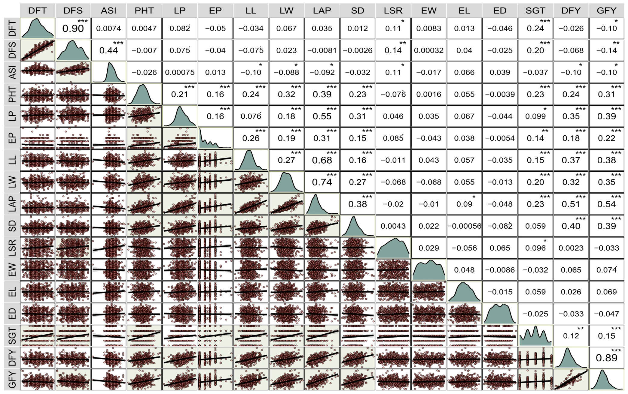

DFT: | Days to 50% tasseling |  | LL: | Leaf length (cm) |  | EL: | Fresh ear length (cm)
DFS: | Days to 50% silking |  | LW: | Leaf width (cm) |  | ED: | Fresh ear diameter (mm)
ASI: | Anthesis to silking interval |  | LAP: | Leaf area per plant (cm²) |  | SGT: | Stay green trait (scale)
PHT: | Plant height (cm) |  | SD: | Stem diameter (cm) |  | GFY: | Green fodder yield (t/ha)
LP: | Number of leaves per plant |  | LSR: | Leaf : stem ratio |  | DFY: | Dry fodder yield (t/ha)
EP: | Number of ears per plant |  | EW: | Fresh ear weight (g) |  | * significant at p<0.05, ** significant at p<0.01,  *** significant at p<0.001
Fig. 1. Correlation coefficients among fodder yield and related traits in maize during Rabi 2023

Fig. 2: Correlation coefficients among fodder yield and related traits in maize during Kharif 2024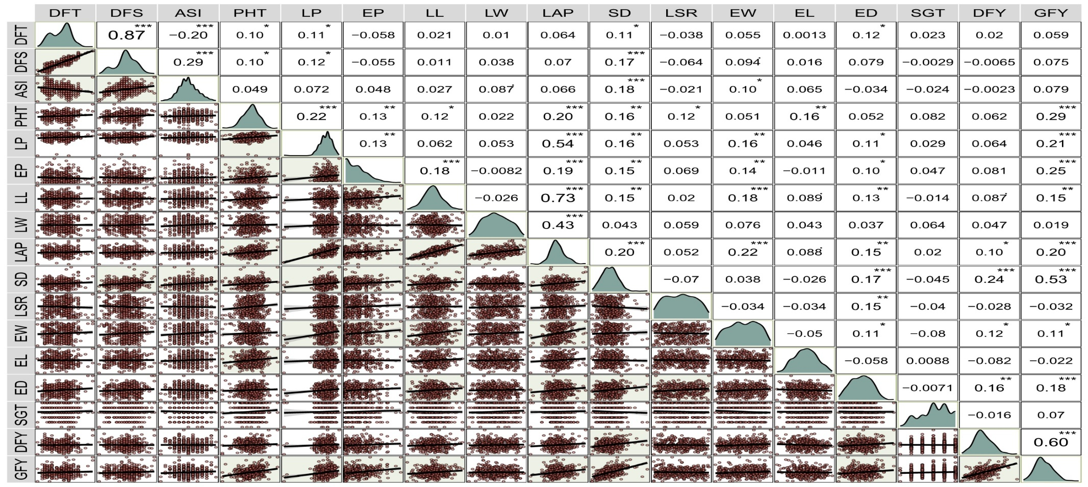
DFT: | Days to 50% tasseling |  | PHT: | Plant height (cm) | LL: | Leaf length (cm) |  | SD: | Stem diameter (cm) | EL: | Fresh ear length (cm) |  | GFY: | Green fodder yield (kg/ha)
DFS: | Days to 50% silking |  | LP: | Number of leaves per plant | LW: | Leaf width (cm) |  | LSR: | Leaf : stem ratio | ED: | Fresh ear diameter (mm) |  | DFY: | Dry fodder yield (kg/ha)
ASI: | Anthesis to silking interval |  | EP: | Number of ears per plant | LAP: | Leaf area per plant (cm²) |  | EW: | Fresh ear weight (g) | SGT: | Stay green trait (scale) |  | * significant at p<0.05, ** significant at p<0.01, *** significant at p<0.001

