Diversity and Nesting behaviour of Xylocopa species in Kangra District of Himachal Pradesh, India

ABSTRACT

Aims: Kangra district, situated in the mid-hills of Himachal Pradesh is known to retain a rich treasure of climatic variability, favourable for diversified vegetation and insect fauna. This study assessed the diversity and nesting behaviour of Xylocopa species in Kangra district.

Study Design: A biodiversity survey was conducted across different selected locations.

Place and Duration of Study:
Five different locations in the Kangra district viz., Palampur, Nagrota Bagwan, Nagrota Suriyan, Fatehpur and Nurpur were surveyed during the year 2024-2025.

Methodology: Insects were collected using sweep net and preserved for further identification. Species diversity was assessed for the collected bees and their active nests were located. Later on, artificial structures were constructed to study the nesting behaviour of the bees.

Results: The study recorded three Xylocopa species: X. fenestrata, X. pubescens and X. nasalis, reflecting a stable and diverse carpenter bee community. Nesting was primarily in sunlit areas, with east or southeast-oriented entrances and tunnels angled slightly downward (14.60–18.60°). X. fenestrate exhibited broad foraging across 15 plant species, including key crops like ridge gourd, brinjal and cucumber, with peak flower visitation rates on ridge gourd (9 flowers/min) and longest foraging duration averaging 9 hours 24 minutes per day. Laboratory rearing documented its complete developmental cycle (36.5 ± 1.50 days). Domiciliation experiments showed a strong preference for bamboo, with only 4 of 70 offered cells accepted, yielding an average acceptance rate of 32.5%, while other substrates were rejected. Associated pollinators observed near Xylocopa nests included Ceratina spp., Megachile spp. and Vespa spp., highlighting the diversity and complexity of the local pollinator guild.

Conclusion: The study revealed that the Kangra district supports a diverse community of large carpenter bees, with Xylocopa fenestrata being the most widespread and adaptable. Its specialized nesting behaviour showed a preference for dry bamboo, indicating the feasibility of artificial domiciliation and its broad foraging range highlights its ecological importance. X. fenestrata also excels as a pollinator of crops like ridge gourd and brinjal.

Keywords: Xylocopa; diversity; nesting behaviour; domiciliation; foraging

1. INTRODUCTION

Insect pollination has great economic and agricultural importance. Pollination is one of the most fundamental ecological processes responsible for maintaining and enhancing global biodiversity (Klein et al., 2007; Gallai et al., 2009). pollination contributes substantially to human societies by enhancing food security, supporting agricultural productivity and improving rural livelihoods (Klein et al., 2007). It underpins the functioning of natural ecosystems and directly supports the stability of agro-ecosystems by sustaining plant reproduction and genetic diversity (Martin 2024). It has been suggested that nearly 60–80 per cent of the world’s flowering plant species rely on animals primarily insects for effective pollination (Kremen et al.,2002).

Wild and domesticated non-Apis bees complement honey bee pollination in many crops by enhancing pollination efficiency through their diverse foraging behaviours and activity patterns, leading to improved crop yield and stability (Garibaldi et al., 2013). Among non-Apis pollinators, large carpenter bee, Xylocopa spp. that burrow in hard dry plant surfaces to dwell, are effective pollinators of many crops of economic importance. Xylocopa bees, unlike honey bees do not form colony but live solitarily (Kesar, 2009; Chun-ling et al., 2018). The genus Xylocopa Latreille (Xylocopinae: Xylocopini) comprises approximately 470 species of large, robust bees, resembling bumble bees. They are geographically widespread, especially in tropical and subtropical regions (Lucia et al., 2015) and are physiologically robust bees.

The subfamily Xylocopinae commonly referred to as the “carpenter bees” comprising four tribes namely, Xylocopini, Ceratini, Manuelini and Allodapini in the family Apidae (Michez et al.,2009). Carpenter bees are divided into two groups i.e. the large carpenter bees of genus Xylocopa and small carpenter bees of genus Ceratina (Michener, 2007). Unlike highly eusocial bees with distinct queen and worker castes, carpenter bees maintain individual males and females, though newly hatched daughters often cohabit nests with their mothers, displaying facultative sociality. These bees are generally long-lived, with lifespans up to three years and potentially one or two generations annually. Large carpenter bees (Xylocopa) are widely recognized as versatile and effective generalist pollinators with an extensive geographical distribution. Their foraging behaviour is marked by the utilization of a broad spectrum of floral resources, a prolonged period of activity throughout the season and a remarkable tolerance to elevated temperatures.
Morphologically, species within the genus exhibit considerable variation in body size, integument coloration and pubescence density, traits that often correspond to ecological specialization and thermal tolerance (Gerling et al., 1989). Additionally, their ability to forage under low-light conditions distinguishes them from many other pollinating insects. These ecological and behavioural traits make Xylocopa species promising candidates for managed pollination, particularly in hot climatic regions, greenhouse environments and in crops that bloom during night time (Sadeh et al., 2007a).
In Xylocopa, the selection of nesting substrates is influenced primarily by the physical characteristics of the wood rather than its botanical origin. The availability and distribution of suitable nesting substrates have been identified as key determinants governing the spatial distribution and local occurrence of Xylocopa species (Hurd 1958; Bernardino and Gaglianone, 2008). Typically, these bees construct unbranched or linear nests in which the tunnel extends in the same direction as the entrance, occasionally incorporating a single right-angle turn.
The architecture of these nests, along with associated nesting behaviours for various Xylocopa species, including X. ordinaria and X. frontalis (Bernardino and Gaglianone, 2008), X. aeratus (Steen and Schwarz, 2000), X. virginica (Prager and Hunter, 2011) and X. nasalis (Hongjamrassilp and Warrit 2014) is largely studied. In some cases, they also construct branched nests, consisting of two or more tunnels, though these still retain a single entrance (Gerling et al. 1989). The architecture of these nests, along with associated nesting behaviours for various Xylocopa species, including X. ordinaria and X. frontalis (Bernardino and Gaglianone, 2008), X. aeratus (Steen and Schwarz, 2000), X. virginica (Prager and Hunter, 2011) and X. nasalis (Hongjamrassilp and Warrit, 2014) is largely studied.
Artificial nesting materials such as bamboo internodes, pithy stems, castor stems, wooden blocks with pre-drilled holes and other hollow cylindrical substrates have been successfully used to accommodate the nesting preferences of Xylocopa spp. These substrates mimic the structural characteristics of naturally excavated cavities (Gerling et al.,1989; Steen and Schwarz, 2000). Xylocopa females readily occupy these artificial substrates when they resembling the physical features of preferred natural nesting materials (Bernardino and Gaglianone, 2008).
By providing standardized nesting substrates, we can accurately monitor developmental stages, brood cell architecture, provisioning patterns and adult emergence rates. The domiciliation of X. virginica and X. aeratus have facilitated detailed insights into reproductive division of labor, nest re-use and cell construction sequences (Prager and Hunter, 2011; Steen and Schwarz, 2000). These bees can work at very high temperature especially in polyhouses, hence, xylocopid is an important candidate pollinator for conservation and augmentation (Buchmann, 2004; Keasar, 2010). The nesting behaviour and biology varies across species, from solitary to semisocial or primitively eusocial nests where the oldest female feeds with both young females and males via trophollaxis (Lucia et al., 2015).
Amidst the worldwide decline of pollinators driven by habitat loss, pesticide use and climate change carpenter bees emerge as resilient and highly adaptable alternatives. Their hardiness makes them ideal candidates for xylocopiculture which is the purposeful rearing and conservation of Xylocopa species. Harnessing their potential in managed pollination systems represents a promising and forward-thinking strategy to enhance pollinator diversity and safeguard sustainable agriculture (Michener, 2007). Understanding the diversity, distribution and nesting preferences of these bees is crucial for several reasons: their role as pollinators of wild plants and crops, their potential as indicators of habitat quality and their conservation needs in the face of changing land use patterns.
Different species of Xylocopa bees have been documented but it is important to know their diversity, nesting behaviour and foraging ecology to make efforts for domiciliation.

2. MATERIALS AND METHODS

2.1 Study Area

Studies were carried out at Bee Research Station, Nagrota Bagwan (Elevation: 870 m, Coordinates: 32.1054° N, 76.3789° E) of Chaudhary Sarwan Kumar Himachal Pradesh Agriculture University, Palampur, District Kangra, Himachal Pradesh, during 2024-25 to generate information on diversity and nesting behaviour of Xylocopa species.

2.2 Sites Surveyed

In 2024, observations were taken on the diversity of bees while in the succeeding year, 2025, observations were taken to study the nesting behaviour and rearing of bees in artificial structures created. The field studies for diversity and nesting behaviour were conducted at Palampur, Nagrota Bagwan,Nagrota Suriyan, Fatehpur and Nurpur of the Kangra district.

2.3 Collection of bees

Sweep net method was used preferentially for their collection. All the specimens were first poisoned with ethyl acetate in an air tight killing jar and later carried to the laboratory. Then, they were carefully mounted using insect pins, labelled and kept in the collection box for further preservation. Photographs of pinned insects were taken using Canon SX740 HS camera. The collected specimens from each site were identified with help of taxonomists at UAS, Bangalore.

2.4 Diversity of Xylocopa species

During the morning hours, hovering bees were observed and by following their settling behaviour, the nesting sites were located. After confirming the presence of Xylocopa bees within a nest, monitoring was carried out to record parameters such as the direction and angle of the nesting substrate and the associated floral resources.

2.5 Type of domicile

Carpenter bees generally prefer dead, rotten wood to make nests. Hence, after locating the nests, the observations were recorded on outer width and depth of nesting structure(cm).

2.6 Rearing of the carpenter bees

After locating the active nests, the bees were carefully transferred for rearing in artificial nesting structures under laboratory conditions. The rearing was conducted in a controlled environment to facilitate continuous observation of their behaviour, development and survival. Necessary provisions such as suitable nesting substrates and food resources were supplied to ensure normal growth and successful completion of the life cycle.

2.7Foraging behaviour of Xylocopa fenestrata

Under field conditions, different vegetations were critically observed at different locations for the presence of carpenter bees to determine their foraging rate, foraging speed and duration of foraging.

2.7.1 Foraging Rate
Foraging rate (the number of flowers visited by Xylocopa bees per minute) was observed visually, i.e. the number of flowers visited by Xylocopa bees in unit time. These observations were recorded in regular visits per minute at 0800 hour, 1000 hour, 1200 hour, 1400 hour and 1600 hour of the day for 3 consecutive weeks during the flowering period (Abrol, 2012).

2.7.2 Foraging Speed

Foraging speed (the time spent in seconds by carpenter bee on a flower) was recorded with the help of stop watch. For this, as soon as the Xylocopa bees visited an individual flower, the stop watch installed in Google Pixel 7 phone was switched on and as the bees were seen leaving the flowers the watch was switched off and the observations were recorded at 0800h, 1000h, 1200h 1400h and 1600h of the day for 3 consecutive weeks.

2.7.3Duration of foraging
With a view to find out the foraging period of Xylocopa on different flowers the observations were taken on different days in a week during the morning and evening hours. During morning hours when Xylocopa started visiting flowers was recorded as initiation time. Similarly, the time where there were no Xylocopa bees on the flower in the evening then it was considered as cessation time. Duration of foraging was calculated as follows:
Duration of foraging = Initiation time – Cessation time (Abrol, 2012).

2.8Domiciliation of the carpenter bees
The following treatments for artificial domiciliation were erected and carefully maintained at BRS, Nagrota Bagwan\=

Chart 1: Treatment Details

Treatment | Material | Hole/Stem Diameter (cms)
T1 | Bamboo Stems  (angled at 45°) | 1. 1.00–1.50 cm  2. 1.60–2.00 cm  3. 2.10–2.50 cm
T2 | Castor Stems | 1. 0.40–0.50 cm  2. 0.51–0.60 cm  3. 0.61–0.70 cm
T3 | Pithy Stems | 1. 1.00–1.50 cm  2. 1.50–2.00 cm  3. 2.00–2.50 cm
T4 | Soda Water Straws | 1. 0.45–0.55 cm  2. 0.56–0.65 cm  3. 0.66–0.75 cm
T5 | Sarkanda (Arundo spp.) | 1. 1.00–1.50 cm  2. 1.50–2.00 cm  3. 2.00–2.50 cm

Following observations were recorded for each nesting materials and on the characteristics below:
1. Cell size
2. Number of cells accepted
3. Sizes of cells accepted
4. Species of carpenter bee or any other pollinator and its family
5. Percent acceptance of each domicile
2.9 Statistical Analysis
Quantitative data on nesting preference, cell dimensions and foraging behaviour were statistically analyzed to determine the significance of differences among treatments and behavioural patterns.
3. RESULTS

3.1 Diversity of Xylocopa species
The field investigation revealed, the presence of three distinct Xylocopa species distributed across these sites. The simultaneous co- occurrence of species in different habitats highlights the ecological suitability of the region for large carpenter bees hence reflecting a stable and diverse Xylocopa community within the surveyed ecosystems. During the survey, in different sites the collected samples were identified as Xylocopa (Biluna) nasalis Westwood, 1838, X. (Ctenoxylocopa) fenestrata Fabricius,1798 and X. (Koptortosoma) pubescens Spinola,1838 as shown in Table 1.

3.1.1 Direction and angle of nesting structure
As evident from Table 2, out of the total surveyed sites, three locations namely, Nagrota Bagwan, Nagrota Suriyan and Bhawarna had Xylocopa nests projected in direct morning sunlight with an eastward orientation (Fig.1). However, the nests recorded at Nurpur and Fatehpur were only partially sunlit, facing south-east direction. The maximum nest tunnel angle was observed at Fatehpur (18.60 ± 1.17°), while the minimum angle of nest tunnel (14.60 ± 1.03°) was recorded at Nagrota Bagwan.
3.1.2 Floral resources

A total of three species of Xylocopa were recorded belonging to family Apidae and order Hymenoptera viz., Xylocopa fenestrata, X. pubescens and X. nasalis (Table3). The species Xylocopa fenestrate was observed foraging on number of crops such as ridge gourd (Luffa acutangular (L.) Roxb), French marigold (Tagetes patula L.), lemon (Citrus limon (L.) Burman f), morning glory (Ipomoea nil), Pride of India (Lagerstroemia speciosa (L.) Pers), brinjal (Solanum melongena L.) and Bush clockvine (Thunbergia erecta (Benth.) T. Anderson). X. pubescens visited crops like calotropis (Calotropis gigantea (L.) W.T. Aiton) and cosmos (Cosmos sulphureus Cav.).
However, X. nasalis was seen to visit the crops like cucumber (Cucumis sativus L.), okra (Abelmoschus esculentus (L.) Moench), cowpea (Vigna unguiculata (L.) Walpers), moss rose (Portulaca oleracea L.) and broccoli (Brassica oleracea var. italica Plenck) as given in Fig. 3.

3.2 Type of domicile
At different locations measurement of nesting structures was recorded. The results as in Table 4 revealed that the mean outer width of nesting structure was 1.45±0.14 cm. The width was just large enough to allow the adult bee to pass through while minimizing exposure to predators and environmental stressor. However, the mean depth of hole (cm) of the nests was found to be 20.58±1.00.

3.3 Rearing of the carpenter bees

Table 5 demonstrates the duration of immature stages (in days) maintained as replications of Xylocopa fenestrata spp. under laboratory conditions (fig 4). The rearing was carried out in two different rearing cages simultaneously. The mean duration(days) recorded of the 1st, 2nd ,3rd, 4th and 5thinstar larvae were 2.50±0.50, 3.50±0.50, 4.50±0.50, 5.00±1.00 and 9.00±1.00 respectively. The pupal stage lasted for 12.00±1.00 days and the mean of all the immature stages was 36.5±1.50 days.

3.4 Foraging behaviour of Xylocopa species

3.4.1 Foraging rate

Foraging rate of X. fenestrate on different floral resources in the month of June, 2025 presented in Table 6. It was observed that the maximum number of flowers visited per min. by Xylocopa bees is highest for Luffa acutangula i.e. 9.00 during the 25th week and the minimum flower visitation per minute was seen on Calotropis gigantea i.e. 5.88 during the 23rdweek.

3.4.2 Foraging speed

The table 7 showed the foraging speed of X. fenestrate on different floral resources. The average time spent on a flower was highest during the 23rd week on Calotropis gigantea which was 12.48 seconds followed by Tagetes patula 11.53 seconds and the least average time spent per flower was on Solanum melongena which was 7.55 seconds during the 25th week.

3.4.3 Duration of foraging
Table 8 showed the foraging duration of Xylocopa bees during May, 2025 at Nagrota Bagwan. The maximum foraging duration was observed on 27th May, 2025 which was 10:10 hours and the minimum was observed on 28/05/25 which was 08:47 hours. On an average Xylocopa foraging initiated at 07:06 hours and the bees remained active till 04:26 hours with the total average duration of 09:24 hours.

3.5Domiciliation of the carpenter bees
3.5.1 Domiciliation behaviour of Xylocopa spp.: number and size of nest cells accepted across different substrates at BRS, Nagrota Bagwan
Table 9 presents the domiciliation behaviour of Xylocopa spp. at BRS, Nagrota Bagwan. Among the various substrates offered bamboo stems, castor stems, pithy stems, soda straws, and sarkanda only bamboo was accepted. Out of 70 bamboo stems, the bees utilized just 4 cells, with mean outer and inner diameters of 1.6 ± 0.15 cm and 0.75 ± 0.09 cm, respectively. The complete rejection of all other materials highlights a marked preference of Xylocopa spp. for bamboo as a nesting substrate.

3.5.2Per cent acceptance of each domicile
Table 10 summarises the nesting acceptance of Xylocopa spp. in bamboo domiciles (n=10), revealing noticeable variation among sites. At Nagrota Bagwan, acceptance ranged between 10–50%, indicating inconsistent nest initiation across bamboo tops. On average, 3.25 nests were established per domicile, reflecting an overall acceptance rate of 32.50%. These results suggest that bamboo tops provide a moderately suitable artificial nesting substrate for carpenter bees in the study area.

3.5.3 Pollinator species associated with carpenter bee
Table 11 showed three major pollinator groups which were recorded across the surveyed locations. Small carpenter bees (Ceratina spp.; Family: Apidae) were observed predominantly in Nurpur. Leaf-cutting bees (Megachile spp.; Family: Megachilidae) were found at both Nagrota Bagwan and Fatehpur, indicating a wider distribution and adaptability across sites. In addition, wasps belonging to the genus Vespa (Family: Vespidae) were documented at Nagrota Bagwan(Fig.5)

Table 1: Diversity of Xylocopa species in Kangra district of Himachal Pradesh
 | Scientific Name |  |  | Nagrota Bagwan | Nagrota  Suriyan | Palampur | Nurpur | Fatehpur
 | Xylocopa fenestrata |  |  | + | + | + | + | +
 | X. pubescens |  |  | - | + | - | + | -
 | X. nasalis |  |  | + | - | + | - | +
 | + indicates presence |  |  |  |  | - Indicates absence

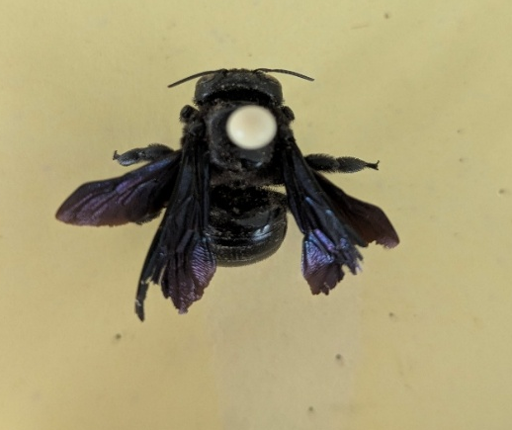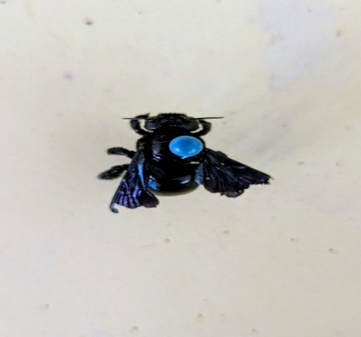
- (b)
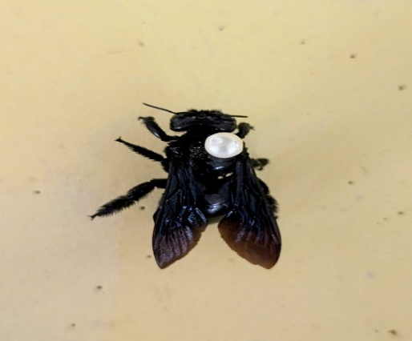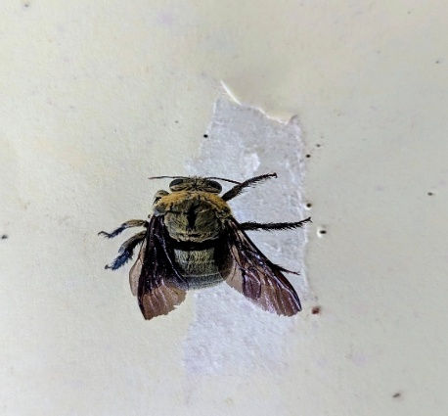
(c) (d)
Fig.1 Diversity of Xylocopa species (a) Xylocopa nasalis (b)(c) X. fenestrata (d) X. pubescens

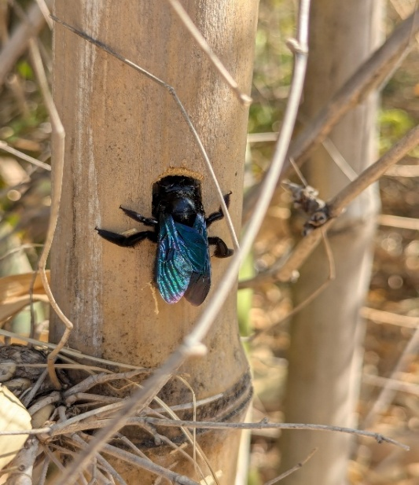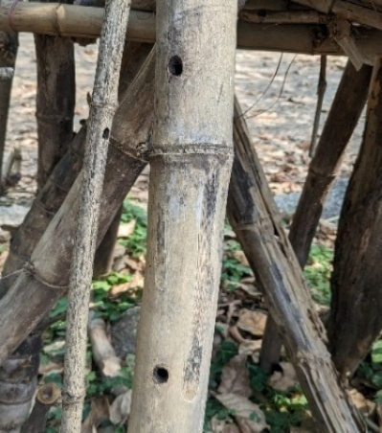
Fig.2 The direction and angle of nesting structures associated with carpenter bees
Table 2: Direction and angle of nests of Xylocopa fenestrata at different locations (n=5)
Location | Direction of Nest Entrance | Angle of Nest Tunnel (°)
Nagrota Bagwan | East | 14.60±1.03
Nurpur | Southeast | 15.60±1.36
Nagrota Suriyan | East | 17.20±1.40
Bhawarna | East | 16.60±1.67
Fatehpur | Southeast | 18.60±1.17

Table 3: Diversity of floral resources associated with Xylocopa spp. of Himachal Pradesh during the year 2024-25.
Xylocopa spp. | Common name | Scientifiic name | Family
X. fenestrata | French marigold | Tagetes patula L. | Asteraceae
 | Ridge gourd | Luffa acutangula (L.) Roxb. | Cucurbitaceae
 | Pride of India | Lagerstroemia speciosa (L.) Pers. | Lythraceae
 | Lemon | Citrus limon (L.) Burm.F. | Rutaceae
 | Morning glory | Ipomoea nil (L.) Roth | Convolvulaceae
 | Brinjal | Solanum melongena L. | Solanaceae
 | Bush clockvine | Thunbergia erecta (Benth.) T. Anderson | Acanthaceae
X. pubescens | Calotropis | Calotropis gigantea (L.) W.T. Aiton | Apocynaceae
 | Cosmos | Cosmos sulphureus Cav. | Asteraceae
X. nasalis | Cucumber | Cucumis sativus L. | Cucurbitaceae
 | Okra | Abelmoschus esculentus (L.) Moench | Malvaceae
 | Cowpea | Vigna unguiculata (L.) Walpers | Fabaceae
 | Moss Rose | Portulaca oleracea L. | Portulacaceae
 | Brocolli | Brassica oleracea var. italica Plenck | Brassicaceae

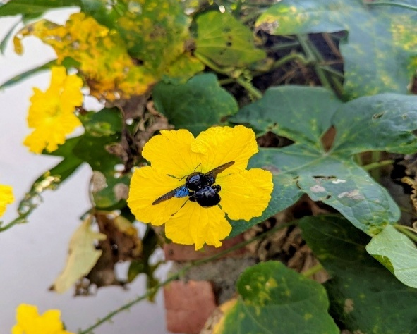 | 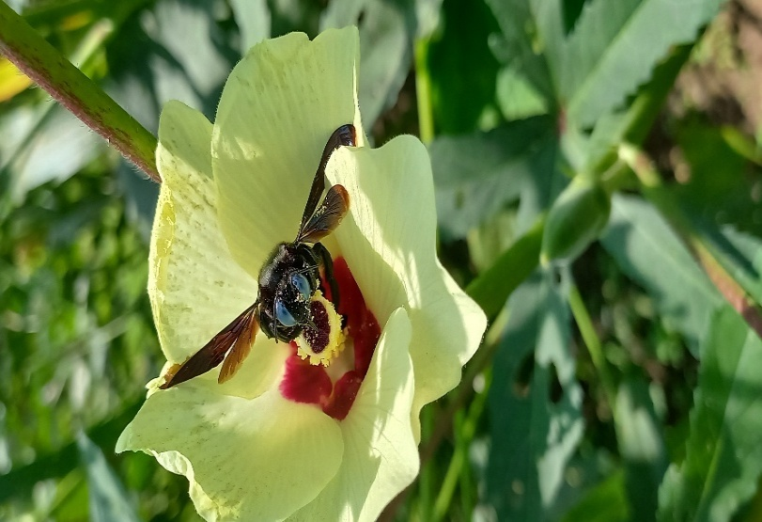
(a) | (b)
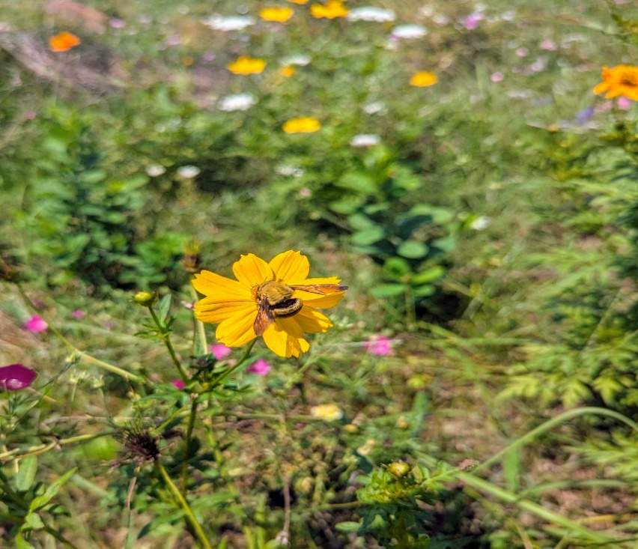 | 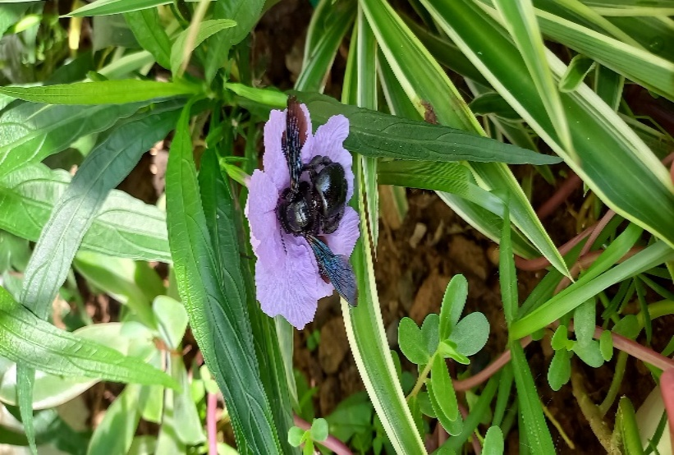
( c) | (d)
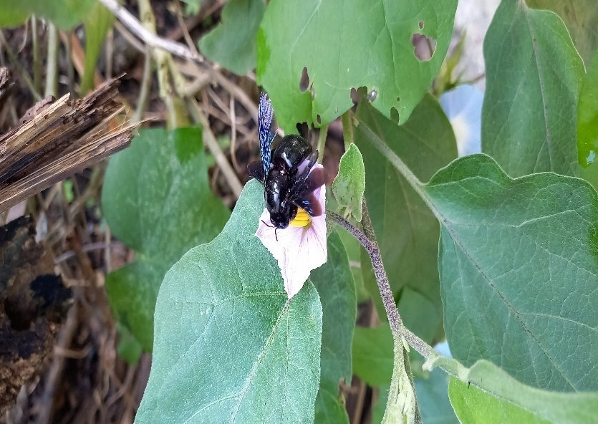 | 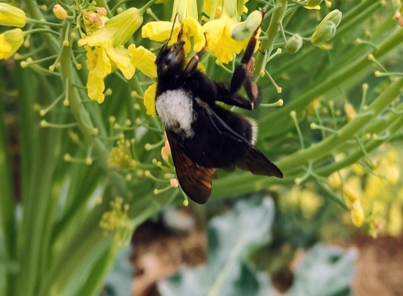
(e) | (f)

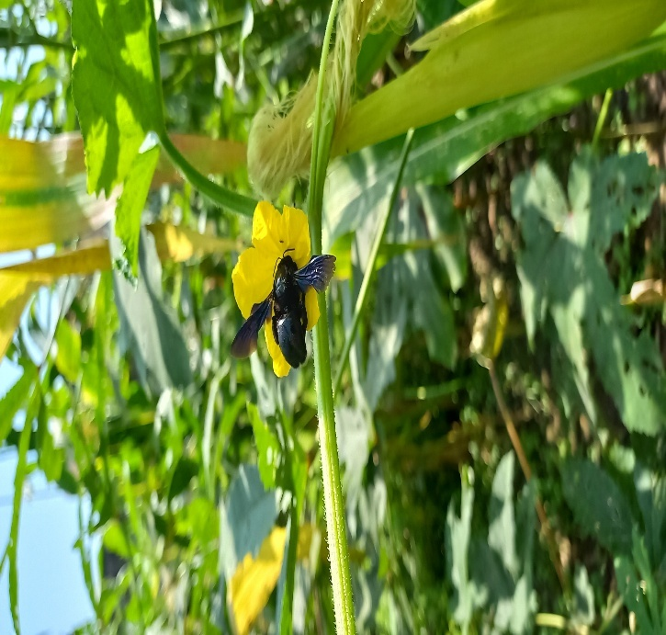 | 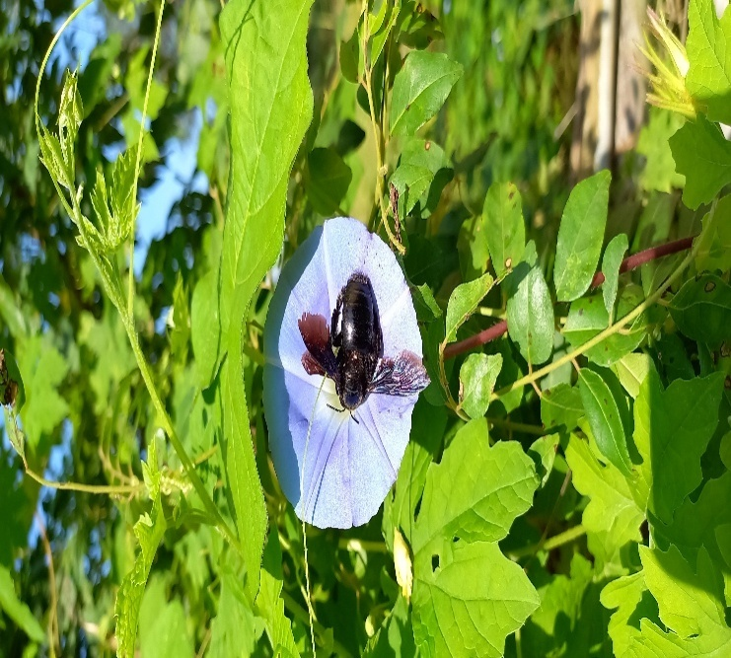
(g) | (h)
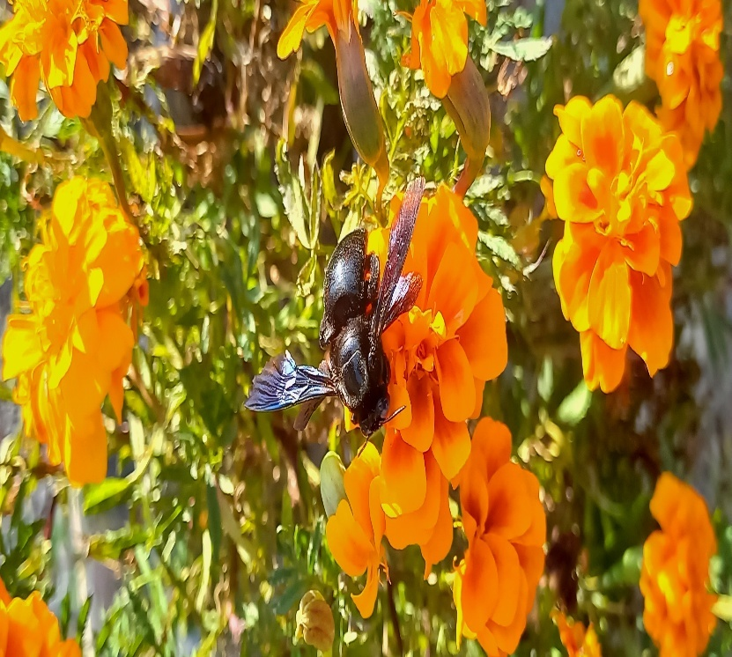 | 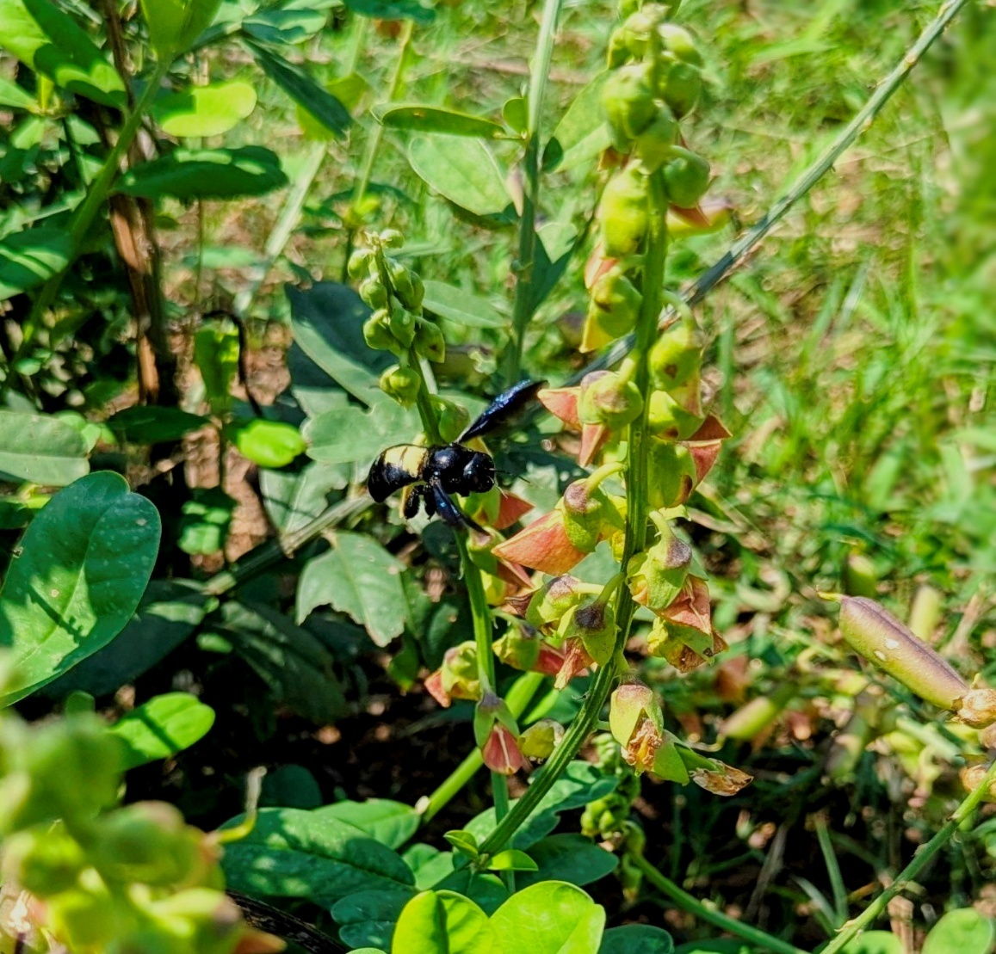
(i) | (j)
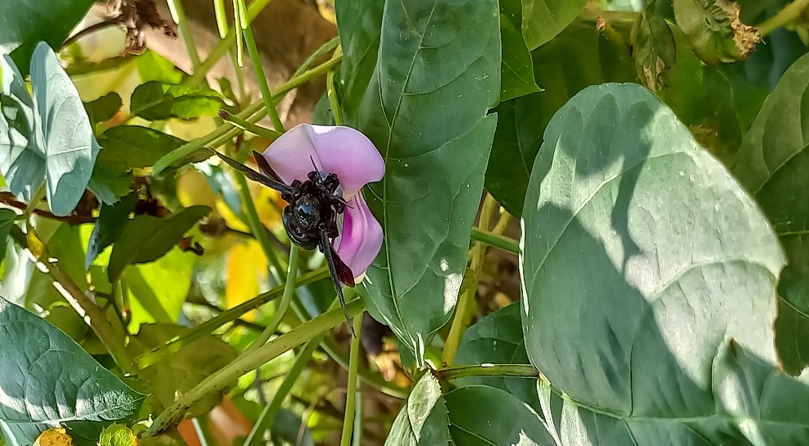 | 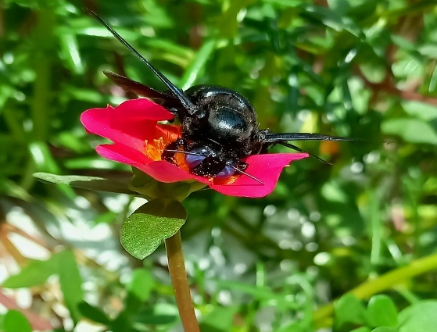
(k) | (l)
Fig.3. Floral resources associated with Xylocopa bees (a) Luffa acutangula (b) Abelmoschus esculentus (c) Cosmos sulphureus (d) Thunbergia erecta (e) Solanum melongena (f)Brassica oleracea var. italica (g)Cucumis sativus (h) Ipomoea nil (i) Tagetes patula (j) Calotropis gigantea (k) Vigna unguiculata (l) Portulaca oleracea

Table 4: Nesting structures of Xylocopa fenestrata at different locations and their dimensions and characteristics (n=5)

Location | Outer width of nesting structure (cm) | Depth of nesting structure (cm)
Nagrota Bagwan | 1.08±0.04 | 20.40±0.68
Nagrota Suriyan | 1.42±0.18 | 20.20±0.86
Bhawarna | 1.74±0.16 | 21.06±1.39
Nurpur | 1.54±0.16 | 20.66±1.07
Mean | 1.45±0.14 | 20.58±1.00

Table 5: Duration of immature stages (in days) of Xylocopa fenestrata under laboratory conditions

Stage | Replication 1  (days) | Replication 2  (days) | Mean duration  (days) | Range (days)
1st instar | 2.00 | 3.00 | 2.50±0.50 | 2-3
2nd instar | 3.00 | 4.00 | 3.50±0.50 | 3-4
3rd instar | 5.00 | 4.00 | 4.50±0.50 | 4-5
4th instar | 4.00 | 6.00 | 5.00±1.00 | 4-6
5th instar | 8.00 | 10.00 | 9.00±1.00 | 8-10
Pupal | 13.00 | 11.00 | 12.00±1.00 | 11-13
Total duration | 35 .00 | 38.00 | 36.50 ±1.50

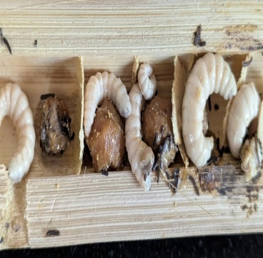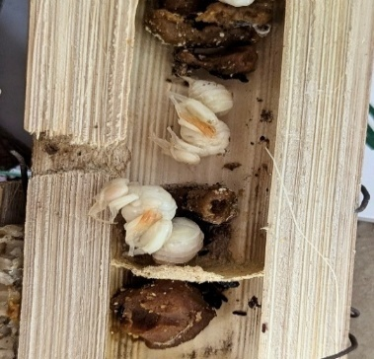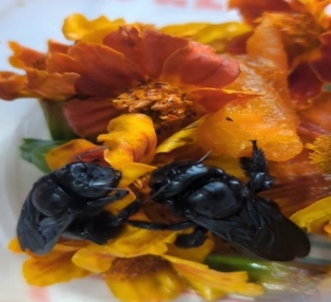
- (b) (c)
Fig.4: Different developmental stages of Xylocopa fenestrata(a) Larval stages (b) pupal stages and (c) The adult (females) of X. fenestrata

Table 6: Foraging rate of X. fenestrata on different plantations in the month of June, 2025

Number of flowers visited/ minute by Xylocopa bee at different time intervals of the day and weeks
Plantations | Calotropis gigantea |  |  | Cosmos sulphureus |  |  | Tagetes patula |  |  |  | Luffa acutangula |  |  |  | Cucumis sativus |  |  |  | Solanum melongena
Time in hours  weeks | 23 | 24 | 25 | 23 | 24 | 25 | 23 | 24 | 25 | 23 |  | 24 | 25 | 23 |  | 24 | 25 | 23 |  | 24 | 25
0800-1000 | 5.00  (2.44) | 5.30  (2.49) | 6.60  (2.74) | 5.40  (2.52) | 5.60  (2.56) | 6.50  (2.73) | 5.00  (2.44) | 4.90  (2.42) | 6.20  (2.67) | 5.80  (2.60) |  | 7.60  (2.92) | 8.40  (3.06) | 6.20  (2.67) |  | 6.60  (2.75) | 5.80  (2.59) | 6.00  (2.64) |  | 6.90  (2.80) | 6.20  (2.67)
1000-1200 | 6.20  (2.68) | 6.30  (2.69) | 7.80  (2.94) | 6.80  (2.78) | 7.30  (2.87) | 8.40  (3.06) | 6.50  (2.73) | 6.60  (2.73) | 8.60  (3.09) | 8.00  (2.99) |  | 9.40  (3.22) | 10.00  (3.39) | 7.80  (2.96) |  | 8.40  (3.06) | 8.90  (3.14) | 7.90  (2.97) |  | 8.80  (3.13) | 9.30  (3.13)
1200-1400 | 7.30  (2.86) | 7.30  (2.85) | 9.80  (3.26) | 7.20  (2.85) | 9.30  (3.12) | 9.20  (3.18) | 7.50  (2.90) | 7.40  (2.88) | 10.00  (3.31) | 9.20  (3.19) |  | 10.30  (3.33) | 10.00  (3.30) | 9.50  (3.23) |  | 10.10  (3.32) | 10.10  (3.32) | 9.70  (3.26) |  | 10.50  (3.38) | 10.80  (3.43)
1400-1600 | 5.00  (2.44) | 5.20  (2.49) | 6.10  (2.65) | 5.20  (2.48) | 4.70  (2.38) | 7.10  (2.84) | 5.70  (2.58) | 5.10  (2.46) | 5.40  (2.52) | 5.60  (2.56) |  | 6.60  (2.74) | 7.10  (2.77) | 5.30  (2.50) |  | 4.70  (2.38) | 5.10  (2.46) | 5.50  (2.54) |  | 5.30  (2.51) | 5.30  (2.40)
Mean | 5.88  (2.61) | 6.03  (2.63) | 7.58  (2.90) | 6.15  (2.66) | 6.73  (2.73) | 7.80  (2.95) | 6.18  (2.66) | 6.00  (2.62) | 7.55  (2.90) | 7.15  (2.84) |  | 8.48  (3.05) | 9.00  (3.13) | 7.20 (2.84) |  | 7.45  (2.88) | 7.48  (2.88) | 7.28  (2.85) |  | 7.88  (2.96) | 7.90  (2.91)
Figures in parentheses are square root transformed values

TABLE OF C.D.
Factors | C.D.
Factor Crop | 0.07
Factor Week | 0.05
Interaction Crop X Week | 0.12
Factor Time | 0.06
Interaction Crop X Time | 0.14
Interaction Week X Time | N/A
Interaction Crop X Week X Time | N/A

Table 7: Foraging speed of X. fenestrata on different plantations in the month of June,2025
 | Time spent/second by Xylocopa bee at different time intervals of the day and weeks
Plantations | Calotropis gigantea |  |  | Cosmos sulphureus |  |  | Tagetes patula |  |  |  | Luffa acutangula |  |  |  | Cucumis sativus |  |  |  | Solanum melongena
Time in  hours  weeks | 23 | 24 | 25 | 23 | 24 | 25 | 23 | 24 | 25 | 23 |  | 24 | 25 | 23 |  | 24 | 25 | 23 |  | 24 | 25
0800-1000 | 14.50  (3.92) | 10.70  (3.41) | 10.30  (3.35) | 12.40  (3.65) | 10.80  (3.43) | 9.10  (3.17) | 12.30  (3.63) | 10.60  (3.40) | 9.50  (3.23) | 12.00  (3.60) |  | 9.90  (3.28) | 9.40  (3.22) | 10.90  (3.44) |  | 9.80  (3.28) | 9.20  (3.18) | 8.40  (3.05) |  | 8.40  (3.05) | 8.30  (3.04)
1000-1200 | 11.80  (3.56) | 8.10  (3.00) | 8.80  (3.13) | 11.20  (3.48) | 8.20  (3.01) | 8.80  (3.12) | 10.60  (3.39) | 8.90  (3.14) | 8.00  (2.99) | 10.70  (3.42) |  | 7.80  (2.95) | 8.00  (3.00) | 9.60  (3.25) |  | 7.80  (2.94) | 8.50  (3.07) | 7.30  (2.87) |  | 7.90  (2.96) | 7.10  (2.83)
1200-1400 | 10.50  (3.38) | 8.00  (2.97) | 7.90  (2.98) | 9.70  (3.26) | 8.10  (3.00) | 8.00  (3.00) | 9.90  (3.29) | 7.80  (2.96) | 6.90  (2.79) | 8.90  (3.14) |  | 6.90  (2.78) | 6.10  (2.65) | 8.10  (3.00) |  | 6.70  (2.75) | 5.90  (2.61) | 5.60  (2.56) |  | 6.00  (2.63) | 6.20  (2.67)
1400-1600 | 13.10  (3.74) | 10.80  (3.74) | 9.20  (3.19) | 12.10  (3.61) | 10.70  (3.41) | 9.90  (3.30) | 13.30  (3.76) | 11.50  (2.53) | 9.50  (3.23) | 12.20  (3.63) |  | 10.40  (3.67) | 8.90  (3.14) | 11.40  (3.52) |  | 10.60  (3.40) | 8.70  (3.11) | 9.20  (3.18) |  | 9.00  (3.15) | 8.60  (3.09)
Mean | 12.48  (3.65) | 9.40  (3.28) | 9.05  (3.16) | 11.35  (3.50) | 9.45  (3.21) | 8.95  (3.15) | 11.53  (3.52) | 9.70  (3.00) | 8.48  (3.06) | 10.95  (3.45) |  | 8.75  (3.17) | 8.10  (3.00) | 10.00  (3.30) |  | 8.72  (3.09) | 8.08  (3.00) | 7.62  (2.92) |  | 7.83  (2.95) | 7.55  (2.91)

*Figures in parentheses are square root transformed values
Table of C.D.

Factors | CD(P=0.05)
Factor Crop | 0.06
Factor Week | 0.04
Interaction Crop x Week | 0.11
Factor Time | 0.07
Interaction Crop x Time | NS
Interaction Week x Time | NS
Interaction Crop x Week x Time | NS

Table 8: Foraging duration of Xylocopa bees during May, 2025 at Nagrota Bagwan

Date of observation | Initiation time (A.M.) | Cessation time  (P.M.) | Foraging duration  (hours)
25/05/25 | 07:02 | 04:32 | 09:30
26/05/25 | 06:45 | 03:45 | 09:00
27/05/25 | 07:15 | 04:58 | 10:10
28/05/25 | 07:35 | 04:22 | 08:47
29/05/25 | 07:00 | 04:10 | 09:10
30/5/25 | 07:07 | 04:30 | 09:23
31/5/25 | 06:59 | 04:48 | 09:49
Mean | 07:06 | 04:26 | 09:24

Table 9: Nesting characteristics of artificial domiciles by Xylocopa fenestrata

Nesting substrate  (n=70) | Cell Size (cm) |  | No. of cells accepted | Size of cells accepted(cm)
Nesting substrate  (n=70) | Outer diameter | Inner diameter | No. of cells accepted
Bamboo stems | 1.82±0.05 | 0.90±0.05 | 4.00 | 1.6±0.15  (outer) | 0.75±0.09  (inner)
Castor stems | 1.00±0.05 | 0.64±0.04 | 0.00 | 0.00 | 0.00
Pithy stems | 1.41±0.07 | 0.92±0.06 | 0.00 | 0.00 | 0.00
Soda water straws | 0.58±0.01 | 0.20±0.01 | 0.00 | 0.00 | 0.00
Sarkanda(Arundo spp.) | 1.23±0.07 | 0.78±0.05 | 0.00 | 0.00 | 0.00
Table 10: Nesting acceptance (%) of Xylocopa spp. in bamboo domiciles (n = 10)

Location | No. of nests in bamboo tops | Acceptance (%)
NagrotaBagwan | 3.00 | 30.00%
 | 4.00 | 40.00%
 | 1.00 | 10.00%
 | 5.00 | 50.00%
Mean | 3.25 | 32.50%

Table 11: Occurrence of other pollinator species visiting Xylocopa spp. nests across different locations

Pollinator | Location | Scientific name | Family
Small carpenter bee | Nurpur | Ceratinaspp. | Apidae
Leaf cutter bee | NagrotaBagwan and Fatehpur | Megachile spp.. | Megachilidae
Wasp | NagrotaBagwan | Vespa spp.. | Vespidae

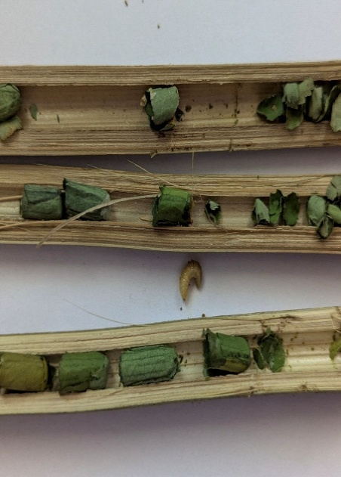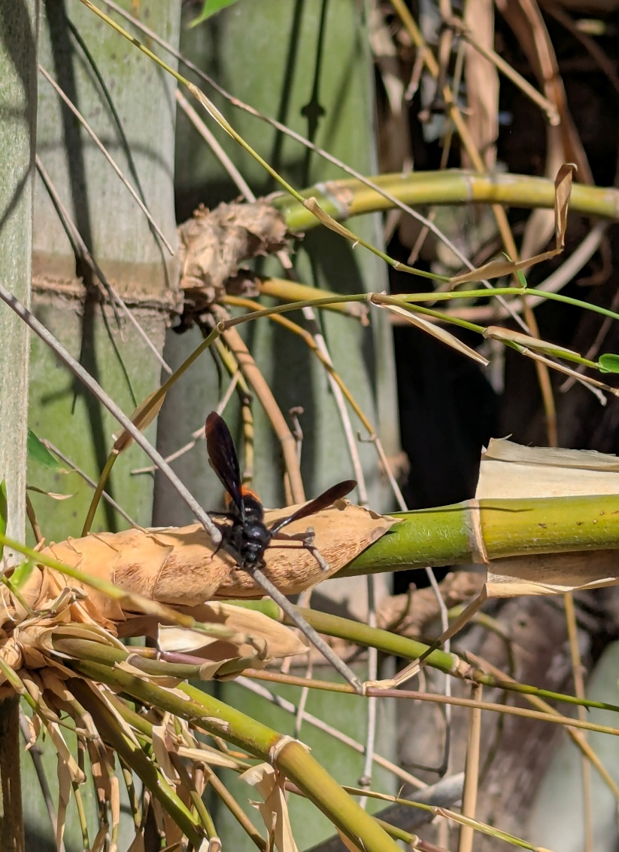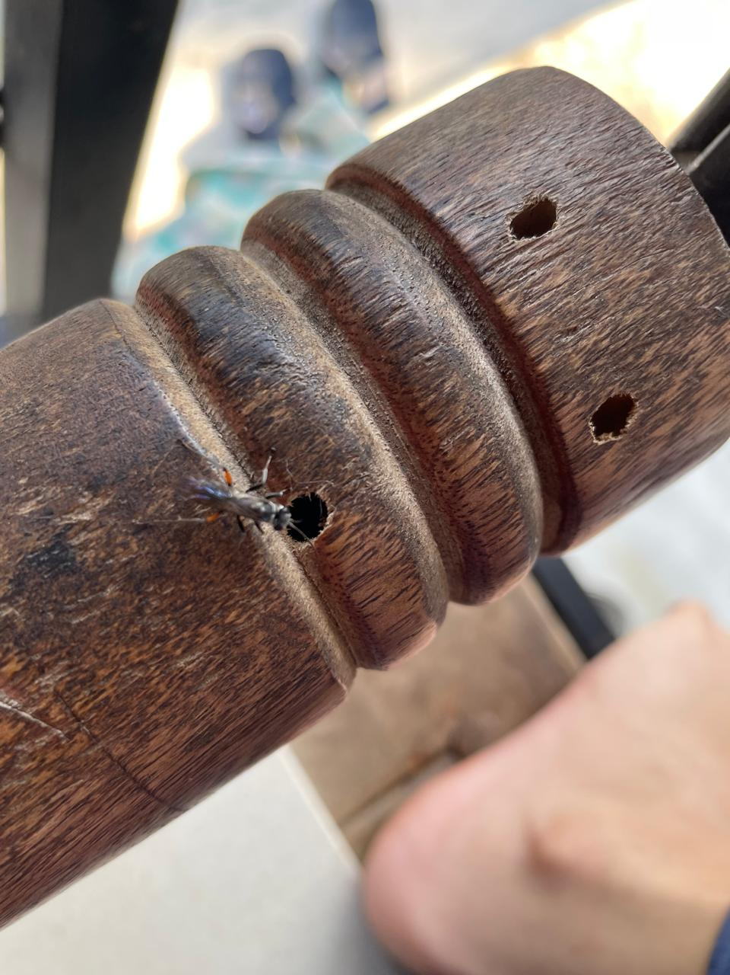
- (b) (c)
Fig.5: Shows the occurrence of other pollinator species visiting Xylocopa spp. nests across different locations: (a) Leaf-cutting bees (Megachile spp.; Family: Megachilidae), (b)Vespa spp. (Family: Vespidae) (c) Small carpenter bees (Ceratina spp.; Family: Apidae)

4. DISCUSSION

Surveys across five sites in Kangra revealed three Xylocopa species X. fenestrata, X. pubescens and X. nasalis reflecting diversity patterns similar to those reported elsewhere in Asia. The stable presence of these species indicates that the region provides suitable habitats and abundant floral resources. The clear dominance of X. fenestrata supports earlier findings by Jyothi et al., (1990) and (Kumar and Chandel, 2003), who also recognized it as a key and efficient pollinator across various Indian crops.

The consistent east to southeast orientation of nest entrances appears to be an important adaptive behaviour, allowing nests to warm quickly with the morning sunlight and enabling earlier foraging which is an advantage in the cooler climate of Himachal Pradesh. The nest tunnels also showed slight downward angles (14.6°–18.6°), which seem to support smoother entry. These observations align with (Sihag, 1993), who reported that a gentle downward slope of about 15° improves bee movement and minimizes pollen loss, while horizontal or upward tunnels hinder efficient entry.

The four Xylocopa species foraged on 15 plant species from 11 families, reflecting their generalist feeding habits and importance as pollinators in both farms and natural habitats. X. fenestrata was the most adaptable, visiting seven plant species, including major vegetables like ridge gourd and brinjal. This supports (Raju and Rao, 2006), who noted that carpenter bees use many plants but rely on a few key species for food. Their visits to crops such as cucumber, okra and broccoli further highlight their value in agriculture, consistent with (He et al.,2018), who identified carpenter bees as efficient pollinators in warm climates.

The recorded nest dimensions an average height of 116.00 ± 7.77 cm, entrance width of 1.45 ± 0.14 cm and tunnel depth of 20.58 ± 1.00 cm fall within the preferred range for many Xylocopa species. This aligns with (Sihag,1993), who reported that most female X. fenestrata select tunnels 10–12 mm wide and 23–30 cm long. The elevated nest height helps protect against predators and flooding, while the narrow entrance allows bees to enter easily but restricts larger intruders.

The successful laboratory rearing of X. fenestrata, with a total development time of 36.50 ± 1.50 days, offers valuable baseline data for future conservation and mass-rearing programs. The detailed documentation of each developmental stage fills an important gap in the species' biology, as highlighted by (Gerling et al., 1989). These results also parallel the findings of (Hogendoorn et al.,2020), who showed that providing artificial nesting substrates can significantly enhance the breeding success of carpenter bee populations.
The foraging behaviour of X. fenestrata showed clear variation with crop type, time of day and observation period. The species achieved its highest flower visitation rate on ridge gourd, followed by brinjal and cucumber, confirming its effectiveness on cucurbit and solanaceous crops as noted by (Rahman et al., 2011) and (Saikia and Irani, 2021). Peak activity occurred between 1200–1400 hours, when bees visited the most flowers and spent the least time per bloom, indicating efficient resource collection during optimal conditions. Slower foraging on Calotropis gigantea likely reflects the flower’s more complex structure, consistent with observations by (Farook et al.,2022).

The species long daily foraging duration averaging over 9 hours demonstrates its strong work capacity and resilience in high temperatures. This extended activity window gives X. fenestrata a clear advantage over honey bees and aligns with the broad thermal tolerance reported by (Somanathan et al.,2019) for large carpenter bees.

The domiciliation experiments revealed a strong preference of Xylocopa for bamboo, with only 4 of 70 offered cells accepted and all other substrates rejected. The moderate bamboo acceptance rate (32.5%) highlights the challenge of consistently attracting nesting females, reflecting behaviours like philopatry and dispersal, as noted by (Garófaloet al., 2021).

Successful nesting by two bees in laboratory cages demonstrates that artificial domiciliation is feasible with proper bamboo logs and provision of food. Initial agitation followed by acceptance indicates an acclimatization period, aligning with findings from (Sadeh et al. 2007b) and (Junqueira et al., 2012), who successfully used artificial nests to support carpenter bee populations for crop pollination.

The observation of other pollinators, including small carpenter bees (Ceratina), leafcutter bees (Megachile) and wasps (Vespa), near Xylocopa nests indicates shared habitats and potential overlap in resource use. This highlights the rich diversity of the local pollinator community and underscores the complex ecological interactions at nesting sites, including competition or cleptoparasitism, as noted by (Gerling et al.,1989).

5. CONCLUSION

The study confirms that the Kangra district hosts a vibrant and diverse community of large carpenter bees, with Xylocopa fenestrata recognized as the most widespread and ecologically flexible species. Its nesting behaviour reveals a high level of specialization, including a strong preference for dry bamboo stems, east–southeast facing entrances, slightly inclined tunnels and areas with minimal human disturbance. The species consistently avoided unsuitable materials such as castor, sarkanda and straws, demonstrating marked substrate selectivity. Its broad foraging range across 15 plant species from 11 families, extended daily activity and ability to withstand adverse weather highlight its ecological value. Moreover, X. fenestrate showed exceptional foraging performance on crops like ridge gourd and brinjal, frequently surpassing honey bees under high-temperature conditions.
Laboratory observations successfully captured the complete developmental cycle of X. fenestrata, confirming its multivoltine behaviour and an average egg-to-adult duration of 36.5 ± 1.50 days. The species moderate acceptance of bamboo domiciles and ability to initiate nesting under controlled conditions demonstrate the promising potential for artificial domiciliation, paving the way for future xylocopiculture. Overall, these findings deepen insight into the species’ nesting biology and foraging ecology while emphasizing its suitability as a managed pollinator. Strengthening domiciliation techniques could significantly contribute to both pollinator conservation and enhanced agricultural productivity.

DISCLAIMER (ARTIFICIAL INTELLIGENCE)

Author(s) hereby declare that NO generative AI technologies such as Large Language Models (ChatGPT, COPILOT, etc) and text-to-image generators have been used during writing or editing of this manuscript.

ACKNOWLEDGEMENTS

The authors are highly thankful to CSKHPKV, Bee Research Station, Nagrota Bagwan, H.P. for the required facilities and infrastructure. Invaluable reviewing by all the co-authors and support extended in the identification of insect samples by a team of taxonomists at UAS, Bangalore is gratefully acknowledged. Especially, Dr. V.V. Belavadi is acknowledged for timely species level identification.

COMPETING INTERESTS

Authors have declared that no competing interests exist.

REFERENCES

- Abrol, D.P. (2012). Pollination Biology: Biodiversity Conservation and Agricultural Production.Springer, Dordrecht, 792 pp.
- Bernardino, A.F. and Gaglianone, M.C. (2008). Nesting biology of Xylocopa frontalis (Hymenoptera: Apidae) in southeastern Brazil. Journal of Hymenoptera Research,17,172–183.
- Buchmann, S.L. (2004).The ecology of pollination and pollinators: Managed pollination systems and conservation. In:Plant-Pollinator Interactions: From Specialization to Generalization, pp. 43–61.
- Chun-ling ,H.E., Chao-dong, Z.H.U. and Yan-ru, W.U. (2018). Foraging behaviour and pollination of carpenter bees Xylocopa spp. (Hymenoptera: Apidae). Chinese Journal of Applied Ecology, 29 (10), 3496-3502.
- Farook, U.B., Khan, T., and Bashir, A. (2022). Floral resources and foraging ecology of large carpenter bees (Xylocopa valga, X. pubescens, X. fenestrata, and X. dejeanii) in Jammu and Kashmir and Ladakh. Journal of Insect Conservation, 26(2), 311-325.
- Gallai, N., Salles, J.M., Settele, J., and Vaissiere, B.E. (2009). Economic valuation of the vulnerability of world agriculture confronted with pollinator decline.Ecological Economics,68(3), 810–821.
- Garibaldi, L.A., Steffan-Dewenter, I., Winfree, R., Aizen, M.A., Bommarco, R., Cunningham, S.A., Kremen, C., Carvalheiro, L.G., Harder, L.D., Afik, O., Bartomeus, I. (2013). Wild pollinators enhance fruit set of crops regardless of honey bee abundance. Science, 339(6127),1608-11.
- Garófalo, C.A., Camillo, E., and Serrano, J.C. (2021). Occupational dynamics and nesting behaviour of Xylocopa frontalis (Hymenoptera: Apidae) in artificial shelters. Apidologie, 52(1),123-135.
- Gerling, D., Hurd, P.D., and Hefetz, A. (1989). Bionomics of the large carpenter bees of the genus Xylocopa. Annual Review of Entomology, 34, 163-190.
- He, X., Wang, Y., and Wu, J. (2018). Foraging behaviour and pollination of carpenter bees Xylocopa spp. (Hymenoptera: Apidae). Annual Review of Entomology, 63, 345-363.
- Hogendoorn, K., Steen, Z., and Schwarz, M.P. (2020). Conservation management of the green carpenter bee Xylocopa aerata through provision of artificial nesting substrate. Journal of Insect Conservation 24(2), 277-286.
- Hongjamrassilp, W., and Warrit, N. (2014). Nesting biology of an Oriental carpenter bee, Xylocopa (Biluna) nasalis Westwood, 1838, in Thailand (Hymenoptera, Apidae, Xylocopinae). Journal of Hymenoptera Research, 41, 75–94.
- Junqueira, C.N., Hogendoorn, K., and Augusto, S.C. (2012). The use of trap nests to manage carpenter bees (Hymenoptera: Apidae: Xylocopini), pollinators of passion fruit. Journal of Economic Entomology, 105(1), 319-327.
- Jyothi, J.V., Reddy, M.S., and Reddy, P.V.R. (1990). Pollination ecology of Moringa oleifera (Moringaceae). Proceedings of the Indian National Science Academy, 56(4), 389-394.
- Keasar, T. (2009). Large carpenter bees as agricultural pollinators. A Journal of Entomology, 1–8.
- Klein, A.M., Vaissière, B. E., Cane, J. H., Steffan-Dewenter, I., Cunningham, S.A., Kremen, C., and Tscharntke, T. (2007). Importance of pollinators in changing landscapes for world crops.Proceedings of the Royal Society B: Biological Sciences, 274, 303–313.
- Kremen, C., Williams, N.M., and Thorp, R.W. (2002). Crop pollination from native bees at risk from agricultural intensification. Proceedings of the National Academy of Sciences (PNAS), 99(26), 16812–16816.
- Kumar, J., and Chandel, R.S. (2003). Foraging behaviour and pollination efficiency of carpenter bees (Xylocopa spp.) in Himachal Pradesh. Indian Journal of Ecology, 30(2), 45-52.
- Lucia, M., Gonzalez, V.H., and Abrahamovich, A.H. (2015). Systematics and biology of Xylocopa subgenus Schonnherria (Hymenoptera, Apidae) in Argentina. ZooKeys, 543, 129–167.
- Martin, M. (2024). Plant pollinator interaction and ecosystem stability. Journal of plant genetics and breeding, 8(6), 244.
- Michener, C.D. (2007). The Bees of the World (2nd ed.). Johns Hopkins University Press, Baltimore.
- Michez, D., Patiny, S., Rasmont, P., and Melotte, J.L. (2009). Phylogeny and classification of the subfamily Xylocopinae (Hymenoptera: Apidae). Zoologica Scripta, 38(5), 475–487.
- Prager, S., and Hunter, F.F. (2011). Nest architecture and behaviour of Xylocopa virginica in North America.Journal of the Kansas Entomological Society, 84(2), 112–120.
- Rahman, A., Ghosh, S., and Roy, S. (2011). Foraging behaviour of Xylocopa fenestrata and X. leucothorax on ridge gourd and cucumber. Journal of Apicultural Science, 55(2), 67-75.
- Raju, A.J.S., and Rao, S.P. (2006). Nesting habits, floral resources and foraging ecology of large carpenter bees (Xylocopa latipes and Xylocopa pubescens) in India. Current Science, 90(9), 1210-1217.
- Sadeh, A. (2007a). Artificial domiciles for carpenter bees in greenhouse pollination.
Apidologie, 38(1), 53–63.
- Sadeh, A., Shmida, A., and Keasar,T. (2007b). The carpenter bee Xylocopa pubescens as an agricultural pollinator in greenhouses. Apidologie,38(6), 508-17.
- Saikia, K., and Irani, P. (2021). Diversity of insect foragers and effect of Xylocopa fenestrata pollination on sponge gourd (Luffa cylindrica). Journal of Pollination Ecology, 28, 45-53.
- Somanathan, H., Saryan, P., and Balamurali, G.S. (2019). Foraging strategies and physiological adaptations in large carpenter bees. Apidologie, 50(1), 1-15.
- Steen, R., and Schwarz, M.P. (2000). Nest architecture and sociality in Australian carpenter bees, Xylocopa (Koptortosoma) aeratus. InsectesSociaux, 47, 1–10.

