α-Chitosan Coating as a Bio-preservative: Mitigating Spoilage and Extending the Shelf-Life of Chilled Squid Rings

Abstract
This study evaluated the effectiveness of a 0.5% α-chitosan edible coating in preserving the quality of squid (Uroteuthis duvaucelii) rings during chilled storage at 4 °C. The coated samples (Tα) and uncoated controls (C) were assessed over 8 days for physicochemical parameters (colour, pH, drip loss, lipid oxidation) and sensory attributes. Results showed that α-chitosan substantially retarded quality deterioration compared to the control. Lightness (L*) decreased sharply in the control, whereas coated samples maintained higher values. Redness (a*) and yellowness (b*) increased more gradually in coated samples, indicating reduced surface oxidation. The rise in pH was significantly suppressed in coated samples relative to the control, suggesting reduced microbial spoilage. Drip loss reached 6.5% in the control but remained significantly lower (3.8%) in coated samples, while TBA values an indicator of lipid oxidation were markedly reduced in the coated group compared to the control. Sensory evaluation further confirmed the preservative effect, with coated samples retaining acceptable odour, texture, and overall acceptability up to Day 8, whereas control samples fell below the acceptability threshold by Day 6. Overall, α-chitosan coating acted as an effective oxygen- and moisture-barrier, slowing biochemical and oxidative spoilage processes and extending the sensory shelf life of squid rings by at least two days. These findings highlight α-chitosan as a promising natural bio-preservative for enhancing the storage stability and commercial quality of cephalopod products.

Keywords: α-chitosan coating, squid rings, shelf-life extension, edible coating, drip loss, sensory quality, bio-preservation, chilled storage, seafood spoilage.

1. Introduction
Squid (Uroteuthis duvaucelii) is a commercially vital seafood commodity valued for its high protein content and unique texture; however, it is highly perishable due to its biological composition, which makes it susceptible to rapid microbial spoilage, autolytic enzymatic activity, and lipid oxidation during cold storage (Kulawik et al., 2020). The deterioration of seafood quality is characterized by the breakdown of proteins into volatile nitrogenous compounds, oxidation of lipids leading to rancidity, and loss of water-holding capacity, all of which severely limit shelf life and consumer acceptance (Jeon et al., 2002; Noshad et al., 2020). To mitigate these post-harvest losses, there has been a growing interest in "clean label" preservation strategies that utilize natural biopolymers as edible coatings to replace synthetic preservatives (Elsabagh et al., 2023; Zhang et al., 2019; Priya et al., 2023). Chitosan, a linear polysaccharide composed of β-(1-4)-linked D-glucosamine and N-acetyl-D-glucosamine, is widely recognized for its biodegradability, biocompatibility, and non-toxicity (Choi et al., 2016). It possesses inherent antimicrobial and antioxidant properties, attributed to its polycationic nature which allows interaction with negatively charged microbial cell membranes and metal ions (Tayel et al., 2020; Liu et al., 2022).
The application of chitosan-based coatings has been extensively studied in various food systems to extend shelf life by forming a semi-permeable barrier against oxygen and moisture (Mahin et al., 2025). Previous research has demonstrated the efficacy of chitosan coatings in preserving the quality of diverse aquatic products, including herring and Atlantic cod (Jeon et al., 2002), Chinese shrimp (Zhang et al., 2019), Pacific white shrimp (Liu et al., 2022), and grey mullet (Aref et al., 2022). These studies have consistently shown that chitosan treatment can inhibit microbial growth, retard lipid oxidation, and maintain sensory attributes such as texture and colour (Kulawik et al., 2020; Held et al., 2024). Furthermore, recent advances suggest that the functionality of chitosan can be enhanced when used in conjunction with other bioactive agents or through specific structural modifications, as seen in studies involving nanoparticles or composite coatings (Tayel et al., 2020; Elsabagh et al., 2023).
Despite the extensive literature on chitosan applications, specific research focusing on the efficacy of α-chitosan coatings for the preservation of Indian squid rings (U. duvaucelii) remains limited. While general chitosan coatings have proven effective for other crustacean and fish species (Noshad et al., 2020; Jiang et al., 2011), the specific physicochemical and sensory protective effects of α-chitosan on cephalopods require detailed investigation. Therefore, the objective of this study was to evaluate the effect of an α-chitosan edible coating on the physicochemical parameters (pH, colour, drip loss, and lipid oxidation) and sensory characteristics of squid rings during chilled storage at 4°C. This research aims to provide a natural, effective alternative for extending the shelf life of high-value squid products, contributing to sustainable seafood processing practices.

2. Materials and Methods
2.1 Sample Preparation
Fresh squid (Uroteuthis duvaucelii) were collected from a fishing harbour in Kochi, Kerala, and transported to the laboratory in insulated containers kept at (4 ± 1 °C). Once at the laboratory, the squid were washed with chilled potable water. The mantle portion was separated, eviscerated, and rinsed to remove any remaining visceral matter. To ensure the samples were uniform for coating, the mantles were cut into rings that were approximately 1 cm wide.
2.2 Preparation of Alpha-Chitosan Coating Solution
The coating solution was made by dissolving 0.5% (w/v) alpha-chitosan in a 1% (v/v) glacial acetic acid solution. This mixture was stirred continuously at room temperature for 12 hours until the chitosan was fully dissolved. Afterward, the solution was filtered and sonicated briefly to remove air bubbles, resulting in a uniform solution ready for application.
2.3 Coating Application, Storage, and Sampling
The squid rings were divided into two groups: the alpha-chitosan coated group (Tα) and the uncoated control group (C). The samples in the coated group were dipped into the chitosan solution for three minutes and then left to drain. The control samples were dipped in chilled distilled water for the same amount of time. All samples were then packed in sterile polyethylene bags and stored at (4 ± 1 °C). Testing was carried out on days 0, 2, 4, 6, and 8, with three samples used for each time point.
2.4 Analytical Methods
2.4.1 Colour analysis
Colour was measured using a Colour Flex EZ colorimeter (HunterLab, USA), which recorded L* (lightness), a* (red–green), and b* (yellow–blue) values based on the CIELAB system. Before the analysis began, the instrument was calibrated using a standard white plate. Each squid sample was placed flat, and measurements were taken three times from different angles to account for surface variations. The average of these readings was used for the final analysis.
2.4.2 Determination of pH
To determine the pH, 5 g of each sample was homogenized with 25 mL of distilled water. A pH meter electrode, which was rinsed with deionized water and dried, was placed into the mixture while it was gently stirred. The pH value was recorded once the reading stabilized on the display. The electrode was cleaned between each sample measurement.
2.4.3 Drip loss
Drip loss was calculated by measuring the weight of the samples. The samples were weighed before storage and then weighed again at each sampling interval. The difference was calculated as a percentage of weight lost compared to the initial weight.
2.4.4 TBA analysis
The Thiobarbituric Acid (TBA) test was performed to measure oxidative changes. A 10 g portion of the homogenized sample was mixed with 2% hydrochloric acid and distilled to collect 50 mL of distillate. For the reaction, 5 mL of this distillate was mixed with 5 mL of TBA reagent in a test tube. A blank was also prepared using distilled water and the reagent. These tubes were heated in a boiling water bath at 100 °C for 30 minutes. After cooling, the absorbance was measured at 538 nm using a UV–Visible spectrophotometer.
TBA value (mg malonaldehyde /kg of sample) = $\frac{O.D×7.8×5}{Volume takem(ml)}$ $×100$.
2.4.5 Sensory analysis
Sensory evaluation of different samples was done by a panel of 10 members, based on a 9-point hedonic scale as described by Jones et al. (1955).
2.4.6 Statistical Analysis
The experimental data were compiled and processed using Microsoft Excel. Statistical analyses were performed using IBM SPSS Statistics and RStudio software. All results are expressed as mean ± standard deviation (SD).
3. Results
3.1 Colour Characteristics
Measurements of L*, a*, and b* values were recorded over the 8-day storage period. On Day 0, lightness (L*) values were similar for both groups, ranging between 72.5 and 72.8. As the storage period continued, lightness decreased in the control group, dropping to 66.5 ± 0.4 on Day 6 and further to 63.2 ± 0.5 by Day 8. The coated group recorded higher lightness values, with 70.1 ± 0.2 on Day 6 and 68.5 ± 0.3 on Day 8. Regarding redness (a*), the control group values shifted from -0.55 ± 0.02 on Day 0 to 1.75 ± 0.06 by Day 8. In comparison, the coated samples recorded an a* value of 0.70 ± 0.05 on the final day. Yellowness (b*) measurements showed a distinct increase in the control group, moving from 3.90 ± 0.05 initially to 13.50 ± 0.12 by Day 8. The coated group showed a smaller increase, reaching a final b* value of 8.50 ± 0.09. These trends are shown in Figure 1.
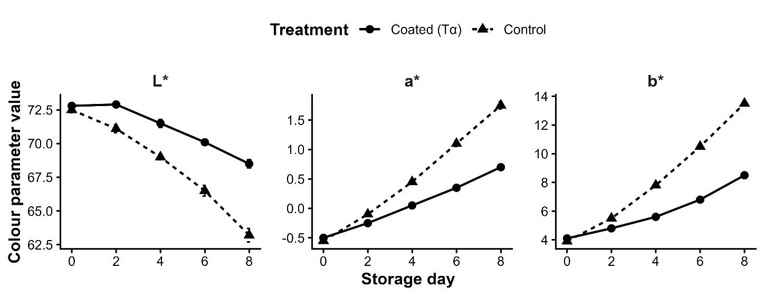
Fig 1. Changes in colour parameters (L*, a*, and b*) of control and α-chitosan–coated squid rings during chilled storage. Coated samples retained higher lightness (L*) and showed slower increases in redness (a*) and yellowness (b*) compared to controls, indicating reduced surface oxidation and discolouration.
3.2 Changes in pH
The pH values were recorded at each interval to monitor chemical changes. On Day 0, the pH was 6.48 ± 0.01 for the control group and 6.45 ± 0.02 for the coated group. By Day 2, the control group pH rose to 6.85 ± 0.03, while the coated group recorded 6.71 ± 0.02. This difference continued on Day 6, where the control group reached 7.55 ± 0.04 compared to 7.15 ± 0.03 for the coated group. By Day 8, the control group pH was 7.88 ± 0.03, whereas the coated group reached 7.45 ± 0.02. Throughout the sampling days from Day 2 onwards, the pH values recorded for the coated samples remained lower than those of the control group. Figure 2 shows the changes in pH.
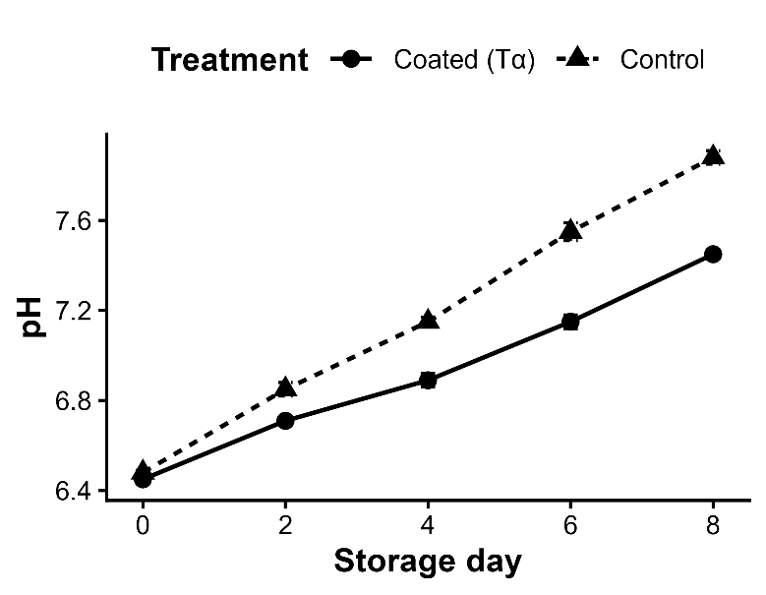
Fig 2. Changes in pH of control and α-chitosan–coated squid rings during chilled storage. pH increased progressively in both groups, with a consistently lower rise in coated samples, indicating delayed biochemical spoilage.
3.3 Drip Loss
Drip loss increased steadily in all samples during storage (Figure 3). Weight measurements taken throughout the storage period showed weight loss in all samples. On Day 0, no drip loss was recorded. On Day 2, the control group showed a loss of 1.5 ± 0.1%, while the coated group showed 0.8 ± 0.1%. As storage progressed to Day 4, the control group lost 2.8%, and the coated group lost 1.5%. By Day 6, the loss was 4.5% for the control and 2.5% for the coated samples. On the final day of storage (Day 8), the total drip loss was recorded at 6.5 ± 0.4% for the control group, compared to 3.8 ± 0.3% for the coated group.
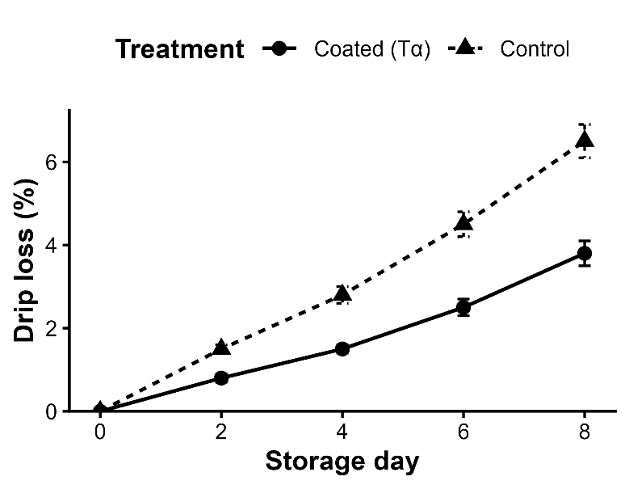
Fig 3. Drip loss (%) of control and α-chitosan–coated squid rings during chilled storage. Moisture loss increased steadily over time, with coated samples showing significantly lower drip loss, reflecting improved water retention during storage.
3.4 Oxidative Rancidity (TBA Analysis)
TBA values were measured to quantify malonaldehyde content. TBA values increased significantly over time, indicating progressive lipid oxidation (Figure 4). On Day 0, values were between 0.033 and 0.035 mg malonaldehyde/kg for both groups. On Day 2, the control group recorded a value of 0.150 ± 0.003 mg/kg, while the coated group was 0.095 ± 0.002 mg/kg. By Day 4, the control value increased to 0.320 ± 0.005 mg/kg, and the coated value was 0.180 ± 0.004 mg/kg. By Day 8, the control group reached a peak of 0.910 ± 0.012 mg/kg. In contrast, the coated group recorded a value of 0.480 ± 0.008 mg/kg on the final day. The TBA values for the coated group were consistently lower than the control group at each sampling point after Day 0.
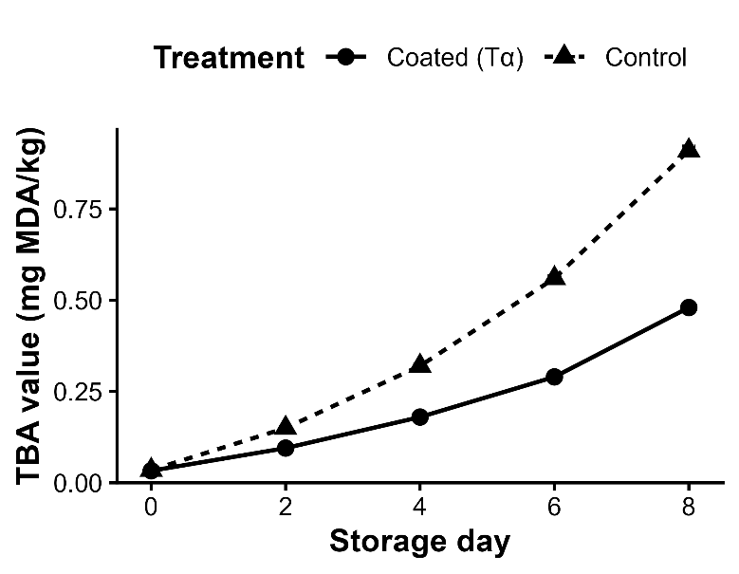
Fig 4. Thiobarbituric acid (TBA) values of control and α-chitosan–coated squid rings during chilled storage. Coated samples exhibited significantly lower malonaldehyde formation throughout storage, demonstrating effective inhibition of lipid oxidation.
3.5 Sensory Analysis
Sensory scores for colour, odour, texture, and overall acceptability showed a consistent decline during chilled storage, with the rate of deterioration differing clearly between treatments. On Day 0, both control and coated (Tα) samples received uniformly high scores (≥ 8.8) across all attributes. As storage progressed, control samples deteriorated rapidly, with marked reductions in odour and texture by Day 4 and overall acceptability falling below the acceptability threshold (score 5) by Day 6. In contrast, coated samples maintained higher scores for all attributes throughout storage, and overall acceptability remained ≥ 5 until Day 8.
The sensory heatmap highlights this trend visually, showing a rapid shift toward lower scores in the control group, whereas coated samples retained warmer (higher-value) colour intensities across all sensory attributes. The line-plot figure further illustrates the divergence between treatments: steep declines occurred in the control group after Day 2, while coated samples showed a slower and more gradual decrease. By the end of storage (Day 8), coated samples retained noticeably better colour, odour, and texture quality than control samples, confirming that α-chitosan coating effectively delayed sensory deterioration and extended sensory shelf-life. The line-plot (Figure 5) clearly shows the divergence between treatments, with coated samples declining more slowly. The heatmap (Figure 6) visualizes the overall pattern of deterioration, highlighting faster quality loss in the control group and greater sensory retention in coated samples.
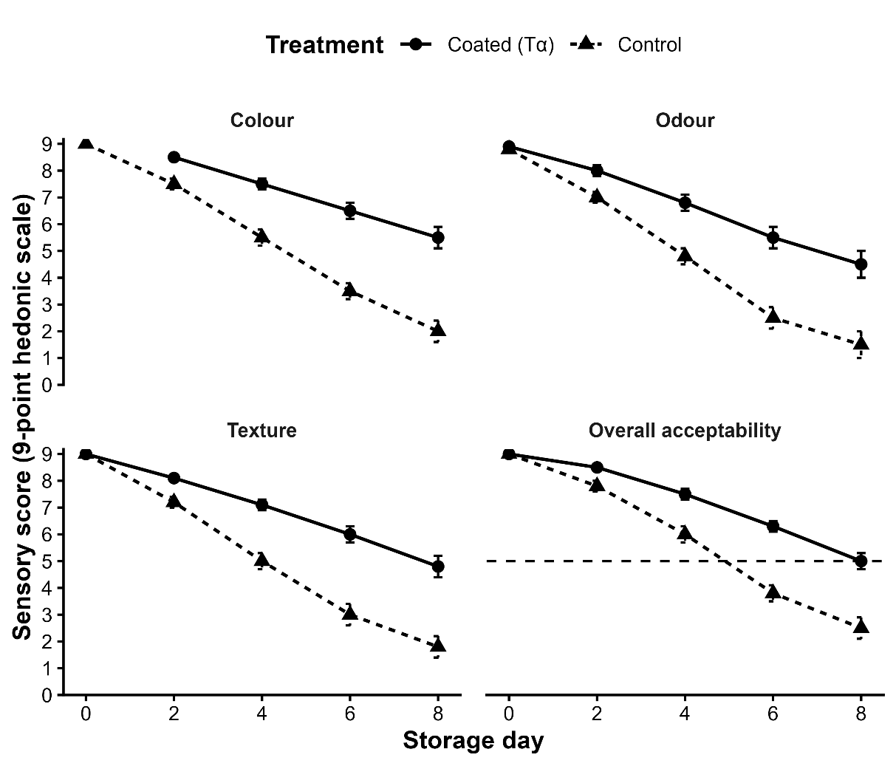
Fig 5. Changes in sensory attributes (mean ± SE) of squid rings during chilled storage. Coated samples showed a slower decline in colour, odour, texture, and overall acceptability compared to control samples. The dotted horizontal line marks the acceptability threshold (score 5).
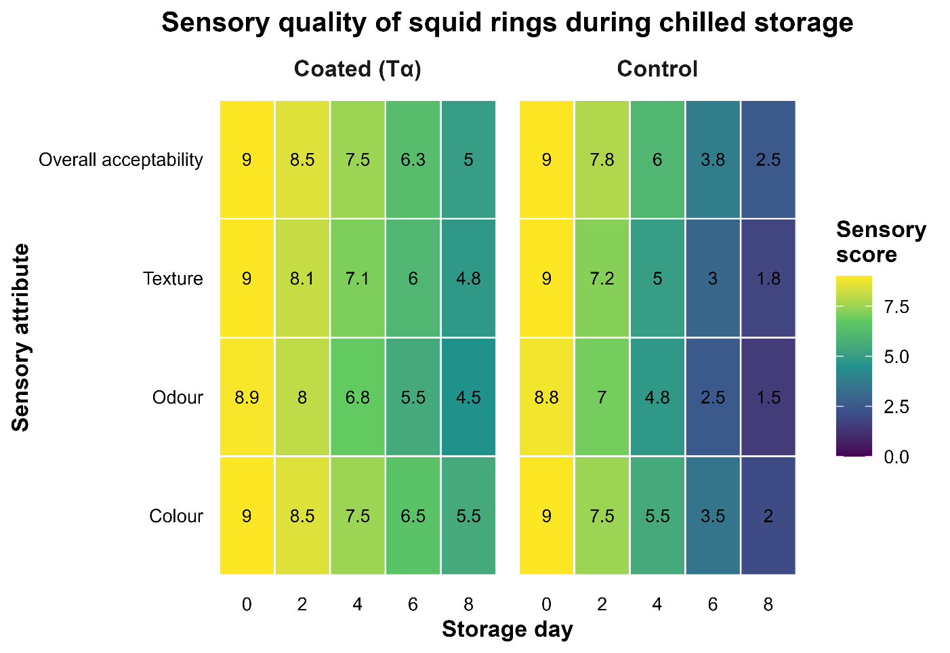
Fig 6. Heatmap showing changes in sensory scores (colour, odour, texture, and overall acceptability) of control and α-chitosan–coated squid rings during chilled storage. Warmer colours indicate higher sensory quality. Coated samples retained higher scores across all attributes, whereas control samples showed rapid deterioration after Day 2.
4. Discussion
The findings of this study demonstrate that α-chitosan coating significantly delays quality deterioration in squid rings during refrigerated storage, corroborating previous research on the preservative efficacy of chitosan in seafood products.
4.1 Colour Characteristics
Colour deterioration was evident in the control samples, with lightness (L*) decreasing from 72.5 on Day 0 to 63.2 by Day 8, accompanied by sharp increases in redness (a*) and yellowness (b*), which rose to 1.75 and 13.50, respectively. These changes suggest progressive oxidation of pigments and interactions between proteins and lipid oxidation products (Zhang et al., 2019). In contrast, α-chitosan–coated samples retained significantly higher lightness (68.5 at Day 8) and exhibited slower increases in a* (0.70) and b * (8.50), indicating effective suppression of oxidative discolouration (Figure 1). These results align with Aref et al. (2022), who reported that chitosan coatings maintain colour stability in grey mullet steaks by limiting oxygen diffusion. Likewise, Zhang et al. (2019) observed delayed melanosis in chitosan-treated shrimp. The film-forming capacity of chitosan likely reduced surface exposure to atmospheric oxygen, thereby inhibiting enzymatic and non-enzymatic browning (Kulawik et al., 2020).
4.2 Changes in pH
pH increased steadily during storage in both groups, but the rate of increase differed markedly. The control samples rose from 6.48 to 7.88, reflecting advancing spoilage, while the coated samples exhibited a slower increase, reaching only 7.45 by Day 8 (Figure 2). Elevated pH is typically associated with microbial degradation of nitrogenous compounds (Liu et al., 2022). The consistently lower pH in coated samples suggests reduced microbial activity, supported by previous studies where chitosan coatings inhibited spoilage microflora in shrimp and fish (Noshad et al., 2020; Tayel et al., 2020). Additionally, the slight acidity of the α-chitosan solution (prepared in acetic acid) may have contributed to maintaining a lower surface pH, further inhibiting microbial proliferation (Held et al., 2024).
4.3 Drip Loss
Drip loss increased in all samples during storage, indicating progressive denaturation of muscle proteins. However, the extent differed greatly between treatments. Control samples reached 6.5% drip loss by Day 8, whereas coated samples showed significantly lower loss (3.8%) over the same period (Figure 3). The reduced drip loss in coated samples may be attributed to the water-binding and film-forming properties of chitosan, which slow moisture migration (Mahin et al., 2025). These findings are consistent with Jeon et al. (2002), who documented reduced moisture loss in chitosan-coated cod and herring, and with Held et al. (2024), who noted that chitosan glazing forms a protective moisture-retention layer in tilapia fillets. Collectively, this indicates that α-chitosan coating helps preserve structural integrity and texture by limiting dehydration.
4.4 Oxidative Rancidity (TBA Analysis)
TBA values increased significantly during storage, indicating progressive lipid oxidation. By Day 8, control samples reached 0.910 mg malonaldehyde/kg, while coated samples reached only 0.480 mg/kg (Figure 4). This substantial reduction reflects chitosan’s known antioxidant properties (Zhang et al., 2021). Previous studies have shown that chitosan chelates pro-oxidant metal ions such as Fe²⁺, reducing their ability to catalyse lipid peroxidation (Kulawik et al., 2020; Tayel et al., 2020). Additionally, the barrier film created by chitosan restricts oxygen diffusion to the tissue surface, further slowing oxidative reactions (Iñiguez-Moreno et al., 2025). Similar reductions in TBARS have been observed in chitosan-coated fish, shrimp, and tuna products (Jeon et al., 2002; Zhang et al., 2019; Elsabagh et al., 2023).
4.5 Sensory Analysis
Sensory evaluation closely reflected the physicochemical trends. Although both groups started with high scores (≥8.8 for all attributes), control samples became unacceptable (<5) by Day 6, driven by sharp declines in odour and texture. In contrast, α-chitosan–coated samples maintained acceptable overall acceptability (≥5) through Day 8, showing clear sensory preservation. The sensory line graph (Figure 5) illustrates the more gradual decline in coated samples, while the heatmap (Figure 6) visualizes the overall shift from high to low quality across all attributes. These findings align with reports by Zhang et al. (2019) and Aref et al. (2022), who found that chitosan coatings extended the sensory shelf life of shrimp and fish.
Texture retention in coated squid is likely due to reduced proteolysis and lower moisture loss, as demonstrated earlier in the drip loss and pH results. Overall, the sensory data confirm that α-chitosan coating delays quality degradation and extends the shelf life of squid rings by at least 2 additional days compared to uncoated controls.
5. Conclusion and Future Directions
This study demonstrates that a 0.5% α-chitosan edible coating effectively preserves the quality of Uroteuthis duvaucelii rings during chilled storage by functioning as a protective barrier against moisture loss and oxidation. The coating significantly retarded lipid peroxidation and drip loss, while also suppressing the rise in pH associated with spoilage, thereby maintaining acceptable sensory attributes for an additional two days compared to uncoated controls. These findings confirm that α-chitosan is a viable, eco-friendly alternative to synthetic preservatives for extending the shelf-life of cephalopods. Future research should further investigate the specific antimicrobial mechanisms against dominant spoilage organisms in squid and explore synergistic formulations with essential oils or plant extracts to enhance the antioxidant capacity and industrial applicability of this biopolymer.

Disclaimer (Artificial intelligence)
Option 1:
Author(s) hereby declare that NO generative AI technologies such as Large Language Models (ChatGPT, COPILOT, etc.) and text-to-image generators have been used during the writing or editing of this manuscript.
Option 2:
Author(s) hereby declare that generative AI technologies such as Large Language Models, etc. have been used during the writing or editing of manuscripts. This explanation will include the name, version, model, and source of the generative AI technology and as well as all input prompts provided to the generative AI technology
Details of the AI usage are given below:
1.
2.
3.

6. References
Aref, S., Habiba, R., Morsy, N., Abdel-Daim, M., & Zayet, F. (2022). Improvement of the shelf life of grey mullet (Mugil cephalus) fish steaks using edible coatings containing chitosan, nanochitosan, and clove oil during refrigerated storage. Food Production, Processing and Nutrition, 4(27). https://doi.org/10.1186/s43014-022-00106-z
Choi, C., Nam, J. P., & Nah, J. W. (2016). Application of chitosan and chitosan derivatives as biomaterials. Journal of Industrial and Engineering Chemistry, 33, 1-10. https://doi.org/10.1016/j.jiec.2015.10.028
Elsabagh, R., Ibrahim, S. S., Abd-Elaaty, E. M., Abdeen, A., Rayan, A. M., Ibrahim, S. F., Abdo, M., Imbrea, F., Şmuleac, L., El-Sayed, A. M., Abd Elghaffar, R. Y., & Morsy, M. K. (2023). Chitosan edible coating: A potential control of toxic biogenic amines and enhancing the quality and shelf life of chilled tuna fillets. Frontiers in Sustainable Food Systems, 7, 1177010. https://doi.org/10.3389/fsufs.2023.1177010
Held, A., Bueno, G. C. F., Fernandes, N. I., Das Chagas, R. A., Goes, M. D., De Araújo, R. P., De Vargas Junior, F. M., De Oliveira, K. M. P., Da Silva, M. I., & Goes, E. S. D. R. (2024). The effect of chitosan ice glazing on the quality of frozen tilapia fillets: Microbiological, physicochemical, and sensory characteristics. Food Science and Technology. https://doi.org/10.5327/fst.00336.
Iñiguez-Moreno, M., Hernández-Varela, J. D., Burelo, M., Elizondo-Luevano, J. H., Araújo, R. G., Treviño-Quintanilla, C. D., & Medina, D. I. (2025). Progress in chitosan-based materials: Enhancing edible coatings and films through modifications and functionalization for food preservation. Process Biochemistry, 156, 175-190. https://doi.org/10.1016/j.procbio.2025.06.001
Jeon, Y. J., Kamil, J. Y., & Shahidi, F. (2002). Chitosan as an edible invisible film for quality preservation of herring and Atlantic cod. Journal of Agricultural and Food Chemistry, 50(18), 5167-5178. https://doi.org/10.1021/jf011693l
Jiang, Z., Neetoo, H., & Chen, H. (2011). Efficacy of freezing, frozen storage and edible antimicrobial coatings used in combination for control of Listeria monocytogenes on roasted turkey stored at chiller temperatures. Food Microbiology, 28(7), 1394-1401. https://doi.org/10.1016/j.fm.2011.06.015
Jones, L. V., Peryam, D. R., & Thurstone, L. L. (1955). Development of a scale for measuring soldiers' food preferences. Journal of Food Science, 20, 512-520. https://doi.org/10.1111/J.1365-2621.1955.TB16862.X
Kulawik, P., Jamróz, E., & Özogul, F. (2020). Chitosan role for shelf-life extension of seafood. Environmental Chemistry Letters, 18(1), 61-74. https://doi.org/10.1007/s10311-019-00935-4
Liu, Y., Zhu, Y., Yang, Y., Hu, S., & Jiang, W. (2022). Quality improvement of shrimp (Litopenaeus vannamei) during refrigerated storage by application of Maillard peptides/water‐soluble chitosan coating. Food Science & Nutrition, 10(9), 2980-2988. https://doi.org/10.1002/fsn3.2894
Mahin, M. I., Rashid, M. H. A., & Mredul, A. R. (2025). Effects of shrimp chitosan based edible coating on the shelf life of selected vegetables in context of attaining SDGs. Applied Food Research, 5(1), 100682. https://doi.org/10.1016/j.afres.2024.100682
Noshad, M., Nasehi, B., & Anvar, A. (2020). Effects of Quince Seed Mucilage and Green Tea Extract as Active Edible Coatings on Quality of Pacific White Shrimps During Cold Storage. Nutrition and Food Sciences Research, 7(2), 29-36. https://doi.org/10.29252/nfsr.7.2.29
Priya, K., Thirunavookarasu, N., & Chidanand, D. V. (2023). Recent advances in edible coating of food products and its legislations: A review. Journal of Agriculture and Food Research, 12, 100623. https://doi.org/10.1016/j.jafr.2023.100623
Tayel, A. A., Elzahy, A. F., Moussa, S. H., Al-Saggaf, M. S., & Diab, A. M. (2020). Biopreservation of shrimps using composed edible coatings from chitosan nanoparticles and cloves extract. Journal of Food Quality, 2020(1), 8878452. https://doi.org/10.1155/2020/8878452
Zhang, Z., Xia, G., Yang, Q., Fan, X., & Lyu, S. (2019). Effects of chitosan‐based coatings on storage quality of Chinese shrimp. Food Science & Nutrition, 7(12), 4085-4094. https://doi.org/10.1002/fsn3.1275
Zhang, X., Ismail, B. B., Cheng, H., Jin, T. Z., Qian, M., Arabi, S. A., ... & Guo, M. (2021). Emerging chitosan-essential oil films and coatings for food preservation-A review of advances and applications. Carbohydrate polymers, 273, 118616. https://doi.org/10.1016/j.carbpol.2021.118616

