Review Article
Biofortification-Based Genetic improvement of Rice for Nutritional Quality Enhancement to Combat Hidden Hunger

Abstract
Micronutrient malnutrition, particularly deficiencies of iron, zinc, and provitamin A, remains a major global public-health challenge, with rice-consuming populations being disproportionately affected due to the inherently low nutrient density of polished rice grains. Biofortification has emerged as a sustainable, cost-effective, and long-term strategy to enhance the nutritional quality of rice, complementing conventional supplementation and food-fortification programs. This review synthesizes the current advances in genetic enhancement of rice for improved nutritional traits, emphasizing both conventional and modern breeding approaches. Progress in identifying quantitative trait loci (QTLs), high-zinc and high-iron donor lines, and key genes regulating micronutrient accumulation is discussed, along with the integration of marker-assisted selection, genomic selection, and transgenic interventions such as overexpression of metal transporters, nicotianamine biosynthesis genes, and provitamin A pathways. Recent breakthroughs using genome editing technologies, particularly CRISPR/Cas systems, have accelerated precision improvement for micronutrient content without compromising yield or grain quality. The review also highlights physiological constraints, bioavailability challenges, genotype × environment interactions, and regulatory considerations associated with biofortified varieties. Future opportunities focus on leveraging pangenomics, multi-omics integration, speed breeding, and gene pyramiding to develop next-generation biofortified rice. Overall, biofortification stands as a promising strategy to combat hidden hunger, and continuous innovation in breeding and biotechnology is critical for delivering nutritionally enhanced rice cultivars to vulnerable populations worldwide.

Keywords: Biofortification, hidden hunger, Quantitative trait loci(Qtl’s), Bio availability, Gene editing technologies.
Biofortification is the process by which the nutritional value of food crops is enhanced by various methods including plant breeding, agronomic practices and modern biotechnological techniques.
INTRODUCTION:
Biofortification efforts began in the mid-1990s, marking the first systematic attempts to enhance the nutrient content of staple crops. The approach gained significant momentum with the launch of the HarvestPlus program in 2003, which provided major global investment for research and large-scale implementation of biofortification activities. HarvestPlus works not only as a funding body but also collaborates with national breeding programs and government initiatives to mainstream nutrient-rich varieties. Through its partner institutions, the program has developed, evaluated, released, and encouraged the adoption of several biofortified crops, including zinc-enriched rice, wheat, and maize; provitamin A–rich maize and cassava; iron-rich beans; and iron-fortified pearl millet. Additionally, the International Potato Center (CIP) and its collaborators have taken the lead in breeding, testing, and disseminating orange-fleshed sweet potato varieties with high provitamin A content.

Table 1: Different nutrient enriched crops release year of initial lines

CROP | NUTRIENT | RELEASE YEAR
Sweet potato | Pro vitamin A | 2007
Bean | Fe, Zn | 2011
Pearl Millet | Fe, Zn | 2011
Rice | Fe, Zn, Pro vitamin A | 2012
Maize | Pro vitamin A | 2013
Wheat | Fe, Zn | 2013
Cassava | Pro vitamin A | 2014

There are some biofortified crops which are released for Asian countries;
- Iron and Zinc fortified pearl millet for India (2012)
- Zinc fortified rice for India and Bangladesh (2013)
- Zinc fortified wheat for India and Pakistan (2013).

Picture 1 : Need for Bio fortification
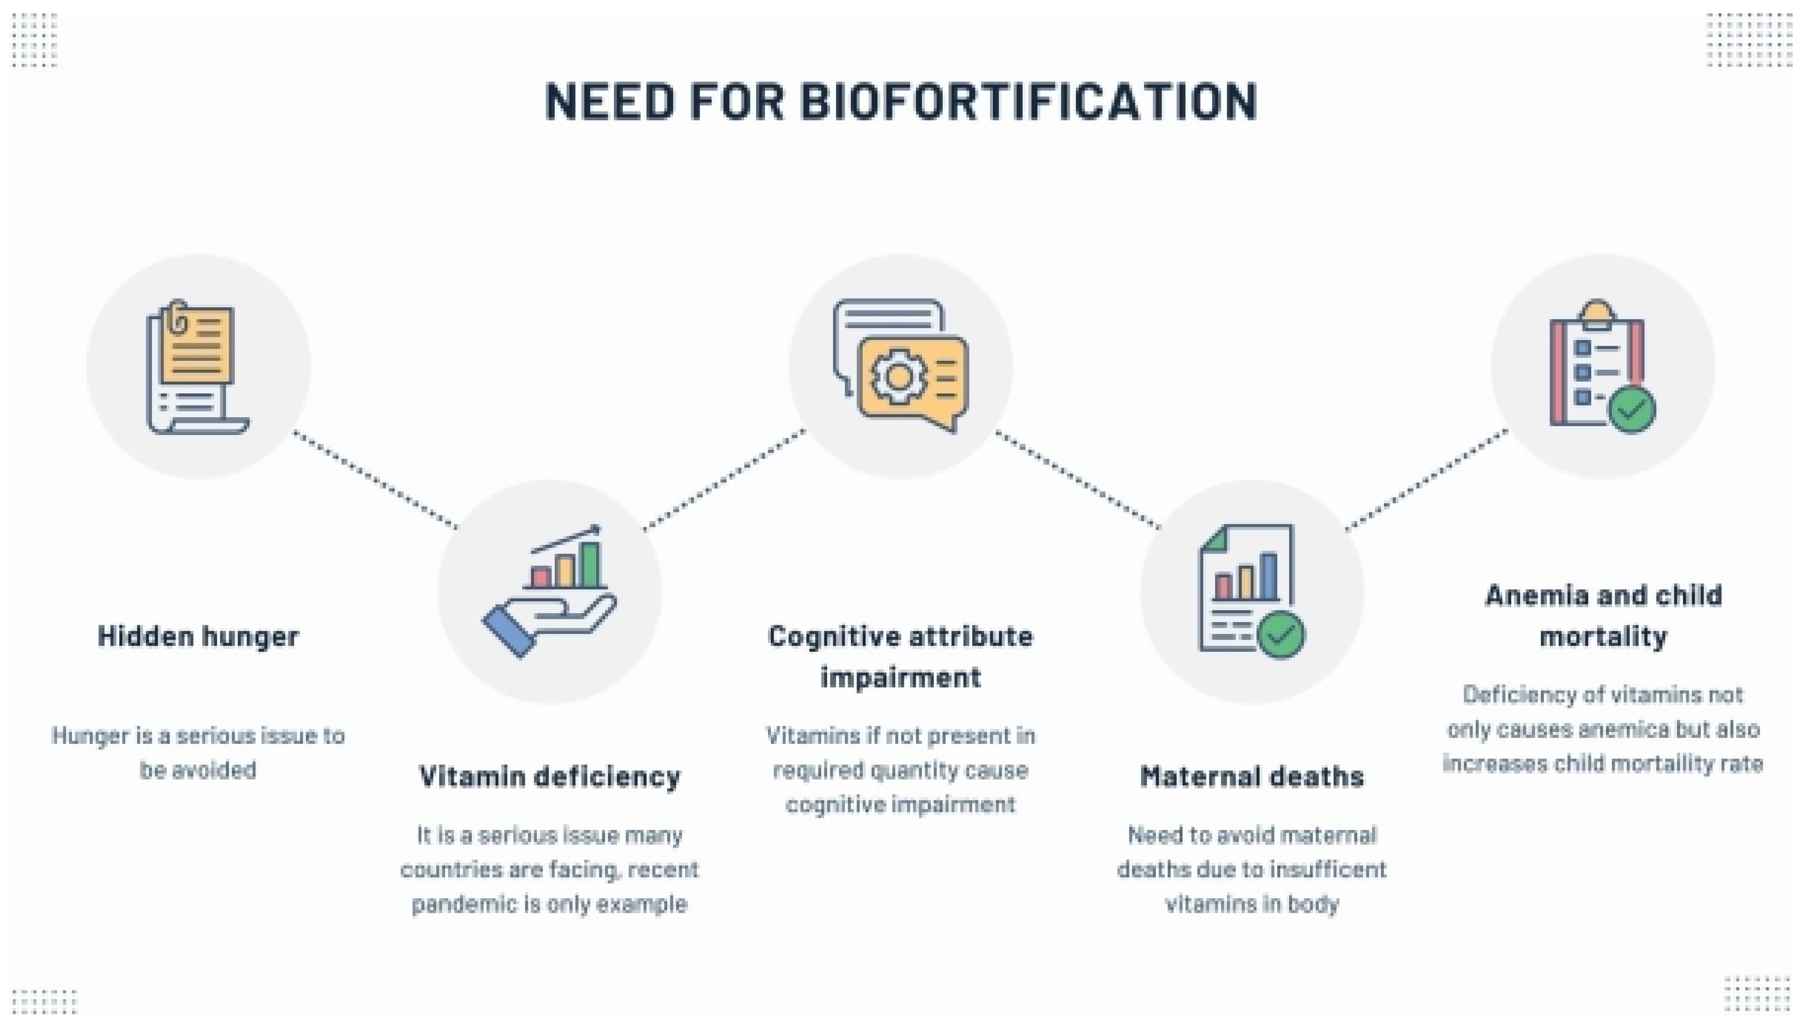

HIDDEN HUNGER

Micronutrient malnutrition—often referred to as “hidden hunger”—affects nearly 20 billion people worldwide, with the burden falling most heavily on populations in developing countries. Biofortifying staple crops has emerged as a powerful approach to improve nutritional security, offering a sustainable, low-cost solution that enhances health and quality of life in communities with limited access to diverse diets or micronutrient-based interventions.

In response to the widespread concern over micronutrient deficiencies, research institutions across the globe have intensified efforts to improve the bioavailability of essential nutrients in major food crops. Through different biofortification strategies, substantial progress has been made in increasing the concentration of iron, zinc, and other vital vitamins and minerals in staple cereals and tubers.

More than 2 billion people suffer from 'hidden hunger,' meaning they do not consume enough nutrients or micronutrients in their regular diet and suffer from malnutrition (Saini et al., 2020).

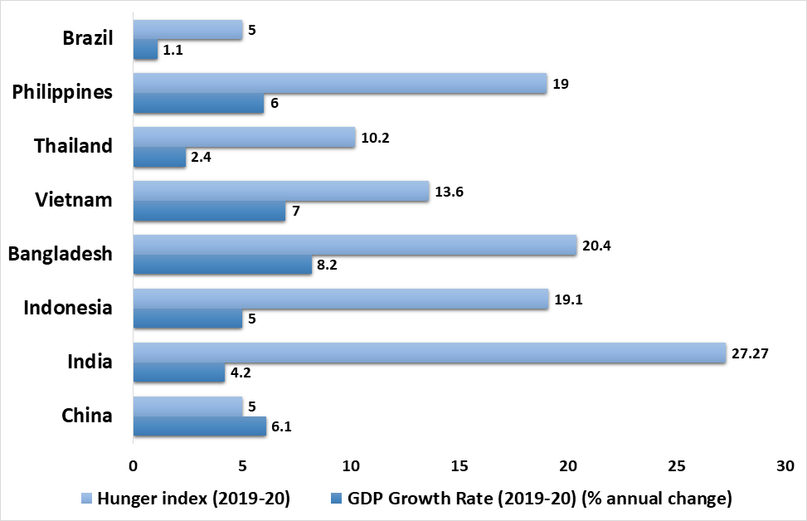
Fig.1.Details of hungerindex of major rice growing countriesworldwide(Sourcehttps://www.statista.com/statistics/255945/top-countries-of-destination-for-us-riceexports2011/andhttps://www.globalhungerindex.org/ranking.html)

The growing burden of micronutrient deficiencies has become a major barrier to achieving the Sustainable Development Goals (SDGs) targeted for 2035, particularly those related to eliminating hunger and poverty, improving maternal health, and reducing child mortality. Iron and zinc deficiencies are among the most prevalent nutritional disorders worldwide, affecting nearly 2 billion people and contributing to more than 800,000 deaths annually.

Hidden hunger can be mitigated through both nutrition-specific and nutrition-sensitive approaches. Nutrition-specific strategies directly influence dietary intake and include food diversification, vitamin and mineral supplementation, altering food choices, and industrial fortification. Nutrition-sensitive interventions, such as crop biofortification and addressing the root social and environmental drivers of malnutrition, complement these direct treatments and offer more sustainable long-term benefits.

In many developing regions, cereals contribute roughly 60% of total caloric intake, and this proportion can rise to 80% in certain populations (Parashar et al., 2023). As a result, deficiencies in iron, zinc, vitamin A, iodine, and selenium are common and often lead to severe health consequences (Das et al., 2019; Parashar et al., 2023).
Rice, the primary staple for more than half of the world’s population, supplies up to 70% of daily energy intake in several Asian countries. Given its central role in the human diet, improving the micronutrient content of rice through biofortification offers a practical and sustainable strategy to combat hidden hunger, particularly for communities that rely heavily on rice and have limited access to diverse nutrient sources.

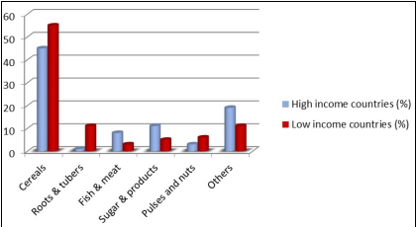
Fig 2: Dietary diversity by sources of dietary energy (FAO, 2008)
From the figure it is clearly observed that in low income countries they consume more cereals but less animal originated products like fish and meats and in other hand high income countries their proportion of energy source from other parts is higher than low income countries showing their diversity in foods. This imbalance in diet plan leads to micronutrient deficiency.

During milling, rice undergoes significant nutrient loss, with essential vitamins and minerals drastically reduced. The removal of the bran, germ, and portions of the endosperm leads to the destruction of nearly 67% of vitamin B3, 80% of vitamin B1, 90% of vitamin B6, along with substantial losses of manganese, phosphorus, and iron. Dietary fiber and beneficial fatty acids are almost completely eliminated during grinding and polishing. Although consumers often prefer white rice for its lighter appearance, softer texture, ease of digestion, and superior cooking qualities, these preferences come at the cost of markedly reduced nutritional value. Despite increased awareness promoting brown rice consumption, white polished rice continues to dominate consumer demand. This highlights the need to develop biofortified rice varieties with endosperm-specific nutrient enrichment so that essential micronutrients are retained even after milling and polishing. Such biofortified varieties not only support better nutritional security but also serve as an important economic resource for low-income farming communities.
Rice varieties can also be classified based on grain pigmentation: non-pigmented types, which make up roughly 85% of cultivated rice, and pigmented types—about 15%—which include red, brown, black, and purple rice (Wijaya et al., 2017). These pigmented grains are rich in health-promoting secondary metabolites such as anthocyanins, flavonoids, and phenolic compounds, contributing to their role as functional foods (Fitri et al., 2021; Fongfon et al., 2021). Red rice is particularly high in iron and zinc, essential for hemoglobin formation and enzymatic functions (Boue et al., 2016). Furthermore, studies have shown that black and red rice possess bioactive compounds capable of inhibiting the proliferation of breast cancer cells (Ghasemzadeh et al., 2018).
Picture 2 : Different Rice varieties
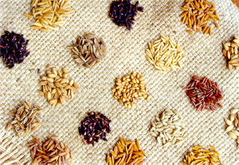

Nutrition gap

Recommended daily intake of vitamin A, Fe and Zn are 600μg, 15mg and 15mg respectively (RDA, 1989) ^{[9]}. Swarna is the most widely grown and consumed rice variety in India which constitutes 0.78mg Fe/100g white rice and 2.28mg Zn/100g brown rice. By consuming twice or thrice a day taking 100-150g rice/meal a person can get hardly 2-3mg Fe and 7-8mg Zn which is 1/5th and half of the recommended daily intake of Fe and Zn respectively.
Table 2: Nutritional composition of brown rice and white rice

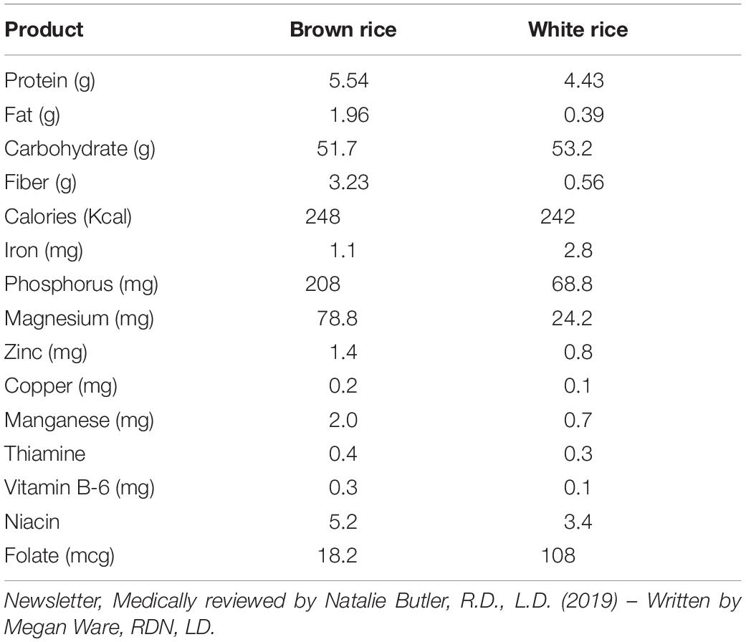

To achieve successful bio fortification, the mechanism of the particular nutrient uptake and the genes involved has to be elucidated and studied. Essentially those varieties are targeted for bio fortification with highly dense micronutrient rich traits which already have highly preferable agronomic traits in the genomic background. Even if the bio fortified rice cannot suddenly increase the concentration in our body, it can definitely increase our daily sufficiency of micronutrient absorption throughout our life cycle (Bouis et al., 2011; Parashar et al., 2023; Herrington et al., 2023).

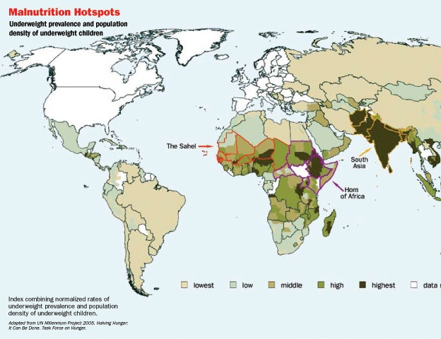

Map 1 : Regions with High Malnutrition Prevalence
Present Dynamics:
World Health Organization data indicate that iron (Fe) and zinc (Zn) are two of the most critical micronutrients for human health, yet their intake remains inadequate in many populations (WHO). Zinc deficiency affects nearly 31% of people worldwide and is associated with more than 400 million child deaths each year. Iron deficiency is even more widespread, with up to 80% of the global population consuming insufficient amounts; around 30% of these individuals develop anemia due to chronic Fe deficiency. Each year, Fe deficiency alone accounts for approximately 0.8 million deaths (Midya et al., 2021). The prevalence of anemia remains high—around 23% in developed nations and nearly 52% in developing countries—emphasizing the urgent need for substantial health investments (WHO, 2015). India carries the world’s highest burden of stunted children under five years of age, with 61.7 million out of the global 162 million cases (NFHS-5, 2020). Addressing malnutrition in a sustainable and coordinated manner is essential for improving health outcomes in a rapidly growing population.

Globally, considerable progress has been made in biofortifying rice with higher levels of Zn, Fe, and protein. Currently, 37 biofortified rice varieties enriched with iron, zinc, protein, or provitamin A have been released for cultivation—16 in India and 21 in other countries. Indian targets include >10 mg/kg Fe, >24 mg/kg Zn, and >10% protein in polished rice, while international targets set Zn levels at >28 mg/kg in polished grains. Despite these advancements, further research is needed to deepen our understanding of micronutrient genetics, uptake pathways, translocation mechanisms, and factors that influence nutrient bioavailability.
Table 3: Baseline intakes, daily requirements, and reported bioavailability ranges of iron, zinc, and protein

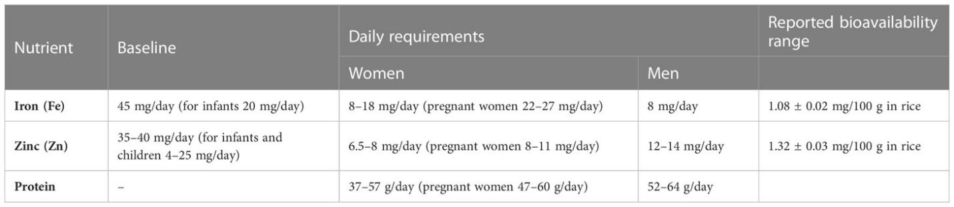

Estimated average requirement (EAR) of daily consumption (Trijatmiko et al., 2016; Matres et al., 2021)

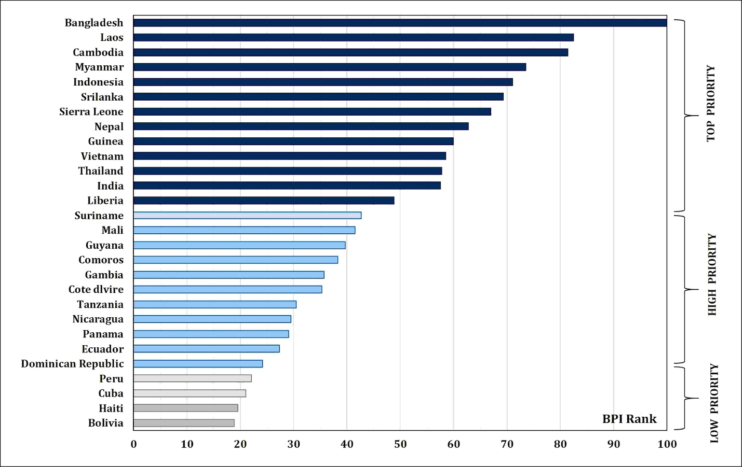

Figure 3 Biofortification priority index (BPI) global rankings and priority levels for rice-consuming countries in Asia, Africa, and Latin America and the Caribbean (LAC).(HarvestPlus, 2020)

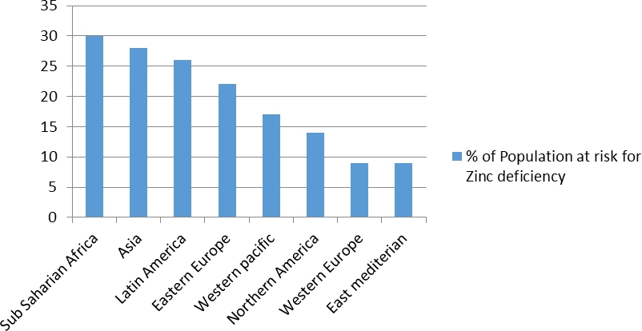
Fig 4: Global Zn deficiency scenario

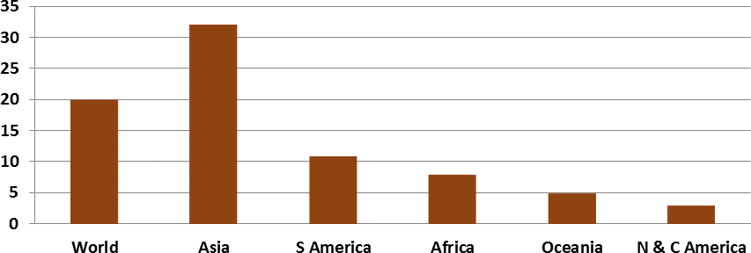
Fig 5: Rice calorie supply as % total calories (by region)

Components for nutritional quality in rice:

Proteins and Aminoacids:
Rice protein is considered nutritionally incomplete because it contains low levels of lysine and several other essential amino acids. To address this limitation, Liu et al. (2016) introduced the lysine-rich protein (LRP) gene from Psophocarpus tetragonolobus into rice under an endosperm-specific promoter, resulting in transgenic lines with a 30% increase in lysine compared to non-transgenic controls. Similarly, Wong et al. (2015) enhanced the lysine content of rice by overexpressing two lysine-rich histone proteins (RLRH1 and RLRH2), achieving a 35% increase in lysine and producing a more balanced amino acid composition that aligns with WHO dietary recommendations.
Numerous landraces and released cultivars have been evaluated for their protein and amino acid profiles. For example, the traditional variety ‘Heera’ contains more than 10% protein. In general, crude protein content measured through the Kjeldahl method ranges from 6–8% across many varieties (ref. 17). The high-protein variety ‘CRR Dhan 310,’ developed by NRRI, has also been released in India and contains more than 10% protein in polished grains. Efforts are ongoing to map genomic regions and identify genes responsible for protein accumulation in rice.

Role of Amino Acids in Enhancing Fe and Zn Bioavailability
Since rice protein lacks essential amino acids such as lysine, increasing levels of specific amino acids—particularly sulfur-containing amino acids like cysteine and methionine—can significantly improve the bioavailability of iron and zinc. Promoter molecules such as ascorbic acid also enhance mineral absorption (Hallberg, 1981; Bhullar & Gruissem, 2013). Even modest increases in these amino acids can positively influence the uptake and utilization of micronutrients.

β-Carotene (Provitamin A)
Several genetic engineering strategies have been successful in enhancing and stabilizing provitamin A in staple crops. In potato, β-carotene content can be increased by introducing the Orange (Or) gene, which promotes chromoplast formation—organelles that act as natural storage sinks for carotenoids. When Or was co-expressed with two additional β-carotene biosynthesis genes used in Golden Rice 2 (GR2), β-carotene accumulation in polished rice reached 26 ppm dry weight, though long-term stability still requires evaluation.
Another strategy involves reducing carotenoid oxidation, a major cause of provitamin A degradation. This approach has improved provitamin A stability during storage in Golden Rice. A similar technique applied in wheat raised β-carotene levels by nearly 31-fold. Additionally, combining enhanced tocochromanol (vitamin E) synthesis—antioxidant compounds—with the GR2 pathway has been shown to significantly increase the metabolic half-life of provitamin A in sorghum grains.

Anthocyanins and Folate
Anthocyanins are powerful antioxidants that offer several health benefits. Zhu et al. (2017) engineered eight anthocyanin biosynthesis genes—two from maize and six from coleus—using an endosperm-specific promoter, leading to the development of “Purple Endosperm Rice,” which contains approximately 1 mg/g of anthocyanins.
Since humans cannot synthesize folate (vitamin B9), deficiency can result in neural tube defects and a higher risk of cardiovascular disorders. Storozhenko et al. (2007) enhanced the folate content of rice by overexpressing two Arabidopsis thaliana genes driven by an endosperm-specific promoter. The resulting transgenic rice accumulated nearly 100 times more folate than wild-type plants.
Picture 3: Purple Endosperm Rice

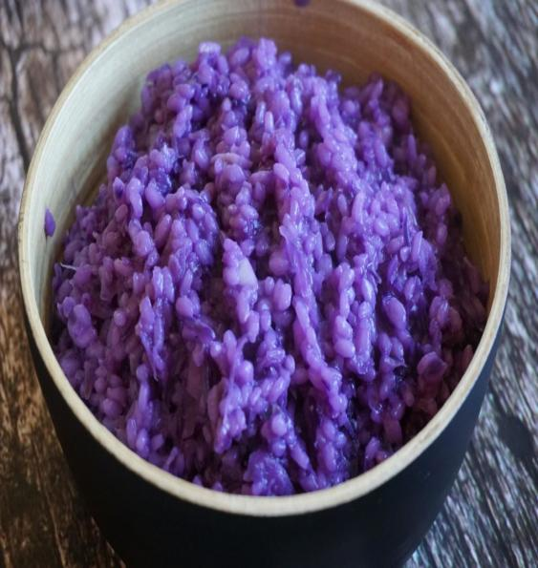

Iron (Fe):
Several studies have attempted to enhance iron concentration in the rice endosperm by introducing genes encoding lactoferrin (an iron-chelating glycoprotein) and ferritin. Human milk naturally contains high levels (1–2 g/L) of lactoferrin (LF). With the aim of developing improved ingredients for infant formula, Nandi et al. [61] engineered transgenic rice expressing the human LF gene under the control of the rice glutelin-1 promoter, resulting in a substantial increase in Fe content. The heterologous protein accumulated up to 0.5% of grain weight, and its bioavailability was validated using a human Caco-2 cell assay. Similarly, Lee et al. [62] reported successful expression of the human LF gene in japonica rice, where it accounted for approximately 1.5% of total soluble protein.
Ferritin, a plastid-localized and non-toxic Fe storage protein, plays a crucial role in maintaining iron homeostasis by storing up to ~4,500 Fe atoms in a readily bioavailable form [63]. Consequently, enhancing Fe content through endosperm-specific expression of ferritin genes has emerged as a key strategy for rice iron biofortification. Numerous studies have shown that ferritin overexpression significantly elevates Fe concentration and improves Fe bioavailability in multiple crops [45, 46, 54–55, 64–68]. For instance, Goto et al. [45] developed rice lines expressing SoyferH1 under the rice GluB1 promoter, achieving a threefold increase in Fe content in brown rice relative to non-transformed controls.

Manganese (Mn):
Manganese functions as a cofactor or activator for a wide array of enzymes with diverse physiological roles. It is essential for photosynthetic oxygen evolution in chloroplasts (Britt, 1996; Clemens et al., 2002a; Rutherford and Boussac, 2004). Mn deficiency makes plants more vulnerable to low-temperature stress and pathogen attack, ultimately contributing to considerable yield losses (Marschner, 1995; Hebbern et al., 2005).
The uptake pathways for Mn are thought to overlap with those for Fe and cadmium (Cd), and substantial interconnections exist among Fe, Zn, and Mn transport in plant systems. Deficiencies of these micronutrients are particularly pronounced in plants grown on alkaline soils, which constitute nearly 30% of global cultivated land (Chen and Barak, 1982). Therefore, developing plant varieties capable of efficient micronutrient uptake in alkaline conditions is a crucial goal for improving agricultural productivity.

Role of Zinc and Iron in Human Health:
Zinc is a vital micronutrient required for numerous physiological and biochemical functions in the human body. It plays a crucial role in enzymatic activity, tissue growth and development, immune function, taste perception, bone mineralization, thyroid regulation, blood clotting, cognitive performance, fetal development, and protection against infectious diseases (Bhowmik et al., 2010; Prasad, 2013; Gammoh and Rink, 2017; Calayugan et al., 2021). Globally, zinc deficiency is considered the fifth most significant risk factor for disease in developing countries (Maret and Sandstead, 2006). In children and adults, inadequate Zn intake can result in stunted growth, dwarfism, delayed sexual maturation, reduced taste sensitivity, poor appetite, and mental fatigue (Stein et al., 2007). Infants, children, adolescents, pregnant women, and lactating mothers have particularly high Zn requirements and are therefore more vulnerable to deficiency.
Iron is one of the most abundant elements on earth and is indispensable for almost all living organisms. It is essential for key metabolic activities, including the synthesis of hemoglobin and myoglobin for oxygen transport, as well as electron transfer in various oxidation–reduction reactions.

Genetics of Zn and Fe Content in Rice
Duplicate epistatic gene interactions governing grain zinc and iron accumulation can be effectively utilized through recombination breeding and heterosis-based approaches, followed by selection in advanced generations. This strategy has strong potential for enhancing both Fe and Zn concentrations in rice grains (Kumar et al., 2020).
Studies conducted between 2012 and 2022 demonstrated moderate to high broad-sense heritability (40.6%–99.8%) for grain Zn content and a wide range for Fe (0.22%–99.7%). Genotypic coefficient of variation (GCV) ranged from low to high (7.6%–45.1%), while phenotypic coefficient of variation (PCV) ranged from moderate to high (11.3%–45.3%). The small differences observed between GCV and PCV values suggest minimal environmental or soil-related effects on the expression of these micronutrient traits (Gregorio, 2002).

Fe and Zn in Rice Germplasm and Biofortification Efforts
Extensive screening of global rice germplasm has identified numerous promising donors with high Fe and Zn concentrations in brown and polished grains. However, grain polishing results in the loss of nearly 90% of iron and 40% of zinc. Multiple QTLs governing Zn concentration and several genes involved in Zn metabolism have been identified in rice.
Through the HarvestPlus program, several high-Zn rice varieties have been released. These include DRR Dhan 45 by IIRR, Chhattisgarh Zincrice-1 by Indira Gandhi Krishi Vishwavidyalaya (IGKV) for the state of Chhattisgarh, and ‘Mukul’ (CRR Dhan 311) by ICAR-NRRI for Odisha.
Transgenic rice lines have also been developed that accumulate three to four times more Fe than wild-type varieties by introducing ferritin genes from different biological sources.

Breeding Approaches for Enhancing Zinc and Iron Content in Rice
Evaluating micronutrient diversity and identifying promising donor parents based on genetic distance within available germplasm, popular cultivars, and advanced breeding lines is a crucial step toward strengthening the genetic base of nutrient-rich rice through pre-breeding initiatives. Several studies have shown that traditional landraces generally possess higher concentrations of key micronutrients, particularly Zn and Fe, compared to widely cultivated varieties (Gayacharan et al., 2018). For example, Vanlalsanga et al. (2019) reported exceptionally high Zn levels (75.8 mg/kg) in the landrace Badalsali, outperforming other evaluated cultivars.

A broad range of variation for zinc and iron content has been observed in rice across multiple studies. In brown rice, Zn content ranged from 6.2 to 71.6 mg/kg (Anuradha et al., 2012), while polished rice exhibited a range of 4.8 to 40.9 mg/kg (Sanjeeva Rao et al., 2020). Iron concentration in brown rice varied between 6.9 and 67.3 mg/kg (Maganti et al., 2020; Anuradha et al., 2012), whereas polished rice contained 0.8 to 36.45 mg/kg (Bollinedi et al., 2020; Raza et al., 2019). As consistently reported, brown rice retains significantly higher Zn and Fe levels than polished rice (Raza et al., 2019; Sanjeeva Rao et al., 2020).
Greater variability in grain micronutrient content, especially Fe and Zn, has been documented among colored rice types such as brown and red rice compared to white-grained genotypes. Red rice, in particular, contains two- to threefold higher concentrations of Zn and Fe relative to white rice (Ramaiah and Rao, 1953). Furthermore, Graham et al. (2001) demonstrated that elevated Fe and Zn levels are often associated with aromatic varieties like Jasmine and Basmati. Aromatic fine-grain accessions show markedly higher micronutrient concentrations in brown rice than coarse-grain types (Raza et al., 2020).

.
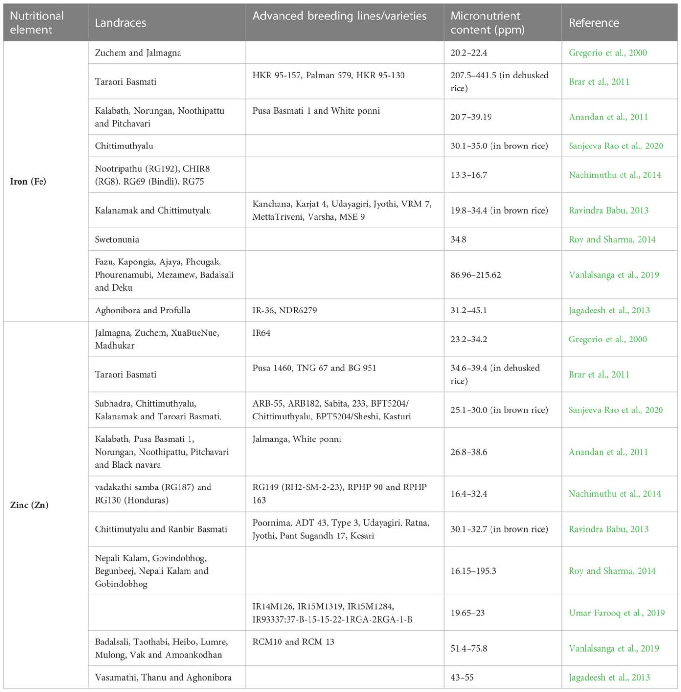
Table 4: Micronutrient-rich rice landraces, advanced breeding lines/varieties, and their iron and zinc content

Biofortification of High-Zinc Rice
Zinc plays a vital role in human health and is also essential for the proper absorption and utilization of iron in the body. In plants, Zn is primarily absorbed from the soil, and several genetic strategies have been implemented to enhance Zn uptake, translocation, and accumulation in rice. Since Zn mobilization involves numerous genes, overexpressing key transporters and chelator biosynthesis genes has proven to be an effective approach for increasing grain Zn concentration and improving bioavailability.
One notable strategy involves the overexpression of nicotianamine synthase (NAS) genes. The introduction of a 35S enhancer element significantly increased NAS activity, resulting in higher Zn accumulation. Transgenic rice expressing the barley NAS gene (HvNAS1) under the rice Actin1 promoter showed nearly a threefold increase in grain Zn levels. Similarly, overexpressing OsIRT, a ZIP family metal transporter, has been shown to elevate Zn accumulation in rice grains. Additional rice ZIP transporters, including OsZIP1, OsZIP2, OsZIP3, and OsZIP4, are associated with Zn homeostasis (Ishimaru et al., 2007).
Lee et al. (2009) demonstrated that genetically engineered rice lines with overexpressed OsIRT and MxIRT genes accumulated higher Fe and Zn concentrations. Boonyaves (2016) reported that the polished grains of genetically modified rice carrying a combination of four genes (AtIRT1, PvFerritin, AtNAS1, and AfPhytase) exhibited maximum Fe and Zn enrichment. Multiple studies have also confirmed that overexpression of rice OsNAS genes leads to substantial increases in Zn accumulation in the endosperm (Johnson, 2011).

Agronomic Strategies for Zinc Biofortification
Agronomic biofortification involves optimizing nutrient application methods, fertilizer doses, critical crop stages for nutrient delivery, the use of biofertilizers or plant growth promoters, and conservation agriculture practices such as minimum or zero tillage.
Several field studies in India have evaluated soil and foliar Zn application methods in rice. Foliar spraying of Zn at the tillering and flowering stages significantly enhanced grain Zn concentrations, with increases ranging from 35.6% to 106.7% compared with the control (Saha et al., 2017; Das et al., 2019; Yadav et al., 2019). In contrast, soil-applied Zn at sowing showed minimal impact on grain Zn content under both controlled and field conditions. Foliar Zn application generally results in a moderate to strong response, often doubling grain Zn levels.
The timing of Zn sprays is critical for maximizing biofortification efficiency, with applications during reproductive stages proving particularly effective (Welch et al., 2013).
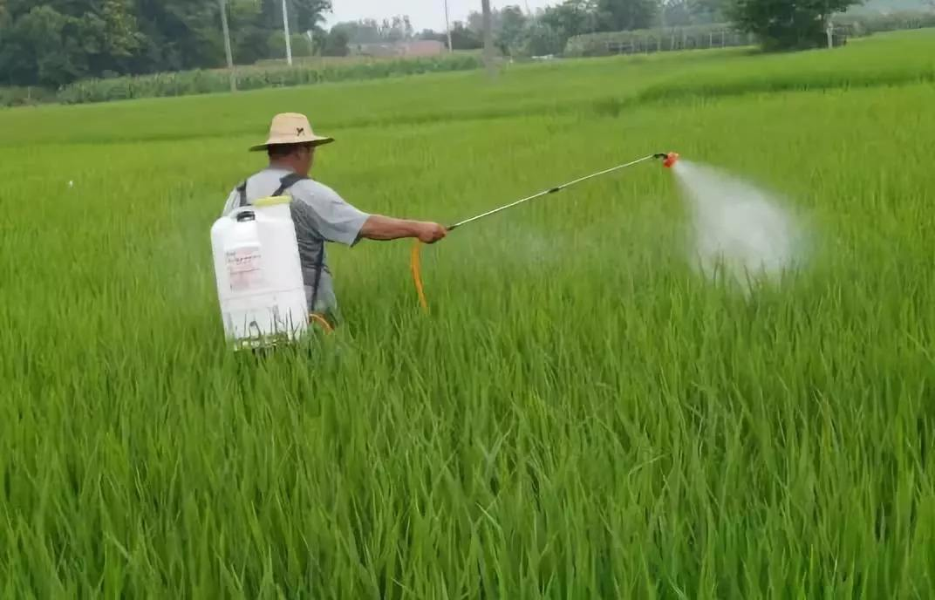
Picture 4: A farmer applying zinc sprays

The probable explanation might be that the foliar Zn application penetrates the cuticle and the cellulose wall via limited or free diffusion and ions are also absorbed by the stomata on the leaves, which altered sub-cellular compartmentation of Zn in the shoot. This enhances more efficient biochemical utilization of Zn in cells of the shoot while only part of the nutrient can be translocated from the shoot to the grain. Shivay et al.(2015) also observed that foliar application of Zn increased Zn content both in the grain and the vegetative parts of the plants and is more suitable than soil application

Picture 5 : Different approaches to enhance nutritional quality of rice.
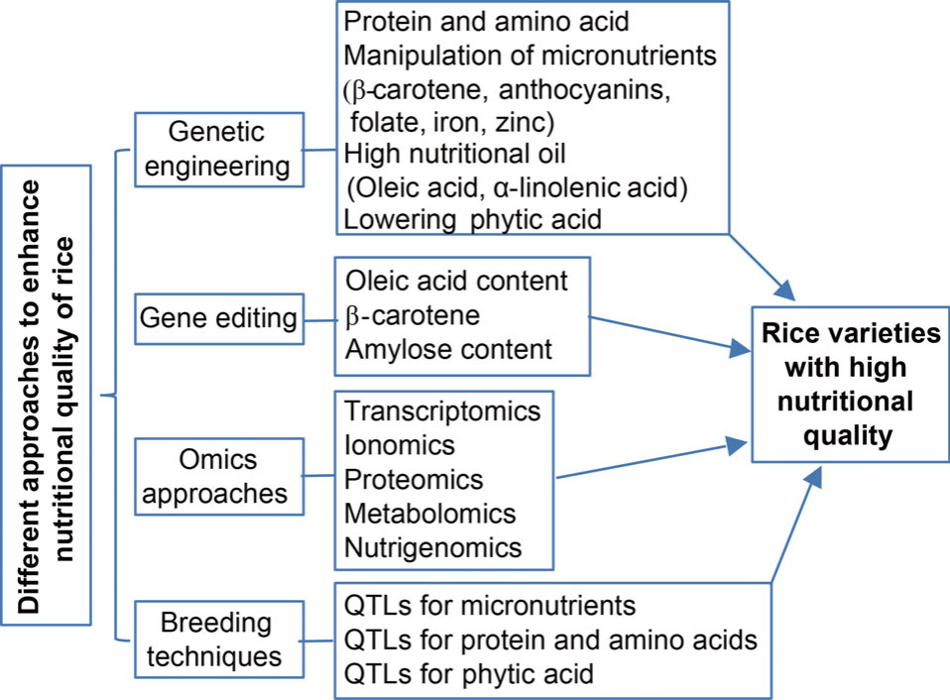

RECENT APPROACHES FOR BIOFORTIFICATION

Transgenic Efforts in the Development of Golden Rice
Vitamin A deficiency (VAD) is a major public health concern in many developing nations and is a leading cause of childhood blindness. The deficiency arises primarily due to inadequate dietary intake of provitamin A–rich foods. Carotenoids play a crucial physiological role in cellular differentiation, growth, reproduction, and vision (Wurtzel et al., 2012) and act as potent antioxidants that help counteract reactive oxygen species (ROS), thereby reducing the risk of cancers, cardiovascular disorders, neurological diseases, and ocular impairments (Bai et al., 2011). Because rice endosperm naturally lacks provitamin A, efforts have focused on engineering its carotenoid biosynthesis pathway to combat VAD—leading to the development of “Golden Rice.”
Golden Rice was engineered to produce β-carotene in the endosperm by introducing key genes involved in the carotenoid biosynthetic pathway. Although rice possesses an inherent β-carotene synthesis pathway, its endosperm does not accumulate the final products. To address this, phytoene synthase (psy) from daffodil (Narcissus pseudonarcissus) and phytoene desaturase (crtI) from the bacterium Erwinia uredovora were introduced into the endosperm of elite indica varieties such as IR64 and BR29 using endosperm-specific promoters (Datta et al., 2006). The resulting transgenic rice accumulated significant levels of β-carotene, offering a dietary source of provitamin A aimed at reducing VAD-related mortality and morbidity.

Golden Rice: The First Breakthrough
The pioneering work by Ye et al. (2000) demonstrated for the first time that rice grains could be engineered to produce β-carotene. Their study revealed that only two transgenes—psy and crtI—were sufficient to activate the carotenoid pathway within the rice endosperm. While the initial experiments were carried out in a japonica background, later research also targeted indica cultivars (Hoa et al., 2003) to broaden the applicability of the technology.
This first-generation Golden Rice, known as GR1, carried the daffodil psy gene and the bacterial crtI gene under the control of the endosperm-specific gt1 promoter. Field evaluations showed that GR1 accumulated carotenoid levels approximately four times higher than those predicted by preliminary laboratory models, marking a significant milestone in biofortification research.
Picture 6 : Golden Rice vs white rice

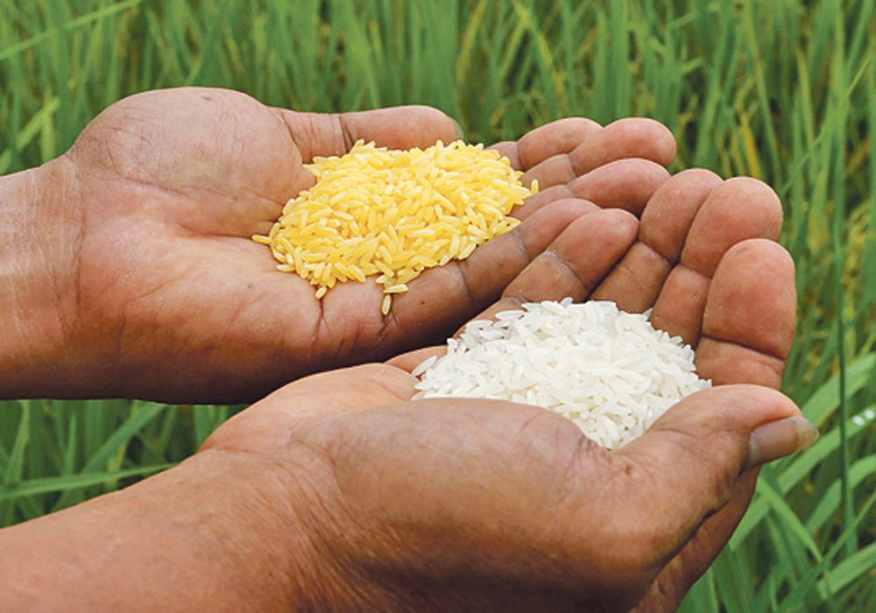

Golden Rice 2

Golden rice 1 gave us the possibility to produce betacarotene in rice endosperm. It also helped us see that to tackle vitamin A deficiency, β-carotene should be produced in higher amounts. Since only two transgenes have been involved in the production of β-carotene, it was simple to understand that by manipulating the enzymatic activities of the products of the two gene, one can achieve higher β-carotene. Normal pathways usually have certain rate limiting steps which controls the entire pathway. Overcoming the rate-limiting step simply by further enhancing the concentration of the rate-limiting enzyme or by shifting to a more active enzyme. Different PSY sources were examined to see that the maize and rice genes were more efficient (Paine et al., 2005). Golden rice 2 was generated to synthesize approximately 37 μg g-1 carotenoids. Among this, only 31 μg g-1 beta-carotene was significantly higher compared to 1.6 μg g-1 found in first generation golden rice (Al-Babili and Beyer, 2005).

There are two grades of golden rice;
- Golden rice1 (SGR1): Promoter is modified here and it contain 5-7μg β-carotene per gram of rice.
- Golden rice2: Replacement of daffodil Pys with maize gene and contain 31 μg β-carotene per gram of rice.

Some β - carotene enriched popular rice varieties are
- IR 64, IR 36: Mega varieties with broad Asian coverage
- BRRI dhan 29: The most popular boro rice variety in Bangladesh
- PSB Rc 82: The most popular Rice variety of Philippines
- OS 6561: Most popular in Vietnam
- Chehirang: Leading variety in Indonesia
- Swarna: Important in India.

Omics Approaches for Developing Nutritious Rice
Omics-based technologies provide sustainable, safe, and highly efficient tools for crop improvement. These approaches allow researchers to detect, quantify, and characterize a wide range of biological molecules—including DNA, RNA, proteins, metabolites, and mineral ions—within living systems. Key omics disciplines such as genomics, transcriptomics, proteomics, metabolomics, and ionomics have significantly advanced our understanding of rice biology and facilitated the development of nutrient-rich rice varieties (Deshmukh et al., 2010; Chaudhary et al., 2015).

Transcriptomics
Transcriptomics focuses on profiling RNA molecules, including both coding and non-coding transcripts. RNA sequencing (RNA-Seq) has enabled the comprehensive analysis of gene expression patterns in indica and japonica rice subspecies. Large-scale RNA-Seq datasets have considerably improved rice genome annotation, leading to the discovery of 1,584 previously unidentified peptides and 101 novel genomic loci associated with these peptides (Ren et al., 2019). These insights contribute to a deeper understanding of transcriptome complexity and functional gene regulation in rice.

Ionomics
Ionomics examines the composition and distribution of mineral nutrients and trace elements in plants across different developmental stages and environmental conditions. This approach helps identify genes, regulatory networks, and pathways involved in mineral uptake, transport, and homeostasis. Advanced analytical tools such as X-ray crystallography, neutron activation analysis, and inductively coupled plasma mass spectrometry are used to characterize the plant ionome (Huang and Salt, 2016). Ionomics plays a vital role in understanding micronutrient dynamics and enhancing Fe and Zn accumulation in rice grains.

Proteomics
Proteomics investigates protein expression profiles and bioactive compound production in rice. It is especially useful for assessing changes in nutritional quality and understanding post-transcriptional regulation in both conventional and transgenic rice lines. Sarkar et al. (2015) conducted comparative proteomic analyses to examine differences in phenolic compounds, anthocyanins, and antioxidant profiles between two high-yielding varieties, KDML105 and Mali Daeng. Their findings, supported by studies such as Maksup et al. (2018), showed that red rice (Mali Daeng) contains significantly higher levels of these beneficial compounds compared to white rice (KDML105).

Metabolomics
Metabolomics quantitatively and qualitatively analyzes small metabolites in biological systems. This approach has revealed substantial variation in the composition of bioactive compounds among different rice varieties, both in raw and cooked forms. Metabolomic profiling of normal versus giant embryo rice demonstrated that giant embryo types possess superior nutritional quality due to their elevated concentrations of health-promoting metabolites (Zhao et al., 2019).

Nutrigenomics
Nutrigenomics explores how nutrient intake influences gene expression and human health. Its primary aim is to improve dietary quality by enhancing macro- and micronutrient levels in staple crops or by integrating beneficial bioactive compounds into edible plant tissues. In the context of rice, nutrigenomics offers valuable insights into designing varieties that meet specific nutritional requirements and support better health outcomes.

Breeding Techniques for Developing Nutritious Rice
Biofortification through plant breeding relies on identifying genetic resources within existing germplasm that possess naturally higher nutrient concentrations. However, improving nutritional quality traits through conventional breeding is challenging because these traits are generally polygenic and quantitatively inherited. The integration of molecular markers has made marker-assisted selection (MAS) a powerful strategy for precisely identifying genomic regions or QTLs associated with nutritional traits (Choudhary et al., 2007).

QTLs for Micronutrient Enhancement
Extensive genetic mapping populations have been developed to unravel the genetic basis of Fe and Zn accumulation in rice grains. Numerous novel QTLs for Fe and Zn content have been mapped using SSR markers in doubled haploid and backcross inbred line populations (Dixit et al., 2019). QTL discovery has substantially improved the efficiency of biofortification breeding programs.
Swamy et al. (2018) reported eight QTLs associated with Zn and one QTL for Fe on chromosomes 2, 3, 4, 6, 8, 11, and 12. Candidate genes located near these QTLs—particularly members of the OsZIP and OsNRAMP transporter families—provide valuable targets for MAS to enhance grain Zn content.

QTLs for Protein and Amino Acid Improvement
Grain protein content (GPC) is a major determinant of the nutritional and sensory quality of rice. Approximately 80 QTLs governing GPC have been identified across all 12 chromosomes. Aluko et al. (2004) identified four QTLs linked to GPC, including Pro6, which is associated with the Wx gene known to influence grain quality.
Linkage mapping has also been extensively used to improve amino acid profiles in rice. Yoo (2017) identified six major-effect QTLs on chromosome 3, explaining 10.2–12.4% of phenotypic variation in amino acid content. A QTL cluster (qAla3, qVal3, qPhe3, qIle3, and qLeu3) was found to regulate five amino acids simultaneously. Such findings offer valuable genetic targets for MAS and aid in pinpointing candidate genes that enhance amino acid accumulation.
Furthermore, the normalized difference spectral index (NDSI) shows a strong correlation with grain protein levels. Genome-wide association studies (GWAS) using NDSI identified 43 genes and three pathways directly associated with protein biosynthesis, highlighting its potential as a rapid phenotyping tool.

Transgenic Approaches for Nutritional Enhancement
Transgenic strategies provide an efficient and sustainable means of improving nutritional traits when the desired genetic variation is absent in conventional germplasm. Several studies have shown that overexpressing genes such as nicotianamine aminotransferase, iron transporter OsIRT1, nicotianamine synthase (OsNAS1 and OsNAS2), and ferritin genes from soybean and common bean can substantially elevate iron levels in rice.
Similarly, zinc accumulation has been improved by overexpressing OsIRT1 and introducing mugineic acid biosynthetic genes from barley (HvNAS1, HvNAAT-A, HvNAAT-B, IDS3). A synergistic combination of nicotianamine synthase, ferritin, and phytase genes (NFP) has resulted in up to a sixfold increase in iron concentration in polished rice.

CRISPR/Cas9 Genome Editing
CRISPR/Cas9 has emerged as a highly precise and efficient tool for targeted genome modification. In rice, more than 46 genomic sites have been successfully edited with mutation frequencies averaging 85.4% (Ma et al., 2015). This technology enables direct manipulation of genes regulating nutrient biosynthesis and storage.

Picture 7 : Illustration of CRISPR/Cas9 Genome Editing
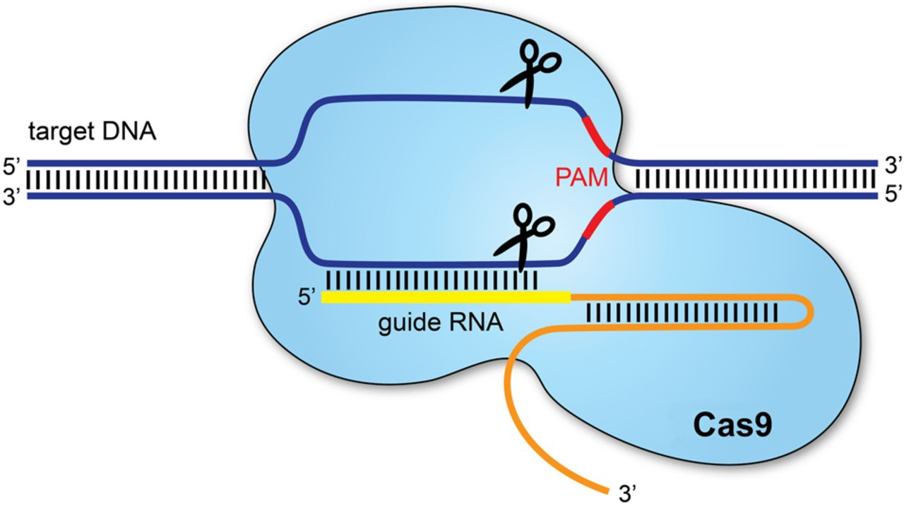

Examples include:
Enhancing β-carotene levels: Knocking out the carotenoid catabolic genes OsCYP97A4, OsDSM2, OsCCD4a, OsCCD4b, and OsCCD7 to increase β-carotene accumulation in the endosperm (Yang et al., 2017).
Increasing iron concentration: Silencing the OsVIT2 gene improved grain Fe content by reducing vacuolar iron sequestration (Ludwig & Slamet-Loedin, 2019).
Reducing phytic acid: CRISPR-mediated knockout of OsITPK1–6 resulted in reduced phytic acid levels and greater micronutrient bioavailability (Jiang et al., 2019).

Biofortification Through Biotechnology
Rice grains deteriorate rapidly during storage, particularly under tropical conditions. To maintain quality and extend shelf life, common post-harvest practices involve removing the embryo, pericarp, testa, and aleurone layers during milling, resulting in the consumption of only the endosperm (Matsuo and Hoshikawa, 1993). Consequently, biofortification is only effective when mineral concentrations are enhanced specifically in the endosperm. Modern biotechnological tools, including plant transformation, offer significant opportunities to enrich trace minerals directly within the endosperm. Genes used for rice biofortification primarily encode metal chelators (especially phytosiderophores), metal transporters, ferritin (an iron storage protein), and phytase.

Constraints and Challenges in Adopting Nutrient-Enriched Rice Varieties

1. Economic and Consumer Acceptance Barriers
Most rice farmers are smallholder growers who are highly price sensitive. Limited access to accurate pricing information and market fluctuations may discourage the cultivation of biofortified varieties. Additionally, nutrient enrichment can alter grain appearance—such as the orange coloration observed in provitamin A–enriched rice—making consumer acceptance difficult. The shorter shelf life of some biofortified grains also increases the cost and complexity of producing stable processed products.

2. Gene × Environment Interactions
Grain zinc content and yield are polygenic traits that are strongly influenced by environmental factors (Anuradha et al., 2012). Agronomic management practices and genotype–environment interactions significantly affect mineral uptake, translocation, and distribution within the plant (Phuke et al., 2017). Identifying stable donor lines across multiple locations—where Fe and Zn contents are consistently and positively correlated with yield—is crucial for designing effective breeding strategies (Naik et al., 2020).

3. Policy and Regulatory Challenges
Transgenic and genome-edited crops offer excellent potential for improving micronutrient bioavailability. However, such crops must undergo rigorous regulatory approval processes. Streamlined, science-based regulatory systems are essential to ensure that biofortified GM crops reach undernourished communities that could greatly benefit from them.

4. Requirements for Successful Biofortification Programs
For biofortification to achieve its intended nutritional impact, three key conditions must be met:
- Agronomic feasibility: Biofortified varieties must combine high and stable micronutrient density with competitive yield and production costs.
- Nutritional efficacy: Nutrients must remain stable during storage, processing, and cooking, and must be bioavailable to humans.
- Adoption by target communities: Farmers and consumers must accept biofortified varieties, supported by proper incentives, awareness programs, and effective delivery systems.

5. Breeding Complexity and Trait Stability
During backcrossing, care must be taken to avoid undesirable changes in other agronomic traits and to prevent segregation of transgenes in subsequent generations. Combining multiple nutritional traits becomes increasingly difficult because simultaneous selection for several traits complicates breeding efforts.

6. Limited Nutrient Stacking and Long Development Time
The first generation of biofortified cultivars typically targeted only one nutrient (e.g., Fe, Zn, or provitamin A). Developing a second nutrient-enhanced version through conventional breeding can take several years. Even when genetic variation exists, stacking multiple micronutrients remains a slow and challenging process.

7. Consumer Acceptability of Provitamin A–Enriched Varieties
Increasing provitamin A levels inevitably alters grain color from white to yellow or orange. Sustaining consumer demand for this visible trait requires strong awareness campaigns emphasizing its health benefits, especially given that biofortified varieties are often sold at prices similar to non-biofortified types.

8. Challenges in Metabolomics
Despite its value, metabolomics faces a major challenge: interpreting large, complex datasets in a biologically meaningful way. Data extraction and integration require sophisticated analytical pipelines and bioinformatics tools.

9. Limitations in Nutrigenomics
Although nutrigenomics holds promise for personalized nutrition and disease prevention, its application is constrained by variability in individual dietary habits, as well as the high cost and time-intensive nature of experimental protocols (Castle and Ries, 2009).

10. Anti-Nutritional Factors and Micronutrient Bioavailability
Bioavailability refers to the proportion of ingested nutrients that can be absorbed and utilized by the body. In plant-based foods, especially rice, the absorption of iron and zinc is typically below 10%, sometimes as low as 1% (Bhatnagar and Padilla-Zakour, 2021). This poor absorption largely results from anti-nutritional factors such as phytic acid (PA), which binds strongly to micronutrients.
PA levels in rice bran range from 2.6–8.7 g/100 g dry weight (Lehrfeld, 1994). Increasing Fe and Zn in brown rice alone is insufficient unless PA levels are simultaneously reduced. QTLs controlling phytate content (e.g., qPA.12) have been identified in IR64/Azucena DH populations (Stangoulis et al., 2007). The ipa mutant exhibited a 45% reduction in PA content and enhanced Zn availability (Larson et al., 2000), demonstrating the potential for targeting PA reduction in biofortified rice.

11. Preventing Post-Harvest Vitamin Degradation
Reducing vitamin degradation after harvest offers an effective complementary strategy for sustaining high nutrient levels in biofortified crops. Storage conditions—particularly prolonged exposure to elevated temperatures—can lead to substantial vitamin losses. Engineering vitamin stabilization mechanisms has shown promising results; for example, folate biofortification combined with folate-stabilizing traits resulted in a 150-fold increase in folate levels in transgenic polished rice.
Other vitamins also degrade during storage. Provitamin A in maize decreased by ~70% after six months in Zambia, and similar losses have been documented in Golden Rice. Nevertheless, the remaining amounts can still provide approximately 40% of the EAR for vitamin A, and degradation eventually stabilizes over time.

Advantages and limitations of rice biofortification
- Rice biofortification have certain advantages i.e. increase in nutritional value,
- Reduced adult and child micronutrient caused mortality,
- Reduced dietary deficiency diseases
- Healthier population with strong and quick immune responses to infections.

Biofortified Rice Varieties
The HarvestPlus program plays a central role in accelerating biofortification breeding in rice and other staple crops to combat micronutrient deficiencies across developing nations. In India, organizations such as the Department of Biotechnology (DBT), the International Rice Research Institute (IRRI), and the Indian Council of Agricultural Research (ICAR) have significantly advanced biofortification research. Under the All India Coordinated Rice Improvement Programme (AICRIP), biofortification trials began in 2013 with an initial zinc threshold of 20 mg/kg, later increased to 24 mg/kg. These efforts culminated in the release of several biofortified rice varieties.
Bangladesh became the first country to approve a β-carotene–rich Golden Rice variety (BRRI Dhan 29) for commercial cultivation. Complementing these efforts, the Government of India launched the POSHAN Abhiyaan nutrition initiative, targeting more than 100 million people and promoting biofortified crops. Seventeen biofortified varieties across eight major crops were officially released, including the high-zinc rice variety CR Dhan 315. Over the past five years, ICAR alone has developed 53 biofortified rice varieties.

Proof of Concept
Agricultural research initially focused on achieving national food security, but there is now a strategic shift toward enhancing the nutritional quality of staple crops. In India, two notable high-nutrient rice varieties—DRR Dhan 45 (high Zn) and CRR Dhan 310 (high protein)—were developed through conventional breeding and released via AICRP-Rice without compromising yield.

SUCCESS STORIES:
Similarly, biofortification success stories have emerged in other crops:
- Pearl millet: The high-iron cultivar Dhanashakti (71 ppm Fe) has been widely adopted.
- Maize: Numerous quality protein maize (QPM) hybrids with enhanced lysine and tryptophan are being cultivated. A provitamin A–rich version of Vivek QPM-9 was recently identified at IARI.
- Lentil: The variety Pusa Vaibhav is recognized for its high zinc content.
- Rice in Bangladesh: BRRI Dhan 62 became the first high-zinc rice variety released in 2013.
- Wheat: Zinc-rich wheat lines developed under the HarvestPlus program are under testing in India and Pakistan.
- Africa: Provitamin A–rich maize varieties have been released in Malawi, Zimbabwe, DR Congo, Zambia, Nigeria, and Ghana.
- Cassava and sweet potato: Provitamin A–enriched cassava and sweet potatoes have been released in Nigeria, DR Congo, Uganda, and Mozambique, with positive nutritional impacts.
- Beans: Iron-enriched bean varieties are under evaluation in DR Congo and Rwanda.
These successes collectively demonstrate that biofortification is a viable strategy for addressing micronutrient malnutrition across diverse agroecological regions.

Future Prospects of Biofortified Rice
Biofortification has emerged as a promising intervention to address micronutrient deficiencies, yet significant research gaps remain. The mechanisms governing nutrient acquisition, transport, and deposition—particularly from soil to seed—are still not fully understood. Advances in understanding these physiological and molecular pathways will be crucial for designing more effective biofortification strategies.
Before biofortified crops (especially GM or genome-edited types) reach consumers, comprehensive safety assessments are essential. Knowledge gaps also persist regarding micronutrient bioavailability, spatial distribution of minerals within grains, and nutrient losses during processing, polishing, and cooking.

Emerging technologies offer opportunities to strengthen biofortification efforts, including:
- Molecular cytogenetics for transferring high Fe/Zn genomic segments
- Breeding for uniform mineral distribution within the grain to reduce losses during polishing
- Manipulation of phytic acid to improve micronutrient bioavailability
- Nanotechnology-based micronutrient fertilizers, which may further enhance biofortification efficiency

The development and deployment of Golden Rice has driven intensive research; however, commercialization has faced delays. Biofortified rice varieties must also satisfy consumer preferences for grain appearance, taste, and cooking quality, while maintaining resistance to abiotic and biotic stresses.
With rapid SNP discovery through next-generation sequencing (NGS), CRISPR/Cas9-mediated genome editing is emerging as a powerful solution to overcome breeding bottlenecks. Integration of genomic selection, speed breeding, and multiparent populations, evaluated across multi-location trials, will improve the understanding of Genotype × Environment × Management (GEM) interactions and accelerate varietal release under the CGIAR product profile–based breeding pipeline.
A key consideration is the post-harvest nutrient retention. For example, under typical processing conditions, Zn rice can meet over 50% of the daily zinc requirement for children. However, heavy milling or parboiling can reduce zinc content significantly—up to 65% in parboiled rice—since Zn migrates to the outer grain layers. Recommendations include:
- Consuming lightly milled or brown parboiled rice, or
- limiting milling to 8–12% bran removal to preserve zinc content.
Cultural preferences for highly polished rice may limit these interventions and must be addressed through consumer awareness programs.

Conclusion :
Micronutrient malnutrition (“hidden hunger”) severely affects cognitive development, immune function, and overall health worldwide. Synergistic interactions among iron, zinc, and vitamins are essential for improving mineral bioavailability and supporting human well-being. The COVID-19 pandemic and rising health concerns have further highlighted the importance of nutrient-dense food crops.
Biofortified rice presents a cost-effective, sustainable, and scalable solution to micronutrient deficiencies. Governments can accelerate adoption by providing incentives and strengthening value chains. Significant advancements have been made, and with continued research, supportive policies, and targeted outreach, biofortified rice can greatly contribute to global nutritional security.
Recent breakthroughs in transgenic and genome editing approaches—including RNAi-mediated suppression of anti-nutritional pathways and CRISPR/Cas9-based interventions—have enabled the development of rice varieties with up to a 6.3-fold increase in iron and a twofold increase in zinc in the grain. These next-generation technologies herald a promising future for nutritionally enhanced rice.

Disclaimer (Artificial intelligence)
Option 1:
Author(s) hereby declare that NO generative AI technologies such as Large Language Models (ChatGPT, COPILOT, etc.) and text-to-image generators have been used during the writing or editing of this manuscript.
Option 2:
Author(s) hereby declare that generative AI technologies such as Large Language Models, etc. have been used during the writing or editing of manuscripts. This explanation will include the name, version, model, and source of the generative AI technology and as well as all input prompts provided to the generative AI technology
Details of the AI usage are given below:
1.
2.
3.

References:

1.Ashoka P., Spandana B., Sai Kanth D.R.K., 2023. Biofortification and Its Impact on Global
Health: Journal of Experimental Agriculture International Volume 45, Issue 10, Page
106-115, 2023; https://doi.org/10.9734/jeai/2023/v45i102203

2. Birla, D. S., Malik, K., Sainger, M., Chaudhary, D., Jaiwal, R., & Jaiwal, P. K. (2017). Progress and challenges in improving the nutritional quality of rice (Oryza sativa L.). Critical Reviews in Food Science and Nutrition, 57(11), 2455-2481. https://doi.org/10.1080/10408398.2015.1084992

3. Sanjeeva Rao, D., Neeraja, C. N., Madhu Babu, P., Nirmala, B., Suman, K., Subba Rao, L. V., Surekha, K., Raghu, P., Longvah, T., Surendra, P., Kumar, R., Babu, V. R., & Voleti, S. R. (2020). Zinc Biofortified Rice Varieties: Challenges, Possibilities, and Progress in India. Frontiers in Nutrition. https://doi.org/10.3389/fnut.2020.00026

4.Senguttuvel, P., Padmavathi, G., Subba Rao, LV., Jasmine, C., 2023. Rice Biofortification:
breeding and genomic approaches for genetic enhancement of grain zinc and iron contents:
Frontiers in Plant Science volume 14 https://doi.org/10.3389/fpls.2023.1138408

5.Howarth Bouis., Jennifer Foley., Keith Lividine., Jaya Jumrani., 2024. Biofortification: Future
Challenges for a Newly Emerging Technology to Improve Nutrition Security Sustainably:
Current Developments in Nutrition, https://doi.org/10.1016/j.cdnut.2024.104478

6.Sundus zafar., Xu Jainlong., 2023. Recent Advances to Enhance Nutritional Quality of Rice:
Rice science, volume 30, Issue 6 https://doi.org/10.1016/j.rsci.2023.05.004

7.Jagadish Jena., Pramod Sethy., Twinkle Jena., 2018. Rice biofortification: A brief review
Journal of Pharmacognosy and Phytochemistry ; 7(1):2644-2647 https://www.jpp.com/download/2018/7-1-10-101.pdf

8. Saltzman, A., Birol, E., Bouis, H. E., Boy, E., De Moura, F. F., Islam, Y., & Pfeiffer, W. H. (2013). Biofortification: Progress toward a more nourishing future. Global Food Security, 2(1), 9-17. https://doi.org/10.1016/j.gfs.2012.12.003

9.Kelvin F. Ofori., Sophia Antoniello., Marcia M. English.,2022. Improving nutrition through biofortification -A systematic review: Frontiers in Nutrition, Sec.Nutrition and Food Science Technology, Volume 9, https://doi.org/10.3389/fnut.2022.1043655

10.Wakeel A., Farooq M., Bashir K., Ozturk L.,2018. Micronutrient malnutrition and biofortification: recent advances and future perspectives. In: Hossain MA, Kamiya T, Burritt DJ, Tran LSP, Fujiwara T, editors. Plant Micronutrient Use Efficiency: Molecular and Genomic Perspectives in Crop Plants. Amsterdam: Elsevier Inc (2018). p. 225–43. https://doi.org/10.1016/B978-0-12-812104-7.00017-4

11.Badiane O, Collins J, Dimaranan B, Ulimwengu J. An Assessment of the New Alliance for Food Security and Nutrition. Addis Ababa: African Union (2018). https://au.int/en/documents/20180401/assessment-new-alliance-food-security-and-nutrition

12.Bouis H. Reducing mineral and vitamin deficiencies through biofortification: Progress under harvestplus. World Rev Nutr Diet. (2018) 118:112–22. https://doi.org/10.1159/000484342

13.Wakeel A, Labuschagne MT. Editorial: crop biofortification for food security in developing countries. Front Sustain Food Syst. (2021) 5:756296. https://doi.org/10.3389/fsufs.2021.756296

14.Garg M, Sharma N, Sharma S, Kapoor P, Kumar A, Chunduri V, et al. Biofortified crops generated by breeding, agronomy, and transgenic approaches are improving lives of millions of people around the world. Front Nutr. (2018) 5:12. https://doi.org/10.3389/fnut.2018.00012

15.Bouis H, Saltzman A, Birol E. Improving nutrition through biofortification. In: Shenggen F, Sivan Y, Rajul P-L editors. Agriculture for Improved Nutrition: Seizing the Momentum. Wallingford: International Food Policy Research Institute (2019). p. 47–57. https://doi.org/10.1079/9781786399311.0047

16.Lowe NM. The global challenge of hidden hunger: perspectives from the field. Proc Nutr Soc. (2021) 80:283–9. https://doi.org/10.1017/S0029665121000902

17.Nayak SN, Aravind B, Malavalli SS, Sukanth BS, Poornima R, Bharati P, et al. Omics technologies to enhance plant based functional foods: an overview. Front Genet. (2021) 12:742095. https://doi.org/10.3389/fgene.2021.742095

18.Godswill AG, Somtochukwu IV, Ikechukwu AO, Kate EC. Health benefits of micronutrients (Vitamins and Minerals) and their associated deficiency diseases: a systematic review. Int J Food Sci. (2020) 3:1–32. https://doi.org/10.47604/ijf.1024

19.Grebmer K, Bernstein J, Hossain N. Global Hunger Index: The Inequalities of Hunger. Washington, DC: International Food Policy Research Institute (2017). 46 p. https://doi.org/10.2499/9780896292710

20.Singh U, Praharaj CS, Singh SS, Singh NP (eds). Biofortification of Food Crops. New Delhi: Springer (2016). p. 1–490. https://doi.org/10.1007/978-81-322-2716-8

21. Stangoulis JCR, Knez M. Biofortification of major crop plants with iron and zinc - achievements and future directions. Plant Soil. (2022) 474:57–76. https://doi.org/10.1007/s11104-022-05330-7
22.Sheoran S, Kumar S, Ramtekey V, Kar P, Meena RS, Jangir CK. Current status and potential of biofortification to enhance crop nutritional quality: an overview. Sustainability. (2022) 14:3301. https://doi.org/10.3390/su14063301
23.ACC/SCN. Fourth Report on the World Nutrition Situation – Nutrition Throughout the Life Cycle. Geneva: ACC/SCN (2000). https://digitallibrary.un.org/record/429000
24.Batis C, Mazariegos M, Martorell R, Gil A, Rivera JA. Malnutrition in all its forms by wealth, education and ethnicity in Latin America: who are more affected? Public Health Nutr. (2020) 23:S1–12. https://doi.org/10.1017/S136898001900466X
25.Buturi CV, Mauro RP, Fogliano V, Leonardi C, Giuffrida F. Mineral biofortification of vegetables as a tool to improve human diet. Foods. (2021) 10:223. https://doi.org/10.3390/foods10020223
26.Lopez Villar J. Tackling Hidden Hunger: Putting Diet Diversification at the Centre. Penang: Third World Network (2015). 75 p. https://www.twn.my/title2/books/tackling_hidden_hunger.htm
27.Cominelli E, Pilu R, Sparvoli F. Phytic acid and mineral biofortification strategies: from plant science to breeding and biotechnological approaches. Plants. (2020) 9:553. https://doi.org/10.3390/plants9050553
28.Ul-Allah S. Combating hidden hunger in agriculture perspective. World Rev Nutr Diet. (2018) 118:161–6. https://doi.org/10.1159/000484511
29.Malik K, Maqbool A. Transgenic crops for biofortification. Front Sustain Food Syst. (2020) 4:571402. https://doi.org/10.3389/fsufs.2020.571402
30.Nair MK, Augustine LF, Konapur A. Food-based interventions to modify diet quality and diversity to address multiple micronutrient deficiency. Front Public Heal. (2016) 3:277. https://doi.org/10.3389/fpubh.2015.00277
31.Kiran A, Wakeel A, Mahmood K, Mubaraka R, Hafsa, Haefele SM. Biofortification of staple crops to alleviate human malnutrition: contributions and potential in developing countries. Agronomy. (2022) 12:452. https://doi.org/10.3390/agronomy12020452
32.Tam E, Keats EC, Rind F, Das JK, Bhutta ZA. Micronutrient supplementation and fortification interventions on health and development outcomes among children under-five in low-and middle-income countries: a systematic review and meta-analysis. Nutrients. (2020) 12:289. https://doi.org/10.3390/nu12020289
33.Ghosh S, Pahari S, Roy T. An updated overview on food supplement. Asian J Res Chem. (2018) 11:691. https://doi.org/10.5958/0974-4150.2018.00122.0

34.Correia LL, Rocha HAL, Campos JS, Silva ACE, Da Silveira DMI, Machado MMT, et al. Interaction between vitamin a supplementation and chronic malnutrition on child development. Cienc Saude Colet. (2019) 24:3037–46. https://doi.org/10.1590/1413-81232018248.22242017
35.Das J, Salam R, Mahmood S, Moin A, Kumar R, Mukhtar K, et al. Food fortification with multiple micronutrients: impact on health outcomes in general population. Cochrane Database Syst Rev. (2019) 12:CD011400. https://doi.org/10.1002/14651858.CD011400.pub2
36.Saghir Ahmad KY. Malnutrition: causes and strategies. J Food Process Technol. (2015) 6:434. https://doi.org/10.4172/2157-7110.1000434
37.Chadare F, Idohou R, Nago E, Affonfere M, Agossadou J, Kévin Fassinou T, et al. Conventional and food-to-food fortification: an appraisal of past practices and lessons learned. Food Sci Nutr. (2019) 7:2781. https://doi.org/10.1002/fsn3.1133
38.Kumar S, Palve A, Joshi C, Srivastava RK, Rukhsar. Crop biofortification for iron (Fe), zinc (Zn) and vitamin A with transgenic approaches. Heliyon. (2019) 5:e01914. https://doi.org/10.1016/j.heliyon.2019.e01914
39.Saltzman A, Andersson MS, Asare-Marfo D, Lividini K, De Moura FF, Moursi M, et al. Biofortification Techniques to Improve Food Security. Reference Module in Food Science. Amsterdam: Elsevier (2016). p. 1–9. https://doi.org/10.1016/B978-0-08-100596-5.03078-X
40.Tanumihardjo SA, Ball AM, Kaliwile C, Pixley KV. The research and implementation continuum of biofortified sweet potato and maize in Africa. Ann N Y Acad Sci. (2017) 1390:88–103. https://doi.org/10.1111/nyas.13315
41.Finkelstein J, Haas J, Mehta S. Iron-biofortified staple food crops for improving iron status: a review of the current evidence. Curr Opin Biotechnol. (2017) 44:138–45. https://doi.org/10.1016/j.copbio.2017.01.003
42.Scott SP, Murray-Kolb LE, Wenger MJ, Udipi SA, Ghugre PS, Boy E, et al. Cognitive performance in Indian school-going adolescents is positively affected by consumption of iron-biofortified pearl millet: a 6-month randomized controlled efficacy trial. J Nutr. (2018) 148:1462–71. https://doi.org/10.1093/jn/nxy113
43.Zia MH, Ahmed I, Bailey EH, Lark RM, Young SD, Lowe NM, et al. Site-specific factors influence the field performance of a Zn-biofortified wheat variety. Front Sustain Food Syst. (2020) 4:135. https://doi.org/10.3389/fsufs.2020.00135
44.Sanjeeva Rao D, Neeraja CN, Madhu Babu P, Nirmala B, Suman K, Rao LVS, et al. Zinc biofortified rice varieties: challenges, possibilities, and progress in India. Front Nutr. (2020) 7:26. https://doi.org/10.3389/fnut.2020.00026
45.Alcorta A, Porta A, Tárrega A, Alvarez MD, Pilar Vaquero M. Foods for plant-based diets: challenges and innovations. Foods. (2021) 10:293. https://doi.org/10.3390/foods10020293

46.Popova A, Mihaylova D. Antinutrients in plant-based foods: a review. Open Biotechnol J. (2019) 13:68–76. https://doi.org/10.2174/1874070701913010068
47.Rawat N, Neelam K, Tiwari VK, Dhaliwal HS. Biofortification of cereals to overcome hidden hunger. Plant Breed. (2013) 132:437–45. https://doi.org/10.1111/pbr.12040
48.Meena PC, Choudhary A, Meena PC, Meena C. Biofortification of cereal crops: an emerging strategy to overcome hidden Hunger. Int J Chem Stud. (2018) 6:776–85. https://www.chemijournal.com/archives/2018/vol6issue3/PartL/6-3-10-900.pdf
49.Pfeiffer WH, McClafferty B. HarvestPlus: breeding crops for better nutrition. Crop Sci. (2007) 47(Suppl. 3):S88–105. https://doi.org/10.2135/cropsci2007.09.0020IPBS
50.Coelho RC, Barsotti RCF, Maltez HF, Lopes Júnior CA, Barbosa HS. Expanding information on the bioaccessibility and bioavailability of iron and zinc in biofortified cowpea seeds. Food Chem. (2021) 347:129027. https://doi.org/10.1016/j.foodchem.2021.129027
51.Sharma K, Tayade A, Singh J, Walia S. Bioavailability of nutrients and safety measurements. In: Egbuna C, Dable Tupas G, editors. Functional Foods and Nutraceuticals. Cham: Springer (2020). p. 543–93. https://doi.org/10.1007/978-3-030-42319-3_25
52.Ram S, Narwal S, Gupta OP, Pandey V, Singh GP. Anti-nutritional factors and bioavailability: approaches, challenges, and opportunities. In: Gupta OP, Pandey V, Narwal S, Sharma P, Ram S, Singh GP, editors. Wheat and Barley Grain Biofortification. Amsterdam: Elsevier Inc (2020). p. 101–28. https://doi.org/10.1016/B978-0-12-818444-8.00004-3
Hamid, H., Thakur, N., & Kumar, P. (2017). Anti-nutritional factors, their adverse effects and need for adequate processing to reduce them in food. Agric International. https://doi.org/10.5958/2454-8634.2017.00013.4
54.Samtiya M, Aluko RE, Dhewa T. Plant food anti-nutritional factors and their reduction strategies: an overview. Food Prod Process Nutr. (2020) 2:6. https://doi.org/10.1186/s43014-020-0020-5
55.Thakur A, Sharma V, Thakur A. An overview of anti-nutritional factors in food. Int J Chem Stud. (2019) 7:2472–9. https://www.chemijournal.com/vol7issue1/PartAD/7-1-10-100.html
56.Praharaj S, Skalicky M, Maitra S, Bhadra P, Shankar T, Brestic M, et al. Zinc biofortification in food crops could alleviate the zinc malnutrition in human health. Molecules. (2021) 26:3509. https://doi.org/10.3390/molecules26123509
57.Olson R, Gavin-Smith B, Ferraboschi C, Kraemer K. Food fortification: the advantages, disadvantages and lessons from sight and life programs. Nutrients. (2021) 13:1118.https:// doi: 10.3390/nu13041118

58.Sriatmi A, Jati SP, Suryoputro A, Fatmasari EY. Stakeholder mapping analysis on the scaling-up nutrition movement during the 1000 days of life between the urban and rural government areas. Unnes J Public Heal. (2021) 10:68–77. https://doi: 10.15294/ujph.v10i1.38029

- Lowe NM. The global challenge of hidden hunger: perspectives from the field. Proc Nutr Soc. (2021) 80:283–9. https://doi: 10.1017/S0029665121000902

- Marques E, Darby HM, Kraft J. Benefits and limitations of non-transgenic micronutrient biofortification approaches. Agronomy. (2021) 11:464. https://doi: 10.3390/agronomy11030464

- Riaz U, Aziz H, Anum W. Plant Micronutrients. Cham: Springer (2020). p. 225–39. https://doi: 10.1007/978-3-030-49856-6_9

- Nielsen FH. Manganese, molybdenum, boron, silicon, and other trace elements. In: Marriott BP, Birt DF, Stallings VA, Yates AA, editors. Present Knowledge in Nutrition. Cambridge, MA: Academic Press (2020). p. 485–500.https:// doi: 10.1016/B978-0-323-66162-1.00029-9

- Food and Agriculture Organization [FAO]. 2020 Flood Impact Rapid Assessment. Rome: FAO (2020).
- Stangoulis JCR, Knez M. Biofortification of major crop plants with iron and zinc - achievements and future directions. Plant Soil. (2022) 474:57–76. https://doi: 10.1007/s11104-022-05330-7

- Sheoran S, Kumar S, Ramtekey V, Kar P, Meena RS, Jangir CK. Current status and potential of biofortification to enhance crop nutritional quality: an overview. Sustainability. (2022) 14:3301. https://doi: 10.3390/su14063301

- Batis C, Mazariegos M, Martorell R, Gil A, Rivera JA. Malnutrition in all its forms by wealth, education and ethnicity in Latin America: who are more affected? Public Health Nutr. (2020) 23:S1–12. https://doi: 10.1017/S136898001900466X

- Buturi CV, Mauro RP, Fogliano V, Leonardi C, Giuffrida F. Mineral biofortification of vegetables as a tool to improve human diet. Foods. (2021) 10:223. https://doi: 10.3390/foods10020223

- Cominelli E, Pilu R, Sparvoli F. Phytic acid and mineral biofortification strategies: from plant science to breeding and biotechnological approaches. Plants. (2020) 9:553. https://doi: 10.3390/plants9050553

- Kiran A, Wakeel A, Mahmood K, Mubaraka R, Hafsa, Haefele SM. Biofortification of staple crops to alleviate human malnutrition: contributions and potential in developing countries. Agronomy. (2022) 12:452.https:// doi: 10.3390/agronomy12020452

- Tam E, Keats EC, Rind F, Das JK, Bhutta ZA. Micronutrient supplementation and fortification interventions on health and development outcomes among children under-five in low-and middle-income countries: a systematic review and meta-analysis. Nutrients. (2020) 12:289.https:// doi: 10.3390/nu12020289

