Genetic diversity assessment of off-season jackfruit (Artocarpus heterophyllus Lam.)

ABSTRACT
This study evaluates the genetic diversity of 30 off-season jackfruit (Artocarpus heterophyllus Lam.) accessions collected from the northern districts of Kerala (Kannur, Kozhikode, and Malappuram) using SSR and ISSR molecular markers. A total of 20 SSR and 10 ISSR markers were employed to characterize the accessions. All ISSR primers exhibited polymorphism, with Polymorphism Information Content (PIC) values ranging from 0.02 to 0.29, whereas 16 out of 20 SSR primers were polymorphic, displaying PIC values between 0.08 and 0.47. Cluster analysis grouped the accessions into two major clusters and four subclusters, with the closest genetic relationship observed between KNR 3 and KNR 7. Principal Coordinate Analysis (PCoA) further supported the presence of distinct genetic groupings, particularly across two districts. Population structure analysis also revealed two major clusters with four subclusters showing varying levels of admixture. Overall, the findings indicate moderate genetic differentiation among the accessions, likely reflecting common ancestry and restricted gene flow due to limited seed dispersal and the geographic proximity of the collection sites.

KEYWORDS: Genetic diversity, molecular markers, jackfruit, SSR, ISSR

- INTRODUCTION

Jackfruit (Artocarpus heterophyllus Lam.), native to the rainforests of India, represents one of the most important underutilized tropical fruit crops (Kavya & Shyamalamma, 2020). The species is monoecious and characterized by the presence of thick white latex in all vegetative and reproductive tissues. India ranks second in global jackfruit production, with extensive cultivation across several states, including Assam, Tripura, Bihar, Uttar Pradesh, the Himalayan foothills, and the southern states of Kerala, Tamil Nadu, and Karnataka (Uikey et al., 2020).
Molecular marker–based approaches have proven highly effective for germplasm evaluation, population structure analysis, and the characterization of genetic diversity (Chhetri, 2023). In particular, Simple Sequence Repeat (SSR) and Inter Simple Sequence Repeat (ISSR) markers provide valuable insights into the distribution of desirable alleles and the genomic regions exhibiting polymorphism (Xu et al., 2024). These markers offer high levels of resolution and reproducibility, making them suitable tools for assessing genetic variability in plant populations (Nakintu et al., 2020). Furthermore, detailed population-level analyses facilitate studies on domestication patterns, conservation of plant genetic resources, and gene pool utilization, as noted by Palupi et al. (2019). SSR and ISSR markers are especially advantageous for diversity analyses because of their high polymorphic information content and effectiveness in distinguishing closely related genotypes. ISSR markers, in particular, have been widely used for plant species identification due to their reliability and reproducibility (Gupta et al., 2011).
Jackfruit exhibits remarkable genetic diversity, which has been attributed to its predominantly cross-pollinated nature and seed-based propagation system (Kavya et al., 2019). Substantial variability exists among naturally growing jackfruit trees, underscoring the importance of in-situ molecular characterization for the identification of superior genotypes with potential commercial value. Germplasm evaluation thus remains a foundational step in identifying elite cultivars suitable for breeding and large-scale cultivation.
Identification and characterization of off-season bearing jackfruit types are particularly valuable, as they can significantly enhance fruit availability during periods of scarcity. Off-season production not only supports year-round supply but also provides farmers with
opportunities for higher income due to premium market prices during non-peak seasons. Despite this importance, studies on off-season jackfruit types from Kerala remain limited compared to other tropical fruit crops, and molecular marker development in jackfruit is still at a preliminary stage (Kavya et al., 2019). Therefore, the present study aims to investigate the genetic diversity of off-season jackfruit accessions collected from the northern districts of Kerala using SSR and ISSR markers.

- MATERIALS AND METHODS

  - Collection of Plant Materials
30 Jackfruit accessions were collected from 3 districts: Kannur, Kozhikode, and Malappuram in North Kerala. The plants were collected using sterile dissection blades, cleaned using tissue paper, and then enclosed in polybags to minimize polyphenol contamination (Ojwang, 2020). The samples were then maintained at -80℃ in the College of Agriculture, Vellayani, for future use. The locations of the collected accessions are given in Table 1.

Table 1. Location of 30 Jackfruit accessions collected
Sl. No. | Accessions | Location (District) | Latitude | Longitude
1 | KNR1 | Kannur | 11° 54' 23.65 N | 75° 22' 29.23E
2 | KNR2 | Kannur | 11° 54' 35.08 N | 75° 22' 26.97 E
3 | KNR3 | Kannur | 11° 54' 25.48 N | 75° 22' 34.77 E
4 | KNR4 | Kannur | 11° 54' 26.10 N | 75° 22' 35.68 E
5 | KNR5 | Kannur | 11° 54' 29.63 N | 75° 22' 24.31 E
6 | KNR6 | Kannur | 11° 54' 29.64 N | 75° 22' 24.24 E
7 | KNR7 | Kannur | 11° 54' 33.51 N | 75° 22' 24.39 E
8 | KZK1 | Kozhikode | 11° 18' 50.34 N | 75° 50' 32.97 E
9 | KZK2 | Kozhikode | 11° 18' 47.99 N | 75° 50' 31.50 E
10 | KZK3 | Kozhikode | 11° 18' 24.35 N | 75° 52' 33.82 E
11 | KZK4 | Kozhikode | 11° 18' 30.62 N | 75° 52' 4.31 E
12 | KZK5 | Kozhikode | 11° 16' 10.43 N | 75° 49' 0.52 E
13 | KZK6 | Kozhikode | 11° 16' 22.88 N | 75° 49' 6.46 E
14 | KZK7 | Kozhikode | 11° 16' 22.83 N | 75° 49' 1.65 E
15 | KZK8 | Kozhikode | 11° 16' 6.26 N | 75° 48' 55.18 E
16 | KZK9 | Kozhikode | 11° 16' 37.61 N | 75° 48' 30.09 E
17 | KZK10 | Kozhikode | 11° 16' 16.05 N | 75° 49' 16.26 E
18 | KZK11 | Kozhikode | 11° 16' 20.56 N | 75° 49' 7.41 E
19 | MPM1 | Malappuram | 11° 13' 50.68 N | 75° 58' 27.91 E
20 | MPM2 | Malappuram | 10° 56' 39.32 N | 76° 2' 23.70 E
21 | MPM3 | Malappuram | 11° 15' 12.02 N | 75° 58' 42.86 E
22 | MPM4 | Malappuram | 11° 14' 18.16 N | 75° 59' 1.30 E
23 | MPM5 | Malappuram | 11° 14' 7.91 N | 75° 57' 34.2 E
24 | MPM6 | Malappuram | 11° 16' 24.87 N | 76° 6' 58.91 E
25 | MPM7 | Malappuram | 10° 52' 1.48 N | 76° 20' 17.04 E
26 | MPM8 | Malappuram | 11° 13' 10.90 N | 75° 59' 35.16 E
27 | MPM9 | Malappuram | 11° 15' 53.62 N | 76° 9' 1.04 E
28 | MPM10 | Malappuram | 11° 15' 18.32 N | 76° 10' 2.56 E
29 | MPM11 | Malappuram | 11° 16' 26.98 N | 76° 9' 8.10 E
30 | MPM12 | Malappuram | 11° 15' 43.44 N | 76° 0' 21.78 E

  - DNA Extraction
Genomic DNA was isolated using a modified CTAB protocol designed to reduce polyphenol contamination and improve DNA quality (Aboul-Maaty & Oraby, 2019). Freshly collected plant tissues were ground in liquid nitrogen, after which a pre-heated CTAB extraction buffer supplemented with β-mercaptoethanol and polyvinylpyrrolidone (PVP) was added. The homogenized mixture was transferred to centrifuge tubes and incubated in a water bath at 65 °C for 45 minutes. Following incubation, the tubes were centrifuged at 10,000 rpm for 10 minutes, and the resulting supernatant was carefully collected.
Purification of the supernatant was performed using a chloroform: isoamyl alcohol mixture (24:1), followed by centrifugation at 12,000 rpm for 10 minutes. The aqueous phase was then precipitated with chilled isopropanol and incubated overnight at –20 °C to facilitate DNA precipitation. The DNA was pelleted by centrifugation at 10,000 rpm for 15 minutes, washed twice with 70% ethanol, and air-dried. The final DNA pellets were dissolved in TE buffer and stored at –20 °C for downstream molecular analyses (Chhetri, 2017).

  - Quantification and gel documentation of DNA
Quantification of the isolated DNA is done using Nano Drop spectrophotometry to measure the amount of nucleotide bases at 260/280nm wavelength by determining the ratio of absorbance. Samples with purity range between 1.8-2 are considered as good quantity and free of impurities (Lucena-Aguilar et al., 2016).
Agarose gel documentation is used to visualize the extracted DNA and confirm the presence of bands, wherein the DNA fragments are separated based on their size. Since DNA fragments are negatively charged, under the influence of electricity, DNA fragments move to the positively charged electrode, based on the molecular size; the lightest fragments move farthest from the negative end, thus separating the different-sized DNA fragments.
The samples were observed in 3% agarose gel, prepared by melting 3.6g agarose in 120mL TAE buffer. Combs are placed to create wells in the gel after gel hardening, the combs are removed, and samples are loaded. The isolated DNA sample is mixed with 6x Gel loading dye (1µL dye and 5µL DNA sample). The gel is run for about 1 hour to separate the bands.

  - Polymerase Chain Reaction
The 30 DNA samples were amplified using Polymerase Chain Reaction (PCR) using 10 ISSR primers (Table 2) and 20 SSR primers (Table 3). Reaction mixture (10 µL) for SSR primer was prepared using 5 µL PCR master mix, 0.5 µL forward primer, 0.5 µL reverse primer, 1 µL DNA extract, and 3 µL nuclease-free water. Reaction mixture for ISSR markers included 5 µL PCR master mix, 2 µL primer, 2 µL DNA extract, and 1 µL nuclease-free water. The SSR markers were selected from previously reported works of Singh et al. (2021), and ISSR primers from Aswini et al. (2018). The details of PCR reaction conditions for SSR and ISSR markers are given in Table 4.

Table 2. ISSR primers deployed for molecular diversity analysis of jackfruit accessions
Primer Name | Sequence
UBC 807 | AGAGAGAGAGAGAGAGT
UBC 809 | AGAGAGAGAGAGAGAGG
UBC 812 | GAGAGAGAGAGAGAGAA
UBC 834 | AGAGAGAGAGAGAGAGYT
UBC 840 | GAGAGAGAGAGAGAGAYT
UBC 841 | GAGAGAGAGAGAGAGATYC
UBC 855 | ACACACACACACACACYT
UBC 858 | TGTGTGTGTGTGTGTGRT
UBC 866 | CTCCTCCTCCTCCTCCTC
TC 10G | TCTCTCTCTCTCTCTCTCTCG

Table 3. SSR primers deployed for molecular diversity analysis of jackfruit accessions

Primer name | Forward primer | Reverse primer
JFSSR 4 | ACAAGAGACTCAAGCCTCAA | TCTTTGACTGCAATGAAGC
JFSSR 8 | CAACCCAAGAAGTAGTATCCA | GAGAAGGACGGAGATTCTTT
JFSSR 12 | TGGATCTTGGTGTCGGTCT | TACCACTCCGTACAGTGGAAA
JFSSR 13 | ACTCAGTTATTGAGCCTTCCT | CAAAGAGACGTGTGATGTTG
JFSSR 15 | CTCCCTGGGAAAGGAATA | CTTAACGATTTGCATTAGGG
JFSSR 18 | CACTAGTGAAACCTTCTGTGG | CTGTTCAGCAGGCAATAACT
JFSSR 19 | GAGTTTATTTCTTGCCCTTG | CTCATCATTTCGCTTTAACC
JFSSR 20 | AAATACCCAGCTCGCAGT | CACCAACAAACTCTTCCTTTC
JFSSR 25 | GTTATCAGAATATCGACAGCAG | GTGTTATTGCAGCTCACAAG
JFSSR 28 | GCCACTAGAAACTCCAAACTT | GGGAATGGGTATGAGTATGAG
JFSSR 32 | CAATCTCCCACTTGTTTGT | CTGTTATATCTTCGGGAAGTG
JFSSR 35 | AAGCGATCAAAGGTGACAT | CTCTCCTCCTTCTTCTTCATC
JFSSR 39 | AATGGCAACTTAGCAAGGTA | ATACGATGTCCCAGAAGTCAT
JFSSR 44 | CAAACCAACACTTATCACTCC | CCATCTTCAAAGTCCGTTC
JFSSR 45 | TTCTCTCACAAACACCCAAA | CCATCTTCAAAGTCCGTTC
JFSSR 47 | GAGAAGCAACCCAATTAAGA | GTGTTCGTGGAACGTAGTG
JFSSR 48 | ACCAAGTCACACATGATTACC | GTGTTCGTGGAACGTAGTG
JFSSR 52 | ACCAAGTCACACATGATTACC | ACAGTGTAGGCACTGTTTCTG
JFSSR 64 | CAGAATACGATGACAAGATGG | CTTCTTCATCGGTAAAGTGC
JFSSR 76 | TCGAAGCAGACAATCAGAAT | AGAGGAGAAGGGACTGAATTT

Table 4. PCR reaction conditions utilized in the molecular diversity analysis

 | SSR Markers (35 cycles) |  | ISSR Markers (35 cycles)
Profile | Temperature | Duration | Temperature | Duration
Lid temperature | 98 ℃ | - | 98 ℃ | -
Initial denaturation | 94 ℃ | 5 min | 94 ℃ | 2 min
Denaturation | 94 ℃ | 45s | 94 ℃ | 30s
Annealing | 45-60 ℃ | 30s | 48-62 ℃ | 45s
Extension | 72 ℃ | 30s | 72 ℃ | 2 min
Final extension | 72 ℃ | 7 min | 72 ℃ | 10 min
Infinite hold | 4 ℃ | - | 4 ℃ | -

  - Gel electrophoresis analysis of PCR product

The PCR product can be viewed and analysed using agarose gel electrophoresis. The reaction mix after PCR is loaded in agarose gel containing a suitable fluorescent dye, and 80V current is passed through the gel using a gel electrophoresis unit. The amplified DNA fragments absorb ethidium bromide, a fluorescent dye, which is illuminated in the presence of UV radiation in a Gel documentation machine. The size of the bands is measured by comparing with a 100bp DNA ladder. The resulting image is used for analyzing the extent of amplification and the number of polymorphic bands. By counting the number of polymorphic bands.

  - Genetic diversity analysis

The presence and absence of bands can be recorded to calculate Polymorphism Information Content (PIC) value, heterozygosity, marker Index, and other parameters like dendrogram, genetic distance, PCoA, and population structure analysis. A PCR amplified image can be used PIC value can be calculated by counting the frequency of amplified alleles and null alleles. The PIC value can be used to understand the ability of a marker to identify polymorphism in a selected population. The PIC value can be calculated for SSR markers and ISSR markers using the following equation:

PIC value for ISSR marker: 2fi(1-fi)

fi: Frequency of amplified allele.
(1-fi): Frequency of null allele (band absent) of marker i.

PIC value for SSR marker: 1- Σpi²
pi: Frequency of i^{th} allele.

- Results
Genetic diversity analysis of 30 jackfruit accessions collected from 3 Northern districts in Kerala: Kannur, Kozhikode, and Malappuram, was done using 20 SSR and 10 ISSR primers.
A total of 7 accessions were collected from Kannur, 11 from Kozhikode and 12 from Malappuram district.

DNA was extracted from the 30 accessions using the modified CTAB method described by Doyle and Doyle (1990) (Plate 1). Quantification and quality analysis of extracted DNA were computed using a spectrophotometer. The readings obtained are used to analyze the purity and concentration of the isolated DNA at A260/ A280. The purity values were in the range of 1.78 to 2.03, thus confirming that the isolated DNA samples are pure and free of protein or RNA contamination. The samples had ample concentration, ranging from 277 ng/µL to 685 ng/µL (Table 5). Furthermore, the bands observed in Plate 1 show concentrated and intact samples without shearing. The samples are subjected to molecular characterization using 20 SSR primers reported by Singh et al. (2021), and 10 ISSR primers reported by Aswini et al. (2018). The annealing temperatures of each primer were standardized by running gradient PCR, ranging at a temperature of 45-60℃ for SSR primers and 48-62℃ for ISSR primers. All 10 ISSR markers were found to be polymorphic, with the highest PIC value in primer UBC 809 (Table 6). 16 out of 20 SSR markers were polymorphic, while 4 SSR markers had only one band in all the 30 samples. The highest PIC value was found in primer JFSSR 39 (Table 7).

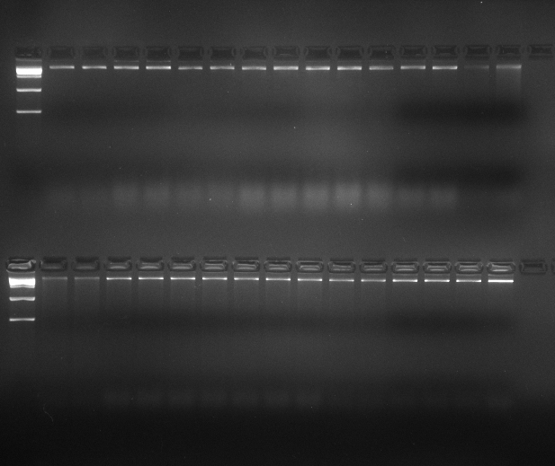
MM 16 17 18 19 20 21 22 23 24 25 26 27 28 29 30
MM 1 2 3 4 5 6 7 8 9 10 11 12 13 14 15
Plate 1: Gel profile of 30 jackfruit DNA samples

Table 5. Quality and quantity of DNA isolated from jackfruit genotypes by Nano Drop Spectrophotometer
S. No. | Accession | Purity | Concentration (ng/µl) | S. No. | Accession | Purity | Concentration (ng/µl)
1 | KNR 1 | 1.87 | 375 | 16 | KZK 9 | 1.87 | 349
2 | KNR 2 | 2.03 | 439 | 17 | KZK 10 | 1.86 | 284
3 | KNR 3 | 1.98 | 358.4 | 18 | KZK 11 | 1.83 | 359
4 | KNR 4 | 1.65 | 295 | 19 | KZK 12 | 1.75 | 354
5 | KNR 5 | 1.92 | 330 | 20 | MPM 1 | 1.92 | 598
6 | KNR 6 | 1.87 | 457 | 21 | MPM 2 | 1.67 | 512
7 | KNR 7 | 1.88 | 685 | 22 | MPM 3 | 2.06 | 359.7
8 | KZK 1 | 1.95 | 397 | 23 | MPM 4 | 1.92 | 283.4
9 | KZK 2 | 2.04 | 479 | 24 | MPM 5 | 1.68 | 372
10 | KZK 3 | 1.78 | 387 | 25 | MPM 6 | 1.85 | 476.5
11 | KZK 4 | 1.83 | 317.6 | 26 | MPM 7 | 1.93 | 357
12 | KZK 5 | 1.92 | 283 | 27 | MPM 8 | 1.87 | 265
13 | KZK 6 | 1.60 | 277 | 28 | MPM 9 | 1.52 | 249.3
14 | KZK 7 | 1.95 | 483 | 29 | MPM 10 | 2.14 | 355
15 | KZK 8 | 1.88 | 547.2 | 30 | MPM 11 | 1.93 | 305.4

Table 6. Details of amplification with selected primers for ISSR assay in jackfruit.

ISSR Primers | Total no. of amplicons | No. of Polymorphic Loci | Polymorphism (%) | PIC Value
UBC 807 | 8 | 6 | 75 | 0.23
UBC 809 | 8 | 6 | 75 | 0.29
UBC 812 | 8 | 7 | 87.5 | 0.18
UBC 834 | 8 | 6 | 75 | 0.30
UBC 840 | 5 | 4 | 80 | 0.04
UBC 841 | 7 | 5 | 71.4 | 0.22
UBC 855 | 7 | 6 | 85.7 | 0.16
UBC 858 | 6 | 3 | 50 | 0.15
UBC 866 | 4 | 2 | 50 | 0.02
TC 10 G | 7 | 5 | 71.4 | 0.24

Table 7. Details of amplification with selected primers for SSR assay in jackfruit.

SSR Primers | Total no. of amplicons | No. of Polymorphic Loci | Polymorphism (%) | PIC value
JFSSR 4 | 4 | 3 | 75 | 0.20
JFSSR 8 | 2 | 1 | 50 | 0.11
JFSSR 12 | 3 | 2 | 66.67 | 0.08
JFSSR 13 | 1 | 0 | 0 | 0.00
JFSSR 15 | 3 | 1 | 33.34 | 0.18
JFSSR 18 | 1 | 0 | 0 | 0.00
JFSSR 19 | 1 | 0 | 0 | 0.00
JFSSR 20 | 3 | 2 | 66.67 | 0.30
JFSSR 25 | 2 | 1 | 50 | 0.12
JFSSR 28 | 1 | 0 | 0 | 0.00
JFSSR 32 | 2 | 1 | 50 | 0.12
JFSSR 35 | 4 | 3 | 75 | 0.12
JFSSR 39 | 2 | 1 | 50 | 0.47
JFSSR 44 | 2 | 1 | 50 | 0.33
JFSSR 45 | 2 | 1 | 50 | 0.39
JFSSR 47 | 2 | 1 | 50 | 0.46
JFSSR 48 | 3 | 2 | 66.67 | 0.12
JFSSR 52 | 2 | 1 | 50 | 0.02
JFSSR 64 | 2 | 1 | 50 | 0.13
JFSSR 76 | 3 | 2 | 66.67 | 0.11

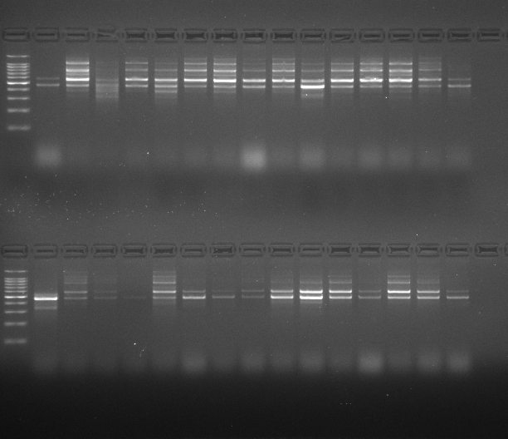
MM 1 2 3 4 5 6 7 8 9 10 11 12 13 14 15
MM 16 17 18 19 20 21 22 23 24 25 26 27 28 29 30
Plate 2. PCR amplification of jackfruit accessions using ISSR primer UBC 809.

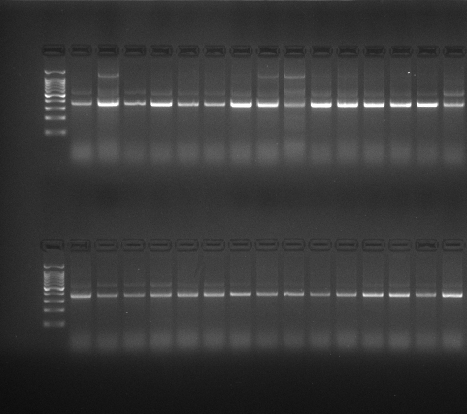
MM 16 17 18 19 20 21 22 23 24 25 26 27 28 29 30
MM 1 2 3 4 5 6 7 8 9 10 11 12 13 14 15
Plate 3. PCR amplification of 30 jackfruit accessions using SSR primers JFSSR 39

Further analysis of band presence–absence data was carried out using the NTSYS-pc software package, applying the Unweighted Pair Group Method with Arithmetic Mean (UPGMA) algorithm (Rohlf, 2005). A dendrogram was constructed based on the genetic distance matrix generated from combined SSR and ISSR marker data. As illustrated in Fig. 1, the dendrogram resolved the 30 jackfruit accessions into two major clusters: Cluster I and Cluster II. Cluster I comprised a single accession (KNR 1), whereas Cluster II included the remaining 29 accessions. Cluster II was further subdivided into two distinct subclusters: Subcluster IIA, containing 13 accessions, and Subcluster IIB, comprising 16 accessions. The similarity coefficients among the accessions ranged from 0.67 to 0.95, indicating moderate to high degrees of genetic relatedness.
A different clustering method was also performed using the STRUCTURE 2.3.4. for population structure analysis. The genetic structure of the 30 accessions in 163 different loci obtained from 30 primers was analyzed using the software, with 10,000 iterations and 1,00,000 repetitions. The results revealed that the data probability was maximum at ΔK = 6, suggesting that there are 6 populations which are genetically different from each other (Fig. 2) with varied levels of admixture in them.
The PCoA plot was generated using the NTSYSpc v.2.10e software, based on a similarity matrix. The plot was generated to analyze the combined data from SSR and ISSR markers (Figure 3). The plot showed a clustering pattern where accessions procured from one particular geographic location formed a separate cluster. Accessions that appear closer together on the plot have more genetic similarity. The first quadrant consists of accessions from Kannur district, forming. Accessions from Kozhikode form a cluster mostly spread across quadrant 4, with very little genetic distance observed between accessions KZK-4 & KZK-5. Accessions from Malappuram district formed a cluster, with varied levels of admixture in them. A few accessions, like MPM-7 & MPM-1, have a closer genetic distance.

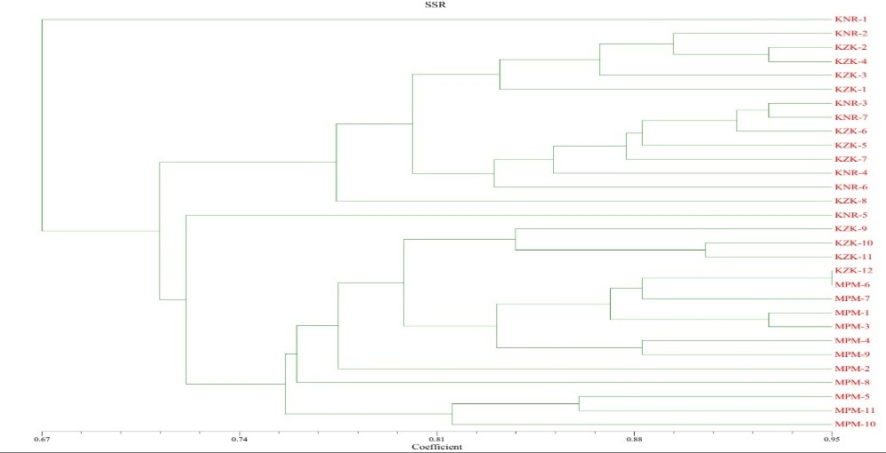
Fig. 1. Dendrogram showing genetic diversity of 30 jackfruit accessions

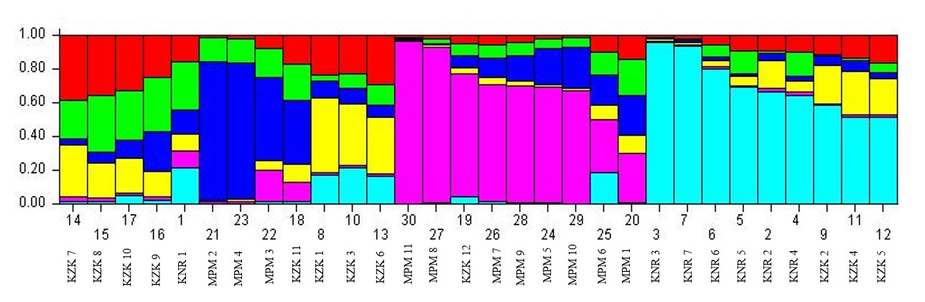
Fig.2. Population structure analysis of 30 jackfruit accessions

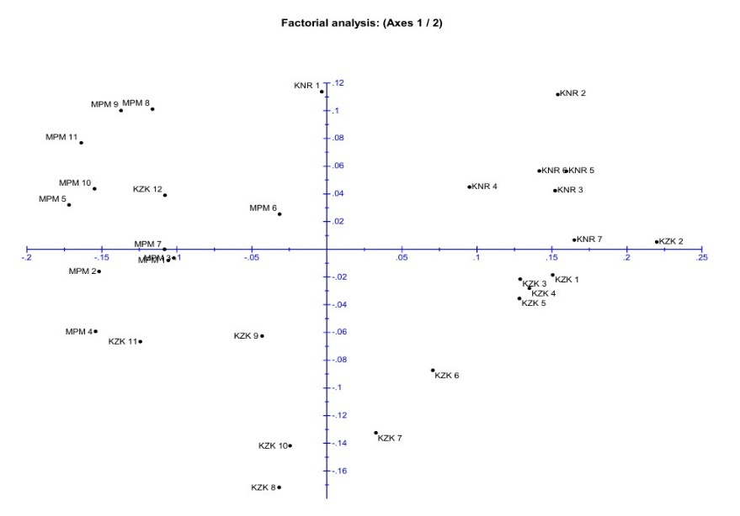

Fig. 3. Principal Coordinate Analysis based on SSR + ISSR combined data

- Discussion
A total of thirty molecular markers were employed for the characterization of thirty jackfruit accessions collected from three districts in Northern Kerala. The accessions included seven from Kannur (KNR 1–KNR 7), eleven from Kozhikode (KZK 1–KZK 12, excluding KZK 10), and twelve from Malappuram (MPM 1–MPM 11). These accessions represented diverse microhabitats across Pallikunnu, Kottali, Podikund, Kunnamangalam, Chevayur, Chevarambalam, Palliserry, Kadampuzha, Cheekkode, Vazhakkad, Vettilappara, and Kinaradappan.
Polymorphism Information Content (PIC) and polymorphism percentage provide essential insights into the discriminatory capacity of molecular markers within a given population (Liu et al., 2019). For ISSR markers, PIC values between 0-0.5 are considered highly informative, whereas for SSR markers, PIC values >0.50 indicate high informativeness, and values <0.25 suggest limited utility (Kumar et al.,).
In the present study, all ISSR primers exhibited high polymorphism, with a strong Marker Index (2.37) and PIC values consistently within the informative range (0.02–0.29). The highest PIC value was recorded for primer UBC 807. Most ISSR primers yielded 7–8 amplicons per sample, and the overall polymorphism percentage reached 65.3%, and the expected heterozygosity value was 0.183, indicating that the ISSR marker system was highly effective for diversity assessment.
SSR markers, however, exhibited comparatively lower levels of polymorphism, reflected in an average PIC value of 0.28 and an overall polymorphism percentage of 45% and the expected heterozygosity value was 0.12. Only 16 of the 20 SSR primers were polymorphic, with JFSSR 39 showing the highest PIC value. The majority of SSR markers produced only 1–2 amplicons. The relatively low PIC values and reduced specificity may be attributed to the geographical proximity and potential genetic relatedness of the sampled accessions. Overall, 26 out of the 30 primers used in the study were polymorphic.

When SSR and ISSR datasets were combined, the resulting dendrogram revealed a notable divergence in accession KNR 1 compared with all other accessions. The dendrogram, derived from similarity matrices based on genetic distance, indicated a 67% similarity between the two major clusters (Fig. 1). Cluster I consisted exclusively of KNR 1, whereas Cluster II included the remaining 29 accessions. High pairwise similarity was observed among certain accessions, including KZK 2 and KZK 4, MPM 1 and MPM 3, and KNR 3 and KNR 7, each showing >88% similarity. The clustering pattern indicated strong genetic linkage and shared ancestry, particularly among accessions originating from the same district. Such insights are valuable for breeding programs targeting trait introgression and germplasm enhancement.
Population structure analysis using STRUCTURE Harvester further corroborated the dendrogram results. The analysis identified six genetically distinct subpopulations (Fig. 2), each represented by unique color clusters (pink, cyan, red, green, blue, and yellow). The two major clusters corresponded to pink and cyan, while four additional subclusters were displayed in green, blue, yellow, and red. Accessions from Kannur predominantly formed a genetically cohesive group with minimal admixture, indicated by the cyan cluster, reflecting strong genetic relatedness and lower intermixing. These findings aligned closely with the patterns observed in the dendrogram.
As per the observations obtained from PCoA, accessions collected from each district formed an individual genetic cluster, except for accessions from Malappuram, which showed moderate levels of genetic admixture. In the first quadrant, all accessions from Kannur district form a close cluster with very little genetic distance between them, except for accession KNR-1. This particular accession shows variation in clustering pattern from all the other accessions, which is consistent with the observations made from the dendrogram.

The high genetic similarity across accessions may be explained by several contributing factors, including close geographical proximity, limited seed dispersal capacity, restricted gene flow among local populations, and possible genetic drift in small or isolated groups. Over time, such mechanisms may contribute to allele fixation and reduced genetic diversity within narrowly distributed populations (Allendorf et al., 2012).

- Conclusion
The results of the study revealed the genetic diversity of 30 jackfruit accessions using 30 primers: 10 ISSR and 20 SSR. It could be concluded that accession KNR 1 is defined as a genetically diverse jackfruit ecotype as observed from the results in the dendrogram and PCoA. Connecting this information with the previously studied morphological characters of the accessions (Arathi, 2023) it was observed that KNR 1 had the lowest glycemic index when compared with other accessions. This information is useful for selecting the accession for trait evaluations for detecting low glycemic index. Moreover, there was a clear distinctiveness in the accessions collected from each of the three districts; accessions from Kannur and Kozhikode formed distinct clusters, with minimal population admixture. Accessions from Malappuram formed a separate cluster, with moderate levels of admixture within the population.

Disclaimer (Artificial intelligence)
Option 1:
Author(s) hereby declare that NO generative AI technologies such as Large Language Models (ChatGPT, COPILOT, etc.) and text-to-image generators have been used during the writing or editing of this manuscript.
Option 2:
Author(s) hereby declare that generative AI technologies such as Large Language Models, etc. have been used during the writing or editing of manuscripts. This explanation will include the name, version, model, and source of the generative AI technology and as well as all input prompts provided to the generative AI technology
Details of the AI usage are given below:
1.
2.
3.

- References

- Aboul-Maaty, N.A.F. and Oraby, H.A.S. 2019. Extraction of high-quality genomic DNA from different plant orders applying a modified CTAB based method. Bull. Natl. Res. Cent.43(1): 25-35.

- Allendorf, F. W., Luikart, G. H., & Aitken, S. N. (2012). Conservation and the genetics of populations. John Wiley & Sons.

- Aswini,A. and Mathew,K. Lila and Abidha,P. S., 20209900140, English, Journal article, India, 0254-8755, 36, (2), New Delhi, International Journal of Tropical Agriculture, (301–310), Serials Publications Pvt. Ltd., Molecular characterization of jackfruit (Artocarpus heterophyllus L.) accessions using ISSR markers., (2018)

- BALAN, A. CHARACTERIZATION OF OFF-SEASON BEARING JACKFRUIT (Artocarpus heterophyllus Lam.).

- Chhetri, A. (2017). Modified Doyle and Doyle Method of DNA Isolation From Jackfruit (Artocarpus heterophyllus Lam.).

- Chhetri, A. ., Kumar, V. ., Hazarika, B. N. ., Wangchu, L. ., & Singh, S. . (2023). Genetic relatedness among the jack fruit (Artocarpus heterophyllus Lam.) genotypes of the North East, India through molecular markers. INDIAN JOURNAL OF GENETICS AND PLANT BREEDING, 83(02), 287–289.https://doi.org/10.31742/ISGPB.83.2.18

- Gupta, M., Chyi, Y. S., Romero-Severson, J., and Owen, J. L. 2011. Amplification of DNA markers from evolutionarily diverse genomes using single primers of simple-sequence repeats. Theor. Appl. Genet.89(7): 998-1006.

- Gayatri, G., Kavya, K. K., & Shyamalamma, S. (2020). Characterization of Selected Jackfruit Germplasm Accessions for Fruit Shape Through Morphological and Marker Based Assay. Indian Journal of Agricultural Research.https://doi.org/10.18805/IJARe.A-5427

- Kavya, K. and Shyamalamma, S. 2020. Characterization of selected jackfruit germplasm accessions for fruit shape through morphological and marker based assay. Indian J. Agric. Res. 56(2): 59-64.

- Kavya, K., Shyamalamma, S., & Gayatri, S. (2019). Morphological and molecular genetic diversity analysis using SSR markers in Jackfruit (Artocarpus heterophyllus Lam.) genotypes for pulp colour. Indian Journal of Agricultural Research, 53(1), 8-16.

- Kumar, S.P.J., Susmita, C., Sripathy, K.V. et al. Molecular characterization and genetic diversity studies of Indian soybean (Glycine max (L.) Merr.) cultivars using SSR markers. Mol Biol Rep 49, 2129–2140 (2022).https://doi.org/10.1007/s11033-021-07030-4

- Liu, X., Liu, C., Xu, F., Liu, C., Yang, Y., & Wei, S. (2019). Transcriptome analysis reveals the genetic basis of heat resistance and thermotolerance in Arabidopsis thaliana. Gene, 721, 144175.https://doi.org/10.1016/j.gene.2019.144175

- Lucena-Aguilar, G., Sánchez-López, A. M., Barberán-Aceituno, C., Carrillo-Ávila, J. A., López-Guerrero, J. A., & Aguilar-Quesada, R. (2016). DNA source selection for downstream applications based on DNA quality indicators analysis. Biopreservation and Biobanking, 14(4), 264–270.https://doi.org/10.1089/bio.2015.0064

- Nakintu, J., Albrecht, C., Kagoro-Rugunda, G., Olet, E. A., Lejju, J. B., Müller, C. M., Gemeinholzer, B., & Andama, M. (2020). Exploring the genetic diversity of jackfruit (Artocarpus heterophyllus Lam.) grown in Uganda based on SSR markers. *Genet. Resour. Crop Evol.*, *67*(3), 605–619.https://doi.org/10.1007/s10722-019-00830-5

- Ojwang, R. (2020). *Nutritional, phytochemical, antioxidant and genetic characterization of jackfruits (Artocarpus heterophyllus) found in selected regions of Kenya and Uganda* [Doctoral dissertation, University of Nairobi].https://erepository.uonbi.ac.ke/handle/11295/112000

- Palupi, D., Rahayu, S.S.B., and Daryono, B.S. 2019. Genetic diversity in jackfruit (Artocarpus heterophyllus Lam.) based on molecular characters in Indonesia. Sabrao J. Breed. Genet.51(1): 57-67.

- Rohlf, F.J. (2005). NTSYS-pc Numerical Taxonomy and Multivariate Analysis System. Version 2.2. Exeter software, New York.

- Singh, D. K., Pandey, A., Choudhary, S. B., Kumar, S., Tribhuvan, K., Mishra, D. C., Bhati, J., Kumar, M., Tomar, J. B., Bishnoi, S. K., Mallick, M. A., Bhadana, V. P., Sharma, T. R., Pattanayak, A., & Singh, B. K. (2021). Development of genic-SSR markers and their application in revealing genetic diversity and population structure in an Eastern and North-Eastern Indian collection of Jack (Artocarpus heterophyllus Lam.). *Ecological Indicators*, *131*, 108143.https://doi.org/10.1016/j.ecolind.2021.108143

- Uikey, A., Sharma, N. & Patel, S. 2020. India is the second largest producer of jackfruit in the world. International Journal of Current Microbiology and Applied Sciences, 9(11): 3022–3026.

- Xu, J., Wang, Y., Wu, K., & Chen, J. (2024). Identification and characterization of functionally relevant SSR markers in natural Dalbergia odorifera populations. BMC Plant Biology.https://doi.org/10.1186/s12870-024-05019-2

