Genetic structure of edible tiger nut accessions (Cyperus esculentus L, 1753) in Côte d’Ivoire : implication in improvment and conservation strategy

Type of article: Original Research Article
ABSTRACT
Cyperus esculentus represents an important source of income for the vulnerable Ivorian population, particularly women. Its low productivity in agroecosystems justifies the implementation of a genetic improvement program, requiring knowledge of the genetic diversity of locally cultivated accessions. Thus, this study evaluated the molecular diversity of 39 accessions of African edible tiger nut collected from eight localities in Côte d'Ivoire using SSR molecular markers. To achieve this objective, DNA from young leaves of these accessions was extracted using the CTAB method and amplified using five microsatellite markers. From the electrophoregrams and with the help of four software programs (GenAlEx 6.5, MEGA 12.0.9, adegenet (R 3.5.1), and STRUCTURE 2.3.4), the parameters of intra- and inter-population genetic diversity (N_{a}, N_{e}, H_{o}, H_{e}, I, P, F_{IS}, F_{IT}, F_{ST}, N_{m}), genetic structure (AMOVA), and spatial structuring (Neighbor-Joining dendrogram, PCoA, DAPC, STRUCTURE) were determined. The result of the statistical analyzes indicates a very high polymorphism (P=0.975%) of the loci and an average allelic richness of three alleles confirmed by the number of effective alleles (N_{e} = 2.269) and the Shannon index (I = 0.871). The studied populations show an observed heterozygosity value of (H_{o}=0.100) against an expected heterozygosity of (H_{e}=0.516) and an inbreeding rate of (F_{IS} = 0.787). Also, the analysis of the genetic structure indicates that 74% of the genetic variability is found within the populations, compared to 12% between the populations. Moreover, the spatial structuring revealed three main genetic groups. These results suggest a marked genetic structuring, modulated by human exchanges of material and clonal reproduction. Additional controls are recommended to exclude potential genotyping biases before concluding on inbreeding. These data nevertheless provide a useful basis for the conservation and improvement of tiger nuts in Côte d'Ivoire.

Keyword : Cyperus esculentus L., Accessions, Genetic diversity, SSR markers, Côte d’Ivoire

- INTRODUCTION
Côte d’Ivoire benefits from a favorable agricultural environment, capable of ensuring food self-sufficiency for its population. Thus, farmers plant a variety of crops in different agro-systems (Casimir, 2021). Among these, the edible tiger nut (Cyperus esculentus) stands out. It is a plant of interest both nutritionally, medicinally, and economically (Edo et al., 2024; Kouamé, 2024; Wani et al., 2024; Yapi et al., 2021). The inadequacy of its production in rural areas necessitates the implementation of a genetic improvement program. The success and reliability of this vision require knowledge of the genetic diversity of locally cultivated accessions. In general, two types of markers are used to reveal this diversity, particularly phenotypic and molecular markers. Phenotypic markers rely on quantitative variables (Rafiq et al., 2023; Sory et al., 2022) and qualitative variables (Asare et al., 2020). They allow for the identification of accessions exhibiting similar or distinct characteristics, thereby contributing to a better structuring of diversity. However, morphological markers have a major limitation: their expression is strongly influenced by environmental conditions (Chaouch khouane, 2022). This constraint has led to
an increasing reliance on molecular markers (Galpérine, 2024). They can be dominant or codominant (Agbahoungba et al., 2021) and directly reveal polymorphism at the DNA level, regardless of environmental parameters. Several types of molecular markers have been developed and used for the species. More recently, highly polymorphic SSR microsatellite markers have been developed. Initially developed for the related species Cyperus rotundus by (Arias et al., 2011), their transferability and effectiveness for studying C. esculentus have been confirmed, notably by (De Castro et al., 2015). Subsequently, they were successfully used in the study of the diversity of several Cyperus species in several West African countries, notably in Ghana (Twumasi et al., 2024a) and Niger (Haoua et al., 2023). Few studies have focused on African accessions of C. esculentus, and virtually none on Ivorian populations. The present study therefore aims to characterize the genetic diversity of Cyperus esculentus accessions cultivated in Côte d’Ivoire using SSR microsatellite markers.

- MATERIALS AND METHODS
  - Biological material
The biological material consisted of 117 fresh leaf individuals (Fig. 1), originating from the tubers of 39 accessions collected in eight localities in Côte d'Ivoire.
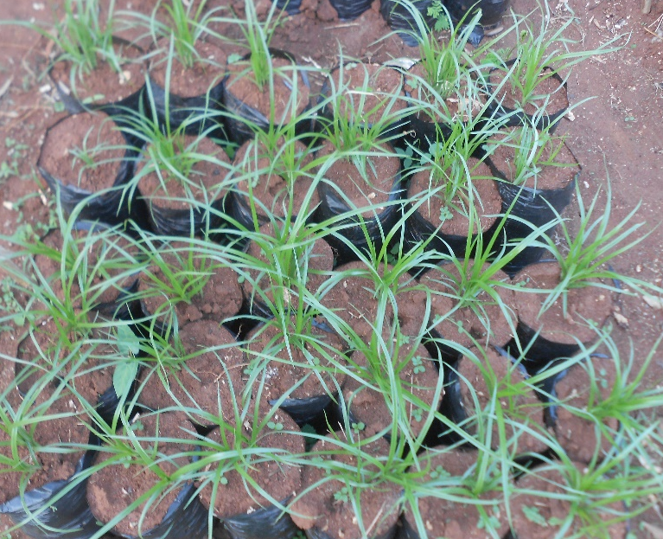
Fig.1. Edible tiger nut plants (Cyperus esculentus)

  - Methods
    - Sample collection
The tubers obtained from the eight localities (Abidjan, Boundiali, Daloa, Ferkessédougou, Man, Samatiguila, Tingréla, and Yamoussoukro) were planted in the field according to a randomized block design (Table 1, 2, and Fig 2). These localities are areas of production and marketing of edible tiger nuts. Two weeks after emergence, young leaves located at the center of the rosette were collected from each individual (3 plants per accession). The samples were immediately placed in labeled envelopes, then stored in a cooler containing ice during transport to the laboratory of the Research Unit in Genetics and Molecular Epidemiology (URGEM) of UJLoG. Upon their arrival, the leaves were stored at -80 °C before being lyophilized using a freeze dryer. This low-temperature drying process allows for the dehydration of plant tissues while preserving the integrity of the DNA (Lingrand et al., 2021).

Table 1 . List of the 39 accessions sampled in eight localities
Nº | Code accessions | Species | Localities | Geographical Location
1 | Ab_mal | Cyperus esculentus | Abidjan | Sud
2 | Ab_BF | Cyperus esculentus | Abidjan | Sud
3 | Ab_mal2 | Cyperus esculentus | Abidjan | Sud
4 | A_22 | Cyperus esculentus | Ferkessedougou | Nord
5 | A_19 | Cyperus esculentus | Ferkessedougou | Nord
6 | A_18 | Cyperus esculentus | Ferkessedougou | Nord
7 | A_23 | Cyperus esculentus | Ferkessedougou | Nord
8 | A_20 | Cyperus esculentus | Ferkessedougou | Nord
9 | A_21 | Cyperus esculentus | Ferkessedougou | Nord
10 | A_09 | Cyperus esculentus | Tingrela | Nord
11 | A_12 | Cyperus esculentus | Tingrela | Nord
12 | A_15 | Cyperus esculentus | Tingrela | Nord
13 | A_14 | Cyperus esculentus | Tingrela | Nord
14 | Tin_sine | Cyperus esculentus | Tingrela | Nord
15 | Tin_lond2 | Cyperus esculentus | Tingrela | Nord
16 | Tin_lond | Cyperus esculentus | Tingrela | Nord
17 | A_08 | Cyperus esculentus | Tingrela | Nord
18 | A_10 | Cyperus esculentus | Tingrela | Nord
19 | A_13 | Cyperus esculentus | Tingrela | Nord
20 | A_11 | Cyperus esculentus | Tingrela | Nord
21 | A_25 | Cyperus esculentus | Boundiali | Nord-Ouest
22 | A_26 | Cyperus esculentus | Boundiali | Nord-Ouest
23 | A_24 | Cyperus esculentus | Boundiali | Nord-Ouest
24 | A_27 | Cyperus esculentus | Boundiali | Nord-Ouest
25 | A_01 | Cyperus esculentus | Samatiguila | Nord-Ouest
26 | A_03 | Cyperus esculentus | Samatiguila | Nord-Ouest
27 | A_04 | Cyperus esculentus | Samatiguila | Nord-Ouest
28 | A_02 | Cyperus esculentus | Samatiguila | Nord-Ouest
29 | A_06 | Cyperus esculentus | Samatiguila | Nord-Ouest
30 | A_05 | Cyperus esculentus | Samatiguila | Nord-Ouest
31 | Dal_f4 | Cyperus esculentus | Daloa | Centre-Ouest
32 | Dal_f1 | Cyperus esculentus | Daloa | Centre-Ouest
33 | Dal_f5 | Cyperus esculentus | Daloa | Centre-Ouest
34 | Dal_f2 | Cyperus esculentus | Daloa | Centre-Ouest
35 | Man_mal | Cyperus esculentus | Man | Ouest
36 | Man_mal2 | Cyperus esculentus | Man | Ouest
37 | Man_mal3 | Cyperus esculentus | Man | Ouest
38 | Ya_bf | Cyperus esculentus | Yamoussoukro | Centre
39 | Ya_mal 2 | Cyperus esculentus | Yamoussoukro | Centre

Table 2. Characteristics of the eight Cyperus esculentus collection zones in Côte d'Ivoire
LOCALITIES | COORDINATES | VEGETATION | CLIMATE | SOIL | RAINFALL (mm/an)
Abidjan | 5° 20’ North  4° 1’West | Dense humid forests,  Savannas | Humid subequatorial | Ferralitic soils, Alluvial soils | 1553-2198
Boundiali | 9°31' North,  6°29' West | Wooded or grassy savannas, Sparse forests | Sudano-Guinean | Ferralitic soils, lithosols | 1300 - 1500
Daloa | 6°53 North  6°27 West | Dense humid forests, Wooded savannas | Tropical humid | Ferralitic soils, hydromorphic or sandy soils | 1300 - 1800
Ferkessedougou | 9°59’ North  -5°19’ Ouest | Grassy savannas | Tropical savanna | Ferralitic soils | 1000 - 1200
Man | 7.3° North  8.5° West | Dense forests | Tropical humid | Ferralitic soils, Clayey | 1500 - 1770
Samatiguila | 9.818° North  –7.561° West | Tree-studded, wooded, grassy savannas | Tropical savanna | Ferralitic soils, Tropical ferruginous | 1200 - 1500
Tingrela | 10°30′ North  6°23′ West | Wooded savannas | Soudanese, Sudano-Guinean | Ferralitic soils, ferruginous | 1000 - 1200
Yamoussoukro | 06° 49-06° 47 North  05°16-05°15 West | Savannas,  Pre-forests | Tropical humid, Baoulean | Ferralitic soils | 900 - 1400
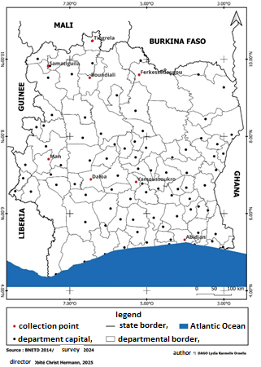
Fig. 2. Geographical location of the eight collection zones in Côte d'Ivoire

    - Molecular genotyping of tiger nut accessions
      - DNA extraction
Genomic DNA was extracted from lyophilized leaves (0.4 g) according to an optimized variant of the CTAB protocol established by (Doyle, 1990), later modified by Kouakou et al. (2022). The samples were ground with beads and then incubated for 30 minutes at 65°C in the presence of CTAB buffer ; the extracts were purified with chloroform-isopropanol and resuspended in TE. The concentration and purity were verified using NanoDrop (260/280 ratio), and the quality was assessed by electrophoresis on a 1% agarose gel stained with GelRedTM.

2.2.2.2. Amplification reaction by polymerase chain reaction, revelation, and visualization of genotypes
Five pairs of SSR primers specific to the genus Cyperus (StvCyR_64a, StvCyR_93ska, StvCyR_156a, StvCyR_254a, and StvCyR_590a), highlighted by (Arias et al., 2011), were used (Table 3). The PCR amplifications were performed in a volume of 25 µL containing : 1X of 10X buffer, 10 mM of dNTPs, 10 pM of each primer, 1U of Taq DNA polymerase (5 U/µL), and 10-50 ng of genomic DNA. The thermal profile as described by Twumasi et al. (2024) included an initial denaturation at 95 °C (3 min), 35 cycles (95 °C: 10 seconds ; Ta 52 °C: 10 sec, 72 °C: 10 sec), and a final extension at 72 °C (10 min).
The amplification products were then separated by electrophoresis on a 2% agarose gel, containing 3 µL of GelRed, in the presence of Tris–Borate–EDTA (TBE) at a concentration of 0.5X and two fluorescent size markers (25 and 100 bp). The visualization of the bands was carried out using an ultraviolet (UV) imaging system called a Transilluminator, allowing for the observation and analysis of the amplified fragments.
Table 3. Characteristics of the microsatellite markers used (Arias et al., 2011b)
Primer | Forward Primer Séquence (5'-3')ª | Reverse Primer Séquence (5'-3')ª | Tandem ou repeated motif^{b} | Allels size (pb)^{c}
StvCyR_64a | GTACAAACCACA  AACCGTAGACCC | ACTCTCCTCCTCC  ATCGTAAGCTC | (GA) | 114–138
StvCyR_93ska | GCAGATATGCCTC  TTCAGAGTTCAG | CAGGAGGACATT  GTTGTAAGAGGG | (AATGG) | 164–174
StvCyR_156a | TGCCCAGCTTTAC  ATCTTAATTGC | CTGAACAACTGG  CACATACAGAGC | (AT) | 182–191
StvCyR_254a | AATCATGAAGGT  GATTGGACAAGG | CATCCATCCTCT  TCTTTGTTCTCG | (TA) | 104–149
StvCyR_590a | TCTGAGGGACTAA  ATGCTAATGTTTTAC | TCAGAAAAGATA  ACGCGTAGCAG | (CTT) | 170–296
ªUniversal linkers attached to sense primers ; ^{b}Number of motif repetitions found in the microsatellite clone ; ^{c}bp=base pair
      - Parameters studied and data analysis
The data was collected from the allele size estimated via gel profiles and then entered to form an analysis matrix. Missing genotypes and loci with inconsistent amplifications were noted and treated as missing in the analyzes.
Analysis of genetic diversity and structure
The genotyping profiles were analyzed to evaluate intra- and inter-population genetic diversity. The following parameters were calculated for each population and for each locus using GenAlEx 6.5 software (Peakall & Smouse, 2012) : the number of observed alleles (Na), the number of effective alleles (Ne), the Shannon diversity index (I), the observed heterozygosity (Ho), and the expected heterozygosity (He) under the assumption of Hardy-Weinberg equilibrium (De Meeûs, 2011). The intra-population fixation index (F_{IS}) was calculated to estimate the deficit or excess of heterozygotes. The genetic differentiation between populations was quantified using Wright's F-statistics (F_{ST}, F_{IT}) and Nei's Gst. Gene flow (Nm) was estimated from F_{ST} according to the formula N_{m} = (1-F_{ST})/(4*_{FST}).
Estimation of intra-population variables
Polymorphisme rate (P %) :
$P=\frac{Number of polymorphic loci}{Number of loci studied}*100$ (1)

Number of observed alleles (Na): This is the average number of alleles observed per locus in a population. It reflects the genetic diversity within a population.
Number of effective alleles (Ne): This is the number of alleles capable of producing the same level of heterozygosity observed in a population.
$Ne=\frac{1}{\sum{p_{i}^{2}}}$ (2)
𝑝𝑖 : frequency of allele i ; $\sum{p_{i}^{2}}$ : expected homozygosity
Shannon-Weaver Diversity Index (I): Designed in the context of information theory (Shanon, 1948), it serves to estimate the diversity of alleles or genotypic profiles in a population.
$I=-\sum_{i=1}^{k}{p_{i}*ln⁡(p_{i})}$ (3)
pi : frequency of allele i in the population; k : number of alleles.
The observed and expected heterozygosities (Ho and He): The observed heterozygosity (Ho) is the actual proportion of heterozygous individuals in a population relative to a given locus, and the expected heterozygosity (Hₑ) is the probability that a randomly chosen individual is heterozygous at that locus.
$Ho=\frac{Number of heterozygous individuals}{Total number of individuals}$ (4)
$He=1-\sum_{i=1}^{l}{p_{i}^{2}}$ (5)
l : number of alleles per locus ; p_{i :} allelic frequency.
Fixation index (F_{IS}): It measures the reduction in observed heterozygosity compared to the expected heterozygosity in a subpopulation. A high F_{IS} (close to 1) indicates a level of inbreeding or a deviation from the Hardy-Weinberg equilibrium.
$F_{IS} =1-\frac{Ho}{He}$ (6)
These parameters expressing diversity were calculated using the GenAlex 6.5 software. This analysis was conducted between the origins of the accessions considered as populations.

Inter-population variables

These are indices defined by Wright, (1978).
Differentiation index (F_{ST}) or Gst : measures the proportion of total genetic variation that is due to differences between subpopulations. A high FST indicates strong genetic differentiation between populations.
$F_{ST}=\frac{Ht-Hs}{Ht}$ (7)
Global fixation index (F_{IT}) : It is a measure of the deviation of observed heterozygosity from that expected at the scale of the entire population.
$F_{IT}=1-\frac{Hi}{Ht}$ (8)
Gene Flow (N_{m}) : refers to the effective transfer of alleles between populations of the same species in population genetics.
$N_{m}=\frac{(1-Fst)}{(4*Fst)}$ (9)
Gene exchange is important when the value of Nm is greater than 1.
These measurements were calculated using the GenAlex 6.5 software.To partition the total genetic variance into three components : among populations, among individuals within populations, and within individuals, a molecular analysis of variance (AMOVA) was performed using the GenAlEx software (version 6.5).

Genetic structuring of edible tiger nut populations

For this study, the natural population represents the place of origin of the accessions. The genetic structuring of the populations was evaluated using several complementary approaches. A genetic dissimilarity matrix between pairs of accessions was calculated from SSR data using the FreeNA software. This matrix served as the basis for constructing a dendrogram using the Neighbor-Joining (NJ) method in the MEGA software (version 12.0.9), allowing for the visualization of hierarchical relationships between accessions.
In parallel, genetic distances were exploited under R (version 3.5.1) using the adegenet package (version 2.1.1) (Jombart, 2008) to perform a Principal Coordinates Analysis (PCoA) and a Discriminant Analysis of Principal Components (DAPC). These multivariate analyzes confirmed the consistency of the observed genetic groupings and evaluated the distribution of individuals in genetic space.
Finally, the Bayesian structure of the populations was studied using the STRUCTURE software (version 2.3.4) (Daniel et al., 2007). The admixture model with correlated allele frequencies was used. Ten independent iterations were performed for each value of K (number of assumed clusters), with a burn-in period of 10,000 iterations followed by 10,000 additional iterations for MCMC chain sampling. The optimal number of genetic groups was determined from the modal value of ΔK, calculated according to the method of Evanno et al.( 2005), using the PopHelperShiny platform.

- RESULTS AND DISCUSSION
  - Characteristics of the genotypic traits of tiger nuts
Figure 3 shows the electrophoretic profiles of the genotypes of tiger nuts from the 5 markers. The results show a variation of genotypes locus by locus. Microsatellite markers being codominant, they show two bands for heterozygous individuals and one band for homozygous individuals. For example, at the StvCyR_93ska marker, homozygotes are of size 100/100 and heterozygotes are of size 78/100. The absence of amplification product for some individuals suggests a PCR failure or insufficient DNA quality.
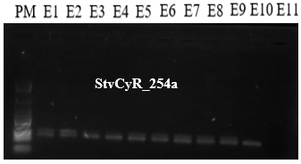
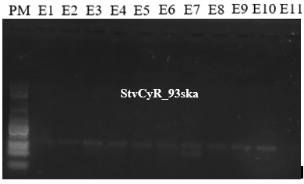
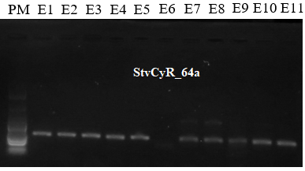
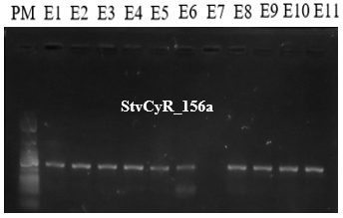
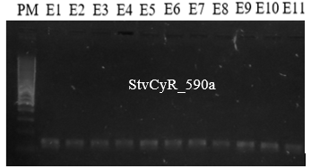
100 pb
25 pb
100 pb

Fig.3. Extract of the profiles obtained on 2% Agarose gel; E: Sample
  - Evaluation of the genetic diversity of Cyperus esculentus accessions
    - Intra-population diversity: At the level of all populations and loci
Table 4 presents the results for the intra-population genetic diversity parameters estimated for each of the 8 defined populations. On average, 97.5 % of the loci used were polymorphic in all the studied populations, with polymorphism rates ranging from 80 % (Man) to 100 %. The average number of alleles is 3.08 and varies from 1.8 (Man) to 3.8 (Ferkessédougou, Samatiguila, and Tingrela). The average observed heterozygosity (Ho = 0.10) is significantly lower than the average expected heterozygosity (He = 0.52), indicating a Hardy-Weinberg disequilibrium and a significant deficit in heterozygotes, confirmed by a probability P_{HWE} = 0.001 and a high average fixation index (F_{IS}) of 0.78. Moreover, out of 117 samples tested, a total of 15 alleles were detected, averaging 3 alleles per locus (Table 5). The number of alleles per locus ranges from 2 (StvCyR_93ska) to 4 (StvCyR_254a), with a maximum of effective alleles (2.81) at locus StvCyR_590a. The observed heterozygosity ranges from 0.04 (StvCyR_93ska) to 0.29 (StvCyR_254a). The expected heterozygosity (He) ranges from 0.43 (StvCyR_93ska) to 0.60 (StvCyR_590a). The observed heterozygosity is low (average of 0.1) compared to the expected heterozygosity (average of 0.52), which indicates a deviation from Hardy-Weinberg equilibrium. Most loci show a significant heterozygote deficit (P < 0.001), confirmed by a high average fixation index (F_{IS}) of 0.54.
The average number of alleles observed (3 alleles per locus) is higher than the threshold of 2 alleles established in the literature (De Meeûs, 2011), thus confirming a notable allelic richness. Haoua et al. (2023) also observed genetic diversity with an average of 4 alleles in 143 samples of nutsedge in Niger. The slight difference with our results could be explained by the size of our sample, which is likely to underestimate the actual number of alleles. Indeed, Hale et al. (2012) indicate that the average number of alleles increases with the sample size. The cultivation of tiger nuts is widespread in Niger, allowing for large samples, while in Côte d'Ivoire it is mainly practiced by women in the North, which limits the scope of collections. The heterozygote deficiency observed by the lower Ho values compared to He suggests an absence of panmixia likely due to inbreeding. The inbreeding coefficient (F_{IS}), very high and positive, confirms a deficit in heterozygotes, thus marked inbreeding. These results corroborate those observed in Cyperus fuscus by Böckelmann et al.( 2015), where a high F_{IS} was accompanied by a low Ho (0.11) and a high He (0.40). This could be explained by high autogamy or reproduction between related individuals (Ohsako & Yamada, 2011). Indeed, in the case of Cyperus esculentus, vegetative reproduction (via tubers) limits genetic mixing and generates clones identical to the mother plant (De Ryck et al., 2023), which contributes to clonal homogeneity. This uniformity reinforces inbreeding and reduces genetic diversity (Armengol et al., 2010).

Table 4. Indices of intra-population genetic diversity in C. esculentus tubers revealed by the five polymorphic nuclear microsatellite markers
Populations | Na | Ne | Ho | He | I | P (%) | P_{HWE} | F_{IS}
Abidjan | 2.6 | 1.95 | 0.095 | 0.480 | 0.76 | 100 | 0.005** | 0.81**
Boundiali | 3.2 | 2.64 | 0.15 | 0.59 | 1.02 | 100 | 0.000*** | 0.78**
Daloa | 3.4 | 2.77 | 0.08 | 0.62 | 1.06 | 100 | 0.001*** | 0.85**
Ferkessédougou | 3.8 | 2.73 | 0.08 | 0.61 | 1.09 | 100 | 0.000*** | 0.87**
Man | 1.8 | 1.64 | 0.00 | 0.36 | 0.51 | 80 | 0.003** | 1.00**
Samatiguila | 3.8 | 2.50 | 0.16 | 0.57 | 1.03 | 100 | 0.002** | 0.72**
Tingrela | 3.8 | 2.17 | 0.09 | 0.51 | 0.90 | 100 | 0.000*** | 0.78**
Yamoussoukro | 2.2 | 1.75 | 0.13 | 0.39 | 0.60 | 100 | 0.02* | 0.48*
Mean | 3.07 | 2.27 | 0.10 | 0.52 | 0.87 | 97.50 | 0.005 | 0.79
SD | 0.17 | 0.11 | 0.05 | 0.02 | 0.05 | 2.50 |  | 0.05
Na: Number of alleles; Ne: Number of effective alleles; Ho: Observed heterozygosity; He: Expected heterozygosity; I: Shannon Index; P: polymorphic locus; P_{HWE}: Probability associated with Hardy-Weinberg equilibrium; FIS: Intra-population fixation index; SD : standard deviation; significant probability (*P < 0.05, ** P < 0.01, *** P < 0.001)

Table 5. Indices of intra-population genetic diversity in C. esculentus tubers
Loci | Na | Ne | I | Ho | He | F_{IS}
StvCyR_64a | 3 | 2.07 | 0.80 | 0.06 | 0.47 | 0.87***
STVCyR93ska | 2 | 1.86 | 0.64 | 0.04 | 0.43 | 0.90***
StvCyR_156a | 3 | 2.24 | 0.87 | 0.06 | 0.52 | 0.88***
StvCyR_254a | 4 | 2.35 | 0.98 | 0.29 | 0.55 | 0.47***
StvCyR_590a | 3 | 2.81 | 1.05 | 0.04 | 0.60 | 0.93***
Mean | 3 | 2.27 | 0.87 | 0.10 | 0.52 | 0.81
Na: Number of alleles; Ne: Number of effective alleles; Ho: Observed heterozygosity; He: Expected heterozygosity; F_{IS} : Intra-population fixation index; ***: significant probability (P <0.05).

    - Evaluation of inter-population diversity
Wright's F-statistics (Table 6) show a strong genetic differentiation among the studied loci. The overall inbreeding coefficient (F_{IT}) is high (0.85), indicating an excess of homozygotes compared to a panmictic population. The average differentiation coefficient (F_{ST}) is 0.20, indicating "significant" genetic differentiation among the populations, particularly for the STVCyR_64a, 156a, 254a, and 590a loci (significant F_{ST}, P ≤ 0.002). The STVCyR_93ska locus exhibits a lower F_{ST} (0.10) and is non-significant (P = 0.21), associated with a high gene flow (N_{m} = 2.13), indicating a strong gene exchange at this locus. For the other loci, N_{m} < 1, which suggests a limitation of gene flow. The significant values of P(G_{ST}) and P(F_{ST}) (P = 0.001) confirm that the populations are not genetically homogeneous. The pairwise genetic differentiation between eight populations of Cyperus esculentus (Tables 7 and 8) reveals significant F_{ST} values (0.10 to 0.33) (Table 7) and a highly variable flow (N_{m}) (0.78 to 9.20) (Table 8). Thus, moderate genetic differentiation and significant gene flow are recorded between the accessions from Samatiguila and Ferkessédougou (F_{ST} = 0.10; N_{m} = 9.20). On the other hand, significant genetic differentiation and low gene flow are observed between the populations of Yamoussoukro and Man (F_{ST} = 0.33; N_{m} = 0.51), indicating marked genetic isolation. This significant gene flow could be explained by human exchanges: farmers share seeds thru markets, community networks, or agricultural initiatives. As these two localities are located in northern Côte d'Ivoire and share similar cultural and agricultural practices, the circulation of genotypes is probably facilitated there (Kouakou, 2020; Soumahoro & Tape, 2023). . Bøhn et al. (2016) showed in Zambia that the exchange of seeds among farmers plays a major role in the spread of genetic diversity. Conversely, the low gene flow could be explained by the fact that these cities, unlike those in the North which are production areas, largely depend on imports for their tiger nuts (coming from northern Ivory Coast or neighboring countries like Mali or Burkina Faso). These imports come from different sources depending on the cities and circulate thru commercial networks, which limits genetic mixing with local material and restricts flow between populations. These results highlight that geographical distance does not always prevent genetic flow.
Table 6. Indices of inter-population genetic diversity in C. esculentus
Loci | F_{IT} | F_{ST} | N_{m} | G_{ST} | D_{est} | P (G_{ST}) | P (F_{ST})
STVCyR64 | 0.898 | 0.24* | 0.80 | 0.17 | 0.26* | 0.002 | 0.002
STVCyR93ska | 0.91 | 0.10 | 2.13 | 0.03 | 0.03 | 0.22 | 0.21
STVCyR156 | 0.91 | 0.24* | 0.799 | 0.18 | 0.33* | 0.001 | 0.001
STVCyR254 | 0.58 | 0.21* | 0.95 | 0.15 | 0.30* | 0.001 | 0.001
STVCyR590 | 0.94 | 0.22* | 0.898 | 0.15 | 0.389* | 0.001 | 0.001
Mean | 0.85 | 0.20 | 1.12 | 0.14 | 0.27 | 0.04 | 0.04
SD | 0.07 | 0.02 | 0.26
F_{IT}: Global inbreeding coefficient; F_{ST}: Index of genetic differentiation between subpopulations; N_{m} : number of migrants per generation; G_{ST}: Nei's index of differentiation for multiallelic loci; D_{est}: Differentiation index proposed by Jost (D); P(G_{ST}): Probability of the significance test for G_{ST}; P(F_{ST}): Probability of the significance test for F_{ST}; SD : Standard deviation ; *: significant probability (P <0.05)

Table 7. Pairwise genetic differentiation of Cyperus esculentus populations based on F_{ST}
 | Abid | Boun | Dalo | Ferke | Man | Sama | Ting | Yakro
Abid | - | ** | ** | ** | ns | ** | ** | **
Boun | 0.14 | - | ns | ns | ** | ns | ns | **
Dalo | 0.16 | 0.03 | - | ns | ** | ns | ns | ns
Ferk | 0.12 | 0.06 | 0.03 | - | ** | ** | ns | ns
Man | 0.097 | 0.15 | 0.18 | 0.16 | - | ** | ** | **
Sama | 0.13 | 0.03 | 0.06 | 0.10 | 0.16 | - | ** | **
Ting | 0.20 | 0.06 | 0.03 | 0.04 | 0.20 | 0.13 | - | **
Yamo | 0.25 | 0.19 | 0.13 | 0.09 | 0.33 | 0.25 | 0.14 | -
Abi : Abidjan ; Boun : Boundiali ; Dalo : Daloa ; Ferke : Ferkessedougou ; Sama : Samatiguila ; Ting : Tingrela ; Yakro : Yamoussoukro; **P <0.05
Table 8. Pairwise genetic differentiation of Cyperus esculentus populations from N_{m}
 | Abid | Boun | Dalo | Ferke | Man | Sama | Ting | Yakro
Abid | -
Boun | 1.18
Dalo | 1.46 | 8.43
Ferk | 1.92 | 4.29 | 8.60
Man | 2.27 | 1.31 | 1.13 | 1.17
Sama | 1.91 | 9.20 | 4.03 | 2.24 | 1.32
Ting | 1.05 | 4.27 | 8.95 | 6.45 | 0.93 | 1.80
Yamo | 0.78 | 1.08 | 1.70 | 2.37 | 0.51 | 0.77 | 1.68 | -
Abi : Abidjan ; Boun : Boundiali ; Dalo : Daloa ; Ferke : Ferkéssedougou ; Sama : Samatiguila ; Ting : Tingréla ; Yakro : Yamoussoukro
  - Genetic differentiation between populations and intra-population diversity of C.esculentus
The AMOVA indicates that the majority of the genetic variance (74%) is attributed to differences between individuals within populations. The variance between populations accounts for only 12% of the total, while the intra-individual variance is 14% (Table 9). These results are close to those of Haoua et al., (2023), who found 73% of intra-population variability. Other studies, such as that of Tayyar et al., (2003), also highlight that the genetic diversity within yellow nutsedge populations is higher than in related species like Cyperus rotundus. This suggests that it is essential, in genetic selection programs, to sample a sufficient number of individuals per population to best capture this diversity (Franco-Duran et al., 2019). Even if the diversity within individuals is limited, it remains significant for conservation, so it is necessary to include all populations in conservation efforts in order to preserve both inter-population diversity and the overall genetic heritage of the species (DeWoody et al., 2021; López-Cortegano et al., 2019).
Table 9. Molecular analysis of variance (AMOVA) by studied populations
Source | df | SS | Variance | Percentage of variance (%) | P F-statistics
Among populations | 7 | 59.56 | 0.21 | 12 | F_{ST} = 0.12**
Among individuals | 109 | 301.22 | 1.26 | 74 | F_{IS} = 0.84**
Within individuals | 117 | 28.51 | 0.24 | 14 | F_{IT} = 0.86*
Total | 233 | 389.29 | 1.71 | 100
df: degree of freedom ; SS: sum of squares ;**: significant probability (P <0.05).

  - Genetic structuring of populations
Figure 4 shows the genetic structure of individuals (accessions) from different surveyed localities using the Neighbor Joining method. Their dispersion in the tree allows them to be divided into three main groups exhibiting a heterogeneous character based on the origin of the accessions. Group I, represented by the red branches, consists of six accessions except for those from Samatiguila (black) and Abidjan (red). Group II (purple) consists of all the accessions. Then, group III (green), the largest, includes seven accessions except for that of Man (purple). The analyzes of genetic structure from DAPC and PCoA (Fig.5) reveal the formation of three distinct genetic groups with the eight studied populations, with 89.9% of the total variation explained by the first two axs (71.3% for axis 1 and 18.6% for axis 2) (Fig. 5b). The Discriminant Analysis of Principal Components (DAPC) (Figure 5a) shows a first group comprising Daloa, Ferkessédougou, and Man, which are genetically close. A second equally close group is composed of Abidjan, Samatiguila, Yamoussoukro, and Boundiali. A third group from Tingrela, relatively isolated. The Bayesian analysis of the genetic structure (Fig. 6) indicates an optimal number of three genetic clusters (K = 3), with a maximum Delta-K value of 82.683 (Fig. 6a). Cluster 1 (green) mainly includes individuals from Boundiali, Ferkessédougou, and Daloa. Cluster 2 (red) is dominated by Abidjan, Samatiguila, and Man. Cluster 3 (blue) mainly includes Yamoussoukro and Tingrela (Fig. 6b). Each individual shows a degree of belonging to these groups, which reflects a moderate genetic mix between populations, confirming that they are not genetically homogeneous.
These three distinct genetic groups (I, II, and III) among the edible tiger nut accessions confirm their variability. Although the groups in the dendrogram are heterogeneous, group II includes accessions from all the surveyed areas. Similarly, (Twumasi et al., 2024b) also identified strong heterogeneity by highlighting four genetic groups in Cyperus esculentus in Ghana using SSR markers. The composition observed in our study suggests that geographical proximity and seed exchanges jointly play an important role in the genetic structuring of populations.
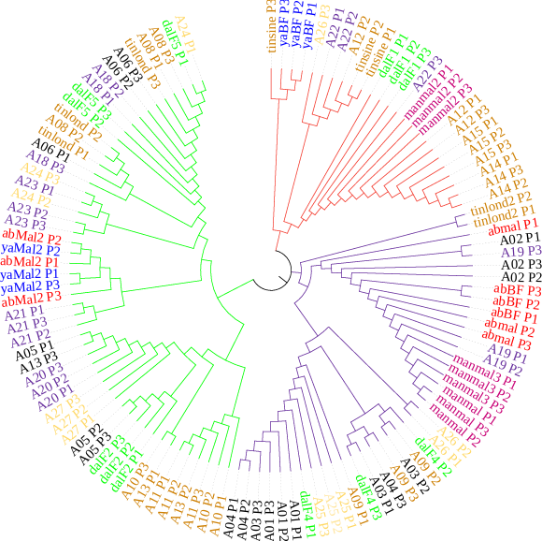
Abidjan
Boundiali
Daloa
Ferkessédougou
Man
Samatiguila
Tingrela
Yamoussoukro
I
II
III
Fig.4. Circular dendrogram based on SSR genetic distances showing the structuring and relationships between Ivorian accessions of Cyperus esculentus circular showing the relationships between C.esculentus accessions in Côte d’Ivoire
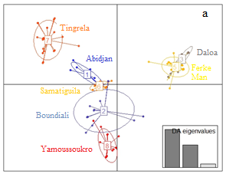 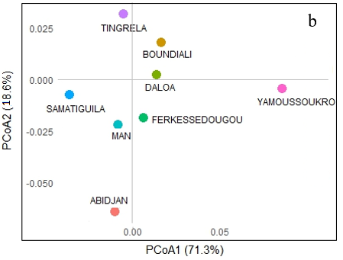Fig.5. Scatter plots of the discriminant analysis of principal components (DAPC) and principal coordinate analysis (PCoA) for 117 individuals of Cyperus esculentus. (a): DAPC plot for eight populations; (b): PCoA plot for eight populations

.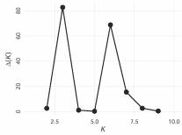
a)
K= 3
b)
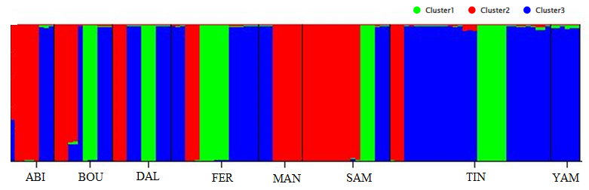
Fig.6. (a) : Representation of the admixture model of the number of accessions of nutsedge according to the established populations based on Delta K (k ranging from 1 to 10), Delta k = f(K); (b): Graphical representation of the estimation of the membership coefficients of the three groups

- Conclusion
This study provides the first molecular mapping of the genetic diversity of edible tiger nuts in Côte d'Ivoire based on SSR markers. The results indicate moderate genetic variability (approximately 3 alleles/locus) and structuring into three independent genetic groups, with the majority of the variance residing between individuals within populations. However, the observed heterozygote deficiency indicates that technical checks (null alleles, genotyping resolution) and an increase in the number of loci and individuals are recommended to definitively establish selection and conservation programs. Nevertheless, this data provides a solid foundation for germplasm conservation and the future development of varietal improvement strategies.
In perspective, expanding the sampling to a larger number of accessions and regions would help consolidate these results and refine the understanding of the allelic richness of the Ivorian germplasm. A genome-wide association study (GWAS) could also be considered to link this genetic polymorphism to agronomic traits of interest.

Disclaimer (Artificial intelligence): Author(s) hereby declare that NO generative AI technologies such as Large Language Models (ChatGPT, COPILOT, etc.) and text-to-image generators have been used during the writing or editing of this manuscript.

REFERENCES
- Agbahoungba, S., SAGBADJA, H. A., Agoyi, E. E., Houinde, P. J., Adandonon, A., Assogbadjo, E. A., & SINSIN, B. (2021). Molecular analysis of the genetic diversity of 50 cowpea (Vigna unguiculata L. Walp) accessions using microsatellite markers. African Journal of Rural Development, 6(2), 1‑18.
- Arias, R. S., Molin, W. T., Ray, J. D., Peel, M. D., & Scheffler, B. E. (2011). Isolation and characterisation of the first microsatellite markers for Cyperus rotundus. Weed Research, 51(5), 451‑460. https://doi.org/10.1111/j.1365-3180.2011.00861.x
- Armengol, J., Vicent, A., León, M., Berbegal, M., Abad‐Campos, P., & García‐Jiménez, J. (2010). Analysis of population structure of Rosellinia necatrix on Cyperus esculentus by mycelial compatibility and inter‐simple sequence repeats (ISSR). Plant Pathology, 59(1), 179‑185. https://doi.org/10.1111/j.1365-3059.2009.02150.x
- Asare, P. A., Kpankpari, R., Adu, M. O., Afutu, E., & Adewumi, A. S. (2020). Phenotypic Characterization of Tiger Nuts (Cyperus esculentus L.) from Major Growing Areas in Ghana. TheScientificWorldJournal, 2020, 7232591. https://doi.org/10.1155/2020/7232591
- Böckelmann, J., Wieser, D., Tremetsberger, K., Šumberová, K., & Bernhardt, K. (2015). Isolation of nuclear microsatellite markers for Cyperus fuscus (Cyperaceae). Applications in Plant Sciences, 3(11), 1500071. https://doi.org/10.3732/apps.1500071
- Bøhn, T., Aheto, D. W., Mwangala, F. S., Fischer, K., Bones, I. L., Simoloka, C., Mbeule, I., Schmidt, G., & Breckling, B. (2016). Pollen-mediated gene flow and seed exchange in small-scale Zambian maize farming, implications for biosafety assessment. Scientific Reports, 6, 34483. https://doi.org/10.1038/srep34483
- Casimir, G. K. (2021). Study on the state of affairs regarding the consideration of agroecological transitions in the provision of agricultural advisory services in Côte d’Ivoire. https://www.inter-reseaux.org/publication/etat-des-lieux-de-la-prise-en-compte-des-transitions-agroecologiques-dans-la-fourniture-des-services-de-conseil-agricole-en-cote-divoire/
- Chaouch khouane, A. (2022). Study of the genetic diversity of some male date palms and attempt to identify genetic fingerprints of dokkars most closely related to "Deglet-Nour" using microsatellite markers [PhD Thesis, MOHAMED KHIDER UNIVERSITY OF BISKRA]. http://thesis.univ-biskra.dz/id/eprint/6031
- Daniel, F., Matthew, S., & Jonathan, K. P. (2007). Inference of population structure using multilocus genotype data : Dominant markers and null alleles. Molecular Ecology Notes, 7(4). https://doi.org/10.1111/j.1471-8286.2007.01758.x
- De Castro, O., Gargiulo, R., Del Guacchio, E., Caputo, P., & De Luca, P. (2015). A molecular survey concerning the origin of Cyperus esculentus (Cyperaceae, Poales) : Two sides of the same coin (weed vs. crop). Annals of botany, 115(5), 733‑745.
- De Meeûs, T. (2011). Introduction to the genetics of natural populations. Applications to parasites and their vectors. Marseilles France: IRD Éditions. 335p. http://www.t-de-meeus.fr/Publications/DeMeeusEmpiricalPopGenBook.pdf
- De Ryck, S., Reheul, D., De Riek, J., De Keyser, E., & De Cauwer, B. (2023). Genetic and morphological variation of Belgian Cyperus esculentus L. clonal populations and their significance for integrated management. Agronomy, 13(2), 572.
- Doyle, J. J. (1990). Isolation of plant DNA from fresh tissue. Focus, 12, 13‑15.
- Edo, G. I., Samuel, P. O., Nwachukwu, S. C., Ikpekoro, V. O., Promise, O., Oghenegueke, O., Ongulu, J., Otunuya, C. F., Rapheal, O. A., Ajokpaoghene, M. O., Okolie, M. C., & Ajakaye, R. S. (2024). A review on the biological and bioactive components of Cyperus esculentus L. : Insight on food, health and nutrition. Journal of the Science of Food and Agriculture, 104(14), 8414‑8429. https://doi.org/10.1002/jsfa.13570
- Kouamé, G. A. A. (2024). Phytochemical and nutritional compositions of the residual flour emissions of defatted tubers of Cyperus esculentus L.(Cyperaceae). Sciences des Structures et de la Matière, 8(2), 3‑23.
- Evanno, G., Regnaut, S., & Goudet, J. (2005). Detecting the number of clusters of individuals using the software structure : A simulation study. Molecular Ecology, 14(8), 2611‑2620. https://doi.org/10.1111/j.1365-294X.2005.02553.x
- Franco-Duran, J., Crossa, J., Chen, J., & Hearne, S. J. (2019). The impact of sample selection strategies on genetic diversity and representativeness in germplasm bank collections. BMC Plant Biology, 19(1), 520. https://doi.org/10.1186/s12870-019-2142-y
- Galpérine, C. (2024). Journeys in the Biological Sciences. Matériologiques Publishing. https://shs.cairn.info/voyages-dans-les-sciences-biologiques--9782373614367

- Hale, M. L., Burg, T. M., & Steeves, T. E. (2012). Sampling for microsatellite-based population genetic studies : 25 to 30 individuals per population is enough to accurately estimate allele frequencies. https://journals.plos.org/plosone/article?id=10.1371/journal.pone.0045170
- Haoua, B., Sani, I. S., Hamissou, Z., & Toudou, A. (2023). Study of the Genetic Diversity of Tiger Nut (Cyperus esculentus) Ecotypes of Niger Using SSR Markers. International Journal of Genetics and Genomics, 11, 18‑26.
- Jombart, T. (2008). adegenet : A R package for the multivariate analysis of genetic markers. Bioinformatics, 24(11), 1403‑1405.
- Kouakou, J.-L., Gonedelé-Bi, S., Assamoi, J.-B., & Assanvo N’Guetta, S.-P. (2022). Optimization of the Cetyltrimethylammonium bromide (CTAB) DNA extraction protocol using forest elephant dung samples. MethodsX, 9, 101867. https://doi.org/10.1016/j.mex.2022.101867
- Kouakou, P.-A. (2020). Determinants of productivity, economic profitability, and social impact of market gardening in the commune of Boundiali, northern Côte d’Ivoire. Moroccan Journal of Agronomic and Veterinary Sciences, 8(1): 35-57. https://www.agrimaroc.org/index.php/Actes_IAVH2/article/view/786
- Lingrand, M., Scotti-Saintagne, C., Oddou-Muratorio, S., Correard, M., Gilg, O., Reï, F., Roig, A., & Brahic, P. (2021). Evaluation of the effect of plant material conservation on DNA quantity and quality, with a view to implementing a sample storage management policy. NOV’AE-Innovative Engineering and Know-How, 106 Technical Notebook, 44-62. https://doi.org/10.17180/novae-2021-005
- Ohsako, T., & Yamada, Y. (2011). Isolation and characterization of microsatellite loci in Schoenoplectus juncoides (Cyperaceae)¹. American Journal of Botany, 98(6). https://doi.org/10.3732/ajb.1100011
- Peakall, R., & Smouse, P. E. (2012). GenAlEx 6.5 : Genetic analysis in Excel. Population genetic software for teaching and research--an update. Bioinformatics (Oxford, England), 28(19), 2537‑2539. https://doi.org/10.1093/bioinformatics/bts460
- Rafiq, M., Saqib, M., Jawad, H., Javed, T., Hussain, S., Arif, M., Ali, B., Bazmi, M. S. A., Abbas, G., & Aziz, M. (2023). Improving quantitative and qualitative characteristics of Wheat (Triticum aestivum L.) through nitrogen application under semiarid conditions. Phyton, 92(4), 1001‑1017.
- Shanon, C. E. (1948). A mathematical theory of communication. BSTJ, 27, 623‑656.
- Sory, S., Traore, R. E., Tiama, D., Kiebre, M., & Kando, P. B. (2022). Caractérisation morphologique du groupe variétal «Folou» ou «Flado» des ignames appartenant à l’espèce D. alata au Burkina Faso. International Journal of Innovation and Applied Studies, 37(2), 416‑423.
- Soumahoro, S., & Tape, S. P. (2023). Food Marketing and Unhealthy Urban Markets : The Cases of Boundiali and Tengrela in the North of Côte d’Ivoire. European Journal of Science, Innovation and Technology, 3(6), 375‑390.
- Tayyar, R. I., Nguyen, J. H., & Holt, J. S. (2003). Genetic and morphological analysis of two novel nutsedge biotypes from California. Weed Science, 51(5), 731‑739.
- Twumasi, P., Asare, P. A., Afutu, E., Amenorpe, G., Addy, S. N. T. T., Prempeh, R. N. A., & Donkor, E. F. (2024a). Genetic Diversity of Tiger Nuts (Cyperus esculentus L.) Grown in Ghana Based on Morpho-Descriptors and SSR Markers. Journal of Agricultural Sciences – Sri Lanka, 19(2), 316‑335. https://doi.org/10.4038/jas.v19i2.10091
- Twumasi, P., Asare, P. A., Afutu, E., Amenorpe, G., Addy, S. N. T. T., Prempeh, R. N. A., & Donkor, E. F. (2024b). Genetic Diversity of Tiger Nuts (Cyperus esculentus L.) Grown in Ghana Based on Morpho-Descriptors and SSR Markers. Journal of Agricultural Sciences – Sri Lanka, 19(2), 316‑335. https://doi.org/10.4038/jas.v19i2.10091
- Wani, P. A., Omobolanle, L. A., Hamid, B., Fayokemi, R. A., Perveen, K., Bukhari, N. A., Sayyed, R. Z., & Mastinu, A. (2024). Evaluation of destruction of bacterial membrane structure associated with anti-quorum sensing and ant-diabetic activity of Cyperus esculentus extract. Heliyon, 10(14). https://www.cell.com/heliyon/fulltext/S2405-8440(24)10159-4
- Wright, S. (1978). Evolution and the genetics of populations. A treatise in four volumes. Volume 4. Variability within and among natural populations. https://www.cabidigitallibrary.org/doi/full/10.5555/19780137995
- Yapi, J. C., Deffan, Z. A. B., Koko, A. C., Diabagate, J. R., Kouamekan, K. B., & Kouame, L. P. (2021). Influence of physicochemical particle size on the characteristics and techno-functional properties of tiger nut (Cyperus esculentus L.) flours. African Agronomy, 33(2), 239-250.

