MICROMORPHOLOGY, MORPHOMETRY AND HISTOCHEMISTRY OF LEFT CORONARY ARTERY IN SHEEP AND GOATS

ABSTRACT
Coronary artery disease is the most common type of cardiovascular disease. Research in coronary artery disease often involves experimental animal models to identify the underlying mechanisms, test procedures, devices etc., and to practice best possible therapeutic interventions. Sheep and goat has evolved as experimental animals and studies on coronary artery disease are in progress in this animal models. This study on the left coronary artery (LCA) in sheep and goat is to report on its histological, histometrical and histochemical details and to assess the similarities and differences for translational significance. The LCA was a small and muscular type of artery in both species and consisted of all the three tunics, ie., inner tunica intima, middle tunica media and outer tunica externa. The histomorphology of the tunics in both the species were similar. Histometric measurements differed between them. The tunica intima and externa were significantly thicker with a significantly higher total wall thickness in goats. In sheep, the tunica media was significantly thicker than the goat. The endothelium of LCA in both the species was positive for acid mucopolysaccharides while the activity for neutral polysaccharides differed. Acid and alkaline phosphatase activity differed in the tunics of LCA in both sheep and goat. Lipid was not found in any of the tunics of LCA in both the species.

Key words: Left coronary artery, histology, histometry, histochemistry, sheep, goat
INTRODUCTION
Arteries undergo progressive changes from birth to death and are affected by numerous diseases. Coronary artery disease (CAD) is the most dangerous and is the cause of death in 6.7% of the total world population (Sheikh et al., 2021). Among the different types of obstructive coronary artery disease; Left main Coronary artery disease (LMCAD) is with higher risk and poorer outcomes (Khawaja et al., 2024). Numerous studies are in progress to address the risk factors, disease progression, molecular and cellular mechanisms of pathogenesis for prevention, early detection, treatment and control of this disease. These studies often utilizes large and small animal models that are vital for understanding the underlying disease pathophysiology behind the disease progression (Parikh and Pierce 2024). The choice of a perfect animal model depends on the physiological and biological closeness of that species and is very critical for success. In, this list, sheep is considered as one of the suitable animal model to test devices, grafts (Ono et al., 2023) and less invasive surgical procedures (Shofti et al., 2004; Boumzebra et al., 2006) for treatment of coronary arterial diseases.
Reports of Ballesteros and Ramirez (2008) established that the knowledge of microscopic structure of LCA is important in determining the complexity and associated effects of this disease. Use of histological and morphometric techniques is essential for examination of disease processes as well as for the investigation of many of the mechanisms that contribute to a wide variety of tissue pathologies (David, 2007). This current study therefore is more appropriate and focus in depth on the microscopic anatomy, micrometry and histochemistry of the left coronary artery in sheep and goat to promote further research in coronary arterial disease in this experimental animals.

MATERIALS AND METHODS
The heart of sheep and goat for this present study were collected from healthy animals slaughtered in nearby slaughter houses of Rajendranagar, Hyderabad. Tissue samples of left coronary artery, approximately 2 cm size were collected from the heart of six healthy sheep and goats. The tissues were washed in normal saline, fixed in 10% neutral buffered formalin and processed for routine paraffin method (Singh and Sulochana 1997). Paraffin sections of 4-5 µm thickness were cut and stained with H & E for micromorphology and micro-architecture, Masson’s trichrome method for differentiating collagen and muscle fibers, Verhoeff’s method for demonstration of elastic fibers, Van-Giesons method for demonstration of collagen fibers (Singh and Sulochana 1997). Histomorphometrical measurements of arterial wall thickness and luminal diameter were done by micrometery. All the measurements were recorded with values of Mean and Standard Error, statistical significance (p<0.05) between groups were analysed by ANOVA, with Tukey HSD test for multiple comparisons using SPSS software.
Histochemistry of the LCA in sheep and goat was studied from routine paraffin and cryo-sections. The paraffin processed sections were subjected to Periodic Acid Schiff (PAS) reaction for demonstration of glycogen, PAS-Alcian blue (AB) method for acid and neutral muco polysaccharides. Cryo-sections of 10-15µm thickness from prefixed chilled formal calcium were subjected to Oil red ‘O’ in propylene glycol method for demonstration of fats, Gomori’s acid phosphatase method for localization of acid phosphatase enzyme, Gomori’s alkaline phosphatase cobalt method (Singh and Sulochana, 1997) for localization of alkaline phosphatase enzyme.

RESULTS AND DISCUSSION
Histological features of LCA revealed all three layers within outwards viz., tunica intima, tunica media and tunica adventitia or externa in both species. The histoarchitecture was typical and resembled muscular artery as observed by Waller et al., (1992) in humans, Awal et al., (2001) in black Bengal goats, Khan et al., (2006) in mammals like buffalo, goat, rabbit and rat. The mean total thicknesses of LCA in sheep and goat were 549.4 ± 0.76 µm, 687.6 ± 0.31 µm respectively. In goats it was thicker and differed significantly than sheep. The mean long and short diameter of lumen was 3571.9 ± 0.59 µm and 635.4 ± 0.61 µm respectively in sheep whereas it was 3065.9 ± 0.18 µm and 639.1 ± 0.15 µm in goats. There was no significant difference in mean long diameter between species but the mean short diameter was higher in goats and differed significantly. In contrary, Sathapathy et al., (2015a) reported that the maximum horizontal luminal diameters of LCA in goats was 47.31 ± 3.58 μm, 47.6 ± 5.8 μm and 30.86 ± 5.24 μm in young, kids and adults respectively. The maximum vertical diameter of lumen at the origin and termination in adults was only 162.93 ± 12.7 μm and 64.54 ± 6.74 μm respectively in goats. In monkey, the mean external diameter of LCA was 1.65 ± 0.39 mm (Nikolic et al., 2004). In pigs it was 6.98 ± 1.56 mm (Gomez and Ballesteros, 2014) and in European bison it measured 15.7 mm (Kupczynska et al., 2015).
The tunica intima in both species consisted of all three sub layers viz., inner endothelium, subendothelial layer and internal elastic membrane or lamina. The mean thickness of the tunica intima in sheep and goat was 26.93 ± 0.15 µm, 49.13 ± 0.14 µm respectively. It was significantly higher in goats. The endothelium in both species was lined by a single layer of endothelial cells, which were flat and squamous. It was folded and seen resting on a thin basement membrane. The subendothelial connective tissue layer consisted of elastic, collagen and occasional smooth muscle cells. Intima was separated from media through a fragmented wavy internal elastic membrane (Fig.1) Our observations are in complete agreement with findings of Khan et al., (2006) in mammals and Sathapathy et al., (2015a) & (2015c) in goats. In contrary, Awal et al., (2001) reported that the subendothelial layer was completely absent in black Bengal goats..
The tunica media in sheep as well as goats comprised predominantly smooth muscle cells and a few fine elastic fibers. The mean thicknesses of the tunica media in sheep and goats were 504.4 ± 0.71 µm, 442.3 ± 0.14 µm respectively. It was significantly higher in sheep than the goats. In both species, the smooth muscle cells were spindle shaped with a centrally located nucleus. The cells were circularly arranged and held together by elastic and collagen fibers (Fig.2). Solitary and wavy elastic fibers were also observed (Fig.3). The number of smooth muscle cell layers ranged from 15 to 20 numbers. Number of this cell layer decreased gradually from origin to termination (Fig.4). Similar reports were made by Awal et al., (2001) in black Bengal goat, Khan et al., (2006) in mammals and Sathapathy et al., (2015a) in goats.
The tunica externa in both species had irregularly arranged collagen and elastic fibers (Fig.5). The mean thicknesses of the tunica externa in sheep and goats were 176.9 ± 1.29 µm, 196.2 ± 0.14 µm respectively. This was significantly higher in goat. This layer was made of collagen fibers and possessed Vasa vasorum and nervi vasorum. Fibrocytes and adipocytes were also observed amongst bundles of collagen fibers. Similar findings were reported by Waller et al., (1992) in humans, Awal et al., (2001) in black Bengal goats, Khan et al., (2006) in mammals. Sathapathy et al., (2015a) in goats who also reported, the presence of lymphatic vessels in this layer.
Histochemical reactions with PAS-AB (alcian blue) were intense and was observed in the endothelium of LCA and indicated the presence of acid mucopolysaccharides in both the species (Fig’s 6 & 7). Similarly activity for PAS-AB was moderate in the subendothelial connective tissue of both these species. In sheep, moderate PAS activity was noticed in the tunica media and sporadic areas of subendothelium (Fig.6) but in goats it was moderate in tunica intima but weak in tunica media (Fig.8). Our findings are in partial agreement with Sathapathy et al., (2014) and (2015b) where they reported that the PAS activity was limited to externa and intima of the coronary artery in goats. Sathapathy et al., (2015c) reported that this PAS activity was at different levels in the endothelium at the origin, middle and at the termination of LCA in young, kids and adult goats.
Alkaline phosphatase activity (AKP) was intense in the tunica intima but weak in tunica media in both sheep and goats (Fig. 9 ). These findings are in acceptance with Sathapathy et al., (2014) and (2015b) who reported that the alkaline phosphatase activity was observed in the endothelium, externa and perivascular connective tissues in the LCA of goats. This activity was intense in the LCA of kids and young ones but was moderate in adults (Sathapathy et al., 2015c). In sheep, the tunica intima was weakly positive for Acid phosphatase activity while in goats it was moderate (Fig.10) and was found scattered in the tunica media. Our results are in partial agreement with the reports of Sathapathy et al., (2014) and (2015b) who found that the ACP activity was seen only in the endothelium and tunica externa. This activity was strong in kids, weak in adult goats but was completely absent in young goats (Sathapathy et al., 2015c).
The response to Oil Red O was negative in the intima and media of both sheep and goat (Fig.11). Our findings were in contrary to the observations of Sathapathy et al., (2014) and (2015b) who found a positive reaction for fat in all the tunics of this vessel in goat

CONCLUSION
The micromorphology of the LCA was almost similar in both the species examined. Histomorphometric features revealed that the thickness of tunica intima and externa was significantly higher in goats but, tunica media was higher in sheep. Histochemical studies showed that the staining intensity of the histological tunics for mucopolysaccharides was different between species. The activity for alkaline and acid phosphatase also varied between species and the reactivity for Oil red O was negative in both species. We conclude that these findings will complement to the existing knowledge of LCA in sheep and goats. The interspecies variations in histomorphometry and histochemical activity are critical and will help to make reliable assessment of LCA in these experimental animal models.
FIGURES
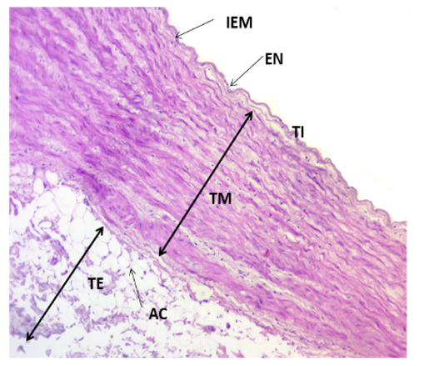
Fig.1-Photomicrograph showing tunics of LCA in adult sheep:
Tunica intima (TI), Endothelium (EN), Internal elastic membrane
(IEM), Tunica media (TM), Tunica externa (TE), Adipocytes (AC).
H & E X10
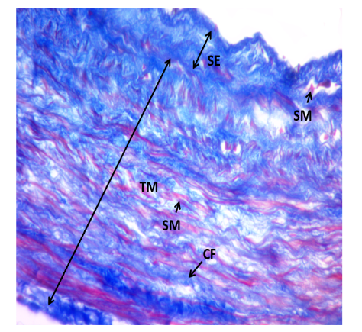

Fig.2- Photomicrograph of LCA in adult sheep showing distribution :
Of collagen fibers and smooth muscle cells
Subendothelial layer (SE), Smooth muscle cell (SM),
Collagen fibers (CF), Tunica media (TM).
Masson’s Trichrome x40

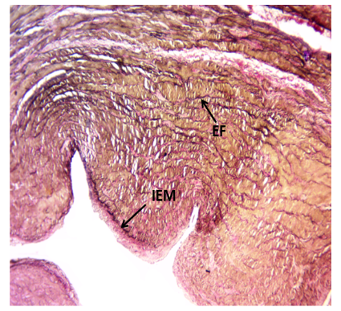

Fig.3-Photomicrograph of LCA in adult goat showing distribution:
Of elastic fibers Elastic fibers (EF), Internal elastic membrane (IEM).
Verhoeff’s X 10

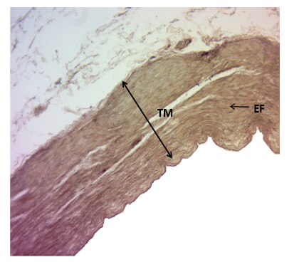
Fig.4-Photomicrograph of LCA in adult sheep showing distribution:
Of elastic fibers Elastic fibers (EF). Tunica media (TM), Elastic fibers (EF). Verhoeff’s X 10

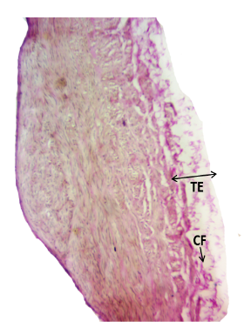

Fig.5- Photomicrograph of LCA in adult sheep showing distribution
of collagen fibers: Tunica externa (TE), Collagen fibers (CF).
Vangieson’s X 10
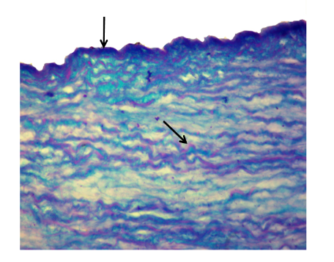
Fig.6- Photomicrograph showing moderate alcian blue activity
in the endothelium (arrow) and moderate PAS activity in tunica
media of LCA in sheep. PAS-AB X 40

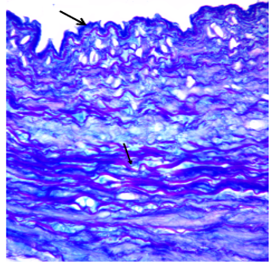
Fig.7- Photomicrograph showing intense alcian blue
activity (arrow) in tunica intima and media of LCA
in goat. PAS-AB X 40

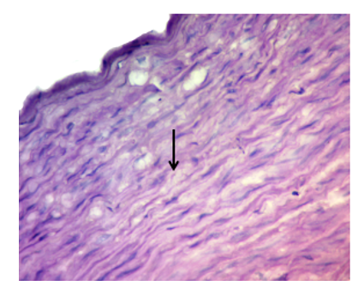

Fig.8-Photomicrograph showing weak PAS activity (arrow)
in tunica media of LCA in goat. PAS X 40

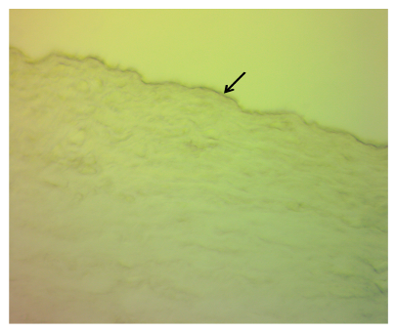
Fig.9- Photomicrograph showing intense alkaline phosphatase
activity in tunica intima (arrow) of LCA in sheep. AKP X 40

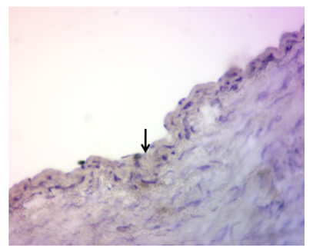

Fig.10-Photomicrograph showing moderate acid phosphatase
activity (arrow) in tunica intima of LCA in goat. ACP X 40
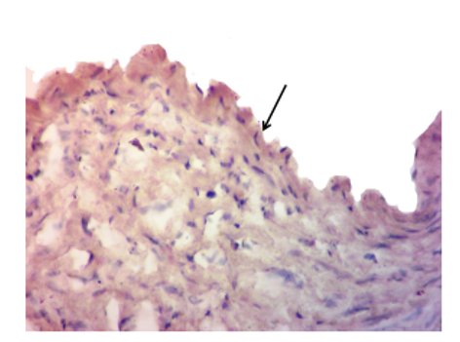
Fig.11-Photomicrograph showing negative activity of lipids
in endothelium (arrow) of LCA in goat. Oil Red O X 40

Disclaimer (Artificial intelligence)
Author(s) hereby declare that NO generative AI technologies such as Large Language Models (ChatGPT, COPILOT, etc.) and text-to-image generators have been used during the writing or editing of this manuscript.

REFERENCES
- Awal, M.A., Asaduzzaman, M., Prodhan, M. A. and Kurohma¬ru, M. (2001) A histological study on the coronary artery of the indigenous black Bengal goat in Bangladesh. Experimental Animals, 50 (1):73-76.
- Boumzebra, D.D., Solem, J.O., Nakeeb, S., Halees, Z.A. (2006) The Sheep as a Model for Coronary Artery Surgery Experiments on Beating Heart The Journal of Tehran Heart Center. 1; 1(1) 12-17

- David, A.T. (2007) Histological and Morphometric Analyses for Rat Carotid Artery Balloon Injury Studies. Methods in Molecular Medicine. 139: 31–66.

- Gomez, F.A., Ballesteros, L.E. (2014) Morphologic expression of the left coronary artery in pigs. An approach in relation to human heart. Revista Brasileria de Cirurgia Cardiovascular, 29 (2):214-20.

- Khan, H., Khan, A.A. and Faruqi, N.A. (2006) Comparative Histol¬ogy of Coronary Arteries in Mammals. Journal of the Anatomical Society of India, 55.

- Khawaja1, M., Britt, M., Khan, M.A., Munaf, U., Arshad, H., Siddiqui R., Virk, H.U.H., Alam, M. and Krittanawong, C. (2024) Left Main Coronary Artery Disease: A Contemporary Review of Diagnosis and Management. Reviews in Cardiovascular Medicine. 25(2): 66

- Kupczynska, M., Barszcz, K., Olbrych, K., Polguj, M., Wysiadecki, G., Topol, M., Nawrot, J.K. (2015) Coronary arteries of the European bison (Bison bonasus). Acta Veterinaria Scandinavica, 57:82.

- Nikolic, V., Teofilovski, P.G., Stankovic, G., Parapid, B., Malobabic, S., Stojic, V. (2004) Third coronary artery in monkey heart. Acta Veterinaria Hungerica, 52 (3):253–7.

- Parikh, M. and Pierce, G.N (2024). Considerations for choosing an optimal animal model of cardiovascular disease. Canadian Journal of Physiology and Pharmacology, 102 (2): 75–85

- Sathapathy, S., Joshi, S.K., Khandate, S.P., Dalvi, R.S., Banubakode, S.B., Mainde, U.P., Nandeshwar, N.C. and Gedam, P.M. (2014) Comparative histochemical studies on the angioarchitecture of coronary and femoral artery in goat (Capra hircus). Indian Journal of Veterinary Anatomy., 26(2): 107

- Sathapathy, S., Khandate, S.P., Nandeshwar, N.C., Dalvi, R.S., Banubakode, S.B., Salankar, A.M., Mainde, U.P., Charjan, R.Y. and Joshi, S.K. (2015a) Histological and micrometrical studies on the angioarchitecture of coronaryartery in goat (Capra hircus). Indian Veterinary Journal.92; 34-37

- Sathapathy, S., Joshi, S.K., Khandate, S.P., Dalvi, R.S., Salankar, A.M., Charjan, R.Y., Mainde, U.P., Banubakode, S.B. and Joshi, S.K. (2015b) Histochemical studies on the angioarchitecture of coronary artery in goat (Capra hircus),Indian Journal of Veterinary Anatomy, 10(1), 37-42

- Sathapathy, S., Joshi, S.K., Dalvi, R.S. and Singh, M.K. (2015c) Histological and histochemical studies on the endothelium of coronary artery in goat (Capra hircus), International Journal of Basic and Appiled Agricultural Research. Vol.13(2).
- Sheikh, M.S., Alduraywish, A., Almaeen, A., Alruwali, M., Alruwaili, R., Alomair, B.M., (2021). Therapeutic value of miRNAs in Coronary Artery Disease (CAD). Oxidative Medicine and Cellular Longevity. 853748,

- Shofti, R., Zaretzki, A., Cohen, E., Engel, A. and Bar-El, Y. (2004). The sheep as a model for coronary artery by pass surgery. Laboratory Animals.38, 149–157

- Singh, U.B. and Sulochana, S. (1997) Handbook of Histologi¬cal and Histochemical technique, 1st ed. Primier Publishing House, Hyderabad: 20-94.

- Waller, B.F., Charles, M.O., Slack, J.D., Pinkerton, C.A., Tasselm, J.V. and Peters, T. (1992) Anatomy, Histology and Pathology of Coronary Arteries: A Review Relevant to New Interventional and Imaging Techniques-Part I. Clinical Cardiology, 15,451-457.

- Ono, M., Kageyama, S., Leary, N,O., El-Kurdi, M.S., Reinöhl, J., Solien, E., Bianco, R.W., Doss, M., Meuris, B., Virmani, R., Cox, M., Onuma, Y., Serruys, P.W. (2022) 1-Year Patency of Biorestorative Polymeric Coronary Artery Bypass Grafts in an Ovine Model. JA C C : Basic to Translational Science. Nov 9;8(1): 1 9 – 3 4

