Serological and Molecular Identification of CMV Subgroup IA Infecting Bhut Jolokia (Capsicum chinense Jacq.) in Assam, India

Abstract
Bhut Jolokia (Capsicum chinense), a high-value chili pepper indigenous to Northeast India, faces significant yield constraints due to viral diseases. Extensive field surveys conducted during 2020-2021 in the major Bhut Jolokia growing districts of Assam (Jorhat, Golaghat, Lakhimpur, and Dhemaji) revealed a high incidence of virus-like symptoms, including mosaic, mottling, leaf distortion, and stunting. Serological detection using Double Antibody Sandwich Enzyme-Linked Immunosorbent Assay (DAS-ELISA) confirmed the widespread presence of Cucumber mosaic virus (CMV), with disease incidence ranging from 30% to 80%. Molecular analysis further validated these findings. Reverse Transcription-Polymerase Chain Reaction (RT-PCR) using specific primers amplified fragments of the replicase (1052 bp) and coat protein (1130 bp) genes. Nucleotide sequencing of these amplicons revealed 98-100% identity among the Assam isolates. Phylogenetic analysis based on both genes unequivocally clustered the Assam CMV isolates within the subgroup IA, showing closest homology with other Indian isolates from chili. This study provides conclusive evidence of CMV as a predominant viral pathogen infecting Bhut Jolokia in Assam and offers essential genetic information for developing effective management strategies.
Keywords: Capsicum chinense, CMV, Phylogeny, RT-PCR, DAS-ELISA, Virus detection, Subgroup IA
Introduction:
Capsicum chinense Jacq., commonly known as Bhut Jolokia, is a critically important agricultural commodity in Northeast India, renowned for its exceptional pungency and high capsaicin content. Its economic value in both domestic and international markets is substantial. However, the productivity of this crop is severely hampered by a complex of pests and diseases, with viral infections being the most devastating (Talukdar et al., 2015). Among these, the Cucumber mosaic virus (CMV), a member of the genus Cucumovirus (family Bromoviridae), is one of the most economically significant plant pathogens worldwide due to its extensive host range, encompassing over 800 plant species (Baruah et al. 2025; Borah et al. 2018; Palukaitis et al., 1992).
In India, mosaic disease in chili has been attributed to several viruses, including CMV, Tobacco mosaic virus (TMV), Potato virus Y (PVY), and Chilli veinal mottle virus (ChiVMV) (Jagadeeswar, 2004). CMV is particularly prevalent in vegetable crops across Northeast India and is efficiently transmitted by more than 60 species of aphids in a non-persistent manner, facilitating its rapid spread in the field (Song and Ryu 2017; Palukaitis et al., 1992). Symptoms of CMV infection in Bhut Jolokia are diverse and often include chlorosis, severe mosaic, mottling, leaf filiformity (shoestring), and stunted growth, leading to significant fruit yield and quality losses (Borah et al., 2019, Routhu et al., 2022; Saikia et al., 2023).
Initial diagnosis based on symptomatology can be misleading, as symptoms often overlap with those caused by other viruses or nutrient deficiencies. Therefore, reliable detection methods are crucial for accurate diagnosis and management. Serological techniques like DAS-ELISA are widely used for initial screening, but molecular methods such as RT-PCR offer higher sensitivity and specificity, especially for viruses present at low titers (Katoch et al., 2003; Kimaru et al., 2020). Cucumber mosaic virus possesses a tripartite, positive-sense, single-stranded RNA genome (RNA1, RNA2, and RNA3), along with two subgenomic RNAs, designated RNA4 and RNA4A. RNA1 encodes the 1a protein, which, together with the RNA2-encoded 2a RNA-dependent RNA polymerase, forms the viral replicase machinery responsible for genome replication (Hayes & Buck, 1990; Roossinck et al., 1999). In addition to the polymerase, RNA2 also produces the 2b protein that plays multiple biological roles, including facilitating systemic infection, modulating symptom expression, and functioning as a suppressor of host RNA silencing defenses (Ding et al., 1994). RNA3 directs the synthesis of two distinct proteins: the 3a movement protein (MP), which enhances cell-to-cell viral spread, and the 3b coat protein (CP), involved in virion encapsidation, short- and long-distance movement within the plant, and vector transmission, particularly by aphids (Canto et al., 1997; Palukaitis et al., 1992).
Genetic characterization and phylogenetic analysis of viral genes, particularly the replicase and coat protein, are essential for understanding the genetic diversity and evolutionary relationships of virus populations, which informs the development of resistant varieties and control measures (Gómez et al., 2009; Rubio et al., 2020). Phylogenetic studies based on serological properties, nucleic acid hybridization, and sequence comparison have classified CMV isolates into two major subgroups, I and II (Palukaitis et al., 1992; Roossinck, 1999). Subgroup I isolates are further separated into two well-supported clusters, IA and IB (Mochizuki & Ohki, 2012).
Although CMV has been reported from Assam, a comprehensive molecular characterization of the virus infecting Bhut Jolokia in this region was lacking. This study was undertaken to (i) survey the incidence of CMV in major Bhut Jolokia growing districts of Assam, (ii) confirm CMV presence using serological and molecular tools, and (iii) genetically characterize the local CMV isolates through sequencing and phylogenetic analysis to determine their taxonomic subgroup.
Materials and Methods:
Field Survey and Sample Collection
A roving survey was conducted during 2020-2021 across Bhut Jolokia fields in four districts of Assam: Jorhat, Golaghat, Lakhimpur, and Dhemaji. Plants exhibiting characteristic viral symptoms such as mosaic, chlorosis, mottling, and leaf distortion were documented and leaf samples were collected. In each surveyed field, between 50 and 100 plants were randomly selected and examined for virus-like symptoms such as severe mosaic, mottling, vein banding, leaf narrowing, puckering, and stunted growth. The numbers of diseased and healthy plants were recorded separately. Disease incidence was expressed as a percentage using the following equation:


Serological Detection by DAS-ELISA
Collected leaf samples were tested for CMV using DAS-ELISA following the protocol of Hobbs et al. (1987). Briefly, polystyrene microtiter plates were coated with CMV-specific IgG (1:200 dilution, obtained from USDA-ARS, Corvallis, USA). Leaf samples were homogenized in extraction buffer, added to the wells, and incubated. After washing, an alkaline phosphatase-conjugated antibody was added. The reaction was developed using p-nitrophenyl phosphate substrate, and the optical density (OD) was measured at 405 nm using an ELISA reader (BioRad). Samples were considered positive if their OD values were at least twice that of the healthy control.
Molecular Detection and Characterization
RNA Isolation
Total RNA (Ribose Nucleic Acid) was extracted from symptomatic leaf tissues using two methods: the standard TRIzol reagent protocol (Yoo et al., 2004; Chomczynski and Sacchi, 1987) and a commercial NucleoSpin® RNA Plant kit (Macherey-Nagel). The concentration and purity of the extracted RNA were assessed using a spectrophotometer (Eppendorf), and RNA integrity was confirmed by 1.0% agarose gel electrophoresis.
cDNA Synthesis and PCR Amplification
First-strand cDNA (Complementary DNA) was synthesized from 100 ng (nanogram) of total RNA using the PrimeScript™ 1st strand cDNA Synthesis Kit (TaKaRa) with oligo(dT) primers. Gene-specific primers were designed for the replicase and coat protein (CP) genes of CMV using Primer3 software after aligning multiple CMV sequences from the NCBI database (Table 1).
Table 1: List of primers used for RT-PCR amplification.
Gene Target | Primer Name | Sequence (5' → 3') | Amplicon Size (bp)
Replicase | GK Rep 4F | TGTAAAAACTACCCTTTGA | 1052 bp
Replicase | GK Rep 4R | AATGTCGAATGAGTTCGGTC | 1052 bp
Coat Protein | GK CMV F | GAGTTCTTCCGCGTCCCGCT | 1130 bp
Coat Protein | GK CMV R | AAACCTAGGAGATGGTTTCA | 1130 bp

Semi-quantitative PCR was performed using EmeraldAmp® MAX PCR Master Mix. The thermal cycling conditions included an initial denaturation at 94°C for 2 min, followed by 35 cycles of 94°C for 30 s, 55-57°C for 45 s, 72°C for 45 s, and a final extension at 72°C for 8 min. The amplified products were separated on a 1.2% agarose gel (1.2 gms of agarose dissolved in 100ml of Tris-Borate buffer), visualized under UV light, and purified using a NucleoSpin Gel and PCR clean-up kit (Macherey-Nagel).
Cloning, Sequencing, and Phylogenetic Analysis
The amplified fragments corresponding to the CMV replicase and coat protein genes were purified from agarose gels using a commercial gel extraction kit, following the manufacturer’s protocol to ensure high-quality DNA suitable for downstream cloning. The purified PCR products were subsequently ligated into the pTZ57R/T cloning vector through T/A cloning chemistry, and the resulting recombinant plasmids were introduced into chemically competent Escherichia coli strain DH5α using a standard heat-shock transformation procedure. Transformed bacterial colonies were screened on LB agar plates supplemented with ampicillin, X-gal, and IPTG to facilitate blue–white selection of positive recombinants. Plasmid DNA was extracted from positive transformants using a plasmid isolation kit and forwarded to a commercial sequencing facility for bidirectional Sanger sequencing.
The deduced nucleotide sequences were subjected to similarity searches using the BLASTn algorithm available at the National Center for Biotechnology Information (NCBI) to determine their closest homologs and confirm taxonomic identity. Multiple sequence alignments incorporating representative CMV sequences retrieved from GenBank were generated using the ClustalW program. Phylogenetic reconstruction was performed in MEGA X software, employing the Maximum Likelihood approach under the Tamura–Nei nucleotide substitution model with 1,000 bootstrap replicates to assess the statistical robustness of tree topologies (Routhu et al., 2023). The characterized sequences from this study were assigned GenBank accession numbers OQ435160.1–OQ435160.4 for the replicase region and OQ435161.1–OQ435161.4 for coat protein sequences, making them publicly accessible for future epidemiological and evolutionary studies.

Results
Disease Incidence and Symptomatology
Extensive roving surveys conducted in the major Bhut Jolokia growing districts of Assam revealed widespread occurrence of virus-like diseases. The highest incidence was recorded in Golaghat district (up to 80%), followed by Jorhat and Lakhimpur districts (40–60%), while Dhemaji exhibited comparatively lower incidence (30%) (Table 2). Plants showed a broad range of foliar symptoms including chlorotic and yellow mosaic patterns, mottling, downward leaf curling, puckering, and shoestring (filiform) leaves. Affected plants frequently exhibited stunted growth with reduced fruit set (Figure 1).
The diversity and severity of symptoms observed strongly implicate infection by CMV, which is known for its wide host range and symptom variability. The variation in incidence between districts appears to reflect agro-ecological differences that influence vector populations and disease spread.
Table 2: Disease incidence and serological detection of CMV in surveyed locations of Assam.
District | Pockets | OD Values @405nm (X-fold over healthy) | Disease Incidence (%)
Jorhat | Borbheta | 0.90-2.00 (1.4-3.1) | 60
Jorhat | Kasogoral | 0.90-2.00 (1.4-3.1) | 50
Golaghat | Misamora | 0.78-2.40 (1.2-3.7) | 80
Golaghat | Buralikson | 0.78-2.40 (1.2-3.7) | 70
Lakhimpur | Lakhimpur | 0.50-1.32 (0.7-2.1) | 60
Dhemaji | Gopak | 0.50-1.32 (0.7-2.1) | 30
OD of healthy control: 0.71

Serological and Molecular Detection
DAS-ELISA detected high virus titers in symptomatic plants, with optical density values exceeding those of healthy controls by more than two-fold. Samples from Golaghat recorded the highest OD values, correlating with higher incidence data (Table 2). The ELISA diagnosis confirmed that CMV is prevalent in major Bhut Jolokia fields, validating symptoms-based field identification.
RT-PCR successfully amplified expected fragments of the replicase gene (1052 bp) (Figure 2) and coat protein gene (1130 bp) (Figure 3) from all ELISA-positive samples, while no amplification was observed from healthy controls. The PCR-positive isolates observed in Figures 2 and 3 (L1–L4) were subsequently sequenced, and the resulting nucleotide data were used for phylogenetic analyses in Figures 4 and 5. This confirms CMV infection at the molecular level. The use of two independent gene markers increased detection reliability and demonstrated primer specificity.
Genetic Characterization and Phylogenetic Analysis
Nucleotide sequence analysis of the replicase and coat protein genes from the four Assam isolates showed 98-100% identity among themselves. BLAST analysis of the replicase gene (OQ435160) revealed the highest homology (99%) with a CMV isolate from chili in Tamil Nadu (ON156440.1). The coat protein gene (OQ435161) shared maximum identity (99%) with a Bhut Jolokia isolate from Assam (MW267939.1). The replicase open reading frame (ORF) was 1052 bases long, encoding a predicted protein of 349 amino acids. The coat protein ORF was 816 bases long, encoding 217 amino acids.
The phylogenetic analysis based on the partial replicase and coat protein gene sequences revealed the evolutionary relationship of the CMV isolates under study with previously reported global isolates (Figures 4 and 5). The adjoining heatmaps represent the pairwise nucleotide identity matrices, where the variation in color intensity corresponds to the degree of sequence similarity among isolates. Darker shades denote higher nucleotide identity values, indicating strong genetic conservation, whereas lighter tones indicate comparatively greater divergence at the nucleotide level. This combined visualization enables simultaneous interpretation of clustering topology and genetic similarity.
Phylogenetic relationships among the CMV isolates obtained from Bhut Jolokia in Assam were examined based on the nucleotide sequences of the replicase and coat protein (CP) genes. Multiple sequence alignment showed very high similarity (98–100%) among the four Assam isolates, suggesting a low level of genetic variation within the regional CMV population. The Maximum Likelihood phylogenetic tree constructed using the replicase gene clearly resolved three major clades: Subgroup IA, Subgroup IB, and Subgroup II. All Assam isolates clustered exclusively within Subgroup IA, forming a strongly supported monophyletic clade with high bootstrap values (>95%). They showed a close evolutionary relationship with CMV isolates previously reported from chili in Tamil Nadu and other parts of Northeast India, indicating a likely common ancestry and regional viral movement (Figure 4). Similarly, phylogenetic grouping based on the CP gene further confirmed that all Assam isolates belonged to Subgroup IA, closely aligned with CMV isolates infecting Solanaceous hosts (Figure 5). The grouping pattern in both trees remained consistent, reflecting no recombination event in the analyzed genomic regions.
The tight clustering of Assam isolates with other severe CMV strains reported from chili supports existing evidence that Subgroup IA is a predominant and aggressive lineage widely distributed across India, particularly in pepper-growing ecosystems. The strong bootstrap support in both gene trees highlights the reliability of marker selection, and the combined analysis strengthens the taxonomic placement of CMV strains infecting Bhut Jolokia. This is among the first reports combining both replicase and CP gene-based phylogenetic analysis of CMV infecting Bhut Jolokia from Assam. The absence of Subgroup II strains in this study suggests host/eco-specific dominance of IA lineage in NE India.
Discussion
This study provides a comprehensive report on the molecular characterization of Cucumber mosaic virus infecting the economically important Bhut Jolokia crop in Assam. The high disease incidence (up to 80%) recorded in our survey aligns with previous reports of CMV being a major constraint in chili cultivation across India (Biswas et al., 2005; Narute et al., 2008; Borah et al., 2019). The variation in incidence among districts could be attributed to differences in vector population dynamics, cultural practices, and environmental conditions.
The combination of DAS-ELISA and RT-PCR proved to be a robust strategy for reliable detection. While DAS-ELISA is excellent for large-scale screening, RT-PCR provided definitive, genome-based confirmation, essential for characterizing the pathogen (Sastry, 2013). The successful amplification of both the replicase and coat protein genes confirms the specificity of the designed primers for the Assam isolates.
The high nucleotide and amino acid sequence identity among the Assam isolates suggest a genetically homogeneous CMV population infecting Bhut Jolokia in this region. The phylogenetic analysis is a key finding of this work, as it clearly classifies the Assam isolates within the CMV subgroup IA. This subgroup has a worldwide distribution and is often associated with severe disease phenotypes (Roossinck, 2002). The close genetic relationship with other Indian CMV isolates indicates a common lineage and possibly a regional movement of the virus through infected planting material or aphid vectors (Nagaraju et al., 2015). This finding is consistent with Borah et al. (2019), who also reported subgroup IA CMV isolates from Bhut Jolokia in Assam. In contrast, studies on CMV from other hosts like banana and coleus in Southern India have reported the prevalence of subgroup IB (Nagendran et al., 2018; Pavitra et al., 2019), highlighting potential host-specific or geographic patterns in CMV strain distribution within India.
The severe foliar distortion and shoestring symptoms observed in the field additionally suggest synergistic reactions that sometimes occur when CMV co-infects with other viruses. Although not tested here, future studies should explore mixed infections to understand the true pathogenic pressure on Bhut Jolokia. Overall, the study highlights an urgent need for 1) Strengthening vector management programs targeting aphids, 2) Continued molecular surveillance to track virus evolution, 3) Evaluation and deployment of virus-resistant cultivars and 4) Awareness programs for farmers on clean planting materials. Given the rising commercial value of Bhut Jolokia in local and international markets, unchecked CMV epidemics may significantly hamper economic returns for farming communities in Assam.
This work establishes a molecular baseline dataset and offers critical resources — including validated primers and phylogenetic characterization — that can support long-term epidemiological modeling and strategic virus management.
Conclusion
In conclusion, our results unequivocally identify Cucumber mosaic virus as a widespread and significant pathogen of Bhut Jolokia in Assam. The virus is present at high incidence levels and is genetically characterized as belonging to the subgroup IA. The genetic homogeneity of the isolates is a positive sign for the potential development of uniform management strategies, such as RNAi-based approaches or the deployment of single, broad-spectrum resistance genes. The genetic data and specific primers developed in this study provide a foundation for future surveillance, breeding for resistance, and epidemiological studies aimed at mitigating the impact of CMV on Bhut Jolokia cultivation in Northeast India.

Data Availability- The nucleotide sequences generated during this study are available in the NCBI GenBank repository under accession numbers OQ435160.1-OQ435160.4 and OQ435161.1-OQ435161.4.
Ethical Statement: This study did not involve human participants, animals, or endangered plant species, and therefore did not require ethical approval. All sample collections were conducted from cultivated Bhut Jolokia fields with the permission of growers, ensuring that no natural habitat or biodiversity was harmed.

Disclaimer (Artificial intelligence)
Option 1:
Author(s) hereby declare that NO generative AI technologies such as Large Language Models (ChatGPT, COPILOT, etc.) and text-to-image generators have been used during the writing or editing of this manuscript.

References
- Baruah, P., Borah, M., Nath, P., Devee, A., & Nath, P. D. (2025). Integrated Management Strategies for Viral Disease Complex in King Chilli. Journal of Advances in Biology & Biotechnology, 28(8), 1588-1594. https://doi.org/10.9734/jabb/2025/v28i82830.
- Biswas, K.K., Pun, K.B., Pant, R.P. and Ahlawat, Y.S. (2005). Mosaic disease in chilli (Capsicum annuum) cv Kalimpong Local in Darjeeling hills of West Bengal and its management. Indian Phytopathology, 58: 456-461.https://epubs.icar.org.in/index.php/IPPJ/article/view/17532
- Borah, M., Berbati, M., Reppa, C., Holeva, M., Nath, P. D., & Voloudakis, A. (2018). RNA-based vaccination of Bhut Jolokia pepper (Capsicum chinense Jacq.) against cucumber mosaic virus. Virusdisease, 29(2), 207-211. https://doi.org/10.1007/s13337-018-0452-6.
- Borah, M.; Gowtham Kumar .R. and Sundaresha Siddappa. (2019). Molecular Detection and Phylogenetic Analysis of Cucumber Mosaic Virus Infecting Bhut Jolokia (Capsicum chinense Jacq.) of Assam. International Journal of Economic Plants 2019, 6(3):126-129.https://doi.org/10.23910/IJEP/2019.6.3.0320
- Canto, T., Prior, D. A., Hellwald, K. H., Oparka, K. J., & Palukaitis, P. (1997). Characterization of Cucumber mosaic virus. Virology, 237(2), 237-248.https://doi.org/10.1006/viro.1997.8804.
- Chomczynski, P., & Sacchi, N. (1987). Single-step method of RNA isolation by acid guanidinium thiocyanate-phenol-chloroform extraction. Analytical biochemistry, 162(1), 156-159. https://doi.org/10.1006/abio.1987.9999.
- Ding S, Shi B, Li W, Symons RH (1996) An interspecies hybrid RNA virus is significantly more virulent than either parental virus. Proc. Natl. Acad. Sci. USA 93:7470-7474.https://doi.org/10.1073/pnas.93.15.7470.
- Gómez, P., Rodríguez-Hernández, A., Moury, B. et al. Genetic resistance for the sustainable control of plant virus diseases: breeding, mechanisms and durability. Eur J Plant Pathol 125, 1–22 (2009). https://doi.org/10.1007/s10658-009-9468-5.
- Hayes RJ, Buck KW (1990) Complete replication of a eukaryotic virus RNA in vitro by a purified RNA-dependent RNA Polymerase. Cell 63(2): 363–368. https://doi.org/10.1016/0092-8674(90)90169-F.
- Hobbs, H., Reddy, D., Rajeshwari, R., & Reddy, A. (1987). Use of direct antigen coating and protein a coating ELISA procedures. Plant Dis, 71(8), 747-749.https://doi.org/10.1094/PD-71-0747
- Jagadeeshwar. (2004) Identification and management of naturally occurring viruses on chilli (Capsicum annuum L.) in Northern Telangana Zone of Andhra Pradesh. Ph.D Thesis submitted to the Acharya N.G. Ranga Agricultural University, Rajendranagar, Hyderabad. http://krishikosh.egranth.ac.in/handle/1/5810017675
- Katoch, M.; Abdin, M. Z.; Ram, R. and Zaidi, A. A. (2003). An overview of diagnostics for viruses infecting gladiolus. Crop Protection, 22(1), 153-156.https://doi.org/10.1016/S0261-2194(02)00139-4
- Kimaru, S. L., Kilalo, D. C., Muiru, W. M., Kimenju, J. W., & Thuku, C. R. (2020). Molecular detection of cucumber mosaic virus and tobacco mosaic virus infecting African Nightshades (Solanum scabrum Miller). International Journal of Agronomy, 2020(1), 8864499. https://doi.org/10.1155/2020/8864499.
- Mochizuki, T., & Ohki, S. T. (2012). Cucumber mosaic virus: viral genes as virulence determinants. Molecular plant pathology, 13(3), 217-225. https://doi.org/10.1111/j.1364-3703.2011.00749.x.
- Nagaraju, N., Padmaja, A., Basana Gowda, G., Pushpa, R. (2015). Vectors of Plant Viruses of Crop Plants in Southeast Asia. In: Chakravarthy, A. (eds) New Horizons in Insect Science: Towards Sustainable Pest Management. Springer, New Delhi.https://doi.org/10.1007/978-81-322-2089-3_16.
- Nagendran, K.; Priyanka, R.; Aravintharaj, R.; Balaji, C. G.; Prashant, S.; Basavaraj, B., and Karthikeyan, G. (2018). Characterization of Cucumber mosaic virus infecting snake gourd and bottle gourd in India. Physiological and Molecular Plant Pathology, 103, 102-106. https://doi.org/10.1016/j.pmpp.2018.05.010
- Narute, I. K.; Sawane, D. M. and Deshmukh, G. P. (2008). Incidence, survey and symptomatoloy of chilli mosaic virus grown under polyhouse condition in western Maharashtra. Journal of Plant Disease Sciences, 3(2), 206-209.
- Palukaitis, P.; Roossinck, M. J.; Dietzgen, R. G. and Francki, R. I. (1992). Cucumber mosaic virus. Advances in virus research, 41, 281-348. https://doi.org/10.1016/s0065-3527(08)60039-1
- Pavithra, B. S.; Govin, K.; Renuka, H. M.; Krishnareddy, M.; Jalali, S.; Samuel, D. K., and Himabindu, K. (2019). Characterization of cucumber mosaic virus infecting coleus (Plectranthus barbatus) in Karnataka. VirusDisease, 30, 403-412.https://doi.org/10.1007/s13337-019-00536-3
- Roossinck MJ, Zhang L, Hellwald KH (1999) Rearrangements in the 5’ nontranslated region and phylogenetic analyses of Cucumber mosaic virus RNA 3 indicate radial evolution of three subgroups. Journal of Virology 73(8): 6752–6758.https://doi.org/10.1128/jvi.73.8.6752-6758.1999.
- Roossinck, M. J. (2002). Evolutionary history of Cucumber mosaic virus deduced by phylogenetic analyses. Journal of virology, 76(7), 3382-3387.https://doi.org/10.1128/jvi.76.7.3382-3387.2002
- Routhu, G. K., Borah, M., Siddappa, S., & Nath, P. D. (2022). Exogenous application of coat protein-specific dsRNA inhibits cognate cucumber mosaic virus (CMV) of ghost pepper. Journal of Plant Diseases and Protection, 129(2), 293-300.https://doi.org/10.1007/s41348-021-00558-4.
- Routhu, G. K., Borah, M., Siddappa, S., & Nath, P. D. (2023). Topical application of coat protein specific dsRNA molecules confers resistance against cognate Potato virus Y (PVY) infecting potato of North-East India. Gene Reports, 31, 101776.https://doi.org/10.1016/j.genrep.2023.101776.
- Rubio, L., Galipienso, L., & Ferriol, I. (2020). Detection of plant viruses and disease management: Relevance of genetic diversity and evolution. Frontiers in plant science, 11, 1092. https://doi.org/10.3389/fpls.2020.01092.
- Saikia, A., Routhu, G.K., Borah, M. (2023). Induction of RNA-Mediated Resistance Against Cucumber Mosaic Virus on Exogenous Application of dsRNA. In: Patra, S., Mitra, S., Singha, S., Kalita, P. (eds) Technologies for Rural Development. NERC 2022. Springer, Singapore. https://doi.org/10.1007/978-981-19-8513-3_2.
- Sastry, K. S. (2013). Diagnosis and detection of plant virus and viroid diseases. In Plant virus and viroid diseases in the tropics: volume 1: introduction of plant viruses and sub-viral agents, classification, assessment of loss, transmission and diagnosis (pp. 233-353). Dordrecht: Springer Netherlands. https://doi.org/10.1007/978-94-007-6524-5_5.
- Song EG, Ryu KH (2017) Engineering resistance to a resistance-breaking strain of Cucumber mosaic virus in plants utilizing viral dsRNA. Plant Biotechnology Reports, 11(6), 429–438. https://doi.org/10.1007/s11816-017-0461-8.
- Talukdar. J.; Saikia, A.K. and Borah, P. (2015). Survey and detection of the diseases of Bhut Jolokia (Capsicum chinense Jacq.) in Assam Journal Crop and Weed, 11(Special Issue):186-192. https://www.cropandweed.com/pdf/volume-11-special-issue/36.pdf.
- Yoo BC, Kragler F, Varkonyi-Gasic E, Haywood V, Archer-Evans S, Lee YM, Lough TJ Lucas WJ (2004) A systemic small RNA signalling system in plants. Plant Cell, 16, 1979–2000. https://doi.org/10.1105/tpc.104.023614.

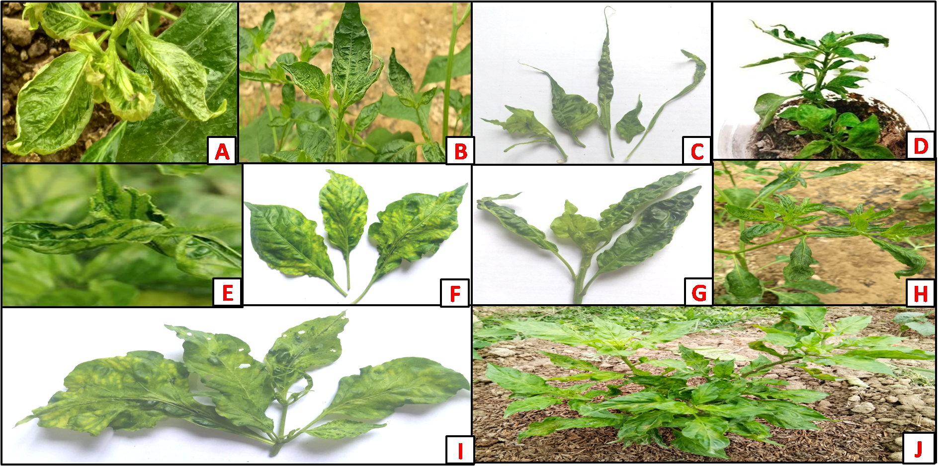
Figure 1: Symptoms observed during survey (a) Curling of leaves, (b) Crinkling of leaves, (c) Filiform leaves, (d) Stunted growth, (e) Vein banding on leaf, (f and g) Mosaic and mottling on leaf (h) Mosaic with puckering of leaf, (i) Green island symptoms and (j) Mosaic with stunted growth.

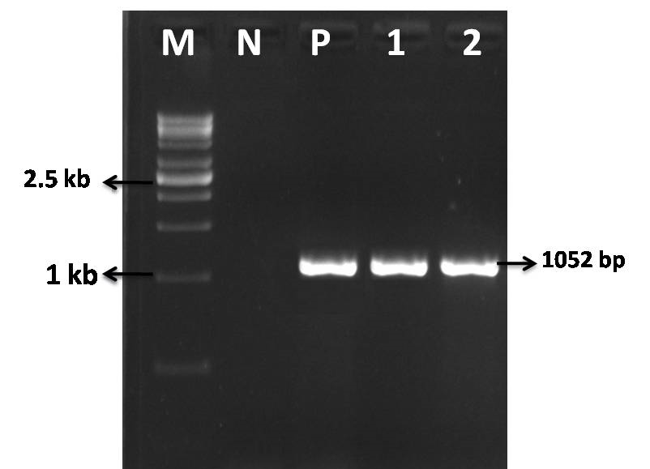
Figure 2: Agarose gel electrophoresis showing amplification of the CMV replicase gene (1052 bp) from Bhut Jolokia isolates.
M: 1 kb DNA ladder; N: Healthy plant control;
L1: CMV-JRT (Jorhat); L2: CMV-GLT (Golaghat)
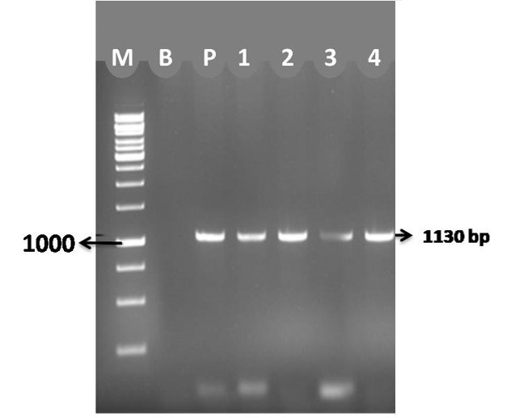
Figure 3: Agarose gel electrophoresis showing amplification of the CMV coat protein gene (1130 bp) from Bhut Jolokia isolates. M: 1 kb DNA ladder; N: Healthy plant control;
L1: CMV-JRT; L2: CMV-GLT; L3: CMV-LKP; L4: CMV-DMJ.
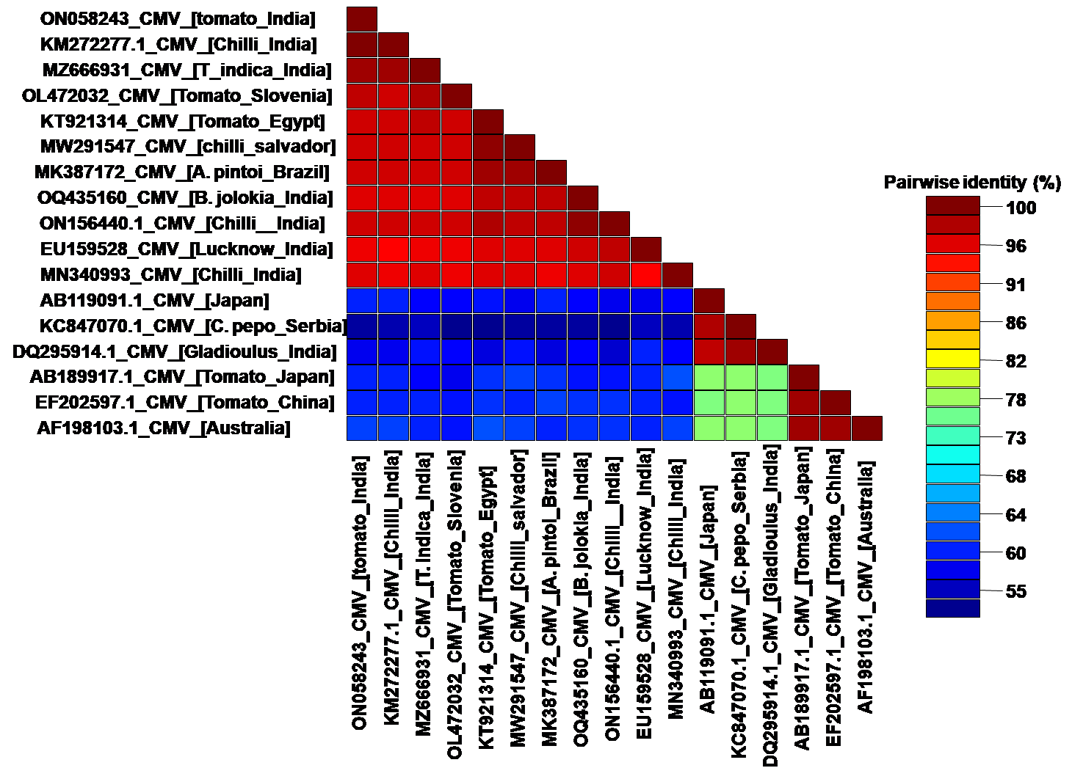
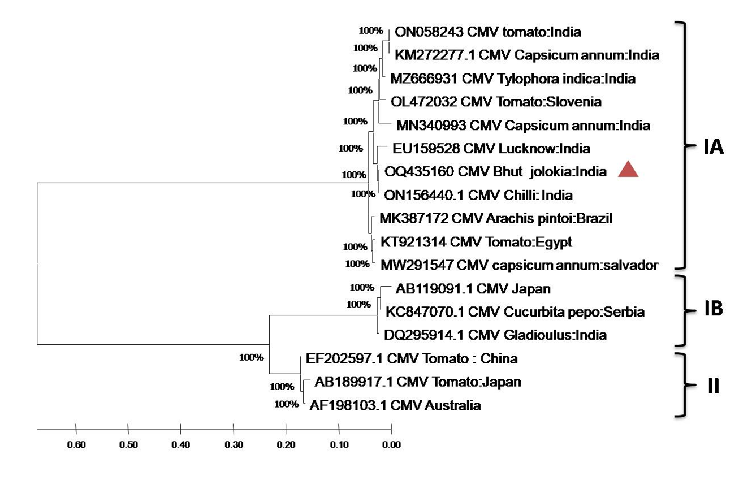
Figure 4: Maximum Likelihood phylogenetic tree (1000 bootstrap replications) based on the CMV replicase gene sequences from Bhut Jolokia isolates in Assam.
The four present isolates (CMV-JRT, CMV-GLT, CMV-LKP, CMV-DMJ) cluster within Subgroup IA along with other Indian CMV isolates. Bootstrap values (%) are shown at branch nodes. Scale bar indicates nucleotide substitutions per site.

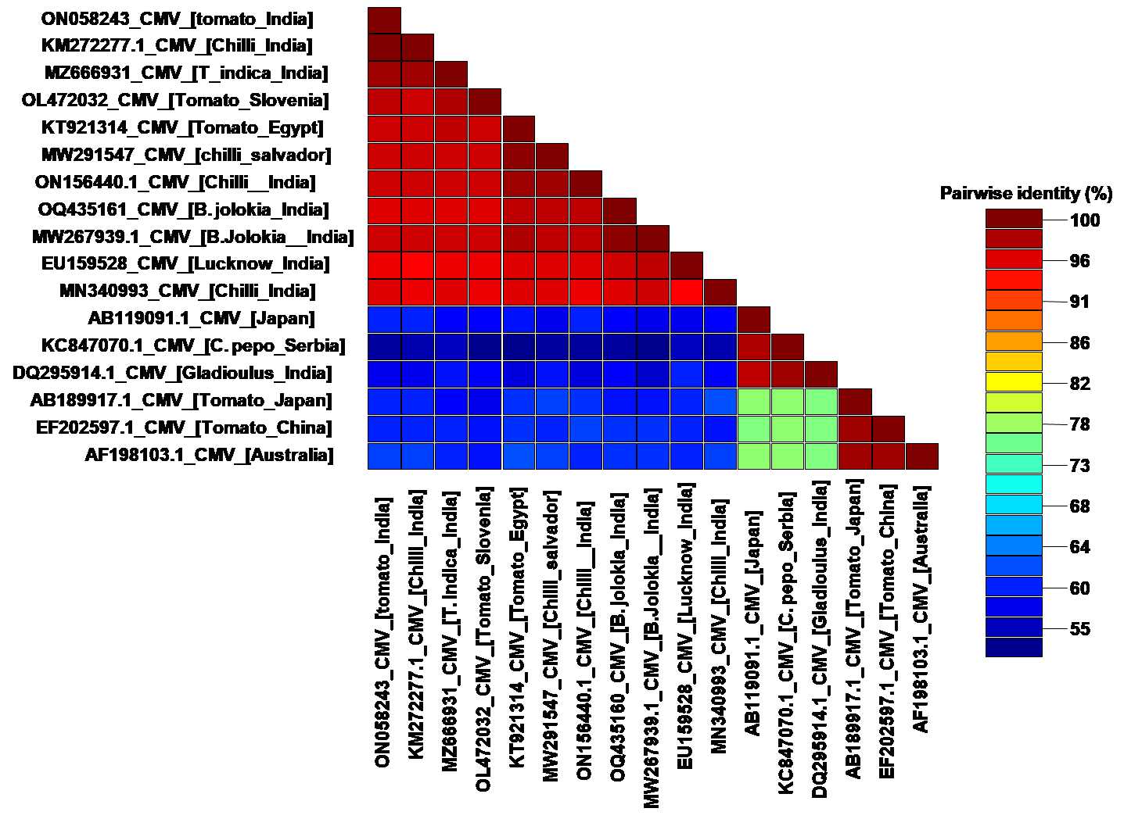
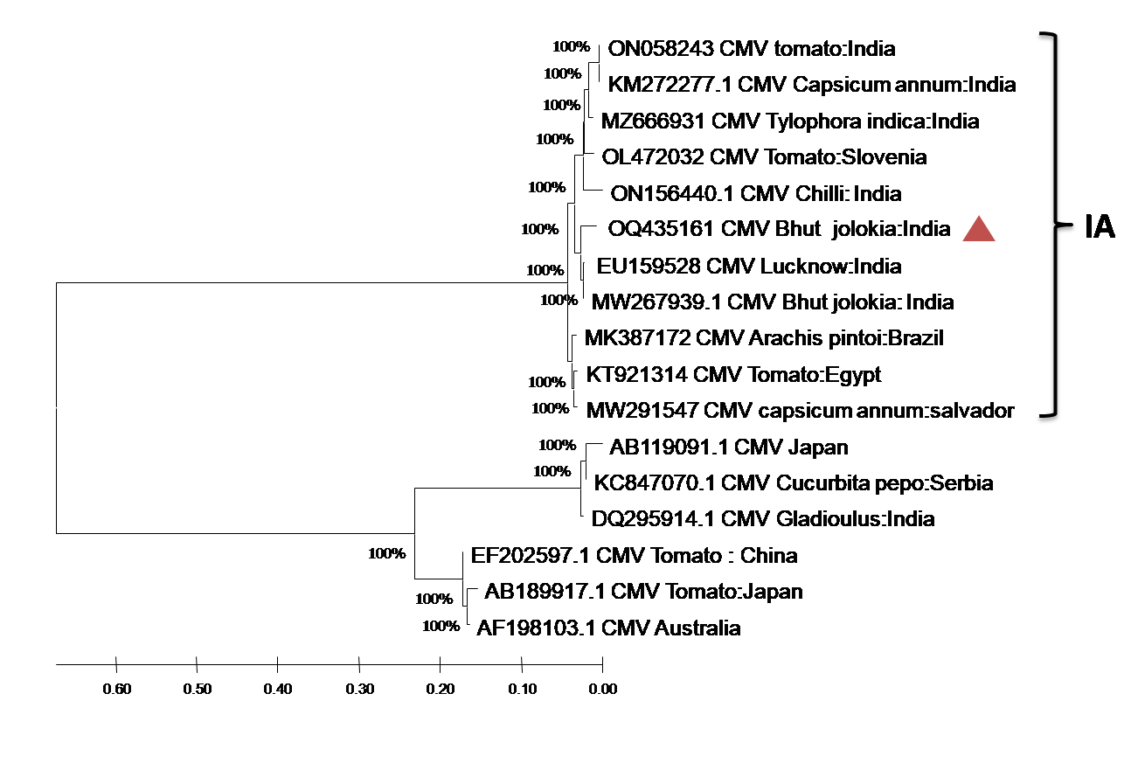
Figure 5: Maximum Likelihood phylogenetic tree (1000 bootstrap replications) based on the CMV coat protein gene sequences from Bhut Jolokia isolates in Assam.
All four sequenced isolates grouped strongly within Subgroup IA, confirming their close relatedness to previously reported CMV strains from chili in India.
Bootstrap values (%) indicated on branches; scale bar denotes nucleotide substitutions per site.

