Long-Term Conservation Tillage: Impacts on Soil Structure, Moisture, and Erosion: A Review

Abstract
Conservation tillage has emerged as a sustainable alternative to conventional ploughing systems, aiming to enhance soil health, improve water-use efficiency, and reduce environmental degradation. Long-term adoption of conservation tillage practices such as zero tillage, minimum tillage, and residue retention has shown significant impacts on soil structure, moisture dynamics, and erosion control. This review synthesizes current knowledge on how long-term conservation tillage influences soil physical properties, hydrological processes, and erosion mechanisms. Results from global and regional studies indicate improved soil aggregation, reduced bulk density, enhanced infiltration, higher soil moisture storage, and substantial reduction in soil loss. The review highlights the potential of conservation tillage as a climate-smart practice and identifies research gaps for future studies.
Keywords: Conservation tillage, soil physical properties, soil erosion, bulk density
Introduction
Conventional tillage methods, involving repeated ploughing and intensive soil manipulation, have been traditionally practiced across agricultural systems for facilitating seedbed preparation, incorporating residues, and managing weeds (Angon, et al., 2023). While these methods provide short-term agronomic benefits, their long-term implications have raised global concerns. Long-term continuous soil disturbance disrupts natural soil structure, accelerates decomposition of organic matter, and increases the susceptibility of soils to erosion, potentially compromising soil fertility and environmental sustainability in the process (Boincean, and Dent, 2019). Intensive tillage can also enhance mineralization of SOC, leading to increased greenhouse gas emissions and undermining long-term soil productivity (Srivastava, 2025).
In contrast, conservation tillage systems are designed to limit soil disturbance while maintaining a protective amount of crop residue on the soil surface: zero tillage, minimum tillage, strip tillage, and mulch-based practices (Carr, et al., 2013). These systems are central to conservation agriculture, which aims at three principles: no or minimum mechanical soil disturbance, permanent soil cover, and crop rotation including legumes ((Srivastava, 2025). After long-term adoption, the practices have been found to be quite beneficial due to considerable improvements in soil aggregation, biological activity, reduced erosion, and water retention. These improvements play an important role in increasing the resilience of agricultural systems against climatic variability (Hussain, et al., 2021).
Carr, P. M., Gramig, G. G., & Liebig, M. A. (2013). Impacts of organic zero tillage systems on crops, weeds, and soil quality. Sustainability, 5(7), 3172-3201.
Long-term conservation tillage has gained significant global attention as the foundation of sustainable intensification, especially in those regions characterized by soil degradation, low water availability, and yield decline (Kan, et al., 2020). Conservation tillage contributes to wider climate-smart agriculture approaches through improved soil organic carbon dynamics, beneficial microbial communities, and reduced erosion. It thus presents a means of maintaining soil health, conserving natural resources, and sustaining crop yields amidst a climate that is becoming increasingly variable (Steponavičienė, et al., 2024).
Despite these clear benefits, adoption is still very uneven because of the constraints created by machinery requirements, weed pressures, residue management challenges, and variable crop responses. The review also identifies gaps in research and practical limitations, highlighting that location-specific assessment, long-term monitoring, and integrated approaches should be taken that combine conservation tillage with crop diversification, precision agriculture, and organic matter management (Sims, et al., 2018).
Soil erosion is greatly affected by soil structure, and the importance of this factor increases as the proportion of silt and fine sand fractions in the soil increases (Wu, et al., 2020). The more silt and sand found in the soil, the more susceptible it is to erosion, meaning that the study area has a potential erosion risk. Earlier work reported an increase in erosion rates with the rise in fractions of sand and silt (Ding, and Huang 2017). Based on physical and chemical analyses, soils in this area are strongly alkaline, with very high calcium levels, though the nitrogen (N) content is notably inadequate. Additionally, low organic matter means low stability of soil aggregates, hence limiting its potential for water and nutrient retention (Kekane, et al., 2015).
Climatic conditions, continuous disturbance of the soil, burning of stubble, and scarce organic amendments have together caused a decline in the fertility of the soil and erosion at an increased rate. The higher concentration of calcium, magnesium, phosphorus, and potassium was also reported in the soil (Meryem and Funda 2015).
Tillage remains a fundamental activity of agricultural land management. It includes soil disturbance, turning of the soil, and reshaping to favorably change the physical condition of the soil for plant growth. The operations serve to break up, loosen, crush, or sometimes compact the soil aggregates (Liang, et al., 2025). Properly done and timely tillage contributes to increased productivity due to improved structure and consequently easier carrying out of agronomic operations. In addition, conservation-effective tillage can enhance erosion control to better retain soil moisture (de Sousa, and Grichar, (2024).
This review assimilates existing literature to assess the impacts of long-term conservation tillage on soil structure, moisture dynamics, and erosion control within a wide range of agroecosystems. It collates evidence from global and regional studies, indicating how conservation tillage modifies main soil physical properties like bulk density, porosity, infiltration rate, and aggregate stability. The review also addresses hydrological consequences in terms of water retention, evapotranspiration patterns, and overall soil-water balance resulting from prolonged conservation tillage (Wang, et al., 2025).
In this study, emphasis is focused on conventional tillage, reduced tillage under dryland farming conditions, mulching practices, and their combined effects regarding soil moisture conservation. (Meryem and Funda, 2015)
Flow chart 1: Impacts of long-term conservation tillage on soil structure, moisture dynamics, and erosion control
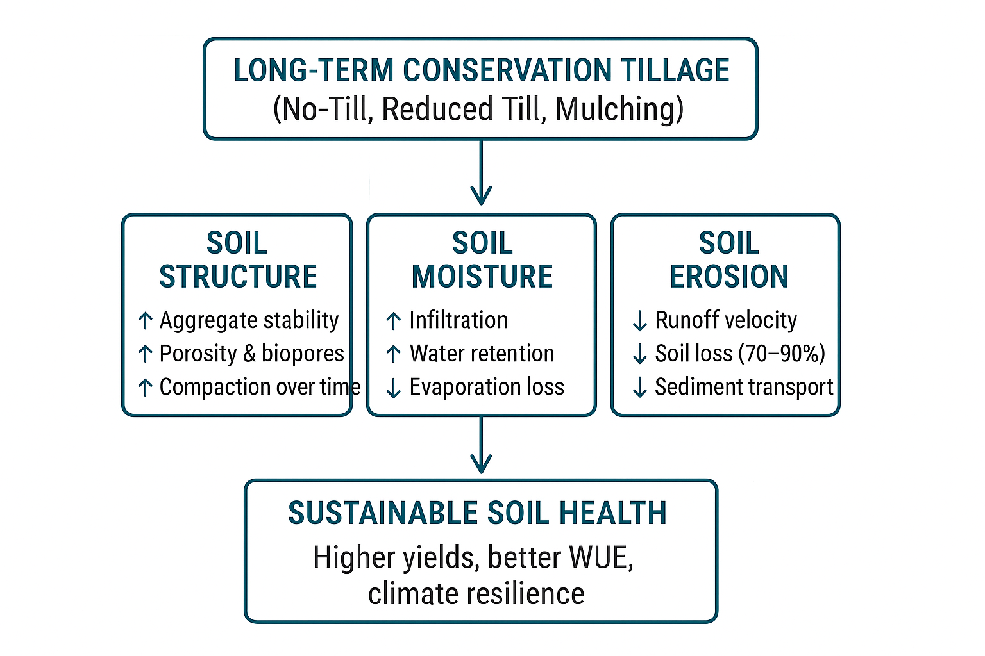
Overall, appreciating the long-term effects of conservation tillage is critical for creating resilient, productive, and sustainable agricultural systems that can help meet global food security requirements without further compromising these key resources.

Table 1. Comparison Between Conventional and Conservation Tillage
Parameter | Conventional Tillage | Long-Term Conservation Tillage
Soil disturbance | High (ploughing, harrowing) | Very low (no-till/minimum till)
Residue cover | <10% | ≥30–90%
Aggregate stability | Low | High (20–50% increase)
Bulk density | Initially low but increases with time | Initially high but stabilizes
Infiltration rate | Low | High (up to 40% increase)
Water erosion | High | Low (70–90% reduction)
Weed pressure | Low initially | Higher (needs IWM)
Fuel/labour use | High | Low

2. Concept and Principles of Conservation Tillage and their impact
Conservation tillage, in general, is a soil management strategy that leaves at least 30% of the crop residue on the surface after planting to reduce erosion, conserve moisture, and improve soil health over time. It stresses minimum soil disturbance and maintenance of ecological functions within the soil. The following principles form the foundation of conservation tillage systems (Reicosky, 2015).
Minimum soil disturbance implies mechanical operations like ploughing, harrowing, or repeated tillage are drastically reduced so that the structure remains intact with no breakdown of the aggregates (Busari, et al., 2015).
Table 2: Impact of Conservation Tillage on Soil Properties

Soil Property | Conventional Tillage | Conservation Tillage | Effect of Conservation Tillage
Soil Organic Matter (%) | 1.2 | 2.1 | Increased due to residue retention
Soil Erosion (tons/ha/year) | 15 | 5 | Decreased erosion in conservation tillage
Soil pH | 6.3 | 6.6 | Slight increase in pH
Bulk Density (g/cm³) | 1.5 | 1.3 | Reduced bulk density, improving porosity
Soil Moisture Content (%) | 20 | 30 | Higher moisture retention in conservation tillage
Microbial Activity (cfu/g) | 2 x 10⁶ | 5 x 10⁶ | Enhanced microbial activity
(Source, Laxman et al., 2024)

Table 3: Impact of Conservation Tillage on Crop Yield

Crop Type | Conventional Tillage Yield (kg/ha) | Conservation Tillage Yield (kg/ha) | Effect of Conservation Tillage
Corn | 4500 | 5100 | 13% increase in yield
Wheat | 3500 | 3800 | 8.5% increase in yield
Soybean | 2200 | 2500 | 13.6% increase in yield
Rice | 6000 | 6300 | 5% increase in yield
Barley | 2800 | 3000 | 7.1% increase in yield
(Source, Laxman et al., 2024)
Conservation tillage marks a major shift from traditional plowing to practices that reduce soil disturbance, maintain crop residues, and promote long-term soil health. With rising challenges from climate change and the need for greater food production, it has become an essential approach for preventing soil degradation and improving resource efficiency (Liang, et al., 2025). Conventional tillage, on the other hand, often accelerates erosion, reduces organic matter, and damages soil structure, ultimately lowering water retention and restricting root growth.
Permanent soil cover with crop residues ensures that the soil surface is protected at all times by plant materials, which reduce raindrop impact, lower evaporation losses, and add to soil organic matter accumulation while decomposing (Boincean, and Dent,, 2019).
Diverse crop rotations or intercropping systems maintain soil fertility, break pest and disease cycles, and improve overall soil biological activity through different rooting patterns and ways of nutrient uptake.
Impact on Soil Properties
Conservation tillage significantly transforms the physical, chemical, and biological attributes of the soil, ultimately contributing to improved soil health, enhanced productivity, and greater resilience of cropping systems against climate variability and environmental stresses (Gómez-Rey, et a., 2012). By minimizing soil disruption and retaining plant residues on the surface, conservation tillage promotes natural soil-building processes (Liang, et al., 2025).

Soil Physical Properties

Soil Structure
Conservation tillage improves soil structure by reducing mechanical disturbance and allowing organic residues to remain on the soil surface, where they gradually decompose and contribute to the formation of stable soil aggregates (Reicosky, 2015). The enhanced aggregation improves soil porosity and permeability, which in turn facilitates better root penetration, increases aeration, supports balanced water movement, and reduces the susceptibility of soil to erosion caused by wind and water (Farahani, et al., 2022).

Bulk Density
In the initial years of adopting conservation tillage, a slight increase in bulk density is often observed because the soil is not loosened mechanically; however, this effect diminishes over time as organic residues accumulate and stimulate microbial and earthworm activity that naturally loosens the soil (Al-Shammary, et al., 2018). As biological processes increase, the soil develops more macropores at deeper layers, reducing compaction and improving root zone conditions (Zi-zheng, et al., 2023).

Water Retention
One of the major advantages of conservation tillage is enhanced water retention, as surface residues minimize water loss through evaporation and encourage greater water infiltration. These residues reduce runoff by absorbing the impact of raindrops, protecting the soil surface, and allowing moisture to seep into the profile (Bekele, et al., 2020). Improved soil structure and preserved macropores further contribute to moisture conservation, making the practice particularly suitable for semi-arid and drought-prone regions (Kool, et al., 2019).

Other Benefits
Residue cover moderates soil temperature by acting as an insulating layer, which reduces temperature fluctuations and creates a more favorable environment for root growth and microbial processes (Sharma, and Kumar, 2013). This moderation also helps crops withstand extreme heat or cold, ultimately supporting consistent growth and development. The overall improvement in soil physical properties under conservation tillage enhances long-term soil fertility, productivity, and sustainability (Liang, et al., 2025).

Soil Chemical Properties

Soil Organic Carbon (SOC)
Conservation tillage promotes the accumulation of soil organic carbon by retaining plant residues and reducing oxidation losses associated with soil disturbance. The increased SOC improves soil structure, enhances water-holding capacity, boosts cation exchange capacity (CEC), and facilitates efficient nutrient cycling (Han, et al., 2016). Over time, enhanced SOC significantly contributes to carbon sequestration, making conservation tillage an important climate-friendly agricultural practice (Liang, et al., 2025).

Nutrient Availability
The gradual decomposition of residues enriches the soil with essential nutrients that are released slowly and steadily, ensuring a more balanced nutrient supply throughout the crop cycle. Minimal soil mixing under conservation tillage may cause nutrient stratification, particularly in the topsoil layer, making it necessary to adopt site-specific nutrient placement strategies and diversified crop rotations (Marschner, and Rengel 2023). Increased organic matter also boosts the availability of micronutrients such as zinc, iron, and boron by improving chelation and microbial transformations (Shah, and Wu 2019).

Soil Biological Properties

Microbial Activity
Conservation tillage enhances the abundance and diversity of soil microorganisms by preserving organic residues, maintaining stable microhabitats, and minimizing physical disturbances. Beneficial microbes such as nitrogen-fixing bacteria, decomposers, and mycorrhizae become more active, contributing to improved nutrient cycling, greater soil aggregation, and enhanced soil fertility (Madejón, et al., 2009).

Earthworms
Earthworm populations increase significantly under conservation tillage because undisturbed soil and ample organic residues provide a suitable environment for their growth and reproduction. Their burrowing activities create vertical and horizontal macropores that improve water infiltration, aerate the soil, and accelerate residue decomposition, further enriching the soil (Peigné, et al., 2009).

Other Soil Fauna & Enzymes
The abundance of soil fauna such as arthropods and nematodes, along with increased activity of soil enzymes like dehydrogenase, phosphatase, and urease, collectively enhances decomposition, accelerates nutrient mineralization, and strengthens biological soil health. These biological processes contribute to a self-sustaining and resilient soil ecosystem (Madejón, et al., 2007).

Impact on Crop Yield
Crop yields under conservation tillage are influenced by soil type, climate, management practices, and crop species, and while initial responses may vary, long-term outcomes are generally favorable (Amini, and Asoodar 2009).

Positive Effects
Conservation tillage enhances crop yields by improving moisture retention, particularly in dry and water-scarce environments, where preserved residues and stable soil structure ensure better water availability. Enhanced microbial activity leads to more efficient nutrient cycling, which supports stronger root growth and improved nutrient uptake. Healthier soils foster robust plant development, resulting in more stable and reliable yields even under adverse climatic conditions (Xiao-Bin, et al., 2006).

Short-Term Yield Reductions
In the early years of transitioning to conservation tillage, farmers may experience slight yield declines due to increased bulk density, higher weed pressure, and challenges associated with planting through surface residues (Büchi, et al., 2017). However, these temporary issues can be effectively managed through integrated weed management, use of cover crops, proper residue handling, and the adoption of specialized planting equipment designed for conservation systems (Schneider, et al., 2017).

Crop-Specific Responses
Cereal crops such as wheat and maize generally respond positively to conservation tillage due to improved water-use efficiency and soil health. Legumes perform well as they benefit from enhanced soil biological activity, which supports nitrogen fixation. Root crops may experience difficulty in compacted soils initially, but strategic practices like strip tillage help mitigate these constraints (Wen, et al., 2023). Oilseed crops show variable responses depending on residue management, nutrient placement, and overall field conditions (Wittwer, et al., 2023).

Long-Term Benefits
With continued implementation, conservation tillage leads to increased productivity, reduced labor and fuel costs, and improved soil fertility, resulting in significant long-term economic and environmental advantages. Additionally, conservation tillage enhances climate resilience by improving water retention, reducing erosion, and increasing carbon sequestration, making it a key strategy in sustainable agricultural development (Nath, et al., 2024).

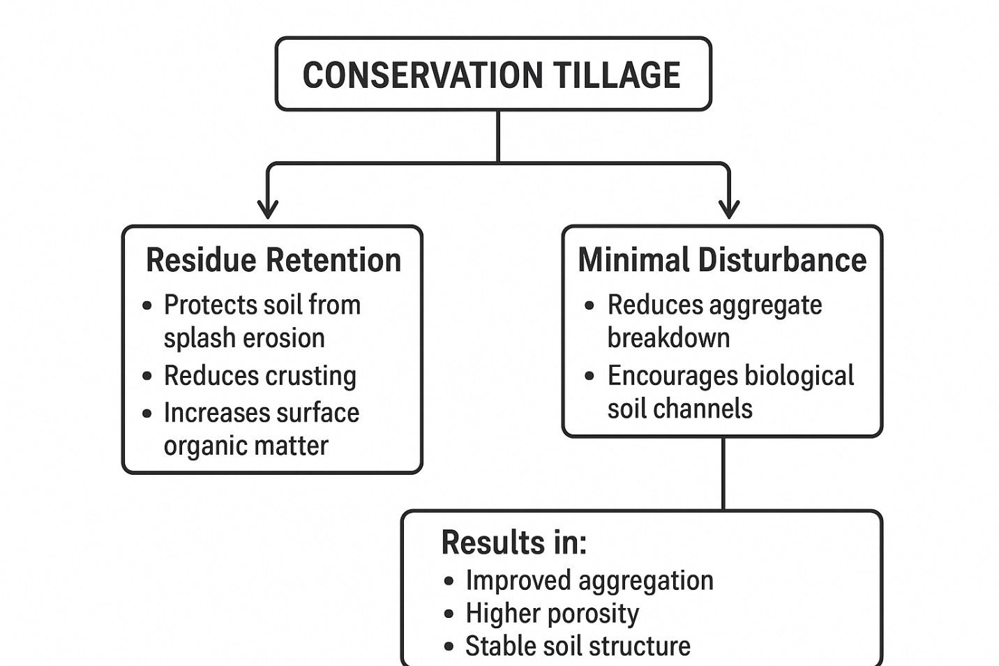
Flow chart 2: Key components of conservation tillage and their combined effects on soil aggregation, porosity, and structural stability
Soil Structural Dynamics under Conservation Tillage
Soil structure, including aggregates, porosity, and stability, is crucial for plant growth and water movement. Conservation tillage improves macroaggregate formation, reduces compaction, and enhances aeration and water flow. Increased microbial and faunal activity acts to bind soil particles together, improving the stability of the structure, which provides resistance to erosion (Schlüter, et al., 2018). The outcome over time is organic matter stratification, improved hydraulic conductivity, and reduced bulk density in surface layers, which permit deeper root growth to improve access to moisture and nutrients (Zhang, et al., 2021).
Crop Water Use Efficiency (WUE)
Water use efficiency, defined as the ratio of yield to water consumed, is improved under conservation tillage because of increased infiltration and reduced evaporation. Residue cover provides mulch that moderates soil temperature and reduces water loss (Mbava, et al., 2020). Increased root growth into deeper layers allows plants to use subsoil moisture more effectively, thereby increasing yield per unit of water and improving drought resistance (Ali, et al., 2017).
Conservation vs. Conventional Tillage
Conservation tillage provides several long-term structural and hydrological advantages over conventional plowing. It offers a congenial habitat to soil microbes, optimizes nutrient cycling, and enhances biological activity (Subbulakshmi, et al., 2009). Conventional tillage may provide a short-term increase in yield but mostly brings long-term degradation of soils. The processes of conservation systems have particular advantages in areas experiencing drought, erosion-prone landscapes, and soils with low organic carbon (Yau, and Sidahmed, 2010).

Table 4: Comparative Analysis of Conservation and Conventional Tillage

Parameter | Conventional Tillage | Conservation Tillage
Soil Aggregate Stability | Low | High
Infiltration Rate | Moderate | High
Surface Runoff | High | Low
Bulk Density | High | Moderate
Root Penetration | Limited | Deep
Soil Organic Matter Retention | Low | High
Water Use Efficiency (WUE) | Moderate | High

Major Types of Conservation Tillage
Zero/No-Tillage (NT) involves placing seeds in untilled soil with no form of soil inversion; crop residues are left undisturbed on the surface to provide maximum protection and conservation of soil moisture (Lal, et al., 2020).
Minimum/Reduced Tillage (MT/RT) refers to systems that are characterized by limiting the extent of soil disturbance to only shallow and necessary operations, which reduces energy use, improves soil stability, and maintains more residue cover compared to conventional tillage. Mulch tillage retains substantial amounts of crop residues on the soil surface with minimal tillage operations. This reduces erosion, improves infiltration, and moderates soil temperature during the growing season. Strip tillage involves the tilling of narrow strips only where seeds are to be planted, while the inter-row areas remain undisturbed. This management allows for better soil warming and seed placement without sacrificing any residue cover or conservation of soil moisture in the untilled zones (Li, et al., 2019).

Conservation Tillage System Architecture

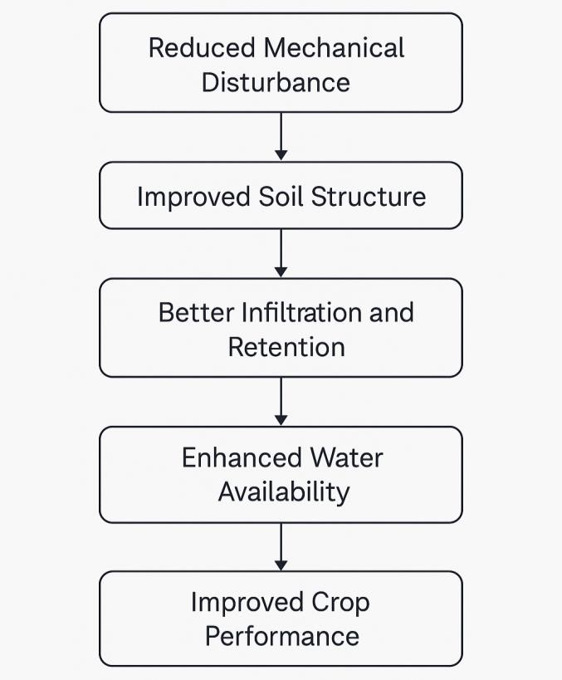
(Source, Iyer, 2024).
Figure 1: Conceptual Framework of Conservation Tillage Impact Pathways
Effects of Tillage on Soil Properties and Crop Production
This can be regarded as one of the most relevant methods for minimizing negative effects resulting from conventional tillage: the adoption of reduced tillage or the elimination of soil disturbance altogether. Under the topic "Effects of various long-term tillage systems on some chemical and biological properties of soil," the research was conducted with the purpose "to evaluate the effect of conventional, reduced, and no‐tillage on some selected soil chemical properties-organic carbon, total nitrogen, and pH-and biological characteristics like total bacterial population, numbers of oligotrophs, copiotrophs, fungi, and the activity of enzymes such as dehydrogenases and acid phosphatase" (Stanek-Tarkowska et al., 2018).
Tillage practices can change the soil hydraulic characteristics, such as infiltration rate, hydraulic conductivity, and water retention, which are the essential ones related to the ability of the soil to absorb and store water coming from rainfall or irrigation. By changing the distribution and arrangement of soil aggregates, tillage alters the movement and retention of water in the soil profile. Therefore, conservation soil moisture by tillage systems assumes greater importance for crop production in arid and semi-arid regions (Blanco 2017).
Previous studies indicate that the net effect of tillage on grain yield is often not significant. However, stover yield tends to increase with application of crop residues like straw. The soil moisture under tied-ridging was about 20% higher than that under other tillage treatments and about 16% greater when 3 Mg ha⁻¹ straw was applied compared to no straw. Water-use efficiency increased linearly with quantity of straw applied. However, in general, it was lower under zero tillage and under tied-ridging or conventional tillage systems. Tied-ridging appears to be the most promising tillage method, and maintaining soil cover with crop residues is essential for achieving satisfactory yields under zero tillage (Mesfine et al., 2005).
Positive Effects of Tillage on Soil Properties and Crop Production
Though the direct effect of tillage on grain yield was not significant, tillage practices had several positive effects on soil properties and crop performance. Tillage, by altering soil structure, influences water infiltration, hydraulic conductivity, and waterholding capacity, all those factors determining the extent to which soil can catch and store water from rainfall or irrigation. Incorporation of straw further enhanced the benefits: stover yield increased with straw application, and seasonal soil moisture levels were about 20% higher under tied-ridging compared with other tillage systems. Similarly, the application of 3 Mg ha⁻¹ of straw increased soil moisture by around 16% over plots that did not receive straw. Water-use efficiency increased proportionally with added straw, though it remained lower under zero tillage and tied-ridging or conventional systems. Overall, tied-ridging emerged as the most advantageous tillage practice, and maintenance of residue cover is crucial to attain satisfactory yields under zero-tillage conditions (Mesfine et al., 2005).
Effect of Different Tillage Practices on Soil Moisture Conservation
Zero Tillage Practice
Zero tillage during the wet season reduced biomass and grain yield. Leaf chlorophyll levels were lower under zero tillage, showing reduced nitrogen uptake (Quddus,et al., 2020). Zero tillage and residue retention lowered early plant growth and significantly increased ear rot incidence. In contrast, during the dry season, zero tillage increased root biomass as measured by electrical capacitance, and residue conservation shortened the anthesis-silking interval, suggesting improved water absorption (Malecka, et al., 2012). The improvement in soil bulk density, nitrogen concentration, and microbial biomass did not result in significant yield differences. Residue conservation increased soil carbon and microbial biomass, while intercropping with jackbean improved soil nitrogen levels. According to the authors, further research is needed to establish precisely how the changes in soil physical and chemical properties caused by conservation tillage affect early maize growth and yield performance over the longer term.
Ward et al. (2006) assessed cash crop performance in no-till systems where cover crops were chemically terminated and flattened with a roller-crimper. Variables measured included yield, soil moisture, leaf temperature, and biomass of the cover crop. Preliminary results showed that winter cover crops lowered yields, presumably due to nitrogen immobilization. Spring tillage greatly increased yields, while there was little difference in yield from fall tilling compared with no-till due to rapid reconsolidation of soils. Ward et al. (2006) recommended continued research to find the tillage–cover crop combinations most effective at improving soil quality and productivity.
Reduced Tillage Practice
In the reduced tillage systems, there remains 10–15 cm height of stubble after crop harvest. Deep ploughing (25–30 cm) followed by shallow harrowing (5–8 cm) is made before winter wheat sowing. Fewer numbers of tillage operations are required in this method compared to conventional systems (Mihovsky, and Pachev, 2012).
Long-term effects on soil structure
Soil structure is of paramount importance in supporting root development, moderating water infiltration, facilitating soil aeration, and allowing for efficient nutrient cycling. In the long term, conservation tillage strongly influences the key physical properties of the soil, such as aggregate stability, bulk density, porosity, and compaction (Mihovsky, and Pachev 2012). These changes, in concert, contribute to improved soil health and increasing resilience of the cropping system.
Soil Aggregate Stability
Conservation tillage increases soil aggregate stability primarily through its promotion of organic carbon accumulation, which acts as a binding agent for soil particles and supports the formation of stable macro-aggregates (Naresh et al., 2017). Long-term experiments that run for 10 to 20 years often report a 20–50% improvement in aggregate stability under conservation tillage systems compared with conventional plough-based cultivation. Residue retention on the soil surface performs a number of critical functions related to aggregate protection, including raindrop impact reduction, mechanical breakdown minimization, and providing a suitable microenvironment for microbial activity that further enhances aggregate formation (Alskaf, 2018).
Bulk Density and Porosity
Long-term no-till systems often have a slightly higher bulk density in the first years as this results from the lack of mechanical loosening, but this condition stabilizes over time due to improvement in soil structure because of biological activity and organic matter accumulation (Marahatta, et al., 2014).
The method of conservation tillage greatly improves soil porosity, largely through the development of biopores made by earthworms, root channels, and other soil biota. These natural pores improve water infiltration, facilitate gaseous exchange, and support deeper root proliferation, contributing to better soil aeration and moisture dynamics (Indoria, et al., 2017).
Soil Compaction
Reduced-tillage and no-tillage systems may be subject to slight surface compaction due to the absence of soil inversion, but in the long term, subsurface compaction generally decreases as roots, soil fauna, and microbial processes break down and restructure the soil profile (Yang, 2022).
Controlled traffic farming (CTF) reduces these risks further by restricting the movement of machinery to pre-defined lanes, thus preventing impairment to the structural condition of the crop zone and enhancing the effectiveness of conservation tillage systems in general (Hamza, and Anderson, 2005).
Impacts on Soil Moisture Dynamics
In this connection, conservation tillage significantly impacts soil-water relationships by altering the infiltration behavior, water-holding capacity, evaporation losses, and the distribution of moisture throughout the soil profile. These changes have significant implications for drought resilience and water-use efficiency in both rainfed and irrigated cropping systems (Li, et al., 2016).
Infiltration and Water Storage
Reduced mechanical disturbance under conservation tillage enhances water infiltration rates, often as much as 40%, because stable soil aggregates and continuous residue cover prevent crusting and improve soil surface porosity. Long-term field studies have shown that conservation tillage systems maintain consistently higher soil moisture storage, especially in the upper layers (0-15 cm) where residue mulch reduces runoff and promotes slow, steady infiltration. This increased water retention contributes to improved water availability during the critical growth stages (Hou, et al., 2012).
Evaporation Loss Reduction
Crop residues left on the surface of the soil act like a very effective mulch layer, regulating soil temperature, protecting the soil from direct solar radiation, and reducing evaporative losses often by 30–50%. Conservation tillage increases water-use efficiency by reducing evaporation and therefore conserving more soil moisture, which is particularly beneficial in dryland and moisture-limited agricultural systems. This reduction in evaporative losses translates into better soil hydration and improved crop performance under water stresss (Humphreys, et al., 2021).
Moisture Availability to Crops
In the long term, conservation tillage enhances plant-available water by increasing the continuity of pores, the water-holding capacity, and the proportion of mesopores responsible for retaining moisture accessible to roots. Organic matter accumulation helps increase the soil's buffering capacity against short-term drought by raising its ability to store and supply water during dry periods. This improved moisture availability supports consistent root activity, better nutrient uptake, and enhanced crop resilience under varying climatic conditions (Bekele, 2020).
Impact on Soil Erosion and Runoff
Soil erosion is one of the most critical threats to sustainable agriculture as it leads to the loss of productive topsoil, the depletion of necessary nutrients, and the reduction of long-term soil productivity. Conservation tillage prevents water and wind erosion by retaining residue cover, improving soil structure, and increasing water infiltration. Over longer terms, conservation tillage systems reduce soil particle detachment, transport, and deposition significantly, lowering the total erosion rate and preserving environmental quality. Quite a number of long-term field studies have been conducted across various agroecological regions, all demonstrating that conservation tillage is very effective in controlling erosion and maintaining soil health under variable climatic conditions (Seitz, et al., 2019).
Reduction in Water Erosion
Conservation tillage greatly reduces water erosion by maintaining a protective residue cover on the soil surface that intercepts the raindrops and prevents the breakdown of the soil aggregates caused by splash erosion. In the long run, no-till and reduced-till systems reduce soil erosion by 70–90% due to the influence of the residue layer on lowering runoff velocity, enhancing surface roughness, and reducing the detachment of soil particles. Increased soil infiltration under conservation tillage further contributes to lower erosion rates, as more water being able to infiltrate the ground reduces the volume of surface runoff and the potential for soil loss during high-intensity rainfall events (Klik, and Rosner, 2020).
Wind Erosion Reduction
Conservation tillage conserves soil from wind erosion by keeping the soil covered at all times with crop residues; these protect the surface from immediate exposure to wind and help trap moving soil particles that would otherwise be eroded. Soil crusting is reduced with mulch and organic residues. The surface remains moist, which reduces the formation of loose, dry soil that is easily lifted and transported by wind. Soil aggregation and surface stability are improved with long-term residue retention, thus lowering emissions of particulate matter and minimizing dust storms, especially in semi-arid and arid farming regions (Jiang, et al., 2024).
Prevention of Sediment and Nutrient Loss
Conservation tillage effectively prevents sediment-bound nutrient losses through a reduction of detachment and transportation of soil particles carrying essential nutrients like nitrogen, phosphorus, and organic carbon. Conservation tillage reduces surface runoff and, consequently, minimizes nutrient leaching. It also ensures that fertilizers and organic amendments are retained in the root zone, thus improving soil fertility and nutrient-use efficiency. Studies have shown that downstream water bodies from agricultural fields practicing long-term conservation tillage tend to have improved water quality; lower sediment loads result in lower eutrophication, reducing the contamination of aquatic ecosystems (Macrae, et al., 2023).
Biological Amendments Under Conservation Tillage
Although this review focuses largely on the impacts of conservation tillage on soil structure, moisture dynamics, and erosion reduction, it is important to note that substantial biological improvements also occur under long-term reduced-disturbance systems. This is because conservation tillage augments soil biological functioning through the increase in organic matter inputs, creation of stable microhabitats, and the support of diverse microbial and faunal communities contributing to improved soil fertility, nutrient cycling, and overall ecosystem resilience (Winkler, et al., 2022).
Soil Organic Carbon Sequestration
Long-term conservation tillage consistently fosters the building of soil organic carbon through reducing the rate of residue decomposition and encouraging carbon stabilization in soil aggregates. Continuous residue retention on the soil surface provides a steady supply of organic inputs, which, over time, make significant contributions to the build-up of carbon in upper soil horizons (ur Rehman, et al., 2023). According to research, long-term no-till systems can increase soil organic carbon stocks at a rate of about 0.2–0.5 t C ha⁻¹ yr⁻¹, thus favorably affecting the structure, water-holding capacity, and the resilience of the soil to climatic stress. This gradual increase in SOC not only contributes to improved crop productivity but also plays a vital role in global carbon sequestration efforts, thereby making conservation tillage a valuable climate-smart agricultural practice.
Enhanced Microbial and Faunal Activity
Conservation tillage creates a more favorable setting for soil microorganisms due to stable temperature levels in the soil, higher moisture, and organic substrate availability throughout. Enhanced microbial biomass and increased activities of key soil enzymes such as dehydrogenase, phosphatase, and urease are commonly observed under long-term no-till systems, thus indicating improved nutrient transformation processes. Earthworm populations further increase significantly under conservation tillage due to reduced physical disturbance and better food availability. This forms natural biopores that enhance soil porosity and aeration. The combined activity of microbes and soil fauna acts to enhance nutrient mineralization, support aggregate stability, and promote a biologically active soil environment that supports directly sustainable soil health and long-term agricultural productivity (Zhang, et al., 2015).
Agronomic and Environmental Benefits
Conservation tillage improves crop productivity in water-limiting environments through a combination of enhanced soil water retention, reduced evaporative losses, and the maintenance of a stable soil microclimate that sustains uninterrupted root growth and nutrient uptake. Input-use efficiency-especially of fertilizers and irrigation water-shows significant gains under conservation tillage due to improved soil structure and biological activities enhancing the nutrient cycle, reducing nutrient leaching, and promoting improved root-soil interactions (Busari, et al., 2015).
Overall, the production costs decrease when conservation tillage greatly reduces fuel consumption, labour input, and machinery wear since this involves fewer and less severe tillage operations than are usually necessary to prepare a seedbed conventionally. Long-term adoption of conservation tillage enhances soil carbon sequestration by facilitating the accumulation of soil organic matter, hence contributing to climate change mitigation by capturing and storing atmospheric carbon in stable pools of soil carbon. Conservation tillage involves reduced soil disturbance; this lowers the emission of greenhouse gases from the soil, in particular carbon dioxide through minimized soil oxidation and nitrous oxide by improving nitrogen dynamics, thus reducing the environmental footprint of agricultural production systems (Liang, et al., 2025).
Challenges and Limitations of Long-Term Conservation Tillage
The wide-scale adoption of conservation tillage has been constrained in various parts of the world by several practical and biological problems, despite its considerable agronomic and environmental advantages. Many regions have experienced yield reductions in their first few years of adoption, partly from low soil temperatures or compaction of heavy-textured soils, possibly inhibiting early crop growth. Weed pressure often intensifies under reduced soil disturbance, calling for integrated weed management strategies that combine herbicide use, crop rotation, and cultural controls. Generally, crop residues remaining on the soil surface harbor pests and pathogens, enhancing disease carry-over between successive seasons. This demands improved monitoring and biological control techniques. Specialized machinery, such as no-till seeders, residue managers, and strip-till planters, imposes additional financial and technical disadvantages on small and marginal farmers. Changes in soil physical properties, like aggregation and porosity, occur rather gradually, and hence their beneficial effects can be obtained only after a long-term commitment; therefore, it is often difficult for farmers to realize immediate benefits from conservation tillage.
Research Gaps and Future Perspectives
Though significant advances have been made, several research gaps still exist that need to be addressed for wider and more efficient adoption of conservation tillage systems. Long-term studies beyond 15 years on different soils and climatic zones are urgently needed to understand the cumulative effects of the soil health, crop productivity, and environmental performances. Comparison studies between conservation tillage and the emerging regenerative approaches offer deeper insights into the relative benefitting of each system to soil carbon sequestration, biodiversity, and ecosystem functioning. Mechanization support matching smallholder farmers' needs, in particular, is partial and requires designs of low-cost equipment adaptable in different regions. There is also a need for additional research to assess GHG emissions under various agroclimatic conditions, including the interaction between soil texture, moisture regimes, and residue load. Integration of conservation tillage with precision agriculture tools-such as remote sensing, variable-rate application, and digital soil mapping-offers promising opportunities to better optimize residue management, seed placement, and input efficiency, thus its comprehensive investigation is warranted. These collective researches will help refine conservation tillage into a climate-resilient and resource-efficient practice.
Conclusion
Long-term conservation tillage improves soil health through better structure, aggregate stability, and increased organic matter content. Higher amount and persistence of residues and lower soil disturbance lead to improved water retention, infiltration, and a better environment for the growth of crops under water-limiting conditions. Its wide adoption has significantly reduced soil erosion and surface runoff, thus reducing nutrient losses and improving environmental quality. Gradual improvement in the biological and physical conditions of the soil leads to increased system resilience, enabling agricultural landscapes to perform better under climatic stressors such as drought, heavy rainfall, and extreme temperatures. Being climate-smart and resource-efficient, conservation tillage represents one potential pathway toward sustainable intensification and low-carbon crop production. However, scaling up will require a well-coordinated approach in terms of research, extension, capacity building, and policy support. With sustained commitment, conservation tillage can help transform global agricultural systems towards sustainability, productivity, and climate resilience.

Disclaimer (Artificial intelligence)
Author(s) hereby declare that generative AI technologies such as Large Language Models, etc. have been used during the writing or editing of manuscripts. This explanation will include the name, version, model, and source of the generative AI technology and as well as all input prompts provided to the generative AI technology
Details of the AI usage are given below:
1. Yes Used ChatGPT
2.
3.

Reference
- Ali, A. B., Elshaikh, N. A., Hong, L., Adam, A. B., & Haofang, Y. (2017). Conservation tillage as an approach to enhance crops water use efficiency. Acta Agriculturae Scandinavica, Section B—Soil & Plant Science, 67(3), 252-262. https://doi.org/10.1080/09064710.2016.1255349
- Alskaf, K. (2018). Conservation agriculture for sustainable land use: the agronomic and environmental impacts of different tillage practices and plant residue retention: farmer uptake of reduced tillage in England (Doctoral dissertation, University of Nottingham). https://eprints.nottingham.ac.uk/51950/1/Conservation%20agriculture%20for%20sustainable%20land%20use.pdf
- Amini, S., & Asoodar, M. A. (2016). The effect of conservation tillage on crop yield production. NY Sci J, 8(3), 25-9. https://doi.org/10.7537/marsnys080315.04
- Angon, P. B., Anjum, N., Akter, M. M., KC, S., Suma, R. P., & Jannat, S. (2023). An overview of the impact of tillage and cropping systems on soil health in agricultural practices. Advances in Agriculture, 2023(1), 8861216. https://doi.org/10.1155/2023/8861216
- Bekele, D. (2020). The effect of tillage on soil moisture conservation: a review. Int. J. Res. Stud. Comput, 6, 30-41. https://doi.org/10.20431/2454-6224.0610004
- Blanco, H., & Lal, R. (2010). Principles of soil conservation and management. Springer. https://doi.org/10.1007/978-1-4020-8709-7
- Blanco-Canqui, H., Wienhold, B. J., Jin, V. L., Schmer, M. R., & Kibet, L. C. (2017). Long-term tillage impact on soil hydraulic properties. Soil and Tillage Research, 170, 38-42. https://doi.org/10.1016/j.still.2017.03.001
- Boincean, B., & Dent, D. (2019). Tillage and conservation agriculture. In Farming the black earth: Sustainable and climate-smart management of chernozem soils (pp. 125-149). Cham: Springer International Publishing. https://doi.org/10.1007/978-3-030-22533-9_6
- Busari, M. A., Kukal, S. S., Kaur, A., Bhatt, R., & Dulazi, A. A. (2015). Conservation tillage impacts on soil, crop and the environment. International soil and water conservation research, 3(2), 119-129. https://doi.org/10.1016/j.iswcr.2015.05.002
- de Sousa, R. N., & Grichar, W. J. (2024). Strategic Tillage and Soil Management: New Perspectives. BoD–Books on Demand.
- Ding, W., & Huang, C. (2017). Effects of soil surface roughness on interrill erosion processes and sediment particle size distribution. Geomorphology, 295, 801-810. https://doi.org/10.1016/j.geomorph.2017.08.033
- Farahani, E., Emami, H., & Forouhar, M. (2022). Effects of tillage systems on soil organic carbon and some soil physical properties. Land Degradation & Development, 33(8), 1307-1320. https://doi.org/10.1002/ldr.4221
- Hamza, M. A., & Anderson, W. K. (2005). Soil compaction in cropping systems: A review of the nature, causes and possible solutions. Soil and tillage research, 82(2), 121-145. https://doi.org/10.1016/j.still.2004.08.009
- Hou, X., Jia, Z., Han, Q., Sun, H., Wang, W., Nie, J., & Yang, B. (2012). Effects of different rotational tillage patterns on soil structure, infiltration and water storage characteristics in dryland. Transactions of the Chinese Society of Agricultural Engineering, 28(5), 85-94. https://doi.org/10.3969/j.issn.1002-6819.2012.05.015
- Humphreys, E., Eberbach, P. L., & Kukal, S. S. (2021). Effects of tillage and mulch on soil evaporation in a dry seeded rice-wheat cropping system. Soil and Tillage Research, 209, 104976 https://doi.org/10.1016/j.still.2021.104976
- Hussain, S., Hussain, S., Guo, R., Sarwar, M., Ren, X., Krstic, D., ... & El-Esawi, M. A. (2021). Carbon sequestration to avoid soil degradation: A review on the role of conservation tillage. Plants, 10(10), 2001. https://doi.org/10.3390/plants10102001
- Indoria, A. K., Rao, C. S., Sharma, K. L., & Reddy, K. S. (2017). Conservation agriculture–a panacea to improve soil physical health. Current science, 52-61. https://doi.org/10.18520/cs/v112/i01/52-61
- Iyer, R. (2024). Long term impact of conservation tillage on soil structure and crop water use efficiency. International Journal of Agronomy (IJAG), 5(2), 1–6.
- Jiang, F., Xue, X., Zhang, L., Zuo, Y., Zhang, H., Zheng, W., ... & Peng, X. (2024). Soil wind erosion, nutrients, and crop yield response to conservation tillage in North China: A field study in a semi-arid and wind erosion region after 9 years. Field Crops Research, 316, 109508. https://doi.org/10.1016/j.fcr.2024.109508
- Kan, Z. R., Virk, A. L., He, C., Liu, Q. Y., Qi, J. Y., Dang, Y. P., ... & Zhang, H. L. (2020). Characteristics of carbon mineralization and accumulation under long-term conservation tillage. Catena, 193, 104636. https://doi.org/10.1016/j.catena.2019.104428
- Kekane, S. S., Chavan, R. P., Shinde, D. N., Patil, C. L., & Sagar, S. S. (2015). A review on physico-chemical properties of soil. International Journal of Chemical Studies, 3(4), 29-32. https://vertexaisearch.cloud.google.com/grounding-api-redirect/AUZIYQEpDRXgDrOYfXDxeTP1qs819UtLL8_ioPg3FZRksyN1KWx6DbTPFgD3MlXuINnCNHk-TXBkHOwiD4THGI1Ma3PytC1e9_bpH_oJ2BjImZkIc4tiDXmpWxexpi7Rl8ue6ZDUJu_6S19spJQXynVBo8ueKOh2L3BSo2IMcB7v4g_mOaILDHKKBjmgTsSSt43pZg==
- Klik, A., & Rosner, J. (2020). Long-term experience with conservation tillage practices in Austria: Impacts on soil erosion processes. Soil and Tillage Research, 203, 104669. https://doi.org/10.1016/j.still.2020.104669
- Kool, D., Tong, B., Tian, Z., Heitman, J. L., Sauer, T. J., & Horton, R. (2019). Soil water retention and hydraulic conductivity dynamics following tillage. Soil and tillage research, 193, 95-100. https://doi.org/10.1016/j.still.2019.05.020
- Kuzucu, M., & Dökmen, F. (2015). The effects of tillage on soil water content in dry areas. Agriculture and agricultural science procedia, 4, 126-132. https://doi.org/10.1016/j.aaspro.2015.03.015
- Lal, R., Eckert, D. J., Fausey, N. R., & Edwards, W. M. (2020). Conservation tillage in sustainable agriculture. In Sustainable agricultural systems (pp. 203-225). CRC Press. https://doi.org/10.1201/9781003070474-15
- Laxman, T., Yamuna, C., Reddy, T. R., & Sudhakar, C. (2024). Impact of conservation tillage on soil properties and crop yield: A review. International Journal of Research in Agronomy, 7(9), 862–867. https://doi.org/10.33545/2618060X.2024.v7.i9k.2396

- Li, B., Wang, L., Kaseke, K. F., Li, L., & Seely, M. K. (2016). The impact of rainfall on soil moisture dynamics in a foggy desert. PloS one, 11(10), e0164982. https://doi.org/10.1371/journal.pone.0164982
- Li, Y., Li, Z., Cui, S., Jagadamma, S., & Zhang, Q. (2019). Residue retention and minimum tillage improve physical environment of the soil in croplands: A global meta-analysis. Soil and Tillage Research, 194, 104292. https://doi.org/10.1016/j.still.2019.06.009
- Liang, X., Rehman, S. U., Zhiqi, W., Raza, M. A., Haider, I., Khalid, M. H. B., ... & Zhongming, M. (2025). Impacts of conservation tillage on agricultural land development: A review. Journal of Soil Science and Plant Nutrition, 25(1), 428-449. https://doi.org/10.1007/s42729-024-02142-9
- Liang, X., Rehman, S. U., Zhiqi, W., Raza, M. A., Haider, I., Khalid, M. H. B., ... & Zhongming, M. (2025). Impacts of conservation tillage on agricultural land development: A review. Journal of Soil Science and Plant Nutrition, 25(1), 428-449. https://doi.org/10.1007/s42729-024-02142-9
- Macrae, M. L., Plach, J. M., Carlow, R., Little, C., Jarvie, H. P., McKague, K., ... & Joosse, P. (2023). Trade‐offs in nutrient and sediment losses in tile drainage from no‐till versus conventional conservation‐till cropping systems (Vol. 52, No. 5, pp. 1011-1023). https://doi.org/10.1002/jeq2.20502
- Madejón, E., Moreno, F., Murillo, J. M., & Pelegrín, F. (2007). Soil biochemical response to long-term conservation tillage under semi-arid Mediterranean conditions. Soil and Tillage Research, 94(2), 346-352. https://doi.org/10.1016/j.still.2006.08.010
- Madejón, E., Murillo, J. M., Moreno, F., López, M. V., Arrúe, J. L., Álvaro-Fuentes, J., & Cantero, C. (2009). Effect of long-term conservation tillage on soil biochemical properties in Mediterranean Spanish areas. Soil and Tillage Research, 105(1), 55-62. https://doi.org/10.1016/j.still.2009.05.007
- Malecka, I., Blecharczyk, A., Sawinska, Z., & Dobrzeniecki, T. (2012). The effect of various long-term tillage systems on soil properties and spring barley yield. Turkish Journal of Agriculture and Forestry, 36(2), 217-226. https://doi.org/10.3906/tar-1104-20
- Marahatta, S., Sah, S. K., MacDonald, A., Timilnisa, J., & Devkota, K. P. (2014). Influence of conservation agriculture practices on physical and chemical properties of soil. Int. J. Adv. Res, 2(12), 43-52. https://www.journalijar.com/article/2157/influence-of-conservation-agriculture-practices-on-physical-and-chemical-properties-of-soil.html
- Mesfine, T., Abebe, G., & Al-Tawaha, A. R. M. (2005). Effect of reduced tillage and crop residue ground cover on yield and water use efficiency of sorghum (Sorghum bicolor (L.) Moench) under semi-arid conditions of Ethiopia. World Journal of Agricultural Sciences, 1(2), 152-160. https://www.idosi.org/wjas/wjas1(2)/12.pdf
- Mihovsky, T. S., & Pachev, I. (2012). Reduced tillage practices. Banat’s Journal of Biotechnology, 3(6), 49-58. https://doi.org/10.7904/2068-4738-iii(06)-49
- Naresh, R. K., Timsina, J., Bhaskar, S., Gupta, R. K., Singh, A. K., Dhaliwal, S. S., ... & Mahajan, N. C. (2017). Effects of tillage, residue and nutrient management on soil organic carbon dynamics and its fractions, soil aggregate stability and soil carbon sequestration: A review. EC Nutrition, 12(2), 53-80. https://ecronicon.net/ecnu-volume12-issue2-fulltext.php
- Nath, C. P., Kumar, N., Hazra, K. K., Dutta, A., Praharaj, C. S., Singh, R., ... & Kumar, D. (2024). Five years of conservation tillage and weed management in a rice-chickpea rotation of northern Gangetic Plains of India: Weed growth, yield benefits and economic profitability. Soil and Tillage Research, 244, 106226. https://doi.org/10.1016/j.still.2024.106226
- Peigné, J., Cannavaciuolo, M., Gautronneau, Y., Aveline, A., Giteau, J. L., & Cluzeau, D. (2009). Earthworm populations under different tillage systems in organic farming. Soil and Tillage Research, 104(2), 207-214. https://doi.org/10.1016/j.still.2009.02.011
- Quddus, M. A., Naser, H. M., Siddiky, M. A., Ali, M. R., Mondol, A. T. M. A. I., Islam, M. A., & Gazipur, B. (2020). Impact of zero tillage and tillage practice in chickpea production. Journal of Agricultural Science, 12(4), 106-118. https://doi.org/10.5539/jas.v12n4p106
- Rehman, S., Ijaz, S. S., Raza, M. A., Din, A. M. U., Khan, K. S., Fatima, S., ... & Ansar, M. (2023). Soil organic carbon sequestration and modeling under conservation tillage and cropping systems in a rainfed agriculture. European Journal of Agronomy, 147, 126840. https://doi.org/10.1016/j.eja.2023.126840

- Reicosky, D. C. (2015). Conservation tillage is not conservation agriculture. Journal of Soil and water conservation, 70(5), 103A-108A. https://doi.org/10.2489/jswc.70.5.103A
- Schneider, F., Don, A., Hennings, I., Schmittmann, O., & Seidel, S. J. (2017). The effect of deep tillage on crop yield–What do we really know?. Soil and tillage research, 174, 193-204. https://doi.org/10.1016/j.still.2017.07.005
- Seitz, S., Goebes, P., Puerta, V. L., Pereira, E. I. P., Wittwer, R., Six, J., ... & Scholten, T. (2019). Conservation tillage and organic farming reduce soil erosion. Agronomy for Sustainable Development, 39(1), 4. https://doi.org/10.1007/s13593-018-0545-z
- Shah, F., & Wu, W. (2019). Soil and crop management strategies to ensure higher crop productivity within sustainable environments. Sustainability, 11(5), 1485. https://doi.org/10.3390/su11051485
- Sims, B., Corsi, S., Gbehounou, G., Kienzle, J., Taguchi, M., & Friedrich, T. (2018). Sustainable weed management for conservation agriculture: Options for smallholder farmers. Agriculture, 8(8), 118. https://doi.org/10.3390/agriculture8080118
- Srivastava, R. K. (2025). Conservation Tillage Practices on GHG Emissions, Soil Health and Overall Agricultural Sustainability. Soil Use and Management, 41(2), e70096. https://doi.org/10.1111/sum.70096
- Stanek-Tarkowska, J., Czyz, E. A., Dexter, A. R., & Slawinski, C. (2018). Effects of reduced and traditional tillage on soil properties and diversity of diatoms under winter wheat. International Agrophysics, 32(3). https://doi.org/10.1515/intag-2017-0016
- Steponavičienė, V., Žiūraitis, G., Rudinskienė, A., Jackevičienė, K., & Bogužas, V. (2024). Long-Term effects of different tillage systems and their impact on soil properties and crop yields. Agronomy, 14(4), 870. https://doi.org/10.3390/agronomy14040870
- Wang, L., Garland, G. M., Ge, T., Guo, S., Kebede, E. A., He, C., ... & Zhao, M. (2025). Integrated strategies for enhancing agrifood productivity, lowering greenhouse gas emissions, and improving soil health. The Innovation. https://doi.org/10.1016/j.xinn.2025.101006
- Ward, J. K., Arriaga, F. J., Balkcom, K. S., Kornecki, T. S., Bergtold, J. S., Price, A. J., & Raper, R. L. (2006). Effects of conservation systems on soil moisture and productivity in cotton. In 2006 ASAE Annual Meeting (p. 1). American Society of Agricultural and Biological Engineers. https://doi.org/10.13031/2013.22261
- Winkler, J., Dvořák, J., Hosa, J., Martínez Barroso, P., & Vaverková, M. D. (2022). Impact of conservation tillage technologies on the biological relevance of weeds. Land, 12(1), 121. https://doi.org/10.3390/land12010121
- Wittwer, R. A., Klaus, V. H., Oliveira, E. M., Sun, Q., Liu, Y., Gilgen, A. K., ... & van der Heijden, M. G. (2023). Limited capability of organic farming and conservation tillage to enhance agroecosystem resilience to severe drought. Agricultural Systems, 211, 103721. https://doi.org/10.1016/j.agsy.2023.103721
- Xiao-Bin, W., Dian-Xiong, C. A. I., WB, H., & UD, P. (2006). Potential effect of conservation tillage on sustainable land use: a review of global long-term studies. Pedosphere, 16(5), 587-595. https://doi.org/10.1016/S1002-0160(06)60092-1
- Yang, P. (2022). Exploring relationships between soil compaction, amelioration and functioning (Doctoral dissertation, Wageningen University and Research). https://doi.org/10.18174/577735
- Yau, S. K., Sidahmed, M., & Haidar, M. (2010). Conservation versus conventional tillage on performance of three different crops. Agronomy Journal, 102(1), 269-276. https://doi.org/10.2134/AGRONJ2009.0242
- Zhang, S., Li, Q., Lü, Y., Sun, X., Jia, S., Zhang, X., & Liang, W. (2015). Conservation tillage positively influences the microflora and microfauna in the black soil of Northeast China. Soil and Tillage Research, 149, 46-52. https://doi.org/10.1016/j.still.2015.01.001
- Zhang, Y., Tan, C., Wang, R., Li, J., & Wang, X. (2021). Conservation tillage rotation enhanced soil structure and soil nutrients in long-term dryland agriculture. European Journal of Agronomy, 131, 126379. https://doi.org/10.1016/j.eja.2021.126379
- Zi-zheng, D. E. N. G., Ming-jing, H. U. A. N. G., & Guo-fang, W. A. N. G. (2023). Effects of conservation tillage on soil structure and bulk density under dryland. Chinese Journal of Soil Science, 54(1), 46-55. https://doi.org/10.19336/j.cnki.trtb.2022010702
- Wu, X., Wei, Y., Cai, C., Yuan, Z., Liao, Y., & Li, D. (2020). Effects of erosion-induced land degradation on effective sediment size characteristics in sheet erosion. Catena, 195, 104843.
- Gómez-Rey, M. X., Couto-Vázquez, A., & González-Prieto, S. J. (2012). Nitrogen transformation rates and nutrient availability under conventional plough and conservation tillage. Soil and Tillage Research, 124, 144-152.
- Reicosky, D. C. (2015). Conservation tillage is not conservation agriculture. Journal of Soil and water conservation, 70(5), 103A-108A.
- Al-Shammary, A. A. G., Kouzani, A. Z., Kaynak, A., Khoo, S. Y., Norton, M., & Gates, W. (2018). Soil bulk density estimation methods: A review. Pedosphere, 28(4), 581-596.
- Bekele, D. (2020). The effect of tillage on soil moisture conservation: a review. Int. J. Res. Stud. Comput, 6, 30-41.
- Sharma, P. K., & Kumar, S. (2023). Soil temperature and plant growth. In Soil physical environment and plant growth: Evaluation and management (pp. 175-204). Cham: Springer International Publishing.
- Han, L., Sun, K., Jin, J., & Xing, B. (2016). Some concepts of soil organic carbon characteristics and mineral interaction from a review of literature. Soil Biology and Biochemistry, 94, 107-121.
- Marschner, P., & Rengel, Z. (2023). Nutrient availability in soils. In Marschner's Mineral Nutrition of Plants (pp. 499-522). Academic press.
- Büchi, L., Wendling, M., Amossé, C., Jeangros, B., Sinaj, S., & Charles, R. (2017). Long and short term changes in crop yield and soil properties induced by the reduction of soil tillage in a long term experiment in Switzerland. Soil and Tillage Research, 174, 120-129.
- Wen, W., Timmermans, J., Chen, Q., & van Bodegom, P. M. (2023). Evaluating crop-specific responses to salinity and drought stress from remote sensing. International Journal of Applied Earth Observation and Geoinformation, 122, 103438.
- Schlüter, S., Großmann, C., Diel, J., Wu, G. M., Tischer, S., Deubel, A., & Rücknagel, J. (2018). Long-term effects of conventional and reduced tillage on soil structure, soil ecological and soil hydraulic properties. Geoderma, 332, 10-19.
- Mbava, N., Mutema, M., Zengeni, R., Shimelis, H., & Chaplot, V. J. A. W. M. (2020). Factors affecting crop water use efficiency: A worldwide meta-analysis. Agricultural Water Management, 228, 105878.
- Subbulakshmi, S., Saravanan, N., & Subbian, P. (2009). Conventional tillage vs conservation tillage–a review. Agricultural Reviews, 30(1), 56-63.

