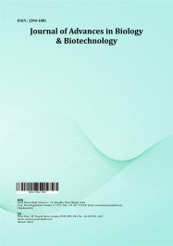
Journal of Advances in Biology & Biotechnology

Volume XXX, Issue XX, Page XX-XX, 20YY; Article no.JABB.149138
ISSN: 2394-1081

Characterization of Genetic Variability in Early Seedling Vigour Traits of Rice (Oryza sativa L.) under Laboratory Conditions

Authors’ Name……………………………………………………

Affiliations……………………………………………………….………………

Authors’ contributions

This work was carried out in collaboration among all authors. ‘Author A’ designed the study, performed the statistical analysis, wrote the protocol, and wrote the first draft of the manuscript. ‘Author B’ and ‘Author C’ managed the analyses of the study. ‘Author C’ managed the literature searches. All authors read and approved the final manuscript.

Article Information

DOI: 10.9734/JABB/2025/XXXXX

Open Peer Review History:
This journal follows the Advanced Open Peer Review policy. Identity of the Reviewers, Editor(s) and additional Reviewers, peer review comments, different versions of the manuscript, comments of the editors, etc are available here:

Received: DD/MM/20YY
………… Article
Published: DD/MM/20YY

ABSTRACT

Early seedling vigour (ESV) is a key determinant of successful establishment in direct-seeded rice (DSR), where rapid germination and early growth uniformly helps to suppress weeds, improve crop stand, and ultimately support higher productivity. The present study evaluates the characterization of Genetic Variability in Early Seedling Vigour Traits of Rice (Oryza sativa L.) under Laboratory Conditions. In this study, 180 rice genotypes were assessed under laboratory conditions to quantify genetic variability in seedling traits and vigour indices and to determine their contribution to ESV through genetic parameter estimation. Analysis of variance showed significant differences among genotypes for all measured traits, indicating substantial genetic diversity and confirming the presence of a broad genetic base suitable for selection. The phenotypic coefficient of variation (PCV) slightly exceeded the genotypic coefficient of variation (GCV) for most traits, suggesting limited environmental influence on trait expression. Broad-sense heritability estimates were consistently high (>80%), and most traits exhibited moderate to high genetic advance as a percentage of mean (GAM), reflecting the predominance of additive gene action and the potential for effective genetic improvement.
Shoot length, total fresh weight of seedling, rate of germination, and Seedling Vigour Index II (SVI II) were identified as strong and reliable selection indicators for enhancing ESV. These findings highlight the importance of multi-environment phenotyping for identifying priority traits in breeding rice better suited to DSR cultivation. By determining key contributors to early seedling vigour, this study provides practical trait-based indices to improve crop establishment and productivity in resource-efficient rice production systems.

Keywords: Early seedling vigour; heritability (h²); GAM; seedling vigour indices; direct-seeded rice.

1. INTRODUCTION

Rice (Oryza sativa L.) is a primary food source for more than half of the world’s population, making its sustained production essential for global food security (Hashim et al., 2023). With increasing challenges such as water scarcity, labour shortages, and climate variability, along with the growing demand for sustainable intensification, direct-seeded rice (DSR) has gained attention as a viable alternative to conventional transplanting (Negi et al., 2023). The efficiency of DSR, however, depends greatly on rapid and uniform seedling emergence—attributes governed by early seedling vigour (ESV). Strong ESV ensures quick germination, uniform stand establishment, and faster biomass accumulation, all of which are crucial for robust crop performance across diverse production environments (Mahender et al., 2015).

Vigorous seedlings enhance early growth dynamics, improve nutrient uptake efficiency, and strengthen competitiveness against weeds, ultimately contributing to better establishment and yield stability under fluctuating field conditions (Nocito et al., 2025; Anandan et al., 2020; Sandhu et al., 2019). Thus, improving ESV is central to realizing the full benefits of DSR, especially under resource-constrained and variable environmental conditions.

A clear understanding of genetic variability is fundamental for the effective improvement of this trait (Koshle et al., 2020; Rathia et al., 2025. ESV is a complex quantitative trait influenced by several morphological and physiological attributes, including shoot length, root length, seedling dry weight, germination percentage, and seedling vigour indices (SVI I and SVI II) (Mahender et al., 2015). Since these traits are affected by both genetic and environmental factors, assessing their variability is essential for developing genotypes well suited to dry direct-seeded rice (DDSR) systems. Genetic parameters such as genotypic and phenotypic coefficients of variation (GCV and PCV), heritability, and genetic advance provide insights into the magnitude of variability, the role of additive gene action, and the potential for genetic improvement through selection. Collectively, these assessments help to identify key traits that can be prioritized in breeding programmes aimed at enhancing seedling establishment and yield stability under direct seeded conditions of Rice .

In this context, the present investigation was carried out to evaluate genetic variability, heritability, and genetic advance for ESV-related traits in rice under laboratory conditions, with the objective of identifying the most influential traits that can be targeted to strengthen early seedling establishment and guide breeding strategies for improving adaptation to DSR systems. The present study evaluates the characterization of Genetic Variability in Early Seedling Vigour Traits of Rice (Oryza sativa L.) under Laboratory Conditions.

2. MATERIALS AND METHODS

2.1 Plant Material and Experimental Design

A total of 180 rice genotypes were evaluated for early seedling vigour-related traits under laboratory conditions. The genotypes were obtained from the ICAR-Indian Institute of Rice Research, Rajendranagar-Hyderabad and the experiments were conducted at the Department of Molecular Biology and Biotechnology, S.V. Agricultural College, ANGRAU, Tirupati, India.
The laboratory experiment was conducted using the paper towel method in a completely randomized design (CRD) with three replications. The field experiment was arranged in a randomized complete block design (RCBD) with two replications. Each genotype was sown in a plot measuring 12 m × 2 m, with a row spacing of 10 cm.

2.2 Trait Measurement

Data on germination percentage(%), shoot length(cm), root length(cm), total seedling length(cm), root number, shoot fresh weight(mg), root fresh weight(mg), total fresh weight(mg), shoot dry weight (mg), root dry weight(mg), total dry weight(mg), rate of germination(%), Seedling Vigour Index I(SVI-I), and Seedling Vigour Index II(SVI-II) were recorded at 14 DAS. Seedling vigour indices were calculated according to Abdul-Baki and Anderson (1973):

SVI-I = Germination percentage(%) × total seedling length(cm)

SVI-II = Germination percentage(%) × seedling dry weight (mg)

2.3 Statistical Analysis

Analysis of variance (ANOVA) and estimation of genetic parameters for all seedling vigour traits were performed using R software (version 4.4.1) to assess genotypic differences. Genetic parameters including genotypic coefficient of variation (GCV), phenotypic coefficient of variation (PCV), broad-sense heritability (H²) and genetic advance as percent of mean (GAM) were estimated.

The magnitude of variability was classified as following the genotypic and phenotypic coefficients of variation (GCV and PCV) were classified as low (<10%), moderate (10–20%) or high (>20%) as per Sivasubramanian and Menon (1973). Broad-sense heritability was categorized as low (<30%), moderate (30–60%), or high (>60%), and genetic advance as percent of mean (GAM) was categorized as low (<10%), moderate (10–20%), or high (>20%) according to Johnson et al. (1955).

3. RESULTS

3.1 Genetic Variability for Early Seedling Vigour Traits

Analysis of variance revealed significant differences (P < 0.001) for all early seedling vigour traits under both laboratory (Table 1) conditions, indicating substantial variability among the genotypes. Further analysis was carried out to partition the observed variability into its genetic components through the estimation of genetic parameters facilitating the identification of traits with potential which can be exploited for selection and improvement of early seedling vigour.

3.2 Genetic Parameter Estimates for Early Seedling Vigour Traits

The estimates of genotypic coefficient of variation (GCV), phenotypic coefficient of variation (PCV), broad sense heritability (H²) and genetic advance as percent of mean(GAM) for early seedling vigour traits under laboratory conditions are presented in Table 3 and summarized in (Fig 1).

In laboratory conditions, PCV values were marginally higher than GCV, indicating limited environmental influence on trait expression. Heritability was high for all traits (> 81% -99) suggesting strong genetic control.

Under lab condition (Table 3), traits such as shoot length(SL), root length(RL), root to shoot ratio(RL/SL), seedling vigour indices SVI I, SVI II and total seedling length(TSL) exhibited high heritability coupled with high GAM, indicating to the predominance of additive gene action and the potential for substantial genetic gain through direct selection. Germination percentage(GP) and seedling dry weight(SDW) showed high heritability but lower variability and moderate GAM, indicating narrower genetic bases.

Under DDSR environment GCV and PCV values were generally higher compared to laboratory conditions, all traits except GP recorded high GCV (>20%) with uniformly high heritability and high GAM > 40%. Broad-sense heritability (h²⁾ was high (>81%) for all traits, with values exceeding 98% for most, suggesting strong genetic control. Traits like root to shoot ratio showed high GAM( 85.65%) followed closely by shoot length (59.81%), seedling vigour index I (46.38%) and total seedling length (45.68%) confirming these as highly responsive selection criteria in field based direct seeding environments.

These results highlight the presence of substantial heritable variation and the effectiveness of direct selection for improving ESV traits under field conditions.

Table 1. Analysis of variance for early seedling vigour traits among rice genotypes under laboratory conditions (1-8 traits)

Source of variance | Df | SL | RL | TSL | RN | SFW | RFW | TFW | SDW
Genotypes | 180 | 78.93*** | 17.44** | 129.09*** | 53.78ns | 1505607ns | 592550.5ns | 16874088*** | 9.97ns
Error | 171 | 16.57 | 11.10 | 33.57 | 44.79 | 1209947 | 441709.3 | 825835.8 | 7.39
CV(%) |  | 9.16 | 19.30 | 9.39 | 21.19 | 51.25 | 47.85 | 12.25 | 59.86

Table 2. Analysis of variance for early seedling vigour traits among rice genotypes under laboratory conditions (9-15 traits)

Source of variance | Df | RDW | TDW | GP-3 | GP-21 | ROG | SVI I | SVI II
Genotypes | 180 | 1.15 ns | 14.85*** | 298.53*** | 449.01*** | 6768.88*** | 540505.5*** | 28755448***
Error | 171 | 1.10 | 9.23 | 143.55 | 209.8 | 1104.38 | 184373.9 | 3601759
CV(%) |  | 41.64 | 42.98 | 26.39 | 26.55 | 36.05 | 65.66 | 33.49
***indicates significance at P<0.001, **indicates significance at P<0.01, ns indicates not significant, SL: Shoot Length (cm), RL: Root Length (cm); TSL: Total Shoot Length (cm); RN: Root Number; SFW: Shoot Fresh Weight (mg); RFW: Root Fresh Weight (mg); TFW: Total Fresh Weight (mg); SDW: Shoot Dry Weight (mg); RDW: Root Dry Weight (mg); TDW: Total Dry Weight (mg); GP-3rd Day: Germination percentage(%); GP-21st Day: Germination percentage(%); ROG: Rate of Germination (%); SVI I: Seedling Vigour Index I ; SVI II: Seedling Vigour Index II

Table 3. Estimates of genetic parameters for early seedling vigor traits in rice under laboratory condition

Trait | Mean | Min | Max | GCV (%) | PCV (%) | Heritability (h², %) | Heritability Category | GAM (%) | GAM Category
SL | 44.43 | 31.50 | 61.37 | 12.56 | 15.55 | 65.30 | High | 20.92 | High
RL | 17.26 | 10.60 | 50.42 | 10.31 | 21.89 | 22.20 | Low | 10.02 | Moderate
TSL | 61.69 | 45.02 | 110.67 | 11.02 | 14.62 | 58.70 | Moderate | 17.68 | Moderate
RN | 31.58 | 19.00 | 89.33 | 6.71 | 22.23 | 9.10 | Low | 4.18 | Low
SFW | 2146.07 | 574.60 | 6392.90 | 17.91 | 54.29 | 10.90 | Low | 12.17 | Moderate
RFW | 1388.78 | 423.80 | 5117.30 | 19.77 | 51.78 | 14.60 | Low | 15.55 | Moderate
TFW | 7415.37 | 645.60 | 19322.20 | 38.20 | 40.11 | 90.70 | High | 74.93 | High
SDW | 4.54 | 0.85 | 47.75 | 24.99 | 64.87 | 14.80 | Low | 19.84 | Moderate
RDW | 2.53 | 0.82 | 7.58 | 5.99 | 42.07 | 2.00 | Low | 1.76 | Low
TDW | 7.07 | 1.70 | 49.70 | 23.71 | 49.08 | 23.30 | Low | 23.59 | High
GP-3 | 45.40 | 6.00 | 106.00 | 19.39 | 32.75 | 35.10 | Moderate | 23.65 | High
GP-21 | 54.55 | 10.00 | 120.00 | 20.04 | 33.27 | 36.30 | Moderate | 24.88 | High
ROG | 92.18 | 25.00 | 900.00 | 57.73 | 68.06 | 71.90 | High | 100.87 | High
SVI I | 653.90 | 80.20 | 8095.70 | 64.53 | 92.06 | 49.10 | Moderate | 93.18 | High
SVI II | 5665.68 | 1347.70 | 57300.00 | 62.59 | 70.99 | 77.70 | High | 113.68 | High
SL: Shoot Length (cm), RL: Root Length (cm); TSL: Total Shoot Length (cm); RN: Root Number; SFW: Shoot Fresh Weight (mg); RFW: Root Fresh Weight (mg); TFW: Total Fresh Weight (mg); SDW: Shoot Dry Weight (mg); RDW: Root Dry Weight (mg); TDW: Total Dry Weight (mg); GP-3rd Day: Germination percentage(%); GP-21st Day: Germination percentage(%); ROG: Rate of Germination (%); SVI I: Seedling Vigour Index I ; SVI II: Seedling Vigour Index II, Category levels: Low (<10%), Moderate (10–20%), High (>20%) for GAM; Low (<30%), Moderate (30–60%), High (>60%) for heritability

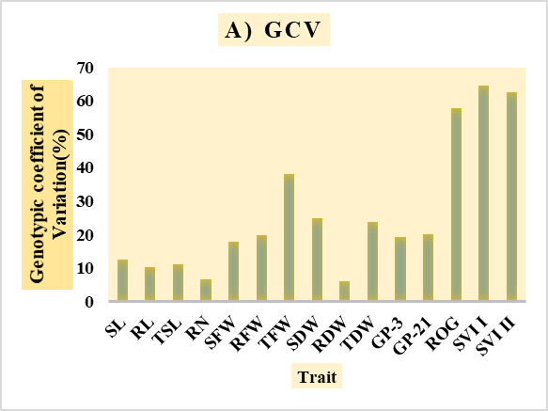 | 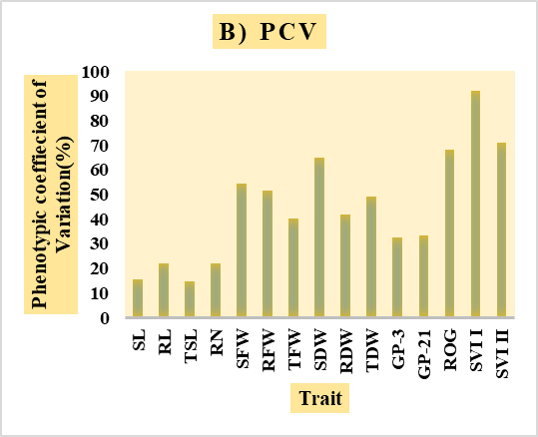
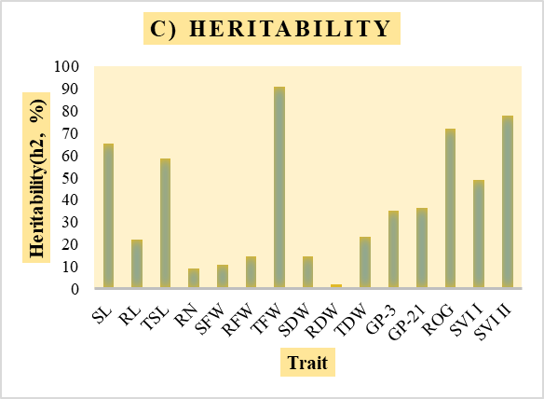 | 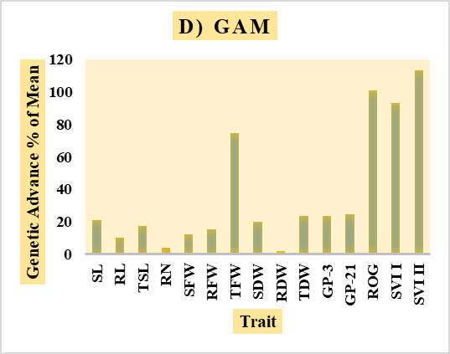
Fig.1. Comparative analysis of genetic variability parameters including (A) Phenotypic Coefficient of Variation (PCV), (B) Genotypic Coefficient of Variation (GCV), (C) Broad-sense Heritability (h²) and (D) Genetic Advance as percentage of Mean (GAM) for early seedling traits of rice genotypes under laboratory conditions

4. DISCUSSION

The present study revealed considerable genetic variability for early seedling vigour (ESV) traits among the 180 rice genotypes evaluated under laboratory conditions. Significant genotypic differences across all measured traits indicate a broad genetic base, supporting previous findings on the importance of genetic diversity for breeding in DSR systems (kumar et al., 2024, Negi et al., 2023, Mahender et al., 2015). The close alignment of phenotypic (PCV) and genotypic (GCV) coefficients of variation confirms that genetic factors predominantly govern trait expression, minimizing environmental influence and validating the reliability of genetic parameters for selection.

High heritability (>80%) coupled with moderate to high genetic advance as a percentage of the mean (GAM) across most traits emphasizes the predominance of additive gene action in governing early seedling vigour traits. The moderate to high heritability and GAM observed for traits such as seed vigour index I, seed vigour index II,germination percentage-3rd &21st day, total shoot length, rate of germination, total fresh weight, seedling dry weight, root length, and shoot length reinforce their effectiveness as reliable selection indices, offering strong potential for achieving substantial genetic gain and enhanced seedling vigour in rice genotypes. Similar findings of high heritability and additive gene action for seedling vigour traits have been reported by Surrora et al. (2023),Dang et al. (2014), Sadhana et al. (2022), Redona et al. (1996), Gong et al. (2024), Kumar et al. (2022), Su et al. (2022) and Akshitha et al.(2020).

Overall the study establishes that seedling vigour in rice is largely governed by genetic factors, exhibiting considerable additive genetic variation and high heritability, which supports effective selection. Root traits play a more prominent role in controlled environments, whereas shoot growth and early biomass accumulation are key determinants under DDSR. These findings offer valuable guidance for breeding rice genotypes with improved seedling vigour specifically adapted to direct-seeded systems

5. CONCLUSION

This study addresses a critical gap by comparing genetic variability and trait contributions to early seedling vigour under laboratory conditions. The findings reveal extensive genetic variability and strong heritability of key early seedling vigour traits, providing a solid foundation for genetic improvement through selection. Analyses of genetic variability confirmed that traits such as shoot length, total fresh weight, rate of germination and seed vigour index II exhibit high heritability genetic advance and have directly affect on seedling vigour indices validating their importance as primary selection criteria. Prioritizing these traits and integrating them into breeding programs will accelerate the development of rice varieties with enhanced early vigour, improved crop establishment, competitiveness, and yield stability in resource-efficient direct-seeded systems

DISCLAIMER (ARTIFICIAL INTELLIGENCE)

Author(s) hereby declare that NO generative AI technologies such as Large Language Models (ChatGPT, COPILOT, etc.) and text-to-image generators have been used during the writing or editing of this manuscript.

Competing interests

Authors have declared that no competing interests exist.

REFERENCES

Abdul Baki, A. A., & Anderson, J. D. (1973). Vigor determination in soybean seed by multiple criteria. Crop Science, 13(6), 630–633.
Akshitha, B., Senguttuvel, P., Latha, V. H., Yamini, K. N., Rani, K. J., & Beulah, P. (2020). Variability and correlation analysis for seedling vigour traits in rice (Oryza sativa L.) genotypes. International Journal of Current Microbiology and Applied Sciences, 9(07), 2877–2887.
Anandan, A., Mahender, A., Sah, R. P., Bose, L. K., Subudhi, H., Meher, J., Reddy, J. N., & Ali, J. (2020). Non-destructive phenotyping for early seedling vigor in direct-seeded rice. Plant Methods, 16, 1–18.
Dang, X., Thi, T. G. T., Dong, G., Wang, H., Edzesi, W. M., & Hong, D. (2014). Genetic diversity and association mapping of seed vigor in rice (Oryza sativa L.). Planta, 239(6), 1309–1319. https://link.springer.com/article/10.1007/s00425-014-2060-z
Gong, W., Proud, C., Vinarao, R., Fukai, S., & Mitchell, J. (2024). Genome-wide association study of early vigour-related traits for a rice (Oryza sativa L.) japonica diversity set grown in aerobic conditions. Biology, 13(4), 261. https://doi.org/10.3390/biology13040261
Hashim, N., Ali, M. M., Mahadi, M. R., Abdullah, A. F., Wayayok, A., Mohd Kassim, M. S., & Jamaluddin, A. (2023). Smart farming for sustainable rice production: An insight into application, challenge and future prospect. Rice Science, 31(1), 47–61.
Johnson, H. W., Robinson, H. F., & Comstock, R. E. (1955). Estimates of genetic and environmental variability in soyabean. Agronomy Journal, 47, 314–318.
Koshle, R., Sarawgi, A. K., Sharma, B., Parikh, M., & Ware, S. (2020). Assessment of genetic variability for early seedling vigour, yield, and its contributing traits in early duration genotypes of rice under direct seeded condition. Journal of Pharmacognosy and Phytochemistry, 9(6), 1225–1229.
Kumar, S., Kumar, S., Krishnan, G. S., & Mohapatra, T. (2022). Molecular basis of genetic plasticity to varying environmental conditions on growing rice by dry/direct-sowing and exposure to drought stress: Insights for DSR varietal development. Frontiers in Plant Science, 13, e1013207.
Kumar, S., Vimal, C. S., Jay, S., Niharika, Y., & Yogendra, P. S. (2024). Path coefficient analysis of rice (Oryza sativa L.) genotype under laboratory conditions. International Journal of Plant and Soil Science, 36(1), 155–162.
Mahender, A., Anandan, A., & Pradhan, S. K. (2015). Early seedling vigour, an imperative trait for direct-seeded rice: An overview on physio-morphological parameters and molecular markers. Planta, 241(5), 1027–1050.
Negi, P., Rane, J., Wagh, R. S., Bhor, T. J., Godse, D. D., Jadhav, P., Anilkumar, C., Sreekanth, D., Sammi Reddy, K., Gadakh, S. R., Boraih, K., Harisha, C., & Basavaraj, P. (2024). Direct-seeded rice: Genetic improvement of game-changing traits for better adaption. Rice Science, 31(4), 417–433.
Nocito, K. D., Murugaiyan, V., Ali, J., Pandey, A., Casal, C., De Asis, E. J., & Dimaano, N. G. (2025). Genome-wide dissection of novel QTLs and genes associated with weed competitiveness in early-backcross selective introgression-breeding populations of rice (Oryza sativa L.). Biology, 14(4), 413.
Rathia, M., Kar, S., Kanwar, R. R., Mandavi, N. C., Thakur, G., & Dansena, V. (2025). Studies on genetic variability and correlation for seedling vigour traits in rice (Oryza sativa L.) genotypes. Journal of Genetics, Genomics and Plant Breeding, 9(1), 2–7.
Redona, E. D., & Mackill, D. J. (1996). Genetic variation for seedling vigor traits in rice. Crop Science, 36(2), 285–290. https://acsess.onlinelibrary.wiley.com/doi/abs/10.2135/cropsci1996.0011183X003600020012x
Sadhana, P., Raju, C. D., Bhargava, K., Rao, L. V., & Kuna, A. (2022). Studies on variability, correlation and path analysis for seedling vigour traits in rice (Oryza sativa L.). International Journal of Environment and Climate Change, 12(10), 121–130.
Sandhu, N., Yadaw, R. B., Chaudhary, B., Prasai, H., Iftekharuddaula, K., Venkateshwarlu, C., Annamalai, A., Xangsayasane, P., Battan, K. R., Ram, M., Cruz, M. T. S., Pablico, P., Maturan, P. C. (2019). Evaluating the performance of rice genotypes for improving yield and adaptability under direct seeded aerobic cultivation conditions. Frontiers in Plant Science, 10, 159.
Sivasubramanian, P., & Menon, P. M. (1973). Inheritance of short stature in rice. Madras Agricultural Journal, 60, 1129–1133.
Su, X., Zhan, J., Wang, J., Li, X., Wei, Y., Wu, H., & Dai, H. (2022). Development status of direct seeding rice and study on response mechanism of submergence. Open Access Library Journal, 9, 1–13.
Suroora, B. K. P., Saraswathi, R., Suresh, R., Renganayaki, P. R., & Sritharan, N. (2023). Characterization of rice (Oryza sativa L.) germplasm for early seedling vigour-related traits under direct seeded condition. International Journal of Plant & Soil Science, 35(19), 2106–2114.

Disclaimer/Publisher’s Note: The statements, opinions and data contained in all publications are solely those of the individual author(s) and contributor(s) and not of the publisher and/or the editor(s). This publisher and/or the editor(s) disclaim responsibility for any injury to people or property resulting from any ideas, methods, instructions or products referred to in the content.
_________________________________________________________________________________
© Copyright (2025): Author(s). The licensee is the journal publisher. This is an Open Access article distributed under the terms of the Creative Commons Attribution License (http://creativecommons.org/licenses/by/4.0), which permits unrestricted use, distribution, and reproduction in any medium, provided the original work is properly cited.

