First molecular evidence of Sacbrood virus in Indian bee (Apis cerana indica F.) colonies of Kerala, India

ABSTRACT
Aim: The study aimed to isolate, characterize and identify the pathogenic entity responsible for viral disease in infected brood of Apis cerana indica colonies of different locations of Kerala.
Study design: Purposive sampling of infected brood samples, RT-PCR, sequencing and phylogenetic analysis.
Place and Duration of Study: Collection of infected brood through purposive sampling was done from the Indian bee apiaries of native beekeepers under the authority of Department of Agricultural Entomology, Kerala Agricultural University, College of Agriculture, Vellayani. Isolation and molecular characterization studies were performed at AICRP on Honey Bees and Pollinators during the period from February 2024 to March 2025.
Methodology: The study involved a purposive sampling of virus infected larvae/pupae from the Indian bee apiaries of Kerala based on the appearance of symptoms. Further, samples were subjected to isolation and characterization using molecular techniques (RNA isolation, RT-PCR and Sequencing). Phylogenetic analysis was performed to realize the evolutionary relationship of the isolates.
Results: The purposive sampling for virus disease incidence resulted in four sample collections (AYI270724, PCK221225, KOL271024, CTPM270425) based on the symptoms from different Indian bee apiaries of various districts (Kollam, Kottayam, Kasargod & Malappuram) of Kerala. The characteristic symptoms observed were in the late larval to pupal stages, the brood cells were uncapped with the head of the pupa oriented upwards exhibiting a sac-like appearance and retarded development. Molecular characterization of four RNA isolates (AYI01, PCK03, KOL01, CTPM01) and RT-PCR using primers specific to ‘Polyprotein gene of SBV genome’ resulted in only one isolate (CTPM01) Chattipparamba from Malappuram produced amplicons (~450-480 bp), while no amplification was observed from the other three isolates (AYI01, PCK03, KOL01). Sequencing of the PCR product revealed that the virus isolate (CTPM01) showed close homology to sacbrood virus isolate II10, Indian sacbrood virus (AcSBV-India-II10) infecting Apis cerana indica with sequence identity 97.69% (NCBI accession number- PX055611.1.).
Conclusion: Molecular characterization of virus infected brood samples revealed that the key pathogenic agent is the Sacbrood virus. The isolate from Malappuram showed close sequence homology to Indian sacbrood viral strains, expanding the known geographic distribution of this virus in Indian honey bee populations. These findings highlight the first molecular evidence of Sacbrood virus infection in the Indian bee colonies of Kerala. This further strengthens the understanding of epidemiology of sacbrood virus in Kerala and forms a foundation for future research and effective management strategies to protect Indian bee colonies of Kerala.

Keywords: Molecular characterization; Sacbrood virus; Apis cerana indica; pathogenic agent

1. INTRODUCTION
Honey bees (Apis spp.) are vital pollinators in natural and agricultural ecosystems, supporting biodiversity and food security (Klein et al., 2007; Potts et al., 2010). Two key domesticated honey bee species in India are Apis mellifera and Apis cerana indica. Among these, the Indian bee, A. cerana indica, is the most used species for commercial beekeeping in Kerala, due to its adaptability to the tropical climate and rich floral diversity, particularly from rubber and coconut plantations (Mathew & sharma 1999). Moreover, Kerala’s favorable climatic conditions further enhance beekeeping potential in the region and accounts for approximately 70 % of India’s annual honey production (Aruna et al., 2018). Earlier reports suggested that the pollination by A. cerana indica improved cucumber yield up to 25% and enhanced crop quality (Anjali et al., 2023). The state remains a key southern hub focused on high-quality and organic honey production.
Adoption of beekeeping requires knowledge regarding bee biology, bee health, different castes, their role in hive and colony management. Among these, maintaining bee health is crucial in beekeeping. Worker bees perform vital tasks like colony maintenance, brood care, and queen selection, which are necessary for sustaining a productive colony. However, colony strength and vigor are frequently compromised by diseases that attack bees during various life stages from brood to adult, thus weakening or incapacitating the bees (Chen et al., 2006). Brood stage is particularly vulnerable to viral and bacterial infections. Major viral diseases include Sacbrood virus (SBV) and TSBV (Thai Sacbrood virus); bacterial diseases include American foulbrood (AFB) caused by Paenibacillus larvae and European foulbrood (EFB) by Melissococcus plutonius. (Arbia and Babbay, 2011). Approximately, 48-50 % of colony losses are also reported in India and other countries due to diseases caused by virus and bacteria attacking both brood and adults (Ullah et al., 2020). SBV was documented in Himachal Pradesh in 1998, causing 2.52–2.92 % brood mortality in Apis mellifera (Sharma et al. 2022), and is closely related to TSBV, first reported in Meghalaya in 1978. TSBV later spread north and south, causing pupal death in A. cerana colonies (Kshirsagar, 1982; Aruna et al., 2017b). In Kerala, about 95 per cent of the Indian bee colonies were lost due to the Sacbrood virus disease.
SBV is a single stranded RNA virus from the family Iflaviridae with the particle size varying between 20-30 nm in diameter (Bailey et al., 1964) which are arranged in a crystalline form in the cytoplasm of fat and tracheal cells of the infected larvae. The virus infects honey bee colonies at the prepupal stage (10 days old), shortly before the brood cells are sealed. Infected larvae fail to pupate properly, showing stretched heads toward the cell cappings. They appear sac-like, with colors changing from white to yellow and then black. The brood cappings often have irregular openings, indicating delayed development, likely due to improper shedding of pupal skin. Larvae show irregular growth, becoming flabby, discolored, and dying as scales, with fluid-filled sacs resulting from moulting disturbances that cause skin changes related to hardening and development (Wei et al., 2022). Honey bee viruses are identified using other methods such as microscopy, ELISA, molecular assays like Reverse transcription polymerase chain reaction (RT-PCR), RT-LAMP, real time PCR. Earlier research on honey bee viruses suggests that RT-PCR is simple and rapid technique for detection and is an effective tool among the molecular techniques available (de Miranda and Sambade, 2005).
In Kerala, data on the incidence of brood diseases in Indian bee colonies is limited. Earlier reports in the state focused on characterization and identified bacteria infecting the brood (Joseph & Amritha, 2020) while viral infection like SBV were confirmed based on symptoms, without molecular characterization. This lack of molecular evidence limits effective monitoring and management of viral diseases. Therefore, the current research was undertaken to conduct a purposive sampling for virus brood disease incidence across multiple districts of Kerala and identify SBV at the molecular level, providing a clear proof that SBV causes brood infection. These findings will enhance understanding of SBV epidemiology in Kerala, establish a foundation for future research, and support the development of effective management strategies to safeguard Indian bee colonies in the region. This molecular approach marks a significant advancement from prior symptom-based studies and is critical for targeted disease control.

2. material and methods

2.1 Purposive sampling and symptomatology
The virus infected brood were collected through purposive sampling from the Indian honeybee apiaries of different locations of Kerala during 2024-2025. Infected brood samples were placed in 15-30 mL sterile glass vials filled with sterile 70 % ethanol and labelled by a code framed using abbreviated form of the location and date, then stored at – 20 ̊ C (Tamilnayagan, et al., 2020). Virus infected brood was identified based on the visible symptoms such as capping pattern, color change and orientation of the brood in the cells. In the adults, the activity of the workers and the presence of queen in the colony was checked to identify the abnormalities in the behavior.

2.2 Molecular characterization
Infected brood with suspected symptoms of virus attack were subjected to isolation and characterized at molecular level through the isolation of RNA, RT-PCR for the confirmation of brood viruses. The nucleotide sequences were phylogenetically analyzed to gain insight into the evolutionary pattern of the viral pathogens.

2.2.1. Isolation of Viral RNA
RNA isolation was done Trizol RNA isoplus protocol. Approximately 100 mg of virus-infected brood sample preserved in 70% ethanol was collected on the same day of sampling. The infected larva was snap-frozen in liquid nitrogen and ground to a fine powder. The powdered tissue sample (100 mg) was homogenized by adding 1 mL of RNA Isoplus in a 1.5 mL centrifuge tube and incubated for 5 min at room temperature. The mixture was centrifuged at 12,000 g for 5 min at 4 °C, and the resulting supernatant was transferred to a new centrifuge tube. To this, 400µL of chloroform (0.4× sample volume) was added, vortexed vigorously, and kept for 5 min at room temperature. The sample was then centrifuged at 12,000 g for 15 min at 4°C.
The upper aqueous phase was transferred to a fresh tube, 1 mL of isopropanol was added, and the sample was incubated for 10 min at room temperature. Following this, the mixture was centrifuged at 12,000 g for 10 min at 4°C, and the RNA pellet was washed with 1 mL of 70% ethanol. The sample was further centrifuged at 7,000 g for 5 min at 4°C. The supernatant was discarded, and the pellet was allowed to precipitate and air-dried until residual ethanol was evaporated. The isolated RNA pellet was resuspended in 50 µL of DEPC-treated water and stored at −20 °C for subsequent analysis.

2.2.2. RT-PCR
cDNA synthesis was performed using thermal cycler. The reverse transcription reaction was set up in a total volume of 10 µL containing 5 µL of 2X RT easy mix, 0.5 µL of oligo dT primer, 1 µL of template RNA (<2.5 µg or <2500 ng), and 3.5 µL of RNase-free water. The reaction mixture was incubated for reverse transcription at 42 °C for 20 min, followed by denaturation at 85 °C for 5 min, each performed for one cycle. The resulting cDNA was used for PCR.

cDNA of the isolates was quantified using “Nanodrop”. 1 μL of cDNA from each viral isolate was used for quantification and measured quantity (ng/μL) and quality (A₂₆₀/A₂₈₀). Polymerase chain reaction (PCR) assays were performed to amplify a specific region of the polyprotein gene of the Sacbrood virus (SBV) genome. The PCR mixture, prepared in a total volume of 10 µL, consisted of 5 µL of 2X Phire Master Mix, 3 µL of distilled water, 0.25 µL each of forward and reverse primers, and 1 µL of template cDNA.
The primers used were SB1 Forward (5′-ACCAACCGATTCCTCAGTAG-3′) and SB1 Reverse (5′-CCTTGAACTCTGCTGTGTA-3′), targeting a gene region near the 5′ end of the SBV genome (Grabensteiner et al.,2001). PCR amplification was carried out using the following cycling conditions: initial denaturation at 95 °C for 5 min; 35 cycles of denaturation at 95 °C for 30 s, annealing at 57 °C for 40 s, and extension at 72 °C for 60 s; followed by a final extension at 72 °C for 7 min; and a hold step at 4 °C indefinitely. These conditions enabled the specific amplification of the target SBV gene region for further analysis.

2.2.3. Sequencing
The sequencing of the PCR products of the viral isolates was performed at Rajiv Gandhi Centre for Biotechnology (RGCB), Thycaud, Thiruvananthapuram, Kerala for the molecular identification. The amplified PCR products were purified using ExoSAP-IT (USB Corporation, USA) to remove residual primers and unincorporated dNTPs. A 5 µl aliquot of each PCR product was mixed with 0.5µL of ExoSAP-IT reagent and incubated at 37 °C for 15 min, followed by enzyme inactivation at 85 °C for 5 min. The purified products were subsequently used for downstream sequencing reactions.
Sequencing using BigDye Terminator v3.1
The sequencing reactions were carried out in a PCR thermal cycler (GeneAmp PCR System 9700, Applied Biosystems, USA) using the BigDye Terminator v3.1 Cycle Sequencing Kit (Applied Biosystems, USA) following the manufacturer’s protocol. Each sequencing reaction mixture was prepared by 1 μL of Exo-sap treated PCR product, 1.9 μL- 5X Sequencing Buffer, 0.3 μL of each forward and reverse primer and 0.2μL sequencing mix and make up to 10μL using distilled water. The sequencing PCR amplification conditions were initial denaturation at 96 °C for 2 min; followed by 30 cycles of denaturation at 96 °C for 30 s, annealing at 50 °C for 40 s, and extension at 60 °C for 4 min; with a final hold at 4 °C indefinitely.
Post sequencing PCR
Post-sequencing PCR clean-up was performed to purify the sequencing reaction products. A clean-up mix consisting of distilled water (5 μL), 125 mM EDTA (0.1 μL), 3 M sodium acetate (pH 4.6) (1 μL), and 100% ethanol (44 μL) was prepared and thoroughly mixed. A 50 µl aliquot of this mix was added to each well of the sequencing plate containing the sequencing PCR product. The plate was vortexed using a Mix-mate vortex mixer and incubated at room temperature for 30 min, followed by centrifugation at 3700 rpm for 30 min. The supernatant was decanted, and 50 µl of 70% ethanol was added to each well. The plate was again centrifuged at 3700 rpm for 20 min, and the ethanol wash was repeated once. The supernatant was carefully decanted, and the pellet was air-dried.
The dried pellet was resuspended in 10 µl of Hi-Di™ Formamide (Applied Biosystems, USA). The purified products were sequenced using an ABI 3500 DNA Analyzer (Applied Biosystems, USA) employing the Sanger sequencing method.
Sequence Analysis
Sequence quality was assessed using Sequence Scanner Software v1 (Applied Biosystems, USA). Sequence alignment and editing of the obtained sequences were carried out using Geneious Pro v5.1.
The SBV gene specific nucleotide sequences of isolates obtained was compared with the available sequences in the NCBI database using the BLAST tool provided by National Centre for Biotechnology Information (NCBI) on the website http://blast.ncbi.nlm.nih.gov/Blast.cgi

2.2.4 Phylogenetic analysis
Phylogenetic analysis of the viral isolates was performed using MEGA 11 to determine evolutionary relationships between the isolates and other viral strains of honey bees. The SBV gene specific sequences were aligned with related reference sequences obtained from the NCBI database, and a Maximum likelihood tree was generated with 1,000 bootstrap replications to evaluate branch confidence.

3. results and discussion

3.1. Samples collected and symptomatology

Virus infected brood samples were collected based on the visible symptoms from Indian bee apiaries of four locations across different districts of Kerala as presented in Table 1. The characteristic symptoms observed were during the late larval to pupal stages, the brood cells were uncapped with the head of the pupa oriented upwards and retarded development as presented by fig. 1 (a&b). Similarly, the studies on the symptomatology of virus infected brood by Wei et al. (2022) and Gong et al. (2016) reported the unusual orientation of the head of the pupa.
In the present study, no noticeable color change was observed in the infected brood. However, the characteristic sac-like appearance of larvae was clearly evident in colonies affected by Sacbrood virus as presented by fig. 1(c). This observation was in agreement with the previous reports describing sac-like form of the prepupae without discoloration in SBV-infected colonies (Kumar et al., 2017). Comparable descriptions were also reported in the investigations on A. cerana indica, where the prepupae retained normal color but developed a fluid-filled sac structure (Yongsawas et al., 2020). These findings strengthen the reliability of sac-like larval morphology as a key field-level diagnostic indicator of Sacbrood virus infection. Disease stress induced behavioral changes among the worker bees which attempted to remove the infected brood from the cells as indicated by the uncapped condition. This response reflects the natural hygienic instinct of honey bees to limit pathogen transmission within the colony, which has been widely documented (Spivak & Danka, 2021; Khan et al., 2021). Under certain circumstances, workers also showed aggressive behavior during inspection. During peak stages of infection, it was observed that the colonies were absconded which is a phenomenon described in SBV-affected Apis cerana colonies (Vung et al., 2018).

Table 1. Details of the apiaries selected for virus infected brood samples
District | Location of apiary | GPS Coordinates  (Latitude & Longitude) | Sample code
Kollam | Ayilara | 8.95°N, 76.97°E | AYI270724
Kottayam | Panackapalam | 9.70°N, 76.76°E | PCK221225
Kasargod | Kolichal | 12.45°N, 75.30°E | KOL271024
Malappuram | Chattipparamba | 11.00°N, 76.10°E | CTPM270425
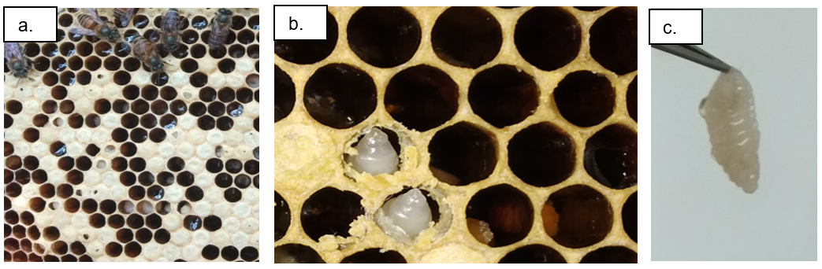

Fig. 1 Virus infected brood from Indian bee apiaries of Kerala.
a) Chewed out capping and uncapped brood pattern, b) Pre-pupal stages head in upright orientation, c) Sac-like form of the pre-pupal stage
3.2. Molecular characterization

3.2.1 Isolation of viral pathogen
RNA isolated from the infected larval samples of different locations were subjected to cDNA synthesis, yielded AYI01, PCK03, KOL01 & CTPM01 four viral isolates. Quantification of cDNA of these viral isolates revealed the quantity in the range of 953.5-1994.4 ng/μL with quality between 1.7-1.8 (A₂₆₀/A₂₈₀) as presented in Table 2.

Table 2. Quantitative and qualitative assessment of cDNA of viral isolates from Indian bee colonies

^{Isolate code} | ^{cDNA quantity}  ^{(ng/μL)} | ^{cDNA quality}  ^{(A260/A280)} | ^{PCR product size}  ^{(bp)}
^{AYI01} | ^{953.5} | ^{1.79-1.81} | ^{No amplification}
^{PCK03} | ^{1234.4} | ^{1.72-1.75} | ^{No amplification}
^{KOL01} | ^{1654.2} | ^{1.74-1.82} | ^{No amplification}
^{CTPM01} | ^{1994.4} | ^{1.73-1.81} | ^{~ 450-480bp}

RT-PCR performed using SB1 Forward (5′-ACCAACCGATTCCTCAGTAG-3′) and SB1 Reverse (5′-CCTTGAACTCTGCTGTGTA-3′) primers resulted in amplification only in the isolate CTPM01 with an amplicon size of approximately 450–480 bp, as presented in Table 2, whereas no amplification was observed in AYI01, PCK03 and KOL01 (Fig. 2). A negative control was included in the assay and showed no amplification, confirming that the reaction was free from contamination and validating that the positive band in CTPM01 was a true amplification event. The absence of bands in the remaining three symptomatic samples, despite visible larval deformities, may be attributed to low viral load, RNA degradation, or sequence variation within the primer-binding region. This further indicates that visual symptoms alone cannot reliably confirm SBV infection without molecular verification. The presence of a clear amplification product exclusively in CTPM01 therefore provides strong molecular evidence for SBV infection in this sample.
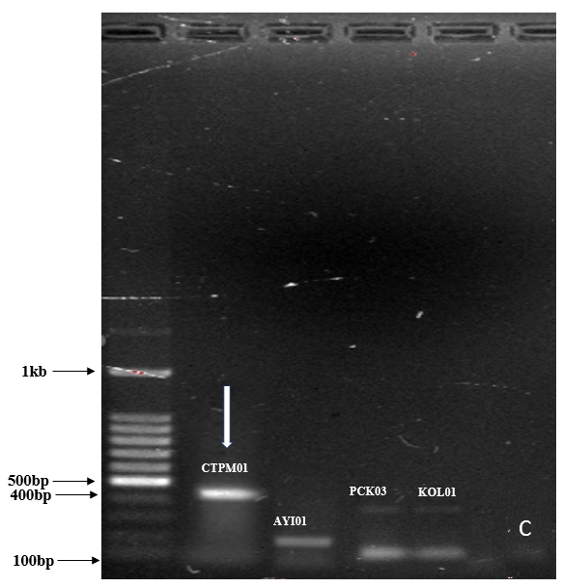

Fig. 2 PCR gel profile of viral isolates exhibiting RTPCR product amplicons using SBV specific primer pairs (Left-Right (Lane-1: 1kb ladder; Lane 2: show amplified product of ~ 450-480 bp concerned with CTPM01 & Lane 3,4,5: showed no amplification with ARK01, PCK03, KOL01, Lane 6: negative control with no visible band).

3.2.2 Sequencing
The amplified product of the viral isolate (CTPM01) obtained from Chattipparamba, Malappuram on sequencing resulted in the nucleotide fragment size of 481 bp as given in the fig. 3. and was found to be homologous to sacbrood virus isolate II10, Indian sacbrood virus (AcSBV-India-II10) infecting Apis cerana indica with sequence identity 97.69 % and the corresponding NCBI accession number was PX055611.1. Consistent with these results, Gong et al. (2016) confirmed that SBV infects the brood stage of Apis cerana, leading to larval death and developmental arrest, with Indian viral isolates exhibiting high sequence identity to other Asian SBV strains. Supporting this, studies by Aruna et al. (2017a) described typical SBV symptoms in Indian honey bees, including larvae with heads oriented upwards, failure to pupate, and accumulation of sac-like fluid, reflecting the symptoms in CTPM01-infected larvae. Additionally, genome sequencing by Aruna et al. (2018) reported near-complete identity between outbreak-associated SBV and previously characterized AcSBV-India isolates, confirming molecular homology as a reliable diagnostic criterion.

3.2.3 Phylogenetic analysis
A phylogenetic tree was constructed using the Maximum Likelihood (ML) method based on the aligned nucleotide sequences of Sacbrood virus (SBV) reference strains retrieved from GenBank, together with the SBV isolate obtained from infected Apis cerana larvae in Kerala (strain CTPM-01). Sequence alignment was performed in MEGA 11 using the ClustalW algorithm. The robustness of the tree topology was evaluated by bootstrap analysis with 1000 replicates, and the corresponding bootstrap support values are shown at the respective branch nodes.
The Kerala SBV isolate (PX055611.1 marked with a red rhombus) as presented in fig. 3 clustered closely with other Asian SBV strains, including sequences from India (ICAR-NBAIR TSBV A1), Thailand (TN-KKM 1), and China (ZJ-1), indicating a high degree of genetic similarity and suggesting a potential common evolutionary lineage and is in accordance with prior reports from Aruna et al. (2018) which showed SBV isolates from the Asian region form a closely related lineage.
The isolate showed clear separation from European (Germany, Belgium) and Nepalese SBV strains, and formed a distinct clade from Chinese SBV (CSBV-BJ/2010) and Tasmanian SBV405, indicating considerable genetic divergence among geographically distant strains as shown in the fig. 3. Similarly, global analyses of SBV by Li et al. (2019) revealed that strains segregate into major lineages reflecting both host species and geography, with Asian (A. cerana/A. mellifera) strains diverging from European/Australian/USA strains by approximately up to ~10% nucleotide difference, as seen in the comparative studies of CSBV/SBV isolates. In Consistent to this, Chang et al. (2020) demonstrated that Taiwanese SBV isolates grouped within the Asian/AC-genotype clade, exhibiting strong relatedness among Asian isolates and greater divergence from non-Asian SBV strains. Hence, it strongly supports our observation that the Kerala isolate (CTPM-01) clusters more closely with the Asian SBV lineage while remaining distinct from European and Australian strains.
The scale bar of 0.20 represents the estimated number of nucleotide substitutions per site, reflecting evolutionary distance between the viral strains. The high bootstrap values for most internal nodes confirmed the reliability and stability of the inferred phylogenetic relationships.
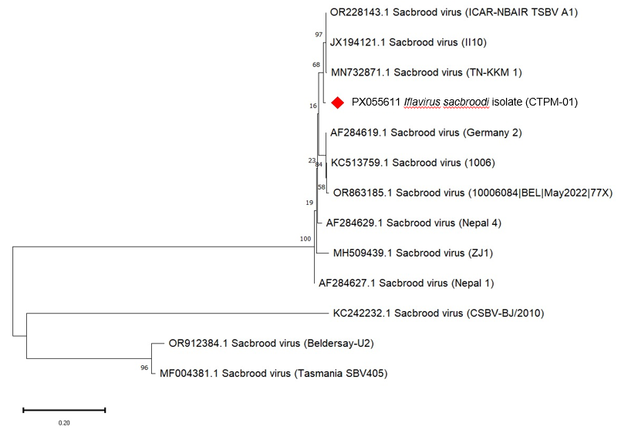
Fig. 3 Phylogenetic tree (Neighbour-joining) illustrating the evolutionary relationship of the SBV strain (CTPM01) from Indian bee brood of Kerala and other selected SBV strains from different regions of the world.

4. Conclusion
Molecular characterization of virus-infected brood samples confirmed that Sacbrood virus (SBV) is the pathogenic agent causing disease. The isolate identified from Malappuram exhibited close sequence homology with other Indian SBV strains, thereby extending the documented geographic distribution of this virus within Indian honey bee populations. This study provides the first molecular evidence of Sacbrood virus infection in Apis cerana colonies in Kerala. These findings contribute to a better understanding of the epidemiology of SBV in the region and establish an important foundation for future research and the development of effective management strategies to safeguard Indian bee colonies in Kerala.

Disclaimer (Artificial intelligence)
Option 1:
Author(s) hereby declare that NO generative AI technologies such as Large Language Models (ChatGPT, COPILOT, etc.) and text-to-image generators have been used during the writing or editing of this manuscript.
Option 2:
Author(s) hereby declare that generative AI technologies such as Large Language Models, etc. have been used during the writing or editing of manuscripts. This explanation will include the name, version, model, and source of the generative AI technology and as well as all input prompts provided to the generative AI technology
Details of the AI usage are given below:
1.
2.
3.

References

- Anjali, K.S., Shailaja, K.K., & Remadevi, O.K. (2023). Evaluation of first-generation Indian bee, Apis cerana indica Fabr. colonies for honey yield and pollination efficiency. Journal of Entomology and Zoology Studies, 11(6), 128-132. https://doi.org/10.22271/j.ento.2023.v11.i6a.9260
- Arbia, A. and Babbay, B. J. (2011). Management strategies of honey bee diseases. Journal of Entomology, 8(1), 1-15. https://doi.org/10.3923/je.2011.1.15
- Aruna, R., Srinivasan, M. R., & Selvarajan, R. (2017a). Efficacy of plant products on sacbrood virus attacking Apis cerana indica Fabricius. J. Entomology Zoology Studies, 5, 1909-1913. https://www.entomoljournal.com/archives/2017/vol5issue5/PartY/5-5-233-656.pdf
- Aruna, R., Srinivasan, M. R., Balasubramanian, V. & Selvarajan, R. (2018). Complete genome sequence of sacbrood virus isolated from Asiatic honey bee Apis cerana indica in India. VirusDisease, 29(4), 453-460. https://doi.org/10.1007/s13337-018-0490-0**​
- Aruna, R., Srinivasan, M. R., Selvarajan, R., Subramanian, S., & Thakur, R. K. (2016). Epidemiology of the Thai Sacbrood Virus Disease Attacking Indian Honey Bee Apis cerana indica F and Morphological Characterization of the Virus Particle using Transmission Electron Microscope. Madras Agricultural Journal, 103(1-3), 51-56. https://masujournal.org/store_file/archive/103-1-3-51-56.pdf
- Bailey, L., Gibbs, A. J. & Woods, R. D. (1964). Sacbrood virus of the larval honey bee (Apis mellifera Linnaeus). Virology, 23(3), 425-429. https://doi.org/10.1016/0042-6822(64)90266-1
- Chang, J. C., Chang, Z. T., Ko, C. Y., Chen, Y. W., & Nai, Y. S. (2020). Genomic sequencing and comparison of sacbrood viruses from Apis cerana and Apis mellifera in Taiwan. Pathogens, 10(1), 14. https://doi.org/10.3390/pathogens10010014
- Chen, Y. P., Pettis, J. S., Collins, A. & Feldlaufer, M. F. (2006). Prevalence and transmission of honeybee viruses. Applied and Environmental Microbiology, 72(1), 606-611.https://doi.org/10.1128/AEM.72.1.606-611.2006
- Chen, Y. P., Higgins, J. A., & Feldlaufer, M. F. (2005). Quantitative Real-Time Reverse Transcription-PCR Analysis of Deformed Wing Virus Infection in the Honeybee (Apis mellifera L.). Applied and Environmental Microbiology, 71(1), 436-441. https://doi.org/10.1128/AEM.71.1.436-441.2005​
- Gong, H.R., Chen, X.X., Chen, Y.P., Hu, F.L., Zhang, J.L., Lin, Z.G., Yu, J.W. & Zheng, H.Q. (2016). Evidence of Apis cerana Sacbrood virus infection in Apis mellifera. Applied and Environmental Microbiology, 82(14), 4282-4292. https://doi.org/10.1128/AEM.03292-15**​
- Grabensteiner, E., Ritter, W., Carter, M. J., Davison, S., Pechhacker, H., Kolodziejek, J., Boecking, O., Derakhshifar, I., Moosbeckhofer, R., Licek, E. & Nowotny, N. (2001). Sacbrood virus of the honeybee (Apis mellifera): Rapid identification and phylogenetic analysis using reverse transcription-PCR. Clinical and Diagnostic Laboratory Immunology, 8(1), 93-104. https://doi.org/10.1128/CDLI.8.1.93-104.2001
- Joseph, J. P. & Amritha, V. S. (2020). Survey and etiology of bacterial brood disease infecting Indian honey bees (Apis cerana indica F.) in Southern Kerala. Journal of Apicultural Research, 59(4), 519-527. https://doi.org/10.1080/00218839.2019.1698224
- Khan, K. A. & Ghramh, H. A. (2021). An investigation of the efficacy of hygienic behavior of various honey bee (Apis mellifera) races toward Varroa destructor (Acari: Varroidae) mite infestation. Journal of King Saud University-Science, 33(3), 101393. https://doi.org/10.1016/j.jksus.2021.101393
- Klein, A. M., Vaissière, B. E., Cane, J. H., Steffan-Dewenter, I., Cunningham, S. A., Kremen, C. & Tscharntke, T. (2007). Importance of pollinators in changing landscapes for world crops. Proceedings of the Royal Society B: Biological Sciences, 274(1608), 303-313. https://doi.org/10.1098/rspb.2006.3721
- Kshirsagar, K. K. (1982). Current incidence of honeybee diseases and parasites in India. Bee World, 63(4), 162-164. https://doi.org/10.1080/0005772X.1982.11097890
- Li, J., Wang, T., Wu, J., Sadd, B. M., Wang, X., Evans, J. D., Rose, R., Zhao, Y., Li, Z., Li, J., Huang, S., Heerman, M., Rodríguez-García, C., Banmeke, O., Brister, J. R., Hatcher, E. L., Cao, L., Hamilton, M. and Chen, Y. (2019). The phylogeny and pathogenesis of sacbrood virus (SBV) infection in European honey bees, Apis mellifera. Viruses, 11(1), 61. https://doi.org/10.3390/v11010061
- Mathew, G. & Sharma, K. (1999). Economics of beekeeping with Apis cerana indica and A. mellifera in rubber smallholdings of Kerala. Indian Journal of Natural Rubber Research, 12(1&2), 49-54. http://rubberscience.in/download.php?id=7q7hfe3ntpsr01o5j72f8u1so0394**​
- Potts, S. G., Biesmeijer, J. C., Kremen, C., Neumann, P., Schweiger, O. & Kunin, W. E. (2010). Global pollinator declines: Trends, impacts and drivers. Trends in Ecology & Evolution, 25(6), 345-353. https://doi.org/10.1016/j.tree.2010.01.007
- Sharma, A., Daroch, R. K., Kapoor, R., & Kumar, I. (2022). Status of bee keeping in Himachal Pradesh, India: A review. The Pharma Innovation, 11(3), 257-265. https://doi.org/10.22271/tpi.2022.v11.i3Sd.11234
- Spivak, M. and Danka, R. G. (2021). Perspectives on hygienic behavior in Apis mellifera and other social insects. Apidologie, 52(1), 1-16. https://doi.org/10.1007/s13592-020-00784-z
- Tamilnayagan, T., Srinivasan, M. R., Selvarajan, R., Subramanian, S., Saravanan, P. A., Muthuswami, M. et al. (2020). Designing of RT-LAMP primers and detection of sacbrood virus from Indian honey bee Apis cerana indica (F.). Indian Journal of Entomology, 82(1), 162-166. https://doi.org/10.5958/0974-8172.2020.00037.1
- Ullah, A., Tlak Gajger, I., Majoros, A., Dar, S. A., Khan, S., Kalimullah, Shah, A. H., Khabir, M. N., Hussain, R., Khan, H. U., Hameed, M., & Anjum, S. I. (2021). Viral impacts on honey bee populations: A review. Saudi Journal of Biological Sciences, 28(1), 523-530. https://doi.org/10.1016/j.sjbs.2020.10.037
- Vung, N. N., Kim, I., Lee, M. Y., Kim, H. K., Kim, D. W. & Choi, Y. S. (2018). Controlling Sacbrood virus disease in Apis cerana colonies with biological methods in Korea. Journal of Apiculture. 33(4), 283-295. https://doi.org/10.17519/apiculture.2018.11.33.4.283
- Wei, R., Chen, G., Li, Y., Sun, L., Dong, K., Long, M. et al. (2022). Sacbrood virus: A growing threat to honeybees and wild pollinators. Viruses, 14(9), 1871. https://doi.org/10.3390/v14091871**
- Yongsawas, R., de Miranda, J. R., Locke, B., Sittipraneed, S., Dangal, B., Sugahara, M., & Chantawannakul, P. (2020). Impact of Sacbrood Virus on Larval Microbiome of Apis mellifera and Apis cerana. Insects. https://doi.org/10.3390/insects11070439

