Original Research Article

Epidemiology and Virulence Profiling of Colletotrichum spp. Causing Turmeric Leaf Spot in Kerala

ABSTRACT
Turmeric, Curcuma longa L., is an economically important spice crop that is increasingly threatened by leaf spot disease caused by species of Colletotrichum genus. An epidemiological survey was conducted across major turmeric-growing regions in Kerala, India, covering the districts of Thiruvananthapuram, Kollam, and Palakkad. High disease pressure was recorded across all surveyed locations, with the Percent Disease Index (PDI) reaching a critical maximum of 64.07% in the Vellanad region (Thiruvananthapuram). A total of twelve fungal isolates were obtained and characterized based on morphological, cultural, and pathogenic features. Among them, isolate CT3, collected from the highly diseased region, displayed significantly higher virulence, evidenced by its shortest duration for symptom appearance (6.33 days) and the largest necrotic lesion area (12.92 cm²). Molecular characterization of CT3 through 28S rRNA sequencing confirmed the isolate as Colletotrichum gloeosporioides (PX369133). This study verifies the presence of highly virulent strains of C. gloeosporioides associated with severe leaf spot epidemics in Kerala, and provides essential insights to support the development of Integrated Disease Management (IDM) strategies, particularly in guiding fungicide application schedules, screening for resistant cultivars, and designing region-specific management interventions.

Keywords: Curcuma longa, Colletotrichum gloeosporioides, Turmeric Leaf Spot, Epidemiological Survey, Percent Disease Index (PDI), Pathogenicity, 28S rRNA
1. INTRODUCTION
Turmeric, Curcuma longa L. (Zingiberaceae), a perennial rhizomatous herb, is one of India’s most economically significant spice crops due to its multifaceted industrial, medicinal, and culinary applications. Its global significance is largely attributed to curcumin, a polyphenolic compound with potent antioxidant, anti-inflammatory, and antimicrobial properties (Chattopadhyay et al., 2004; Prasad & Aggarwal, 2011; El-Saadony et al., 2025). In addition to its well-known use as a spice and natural food colorant, turmeric plays a substantial role in the pharmaceutical, textile, and cosmetic industries, making it a high-value commodity in international trade (Ravindran et al., 2007). India is the world’s leading producer and exporter of turmeric, where it ranks among the principal spice crops and plays a major role in national export earnings (Jyothirmai et al., 2024; Mugilan et al., 2025). Given its year-round cultivation in various agroclimatic zones, maintaining crop health is crucial for sustaining both yield and quality.
Among the biotic constraints affecting C. longa, foliar diseases constitute one of the more significant threats to biomass production and quality. Leaf spot disease, primarily caused by species of Colletotrichum (such as C. capsici and C. gloeosporioides), is recognized as a major limiting factor that reduces both quantitative rhizome yields and the qualitative content of curcumin (Patel et al., 2005; Pasuvaraji et al., 2013; Kumawat et al., 2022). The severity of leaf spot directly correlates with economic damage. Studies on severe infections, defined as disease severity exceeding 50% PDI, have reported yield losses of up to 62% on a fresh weight basis. Critically, this destruction of photosynthetic leaf area also impairs the synthesis of secondary metabolites, resulting in a corresponding loss of curcumin content, which can exceed 50 % in severely diseased plants compared to disease-free controls (Hudge & Ghugul, 2010).
Field symptomology typically manifests as large, irregular brown lesions appearing on the leaf, often bordered by a distinct yellow halo, which can progress to cause severe leaf blight and extensive yellowing (Guji and Woga, 2019). The presence of multiple Colletotrichum species or pathotypes associated with a single host (Cannon et al., 2012) highlights the need for precise identification and characterization of the local pathogenic population to ensure effective disease management.
2. MATERIAL AND METHODS
2.1 Study area, survey, and data collection
An extensive epidemiological survey was carried out across three major turmeric-growing districts of Kerala - Thiruvananthapuram, Kollam, and Palakkad - representing various agro-ecological units (AEUs) within the state. A total of 12 locations were selected for sampling, where turmeric plants exhibiting characteristic leaf spot symptoms were collected. Sampling was performed during the typical peak disease period, corresponding to the late vegetative to early reproductive stage of the crop, approximately 7 - 8 months after planting (MAP), during October - November 2025. At each location, geographic coordinates and specific AEU identification were recorded (Table 1).
Table 1. Locations surveyed for the collection of leaf spot-infected and healthy turmeric leaf samples
District | Location Code | Location | AEU | Co-ordinates
THIRUVANAN-  THAPURAM  (AEU 8, 9) | T1 | Vellayani | 8 | 8.430167 °N, 76.987333 °E
THIRUVANAN-  THAPURAM  (AEU 8, 9) | T2 | Palapoor | 8 | 8.438727 °N, 76.977013 °E
THIRUVANAN-  THAPURAM  (AEU 8, 9) | T3 | Vellanad | 8 | 8.554119 °N, 77.05499 °E
THIRUVANAN-  THAPURAM  (AEU 8, 9) | T4 | Aruvikkara | 9 | 8.587483 °N, 77.030337 °E
THIRUVANAN-  THAPURAM  (AEU 8, 9) | T5 | Kollayil | 8 | 8.384366 °N, 77.117102 °E
KOLLAM  (AEU 3, 9) | K1 | Neduvathoor | 9 | 8.970014 °N, 76.746544 °E
KOLLAM  (AEU 3, 9) | K2 | Ezhukone | 9 | 8.986040 °N, 76.716132 °E
KOLLAM  (AEU 3, 9) | K3 | Kalluvathukkal | 3 | 8.827122 °N, 76.731646 °E
PALAKKAD  (AEU 22) | P1 | Alathur | 22 | 10.625872 °N, 76.543615 °E
PALAKKAD  (AEU 22) | P2 | Kuzhalmannam | 22 | 10.690858 °N, 76.600396 °E
PALAKKAD  (AEU 22) | P3 | Nemmara | 22 | 10.541629 °N, 76.620554 °E
PALAKKAD  (AEU 22) | P4 | Melarcode | 22 | 10.615566 °N, 76.56192 °E

Disease incidence (DI) was calculated as the percentage of plants exhibiting visible leaf spot symptoms, using the formula:
$Disease Incidence \left(DI\right)=\frac{Number of infected plants}{Total number of plants observed}x 100$
Disease severity was assessed as Percent Disease Index (PDI) using a 0–9 scale (Table 2). PDI was calculated following the method of Datar and Mayee (1981):
$Percent Disease Index \left(PDI\right)=\frac{Sum of individual disease ratings}{Total number of leaves observed x Maximum score } x 100$
Table 2. Disease severity scale (0–9) for quantifying turmeric leaf spot infection
Infected Area on Leaf (%) | Score
0 | 0
Less than 1 | 1
1 to 10 | 3
11 to 25 | 5
26-50 | 7
More than 50 | 9

2.2. Isolation of the pathogen, proving Koch’s postulates and virulence profiling
2.2.1 Isolation and proving Koch’s postulates
Isolation procedures followed standard protocols for fungal pathogens. Small sections were cut from the advancing edge of necrotic lesions on symptomatic turmeric leaves. These tissues were subjected to surface sterilization by immersion in 0.1% mercuric chloride (HgCl₂) solution for 30s. Tissues were then rinsed three times in sterile distilled water and air-dried on sterile filter paper before being plated onto Potato Dextrose Agar (PDA) medium.
Colonies displaying characteristic Colletotrichum morphology (Weir et al., 2012; Liu et al., 2016) were purified using the hyphal-tip technique to obtain single-strain cultures. To prove Koch’s postulates, pathogenicity tests were conducted. A 5 mm culture disc was taken from the actively growing margin of seven-day-old pure cultures. Healthy, detached turmeric leaves were selected, and the inoculation site was pin-pricked slightly using a sterile needle. The culture disc was placed on the pin-pricked site, and a piece of moist cotton was placed on top to maintain localized humidity. Control leaves were treated identically with a sterile, non-colonized PDA disc and moist cotton. Successful establishment of the disease was confirmed by the development of typical yellow to brown symptoms after several days. Koch’s postulates were considered complete only after the identical fungal pathogen was successfully re-isolated from the artificially infected tissue (Agrios, 2005; Sinclair & Dhingra, 2017).
2.2.2 Virulence profiling of isolates
Virulence of the 12 isolates was quantified using the detached leaf assay described above. Two metrics were recorded for each isolate:
- Days Taken for Symptom Development (DTSD): The time, in days, required for visible necrotic or chlorotic lesions to appear post-inoculation.
- Lesion Size: The length and breadth of the necrotic lesions were measured at 12 Days after inoculation (DAI), and the lesion area (cm²) was calculated as an objective measure of pathogen virulence.

2.3. Morphological, cultural, and conidial characterization
Twelve confirmed Colletotrichum isolates (CT1–CT5 from Thiruvananthapuram, CK1–CK3 from Kollam, and CP1–CP4 from Palakkad) were subjected to morphological and cultural characterization.
2.3.1. Cultural characteristics
The isolates were cultured on PDA medium at 27℃ ± 1℃. Colony characteristics, including color (front and rear views), margin, texture (fluffy, cottony, or velvety), and presence of zonation or pigmentation, were recorded after nine days of incubation (9 DAI). Radial mycelial growth was measured at 3, 5, and 7 DAI to determine the rate of growth (cm day⁻¹).
2.3.2. Micromorphological characteristics
Microscopic observations were performed on slide preparations from seven-day old cultures. Measurements were taken for:
- Conidia: Size (Length, Breadth, in μm) and shape (oblong, cylindrical, dumbbell, or fusiform).
- Mycelia: Average width (μm) and septal distance (μm).
2.4. Molecular characterization of the most virulent isolate
The isolate exhibiting the highest level of virulence across all disease parameters was selected and subjected to detailed molecular characterization to confirm its taxonomic identity and pathogenic relevance. Total genomic DNA was extracted from the mycelial growth using the NucleoSpin Plant II Kit (Macherey-Nagel). About 100mg of mycelium was homogenized in liquid nitrogen, and the DNA was purified following the manufacturer's protocol, including incubation at 65℃ and subsequent elution in buffer PE. The quality of the extracted DNA was subsequently verified via 0.8% agarose gel electrophoresis.
The D1/D2 region of the Large Subunit (LSU) ribosomal DNA (28S rRNA gene) was targeted for Polymerase Chain Reaction (PCR) amplification to confirm the genus and species complex placement. The PCR was carried out in a 20 μL reaction volume containing 1X Phire PCR buffer, 0.2 mM each dNTPs,1 μL DNA, 0.2 μL Phire Hotstart II DNA polymerase, 0.1 mg/mL BSA, 3% DMSO, and 0.5 M Betaine. Amplification utilized the universal fungal primers LR0R (Forward: 5' ACCCGCTGAACTTAAGC 3') and LR5 (Reverse: 5' TCCTGAGGGAAACTTCG 3'), with a concentration of 5 pM each. The thermal cycling profile consisted of an initial denaturation step at 98℃ for 1 min, followed by 40 cycles of denaturation (98℃ for 5 s), annealing (54℃ for 10 s), and extension (72℃ for 15 s), concluding with a final extension at 72℃ for 2 min. Successfully amplified products were checked on a 1.2% agarose gel and purified using ExoSAP-IT (GE Healthcare) to remove residual primers and dNTPs before sequencing.
The purified PCR amplicons were sequenced using the BigDye Terminator v3.1 Cycle Sequencing Kit (Applied Biosystems). Post-sequencing, the resulting sequence data were checked for quality and subjected to NCBI Basic Local Alignment Search Tool (BLAST) analysis.
3. RESULTS AND DISCUSSION
3.1. Epidemiological survey and data collection
The survey across Thiruvananthapuram, Kollam, and Palakkad revealed substantial and regionally variable disease pressure on turmeric crops, generally observed at the 7–8 MAP stage, coinciding with the peak vegetative phase crucial for rhizome filling. Field symptoms predominantly included large, irregular brown lesions defined by distinct yellow halos, marginal necrosis, and progressive leaf blight. Quantitative assessment of disease metrics showed high variability in both Disease Incidence (DI) and Percent Disease Index (PDI) across the 12 locations (Table 3). Disease Incidence ranged from 25.23% to 86.37%. Crucially, the PDI peaked significantly at 64.07% in Vellanad (T3), situated in the Thiruvananthapuram district (AEU 8). This maximum severity was distinct from all other locations, highlighting a severe, localized epidemic (Table 3).
The recorded maximum PDI of 64.07% in Kerala is exceptionally high, significantly exceeding severity levels typically reported in other South Indian turmeric regions. This extreme severity has profound implications for crop production, as PDI exceeding 50% leads to dramatic yield losses, potentially up to 62% on a fresh weight basis, and a 50% reduction in marketable curcumin content (Hudge & Ghugul, 2010). The intense disease pressure in AEU 8 (Thiruvananthapuram) suggests that local environmental factors, such as high rainfall and humidity, which positively correlate with disease progression - combined with a susceptible host, created ideal conditions for this destructive epidemic (Pokhrel, 2021).
Table 3. Disease Incidence and Percent Disease Index (PDI) of leaf spot in surveyed locations
Location Code | Location | Disease Incidence (%) | PDI (%)
T1 | Vellayani | 42.73 | 40.74
T2 | Palapoor | 31.50 | 32.59
T3 | Vellanad | 86.37 | 64.07
T4 | Aruvikkara | 47.00 | 41.85
T5 | Kollayil | 42.90 | 40.37
K1 | Neduvathoor | 25.23 | 21.11
K2 | Ezhukone | 42.57 | 31.67
K3 | Kalluvathukal | 70.33 | 41.11
P1 | Alathur | 55.67 | 35.56
P2 | Kuzhalmannam | 53.37 | 36.48
P3 | Nemmara | 26.43 | 27.59
P4 | Melarcode | 41.63 | 36.54

3.2. Isolation of the pathogen, proving Koch’s postulates and virulence profiling
Twelve fungal isolates were successfully recovered from symptomatic leaf tissues via tissue isolation and purified using the hyphal tip method. The pathogenicity of all isolates was confirmed on detached turmeric leaves, proving Koch's postulates by reproducing typical disease symptoms (Plate 1) and subsequently re-isolating the identical pathogen from the lesions (Agrios, 2005). The subsequent detached leaf inoculation assay provided quantifiable evidence of significant differences in pathogenicity among the isolates.
Isolate CT3, recovered from the location with the maximum PDI (Vellanad, T3), achieved symptom development (DTSD) in the shortest mean time, 6.33 ± 0.58 days, and produced the largest necrotic lesion area at 12 DAI, measuring 12.92 ± 6.95 cm². This was statistically superior to all other isolates (Table 4). In comparison, the least virulent isolates (CT5, CK1, and CP2) required 9.67 ± 0.58 days for symptom expression and developed minimal lesions. The rapid progression of symptoms in CT3 suggests a short incubation period, indicative of a strain capable of overcoming host defenses quickly and amplifying its population rapidly to cause high PDI levels in the field.
Table 4. Days taken for symptom development and lesion size (at 12 DAI) on detached turmeric leaves following artificial inoculation with Colletotrichum isolates
Isolate | Days Taken for Symptom Development | Lesion Size (cm²)
CT1 | 7.67 ± 1.16^{b} | 5.49 ± 3.70^{b}
CT2 | 8.33 ± 0.58^{bc} | 4.89 ± 1.13^{b}
CT3 | 6.33 ± 0.58ª | 12.92 ± 6.95ª
CT4 | 8.00 ± 0.00^{bc} | 5.22 ± 1.29^{b}
CT5 | 9.67 ± 0.58^{d} | 3.13 ± 0.89^{b}
CK1 | 9.67 ± 0.58^{d} | 3.87 ± 4.75^{b}
CK2 | 8.33 ± 0.58^{bc} | 3.93 ± 1.72^{b}
CK3 | 8.67 ± 1.16^{bcd} | 4.01 ± 2.18^{b}
CP1 | 8.33 ± 1.16^{bc} | 4.05 ± 5.84^{b}
CP2 | 9.67 ± 0.58^{d} | 2.00 ± 1.89^{b}
CP3 | 8.00 ± 0.00^{bc} | 2.05 ± 0.84^{b}
CP4 | 9.00 ± 0.00^{cd} | 2.10 ± 1.42^{b}
SEm ± | 0.408 | 1.947
CD (0.05) | 1.192 | 5.682
Values are mean of 3 replications ± standard deviation; SE - Standard Error; C.D - Critical difference at 0.05 level of significance. Treatments with the same letter grouping are not significantly different.
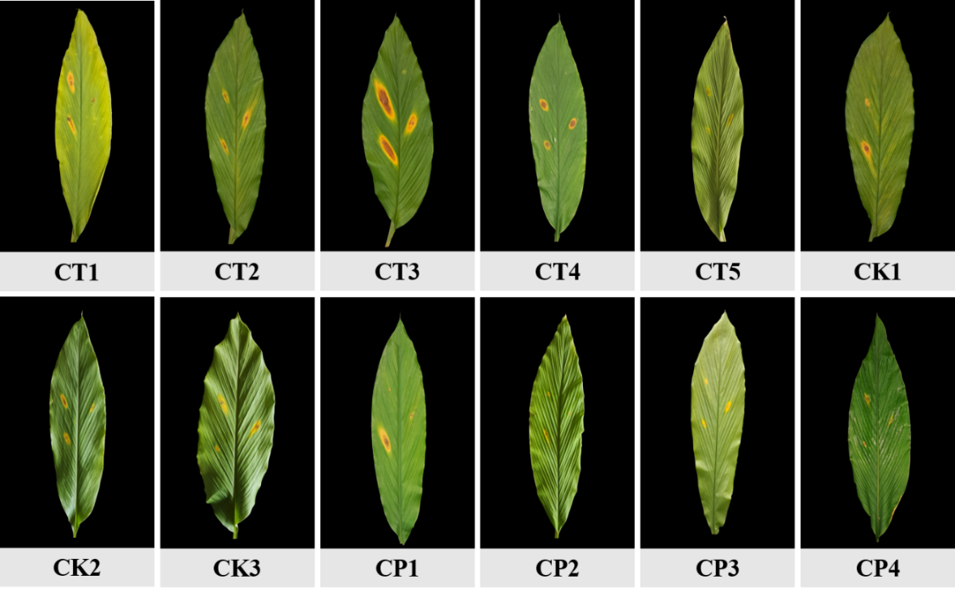
Plate 1. Artificial inoculation assay demonstrating the pathogenic virulence of 12 Colletotrichum isolates (CT1–CP4) on healthy, detached turmeric leaves, observed at 12 Days After Inoculation (12 DAI).
3.3. Morphological, cultural, and conidial characterization
The 12 isolates demonstrated significant diversity in cultural and morphological characteristics. Colony morphology was highly variable (Plate 2), with front colony color ranging from pure white and off-white to ash grey, light grey, and various shades of light brown or tan. The reverse colony surface also showed considerable variation, including dark grey to black pigmentation, light to dark brown centers, and distinct concentric zonation patterns composed of alternating tan, brown, and cream-colored rings. Mycelial texture differed noticeably among the isolates, encompassing fluffy or cottony growth, dense and velvety surfaces, and in some cases slightly granular or powdery zones corresponding to ring formations. Analysis of radial growth revealed differences in metabolic vigor, which directly correlated with pathogenicity. Isolates CT3, CT2, and CK3 demonstrated the highest growth rate, peaking at about 1.25 cm day⁻¹ and achieving full plate coverage (DTCP) in just 7 days, indicating superior in vitro metabolic efficiency. These differences in cultural phenotype and growth rate are detailed in Table 5.
Table 5. Cultural and Growth Characteristics of Colletotrichum Isolates on PDA Media (9 DAI)
Isolate | Colony Colour (Front View) | Colony Colour (Rear View) | Pattern of Mycelia Growth | Rate of growth (cm day⁻¹) | DTCP*
CT1 | White with black patches | Dark grey to black center, light brown periphery | Cottony, fluffy | 1.09 ± 0.01 | 8
CT2 | Whitish-grey with dark grey/black patches | Dark grey/black center, ashy halo | Fluffy | 1.25 ± 0.01 | 7
CT3 | Off-white | Light tan center, creamy margin | Velvety, dense | 1.25 ± 0.00 | 7
CT4 | Light brown/tan | Off white centre with greyish rings | Cottony | 1.14 ± 0.01 | 8
CT5 | Off-white | Dark grey/black center, light grey margin | Fluffy, cottony | 1.16 ± 0.01 | 8
CK1 | Brown/tan | Dark grey to black | Fluffy, cottony | 1.08 ± 0.01 | 8
CK2 | White to light grey | Dark grey/black center, tan periphery | Fluffy, cottony | 1.15 ± 0.02 | 8
CK3 | Greyish-white with concentric rings | Light brwon center with alternating light tan rings | Dense, velvety to cottony | 1.24 ± 0.01 | 7
CP1 | White | Dark black/grey center with a distinct white outer region | Fluffy, cottony | 1.11 ± 0.01 | 8
CP2 | Light brown/beige, brown ring near periphery | Mix of dark brown, black, and grey concentric rings | Fluffy, slightly granular | 1.05 ± 0.01 | 9
CP3 | Ash grey with tan/brown concentric rings | Dark grey center, off white periphery | Sparse, powdery in rings | 1.14 ± 0.02 | 8
CP4 | White to ash grey, showing clear zonation | Brown center, with concentric rings of brown/tan and cream | Cottony, fluffy | 1.11 ± 0.01 | 8
*DTCP: Days Taken for Completing growth in Petri dish (90mm)
Microscopic examination also revealed noticeable variability in the fungal structures among isolates (Table 6). The isolates predominantly produced conidia that were oblong/dumbbell-shaped, a morphology that corresponds with descriptions of Colletotrichum species reported in earlier studies (Weir et al., 2012; Gautam, 2014; Bedsole et al., 2024). Mycelial width varied across the isolates, ranging from 2.23 μm to 4.12 μm, and septal distances varied from 20.22 μm to 24.22 μm. Conidial dimensions, measured as length by breadth, varied from 10.19 x 2.84 μm up to 15.7 x 4.16 μm. The specific details regarding the size, shape, and mycelial measurements for all isolates are provided in Table 6.
Table 6. Mycelial and conidial characteristics of Colletotrichum isolates
Isolate | Mycelia |  | Conidia
Isolate | Width of Mycelia (μm) | Septal Distance (μm) | Size (L x B, μm) | Shape
CT1 | 2.27 | 20.22 | 13.42 x 2.82 | Oblong
CT2 | 2.66 | 20.63 | 10.64 x 2.37 | Oblong
CT3 | 4.12 | 24.22 | 15.7 x 4.16 | Dumbbell
CT4 | 2.3 | 20.92 | 12.93 x 2.81 | Dumbbell
CT5 | 3.96 | 22.97 | 14.8 x 3.08 | Oblong
CK1 | 3.84 | 23.57 | 10.68 x 3.48 | Oblong
CK2 | 2.23 | 22.69 | 12.5 x 2.93 | Oblong
CK3 | 2.82 | 24.18 | 10.97 x 2.7 | Oblong
CP1 | 2.95 | 22.01 | 10.53 x 2.88 | Dumbbell
CP2 | 2.75 | 21.58 | 10.83 x 3.19 | Oblong
CP3 | 2.78 | 23.06 | 10.19 x 2.84 | Oblong
CP4 | 3.1 | 22.32 | 12.24 x 2.92 | Dumbbell

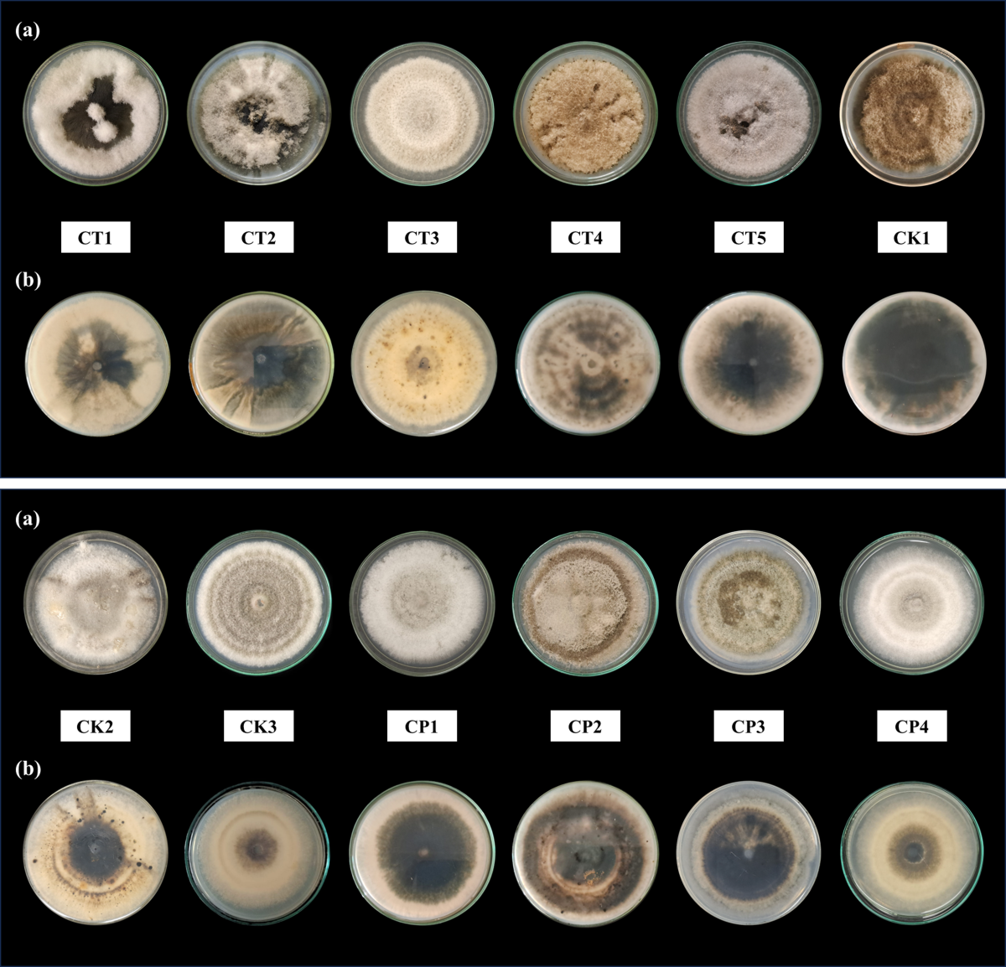
Plate 2. Cultural characteristics of the 12 Colletotrichum isolates (CT1–CP4) recovered from turmeric leaf spot lesions, cultured on Potato Dextrose Agar (PDA) medium 9 days after incubation (9 DAI). (a) Front view. (b) Rear view.
3.4. Molecular characterization of most virulent isolate
Sequencing of the D1/D2 region of the 28S ribosomal DNA (LSU) for the highly virulent isolate CT3 confirmed its phylogenetic identity. BLAST analysis of the obtained sequence revealed top matches with reference sequences of Colletotrichum gloeosporioides, showing strong nucleotide similarity. Accordingly, the isolate was identified as C. gloeosporioides (GenBank Accession: PX369133). Although C. capsici is frequently reported as the predominant causal agent of turmeric leaf spot in India, several studies have also documented C. gloeosporioides as an etiological agent associated with leaf spot and blight symptoms on turmeric (Patel et al., 2005; Chawda et al., 2012). Therefore, the molecular confirmation of CT3 as C. gloeosporioides aligns with existing reports demonstrating the involvement of this species in turmeric foliar disease complexes.
4. CONCLUSION
The epidemiological investigation successfully quantified the severity and distribution of turmeric leaf spot caused by Colletotrichum species across three diverse districts in Kerala. The documented maximum Percent Disease Index (PDI) of 64.07% in the Vellanad region (T3) of Thiruvananthapuram district establishes an exceptionally high level of disease pressure, significantly exceeding historically reported severity in South Indian turmeric cultivation. Given that PDI above 50% correlates directly with dramatic reductions in both rhizome yield and marketable curcumin content, this severe, localized epidemic poses a major economic threat to the state's spice production. The high incidence observed, particularly during the critical 7–8 months after planting, underscores the urgent need for targeted intervention strategies within these specific agro-ecological units.
Through the isolation and subsequent characterization of 12 fungal strains, this study confirmed Colletotrichum gloeosporioides (GenBank: PX369133) as the causal agent of the severe outbreaks, successfully proving Koch's postulates. The key finding was the identification of isolate CT3, recovered from the highest severity location, as the highly virulent pathotype. This strain exhibited statistically superior virulence, demonstrating the shortest incubation period (Days Taken for Symptom Development of 6.33 days) and producing the largest necrotic lesion area (12.92 cm²). This highly virulent pathogenic profile was supported by superior in vitro metabolic characteristics, including the fastest radial growth rate (1.25 cm day⁻¹).
The data presented here provides essential, localized knowledge critical for designing and implementing effective Integrated Disease Management (IDM) strategies. The substantial disease severity highlights the need for prioritizing preventative control measures, such as timely fungicidal applications, synchronized with the peak disease period identified in the survey. Furthermore, the establishment of the highly virulent CT3 strain as the most destructive pathotype offers a crucial reference isolate for screening local turmeric germplasm to identify durable sources of genetic resistance, a sustainable path toward protecting the economic viability and productivity of turmeric cultivation in Kerala.
Disclaimer (Artificial intelligence)
Author(s) hereby declare that NO generative AI technologies such as Large Language Models (ChatGPT, COPILOT, etc.) and text-to-image generators have been used during the writing or editing of this manuscript.

REFERENCES
Agrios, G. N. (2005). Plant pathology (5th ed.). Academic Press. https://www.elsevier.com/books/plant-pathology/agrios/978-0-12-044565-3
Bedsole, C. O., Cowser, M., Martin, T., Hamilton, J., Gonzalez Rodriguez, L., Chappell, T. M., & Shaw, B. D. (2024). Morphological variations and adhesive distribution: A cross-species examination in Colletotrichum conidia. Frontiers in Fungal Biology, 5. https://doi.org/10.3389/ffunb.2024.1481865
Cannon, P. F., Damm, U., Johnston, P. R., & Weir, B. S. (2012). Colletotrichum – current status and future directions. Studies in Mycology, 73, 181–213. https://doi.org/10.3114/sim0014
Chattopadhyay, I., Biswas, K., Bandyopadhyay, U., & Banerjee, R. K. (2004). Turmeric and curcumin: Biological actions and medicinal applications. Current Science, 87(1), 44–53. https://www.jstor.org/stable/24107978
Chawda, S. K., Sabalpara, A. N., & Pandya, J. R. (2012). Epidemiology of turmeric (Curcuma longa L) leaf spot caused by Colletotrichum gloeosporioides (Penz and Sacc). The Bioscan, 7(3), 441–444. https://thebioscan.com/index.php/pub/article/view/1065
Datar, V.V. & Mayee, C.D. (1981). Assessment of Loss in Tomato Yield Due to Early Blight. Indian Phytopathology, 34, 191-195. https://www.cabidigitallibrary.org/doi/full/10.5555/19821381280
El-Saadony, M. T., Saad, A. M., Mohammed, D. M., Alkafaas, S. S., Ghosh, S., Negm, S. H., Salem, H. M., Fahmy, M. A., Mosa, W. F. A., Ibrahim, E. H., AbuQamar, S. F., & El-Tarabily, K. A. (2025). Curcumin, an active component of turmeric: Biological activities, nutritional aspects, immunological, bioavailability, and human health benefits - a comprehensive review. Frontiers in Immunology, 16. https://doi.org/10.3389/fimmu.2025.1603018
Gautam, A. (2014). Colletotrichum gloeosporioides: Biology, Pathogenicity and Management in India. Journal of Plant Physiology & Pathology, 2(2). https://doi.org/10.4172/2329-955X.1000125
Guji, M.J. and Woga, W.G. (2019). Assessment of Colletotrichum Leaf Spot Disease of Turmeric in Major Growing Area of Southwestern Ethiopia. International Journal of Research in agriculture and Forestry, 6(12), 24-27. https://www.researchgate.net/publication/346564989_Assessment_of_Collototrichum_Leaf_Spot_Disease_of_Turmeric_in_Major_Growing_Area_of_Southwestern_Ethiopia
Hudge, B. V., & Ghugul, S. A. (2010). Losses in yield and quality of turmeric due to leaf spot disease caused by Colletotrichum capsici. International Journal of Agricultural Sciences, 6(1), 43-45. http://researchjournal.co.in/upload/assignments/6_43-45-7.pdf
Jyothirmai, A., Kshirsagar, P., Torane, S., Thorat, V., Kadam, J., & Mali, P. (2024). Export performance and trade direction of turmeric from India: Markove chain approach. International Journal of Agriculture Extension and Social Development, 7(9), 98–102. https://doi.org/10.33545/26180723.2024.v7.i9b.1025
Kumawat, H., Choudhary, A. K., Lekharam, & Patil, V. (2022). Epidemiology of turmeric (Curcuma longa L) leaf spot caused by Colletotrichum capsici (Butler and Bisby). The Pharma Innovation Journal, 11(12), 613–616. https://www.thepharmajournal.com/archives/?year=2022&vol=11&issue=12&ArticleId=17257
Liu, F., Tang, G., Zheng, X., Li, Y., Sun, X., Qi, X., Zhou, Y., Xu, J., Chen, H., Chang, X., Zhang, S., & Gong, G. (2016). Molecular and phenotypic characterization of Colletotrichum species associated with anthracnose disease in peppers from Sichuan Province, China. Scientific Reports, 6(1), 32761. https://doi.org/10.1038/srep32761
Mugilan, G., Divya, K., Malarkodi, M., Kavitha, M., & Kumar, G. A. (2025). Export performance and market retention of turmeric oleoresin from India: A Markov chain approach. Plant Science Today, 12(sp1). https://doi.org/10.14719/pst.10127
Pasuvaraji, A., Sevugapperumal, N., & Chandrasekaran, A. (2013). Morphological characterization and molecular phylogeny of Colletotrichum capsici causing leaf spot of Turmeric. The Bioscan, 8, 331–337. https://thebioscan.com/index.php/pub/article/view/322/303
Patel, R.V., Joshi, K.R., Solanky, K.U., & Sabalpara, A.N. (2005). Colletotrichum gloeosporioides: a new leaf spot pathogen of turmeric in Gujarat. Indian phytopathology, 58, 125. https://epubs.icar.org.in/index.php/IPPJ/article/view/17458
Pokhrel, A. (2021). Role of individual components of the disease triangle in disease development: A review. Journal of Plant Pathology & Microbiology, 12, 573. https://www.walshmedicalmedia.com/open-access/role-of-individual-components-of-disease-triangle-in-disease-development-a-review-84806.html
Prasad, S., & Aggarwal, B. B. (2011). Turmeric, the Golden Spice: From Traditional Medicine to Modern Medicine. In I. F. F. Benzie & S. Wachtel-Galor (Eds.), Herbal Medicine: Biomolecular and Clinical Aspects (2nd ed.). CRC Press/Taylor & Francis. https://www.ncbi.nlm.nih.gov/books/NBK92752/
Ravindran, P. N., Babu, K. N., & Sivaraman, K. (Eds.). (2007). Turmeric: The genus Curcuma. CRC Press. https://doi.org/10.1201/9781420006322
Sinclair, J. B., & Dhingra, O. D. (2017). Basic Plant Pathology Methods (2nd ed.). CRC Press. https://doi.org/10.1201/9781315138138
Weir, B. S., Johnston, P. R., & Damm, U. (2012). The Colletotrichum gloeosporioides species complex. Studies in Mycology, 73, 115–180. https://doi.org/10.3114/sim0011

