Assessment of Correlation and Path Analysis for Early Seedling Vigour Traits in Rice (Oryza sativa L.) under Laboratory Conditions

ABSTRACT
Early seedling vigour (ESV) is a critical trait for successful crop establishment in direct-seeded rice systems, where rapid germination and uniform seedling growth provide a competitive advantage against weeds, ensure better stand establishment, and ultimately contribute to higher yield. The present study evaluated 180 rice genotypes under laboratory conditions to assess genetic variability and trait contributions to ESV through correlation and path coefficient analysis of seedling traits and vigour indices. The path coefficient analysis identified critical factors influencing the vigour indices root length was the primary driver of Seedling Vigour Index I (SVI I) in laboratory conditions, while shoot elongation traits dominated under dry direct-seeded rice environments. Seedling dry weight was the main direct contributor to Seedling Vigour Index II (SVI II) across both environments. Strong positive correlations were found among key traits especially between total seedling length and SVI I and between dry weight and SVI II. Overall seedling dry weight, shoot length, root length and total seedling length emerged as reliable selection indices for improving ESV. The findings underscore the critical role of multi-environment phenotyping in prioritizing traits for breeding rice adapted to direct-seeded systems. By identifying key contributors to early seedling vigour, this study provides valuable selection indices to enhance crop establishment and productivity in resource-efficient rice cultivation.This integrated phenotyping approach revealed substantial genetic variation for early seedling vigour, supporting the selection of genotypes with rapid early growth and biomass accumulation, essential for improving establishment and performance in DSR systems.
Keywords: Early seedling vigour, direct-seeded rice, rice genotypes, correlation, path analysis, seedling vigour index

Introduction
Rice cultivation is undergoing a major transformation globally with a noticable shift from traditional transplanted rice (TPR) systems to direct-seeded rice (DSR) driven by increasing concerns over water scarcity, labour shortages, rising production costs, greenhouse gas emissions and declining soil health (Farooq et al., 2010; Jagdeep & Singh, 2024; Dey et al., 2025). DSR has emerged as a sustainable alternative, eliminating the need for puddling and manual transplanting. It offers significant reductions in water and labour requirements lowering production costs and conserves resources (Jat et al., 2012; Kumar et al., 2022). Moreover, DSR reduces methane emissions due to the absence of prolonged anaerobic soil conditions and enables mechanized and timely sowing (Sandhu et al., 2021; Kumar et al., 2024). Additionally, DSR allows earlier crop maturity, providing flexibility in crop rotation and improving land use efficiency (Jat et al., 2022).
Despite these advantages, the adoption of DSR is limited by challenges such as poor seedling establishment, low germination rates, intense weed pressure, nematode infestation, lodging and inconsistent emergence under suboptimal conditions (Negi et al., 2024; Singh et al., 2024). Among these, inadequate seedling establishment and weed competition are critical constraints, directly affecting crop success and yield stability. Therefore, the success of DSR largely depends on the development of rice genotypes with high early seedling vigour (ESV) and effective weed management strategies (Singh et al., 2017; Suroora et al., 2023).
Early seedling vigour is a vital seed quality characteristic that plays a significant role in enhancing crop yield by facilitating rapid and uniform germination, quick establishment of seedlings, and early biomass accumulation (Mahender et al., 2015). Genotypes with high ESV can outcompete weeds, establish rapidly and perform better under variable field conditions like direct seeded wet and dry conditions making ESV a critical breeding target (Anandan et al., 2020; Dayala et al., 2025; Sagar et al., 2025). Despite its importance, ESV expression varies widely among rice genotypes and across environments. Limited information is available on the genetic variability and interrelationships of ESV traits under both laboratory and field conditions. Understanding this variability is essential to identify superior genotypes that can be used in breeding programs or directly adopted for DSR cultivation.
This study aimed to assess early seedling vigour in a diverse set of rice genotypes under laboratory conditions, with the objective of identifying high-vigour genotypes suitable for improving crop establishment and performance in DSR systems.
Materials and Methods
Plant Material and Experimental Setup
A total of 180 rice genotypes (like BPT5204, NLR34449.. ), recommended for irrigated ecosystems, were obtained from the ICAR-Indian Institute of Rice Research, Rajendranagar, Hyderabad. These genotypes were evaluated for early seedling vigour-related traits under laboratory conditions. The experiments were conducted at the Department of Molecular Biology and Biotechnology, S.V. Agricultural College, ANGRAU, Tirupati.
Seed Preparation and Surface Sterilization
To overcome seed dormancy, all seeds were subjected to dry heat treatment at 50°C for 48 hours (ISTA, 2018). Following this, seeds were thoroughly rinsed with sterile distilled water. Surface sterilization was performed by immersing the seeds in a 1% sodium hypochlorite solution for 15 minutes, followed by three successive washes with sterile distilled water to ensure aseptic conditions for experiment.
Experimental conditions:
Laboratory Evaluation Using Paper Towel Method
The laboratory experiment was conducted using the paper towel method in a completely randomized design (CRD) with three replications. Autoclaved brown paper towels measuring 30 × 20 cm were moistened with sterile distilled water and twenty-five surface-sterilized seeds were evenly spaced on each towel. To maintain adequate moisture and prevent contamination, the towels were covered with sterile polythene sheets, folded inward from both ends and secured with rubber bands. Each experimental unit was properly labeled and placed in a water container in a slanting position to ensure uniform moisture distribution during germination. Observations were recorded on the 14th day after sowing, using ten randomly selected seedlings per replication for trait measurements.
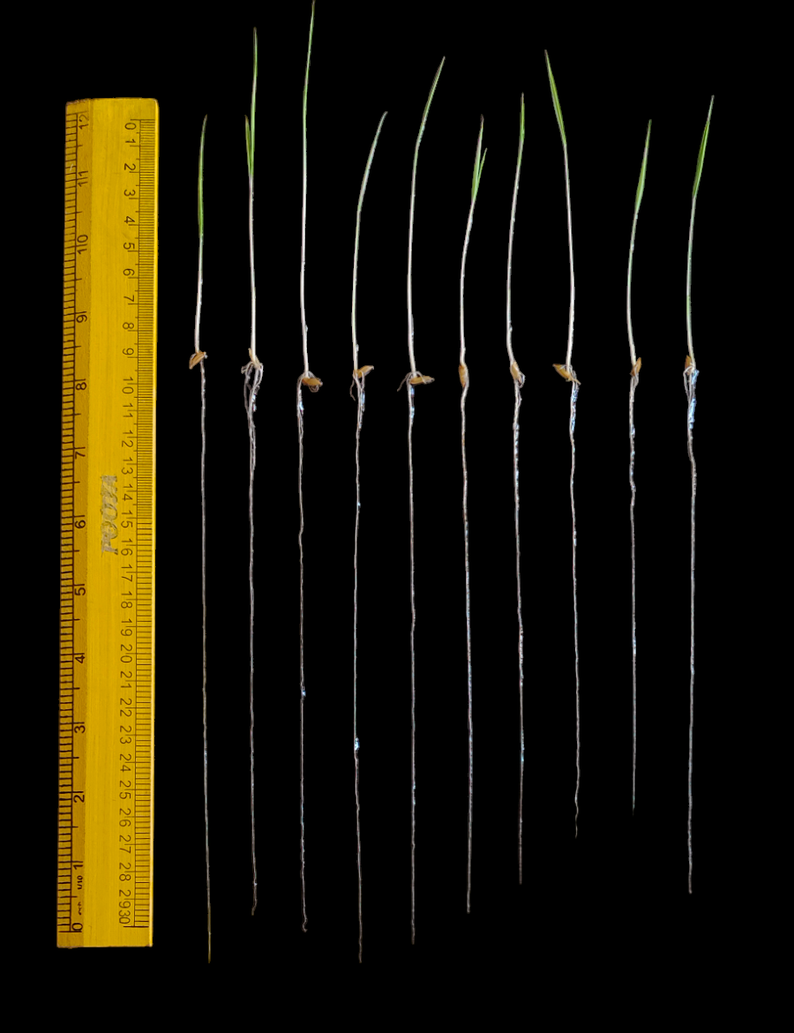
Fig.1 Seedling being selected, based on their germination percentage, shoot length and root length

Trait Measurement
Data on germination percentage (%), shoot length (cm), root length (cm), root-to-shoot length ratio, total seedling length (cm), seedling dry weight (mg), Seedling Vigour Index I (SVI-I), and Seedling Vigour Index II (SVI-II) were recorded at 14 DAS. Seedling vigour indices were calculated according to Abdul-Baki and Anderson (1973):
SVI-I = Germination percentage (%) × total seedling length (cm)
SVI-II = Germination percentage (%) × seedling dry weight (mg)
Statistical analysis
Correlation and Path coefficient analysis was carried out using GRAPES software (https://www.kaugrapes.com/) to determine the direct and indirect effects of seedling vigour traits on overall early seedling vigour performance. Correlation analysis among seedling vigour-related traits is essential for understanding the relationships among traits and for identifying key selection criteria that can simultaneously enhance multiple components of seedling vigour. In this study, Pearson’s correlation coefficients were computed under laboratory conditions. Path coefficient analysis is used to estimate the relationships between traits by partitioning correlation coefficients in to direct and indirect effects.
Results

In this study, Seedling Vigour Index I (SVI I) and Seedling Vigour Index II (SVI II) were considered as dependent variables, while early seedling traits (SL, RL, TSL, RN, SFW, RFW, TFW, SDW, RDW, TDW, GP-3rd day, GP-21st day, ROG, SVI I and SVI II) were used as independent variables.

When SVI II was the dependent variable results exhibited clear environmental differences. Under laboratory conditions, rate of germination (0.801) exerted the strongest direct influence, followed by germination percentage-3rd day (0.467), germination percentage-21st day (0.379), seed vigour index I (0.244) total fresh weight (0.211) and root fresh weight (0.081). From the table 1 & Fig. 2, Indirect contributions were prominent, particularly via Shoot Length (SL), Root Length (RL), Total Shoot Length (TSL), Root Number (RN), Shoot Fresh Weight (SFW), Shoot Dry Weight (SDW) and Total Dry Weight (TDW). (Table 1; Fig. 2)
For SVI I, a consistent pattern was observed where seed vigour index II (1.812) recorded the highest, followed by shoot dry weight (0.451), shoot length (0.338), total shoot length (0.271), total dry weight (0.229), root length (0.181) and root number (0.033.) Negative effects were recorded for Shoot Fresh Weight (SFW), Root Fresh Weight (RFW), Total Fresh Weight (TFW), Root Dry Weight (RDW), Germination percentage - 3rd day, Germination percentage - 21st day and Rate of Germination (ROG) (Tables 2; Fig. 1).
The analysis indicate Rate of Germination (ROG) and Germination Percentage (GP) acts as fundamental drivers of SVI II under laboratory conditions. In contrast, SVI I was driven primarily by Seed Vigour Index I (SVI II) and Shot Dry Weight (SDW).

Table 1. Path coefficient analysis showing direct, indirect and genotypic correlation effects of early seedling vigour traits on Seedling vigour index II in rice genotypes under laboratory conditions

TRAIT | SL | RL | TSL | RN | SFW | RFW | TFW | SDW | RDW | TDW | GP-3RD DAY | GP-21ST  DAY | ROG | SVI I | Genotypic correlation with SVI II
SL | -0.201 | -0.417 | -0.639 | -0.148 | -0.015 | 0.142 | 0.241 | -0.354 | 0.151 | -0.125 | 0.809 | 0.641 | 0.516 | 0.156 | 0.757
RL | -0.792 | -0.106 | -0.718 | -0.164 | -0.015 | 0.178 | 0.284 | -0.394 | 0.158 | -0.137 | 1.016 | 0.75 | 0.563 | 0.15 | 0.771
TSL | -0.799 | -0.472 | -0.161 | -0.162 | -0.016 | 0.161 | 0.268 | -0.387 | 0.162 | -0.136 | 0.916 | 0.711 | 0.562 | 0.164 | 0.811
RN | -1.255 | -0.733 | -1.098 | -0.024 | -0.03 | 0.322 | 0.56 | -0.704 | 0.319 | -0.253 | 1.655 | 1.189 | 1.169 | 0.39 | 1.508
SFW | -0.506 | -0.265 | -0.431 | -0.116 | -0.006 | 0.177 | 0.507 | -0.344 | 0.145 | -0.121 | 0.479 | 0.487 | 0.225 | 0.112 | 0.342
RFW | -0.353 | -0.232 | -0.319 | -0.094 | -0.013 | 0.081 | 0.414 | -0.298 | 0.154 | -0.112 | 0.333 | 0.382 | 0.136 | 0.074 | 0.154
TFW | -0.231 | -0.143 | -0.205 | -0.063 | -0.015 | 0.16 | 0.211 | -0.206 | 0.095 | -0.074 | 0.223 | 0.233 | 0.099 | 0.069 | 0.152
SDW | -0.353 | -0.207 | -0.309 | -0.083 | -0.01 | 0.12 | 0.215 | -0.202 | 0.209 | -0.132 | 0.385 | 0.308 | 0.269 | 0.163 | 0.372
RDW | -1.018 | -0.56 | -0.878 | -0.254 | -0.03 | 0.421 | 0.668 | -1.415 | 0.03 | -0.448 | 1.733 | 1.256 | 1.023 | 0.474 | 1.001
TDW | -0.331 | -0.191 | -0.289 | -0.079 | -0.01 | 0.12 | 0.206 | -0.351 | 0.176 | -0.076 | 0.417 | 0.322 | 0.275 | 0.153 | 0.343
GP-3RD DAY | -0.349 | -0.23 | -0.316 | -0.084 | -0.006 | 0.058 | 0.1 | -0.166 | 0.111 | -0.068 | 0.467 | 0.395 | 0.788 | 0.22 | 0.919
GP-21STDAY | -0.34 | -0.209 | -0.302 | -0.074 | -0.008 | 0.082 | 0.129 | -0.164 | 0.099 | -0.064 | 0.487 | 0.379 | -0.173 | -0.057 | -0.217
ROG | -0.13 | -0.075 | -0.113 | -0.035 | -0.002 | 0.014 | 0.026 | -0.068 | 0.038 | -0.026 | 0.459 | -0.082 | 0.801 | 0.25 | 1.059
SVI I | -0.128 | -0.065 | -0.108 | -0.038 | -0.003 | 0.025 | 0.06 | -0.135 | 0.058 | -0.048 | 0.42 | -0.089 | 0.82 | 0.244 | 1.013
SL: Shoot Length (cm), RL: Root Length (cm); TSL: Total Shoot Length (cm); RN: Root Number; SFW: Shoot Fresh Weight (mg); RFW: Root Fresh Weight (mg); TFW: Total Fresh Weight (mg); SDW: Shoot Dry Weight (mg); RDW: Root Dry Weight (mg); TDW: Total Dry Weight (mg); GP-3rd Day: Germination percentage(%); GP-21st Day: Germination percentage(%); ROG: Rate of Germination (%); SVI I: Seedling Vigour Index I ; SVI II: Seedling Vigour Index II; Residual effect: -0.098

Table 2. Path coefficient analysis showing direct, indirect and genotypic correlation effects of early seedling vigour traits on Seedling vigour index I in rice genotypes under laboratory conditions

TRAIT | SL | RL | TSL | RN | SFW | RFW | TFW | SDW | RDW | TDW | GP-3RD DAY | GP-21ST  DAY | ROG | SVI II | Genotypic correlation with SVI I
SL | 0.338 | 0.713 | 1.078 | 0.207 | -0.054 | -0.175 | -0.462 | 0.791 | -0.137 | 0.377 | -1.492 | -1.323 | -0.596 | 1.372 | 0.637
RL | 1.33 | 0.181 | 1.21 | 0.23 | -0.053 | -0.218 | -0.544 | 0.882 | -0.143 | 0.413 | -1.872 | -1.548 | -0.65 | 1.397 | 0.615
TSL | 1.342 | 0.808 | 0.271 | 0.227 | -0.057 | -0.197 | -0.513 | 0.866 | -0.148 | 0.411 | -1.688 | -1.468 | -0.649 | 1.469 | 0.673
RN | 2.107 | 1.255 | 1.852 | 0.033 | -0.104 | -0.395 | -1.072 | 1.573 | -0.29 | 0.764 | -3.052 | -2.456 | -1.349 | 2.733 | 1.598
SFW | 0.849 | 0.453 | 0.726 | 0.162 | -0.021 | -0.217 | -0.971 | 0.77 | -0.132 | 0.366 | -0.883 | -1.005 | -0.259 | 0.62 | 0.458
RFW | 0.592 | 0.396 | 0.537 | 0.132 | -0.046 | -0.1 | -0.793 | 0.667 | -0.14 | 0.338 | -0.613 | -0.789 | -0.157 | 0.278 | 0.302
TFW | 0.387 | 0.245 | 0.346 | 0.088 | -0.051 | -0.196 | -0.403 | 0.46 | -0.086 | 0.225 | -0.411 | -0.481 | -0.114 | 0.276 | 0.284
SDW | 0.593 | 0.355 | 0.521 | 0.116 | -0.036 | -0.148 | -0.412 | 0.451 | -0.19 | 0.4 | -0.709 | -0.636 | -0.31 | 0.674 | 0.668
RDW | 1.71 | 0.958 | 1.479 | 0.356 | -0.104 | -0.517 | -1.279 | 3.163 | -0.027 | 1.355 | -3.195 | -2.593 | -1.181 | 1.815 | 1.941
TDW | 0.556 | 0.327 | 0.487 | 0.111 | -0.034 | -0.147 | -0.395 | 0.786 | -0.16 | 0.229 | -0.769 | -0.666 | -0.317 | 0.621 | 0.628
GP-3RD DAY | 0.586 | 0.394 | 0.532 | 0.118 | -0.022 | -0.071 | -0.192 | 0.371 | -0.101 | 0.205 | -0.861 | -0.816 | -0.909 | 1.666 | 0.9
GP-21STDAY | 0.571 | 0.358 | 0.509 | 0.104 | -0.027 | -0.101 | -0.248 | 0.366 | -0.09 | 0.195 | -0.898 | -0.783 | 0.2 | -0.393 | -0.235
ROG | 0.218 | 0.127 | 0.191 | 0.048 | -0.006 | -0.017 | -0.05 | 0.151 | -0.035 | 0.079 | -0.847 | 0.169 | -0.924 | 1.918 | 1.024
SVI II | 0.256 | 0.14 | 0.22 | 0.05 | -0.007 | -0.015 | -0.061 | 0.168 | -0.027 | 0.079 | -0.792 | 0.17 | -0.979 | 1.812 | 1.013

SL: Shoot Length (cm), RL: Root Length (cm); TSL: Total Shoot Length (cm); RN: Root Number; SFW: Shoot Fresh Weight (mg); RFW: Root Fresh Weight (mg); TFW: Total Fresh Weight (mg); SDW: Shoot Dry Weight (mg); RDW: Root Dry Weight (mg); TDW: Total Dry Weight (mg); GP-3rd Day: Germination percentage(%); GP-21st Day: Germination percentage(%); ROG: Rate of Germination (%); SVI I: Seedling Vigour Index I ; SVI II: Seedling Vigour Index II; Residual effect: -0.01

SVI I
SDW
SL
TSL
TDW
ROG
GP-3rd
GP-21st
0.451**
0.338**
0.271**
-0.924**
0.229**
-0.861**
-0.783**

:Strong positive direct effect (≥ 0.6)
: Moderate positive direct effect (0.3 to < 0.6)
: Negative direct effect (< 0)
*significant at 5% level, **significant at 1% level,
ns-non significant

SDW - Shoot dry weight
SL - Shoot length
TSL - Total shoot length
TDW - Total dry weight
ROG - Rate of germination
GP-3rd - Germination percentage (3rd day)
GP-21st - Germination percentage (21st day)
TFW - Total fresh weight
SVI I - Seed vigour index I
SVI II - Seed vigour index II

SVI II
ROG
GP-3rd
GP-21ST
TFW
SDW
SL
TSL
0.801**
0.467**
0.379**
-0.202**
0.211**
-0.201**
-0.161**

Fig.2. Path diagrams depicting direct effects of rice seedling traits on seedling vigour indices under laboratory conditions

Correlograms and correlation matrices, illustrating the direction, strength, and statistical significance of inter-trait associations are presented in Fig. 3 and Table 3.

Under laboratory conditions, Rate of Germination(ROG) showed a very strong positive correlation with Seed Vigour Index I(SVI I) (r = 0.973), indicating that variation in Rate of Germination(ROG) is a major contributor to overall seedling growth. Shoot Dry weight(SDW) was also highly correlated with Total Dry weight (TDW) (r = 0.958), highlighting biomass accumulation as a key determinant of vigour. In addition, Rate of Germination(ROG) was strongly correlated with Seed Vigour Index I(SVI I) (r = 0.856) reaffirming the dependence of vigour index on seedling elongation traits.
In addition to that, Rate of Germination(ROG) showed a negative correlation with Root Fresh Weight(RFW) (r = -0.057) and also with Shoot Fresh Weight(SFW) (r = -0.021), Total Fresh Weight(TFW) (r = -0.057) and Root Length(RL) (r = -0.044).
Germination percentage - 3rd day also showed negative correlation with shoot length, shoot dry weight and total dry weight.

The correlation between SVI-I and SVI-II was high under laboratory conditions (r = 0.834), suggesting complete dependence between seedling elongation (SVI-I) and biomass accumulation (SVI-II), particularly in controlled environments (Surrora et al., 2023).

These findings underscore the importance of considering both elongation and biomass traits in selection strategies and support the integration of complementary evaluation methods to capture the full spectrum of seedling vigour expression across diverse growing conditions.

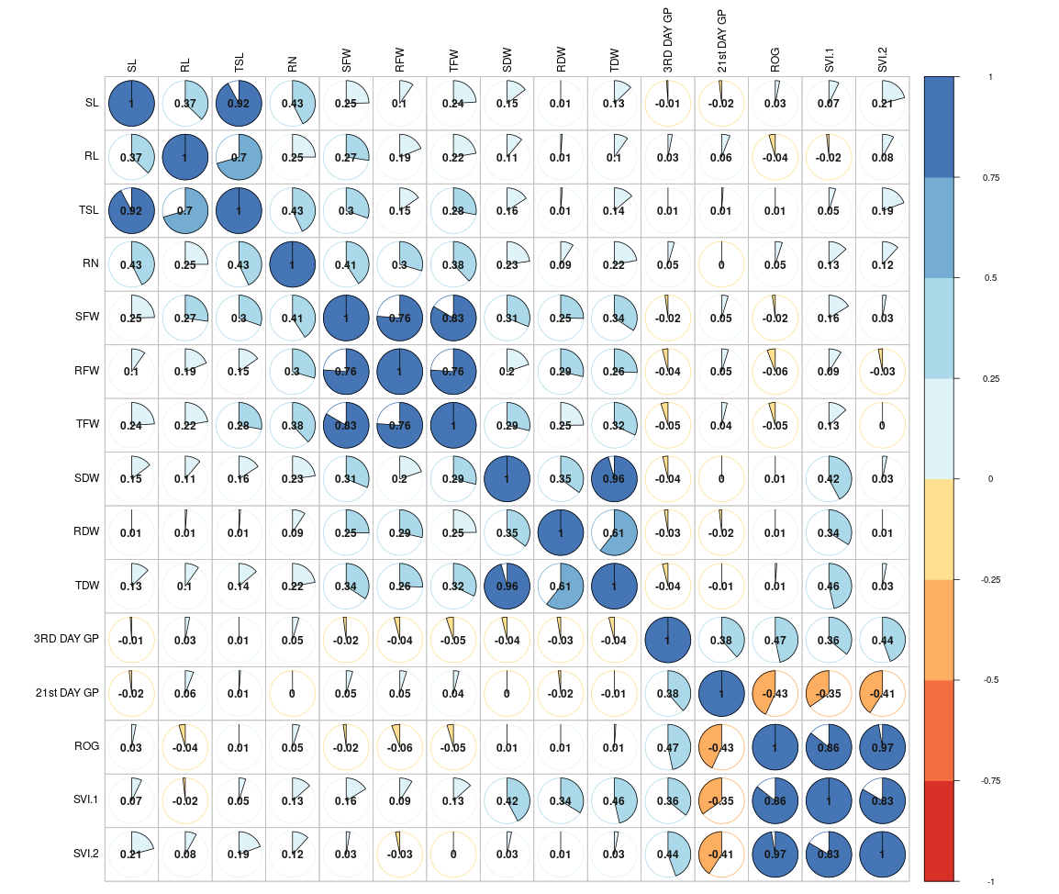
Fig. 3: a) Correlogram showing Pairwise Relationships among Seedling Vigour Traits under laboratory condition SL: Shoot Length (cm), RL: Root Length (cm); TSL: Total Shoot Length (cm); RN: Root Number; SFW: Shoot Fresh Weight (mg); RFW: Root Fresh Weight (mg); TFW: Total Fresh Weight (mg); SDW: Shoot Dry Weight (mg); RDW: Root Dry Weight (mg); TDW: Total Dry Weight (mg); GP-3rd Day: Germination percentage(%); GP-21st Day: Germination percentage(%); ROG: Rate of Germination (%); SVI I: Seedling Vigour Index I ; SVI II: Seedling Vigour Index II

Table 3. Correlation Matrix showing Pairwise Relationships among Seedling Vigour Traits under laboratory condition | SL | RL | TSL | RN | SFW | RFW | TFW | SDW | RDW | TDW | GP-3RD DAY | GP-21ST  DAY | ROG | SVI II | SVI I
SL | 1 | 0.373*** | 0.921*** | 0.425*** | 0.246*** | 0.097 | 0.24*** | 0.147** | 0.01 | 0.128* | -0.01 | -0.018 | 0.031 | 0.072 | 0.209***
RL | 0.373*** | 1 | 0.705*** | 0.25*** | 0.273*** | 0.188*** | 0.223*** | 0.111* | 0.01 | 0.098 | 0.031 | 0.059 | -0.044 | -0.016 | 0.08
TSL | 0.921*** | 0.705*** | 1 | 0.43*** | 0.303*** | 0.153** | 0.277*** | 0.159** | 0.012 | 0.139* | 0.005 | 0.011 | 0.005 | 0.048 | 0.193***
RN | 0.425*** | 0.25*** | 0.43*** | 1 | 0.409*** | 0.296*** | 0.38*** | 0.228*** | 0.091 | 0.222*** | 0.045 | -0.001 | 0.05 | 0.135* | 0.117*
SFW | 0.246*** | 0.273*** | 0.303*** | 0.409*** | 1 | 0.762*** | 0.834*** | 0.311*** | 0.253*** | 0.342*** | -0.021 | 0.046 | -0.021 | 0.163** | 0.027
RFW | 0.097 | 0.188*** | 0.153** | 0.296*** | 0.762*** | 1 | 0.761*** | 0.198*** | 0.285*** | 0.256*** | -0.04 | 0.048 | -0.057 | 0.089 | -0.03
TFW | 0.24*** | 0.223*** | 0.277*** | 0.38*** | 0.834*** | 0.761*** | 1 | 0.288*** | 0.249*** | 0.321*** | -0.05 | 0.039 | -0.045 | 0.133* | -0.001
SDW | 0.147** | 0.111* | 0.159** | 0.228*** | 0.311*** | 0.198*** | 0.288*** | 1 | 0.352*** | 0.958*** | -0.037 | -0.004 | 0.01 | 0.423*** | 0.032
RDW | 0.01 | 0.01 | 0.012 | 0.091 | 0.253*** | 0.285*** | 0.249*** | 0.352*** | 1 | 0.606*** | -0.026 | -0.017 | 0.007 | 0.338*** | 0.007
TDW | 0.128* | 0.098 | 0.139* | 0.222*** | 0.342*** | 0.256*** | 0.321*** | 0.958*** | 0.606*** | 1 | -0.039 | -0.009 | 0.011 | 0.464*** | 0.029
GP-3RD DAY | -0.01 | 0.031 | 0.005 | 0.045 | -0.021 | -0.04 | -0.05 | -0.037 | -0.026 | -0.039 | 1 | 0.385*** | 0.467*** | 0.358*** | 0.445***
GP-21STDAY | -0.018 | 0.059 | 0.011 | -0.001 | 0.046 | 0.048 | 0.039 | -0.004 | -0.017 | -0.009 | 0.385*** | 1 | -0.431*** | -0.347*** | -0.408***
ROG | 0.031 | -0.044 | 0.005 | 0.05 | -0.021 | -0.057 | -0.045 | 0.01 | 0.007 | 0.011 | 0.467*** | -0.431*** | 1 | 0.856*** | 0.973***
SVI II | 0.072 | -0.016 | 0.048 | 0.135* | 0.163** | 0.089 | 0.133* | 0.423*** | 0.338*** | 0.464*** | 0.358*** | -0.347*** | 0.856*** | 1 | 0.834***
SVI I | 0.209*** | 0.08 | 0.193*** | 0.117* | 0.027 | -0.03 | -0.001 | 0.032 | 0.007 | 0.029 | 0.445*** | -0.408*** | 0.973*** | 0.834*** | 1

*** Correlation is significant at 0.001 level ,** Correlation is significant at 0.01 level, * Correlation is significant at 0.05 level (two tailed)

SL- Shoot length; RL- Root length; TSL- Total shoot length; RN- Root number; SFW- Shoot fresh weight; RFW- Root fresh weight; TFW- Total fresh weight; SDW- Shoot dry weight; RDW- Root dry weight; TDW- Total dry weight; GP-3rd day- Germination percentage on 3rd day; GP-21st day- Germination percentage on 21st day; ROG- Rate of germination; SVI I- Seed vigour index I; SVI II- Seed vigour index II

Discussion
Significant genotypic variation was observed for early seedling vigour (ESV) traits under laboratory conditions. In particular, superior performance under laboratory-based ESV evaluations can be attributed to the optimal and stress-free conditions of the germination paper method(ISTA, 2018) which promote rapid and uniform germination. These conditions tend to enhance elongation-related traits such as shoot length, root length and total seedling length, ultimately leading to higher values for indices like Seedling Vigour Index I (SVI-I), which is primarily based on seedling length.
Our findings align with earlier studies by Abdul-Baki and Anderson (1973), Wang et al. (2011), and Sagar et al. (2025), which also demonstrated improved seedling elongation under controlled environments. The uniformity and rapidity of germination in such settings enable efficient assessment of seedling length-based indices, making them reliable indicators of early seedling vigour under laboratory conditions.
Mahender et al. (2015) defined ESV as a combination of rapid, uniform germination and early biomass accumulation traits essential for robust establishment under DDSR. While Padmashree (2022) and Singh et al. (2017) emphasized the value of SVI-I for assessing seedling elongation, Subramanian et al. (2025) and Sanghmitra et al. (2021) demonstrated the importance of early dry matter accumulation in enhancing seedling vigour. Barik et al. (2019) observed that increased dry weight by the 15th day after sowing is indicative of efficient resource partitioning, while Addanki et al. (2018) reported that high-vigour seedlings with greater SVI-I and SVI-II develop into more resilient and productive plants. These findings strongly support to identify genotypes with superior performance under DDSR conditions.
Correlation analysis revealed strong positive associations among key ESV traits, such as shoot length, total seedling length, SVI-I, dry weight, and SVI-II, laboratory conditions. These relationships suggest that the traits are governed by shared genetic factors, supporting the potential for simultaneous selection. Notably, the high correlation between SVI-I and SVI-II highlights that while these indices are related, they capture distinct physiological processes—elongation and biomass accumulation, respectively. This distinction reinforces the importance of using both indices for a comprehensive assessment of seedling vigour.
These findings are supported by previous studies (Surrora et al., 2023; Padmashree et al., 2022; Akshitha et al., 2020), which also reported significant positive associations among seedling length, dry weight, and vigour indices. Similarly, Addanki et al. (2018), Bordoloi and Sarma (2018), Barik et al. (2019), Beerelli et al. (2020), Katiyar et al. (2019), and Bharamappanavara et al. (2023) documented consistent positive correlations among key seedling vigour parameters. Together, these insights from the results and discussion clearly demonstrate the robustness of the observed relationships among seedling vigour traits, thereby laying a solid foundation for the conclusion of this study.

Conclusion
The present study provides valuable insights into the interrelationships among key early seedling vigour traits in rice by integrating correlation and path coefficient analyses under controlled laboratory conditions. The significant positive correlations observed among traits such as seedling shoot length, root length, seedling dry weight, and vigour index indicate their collective contribution to early growth performance and their potential as reliable selection criteria. Path analysis further clarified these relationships by partitioning direct and indirect effects, revealing that traits with strong direct effects on vigour index are particularly impactful for improving early seedling establishment.
These findings underscore the importance of early seedling vigour as a foundational component for enhancing crop establishment, especially in direct-seeded rice systems where rapid and uniform emergence is critical. The study also highlights specific traits that breeders can prioritize in selection programmes to develop varieties with superior early growth characteristics. Overall, this work contributes to a deeper understanding of seedling-stage physiology in rice and offers practical implications for breeding strategies aimed at improving productivity and resilience in modern rice cultivation systems.

Disclaimer (Artificial intelligence)
Option 1:
Author(s) hereby declare that NO generative AI technologies such as Large Language Models (ChatGPT, COPILOT, etc.) and text-to-image generators have been used during the writing or editing of this manuscript.

References

Abdul Baki, A.A and Anderson, J.D. (1973). Vigor determination in soybean seed by multiple criteria 1. Crop Sci., 13(6), 630–633.
Addanki, K.R., Balakrishnan, D., Yadavalli, V.R., Surapaneni, M., Mesapogu, S., Beerelli, K. and Neelamraju, S. (2019). Swarna × Oryza nivara introgression lines, A resource for seedling vigour traits in rice. Plant Genet. Resour., 17(1), 12–23.
Akshitha, B., Senguttuvel, P., Latha, V.H., Yamini, K.N., Rani, K.J. and Beulah, P. (2020). Variability and Correlation Analysis for Seedling Vigour Traits in Rice (Oryza sativa L.) Genotypes. Int. J. Curr. Microbiol. App. Sci., 9(07): 2877–2887. https://doi.org/10.20546/ijcmas.2020.907.341
Anandan, A., Mahender, A., Sah, R.P., Bose, L.K., Subudhi, H., Meher, J., Reddy, J.N. and Ali, J. (2020). Non-destructive phenotyping for early seedling vigor in direct-seeded rice. Plant Methods, 16, 1–18.
Barik, J., Kumar, V., Lenka, S.K. and Panda, D. (2019). Genetic potentiality of lowland indigenous indica rice (Oryza sativa L.) landraces to anaerobic germination potential. Plant Physiol. Rep., 24, 249–261.
Beerelli, K., Balakrishnan, D. and Neelamraju, S. (2020). Variability and correlation of yield traits in BIL × BIL populations derived from Swarna × O. nivara. J. Rice Res., 13(1), 1–12.
Bharamappanavara, M., Madhyavenkatapura, A.S., Appaiah, M.C., Patil, B.S., Vijjeswarapu, A., Senguttuvel, P., Madhav, M.S., Rathod, S., Mondal, T.K., Ramappa, L. and Mathada, U.R. (2023). Genetic analysis of early seedling vigour in Oryza glaberrima accessions under laboratory and direct-seeded rice conditions. Cereal Res. Commun., 51(4), 991–1002.
Bordoloi, D. and Sarma (2018). Aerobic versus anaerobic germination performance of selected rice (Oryza sativa L.) genotypes with or without submergence tolerance. J. Exp. Biol. Agric. Sci., 6(6), 947–958.
Dayala, S., Balakrishnan, D., Kar, J. L. Ganguli, S., Sundaram, R.M. and Subba Rao, L.V. (2025). Diversity of Indian rice cultivars and landraces for seedling vigour and their association for yield related traits. Vegetos, 38, 619–631. https://doi.org/10.1007/s42535-023-00777-0
Dey, S., Abbhishek, K., Saraswathibatla, S., & Das, D. (2025). Economic suitability of direct seeded rice across different geographies in India. PLOS ONE, 20(4), e0321472. https://doi.org/10.1371/journal.pone.0321472
Farooq, M., Siddique, K.H., Rehman, H., Aziz, T., Lee, D., & Wahid, A. (2011). Rice direct seeding: Experiences, challenges and opportunities. Soil and Tillage Research, 111(2), 87–98. https://doi.org/10.1016/j.still.2010.10.008
Jagdeep, S. and Singh, G. (2024). A Review on Direct Seeded Rice: A Sustainable Approach to Paddy Cultivation. Int. J. Sci. Res. Eng. Trends, 10(5): 2395–566.
Jat, R.A., Dungrani, R.A., Arvadia, M.K. and Sahrawat, K.L. 2012. Diversification of rice (Oryza sativa L.)-based cropping systems for higher productivity, resource-use efficiency and economic returns in south Gujarat, India. Archives of Agronomy and Soil Science. 58(6): 561-572.
Jat, R.K., Meena, V.S., Kumar, M., Jakkula, V.S., Reddy, I.R., & Pandey, A.C. (2022). Direct Seeded Rice: Strategies to Improve Crop Resilience and Food Security under Adverse Climatic Conditions. Land, 11(3), 382. https://doi.org/10.3390/land11030382
Katiyar, D., Srivastava, K.K., Prakash, S., Kumar, M., Gupta, M. (2019). Study correlation coefficients and path analysis for yield and its component characters in rice (Oryza sativa L.). J. Pharmacognosy Phytochem., 8(1), 1783–1787.
Kumar, A., Verma, R.L., Sah, R.P., Satapathy, B.S., Mohanty, S., Tripathi, R., Chattopadhyay, K., Samantaray, S. and Nayak, A.K. (2024). Direct Seeded Rice: A Technology for Enhancing Climate Resilience. NRRI Research Bulletin No. 50, ICAR-National Rice Research Institute, Cuttack, India, pp. 32.
Mahender, A., Anandan, A., Pradhan, S.K. (2015). Early seedling vigour, an imperative trait for direct-seeded rice: an overview on physio-morphological parameters and molecular markers. Planta, 241(5), 1027–1050. https://doi.org/10.1007/s00425-015-2273-9
Negi, P., Rane, J., Wagh, R.S., Bhor, T.J., Godse, D.D., Jadhav, P., Anilkumar, C., Sreekanth, D., Sammi Reddy, K., Gadakh, S.R., Boraih, K., Harisha, C. and Basavaraj, P. (2024). Direct-Seeded Rice: Genetic Improvement of Game-Changing Traits for Better Adaption. Rice Science, 31(4), 417–433. https://doi.org/10.1016/j.rsci.2024.04.006
Padmashree, R., Nakul, D.M., Kalyani, M.B., Phule, A., Honnappa, Senguttuvel, P., Madhav, M.S., Anantha, M.S., Balakrishnan, D., Gireesh, C., Manasa, V. and Lokesha, R. (2022). Phenotypic evaluation of seedling vigour related traits in a set of rice lines. J. Rice Res., 15(1), 1–8.
Sagar, S.P.P., Diwan, J.R., Gireesh, C., Tembhurne, B.V., Mahantashivayogayya, K., Suma, T.C. and Saroja, N.R. (2025). Multivariate Analysis Of Early Seedling Vigour And Its Component Traits In A Subset Of Rice (Oryza Sativa L.) 3k Panel. Plant Archives, 25(1), 2060–2068.
Sandhu, N., Yadav, S., Kumar Singh, V., & Kumar, A. (2021). Effective crop management and modern breeding strategies to ensure higher crop productivity under direct seeded rice cultivation system: A review. Agronomy, 11(7), 1264.
Sandhu, N., Yadaw, R.B., Chaudhary, B., Prasai, H., Iftekharuddaula, K., Venkateshwarlu, C., Annamalai, A., Xangsayasane, P., Battan, K.R., Ram, M., Cruz, M.T.S., Pablico, P., Maturan, P.C. (2019). Evaluating the performance of rice genotypes for improving yield and adaptability under direct seeded aerobic cultivation conditions. Front Plant Sci., 10, 159.
Singh, S.K., Jainth, H.J.K., Maurya, S., Kumar, A., Yadav, S., and Sah, D. (2024). Direct-Seeded Rice: Potential Benefits, Constraints and Prospective. Journal of Scientific Research and Reports, 30(7), 272–280. https://doi.org/10.9734/jsrr/2024/v30i72143
Singh, U.M., Yadav, S., Dixit, S., Ramayya, P.J., Devi, M.N., Raman, K.A., & Kumar, A. (2017). QTL Hotspots for Early Vigor and Related Traits under Dry Direct-Seeded System in Rice (Oryza sativa L.). Frontiers in Plant Science, 8, 229771. https://doi.org/10.3389/fpls.2017.00286
Subramanian, S., Ramamoorthy, P., Alagesan, S., et al. (2024). Unlocking the genetic potential of Indian rice germplasm across different environments for early seedling vigour. Genet Resour Crop Evol, 72, 1459–1476. https://doi.org/10.1007/s10722-024-02055-7
Suroora, B.K.P., Saraswathi, R., Suresh, R., Renganayaki, P.R. and Sritharan, N. (2023). Characterization of Rice (Oryza sativa L.) Germplasm for Early Seedling Vigour-related Traits under Direct Seeded Condition. International Journal of Plant & Soil Science, 35(19), 2106–2114. https://doi.org/10.9734/ijpss/2023/v35i193762
Wang, Z., Wang, J., Zhou, R., Wang, J. and Zhang, H. (2011). Identification of quantitative trait loci for cold tolerance during germination and seedling stages in rice (Oryza sativa L.). Euphytica, 181, 405–413.

