Phylogenetic analysis of annexin genes in selected monocot and dicot plants

Abstract
Annexins are a diverse family of calcium-dependent phospholipid-binding proteins involved in membrane transport, signal transduction, and various stress responses in plants. This study presents a comprehensive phylogenetic analysis of annexin genes across multiple monocot and dicot plant species. The study involved downloading the complete annexin gene sequences from reliable databases. Phylogenetic trees were carefully constructed for individual plant species, followed by a comparative analysis that distinguished the evolutionary approach of annexin genes among monocots and dicots. The analysis revealed significant evolutionary divergence and conserved clades within the annexin gene family, suggesting both lineage-specific expansions and ancient gene duplications. The results of this study provide new insights into the molecular evolution of annexins and highlight their potential role in plant adaptation and resilience. The comprehensive phylogenetic analyses performed in this work not only contribute to the understanding of annexin gene evolution but also lay the foundation for future functional studies aimed at exploiting annexins for crop improvement and stress management.
Keywords: Annexin, phylogenetic tree, monocots, dicots, database, abiotic stress, divergence

1. Introduction
Annexins are a highly conserved protein family characterized by their ability to bind to phospholipids in a calcium-dependent manner. These proteins are found in a wide variety of eukaryotic organisms and are involved in a number of cellular functions (Gerke et al., 2005). Annexins family have been found to be present in nearly all plant species, characterized by a short N-terminal region and conserved annexin repeats. They exhibit Ca²⁺ channel–regulating, peroxidase, and ATPase/GTPase activities, which collectively confer their functional specificity (Wu et al., 2022). In plants, annexins have been shown to be involved in important physiological processes, including vesicle transport, cytoskeletal rearrangements, ion channel regulation, and responses to biotic and abiotic stress. Due to their diverse roles, annexins are considered to be integral in the regulation of plant growth, development, and stress adaptation (Laohavisit and Davies, 2011). Plant annexins are soluble proteins that associate with cellular membranes and exhibit both calcium-dependent and independent functions. They bind F-actin, hydrolyze ATP/GTP, and act as peroxidases or cation channels, contributing to growth and stress signaling. Their expression and localization are tightly regulated across species by developmental and environmental cues (Xie et al., 2025). With the growing availability of genome sequences across diverse species and supporting functional studies, it is now well established that environmental stresses, including salinity, drought, and high temperatures, significantly influence annexin gene expression in many plant species (Tong et al., 2025). Jami and co-workers conducted a comparative analysis of annexin gene families across sequenced Viridiplantae genomes, from unicellular green algae to multicellular plants, and identified 149 genes. Phylogenetic analysis classified these annexins into nine arbitrary groups, each showing distinct patterns in the occurrence and distribution of bona fide type II calcium-binding sites within their four annexin domains (Jami et al., 2012a). Plant species have Annexin multigene families that vary in the number of members they consist of (Yadav et al., 2018). The evolutionary history of the annexin gene family in plants is of particular interest due to its potential implications for plant adaptation and diversification (Clark et al., 2012). Over the course of evolution, gene duplication events, followed by neo-functionalization or sub-functionalization, have likely played a pivotal role in the expansion and diversification of the gene families in different plant lineages (Panchy et al., 2016). Understanding these evolutionary processes requires a detailed phylogenetic analysis that can reveal the relationships between annexin genes from various plant species and provide insights into their functional evolution.
This study focuses on the phylogenetic analysis of annexin genes across a wide range of monocot and dicot plants, representing two major evolutionary lineages within the angiosperms. Monocots, such as grasses (including important crops like rice, wheat, maize sorghum and barley) and dicots, which include a large diversity of species such as legumes (e.g., soybeans and chickpeas), are two groups of plants differ not only in their morphological characteristics but also in their evolutionary history, which may have influenced the diversification of their annexin gene families. The aim of this study is to perform a comprehensive phylogenetic analysis of annexin genes in both monocots and dicots using MEGA11, a widely used software suite for molecular evolutionary genetic analysis.

2. Materials and methods
2.1 Selection of plant species
For the phylogenetic analysis of annexin genes across diverse plant species, we began by systematically selecting and compiling the required gene sequences from established genomic databases. Plant species were chosen based on their agricultural significance and the availability of complete genomic information. The selected plant species are listed in table 1. Together, these species, spanning major cereals, legumes, and key model organisms, provide a broad and representative framework for a comprehensive comparative study of annexin gene evolution.

Table 1: Plant species selected for the phylogenetic analysis of annexin genes
Name of the crop | Scientific name | Monocot/Dicot | Remark
Rice | Oryza sativa | Monocot | A staple food for a large portion of the global population, making it a vital crop for genetic and agronomic research
Wheat | Triticum aestivum | Monocot | One of the most widely cultivated crops in the world, characterized by its complex hexaploid genome
Barley | Hordeum vulgare | Monocot | An important cereal crop with a relatively simple diploid genome
Sorghum | Sorghum bicolor | Monocot | A drought-tolerant crop important for food, livestock feed, and biofuel production
Maize | Zea mays | Monocot | A major staple crop with a complex and well-studied genome.
Thale cress | Arabidopsis thaliana | Dicot | A model organism widely used in plant genetics and molecular biology.
Soybean | Glycine max | Dicot | A major source of protein and oil, widely studied for its genetic and agronomic traits
Mung bean | Vigna radiata | Dicot | A protein-rich legume valued for its nutritional and agricultural importance
Chickpea | Cicer arietinum | Dicot | An important legume crop known for its high nutritional value and global dietary significance
Tobacco | Nicotiana tabacum | Dicot | A model organism in plant biology and an important commercial crop

2.2 Genomic databases used
To retrieve the annexin gene sequences, we utilized several specialized genomic databases, each chosen for its reliability and suitability for particular plant species.
Rice Annotation Project Database: This database was used to obtain annexin gene sequences for Oryza sativa. It provides a comprehensive and curated collection of rice-specific genomic data, ensuring accurate sequence retrieval (https://rapdb.dna.affrc.go.jp/index.html).
Wheat Ensembl: Given the complexity of the hexaploid wheat genome, Wheat Ensembl was employed to access high-quality and complete sequence data for Triticum aestivum. Its tools and annotations are specifically tailored to address the challenges of wheat genomics (https://plants.ensembl.org/Triticum_aestivum/Info/Index).
Plant Ensembl: For the remaining plant species viz., Glycine max, Cicer arietinum, Hordeum vulgare, Vigna radiata, Nicotiana tabacum, Zea mays, Sorghum bicolor, and Arabidopsis thaliana Plant Ensembl served as the primary source. This database offers extensive genomic resources across a wide range of plant taxa, making it well-suited for comparative analyses (https://plants.ensembl.org/index.html).
NCBI (National Center for Biotechnology Information): In instances where specific sequences were unavailable in the above databases, NCBI was used as a supplementary resource to ensure a complete and comprehensive dataset (https://www.ncbi.nlm.nih.gov/).

2.3 Sequence alignment and phylogenetic tree construction
All annexin gene sequences were first collected and prepared for analysis. Sequence alignment was conducted using MEGA11 (Molecular Evolutionary Genetics Analysis), selected for its robust performance with large and diverse datasets (Tamura et al., 2021). FASTA sequences were imported into MEGA11, where homologous regions were identified and aligned across species. Phylogenetic analysis was performed using the Test Neighbor-Joining (NJ) method, chosen for its efficiency and suitability for large datasets. The “Build/Test Neighbor-Joining Tree” option in MEGA11 was used to generate the phylogenetic tree, with customization of parameters, visualization settings, and statistical support assessments.

3. Results
3.1 Phylogenetic analysis of rice (Oryza sativa) annexin genes
The phylogenetic tree in figure 1 represents the evolutionary relationships between various annexin genes in Oryza sativa (rice). The tree shows how these genes have evolved, diverged, or remained conserved over time. The branching pattern, along with the bootstrap values, provides insight into the reliability of the groupings and potential functional similarities or differences between these annexin genes. The length of the horizontal branches indicates evolutionary distance, with longer branches representing greater divergence in gene sequences, while shorter branches indicate close evolutionary relationships. At the top of the tree, Ann3 and Ann4 (Os05t0382600-02/-03 and Os05t0382900-01/-02) cluster closely together, with bootstrap values ​​of 100, showing very strong support for this clade. This high confidence suggests that these genes are duplicated or have evolved recently with minimal divergence, indicating strong conservation. The short branch lengths within this clade highlight the high sequence similarity between these genes, which may suggest that they perform similar functions or are similarly regulated within the plant. Furthermore, Ann8 (Os09t0368850-01) diverges from the others with a relatively longer branch, indicating significant evolutionary distance. This suggests that Ann8 has accumulated more genetic changes over time, likely leading to different functional characteristics than other annexins. The moderate bootstrap value of 62 here suggests some uncertainty and shows that even if this gene is unique, its exact location in the tree may vary slightly depending on the data or methods used. Ann1 (Os01t0497400-00) and Ann6 (Os07t0659600-01) are grouped together with a bootstrap value of 73. The evolutionary distance between these genes, as represented by branch lengths, is moderate, suggesting that while they are related in some respects, enough genetic differences have accumulated to potentially differentiate their functions or expression patterns. The tree also contains a well-supported clade with Ann2 (Os02t0753800-01), and Ann5 (Os06t0221200-01) which is supported by a robust bootstrap value of 100. The tight clustering and relatively short branches of this group indicate high sequence similarity, suggesting either recent gene duplications or conservation of these genes, likely due to their importance in some cellular processes in rice. The bottom part of the tree shows Ann9 (Os09t0394900-01) and Ann7 (Os08t0425700-01) with bootstrap value of 100, indicating high confidence in their evolutionary relationship. The close evolutionary proximity between these genes suggests that they may have similar functions or regulatory mechanisms. Furthermore, the placement of Ann10 (Os09t0453300-01/-02) with strong bootstrap underscores the conservation of this annexin gene and potentially highlights its importance in rice biology. Overall, this phylogenetic analysis highlights the evolutionary dynamics within the annexin gene family in Oryza sativa. Some genes, such as Ann3 and Ann4, appear to be highly conserved, indicating limited divergence and suggesting strong evolutionary pressure to preserve their sequences and functions. In contrast, genes such as Ann8 show greater divergence, which may reflect functional specialization or adaptation to different cellular roles.

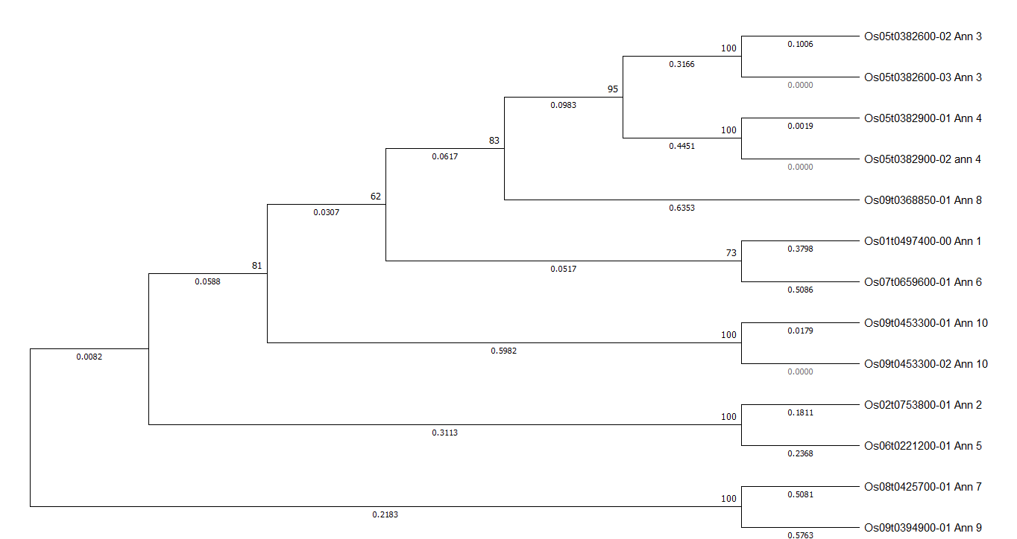
Figure 1: Phylogenetic tree of rice (Oryza sativa L.) annexin genes

3.2 Phylogenetic analysis of wheat (Triticum aestivum) annexin genes
The phylogenetic tree in figure 2 represents the evolutionary relationships of annexin genes in Triticum aestivum (wheat). The length of the ramification annotated by digital values ​​is evolving distances between the genes. High bootstrap values ​​(≥70%) indicate strong support for clustering, suggesting robust evolutionary relationships. The tree reveals several clades or clusters of annexin genes, often grouped by chromosomal location. For example, genes on chromosomes 4A, 4B, and 4D are densely clustered together, indicating recent gene duplication events common in polyploid species such as wheat. Chromosome-specific clades, such as those for 6A, 6B, and 6D, suggest a high degree of sequence conservation in genes between same origins of chromosomes, reflecting limited evolutionary divergence. The chromosomal distribution of these annexin genes shows a wide spread across different wheat chromosomes, with notable clustering in groups such as chromosome sets 4, 2, and 6. The conservation of annexin genes on homoeologous chromosomes 6A, 6B, and 6D suggests minimal evolutionary divergence, while other clusters indicate possible specialization associated with specific chromosome arms. These evolutionary insights have practical applications. Understanding the phylogenetic relationships among annexin genes can facilitate breeding programs aimed at improving stress resistance and other traits in wheat. Furthermore, this analysis contributes to our broader understanding of genome evolution in polyploid species and shows how gene duplication and divergence shape functional diversity.

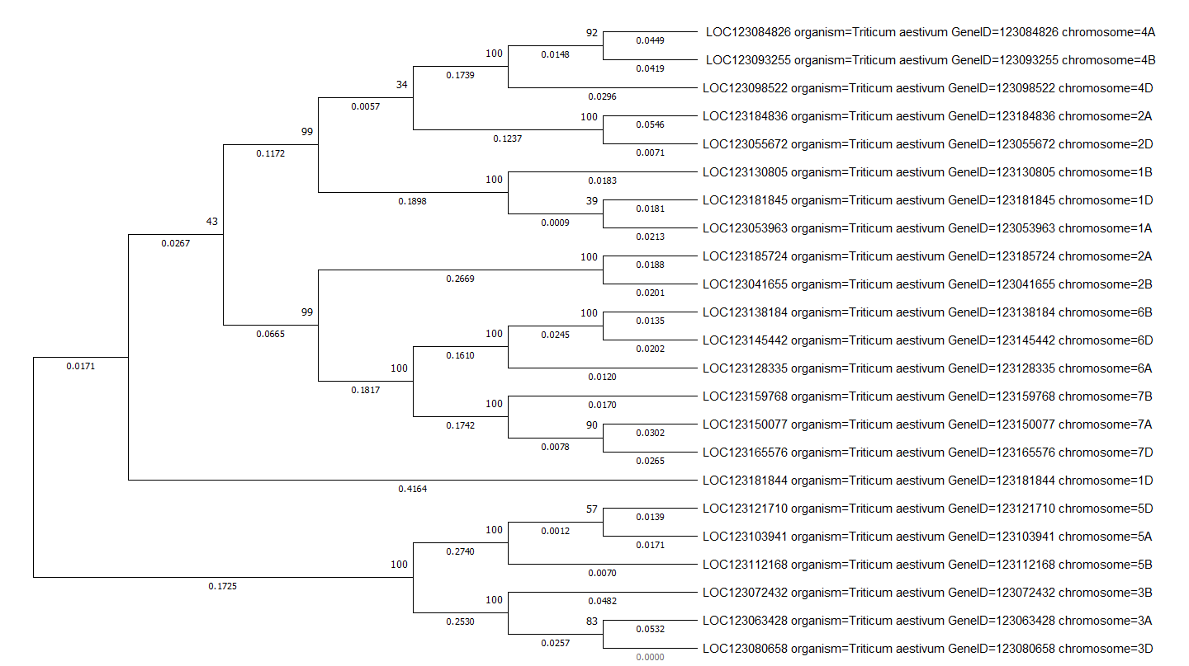
Figure 2: Phylogenetic tree of wheat (Triticum aestivum) annexin genes

3.3 Phylogenetic analysis of barley (Hordeum vulgare) annexin genes
Based on the tree (figure 3), the phylogenetic analysis of the Hordeum vulgare (barley) annexin genes revealed distinct evolutionary relationships among these genes. The tree comprises several well-supported clusters with high bootstrap values (100), indicating dependable cluster of specific genes. For instance, the cluster of LOC123447042 and LOC123439981 with a bootstrap value of 100 suggests that these genes may have shared a recent common ancestor and may possess similar functions. On the other hand, lower bootstrap values, such as 40 or 62, indicate branches with lower confidence, indicating potential variability or evolutionary instability within these groups. This could potentially indicate recent duplications or functional divergence. Sequences with shorter branch lengths represent genes with minimal divergence, likely maintaining similar structural or functional roles. Genes connected by longer branches indicate greater evolutionary distance and may reflect more diverse functions. The tree shows a mixture of conserved and diversified annexin genes in barley. Key functional roles are preserved through evolutionary pressure, while more distant branches suggest functional alterations or adaptation. Further functional analysis of barley annexins and their roles in plant stress responses can be guided by these insights.

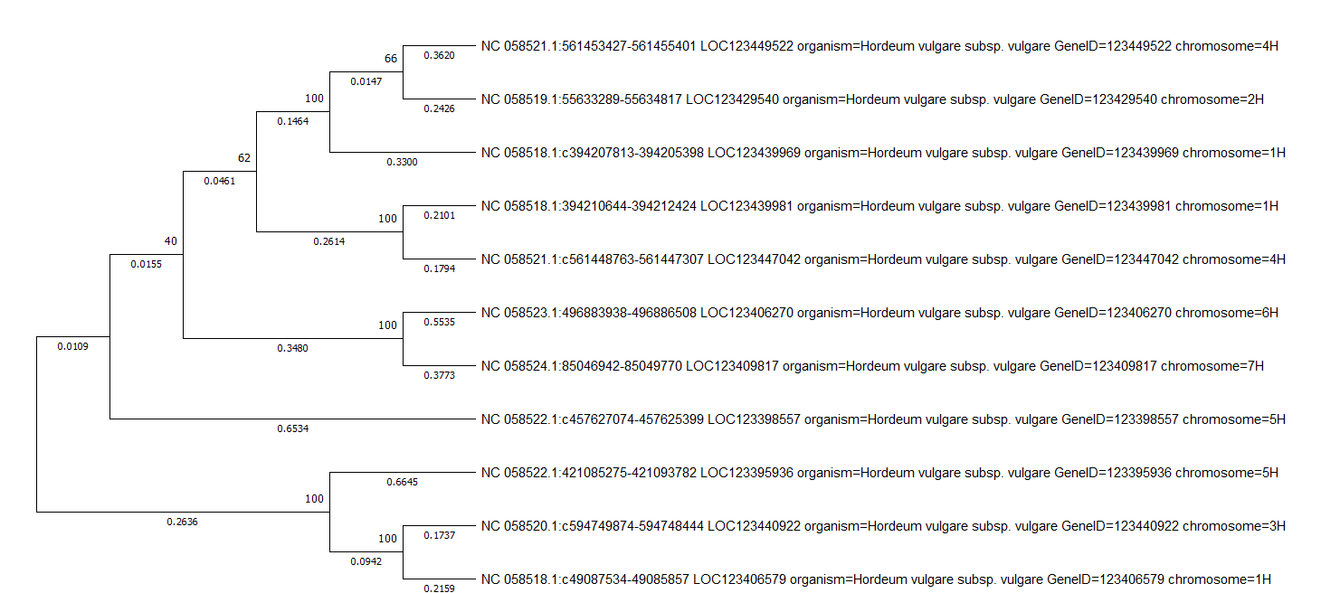
Figure 3: Phylogenetic tree of barley (Hordeum vulgare) annexin genes

3.4 Phylogenetic analysis of sorghum (Sorghum bicolor) annexin genes
The phylogenetic tree shown in figure 4 represents the evolutionary relationships between annexin gene sequences in Sorghum bicolour (Sorghum). The annexin genes in Sorghum bicolor are grouped into distinct clusters that could represent different subfamilies of annexin genes. For example, genes on chromosome 1 and 9, particularly LOC8080814 and LOC110430077, are clustered closely together with a bootstrap value of 100, indicating a close evolutionary relationship and suggesting that they may have arisen from a recent gene duplication event or may have a similar function. Longer branches indicate greater divergence, as seen in the case of the branch of LOC8075631 on chromosome 7. This suggests that this gene is more divergent and may have undergone significant changes over time than others in the tree. The chromosomal distribution of annexin genes across multiple chromosomes, including chromosomes 1, 2, 4, 7, 9, and 10, suggests the possibility of gene duplication events throughout the evolutionary history of Sorghum bicolor. Such duplication events may have contributed to the expansion and diversification of the annexin gene family in this species, allowing for functional redundancy or specialization. Furthermore, the close clustering of some genes, such as genes on chromosomes 1 (LOC8080814) and 9 (LOC110430077), suggests the existence of paralogous genes that are likely the result of duplication within the genome. These paralogs may have evolved different functions or have undergone sub-functionalization or neo-functionalization, either retaining parts of their original function or acquiring new functions over time. The distribution of annexin genes across different chromosomes and evidence of gene duplication highlight how evolutionary processes have shaped the annexin gene family, enabling functional diversity and potentially contributing to plant resilience. In the context of crop breeding, understanding the evolutionary relationships and functional diversification of annexin genes can provide valuable insights into their role in stress tolerance and developmental processes. Such knowledge can be applied to improve the stress resistance of crops such as Sorghum bicolor, making them more adaptable to changing environmental conditions.

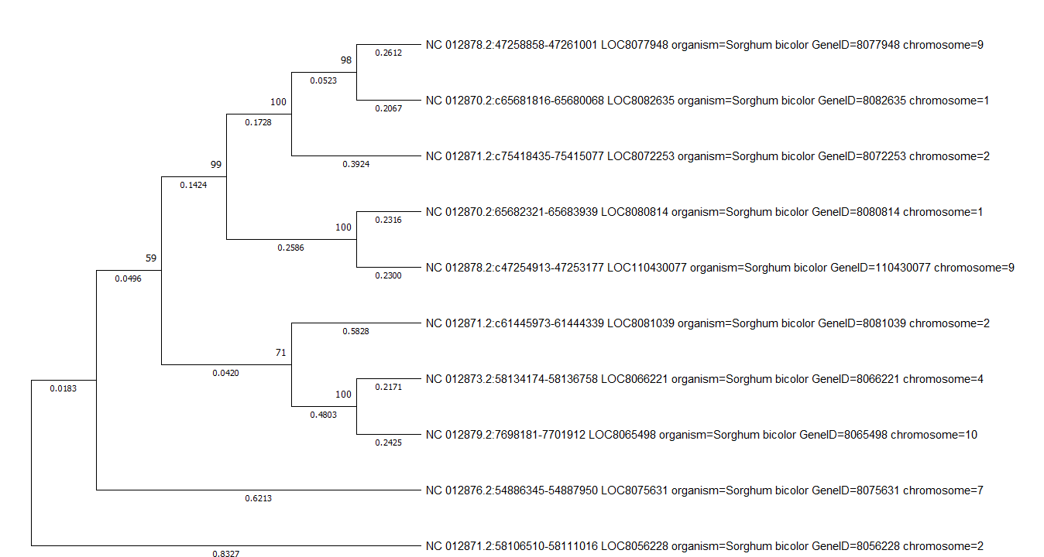
Figure 4: Phylogenetic tree of sorghum (Sorghum bicolor) annexin genes

3.5 Phylogenetic analysis of maize (Zea mays) annexin genes
The phylogenetic tree shown in figure 5 represents the evolutionary relationships between the genes of Annexin in Zea mays (maize). The lengths of the branch, which reflect the evolutionary divergence, show that some genes, such as those associated with LOC103649719 (Chr 3) and LOC103634843 (Chr 8) and LOC101027188 (Chr 1) and LOC100273477 (Chr 6), are very similar, as indicated by their small branch lengths. This suggests redundancy or a very recent divergence event. The tree also highlights possible gene duplication events within the genome of Zea mays, since the annexin genes are distributed on multiple chromosomes, including chromosomes 1, 2, 3, 5, 6 and 7. Gene clusters on specific chromosomes, such as those on chromosome 6 (LOC100273477 and LOC542749), indicate closely related genes that may have arisen through duplication and subsequent divergence. In addition, some clades show significant divergence, suggesting functional specialization. For example, the relatively long branches connecting genes such as LOC100289051 (chromosome 4) and LOC100193535 (chromosome 7) indicate substantial divergence, suggesting that these genes may have acquired distinct roles in maize. The overall tree structure suggests that gene duplication followed by diversification played a key role in the formation of the annexin gene family, enabling a range of functions that may include responses to environmental stresses or specific developmental processes. These results could be useful for understanding the evolutionary dynamics of annexin genes in maize and could be used to improve plant traits such as stress tolerance and growth regulation.
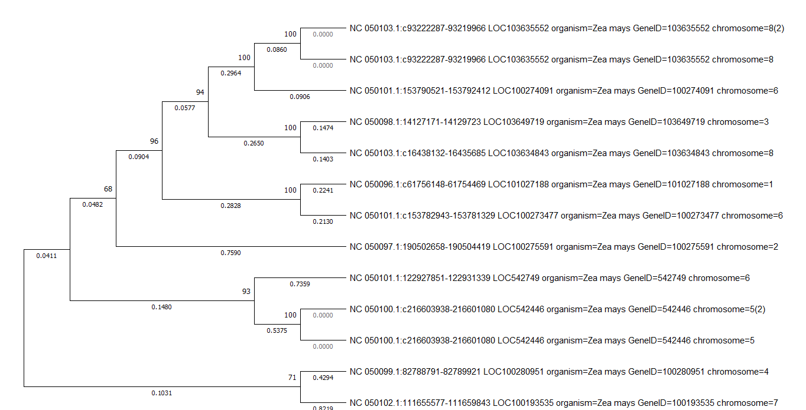
Figure 5: Phylogenetic tree of maize (Zea mays) annexin genes

3.6 Phylogenetic analysis of thale cress (Arabidopsis thaliana) annexin genes
The phylogenetic tree shown in figure 6 provided a comprehensive perspective on the evolutionary relationships within the annexin gene family of Arabidopsis thaliana. It delineates the divergence of eight specific annexin genes (AnnAt1 to AnnAt8), showcasing their evolutionary progression over time. The tree is structured into distinct clusters that mirror the evolutionary history of these genes. For example, AnnAt2 and AnnAt7, both located on chromosome 5, are closely grouped, supported by a bootstrap value of 97. This clustering suggests these genes share a recent common ancestor and likely originated from a gene duplication event. Ann6, also on chromosome 5, clusters closely with AnnAt2 and AnnAt7, indicating a shared evolutionary path, possibly the result of tandem duplication events within this chromosome. The grouping of these genes implies they might have similar or related functions in the plant’s cellular processes, reflecting the evolutionary pressure to maintain functional redundancy. Another prominent gene includes AnnAt1, positioned as an intermediate node. This arrangement suggests that after duplication AnnAt1 diverged significantly, acquiring distinct functions or regulatory elements. At the base of the tree, we find a cluster containing AnnAt3 and AnnAt4, both located on chromosome 2. These genes are highly similar, with a bootstrap value of 89 supporting their close relationship. Their clustering, separate from the other annexin genes, suggests they represent a more distinct evolutionary lineage within the Arabidopsis thaliana annexin gene family, possibly retaining unique functions or responding to different physiological conditions. The overall structure of the tree reveals that annexin genes in Arabidopsis thaliana have undergone both tandem and segmental duplications, leading to the expansion and diversification of this gene family. The presence of multiple annexin genes on chromosomes 1, 2, and 5, with varying degrees of relatedness, underscores the role of gene duplication as a catalyst for genetic innovation, enabling the retention of essential functions while also facilitating specialization.

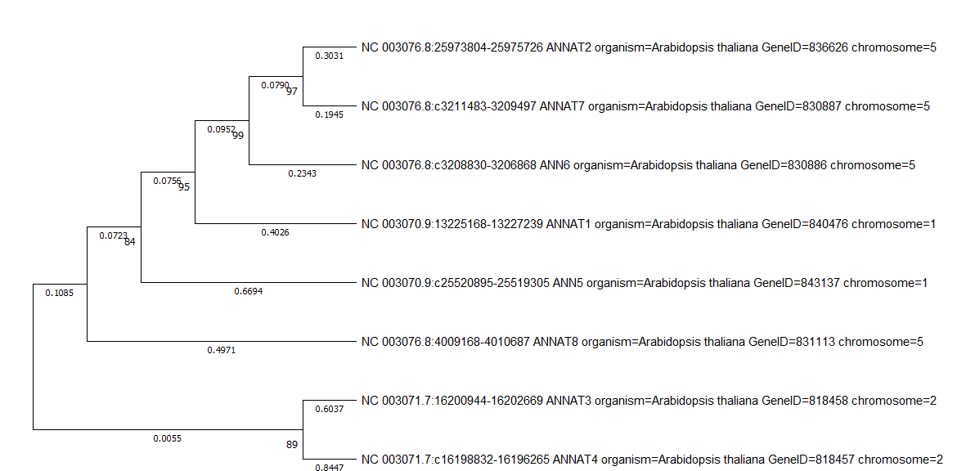
Figure 6: Phylogenetic tree of thale cress (Arabidopsis thaliana) annexin genes

3.7 Phylogenetic analysis of soybean (Glycine max) annexin genes
The phylogenetic tree (figure 7) showcases the evolutionary relationships among annexin genes in Glycine max (soybean). The tree is structured into distinct clusters, each revealing close evolutionary ties among specific genes scattered across various chromosomes. For example, the top cluster groups annexin genes primarily found on chromosomes 13 and 15, including LOC100794511 (chromosome 15), LOC100782110 (chromosome 13), and LOC100784424 (chromosome 13), all of which have received robust bootstrap score indicating recent duplication events. In the middle section, a cluster includes Ann11 (Chr 15) and LOC100784954 (Chr 13) and another cluster includes LOC100815639 (Chr 8) and LOC100796047 (Chr 5), all of which have high bootstrap values supporting their close evolutionary relationship. Further down, another cluster contains genes like LOC100781784 (Chr15), LOC100816900 (Chr 9), and one more cluster includes LOC100797149 (Chr 15) and LOC100785486 (Chr 13), reflecting a shared origin despite their distribution across different chromosomes. At the bottom of the tree, a distinct group of annexin genes from chromosomes 5, 7, 8, 9, and 20 demonstrates strong support for their close relationship. Moreover, genes like Ann14 (Chr13) and remaining genes below this show tight clustering and suggest ancient duplication events followed by diversification. Additionally, a subgroup of closely related genes such as LOC100799388 (Chr20) with LOC113002161 (Chr7), LOC100802168 (Chr9) with LOC100820062 (Chr7) and LOC100794685 (Chr8) with LOC100816812 (Chr5) shows recent divergence, maintaining high similarity despite their location on different chromosomes. The tree offers a comprehensive view of the complex evolutionary history of annexin genes in soybean, underscoring the importance of gene duplication in enabling the adaptation and functional diversification of this gene family.

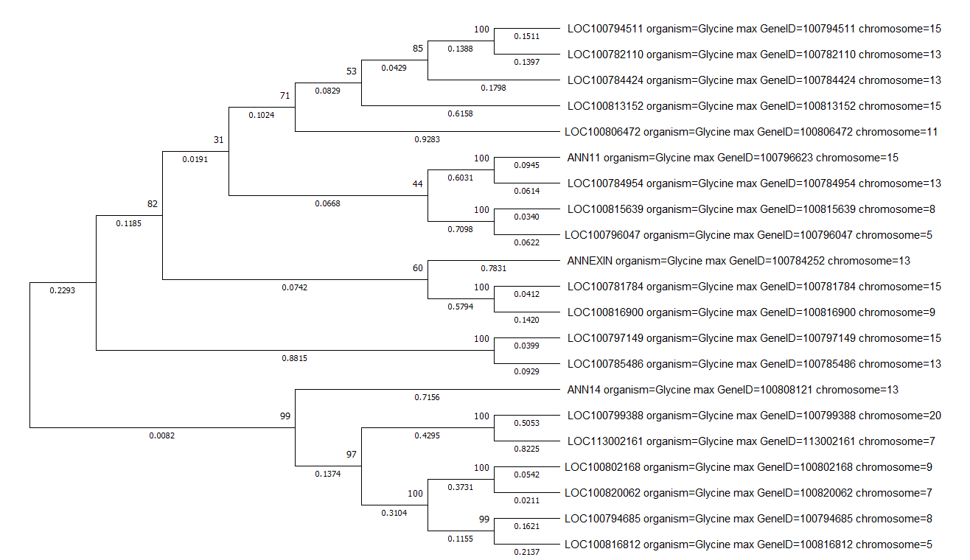
Figure 7: Phylogenetic tree of soybean (Glycine max) annexin genes

3.8 Phylogenetic analysis of mung bean (Vigna radiata) annexin genes
The phylogenetic tree (figure 8) of Vigna radiata (mung bean) annexin genes uncovers significant evolutionary relationships and clustering patterns. The tree's structure suggests that genes located on chromosomes 5, and 7 form a closely related cluster (first four genes from top of the tree), supported by high bootstrap values (e.g., 74, 75, 99), indicating a robust evolutionary relationship. It is likely that these genes share a recent common ancestor and may have conserved functions within the Vigna radiata. The clustering of genes from different chromosomes, such as those on chromosomes 5 and 7, points to conserved evolutionary pressures or functional similarities. Conversely, genes like LOC106764283 (on chromosome 6) and LOC106764856 (on chromosome 10) exhibit longer branch lengths, indicating greater evolutionary divergence and possibly distinct functional roles. The overall distribution of these annexin genes across multiple chromosomes suggests a history of segmental duplications or translocations in the evolutionary history of Vigna radiata. The presence of outlier genes with longer branches indicates that they may have adapted to specific functions or undergone divergent evolutionary paths. The clustering patterns and branch lengths also suggest potential tandem duplications, particularly among closely related genes on the same chromosome. Understanding these evolutionary relationships sheds light on the functional diversification of annexin genes in Vigna radiata, highlighting the importance of further experimental validation to explore their specific roles in stress responses and cellular regulation in legumes.

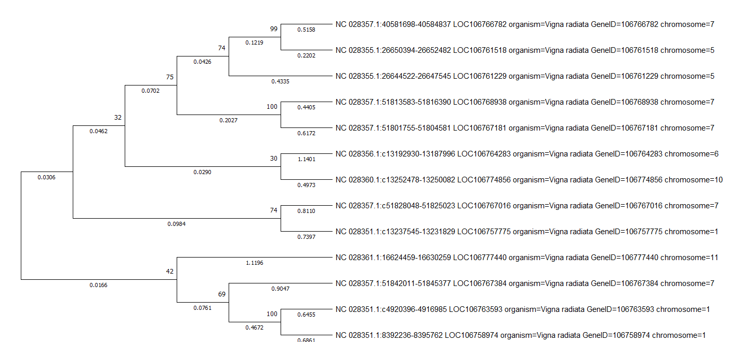
Figure 8: Phylogenetic tree of mung bean (Vigna radiata) annexin genes

3.9 Phylogenetic analysis of tobacco (Nicotiana tabacum) annexin genes
The phylogenetic tree (figure 9) of annexin genes from Nicotiana tabacum (tobacco) illustrates their evolutionary relationships and grouping patterns. The initial cluster comprises genes such as LOC107825155, LOC107828666, LOC107815719, and LOC107771458, which are closely associated and backed by high bootstrap values, indicating robust evolutionary conservation. Similarly, towards bottom half of the tree, LOC107825859 clusters with LOC107824389; LOC107803993 clusters with LOC107769028, and LOC107824085 clusters with LOC107817937. This suggests that these genes may have originated from recent duplications and likely share similar functions with genes in same cluster. The second cluster comprises genes such as LOC1078761076 and LOC107821785, which exhibit longer branch lengths, indicating greater sequence divergence and possibly distinct evolutionary pathways. The distribution of these genes across unassigned chromosomes suggests the potential for genome rearrangements or incomplete assembly in Nicotiana tabacum. Overall, the tree highlights both conserved and divergent evolutionary patterns among annexin genes, emphasizing the need for further experimental validation to better understand their specific roles, especially in stress responses and cellular regulation in Nicotiana tabacum.

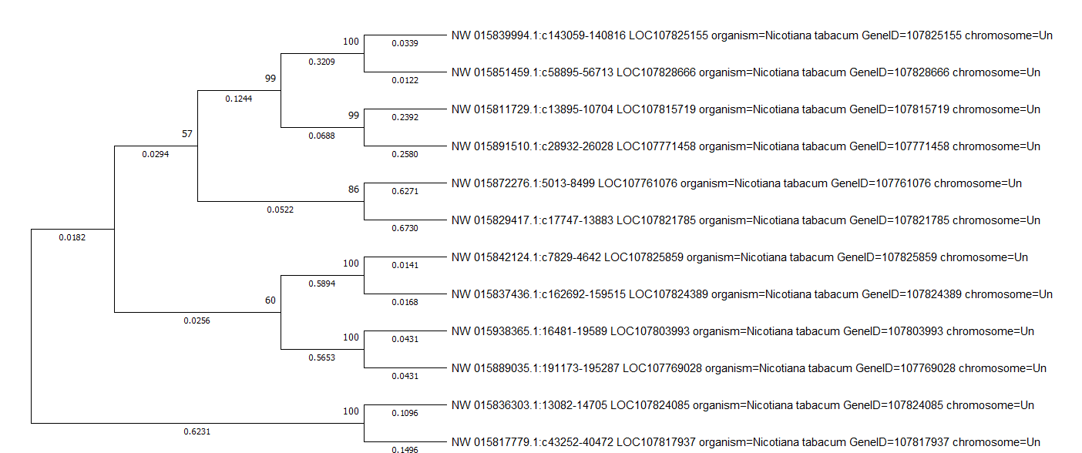
Figure 9: Phylogenetic tree of tobacco (Nicotiana tabacum) annexin genes

3.10 Phylogenetic analysis of chickpea (Cicer arietinum) annexin genes
The phylogenetic tree (figure 10) of Cicer arietinum (chickpea) annexin genes offers significant insights into their evolutionary relationships and genomic distribution. The tree is divided into two main clades, with different groups of closely related genes highlighted. The initial clade comprises genes such as LOC101506580 (chromosome Ca7) and LOC101508627 (unassigned), which are strongly supported by good bootstrap values. Similarly, LOC10149031 (Un) and LOC101488440 (Chr Ca6) show very high bootstrap value (100) indicating their close relationship and potential similar functions. The second clade contains genes such as LOC1014505799 (Chr Ca6) and LOC101506915 (Chr Ca7) which indicate that these genes have undergone moderate evolutionary divergence. The lengths of the branches provide additional insights into the evolutionary divergence among these genes. Genes such as LOC101506254 (Chr Ca7) and LOC101501647 (Chr Ca2) exhibit shorter branch lengths, indicating more recent divergence and likely functional conservation. However, genes like LOC101489476 and LOC101506915, both on chromosome Ca7, have longer branch lengths, indicating significant divergence and potential specialization. The tree also suggests possible gene duplication events, especially among genes located on the same chromosome, such as LOC101506580, LOC101506915, LOC101506254 and LOC101489476 on chromosome Ca7, which appear to have diverged slightly after duplication. The phylogenetic analysis shows that Cicer arietinum annexin genes show a mix of conserved and divergent patterns. The tree shows that some annexin genes are mapped to specific chromosomes (Ca1, Ca6, and Ca7), while others are still unassigned, indicating potential gaps in the current genome assembly or uncharacterized regions. This study shows that annexin genes in chickpea are complicated and needs more research to understand how they help plants grow and respond to stress.

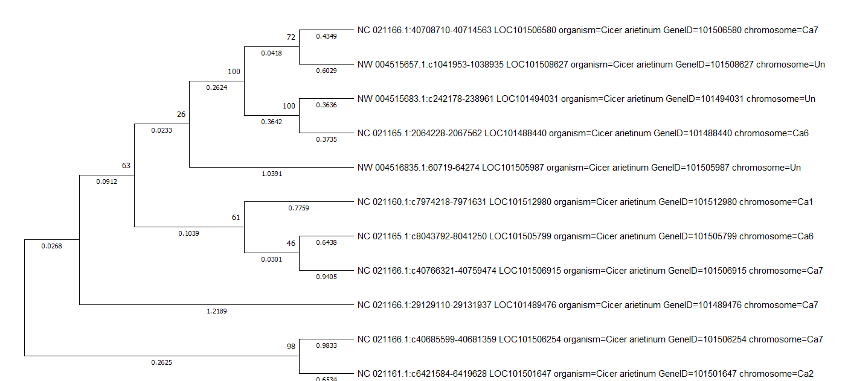
Figure 10: Phylogenetic tree of chickpea (Cicer arietinum) annexin genes

3.11 Overall phylogenetic analysis of annexin genes of selected monocot plants
The phylogenetic tree offers a detailed comparison of the evolutionary relationships among annexin genes in various monocot species (figure 11), including Oryza sativa (rice) Triticum aestivum (wheat), Hordeum vulgare (barley), Zea mays (maize), and Sorghum bicolor (sorghum). This tree not only maps out the evolutionary paths of these genes but also highlights significant differences and similarities between the species.
One of the most prominent observations is the species-specific clustering of some of the annexin genes, particularly in wheat. Triticum aestivum and Hordeum vulgare are members of the Poaceae family, and show a close evolutionary relationship, as their annexin genes are clustered together. This suggests that these genes share a more recent common ancestor and may have been conserved through similar evolutionary pressures, potentially leading to analogous functional roles in these plants.
In contrast, annexin genes from Zea mays and Sorghum bicolor also show clustering but are on branches other than wheat and barley. This separation indicates the evolutionary divergence between these species and reflects the different evolutionary paths of subfamilies within Poaceae. Such divergence may have led the annexin genes of maize and sorghum to adapt to different environmental conditions or physiological needs, which could result in annexin proteins with different functional properties than those of wheat and barley.
The tree also shows several gene duplication events, particularly in Triticum aestivum, where several annexin genes are close to each other. These duplications likely contributed to the expansion of the annexin gene family and allowed functional diversification. In wheat, for example, different annexin genes may have specialized roles, perhaps in response to diverse selective pressures such as stress tolerance or developmental regulation.
The tree allows for cross-species comparisons, showing that while some annexin genes are conserved across monocots, others have diverged significantly. For example, the clustering of annexin genes from Zea mays and Sorghum bicolor suggests a common evolutionary path, while their divergence from annexins from Triticum aestivum indicates distinct evolutionary trajectories. This difference may be related to the adaptation of maize and sorghum to tropical climates, in contrast to the temperate environments where wheat and barley thrive.
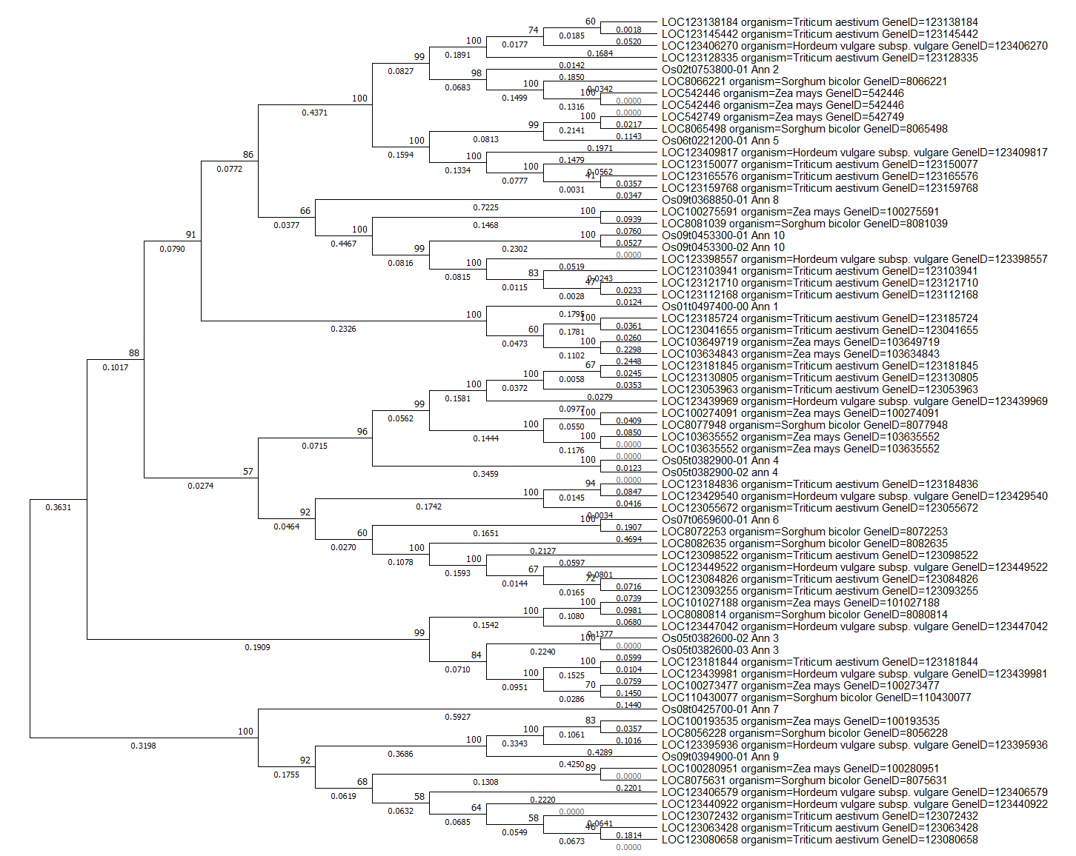
Figure 11: Overall phylogenetic tree of annexin genes of selected monocot plants

3.12 Overall phylogenetic analysis of annexin genes of selected dicot plants
The phylogenetic tree provided a detailed representation of the evolutionary relationships among annexin genes across various dicotyledonous plant species (figure 12), including Glycine max (soybean), Vigna radiata (mung bean), Arabidopsis thaliana (thale cress), Cicer arietinum (chickpea), and Nicotiana tabacum (tobacco). The tree is constructed using a distance-based method given the presence of branch length annotations that signify evolutionary distances. Each node within the tree represents a hypothetical common ancestor, with the branch lengths reflecting the number of mutations or evolutionary changes that have occurred. Within the tree, some of the clades represent species-specific groupings, reflecting the evolutionary history and divergence of annexin genes within these species. For example, Glycine max (soybean) annexins cluster into several distinct clades with high bootstrap values, indicating high evolutionary stability and suggesting recent gene duplication events within the species. These gene duplications likely led to the emergence of multiple paralogs in the soybean genome that may have functionally diversified. Similarly, Vigna radiata (mung bean) annexins are closely related to Glycine max annexins, reflecting the close evolutionary relationship between these legumes and indicating that the annexin genes of these species do not diverge significantly from their common ancestor.
Arabidopsis thaliana (thale cress) annexins occur in several clades, suggesting significant evolutionary diversification within this species. The distribution of Arabidopsis annexins in different clades suggests that these genes have undergone functional divergence and have probably adapted to different roles within the plant. The annexins of Cicer arietinum are even wider on the tree, which reflects an old divergence and a potential functional specialization in response to various evolutionary pressures. The annexin of Nicotiana tabacum (tobacco) form a separate and well supported clade, which suggests that the specific gene extension and the possible functional specialization within this species. The separation of tobacco annexins from those of other species suggests a unique evolutionary pressure that the annexin family has undergone in tobacco, possibly in response to the specific environmental or physiological needs of the plant.
The phylogenetic tree also offers significant evolutionary insights. The clustering of annexins within species, particularly in Nicotiana tabacum, suggests that gene duplication has played a major role in the expansion of the annexin gene family in these plants. Gene duplications are common in plant genomes and provide raw material for evolutionary innovation, where duplicated genes can either acquire new functions (neo-functionalization) or subdivide their original function (sub-functionalization). The scattered placement of Arabidopsis thaliana and Cicer arietinum annexins across the tree further suggests that these genes have undergone functional divergence, possibly adapting to different cellular roles or environmental conditions. The distinct clustering of Nicotiana tabacum annexins suggests that these genes have evolved unique functions in tobacco, possibly related to adaptation of the plant to specific environmental stressors. In conclusion, the phylogenetic tree of dicot annexin genes provides a comprehensive overview of their evolutionary relationships, highlighting significant diversification within and between species. The observed gene duplications, species-specific clades, and functional divergence highlight the dynamic nature of the annexin gene family in plants. These findings provide the basis for future functional studies to investigate the roles of annexins in plant development, stress response, and adaptation to changing environmental conditions.

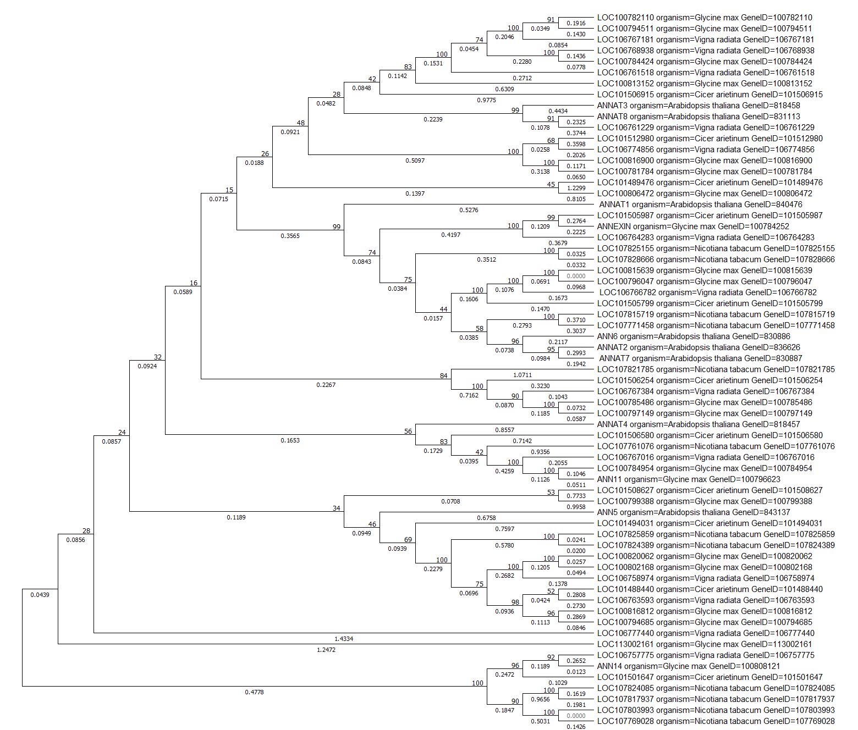
Figure 12: Overall phylogenetic tree of annexin genes of selected dicot plants

4. Discussion
A deeper understanding of how annexins relate to environmental adaptation and plant evolution is crucial. These insights will advance knowledge of this gene family and support efforts to improve plant tolerance to abiotic stresses under changing climate conditions (Tong et al., 2025). Although plant annexins have attracted considerable interest, research on them still lacks the depth and breadth achieved for animal annexins (Xie et al., 2025). Bioinformatic approaches are revolutionizing biological research (Jaiswal et al., 2023). In silico analysis using bioinformatic tools provides valuable insights and lays the foundation for further experiments.
The Gramineae family, consisting of monocotyledonous grasses, includes several essential food crops such as rice, maize, wheat, barley, and sorghum (Kumar et al., 2024). Rice, a staple food for over half of the global population, is cultivated in more than 100 countries, with Asia contributing about 90% of total production. Beyond providing calories, rice also supplies essential nutrients such as magnesium, phosphorus, manganese, selenium, iron, folic acid, thiamin, and niacin, although it is naturally low in fiber and fat (Fukagawa and Ziska, 2019). A total of 10 annexins are identified in rice. These annexin proteins are 16 to 64% similar to each other and their phylogenetic analysis with other annexin family of monocots classified them in four orthologs (Jami et el., 2012b). The rice annexin gene OsAnn5 has been reported to tolerate cold stress at seedling stage (Que et al., 2023).
Wheat (Triticum aestivum) is one of the world’s most important staple crops, playing a crucial role in global food security and serving as a central component of the human diet (Pant et al., 2025). The wheat annexin gene TaAnn12 has been reported to play important role in plant disease resistance by regulating accumulation of ROS and Callose (Shi et al., 2023). It has been reported that when durum wheat annexin (TdAnn6) was overexpressed in Arabidopsis, it helps plant tolerate salt and osmotic stress by modulating antioxidant machinery (Harbaoui et al., 2021). Evolutionary phylogenetic analyses of annexin gene family among Triticum aestivum, Triticum urartu, Aegilops tauschii, and Hordeum vulgare reveals that the nucleotide diversity among these species are very low, and are strongly conserved. Only Ann2 and Ann5 are more genetically variable. Neutrality test states that Ann2, Ann6, and Ann7 showed deviation from neutral evolution. Also the Ann2 went for positive selection and Ann6 and Ann7 went under purifying selection that maintains their functional integrity by removing deleterious mutations (Xu et al. 2016).
Barley (Hordeum vulgare) is a winter cereal valued for its small seeds and self-pollinating nature. Its flour is widely used in processed foods, enhancing both flavour and nutrition. Barley grains contain complex carbohydrates as major components followed by proteins, lipids, β-glucans, and ash. They are also a notable source of phenolic compounds (Kaur et al., 2024). In a study on Barley pan genome using 12 reference gene revealed structural, functional and expression differences between wild and cultivated barley. The study also highlight that the annexin genes in barley are also involved in response to various environmental stresses. Specially, cis-acting element analysis and large scale transcriptome data implicated annexins in stress response machinery (Chen et al., 2024).
Sorghum (Sorghum bicolor) is an important model grass and commercially valuable crop (Kumar et al., 2024). Genome wide identification of annexin gene family in Sorghum bicolor resulted in nineteen annexin genes and are phylogenetically grouped and distributed across seven chromosomes. Analysis revealed conserved evolution, diverse subcellular localization, stress and hormone-response promoter elements, miRNA regulation, and upregulation of several SbAnns under high-temperature stress (Whyte and Sipahi, 2024).
Maize or corn (Zea mays) is a major annual cereal crop of the Poaceae family and a staple food in many regions. As the world’s third most important crop after rice and wheat, it provides essential nutrients and valuable phytochemicals, including carotenoids, phenolic compounds, and phytosterols, which contribute to the prevention of chronic diseases (Shah et al., 2016). Pan genome analysis of 26 maize genomes identified 12 annexin genes, including 9 core and 3 near-core members, emphasizing the limitations of single-reference studies. Most genes showed purifying selection, while ZmAnn10 displayed positive selection in some varieties. Phylogeny grouped annexins into six clusters, and structural variants produced atypical forms. Expression and co-expression analyses revealed diverse tissue- and stress-specific roles, with four genes (ZmAnn2, ZmAnn6, ZmAnn7, ZmAnn9) linked to cold-stress modules (Liu et al., 2025). Maize annexin genes ZmAnn33 and ZmAnn35 have been reported to confer chilling stress tolerance during seed germination and to facilitate cell membrane recovery (He et al., 2019).
Arabidopsis thaliana, a Brassicaceae plant, is a crucial model organism due to its small genome, short life cycle, easy cultivation, and high seed production. Despite limited agricultural value, it remains widely used to study plant development and environmental responses, greatly advancing modern plant science (Ferjani et al., 2023). In Arabidopsis 8 annexin genes have been reported with different sequence identities. In real-time quantitative reverse transcription PCR (qRT-PCR) analysis under de-etiolation and abiotic stress, all the annexins that were expressed in germinating seeds showed consistent increase up to day 7. Expression patterns differed across dark-grown tissues, while red/far-red light affected only two genes. Most annexins showed differential regulation under salt, drought, heat, and cold, suggesting key roles in stress responses (Cantero et al., 2006).
Common tobacco (Nicotiana tabacum) is a major global non-food crop, widely cultivated in countries such as China, Brazil, India, and the USA. Beyond its economic importance, it serves as a valuable model organism in plant biology and genetics due to its short growth cycle, biochemical complexity, and ease of genetic manipulation (Tong et al., 2024). A novel tobacco annexin gene NtAnn12 has been reported to be induced during Rhodococcus fascians infection and during gall development in leaf. It was also found to be induced by salt stress and abscisic acid (ABA). The promoter-GUS and qRT-PCR analyses showed altered development expression and strong up-regulation during leafy gall formation, that suggests annexins role in Ca²⁺-dependent biotic and abiotic stress signaling and development (Vandeputte et al., 2007).
Mungbean (Vigna radiata L.; Family: Fabaceae), also known as green gram or moong bean, is an ancient pulse crop that originated in India over 3,500 years ago and later spread worldwide. It is a key protein source in vegetarian diets, though low in sulfur-containing amino acids. Rich in carbohydrates, vitamins, zinc, and other minerals, Mung bean is also valued for its detoxifying properties, which support immunity, reduce cholesterol, and help protect against diabetes (Tripathi et al., 2021). Very little research has been conducted on annexins in mung bean, and more comprehensive studies are needed for deeper functional analysis and future advancements in this crop.
Chickpea (Cicer arietinum L.) is the world’s third most important pulse crop, produced largely in developing countries. The Indian subcontinent, including India, Pakistan, Myanmar, Bangladesh, and Nepal, accounts for nearly 70% of global chickpea production and consumption (Arriagada et al., 2022). The genome wide identification and in silico analyses of annexin genes in chickpea, identified 113 annexin genes. Several annexins had four conserved domains, while CaAnn5, CaAnn12, and CaAnn13 possessed fewer domains. Gene structure analysis revealed multiple exons and 3–5 introns in most genes. Expression profiling across tissues and drought-stressed roots showed differential expression patterns, suggesting roles in growth, development, and stress adaptation. These results provide a foundation for functional characterization of CaAnn genes and their regulatory elements.
Among major agricultural crops, soybean (Glycine max L. Merrill) stands out for its versatility, nutritional value, and economic importance. Native to East Asia, it has become a global agricultural powerhouse, shaping modern agriculture, nutrition, and industry. Today, soybean is a key contributor to global food security, a source of diverse products, and a central focus of scientific research (Mishra et al., 2024). A total of 23 annexin genes are identified in the soybean. Most genes encoded proteins with four annexin repeats, typically containing type II Ca²⁺-binding sites in repeats one and four. Several genes (GmAnn1, 10, 11, 12, 14) exhibited distinct organ-specific expression. The expression of these annexins were strongly induced by draught and ABA response, while GmAnn1, 11, 12, and 14 also responded to cold, and GmAnn1, 11, and 12 were induced by high salinity, suggesting key role of annexins in stress tolerance (Feng et al., 2013).
Annexins are an important class of Ca²⁺-dependent phospholipid-binding proteins involved in a wide range of abiotic and biotic stress responses. Expression analyses demonstrate their roles in plant stress adaptation, growth, and development. Annexins contribute to key cellular processes, including cell division and elongation, ion channel regulation, peroxidase and ATPase activities, and exocytosis. They also share a highly conserved evolutionary history (Xie et al., 2025). Although plant annexins have been identified and studied in many species, comprehensive analyses aimed at elucidating their precise functions in growth regulation and stress tolerance remain limited. Further exploration of annexin biology holds significant potential for improving crop resilience and agricultural productivity.

5. Conclusion
In conclusion, this study provides a comprehensive phylogenetic assessment of the annexin gene family in some selected monocot as well as dicot plants, uncovering crucial insights into evolutionary processes underlying their duplication, divergence, and functional specialization. Through molecular evolutionary analyses, it highlights key patterns that shape annexin diversity and offers a foundation for future research on their biological roles in crop improvement and stress tolerance. These findings not only advance our understanding of plant molecular evolution but also hold practical relevance for developing breeding strategies aimed at enhancing stress resilience in economically important crops. As climate change intensifies pressures on global agriculture, insights into the evolution and function of annexin genes become increasingly vital and timely.

Limitations: Given that the present work is an in silico investigation, subsequent functional and experimental validation is essential to substantiate the results.

Disclaimer (Artificial Intelligence)
Author(s) hereby declare that generative AI technologies such as Large Language Models, etc have been used during writing or editing of this manuscript. This explanation will include the name, version, model, and source of the generative AI technology and as well as all input prompts provided to the generative AI technology.

Details of the AI usage are given below:
1. Name of AI tool: ChatGPT (OpenAI)
2. Model/version: GPT-5.1
3. Purpose of use: To check grammar, spelling and improve sentence flow.
4. Input provided: Portions of the manuscript text were input to suggest minor language refinements.

References
- Arriagada, O., Cacciuttolo, F., Cabeza, R. A., Carrasco, B., &Schwember, A. R. (2022). A comprehensive review on chickpea (Cicer arietinum L.) breeding for abiotic stress tolerance and climate change resilience. International Journal of Molecular Sciences, 23 (12), 6794. https://doi.org/10.3390/ijms23126794
- Cantero, A., Barthakur, S., Bushart, T. J., Chou, S., Morgan, R. O., Fernandez, M. P., Clark, G. B., & Roux, S. J. (2006). Expression profiling of the Arabidopsis annexin gene family during germination, de-etiolation and abiotic stress. Plant Physiology and Biochemistry : PPB, 44(1), 13–24. https://doi.org/10.1016/j.plaphy.2006.02.002
- Chen, L., Chen, K., Xi, X., Du, X., Zou, X., Ma, Y., Song, Y., Luo, C., &Weining, S. (2024). The evolution, expression patterns, and domestication selection analysis of the annexin gene family in the barley pan-genome. International Journal of Molecular Sciences, 25(7), 3883. https://doi.org/10.3390/ijms25073883
- Clark, G. B., Morgan, R. O., Fernandez, M. P., & Roux, S. J. (2012). Evolutionary adaptation of plant annexins has diversified their molecular structures, interactions and functional roles. The New Phytologist, 196(3), 695–712. https://doi.org/10.1111/j.1469-8137.2012.04308.x
- Feng, Y. M., Wei, X. K., Liao, W. X., Huang, L. H., Zhang, H., Liang, S. C., & Peng, H. (2013). Molecular analysis of the annexin gene family in soybean. Biologia Plantarum, 57(4), 655-662. https://doi.org/10.1007/s10535-013-0334-0
- Ferjani, A., Tsukagoshi, H., &Vassileva, V. (2023). Editorial: Model organisms in plant science: Arabidopsis thaliana. Frontiers in Plant Science, 14, 1279230. https://doi.org/10.3389/fpls.2023.1279230
- Fukagawa, N. K., & Ziska, L. H. (2019). Rice: Importance for global nutrition. Journal of Nutritional Science and Vitaminology, 65 (Supplement), S2–S3. https://doi.org/10.3177/jnsv.65.S2
- Gerke, V., Creutz, C. E., & Moss, S. E. (2005). Annexins: linking Ca²⁺ signaling to membrane dynamics. Nature Reviews Molecular Cell Biology, 6(6), 449–461. https://doi.org/10.1038/nrm1661
- Harbaoui, M., Ben Romdhane, W., Ben Hsouna, A., Brini, F., & Ben Saad, R. (2021). The durum wheat annexin, TdAnn6, improves salt and osmotic stress tolerance in Arabidopsis via modulation of antioxidant machinery. Protoplasma, 258(5), 1047–1059. https://doi.org/10.1007/s00709-021-01622-4
- He, F., Gao, C., Guo, G., Liu, J., Gao, Y., Pan, R., Guan, Y., & Hu, J. (2019). Maize annexin genes ZmANN33 and ZmANN35 encode proteins that function in cell membrane recovery during seed germination. Journal of Experimental Botany, 70(4), 1183–1195. https://doi.org/10.1093/jxb/ery452
- Jaiswal, C., Pant, K. K., Behera, R. K. S., Bhatt, R., & Chandra, V. (2023). Development of new molecules through molecular docking. In P. Verma (Ed.), Industrial microbiology and biotechnology (Chapter 22). Springer. https://doi.org/10.1007/978-981-99-2816-3_22
- Jami, S. K., Clark, G. B., Ayele, B. T., Ashe, P., & Kirti, P. B. (2012a). Genome-wide comparative analysis of annexin superfamily in plants. PloS one, 7(11), e47801. https://doi.org/10.1371/journal.pone.0047801
- Jami, S. K., Clark, G. B., Ayele, B. T., Roux, S. J., & Kirti, P. B. (2012b). Identification and characterization of annexin gene family in rice. Plant Cell Reports, 31(5), 813–825. https://doi.org/10.1007/s00299-011-1201-0
- Kaur, A., Purewal, S. S., Phimolsiripol, Y., & PuniaBangar, S. (2024). Unraveling the hidden potential of barley (Hordeum vulgare): An important review. Plants, 13 (17), 2421. https://doi.org/10.3390/plants13172421
- Kumar, A. V., Prashanth, B., Chandra, V., & Singam, P. (2024). In silico analysis and characterization of the F5H gene family in Sorghum bicolor and its role in lignin production. Plant Cell Biotechnology and Molecular Biology, 25 (11-12), 84–106. https://doi.org/10.56557/pcbmb/2024/v25i11-128885
- Laohavisit, A., & Davies, J. M. (2011). Annexins. New Phytologist, 189(1), 40–53. https://doi.org/10.1111/j.1469-8137.2010.03533.x
- Liu, X., Zhang, M., Zhao, X., Shen, M., Feng, R., & Wei, Q. (2025). The evolution, variation and expression patterns of the annexin gene family in the maize pan-genome. Scientific Reports, 15(1), 5711. https://doi.org/10.1038/s41598-025-89119-5
- Mishra, R., Tripathi, M. K., Sikarwar, R. S., Singh, Y., & Tripathi, N. (2024). Soybean (Glycine max L. Merrill): A multipurpose legume shaping our world. Plant Cell Biotechnology and Molecular Biology, 25 (3-4), 17-37. https://doi.org/10.56557/PCBMB/2024/v25i3-48643
- Panchy, N., Lehti-Shiu, M., & Shiu, S. H. (2016). Evolution of gene duplication in plants. Plant Physiology, 171(4), 2294–2316. https://doi.org/10.1104/pp.16.00523
- Pant, K. K., Naik, J., Barthakur, S., & Chandra, V. (2025). High-temperature stress in wheat (Triticum aestivum L.): Unfolding the impacts, tolerance, and methods to mitigate the detrimental effects. Cereal Research Communications, 53, 1171–1197. https://doi.org/10.1007/s42976-025-00634-7
- Que, Z., Lu, Q., Li, Q., & Shen, C. (2023). The rice annexin gene OsAnn5 is involved in cold stress tolerance at the seedling stage. Plant Direct, 7(11), e539. https://doi.org/10.1002/pld3.539
- Shah, T. R., Prasad, K., & Kumar, P. (2016). Maize-A potential source of human nutrition and health: A review. Cogent Food & Agriculture, 2 (1), Article 1166995. https://doi.org/10.1080/23311932.2016.1166995
- Shi, B., Liu, W., & Ma, Q. (2023). The wheat annexin TaAnn12 plays positive roles in plant disease resistance by regulating the accumulation of reactive oxygen species and callose. International Journal of Molecular Sciences, 24(22), 16381. https://doi.org/10.3390/ijms242216381
- Tamura, K., Stecher, G., & Kumar, S. (2021). MEGA11: Molecular Evolutionary Genetics Analysis Version 11. Molecular Biology and Evolution, 38(7), 3022–3027. https://doi.org/10.1093/molbev/msab120
- Tong, T., Zhang, Y., Jiang, W., Chen, G., Zeng, F., Xue, D., Qin, Y., Deng, F., & Chen, Z. H. (2025). Function and evolution of plant annexins in response to abiotic stresses. BMC Plant Biology, 25(1), 1428. https://doi.org/10.1186/s12870-025-07450-5
- Tong, Z., Huang, Y., Zhu, Q.-H., Fan, L., Xiao, B., & Shen, E. (2024). Retrospect and prospect of Nicotiana tabacum genome sequencing. Frontiers in Plant Science, 15, 1474658. https://doi.org/10.3389/fpls.2024.1474658
- Tripathi, A., Debnath, S., & Shukla, S. (2021). Review on biotechnological advances in Vigna radiata and their future prospects. Journal of Crop Science and Biotechnology, 24(3), 245-258. https://doi.org/10.1007/s12892-021-00086-5
- Vandeputte, O., Lowe, Y. O., Burssens, S., VAN Raemdonck, D., Hutin, D., Boniver, D., Geelen, D., El Jaziri, M., & Baucher, M. (2007). The tobacco Ntann12 gene, encoding an annexin, is induced upon Rhodoccocus fascians infection and during leafy gall development. Molecular Plant Pathology, 8(2), 185–194. https://doi.org/10.1111/j.1364-3703.2007.00385.x
- Whyte, T. D., & Sipahi, H. (2024). Genome-wide characterization and expression analysis of annexin genes under high-temperature stress in Sorghum bicolor L. Romanian Agricultural Research, (41), 165-178. www.incda-fundulea.ro; doi.org/10.59665/rar4116
- Wu, X., Wang, Y., Bian, Y., Ren, Y., Xu, X., Zhou, F., & Ding, H. (2022). A critical review on plant annexin: structure, function, and mechanism. Plant Physiology and Biochemistry, 190, 81–89. https://doi.org/10.1016/j.plaphy.2022.08.019
- Xie, C., Zhu, M., Shi, R., Yang, L., An, X., & Wang, C. (2025). Annexins: central regulators of plant growth and stress signaling. Acta Biochimica et BiophysicaSinica, 57(4), 507–520. https://doi.org/10.3724/abbs.2024228
- Xie, C., Zhu, M., Shi, R., Yang, L., An, X., & Wang, C. (2025). Annexins: central regulators of plant growth and stress signaling. Acta Biochimica et Biophysicasinica, 57(4), 507–520. https://doi.org/10.3724/abbs.2024228
- Xu, L., Tang, Y., Gao, S., Su, S., Hong, L., Wang, W., Fang, Z., Li, X., Ma, J., Quan, W., Sun, H., Li, X., Wang, Y., Liao, X., Gao, J., Zhang, F., Li, L., & Zhao, C. (2016). Comprehensive analyses of the annexin gene family in wheat. BMC Genomics, 17, 415. https://doi.org/10.1186/s12864-016-2750-y
- Yadav, D., Boyidi, P., Ahmed, I., & Kirti, P. B. (2018). Plant annexins and their involvement in stress responses. Environmental and Experimental Botany, 155, 293–306. https://doi.org/10.1016/j.envexpbot.2018.07.002

