Review Article

Unravelling the genetic resources and breeding potential of Capsicum landraces of Northeast India

ABSTRACT
Northeast India, characterised by its unique geography, ethnic diversity, and remarkable ecological richness, represents a major hotspot for crop genetic resources, particularly for diverse and distinctive chilli landraces. The region harbours unique Capsicum landraces such as Bhut Jolokia, Dalle Khursani, Mizo chilli and Hathei Chilli. This region sustains an extraordinary range of chilli varieties, many carrying geographical indications. These Capsicum landraces represent not only culinary treasures but also powerful genetic reservoirs, exhibiting remarkable capsaicinoids concentrations, phytochemical richness, and pronounced trait diversity. In the face of rising climatic and biotic stresses, their inherent resilience, nutritional value, and broad-spectrum bioactivity make them invaluable for future breeding programs. Recent molecular and morphological studies reveal significant intra- and interspecific variations among these landraces, highlighting their potential as sources of important alleles for tolerance to drought, pests, and diseases. Furthermore, the diverse metabolite profiles and distinctive fruit morphologies of Northeast Indian Capsicum support their industrial, pharmaceutical, and nutraceutical applications, promising enhanced global food security and sustainable agriculture. However, many of these resources remain underexplored due to limited research coverage, conservation efforts, and technical know-how. Emphasis is thus placed on systematic conservation and molecular exploitation of these Capsicum genetic resources to ensure their sustainable use and to unlock novel traits for crop improvement worldwide. This review synthesises advances in the genetic, biochemical, and morphological characterisation of these regional resources, underscoring their critical importance as a foundation for global chilli improvement and agricultural resilience
Keywords: Capsaicinoids, chilli landraces, climate resilience, Geographical Indication, metabolomic profiling, nutraceutical, trait diversity
1. INTRODUCTION
Northeast India is acknowledged as a biodiversity hotspot, harbouring an extraordinary range of flora and fauna, including numerous indigenous and endangered species. Globally, the region forms part of the Indo-Burma hotspot and includes four global priority ecoregions identified by the World-Wide Fund for Nature (Jain & Das, 2022). Comprising eight states [Arunachal Pradesh, Assam, Manipur, Meghalaya, Mizoram, Nagaland, Sikkim, and Tripura], this region possesses warm and humid agroclimatic conditions that favour the growth, adaptation, and diversification of Capsicum species, leading to the development of several distinctive landraces (Tara et al., 2025).
Capsicum species, belonging to the family Solanaceae, are globally significant crops valued for their culinary, cultural, medicinal, and industrial applications. In India, both green and red chillies are widely consumed, while industrially, chillies are processed into powders, oleoresins, colouring agents, and pharmaceutical extracts (Bhavani et al., 2020). Economically, chilli is one of India’s most important spice commodities; the country is the world’s leading producer and exporter of dry chillies, contributing nearly 36% of global production, with exports accounting for 48% of India’s total spice export revenue in 2023–2024 (Spices Board, 2024). The historical origins of Capsicum trace back to South America, where archaeological evidence indicates cultivation as early as 7000 B.C. Of nearly 30 recognised species, five vis., C. annuum, C. chinense, C. frutescens, C. baccatum, and C. pubescens, were domesticated and eventually spread across continents (Naseem et al., 2024; Roy et al., 2024). Chillies have deep cultural roots, reflected in more than 200 names worldwide, including ‘Capsicum,’ ‘chilli pepper,’ and ‘paprika’ (Madala & Nutakki, 2020), while the Indian linguistic landscape preserves early Sanskrit terms such as ‘Katuvira,’ ‘Bruchi,’ ‘Mairichi phalam’, and ‘Ujjvala’ (De, 2003).
A major shift in global chilli cultivation occurred after 1493, when Christopher Columbus introduced chillies to Europe. Portuguese and Arabian traders subsequently dispersed them across Asia. Following Vasco da Gama’s arrival on the Malabar Coast in 1498, chillies rapidly became integrated into Indian agriculture and cuisine. Christian missionaries later introduced Capsicum species to Northeast India, contributing to the exceptional diversity observed in the region today (Swamy, 2023). Among these, C. chinense landraces such as Bhut Jolokia are renowned for their extreme pungency and distinctive aroma (Baruah et al., 2023). Pungency originates from capsaicinoids, the bioactive metabolites synthesised in the placental tissues, which also confer antioxidant, antimicrobial, and analgesic properties, thereby enhancing their value in the food and pharmaceutical industries (Swamy, 2023).
Despite their prominence, chilli cultivation faces challenges, including inconsistent yields, variability in pungency, susceptibility to pests and diseases, and increasing climate-related stresses. Addressing these limitations requires a holistic understanding of the crop’s evolutionary origins, economic role, genetic diversity, biochemical attributes, and breeding potential. Although numerous studies have examined individual traits of Northeast Capsicum landraces, such as phytochemical profiles, extreme pungency, or cultural significance, the literature remains fragmented. There is presently no integrated and updated synthesis that links morphological, molecular, biochemical, geographical, and economic attributes of these landraces to their broader applications in breeding, conservation, and industry. This gap limits the effective utilisation of these valuable genetic resources. To address this, a systematic literature review was conducted using Google Scholar, PubMed, ScienceDirect, Springer, and ResearchGate. Peer-reviewed articles, review papers, Spices Board documents, and research reports were screened. Studies relevant to genetic diversity, morphology, phytochemistry, adaptive traits, and industrial relevance were prioritised and critically synthesised. Accordingly, the objective of this review is to provide a comprehensive, chronologically structured synthesis of recent advances in the morphological, molecular, biochemical, and geographical characterisation of Northeastern Indian Capsicum landraces, highlighting their genetic richness, economic significance, adaptive traits, and potential contributions to climate-resilient breeding and value-added industries.
2. Capsicum species and their diversity: India
Chiltepín (Capsicum annuum var. glabriusculum) is recognised as a significant wild progenitor of chilli, serving as a crucial genetic resource for crop improvement (Votava et al.,2002). The concentration of capsaicinoids in chiltepín fruits varies significantly based on geographic location and environmental conditions. Some regions in northeastern Mexico, like Tamaulipas state, produce up to 84 tons of wild chilli annually. The variability in capsaicinoid levels is a key factor for breeding programs aiming to enhance flavour and marketability in cultivated varieties (Martínez-Ávalos et al., 2018).
The most popular species in India is C. annuum, are well-known for its pungent and non-pungent fruit varieties. Conversely, C. frutescens, C. chinense, and C. baccatum are less widely grown and are often limited to farmhouse gardening in various places. The majority of Capsicum species are diploid with 24 chromosomes (2n = 2x = 24); however, variations in chromosome numbers, such as 2n = 32 and 2n = 48, have also been reported in certain species, like Dalle Khursani. Although most species are self-pollinating, cross-pollination does occur and contributes to species variation (Bhutia et al., 2019). Reported rates of natural cross-pollination in chilli are relatively low, typically ranging from 4% to 5% under normal field conditions (Maulani et al., 2023). Over time, India's native ethno-agricultural practices and the country's current climate have promoted the expansion and diversity of chilli (Swetha et al., 2023). According to Kishorkumar et al. (2024) India is considered a secondary hub for chilli diversity. As a result, several unique chilli landraces have emerged in different regions, with notable differences in characteristics such as size, shape, colour and heat levels. The classification and relationships among the major domesticated Capsicum species, along with the key cultivars of C. annuum exhibiting distinct fruit morphology and pungency levels, are illustrated in Fig. 1, providing a visual overview of their taxonomic diversity and agronomic relevance.
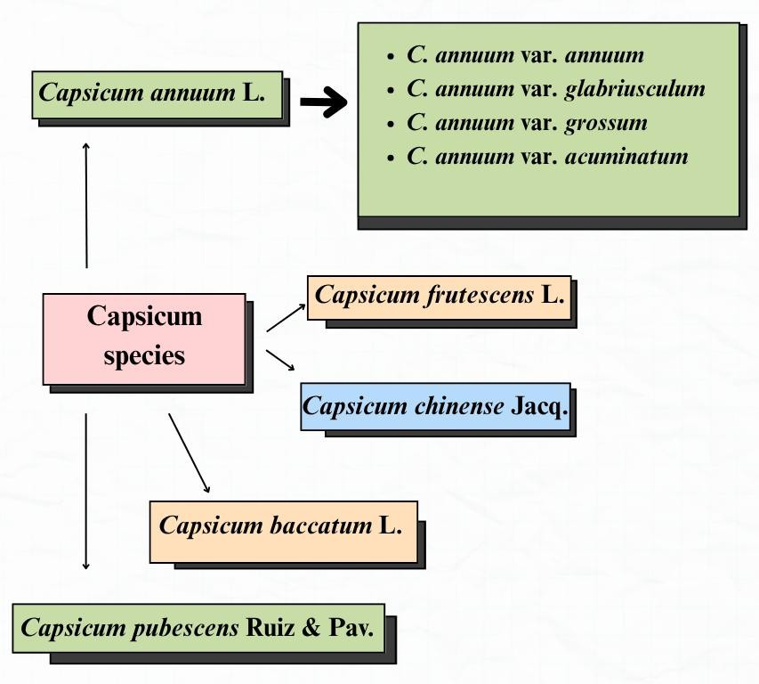
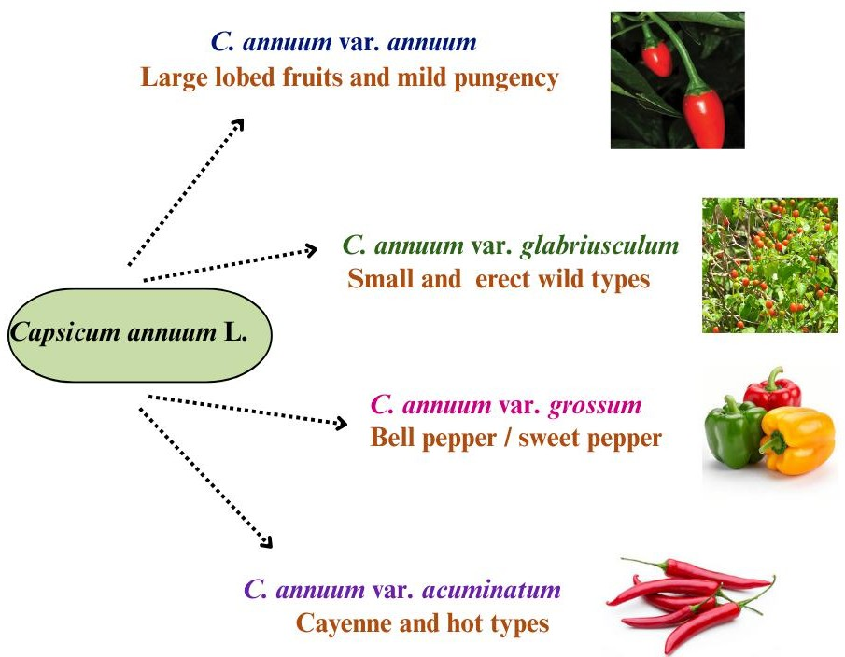
Fig. 1 Domesticated species of Capsicum spp. and major cultivars of C. annuum L.

2.1 Regional diversity of Capsicum landraces in the Northeastern India
The primary cultivated species in this region are C. annuum, C. chinense, and C. frutescens, which collectively exhibit considerable genetic, morphological, and biochemical variation. These taxa constitute the main components of chilli cultivation and represent significant diversity within the genus (Dutta et al., 2025).Capsicum annuum L. is the most widely cultivated Capsicum species across India, including the Northeastern Himalayan region, showing extensive diversity in fruit shape, size, colour, and pungency, from hot chillies to sweet bell peppers (Naseem et al., 2024). C. frutescens L. (Bird’s eye chilli) is widely cultivated in Northeast India and is exemplified by landraces such as Dhani chilli in West Bengal. It is characterised by small yet intensely pungent fruits, erect and upright, with perennial growth and consistent cytogenetic features, including two pairs of satellite-bearing chromosomes (Jha & Bhowmick, 2021). C. chinense Jacq., particularly the Bhut Jolokia or Naga King chilli, stands out for its exceptional pungency and unique aroma. Findings from Baruah et al. (2024) reveals that, Bhut Jolokia, distributed mainly across Assam, Nagaland, Manipur, and Mizoram, is notable for its unusually high capsaicin content compared to other Indian varieties.

2.2 Geographical Indication (GI) tagged northeastern Chilli landraces
2.2.1 Bhut Jolokia
Native to Assam, Nagaland, and Manipur in northeast India, Bhut Jolokia is a landrace of Capsicum chinense, also known as ‘Ghost Pepper’. It is also referred to as ‘Naga Jolokia’, ‘Raja mirchi’ and ‘Naga King Chilli’ in Nagaland, ‘Bih Jolokia’ in Assam, ‘Umorok’ in Manipur, ‘Naga Morich’ and ‘Nagahari’ in Bangladesh, and ‘Dorset Naga’ in the United Kingdom (Baruh et al.,2014). It’s extremely high capsaicin content has earned its place in the Guinness book of world records (2006) as the world's hottest chilli, with a Scoville Heat Unit (SHU) exceeding 1,000,000 SHU units (Sarwa et al.2014; Ksh et al., 2023). This unique genotype is an interspecific hybrid of C. chinense and C. frutescens, with strong pungency and stable genetic homogeneity, according to molecular and morphological analysis (Purkayastha et al., 2012). Due to its distinct regional identity and economic significance, the Naga King Chilli was granted a Geographical Indication (GI) status to Nagaland in 2008 (Tara et al., 2020). It has long been used to treat ailments like sore throats, arthritis, gastritis, and respiratory disorders, and it has significant cultural and medicinal value (Baruah et al., 2023). Sarpras et al. (2016) conducted a comprehensive metabolite and gene expression profiling study and found that Bhut Jolokia exhibits significantly higher expression of metabolites such as dihydrocapsaicin and tocopherols, as well as pungency-related genes like Pun1 and Acs1.
2.2.2 Dalle Khursani
Dalle Khursani (C. annuum), a landrace predominantly cultivated in the mid-hill zones of Sikkim and Darjeeling, possesses distinctive characteristics such as perennial growth and winter hardness, enabling its resilience in mountainous temperate climates (Verma et al., 2024). Furthermore, analyses have confirmed high concentrations of capsaicinoids and other secondary metabolites, which account for its notable pungency, robust flavour, and potential nutraceutical applications (Ghimiray et al., 2024). While genetic studies classify it within the Capsicum annuum species, this landrace maintains significant intra-landrace diversity. This genetic variation makes it a valuable resource for breeding programs seeking to enhance heat and stress tolerance in chilli crops (Colney et al., 2018).
2.2.3. Mizo chilli
The Mizo Chilli (Hmarcha te), a highly pungent Capsicum frutescens landrace indigenous to the hills of Mizoram, was granted Geographical Indication (GI) status in 2021. This designation recognises the unique characteristics imparted by the region's specific agro-climatic conditions (Spices Board, 2023). The landrace is distinguished by its exceptional pungency; studies report that Grade A fruits may contain capsaicin levels as high as 607.9 mg per 100 g dry weight (Dutta et al., 2025). Beyond its culinary applications, the Mizo Chilli holds significant ethnopharmacological value, traditionally employed by Mizo communities as an analgesic and anti-inflammatory agent (Phairong et al., 2020)
2.2.4. Hathei Chilli
The Hathei Chilli (Capsicum annuum L.), locally known as “Sirarakhong Hathei”, is an indigenous landrace cultivated exclusively in Sirarakhong village, Ukhrul district of Manipur. This chilli is recognised for its deep natural red colour, moderate pungency, and rich pigment content, characteristics that make it highly valued both for culinary uses and as a natural colorant (Spices board, 2023).
The distribution of GI tagged chilli landraces across the Northeastern states such as Bhut Jolokia (Assam, Nagaland, and Manipur), Dalle Khursani (Sikkim and Darjeeling), Mizo Chilli (Mizoram), and Hathei Chilli (Manipur) is depicted in Fig. 2
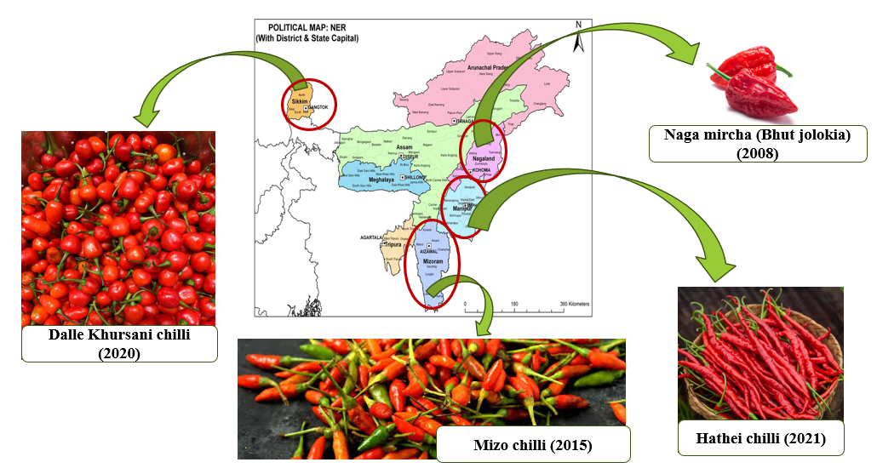

Fig.2 Geographical indication tagged chillies of Northeast India

3. Breeding Perspectives and Genetic Improvement Strategies
Integrating morphological, molecular, and biochemical evaluations enables the accurate characterization of genetic diversity, facilitating the identification of promising parental lines and enhancing the predictability of breeding outcomes. Such a combined approach ensures that Capsicum improvement strategies in Northeast India not only exploit visible phenotypic diversity but also harness underlying genomic variation to develop climate-resilient, high-yielding, and nutritionally enriched cultivars.
3.1 Genetic diversity based on morphological traits
Morphological diversity reflects the visually perceptible variation in plant form and structure, assessed through standardized descriptive markers that emphasize highly heritable traits. The International Plant Genetic Resources Institute (IPGRI) descriptors covering plant habit, leaf and floral morphology, and fruit attributes such as size, shape, color, and pungency, are widely used in India to ensure uniformity in germplasm evaluation. Saisupriya et al. (2021) documented that morphological characterisation is a key prerequisite for varietal improvement, providing essential indicators of genetic diversity, breeding value, and yield potential. Studies on C. annuum germplasm consistently reveal broad variation across qualitative traits (leaf shape, fruit position, surface texture) and quantitative parameters, with fruit wall thickness often showing high coefficients of variation (Gurung et al., 2020). Considerable diversity in fruit morphology, pungency, bearing habit, and crop duration has been observed nationwide influenced by local agroecological conditions and traditional cultivation practices (Das et al., 2025). Datta and Das (2014) reported significant variability among 53 C. annuum genotypes from West Bengal, using 23 IPGRI traits, and noted high heritability for capsaicin content, yield per plant, and fruit number. Similarly, Patra et al. (2019) identified distinct groupings among six endangered C. annuum landraces from Odisha, underscoring marked genetic divergence within regional germplasm.
3.2 Genetic diversity based on biochemical traits
Capsaicin, the compound responsible for chilli pungency, varies among types and determines each chilli’s heat level. The Northeast region of India serves as a crucial centre of Capsicum diversity, harbouring highly pungent landraces such as Bhut Jolokia and Dalle Khursani (Colney et al., 2018; Baruah et al., 2023; Meitei et al., 2025). According to Baruah et al. (2023) and Meitei et al.(2025) the extreme pungency of these cultivars, driven by elevated capsaicinoid levels, enhances their economic importance for industrial extraction. Molecular characterisation using SSR markers and sequencing of key pungency genes like Acs1, Kas1, and pAmt/Pun1 revealed that Dalle Khursani accessions are genetically closer to pungent C. annuum (Colney et al., 2018). Furthermore, large-scale genetic evaluation of C. chinense (ghost pepper) identified high variability and demonstrated that capsaicin content, fruit yield per plant, fruit length, and fruit girth exhibits high heritability with substantial genetic advance, indicating that direct selection is an effective breeding strategy (Baruah et al., 2023). Complementary untargeted metabolomic profiling of four heirloom Northeastern landraces representing C. chinense, C. annuum, and C. frutescens genotypes identified 2,702 putative metabolites, showing greater variation among species than within species, and confirming significant variability in capsaicin content that provides molecular biomarkers and targets for chilli improvement programs (Meitei et al., 2025). Complementing this profile, these peppers contain abundant carotenoids; total carotenoid content varied significantly across genotypes, registering values up to 7.72 mg/100 g dry weight (Dubey et al., 2015), with carotene levels reaching 4.45 mg/L in some accessions (Mena et al., 2018). The key biochemical constituents, such as capsaicin, ascorbic acid, carotenoids, and flavonoids are summarised in Fig. 3, which illustrates their physiological roles in determining pungency, antioxidant capacity, and overall therapeutic potential.
Such extensive biochemical diversity directly complements the documented therapeutic potential of Northeast Indian chillies, particularly the highly pungent landraces. The exceptionally high capsaicinoid concentrations found in Bhut Jolokia (C. chinense) and Mizo chilli (C. frutescens) serve as the biochemical basis for their medicinal and ethnopharmacological importance. The naturally elevated capsaicin content observed in Bhut Jolokia enhances its pharmaceutical relevance, aligning with contemporary findings that highlight its strong analgesic and anti-inflammatory properties (Phairong et al., 2020).
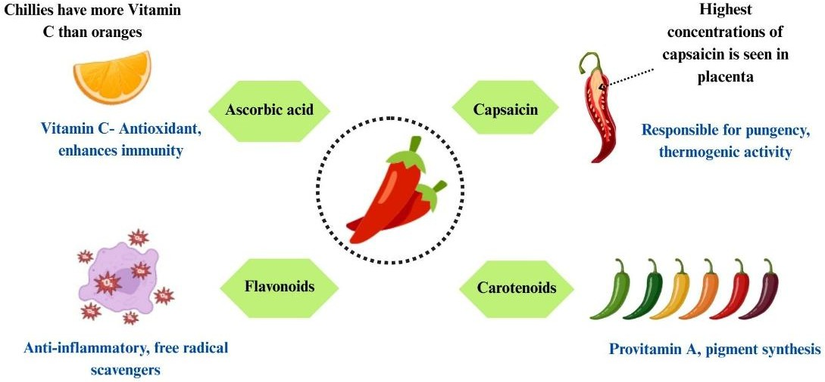

Fig.3 Major biochemical compounds of chilli

3.3 Genetic diversity based on molecular traits
Molecular markers are now crucial to the development of Capsicum breeding and genetic research. Both non-PCR-based RFLP and PCR-based techniques like RAPD, AFLP, SNP, and SSR have been used extensively to support marker-assisted selection, study genetic diversity, and create linkage maps. These resources have enhanced researchers' comprehension of the Capsicum genome and development of new cultivars (Anani et al., 2025). A significant accomplishment in Capsicum genetics was made by Tanksley et al. (1988) when they used an interspecific hybrid between C. annuum and C. chinense to create the first genetic linkage map (Meena et al., 2020). With 85 RFLP markers dispersed across 14 linkage groups, this map aided future breeding efforts by enabling the identification of QTLs associated with agronomic traits. Because SSR markers are highly polymorphic and reproducible, they are frequently employed to evaluate genetic diversity and population structure in Capsicum species. In India, SSR-based research has made it possible to accurately identify chilli landraces and use marker-assisted breeding. In their evaluation of 64 Capsicum annuum accessions using SSR markers, Dhaliwal et al. (2014), for instance, found significant genetic heterogeneity and categorised the accessions into nine groups. Verma et al. (2024) investigated a number of Capsicum species from Northeast India using 47 SSR markers and discovered 230 alleles with a mean PIC of 0.61 and 69% intra-population diversity. Their results demonstrated that adaptive genetic divergence was influenced by temperature, altitude, and local selection. Colney et al. (2018) used 30 SSRs to identify cultivar-specific markers (HpmsE116, HpmsE139) that differentiate pungent from non-pungent cultivars in 22 accessions of C. chinense and C. annuum. Sequencing of important pungency genes (Pun1, Acs1, Kas1) revealed elite-line-specific new SNPs and InDels that offer molecular tools for targeted breeding.
3.4 Northeastern Capsicum species: A source for climatic and biotic resilient breeding
As described by Roy et al. (2024) Capsicum species across Northeast India, exhibit diverse adaptive responses to abiotic and biotic stresses crucial for climate resilience. C. chinense (Naga King Chilli) thrives in mildly warm and humid conditions (12.2°C–28.6°C) but remains highly susceptible to extreme heat and submergence, showing low recovery rates. However, its accumulation of high proline content under drought stress indicates inherent tolerance mechanisms (Roy et al., 2024). Rai et al. (2014) identified Naga King Chilli as a novel source of resistance to pepper leaf curl virus, while certain C. chinense genotypes (Bhut Jolokia) were found symptomless or resistant to anthracnose caused by Colletotrichum capsici (Garg et al., 2013). In contrast, the Dalle chilli (C. annuum) landrace serves as a valuable winter hardy resource, adapted to cool and humid conditions suitable for breeding frost-tolerant varieties (Verma et al., 2024). Shin & Yun (2010) reported increasing vulnerability of endemic chilli cultivation due to rising incidences of thrips-transmitted tospoviruses, whitefly-transmitted begomoviruses, and bacterial diseases intensified by elevated temperature and CO₂ levels. To counter such climate-induced stresses, the use of protected cultivation systems like low-cost polyhouses has been suggested as an effective intervention (Verma et al., 2024).
Recent work on Northeastern Capsicum has identified key donor genotypes for breeding against major biotic stresses. Bhut Jolokia and related chilli lines (BS-27, BS-28, BS-35, BS-37, CC-0189, Hisar Sakti, IC-326272, IC-383072) showed stable resistance or near-immunity to die-back and fruit rot caused by Colletotrichum capsici under epiphytotic screening, making them priority parents for anthracnose and die-back-resistance breeding (Thabrez et al., 2024). In parallel, induced systemic resistance against collar rot has been shown in Bhut Jolokia using the rhizobacterium Bacillus megaterium JPR68, which increases salicylic acid levels, defence enzyme activity and plant yield. This approach can be combined with host genetic resistance to develop breeding pipelines that integrate rhizobacteria-mediated protection with conventional resistance breeding (Gogoi et al., 2025). However, U-morok and Bhut Jolokia are increasingly threatened by genetically diverse chilli veinal mottle virus and recombinant cotton leaf curl Multan virus, betasatellite complexes, emphasising the need to combine Northeastern C. chinense resistance sources with systematic virus monitoring and selection to achieve durable resistance under evolving pathogen populations (Devi et al., 2022; Yogindran et al., 2021).
CONCLUSION AND FUTURE PROSPECTS
A clearer perspective on the diversity and genetic potential of Northeastern chillies is essential for directing breeding efforts and conservation planning. Northeast India holds an unparalleled repository of Capsicum genetic resources, encompassing an extraordinary range of landraces distinguished by their unique phytochemical compositions, morphological diversity, and notable adaptive traits. In particular, landraces such as Bhut Jolokia, Dalle Khursani, Mizo chilli, and Hathei Chilli serve as vital genetic reservoirs contributing to enhanced resilience, nutritional value, and multifaceted utility in breeding, nutrition, and therapeutic innovation. Comprehensive morphological, biochemical, and molecular characterisations have substantially advanced our understanding of these resources, illuminating their significance not only in regional agriculture but also within the global context of chilli improvement programs.
However, substantial gaps remain in both research intensity and systematic conservation efforts, leaving many valuable genetic resources underutilised. To harness the full breeding potential and ensure sustainable utilisation, future research should emphasise high-throughput genomic and metabolomic profiling, functional validation of adaptive and quality-related alleles, and participatory on-farm conservation strategies. Integrating advanced biotechnological approaches with traditional knowledge can unlock novel traits conferring tolerance to emerging biotic and abiotic stresses. Strengthened regional, national, and international collaborations, coupled with policy support for germplasm protection and equitable benefit-sharing, will be essential to safeguard and leverage Northeast India’s Capsicum diversity for food security, climate resilience, and the development of next-generation nutraceutical and pharmaceutical products.
DISCLAIMER (ARTIFICIAL INTELLIGENCE)
The author(s) hereby declare that generative AI technologies and language assistance tools were used during the writing and editing of this manuscript. The following tools were employed exclusively for grammar correction, language refinement, and structural clarity. All intellectual content, interpretation, and scientific conclusions are entirely the author’s own.
Details of AI usage are as follows:
- Grammarly – Used for grammar, punctuation, and style correction.
- ChatGPT (GPT-5, OpenAI) – Used for improving sentence flow, paraphrasing, and ensuring academic tone consistency.
- NotebookLM (Google) – Used for organizing references, summarizing sections, and ensuring logical coherence.
ACKNOWLEDGEMENTS
The author(s) gratefully acknowledge Kerala Agricultural University for their facilities and academic
support. All figures in this review article were designed and created by the authors.
COMPETING INTERESTS
Authors have declared that no competing interests exist.

REFERENCES
Anani, P. Y., Bayor, H., Karikari, B., Amegbor, I. K., Nyarko, G., Hudu, A. R., & Labuschagne, M. (2025). Genetic diversity and population structure analysis of Capsicum annuum cultivated in the Northern region of Ghana using simple sequence repeat markers. Cogent Food & Agriculture, 11(1), 2537137. https://doi.org/10.1080/23311932.2025.2537137
Baruah, J., Begum, T., & Lal, M. (2024). Estimation of environment stability for fruit yield and capsaicin content by using two models in Capsicum chinense Jacq. (Ghost pepper) with multi-year evaluation. PeerJ, 12, e17511. https://doi.org/10.7717/peerj.17511
Baruah, J., Munda, S., Sarma, N., Begum, T., Pandey, S. K., Chanda, S. K., Sastry, G. N., & Lal, M. (2023). Estimation of genetic variation in yield, its contributing characters and capsaicin content of Capsicum chinense Jacq. (Ghost pepper) germplasm from Northeast India. PeerJ, 11, e15521. https://doi.org/10.7717/peerj.15521
Baruah, S., Zaman, M. K., Rajbongshi, P., & Das, S. (2014). A review on recent researches on Bhut Jolokia and pharmacological activity of capsaicin. International Journal of Pharmaceutical Sciences Review and Research, 24(2), 89–94
Bhagowati, R. R., & Changkija, S. (2009). Genetic variability and traditional practices in Naga King Chilli landraces of Nagaland. Asian Agri-History, 3, 171–180.
Bhavani, B., Anilkumar, C., Rao, A. M., & Ramesh, S. (2020). Genetics of fruit oleoresin and capsaicin contents in chilli inter-species (Capsicum annuum × C. chinense) cross. Plant Genetic Resources: Characterization and Utilization, 18(1), 28–30. https://doi.org/10.1017/S1479262119000418
Bhutia, K. L., Bhutia, N. D., & Khanna, V. (2019). Rich genetic diversity of Capsicum species in Northeast India as a potential source for chilli crop improvement.
Choi, M.-H., Kim, M.-H., & Han, Y.-S. (2023). Physicochemical properties and antioxidant activity of colored peppers (Capsicum annuum L.). Food Science and Biotechnology, 32(2), 209–219. https://doi.org/10.1007/s10068-022-01177-x
Colney, L., Tyagi, W., & Rai, M. (2018). Morphological and molecular characterization of two distinct chilli cultivars from Northeastern India with special reference to pungency-related genes. Scientia Horticulturae, 240, 1–10. https://doi.org/10.1016/j.scienta.2018.05.045
Das, S., Kar, S., Das, A., Banik, B., Mili, M., Bose, A., Bhattacharya, P., Debbarma, S., Bora, D., & Datta, B. K. (2025). Evaluating the palynological features of economically significant Chilli crop through light and scanning electron microscopy. Discover Plants, 2(1), 127. https://doi.org/10.1007/s44372-025-00220-5
De, A. K. (Ed.). (2003). Capsicum: The genus Capsicum. Taylor & Francis.
Devi, H. C., Sharma, S. K., Devi, K. S., Devi, O. P., Roy, S. S., & Devi, Ph. S. (2022). Pathogenic and genetic diversity of chilli veinal mottle virus associated with U-morok (Capsicum chinense) decline in Manipur state of North East India. Indian Phytopathology, 75(4), 1221–1229. https://doi.org/10.1007/s42360-022-00566-w
Dubey, R. K., Singh, V., Upadhyay, G., Pandey, A. K., & Prakash, D. (2015). Assessment of phytochemical composition and antioxidant potential in some indigenous chilli genotypes from North east India. Food Chemistry, 188, 119–125. https://doi.org/10.1016/j.foodchem.2015.04.088
Dutta, D., Das, S. K., Haider, I., Sony, S. K., & Mitra, S. (2025). Evaluation of genetic diversity among Naga chili (Capsicum chinense Jacq.) samples available in Bangladesh. Plant Tissue Culture and Biotechnology, 34(2), 133–140. https://doi.org/10.3329/ptcb.v34i2.78828
Garg, R., Kumar, S., Kumar, R., Loganathan, M., Saha, S., Kumar, S., Rai, A. B., & Roy, B. K. (2013). Novel source of resistance and differential reactions on chilli fruit infected by Colletotrichum capsici. Australasian Plant Pathology, 42(2), 227–233. https://doi.org/10.1007/s13313-012-0194-7
Gogoi, P., Sharmah, B., Manna, P., Gogoi, P., Baishya, G., & Saikia, R. (2025). Salicylic acid induced by Bacillus megaterium causing systemic resistance against collar rot in Capsicum chinense. Plant Cell Reports, 44(4), 86. https://doi.org/10.1007/s00299-025-03470-5
Ghimiray, T. S., Majumdar, B., & Man, S. (2024). Determination of capsaicin content and pungency levels in Dalle Khursani accessions, a polyploid Capsicum species specific to Darjeeling–Sikkim Himalaya, India. Plant Biology. https://doi.org/10.1101/2024.09.25.614886
Gurung, T., Sitaula, B. K., Penjor, T., & Tshomo, D. (2020). Genetic diversity of chili pepper (Capsicum spp.) genotypes grown in Bhutan based on morphological characters. SABRAO Journal of Breeding and Genetics, 52(4), 446–464.
Jain, A., & Das, A. (2022). North-East India: A Unique Biodiversity Paradise Unexplored or Lost? International Journal of Scientific and Research Publications (IJSRP), 12(4), 112. https://doi.org/10.29322/IJSRP.12.04.2022.p12417
Jha, T. B., & Bhowmick, B. K. (2021). Conservation of floral, fruit and chromosomal diversity: A review on diploid and polyploid Capsicum annuum complex in India. Molecular Biology Reports, 48(7), 5587–5605. https://doi.org/10.1007/s11033-021-06355-4
Kishorkumar, G. K., Ajjappalavara, P. S., Jawadagi, R. S., Satish, D., Nishani, S., Ravikumar, B., Patil, H. B., & Vinaykumar, M. M. (2024). Character association and path analysis studies for yield and yield attributes in industrially valued elite dry chilli (Capsicum annuum L.) genotypes. Plant Archives, 25(1). https://doi.org/10.51470/PLANTARCHIVES.2025.v25.supplement-1.072
Ksh, V., Anand, V., Rana, V. S., Mishra, J., Varghese, E., Upadhyay, N., & Kaur, C. (2023). Extraction of capsaicin from Capsicum chinense (cv Bhut Jolokia) using supercritical fluid technology and degradation kinetics. Chemical Papers, 77(11), 6747–6761. https://doi.org/10.1007/s11696-023-02974-2
Madala, N., & Nutakki, M. K. (2020). Hot pepper: History, health and dietary benefits & production.
Martínez-Ávalos, J. G., Venegas-Barrera, C. S., Martínez-Gallegos, R., Torres-Castillo, J. A., Olazarán Santibáñez, F. E., Mora-Olivo, A., Guerra-Pérez, A., et al. (2018). A review on the geographical distribution, fruit production and concentration of capsaicinoids in Capsicum annuum var. Glabriusculum in the northeastern region of Mexico. Chemistry. https://doi.org/10.20944/preprints201811.0517.v1
Maulani, R., Murti, R. H., & Purwantoro, A. (2023). Molecular diversity in populations of chili (Capsicum annuum L.). SABRAO Journal of Breeding and Genetics, 55(1), 15–24. https://doi.org/10.54910/sabrao2023.55.1.2
Meitei, A. L., Yogendra, K., Sanivarapu, H., Meetei, N. T., Rai, M., & Tyagi, W. (2025). Metabolite profiling reveals differential accumulation of secondary metabolites related to flavour and colour across four heirloom chilli landraces. Physiology and Molecular Biology of Plants, 31(3), 477–491. https://doi.org/10.1007/s12298-025-01576-4
Meena, O. P., Dhaliwal, M. S., & Jindal, S. K. (2020). Heterosis breeding in chilli pepper by using cytoplasmic male sterile lines for high-yield production with special reference to seed and bioactive compound content under temperature stress regimes. Scientia Horticulturae, 262, 109036. https://doi.org/10.1016/j.scienta.2019.109036
Mena, E., Warade, S., & Ansari, M. T. (2018). Evaluation of capsaicin, ascorbic acid, α-carotene and β-carotene in Bhut Jolokia (Capsicum chinense Jacq.) genotypes from Northeast India.
Naseem, M., Rana, R. M., Mahmood Ul Hassan, Khan, M. A., Binobead, M. A., Elsadek, M. F., Elsalahy, H. H., & Iqbal, R. (2024). High-performance liquid chromatography (HPLC)-based genetic diversity profiling of chilli germplasm for fruit pungency and phytochemical contents. BMC Plant Biology, 24(1), 368. https://doi.org/10.1186/s12870-024-05055-y
Patel, J. S., Prajapati, K. N., Tiwari, K., Chaudhari, M. K., Gondaliya, S. B., Joshi, V. A., & Vyas, S. R. (2024). Assessing chilli genotypes: A study of morphological and nutritional traits. Asian Journal of Research in Biochemistry, 14(4), 84–94. https://doi.org/10.9734/ajrb/2024/v14i4296
Phairong, M. M., Lalbiaknunga, J., & Lalnunmawia, F. (2020). Mizo chilli (Capsicum frutescens): A potential source of capsaicin with broad-spectrum ethnopharmacological applications. Journal of Pharmacognosy and Phytochemistry, 9(5), 670–672. https://doi.org/10.22271/phyto.2020.v9.i5j.12306
Prasad, N. S., Raghavendra, R., Lokesh, B. R., & Naidu, K. A. (2004). Spice phenolics inhibit human PMNL 5-lipoxygenase. Prostaglandins, Leukotrienes and Essential Fatty Acids, 70(6), 521–528. https://doi.org/10.1016/j.plefa.2003.11.006
Purkayastha, J., Alam, S., Gogoi, H., Singh, L., & Veer, V. (2012). Molecular characterization of “Bhut Jolokia,” the hottest chilli. Journal of Biosciences, 37(4), 757–768. https://doi.org/10.1007/s12038-012-9249-8
Rai, V. P., Kumar, R., Singh, S. P., Kumar, S., Kumar, S., Singh, M., & Rai, M. (2014). Monogenic recessive resistance to pepper leaf curl virus in an interspecific cross of Capsicum. Scientia Horticulturae, 172, 34–38. https://doi.org/10.1016/j.scienta.2014.03.039
Roy, S. J., Regon, P., & Tanti, B. (2024). Morpho-physiochemical responses of Capsicum chinense Jacq. (Bhut Jolokia) under different abiotic stresses. Vegetos, 37(5), 1817–1832. https://doi.org/10.1007/s42535-024-00825-3
Saisupriya, P., Saidaiah, P., & Pandravada, S. R. (2021). Morphological characterization of chilli (Capsicum annuum L.) germplasm. Biological Forum – An International Journal, 13(4), 866–872.
Sarpras, M., Gaur, R., Sharma, V., Chhapekar, S. S., Das, J., Kumar, A., Yadava, S. K., Nitin, M., Brahma, V., Abraham, S. K., & Ramchiary, N. (2016). Comparative analysis of fruit metabolites and pungency candidate genes expression between Bhut Jolokia and other Capsicum species. PLOS ONE, 11(12), e0167791. https://doi.org/10.1371/journal.pone.0167791
Sarwa, K. K., Das, P. J., & Mazumder, B. (2014). A nanovesicle topical formulation of Bhut Jolokia (hottest Capsicum): A potential anti-arthritic medicine. Expert Opinion on Drug Delivery, 11(5), 661–676. https://doi.org/10.1517/17425247.2014.891581
Shin, J.-W., & Yun, S.-C. (2010). Elevated CO₂ and temperature effects on the incidence of four major chili pepper diseases. The Plant Pathology Journal, 26(2), 178–184. https://doi.org/10.5423/PPJ.2010.26.2.178
Shobana, S., & Naidu, K. A. (2000). Antioxidant activity of selected Indian spices. Prostaglandins, Leukotrienes and Essential Fatty Acids, 62(2), 107–110. https://doi.org/10.1054/plef.1999.0128
Spices Board, Ministry of Commerce & Industry, Government of India. (2023, March 31). List of Geographical Indication (GI) tags registered for spices [PDF]. Spices Board India. https://www.indianspices.com/sites/default/files/List_of_GItags_for_spices_BJ.pdf
Spices Board, Ministry of Commerce & Industry, Government of India. (2024). Spices Board India. https://www.indianspices.com/
Surh, Y.-J. (2002). Anti-tumor promoting potential of selected spice ingredients with antioxidative and anti-inflammatory activities: A short review. Food and Chemical Toxicology, 40(8), 1091–1097. https://doi.org/10.1016/S0278-6915(02)00037-6
Swamy, K. R. M. (2023). Origin, distribution, taxonomy, botanical description, genetic diversity and breeding of Capsicum (Capsicum annuum L.). International Journal of Development Research, 13(3), 61956–61977.
Swetha, B. (2023). Variability studies and genetic divergence in chilli (Capsicum spp.) genotypes using multivariate analysis. Electronic Journal of Plant Breeding, 14(3). https://doi.org/10.37992/2023.1403.105
Tanksley SD, Bernatzky R, Lapitan NL and Prince JP (1988). Conservation of gene repertoire but not gene order in pepper and tomato. Proc. Natl. Acad. Sci. U. S. A. 85: 6419-6423
Tara, K. K., Dutta, M., Laishram, R., Chiru, T. G., & Rajkumari, N. (2025). Cultural significance and economic potential of Naga King Chilli (Capsicum chinense J.) in Northeast India: A review. Plant Archives, 25(1), 1817–1825. https://doi.org/10.51470/PLANTARCHIVES.2025.v25.no.1.264
Thabrez, M., Singh, A. K., Kumar, D., Singh, R., Singh, S. K., & M, V. (2024). Unravelling the novel source of resistance and differential reactions on chilli die back and fruit rot through screening of various chilli genotypes. Agriculture Association of Textile Chemical and Critical Reviews, 12(4). https://doi.org/10.21276/AATCCReview.2024.12.04.611
Tiwari, A., Kaushik, M. P., Pandey, K. S., & Dangi, R. S. (2005). Adaptability and production of hottest chilli variety under Gwalior agro-climatic conditions. Current Science, 88(10), 1545–1546.
Verma, V. K., Pandey, A., Thirugnanavel, A., Rymbai, H., Dutta, N., Kumar, A., Bhutia, T. L., et al. (2024). Ecology, genetic diversity, and population structure among commercial varieties and local landraces of Capsicum spp. grown in northeastern states of India. Frontiers in Plant Science, 15, 1379637. https://doi.org/10.3389/fpls.2024.1379637
Votava, E. J., Nabhan, G. P., & Bosland, P. W. (2002). Genetic diversity and similarity revealed via molecular analysis among and within an in situ population and ex situ accessions of chiltepin (Capsicum annuum var. Glabriusculum).
Yogindran, S., Kumar, M., Sahoo, L., Sanatombi, K., & Chakraborty, S. (2021). Occurrence of Cotton leaf curl Multan virus and associated betasatellites with leaf curl disease of Bhut-Jolokia chillies (Capsicum chinense Jacq.) in India. Molecular Biology Reports, 48(3), 2143–2152. https://doi.org/10.1007/s11033-021-06223-1

