Optimisation of Regeneration and Agrobacterium-Mediated Transformation Protocol for Black Rice (Oryza sativa L. cv. Chakhao poireiton)

.
ABSTRACT

Aims:
To develop and optimise an efficient in vitro regeneration and Agrobacterium-mediated transformation protocol for black rice (Oryza sativa L. cv. Chakhao poireiton), a nutritionally rich but low-yielding and stress-susceptible variety, thereby establishing a reproducible system for its genetic improvement.
Study Design:
The study used an experimental design with seven callus-induction treatments (combinations of VACA and 2,4-D) and four shoot-regeneration treatments (various kinetin and kinetin–BAP combinations). Each treatment was replicated three times, with multiple callus samples per replicate. Afterwards, we performed Agrobacterium-mediated genetic transformation using strain LBA4404 to evaluate gene delivery efficiency.
Place and Duration of Study:
This research was conducted at the Agricultural Biotechnology Laboratory, Faculty of Agricultural Science and Technology, Assam Agricultural University, Jorhat, India.
Methodology:
Mature black rice embryos were cultured on N6-based media with varying concentrations of 2,4-D (1.0 to 2.5 mg L⁻¹) and VACA (0 to 1.0 g L⁻¹) to assess callus induction. Regeneration potential was evaluated with different combinations of kinetin and BAP in N6RH50 medium. To determine the minimum lethal dose for selecting transformants, hygromycin sensitivity tests were performed at concentrations ranging from 0 to 60 mg L⁻¹. Transformation was conducted using Agrobacterium tumefaciens strain LBA4404 with the binary vector pCAMBIA1304, and successful T-DNA delivery was confirmed through GUS histochemical assays.
Results:
The combination of 1 g L⁻¹ VACA and 2 mg L⁻¹ 2,4-D yielded the highest callus induction frequency(60%) with friable, embryogenic calli. The maximum shoot regeneration rate (55%) was achieved with both 4 mg L⁻¹ and 5 mg L⁻¹ kinetin4 - –5 mg L⁻¹ kinetin in N6RH50 medium. Hygromycin at 30 mg L⁻¹ was found to be the minimum lethal concentration for selection. Transformed calli exhibited strong blue colouration in GUS assays, confirming successful gene delivery.
Conclusion:
The optimised regeneration and transformation system provides a reliable, reproducible platform for the genetic improvement of black rice, laying the foundation for future molecular breeding and functional genomics to enhance yield and stress tolerance.

Keywords: [Regeneration optimisation; GUS assay; embryogenic callus; auxin–cytokinin balance; transformation efficiency.)

1. INTRODUCTION

Black rice (Oryza sativa L.), particularly the Chakhao variety, a group of Manipuri rice landraces, is prized for its distinctive anthocyanin-rich pericarp, high nutritional value, and medicinal properties, such as anti-inflammatory, anticancer, and antioxidant effects (Sompong et al., 2011). In Northeast India, particularly in Manipur, the species is also of great significance from a cultural and economic standpoint (Chandra et al., 2025). However, its commercial cultivation is limited due to its lengthy growth period, low yield potential, and susceptibility to both biotic and abiotic stresses (Kumari, 2020). As a result, because of these challenges, black rice genetic improvement must be given top priority by both breeders and policymakers. To date, conventional breeding techniques have not been able to enhance complex traits such as yield stability and stress tolerance in black rice due to low genetic diversity and strong linkage drag from undesirable traits (Mbanjo et al., 2020). Modern plant biotechnology, particularly genetic transformation, offers an alternative approach for rapidly introducing beneficial genes and analysing gene function (Hiei et al., 2014). Agrobacterium tumefaciens-mediated transformation is the most widely used method for rice transformation due to its high efficiency, stable gene integration, and relatively low transgene copy number (Nishimura et al., 2006). However, the effectiveness of this approach is greatly affected by genotype-specific responses during in vitro regeneration; thus, the development of optimised protocols for resistant cultivars such as Chakhao poireiton (Cheng et al., 2004; Ali et al., 2023) becomes essential. The success of Agrobacterium-mediated transformation depends on the efficient selection of transformed tissues, efficient shoot regeneration, and the induction of morphogenetically competent calli. The ratio of auxins to cytokinins in the medium is an important factor in these processes (Asghar et al., 2022). Selection pressure is commonly applied using antibiotics such as geneticin or hygromycin, which must be precisely calibrated to avoid escapes and excessive tissue death (Sah et al., 2014; Greenwood & Glaus, 2022). Although elite indica and japonica rice transformation systems have advanced significantly (Hiei & Komari, 2008; Sahoo et al., 2011), there are few reports of systematic optimisation studies for pigmented rice genotypes. The Chakhao variety currently faces a significant obstacle to molecular breeding and functional genomics due to the lack of a reliable, high-efficiency transformation method. Consequently, the current study set out to develop an Agrobacterium-mediated transformation and regeneration protocol that is efficient and ideal for Chakhao poireiton to bridge this gap. Hence, this work was envisaged to improve critical parameters for callus induction, shoot regeneration, and transformant selection, laying the groundwork for future genetic improvement strategies aimed at yield, stress resilience, and nutritional enhancement in black rice.

2. material and methods

2.1 Plant Material and Sterilisations.
Seeds of black rice (Oryza sativa L. cv. Chakhao poireiton) were obtained from local farmers of Manipur, India. Mature grains were dehusked manually and surface sterilised with 70% ethanol for 1 min, followed by immersion in 0.1% mercuric chloride (HgCl₂) for 5 min under aseptic conditions. The seeds were rinsed five times with sterile distilled water to remove traces of sterilant and blot-dried on sterile filter paper prior to inoculation (Hiei & Komari, 2008).
2.2 Callus Induction and Maintenance
Mature embryos were cultured on modified 2N6 medium (Chu et al., 1975) to induce callus formation. The medium was supplemented with vitamin assay casamino acids (VACA) at 0, 0.1, 0.25, 0.5, 0.75, and 1.0 g L⁻¹ and 2,4-dichlorophenoxyacetic acid (2,4-D) at 0, 1.0, 1.5, 2.0, and 2.5 mg L⁻¹. The treatment containing 0 g L⁻¹ VACA and 0 mg L⁻¹ 2,4-D served as the control (blank). After adjusting the medium pH to 5.0, agar (0.8%) was added, and the medium was autoclaved for 15 minutes at 121°C. Cultures were incubated in complete darkness at 30 ± 2°C for 7–10 days. Every ten days, calli that were actively proliferating were subcultured to a new medium for continued growth (Figure 1A–B). Callus induction frequency (CIF) was calculated as the proportion of explants that developed callus (Rashid et al., 1996). The relative growth rate (RGR) of calli was calculated at two intervals: 26–39 days and 39–52 days after inoculation.
2.3 Shoot Regeneration
Twenty-day-old embryogenic calli were transferred to the regeneration medium (N6RH50) and subjected to three cytokinin treatments: kinetin (1.5 mg L⁻¹), BAP (0.5 mg L⁻¹) + kinetin (0.5 mg L⁻¹), and kinetin (4.5 mg L⁻¹). A control (blank) treatment consisting of basal N6RH50 medium without any cytokinin supplementation was included to evaluate the baseline regeneration response. The selected cytokinin concentrations were based on optimisation ranges reported in earlier studies on rice regeneration, particularly those described by Ramesh et al. (2004) and similar regeneration protocols used in indica and black rice cultivars. Cultures were maintained at 28 ± 2°C under a 16/8-hour light–dark cycle. After 14 days, the regeneration frequency was calculated as described by Ramesh et al. (2004). In N6RH50 medium, 4.5 mg L⁻¹ kinetin yielded the highest shoot regeneration (~55%). Twenty-day-old embryogenic calli were placed in regeneration medium (N6RH50) containing three distinct cytokinin treatments: kinetin (1.5 mg L⁻¹), BAP (0.5 mg L⁻¹) + kinetin (0.5 mg L⁻¹), and kinetin (4.5 mg L⁻¹). Cultures were maintained at 28 ± 2°C under a 16:8 light: dark photoperiod. After 14 days, the regeneration frequency was computed (Ramesh et al., 2004). In N6RH50 medium 4.5 mg L⁻¹ kinetin produced the maximum shoot formation (~55%).
2.4 Agrobacterium-Mediated Transformation
Agrobacterium tumefaciens strain LBA4404, carrying the binary vector pCAMBIA1304 containing the GUS A (uidA) reporter gene and the hptII selectable marker gene, was used for transformation (Jefferson et al., 1987). The strain and plasmid were obtained from Life Technologies (India) Pvt. Ltd and maintained in our laboratory under standard culture conditions. Actively growing embryogenic calli were immersed in a bacterial suspension prepared in AAM medium (OD₆₆₀ = 0.3) (Hiei et al., 1994) supplemented with 100 µM acetosyringone and gently shaken for 15 minutes. To remove excess bacteria, calli were blotted dry and co-cultivated on 2N6-As medium at 25°C in the dark for three days. They were then transferred to the selection medium (2NBKCH40) containing hygromycin (30 mg L⁻¹) and cefotaxime (250 mg L⁻¹) (Komari et al., 1996). Surviving calli were subcultured every ten days to promote the growth of transformed tissues. Agrobacterium tumefaciens strain LBA4404 carrying the binary vector pCAMBIA1304, which contains the GUSA reporter and hptII selectable marker genes, was used for transformation (Jefferson et al., 1987). Calli that were actively growing were submerged in a bacterial suspension made in AAM medium (OD660 = 0.3) (Hiei et al., 1994), and then 100 µM acetosyringone was added and the calli were gently shaken for 15 minutes. To eliminate Agrobacterium-infected calli, the calli were blotted dry and co-cultivated on 2N6-As medium at 25°C in the dark for three days. After that, they were transferred to selection medium (2NBKCH40) containing hygromycin (30 mg L⁻¹) and cefotaxime (250 mg L⁻¹) (Komari et al.,1996). To encourage the growth of altered tissues, while surviving calli were subcultured every ten days.
2.5 Optimisation of Hygromycin Concentration
Untransformed calli were inoculated on 2N6 medium containing 0, 10, 20, 30, 40, 50, and 60 mg L⁻¹ hygromycin to determine the minimum lethal dose (MLD) for effective selection (Figure 4). The inclusion of lower concentrations (10 and 20 mg L⁻¹) was based on earlier reports indicating that hygromycin sensitivity in rice calli typically begins within this range (Cheng et al., 1998; Hiei et al., 1994). Observations were recorded after ten days. Since complete mortality of non-transformed tissues was consistently observed at ≥30 mg L⁻¹, this concentration was considered the critical threshold for selection. The survival rate (%) was calculated as the mean ± SE of three replicates. Untransformed calli were inoculated on 2N6 medium containing 0, 30, 40, 50, and 60 mg L⁻¹ hygromycin in order to find the minimum lethal dose (MLD) of hygromycin for selection (Figure 4). Ten days later, observations were documented (Cheng et al., 1998). For the selection of transformed cells, complete mortality at ≥30 mg L⁻¹ was considered the critical threshold. The survival rate (%) was calculated as the mean ± SE of three replicates.
2.6 Histochemical GUS Assay
The Jefferson et al. (1987) method was used to confirm gusA expression in transformed calli using the histochemical GUS assay. After being submerged in Buffer P (50 mM phosphate buffer, pH 6.8, containing 0.1% Triton X-100) for one hour at 37°C, the calli were transferred to Buffer X (1 mM X-Gluc in Buffer P with 20% methanol) for five minutes under a light vacuum. For the entire night, the tissues were incubated in the dark conditions at 37°C. While control (non-transformed) tissues remained unstained, transformed calli showed blue colouration, which indicated GUS activity.
2.7 Statistical Analysis
All experiments were conducted in triplicate, and data were expressed as mean ± standard error (SE). Statistical analyses were performed using one-way analysis of variance (ANOVA), and treatment means were compared using Tukey’s HSD test (p < 0.05, p < 0.01, p < 0.001) with GraphPad Prism version 10 software (Motulsky, 2023).

3. results and discussion

3.1 Callus Induction Frequency
Mature embryos of the black rice variety Oryza sativa L. cv. Chakhao Poireiton were cultured on N6-based media with varying levels of VACA (0 to 1 g L⁻¹) and 2,4-D (1.0 to 2.5 mg L⁻¹) to assess the effects of these factors on callus induction frequency (CIF). The combination of 1 g L⁻¹ VACA and 2 mg L⁻¹ 2,4-D yielded the highest CIF, significantly surpassing other treatments. Calli from this combination were cream-colored, friable, and embryogenic, making them suitable for regeneration. In contrast, 2,4-D alone did not produce high-quality callus, and VACA alone produced only compact, non-embryogenic callus. This indicates that both 2,4-D and VACA are essential for effective callus induction in Chakhao Poireiton. These results align with previous studies showing that 2,4-D is a key auxin for embryogenic callus formation, while amino acid-rich supplements enhance callus quality (Rashid et al., 1996). Similar interactions have also been noted in other black rice varieties, confirming the efficacy of this optimised combination for difficult genotypes.

3.2 Relative growth rate of callus under optimized auxin concentrations
The relative growth rate (RGR) of callus was measured over two specific growth periods: from 26 to 39 days and from 39 to 52 days after the culture began. The medium that included 1 g L⁻¹ VACA and 2 mg L⁻¹ 2,4-D showed the highest RGR, achieving 0.48 ± 0.03 g g⁻¹ day⁻¹ during the first interval and 0.52 ± 0.04 g g⁻¹ day⁻¹ in the second. These results were significantly better (p < 0.05) than those of all other auxin treatments, as revealed by Tukey’s HSD test (see Figure 2). The consistently high RGR across both periods indicates that this hormonal combination not only facilitates rapid callus formation but also supports sustained vigorous growth over time.

3.3 Shoot regeneration efficiency
To determine the optimal cytokinin regime for regeneration, calli were grown on N6RH50 medium supplemented with different concentrations of kinetin and BAP. Just 4-5 mg/L of kinetin was needed to achieve the maximum regeneration efficiency of 55% (Figure 3). To determine the optimal cytokinin regime for regeneration, calli were cultured on N6RH50 medium supplemented with varying concentrations of kinetin and combinations of kinetin and BAP. A concentration of 5 mg L⁻¹ kinetin resulted in the highest and significantly superior regeneration efficiency (55%) compared to all other treatments (Figure 3). Lower concentrations of kinetin (e.g., 1.5 mg L⁻¹) and the kinetin–BAP combination (0.5 mg L⁻¹ BAP + 0.5 mg L⁻¹ kinetin) produced significantly lower regeneration rates, with the kinetin–BAP combination showing the least regeneration response. Calli regenerated under the optimal kinetin level produced healthy green shoots, confirming its suitability for efficient shoot induction. However, in this way, it produced healthy green shoots, but lower regeneration percentages were caused by lower kinetin levels or kinetin–BAP combinations (Ramesh et al., 2004).

3.4 Hygromycin sensitivity assay for selection of transformants
In order to determine the minimum lethal concentration for efficient selection following transformation, the sensitivity of black rice callus to hygromycin was evaluated. At hygromycin concentrations ≥30 mg/L, no calli survived, and complete mortality and browning were observed (Figure 4). Consequently, this concentration was chosen as the post-transformation selection standard (Cheng et al., 1998; Hiei et al., 1994). Confirmation of transformation by histochemical GUS assay
Calli underwent histochemical GUS staining after being transformed by Agrobacterium tumefaciens LBA4404 using the pCAMBIA1304 vector. In contrast to control calli, which displayed no staining, transformed calli displayed intense blue coloration, signifying the expression of the gusA reporter gene (Jefferson et al., 1987) (Figure 5). Under the optimised transformation protocol, these findings validate transient expression in black rice callus and successful T-DNA delivery.
A regeneration protocol has been developed. We have developed a dependable and reproducible Agrobacterium-mediated transformation in vitro regeneration and protocol for the culturally and agronomically valuable black rice cultivar Chakhao poireiton by carefully optimising the media components and selection criteria. Our results corroborate those found in broomcorn millet, where moderate auxin levels perform better than oversaturating concentrations, which instead resulted in tissue browning and reduced potential for regeneration (Cui et al., 2025). It has been We showed that the auxin–humic acid combination of 1 g/L⁻¹ VACA and 2 mg/L⁻¹ 24-D produced friable embryogenic calli and significantly increased the frequency of callus induction. Through auxin-like activity, humic substances further improve callus competence and quality (Muscolo et al., 2022). Indica rice lines that support high RGR media and display improved transformation and regeneration rates showed a similar pattern as reported by (Zaidi et al., 2006). With high relative growth rates over two successive growth phases, the callus also showed a sustained proliferation capacity under this ideal hormonal regime, indicating its suitability for use in further downstream procedures. Supplements like Pluronic F-68 and (Kok et al., 2020) promote the development of calluses. We discovered that the highest regeneration efficiency of 55 per cent for shoot organogenesis was produced by 4.5 mg/L ⁻¹ kinetin alone on N6RH50 medium. This validates that, as shown in IR-64 and related lines, kinetin was superior to BAP or mixed cytokinin regimes in shoot induction for resistant indica cultivars (Birla and Jaiwal, 2018). Similar kinase-centric media improved plantlet regeneration in Malaysian indica rice (Teh et al., 2018). To optimise transformant selection, a threshold of 30 mg/L⁻¹ hygromycin was set. Complete callus mortality was the outcome of this threshold which effectively removed non-transformed tissue while preserving the possibility of regeneration (Figure 4). Although genotype-specific modifications are required to prevent over-selection that could suppress even transformed tissues, this concentration is consistent with results in a range of rice genotypes where 30 to 50 mg/L⁻¹ provides effective selection without compromising regeneration. The transient gusA expression following Agrobacterium tumefaciens LBA4404 transformation was confirmed in treated calli by intensely stained GUS, whereas controls were not stained (Figure 5). This confirms promoter-driven expression and T-DNA delivery, and it aligns with successful protocols in other indica cultivars such as MR219 and Northeast rice accessions, where transformation efficiency was consistently demonstrated by GUS assays (Rahman et al., 2011; Dey et al., 2015). Since transformation efficiency is known to be influenced by a number of variables, including bacterial strain, optical density, co-cultivation time, acetosyringone concentration and selection agent choice, these variables must all be optimised for greater integration rates. The foundation for functional genomics and molecular breeding of Chakhao poireiton is laid by our optimised protocol, which includes callus initiation, shoot regeneration, and initial gene delivery. This could open the door to traits that improve yield and stress tolerance. However, stable transgenic selection and molecular confirmation (PCR, Southern blotting, or sequencing) are required to transform transient gene expression into stable genetic integration (Thangadurai et al., 2020). Confirming that the procedure works with other Oryza sativa cultivars and looking into enhancements like surfactants antinecrotic supplements or alternative antibiotic regimens could further improve transformation results (Huynh et al., 2022). Therefore, this study is a major step forward in the genetic modification of black rice, opening the door for targeted biotechnological interventions that will allow the development of advanced traits.
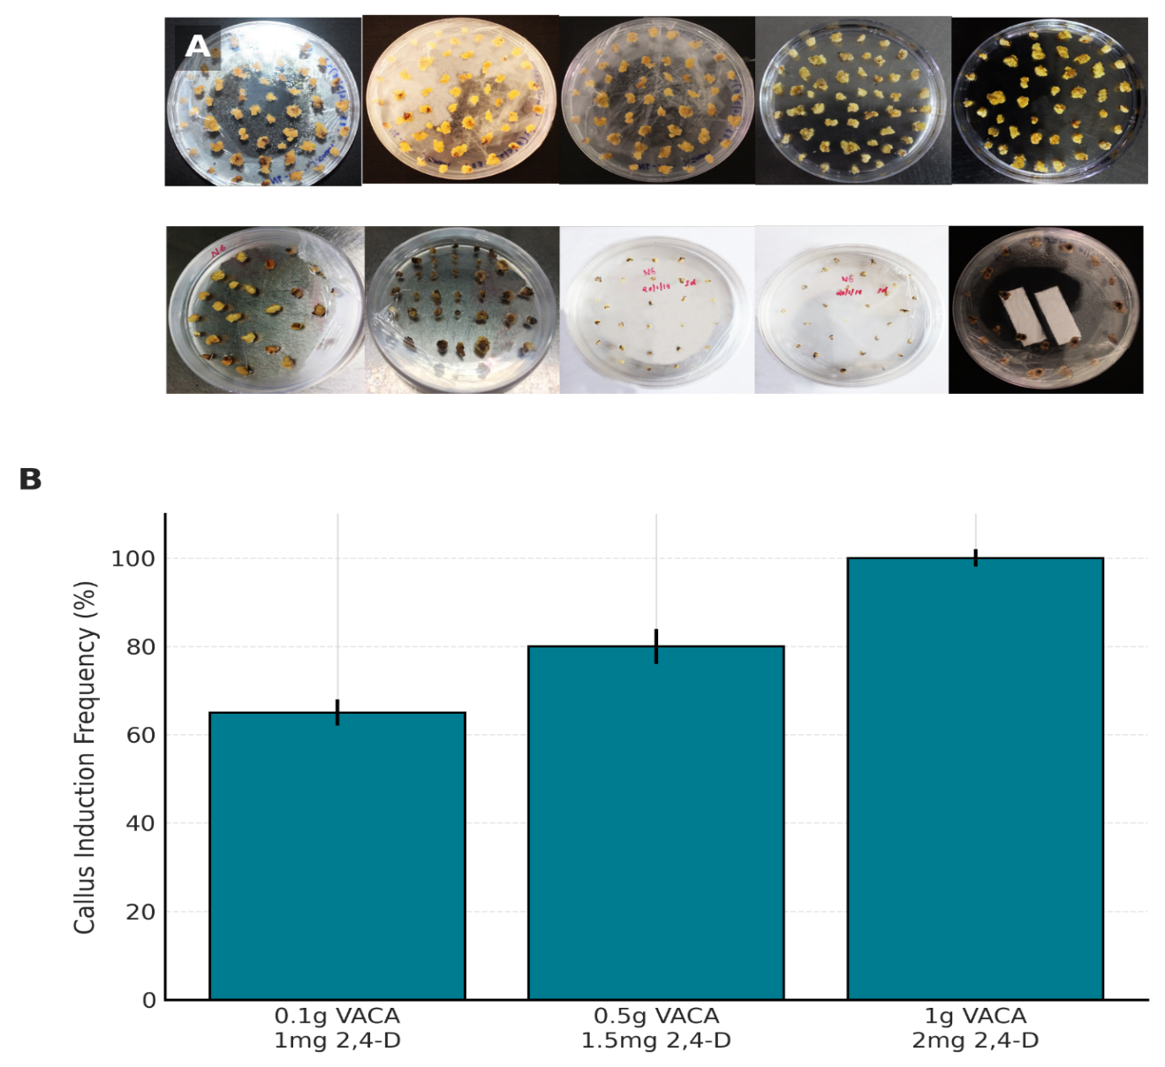

Fig. 1. Effect of 2,4-D and VACA concentrations on callus induction frequency (CIF) in black rice (Oryza sativa L. cv. Chakhao poireiton).
(A) Callus induction at different 2,4-D and VACA concentrations (20 days of culture).(B) Callus induction frequency (%) showing the highest CIF with 1 g L⁻¹ VACA + 2 mg L⁻¹ 2,4-D, indicating the optimal medium composition for initiating callus from mature embryos. Data represent mean ± SE of three replicates.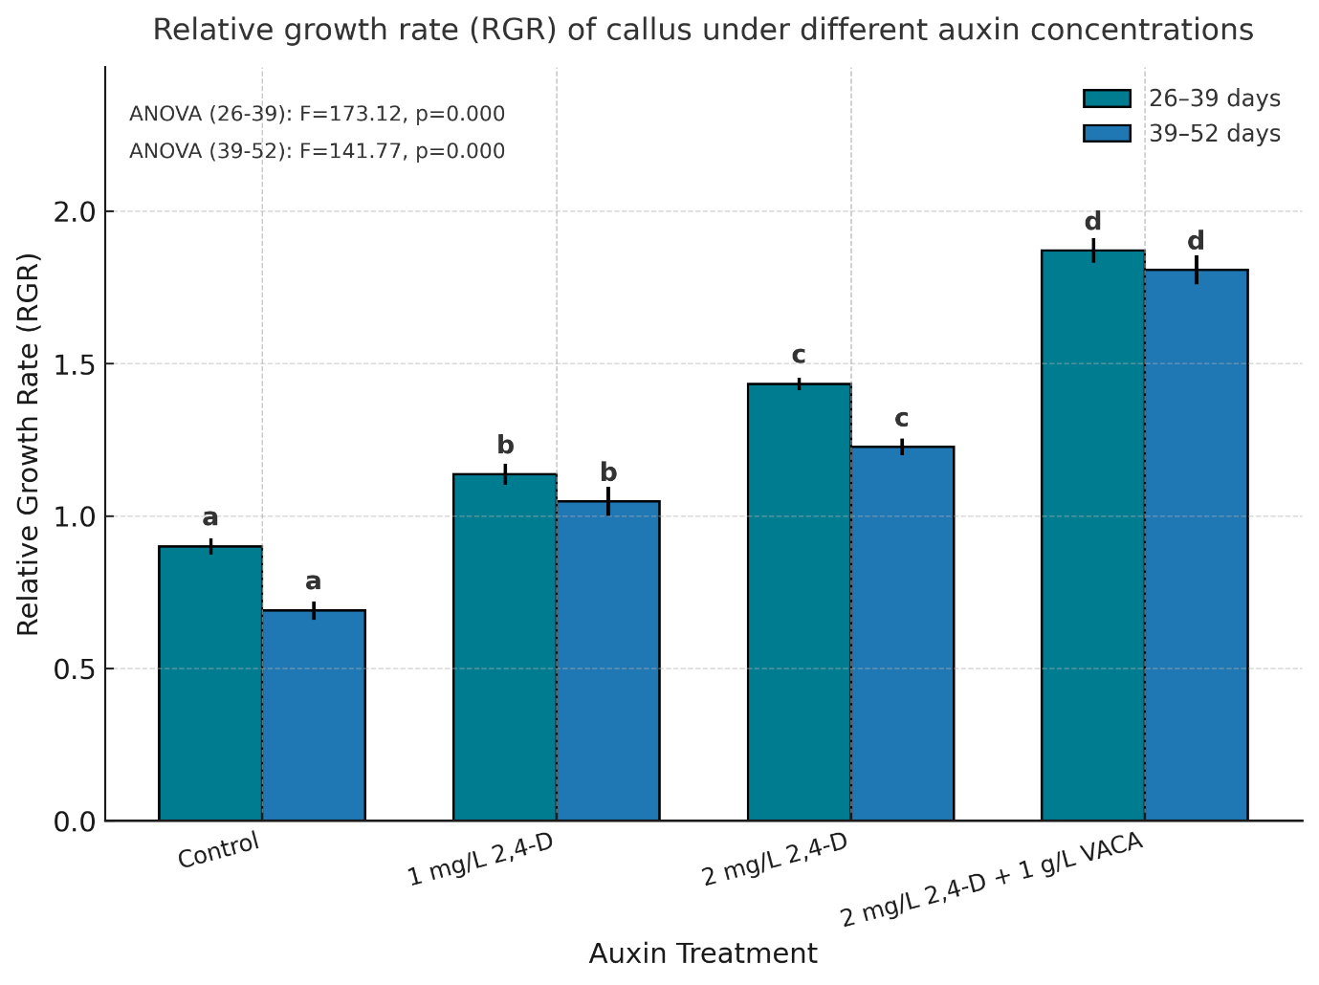
Fig. 2. Effects of VACA and auxin (2,4-D) concentrations on the relative growth rate (RGR) of callus derived from mature embryos of Oryza sativa L. cv. Chakhao Poireiton.

Calli were cultured on 2N6 medium supplemented with different combinations of vitamin assay casamino acids (VACA; 0–1 g L⁻¹) and 2,4-D (1–2 mg L⁻¹), representing three treatment groups included in the experiment. Petri dishes were labeled according to the corresponding VACA–2,4-D treatment to ensure proper identification. RGR was measured during two growth intervals (26–39 days and 39–52 days after culture initiation). Bars represent mean ± SE (n = 4). Different letters above the bars indicate statistically significant differences among treatments based on Tukey’s HSD test (p < 0.05). The medium containing 1 g L⁻¹ VACA + 2 mg L⁻¹ 2,4-D showed the highest RGR, confirming its suitability for sustained callus proliferation.Fig. 2. Relative growth rate (RGR) of callus under different auxin concentrations.
RGR was recorded during two growth intervals (26–39 days and 39–52 days after culture initiation) in calli derived from mature embryos of black rice (Oryza sativa L. cv. Chakhao Poireiton*). Bars represent mean ± SE (n = 4). Distinct letters above bars indicate statistically significant differences among treatments according to Tukey’s HSD test (p < 0.05) following one-way ANOVA. The medium supplemented with 1 g L⁻¹ VACA + 2 mg L⁻¹ 2,4-D exhibited the highest RGR, confirming its suitability for sustained callus proliferation.

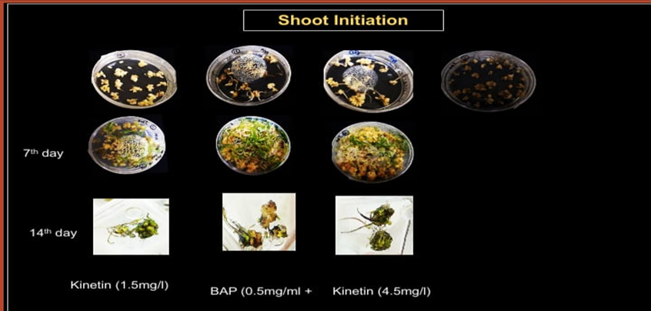
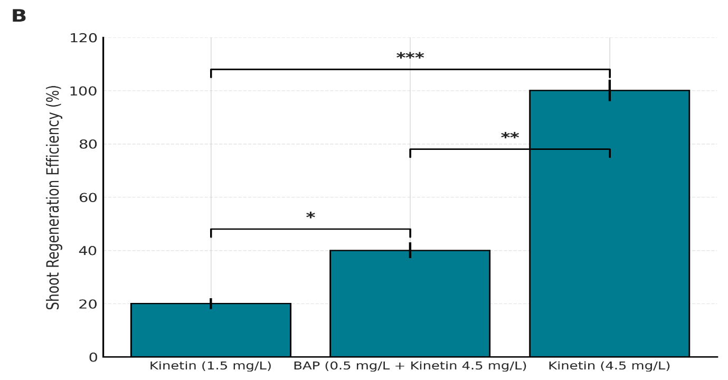
Fig. 3. Shoot regeneration efficiency of black rice callus under different cytokinin treatments in black rice callus.
(A) Shoot initiation and regeneration response of black rice (Oryza sativa L. cv. Chakhao poireiton*) calli cultured on N6RH50 medium supplemented with various cytokinin combinations for 7 and 14 days.
(B) Regeneration percentages (mean ± SE, n = 3) compared across kinetin alone and kinetin–BAP combinations. Maximum regeneration (≈ 55 %) was observed using 4.5 mg L⁻¹ kinetin in N6RH50 medium. Significance levels: p < 0.05 (), p < 0.01 (), p < 0.001

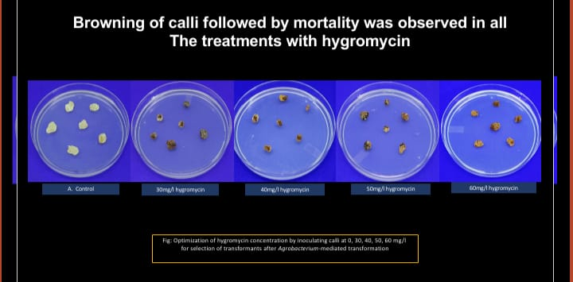

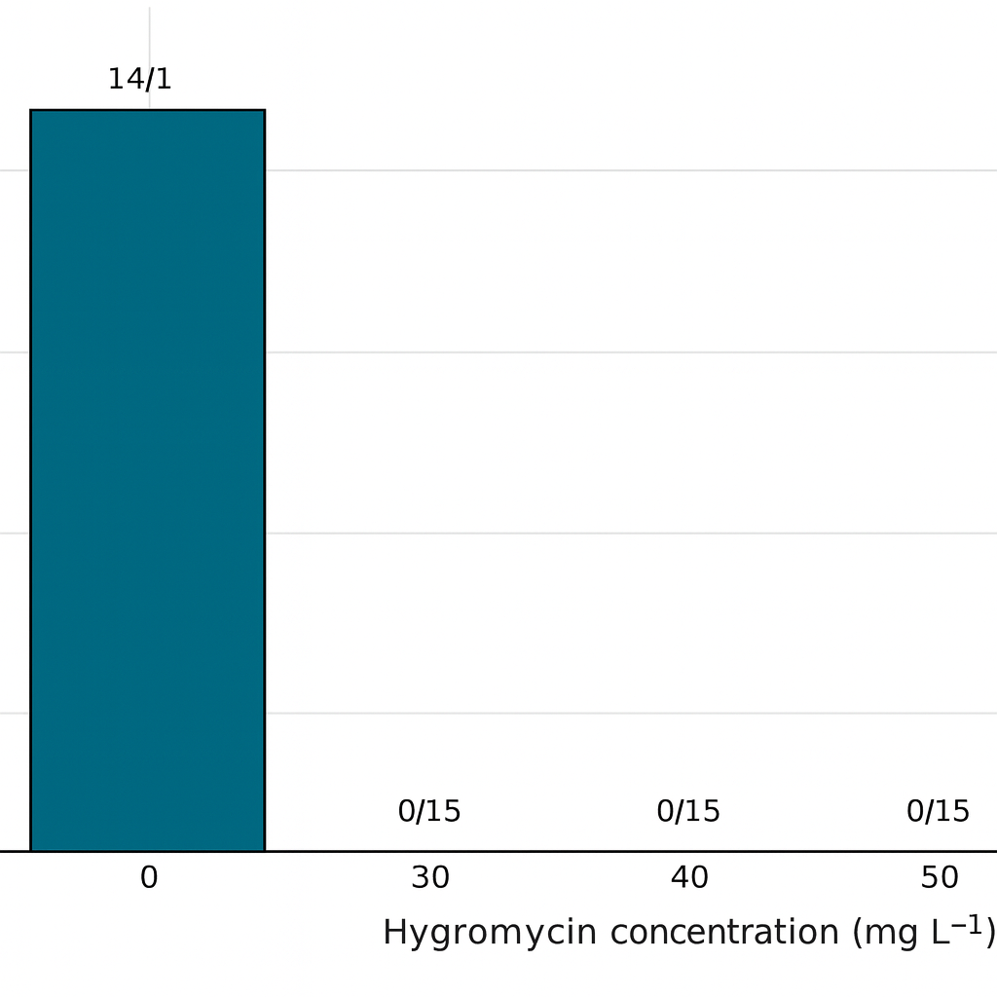

Fig. 4 Callus survival (%) of Oryza sativa L. cv. Chakhao Poireiton under different hygromycin concentrations.
Survival was recorded after 10 days of exposure to 0, 30, 40, 50, and 60 mg L⁻¹ hygromycin. Calli showed high survival in the absence of hygromycin, while no survival occurred at concentrations ≥30 mg L⁻¹, indicating that 30 mg L⁻¹ is the minimum lethal dose for selection.
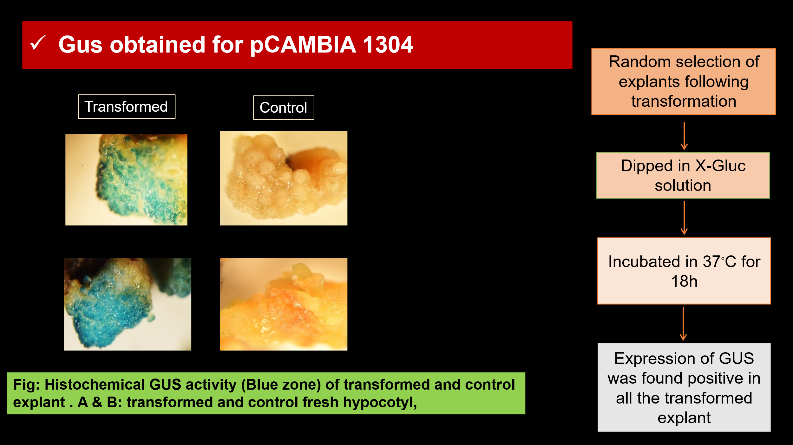

Fig. 5. Histochemical GUS assay of transformed and control black rice callus.
Transformed calli showed intense blue colouration after X-Gluc staining, confirming gusA reporter gene expression. No staining was observed in control calli

4. Conclusion

This study establishes a reproducible and efficient in vitro regeneration and preliminary genetic transformation protocol for the black rice cultivar Chakhao Poireiton, a nutritionally important genotype known for its extreme recalcitrance to tissue culture. Optimization of culture conditions demonstrated that 1 g L⁻¹ VACA combined with 2 mg L⁻¹ 2,4-D supports high-frequency induction of friable, embryogenic calli with sustained growth across subculture cycles. A regeneration efficiency of 55% was obtained using 5 mg L⁻¹ kinetin, representing the most effective cytokinin concentration for shoot development. Hygromycin screening confirmed 30 mg L⁻¹ as the minimum lethal dose suitable for selective elimination of non-transformed calli. Agrobacterium tumefaciens strain LBA4404 facilitated successful T-DNA delivery, as evidenced by strong transient GUS expression. These results provide a structured and scalable framework for regeneration and gene introduction in Chakhao Poireiton, addressing a long-standing technical constraint in its molecular improvement. Although transient expression was confirmed, further validation through PCR, Southern blotting, or sequencing is required to establish stable integration and heritable transgene expression. Additional refinement of transformation parameters—including bacterial density, co-cultivation duration, acetosyringone levels, and recovery conditions—may enhance stable transformation frequencies.

Future Prospects
The protocol developed here lays a foundation for targeted genetic improvement of black rice using contemporary tools such as CRISPR/Cas genome editing. Such advancements could support the enhancement of bioactive compound content, yield traits, and tolerance to abiotic stress. Integration with omics-based approaches, particularly transcriptomics and metabolomics, may aid in identifying precise gene targets for transformation. Adapting this workflow to other recalcitrant rice landraces and wild relatives could broaden its utility for wider rice germplasm improvement. In combination with speed breeding and marker-assisted selection, optimized regeneration and transformation systems have the potential to accelerate the development of climate-resilient and nutritionally superior rice varieties, contributing to long-term food and nutritional security under changing environmental conditions.The current study creates a repeatable and efficient in vitro regeneration and initial genetic transformation protocol for the black rice cultivar Chakhao poireiton, a genotype valued for its nutritional profile and cultural significance but, thought to be extremely resistant in tissue culture. By carefully optimizing key parameters, we demonstrated that the combination of 1 g/L⁻¹ VACA and 2 mg/L⁻¹ 24-D supports high-frequency induction of friable embryogenic calli while maintaining sustained relative growth rates across subculture cycles. A 55% regeneration efficiency was achieved with the optimal kinetin dosage of 4-5 mg L⁻¹ for shoot regeneration. Hygromycin sensitivity tests revealed that a 30 mg L⁻¹ threshold was an effective selection pressure for eliminating non-transformed calli without appreciably reducing regeneration potential. Transformation attempts using Agrobacterium tumefaciens strain LBA4404 showed strong GUS expression in transient assays indicating the successful delivery of T-DNA. Together these findings provide a methodical framework for regenerating and introducing foreign genes to overcome a long-standing bottleneck in Chakhao poireitons molecular improvement. PCR Southern blotting or sequencing are still required to confirm stable genetic integration and heritable expression even though the efficacy of transient transformation was established. Transformation parameters such as bacterial density co-cultivation duration acetosyringone supplementation and post-transformation recovery conditions could be optimized to further boost stable transformation frequencies. Future Prospects: Using genome editing tools like CRISPR/Cas the method developed here paves the way for the introduction or improvement of traits in black rice such as enhanced bioactive compound accumulation enhanced yield potential and resistance to abiotic stress. Using omics-based methods particularly transcriptomics and metabolomics may aid in the selection of particular target genes for transformation. Modifying this protocol for other resistant rice landraces and wild relatives may also increase its applicability to more extensive rice germplasm improvement. Combining speed breeding marker-assisted selection and optimized regeneration and transformation pipelines could greatly accelerate the long-term development of climate-resilient nutritionally improved rice varieties. In the face of shifting environmental conditions this would promote food and nutritional security.

Disclaimer (Artificial intelligence)
The author (s) hereby declare that generative AI technologies have been used during the grammar
editing of this manuscript. These tools were used only for grammar correction. All scientific content,
data analysis, interpretations, and conclusions were produced entirely by the authors.
Details of AI usage:
Name / Version: Grammarly Premium (AI-based writing assistant)
Purpose: Grammar correction, language refinement, and improvement of readability
Input Provided: Sections of the manuscript text requiring grammatical editing (no scientific content,
results, or interpretations were generated by the AI tool)

References

- Sompong, R., Siebenhandl-Ehn, S., Linsberger-Martin, G. & Berghofer, E. (2011). Physicochemical and antioxidative properties of red and black rice varieties from Thailand, China and Sri Lanka. Food Chemistry, 124(1), 132–140.
- Chandra, Ajay & Murali, Sreema & Sengupta, Priyanuj & Tamuli, Ranjan. (2025). Indigenous Black Rice Landraces: Promising Superfood for Health and Nutritional Security in the Northeast States, India. Agri-India Today, 5(5), 116-120.
- Kumari, S. (2020). Black rice- An Emerging ‘Superfood’. Pantnagar Journal of Research, 18(1), 15-18. https://www.gbpuat.res.in/uploads/archive/18.1.5.pdf
- Mbanjo EGN, Kretzschmar T, Jones H, Ereful N, Blanchard C, Boyd LA and Sreenivasulu N (2020) The Genetic Basis and Nutritional Benefits of Pigmented Rice Grain. Front. Genet. 11:1-18. doi: 10.3389/fgene.2020.00229
- Hiei, Y., Ishida, Y., Komari, T. (2014). Progress of cereal transformation technology mediated by Agrobacterium tumefaciens. Frontiers in Plant Science, 5, 628.
- Nishimura, A., et al. (2006). A protocol for Agrobacterium-mediated transformation in rice. Nature Protocols, 1, 2796–2802.
- Ali, A., Nongpiur, R.C. & Chrungoo, N.K. (2023). An efficient Agrobacterium-mediated transformation and regeneration protocol for aromatic black rice, Oryza sativa L. (cv. Chakhao Poireiton and Chakhao Amubi). Plant Cell Tiss Organ Cult, 152, 619–633. https://doi.org/10.1007/s11240-022-02435-w.
- Asghar, S., Ghori, N., Hyat, F., Li, Y., & Chen, C. (2022). Use of auxin and cytokinin for somatic embryogenesis in plant: a story from competence towards completion. Plant Growth Regul, 99, 413–428. https://doi.org/10.1007/s10725-022-00923-9.
- Sah, S. K., Kaur, A., Kaur, G., & Cheema, G. S. (2014). Genetic transformation of rice: problems, progress and prospects. J Rice Res, 3(1), 132.
- Greenwood, J. R., & Glaus, A. N. (2022). Optimized rice transformation protocol for transformation of the blast susceptible Indica rice accession CO39. CABI Agriculture and Bioscience, 3(1), 35.
- Sahoo, K. K., et al. (2011). An improving protocol for efficient transformation and regeneration of diverse indica rice cultivars. Plant Methods, 7(1), 49.
- Cheng, M., Lowe, B., Spencer, T., Ye, X., & Armstrong, C. (2004). Factors influencing Agrobacterium-mediated transformation of monocotyledonous species. In Vitro Cellular & Developmental Biology – Plant, 40(1), 31-45.
- Chu, C. C., Wang, C. C., Sun, C. S., Hsu, C., Yin, K. C., Chu, C. Y., & Bi, F. Y. (1975). Establishment of an efficient medium for anther culture of rice through comparative experiments on the nitrogen sources. Scientia Sinica, 18, 659–668.
- Hiei, Y., Ohta, S., Komari, T., & Kumashiro, T. (1994). Efficient transformation of rice (Oryza sativa L.) mediated by Agrobacterium and sequence analysis of the boundaries of the T-DNA. The Plant Journal, 6, 271–282.
- Hiei, Y., & Komari, T. (2008). Agrobacterium-mediated transformation of rice using immature embryos or calli induced from mature seed. Nature Protocols, 3, 824–834.
- Jefferson, R. A., Kavanagh, T. A., & Bevan, M. W. (1987). GUS fusions: β-glucuronidase as a sensitive and versatile gene fusion marker in higher plants. EMBO Journal, 6, 3901–3907.
- Komari, T., Hiei, Y., Saito, Y., Murai, N., & Kumashiro, T. (1996). Vectors carrying two separate T-DNAs for co-transformation of higher plants mediated by Agrobacterium tumefaciens and segregation of transformants free from selection markers. Plant Journal, 10(1), 165-174. https://doi.org/10.1046/j.1365-313x.1996.10010165.x.
- Ramesh, M., Nagadhara, D., Reddy, V. D., & Rao, K. V. (2004). Production of transgenic indica rice resistant to yellow stem borer and sap-sucking insects using super-binary vectors of Agrobacterium tumifaciens. Plant Science, 166(4), 1077-1085.
- Rashid, H., Yokoi, S., Toriyama, K., & Hinata, K. (1996). Transgenic plant production mediated by Agrobacterium in rice (Oryza sativa L.). Plant Cell Reports, 15(10), 727-730.
- Cheng, X., Sardana, R., Kaplan, H. & Altosaar, I. (1998). Agrobacterium-transformed rice plants expressing synthetic cryIA(b) and cryIA(c) genes are highly toxic to Chilo suppressalis (Lepidoptera: Pyralidae). PNAS , 95(6), 2767-2772.
- Hiei, Y., Ohta, S., Komari, T. & Kumashiro, T. (1994). Efficient transformation of rice (Oryza sativa L.) mediated by Agrobacterium and sequence analysis of the boundaries of the T-DNA. Plant Journal, 6, 271–282.
- Motulsky, H. (2023). GraphPad Prism Version 10. GraphPad Software LLC, San Diego, CA, USA.
- Cui, Z., Wei, W., Han, X. et al. (2025). An optimized protocol for in vitro regeneration and genetic transformation of broomcorn millet. BMC Genomics 26, 725. https://doi.org/10.1186/s12864-025-11899-x.
- Muscolo, A., Sidari, M., Cozzolino, V., Nuzzo, A., Nardi, S., & Piccolo, A. (2022). Molecular characteristics of humic substances from different origins and their effects on growth and metabolism of Pinus laricio callus. Chemical and Biological Technologies in Agriculture, 9(1), 72.
- Zaidi, M. A., Narayanan, M., Sardana, R., Taga, I., Postel, S., Johns, R., McNulty, M., Mottiar, Y., Mao, J., Loit, E.& Altosaar, I. (2006). Optimizing tissue culture media for efficient transformation of different indica rice genotypes. Agron Res, 4(2), 563-575.
- Kok, A.DX., Wan Abdullah, W.M.A.N., Tan, NP. et al. (2020). Growth promoting effects of Pluronic F-68 on callus proliferation of recalcitrant rice cultivar. 3 Biotech 10, 116. https://doi.org/10.1007/s13205-020-2118-5.
- Birla, D. S., & Jaiwal, P. K. (2018). In vitro plant regeneration of two Indica rice cultivars, PB-1 and IR-64. https://agribiop.com/in-vitro-plant-regeneration-of-two-indica-rice-cultivars-pb-1-and-ir-64/
- Teh, C. Y., Maziah, M., Shaharuddin, N. A., & Ho, C. (2018). Efficient in vitro multiple shoots regeneration system from rice shoot apex in recalcitrant Malaysian Indica rice cultivars (Oryza sativa L.). Indian J Biotechnol, 17(3), 504-13.
- Rahman, Z. A., Seman, Z. A., Basirun, N., Julkifle, A. L., Zainal, Z., & Subramaniam, S. (2011). Preliminary investigations of Agrobacterium-mediated transformation in indica rice MR219 embryogenic callus using gusA gene. African Journal of Biotechnology, 10(40), 7805-7813.
- Dey, M., Panda, S. K., & Sahoo, L. (2015). Establishment of an efficient regeneration system amenable to Agrobacterium mediated transformation of two elite indica rice varieties of north east India. International Journal of Applied Sciences and Biotechnology, 3(4), 680-686.
- Thangadurai, D. et al. (2020). Transformation Techniques and Molecular Analysis of Transgenic Rice. In: Roychoudhury, A. (eds) Rice Research for Quality Improvement: Genomics and Genetic Engineering. Springer, Singapore. https://doi.org/10.1007/978-981-15-4120-9_9.
- Huynh, J., Hotton, S.K., Chan, R. et al. (2022). Evaluation of novel surfactants for plant transformation. BMC Res Notes 15, 360. https://doi.org/10.1186/s13104-022-06251-5

