In Silico Identification of Conserved Hypothetical Proteins as Novel Drug Targets and Phytochemical Inhibitors against Clostridium perfringens

Abstract
The growing global threat of antimicrobial resistance (AMR) necessitates the urgent identification of new drug targets against pathogens such as the Gram-positive, spore-forming anaerobe Clostridium perfringens, a major cause of diarrhea, enterotoxemia, and myonecrosis in humans and animals. We propose that conserved hypothetical proteins (HPs)—a largely uncharacterized component of the C. perfringens proteome—represent an overlooked resource for novel therapeutics. Using a stringent subtractive proteomics and in silico pipeline, we analyzed 2661 C. perfringens proteins. We focused on 1179 HPs, identifying 496 conserved across strains. Sequential filtering based on physicochemical properties, subcellular localization, and non-homology to the human gut microbiome yielded 22 promising non-homologous HPs suitable as drug targets.
To identify lead compounds, we screened 69 drug-like phytochemical ligands with known antibacterial activity. Molecular docking revealed strong inhibitory interactions for multiple ligand–protein pairs, with binding energies as low as –10.6 kcal/mol (e.g., (+)-galbacin, tuberosin, and (–)-asarinin against specific HPs). These findings strongly support the utility of conserved hypothetical proteins as a rich, untapped source of new antimicrobial targets. Our study demonstrates that in silico analyses can rapidly accelerate drug discovery against fast-evolving pathogens by prioritizing novel targets and corresponding lead compounds for subsequent experimental validation. As a critical next step, these candidate proteins and their top-scoring ligand interactions should undergo experimental validation through biochemical assays, structural characterization, and in vitro inhibition studies to confirm their therapeutic potential.

Keywords: Antimicrobial resistance (AMR), Clostridium perfringens, Hypothetical proteins, In-silico drug discovery, Subtractive proteomics

Introduction:
The rapid global rise of Antimicrobial Resistance (AMR) constitutes an urgent public health crisis, demanding the discovery of therapeutics with novel mechanisms of action [7][16]. The Gram-positive, spore-forming anaerobe Clostridium perfringens is a critical pathogen in this context, causing a spectrum of severe conditions including food poisoning, enterotoxemia, and rapidly progressing myonecrosis (gas gangrene) via potent toxins like alpha toxin [1][2][3][4]. The increasing prevalence of C. perfringens strains resistant to frontline antibiotics, such as clindamycin and penicillin, severely threatens the long-term efficacy of current treatments [7][8][9]. The limited diversity of existing drug targets—often focused on a narrow subset of well-characterized essential proteins—exacerbates this challenge, driving cross-resistance and slowing the development of new anti-infectives. An expansion of the druggable proteome is critically needed to combat rapidly evolving pathogens like C. perfringens.
We propose that conserved hypothetical proteins (HPs) represent a vast, untapped reservoir of novel drug targets. Hypothetical proteins are computationally predicted gene products lacking experimental validation; yet they constitute a significant fraction of bacterial proteomes (e.g., 1,179 of 2,661 proteins in C. perfringens are HPs)[5][6]. While historically overlooked in drug discovery, the presence of a conserved subset of these HPs across bacterial strains strongly implies their functional importance and possible essentiality for survival or pathogenesis [18]. Targeting these conserved HPs offers a distinct, dual advantage: it dramatically broadens the array of potential drug targets and allows for the identification of Achilles' heels unique to the pathogen [5]. Crucially, non-homology to human host proteins means targeting these HPs carries a significantly reduced risk of off-target toxicity.
The bottleneck in characterizing and drugging novel targets can be overcome by leveraging advanced methodologies. Traditional experimental validation is often resource-intensive and time-consuming, particularly for poorly studied proteins. A computational pipeline utilizing a subtractive proteomics and comparative genomics approach is a rapid, cost-effective, and scalable alternative [13][14][17][19]. These techniques allow for the initial prioritization of proteins based on essentiality, subcellular localization, physicochemical stability, and critically, non-homology to the human gut microbiome to maximize target specificity. Furthermore, modern molecular docking is a powerful tool that bridges the gap between target identification and lead compound development [15]. It allows for the high-throughput virtual screening of potential ligands, predicting their binding affinity and orientation with high accuracy (e.g., against key functional sites involved in toxin secretion or proliferation).
For fast-progressing and understudied pathogens like C. perfringens, an integrated strategy offers a highly efficient route to novel therapies. Here, we describe a comprehensive computational analysis employing subtractive proteomics and molecular docking, focusing on the conserved hypothetical proteome of C. perfringens. The aim of this study is to identify and characterize a set of highly promising, non-host-homologous hypothetical protein targets and to predict potent small-molecule phytochemical ligands that inhibit their function, thereby accelerating the pipeline for developing new antibiotics.

Materials and Methods

Protein Sequence Retrieval
The complete amino acid sequences, along with the corresponding genome data for the Clostridium perfringens hypothetical proteins were retrieved from the National Center for Biotechnology Information (NCBI) GenBank database. (https://www.ncbi.nlm.nih.gov/genbank/) [21].

Physicochemical Characterization
The physicochemical properties of each protein sequence, including molecular weight, theoretical isoelectric point (pI), amino acid composition, instability index, aliphatic index, and grand average of hydropathicity (GRAVY), were discerned using the ProtParam tool available on the ExPASy server (https://web.expasy.org/protparam/) [25].

Antigenicity Prediction
Antigenicity of the selected proteins was determined using the VaxiJen v2.0 server (http://www.ddg-pharmfac.net/vaxijen/), using the bacterial model and the default threshold values [23].

Homology Analysis
To identify which bacterial proteins were considered non-homologous relative to human proteins, each sequence was subjected to BLASTp analysis (https://blast.ncbi.nlm.nih.gov/Blast.cgi) against the set of bacteria within the human gut flora with an E-value cutoff of 1e-5 [20].

Tertiary Structure Modeling
The tertiary structures of the non-homologous proteins were generated using SWISS-MODEL (https://swissmodel.expasy.org/) [22][29]. The best scoring models were selected based on Global Model Quality Estimation (GMQE) and QMEAN scores.

Ligand Selection and Preparation
Candidate ligands were selected from phytochemical compounds listed in Dr. Duke’s Phytochemical and Ethnobotanical Databases (https://phytochem.nal.usda.gov/). The SMILES for each phytochemical were retrieved from the PubChem database (https://pubchem.ncbi.nlm.nih.gov/) for further processing. Pharmacokinetics and drug-likeness of each of the selected compounds were evaluated using the SwissADME tool (http://www.swissadme.ch/). Protein structures were then prepared for docking using UCSF Chimera (https://www.cgl.ucsf.edu/chimera/) [27], and energy minimization of ligands was performed using Babel in PyRx.

Molecular Docking
Molecular docking was performed using AutoDock Vina [28], part of the PyRx platform, to predict the binding energy and interaction between each phytochemical and the modeled proteins. The docked complexes were evaluated based on binding energy scores, and interaction visualization was performed using UCSF Chimera.

Results

Identification and Characterization of Novel Drug Targets: The primary objective of this study was to employ a subtractive proteomics pipeline to identify novel, non-host-homologous drug targets within the uncharacterized portion of the Clostridium perfringens proteome. The complete proteome was retrieved from NCBI, yielding 2,661 total proteins. Of these, 1,179 proteins were annotated as hypothetical proteins (HPs), highlighting the considerable lack of experimental characterization in the C. perfringens proteome

We prioritized targets by selecting the subset of HPs considered conserved hypothetical proteins (CHPs) across clinically relevant C. perfringens strains. This filtering step yielded 496 candidate CHPs, which were hypothesized to be essential for basic cell biology or virulence.

In Silico Filtering and Target Prioritization :

The 496 CHPs were subjected to sequential filtering based on pharmacological and biological criteria:

Physicochemical Filtering: The stability and feasibility of the 496 CHPs for therapeutic development were assessed using ProtParam. Based on the Instability Index (II) threshold, 390 proteins were retained, exhibiting predicted physicochemical stability suitable for persistence and effective drug binding under physiological conditions.

Subcellular Localization: Drug targets must be accessible to therapeutic agents. Subcellular localization prediction was performed using PSORTb, which identified 313 proteins situated in the cytoplasmic or cell membrane regions. To increase confidence in these crucial predictions, cross-validation was performed using CELLO v2.5, confirming 291 proteins within these accessible compartments.

Non-Homology Subtraction (Pathogen Specificity):To ensure high specificity and minimize the risk of off-target toxicity to the human host and the crucial gut microbiota, the 291 candidates were subjected to rigorous non-homology analysis. BLASTp analysis was conducted against a comprehensive set of reference proteomes from the human gut flora, including Bacteroides, Enterococcus, Escherichia, Enterobacter, Klebsiella, Bifidobacterium, Staphylococcus, Lactobacillus, Proteus, Pseudomonas, Salmonella, Faecalibacterium, Peptostreptococcus, and Peptococcus.

A protein was classified as homologous and subsequently removed if it displayed sequence identity with query coverage. This highly selective subtractive process reduced the pool to 22 final, non-homologous hypothetical protein targets. The detailed physiochemical properties and predicted subcellular locations for these 22 most promising drug candidates are summarized in Table 1 and Figure 1.

Table 1 Physicochemical characterization and antigenicity prediction of conserved hypothetical proteins of Clostridium perfringens.
Physicochemical and immunological properties of 22 non-homologous hypothetical proteins identified through subtractive proteomics analysis. Parameters include subcellular localization, amino acid length, molecular weight, theoretical isoelectric point (pI), instability index (II), aliphatic index, grand average of hydropathicity (GRAVY), and antigenicity prediction scores. Proteins predicted as probable antigens are highlighted as potential vaccine or drug target candidates.
Protein Name | Subcellular Localization | Number of Amino Acids | Molecular Weight | Theoretical pI | Instability Index (II) | Aliphatic Index | GRAVY | Antigen Prediction Score
CPE0133 | Membrane | 308 | 34914.36 | 9.52 | 22.74 | 137.27 | 0.975 | 0.7249 ( Probable ANTIGEN ).
CPE0245 | Membrane | 775 | 89675.9 | 8.93 | 27.69 | 125.87 | 0.39 | 0.4851 ( Probable ANTIGEN ).
CPE0246 | Cytoplasmic | 422 | 50266.98 | 9.03 | 29.01 | 95.81 | -0.663 | 0.3871 ( Probable NON-ANTIGEN ).
CPE0657 | Cytoplasmic | 445 | 52081.29 | 8.97 | 39.58 | 91.57 | -0.583 | 0.4922 ( Probable ANTIGEN ).
CPE0662 | Membrane | 267 | 31159.99 | 8.22 | 36.04 | 101.65 | -0.291 | 0.4799 ( Probable ANTIGEN ).
CPE0708 | Membrane | 403 | 44804.82 | 8.25 | 29.12 | 111.49 | 0.442 | 0.3974 ( Probable NON-ANTIGEN ).
CPE0836 | Membrane | 542 | 62333.93 | 9.16 | 37.72 | 114.87 | -0.024 | 0.5817 ( Probable ANTIGEN ).
CPE0969 | Membrane | 636 | 74092.36 | 8.82 | 32.43 | 117.37 | 0.241 | 0.4892 ( Probable ANTIGEN ).
CPE1094 | Cytoplasmic | 537 | 60493.66 | 5.52 | 39.63 | 94.93 | -0.28 | 0.3218 ( Probable NON-ANTIGEN ).
CPE1362 | Cytoplasmic | 186 | 21543.62 | 5.77 | 16.78 | 80.59 | -0.56 | 0.2306 ( Probable NON-ANTIGEN ).
CPE1509 | Membrane | 472 | 56004.71 | 9.66 | 34.75 | 124.07 | 0.187 | 0.3616 ( Probable NON-ANTIGEN ).
CPE1510 | Membrane | 155 | 18327.12 | 9.63 | 30.51 | 135.74 | 0.692 | 0.5600 ( Probable ANTIGEN ).
CPE1576 | Cytoplasmic | 122 | 13713.03 | 6.34 | 30.4 | 103.85 | -0.087 | 0.1768 ( Probable NON-ANTIGEN ).
CPE1922 | Membrane | 391 | 44532.81 | 9.15 | 36.86 | 105.45 | 0.006 | 0.6308 ( Probable ANTIGEN ).
CPE2021 | Cytoplasmic | 93 | 10436.05 | 5.19 | 32.35 | 119.46 | -0.175 | 0.3558 ( Probable NON-ANTIGEN ).
CPE2044 | Membrane | 536 | 61232.48 | 9.41 | 35.49 | 133.25 | 0.58 | 0.4741 ( Probable ANTIGEN ).
CPE2210 | Cytoplasmic | 326 | 37198.89 | 6 | 35.62 | 82.85 | -0.513 | 0.5727 ( Probable ANTIGEN ).
CPE2344 | Cytoplasmic | 313 | 36624.24 | 5.08 | 35.3 | 108.63 | -0.216 | 0.2982 ( Probable NON-ANTIGEN ).
CPE2564 | Cytoplasmic | 223 | 25329.22 | 9.21 | 25.59 | 97.04 | -0.463 | 0.5950 ( Probable ANTIGEN ).
CPE2571 | Membrane | 213 | 24865.09 | 9.74 | 28.01 | 123.1 | 0.721 | 0.5475 ( Probable ANTIGEN ).
CPE2638 | Membrane | 331 | 36586.59 | 9.7 | 12.23 | 137.79 | 0.946 | 0.5370 ( Probable ANTIGEN ).
CPE2648 | Membrane | 354 | 41140.84 | 9.29 | 24.09 | 147.6 | 1.138 | 0.7841 ( Probable ANTIGEN ).

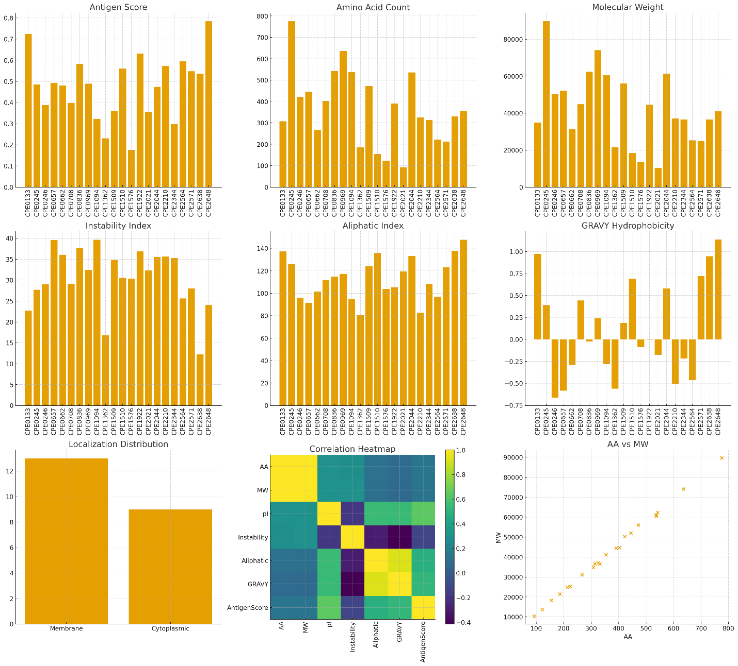
Figure 1 Comprehensive bioinformatic analysis of 22 CPE proteins.
This multi-panel figure summarizes key physicochemical and immunogenic properties of the analyzed proteins. Panels include: antigen prediction scores, amino acid composition, molecular weight distribution, instability index, aliphatic index, GRAVY hydrophobicity, and subcellular localization frequencies (Membrane vs Cytoplasmic). A correlation heatmap highlights relationships among biochemical parameters, showing strong associations between amino acid count and molecular weight, as well as between aliphatic index and GRAVY values. The amino acid count vs. molecular weight scatter plot further confirms the linear relationship between sequence length and protein mass. Together, these analyses provide an integrated overview of structural, stability-related, hydrophobic, and antigenic features across the CPE protein dataset.

Ligand Screening and Molecular Docking

Phytochemical Ligand Selection: A library of 669 phytochemical compounds previously noted to possess antibacterial activity was sourced from Dr. Duke's Phytochemical and Ethnobotanical Databases. These compounds were initially filtered for favorable oral bioavailability and pharmacokinetics using the SwissADME tool. Only molecules that successfully satisfied all five standard drug-likeness rules (Lipinski, Ghose, Veber, Egan, and Muegge) were retained. This screening step yielded 69 highly promising small-molecule phytochemical candidates for molecular docking.

Virtual Screening and Binding Affinity: To predict the inhibitory potential of the 69 lead compounds against the 22 final protein targets, molecular docking was performed using the AutoDock Vina program within the PyRx platform. The docking analysis quantified the binding strength by calculating the predicted binding energy (in kcal/mol). The lower (more negative) the binding energy, the stronger the predicted affinity and the higher the likelihood of efficacious inhibition (Figure 2). The results, specifically highlighting the ligands that exhibited the lowest (most favorable) binding energy for each of the 22 protein targets, are presented in Table 2.

Table 2 Molecular docking analysis of phytochemical ligands with conserved hypothetical proteins of Clostridium perfringens.
Predicted binding affinities (ΔG, kcal mol⁻¹) of selected phytochemical ligands docked with 22 prioritized hypothetical proteins identified through subtractive proteomics analysis. Lower binding energies indicate stronger predicted protein–ligand interactions. Several compounds, including (+)-Galbacin, (–)-Asarinin, and Tuberosin, exhibited high binding affinities (ΔG ≤ –9.0 kcal mol⁻¹), suggesting their potential as lead molecules for further experimental validation.
Protein Name | Ligand(s) | Binding Energy (𝚫G) (kcal/mol)
CPE0133 | Tuberosin | -9.3
CPE0245 | (+)-Galbacin | -10.6
CPE0246 | Glabridin | -8.6
CPE0657 | (+)-Galbacin | -8.7
CPE0662 | 8-(3,3-Dimethylallyl)spatheliachromene | -8.7
CPE0708 | (+)-Galbacin | -8.8
CPE0836 | Galdosol  Stemonine | -8.9
CPE0969 | (-)-Asarinin | -9.4
CPE1094 | Tuberosin | -8.7
CPE1362 | Stemonine | -9
CPE1509 | (+)-Galbacin | -8.5
CPE1510 | (+)-8-Hydroxycalamenene | -7.9
CPE1576 | (-)-Asarinin  (+)-Galbacin  Sesamin | -8.2
CPE1922 | Glabridin | -9.1
CPE2021 | (-)-Asarinin  Sesamin | -6.7
CPE2044 | (+)-Galbacin | -10.1
CPE2210 | Ammoresinol | -8.9
CPE2344 | Galdosol | -9.1
CPE2564 | Tuberosin | -8.1
CPE2571 | (+)-Galbacin | -10.2
CPE2638 | (+)-Galbacin | -9.6
CPE2648 | (-)-Asarinin  Sesamin | -9.5

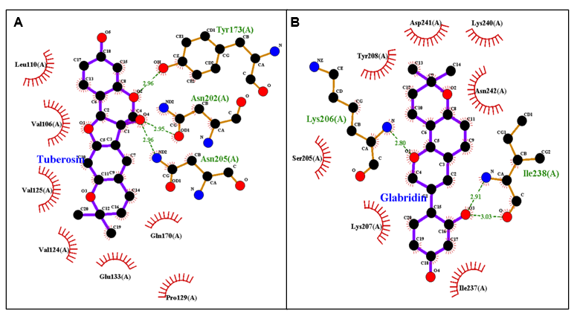
Figure 2 Representative 2D interaction diagrams of ligand–protein complexes in Clostridium perfringens.
(A) Interaction of Tuberosin with the hypothetical protein CPE0133, showing hydrogen bonds with residues Tyr173(A), Asn202(A), and Asn205(A) (green dashed lines) and surrounding hydrophobic contacts (red arcs).
(B) Interaction of Glabridin with the hypothetical protein CPE0246, highlighting hydrogen bonding with Lys206(A), Ile238(A), and Asn242(A) along with adjacent hydrophobic interactions. These panels represent typical binding patterns observed among the top-ranked ligand–protein complexes identified through molecular docking analysis.

Discussion
Antimicrobial resistance continues to rise at an alarming rate, and pathogens like Clostridium perfringens, which act rapidly once inside the host, demand new ways of thinking about therapeutic intervention. Instead of continuing to focus on the classic virulence factors—α-toxin, enterotoxins, collagenases, and other well-known molecules—we explored a different angle that concentrates on the basic machinery the bacterium needs to survive. Using a rigorous subtractive proteomics approach, we filtered the entire C. perfringens proteome down to 22 proteins that are essential, non-homologous to humans and gut flora, and likely to represent strong therapeutic targets. Interestingly, most of these turned out to be Conserved Hypothetical Proteins (CHPs), which are often ignored simply because their functions are unclear.
This shift away from canonical targets offers a contrast to existing research. Several groups have worked on neutralizing α-toxin activity or interfering with quorum sensing, which certainly helps reduce tissue damage or limit virulence but does not necessarily stop the bacteria from growing or persisting. For instance, there have been inhibitors developed targeting the PLC domain of α-toxin [32], whereas Garcia et al. (2020) [33] focused on small molecules that interfere with quorum-sensing systems. These efforts reduce virulence expression but don’t necessarily affect the organism’s ability to survive.
By concentrating on proteins that the pathogen cannot live without—such as those involved in central metabolism, DNA repair, and maintaining the cell wall—we target its fundamental vulnerabilities. The physicochemical properties of these proteins support their relevance: the average Instability Index (~31) implies overall protein stability, and the positive GRAVY values among the 14 membrane-associated proteins indicate hydrophobic character, which aligns with the behavior of membrane-embedded drug targets. Such targets are often overlooked in conventional soluble-enzyme drug screens [34].
The abundance of CHPs in our set is particularly intriguing. This observation echoes the findings of Badie et al. (2021) [35] in Acinetobacter baumannii, where disrupting CHPs significantly impaired bacterial fitness. Our results reinforce the idea that these poorly characterized proteins can be essential for survival, and because they lack homology to human or commensal proteins, they represent species-specific vulnerabilities that could be exploited without harming beneficial microbiota.
We also observed high aliphatic index values across our protein set (average ~115), suggesting thermostability, and this may translate to more stable, robust drug interactions. Proteins such as CPE2648, which has both a high GRAVY score and a strong antigenic prediction, stand out as especially promising candidates that might yield bactericidal effects if targeted appropriately. Moreover, 14 of our proteins were predicted to be probable antigens, offering potential not only for small-molecule therapies but also for developing conjugate vaccines or diagnostic biomarkers.
The computational pipeline used here is adaptable and can be applied to other important pathogens such as C. difficile or multidrug-resistant Klebsiella pneumoniae. While this framework accelerates early-stage discovery, all 22 proteins remain computational predictions until validated experimentally. Because computational models can overlook viable candidates or mistakenly prioritize non-essential ones, the next step involves extensive in vitro and in vivo validation to confirm essentiality, structural druggability, and ligand accessibility.
Overall, our work suggests that essential, non-homologous CHPs offer a promising and underexplored set of drug targets for C. perfringens. This approach moves beyond traditional toxin-focused strategies and instead probes the core elements of bacterial survival. As antimicrobial resistance continues to grow, expanding our target landscape through computational pipelines such as this provides a powerful and efficient route toward identifying the next generation of therapeutics.

Conclusion
This study leveraged a robust subtractive proteomics and molecular docking pipeline to address the urgent need for novel therapeutic interventions against the rapidly evolving pathogen, Clostridium perfringens. Through sequential in silico filtering based on essentiality, stability, cellular accessibility, and non-homology, we successfully narrowed the complete proteome to 22 high-priority conserved hypothetical protein (CHP) drug targets. Crucially, the non-homology screen confirmed the predicted high specificity of these targets against the human gut microbiome, minimizing the risk of off-target dysbiosis associated with current broad-spectrum antimicrobials.
Furthermore, a comprehensive molecular docking screen identified 69 drug-like phytochemical compounds that exhibited favorable binding affinities for these 22 targets, providing concrete chemical starting points for drug development.
This work provides a powerful, validated blueprint that dramatically accelerates the initial stages of target and lead compound identification. The 22 unique protein candidates are now primed for immediate experimental validation through essentiality testing and in vitro binding assays, representing a significant step toward developing a new class of targeted antibiotics to combat C. perfringens and providing a scalable methodology to fight the global threat of antimicrobial resistance.

Abbreviations
Kcal – kilocalories; Mol – mole; AMR - Antimicrobial Resistance; NCBI - National Center for Biotechnology Information; pI - theoretical isoelectric point; GRAVY - grand average of hydropathicity; BLAST - Basic Local Alignment Search Tool; GMQE - Global Model Quality Estimation; QMEAN - Qualitative Model Energy Analysis; SMILES - Simplified Molecular-Input Line-Entry System; ADME - Absorption, Distribution, Metabolism, and Excretion; UCSF - University of California, San Francisco
Ethics approval and consent to participate: Not applicable.
Consent for publication: Not applicable.
Data Availability Statement: All data generated or analyzed during this study are included in this published article.
Declaration of Competing Interest: The authors declare that the research was conducted in the absence of any commercial or financial relationships that could be construed as a potential conflict of interest.

Disclaimer (Artificial intelligence)
Author(s) hereby declare that NO generative AI technologies such as Large Language Models (ChatGPT, COPILOT, etc.) and text-to-image generators have been used during the writing or editing of this manuscript.
References:
[1] Yao, P., & Annamaraju, P. (2023, August 8). Clostridium perfringens. PubMed. https://www.ncbi.nlm.nih.gov/books/NBK559049/
[2] Mada, T., Ochi, K., Okamoto, M., & Takamatsu, D. (2025). First genomic analysis of a Clostridium perfringens strain carrying both the cpe and netB genes and the proposal of an amended toxin-based typing scheme. Frontiers in Microbiology, 16. https://doi.org/10.3389/fmicb.2025.1580271
[3] Li, J., Paredes-Sabja, D., Sarker, M. R., & McClane, B. A. (2016). Clostridium perfringens sporulation and sporulation-associated toxin production. Microbiology Spectrum, 4(3). https://doi.org/10.1128/microbiolspec.tbs-0022-2015
[4] Geremia, N., et al. (2024). A subanalysis of Clostridium perfringens bloodstream infections from a 5-year retrospective nationwide survey (ITANAEROBY). Anaerobe, 102901. https://doi.org/10.1016/j.anaerobe.2024.102901
[5] Chakma, V., et al. (2023). In silico analysis of a novel hypothetical protein (YP_498675.1) from Staphylococcus aureus. Journal of Genetic Engineering and Biotechnology, 21(1), 135. https://doi.org/10.1186/s43141-023-00613-7
[6] Rahman, M. A., Heme, U. H., & Parvez, K. (2022). In silico functional annotation of hypothetical proteins from Bacillus paralicheniformis strain Bac84. PLOS ONE, 17(10), e0276085. https://doi.org/10.1371/journal.pone.0276085
[7] Schuetz, A. N. (2014). Antimicrobial resistance and susceptibility testing of anaerobic bacteria. Clinical Infectious Diseases, 59(5), 698–705. https://doi.org/10.1093/cid/ciu395
[8] Ramatla, T., et al. (2025). Prevalence and antimicrobial resistance patterns of Clostridium perfringens from healthy broiler chickens. One Health, 21, 101156. https://doi.org/10.1016/j.onehlt.2025.101156
[9] Archambault, M., & Rubin, J. E. (2020). Antimicrobial resistance in Clostridium and Brachyspira spp. and other anaerobes. Microbiology Spectrum, 8(1). https://doi.org/10.1128/microbiolspec.arba-0020-2017
[10] Yang, Z., Hou, J., Mu, M., & Wu, S. Y. (2020). Subtractive proteomics and systems biology analysis revealed novel drug targets in Mycoplasma genitalium strain G37. Microbial Pathogenesis, 145, 104231. https://doi.org/10.1016/j.micpath.2020.104231
[11] Maurya, S., Akhtar, S., Siddiqui, M. H., & Khan, M. K. A. (2020). Subtractive proteomics for identification of drug targets in bacterial pathogens: A review. International Journal of Engineering Research, 9(1). https://doi.org/10.17577/ijertv9is010169
[12] Subramani, N. K., & Venugopal, S. (2025). Identification of novel drug targets and small molecule discovery for MRSA infections. Frontiers in Bioinformatics, 5. https://doi.org/10.3389/fbinf.2025.1562596
[13] Shami, A., et al. (2023). In silico subtractive proteomics and molecular docking for novel inhibitors against Streptococcus pneumoniae strain D39. Life, 13(5), 1128. https://doi.org/10.3390/life13051128
[14] Rehman, A., et al. (2021). In silico core proteomics and molecular docking for inhibitors of Streptococcus pyogenes. International Journal of Environmental Research and Public Health, 18(21), 11355. https://doi.org/10.3390/ijerph182111355
[15] Agu, P. C., et al. (2023). Molecular docking as a tool for discovering molecular targets of nutraceuticals. Scientific Reports, 13(1). https://doi.org/10.1038/s41598-023-40160-2
[16] Khameneh, B., Eskin, N. A. M., Iranshahy, M., & Fazly Bazzaz, B. S. (2021). Phytochemicals: A promising weapon against antibiotic-resistant bacteria. Antibiotics, 10(9), 1044. https://doi.org/10.3390/antibiotics10091044
[17] Yang, H., et al. (2017). In silico prediction of chemical subcellular localization via multi-classification methods. MedChemComm, 8(6), 1225–1234. https://doi.org/10.1039/c7md00074j
[18] Galperin, M. Y. (2004). “Conserved hypothetical” proteins: Prioritization of targets for experimental study. Nucleic Acids Research, 32(18), 5452–5463. https://doi.org/10.1093/nar/gkh885
[19] Kushwaha, N., Nandi, D., & Singh, B. (2025). Subtractive proteomic approaches to identify drug targets: Hypothetical proteins of multidrug-resistant P. aeruginosa. ACS Omega. https://doi.org/10.1021/acsomega.5c02268
[20] Altschul, S. F., Gish, W., Miller, W., Myers, E. W., & Lipman, D. J. (1990). Basic local alignment search tool. Journal of Molecular Biology, 215(3), 403–410. https://doi.org/10.1016/S0022-2836(05)80360-2
[21] Benson, D. A., et al. (2012). GenBank. Nucleic Acids Research, 41(D1), D36–D42. https://doi.org/10.1093/nar/gks1195
[22] Daina, A., Michielin, O., & Zoete, V. (2017). SwissADME: A free tool to evaluate pharmacokinetics, drug-likeness, and medicinal chemistry friendliness. Scientific Reports, 7(1). https://doi.org/10.1038/srep42717
[23] Doytchinova, I. A., & Flower, D. R. (2007). VaxiJen: A server for prediction of protective antigens, tumour antigens and subunit vaccines. BMC Bioinformatics, 8(1). https://doi.org/10.1186/1471-2105-8-4
[24] USDA. Dr. Duke’s Phytochemical and Ethnobotanical Databases. https://phytochem.nal.usda.gov/
[25] Gasteiger, E., et al. (2005). Protein identification and analysis tools on the ExPASy server. In The Proteomics Protocols Handbook (pp. 571–607). https://doi.org/10.1385/1-59259-890-0:571
[26] Kim, S., et al. (2022). PubChem 2023 update. Nucleic Acids Research, 51(D1). https://doi.org/10.1093/nar/gkac956
[27] Pettersen, E. F., et al. (2004). UCSF Chimera—A visualization system for exploratory research and analysis. Journal of Computational Chemistry, 25(13), 1605–1612. https://doi.org/10.1002/jcc.20084
[28] Trott, O., & Olson, A. J. (2009). AutoDock Vina: Improving docking speed and accuracy. Journal of Computational Chemistry, 31(2). https://doi.org/10.1002/jcc.21334
[29] Waterhouse, A., et al. (2018). SWISS-MODEL: Homology modelling of protein structures and complexes. Nucleic Acids Research, 46(W1), W296–W303.
[30] Yu, C.-S., Lin, C.-J., & Hwang, J.-K. (2004). Predicting subcellular localization of proteins for Gram-negative bacteria. Protein Science, 13(5), 1402–1406. https://doi.org/10.1110/ps.03479604
[31] Yu, N. Y., et al. (2010). PSORTb 3.0: Improved protein subcellular localization prediction. Bioinformatics, 26(13), 1608–1615. https://doi.org/10.1093/bioinformatics/btq249
[32] Sakurai, J., Nagahama, M., & Oda, M. (2004). Clostridium perfringens alpha-toxin: Characterization and mode of action. Journal of Biochemistry, 136(5), 569–574. https://doi.org/10.1093/jb/mvh161
[33] Vidal, J. E., Ma, M., Saputo, J., Garcia, J., Uzal, F. A., & McClane, B. A. (2012). Evidence that the Agr-like quorum-sensing system regulates toxin production and pathogenicity in Clostridium perfringens type C isolate CN3685. Molecular Microbiology, 83(1), 179–194. https://doi.org/10.1111/j.1365-2958.2011.07925.x
[34] Yin, H., & Flynn, A. D. (2016). Drugging membrane protein interactions. Annual Review of Biomedical Engineering, 18, 51–76. https://doi.org/10.1146/annurev-bioeng-092115-025322
[35] Badie, O. H., Basyony, A. F., & Samir, R. (2022). Computer-based identification of potential druggable targets in MDR Acinetobacter baumannii. Microorganisms, 10(10), 1973. https://doi.org/10.3390/microorganisms10101973

