Original Research Article
Eco-Friendly Adsorption of Adenine on MMT: A Green Chemistry Approach to Prebiotic Surface Processes

ABSTRACT
The adsorption of adenine on montmorillonite (MMT) clay, both in its natural form and exchanged with divalent cations (Ca²⁺, Mg²⁺, Ni²⁺), was investigated under varying pH, temperature, and concentration conditions to gain insights into the role of mineral surfaces in prebiotic molecular organisation. Adsorption isotherms, thermodynamic parameters, and the influence of cations were examined. The presence of divalent cations enhanced adsorption by neutralising the negatively charged clay surface, promoting electrostatic interactions. Thermodynamic analysis revealed that the adsorption process was spontaneous (ΔG°: –2.96 to –3.71 kJ·mol⁻¹), driven by weak intermolecular forces, with enthalpy values ranging from 5.46 to 7.09 kJ·mol⁻¹ and positive entropy contributions. These findings suggest that montmorillonite (MMT) clay could have acted as an effective adsorbent for concentrating and stabilising biomolecules like adenine under early Earth conditions, potentially facilitating the emergence of complex organic compounds and self-replicating systems. The study highlights the importance of mineral–organic interactions in prebiotic chemistry and provides mechanistic insights into the possible role of clay minerals in the chemical evolution of life.

Keywords: Adenine, Adsorption, Cation surface exchange, Divalent Cations, Green chemistry, Montmorillonite Clay (MMT), Prebiotic Conditions

1. INTRODUCTION

Prebiotic chemistry explores how simple organic molecules transitioned into complex biomolecules under early Earth conditions. Studies have shown that amino acids, nucleic acid bases, and sugars can form under prebiotic wetting-drying conditions. However, the mechanisms that led to their concentration and polymerization remain unclear. A key focus of this field is not only on producing basic biomolecules—including amino acids, nucleobases, and simple sugars—but also on understanding the processes that allowed these monomers to gather, concentrate, and undergo polymerization reactions under likely prebiotic conditions (Cleaves et al., 2012; Yan et al., 2024). However, creating these molecules in dilute primordial oceans was not enough. Without a way to focus and organize these scattered building blocks, the chances of forming larger, information-carrying polymers like RNA and peptides remained very low (Hazen et al., 2005).
In this setting, John Desmond Bernal (1949) proposed a revolutionary idea in the mid-20th century: minerals, especially clays, might serve as natural catalysts and templates for prebiotic reactions. Bernal’s hypothesis pointed out that clay minerals could adsorb organic molecules onto their surfaces, effectively concentrating them from dilute solutions. Furthermore, these surfaces might help align and activate monomers, reducing the energy barriers for condensation reactions. This concept formed the basis for what is now seen as an important area in prebiotic chemistry - the study of surface – catalyzed reactions (Cairns-Smith 1982).
Among various mineral options, MMT has received special attention. Montmorillonite, a part of the smectite family of clay minerals, has a layered structure with a high cation-exchange capacity and a large specific surface area (Brigatti et al., 2023). These features make it an effective natural adsorbent (Azzouz et al., 2024). Laboratory research has shown that montmorillonite can catalyze the formation of RNA oligomers from activated nucleotides, clearly demonstrating its potential relevance to prebiotic chemistry (Ferris et al., 2002; Joshi et al., 2009)
In nature, montmorillonite often has interlayer spaces filled with various exchangeable cations, such as sodium, calcium, magnesium, or transition metals (Hashizume 2015). These cations can interact with organic molecules through electrostatic forces or coordinate bonds, potentially improving adsorption and affecting the orientation of adsorbed species (Paukku et al., 2007). Such interactions may significantly impact the efficiency of prebiotic reactions and the stability of fragile biomolecules under shifting conditions (Ramírez-Vázquez et al., 2025).
Adenine, one of the standard nucleobases, is particularly interesting in this context. As a key component of nucleic acids (DNA and RNA) and essential coenzymes like ATP and NADH, adenine's prebiotic synthesis, stability, and adsorption behaviour have been widely studied (Stumm et al., 1996; Oro, 1961). However, the exact pathways through which adenine could have been concentrated and protected from degradation in early Earth environments are still being explored. Understanding how adenine interacts with mineral surfaces like MMT and how these interactions change in the presence of different metal cations can provide valuable insights into the likelihood of early genetic materials forming under realistic geochemical conditions (Franchi et al., 2004).
This research investigates the adsorption behaviour of adenine on montmorillonite clay, both in its natural sodium form and after cation exchange with various biogenic metal ions. By changing experimental conditions—such as pH, ionic strength, and temperature—this study aims to clarify how different environmental factors affect adenine’s attachment to the clay surface (Parida et al., 2006). Particular attention is given to understanding the mechanisms of adsorption, whether they occur mainly through cation bridging, hydrogen bonding, or van der Waals forces, and how these mechanisms might vary with changes in the clay’s cationic composition (Biondi et al., 2010).
Such insights have broader implications for prebiotic chemistry and the origin of life. MMT may have played a crucial role not only as a catalytic surface but also as a primitive structure that protected fragile molecules from hydrolytic degradation (Paukku et al.,2007) and encouraged subsequent polymerisation events (Ma et al., 2025). The combined effects of metal ions and mineral surfaces enhance our understanding of the complex geochemical environments that may have supported the beginnings of life(Cavallaro et al., 2019).
In summary, by connecting laboratory adsorption studies with realistic prebiotic scenarios, this work seeks to illuminate a fundamental question: how did simple bio-monomers evolve from scattered organic compounds in a primordial soup into organized, information-carrying polymers that laid the groundwork for life? The answer may partly lie in the remarkable properties of Earth’s abundant clay minerals and the metal ions that naturally interact with them (Liu et al., 2019; Hazen et al., 2010).

2. MATERIALS AND METHODS
Chemicals and reagents
Calcium (II) chloride, magnesium (II) chloride, and nickel (II) chloride were obtained from BDH Co., USA. All chemicals used were of analytical grade and employed without further purification. Solutions were prepared using triply distilled water. Montmorillonite was sourced from E. Merck Chemical Company, Mumbai, and purified through sedimentation in water. The purity of the <2 µm samples was confirmed by X-ray diffraction (XRD).
Preparation of Homoionic Clays
Homoionic forms of MMT were prepared using a saturation method. (Bhatt et al., 2021) with 50 mL of 1M solutions of calcium, magnesium, and nickel chlorides. Excess salts were removed through repeated washing and centrifugation until chloride ions were no longer detected with the silver nitrate test (Bhatt et al., 2022). The resulting divalent cation-exchanged montmorillonites were dried under vacuum at room temperature. The dried products were then ground and sieved to obtain a particle size of 125 µm.
Adsorbate and Adsorbents:
Montmorillonite is a smectite clay mineral characterized by a 2:1 layer structure, comprising two tetrahedral silica sheets sandwiching an octahedral alumina sheet. It has negatively charged surfaces due to isomorphic substitution (e.g., Al³⁺ replacing Si⁴⁺), balanced by exchangeable interlayer cations. Adenine is a purine base with several electron-donating atoms (nitrogen and amino groups), which can coordinate metal ions. Adenine was selected as the adsorbate. Montmorillonite clay was used as the adsorbent, both in its natural form and when exchanged with divalent cations (Ca²⁺, Mg²⁺, Ni²⁺).
Adsorption Studies: Adsorption Quantification
The adsorption of adenine on montmorillonite and cation-exchanged montmorillonites was studied as a function of pH, temperature, and adsorbate concentration. To maintain precise pH conditions while preventing complex formation, appropriate buffering agents were employed:
pH 1.0 – 2.0: 0.2M potassium chloride and 0.2M hydrochloric acid
pH 3.0 – 8.0: 0.2M acetic acid and 0.2M sodium acetate
pH 9.0: 0.2M borax and 0.2M hydrochloric acid
pH 10.0: 0.2M borax and 0.2M sodium hydroxide
The pH of the solutions was verified using a digital pH meter (Agronic Digital-511) and further confirmed by conductivity measurements. Buffered adenine solutions were incubated with 50 mg of MMT clay for 18 hours. Supernatant concentrations were measured spectrophotometrically at 260 nm to determine adenine levels. The adsorption of the adsorbate, measured after 18 hours as a function of temperature, reached a maximum at 25°C. The suspensions were centrifuged at 3500 rpm for 30 minutes, and the supernatant was decanted, leaving the clay residue. The pH of the solution was measured again and remained almost unchanged. The equilibrium concentration of adsorbent and the amount adsorbed were used to construct the adsorption isotherm. The initial part of the adsorption isotherm plot, between the amount adsorbed and the equilibrium concentration of adenine, displays a linear relationship.
Desorption of Adenine
Post-adsorption, the clay-adenine complexes were collected by centrifugation at 10,000 rpm for 10 minutes. The resulting pellets were washed repeatedly with 1 mL of double-distilled water and centrifuged after each wash to remove any unbound adenine. Washing continued until no further adenine was detected in the supernatant, as confirmed by UV-Vis spectrophotometry at 260 nm, the characteristic absorption peak of adenine. To induce desorption, the washed pellets were treated with either 0.1 M HCl, 0.1 M NaOH, or 1 M NaCl to disrupt the interactions between adenine and the clay surface. The suspensions were gently shaken or incubated at room temperature for 1–2 hours, followed by centrifugation to separate the desorbed adenine in the supernatant. The presence and concentration of desorbed adenine were confirmed by recording UV-VIS absorption spectra using aJasco-V550 spectrophotometer, specifically monitoring the absorbance at 260 nm (Lopez et al.,1990, Samadi et al.,2019; Vona et al.,1993).

3. RESULT AND DISCUSSION
3.1 Effect of pH, Temperature, and Concentration on Adsorption
The adsorption behaviour of adenine on montmorillonite (MMT) and cation-exchanged montmorillonite clays was systematically examined in aqueous media under varying physicochemical conditions to identify the optimum parameters for maximum adsorption efficiency. The experiments were conducted across a pH range of 3.0–10.0, where adenine remain structurally stable, at which adenine is chemically stable, avoiding thermal degradation pathways over the experimental time period a temperature range of 20–25°C and adenine concentrations from 9.0 × 10⁻⁵ M - 1.0 × 10⁻⁵ M. These conditions were chosen to simulate plausible prebiotic environments near the lithosphere–hydrosphere interface or the primitive sea bottom, where clay–organic interactions might have facilitated molecular concentration and organization.
Temperature-dependent adsorption data revealed a marked enhancement at 25°C, indicating that this temperature favoured optimal binding without inducing thermal desorption. The pH-dependent studies demonstrated that adenine adsorption strongly reached a maximum at pH 6.6 and pH 7.0, but we chose 7.0. At this pH, adenine remains intact, while the MMT surface carries sufficient negative charge to promote effective adsorption. Additionally, neutral pH reflects plausible prebiotic aquatic environments and serves as a standard reference point for comparing adsorption behaviour across different clay systems. Consequently, all subsequent adsorption experiments were performed at 25 °C and pH 7.0, with the temperature and pH maintained using an ultra-thermostat to ensure equilibrium consistency.
The pronounced influence of pH on adsorption efficiency underscores the role of electrostatic and hydrogen-bonding interactions between adenine molecules and the surface functional groups of montmorillonites. The observed trend suggests that surface charge modulation of the clay and the protonation state of adenine collectively determine the extent of surface affinity. The experimental data depicting the effect of pH on adenine adsorption at 25 °C are presented in Figure 1, with corresponding quantitative results tabulated in Table 1.
3.2 Adsorption Isotherms and Langmuir Model
Adsorption isotherms of adenine on montmorillonite were established over the concentration range of 9.0 × 10⁻⁵ M - 1.0 × 10⁻⁵ M under pH 3.0–10.0 and temperatures between 20 to 25 °C. The resulting isotherms (Figure 2) exhibited a distinct asymptotic profile, characteristic of Langmuir-type monolayer adsorption, implying homogeneous surface sites and the absence of lateral interactions between adsorbed molecules. The Langmuir equation quantitatively described the adsorption process:
-------(I)

where C_{eq} is the equilibrium concentration of adenine (mg L⁻¹), Xₑ is the amount of solute adsorbed per gram of adsorbent (mg g⁻¹), K_{L} is the Langmuir constant related to the affinity of binding sites, and X_{m} denotes the monolayer adsorption capacity (mgg⁻¹). The constant K_{L} is thermodynamically linked to the enthalpy of adsorption (ΔH°) by the relation (K_{L}​∝ e-^{ΔH°/RT}). Langmuir parameters (X_{m} and K_{L}) were obtained from the slope and intercept of the linear plot of C_{eq}/Xₑ versus C_{eq} (Figure 3). The asymptotic value of X_{e} was extrapolated from the saturation point on the adsorption curve, providing insight into the monolayer formation limit.
The adsorption performance, expressed in terms of percent binding, was calculated using the relation:
% Binding=C_{bf}−C_{af}/C_{bf} x 100%
where C_{bf} and C_{af} represent the solute concentrations before and after adsorption, respectively.
The analysis revealed that the adsorption capacity and Langmuir constants varied significantly with the type of clay and the nature of the exchangeable cations. This variation highlights the crucial role of surface charge density, cationic bridging, and specific ion–π interactions in modulating adenine–clay binding affinity under prebiotic conditions.
3.3 Role of Divalent Cations
Adsorption was enhanced in the presence of divalent cations, following the trend: MMT-Ca²⁺ > MMT-Ni²⁺ > MMT-Mg²⁺ > MMT-Clay. This pattern shows cation intercalation neutralizes the negatively charged montmorillonite surface, improving binding (Schemes I and II). Similar cation-mediated enhancement in nucleobase adsorption has been reported earlier for montmorillonite systems (Ferris et al.,1993).
3.4 Thermodynamic Analysis of Adenine Adsorption on MMT Clay
The thermodynamic behaviour of adenine adsorption on montmorillonite was evaluated through standard Gibbs free energy (ΔG°), enthalpy (ΔH°), and entropy (ΔS°) calculations, derived using the following relationships (Schulthes et al.,1996).
ΔG° = −RT lnK° -------(II)
where K° is the thermodynamic equilibrium constant obtained from the slope of the plot of C_{eq}/X_{e}), R is the gas constant, and T is the absolute temperature. The derived parameters are summarised in Table 2. The standard Gibbs free energy change (ΔG°) ranged between –2.96 and –3.71 kJ mol⁻¹, remaining consistently negative under all experimental conditions. These values confirm that adenine adsorption onto montmorillonite is a spontaneous and thermodynamically favourable process. The exergonic nature of the interaction suggests that adsorption proceeds without external energy input, driven by weak but persistent intermolecular forces such as van der Waals attractions, hydrogen bonding, and electrostatic interactions rather than covalent bonding. This indicates that montmorillonite serves as an effective, reversible scaffold for adenine retention in aqueous environments.
Application of the Clausius–Clapeyron relationship revealed that the standard enthalpy change (ΔH°) lies between 5.46 and 7.09 kJ mol⁻¹. These moderate positive values denote a weakly endothermic process dominated by non-covalent interactions. The low magnitude of ΔH° suggests physisorption rather than chemisorption, implying that adsorption–desorption equilibria are easily attainable under environmental conditions. Such an energy profile supports the hypothesis that montmorillonite could have acted as a transient yet selective molecular host in prebiotic aqueous systems (Ertem et al.,1986).
The entropy change (ΔS°) values, ranging from 0.19 to 0.23 kJ mol⁻¹ K⁻¹, indicate a net increase in system disorder during adsorption. This positive ΔS° likely results from the displacement of interlayer water molecules and reorganisation of surface charge distributions upon adenine adsorption. The combined positive ΔH° and ΔS° values suggest that the process is entropically driven, governed by structural rearrangements at the clay–water interface rather than purely energetic stabilisation.
Collectively, these thermodynamic results in Table 3 reveal the delicate balance of molecular forces behind adenine–clay interactions. They show that adsorption is spontaneous, entropically favoured, and maintained by weak non-covalent interactions — features consistent with reversible adsorption phenomena important for prebiotic molecular concentration and stabilization. Adenine’s greater affinity for montmorillonite, compared to smaller pyrimidine bases, may result from its extended conjugated system, which boosts π–π and London dispersion interactions with the clay surface. Exchangeable cations such as Mg²⁺, Ca²⁺, and Ni²⁺ further increase this affinity through electrostatic stabilization and cation-π–π coordination, aiding in enhanced molecular retention.
These findings substantiate the role of clay minerals as potential prebiotic catalysts and molecular concentrators. By offering a dynamic yet selective adsorption environment, montmorillonite could have facilitated the accumulation and organisation of nucleic acid bases, thereby contributing to the early steps in chemical evolution on the prebiotic Earth.

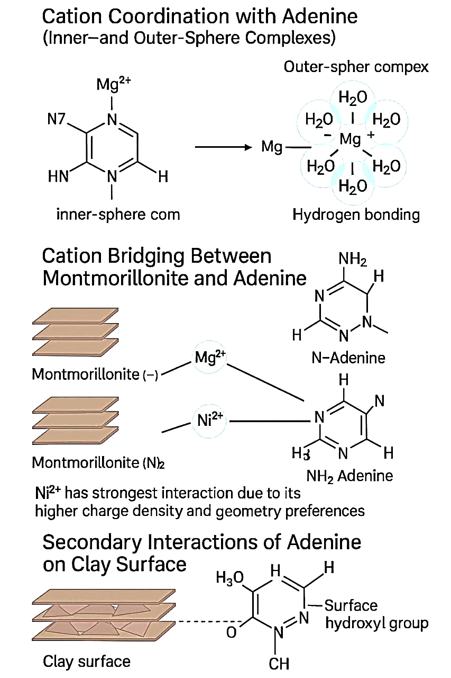
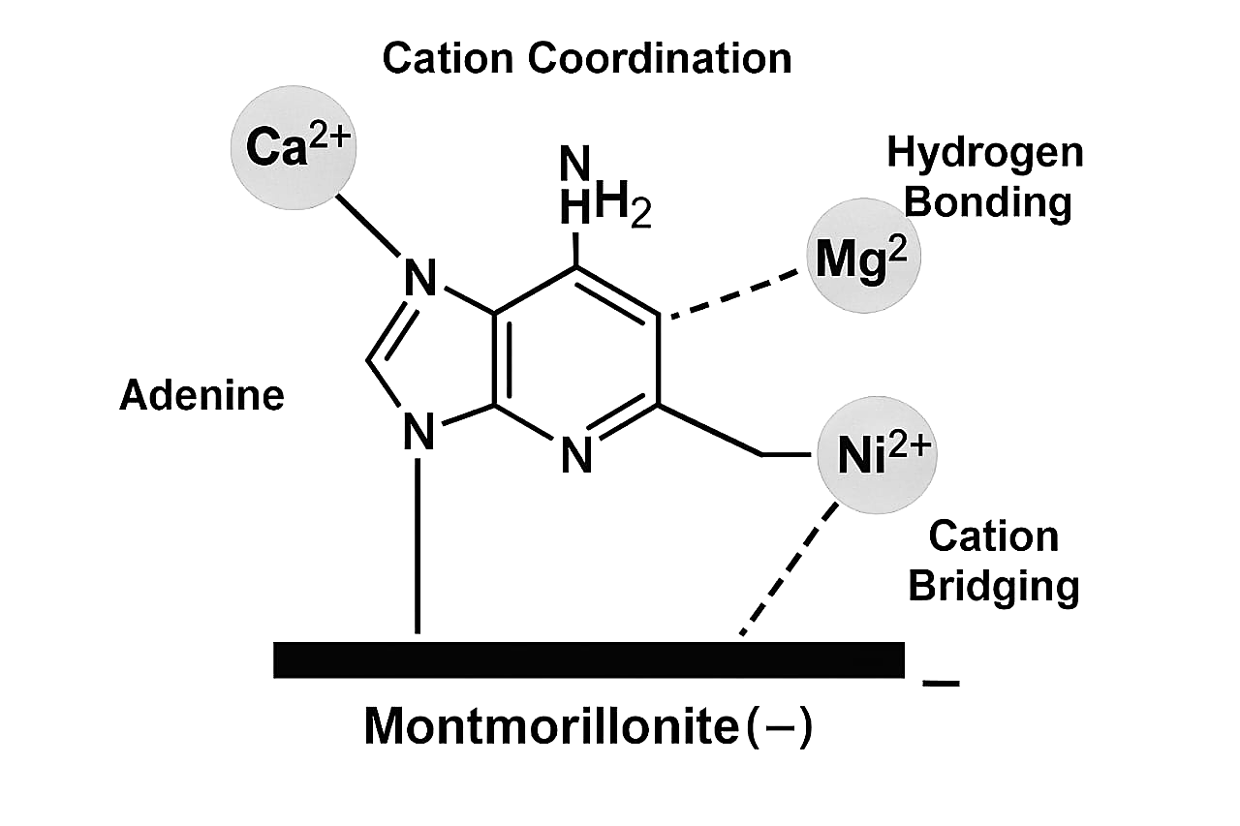
Scheme 1 Graphical Representation Scheme 2

Schemes 1 and 2 show the molecular interactions between adenine and montmorillonite clay. of the mechanism of molecular interactions between adenine and divalent cations (Ca²⁺, Mg²⁺, Ni²⁺) when associated with montmorillonite, a type of clay mineral,

Table 1. Percent Binding of Adenine on MMT Clay with or without Divalent Cations at 20ºC

Adsorbate | % Binding on MT | % Binding on M-Ca²⁺ | % Binding on M-Mg²⁺ | % Binding on M-Ni²⁺
Adenine | 8.89 | 11.11 | 10.00 | 12.22
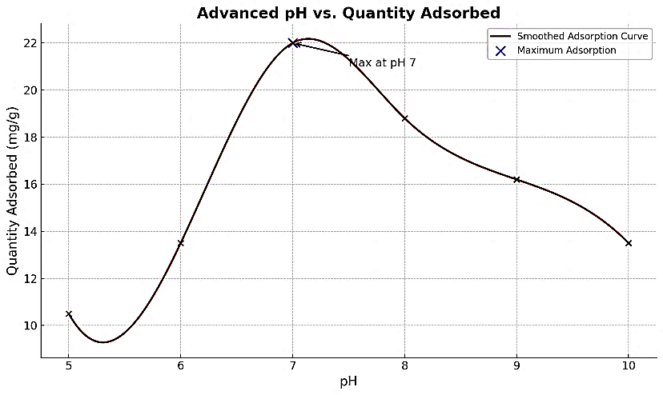
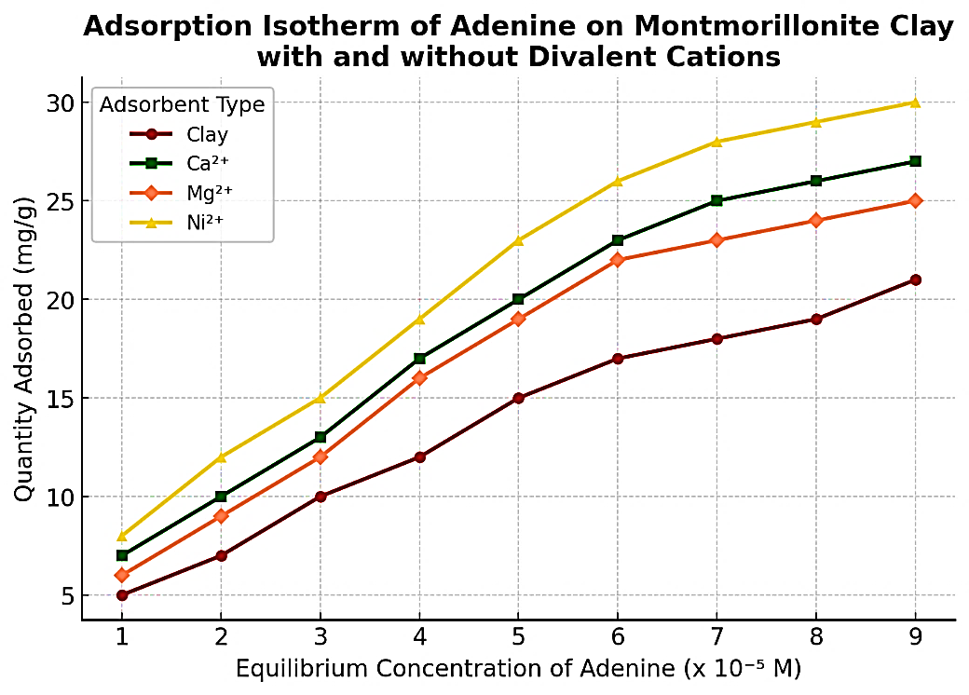
Fig. 1. Adsorption of adenine on MMT as a function of pH
Table 2. Langmuir constants (X_{m} and K_{L}) for the adsorption of adenine on MMT clay
with or without cations (Ca²⁺, Mg²⁺, and Ni²⁺) at 20˚C

Adsorbents | Maximum Adsorption Capacity, X_{m} (mg/g) | Langmuir Constant, K_{L} (L/mg) | Correlation Coefficient, r²
MMT-Clay | 21.77 | 33.18 | 0.99
MMT-Ca²⁺ | 27.09 | 190.48 | 0.99
MMT-Mg²⁺ | 24.28 | -150.74 | 0.99
MMT-Ni²⁺ | 29.70 | 3395.29 | 0.99

Fig. 2. Adsorption isotherm of adenine on MMT clay in the presence or absence of metal cations

Table -3: Thermodynamic Parameters for the Adsorption of Adenine on MMT clay
and Different Cations
Adsorbent | 20°C |  | 30°C |  | Thermodynamic Parameters
 | lnK₀ | ΔG˚  (kJ/mol) | lnK₀ | ΔG˚  (kJ/mol) | ΔH˚  (kJ/mol) | ΔS˚  (kJ/molK)
M-Clay | 1.52 | -3.71 | 0.79 | -1.97 | 5.46 | 0.19
M-Ca²⁺ | 1.31 | -3.18 | 0.48 | -1.20 | 6.12 | 0.21
M-Mg²⁺ | 1.41 | -3.44 | 0.52 | -1.31 | 6.71 | 0.23
M-Ni²⁺ | 1.21 | -2.96 | 0.43 | -1.09 | 7.09 | 0.20
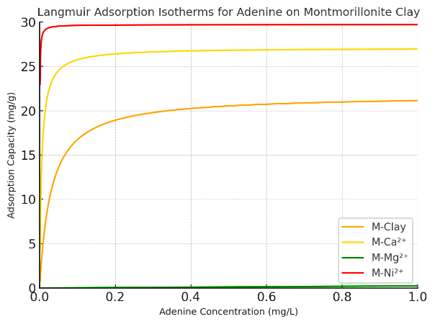
K₀, thermodynamic equilibrium constant; ln, natural logarithmic value of K0; ΔG˚, change in Gibbs
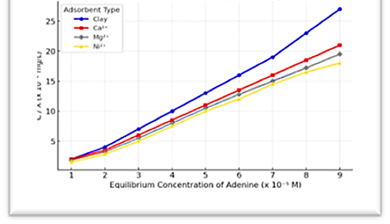
free energy

(a) (b)
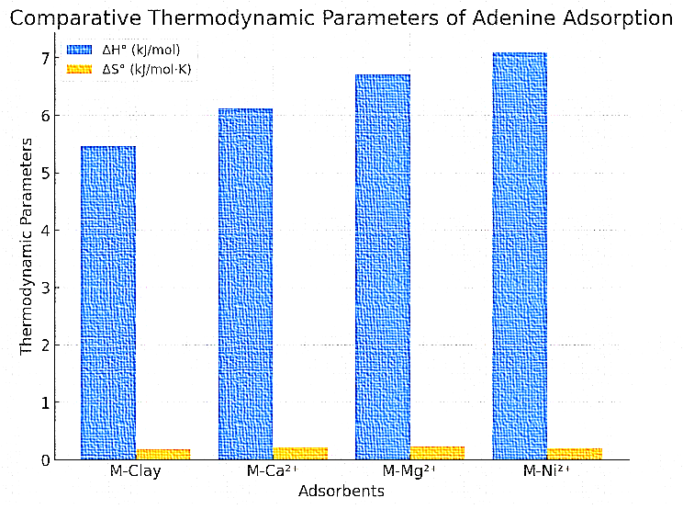
Fig. 3. The Langmuir adsorption isotherms (a) and a graphical representation (b) of adenine on MMT clay with different cations.

Fig. 4. The comparative bar chart displaying the thermodynamic parameters (ΔH° and ΔS°) for adenine adsorption on MMT clay with different cations.

The thermodynamic analysis of adenine adsorption on modified MMT clays reveals important insights into the role of different cations. The enthalpy change (ΔH°) values range from 5.46 kJ/mol for MMT-Clay (unmodified) to 7.09 kJ/mol for M-Ni²⁺, indicating that the adsorption process is exothermic but not highly energy-releasing. The increasing ΔH° trend suggests that Ni²⁺ stabilizes the adsorption more effectively than other cations, likely due to stronger electrostatic and possible transition metal-ligand interactions. Entropy change (ΔS°) values are also positive, ranging from 0.19 to 0.23 kJ/mol⁻K, which implies increased disorder at the solid-liquid interface during adsorption. This disorder may stem from structural rearrangements on the montmorillonite surface. Among the cation-modified clays, M-Mg²⁺ exhibits the highest entropy change (0.23 kJ/mol-K), suggesting a more disordered adsorption process, possibly due to weaker interactions compared to Ca²⁺ and Ni²⁺. Comparing (fig.4) the adsorbents, MMT-Clay, which lacks cation modification, shows the lowest ΔH° and ΔS°, reflecting weaker interactions and minimal adsorption. In contrast, M-Ca²⁺ and M-Mg²⁺ exhibit moderate thermodynamic values, indicating enhanced adsorption via charge neutralization. Notably, M-Ni²⁺ shows the highest ΔH°, indicating the strongest cation, likely due to stronger electrostatic interactions and possible transition-metal-ligand interactions.

4. CONCLUSION
The thermodynamic study of adenine adsorption onto MMT shows a complex connection of molecular forces involved in this process, which significantly impacts prebiotic chemistry. The consistently negative Gibbs Free energy(G°) indicates that adsorption occurs spontaneously and is energetically favorable. This confirms that N-bases naturally prefer mineral surfaces. Although the heat release is low due to the positive enthalpy change, the adsorption process remains stable. .it mainly relies on weak but significant intermolecular interactions like Vander Waal forces, hydrogen bonding, and electrostatic attractions. The positive entropy changes point to some molecular rearrangement at the clay interface, further showing that adenine retention is dynamic yet thermodynamically possible.
Among the N - bases studied, adenine shows the highest adsorption affinity, likely because of its molecular size and stronger dispersion interactions. The presence of exchangeable cations like Mg²⁺, Ca²⁺ and Ni²⁺ also affects adsorption behaviour by promoting electrostatic stabilization and cation Pi interactions. These findings emphasize the role of clay minerals as effective prebiotic collectors, capable of selectively adsorbing and stabilizing biologically important molecules under early Earth conditions.
Overall, this study supports the idea that MMT clay might have acted as a crucial natural catalyst in prebiotic chemistry, facilitating the accumulation and preservation of key organic compounds. The ability of these mineral surfaces to encourage molecular retention without needing strong covalent bonds suggests a possible way primordial biomolecules could have organized. This organization may have played a role in the development of self-replicating systems. These insights enhance our understanding of the chemical processes that might have contributed to the origins of life and highlight the importance of clay minerals in early biochemical evolution.
ACKNOWLEDGEMENTS
The author gratefully acknowledges Ret. Prof. Chandra Kala Pant, DSB Campus, Kumaon University, Nainital, for her invaluable suggestions and supervision, which greatly contributed to the development of this manuscript. The author also extends sincere thanks to the institution for its support.
Competing
The author declares that she has no known competing financial interests or personal relationships that could have appeared to influence the work reported in this paper.

CONSENT: Not applicable
CONFLICT OF INTEREST
The authors declare that there is no conflict of interest regarding the publication of this paper. The study was conducted solely for academic and scientific purposes without any external commercial influence or sponsorship.
ETHICAL APPROVAL
This study does not involve human participants, animals, or any sensitive data; therefore, no ethical issues are associated with the research. All experiments were conducted using standard laboratory procedures and materials, and no ethical approval was required.

Authors’ contribution
The author's conceptualization of the research problem, laboratory work, manuscript writing and critical revision.

DISCLAIMER (Artificial intelligence)
The author hereby declares that NO generative AI technologies, such as Large Language Models (ChatGPT, COPILOT, etc.) and text-to-image generators, have been used during the writing or editing of this manuscript. Grammarly is used throughout the manuscript writing

REFERENCES
- Cleaves II, H. J., Scott, A. M., Hill, F. C., Leszczynski, J., Sahai, N., & Hazen, R. (2012). Mineral–organic interfacial processes: potential roles in the origins of life. Chemical Society Reviews, 41(16), 5502–5525.https://doi.org/10.1039/C2CS35112A .
- Yan, Y., & Yang, H. (2024). Interactions of Clay Minerals with Biomolecules and Protocells Complex Structures in the Origin of Life: A Review. Advanced Functional Materials, 34(41),https://doi10.1002/adfm.202406210.
- Hazen, R. M., Papineau, D., Bleeker, W., Downs, R. T., Ferry, J. M., McCoy, T., Sverjensky, D., & Yang, H. (2005). Mineral Evolution. American Mineralogist, 90(10), 1473–1499.https://doi.org/10.2138/am.2005.1871
- J. D. Bernal, Proc. Phys. Soc. B, 62, 537–558 (1949).
- Cairns-Smith, A. G. (1982). Genetic takeover and the mineral origins of life. Cambridge Univ. Press. https://www.cambridge.org/core/journals/genetics-research/article/genetic-takeover-and-the-mineral-origins-of-life-by-a-g-cairnssmith-first-published-1982-first-paperback-edition-1987-cambridge-university-press-isbn-0-521-34682-7/10101010101010101010101010101010
- Brigatti, M. F., Galan, E., & Theng, B. K. G. (2006). Structures and mineralogy of clay minerals, F. Bergaya, B. K. G. Theng, & G. Lagaly (Eds.), Handbook of Clay Science (pp. 19–86). https://doi.org/10.1016/S1572-4352(05)01002-0
- Azzouz, A., Arus, V. A., & Platon, N. (2024). Role of Clay Substrate Molecular Interactions in Some Dairy Technology Applications. International Journal of Molecular Sciences, 25(2), 808.
- Ferris, J. P. (2002). Montmorillonite catalysis of 30-50 oligonucleotides: laboratory demonstration of potential steps in the origin of the RNA world. Origins of Life and Evolution of the Biosphere, 32, 311–332.https://doi.org/10.1023/A:1020543312109
- P. C. Joshi, M. F. Aldersley, J. W. Delaono, J.P. Ferris, (2009). Orig. Life Evol. Biosph., 39, 229–238.
- H. Hashizume, J. Nucleic Acids, Article ID 216507 (2015).
- Paukku, Y., Michalkova, A., & Leszczynski, J. (2007). Adsorption and Decomposition of Dimethyl Methylphosphonate on Y2O3 Nanoparticles. The Journal of Physical Chemistry C, 111(8), 3233–3240.https://doi.org/10.1021/jp0650376
- Ramírez-Vázquez, L., Duarte-Ruiz, A. A., Santiago-Santos, M. G., Tercero, G. C., & Cruz-Castañeda, J. A. (2025). Stability of adenine in interaction with saponite in a simulated hydrothermal impact-generated system and its implications for Astrobiology. Planetary and Space Science, 106151.
- Stumm, W., & Morgan, J. J. (1996). Aquatic chemistry: Chemical equilibria and rates in natural waters. John Wiley & Sons. https://www.wiley.com/en-us/Aquatic+Chemistry%3A+Chemical+Equilibria+and+Rates+in+Natural+Waters%2C+3rd+Edition-p-9780471511854
- Oro, J. (1961). Mechanism of synthesis of adenine from hydrogen cyanide under possible primitive Earth conditions. Nature, 191, 1193–1194.https://doi.org/10.1038/1911193a0
- M. Franchi, E. Gallori, L. Vanni, (2004) Int. J. Astrobiology, 3, 127–136.
- K. M. Parida, S. S. Dash (2006). Adsorption, 12, 219–232.
- E. Biondi, S. Branciamore, M. C. Maurel & E. Gallori, (2010) Geochem. Cosmochim. Acta, 74, 479–488.
- Ma, L., Liang, Z., Hou, Y., Zhang, R., Fan, K., & Yan, X. (2025). Nanozymes and Their Potential Roles in the Origin of Life. Advanced Materials, 37(6), 2412211
- Hazen, R. M., & Sverjensky, D. A. (2010). Mineral surfaces, geochemical complexities, and the origins of life. Cold Spring Harbor Perspectives in Biology, 2(5), a002162. https://doi.org/10.1101/cshperspect.a002162 .
- Y. Liu, Y. Liu & H. Zhou, (2019) Adv. Colloid Interface Sci., 270, 108–121.
- G. Cavallaro, G. Lazzara & S. Milioto, (2019) Adv. Colloid Interface Sci., 267, 28–45.
- H. Bhatt, N. Pandey, C. K. Pant, (2021) Int. J. of Innovative Research in Technology, Volume 8, Issue 3, 1039-1044.
- H. Bhatt, C. K. Pant, (2022), Int. J. of Science, Research and Reviews, 11 (4), 86-93.
- F. López Arbeloa, (1990) J. Colloid Interface Sci.,137,104–110 (.https://doi.org10.1016/0021-9797(90)90297-3Samadi Pourshamsian, (2019) J. Mol. Liq., 282,248–255. https://doi.org10.1016/j.molliq.2019.03.033
- Vona, A., Romano, C., Dingwell, D. B., & Giordano, D. (2011). The rheology of crystal-bearing basaltic magmas from Stromboli and Etna. Geochimica et Cosmochimica Acta, 75, 3214–3236. https://doi.org/10.1016/j.gca.2011.03.031
- J. P. Ferris and G. Ertem, Science, (1993), 259, 513–516.
- Schulthess, C. P., & Dey, K. (1996). Estimation of Langmuir Constants Using Linear and Nonlinear Methods. Soil Science Society of America Journal. https://doi.org/10.2136/sssaj1996.03615995006000020014x
- G. Ertem, (1986) Origins of Life and Evolution of the Biosphere,16(3–4), 183–197.

