Original Research Article

Evaluation of Water and Sediment Pollution by Heavy Metals, Agricultural Pesticides, and Hydrocarbons in Lake Nokoué, Benin
.
ABSTRACT
Lake Nokoué, the largest source of fish products in southern Benin, is unfortunately threatened by advanced chemical pollution. The objective of this study is to assess the level of contamination of the lake's water-sediment matrix by trace metals, agricultural pesticides, hydrocarbons, and polychlorinated biphenyls. Ten (10) study stations were selected for water and sediment sampling in August 2024. The The measurements of trace metal elements (TME) were performed using an atomic absorption spectrophotometer, and the pesticides, hydrocarbons, and polychlorinated biphenyls were measured using gas chromatography. R and QGIS software were used for data processing and to produce the various maps. The average TME levels obtained in the water were 0.004 mg/L, 1.36 mg/L, 0.167 mg/L, 0.001 mg/L, 0.002 mg/L, and 0.001 mg/L for lead, copper, cadmium, arsenic, zinc, and mercury, respectively. All are below the standard except for cadmium. The levels of pesticides and total hydrocarbons obtained in the water are all above the standard and are 0.08 mg/L; 2.47 mg/L; 0.66 mg/L, 1.96 mg/L; 0.06 mg/L and 0.07 mg/L respectively for glyphosate, atrazine, flubendiamide, spirotetramat, total polycyclic aromatic hydrocarbons (PAHs) and total petroleum hydrocarbons (TPHs). However, the levels found in sediments for the three types of pollutants are below the standard and are 0.298 mg/kg; 0.006 mg/kg; 2.408 mg/kg; 0.010 mg/kg; 0.133 mg/kg; 5.899 mg/kg; 0.462 mg/kg; 0.556 mg/kg; 0.144 mg/kg and 0.156 mg/kg respectively for cadmium, lead, copper, mercury, glyphosate, atrazine, flubendiamide, spirotetramat, PAHs, and PTS. Furthermore, polychlorinated biphenyls (PCBs) are not present in either matrix.Principal component analysis (PCA) shows that trace metals (TM), pesticides, polycyclic aromatic hydrocarbons (PAHs), and total hydrocarbons (THC) present in water and sediments originate from the same sources. In terms of water pollution, the stations at Vékky, Zogbo, and Gogomey are more contaminated with TMMs, while those at Aguégué, Sô-Ava, and Agbato show higher levels of pollution from hydrocarbons and pesticides (glyphosates). In terms of sediments, the Gogomey and Ganvié stations are heavily polluted with TME, those of Totchè, Ganvié1 and Aguégué with PAHs and TOH, and Zogbo and Epkè with pesticides. In light of the results obtained, this lake appears to be a problematic area for water contamination by trace metals (TM), pesticides, PAHs, and PHTs.

Keywords: TME, pesticides, hydrocarbons, BCP, water-sediment.
1. INTRODUCTION
Every day, various types of pollutants are released into the environment, particularly into aquatic ecosystems. These pollutants include trace metals (TMs), agricultural pesticides, hydrocarbons, and polychlorinated biphenyls (PCBs), which are considered hazardous due to their toxic effects, persistence, and ability to accumulate in ecosystems (Harte et al., 1991; Schuurmann and Markert, 1998). In these aquatic ecosystems, a large proportion of these chemical compounds are of anthropogenic (Veena et al., 1997; Sanou et al., 2020) or natural (El Morhit et al., 2013) origin. The concern about contamination by these chemical pollutants stems from the fact that they accumulate in organisms (plants or animals), water, and sediments, where they sometimes reach toxic levels (Kayalto & Mbofung, 2009; Lévêque & Paugy, 1999).
However, Africa appears to be the continent least affected by this type of pollution due to its low level of industrialization.But nowadays, information exists across many countries on the continent, reporting on these numerous chemical pollutants, which accumulate in sediments, water, and fishery resources (Chouti, 2011; Coulibaly & Ouedraogo 2022; Oumar et al., 2014). This is justified by work carried out by several authors on the continent in this area (Altındağ & Yiğit, 2005; Cherifi & Mekhissi, 2022; Coulibaly & Ouedraogo, 2022; Dione, 2022; El Morhit et al., 2013; Kayalto & Mbofung, 2009; Ouro-Sama et al., 2014; Samia & Emam, 2024; Zerrouqi et al., 2013) in Nigeria, Senegal, Burkina Faso, Chad, Togo, Algeria, and Morocco, respectively.
In recent years, following the increase in income-generating activities (agriculture, industry, crafts, etc.), Benin's aquatic ecosystems have experienced numerous physical, chemical, and biological disturbances (Goussanou et al., 2018).This situation has led to a risk of water quality deterioration and fish stock depletion in these ecosystems (Hounkpe et al., 2017). Studies conducted by Agbohessi et al. (2012), Chouti et al. (2017), Lawani et al. (2017), Yehouenou et al. (2013), and Yèhouénou and Pazou (2005) show that the lake is contaminated with organochlorine pesticides and heavy metals. In addition, the work of Dovonou et al. (2019), Goussanou et al. (2018), and Manou et al. (2020) on this lake shows that crabs, sediments, water, fish, and shrimp are contaminated with ETMs (lead, cadmium, and copper) and PAHs. Finally, recent work by Agbohessi et al. (2023) confirms this chemical pollution, mentioning that Lake Nokoué receives several pollutants such as pesticides (endosulfan, DDT), polycyclic aromatic hydrocarbons (naphthalenes, fluorene), and toxic metals (lead, cadmium, copper). Industrial detergents, polychlorinated biphenyls, dioxins, and related products are also suspected in this ecosystem.
However, in addition to all this pollution, the lake is likely to experience even more pollution in the coming years, as it is home to one of the country's leading tourist attractions, Ganvié, which the National Agency for the Promotion of Heritage and Tourism Development in Benin (ANPT) plans to develop. With the aim of making Benin one of the leading destinations in West Africa, the ANPT has planned several projects, including one entitled “Reinventing the lakeside city of Ganvié.” The goal of this project is to make Ganvié a flagship site for promoting tourism that respects the surrounding hydrosystem, Lake Nokoué. To carry out this project while minimizing its potential negative impacts on habitat quality and biodiversity loss, the ANTP commissioned a preliminary scientific study to assess the current situation and propose actions to ensure that the project does not affect biodiversity and fishing, but rather enables the sustainable management of biodiversity and fishing activities. It is in this context that this study was initiated, with the aim of assessing the level of contamination of the water-sediment matrix of Lake Nokoué by TME, agricultural pesticides, hydrocarbons, and polychlorinated biphenyls.
2. material and methods
2.1 MATERIAL
2.1.1 Geographic location of the study area
Lake Nokoué is located in the southeast of the country, between parallels 6°20' and 6°30' north and meridians 2°20' and 2°35' (Dovonou et al., 2019). Considered the largest lake in Benin with an area of 150 km² at low water, it extends across the departments of Ouémé, Atlantique, and Littoral, and is bordered to the west by the Abomey-Calavi plateau -Calavi plateau, to the east by the Porto-Novo lagoon, to the north by the floodplain of the Ouémé and Sô rivers, and to the south by the city of Cotonou (Dovonou et al., 2019). Lake Nokoué has an average length of 20 km in its east-west direction and a width of 11 km in its north-south direction (Dovonou, 2012). Figure 1 shows the geographical location of Lake Nokoué.
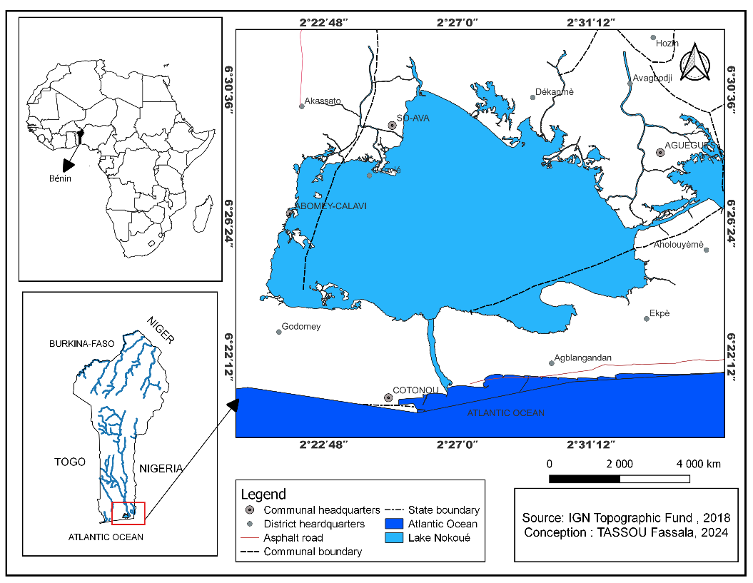

Figure 1 : Map showing the location of Lake Nokoué
2.1.2 Field equipment
During this study, various types of equipment were used to collect data :
- A motorized boat was used to travel across the lake;
- A Garmin 72 GPS navigator was used to locate the sampling stations.
- New plastic bottles were used to collect water samples for trace metal analysis.
- Opaque glass bottles were used to collect water samples for pesticide, hydrocarbon, and polychlorinated biphenyl analysis.
- Zip-lock bags were used to collect sediments for TME analysis.
- Zip-lock bags and aluminum foil were used to collect sediments for pesticide, hydrocarbon, and polychlorinated biphenyl analysis.
- Markers and adhesive paper were used to label the samples.
- A camera was used to take photos.
- Coolers containing ice were used to preserve and store water and sediment samples taken from the lake.
2.1.3. Laboratory equipment
-The atomic absorption spectrophotometer (AAS) was used to measure trace metal element (TME) concentrations ;
-Gas chromatography was used to measure pesticide and hydrocarbon concentrations
2.2 METHODS
2.2.1 Sampling
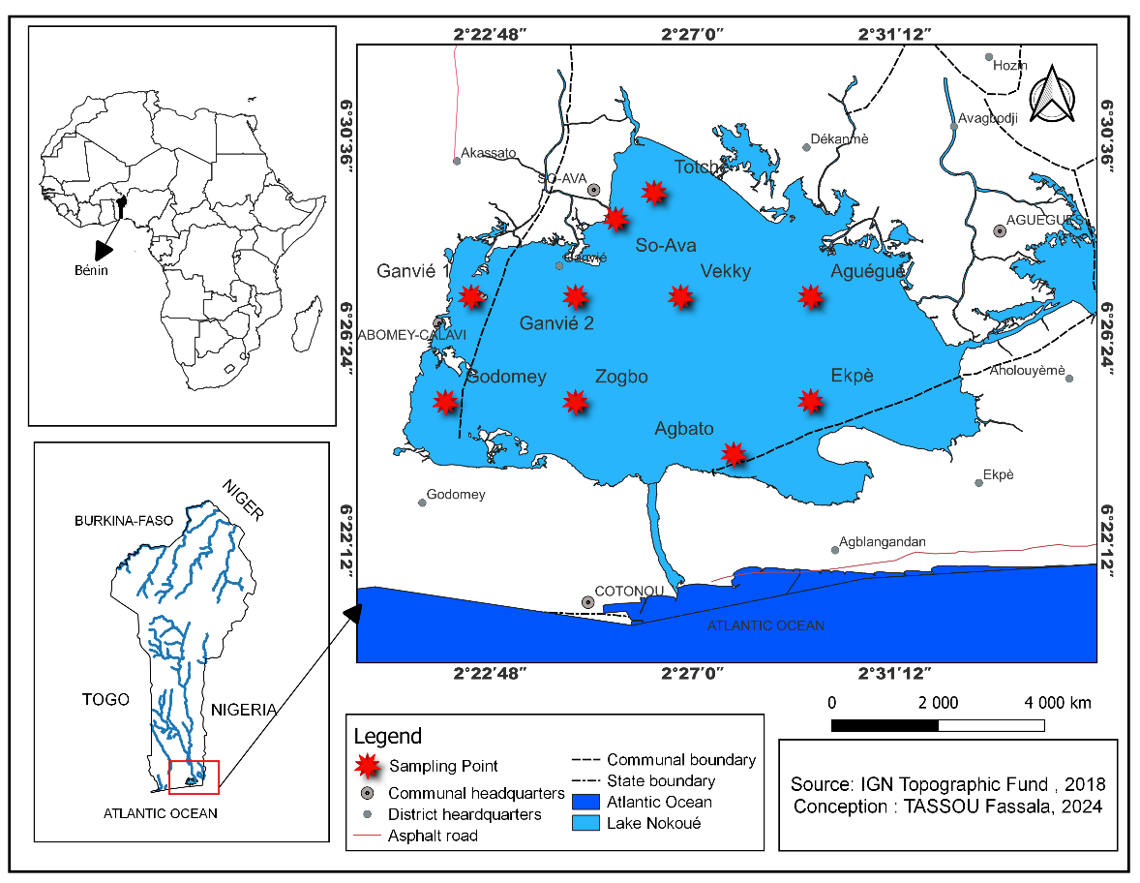
Sampling was carried out at 10 stations identified during the site visit (Figure 2), once in August for ETM, pesticides, and hydrocarbons, and for physicochemical parameters over a period of six months (from January to June).

Figure 2: Map showing the geographical location of Lake Nokoué and the sampling sites
2.2.1.1. Water sampling:
Water samples were taken from the lake at the 10 study stations from the top 5 cm.
- For water samples intended for TME testing, the sample was collected using new 1L polyethylene bottles that had been rinsed three times with distilled water and then with the sample itself.
- For samples intended for pesticide and hydrocarbon analysis, given the sensitivity of pesticides and hydrocarbons to light, water samples were collected in opaque 1-liter glass containers and rinsed with sulfuric acid at 10°C, then with distilled water and the sample itself three times in succession.

2.2.1. 2. For sediment sampling:

Sediment sampling from the lagoon bottom for ETM analysis was carried out using an Eckman grab, which is a tool that is well suited to sampling sediment from the bottom of bodies of water. Once collected, these samples were transferred to zip-lock bags.

For sediment sampling for pesticide and hydrocarbon analysis, in order to avoid photochemical reactions, sediment samples (approximately 200 g) were collected in aluminum foil to protect the sediments from light. These samples are stored at 20°C until analysis.

2.2.2. Analysis protocols
- Analysis protocols for ETMs in water and sediments
The analysis of ETMs in water and sediment was performed using an atomic absorption spectrophotometer (AAS) from Agilent, California, USA, coupled to a computer and operated using the MP-AAS software interface. For each water sample, 25 mL was collected in a PTFE beaker. In the case of sediments, 1 g ± 0.05 g of air-dried sediments, sieved to 2 mm, were accurately weighed and placed in a 250 mL conical flask. Under a fume hood, 10 mL of nitric acid was added to the water, while a digestion mixture (perchloric, nitric, and sulfuric acids in a 1:2:2 ratio) was poured into the sediment bottles. The mixtures were heated for 15 to 20 minutes on a hot plate until white smoke appeared. After cooling, the volume was brought to 50 mL with distilled water. The mixture was then boiled to solubilize the metals, cooled again, filtered through Watman 42 filter paper into a 50 mL flask, and made up with distilled water. The mineralized samples were finally transferred to plastic bottles for analysis by atomic absorption spectrometry (AAS) to measure trace metal element (TME) content.
- Analysis protocol for pesticides in water and sediments
Pesticide levels in water and sediment samples were determined using an Agilent 7820A gas chromatograph coupled with a 5975C inert mass spectrometer (with triple-axis detector) with an electron impact source (Agilent Technologies). Five-point serial dilution standards (0.25 to 4.00 ppm) were prepared to calibrate the gas chromatograph coupled with a mass spectrometer (GC-MS). Pesticide levels were determined by GC-MS, using selective ion monitoring (SIM) mode and scan mode for sensitive detection. The analysis was performed with an Agilent 7820A equipped with an HP-5 capillary column (30 m × 0.32 mm × 0.25 µm) and a constant flow helium carrier gas. The injection of 1 µL of sample is done without splitting at 250 °C. The four programmable parameters follow a gradient from 60°C to 280°C over 29 minutes. The electron ionization source operates at 70 eV with temperatures adjusted to optimize detection. After calibration, the samples were analyzed to quantify the concentration of pesticides.

- Analysis protocol for hydrocarbons in water and sediments

However, HP, PAH, and PCB analysis was performed using a gas chromatography-mass spectrometer (GC-MS). The analysis of petroleum hydrocarbons (PH), polycyclic aromatic hydrocarbons (PAH), and polychlorinated biphenyls (PCB) was performed by gas chromatography coupled with a mass spectrometer (GC-MS), according to the following protocol: 100 mL of water was collected in a 250 mL separation funnel, and 10 g ± 0.05 g of homogenized sediment was weighed into a Teflon bottle of the same volume (or equivalent). Three successive extractions with 20 mL of methylene chloride were performed, with vigorous shaking between each. After settling for at least 10 minutes, the organic phase was then concentrated to 1–2 mL in a rotary evaporator. Anhydrous sodium sulfate was added to remove residual water, and the purified extracts were deposited in columns prepared prior to GC-MS analysis.

2.2.3 Statistical data processing and analysis

Two methods were used to analyze the spatial distribution of pollutants in water and sediment: Geographic Information Systems (GIS), which is a cartographic method, and geostatistical analysis, which is an interpolation method (Kriging). The cartographic method allows pollutant concentrations to be integrated into GIS systems in order to visualize and analyze their spatial distribution: in this case, using Qgis 3.22 software. The “Kriging” method is a geostatistical interpolation method that estimates pollutant concentrations in unsampled areas based on available data. In this case, ArcMap 10.8 software was used to estimate these different pollutants across the entire lake, in both water and sediment. This method was chosen because it differs from others in its static approach and its ability to take uncertainties into account, offering high precision. To study the correlation between pollutants in the matrix (water-sediment) on the one hand and between pollutants and stations on the other, R software was used for Principal Component Analysis (PCA).
3. results and discussion
3.1 RESULTS
3.1.1 Spatial distribution of heavy metals, pesticides, and hydrocarbons in water and sediment
3.1.1.2. Spatial distribution of heavy metals in water and sediment
The average, maximum, minimum, and standard deviation values for the concentrations of the six (06) TMEs (cadmium, copper, lead, arsenic, zinc, and mercury) measured at the ten (10) stations are summarized in Table below: The concentrations of the various TMEs measured in the water are compared with the World Health Organization standards (WHO 2017).
Table 1 : Summary of trace metal elements measured in Lake Nokoué
Parameter | Cd water | Cd sed | Pb water | Pb sed | Cu water | Cu sed | As water | As sed | Zn water | Zn sed | Hg water | Hg sed
Agbato | 0,000 | 0,070 | 0,000 | 0,000 | 0,000 | 0,570 | 0,000 | 0,000 | 0,000 | 0,000 | 0,000 | 0,000
Godomey | 0,670 | 0,460 | 0,020 | 0,010 | 5,380 | 3,720 | 0,010 | 0,000 | 0,010 | 0,000 | 0,000 | 0,000
Zogbo | 0,330 | 0,290 | 0,010 | 0,010 | 2,680 | 2,350 | 0,000 | 0,000 | 0,000 | 0,000 | 0,000 | 0,000
Ekpè | 0,090 | 0,540 | 0,000 | 0,010 | 0,760 | 4,370 | 0,000 | 0,000 | 0,000 | 0,000 | 0,000 | 0,000
Ganvié 2 | 0,000 | 0,540 | 0,000 | 0,010 | 0,000 | 4,370 | 0,000 | 0,000 | 0,010 | 0,000 | 0,000 | 0,000
Vekky | 0,280 | 0,080 | 0,010 | 0,000 | 2,230 | 0,680 | 0,000 | 0,000 | 0,000 | 0,000 | 0,010 | 0,010
Aguégué | 0,160 | 0,380 | 0,000 | 0,010 | 1,300 | 3,040 | 0,000 | 0,000 | 0,000 | 0,000 | 0,000 | 0,000
So-Ava | 0,080 | 0,080 | 0,000 | 0,000 | 0,620 | 0,640 | 0,000 | 0,000 | 0,000 | 0,000 | 0,000 | 0,000
Totchè | 0,000 | 0,160 | 0,000 | 0,000 | 0,000 | 1,300 | 0,000 | 0,000 | 0,000 | 0,000 | 0,000 | 0,000
Ganvié 1 | 0,080 | 0,380 | 0,000 | 0,010 | 0,650 | 3,040 | 0,000 | 0,000 | 0,000 | 0,000 | 0,000 | 0,000
Mean | 0,169 | 0,298 | 0,004 | 0,006 | 1,362 | 2,408 | 0,001 | 0,000 | 0,002 | 0,000 | 0,001 | 0,001
Maximum | 0,670 | 0,540 | 0,020 | 0,010 | 5,380 | 4,370 | 0,010 | 0,000 | 0,010 | 0,000 | 0,010 | 0,010
Minimum | 0,000 | 0,070 | 0,000 | 0,000 | 0,000 | 0,570 | 0,000 | 0,000 | 0,000 | 0,000 | 0,000 | 0,000
Standard Deviation | 0,210 | 0,189 | 0,007 | 0,005 | 1,687 | 1,525 | 0,003 | 0,000 | 0,004 | 0,000 | 0,003 | 0,003
Norm | 0,017ug/L | 0,60mg/Kg | 0,01mg/L | 35mg/Kg | 2mg/L | 36mg/Kg | 0,003mg/L | 5,9mg/Kg | 0,01mg/L | 120mg/Kg | 0,006mg/L | 0,17mg/Kg

(Cd)=Cadmium ; (Cu)=Copper ; (Pb)=Lead ; (As)=Arsenic ; (Zn)=Zinc ; (Hg)=Mercury, Sed=Sediment
- Cadmium
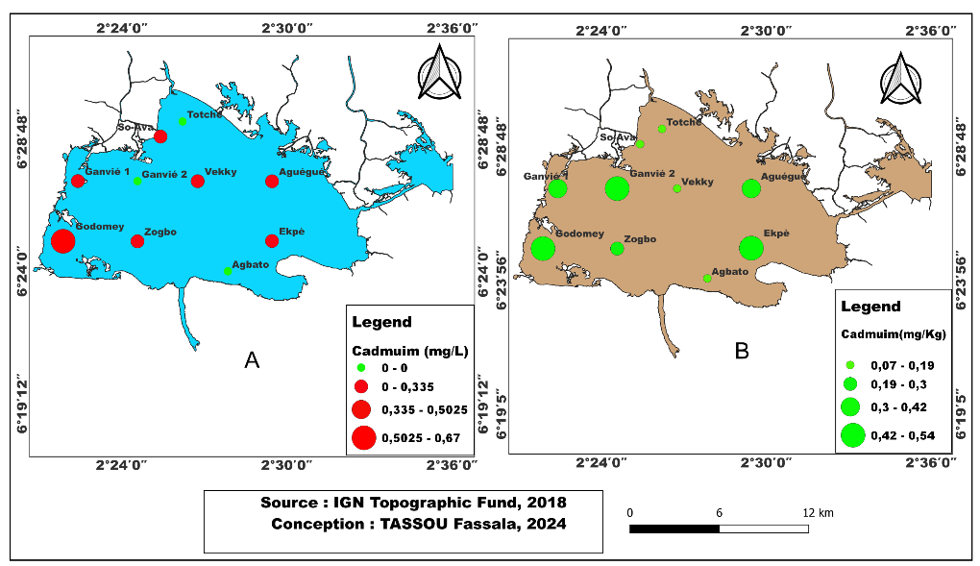

Figure 3: Spatial variation of cadmium in water (A) and sediment (B) in Lake Nokoué.

Figure 3 (A and B) shows the spatial distribution of cadmium content in water (A) and sediment (B) at the ten (10) stations. The cadmium content in water (Figure A) exceeds the recommended threshold (0.017 ug/L or 0.000017 mg/L) with a maximum value of 0.67 mg/L at Godomey, except at Totchè, Ganvié2, and Agbato where it is zero. The average cadmium content in the water across the entire lake is 0.17 ± 0.21 mg/L. The cadmium content in sediment (Figure 3 B) is below the standard (35 mg/kg), with low levels in Sô-Ava, Totchè, Vêkky, and Agbato and higher levels in Ganvié2, Godomey, and Ekpè. The average cadmium content in sediment across the entire lake is 0.298 ± 0.19 mg/kg, which is below the standard (0.60 mg/kg).

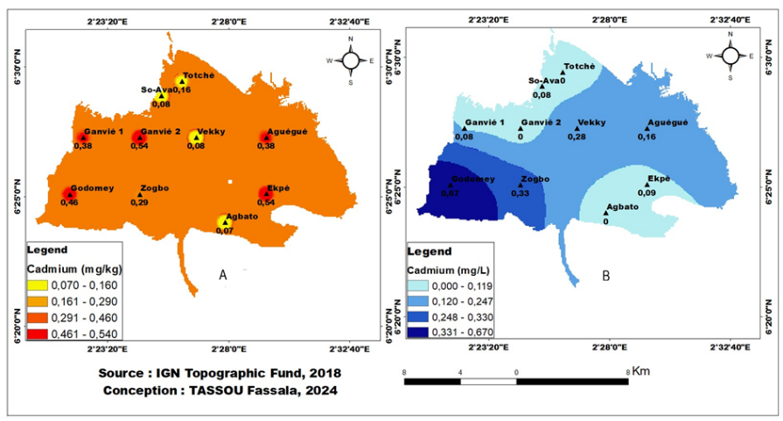
Figure 4 : Estimation of cadmium content in water (B) and sediment (A) across the entire lake.
A

Figure 4 (A and B) shows the estimated cadmium content in water and sediment across the entire lake. This figure shows that cadmium is found throughout the sediment (Figure 4A). However, in water (Figure 4B), cadmium is more concentrated in Godomey, Zogbo, Vékky, Aguégué, and the Cotonou channel, with levels above the standard (0.017 mg/L).

- Copper
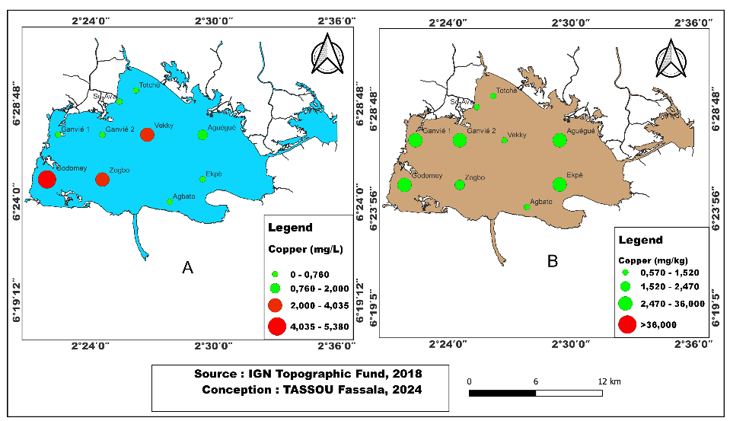
Figure 5 : Spatial variation of copper in water (A) and sediment (B) in Lake Nokoué.
Figure 5 (A and B) shows the spatial variation in copper content in water (A) and sediment (B) measured at the 10 stations. The copper content in water (Figure 5 A) at the stations (Godomey, Zogbo, and Vêkky) exceeds the WHO recommended threshold (2 mg/L), with a maximum value of 5.38 mg/L at Godomey. This content is zero at Agbato, Ganvié 2, and Totchè. An average value of 1.362 ± 1.69 mg/L was recorded for the lake as a whole. The copper content in the sediment (Figure 5B) is below Canadian standards (36 mg/kg), with high levels observed at Godomey, Ganvié 1, and Ekpè. The maximum value was 4.37 mg/kg in Ganvié 2 and the minimum value was 0.57 mg/kg in Agbato, with an average value of 2.408 ± 1.53 mg/kg across the entire lake.

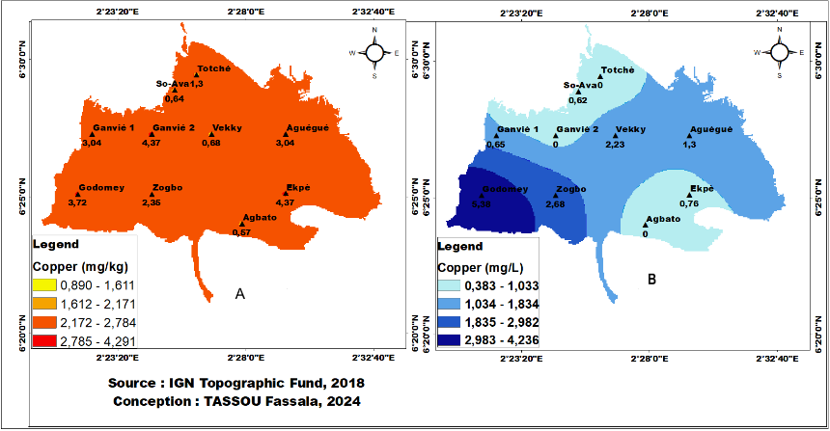
Figure 6 : Estimated copper content in water (B) and sediment (A) across the entire lake.
Figure 6 (A and B) shows the estimated copper content in water and sediment across the entire lake. This figure shows that copper is found throughout the sediment (Figure 6A). However, in water (Figure 6B), copper is more concentrated in Godomey, Zogbo, Vékky, Aguégué, and the Cotonou channel, with levels above the standard.
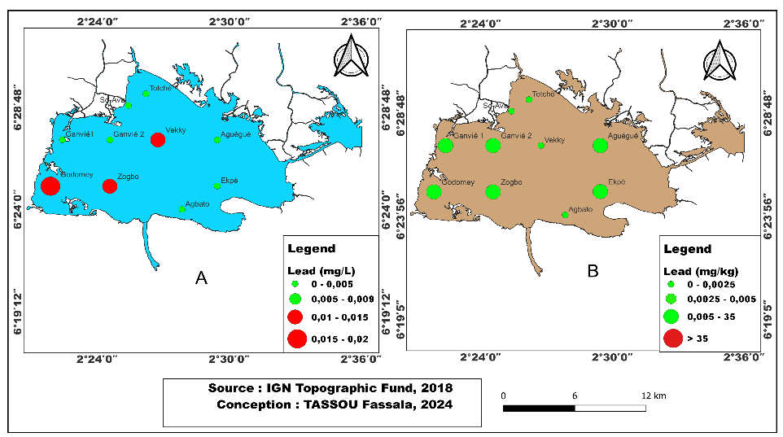
- Lead

Figure 7 : Spatial distribution of lead levels in water (A) and sediments (B) at the 10 stations.
Figure 7 (A and B) shows the spatial distribution of lead levels in water (A) and sediments (B) at the 10 stations. Lead levels in water (Figure 7A) at the Godomey, Zogbo, and Vékky stations exceed the WHO standard (0.01 mg/L), with a maximum value of 0.020 mg/L at Godomey. Levels are zero at the other stations. The average value is 0.004 ± 0.007 mg/L for the lake as a whole. The lead content in the sediment (Figure 7B) at the 10 stations is below the Canadian standard (35 mg/kg). The same levels of 0.01 mg/kg are found at all stations except Agbato, Vékky, Sô-Ava, and Totchè, where it is zero.

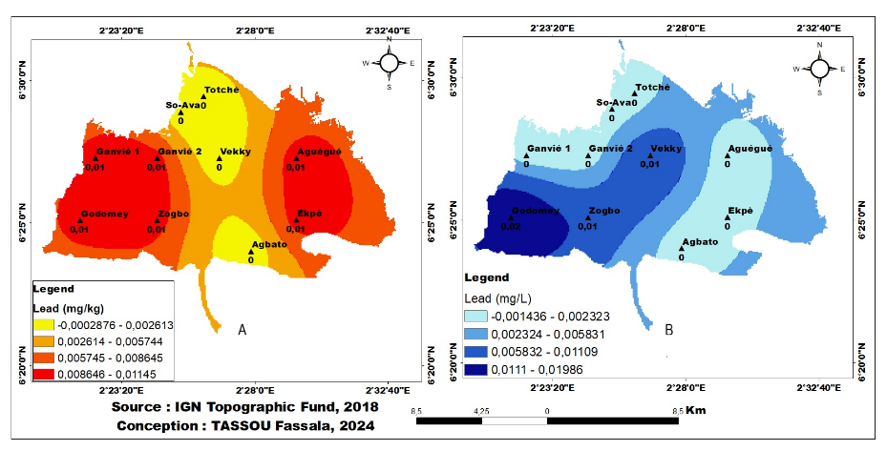
Figure 8 : Estimation of lead content in water (B) and sediment (A) across the entire lake.
Figure 8 shows the estimated lead content in water and sediment across the entire lake. This figure shows that the lead content in sediment is more concentrated in Ganvié1, Godomey, Ganvié2, Ekpè, and Aguégué (Figure 8A). However, in water (Figure 8B), this content is more concentrated in Godomey, Zogbo, Vekky, and the Cotonou channel.
For ETMs (arsenic, zinc, and mercury), these three (03) metals are virtually non-existent in water and sediment. Nevertheless, arsenic is present in water at only one station (Godomey) with a value of 0.010mg/L, which is above the WHO standard of 0.003mg/L, and is completely absent in sediment at all ten (10) stations. Zinc was found in the water at two stations (Godomey and Ganvié2) with a value of 0.010 mg/L, which is equal to the WHO standard of 0.01 mg/L, and was absent from the sediment at all ten (10) stations. Mercury was found in the water and sediment at only one station (Vékky) with a value of 0.010 mg/L, which is above the WHO standard of 0.006 mg/L for water and below the standard of 0.17 mg/kg for sediment.
3.1.2.3. Spatial Distribution of Pesticides in Water and Sediment
The mean, minimum, maximum, and standard deviation values of the four quantified pesticides (Glyphosate, Atrazine, Flubendiamide, and Spirotetramat) across the ten sampling stations are summarized in Table 2 below. The concentrations of the various pesticides measured in the water samples are compared with the Canadian water quality guidelines. However, specific regulatory thresholds for their concentrations in sediments have not yet been clearly established.
Parameter | Gly water | Gly sed | Atrazine water | Atrazine sed | Fluben water | Fluben sed | Spiro water | Spiro sed
Agbato | 0,002 | 0,020 | 1,428 | 3,995 | 0,122 | 0,000 | 0,000 | 0,000
Godomey | 0,005 | 0,076 | 2,858 | 6,491 | 0,467 | 0,000 | 0,000 | 0,771
Zogbo | 0,119 | 0,358 | 1,026 | 16,146 | 0,329 | 0,269 | 0,142 | 1,451
Ekpè | 0,022 | 0,209 | 4,358 | 3,219 | 5,664 | 4,352 | 7,589 | 1,211
Ganvié 2 | 0,016 | 0,352 | 0,750 | 8,903 | 0,000 | 0,000 | 6,539 | 2,127
Vekky | 0,134 | 0,244 | 4,456 | 6,162 | 0,000 | 0,000 | 2,253 | 0,000
Aguégué | 0,127 | 0,004 | 4,712 | 4,168 | 0,000 | 0,000 | 1,011 | 0,000
So-Ava | 0,138 | 0,010 | 1,837 | 3,535 | 0,000 | 0,000 | 0,000 | 0,000
Totchè | 0,146 | 0,023 | 1,726 | 3,472 | 0,000 | 0,000 | 0,926 | 0,000
Ganvié 1 | 0,132 | 0,032 | 1,582 | 2,898 | 0,000 | 0,000 | 1,124 | 0,000
Mean | 0,084 | 0,133 | 2,473 | 5,899 | 0,658 | 0,462 | 1,958 | 0,556
Maximum | 0,146 | 0,358 | 4,712 | 16,146 | 5,664 | 4,352 | 7,589 | 2,127
Minimum | 0,002 | 0,004 | 0,750 | 2,898 | 0,000 | 0,000 | 0,000 | 0,000
Standard Deviation | 0,063 | 0,144 | 1,511 | 4,065 | 1,767 | 1,370 | 2,793 | 0,790
Norm | 0 ,1ug/L | 820ug/Kg | 0,5ug/L | - | 0,1ug/L | - | 0,1ug/L | -
Table 2: Summary of Pesticides Quantified in the Lake Nokoué.

(Gly)=Glyphosate, Fluben=Flubendiamide, Spiro= Spirotétramate, Sed= Sediment
- Glyphosate
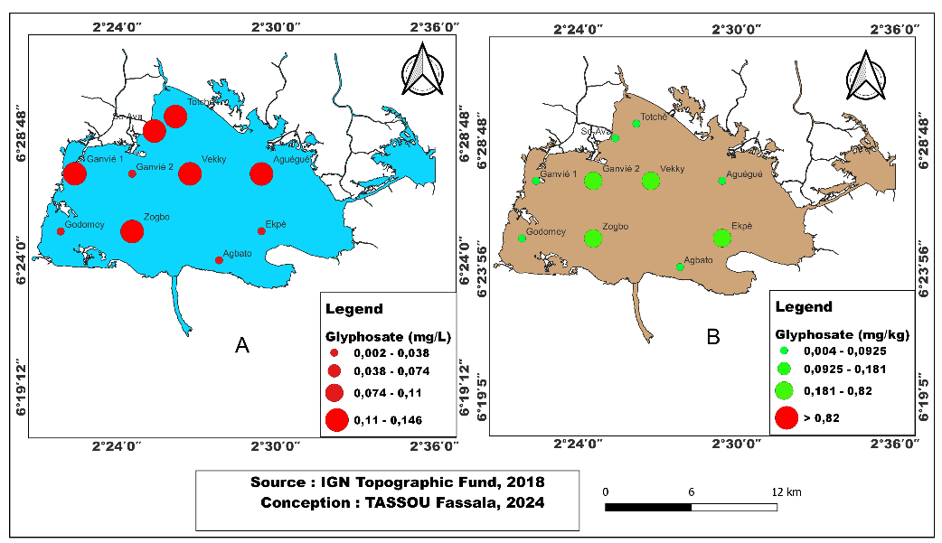
Figure 9 : Spatial Distribution of Glyphosate in Water (A) and Sediment (B) across the Ten Stations
Figure 9 (A and B) depicts the spatial distribution of glyphosate concentrations in both water and sediment. The glyphosate levels in water (Figure 9A), recorded across the ten sampling stations, exceed the recommended guideline value of 0.1 µg/L (0.0001 mg/L), with a maximum concentration of 0.146 mg/L observed at Totchè and a minimum of 0.002 mg/L at Agbato. The overall mean concentration for the lake is 0.084 ± 0.06 mg/L.Conversely, glyphosate concentrations in sediment (Figure 9B) remain below the established threshold of 820 µg/kg (0.82 mg/kg), reaching a maximum of 0.36 mg/kg at Zogbo and a minimum of 0.004 mg/kg at Aguégué. The mean sediment concentration across the lake is 0.13 ± 0.14 mg/kg.

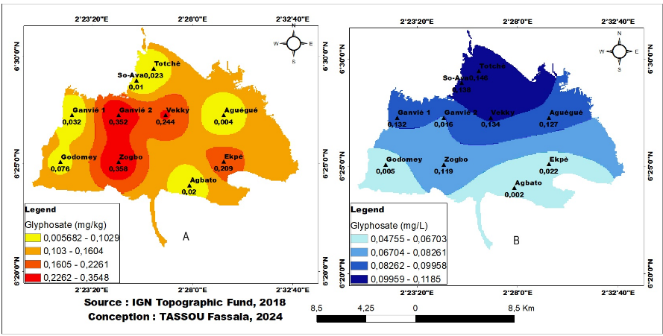
Figure 10: Estimated Glyphosate Concentrations in Sediment (A) and Water (B) across the Entire Lake
Figure 10 (A and B) presents the estimated spatial distribution of glyphosate concentrations in both sediment and water throughout the lake. In sediment (Figure 10A), glyphosate concentrations are markedly elevated at Ganvié 2, Zogbo, Vékky, and Epkè. In water (Figure 10B), elevated glyphosate levels are observed across nearly the entire lake, indicating widespread contamination.
- Atrazine
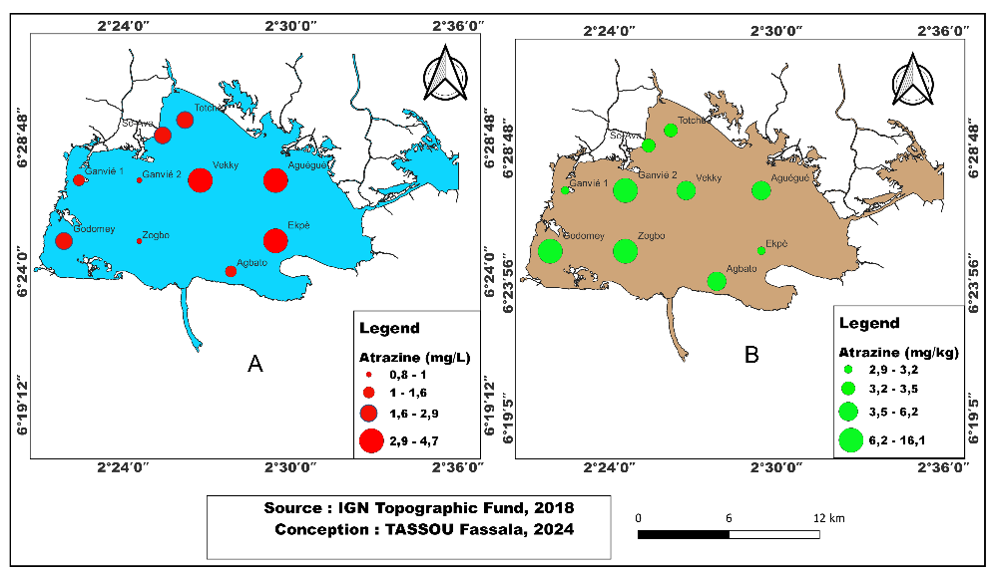

Figure 11: Spatial Distribution of Atrazine in Water (A) and Sediment (B) across the Ten Stations
Figure 11 (A and B) depicts the spatial distribution of atrazine concentrations in both water and sediment across the ten sampling stations. Atrazine levels in water (Figure 11A) exceed the Canadian guideline of 0.5 µg/L (0.0005 mg/L), reaching a maximum of 4.712 mg/L at Aguégué and a minimum of 0.750 mg/L at Ganvié 2. The mean concentration across the lake is 2.473 ± 0.75 mg/L.
In sediment (Figure 11B), the highest atrazine concentrations are observed at Godomey, Zogbo, and Ganvié 1, with a maximum of 16.146 mg/kg at Zogbo and a minimum of 2.90 mg/kg at Ganvié 1. The mean sediment concentration for the lake as a whole is 5.90 ± 4.07 mg/kg.
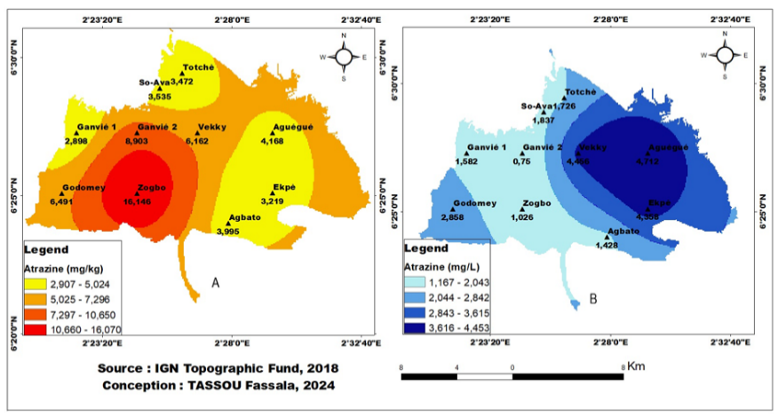
Figure 12: Estimated Atrazine Concentrations in Water (A) and Sediment (B) across the Entire Lake
Figure 12 (A and B) presents the estimated distribution of atrazine concentrations in both water and sediment throughout the lake. Atrazine levels are notably higher in sediment (Figure 12A) at Zogbo, Godomey, Ganvié 2, Vékky, and the Cotonou channel, a pattern that is similarly observed in the water (Figure 12B).
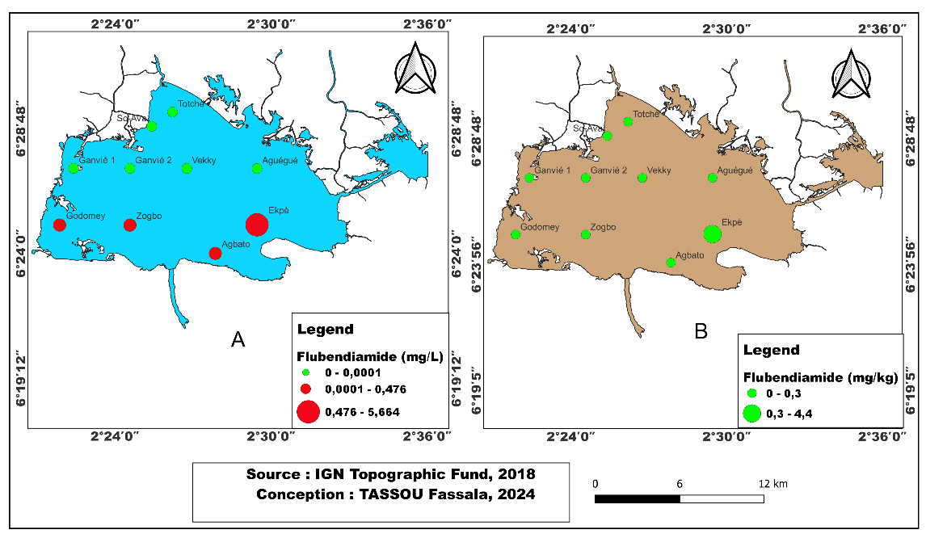
- Flubendiamide

Figure 13 : Spatial Distribution of Flubendiamide in Water (A) and Sediment (B) across the Ten Stations
Figure 13 (A and B) illustrates the spatial distribution of flubendiamide concentrations in both water and sediment across the ten sampling stations. Flubendiamide concentrations in water (Figure 13A) exceed the Canadian guideline of 0.1 µg/L (0.0001 mg/L) at Godomey, Zogbo, Agbato, and Epkè, reaching a maximum of 5.66 mg/L at Epkè, while remaining undetectable at the other stations. The mean water concentration across the lake is 0.66 ± 1.77 mg/L.
In sediment, flubendiamide was undetectable at all stations except Zogbo and Epkè, with a maximum concentration of 4.35 mg/kg at Epkè. The mean sediment concentration across the lake is 0.46 ± 1.37 mg/kg.
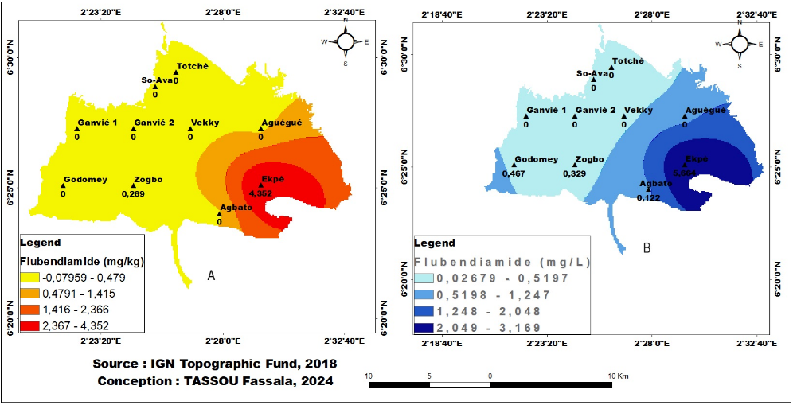
Figure 14: Estimated Flubendiamide Concentrations in Sediment (A) and Water (B) across the Entire Lake
Figure 14 (A and B) presents the estimated distribution of flubendiamide concentrations in both waterand sediment throughout the lake. Flubendiamide levels are notably higher in sediment (Figure 14A) at Epkè, Aguégué, and Agbato, a pattern that is similarly observed in the water (Figure 14B).
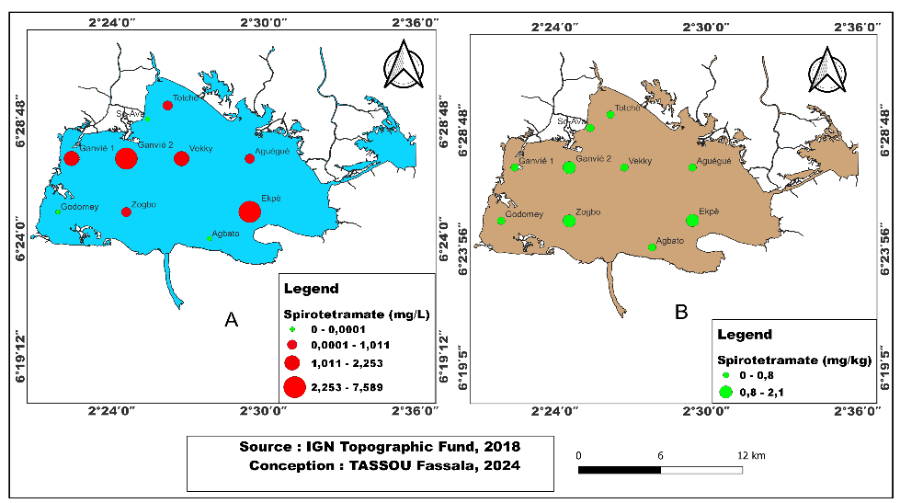
- Spirotétramate

Figure 15: Spatial Distribution of Spirotetramat in Water (A) and Sediment (B) across the Ten Stations
Figure 15 (A and B) illustrates the spatial distribution of spirotetramat concentrations in both water and sediment across the ten sampling stations. In water (Figure 15A), spirotetramat was undetectable at Godomey, Totchè, and Agbato, whereas at the other stations, concentrations exceed the Canadian guideline of 0.1 µg/L (0.0001 mg/L), reaching a maximum of 7.59 mg/L at Epkè. The mean water concentration across the lake is 1.96 ± 2.79 mg/L.
Regarding sediment (Figure 15B), spirotetramat was undetectable at several stations, except at Godomey, Zogbo, Epkè, and Ganvié 2, where the maximum concentration of 2.13 mg/kg was recorded at Ganvié 2. The mean sediment concentration across the lake is 0.56 ± 0.79 mg/kg.

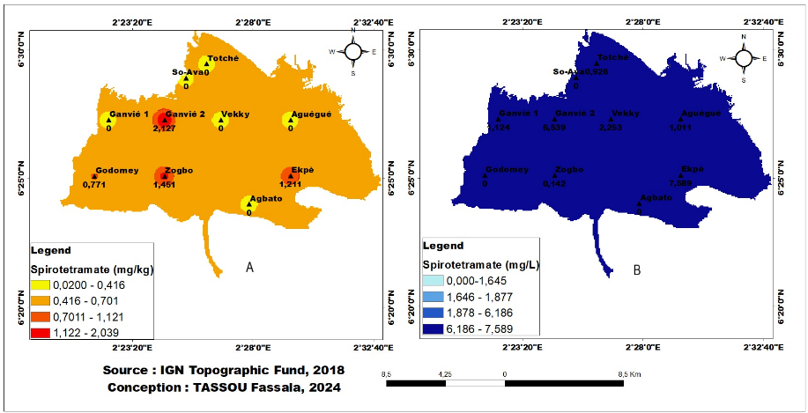
Figure 16: Estimated Spirotetramat Concentrations in Sediment (A) and Water (B) across the Entire Lake.
Figure 16 (A and B) presents the estimated distribution of spirotetramat concentrations in both water and sediment throughout the lake. Spirotetramat is detected throughout the lake in both sediment (Figure 16A) and water (Figure 16B), with water concentrations exceeding the established guideline.
3.1.2.3. Spatial Distribution of Hydrocarbons in Water and Sediment
The mean, minimum, maximum, and standard deviation values of the quantified hydrocarbons—including total polycyclic aromatic hydrocarbons (PAHs), total petroleum hydrocarbons (TPHs), and total polychlorinated biphenyls (PCBs)—across the ten sampling stations are summarized in Table 3 below. The concentrations of these hydrocarbons in both water and sediment are compared with Canadian regulatory guidelines.
Table 3: Summary of Hydrocarbon Concentrations Measured in Lake Nokoué.
Paramètres | PAHs water | PAHs sediment | TPH water | TPH sediment | PCBs sediment | PCBs water
Agbato | 0,147 | 0,145 | 0,158 | 0,157 | 0 | 0
Godomey | 0,018 | 0,137 | 0,019 | 0,148 | 0 | 0
Zogbo | 0,050 | 0,134 | 0,054 | 0,145 | 0 | 0
Ekpè | 0,028 | 0,118 | 0,030 | 0,127 | 0 | 0
Ganvié 2 | 0,033 | 0,151 | 0,036 | 0,163 | 0 | 0
Vekky | 0,075 | 0,142 | 0,081 | 0,153 | 0 | 0
Aguégué | 0,121 | 0,149 | 0,131 | 0,161 | 0 | 0
So-Ava | 0,119 | 0,150 | 0,129 | 0,162 | 0 | 0
Totchè | 0,034 | 0,161 | 0,037 | 0,174 | 0 | 0
Ganvié 1 | 0,030 | 0,157 | 0,032 | 0,170 | 0 | 0
Mean | 0,065 | 0,144 | 0,071 | 0,156
Maximum | 0,147 | 0,161 | 0,158 | 0,174 | 0,000 | 0,000
Minimum | 0,018 | 0,118 | 0,019 | 0,127 | 0,000 | 0,000
Standard Deviation | 0,047 | 0,012 | 0,051 | 0,014 | 0 | 0
Norm | 0,01mg/L | 1000mg/Kg | 0,01mg/L | 1000mg/Kg | - | -

PAHs=hydrocarbures aromatiques polycycliques totaux, TPH= hydrocarbure pétroliers totaux, BCPs =polychlorobiphényles.

- Hydrocarbures Aromatiques Polycycliques Totaux (PAHs)
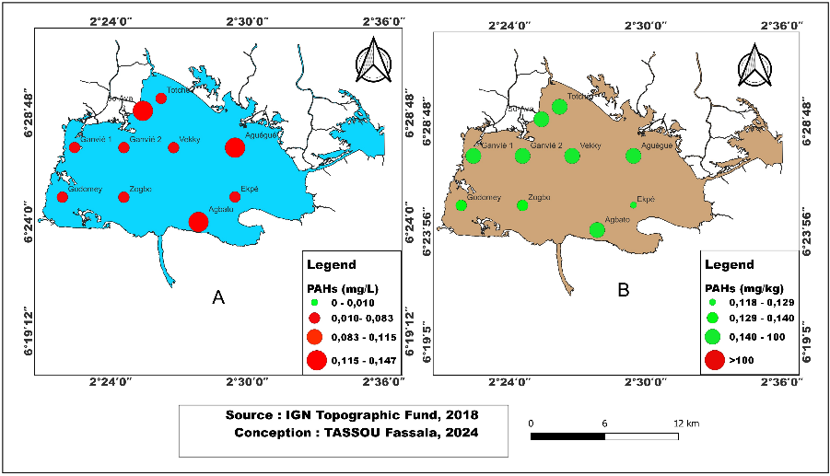
Figure 17: Spatial Distribution of Total Polycyclic Aromatic Hydrocarbons (PAHs) in Water (A) and Sediment (B) across the Ten Stations
Figure 17 (A and B) illustrates the spatial distribution of total polycyclic aromatic hydrocarbon (PAH) concentrations in both water and sediment across the ten sampling stations. In water (Figure 17A), PAH concentrations at all ten stations exceed the Canadian guideline of 0.01 mg/L, with a maximum of 1.14 mg/L recorded at Agbato and a minimum of 0.02 mg/L at Godomey. The mean concentration across the lake is 0.07 ± 0.05 mg/L, which is above the recommended limit.
In sediment (Figure 17B), PAH concentrations at all ten stations are below the guideline value of 1000 mg/kg, with a maximum of 0.16 mg/kg at Totchè and a minimum of 0.12 mg/kg at Epkè. The mean sediment concentration across the lake is 0.14 ± 0.01 mg/kg.

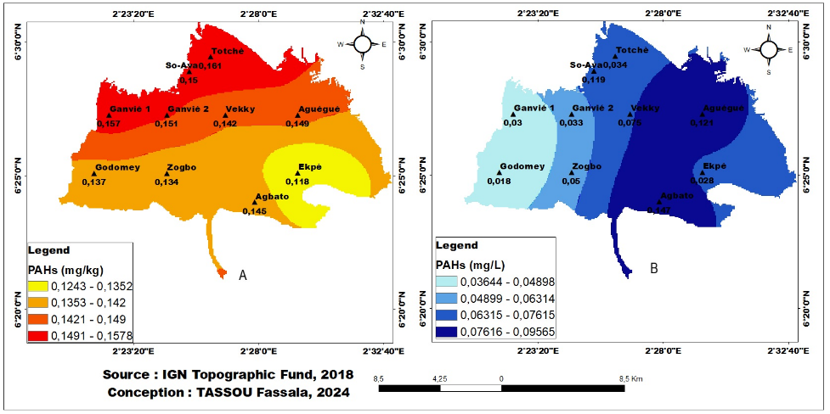
Figure 18 : Estimated PAH Concentrations in Sediment (A) and Water (B) across the Entire Lake
Figure 18 (A and B) presents the estimated distribution of polycyclic aromatic hydrocarbons (PAHs) in both water and sediment throughout the lake. PAH concentrations in sediment (Figure 18A) are highest at Totchè, Sô-Ava, Ganvié 1, and Ganvé 2. In contrast, PAH levels in water (Figure 18B) exceed the guideline values, with particularly elevated concentrations observed at Vékky, Aguégué, Agbato, and the Cotonou Channel.
- Hydrocarbures pétroliers totaux (HPT)
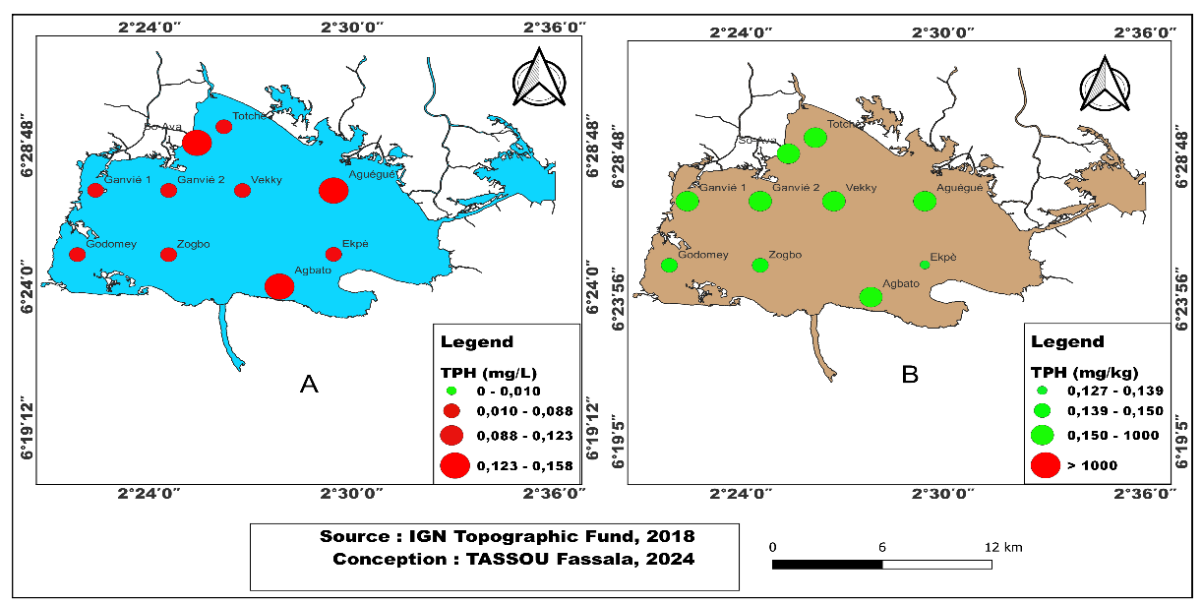

Figure 19: Spatial Distribution of Total Petroleum Hydrocarbons (TPHs) in Water (A) and Sediment (B) across the Ten Stations

Figure 19 (A and B) illustrates the spatial distribution of total petroleum hydrocarbon (TPH) concentrations in both water and sediment across the ten sampling stations. In water (Figure 19A), TPH concentrations at all ten stations exceed the Canadian guideline of 0.01 mg/L, with a maximum of 0.16 mg/L recorded at Agbato and a minimum of 0.019 mg/L at Godomey. The mean water concentration across the lake is 0.07 ± 0.05 mg/L.
In sediment (Figure 19B), TPH concentrations at all stations remain below the guideline value of 1000 mg/kg, with a maximum of 0.17 mg/kg observed at Totchè and a minimum of 0.13 mg/kg at Epkè. The mean sediment concentration across the lake is 0.16 ± 0.01 mg/kg.

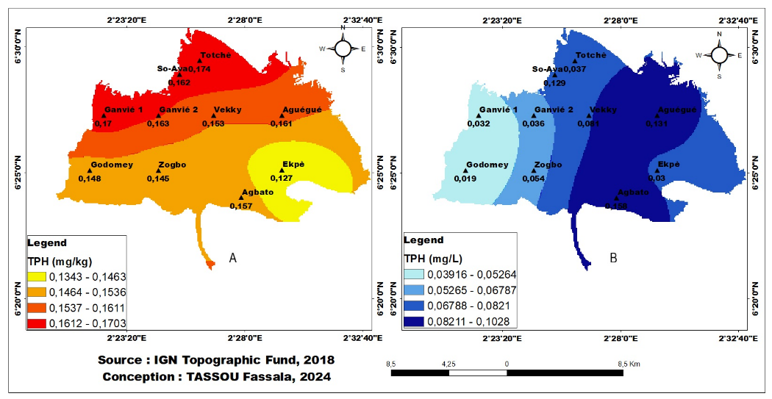
Figure 20: Estimated Total Petroleum Hydrocarbon (TPH) Concentrations in Sediment (A) and Water (B) across the Entire Lake

Figure 20 (A and B) presents the estimated distribution of total petroleum hydrocarbons (TPHs) in both water and sediment throughout the lake. TPH concentrations in sediment (Figure 20A) are highest at Totchè, Sô-Ava, Ganvié 1, and Ganvié 2. In contrast, TPH levels in water (Figure 20B) exceed the guideline values, with particularly elevated concentrations observed at Vékky, Aguégué, Agbato, and the Cotonou Channel.
Regarding PAHs, twenty-two polycyclic aromatic hydrocarbons were quantified in both water and sediment. Among these, only three compounds were detected: acenaphthylene (in water) and benzo[e]pyrene and 3-methylcholanthrene (in both water and sediment). Concerning PCBs, fourteen polychlorinated biphenyls were analyzed, all of which were undetectable in both water and sediment.

3.1.3. Correlation between Trace Elements, Pesticides, and Hydrocarbons in Water and Sediment across the Sampling Stations
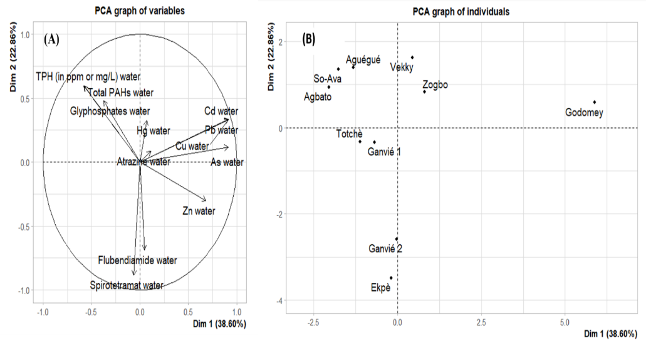

Figure 21: Principal Component Analysis of Pollutants in Water (A) and Station Characteristics (B) in Terms of Water Pollutants
The principal component analysis (PCA) presented in Figure 21 (A and B) allowed for the assessment of correlations among different water pollutants along the first two axes, designated as Dim 1 and Dim 2. These two axes collectively explain 61.46 % of the observed variability, with Dim 1 accounting for 38.60 % and Dim 2 for 22.86 % of the variance, providing a significant representation of the overall influence of pollutants on the sampling stations.The correlation analysis among the three groups of water pollutants (Figure 21 (A and B)) indicates that cadmium, lead, copper, and arsenic are strongly correlated with each other and are characteristic of the stations Vékky, Zogbo, and Godomey, suggesting a common source for these trace elements in water. Total polycyclic aromatic hydrocarbons (PAHs), total petroleum hydrocarbons (TPHs), and glyphosate are also strongly correlated, reflecting the status of stations Aguégué, Sô-Ava, and Agbato, implying a shared source. In contrast, Totchè, Ganvié 1, Ganvié 2, and Epkè are distinguished by elevated spirotetramat concentrations. Furthermore, no station exhibited high levels of zinc or flubendiamide.
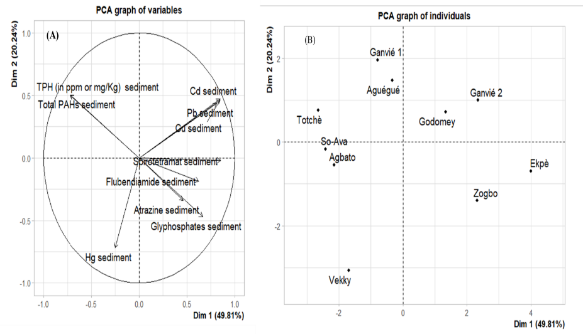
Figure 22: Principal Component Analysis of Sediment Pollutants (A) and Station
Characteristics (B) in Terms of Sediment Contamination
The principal component analysis (PCA) depicted in Figure 22 (A and B) enabled the evaluation of correlations among sediment pollutants along the first two axes, designated Dim 1 and Dim 2. These axes account for 70.05 % of the observed variability, with Dim 1 explaining 49.81 % and Dim 2 20.24 % of the total variance, providing a robust representation of the overall influence of pollutants on the sampling stations.
The correlation analysis of sediment contaminants (Figure 22 (A and B)) indicates that lead, copper, and cadmium are strongly interrelated and characterize the stations Gogomey and Ganvié 2, suggesting a common source for these trace elements. Total polycyclic aromatic hydrocarbons (PAHs) and total petroleum hydrocarbons (TPHs) are also strongly correlated, reflecting the conditions at Totchè, Ganvié 1, and Aguégué, which implies a shared origin of hydrocarbons in the sediment.
The pesticides spirotetramat, flubendiamide, glyphosate, and atrazine exhibit strong intercorrelations and characterize the stations Zogbo and Epkè, indicating a common source for the pesticides detected in sediments. Conversely, the stations Sô-Ava, Agbato, and Vékky are distinguished by elevated mercury concentrations.

3.2 DISCUSSION
The present study provided a comprehensive assessment of the chemical pollution status within the water–sediment matrix of Lake Nokoué.

3.2.1. Spatial Distribution of Trace Metals (ETMs) in Water and Sediment
The mean concentrations of trace metals (ETMs) detected in the water samples were 0.169 mg/L, 1.36 mg/L, 0.004 mg/L, 0.001 mg/L, 0.001 mg/L, and 0.002 mg/L for cadmium, copper, lead, arsenic, zinc, and mercury, respectively. All these values fall below the Canadian guideline thresholds (Canadian Council of Ministers of the Environment, 1999), with the exception of cadmium, which exceeds the permissible limit. The concentrations obtained in this study are higher than those reported by Agbohessi et al. (2023) (0.03 mg/L), Agbandou et al. (2018) (0.11 mg/L), and Kpiagou et al. (2022) (0.0004 mg/L) in the Didagou basin (Togo) for cadmium, copper, lead, zinc, and mercury. Conversely, they remain lower than the concentrations reported by Kaki et al. (2011) (10.1 mg/L) and Naeem et al. (2023) (6.66 mg/L) for lead and mercury, respectively.

The mean concentrations of ETMs in sediments were 0.298 mg/kg, 2.408 mg/kg, 0.006 mg/kg, and 0.001 mg/kg for cadmium, copper, lead, and mercury, respectively. These values are below the established Canadian sediment quality guideline thresholds (Canadian Council of Ministers of the Environment, 1999). However, the observed levels are higher than those reported by Ouattara et al. (2021) (0.2 mg/kg for lead) in the N’Zi River (Côte d’Ivoire), yet lower than the findings of Hounkpatin et al. (2012) (0.74 mg/kg), Goussanou et al. (2018) (16.45 mg/kg) in the Nokoué–Porto-Novo lagoon complex, and Chouti (2011) (21.3 mg/kg) in Lake Ahémé, as well as the range reported by Zoffoun & Dassi (2019) (0.03–0.13 mg/kg) for cadmium, copper, lead, and mercury, respectively.

The elevated concentrations of ETMs in Lake Nokoué can be attributed to the continuous inflow of household waste from lakeside communities, biomedical waste from hospitals and clinics located within these settlements, and, more importantly, from major hospitals situated in Cotonou. Such waste materials contain toxic substances associated with radiological equipment, laboratory reagents, dental care, expired pharmaceuticals, and broken thermometers or batteries. These sources release hazardous chemical elements such as toxic metals—including lead and copper from spent batteries, cadmium, and zinc—into the aquatic environment (Adjagodo et al., 2016; Bankolé & Olou, 2000).

Furthermore, the lake receives significant inputs of untreated domestic and urban wastewater as well as surface runoff from the city districts of Cotonou and Abomey-Calavi through the Cotonou Channel, contributing to the chemical contamination of the aquatic system (Saizonou et al., 2014; Youssao et al., 2011).

3.2.2. Spatial Distribution of Pesticides in Water and Sediment
The mean concentrations of pesticides detected in the water samples were 0.084 ± 0.063 mg/L, 2.473 ± 1.51 mg/L, 0.658 ± 1.77 mg/L, and 1.958 ± 2.79 mg/L for glyphosate, atrazine, flubendiamide, and spirotetramat, respectively. These concentrations are significantly higher than the Canadian environmental quality guidelines. The results obtained in this study exceed those reported by Goura et al. (2023) (0.01 mg/L) in the shrimp fisheries waters of the Lower Ouémé at Ouinhi, Gbaguidi et al. (2011) (0.10 mg/L) in the Agbodo River, and Aikpo et al. (2015) (0.0017 mg/L) in Lake Toho for atrazine and glyphosate, respectively. However, the concentrations reported by Goura et al. (2023)—1.88 mg/L, 2.11 mg/L, and 2.77 mg/L for glyphosate, and 3.40 mg/L and 3.05 mg/L for atrazine in the municipalities of Kétou, Zagnanado, and Ouinhi—are higher than those found in the present study.

The mean concentrations of pesticides in the sediments across the entire lake were 0.133 ± 0.14 mg/kg, 5.899 ± 4.07 mg/kg, 0.462 ± 1.37 mg/kg, and 0.556 ± 0.79 mg/kg for glyphosate, atrazine, flubendiamide, and spirotetramat, respectively. It should be noted that no previous studies have specifically investigated these pesticide types in sediment matrices.

The elevated concentrations of pesticides observed in the lake’s waters can be attributed to intensive agricultural activities conducted along its shores, particularly vegetable farming. Among organophosphates, glyphosate [N-(phosphonomethyl)glycine] is the only one widely used in agriculture in Benin, serving as a broad-spectrum, post-emergent systemic herbicide. In order to reduce labor associated with manual weeding and free up time for other income-generating activities, farmers frequently overuse this herbicide, marketed under multiple commercial names. Following rainfall or irrigation, glyphosate residues are washed off treated fields and enter surface waters, thereby contaminating aquatic ecosystems and posing risks to aquatic organisms and water users (Agbohessi et al., 2023; Solomon & Thompson, 2003; Thorat et al., 2022). This process likely explains the high concentration of glyphosate detected in Lake Nokoué.

Moreover, cotton cultivation in Benin is characterized by intensive pesticide application. Among the most commonly recommended pesticides for cotton protection is Tihan 175 O-TEQ, which contains flubendiamide (100 g/L) and spirotetramat (75 g/L) and is applied during two to four of the six recommended treatment cycles, depending on the ecological zone (Agbohessi et al., 2012). This composition corroborates the elevated concentrations of these compounds detected in the study area. These findings further confirm both the density of agricultural practices surrounding the lake and the contribution of pesticide-contaminated upstream inflows.

Additionally, the Ouémé River, originating from the Atacora highlands in northern Benin, serves as a major conduit for agricultural effluents containing pesticide residues from northern and central cotton-growing basins. During flood events, these residues are transported downstream to Lake Nokoué before ultimately discharging into the Atlantic Ocean via the Cotonou Channel. Along this route, a significant proportion of the pesticide load is deposited within the lake, thereby contributing to its contamination.

Adechian et al. (2015) also reported that the most frequently detected active ingredients in pesticides used within Benin’s cotton basin include glyphosate, atrazine, flubendiamide, spirotetramat, and several pyrethroids such as emamectin, cyfluthrin, cypermethrin, and betacyfluthrin. This observation provides further support for the findings of the present study.

3.2.3 Spatial Distribution of Hydrocarbons in Water and Sediment
The mean concentrations of hydrocarbons in the water were 0.065 ± 0.047 mg/L and 0.071 ± 0.051 mg/L for total polycyclic aromatic hydrocarbons (PAHs) and total petroleum hydrocarbons (TPHs), respectively. These concentrations exceed the Canadian environmental quality guidelines. The total aromatic hydrocarbons identified include acenaphthylene (in water), benzo[e]pyrene, and 3-methylcholanthrene. These concentrations are considerably higher and differ from those reported by Tossou (2001), who found values ranging from 0.067 to 0.137 μg/L, and by Dovonou et al. (2019), who reported concentrations of naphthalene (0.01–0.03 μg/L), acenaphthene (0.02–0.05 μg/L), anthracene (0.09–0.1 μg/L), fluoranthene (0.0–0.06 μg/L), and acenaphthene (0.07–0.1 μg/L).
The mean concentrations of total hydrocarbons in the sediment were 0.14 ± 0.01 mg/kg and 0.16 ± 0.01 mg/kg for total PAHs and total TPHs, respectively. These values are below the Canadian guideline thresholds. It should be noted that these hydrocarbons have not previously been quantified in the sediments of Lake Nokoué.
The elevated levels of hydrocarbons observed in the lake can be primarily explained by the proximity of Benin to Nigeria, which facilitates illicit trafficking of petroleum products such as gasoline, diesel, engine oil, and kerosene (Hoteyi et al., 2014). Furthermore, the literature indicates that, in addition to the discharge of used engine oils from motorized boats regularly emptied into the lake, the water body is often used as a storage site for jerrycans filled with petroleum products, which remain submerged for days or even months (Dovonou, 2008; Dovonou et al., 2011; Dovonou et al., 2019; Hoteyi et al., 2014). Such practices contribute significantly to the accumulation of hydrocarbons in the aquatic environment.
Moreover, certain traders deliberately submerge or spill containers of petroleum products into the lake to evade law enforcement inspections (Hoteyi et al., 2014). In an attempt to avoid shipwrecks or to reduce load weight while fleeing customs pursuit, voluntary discharges of fuel are often performed to stabilize overloaded boats. Accidental spills also occur due to the rupture of used containers or the capsizing of boats, especially during storms or under strong, uncontrolled currents (Dovonou, 2008). These various circumstances lead to the massive discharge of petroleum-derived pollutants into the water body, thereby compromising the physicochemical quality of this aquatic ecosystem.
With regard to polychlorinated biphenyls (PCBs), no detectable concentrations were recorded in either the water or sediment samples from the lake, which contrasts with the findings of Dovonou et al. (2019), who reported potential PCB contamination in the aquatic environment.
The observed variations across the results may be attributed to differences in sampling environments and collection conditions, including the hydrological regime, geographic location of the water bodies, and the sampling period, which were not identical across studies. Similarly, the relatively low pollutant concentrations detected in sediments may be explained by the constant interaction between sediment and water. Due to leaching processes, contaminants initially adsorbed onto sediment particles may subsequently be released into the water column.

4. Conclusion

The assessment of pollution in Lake Nokoué in this study reveals that the lake's water is heavily polluted by heavy metals (cadmium), pesticides (glyphosate, atrazine, flubendiamide, and spirotetramat), polycyclic aromatic hydrocarbons, and total petroleum hydrocarbons, which are well above the recommended standard. On the other hand, the lake's sediments are less contaminated by these three types of pollutants, but require special attention. This could be justified by the hydrography of this ecosystem, as it is the receptacle for watercourses from the cotton basin, effluents carried by rainwater collectors from surrounding towns, and the transport of contraband petroleum products. Therefore, in order to avoid an ecological disaster with a heavy toll on public health, it is imperative to pay more attention to the pollution of this lake in order to curb the erosion of biodiversity and, above all, to preserve the health of the populations that consume aquatic products.

COMPETING INTERESTS DISCLAIMER:
Authors have declared that they have no known competing financial interests OR non-financial interests OR personal relationships that could have appeared to influence the work reported in this paper.

Disclaimer (Artificial intelligence)
Option 1:
Author(s) hereby declare that NO generative AI technologies such as Large Language Models (ChatGPT, COPILOT, etc.) and text-to-image generators have been used during the writing or editing of this manuscript.
Option 2:
Author(s) hereby declare that generative AI technologies such as Large Language Models, etc. have been used during the writing or editing of manuscripts. This explanation will include the name, version, model, and source of the generative AI technology and as well as all input prompts provided to the generative AI technology
Details of the AI usage are given below:
1.
2.
3.

References
[1] Adjagodo, A., Tchibozo, M. A. D., Kelome, N. C., & Lawani, R. (2016). Flux des polluants liés aux activités anthropiques, risques sur les ressources en eau de surface et la chaine trophique à travers le monde : Synthèse bibliographique. International journal of biological and chemical sciences, 10(3), Article 3. https://doi.org/10.4314/ijbcs.v10i3.43

[2] Agbohessi, P., Guedegba, L., Pelebe, R., & Toko I. I. (2023). Exposition de la faune ichthyenne et autres animaux aquatiques aux polluants organiques, chimiques et biologiques dans le lac Nokoué au Sud du Bénin : Synthèse documentaire. Revue Marocaine des Sciences Agronomiques et Vétérinaires, 11(3), Article 3. https://doi.org/10.4314/ijbcs.v15i6.33

[3] Agbohessi, P. T., Toko, I. I., Attakpa, E. Y., & Kestemont, P. (2012). Synthèse des caractéristiques physico-chimiques et effets écotoxicologiques du Tihan 175 O-TEQ utilisé dans la protection phytosanitaire du cotonnier au Bénin. International Journal of Biological and Chemical. https://doi.org/10.4314/ijbcs.v6i5.34

[4] Agbohessi, T. P., Toko, I. I., & Kestemont, P. (2012). État des lieux de la contamination des écosystèmes aquatiques par les pesticides organochlorés dans le Bassin cotonnier béninois. Cahiers agricultures, 21(1), Article 1. https://doi.org/10.4314/ijbcs.v12i3.26

[5] Altındağ, A., & Yiğit, S. (2005). Assessment of heavy metal concentrations in the food web of Lake Beyşehir, Turkey. Chemosphere, 60(4), 552–556. https://doi.org/10.1016/j.chemosphere.2005.01.009

[6] Cherifi, A., & Mekhissi, M. E. M. (2022). Contribution to the assessment of marine pollution by heavy metals in algae (case of Bouzadjer), Wilaya of Ain Temouchent. https://dspace.univ-temouchent.edu.dz/handle/123456789/1562

[7] Chouti, W. (2011). Study of chemical pollution in a tropical lagoon (water, sediments, fish): Case of the Porto-Novo lagoon (Southern Benin) [PhD Thesis]. Single doctoral thesis, University of Abomey-Calavi, Benin. https://doi.org/10.21474/ijar01/7838

[8] Coulibaly, N. D., & Ouedraogo, A. (2022). Evaluation of heavy metal content in the liver and muscle tissues of Nile tilapia and African catfish in the Nagbangre fishery, Burkina Faso. Sciences Naturelles et Appliquées, 41(2(1)), Article 2(1). https://revuesciences-techniquesburkina.org/index.php/sciences_naturelles_et_appliquee/article/view/1148

[9] Dione, C. T. (2022). Determination of organic pollutant and heavy metal content in fish from the bays off the coast of Dakar (Soumbédioune and Hann) [PhD Thesis, University of Strasbourg; Cheikh Anta Diop University (Dakar)]. https://theses.hal.science/tel-04121735/

[10] Dovonou, F. E., Ibikounle, M., Akouedegni, C. G., Aissi, V., Dossou, M. P., & Mama, D. (2019). Impacts of polycyclic aromatic hydrocarbons on fish: The case of tilapia from Lake Nokoué in southern Benin (West Africa). European Scientific J, 36, 458–474. https://doi.org/10.19044/esj.2019.v15n36p458

[11] El Morhit, M., Belghity, D., & El Morhit, A. (2013a). Metal contamination of Pagellus acarne, Sardina pilchardus, and Diplodus vulgaris from the southern Atlantic coast (Morocco). LARHYSS Journal P-ISSN 1112-3680/E-ISSN 2521-9782, 14. https://www.asjp.cerist.dz/en/article/1000

[12] El Morhit, M., Belghity, D., & El Morhit, A. (2013b). Metal contamination of Pagellus acarne, Sardina pilchardus and Diplodus vulgaris from the southern Atlantic coast (Morocco). LARHYSS Journal P-ISSN 1112-3680/E-ISSN 2521-9782, 14, Article 14. https://www.asjp.cerist.dz/en/article/1000

[13] Goussanou, A., Youssao, A. K. A., Dagan, S. B., & Youssao, A. K. I. (2018). Bioaccumulation of Heavy Metals (Pb, Cd, Cu, Zn, Fe, Cr, Ni, As) by Cardisoma Armatum Crabs (Herklots, 1851) in the “Lake Nokoué-Porto—Novo Lagoon” Complex in Southern Benin. Afr. Sci, 14, 255–266. https://doi.org/10.12692/ijb/12.1.98-110

[14] JB, H., NC, K., RAN, L., & ARMA, A. (2017). State of play of aquatic ecosystem pollution in Benin (West Africa). Larhyss Journal, 30. https://doi.org/10.4314/ijbcs.v12i2.34

[15] Kayalto, B., & Mbofung, C. M. (2009). Contribution to the assessment of heavy metal contamination of three fish species, sediments, and waters of Lake Chad. [PhD Thesis, ENSAI-University of Ngaoundéré, Cameroon]. https://auf.hal.science/hal-00825482/document

[16] Lévêque, C., & Paugy, D. (1999). Impacts of human activities. Fish of African inland waters, Diversity, Ecology, Human use. IRD Edition, Paris, 365–383. https://horizon.documentation.ird.fr/exl-doc/pleins_textes/divers10-01/010020000.pdf

[17] Manou, B. E., Sohounnon, M., Dovonou, F., Koumolou, L., & EDORH, P. A. (2020a). Évaluation des risques d’intoxication alimentaire liés à la consommation des produits halieutiques du lac Nokoué, Bénin, Afrique de l’Ouest. Afrique Science, 16(5), 292‑302. https://doi.org/10.35759/jabs.154.8

[18] Oumar, B., Ekengele, N. L., & Balla, O. A. D. (2014). Assessment of the level of heavy metal pollution in Lakes Bini and Dang, Adamawa Region, Cameroon. Africa Science: International Journal of Science and Technology, 10(2), Article 2. https://www.ajol.info/index.php/afsci/article/view/109662

[19] Ouro-Sama, K., Solitoke, H. D., Gnandi, K., Afiademanyo, K. M., & Bowessidjaou, E. J. (2014). Assessment and health risks of heavy metal bioaccumulation in fish species of the Togolese lagoon system. VertigO - the electronic journal in environmental sciences, 14(2), Article 2. https://doi.org/10.4000/vertigo.15093

[20] Samia, A., & Emam, A. S. (2024). ARTICLE INFO ABSTRACT. https://journals.ekb.eg/article_303529.html. https://doi.org/10.21608/ejabf.2023.303529

[21] Sanou, A., Coulibaly, S., & Atse, B. C. (2020). Evaluation of the heavy metal binding capacity of sediments from a pond fish farm. Afrique Science, 16(4), 85–97. https://www.afriquescience.info/7-evaluation-de-la-capacite-de-fixation-des-metaux-lourds-par-les-sediments-d-une-ferme-piscicole-en-etang/

[22] Veena, P., Cornetta, K., Davidson, A., Agüero, B., McMahel, J., Traycoff, C. M., & Srour, E. F. (1997). Preferential sequestration in vitro of BCR/ABL negative hematopoietic progenitor cells among cytokine nonresponsive CML marrow CD34+ cells. Bone marrow transplantation, 19(12), 1213–1221. https://doi.org/10.1038/sj.bmt.1700818

[23] Zerrouqi, Z., Sbaa, M., Chafi, A., & Aqil, H. (2013). Contribution to the study of water quality in the Nador lagoon: Impact of anthropization. Bulletin of the Scientific Institute, Rabat, Life Sciences Section, 35, 51-59. https://doi.org/10.5150/cmcm.2011.039

