Biflavonoids from Ochna schweinfurthiana Restore Rotenone Toxicity in Drosophila melanogaster: Implications for Parkinson's Disease
Abstract:
Nowadays, neurodegenerative diseases represent a major health problem worldwide, with Parkinson's disease being the second most common neurodegenerative disease after Alzheimer's disease. Medical research has led to the development of a large number of drugs and palliative therapies; however, they have not succeeded in curing or halting the progression of the disease, have numerous side-effects and are subject to a loss of efficacy over time.
The aim of this study was to evaluate the effects of 3 biflavonoids on key targets involved in the pathophysiological process of rotenone-induced PD, using Drosophila melanogaster as an animal model. In silico molecular docking analysis was carried out using Molegro virtual Docker software between pathological PD targets (alpha-synuclein, acetylcholine esterase, super oxide dismutase, nitric oxide synthase, catalase) and the 3 biflavonoids. The toxicity of the biflavonoids was then assessed to determine the appropriate treatment dose for Drosophila exposed to 250/500 µM rotenone for 7 days. Motor activity was assessed by negative geotaxis and open field assays; oxidative stress markers and acetylcholinesterase activity were also assayed.
The 3 biflavonoids OB3B, OE1 and OSF3/EF1 (Isochamaejasmin, Chamaejasmin, and Amentoflavone) all obtained excellent interaction scores with the pathological targets; showing significant activity (p < 0.001) by increasing GSH levels and reducing MDA and NO levels, with an increase in acetylcholinesterase activity and a restoration of the balance of activity between SOD and catalase. Finally, OSF3/EF1 proved to be the best of the 3 biflavonoids studied. These observations position these molecules as potential candidates for the formulation of more effective lead drug candidates for PD treatment.
Key words: Parkinson's disease, biflavonoids, rotenone, Drosophila melanogaster, in silico
Introduction
With the aging and longer lifespan of the global population, age-related diseases are receiving increased attention from the scientific community. Neurodegenerative diseases are a major health problem in the world; with Parkinson’s disease (PD) being the second most common after Alzheimer’s disease (Aqsa et al., 2025; P. Supriya & S. Rajaram, 2021). More than 11 million people worldwide suffer from it (Luo et al., 2024); including 1% of the population over 50 years old, 1.5 to 2% of the population over 60 years old and 4% of the population over 80 years old (Ayajuddin et al., 2022; Blauwendraat et al., 2020; Dorsey et al., 2018). PD is characterized by a set of motor symptoms such as resting tremors, bradykinesis, rigidity, and postural instability, as well as various other non-motor symptoms (Jankovic & Tan, 2020). Furthermore, patients experience slow degeneration of dopaminergic neurons in the substantia nigra pars and the formation of intracytoplasmic inclusions with abnormal Lewy bodies (LB) composed of α-synuclein.
Currently, the exact cause of the disease is not known, as several molecular mechanisms are involved in its pathogenesis, namely neuroinflammation and oxidative stress. PD is considered a multifactorial disease resulting, in most cases, from the combined effects of several risk factors, notably genetic mutations of about 20 genes and environmental exposure to certain toxins. For instance, most pesticides such as 1-methyl-4-phenyl-1,2,3,6-tetrahydropyridine (MPTP), paraquat and rotenone (Blauwendraat et al., 2020) have been demonstrated to cause PD. Numerous study models have been developed, including cellular and animal models involving human mutated α-synuclein (A53T), chronic exposure to rotenone, 6-hydroxydopamine, and MPTP (Segura-Aguilar, 2018; Varga et al., 2014). The model based on rotenone toxicity is particularly interesting and relevant to reproduce the crucial pathological and biochemical characteristics of PD. Indeed, rotenone, a widely used natural pesticide can cross the blood-brain barrier and accumulate in the mitochondria of neuronal cells where it disrupts oxidative phosphorylation by inhibiting respiratory chain complex I. It was shown in vitro that rotenone induced cell apoptosis, α-synuclein accumulation and aggregation, and oxidative stress causing the degeneration of dopaminergic neurons (Sayed et al., 2022).
Drosophila melanogaster’s dopaminergic system presents functional and molecular similarities with that of mammals, constituting an ideal experimental model for the study of PD. Regarding the pathophysiological mechanism, genetic investigations revealed that 75% of human genes related to the disease have functional orthologues in drosophila with 80% of domains conserved at the protein level (Wangler et al., 2017). Drosphila melanogaster thus allows for in-depth cellular and molecular studies that provide a unique perspective on the mechanisms and pathways underlying the pathogenesis of PD (Xiong & Yu, 2018). Currently, several strategies are used for the treatment of the disease; ranging from simple medication to the use of nanotechnologies like deep brain stimulation (Martinez-Fernandez et al., 2018; Torres-Ortega et al., 2019). Many drugs are approved and used to treat the various symptoms characteristic of the neuropathology, the most common being levodopa (L-DOPA), a precursor of dopamine, which increases dopamine levels in the brain. In addition, we have dopaminergic agonists that act directly on dopaminergic receptors such as pramipexole, which are inhibitors that oppose the degradation of dopamine in the brain or even catechol O-methyltransferases (ICOMT) like entacapone (Armstrong & Okun, 2020). Unfortunately, these drugs have undesirable side effects and are prone to a loss of effectiveness over time, which cannot cure the disease or stop its progression. Thus, the search for new molecules with fewer side effects or capable of stopping the progression of the disease is increasingly solicited. The purpose of this study was to investigate in silico, in vivo and in vitro, the neuroprotective and curative effect of 3 biflavonoids against the toxicity induced by rotenone in Drosophila.
Material and methods
Animals
Drosophila melanogaster used in this work were a donation from Prof Charles Wondji from the CRID (Center for Research on Infectious Diseases), Yaoundé, Cameroon.
Plant material

The biflavonoids used in this research were isolated from the plant Ochna rhizomatosa as described by (Messi et al., 2022) from the laboratory of organic chemistry of the University of Yaoundé I and named OB3B (Isochamaejasmin), OE1 (Chamaejasmin) and OSF3/EF1 (Amentoflavone).

Preparation of the breeding medium for Drosophila
To prepare the culture medium, 4 g agar, 5 g glucose, 7 g corn flour and 5 g yeast were mixed with 200 ml distilled water, and stirred vigorously for 2 minutes. The mixture was then placed in a water bath at 100°C, stirred for 10 minutes to ensure perfect homogeneity. After removing the mixture from the water bath, we continued to stir constantly for 30 minutes to allow gradual cooling. Once cooled, it was transferred to breeding bottles. To facilitate the transfer of Drosophila, they were asleep by the cold on ice, preventing their movements during the culture bottle change.
In silico analysis: Molecular docking
This method is based on the preparation of molecules (ligand and receptor), the use of search algorithms to explore the different possible conformations, and the evaluation of interactions using scoring systems taking into account hydrogen interactions, steric and electrostatic (Oliveira et al., 2026). The results were then analysed to identify the most likely poses and key interactions, which is essential for drug discovery and the study of the mechanisms of action of ligands and receptors.
3D crystal structures of targets used for docking were obtained from the Protein Data Bank (PDB) RCSB (https://www.rcsb.org/) with the following access codes: α-synuclein (PDB ID: 1XQ8), Catalase (PDB ID: 8WZK), SOD (PDB ID: 8VJ5), NO synthase (PDB ID: 2NOS), and Acetylcholinesterase (AchE) (PDB ID: 7E3D). The structure data files (SDF) of biflavonoids and receptors have been downloaded in mol format from the PubChem database and saved.
The molecular anchoring analysis was carried out using MVD software (Molegro Virtual Docker) by importing into the workspace the structures of each biflavonoid and previously prepared targets and by removing water molecules, ions and bound ligands as described by (Dere et al., 2026). The cavities were detected to identify potential binding sites on the target proteins. At the end of the Docking, the best poses were selected for each analysis based on MolDock scores and interactions.
Evaluation of the effect of biflavonoids on the morphological and physical parameters of intoxicated drosophila
Screening for the concentration of rotenone inducing toxicity in Drosophila
Flies were divided into 9 groups (30/groups; 3 replicates each) in which they were exposed to increasing concentrations of rotenone (125, 250 and 500μM) dissolved in two different solvents (ethanol and DMSO). The number of live Drosophila in each group was recorded every day over a period of 7 days and the results expressed as survival percentage. The ideal concentration for the study was chosen; thanks to the negative geotaxis test used to evaluate the mobility of Drosophila. The following table 1 summarizes the different groups and the composition of the diet for each group:

Table 1: Composition of the different types of livestock by treatment group.
Groups | TrEatment
Group I | Normal diet
Group II | Diet + ethanol
GroupIII | Diet + DMSO
Group IV | Diet + rotenone 125µM + ethanol
Group V | Diet + rotenone 250µM + ethanol
GroupVI | Diet + rotenone 500µM + ethanol
Group VII | Diet + rotenone 125µM + DMSO
Group VIII | Diet + rotenone 250µM + DMSO
Group IX | Diet + rotenone 500µM + DMSO

Evaluation of the toxicity of biflavonoids
Flies were divided into 7 groups (30/groups; 3 replicates each) in which they were exposed to two doses of biflavonoids. The number of drosophilae still alive in each group was recorded every day over a 7-day period and the results expressed as a survival percentage. The following table 2 summarizes different groups and the composition of the diet for each:
Table 2: Composition of the different types of livestock by treatment group for each biflavonoid.
GROUPS | TREATMENT
Group I | Normal diet
Group II | Diet + OB3B 250µM
Group III | Diet + OE1 250µM
Group IV | Diet + OSF3/EF1 250µM
Group V | Diet + OB3B 500µM
Group VI | Diet + OE1 500µM
Group VII | Diet + OSF3/EF1 500µM

Negative Geotaxis tests
In this test, the flies were placed in a vertical tube, and their behaviour was observed when they were confronted with gravity as described by (Zhong et al., 2022). Normally, Drosophila tend to move up the tube due to their exploration instinct. However, in case of stress or exposure to specific compounds, their ability to climb may be impaired, manifested as a decrease in the number of Drosophila reaching the top of the tube. By calculating the percentage of drosophila having reached the top of the tube, one can evaluate the impact of various factors on their locomotor behaviour and well-being. This impact is calculated according to the following formula:
$$Performance index=\frac{(NT+NH-NB) *100}{2 * NT}$$
NH = Number of flies crossing the 6cm line; NB= Number of flies that did not cross the 6cm line; NT = Number of flies in the tube.
Drosophila were divided into 9 groups, the composition of which is summarized in Table 3 below (7 days of exposure).
Table 3: Grouping of Drosphila for the Negative Geotaxis test
GROUPS | TREATMENT
Group I | Normal diet + ethanol
Group II | Diet + rotenone 250µM
Group III | Diet + rotenone 250µM + Levodopa 1mM
Group IV | Diet + rotenone 250µM + OB3B 250µM
Group V | Diet + rotenone 250µM + OE1 250µM
Group VI | Diet + rotenone 250µM + OSF3/EF1 250µM
Group VII | Diet + rotenone 250µM + OB3B 500µM
Group VIII | Diet + rotenone 250µM + OE1 500µM
Group IX | Diet + rotenone 250µM + OSF3/EF1 500µM

Five flies from the control and treated groups were briefly immobilized using ice and placed separately in labelled vertical glass columns (length: 15 cm, diameter: 1.5 cm). After recovering from cold exposure (about 20 min), the flies were gently tapped to the bottom of the column. Then, those who were able to climb up to the 6 cm mark at the top and those remaining at the bottom were counted separately. The data were expressed as a percentage of flies that had crossed the column up to 6 cm and beyond in 6 seconds. The operation was spotted three times.
Open field Test
This method was used to evaluate the effective locomotor capacity of Drosophila on a horizontal plane (McMullen et al., 2025). In this test, flies were placed in a horizontal arena locked after falling asleep by the cold. Flies’ motor capacity was evaluated by counting the number of squares crossed during a time lapse of 30 seconds. Drosophila were divided into 9 groups as described in the geotaxis test. Each fly was kept in an arena divided into squares (1 cm x 1 cm) measuring 9 cm in diameter, which can be covered by a Petri dish. The activity and movement of the fly was recorded with a video camera and the distance traveled was recorded by the resulting trajectory during a 30 s time window, which was calculated through the number of squares traversed by each analyzed fly. Video-assisted movement tracking allows the quantification of immobility (time spent without locomotion) and distance traveled (number of squares crossed). Three (3) flies were included for each treatment group in the test.
Evaluation of biochemical parameters in the homogenate of Drosophila
The flies were anesthetized on ice, their bodies crushed and homogenized in 0.1 M phosphate buffer; pH 7.4. The homogenates were filtered then centrifuged at 4000g for 10 minutes. the supernatants were collected, kept at -20°C for assays.
Protein assay
Protein quantification was performed using the Biuret method (Sapan et al., 1999). In different tubes, we added distilled water, biuret reagent and samples. The absorbance of the solution was read at 540 nm against the blank.
Superoxide dismutase assay
Precise volumes of homogenate, carbonate buffer and adrenaline were added to each tube (blank and sample) (Mateo et al., 2010). After homogenization, the absorbance of the test tubes (sample) was measured at 480 nm at 20 and then at 80 seconds against the blank.
Catalase assay
Catalase activity was measured by colorimetric assay (Li et al., 2019). The tubes were plugged using glass beads and the solutions were heated to 100°C for 10 minutes. After cooling, the absorbance of the samples was read against the blanc at 570 nm.
Evaluation of acetylcholinesterase activity
Fifty (50) μL of homogenate was introduced into each sample tube containing 950 μL Tris-HCl 50mM buffer, pH 7.4; 100 μL 2-dithio bis-nitrobenzoic acid (DTNB) and 20 μL 15 mM acetylthiocholine iodide (ATCI) (Yip et al., 1991). The absorbances were read with the spectrophotometer at 412 nm at 1-minute intervals for 5 min against the blanc.
Evaluation of protection parameters and oxidative stress
One hundred (100) μL of homogenate was introduced into each sample tube containing 1500 μL of Ellman reagent (Owen & Butterfield, 2010). The absorbances were read with the spectrophotometer at 412 nm against the blank.
Malondialdehyde assay
Two hundred fifty (250) μL of homogenate was introduced into each sample tube containing 125 μL of TCA 20% and 250 μL of TCA 0.67% (Polzin et al., 2019). The absorbances were read with the spectrophotometer at 530 nm against the blank.
Nitric oxide (NO) Assay
The protocol first consisted of preparing a series of sodium nitrite (NaNO2) standards at known concentrations (Tsikas, 2007). One hundred (100) μL of homogenate was introduced into each sample tube containing 400 μL of distilled water and 500 μL of Griess reagent. The absorbances were read with the spectrophotometer at 546 nm against the blank.
Statistical analyses
Assays were carried out in triple, the data entered into the Excel 2019 spreadsheet and analyzed using the GraphPad Prism software version 8.0.1. The results are expressed as a mean +/- standard deviation. The statistical analyses were carried out using the ANOVA one-way test followed by the Turkey post-test for a significance threshold P<0.05; and the linear correlation was performed using the non-parametric Spearman test.
RESULTS

In silico analyses: Molecular docking
Tables 4 to 8 show the results obtained with the biflavonoids on different molecular targets.

Highest Score Very Interesting Score
Interesting Score Least Interesting Score

Table 4: Docking scores and interaction details for each biflavonoid with αlpha-synuclein
Ligand | MolDock Score (Kcal/mol) | Rerank Score (Kcal/mol) | Interaction (Kcal/mol) | Hbond (Kcal/mol)
OB3B | -110.026 | -82.5857 | -129.858 | -4.08464
OE1 | -107.577 | -79.764 | -127.486 | -3.48556
OSF3/EF1 | -118.27 | -93.9452 | -148.601 | -8.55256

Ligands | Hydrogen bonds | Steric interactions
OB3B | 2 Bonds : 1 with Glu 35 and 1 with Val 40 | 7 interactions: 2 with Lys 32, 2 with Gly 36, 2 with Glu 35 and 1 with Thr 33
OE1 | 2 Bonds: 1 with Val 40 and 1 with Lys 32 | 9 interactions: 4 with Lys 32, 2 with Gly 36, 2 with Glu 35 and 1 with Thr 33
OSF3/EF1 | 4 Bonds: 1 with Lys 32, 1 with Lys 43, 1 with Glu 35 and Gly 36 | 5 interactions: 2 with Glu 35, 1 with Lys 43, 1 with Gly 36 and 1 with Thr 33

Table 5: Docking scores and interaction details for each biflavonoid with acetylcholinesterase
Ligand | MolDock Score (Kcal/mol) | Rerank Score (Kcal/mol) | Interaction (Kcal/mol) | Hbond (Kcal/mol)
OB3B | -134.885 | -95.0224 | -156.654 | -13.1647
OE1 | -134.797 | -94.498 | -156.606 | -13.1292
OSF3/EF1 | -139.967 | -125.52 | -175.092 | -7.87775
Benzatropine | -87.4285 | -65.3332 | -109.042 | -2.36436

Ligands | Hydrogen bonds | Steric interactions
OB3B | 6 Bonds: 1 with Arg 296(B), 1 with Pro 368(B), 1 with Asn 533(B), 1 with His 405(B), 1 with Trp 532(B) and 1 with Glu 313(B) | 5 interactions: 2 with Trp 532(B), 1 with Cys 409(B), 1 with Arg 296(B) and 1 with His 405(B)
OE1 | 6 Bonds: 1 with Arg 296(B), 1 with Pro 368(B), 1 with Asn 533(B), 1 with His 405(B), 1 with Trp 532(B) and 1 with Glu 313(B). | 6 interactions: 2 with Trp 532(B), 1 with Pro 410(B), Cys 409(B), 1 with Arg 296(B) and 1 with His 405(B)
OSF3/EF1 | 4 Bonds: 1 with Asp 404(B), 1 with Asn 233(B), 1 with His 405(B) and 1 with Glu 313(B) | 14 interactions: 4 with Pro 235(B), 3 with his 405(B), 2 with Thr 238(B), 1 with Glu 313(B), 1 with Pro 410(B), 1 with Leu 540(B), 1 with Gln 413(B) and 1 with Asn 233(B)
Benzotropine | 1 Bond with Arg 296(B) | 4 interactions: 2 with His 405(B), 1 with Trp 532(B) and 1 with Pro 235(B)

Table 6: Docking scores and interaction details for each biflavonoid with Superoxide Dismutase (SOD)
 | Ligand | MolDock Score (Kcal/mol) | Rerank Score (Kcal/mol) | Interaction (Kcal/mol) | Hbond (Kcal/mol)
OB3B |  | -120.749 | -62.8637 | -144.215 | -3.67482
OE1 |  | -120.788 | -63.4249 | -144.274 | -3.67636
OSF3/EF1 |  | -120.955 | -104.297 | -162.344 | -1.96654

Ligands | Hydrogen bonds | Steric interactions
OB3B | 2 Bonds: 1 with Glu 43(A) and 1 with Leu 49(B) | 16 interactions: 5 with Leu 49(B), 3 with Asn 39(A), 3 with Met 0(A), 2 with Lys 1(A), 2 with Gln 46(A), and 1 with Glu 43(A)
OE1 | 2 Bonds: 1 with Glu 43(A) and 1 with Leu 49(B) | 17 interactions: 5 with Leu 49(B), 3 with Asn 39(A), 3 with Met 0(A), 2 with Gln 46(A), 1 with Lys 1(A), 1 with Glu 43(A), 1 with Glu 42(A) and 1 with Gly 52(B)
OSF3/EF1 | 1 Bond with Asn 39(A) | 12 interactions: 3 avec Met 0(A), 3 with Glu 42(B), 2 with Leu 49(B), 1 with Asn 39(A), 1 with His 2(A), 1 with Ala 50(B) and 1 with Lys 1(A)

Table 7: Docking scores and interaction details for each biflavonoid with Catalase
Ligand | MolDock Score (Kcal/mol) | Rerank Score (Kcal/mol) | Interaction (Kcal/mol) | Hbond (Kcal/mol)
OB3B | -122.14 | -96.3037 | -142.724 | -10.8078
OE1 | -122.078 | -96.9271 | -142.68 | -10.5125
OSF3/EF1 | -150.727 | -108.433 | -182.694 | -12.9435

Ligands | Hydrogen bonds | Steric interactions
OB3B | 4 Bonds: 1 with His 466(C), 1 with Ser 254(C), 1 with Gln 255(A) and 1 with Arg 170(C) | 6 interactions: 2 with Pro 258(A), 1 with Ala 123(C), 1 with Ser 122(C), 1 with Gly 118(C) and 1 with Arg 170(C)
OE1 | 4 Bonds: 1 with His 466(C), 1 with Ser 122(C), 1 with Gln 255(A) and 1 with Arg 170(C) | 6 interactions: 2 with Pro 258(A), 1 with Ala 123(C), 1 with Ser 122(C), 1 with Gly 118(C) and 1 with Arg 170(C)
OSF3/EF1 | 6 Bonds: 1 with Arg 263(C), 1 with Asp 257(C), 1 with Ser 254(A), 1 with Lys 177(A), 1 with Ala 123(A) and 1 with Arg 127(A) | 9 interactions: 2 with Lys 177(A), 2 with Gly 121(C), 1 with Val 126(A), 1 with Ser 122(A), 1 with Ser 254(C), 1 with Gln 255(A) and 1 with Ser 254(A)

Table 8: Docking scores and interaction details for each biflavonoid with nitric oxide synthase
Ligand | MolDock Score (Kcal/mol) | Rerank Score (Kcal/mol) | Interaction (Kcal/mol) | Hbond (Kcal/mol)
OB3B | -143.013 | -90.4575 | -170.519 | -2.33875
OE1 | -143.143 | -90.2868 | -170.472 | -1.5436
OSF3/EF1 | -186.841 | -119.358 | -215.052 | -10.6518

Ligands | Hydrogen bonds | Steric interactions
OB3B | 3 Bonds: 1 with Arg 193, 1 with Trp 188 and 1 with Cys 194 | 11 interactions: 3 with Cys 194, 2 with Gly 365, 1 with Trp 366, 1 with Arg 193, 1 with Phe 363, 1 with Leu 203, 1 with Val 346 and 1 with Met 349
OE1 | 3 Bonds: 1 with Cys 194, 1 with Trp 188 and 1 with Arg 193 | 14 interactions: 4 with Cys 194, 3 with Gly 365, 1 with Trp 366, 1 with Trp 188, 1 with Arg 193, 1 with Leu 203, 1 with Phe 363, 1 with Val 346 and 1 with Met 349
OSF3/EF1 | 3 Bonds: 1 with Tyr 483, 1 with Arg 193 and 1 with Trp 366 | 11 interactions: 2 with Gly 365, 2 with Val 346, 1 with Trp 366, 1 with Trp 188, 1 with Asn 364, 1 with Leu 203, 1 with Tyr 483, 1 with Ala 191 and 1 with Arg 193

Effect of biflavonoids on Drosophila viability

The first experiment we conducted was to find out the possible toxic effect of rotenone and the biflavonoids on drosophila’s viability. As shown in Figure 1A and B, DMSO was toxic to flies and was therefore replaced by ethanol for rotenone dissolution and used for 2 days. Figures 1 C, D, and E show that the 3 biflavonoids have no effect on drosophila viability at the concentrations tested.

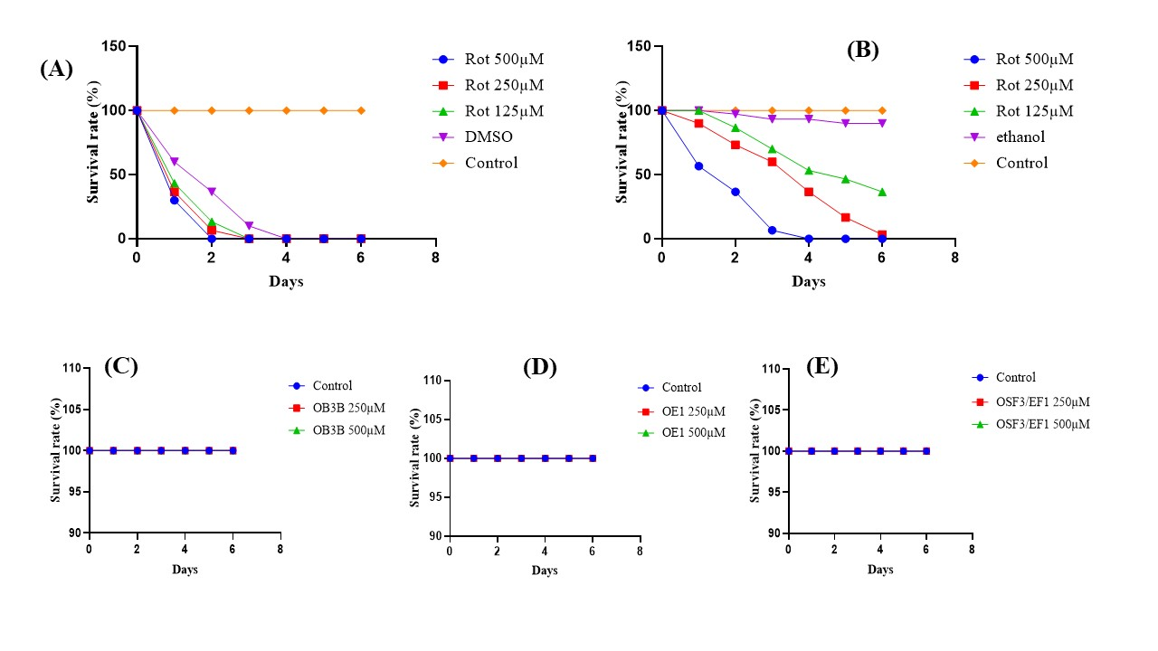

Figure 1: Toxicity of rotenone AND BIFLAVONOIDS on drosophila (exposure for 7 days).
(A-B): Drosophila fed a standard diet with rotenone. (A) Effect of different concentrations of rotenone and DMSO used as a solvent on Drosophila aged 3 to 5 days. (B) Effect of different concentrations of rotenone with ethanol as a solvent on Drosophila aged 3 to 5 days. (C-D): Control: Drosophila fed a standard diet without rotenone. (C) Toxicity of OB3B on Drosophila aged 3 to 5 days. (D) Toxicity of OE1 on Drosophila aged 3 to 5 days. (E) Toxicity of OSF3/EF1 on Drosophila aged 3 to 5 days. Each bar represents the mean ± SEM, n=3 replicates.

Effect of biflavonoids on locomotor, anxiety and willingness to explore of intoxicated Drosophila
Bioflavonoid’s effects on locomotion and anxiety was investigated using the negative geotaxis and the open field test respectively. The results obtained showed that treatment with rotenone at 250 and 500 µM significantly reduced flies’ mobility and their desire to explore their environment. However, treatment with biflavonoids and with the reference drug levodopa significantly increased these functions in drosophila as shown in Figure 2 below.

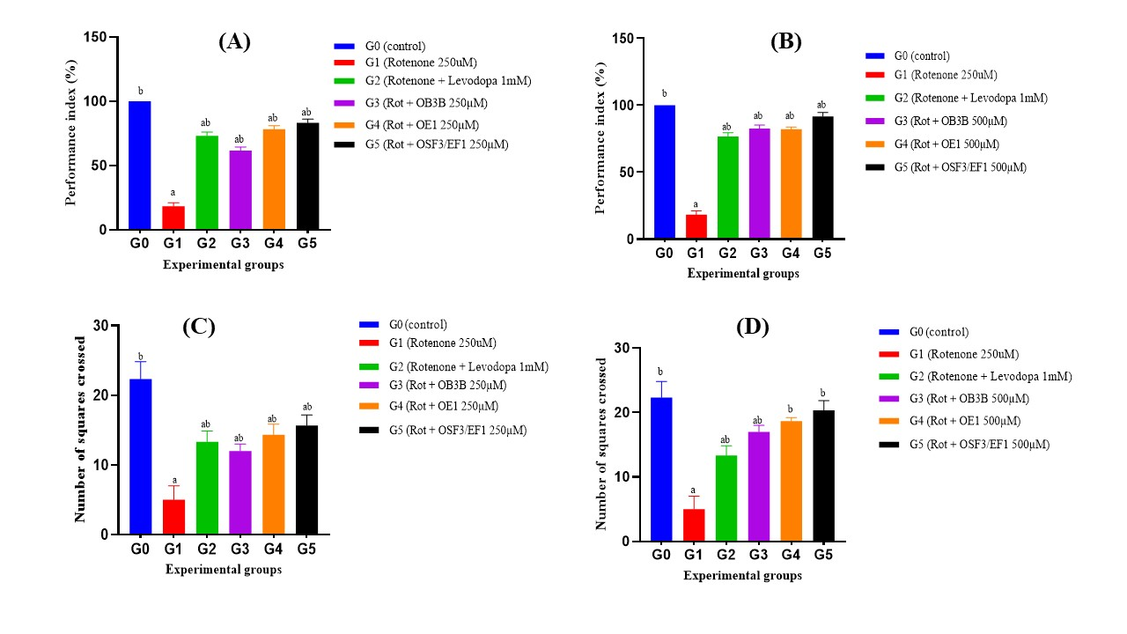

Figure 2: Effect of biflavonoids on the mobility of flies in geotaxis and open field test
Drosophila fed a standard diet with rotenone. (A) Effect of biflavonoids at a concentration of 250µM on Drosophila aged 3 to 5 days. (B) Effect of biflavonoids at a concentration of 500µM on Drosophila aged 3 to 5 days. a= significant compared to the control group p<0.05; b= significant compared to the negative control group (poisoned with rotenone) p<0.05. Rot= Rotenone. (C) Effect of biflavonoids at a concentration of 250µM on Drosophila aged 3 to 5 days. (D) Effect of biflavonoids at a concentration of 500µM on Drosophila aged 3 to 5 days. a= significant compared to the control group p<0.05\; b= significant compared to the negative control group (poisoned with rotenone) p<0.05. Rot= Rotenone. Each bar represents the mean ± SEM, n=3 replicates.

Effect of biflavonoids on the biochemical parameters

Effect of biflavonoids on protein levels

As shown in Figure 3 below, protein level is high in groups treated with rotenone only, at 250 µM and 500 µM respectively (Figure 3 A and B). The same was observed for super oxide dismutase activity (Figure 3 C and D). We can observe a reduced level of protein and super oxide dismutase activity following additional treatment with the biflavonoids.
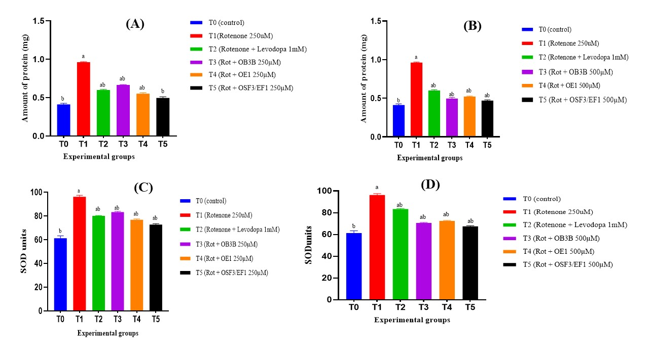

Figure 3: Effect of biflavonoids on total protein content and SOD.
Control: Drosophila fed a standard diet without rotenone. (A) Protein: Effect of biflavonoids at a concentration of 250µM on Drosophila aged 3 to 5 days. (B) Protein: Effect of biflavonoids at a concentration of 500µM on Drosophila aged 3 to 5 days. a= significant compared to the control group (p<0.05); b= significant compared to the negative control group (poisoned with rotenone) (p<0.05). Rot= Rotenone. Control: Drosophila fed a standard diet without rotenone. (C) SOD: Effect of biflavonoids at a concentration of 250µM on Drosophila aged 3 to 5 days. (D) SOD: Effect of biflavonoids at a concentration of 500µM on Drosophila aged 3 to 5 days. a= significant compared to the control group (p<0.05); b= significant compared to the negative control group (poisoned with rotenone) (p<0.05). Rot= Rotenone. Each bar represents the mean ± SEM, n=3 replicates.

Effect of biflavonoids on Catalase activity and GSH concentration

In addition to the previously tested parameters, catalase activity and glutathione levels were also assayed. Results show a significantly reduced concentration of catalase activity and glutathione levels in rotenone treated groups. However, treatment with levodopa and the biflavonoids significantly restored and increased enzyme activity and glutathione levels as shown in Figure 4 below.
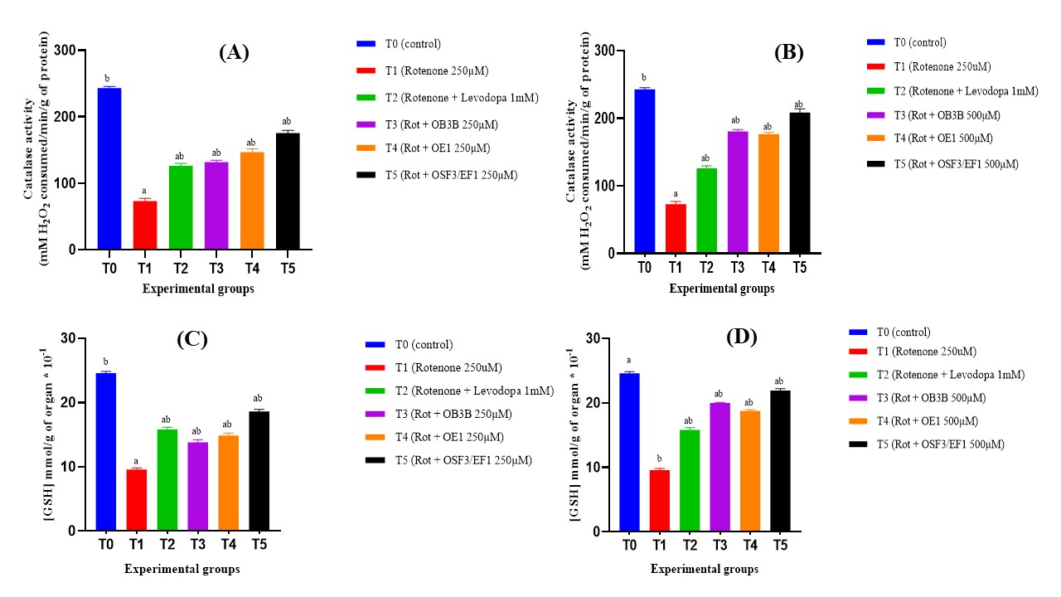

Figure 4: Effect of biflavonoids on catalase activity AND GSH concentration.
Control: Drosophila fed a standard diet without rotenone. (A) Catalase Effect of biflavonoids at a concentration of 250µM on Drosophila aged 3 to 5 days. (B)Catalase: Effect of biflavonoids at a concentration of 500µM on Drosophila aged 3 to 5 days. a= significant compared to the control group (p<0.05); b= significant compared to the negative control group (poisoned with rotenone) (p<0.05). Rot= Rotenone. Control: Drosophila fed a standard diet without rotenone. (C) GSH: Effect of biflavonoids at a concentration of 250µM on Drosophila aged 3 to 5 days. (D) GSH: Effect of biflavonoids at a concentration of 500µM on Drosophila aged 3 to 5 days. a= significant compared to the control group (p<0.05); b= significant compared to the negative control group (poisoned with rotenone) (p<0.05). Rot= Rotenone. Each bar represents the mean ± SEM, n=3 replicates.

Effect of biflavonoids on Nitric oxide and malondialdehyde levels

Figure 5 below shows the effect of biflavonoids on drosophila after intoxication with rotenone at 250µM and 500 µM as far as nitric oxide and malondialdehyde levels is concerned. All the drugs tested significantly reduced nitric oxide levels in comparison to the rotenone treated group (Figure 5 A and B). The same result was obtained for malondialdehyde levels in the same homogenates.
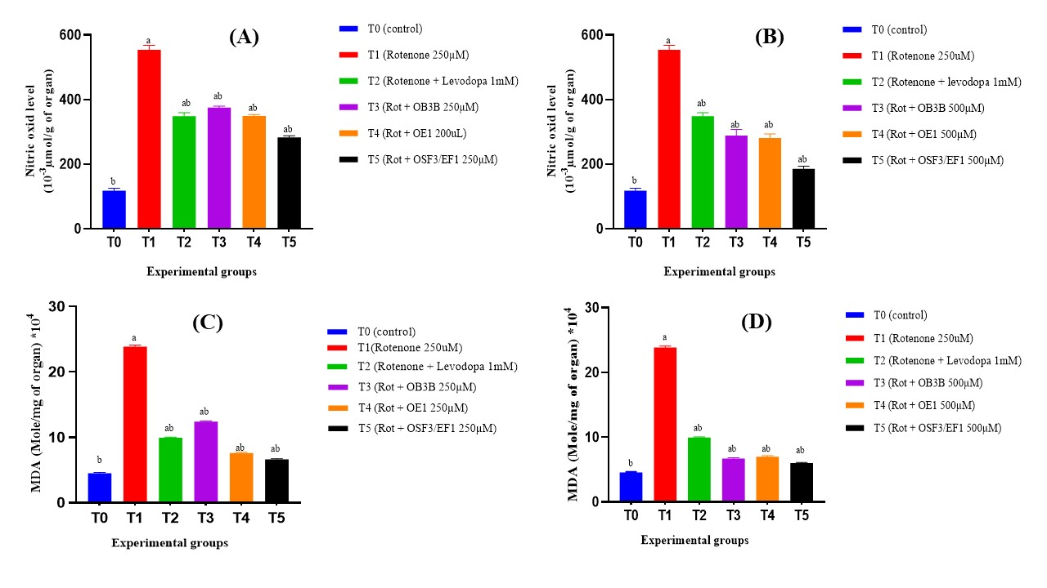

Figure 5: Effect of biflavonoids on nitric oxide AND MDA levels.
Control: Drosophila fed a standard diet without rotenone. (A)NO: Effect of biflavonoids at a concentration of 250µM on Drosophila aged 3 to 5 days. (B) NO: Effect of biflavonoids at a concentration of 500µM on Drosophila aged 3 to 5 days. a= significant compared to the control group (p<0.05); b= significant compared to the negative control group (poisoned with rotenone) (p<0.05). Rot= Rotenone. Control: Drosophila fed a standard diet without rotenone. (C) MDA: Effect of biflavonoids at a concentration of 250µM on Drosophila aged 3 to 5 days. (D) MDA: Effect of biflavonoids at a concentration of 500µM on Drosophila aged 3 to 5 days. a= significant compared to the control group (p<0.05); b= significant compared to the negative control group (poisoned with rotenone) (p<0.05). Rot= Rotenone. Each bar represents the mean ± SEM, n=3 replicates.
Effect of biflavonoids on Acetylcholinesterase activity

We investigated the effect of the biflavonoids on acetylcholine esterase activity. Results presented in figure 6 show that, in comparison to the control (without rotenone), flies treated with the drugs have significantly increased acetylcholine esterase activity that was previously inhibited due to rotenone treatment. The same trend was obtained with rotenone at 250µM (Fig 6A) and 500 µM (Fig 6B).

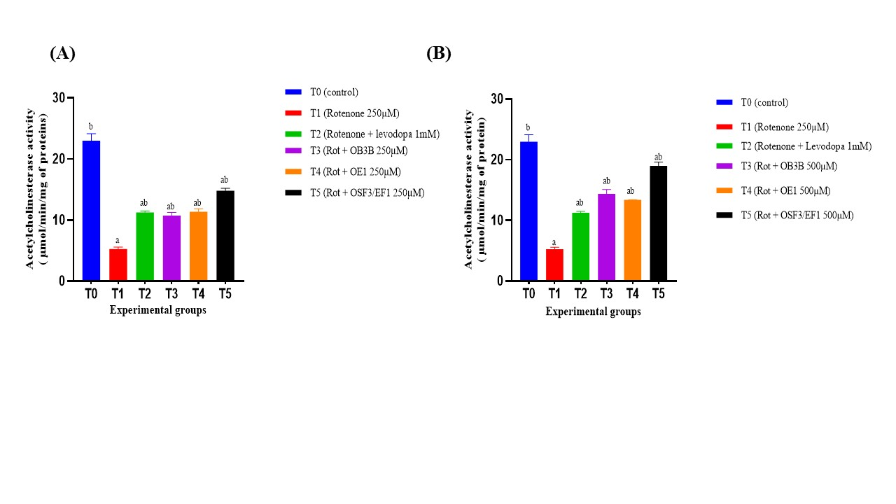

Figure 6: Effect of biflavonoids on acétylcholinesterase activity.
Control/T0: Drosophila fed with a standard diet without rotenone. (A) Effect of biflavonoids at a concentration of 250µM rotenone on Drosophila aged 3 to 5 days. (B) Effect of biflavonoids at a concentration of 500µM rotenone on Drosophila aged 3 to 5 days. a= significant compared to the control group (p<0.05); b= significant compared to the negative control group (poisoned with rotenone) (p<0.05). Rot= Rotenone. Each bar represents the mean ± SEM, n=3 replicates. Each bar represents the mean ± SEM, n=3 replicates.

DISCUSSION
Exposure to environmental toxins has been associated with the pathogenesis of neurological and particularly neurodegenerative disorders; among which Parkinson’s disease, characterized by the selective degeneration of nigrostriatal dopaminergic neurons (Newell et al., 2025). Although major research has been conducted on the genes responsible for some rare hereditary cases, epidemiological studies have suggested an association with environmental toxins such as rotenone (Kim et al., 2025). Indeed, rotenone is a widely used pesticide capable of triggering biological processes at the center of the genesis of neuropathology, notably protein aggregation, oxidative stress, and neuroinflammation (Aryal & Lee, 2019).
In recent years, Drosophila melanogaster has been widely used as a model to obtain data on the pathophysiology of several neurodegenerative diseases, including to evaluate the therapeutic properties of drugs derived from plants; thus, becoming a key advantage in medical research (Pratomo et al., 2022; Yi et al., 2021). This animal model has notably made it possible to evaluate the properties of many compounds, including a particular class chemical compounds called biflavonoids, which have already demonstrated a potential superior to their mono-flavonoic counterparts and promising properties against HIV and malaria; but also against the toxicity of the β-amyloid responsible for Alzheimer’s disease and neuroinflammation (Messi et al., 2022; Owona et al., 2025; Thapa et al., 2011). This study aimed to evaluate the effect of three biflavonoids (OB3B, OE1 and OSF3/EF1) against the toxicity of rotenone in Drosophila melanogaster applied to the potential treatment of Parkinson’s disease.
Molecular docking results revealed that OB3B, OE1 and OSF3 possessed excellent interaction energies with pro-inflammatory targets (caspase 1, COX-2 and TNF-α) compared to reference drugs; which suggests their potential anti-inflammatory in particular, which can inhibit the NLRP3 inflammasome involved in pathophysiology as demonstrated by (Owona et al., 2025). Even if OSF3 is slightly outmatched compared to OB3B and OE1 for interaction with TNF-α (-183.192 kcal/mol for OSF3 and -197.316 Kcal/mol and -197.349 Kcal/mol for OB3B and OE1 respectively), it seems to be better than the other two with much better interaction scores with the other therapeutic targets tested. Overall, the three biflavonoids possess good binding affinities with antioxidant enzymes (SOD and Catalase), NO synthase, acetylcholinesterase, MAO-B, adenosine A2A receptors and α-synuclein; allowing us to partially assert their antioxidant and modulatory potential of the dopaminergic and cholinergic pathways.
Drosophila intoxicated with 250μM rotenone dissolved in ethanol presented a locomotor deficit through the lack of flies’ response to the geotaxis test; as well as to the open field test which are one of the characteristics of Parkinson’s disease. These observations are similar to those of Sudati et al. but partially different from those of Tibashailwa et al. who used a mutant strain with white eyes for induction with 500μM rotenone dissolved in DMSO (Sudati et al., 2013; Tibashailwa et al., 2023). It is interesting to note, however, that the 3 biflavonoids overall significantly interfered with the reduction in mobility induced by rotenone.
Acetylcholinesterase is an enzyme that modulates learning, sleep and arousal, memory, attention, stress response and locomotor activities; it hydrolyses acetylcholine into choline and acetate, serving as a means of cholinergic neurotransmission between synapses. Our results revealed that OB3B, OE1 and OSF3/EF1 significantly attenuated the inhibition of acetylcholinesterase activity induced by rotenone compared to the intoxicated group (Figure. 6).
Since oxidative stress is largely involved in the pathogenesis of Parkinson’s disease (Liu et al., 2025), we evaluated the status of certain markers of oxidative stress in the different treatment groups. The rotenone-poisoned group showed high SOD activity, which is in line with previous studies by Zhou and al in 2015 who reported that rotenone induced an increase in H₂O₂ levels resulting in neuronal cell death (Zhou et al., 2015). We also observed in intoxicated drosophila, a very reduced activity of Catalase, whose role is normally to ensure the dismutation of hydrogen peroxide from SOD activity into oxygen and water; minimizing the risks associated with the generation of hydroxyl radicals by the Fenton reaction. Thus, the inhibitory effect of rotenone on catalase activity observed in Drosophila melanogaster suggests an increase in the susceptibility of flies to oxidative stress; which is similar to the work of (Javed et al., 2016). In this study, the significant increase in SOD activity and decrease in Catalase activity caused by rotenone were prevented in a dose-dependent manner in Drosophila that received both rotenone and each biflavonoid thus confirming their antioxidant property (Figure 4).
The determination of total thiols is vital because they play a key role in biological processes; especially GSH, an important antioxidant molecule preventing cellular damage that can be caused by ROS, free radicals and peroxides (Tison et al., 1994). Thus, the decrease in GSH levels observed in drosophila poisoned by rotenone shows the impairment of their ability to combat damage caused by free radicals and peroxide generated by SOD activity. However, the tested biflavonoids made it possible to fight against the reduction of GSH concentrations; which confirms their antioxidant potential. In addition, it is relevant to note that the decrease in GSH level in the dopaminergic neurons of the substantia nigra is one of the key events occurring in patients with Parkinson’s disease as shown in the study by (Garrido et al., 2011).
Overall, the biflavonoids under investigation in this study could represent therapeutic candidates to alleviate the symptoms of Parkinson’s disease. A significant increase in nitric oxide concentration in Drosophila exposed to rotenone; and a decrease in the groups that received both rotenone and biflavonoids were observed. These observations are similar to those of X. Zhang et al; having investigated the potential of baicalin in Parkinson’s disease therapy and having obtained high nitrite levels in rats poisoned with rotenone (Zhang et al., 2017). Indeed, nitric oxide is considered to be a pro-inflammatory mediator when it is overproduced by inducible oxide nitric synthase (iNOS); thus the effective suppression of NO accumulation mediated by rotenone suggests the anti-inflammatory properties of our biflavonoids; which also allowed a substantial reduction in the amount of MDA; a marker for lipid peroxidation and tissue damage, compared to the intoxicated group (Figure 5). We can therefore also affirm their possible beneficial effect on maintaining tissue integrity.
The results of this study are in agreement with the investigations conducted by Farombi et al on the therapeutic potential of biflavonoids from the Garcinia Kola seed fraction (Farombi et al., 2018) and suggests that our 3 biflavonoids could be promising candidates for the development of effective treatments against the sporadic form of Parkinson’s disease; OSF3/EF1 being the best of the three. Additional research is however necessary in order to confirm their effectiveness in animal models much closer to humans.
Conclusion:
The biflavonoids under investigation in this study appear to be promising lead drugs for the treatment of neurodegenerative diseases like Parkinson’s disease by targeting the main receptors involved in the disease and restoring locomotor deficits. Future studies will focus on more investigations at the biochemical levels trying to understand the mode of action of the compounds.
Disclaimer (Artificial intelligence)
Author(s) hereby declare that NO generative AI technologies such as Large Language Models (ChatGPT, COPILOT, etc.) and text-to-image generators have been used during the writing or editing of this manuscript.

REFERENCES
- Aqsa, F., Laraib, F., Lohana, A., Shahani, A., Assaram, K., & Irshad, N. U. N. (2025). Strengthening Parkinson's disease epidemiology: refining diagnosis and survival metrics. Neurol Sci, 46(11), 6059-6060. https://doi.org/10.1007/s10072-025-08412-3
- Armstrong, M. J., & Okun, M. S. (2020). Diagnosis and Treatment of Parkinson Disease: A Review. JAMA, 323(6), 548-560. https://doi.org/10.1001/jama.2019.22360
- Aryal, B., & Lee, Y. (2019). Disease model organism for Parkinson disease: Drosophila melanogaster. BMB Rep, 52(4), 250-258. https://doi.org/10.5483/BMBRep.2019.52.4.204
- Ayajuddin, M., Phom, L., Koza, Z., Modi, P., Das, A., Chaurasia, R., Thepa, A., Jamir, N., Neikha, K., & Yenisetti, S. C. (2022). Adult health and transition stage-specific rotenone-mediated Drosophila model of Parkinson's disease: Impact on late-onset neurodegenerative disease models. Front Mol Neurosci, 15, 896183. https://doi.org/10.3389/fnmol.2022.896183
- Blauwendraat, C., Nalls, M. A., & Singleton, A. B. (2020). The genetic architecture of Parkinson's disease. Lancet Neurol, 19(2), 170-178. https://doi.org/10.1016/S1474-4422(19)30287-X
- Dere, D., Pehlivan, S. N., da Silva, A. D., & de Azevedo, W. F., Jr. (2026). Hands-On Docking with Molegro Virtual Docker. Methods Mol Biol, 2984, 125-138. https://doi.org/10.1007/978-1-0716-4949-7_9
- Dorsey, E. R., Sherer, T., Okun, M. S., & Bloem, B. R. (2018). The Emerging Evidence of the Parkinson Pandemic. J Parkinsons Dis, 8(s1), S3-S8. https://doi.org/10.3233/JPD-181474
- Farombi, E. O., Abolaji, A. O., Farombi, T. H., Oropo, A. S., Owoje, O. A., & Awunah, M. T. (2018). Garcinia kola seed biflavonoid fraction (Kolaviron), increases longevity and attenuates rotenone-induced toxicity in Drosophila melanogaster. Pestic Biochem Physiol, 145, 39-45. https://doi.org/10.1016/j.pestbp.2018.01.002
- Garrido, M., Tereshchenko, Y., Zhevtsova, Z., Taschenberger, G., Bahr, M., & Kugler, S. (2011). Glutathione depletion and overproduction both initiate degeneration of nigral dopaminergic neurons. Acta Neuropathol, 121(4), 475-485. https://doi.org/10.1007/s00401-010-0791-x
- Jankovic, J., & Tan, E. K. (2020). Parkinson's disease: etiopathogenesis and treatment. J Neurol Neurosurg Psychiatry, 91(8), 795-808. https://doi.org/10.1136/jnnp-2019-322338
- Javed, H., Azimullah, S., Abul Khair, S. B., Ojha, S., & Haque, M. E. (2016). Neuroprotective effect of nerolidol against neuroinflammation and oxidative stress induced by rotenone. BMC Neurosci, 17(1), 58. https://doi.org/10.1186/s12868-016-0293-4
- Kim, Y., Seo, E., Kang, A., Kang, M. G., Jang, K. B., Oh, S., & Kim, Y. (2025). A neuroprotective effect of newly isolated probiotic bacterium Lactobacillus acidophilus SLAM_LAA02 in a rotenone-induced mouse model of Parkinson's disease. Biomed Pharmacother, 194, 118896. https://doi.org/10.1016/j.biopha.2025.118896
- Li, Y., Luo, G., Qing, Z., Li, X., Zou, Z., & Yang, R. (2019). Colorimetric aminotriazole assay based on catalase deactivation-dependent longitudinal etching of gold nanorods. Mikrochim Acta, 186(8), 565. https://doi.org/10.1007/s00604-019-3677-1
- Liu, T., Kong, X., Qiao, J., & Wei, J. (2025). Decoding Parkinson's Disease: The interplay of cell death pathways, oxidative stress, and therapeutic innovations. Redox Biol, 85, 103787. https://doi.org/10.1016/j.redox.2025.103787
- Luo, Y., Qiao, L., Li, M., Wen, X., Zhang, W., & Li, X. (2024). Global, regional, national epidemiology and trends of Parkinson's disease from 1990 to 2021: findings from the Global Burden of Disease Study 2021. Front Aging Neurosci, 16, 1498756. https://doi.org/10.3389/fnagi.2024.1498756
- Martinez-Fernandez, R., Rodriguez-Rojas, R., Del Alamo, M., Hernandez-Fernandez, F., Pineda-Pardo, J. A., Dileone, M., Alonso-Frech, F., Foffani, G., Obeso, I., Gasca-Salas, C., de Luis-Pastor, E., Vela, L., & Obeso, J. A. (2018). Focused ultrasound subthalamotomy in patients with asymmetric Parkinson's disease: a pilot study. Lancet Neurol, 17(1), 54-63. https://doi.org/10.1016/S1474-4422(17)30403-9
- Mateo, H., Sanchez-Moreno, M., & Marin, C. (2010). Enzyme-linked immunosorbent assay with purified Trypanosoma cruzi excreted superoxide dismutase. Clin Biochem, 43(15), 1257-1264. https://doi.org/10.1016/j.clinbiochem.2010.07.015
- McMullen, E., de la Flor, M., Gunaratne, G., O'Connor, J., & Roman, G. (2025). opynfield: An Open-Source Python Package for the Analysis of Open Field Exploration Data. Neuroinformatics, 23(4), 58. https://doi.org/10.1007/s12021-025-09753-2
- Messi, A. N., Bonnet, S. L., Owona, B. A., Wilhelm, A., Kamto, E. L. D., Ndongo, J. T., Siwe-Noundou, X., Poka, M., Demana, P. H., Krause, R. W. M., Ngo Mbing, J., Pegnyemb, D. E., & Bochet, C. G. (2022). In Vitro and In Silico Potential Inhibitory Effects of New Biflavonoids from Ochna rhizomatosa on HIV-1 Integrase and Plasmodium falciparum. Pharmaceutics, 14(8). https://doi.org/10.3390/pharmaceutics14081701
- Newell, M. E., Aravindan, A., Babbrah, A., & Halden, R. U. (2025). Epigenetic Biomarkers Driven by Environmental Toxins Associated with Alzheimer's Disease, Parkinson's Disease, and Amyotrophic Lateral Sclerosis in the United States: A Systematic Review. Toxics, 13(2). https://doi.org/10.3390/toxics13020114
- Oliveira, J. M. V., da Silva, A. D., Soares, A., & de Azevedo, W. F., Jr. (2026). Molegro Virtual Docker for Docking Screens. Methods Mol Biol, 2984, 139-152. https://doi.org/10.1007/978-1-0716-4949-7_10
- Owen, J. B., & Butterfield, D. A. (2010). Measurement of oxidized/reduced glutathione ratio. Methods Mol Biol, 648, 269-277. https://doi.org/10.1007/978-1-60761-756-3_18
- Owona, B. A., Mary, A., Messi, A. N., Ravichandran, K. A., Mbing, J. N., Pegnyemb, E., Moundipa, P. F., & Heneka, M. T. (2025). Biflavonoid Methylchamaejasmin and Khaya grandifoliola Extract Inhibit NLRP3 Inflammasome in THP-1 Cell Model of Neuroinflammation. Mol Neurobiol, 62(2), 1605-1619. https://doi.org/10.1007/s12035-024-04365-4
- Polzin, A., Dannenberg, L., Schneider, T., Knoop, B., Naguib, D., Helten, C., Pohl, M., Kelm, M., Zeus, T., & Hohlfeld, T. (2019). Malondialdehyde Assay in the Evaluation of Aspirin Antiplatelet Effects. Pharmacology, 103(1-2), 23-29. https://doi.org/10.1159/000493754
- Pratomo, A. R., Salim, E., Hori, A., & Kuraishi, T. (2022). Drosophila as an Animal Model for Testing Plant-Based Immunomodulators. Int J Mol Sci, 23(23). https://doi.org/10.3390/ijms232314801
- Sapan, C. V., Lundblad, R. L., & Price, N. C. (1999). Colorimetric protein assay techniques. Biotechnol Appl Biochem, 29(2), 99-108. https://www.ncbi.nlm.nih.gov/pubmed/10075906
- Sayed, A. S., El Sayed, N. S., Budzynska, B., Skalicka-Wozniak, K., Ahmed, M. K., & Kandil, E. A. (2022). Xanthotoxin modulates oxidative stress, inflammation, and MAPK signaling in a rotenone-induced Parkinson's disease model. Life Sci, 310, 121129. https://doi.org/10.1016/j.lfs.2022.121129
- Segura-Aguilar, J. (2018). Neurotoxins as Preclinical Models for Parkinson's Disease. Neurotox Res, 34(4), 870-877. https://doi.org/10.1007/s12640-017-9856-0
- Sudati, J. H., Vieira, F. A., Pavin, S. S., Dias, G. R., Seeger, R. L., Golombieski, R., Athayde, M. L., Soares, F. A., Rocha, J. B., & Barbosa, N. V. (2013). Valeriana officinalis attenuates the rotenone-induced toxicity in Drosophila melanogaster. Neurotoxicology, 37, 118-126. https://doi.org/10.1016/j.neuro.2013.04.006
- Thapa, A., Woo, E. R., Chi, E. Y., Sharoar, M. G., Jin, H. G., Shin, S. Y., & Park, I. S. (2011). Biflavonoids are superior to monoflavonoids in inhibiting amyloid-beta toxicity and fibrillogenesis via accumulation of nontoxic oligomer-like structures. Biochemistry, 50(13), 2445-2455. https://doi.org/10.1021/bi101731d
- Tibashailwa, N., Stephano, F., Shadrack, D. M., Munissi, J. J. E., & Nyandoro, S. S. (2023). Neuroprotective potential of cinnamoyl derivatives against Parkinson's disease indicators in Drosophila melanogaster and in silico models. Neurotoxicology, 94, 147-157. https://doi.org/10.1016/j.neuro.2022.11.010
- Tison, F., Coutelle, C., Henry, P., & Cassaigne, A. (1994). Glutathion S-transferase (class mu) phenotype in Parkinson's disease. Mov Disord, 9(1), 117-118. https://doi.org/10.1002/mds.870090128
- Torres-Ortega, P. V., Saludas, L., Hanafy, A. S., Garbayo, E., & Blanco-Prieto, M. J. (2019). Micro- and nanotechnology approaches to improve Parkinson's disease therapy. J Control Release, 295, 201-213. https://doi.org/10.1016/j.jconrel.2018.12.036
- Tsikas, D. (2007). Analysis of nitrite and nitrate in biological fluids by assays based on the Griess reaction: appraisal of the Griess reaction in the L-arginine/nitric oxide area of research. J Chromatogr B Analyt Technol Biomed Life Sci, 851(1-2), 51-70. https://doi.org/10.1016/j.jchromb.2006.07.054
- Varga, S. J., Qi, C., Podolsky, E., & Lee, D. (2014). A new Drosophila model to study the interaction between genetic and environmental factors in Parkinson's disease. Brain Res, 1583, 277-286. https://doi.org/10.1016/j.brainres.2014.08.021
- Wangler, M. F., Hu, Y., & Shulman, J. M. (2017). Drosophila and genome-wide association studies: a review and resource for the functional dissection of human complex traits. Dis Model Mech, 10(2), 77-88. https://doi.org/10.1242/dmm.027680
- Xiong, Y., & Yu, J. (2018). Modeling Parkinson's Disease in Drosophila: What Have We Learned for Dominant Traits? Front Neurol, 9, 228. https://doi.org/10.3389/fneur.2018.00228
- Yi, Y., Xu, W., Fan, Y., & Wang, H. X. (2021). Drosophila as an emerging model organism for studies of food-derived antioxidants. Food Res Int, 143, 110307. https://doi.org/10.1016/j.foodres.2021.110307
- Yip, V., Carter, J. G., Pusateri, M. E., McDougal, D. B., Jr., & Lowry, O. H. (1991). Distribution in brain and retina of four enzymes of acetyl CoA synthesis in relation to choline acetyl transferase and acetylcholine esterase. Neurochem Res, 16(6), 629-635. https://doi.org/10.1007/BF00965548
- Zhang, X., Yang, Y., Du, L., Zhang, W., & Du, G. (2017). Baicalein exerts anti-neuroinflammatory effects to protect against rotenone-induced brain injury in rats. Int Immunopharmacol, 50, 38-47. https://doi.org/10.1016/j.intimp.2017.06.007
- Zhong, L., Yang, Z., Tang, H., Xu, Y., Liu, X., & Shen, J. (2022). Differential analysis of negative geotaxis climbing trajectories in Drosophila under different conditions. Arch Insect Biochem Physiol, 111(2), e21922. https://doi.org/10.1002/arch.21922
- Zhou, Q., Liu, C., Liu, W., Zhang, H., Zhang, R., Liu, J., Zhang, J., Xu, C., Liu, L., Huang, S., & Chen, L. (2015). Rotenone induction of hydrogen peroxide inhibits mTOR-mediated S6K1 and 4E-BP1/eIF4E pathways, leading to neuronal apoptosis. Toxicol Sci, 143(1), 81-96. https://doi.org/10.1093/toxsci/kfu211
- P. Supriya & S. Rajaram. (2021). Literature Review on History and Pharmacotherapy of Parkinson`s Disease. Journal of Pharmaceutical Research International, 33(47A), 839–849. https://doi.org/10.9734/jpri/2021/v33i47A33082

