A Mixed-Methods Study on Illicit Substance Use: Urinalysis among Adults in Nightlife Settings and a Consumption Survey among Adolescents in Yaoundé, Cameroon

Abstract:
The consumption of illicit and other psychotropic substances remains a public health and safety issue worldwide in general and in Cameroon in particular. This is an alarming growing phenomenon in developing countries that negatively affects the youth. In this study, psychoactive substances were searched and detected in urine of adults attending dancing clubs and bars in the city of Yaoundé. To this end, a total of 70 urine samples were collected from the environment of establishments (public toilets) in the city’s popular neighborhoods (7 city councils). After acid and alkaline double extraction of each urine sample, the drug families were detected by colorimetric methods and identified by Thin Layer Chromatography (TLC). The frequencies of detection of the different drug families in total samples were 29% for the cannabinoid family, nutmeg and stimulants (amphetamines, methamphetamines, methadone, cocaine, codeine and ecstasy); and 39% of opioids and their derivatives respectively in the acid extract. However, in the basic extract, results showed the detection of 45% of cannabinoids and nutmeg, 13% of stimulants and 26% of opioids derivatives. Altogether, our results showed that Yaoundé 5 District council is the area with the highest concentration of illicit drug consumers in Yaoundé. From these observations, an awareness campaign was organized in three secondary schools. A total of 250 participants were enrolled. The prevalence of illicit drug consumption was 11,2% with tramadol being the most used. Motivators for illicit drug consumption were to feel powerful, to be courageous and to be able to work longer. Overall, results show a high consumption of illicit drugs among adults and urge for appropriate measures to be taken in order to limit drug consumption issue. Nevertheless, the consumption of illicit drugs by adolescent learners was low. Altogether, our findings can guide country’s policymakers on strategies to prevent and regulate illicit consumption of prohibited drugs and accentuate programs put in place to avoid drug consumption by secondary school adolescents.
Key words: Adults, adolescents, illicit and psychoactive drugs, Awareness, Yaoundé.

Introduction:
The consumption of psychoactive substances among adults and adolescents has become serious health and security issues worlwide. Psychoactive substances including cathinones, opioids and cannabinoids are rising in popularity among schoo-aged children (Warrick et al., 2017). Indeed, it is well known that adolescents are more vulnerable to drug addiction and the misuse of prohibited drugs such as opioids, benzodiazepines and other synthetic stimulants among adolescents is increasing all over the world (Iwanicki et al., 2020; Martins & Ghandour, 2017; Novak et al., 2016). Moreover, 5.8% of the global population aged 15-64 was estimated to have used illicit drugs in 2021 (Tobolska-Rydz, 1985). According to the United Nations Office on Drugs and Crime (UNODC), 5.5% of the population aged between 15 and 64 years had used drugs at least once in their lifetime (McDonell et al., 2021). Many reasons can be attributed to the consumption of psychoactive substances by the population, but the main reason is the sensation of pleasure after consumption, leading to a frequent desire of finding relief from life difficulties (Sampaio et al., 2024). Indeed, psychoactive substances interact with the central nervous system, leading to effects such as mood, cognitive, perception and behavioral changes. It is worth mentionning that some of these drugs can be legal such as caffeine, nicotine (found in tobacco), alcohol or illegal such as cannabis (marijuana), cocaine, ecstasy, heroin, ketamine, methamphetamine (Anderson et al., 2018; Lo et al., 2022).
As far as North, West and Central Africa is concerned, tramadol remains the main driver of non-medical use of prescription drugs (Kurth et al., 2018; Salm-Reifferscheidt, 2018). In Tanzania for instance, a study reporting on substance use among secondary school adolescents revealed that 35% had used tramadol, and 18% had used Refnol for non-medicacal purposes (Gift & Mweya, 2024). Unfortunately, the miuse of all these substances can lead to Substance use disorder (SUD), Drug addiction, development of mental health disorders or neurological disorders (Fuster et al., 2024; Liu & Li, 2018).
Psychoactive substances use among young adults have reached alarming levels in Cameroon, especially in high schools and universities milieu, where over 12.000 youths below 16 years of age have used a psychoactive substance (Metuge et al., 2022). According to the Ministry of Public Health, 60% of young people aged between 20 to 25 have already used psychoactive substances at least once and the more frequently used drugs are alcohol, tobacco, cannabis, tramadol and marijuana (Mbanga et al., 2018). The situation seems to be similar in cities as well as in the rural areas. For instance, a study conducted in the rural area among the Baka population revealed a high consumption of psychoactive substances causing health issues including decrease in fertility (Gallois et al., 2021). The Global Youth Tobacco Survey (GYTS) reported in 2008 that 15% of students between the ages of 13 and 15 smoke regularly, and 44% of school children have already smoked their first cigarette (Ekwoge et al., 2024).
According Ekwoge et al., 2024, the drugs mostly consumed by students in schools are: alcohol, vap/shisha, tobacco or cigarettes, and tramadol. Another author reported that the most used substances are tobacco, alcohol, tramadol and cannabis (Metuge et al, 2022). A cross-sectional analysis among secondary school students in Douala (country’s largest city) revealed a prevalence of drug use of 42.8%, with alcohol being the most frequently consummed, followed by caffeine, nicotine, cannabis and tramadol (Nkouonlack et al., 2023).
Alltogether, these studies reveal a high prevalence of psychoactive substance’s consumption among adults and adolescents in Cameroon. If in most cases mentionned above the results obtained are based on participants declarations, reports aiming at detecting the presence of illicit drugs in biological fluids are scarce. Indeed, once absorbed, drugs are distributed throughout the body, then metabolized before being excreted. The metabolic products, excreted through urine and other biological fluids, in the form of glucuronic derivatives or sulfates, can be detected and provide information on drug use by an individual (Allen, 2011; Verstraete, 2004).
This manuscript addresses a growing public health issue in a region where empirical, bio-analytically confirmed data on drug use is scarce. The dual approach of combining objective urine drug detection in adults with a self-reported survey in adolescents, provides a valuable, multi-faceted perspective on the problem in Yaoundé, Cameroon. The findings are important for local and national policymakers to target interventions, particularly the identification of Yaoundé 5 as a high-risk area. Also, the study highlights the specific threat of Tramadol and other prescription drug misuse among youth, a trend of global concern, thereby contributing to the broader literature on non-medical prescription drug use in low-resource settings.

Material and Methods
Material: The following material was used: a rotary agitator; a 1620 g bench-top centrifuge, Glasstubes; Micropipettes; Falcon tubes, a tank for TLC; a hood; a freezer, a refrigerator; a rotary evaporator; a water bath; an iodine vapour tank and silica gel plaques.
Mercury Nitrate, Acidified Iodoplatinate Reagent, Platinum Chloride, Potassium Iodide, Mandelin Reagent, Sulphuric Acid, Ammonium Chloride (NH4Cl), Ammonium Hydroxide (NH4OH), hydrochloric acid (HCl), methanol, urine samples and nitric acid.
Study design and participant recruitment
We used a descriptive cross-sectional study; conducted over a period of 3 months (March to May 2024). The target populations were people frequenting drinking establishments in the city of Yaoundé. Authorization were obtained from the seven town halls of the city of Yaoundé, allowing the collection of urine samples through the various public toilets of drinking establishments. Regarding the awareness activity, participants were recruited in secondary schools using a questionnaire.
Study area
The study was carried out in the Central Region of Cameroon, Mfoundi Department, more precisely in the city of Yaoundé. With a population of 2,440,462 (in 2011), Yaoundé is located in the humid tropical part of the country, but its climate is temperate because it is located at an altitude above 1000 m. This mountainous location divides the city into neighborhoods according to the hills. Uncontrolled urban growth leads to the colonization of areas unsuitable for sustainable urbanization, particularly through the occupation of fragile slopes and unsanitary lowlands. Regarding the activities practiced, in addition to the formal public and private sectors, the labor market in the city of Yaoundé is characterized by a preponderance of the informal sector. Young people aged 15 to 34 work mainly in this sector (92%), some of whose activities expose them to the consumption of drugs and psychotropic substances. For example, we can cite among others street vendors, prostitution, Building and Public Works (BTP), motorcycle taxis, street drug sales, security service, service in nightclubs and snack bars. The Department of Mfoundi has seven district communes called District Communes from Yaoundé 1 to Yaoundé 7, as shown in Figure 1 below.

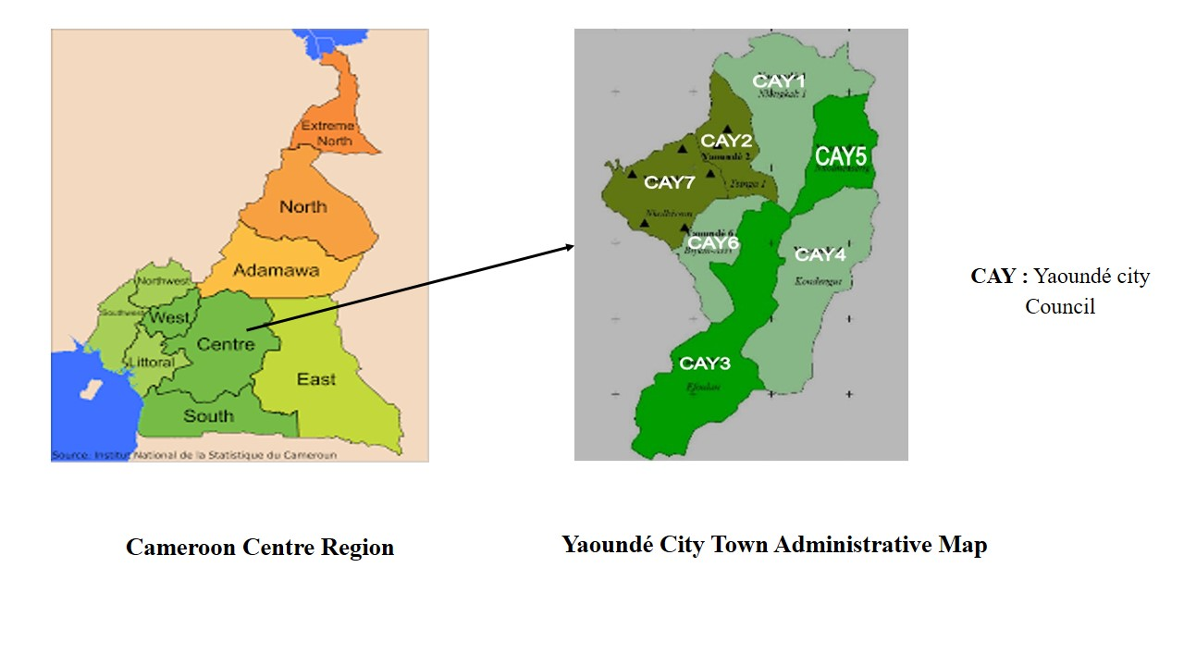

Figure 1 : Representation of Cameroon’s map and Yaoundé city capital showing the seven sub-divisions.

Sample collection
Urine samples were collected in public toilets of drinking establishments in the neighborhoods most exposed to prostitution and drug consumption in the city of Yaoundé using a 50 mL syringe and then introduced into a 250 mL glass bottle. The bottles were then labeled and stored in a freezer at -20°C for subsequent analysis.
The urine samples were subjected to two types of extraction namely, acid and basic extraction.
Detection of Different Drug Families by Colorimetric Analysis
Colorimetric tests are considered the primary presumptive toxicological identification tool used by toxicologists and analysts to identify molecules in samples. The identification of different families of drugs in urine samples was done by colorimetric test procedure usually used by the National Institute of Justice (US Department of Justice, USA). This procedure determines the presence of drugs and their nature in a suspect sample (biological or chemical).
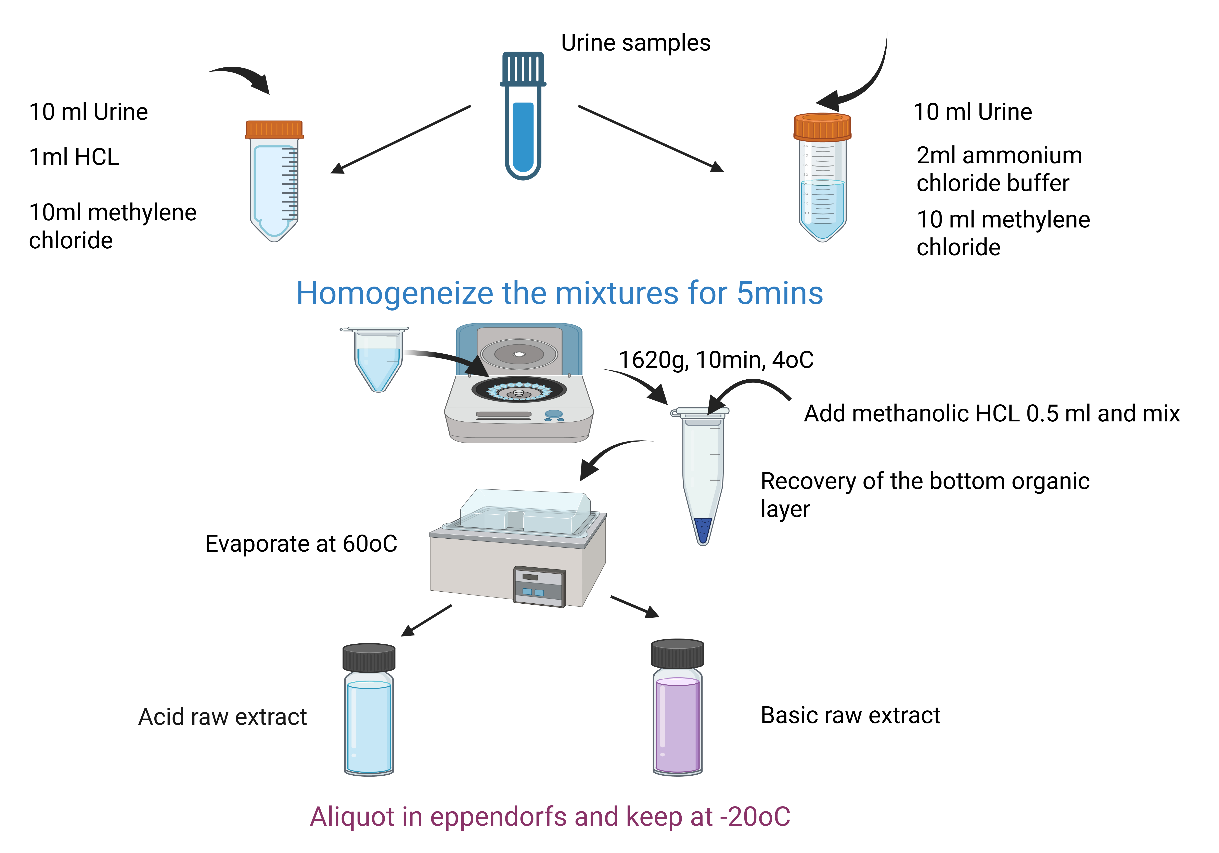
Figure 2 : Extraction of urine extreta using acid and basic methods

Identification of different families of drugs by Thin Layer Chromatography (TLC)
The following psychotropic substances: Migralgine (a medication composed of paracetamol, caffeine, and codeine phosphate hemihydrate); Tramadol (tramadol hydrochloride); Morphine (morphine sulfate); Valium (diazepam); and nutmeg, used as reference drugs, were purchased from the "Mandela" Pharmacy, located in the Melen district of Yaoundé, at the "face CHU" location, and at the Mokolo Market.
The volume (5 µL) of solution containing 10 µg of analyte was applied to the starting line of the plate in the appropriate lane using a micropipette (capillary pipette) to form a spot of 5 mm in diameter. The samples to be analyzed were applied, followed by the standards or standard mixtures in order to reduce the risk of cross-contamination. Eighteen (18) samples were placed on each plate, including 9 acidic extracts and 9 basic extracts. For chromatogram development, the mobile phase consisted of a solvent mixture of ethyl acetate, methanol, and sodium hydroxide (in the proportions 85/10/5, v/v/v). The solvent was added 30 minutes before chromatogram development to ensure the tank was saturated with solvent vapor. The plate was then gently placed so that the solvent did not exceed the line. After migration, the plate was removed and placed under a fume hood until dry. The chromatogram was then examined under ultraviolet light at 254 nm for the plate with a fluorescence indicator and the position of the fluorescent spots was noted. For plates without fluorescence indicator, the position of the spots was recorded in daylight. Subsequently, they were immersed in the iodine vapor tank and the position of the spots recorded. The same spots were confirmed after spraying with a dilute sulfuric acid solution. The front-end ratios were determined and drug identification was performed by comparing the front-end ratios of the spots left by the samples to the front-end ratios of the spots left by the reference molecules.
Study design
We undertook a cross-sectional study with the aim of determining the prevalence of illicit drug consumption and evaluate the measures taken by state authorities to limit drug consumption in school milieu. The study was conducted from May 2nd 2023 to June 24th 2023.
Study location
The 03 secondary schools visited were located in Yaoundé, the country’s city capital.
Study participants
Adolescent students were selected to participate in this study (public and catholic private schools) in Yaounde municipality.
Inclusion/exclusion criteria
We have included students who voluntarily accepted to provide information and signed a consent form. However, students under 13 and above 23 years old were excluded.
Data collection
To collect data, we used a questionnaire (the world health organization student drug use survey model). All participants received an information sheet. After administration, students were given about 20 mins to fill out the questionnaire.
Statistical analysis and data management
The confidentiality of the data collected was assured. Data were analysed using SPSS version 25. Data comparison was performed by the Chi-square test. Odds ratios and nominal 95% confidence intervals were determined. Statistical significance was set at p<0.05.

RESULTS
Number of urine samples collected and prepared concentrates
At the end of our study, a total of 70 urine samples were collected in the 7 Municipalities of the city of Yaoundé (CAY), 10 samples per municipality. For each urine sample, one acid and another base extract were prepared, a total of 140 extracts as shown in Table 1 below.
Table 1: Summary of establishments surveyed in the 7 CAY, samples collected and acid and basic extracts obtained.
Yaoundé city Council (CAY) | Number of establishments surveyed | Number of samples collected | Number of acid raw extracts | Number of basic raw extracts | Total number of extracts
CAY 1 | 10 | 10 | 10 | 10 | 20
CAY 2 | 10 | 10 | 10 | 10 | 20
CAY 3 | 10 | 10 | 10 | 10 | 20
CAY 4 | 10 | 10 | 10 | 10 | 20
CAY 5 | 10 | 10 | 10 | 10 | 20
CAY 6 | 10 | 10 | 10 | 10 | 20
CAY 7 | 10 | 10 | 10 | 10 | 20
TOTAL | 70 | 70 | 70 | 70 | 140
Different drug families in urine samples/ Frequency of detection of different drug families
Table2 below shows the positive percentages of acid and base extracts for the detection of different drug families from Duquenois-Levine, Mandelin and nitric acid reactions. It appears that the basic extract achieves a higher percentage of positivity (45%) than the acid extract (29%) for the cannabinoid family and nutmeg; similarly, the basic extract achieves a higher percentage of positivity (16%) than the acid extract (1%) for the family of amphetamines, methamphetamine, methadone, codeine, cocaine, ecstasy and other analgesics; while the acid extract achieves a higher percentage of positivity (39%) than the basic extract (26%) for the family of opioid derivatives (heroin, morphine, methadone), lysergic acid diethylamide (LSD). This positivity makes it possible to suspect the presence of these drug families in the different types of extracts.

Table 2: Number of positive samples per drug family expressed as a percentage in urine
Drug families | Number of positive samples by drug family  expressed as a percentage of urine
Drug families | Acid raw extract |  | Basic raw extract |  | Total
Drug families | Number | (%) | Number | (%) | Number | (%)
Cannabinoïds and muscade | 21 | 29% | 32 | 45% | 53 | 74
Amphetamins, methamphetamin, methadone, cocaïne, codeine and ecstasy | 1 | 1% | 12 | 16% | 13 | 17
opioids derivatives (heroin, morphine, methadone) | 28 | 39% | 19 | 26% | 47 | 65
High concentration area of drugs in urine excreta in Yaoundé
Table 3 below shows the distribution of positive samples according to Yaoundé Town Districts. Yaoundé 5 is the area where several drugs or their metabolites were found in urine excreta, with a total of 29 positive samples; followed by Yaoundé 6, 2, 4, 1, 7 and 3 respectively with 19, 18, 17, 13, 9 and 7 positive samples.
Table 3: High concentration area of drugs in urine excreta in Yaoundé
Drug families | Type of extract | Number of positive samples | CAY1 | CAY2 | CAY3 | CAY4 | CAY5 | CAY6 | CAY7
Cannabinoïds and muscade | Acid raw extract | 21 | 2 | 2 | 1 | 3 | 7 | 4 | 1
Cannabinoïds and muscade | Basic raw extract | 32 | 2 | 6 | 2 | 4 | 10 | 5 | 3
Amphetamins, methamphetamin, methadone, cocaïne, codeine and ecstasy | Acid raw extract | 1 | 0 | 0 | 0 | 0 | 1 | 0 | 0
 | Basic raw extract | 12 | 2 | 0 | 1 | 3 | 4 | 2 | 0
opioids derivatives (heroin, morphine, methadone) | Acid raw extract | 28 | 4 | 5 | 1 | 4 | 6 | 4 | 4
opioids derivatives (heroin, morphine, methadone) | Basic raw extract | 19 | 3 | 5 | 2 | 3 | 1 | 4 | 1
Total | / | 112 | 13 | 18 | 07 | 17 | 29 | 19 | 09

Drug consumption survey in some secondary schools
Two hundred fifty adolescents from 03 secondary schools have finally accepted to participate in this study.
Description of participant features regarding drug consumption
Participants were devided in 2 groups. From five students (180) 69%, and upper six students respectively (80); 31%. The socio-demographic characteristics of the students are shown in table 4 below. Most of the students were living with their father and mother (43%). Drug consumption was observed to be high in upper 6 students when compared with their from 5 counterparts. Moreover, drug consumption was also related to increased age. As far as alcohol consumption is concerned, living arrangements were not related to alcohol consumption. However, increase alcohol consumption by students was related to their age and class level (table 4).
Table 4: Univariate logistic regression analysis of factors associated with alcohol consumption in the study population.
 |  | Do you drink alcohol? |  | Crude Odd Ratio | 95% Confidence interval | P-value
Variable | Category | Yes (variable answer) | No
Age group | <13 (Reference) | 0 | 6
Age group | 13-16 | 6 | 30
Age group | 17-21 | 26 | 52
Age group | >21 | 49 | 51
Class level | From 5 | 49 | 121 | /
Class level | Upper 6 | 48 | 48 | 2,47 | 1,43 to 4,10 | P=0,0010
Living arrangements | Alone or with friends | 22 | 25 | /
Living arrangements | Mother | 12 | 20 | 0,68 | 0,26 to 1,69 | P=0,41
Living arrangements | Father | 6 | 8 | 0,85 | 0,24 to 2,83 | P=0,79
Living arrangements | Father and Mother | 30 | 80 | 0,41 | 0,20 to 0,85 | P=0,016

Table 5-A: Univariate logistic regression analysis of factors associated with drug use at least once in the study population.
 |  | Drug consumption (At least once?) |  | Crude Odd Ratio | 95% Confidence interval | P-value
Variable | Category | Yes (variable answer) | No
Age group | <13 (Reference) | 0 | 6
Age group | 13-16 | 0 | 37
Age group | 17-21 | 4 | 85
Age group | >21 | 15 | 84
Class level | From 5 (Reference) | 7 | 180 | /
Class level | Upper 6 | 14 | 80 | 3,50 | 1,49 to 8,67 | P=0,0047
Living arrangements | Alone or with friends (reference) | 8 | 39 | /
Living arrangements | Mother | 2 | 30 | 0,49 | 0,10 to 1,88 | P=0,33
Living arrangements | Father | 0 | 17 | 0,35 | 0,018 to 2,22 | P=0,35
Living arrangements | Father and Mother | 5 | 112 | 0,27 | 0,08 to 0,83 | P=0,023

 |  | Drug consumption (At least once?) |  | Crude Odd Ratio | 95% Confidence interval | P-value
Variable | Category | Yes (variable answer) | No
Age group | <13 (Reference) | 0 | 6
Age group | 13-16 | 0 | 37
Age group | 17-21 | 4 | 85
Age group | >21 | 15 | 84
Class level | From 5 (Reference) | 7 | 180 | /
Class level | Upper 6 | 14 | 80 | 3,50 | 1,49 to 8,67 | P=0,0047
Living arrangements | Alone or with friends (reference) | 8 | 39 | /
Living arrangements | Mother | 2 | 30 | 0,49 | 0,10 to 1,88 | P=0,33
Living arrangements | Father | 0 | 17 | 0,35 | 0,018 to 2,22 | P=0,35
Living arrangements | Father and Mother | 5 | 112 | 0,27 | 0,08 to 0,83 | P=0,023

Table 5-B: Univariate logistic regression analysis of factors associated with smoking in the study population.
 |  | Do you smoke? |  | Crude Odd Ratio | 95% Confidence interval | P-value
Variable | Category | Yes (variable answer) | Non
Age group | <13 (Reference) | 0 | 4
Age group | 13-16 | 1 | 34
Age group | 17-21 | 3 | 74
Age group | >21 | 5 | 91
Class level | From 5 (Reference) | 6 | 159 | /
Class level | Upper 6 | 4 | 90 | 1,21 | 0,30 to 4,38 | P=0,76
Living arrangements | Alone or with friends (reference) | 2 | 42 | /
Living arrangements | Mother | 1 | 29 | 0,7211 | 0,03 to 7,89 | P=0,79
Living arrangements | Father | 1 | 15 | 1,40 | 0,06 to 15,66 | P=0,78
Living arrangements | Father and Mother | 3 | 105 | 0,61 | 0,09 to 4,76 | P=0,59

As shown in the tables above, living with the father and mother at the same time significantly reduces the risk of consuming alcohol and drugs by 2.43 and 3.70 times respectively (OR = 0.41 and 0.26) compared to living alone or with friends (reference modalities). The higher-class level is a risk factor for consumption. However, age showed no influence.

Prevalence of illicit drug consumption among school participants
Twenty eight participants (28) in our study had admitted using illicit drugs, giving a prevalence of non-autorised use of illicit drugs by adolescents school children of 11.2%. The most frequently misused drugs were tramadol (opioids) mwith a prevalence of 35.71%, followed by caffeine (25%), diazepam (sleep medication) 14,29%, amphetamine 10,71% and others (7,14%). (Figure 3A).
Factors motivating the use of illicit drugs
Data analysis show that several reasons account for drug consumption by student participants. These included personal reasons and influence from best friends. Motivators for illicit drug use are reported in figure 3B below.

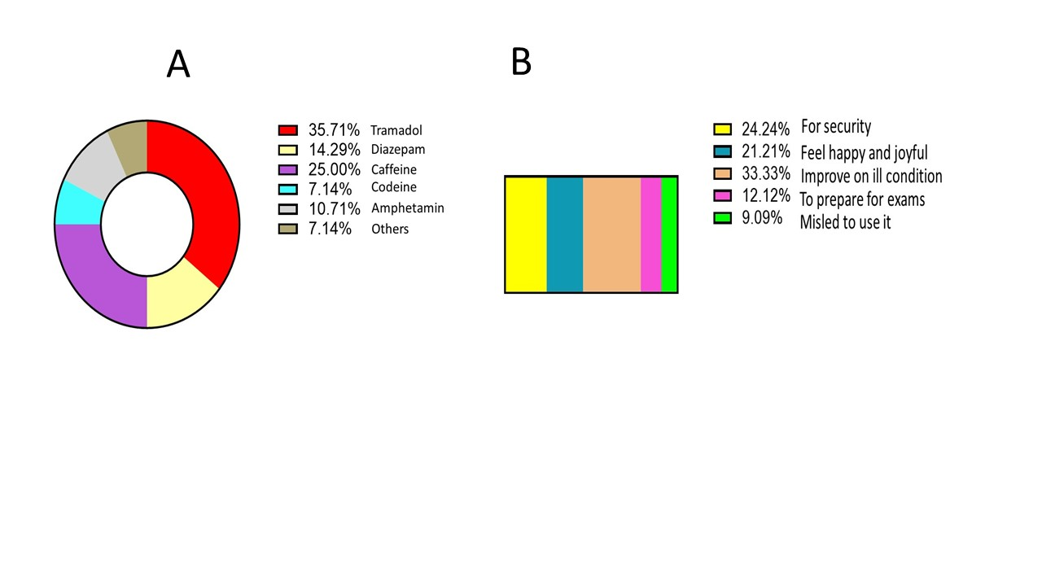

Figure 3 :Frequency of commonly used illicit drugs (A) and factors (B) motivating illicit drug consumption by secondary school students.

Discussion
Drug use is a public health and safety issue with significant impact on the well-being of consumers. The aim of this work was to search for drugs and psychotropic substances consumed by adults attending dancing clubs and bars in the first part, and determine the prevalence and factors associated with illicit drugs consumption by young adolescents in some public and private secondary schools in Yaoundé in the second part.
In order to identify the type of drugs frequently consumed by adult population, we conducted a study aiming at collecting urine samples in bars and dancing clubs. Due to cultural reasons, it remains very difficult for people to provide urine samples for any reason. Therefore, we used a method of collecting pooled urine from public toilets. Urines were collected only from people who forgot to flush out the toilets. After collection, the toilets were properly cleaned up while waiting for the next person in order to make sure that the urine collected corresponded to the appropriate individual. The collection period lasted 3 months with our teams visiting the bars every weekend. Our results show that Yaoundé 5 council is the most affected by illicit drug consumption, certainly due to the high promiscuity and the elevated number of bars and dancing clubs in comparison to the other councils. Indeed, detection of drugs of abuse in urine is routinely accomplished by utilizing solid-phase extraction to isolate drugs (Li & Musselman, 2018). To this end, commercially available immunoassay systems (TDx, BCL, PFI-20 opiates and PFI-morphine) are available in the market (Simpson et al., 1989). The chromatographic method used in this study has been widely used to detect drugs from biological samples with success, and appears to be a powerful tool especially in areas with low resources (Moffat, 1975). Moreover, TLC is simple, valid as an initial screening tool in ressource-limited settings and is effective for separating and identifying compounds in complex mixtures. However, it has some limitations such as the lower specificity and sensitivity compared to other techniques such as GC-MS or LC-MS/MS or high performance liquid chromatography (HPLC) (Nikolin et al., 2004). Therefore, the results obtained in this study are initial and presumptive and future studies will focus on using more specific methods as mentioned above.
From our methodology, we emphasize that the basic solvent extracts more compounds of the family of cannabinoids and nutmeg. Whereas for the family of opioid derivatives (heroin, morphine, methadone), it is the acid solvent that is best indicated. Indeed, a chemical compound has different solubility in different solvents depending on its structure (Huang et al., 2024) and these different families of drugs were found to be much more soluble in the appropriate solvents (acid or base). The main drugs identified in the extracts by Thin Layer Chromatography (TLC) were valium (benzodiazepine), tramadol, nutmeg, codeine and acetaminophen, in the proportions of 25.71%, 15%, 15% and 14.29% respectively. Our results corroborate those of (Ekwoge et al., 2024), who conducted a survey on drug use in schools in Yaoundé. According to their results, the most commonly used drugs in the city were alcohol, cigarettes, shisha, tramadol and secondarily diazepam and cocaine. Our results are also similar to those of (Ko et al., 1992) who studied the prevalence of amphetamine use among 3200 adolescent students aged 12-15 years with a response rate of 98.6%. The results obtained in our study add up to those of (Mbanga et al., 2018 who, working on the prevalence of drug use by medical and nursing students in several regions of Cameroon, have observed an overall prevalence of drug use of 1,64%, with tramadol and marijuana considered to be the drugs most commonly used. However, the high propensity of certain non-steroidal anti-inflammatory drugs (NSAIDs) in urine samples, especially codeine, acetaminophen could be due to the presence of similar chemical structures, reflecting the high consumption of tramadol. The same is true of the strong positivity of the reaction of the walnut and nutmeg, which would reflect a new trend of drug use whose effects are similar to those of cannabis. These products, which are part of the composition of shisha tobacco, because of their effects and aroma, are appreciated by young people.
We found that the prevalence of illicit drug consumption was 11.2 % among the adolescent investigated. Our data show that tramadol (opioid) is the most frequently used drug among adolescents; followed by caffeine (not really illicit) and diazepam (used for sleep troubles) and amphetamine (powerful stimulant used for sleep troubles) drugs that activate the central nervous system. Overall, the use of illicit drugs by the youth is on the rise in Cameroon. These data confirm what was observed in previous studies showing that the use of stimulants and opioids such as cannabis and tramadol are on the rise among adolescents (Mbanga et al., 2018; Metuge et al., 2022). Moreover, (Metuge et al., 2022) showed that the commonest substances used by the youth in Cameroon are alcohol (98.4%), tobacco (28.3%), tramadol (7.5%) and cannabis (6.8%) (Metuge et al., 2022). One of the reasons that favors this situation is that these drugs are easily available in the streets without any medical prescription needed (Tettey et al., 2021).
Opioid drugs remain the main drugs used without prescription in several African countries including West, central and North Africa (Tomas-Rossello et al., 2010). Our findings with tramadol align with these observations. Another research study conducted in the neighboring country Nigeria reported a high prevalence of tramadol among secondary school students (Idowu et al., 2018). In Cameroon, illicit drug consumption is most often associated with alcohol and tobacco misuse; which in most of the case lead to violence and indiscipline on school campuses. It is therefore necessary to conduct further investigations to study the relationship between alcohol consumption leading to tramadol addiction. In correlation with previous findings, we observed that the desire to achieve happiness feelings, courage in daily life situations and the need to improve on school performances are the main reasons why school adolescents take illicit drugs (Fig 3). In the same line with the above findings, (Mbanga et al., 2018) reported that the main motivators for stimulants and opioids consumption among youth were to experience cognitive enhancement, stay alert and to feel powerful (Drazdowski, 2016). Many other studies in the literature reported that students had become addicted to tramadol following its chronic use (Arzoun et al., 2022; Mo et al., 2021).
This study is therefore a contribution to the prevention of illicit drug consumption by secondary school students in Cameroon. Moreover, our study highlights the high prevalence of tramadol in the school settings investigated. Our findings could help school authorities to prevent the use of illicit drugs in and around school campus. This will therefore help state authorities to solve the issue of violence and indiscipline in the society (Oshodi et al., 2010).
Overall, these data are of great interest for both forensic and medical science. Our future studies will focus on developing tools that could facilitate detection of drugs of abuse not only in the urine, but in exhaled breath similar to the breath alcohol test (Trefz et al., 2017).

Conclusion:
In conclusion, this study outlined the high level of illicit drug consumption in all seven city councils in Yaoundé, with Yaoundé 5 city council being the area with the highest drug consumption. Investigation of illicit drugs consumption in 3 city’s secondary schools showed a high prevalence of tramadol consumption among adolescents, added to alcohol, codeine and diazepam. Our findings could help scientist and state authorities to develop screening tools and specific interventions to limit drug use in the society.
Ethical approval
Ethical documentation was obtained from the institutional review board, University of Yaoundé 1 (2023/1274-03/UY1/SG/IRB/FS). Autorization was also obtained from various school administrators.
Consent
As per international standards, parental written consent has been collected and preserved by the author(s). Students were informed on the importance of the study after our team conducted several power point presentations on brain diseases and the effect of illicit drugs on the brain.

Acknowledgements: We would like to thank the participants and the different authorities who have facilitated this study.

Disclaimer (Artificial intelligence)
Option 1: Option 1 applies
Author(s) hereby declare that NO generative AI technologies such as Large Language Models (ChatGPT, COPILOT, etc.) and text-to-image generators have been used during the writing or editing of this manuscript.

References
- Allen, K. R. (2011). Screening for drugs of abuse: which matrix, oral fluid or urine? Ann Clin Biochem, 48(Pt 6), 531-541. https://doi.org/10.1258/acb.2011.011116
- Anderson, P., Gual, A., & Rehm, J. (2018). Reducing the health risks derived from exposure to addictive substances. Curr Opin Psychiatry, 31(4), 333-341. https://doi.org/10.1097/YCO.0000000000000432
- Arzoun, H., Srinivasan, M., Sahib, I., Fondeur, J., Escudero Mendez, L., Hamouda, R. K., & Mohammed, L. (2022). Opioid Use in Patients With Sickle Cell Disease During a Vaso-Occlusive Crisis: A Systematic Review. Cureus, 14(1), e21473. https://doi.org/10.7759/cureus.21473
- Drazdowski, T. K. (2016). A systematic review of the motivations for the non-medical use of prescription drugs in young adults. Drug Alcohol Depend, 162, 3-25. https://doi.org/10.1016/j.drugalcdep.2016.01.011
- Ekwoge, H. T., Mbah, S. A., Fodjo, J. N. S., Mbange, G. L., Ngarka, L., Ntone, F. E., & Njamnshi, A. K. (2024). Substance use among students of two high schools in Yaounde, Cameroon. Pan Afr Med J, 49, 121. https://doi.org/10.11604/pamj.2024.49.121.43487
- Fuster, D., Zuluaga, P., & Muga, R. (2024). Substance use disorder: Epidemiology, medical consequences and treatment. Med Clin (Barc), 162(9), 431-438. https://doi.org/10.1016/j.medcli.2023.11.016 (Trastorno por uso de sustancias: epidemiologia, complicaciones medicas y tratamiento.)
- Gallois, S., van Andel, T. R., & Pranskaityte, G. (2021). Alcohol, drugs and sexual abuse in Cameroon's rainforest. Soc Sci Med, 277, 113929. https://doi.org/10.1016/j.socscimed.2021.113929
- Gift, A., & Mweya, C. N. (2024). Prevalence and factors influencing substance abuse among secondary school students in Mbeya City, Tanzania. Afr Health Sci, 24(3), 430-437. https://doi.org/10.4314/ahs.v24i3.47
- Huang, Y., Zhu, M., Lan, H., Huang, D., Lan, M., & Huang, Y. (2024). Carane-3,4-diol Derivatives as Potential Water-Based Herbicides. Chem Biodivers, 21(6), e202301867. https://doi.org/10.1002/cbdv.202301867
- Idowu, A., Aremu, A. O., Olumide, A., & Ogunlaja, A. O. (2018). Substance abuse among students in selected secondary schools of an urban community of Oyo-state, South West Nigeria: implication for policy action. Afr Health Sci, 18(3), 776-785. https://doi.org/10.4314/ahs.v18i3.36
- Iwanicki, J. L., Schwarz, J., May, K. P., Black, J. C., & Dart, R. C. (2020). Tramadol non-medical use in Four European countries: A comparative analysis. Drug Alcohol Depend, 217, 108367. https://doi.org/10.1016/j.drugalcdep.2020.108367
- Ko, Y. C., Su, I. H., Lan, S. J., Yen, Y. Y., Wu, M. C., & Lee, C. H. (1992). [Risk factors related to the use of amphetamines in adolescent students]. Gaoxiong Yi Xue Ke Xue Za Zhi, 8(1), 24-34. https://www.ncbi.nlm.nih.gov/pubmed/1548737
- Kurth, A. E., Cherutich, P., Conover, R., Chhun, N., Bruce, R. D., & Lambdin, B. H. (2018). The Opioid Epidemic in Africa And Its Impact. Curr Addict Rep, 5(4), 428-453. https://doi.org/10.1007/s40429-018-0232-9
- Li, F., & Musselman, B. (2018). High-Throughput Extraction and Detection of Drugs in Urine: Parallel Sampling with Solid-Phase Microextraction (SPME) Fibers Coupled with Direct Analysis in Real Time-Mass Spectrometry (DART-MS) Detection. Methods Mol Biol, 1810, 97-106. https://doi.org/10.1007/978-1-4939-8579-1_9
- Liu, J. F., & Li, J. X. (2018). Drug addiction: a curable mental disorder? Acta Pharmacol Sin, 39(12), 1823-1829. https://doi.org/10.1038/s41401-018-0180-x
- Lo, J. O., Hedges, J. C., & Girardi, G. (2022). Impact of cannabinoids on pregnancy, reproductive health, and offspring outcomes. Am J Obstet Gynecol, 227(4), 571-581. https://doi.org/10.1016/j.ajog.2022.05.056
- Martins, S. S., & Ghandour, L. A. (2017). Nonmedical use of prescription drugs in adolescents and young adults: not just a Western phenomenon. World Psychiatry, 16(1), 102-104. https://doi.org/10.1002/wps.20350
- Mbanga, C. M., Efie, D. T., Aroke, D., & Njim, T. (2018). Prevalence and predictors of recreational drug use among medical and nursing students in Cameroon: a cross sectional analysis. BMC Res Notes, 11(1), 515. https://doi.org/10.1186/s13104-018-3631-z
- McDonell, M. G., Skalisky, J., Burduli, E., Foote, A., Sr., Granbois, A., Smoker, K., Hirchak, K., Herron, J., Ries, R. K., Echo-Hawk, A., Barbosa-Leiker, C., Buchwald, D., Roll, J., & McPherson, S. M. (2021). The rewarding recovery study: a randomized controlled trial of incentives for alcohol and drug abstinence with a rural American Indian community. Addiction, 116(6), 1569-1579. https://doi.org/10.1111/add.15349
- Metuge, C. E., Dzudie, A., Ebasone, P. V., Assob, J. C. N., Ngowe, M. N., Njang, E., Mabouna, S., & Eyoum, C. (2022). Prevalence and factors associated with substance use among students in tertiary institutions in Buea, Cameroon. Pan Afr Med J, 41, 103. https://doi.org/10.11604/pamj.2022.41.103.29272
- Mo, G., Jang, T., Stewart, C., Khoury, L., Ferguson, N., Egini, O., Muthu, J., Dutta, D., Salifu, M., & Lim, S. H. (2021). Chronic opioid use in patients with sickle cell disease. Hematology, 26(1), 415-416. https://doi.org/10.1080/16078454.2021.1932328
- Moffat, A. C. (1975). The standardisation of thin-layer chromatographic systems for the identification of basic drugs. J Chromatogr, 110(2), 341-347. https://doi.org/10.1016/0021-9673(75)85015-1
- Nikolin, B., Imamovic, B., Medanhodzic-Vuk, S., & Sober, M. (2004). High perfomance liquid chromatography in pharmaceutical analyses. Bosn J Basic Med Sci, 4(2), 5-9. https://doi.org/10.17305/bjbms.2004.3405
- Nkouonlack, C., Shifu, I. N., Atchou, J. G. B., Eyoum, C., Dinayen, D. Y., Nsagha, D. S., & Njamnshi, A. K. (2023). Prevalence and associated factors of non-medical use of prescription drugs among adolescents in secondary schools in Buea, Cameroon: a cross-sectional study. BMC Psychiatry, 23(1), 695. https://doi.org/10.1186/s12888-023-05120-0
- Novak, S. P., Hakansson, A., Martinez-Raga, J., Reimer, J., Krotki, K., & Varughese, S. (2016). Nonmedical use of prescription drugs in the European Union. BMC Psychiatry, 16, 274. https://doi.org/10.1186/s12888-016-0909-3
- Oshodi, O. Y., Aina, O. F., & Onajole, A. T. (2010). Substance use among secondary school students in an urban setting in Nigeria: prevalence and associated factors. Afr J Psychiatry (Johannesbg), 13(1), 52-57. https://doi.org/10.4314/ajpsy.v13i1.53430
- Salm-Reifferscheidt, L. (2018). Tramadol: Africa's opioid crisis. Lancet, 391(10134), 1982-1983. https://doi.org/10.1016/S0140-6736(18)31073-0
- Sampaio, G. R., Lima, G. S., de Souza, S. B., & Soares, D. M. (2024). Use of psychoactive substances among university students from 2019 to 2020: A systematic review. Brain Behav Immun Health, 35, 100724. https://doi.org/10.1016/j.bbih.2024.100724
- Simpson, D., Jarvie, D. R., & Heyworth, R. (1989). An evaluation of six methods for the detection of drugs of abuse in urine. Ann Clin Biochem, 26 ( Pt 2), 172-181. https://doi.org/10.1177/000456328902600215
- Tettey, J. N. A., Crean, C., Rodrigues, J., Angeline Yap, T. W., Lee Wendy Lim, J., Shirley Lee, H. Z., & Ching, M. (2021). United Nations Office on Drugs and Crime: Recommended methods for the Identification and Analysis of Synthetic Cannabinoid Receptor Agonists in Seized Materials. Forensic Sci Int Synerg, 3, 100129. https://doi.org/10.1016/j.fsisyn.2020.11.003
- Tobolska-Rydz, H. (1985). [Drug addiction on a world-wide scale during the last 5 years in the light of the report of the International Committee for Narcotics Control]. Pol Tyg Lek, 40(48), 1358-1360. https://www.ncbi.nlm.nih.gov/pubmed/3831980 (Narkomania w skali swiatowej w ostatnim piecioleciu w swietle publikacji Miedzynarodowego Organu Kontroli Narkotykow.)
- Tomas-Rossello, J., Rawson, R. A., Zarza, M. J., Bellows, A., Busse, A., Saenz, E., Freese, T., Shawkey, M., Carise, D., Ali, R., & Ling, W. (2010). United Nations Office on Drugs and Crime International Network of Drug Dependence Treatment and Rehabilitation Resource Centres: Treatnet. Subst Abus, 31(4), 251-263. https://doi.org/10.1080/08897077.2010.514243
- Trefz, P., Kamysek, S., Fuchs, P., Sukul, P., Schubert, J. K., & Miekisch, W. (2017). Drug detection in breath: non-invasive assessment of illicit or pharmaceutical drugs. J Breath Res, 11(2), 024001. https://doi.org/10.1088/1752-7163/aa61bf
- Verstraete, A. G. (2004). Detection times of drugs of abuse in blood, urine, and oral fluid. Ther Drug Monit, 26(2), 200-205. https://doi.org/10.1097/00007691-200404000-00020
- Warrick, B. J., Tataru, A. P., & Gerona, R. (2017). New Psychoactive Substances in Pediatric Patients. Pediatr Clin North Am, 64(6), 1223-1241. https://doi.org/10.1016/j.pcl.2017.08.003

