Case report
Fatal Rupture of Subcapsular Hepatic Hematoma in Preeclampsia with Severe Features: A Catastrophic Obstetric Emergency

.
ABSTRACT

Background
Subcapsular hepatic hematoma in pregnancy is a rare complication, and it’s a life-threatening complication associated with severe preeclampsia and HELLP syndrome. Subcapsular hepatic hematoma complicates approximately 1 in 40,000 and 1 in 250,000 pregnancies. Timely identification and interdisciplinary management are essential for improving maternal outcomes.
Management approach is multidisciplinary treatment options range from conservative treatment to surgical modalities, including hepatic resection, hepatic artery ligation, and liver transplantation, depending on hemodynamic stability and trauma severity.
Case
We present a case of a 25-year-old gravida 3 para 2 at gestational age 32+6 weeks with severe preeclampsia who developed sudden epigastric pain and hypovolemic shock. A trans abdominal ultrasound revealed intrauterine fetal demise and a large right-lobe Subcapsular hepatic hematoma with hemoperitoneum.
Management
An emergency laparotomy revealed a ruptured Subcapsular hematoma affecting over 60% of the liver surface. Primary hemostasis was accomplished using Feliciano perihepatic packing. Despite all intensive resuscitation measures and re-exploration.
Outcome
The patient ultimately succumbed to hemorrhagic shock and multiple organ failure.
This case outlines the importance of early identification, diligent observation, and prompt multidisciplinary intervention in severe maternal hypertension aggravating hypertensive disorder in pregnancy, especially in severe preeclampsia.
Subcapsular hepatic hematoma is a critical yet preventable contributor to maternal mortality linked to severe preeclampsia. Careful clinical assessment, timely imaging, and swift surgical intervention are crucial for improving survival rates. This example underscores the necessity of prompt identification, swift resuscitation, interdisciplinary collaboration, and availability of modern surgical methods to enhance outcomes in this rare yet severe condition.

Keywords: Keywords: hepatic hematoma, preeclampsia, HELLP syndrome, Subcapsular hematoma, Feliciano packing, transfusion.

1. INTRODUCTION

Subcapsular hepatic hematoma is rare and has potentially fatal consequences linked to hypertensive disorders of pregnancy, especially severe preeclampsia and HELLP syndrome (Wicke et al., 2004). Despite its rarity, with an estimated frequency of 1–2 per 100,000 pregnancies, subcapsular hepatic hematoma is associated with considerable maternal and neonatal morbidity and mortality, particularly in cases of hepatic rupture (Wicke et al., 2004; Rinehart et al., 1999). Recent case reports underscore the severity of this illness despite advancements in maternal care (Azar et al., 2025; Chawanpaiboon et al., 2025).
The pathogenesis of subcapsular hepatic hematoma in preeclampsia is intricate. It is thought to stem from endothelial dysfunction, hepatic sinusoidal obstruction, periportal hemorrhage, and fibrin deposition, resulting in hepatocellular necrosis and capsular distension (Liu et al., 2023). These gradual alterations predispose the liver to the formation of subcapsular hematomas, which may expand and rupture spontaneously or under elevated intra-abdominal pressure. The literature reports hepatic rupture in the absence of complete HELLP syndrome, underscoring the unpredictable nature of the condition (Kang et al., 2025; Sucan et al., 2025).
Clinically, SLH frequently manifests with ambiguous or nonspecific symptoms, including epigastric pain, discomfort in the right upper quadrant, nausea, vomiting, or referred pain to the shoulder tip. These symptoms are often erroneously attributed to more prevalent gastrointestinal or musculoskeletal disorders during pregnancy, leading to frequent diagnostic delays (Sucan et al., 2025; McBride et al., 2023). Delayed identification poses significant risks, as hematoma expansion or rupture may result in extensive intraperitoneal hemorrhage, hemodynamic instability, disseminated intravascular coagulation (DIC), and multiorgan failure—key factors in maternal mortality (Wicke et al., 2004; Rinehart et al., 1999).
Ultrasonography is generally the primary diagnostic tool performed at the patient’s bedside; it's readily available and safe during pregnancy; however, its sensitivity is limited, especially in unstable patients or those with significant obesity. Computed tomography (CT) is the imaging modality of choice for diagnosing Subcapsular hematoma. It provides enhanced detail for delineating the extent of the hematoma, ongoing hemorrhage, and related problems (McBride et al., 2023; Liu & Yang, 2025). CT imaging is acknowledged as the most sensitive technique for delineating hematoma anatomy and directing urgent management (Wicke et al., 2004).
Effective management of Subcapsular hepatic hematoma requires a prompt, multidisciplinary approach involving obstetricians, hepatobiliary or general surgeons, anesthesiologists, interventional radiologists, and critical care specialists. Treatment may encompass hemodynamic stabilization, immediate delivery, perihepatic packing, hepatic artery ligation, or endovascular methods. The Feliciano perihepatic packing technique is a surgical method for managing hepatic hemorrhage in trauma and has been effectively utilized in obstetric scenarios (Baldoni et al., 2011; Caruso, 1999). Notwithstanding rigorous control, problems including disseminated intravascular coagulation, shock, and multisystem failure persist as significant threats (Rinehart et al., 1999; Wicke et al., 2004).
We present the case of a 25-year-old gravida 3 para 2 at 32 weeks and 6 days of gestation with a ruptured Subcapsular hepatic hematoma associated with severe preeclampsia. This case reinforces the diagnostic challenges of Subcapsular hepatic hematoma, due to its nonspecific symptoms, and highlights the need for timely imaging and a multidisciplinary approach. This example signified an evidence gap regarding the optimal timing of imaging and action, underscoring the need for further research to develop guidelines that could markedly enhance patient outcomes in similar situations.
2. CASE PRESENTATION
A 25-year-old woman, gravida 3 para 2, at 32 weeks and 6 days of gestation with preeclampsia with severe features, was referred from a regional hospital for maternal and fetal surveillance. She was admitted to the Department of Obstetrics and Gynecology at the Georgetown Public Hospital Corporation. Her antenatal course had been uneventful. She did not present with abdominal pain, vaginal bleeding, or leakage of fluid per vagina.
On admission, her pulse rate was 82 beats per minute, and her blood pressure was 130/90 mmHg. Speculum examination revealed a healthy vagina and cervix, with no abnormal discharge or bleeding. Abdominal examination showed a non-tender uterus corresponding to 30 weeks’ gestation with absent fetal heart sounds.
Baseline laboratory investigations revealed hemoglobin of 12.4 g/dL, platelet count 108 × 10⁹/L, total leukocyte count 15.3 × 10⁹/L, INR 1.0, creatinine 0.9 mg/dL, SGOT 28 IU/L, SGPT 21.2 IU/L, and LDH 288 IU/L. Urine dipstick testing showed 3+ proteinuria. Obstetric ultrasonography confirmed a single intrauterine fetal demise with normal liquor and an anterior placenta, without evidence of fetal malformations.
Approximately 30 minutes after arrival in the triage area, the patient experienced a sudden onset of severe epigastric pain. Her blood pressure dropped acutely to 74/46 mmHg. On re-examination, the abdomen was distended and tender; the uterine fundal height could not be appreciated. Magnesium sulphate was administered for eclampsia prophylaxis and planned termination of pregnancy.
While being prepared for emergency surgery, repeat laboratory investigations revealed hemoglobin of 6.7 g/dL, platelet count of 115 × 10^9/L, total leukocyte counts of 39 × 10^9/L, and creatinine of 1.6 mg/dL. Her pulse rate was 70 beats per minute, and her blood pressure had further declined to 60/39 mmHg. Resuscitative measures were initiated immediately. Ultrasound assessment indicated the presence of free fluid in the perihepatic, pericholecystic, and splenorenal regions, along with a hyperechoic area in the right hepatic lobe indicative of a ruptured Subcapsular hematoma.
A suspected diagnosis of a ruptured Subcapsular hepatic hematoma accompanied by intrauterine fetal death was established. The massive blood transfusion protocol was initiated. Consults were requested from the general surgery, anesthesia, and intensive care departments. The patient was transported for an urgent exploratory laparotomy.
Hemostasis was attempted using the Feliciano perihepatic packing technique, placing four large laparotomy pads. Adequate hemostasis was achieved. An abdominal drain was placed in the subhepatic space and pouch of Douglas. A cesarean section was carried out routinely, with a fresh stillbirth extracted. The total blood loss was 3.3 liters. The patient received multiple transfusions, which included 11 units of packed red blood cells, 8 units of fresh frozen plasma, 8 units of cryoprecipitate, and 3 units of platelets.
Postoperatively, the patient was transferred to the intensive care unit for close monitoring. Approximately 45 minutes later, there were 1.1 liters of frank blood drained from the abdominal site, prompting urgent re-exploration by a hepatobiliary surgeon. During the second surgery, an additional 1.2 litres of hemoperitoneum were noted, with active bleeding from liver segments V, VI, and VII. Hemostasis was achieved with perihepatic packing using seven laparotomy sponges and compression of the inferior vena cava.
Despite continued intensive care, including ventilator support, inotropic support, blood component therapy, and dialysis for acute renal failure, the patient developed hypovolemic shock, disseminated intravascular coagulation, metabolic acidosis, and ultimately multi-organ failure. She succumbed despite aggressive multidisciplinary management.

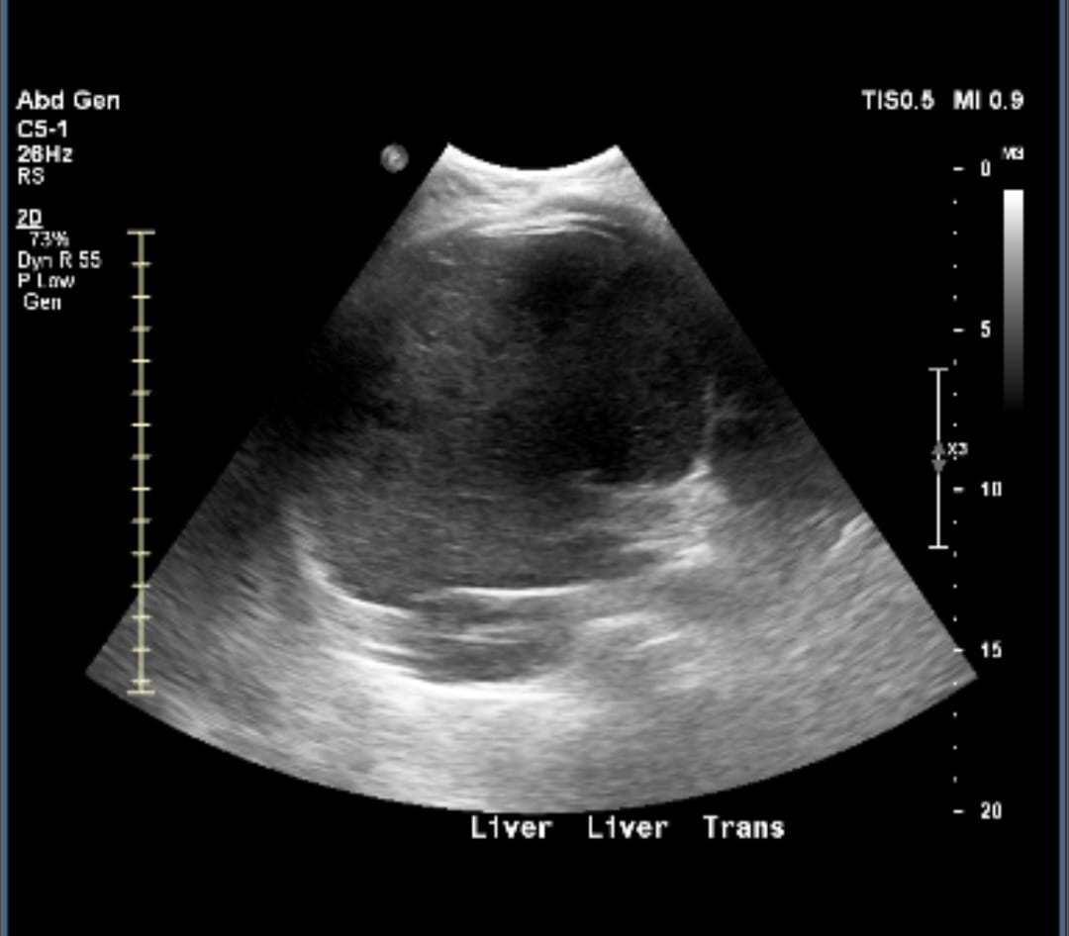
Figure:1 Hepatic ultrasonography revealing a well-defined subcapsular hematoma in the right lobe of the liver.

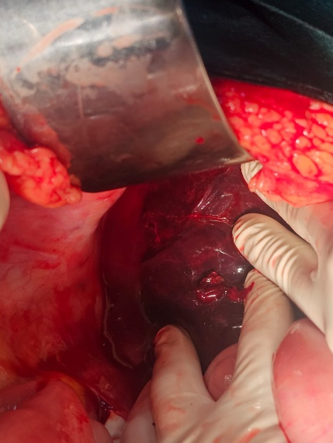
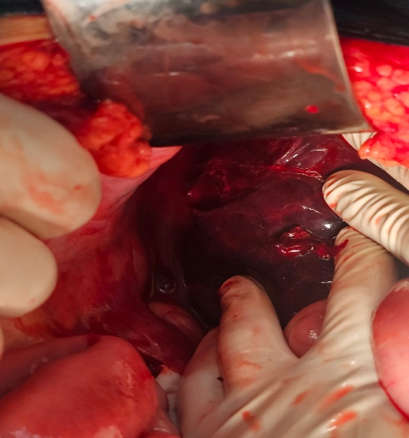
Figure 2: Intraoperative findings of a ruptured subcapsular hematoma of the right hepatic lobe in a patient with severe preeclampsia.
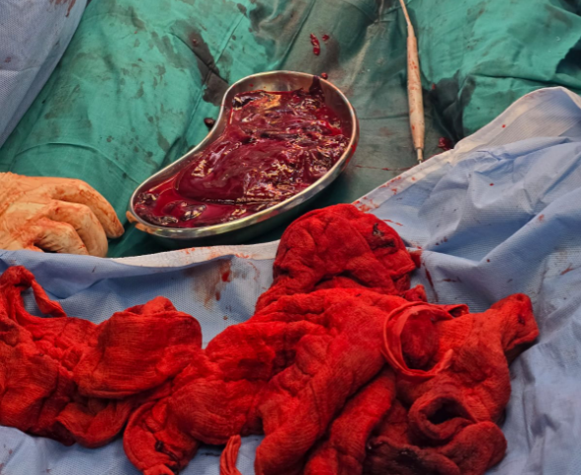
Figure 3: Intraoperative collection of blood clots and blood-soaked laparotomy packs following surgical evacuation of a ruptured subcapsular hepatic hematoma.

3. DISCUSSION

Subcapsular hepatic hematoma (SLH) is an extremely rare condition, yet it potentially can cause complications of pregnancy, primarily severe preeclampsia and HELLP syndrome. Approximately 75% of cases affect the right lobe of the liver, and only 25% of patients have involvement of the left lobe of the liver. The etiological factors include periportal fibrin accumulation, hepatocellular necrosis, and intrahepatic hemorrhage, leading to expansion of the Glisson’s capsule and, in severe cases, rupture. The reported incidence ranges from 1 in 40,000 to 1 in 250,000 pregnancies, with maternal mortality rates between 30% and 50% in instances of rupture (Wicke et al., 2004).
The clinical presentation can be confusing and non-specific, mimicking other medical conditions and further delaying diagnosis. Patients may present with right upper quadrant or epigastric pain, nausea, vomiting, and, in severe cases, sudden hemodynamic instability as seen in this case. The patient was initially stable but thereafter had acute epigastric pain and severe hypotension, suggesting capsular rupture and hemoperitoneum. Ultrasonography is the principal imaging modality for diagnosing hepatic pathology; however, CT scans demonstrate superior sensitivity for characterizing the extent of hepatic impairment. Nevertheless, a CT scan could not be obtained in this patient because her hemodynamic instability rendered further imaging unsafe. A high index of suspicion is crucial when evaluating women who exhibit unexplained upper abdominal pain.
Management depends on the patient's hemodynamic status and the severity of liver damage. Conservative treatment and careful observation, along with sequential imaging and extensive care support, are appropriate for hemodynamically stable patients with localized hematomas. Surgical intervention is necessary for ruptured or expanding hematomas or for patients who remain unstable despite resuscitation efforts.
Other management options for severe hepatic injury may include hepatic artery ligation, partial hepatectomy, and, in rare cases, liver transplantation. Selective hepatic artery embolization via interventional radiology can be considered for hemodynamically stable patients. However, due to limited resources, liver transplantation is not available at our institution.
The Feliciano perihepatic packing method was utilized to address hepatic bleeding. This technique, first described by Feliciano et al. (1986), involves the circumferential placement of laparotomy packs to ensure effective hemostasis.

4. Conclusion

Subcapsular hepatic hematoma is a rare but life-threatening obstetric emergency seen in preeclampsia and HELLP syndrome that can result in maternal mortality. Women presenting with severe epigastric or right upper quadrant pain should be urgently evaluated for hepatic involvement. Timely diagnosis, aggressive resuscitation, and multidisciplinary management, including perihepatic packing, play a critical role in improving maternal outcomes.

CONSENT
As per international standards or university standards, patient(s) written consent has been collected and preserved by the author(s).
ETHICAL APPROVAL
As per international standards or university standards written ethical approval has been collected and preserved by the author(s).

Disclaimer (Artificial intelligence)

Author(s) hereby declare that NO generative AI technologies such as Large Language Models (ChatGPT, COPILOT, etc.) and text-to-image generators have been used during the writing or editing of this manuscript.

References
- Azar, R. S., Leon, J. M., Tass, R. V., & Guillemin, R. (2025). Subcapsular Hepatic Hematoma Secondary to Preeclampsia With a Successful Maternal Outcome: A Case Report. Cureus, 17(3), e80911–e80911. https://doi.org/10.7759/cureus.80911
- Kang, Y. et al. (2025) ‘Intraoperatively diagnosed spontaneous rupture of a subcapsular liver hematoma with incomplete hemolysis, elevated liver enzymes, low platelets (HELLP) syndrome: A case report and literature review’, Medicine, 104(35), p. e44186. https://doi.org/10.1097/md.0000000000044186.
- Liu, J., Liu, L., Liao, G., & Yao, L. (2023). Conservative Treatment of Huge Hepatic Subcapsular Hematoma Complicated with Hepatic Infarction after Cesarean Section Caused by HELLP Syndrome – a Case Report and Literature Review. Zeitschrift Für Geburtshilfe Und Neonatologie, 227(03), 219–226. https://doi.org/10.1055/a-1967-2451

- Sucan, H. et al. (2025) ‘A Case of Eclampsia Complicated by HELLP Syndrome, Rupture of Subcapsular Hepatic Hematoma, and Thrombotic Microangiopathy’. https://doi.org/10.22541/au.173935682.23296698/v1.
- Liu, G., & Yang, H. (2025). Surgical management for subcapsular hematoma of the liver with preeclampsia: a case report. https://doi.org/10.21203/rs.3.rs-7108560/v1
- Chawanpaiboon, S., Janchua, M., Luamprapat, P., Chawanpaiboon, P., & Maimaen, S. (2025). Managing Life-Threatening Spontaneous Liver Rupture in Pregnancy: A Case Study. American Journal of Case Reports, 26. https://doi.org/10.12659/ajcr.946909

- S. Ainslie McBride, Small, R., Hurd, K., & Sunette Claassens. (2023). Preeclampsia and HELLP syndrome complicated by subcapsular liver hematoma and rupture. Canadian Medical Association Journal, 195(45), E1543–E1545. https://doi.org/10.1503/cmaj.230851
- Rinehart, B. K., Terrone, D. A., Magann, E. F., Martin, R. W., May, W. L., & Martin, J. N., Jr. (1999). Pre-eclampsia associated hepatic hemorrhage and rupture: Mode of management related to maternal and perinatal outcome. Obstetrical & Gynecological Survey, 54(3), 196–202. https://doi.org/10.1097/00006254-199903000-00024

- Wicke, C., Pereira, P. L., Neeser, E., Flesch, I., Rodegerdts, E. A., & Becker, H. D. (2004). Subcapsular liver hematoma in HELLP syndrome: Evaluation of diagnostic and therapeutic options—A unicenter study. American Journal of Obstetrics and Gynecology, 190(1), 106–112. https://doi.org/10.1016/j.ajog.2003.08.029
- Baldoni, F., Salomone Di Saverio, Antonacci, N., Coniglio, C., Aimone Giugni, Montanari, N., Biscardi, A., Villani, S., Gordini, G., & Tugnoli, G. (2011). Refinement in the technique of perihepatic packing: a safe and effective surgical hemostasis and multidisciplinary approach can improve the outcome in severe liver trauma. The American Journal of Surgery, 201(1), e5–e14. https://doi.org/10.1016/j.amjsurg.2010.05.015
- Caruso, D. M. (1999). Perihepatic Packing of Major Liver Injuries. Archives of Surgery, 134(9), 958. https://doi.org/10.1001/archsurg.134.9.958

