Distribution of Selected Occlusal Traits among a Sample of Sudanese Orthodontic Patients: A descriptive cross-sectional study

ABSTRACT
Background: The objectives of this study were to assess the prevalence of malocclusion among a sample of Sudanese patients seeking orthodontic treatment, to estimate the distribution of various malocclusion traits in the same cohort, and to evaluate the link between various malocclusion categories and specific malocclusion traits.
Methods: A descriptive cross-sectional study of 300 Sudanese patients’ casts was conducted. The casts were collected from patients attending the Orthodontic Training Centre in Khartoum, Sudan. The data were obtained from 300 sets of pretreatment orthodontic study models, which were articulated through bite registration using silicone material to assess the prevalence of malocclusion.
Results: Three hundred participants met the inclusion criteria (Mean age 21.42; SD 7.91). Of these, 95 (32%) were males and 205 (68%) were females. In order of prevalence, Class II division 1 malocclusion was the most prevalent type (126; 42%). Class I malocclusion was the second most prevalent type (118; 39%), followed by Class III malocclusion (47; 16%). Class II division 2 was present among 9 (3%) participants. No significant differences related to age (p = 0.231) and gender (p = 0.496) were found.
Conclusion: Class II division 1 malocclusion displayed the most significant prevalence in the sample, while Class III malocclusion showed the lowest prevalence. An open bite was primarily associated with Class III malocclusion. The prevalence of malocclusion in this study was comparable to that reported in regional populations.
Keywords: Deep bite, open bite, malocclusion, dental classification, skeletal classification.
INTRODUCTION
Malocclusion is defined as a deviation from the normal occlusion. Occasionally, it results from abnormalities in skeletal growth and dental development, as well as from various environmental influences.^{1,23} It is deemed a dental public health concern with a relatively high prevalence in some populations.²
In this context, malocclusion has been described as having negative, detrimental impacts on individuals across several areas, including dental health, psychological well-being, and social well-being.³⁻⁶ Hence, adversely affecting individuals’ social interaction is due to patient-reported impairment in oral aesthetics, as well as to predisposing them to the development of function-related problems, such as speech issues.
Therefore, orthodontic treatment is highly sought after; it is plausible to assume that there is a contingent of individuals with malocclusion in specific populations who are in great need yet lack treatment.⁷ Nevertheless, such a high prevalence of malocclusion in some populations (97.6%) does not reflect a burgeoning demand for treatment.⁸ Thus, knowledge of malocclusion prevalence is equally essential for both orthodontists and healthcare commissioners. For instance, it has been estimated that 11% of the National Health Service (England, UK) spending on dentistry is directed to orthodontic treatment.⁹
Several objective measures have been used to assess and describe malocclusion. Among these are the Angle’s malocclusion classification and the British Standards Institute’s incisor classification (BSI). The Angle’s system has been widely used as a qualitative epidemiological instrument; however, it is associated with high inter-examiner reliability errors.¹⁰ Unlike the Angle’s system, the BSI has shown good inter-examiner and intra-examiner agreement, hence rendering it reliable.¹¹
Regarding the prevalence and distribution of malocclusion traits and features, differences exist among populations.^{12,13} This wide range of distribution is attributed to an interplay of racial, genetic, and environmental factors.¹² For instance, Class III malocclusions are more common among Asian races, while Class II malocclusions are more common in individuals of European descent.¹²
In the literature, few studies have investigated the prevalence of malocclusion in Sudan.^{14,15,16} Thus, the objectives of this study were to: (i) estimate the prevalence of malocclusion among a sample of Sudanese orthodontic patients; and to (ii) estimate the prevalence of individual traits of malocclusion in the same cohort.
MATERIAL AND METHODS
A cross-sectional study of a Sudanese sample of 300 patients (95 males and 205 females), aged 9 to 51 years, who visited the Mageet Orthodontic Training Centre for dental treatment. Informed consent is obtained at the beginning of orthodontic records, before starting treatment. Informed consents were routinely obtained from all patients, parents, and/or guardians before commencing orthodontic treatment.
The vertical relationship was classified as complete deep bite, ⅔ deep bite, normal bite (⅓), edge-to-edge, 0.1-2.9mm open bite, and 3-8mm open bite (Figure 1).
Figure 1. Vertical classification
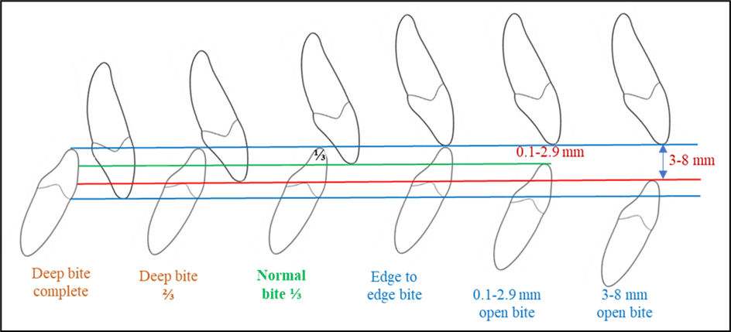
Ethical approval was obtained from the Ethics Committee of the Orthodontic Training Centre.
This study was conducted in the capital of Sudan, Khartoum. It has a population of 6,344,348 as of the year 2023, with a growth rate of 2.99% from 2022.
Power analysis (sample size calculation):
Power analysis was done based on the results of the paper entitled: The prevalence of malocclusion and the need for orthodontic treatment among adolescents in the northern border region of Saudi Arabia: An epidemiological study.²⁰

Sample size can be estimated using the formula:
n = $\frac{Z^{2} P(1-P)}{d^{2}}$
Where n is the sample size, Z is the statistic corresponding to the level of confidence, and P is the expected prevalence. The level of confidence usually aimed for is 95%. d is the Precision (or margin of error) with which a researcher is willing to measure the variables. The margin of error is set at 5%. The estimated Sample Size is 272.
A descriptive cross-sectional prospective study of 300 Sudanese orthodontic patients (88 males and 212 females) was conducted. The mean age of the participants was 21.42; SD 7.91 years. The participants were patients attending the Orthodontic Training Centre in Khartoum, Sudan. Data collection and orthodontic assessments were conducted by the first author (AOM) for the participants over a 9-month period, from June 2021 to March 2022.
Patients were included according to the following criteria: Subjects from a Sudanese ethnic background; permanent dentition; no abnormal tooth morphology; no hypodontia or supernumerary teeth, no prior history of orthodontic treatment; no previous maxillofacial surgery; no factors which prevented accurate measurement of vertical relationship, including tooth restorations; no crown and bridges or broken anterior teeth altering tooth morphology on study models.
A three-hundred set of orthodontic study models was therefore examined. After articulating the casts using a wax bite guide, the anteroposterior relationship was assessed using the Angle and BSI classification systems. Vertical measurements were measured using a sharp pencil to mark complete overbite, ⅔^{rd} and ⅓^{rd} vertical relation. Then, the measurement was taken from the marked area on the incisal edge and divided by the total incisogingival height of the lower incisor (Figure 2A).
Figure 2. A (deep bite), B (anterior open bite), vertical assessment and C (electric digital calliper)
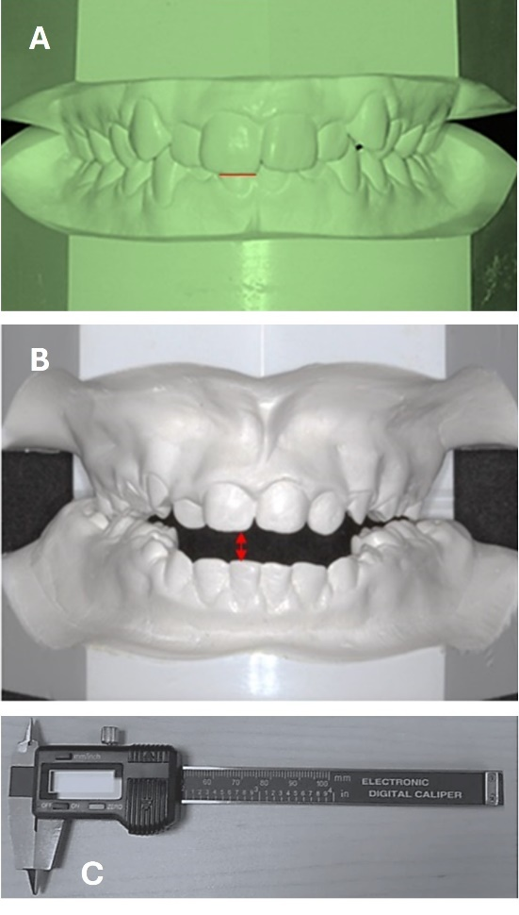
The overbite was measured and subgrouped into complete deep bite, deep bite ⅔, normal bite ⅓, and edge-to-edge.
Edge-to-edge relation was recorded when the tips of the upper incisors touch the tips of the lower incisors. The open bite was measured using an electronic digital calliper (Figure 2B). Two open bite groups were formed: 0.1-2.99mm and 3-8mm.
To test for intra-examiner reliability, measurements were repeated by the same examiner one month after initial assessment for 30 study models using the same electronic digital calliper (Figure 2C. The intraclass correlation coefficient was excellent (0.91-1).
The obtained data were analysed using descriptive statistics (frequencies and percentages) in the Statistical Package for Social Sciences (SPSS version 19, IBM Statistics, Chicago, IL), and statistical significance was set at p<0.05.
RESULTS
Three hundred participants met the inclusion criteria (Mean age 21.42; SD 7.91). Of these, 95 (32%) were males and 205 (68%) were females. As shown in Figure 3, according to the BSI classification, Class II, division 1 malocclusion was the most prevalent type among the participants (126; 42%). Class I malocclusion was the second most prevalent type (118; 39%), followed by Class III malocclusion (47; 16%). Whereas Class II division 2 was present among 9 (3%) participants.
Gender-related differences among participants were not significant (p = 0.496) (Table 1). Moreover, age-related differences were examined (p = 0.231) (Table 1).
Table 1. Gender and age distribution / malocclusion
Description |  | Class I | Class II division 1 | Class II division 2 | Class III
Gender | Male | 34 (35.8) | 41 (43.2) | 2 (2.1) | 18 (18.9)
Gender | Female | 84 (41) | 85 (41.5) | 7 (3.4) | 29 (14.1)
Age / years | 9-13 | 34 (30.2) | 18 (41.9) | 2 (24.7) | 10 (23.3)
Age / years | >13 | 105 (40.9) | 108 (42) | 7 (2.7) | 37 (14.4)
The distribution of the range of bite depth for the total sample is shown in Figure 4. One hundred and sixty-eight participants (56%) of the total sample had normal bite depth; 65 participants (22%) had a deep bite of ⅔; 27 participants (9%) had an open bite of 0.1-2.99mm; 21 participants (7%) had a complete deep bite; 10 participants (3%) had an open bite of 3-8mm, whereas 9 participants (3%) had an edge-to-edge bite tendency.
The association of different malocclusion types with the selected occlusal traits is illustrated in Figures 4 and 5. According to the BSI classification, Class II division 1 was mainly associated with complete deep bites (67%) and 2/3 deep bites (60%). Class III was primarily associated with edge-to-edge bite (89%), open bites measuring 3-8 mm (50%), and open bites measuring 0.1-2.99 mm (30%).
Figure 3. Distribution of malocclusion types of the total sample in percentages
Figure 4. Distribution of overbite depth in percentages

Figure 5. Association of malocclusion types (BSI) of the total sample with the range of bite depth in percentages
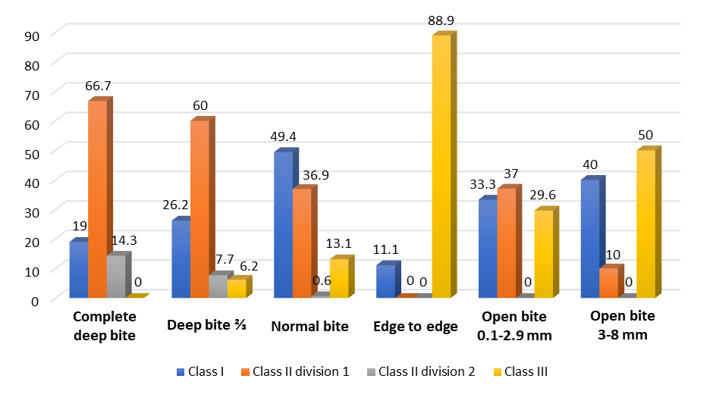

According to Angle’s system, among the participants, Class II malocclusion was mainly linked with deep bites (61; 45.2%) but was much less associated with open bites (11; 8.1%). Class III malocclusion was mainly related to open bites (21; 44.7%) but was much less linked with deep bites (4; 8.5%). These results were statistically significant (p < 0.001).
Distribution of the total samples based on the range of bite depth in frequency and percentages are as follows: complete deep bite (21; 7%); deep bite 2/3 (65; 22%); normal bite (168; 56%); edge to edge (9; 3%); open bite 0.1-2.99 mm (27; 9%); open bite 3-8 mm (10; 3%). Gender and age-related differences among the participants are shown in Tables 2 and 3.
Table 2. Crosstabulation of gender and malocclusion types (Angle’s) in frequency and percentages
 |  |  |  | Deep bite | Normal | Open bite | Total
Class I | Gender | Male | Count | 3 | 25 | 6 | 34
Class I | Gender | Male | % within new complication | 14.3% | 30.1% | 42.9% | 28.8%
Class I | Gender | Female | Count | 18 | 58 | 8 | 84
Class I | Gender | Female | % within new complication | 85.7% | 69.9% | 57.1% | 71.2%
Class I | Total |  | Count | 21 | 83 | 14 | 118
Class I |  |  | % within new complication | 100.0% | 100.0% | 100.0% | 100.0%
Class II | Gender | Male | Count | 19 | 24 | 0 | 43
Class II | Gender | Male | % within new complication | 31.1% | 38.1% | 0.0% | 31.9%
Class II | Gender | Female | Count | 42 | 39 | 11 | 92
Class II | Gender | Female | % within new complication | 68.9% | 61.9% | 100.0% | 68.1%
Class II | Total |  | Count | 61 | 63 | 11 | 135
Class II |  |  | % within new complication | 100.0% | 100.0% | 100.0% | 100.0%
Class III | Gender | Male | Count | 1 | 8 | 9 | 18
Class III | Gender | Male | % within new complication | 25.0% | 36.4% | 42.9% | 38.3%
Class III | Gender | Female | Count | 3 | 14 | 12 | 29
Class III | Gender | Female | % within new complication | 75.0% | 63.6% | 57.1% | 61.7%
Class III | Total |  | Count | 4 | 22 | 21 | 47
Class III |  |  | % within new complication | 100.0% | 100.0% | 100.0% | 100.0%
Total | Gender | Male | Count | 23 | 57 | 15 | 95
Total | Gender | Male | % within new complication | 26.7% | 33.9% | 32.6% | 31.7%
Total | Gender | Female | Count | 63 | 111 | 31 | 205
Total | Gender | Female | % within new complication | 73.3% | 66.1% | 67.4% | 68.3%
Total | Total |  | Count | 86 | 168 | 46 | 300
Total |  |  | % within new complication | 100.0% | 100.0% | 100.0% | 100.0%

Table 3. Crosstabulation of age groups and malocclusion types (Angle’s) in frequency and percentages
 |  |  |  | Deep bite | Normal | Open bite | Total
Class I | Age  years | 9 - 13 | Count | 2 | 8 | 3 | 13
Class I | Age  years | 9 - 13 | % within new complication | 9.5% | 9.6% | 21.4% | 11.0%
Class I | Age  years | > 13 | Count | 19 | 75 | 11 | 105
Class I | Age  years | > 13 | % within new complication | 90.5% | 90.4% | 78.6% | 89.0%
Class I | Total |  | Count | 21 | 83 | 14 | 118
Class I |  |  | % within new complication | 100.0% | 100.0% | 100.0% | 100.0%
Class II | Age years | 9 - 13 | Count | 11 | 7 | 2 | 20
Class II | Age years | 9 - 13 | % within new complication | 18.0% | 11.1% | 18.2% | 14.8%
Class II | Age years | > 13 | Count | 50 | 56 | 9 | 115
Class II | Age years | > 13 | % within new complication | 82.0% | 88.9% | 81.8% | 85.2%
Class II | Total |  | Count | 61 | 63 | 11 | 135
Class II |  |  | % within new complication | 100.0% | 100.0% | 100.0% | 100.0%
Class III | Age years | 9 - 13 | Count | 1 | 5 | 4 | 10
Class III | Age years | 9 - 13 | % within new complication | 25.0% | 22.7% | 19.0% | 21.3%
Class III | Age years | > 13 | Count | 3 | 17 | 17 | 37
Class III | Age years | > 13 | % within new complication | 75.0% | 77.3% | 81.0% | 78.7%
Class III | Total |  | Count | 4 | 22 | 21 | 47
Class III |  |  | % within new complication | 100.0% | 100.0% | 100.0% | 100.0%
Total | Age years | 9 - 13 | Count | 14 | 20 | 9 | 43
Total | Age years | 9 - 13 | % within new complication | 16.3% | 11.9% | 19.6% | 14.3%
Total | Age years | > 13 | Count | 72 | 148 | 37 | 257
Total | Age years | > 13 | % within new complication | 83.7% | 88.1% | 80.4% | 85.7%
Total | Total |  | Count | 86 | 168 | 46 | 300
Total |  |  | % within new complication | 100.0% | 100.0% | 100.0% | 100.0%

DISCUSSION
This study aimed to quantify the prevalence of malocclusion among a sample of orthodontic patients in Sudan, estimate the distribution of specific malocclusion features within the same cohort, and examine the association between different malocclusions and selected occlusal traits. Assessing patients seeking orthodontic treatment and evaluating the prevalence of malocclusion types are crucial for planning orthodontic service provision and influencing patients’ motivation to pursue orthodontic treatment. ^{13,14,15,16.}
In our study, among the participants, 39% had Class I malocclusion; 42% had Class II division 1 malocclusion; 16% had Class III malocclusion; and 3% had Class II division 2 malocclusion. While Class II division 1 malocclusion had the highest prevalence, Class II division 2 malocclusion had the lowest. Based on both Angle’s system and BSI classification, Class II malocclusion was the most prevalent type of malocclusion, followed by Class I malocclusion (Figure 3). These findings have implications for clinical practice, i.e., implying that orthodontists in Sudan are more likely to encounter and manage Class II malocclusions.
In contrast to our findings, in Saudi Arabia, a higher prevalence of Class I malocclusion (52.8%) was reported, while Class II malocclusion was lower among orthodontic patients (31.8%), followed by Class III malocclusion (15.4%).¹⁵ Similarly, in Nigeria (76.5%) and India (77.3%), a greater prevalence of Class I malocclusion was reported.^{17,18} In Turkey, similar to our findings regarding Class II division 2 malocclusion and Class III malocclusion, the frequencies were 5% and 12%, respectively, while Class I malocclusion was observed in 64% of cases.¹⁹ Disparities in the context of sample size and methodology should be considered when taking these comparisons into account. In this study, we also explored age-related differences (p = 0.231) and gender-related differences (p = 0.496), both of which were statistically insignificant.
A distinct occlusal feature explored in this study was overbite. A full range of overbite depth, from complete deep bites to open bites, occurs with all types of malocclusions. Such occlusal features can be related to one type of malocclusion more than the other, with wide individual variation. In the present study, the prevalence of normal overbite was 56%; Deep bite 2/3 was 22%; Open bite 0.1-2.99mm was 9%; Complete deep bite was 7%; and was 3% for open bite 3-8mm and edge-to-edge bite. Comparable results were observed among a sample of 500 in Saudi Arabia: increased deep bite was observed in 23.4%, and reduced overbite was observed in 12.2%. Similarly, 64.4% of their participants showed normal overbite.¹⁹⁻²²
The relationship between malocclusion types and the range of bite depth is highlighted in Figure 5. In the present study, an open bite of 3-8mm was primarily associated with Class III malocclusion (50%), followed by Class I malocclusion (40%). Class III malocclusion was mainly associated with an edge-to-edge bite (88.9%). Whereas Class II division 1 was primarily related to a complete deep bite (approximately 67%). Deep overbite and open bite are among the most difficult malocclusion features to manage and treat, partly due to their detrimental impact on the stability of orthodontic treatment. Therefore, our findings may be used to reflect the status of these malocclusion features in Sudan.
Considering the limitations of this study is deemed appropriate at this stage. The lack of assessment of orthodontic treatment needs is considered a limitation; however, the sample size of the present study was comparable to that of other regional studies.¹⁶⁻²⁰ Prior research evaluating the prevalence of malocclusion in Sudan is limited; therefore, it was not possible to compare the results of this sample to a similar cohort in Sudan, also due to numerous methodological differences.^{14,15} The authors will thus evaluate the orthodontic treatment needs of study participants and report these along with the prevalence of malocclusion in this sample of clinic patients. This will provide more detailed information on malocclusion in the study sample, enabling comparison with relevant literature. Examining other variables, such as crowding, overjet, facial profile, and treatment needs, might also have been beneficial. The distribution of the prevalence of malocclusions into bilateral or unilateral would be of great importance for the result of the study, since not all malocclusions have the same sagittal severity bilaterally. That is, classifying the malocclusion in Class II or Class III subdivisions would significantly enhance the information provided by the study.

CONCLUSION and Recommendations
- Prevalence of malocclusion in Sudan is comparable to that reported in regional studies.
- Class II division 1 displayed the most significant prevalence, followed by Class I, then Class III, and the least was Class II division 2.
- Open bite was associated mainly with Class III malocclusion in a sample of Sudanese patients.
Further investigation, including evaluation of orthodontic treatment needs among Sudanese patients, is needed.
Consent:
Witten informed consents were routinely obtained from all patients, parents, and/or guardians before commencing orthodontic treatment.

LIST OF ABBREVIATIONS
(BSI) British Standards Institute’s incisor classification

Disclaimer (Artificial intelligence)
Option 1:
Author(s) hereby declare that NO generative AI technologies such as Large Language Models (ChatGPT, COPILOT, etc.) and text-to-image generators have been used during the writing or editing of this manuscript.
Option 2:
Author(s) hereby declare that generative AI technologies such as Large Language Models, etc. have been used during the writing or editing of manuscripts. This explanation will include the name, version, model, and source of the generative AI technology and as well as all input prompts provided to the generative AI technology
Details of the AI usage are given below:
1.
2.
3.

REFERENCES
- Proffit, W. R. (1978). Equilibrium theory revisited: factors influencing position of the teeth. The Angle Orthodontist, 48(3), 175–186. https://doi.org/10.1043/0003-3219(1978)048<0175:ETRFIP>2.0.CO;2
- Proffit, W. R., Fields, H. W. Jr, & Moray, L. J. (1998). Prevalence of malocclusion and orthodontic treatment need in the United States: estimates from the NHANES III survey. International Journal of Adult Orthodontics and Orthognathic Surgery, 13(2), 97-106. https://pubmed.ncbi.nlm.nih.gov/9743642/
- Davies TM, Orth D, Shaw WC, Addy M, Dummer PM. The relationship of anterior overjet to plaque and gingivitis in children. Am J Orthod Dentofac Orthop. 1988; 93(4): 303-309.
- Magalhães, I. B., Pereira, L. J., Marques, L. S., & Gameiro, G. H. (2010). The influence of malocclusion on masticatory performance. A systematic review. Angle Orthodontist, 80(5), 981–987. https://doi.org/10.2319/011910-33.1
- Agou, S., Locker, D., Streiner, D. L., & Tompson, B. (2008). Impact of self-esteem on the oral-health-related quality of life of children with malocclusion. American Journal of Orthodontics and Dentofacial Orthopedics, 134(4), 484-489. https://doi.org/10.1016/j.ajodo.2006.11.021
- Agou, S., Locker, D., Muirhead, V., Tompson, B., & Streiner, D. L. (2011). Does psychological well-being influence oral-health-related quality of life reports in children receiving orthodontic treatment? American Journal of Orthodontics and Dentofacial Orthopedics, 139(3), 369-377. https://doi.org/10.1016/j.ajodo.2009.05.034
- Abu Alhaija, E. S. J., Al-Nimri, K. S., & Al-Khateeb, S. N. (2004). Orthodontic treatment need and demand in 12-14-year-old north Jordanian school children. *European Journal of Orthodontics*, *26*(3), 261-263. https://doi.org/10.1093/ejo/26.3.261
- Rwakatema, D. S., Nganga, P. M., & Kemoli, A. M. (2006). Prevalence of malocclusion among 12-15-year-olds in Moshi, Tanzania, using Bjork's criteria. East African Medical Journal, 83(7), 372-379. https://doi.org/10.4314/eamj.v83i7.9449
- NHS Digital. (2012). NHS Dental Statistics - England, 2011-2012: Annex 4 (Clinical). NHS Dental Statistics for England. https://www.nhs.uk/nhs-dental-statistics-for-england-2011-12
- Gravely, J. F., & Johnson, D. B. (1974). Angle's classification of malocclusion: An assessment of reliability. British Journal of Orthodontics, 1(3), 79–86. https://doi.org/10.1179/bjo.1.3.79
- Williams, A. C., & Stephens, C. D. (1992). A modification to the incisor classification of malocclusion. British Journal of Orthodontics. https://doi.org/10.1179/bjo.19.2.127
- Alhammadi, M. S., Halboub, E., Fayed, M. S., Labib, A., & El-Saaidi, C. (2018). Global distribution of malocclusion traits: A systematic review. Dental Press Journal of Orthodontics, 23(6), 40.e1-40.e10. https://doi.org/10.1590/2177-6709.23.6.40.e1-10.onl
- Wilmot, J. J., Barber, H. D., Chou, D. G., & Vig, K. W. (1993). Associations between severity of dentofacial deformity and motivation for orthodontic-orthognathic surgery treatment. The Angle Orthodontist, 63(4), 283-288. https://doi.org/10.1043/0003-3219(1993)063<0283:ABSODD>2.0.CO;2
- Ibrahim, H. A., & Abuaffan, A. H. (2014). Prevalence of malocclusion and orthodontic treatment needs in Down syndrome Sudanese individuals. Orthodontic Journal of Nepal, 4(2), 32–36. https://doi.org/10.3126/ojn.v4i2.13896
- Razan A Awad and Amal H Abuaffan. Prevalence of Malocclusion in a Sample of Sudanese University Students by the Index of Orthodontic Treatment Need Index (IOTN). EC Dental Science. 2018 Jan; 17(1): 15-22.
- Mahmoud, N. M., Eltahir, H. E., & Mageet, A. O. (2017). Tooth Size Discrepancy among Different Malocclusion Groups in a Sudanese Sample. Journal of Orthodontics & Endodontics, 3(10). https://doi.org/10.21767/2469-2980.100044
- Onyeaso, C. O., Aderinokun, G. A., & Arowojolu, M. O. (2002). The pattern of malocclusion among orthodontic patients seen in Dental Centre, University College Hospital, Ibadan, Nigeria. Afr J Med Med Sci, 31(3), 207-211. https://pubmed.ncbi.nlm.nih.gov/12751558/
- Gul-e-Erum, & Fida, M. (2008). Pattern of malocclusion in orthodontic patients: a hospital based study. *Journal of Ayub Medical College Abbottabad*, *20*(1), 43–47. https://pubmed.ncbi.nlm.nih.gov/19024184/
- Sayin, M. O., & Türkkahraman, H. (2004). Malocclusion and crowding in an orthodontically referred Turkish population. Angle Orthodontist, 74(5), 635-639. https://doi.org/10.1043/0003-3219(2004)074<0635:MACIAO>2.0.CO;2
- Gudipaneni, R. K., Aldahmeshi, R. F., Patil, S. R., & Alam, M. K. (2018). The prevalence of malocclusion and the need for orthodontic treatment among adolescents in the northern border region of Saudi Arabia: An epidemiological study. BMC Oral Health, 18(1), 16. https://doi.org/10.1186/s12903-018-0476-8
- Mwangi, C. W., Richmond, S., & Hunter, M. L. (2009). Relationship between malocclusion, orthodontic treatment, and tooth wear. American journal of orthodontics and dentofacial orthopedics,136(4),529-535.https://www.sciencedirect.com/science/article/pii/S0889540609006763
- Shaw, W. C., Addy, M., & Ray, E. C. (1980). Dental and social effects of malocclusion and effectiveness of orthodontic treatment: a review. Community dentistry and oral epidemiology, 8(1), 36-45. https://onlinelibrary.wiley.com/doi/abs/10.1111/j.1600-0528.1980.tb01252.x
- Mohammad Jaradat. (2018). An Overview of Class III Malocclusion (Prevalence, Etiology and Management). Journal of Advances in Medicine and Medical Research, 25(7), 1–13. https://doi.org/10.9734/JAMMR/2018/39927

